Week 5
Power

Day 3

NAME:______________________

Day 3 Agenda

Topic | Activity
Warm-Up!
English Language Arts | - Read the article, They Dance Alone  - Respond to questions about the text.  - Read and analyze the lyrics to the song, They Dance Alone and write a response piece.
Science | - Read about Wind Power  - Answer questions about what you read  - Draw a picture and explain
Mindfulness Moment!
Math | - Power: Marching and and Power of Solidarity Movements
Health | - How are privacy and power related?
Mindfulness Moment!
Civics/Social Studies | - Consider types of governmental powers  - Direct democracy v. Representative democracy

Warm-up Activity: Write a journal entry around the daily quote on identity.
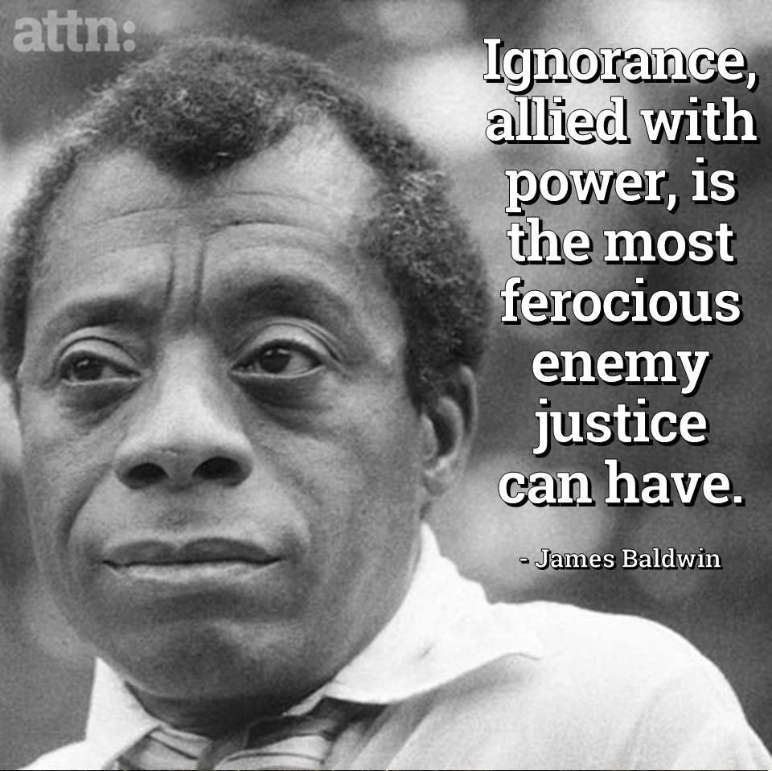

Day 3: Fighting power in disguise
English Language Arts

What is this lesson about? Today you will be reading about a group of women who fought against abuse of power in their country. They protested in a way that was considered “quiet” but yet were able to make themselves heard throughout the world.

Step 1: Before reading

expropriate: to (especially the government) take away from its owner | permeate: to spread out or disperse | ire: anger, annoyance
poignantly: causing a feeling of sadness or regret | atrocity: a cruel act | ghastly: causing great horror or fear

Step 2: Read the article from The International News by Haris Ahmed.
Background: General Augusto Pinochet, who ruled Chile as a dictator for 17 years, led the military coup that overthrew Chile's elected socialist president, Salvador Allende, in 1973. He was ruthless in eliminating his political opponents in Chile, and ultimately was held responsible for the torture and deaths of thousands of people. The article below tells the story of La Cueca, considered the national dance of Chile, and how it was used to protest Pinochet’s power. It was also one way in which women, who seemed powerless, were able to protest and gain world-wide attention for what was happening in Chile.

They Dance Alone
Haris Ahmed, May 10, 2018
La Cueca has been around in Chile for generations. Rooted deep in the country’s working-class culture, the dance is believed to have European Spanish, African and indigenous roots. It arrived in Chile in the 19th century, becoming popular in its working class and rural taverns in the early 20th century.
La Cueca is all about romantic conquest. It imitates the mating ritual of a rooster and a hen, and hence, requires a male and a female participant. The use of a handkerchief is vital too, as partners raise it above their heads or behind their backs as they stomp their feet and circle one another. It is important that the dancers maintain strong eye contact throughout the different steps and movements. The dance ends with the man on his knees, having symbolically been able to woo his woman. The dance is a celebration of love.
After the CIA-backed push against Salvador Allende’s socialist government in 1973, the cueca came under the shadow of Augusto Pinochet’s tyrannical regime. Apart from the curfews, torture and enforced disappearances, the cueca, too, did not escape his gaze. He expropriated the dance from the working class and incorporated it into his military parades, so much so that the dance became a symbol of the dictatorship’s oppression. It was also declared Chile’s national dance in 1979.
With fear permeating the very fabric of society, any form of political dissent was cracked down upon extremely violently. Painters, poets, intellectuals and writers were tortured for merely expressing their aversion to the dictator’s authoritarian rule. Special ire was reserved for leftists and socialists. Enforced disappearances were routine, with those picked up rarely ever heard of or seen again.
It was in these times, at the height of Pinochet’s oppression in 1983, when la cueca took on an entirely new meaning. Several women whose husbands and sons had been ‘picked up’ by Pinochet’s regime and had been missing for years decided to perform the cueca in public without their partners. The aim was to force those in attendance to ask where their partner was. The women had a picture of their loved one around their neck. Thus, was born the la cueca sola.
A Chilean writer later writing about the dance described it poignantly: “Through la cueca sola, the dancers tell a story with their solitary feet, the story of the mutilated body of a loved one. Through their movements and the guitar music, the women also recreate the pleasure of dancing with the missing person”. The striking visual of the solo dancer, thus, displayed the absence of the lost lives.
These brave women were known as the ‘arpilleristas’, because with the men of their households gone, the women depended on these brightly coloured patchwork pictures called ‘arpilleras’ for a living. These arpilleras were made of simple materials such as burlap and scraps of clothing, often from the clothes of the men who had gone missing, as economic constraints meant these women could not afford to buy new fabric. The pictures depicted scenes of hardship and violence that these women experienced during the dictatorship. These arpilleras depicted politically motivated messages.
Thus, la cueca sola was an expression of disgust at Pinochet and his regime, while also being just one part of the diverse womens’ rights movement that the women led against the Pinochet regime. These women had become familiar with each another after seeing each other daily on their visits to jails, courthouses and mortuaries as they searched in vain for their loved ones. Predictably, the Pinochet regime did not take all this lightly. Many of these women were detained by law enforcement, and were stripped naked, humiliated and tortured. This only further strengthened their resolve to fight for their loved ones’ emancipation. The beautifully crafted arpilleras were the only way their message could penetrate the print and broadcast censorship, which had barred all outlets from reporting on any human rights violations of the regime.
However, la cueca sola, did not escape the attention of the world. Rock icon Sting wrote and sang the song ‘They Dance Alone’ in 1987 in which he poignantly pointed to the pain and grace of these women:
They’re dancing with the missing/ They’re dancing with the dead/ They dance with the invisible ones/ Their anguish is unsaid.
Sting’s effort made the world sit-up and take notice of these extraordinary women, and the atrocities carried out by Pincohet’s regime. However, there are few happy endings in life. Very few who had been detained and tortured ever returned to tell their tale – and the tales were ghastly indeed.
Pinochet was never convicted of the many crimes he was accused of. He was charged for murder, torture, developing and using nerve gas on his opponents, partaking in the trans-continental drug trafficking operations, among other crimes. He died of heart failure in 2006 while he was under house-arrest. Since the return of democratic rule in Chile in the 1990, the country has tried its best to forget its past, but the ghosts still linger.
In those dark times, the arpilleristas were those remarkable women who raised their voice for their loved ones when there was no one to do it for them. They gave Chilean women a brand new identity and, using dance as a medium of dissent, reclaimed the cueca for the Chilean people from Pinochet’s clutches, all the while bearing their unspeakable grief with a grace that cannot be put into words.
The arpilleristas are a lesson for all autocrats around the world that no matter how tightly they curb freedoms and no matter how furiously they attempt to stifle all voices of dissent, resistance will arise from where they least expect it. Democracy sustains in a strong society and flourishes only where people are masters of their own destiny and retain the will to resist any efforts made to alter it against their wishes.
https://www.thenews.com.pk/print/314802-they-dance-alone

Step 3: Answer the following questions:

- Why did the women decide to dance the Cueca Sola in public alone?

- Why did the dance, which was originally a dance of love, come to represent Pinochet’s oppression?

- The women who danced also created “arpilleras” or quilt squares which they sold both in Chile and internationally to support themselves and their families. What were the squares made of and what did they depict?

- How did Pinochet react to the Arpellistas?

- The arpilleras (quilt squares) were sold to tourists and internationally. Pinochet, at one point, confiscated and outlawed the selling of these arpilleras. Why do you think he did that? Explain.

- What was the benefit for the women that a world famous musician like Sting decided to release a song that told their stories?

- In the last paragraph of the article, the author writes,

“The arpilleristas are a lesson for autocrats (rulers with absolute power) around the world that no matter how tightly they curb freedoms and no matter how furiously they attempt to stifle all voices of dissent, resistance will arise from where they least expect it.”

Explain how these women were considered “the least expected”. How were they able to use that to fight against power and to gain some power for their resistance?

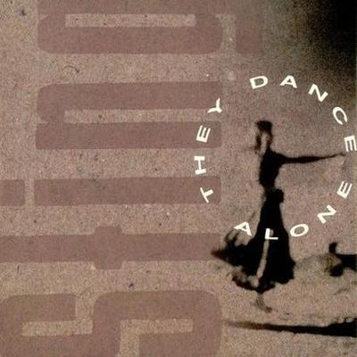
Step 3: Read and Annotate:

Before you read:
During the 1970s , Sting and his band The Police, toured Chile at the height of the Pinochet regime. He told the Independent On Sunday in 1994: "I asked Amnesty International what they thought and their advice was that I should go, because rock'n'roll means freedom in these countries. So we went out there and it was pretty painful. There were troops and tanks on every street. While there, he witnessed the Arpellistas, "This was something that I saw when I went to Chile with the Police. The mothers and wives of "the disappeared" do this amazing thing; they pin photographs of their loved ones to their clothes and go out in groups and do this folk dance with invisible partners in front of the police station. It's this incredible gesture of grief and protest. But it's a feminine way of combating oppression. The masculine way is to burn cars or to throw rocks. Yet this feminine way is so much more powerful because what can the police do These women are simply dancing. What I'm trying to say on the record is that the female ultimately is superior to the male. That's what will bring Pinochet down - the mother's sense of injustice." When he released the song in in 1987, the song was banned in Chile.

As you read, pay close attention to the images that the author creates as he describes the dance.

They Dance Alone (Gueca Solo)
Sting

1 | Why are these women here dancing on their own?  Why is there this sadness in their eyes?  Why are the soldiers here  Their faces fixed like stone?  I can't see what it is they despise | Who is the author describing in this stanza?
2 | (Chorus)  Dancing with the missing  They're dancing with the dead  They dance with the invisible ones  Their anguish is unsaid  They're dancing with their fathers  They're dancing with their sons  Dancing with their husbands  They dance alone  They dance alone | Summarize what the author is describing in this stanza.
3 | The only form of protest they're allowed  I've seen their silent faces, they scream so loud  If they were to speak these words  They'd go missing, too  Another woman on the torture table  What else can they do? | What is the risk that the women run by protesting in this way?
4 | (chorus)
5 | One day we'll dance on their graves  One day we'll sing our freedom  One day we'll laugh in our joy  And we'll dance  One day we'll dance on their graves  One day we'll sing our freedom  One day we'll laugh in our joy  And we'll dance | What is the author picturing in this stanza? How will the dance be different?
6 | Hey Mr. Pinochet  You've sown a bitter crop  It's foreign money that supports you  One day the money's going to stop  No wages for your torturers  No budget for your guns  Can you think of your own mother  Dancing with her invisible son | Summarize this stanza.
7 | (Chorus)
8 | One day we'll dance on their graves  One day we'll sing our freedom  One day we'll laugh in our joy  And we'll dance  One day we'll dance on their graves  One day we'll sing our freedom  One day we'll laugh in our joy  And we'll dance  And we'll dance | Why does the author end with repeating this stanza—what is the tone or attitude of the author in this stanza?

Step 5: Read, Think, Write, Share

When Sting wrote this song, he was moved by the fact that the women used what he called “feminine power” instead of being overt/explicit and using either violent or even very traditional ways of protesting. So, in many ways, these women used what could be called “subversive” or hidden ways of protesting and to make their voices heard. What were the advantages of doing this? Do you think it was effective? Why or why not?

Student Feedback:

Circle the emojis that best represents how this activity made you feel. | 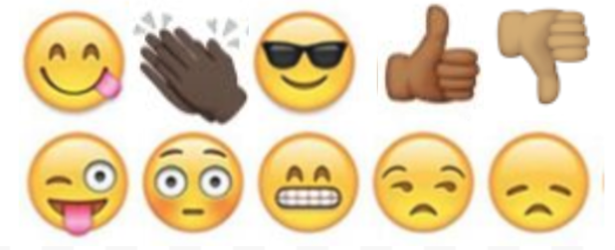  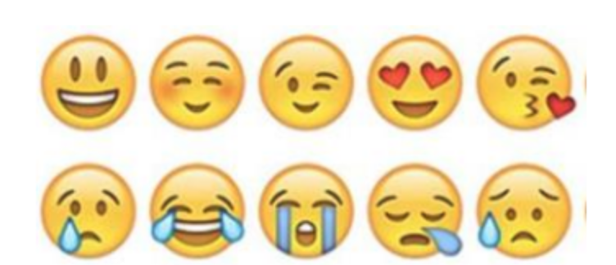

Day 3: Wind Power
Science

What is this lesson about?: Today you will read through the Wind Power passages. You will answer a few questions about what you read. You will complete a Wind Power activity.

Step 1: Read through the Wind Power passages

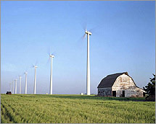
Wind Power
What is wind power?
Wind power is energy, such as electricity, that is generated directly from the wind. It is considered a renewable energy source because there is always wind on the Earth and we aren't "using up" the wind when we make energy from it. Wind power also does not cause pollution.

Wind Turbines and Wind Farms
In order to make electricity from wind, energy companies use large windmills called wind turbines. They are called this because they use turbine generators to generate the electricity.

In order to create a lot of energy capable of powering thousands of homes, energy companies build large wind farms with lots of wind turbines. They usually build these in consistently windy places. Some companies build wind farms out in the ocean. These are called offshore wind farms.

How tall are wind turbines?
Wind turbines are really big structures. The tower itself is typically between 200 and 300 feet tall. When you add in the height of the blades, some turbines tower 400 feet high! The blades are quite big, too. There are typically three wind blades on a wind turbine. Each blade is usually between 115 and 148 feet long.

How does a wind turbine work?
A wind turbine works the opposite of a fan. Instead of using electricity to turn the blades to make wind, it uses the wind to turn the blades to make electricity.

When the wind turns the blades, the blades turn a shaft inside the turbine. This shaft is big, but turns slowly. The shaft, however, is connected to a number of gears which causes a smaller shaft to turn much faster. This smaller shaft drives the electrical generator which generates the electricity that can be used by homes and businesses.

What if there isn't any wind?
If there isn't any wind, then no energy will be generated by the wind turbine. However, engineers do a lot of measurements and calculations to figure out the best areas to place the wind turbines. The wind won't be blowing all the time, but the important thing is how much the wind blows on average.

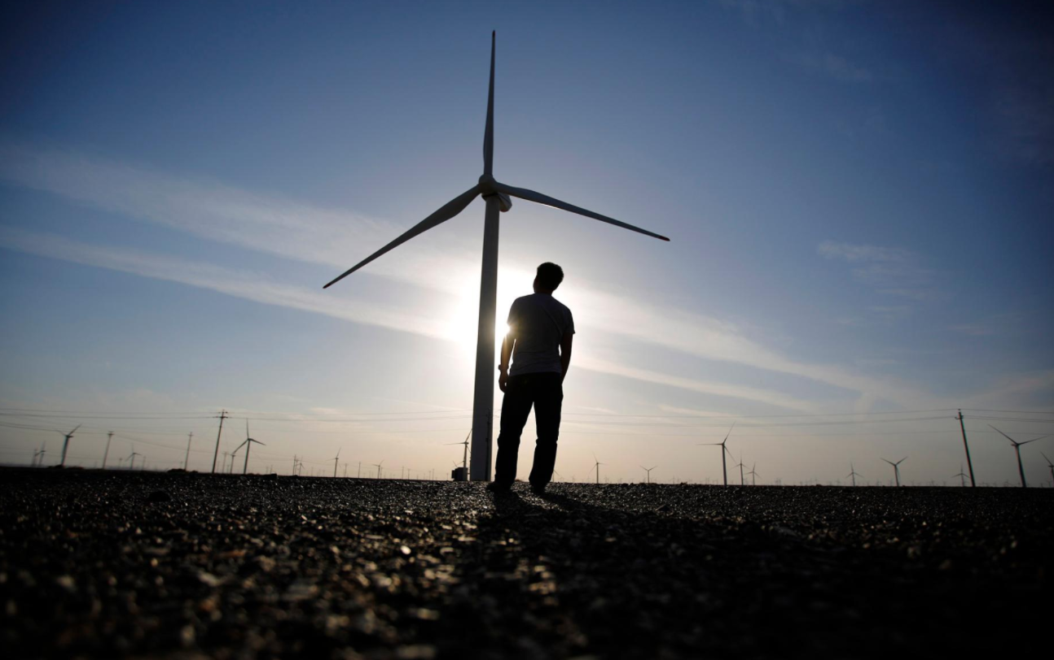
History of Windmills
Windmills have been used since the Middle Ages in order to harness the energy of the wind. They were initially used to pump water or to grind flour. They are still used in many places of the world today to pump water. It was in the late 1800s and early 1900s that windmills were first used to generate electricity.

Are there any drawbacks to wind power?
One major issue some people have with wind power is how the wind turbines mess up the view or landscape. Other drawbacks include the large blades killing birds and noise pollution from the turbine. Most people agree that the positives of a fully renewable and clean energy resource far outweigh the negatives.

Fun Facts about Wind Power
- For a wind turbine to make money it must be placed in a spot with an average annual wind speed of 15 miles per hour.
- In 2011, the top wind power producing state in the United States was Texas. Texas was followed by Iowa, California, Minnesota, and Illinois.
- Around 3% of the electricity in the United States in 2011 was provided by wind power. This was enough to power around 10 million homes.
- Tax breaks and new technologies have helped the output from wind power to grow significantly in the last 10 years.
- The largest wind farm in the United States is the Horse Hollow Wind Energy Center in Texas. It has 421 wind turbines.
Wind is the movement of air from an area of high pressure to an area of low pressure. In fact, wind exists because the sun unevenly heats the surface of the Earth. As hot air rises, cooler air moves in to fill the void. As long as the sun shines, the wind will blow. And wind has long served as a power source to humans.

Ancient mariners used sails to capture the wind. Farmers once used windmills to grind their grains and pump water. Today, more and more wind turbines wring electricity from the breeze. Over the past decade, wind turbine use has increased more than 25 percent per year. Still, it only provides a small fraction of the world's energy.

How it Works
Most wind energy comes from turbines that can be as tall as a 20-story building and have three 200-foot (60-meter)-long blades. The wind spins the blades, which turn a shaft connected to a generator that produces electricity.

The biggest wind turbines generate enough electricity in a year (about 12 megawatt-hours) to supply about 600 U.S. homes. Wind farms have tens and sometimes hundreds of these turbines lined up together in particularly windy spots. Smaller turbines erected in a backyard can produce enough electricity for a single home or small business.

The Booming Wind Energy Industry
Wind is a clean source of renewable energy that produces no air or water pollution. And since the wind is free, operational costs are nearly zero once a turbine is erected. Mass production and technology advances are making turbines cheaper, and many governments offer tax incentives to spur wind-energy development.

Drawbacks include complaints from locals that wind turbines are ugly and noisy. The slowly rotating blades can also kill birds and bats, but not nearly as many as cars, power lines, and high-rise buildings do. The wind is also variable: If it's not blowing, there's no electricity generated.

Nevertheless, the wind energy industry is booming. Thanks to global efforts to combat climate change, such as the Paris Agreement, renewable energy is seeing a boom in growth, with wind energy leading the way. From 2000 to 2015, cumulative wind capacity around the world increased from 17,000 megawatts to more than 430,000 megawatts. In 2015, China also surpassed the EU in the number of installed wind turbines and continues to lead installation efforts.

Industry experts predict that if this pace of growth continues, by 2050 one third of the world's electricity needs will be fulfilled by wind power.

Step 2: Answer the following questions

- What are large windmills used for generating electricity called?
  - Energy mills
  - Wind turbines
  - Winders

- Which of the following works the opposite of a wind turbine?
  - Nuclear power plant
  - Solar panel
  - Electric fan

- Around how long is the typical blade on a wind turbine?
  - 20 feet
  - Over 100 feet
  - 50 feet

- What US state produces the most energy from wind?
  - Texas
  - California
  - Washington

- What do we call a large group of wind turbines used to generate electricity?
  - Wind mill
  - Wind pack
  - Wind farm

- What is a drawback to using wind turbines to generate electricity?
  - The blades can kill birds
  - They can cause noise pollution
  - All of the above
  - None of the above

- Wind turbines will continue to generate energy even when there isn't any wind.
  - TRUE
  - FALSE

Step 3: Draw an image/picture

Draw a picture of your own wind farm. Where is it located? What do you hope will happen as a result of your wind farm?

Student Feedback:

Circle the emojis that best represents how this activity made you feel. | 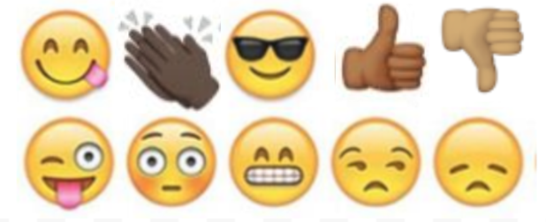  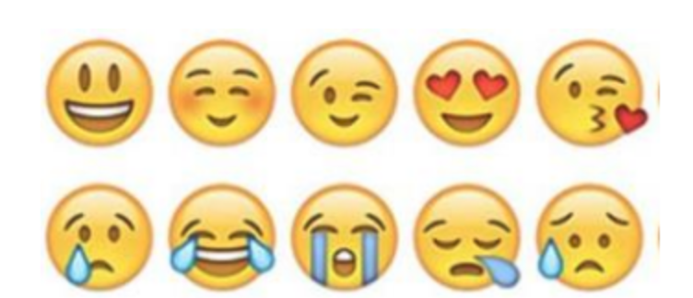

Mindfulness Moment!

How can I express my feeling without hurting anyone?

Day 3: Power/Marching and Organizing
Math

What is this lesson about?: Today we will be looking at Marching and Power of the Marching...

Activity #1: The Selma to Montgomery, Alabama March for Voting Rights in 1965

Background: Just over 55 years ago, Civil Rights leaders attempted to march over the Edmund Pettus Bridge in Selma, Alabama and then continue on to Montgomvery, Alabama. The march was to be a nonviolent march, designed to highlight the restrictions African Americans faced when trying to exercise their right to vote in Alabama and in the South.

[Christina, Insert photo from the 1st March -- Rep. Lewis/others getting beaten back]

In the years directly following the Civil War, African American participation in voting grew significantly, often under protection of federal troops. However, by the late 1800s and the turn of the century, many states in the south started to enforce restrictions on voting, including a poll tax and a literacy test.

Questions from an actual Literacy Test Poll Tax Flier

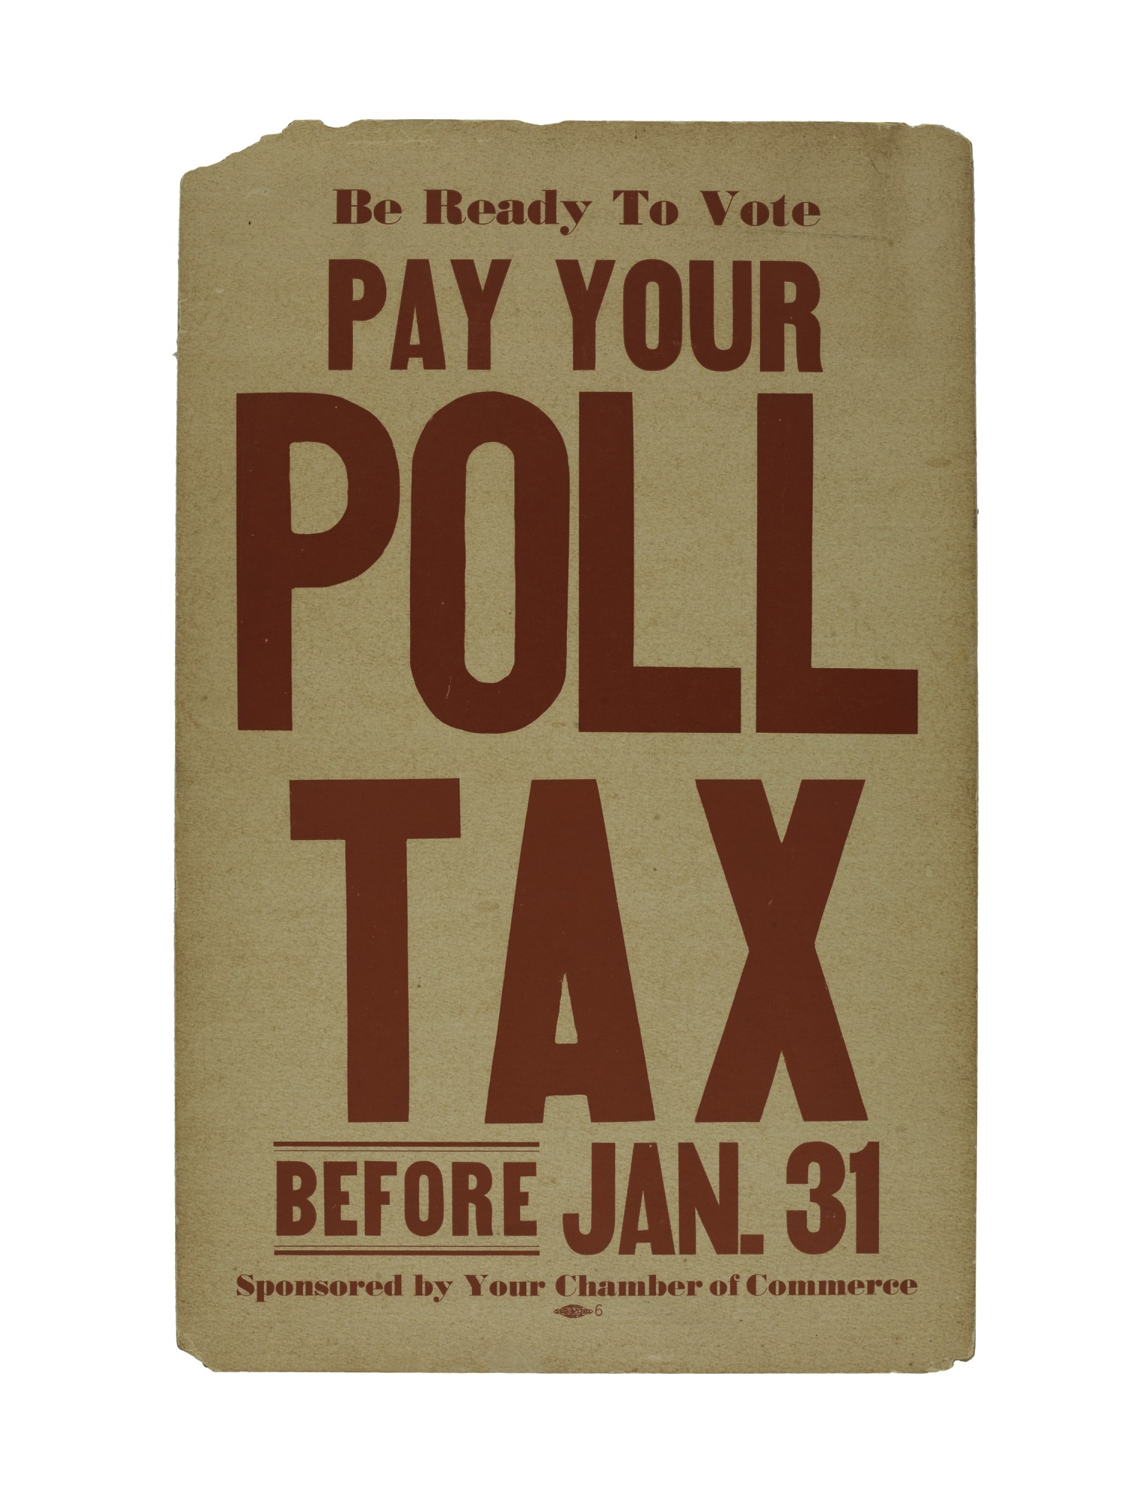
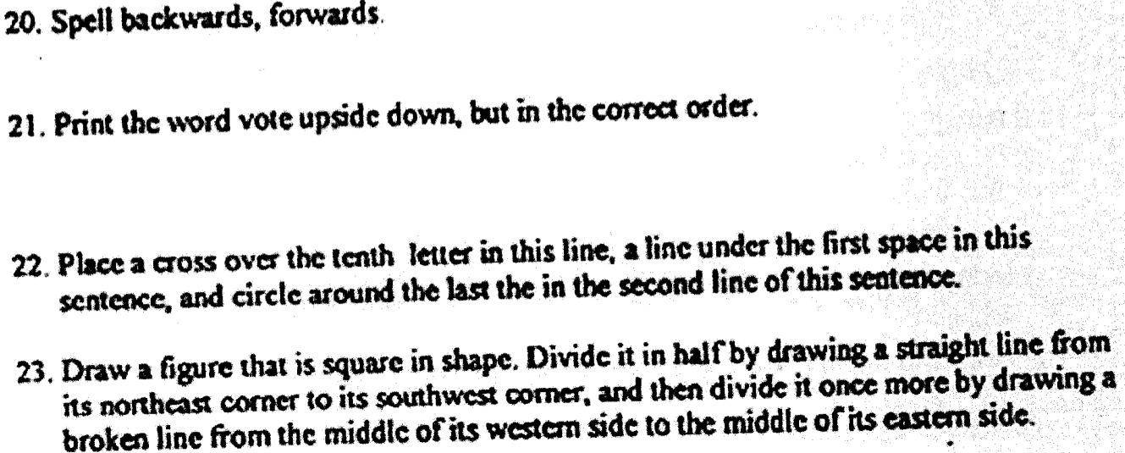

Exception: if your family voted BEFORE the Civil War, you did NOT have to pay….No Black families were able to vote before the Civil War...

With these barriers, African American voting in Alabama and throughout the South plummeted.

For example, in Dallas County, Alabama--where the city of Selma is located--the Black population remained fairly flat from 1890 until 1964, with right around 15,000 eligible voters. In 1880 nearly one-half of them registered to vote, but by 1964, only 156 of the approximately 15,000 eligible Black voters (1%) were registered! By contrast nearly 66% of eligible White voters were registered.

***

On March 5, 1965, a group of Civil Rights leaders organized a protest March to draw attention to the unfair laws and restrictions related to Black voter registration.

Approximately 600 prepared for the March. The marchers were turned back brutally. Videos of the violence circulated widely.

After two weeks of negotiations, that included representatives from the federal government, a 2nd March was organized, with assurances that the marchers would not be harmed. 3,200 started the 50+ mile march over the bridge toward Montgomery.

Along the way, and over the 5 days that followed, nearly 25,000 people joined the march.

This growth, from 600 marchers to nearly 25,000 is remarkable. To help us, we are going to round the numbers off to 600 (first march), 3,000 (start of 2nd march) and 24,000 (end of 2nd march).

- How many times more people started the 2nd march than started the first march?

- If you were going to diagram that, how many add-ons would you place around each of the first marchers? See below-
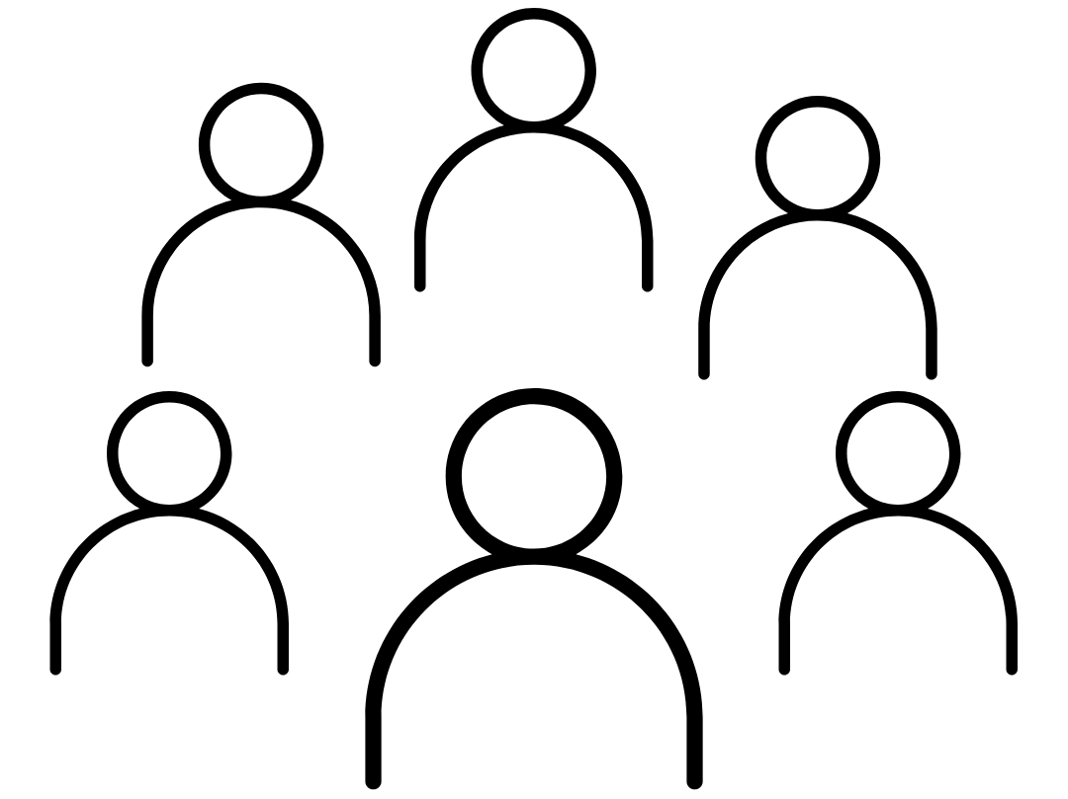
- If you were going to use this same model, how many objects would be orbiting each of the first marchers by the end of the 2nd march? (Hint: what is 24,000 divided by 600?)

- Could you even fit that drawing below?

Discuss/Consider: What do you think took place that lead to so many more people joining the marches?

Activity 2: Assessing increased access to the Polls

Shortly after the Selma to Montgomery march, Congress passed the Voting Rights Act of 1965 and it was signed into law by the President.

The charts below show the change in Black registered voters between 1964 and 1972 in Dallas County, Alabama--where Selma is located.
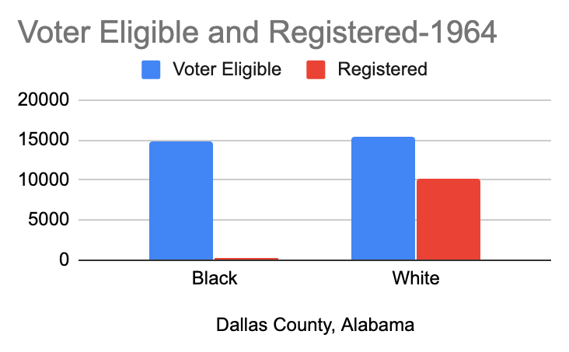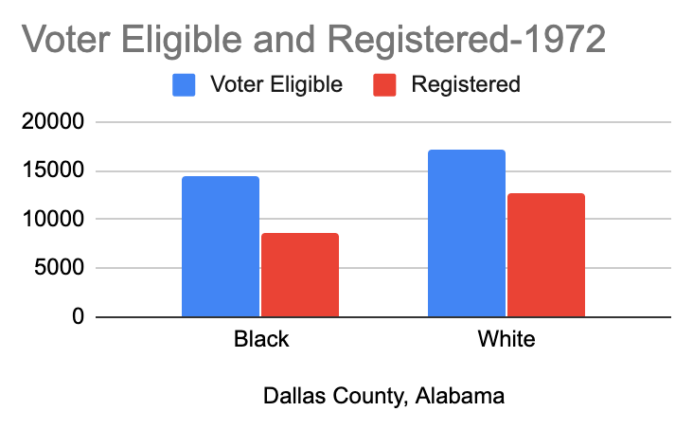
Based on the above charts….
- In 1964 before the March and the passage of the Voting Rights Act, about how many African Americans eligible to vote were registered in Dallas County?

- By 1972, about how many African Americans eligible to vote were registered in Dallas County?
  - Estimating from the chart, about what % of eligible African American voters registered to vote in 1972?

Discuss/Consider:
- What difference does it make, or should it make, if people vote or not?
- What is an example of a policy or law that could change based on who votes in a local election?
- What about in a Presidential Election?
- Do you know if judges are elected or appointed in your state?

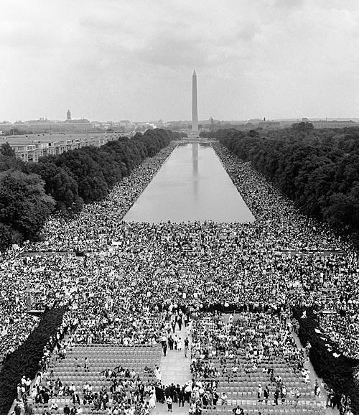
Activity 3: Understanding the March on Washington, and what it took to sustain it….

Background: The March on Washington, which took place on August 28, 1963, was one of the largest civil rights rallies in US history, and one of the most famous examples of nonviolent, mass direct action. The March on Washington was highly publicized in the news media, and helped to gather momentum for the passage of the Civil Rights Act in 1964. The majority of the demands revolved around issues of economic justice – like equal access to public facilities and accommodations, housing, education, and jobs.

In fact the full name of the March was the March for Jobs and Freedom. 1963 was the 100th anniversary of Abraham Lincoln’s Emancipation Proclamation, and one of the major themes of the rally was that the promises of emancipation remained unfulfilled.
More than 250,000 people attended the March, with many of them traveling hundreds, some more than one thousand, of miles to join in the March and rally. Organizing so many people was a huge task, clearly. And the person in charge of the logistics was Bayard Rustin. In this activity, we are going to focus on some of the logistics of the March and answer the question, what does it take to make such an event take place?
Busses: Many of the attendees came to Washington, DC by bus, usually in large groups, sponsored by local churches or organizing groups.
Assume that you are in charge of organizing a bus ride from your city to Washington, DC. Complete the following chart:

Hometown:
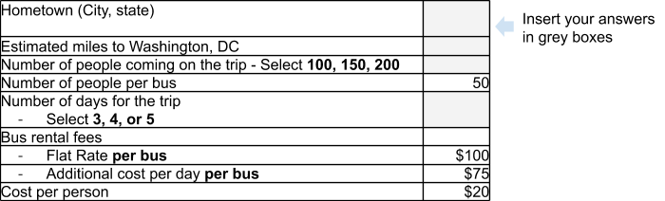
Based on this information, how much will it cost you to rent your bus and bring your local group to the March. Remember to calculate the cost based on the # of people, the # of bussed you will need, the # of days you will spend going and coming, and to take into the cost for each day and for each rider. Use the space below to calculate your answer.
Food and Housing: Many of the attendees who came to Washington, DC for the March stayed in local churches and other facilities like recreation centers. So it wasn’t as costly as staying in hotels. But people needed places to sleep and food to eat.
Assume that you were able to negotiate a good deal with Howard University. They charged you:
- $10 per night per person to sleep in the dorm.
- $5 (total) for breakfast and lunch each day.
Your group decided to stay in DC two nights and two days.

Based on the number of people you brought with you (from above), how much would it cost for your housing and to ensure that everyone got breakfast and lunch both days?
Organizing and preparing for the March and the Attendees.
Bayard Rustin had a huge job to plan for such a large event on the Mall. This chart outlines some of the main costs of putting on the event.
Items(s) | Cost
City Permits | $10,000
Stage and Sound System | $5,500
Port a Potties  - Required to have 1 for every 500 people attending  - Use estimates of 250,000 attendees | $10 rental fee for the 1 day for each Port-a-Pottie
City Fees for Police, Fire, Rescue | $20,000 flat fee, plus  $5,000 additional for every 50,000 people over 100,000
Private security | $2,500
How much money would Bayard Rustin need to raise to host the March on the Mall?
- Be careful with the cost of the Port-a-Potties and the cost of Police, Fire, Rescue. Remember to use the # of attendees as 250,000.

Activity 4: Media Coverage of the March and the Speeches
Back in 1963 there wasn’t any cable TV, nor did the Internet exist. But there was basic TV. Based on estimates from the TV ratings, nearly 1 in 10 households watched Martin Luther King, Jr’s final I have a Dream Speech that day.
- Assuming there were 80 million households then, how many people watched the speech live?
- The speech was covered on the TV news repeatedly for days, with estimates of over an additional 20 million people viewing the speech on the local news.
How many people in the US saw the speech on TV that week?
It is estimated that nearly 10 million Americans watch a clip of that speech every year now--most on or around the Martin Luther King, Jr holiday.
- Assuming this same number of viewers each year from 1965 to the present (2020), how many millions of times has that speech been viewed?

Consider/Discuss: Some of the most popular songs over the last few years get hundreds of millions of views over just 2-3 months on YouTube.
- Is this good or bad?
- What could be done, if anything, to increase the viewership of important events and speeches on social media?

Student Feedback:

Circle the emojis that best represents how this activity made you feel.

Day 3: How are privacy and power related?
Health

What is this lesson about?: In today’s lesson, we will look at how privacy and power are critical components in relationships.

Step 1: Warm-Up In the relationship belowdo you feel like one person has more power than the other person?

Who’s got the POWER?
A girl convinces her boyfriend that they won’t put passwords on their phones and can check each others’ texts and social media accounts whenever they feel like it.

Who has the POWER? Why?

Step 2: Read about the behaviors below.
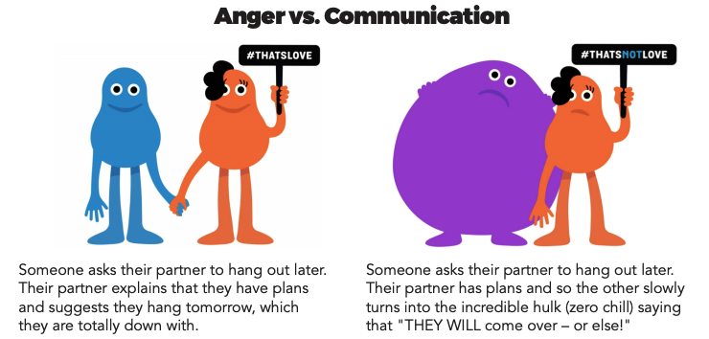

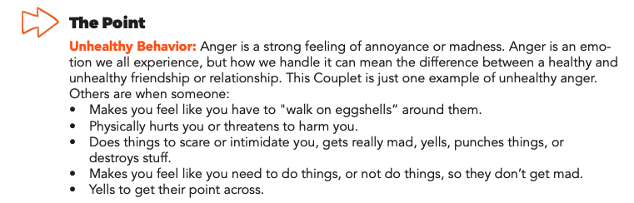

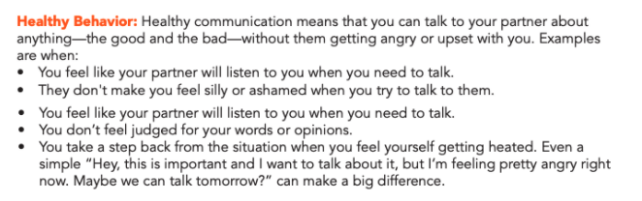
Step 3: Complete the Activity.

Write a letter to a friend who insists that they should have your passwords so they can control what you do on your phone and on social media. Tell them why privacy is important and how it helps you maintain a healthy relationship.

Dear

Student Feedback:

Circle the emojis that best represents how this activity made you feel.

Mindfulness Moment!

What went well for me today and how did I contribute to it?

Day 3: Governmental Powers: Direct v. Representative Democracies
Social Studies/Civics
What is this lesson about?: Today you will continue exploring different types of government, and will focus on direct democracies and representative democracies. Below is a reminder of our Elite 8 bracket. Fill in who won the face-offs for the last 2 lessons below.

Types of Government Bracket
Monarchy
Oligarchy
Dictatorship
Theocracy
Direct Democracy
Representative Dem.
Communism
Anarchy

Step 1: Compare Direct and Representative Democracies

Direct Democracy  In a true direct democracy, every single law, bill, or issue of justice is voted on by all the people. One advantage of a direct democracy is that people can see the changes being reflected in the system faster because they determine everything with their votes. Also citizens have power of voting and individual rights, which is a benefit as it increases self-empowerment for people. Alternatively, disadvantages of a direct democracy include the potential for the people to vote negligently, or without proper care and consideration. This could be bad because the people’s vote is very important in a direct democracy. | Representative Democracy  A representative democracy is a system of government in which all eligible citizens vote on representatives to pass laws for them. The people vote to elect their representatives or leaders, and then the representatives act on behalf of the voters. Advantages of a representative democracy include more freedom for individuals and people have a right to vote and voice their opinion. On the other hand, disadvantages include people potentially voting for representatives without full information or without exercising care. There is also the possibility of corruption because there are a lot of people operating the government and it can be difficult to hold everyone accountable.

Step 2: Read the article and answer questions

The difference between a democracy and a republic
By USHistory.org, adapted by Newsela staff

Nowhere is the word "democracy" mentioned in the Declaration of Independence or the U.S. Constitution. How could that be? Our government is a democracy!

Well, for one, as we'll discuss later, the Founders actually feared democratic rule. In the late 18th century, rule by the people was thought to lead to chaos and disruption. Yet a democratically based government was seen as superior to the kings and queens of Europe.
Democracy Gives Power To The People
Democracies did not begin with the founding of the United States. The term "democracy" comes from two Greek words: "demos" (the people) and "kratia" (power or authority). So of course, democracy is a form of government that gives power to the people. But how, when and to which people? The answer to those questions changes through history.
Democracies are based on "rule of law." The ancient Greeks (particularly Aristotle) valued natural law. This is the idea that human societies should be ruled by certain general principles of what is right that are common to human nature. The Greeks are famous for practicing direct democracy. This is a system in which citizens meet to discuss all new laws. Then they voted, making decisions by majority rule. However, only free males were considered to be citizens, not women or slaves. So their democracy was certainly limited. Today, direct democracy is practiced in New England town meetings, where all citizens of voting age meet to decide important political decisions.

America's Population Was Too Big For A Direct Democracy
But how could direct democracy work in a large population with many different groups spread over long geographical distances? Generally, the answer has been that it can't. In the place of direct democracy, the American Founders chose "indirect" or "representative" democracy. In this system, Representatives are chosen by the people to make decisions for them. The representative body, Congress, was considered to be the right size for doing the business of government.
The Founders preferred the term "republic" to "democracy." This is because in a republic, the interests of the people are represented by more knowledgeable or wealthier citizens. These representatives are responsible to those that elected them. Today, we tend to use the terms "republic" and "democracy" to mean the same thing. It can all get a little confusing. Sometimes people call the United States "the Republic," and other countries use the term also in their names, like the Republic of Ghana, in Africa.
One of the issues many people have with representative democracy is that the representatives become the "elites" that seldom consult ordinary citizens. Even though they are elected, a truly representative government doesn't really exist.

What type of democracy does the U.S. have? Explain your answer.

What type of government did the newly formed United States want to move away from? What type of government had they revolted against in the American Revolution?

What is a potential problem with representative democracy discussed in the article above?

What is the biggest difference between a direct democracy and a representative democracy?

Step 3: Read the article and answer questions

Where Does Democracy Come From?
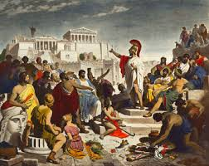
Winston Churchill once said democracy 'is the worst form of government in the world, except all those other forms that have been tried from time to time.' Many human societies have practiced some form of democracy over the millennia, the most important (for the American version, at any rate) example originated in ancient Greece. The world's first working democracy, as far as we can tell, was established by Cleisthenes in the Greek city-state of Athens, around 508 BCE.
The Greeks came up with the form of government that we call direct democracy, which is a precursor to representative democracy. In a direct democracy, all eligible citizens vote on every issue. For example, if a direct democracy were considering a tax increase, all the eligible voters would vote on that decision. This form of government is often called 'participatory' or 'Aristotelian democracy.' In Athens, the concept of 'eligible' voters only included male citizens and excluded all others (slaves and women could not vote).
However, imagine for a moment having to vote on every single thing that happens in a country—it would be impossible, for many reasons, especially in a country the size of the U.S. The Greeks thought so, too, so they came up with a way to choose a smaller subset of individuals to do the voting. In Athens, for example, the citizens made use of a device called a kleroterion, which was something like a bingo-ball selector. Each citizen would receive a token representing him; several hundred were picked each day, and for a time, they would make decisions for the entire city-state. This was an early form of the next evolution of democracy, called representative democracy.

Basics of a Democracy
But what is democracy, anyhow? It's generally agreed that there are five criteria that are necessary for any society to call itself democratic:
- Equality in voting
- Effective participation
- Enlightened understanding
- Citizen control of the agenda
- Inclusion (must be open to all citizens within a nation)

What type of democracy did the early Greeks have?

Is a direct democracy always possible? What may make it difficult to have this type of government?

In a democracy, ‘the people’ are supposed to have the power. Either directly or through a representative. Do you feel like you have political power in the U.S.? Why or why not.

If you’re not 18 yet and are not able to vote, how might youth be able to influence politics and use their power? (hint: think about how students have responded after school shootings)

Step 7: Organize your thoughts
Complete the graphic organizer on the next page to help you compare and contrast Direct and representative democracies. After completing the graphic organizer, you will reflect on these forms of governments and choose which one you prefer.
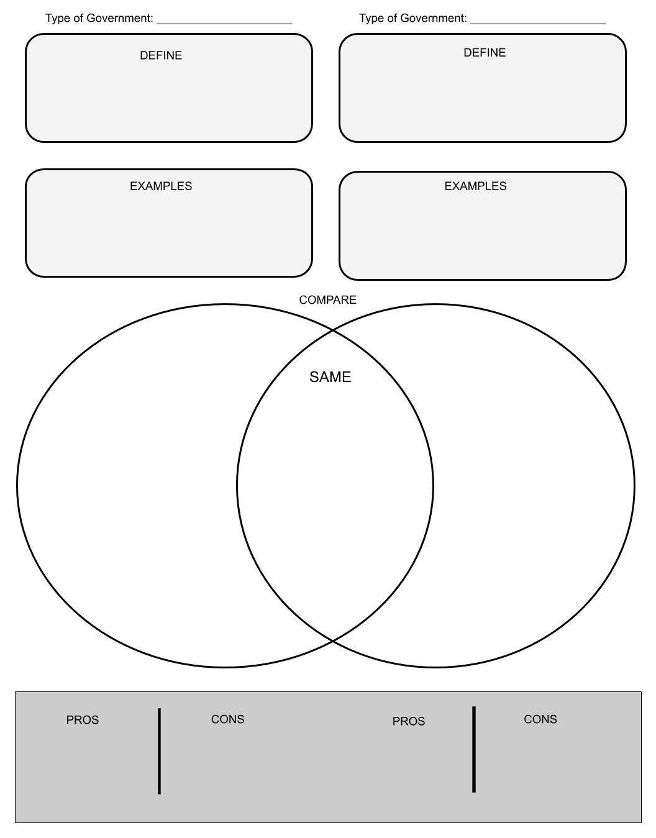

Step 8: Reflect

Complete the bracket below and choose which type of government you prefer:
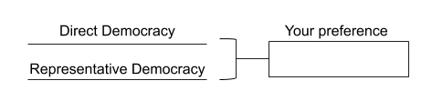

- Why do you prefer that governmental system? (share three reasons)

- How does it compare to the current governmental system you live in now? (share three reasons)

Step 9: Discuss
- With a partner, share and compare your graphic organizer.
- Can you improve your graphic organizer after discussing with your partner?
- Share what you chose as your winner for this bracket face-off and why.

Student Feedback:

Circle the emojis that best represents how this activity made you feel.

