Week 1
Strength

Day 2

NAME:______________________

Day 2 Agenda

Topic | Activity
Warm-Up!
English Language Arts | - Read a short bio about Frances Harper as well as a short speech she gave  - Respond to questions about the readings  - Prepare a short story to share as a speech
Science | - Design your own bridge and test its strength
Mindfulness Moment!
Math | - Understanding the difference between increase or decrease and percentage increase and decrease
Mindfulness Moment!
Civics/Social Studies | - Read an article about the aftermath of WWI in Europe  - Answer questions about the article
Warm-up Activity: Write a journal entry around the daily quote on strength.
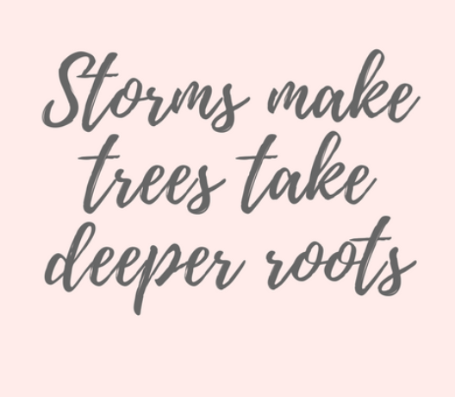

Day 2: English Language Arts
Strong Women

What is this lesson about?: Today you will continue our series on strong women, in line with Women’s History Month. You will learn about Frances Harper, a 19th-century black woman activist who struggled against segregation, you will learn about her work to encourage others to stand up to segregation, and you will analyze part of a speech she gave. You will then have an opportunity to write a speech to encourage people to take action around an issue you care about.

Step 1: Read the following text.
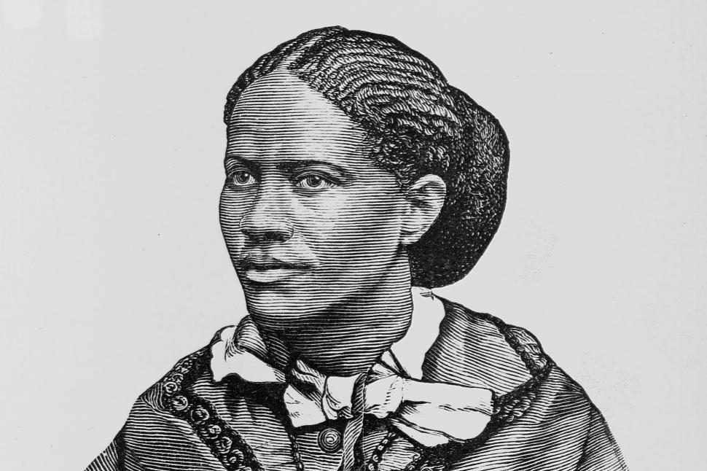
Born free in Baltimore in 1824, Frances Watkins taught at Wilberforce University, lectured for the Maine Anti-Slavery society before the Civil War and collaborated extensively with white suffragists and abolitionists. She married Fenton Harper in 1860 and, until her husband died in 1864, attempted to run a small farm in Ohio. His death left her with a young daughter and very few financial resources. She began a new lecture tour in the South, addressing audiences of freed slaves, and continued to speak at woman suffrage conventions, where her audience was primarily white. Already the best-known and loved African American poet of her time, Harper also began writing novels in 1869.

Harper’s first novel, Minnie’s Sacrifice, tells the story of a young woman from a wealthy family who leaves home to teach the children of former slaves. The heroine, Minnie, gets lynched by the Ku Klux Klan, sacrificing her life for her people. While Harper wrote this novel, she was teaching in the South and often threatened by former slave traders, “rebels” and the Klan. Although Harper, like Minnie, was in grave danger, she wrote letters to Northern friends repeatedly reassuring them that she was not afraid.

Like Rosa Parks who followed her, Harper rarely seemed afraid. In an April 23, 1858, letter she wrote to the Liberator, an anti-slavery newspaper, Harper described her reaction to segregation on public transportation:

I have been insulted on several railroad cars. The other day, in attempting to ride in one of the city cars, after I had entered, the conductor came to me, and wanted me to go out on the platform. Now, was not that brave and noble? As a matter of course, I did not. Some one interfered, and asked or requested that I might be permitted to sit in a corner. I did not move, but kept the same seat. When I was about to leave, he refused my money, and I threw it down on the car floor, and got out, after I had ridden as far as I wished. Such impudence!

Step 2: Answer the following questions

Below are two inferences from the text. Circle one of the inferences. Then cite two lines from the text that support that inference.

Inference | Frances Harper was a strong individual who fought for what she believed in.
 | After the Civil War African Americans faced prejudice and discrimination but showed great perseverance.

Line 1:

Line 2:

The passage notes that although Harper “was in grave danger, she wrote letters to Northern friends repeatedly reassuring them that she was not afraid.” Why do you think Harper did this?

In one of her poems, Harper writes:
Let me make the songs for the weary,
Amid life’s fever and fret,
Till hearts shall relax their tension,
And careworn brows forget.

What is the message of this poem stanza?

How is the message of this poem similar to the message of the letters she wrote to friends reassuring them that she was not afraid?

Do you think Frances Harper was a strong woman? Why or why not?

What part of her life story do you identify or relate to most? How are you similar to Frances Harper?

Step 3: Read the following text.

Excerpt from “We Are All Bound up Together: Proceedings of the Eleventh Women’s Rights Convention,” May 1866, pages 45-48. Below is an excerpt from Frances Harper’s speech at a women’s convention.

Frances Watkins Harper — “You white women speak here of rights. I speak of wrongs. I, as a colored woman, have had in this country an education which has made me feel as if I were in the situation of Ishmael, my hand against every man, and every man’s hand against me. Let me go to-morrow morning and take my seat in one of your street cars — I do not know what they will do it in New York, but they will in Philadelphia — and the conductor will put up his hand and stop the car rather than let me ride.”

A Lady [from the audience] — “They will not do that here.”

Mrs. Harper — “They do in Philadelphia. Going from Washington to Baltimore this Spring, they put me in the smoking car.”

Loud Voices [from the audience] — “Shame.”

Mrs. Harper — “Aye, in the capital of the nation, where the black man consecrated himself to the nation’s defense, faithful when the white man was faithless, they put me in the smoking car! They did it once; but the next time they tried it, they failed; for I would not go in. I felt the fight in me; but I don’t want to have to fight all the time. To-day I am puzzled where to make my home. I would like to make it in Philadelphia, near my own friends and relations, but if I want to ride in the streets of Philadelphia, they send me to ride on the platform with the driver.”

Cries [from the audience] — “Shame.”

Mrs. Harper — “Have women nothing to do with this? Not long since, a colored woman took her seat in an Eleventh Street car in Philadelphia, and the conductor stopped the car, and told the rest of the passengers to get out, and left the car with her in it alone, when they took it back to the station. One day I took my seat in a car, and the conductor came to me and told me to take another seat. I just screamed “murder.” The man said if I was black I ought to behave myself. I knew that if he was white he was not behaving himself. Are there not wrongs to be righted?”

Step 4: Answer the following questions.

According to Harper, black women had to endure social “wrongs” as well as demand “rights.” What does her streetcar story tell us about the way white men and women saw black women?

Harper says “I felt the fight in me; but I don’t want to have to fight all the time. Today I am puzzled where to make my home.” What is Harper implying here? The way she is being treated is preventing her from doing what?

Why does the audience cry out, “Shame,” while Harper speaks?

Who do you think the audience believes should be ashamed?

What do you think Harper wanted to accomplish by giving this speech?

Step 4: Prepare a short story to share as a speech.

Frances Harper shared personal experiences to shed light on injustices and encourage people to take action against wrongdoings. Each of us has personal experiences we can share to help others see why they should act in different or more positive ways. Think about something you have experienced (a time when somebody treated you wrongly or you witnessed another person being treated poorly) and write a short speech using that story to inspire people to take action. (use the below outline when preparing your speech)

My Speech to Inspire Action

Today I want to share a story with you…
(write your experience here-- think about how old you were, who was involved, what happened)

After this, I learned something…
(Write the lesson you learned from this experience. What is the message you want listeners to take away after hearing your story?)

Here’s what I am asking of you....
(Make a plea to your audience, ask them to do something, tell them how you want them to act in similar situations to your story)

Student Feedback:

Circle the emojis that best represents how this activity made you feel.

Day 2: Science
Bridges

What is this lesson about?: Today you will practice building your own bridge and test the strength of the bridge. You will be asked to incorporate concepts you learned previously about bridge designs in order to make the best possible bridge.

Step 1: Consider the following photos and make a prediction.
Think back to yesterday and the image of the piece of paper on the textbooks… Consider the image to the right.

Do you think folding the paper like this would make the paper bridge stronger? Why or why not?

Step 2: Design a bridge!

Using only two pieces of paper, you will design two different bridges. Construct the bridges by manipulating the pieces of paper in any way you want. You will then place the paper bridge between two objects (for example, two books) and test the strength of your bridge designs.

Design 1
Draw a sketch of how you manipulated the paper and shaped your bridge.

Design 2
Draw a sketch of how you manipulated the paper and shaped your bridge.

Before you go on, make a hypothesis: which of your bridge designs do you think will be the strongest?

Step 3: Test the strength of your bridges

To test the strength of your designs, you will place objects on the bridges to see which one holds the weight better. Remember to place your bridge across two objects to create an actual bridge. You can use any object of your choosing to test your bridges’ strength (for example, a pencil, eraser, coin, etc.).

Step 4: Reflection

Was your design 1 or 2 stronger?

Did you select the correct bridge in your hypothesis of which design would be stronger? Why or Why not?

In what way, were your bridges successful?

What would you have done differently in designing your bridges?

Student Feedback:
Circle the emojis that best represents how this activity made you feel.

Mindfulness Moment!
STOP is an acronym that stands for:
S: Stop. Whatever you’re doing, just pause momentarily.
T: Take a breath. Reconnect with your breath. The breath is an anchor to the present moment.
O: Observe. Notice what is happening. What is happening inside you, and outside of you? Where has your mind gone? What do you feel? What are you doing?
P: Proceed. Continue doing what you were doing. Or don’t: Use the information gained during this check-in to change course. Whatever you do, do it mindfully.

Day 2: Math
Percents and the Strength of Smart Decisions

What is this lesson about?: Today we are going to do a number of activities that will help you understand what it means when a number increases or decreases by a certain percent.

We will also learn how to calculate the percent increase and percent decrease between numbers.

First, take a few minutes for today’s warm up:
Take a few minutes to answer questions below.

What’s a better deal?

$20 off of a $200 phone or $50 off of a different $500 phone?
What do you think? Write it down.

There is no right answer here…. Things to consider:
→ How much will each phone cost after the discounts?

→ How much money do you have to spend?

→ Which of the phones really meets your needs?

→ which phone is actually better?

What’s a better deal?
$20 off of a $200 phone at Best Buy vs $50 off the exact same phone listed at $220 at a different store?

Discuss: Why is this second question so much easier to answer clearly?

Step 1: What’s a better deal? Understanding Percents.

Answer the problems below, complete the graph/bar chart and then try to answer the word problems.

Kenny’s dad makes him a deal on his birthday: He tells Kenny that if instead of taking $100 on his birthday, he will give him $110 next year.

- How much money will Kenny earn by letting his dad keep the $100 for one year?

Sondra’s dad makes her a deal on her birthday. He tells her that if instead of taking $50 today, he will keep the $50 and give her $60 next year.

- How much money will Sondra earn by letting her dad keep the $50 for one year?

Marcus’s dad makes him a deal on his birthday. He tells him that if instead of taking $10 today, he will keep the $10 and give him $20 next year.

- How much money will Marcus earn by letting his dad keep the $10 for one year?

Who made more money by giving their birthday money to their dad for the year, Kenny, Sondra or Marcus?

Who did ‘better’ over the year--Kenny, Sondra or Marcus? Who’s money got stronger, comparatively?

Explain your answer below:

Would you take any of those deals if they were offered to you by one of your parents? Why, why not?

Complete the graph below to help illustrate this example.
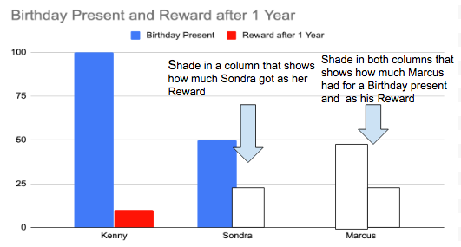
How much money did Kenny have to give up for a year in order to earn $10?

How about Sondra?

And how about Marcus?

Step 2: Complete the problems below

Let’s use information from Kenny, Sondra and Marcus--above--to help us think about percentages and percentage increases.

By what percent (%) did the $100 that Kenny gave to his dad grow over one year?

Here is how you calculate % change:

Make a fraction: Change from year 1 to year 2/Original Investment.

So, for Kenny, this looks like:
→ $10/$100
→ reduce this to $1/$10.
→ 1 divided by 10 = .10 --- say that aloud as 10 hundredths.
→ 10 hundredths is equal to 10%

So, Kenny earned 10%...

Now, try this for Sondra:
For Sondra, this looks like:
→ $___/$100
→ reduce this to $__/$10.
→ ___divided by 10 = .___ --- say that aloud as ____ hundredths.
→ ____ hundredths is equal to ____%

So, Sondra earned _____%

Now, try this for Marcus:
For Marcus, this looks like:
→ $____/$100
→ reduce this to $____/$1.
→ ____ divided by 1 = ____ → say that aoud as 1 whole!
→ 1 whole is equal to 100%

So, Marcus earned _____% by giving his mom the money for one year!

Discuss your answers with your classmates, if permitted.

Step 3: Understanding percentages increase and decrease.

Complete each of the problems below. Use the information provided to answer the questions.

The chart below shows the population of New Orleans (rounded off) in over three time periods. Use the charts to answer each question below.

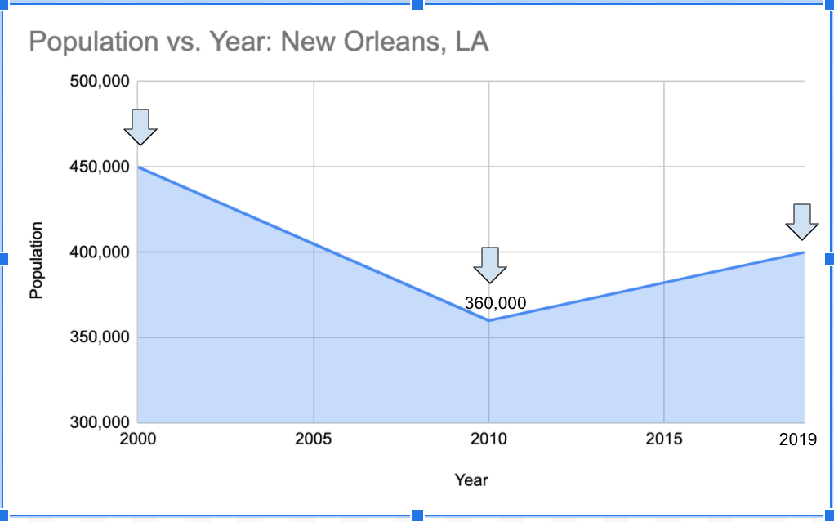
What was the total population of New Orleans in 2000?

What was the total population of New Orleans in 2010?

By how much did the population decrease?

By what percentage did the population decrease?

→ Use these steps to help you calculate this

→ Make a fraction: How much did the population decrease by dividing by the population in 2000.

→ Write the population decrease (as a negative) here:

→ Write the population in 2000 here:

Reduce the fraction:

Divide the top # by the bottom #, using a calculator if needed.

By what % did the population in New Orleans decrease between 2000 and 2010?

Note: In 2005, Hurricane Katrina struck New Orleans and many families had to leave the city, greatly speeding up a long decline in the population..

Now, let’s see what has happened between 2010 and 2019?

What was the total population of New Orleans in 2010?
What was the total population of New Orleans in 2019?
By how much did the population decrease over this time?
By what percentage did the population increase?
Use these steps to help you calculate this

→ Make a fraction: How much did the population increase between 2010 and 2019 by divided by the population in 2010.

→ Write the population increase (between 2010 and 2019)
here (look at the graph):
_______________
→ Write the population in 2010 here:

Reduce the fraction:

Divide the top # by the bottom #, using a calculator if needed.

By what % did the population in New Orleans increase between 2010 and 2019?

Student Feedback:

Circle the emojis that best represents how this activity made you feel.

Mindfulness Moment!
Use the diagrams below to help focus on and deepen your breathing. Using your finger, trace along the shape as you breathe in and breath out.
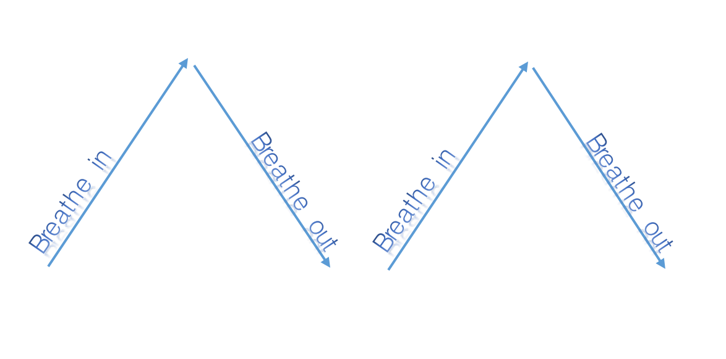
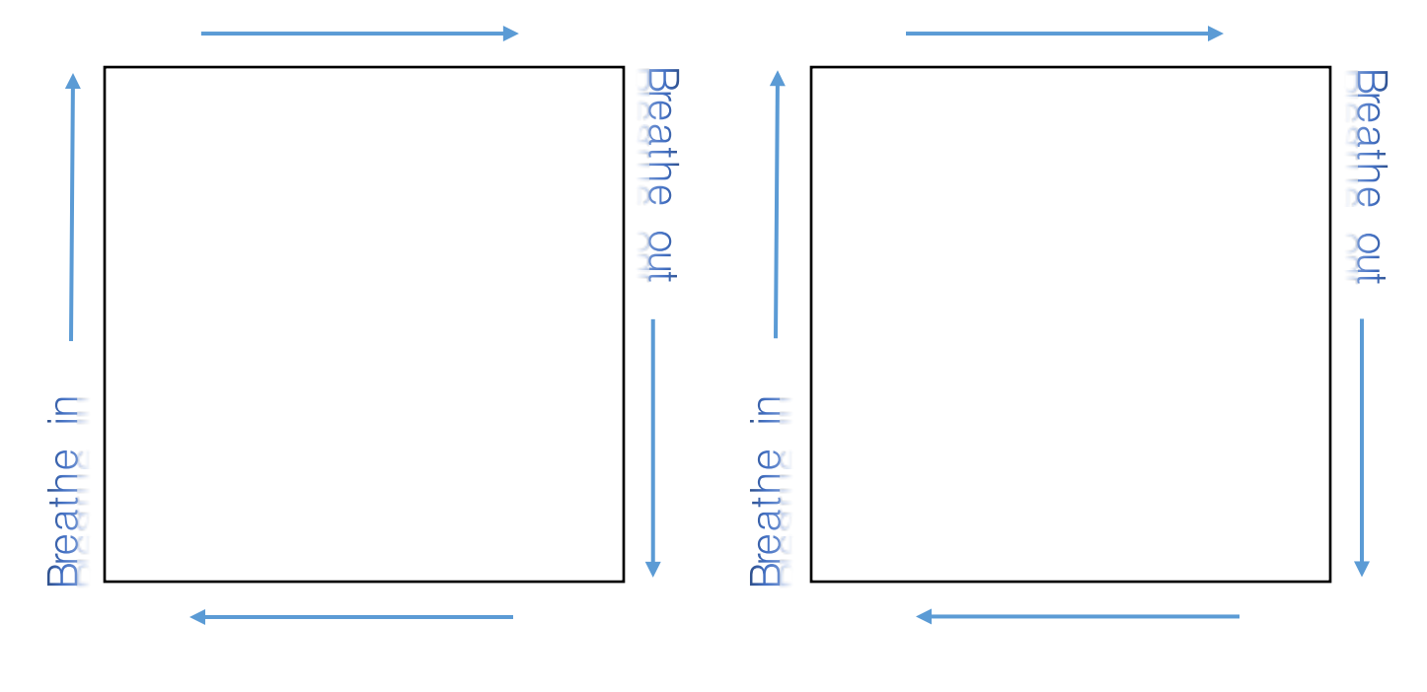

Day 2: Civics/Social Studies
World War I

What is this lesson about?: Today you will study the outcomes of WWI and what happened to Europe after the war ended. You identify and respond to questions about some of the key concepts of WWI. You will then have the opportunity to reflect on what life was like during and after WWI.

Step 1: Read the following article.

After World War I, Nations Were Changed Forever
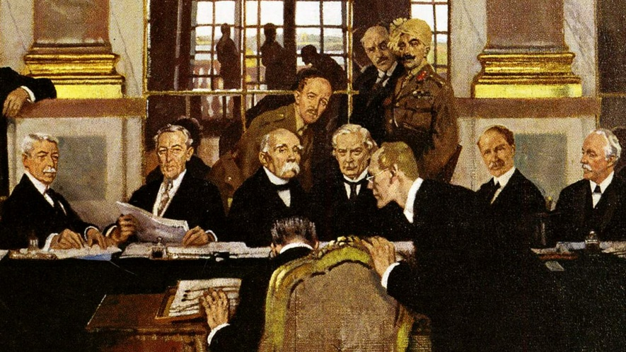
World War I was larger than any war that came before it. It was fought between two sides. The winners were Britain, France, Russia, Italy and the United States. The powers that lost were Germany, the Austro-Hungarian Empire and the Ottoman Empire. The Ottoman Empire was based in today's Turkey, while the Austro-Hungarian Empire occupied the center of Europe.

The war was fought 100 years ago and caused the deaths of millions of people. It left Europe and the world greatly changed. It also set the stage for World War II and many of the horrors that came with it.

A new great power
World War I changed the United States in two important ways. First, it turned the U.S. army into a large, modern fighting force. For the first time, the United States became a match for even the greatest European power.

Second, the war made the United States a much greater economic force, too. Many of the countries in Europe were broken and tired because of the war. This allowed the United States to control much more of the world's trade and business. The country quickly grew richer than it had ever been.

The rise of communism and socialism
World War I greatly weakened Russia. Before the war ended, communist revolutionaries took over the government, and Russia's king, the czar, was killed. This was called the Russian Revolution. Communists, led by Vladimir Lenin, did not want a few people to own all the factories and land as property. They had the government take over those lands instead.

Germany also formed a new government. It was called the Weimar Republic, and it mixed democracy with socialism. Germans could now vote for their leaders in the government. Socialism was less extreme than communism because it did not get rid of private property. But Germany's new government soon came under great pressure. In the end, it was toppled by Adolf Hitler and his Nazi Party. With Hitler in power, the stage for World War II was set.

Nationalism transforms Europe
The German, Russian, Ottoman and Austro- Hungarian Empires fell apart. New countries were formed in Europe, in part due to nationalism.

Nationalism is the idea that people with the same culture have the right to their own separate country. After the war, many people wanted to break from the old empires and form their own nations. But nationalism also caused many problems, especially in Eastern Europe. Many countries had more than one culture and race. Nationalism led to hatred and fighting between these various groups.

The myths of victory and failure
At the end of World War I, the German General Erich Ludendorff wanted Germany to refuse the peace treaty. This treaty, or deal, was written by the winners of the war, and Germany saw it as very unfair. Ludendorff said the army could still fight on. But the new German government wanted peace, so it declared the war over.

This decision gave Ludendorff and other German military leaders someone to blame for Germany's defeat. This started the idea that the German army could have won, but was "stabbed in the back" by socialists and the government. This idea weakened the power of the Weimar Republic. In the end, it allowed Adolf Hitler to rise to power.
Britain was also greatly changed by the war. Its suffering was so great that it wanted to avoid another war at all costs. That made it give in to Hitler when he wanted to grab new territories for Germany. This was called appeasement. But as this went on, World War II became more and more certain.

A "lost generation"
Eight million people died during World War I. Many others were so badly hurt by the war that they took their own lives. In much of Europe, it was hard to find someone who had not lost a loved one to the war.

Step 2: Answer the following questions.

Give two reasons why WWI led to WWII.

1.

2.

In what ways did WWI change the U.S.?

What new countries were created after WWI?

What is the definition of nationalism?

How did nationalism create tensions in Europe after WWI?

Step 3: Time Capsule Activity

Imagine you are opening a time capsule that was made during WWI. You will uncover 5-7 artifacts from the war to help people understand what life was like in 1917. Draw 5-7 artifacts that you unearthed from the time capsule.

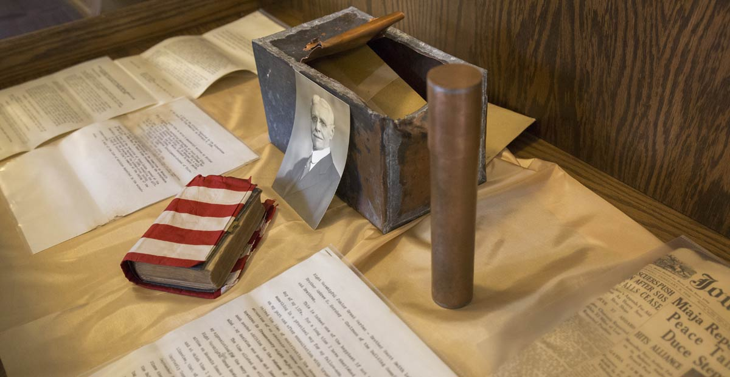

Draw 5-7 items that you found in the WWI time capsule that was buried in 1917.

Student Feedback:

Circle the emojis that best represents how this activity made you feel.

Creative Activities: Puzzles
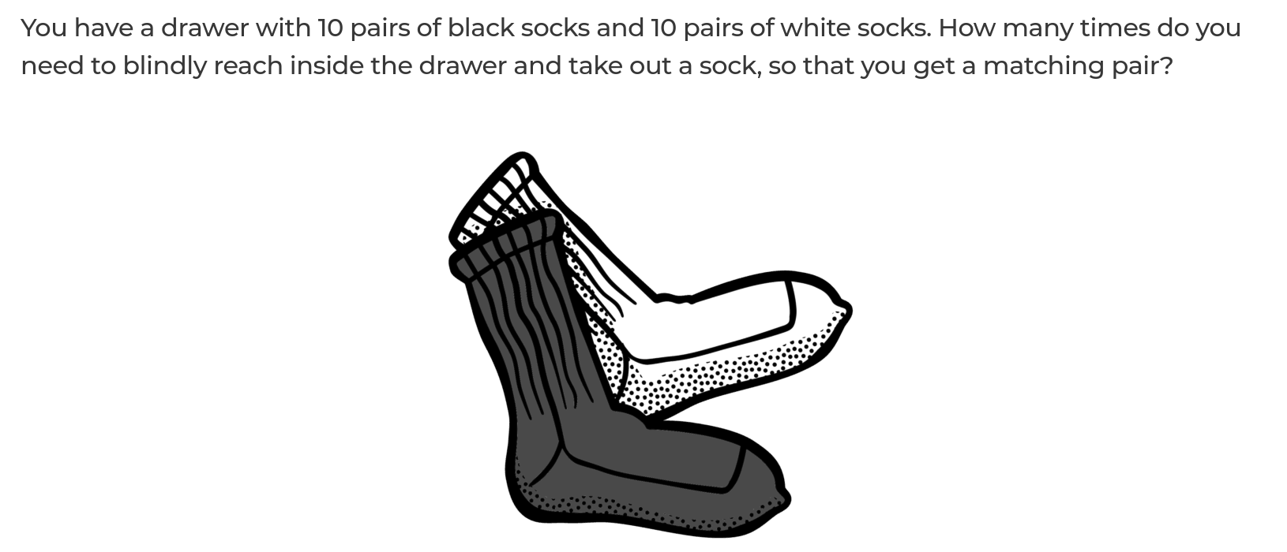

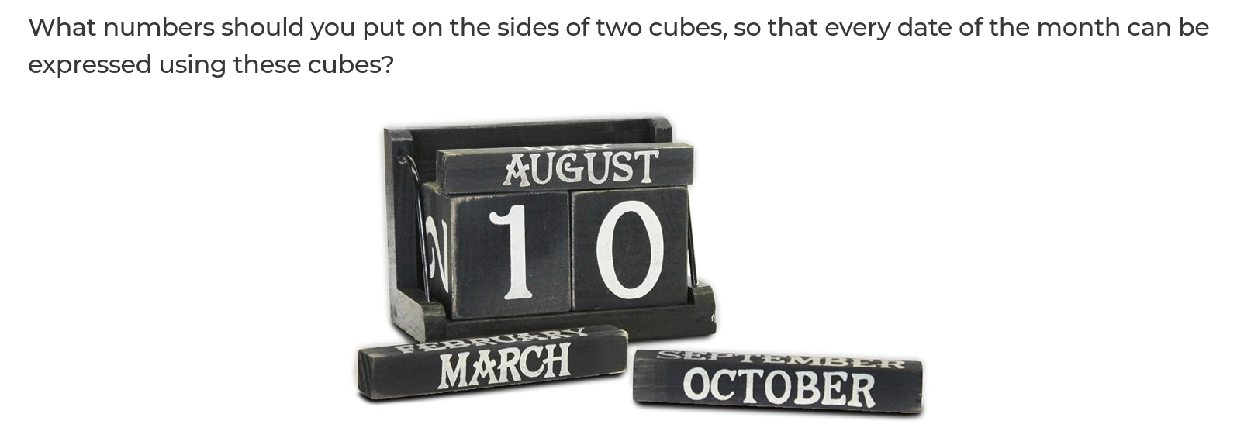

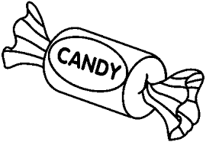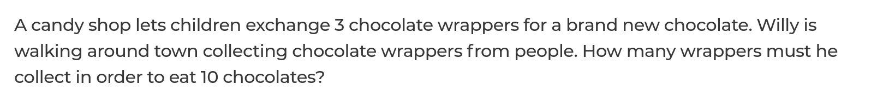

ANSWERS: Puzzles

