Week 8
Freedom

Day 1

NAME:______________________

Day 1 Agenda

Topic | Activity
Warm-Up!
English Language Arts | - Create their own definition of Freedom.  - Read and Annotate the poem: Refugee in America by Langsont Hughes  - Respond to questions about the reading.  - Respond to a quote about Freedom.
Science | - Read about the North Star to Freedom  - Answer questions about what you read  - Draw a picture and explain
Mindfulness Moment!
Math | - Word Problems: Sharecropping: Freedom, or not  - Skills: Fractions
Health | - Freedom of speech and health
Mindfulness Moment!
Civics/Social Studies | - Religious liberty in colonial America

Warm-up Activity: Write a journal entry around the daily quote on identity.

Day 1: Defining Freedom
English Language Arts

What is this lesson about? Over the next week, you will be reading, thinking, talking and writing about “freedom”. While we often think about freedom being the ability to do what we want to be, the concept is much more complex. As you read and think about the concept of freedom this week, consider your own definition of Freedom and what it means to you as an individual and as a part of society.

Step 1: Read, Think, Write
Below, read the multiple definitions of freedom according to Merriam-Webster’s Dictionary. Read through the definitions carefully then think: What does freedom mean to you? Write for 9 minutes and give your own definition of freedom. Give examples of what freedom looks and feels like.

Freedom: noun
noun: freedom
- the power or right to act, speak, or think as one wants without hindrance or restraint.
"we do have some freedom of choice"
synonyms: | right to, entitlement to; More
2. absence of subjection to foreign domination or despotic government.
"he was a champion of Irish freedom"
synonyms: | independence, self-government, self-determination, self-legislation, self rule, home rule, sovereignty, autonomy, autarky, democracy; More
3. the state of not being imprisoned or enslaved.
"the shark thrashed its way to freedom"
Synonyms. | liberty, liberation, release, emancipation, deliverance, delivery, discharge, nonconfining

4. the state of being physically unrestricted and able to move easily.
"the shorts have a side split for freedom of movement"
the state of not being subject to or affected by (a particular undesirable thing).
5. the power of self-determination attributed to the will; the quality of being independent of fate or necessity.
synonyms: | scope, latitude, leeway, margin, flexibility, facility, space, breathing space, room, elbow room; More

6. unrestricted use of something.
"the dog is happy having the freedom of the house when we are out"
familiarity or openness in speech or behavior.
plural noun: freedoms
synonyms: | naturalness, openness, lack of reserve/inhibition, casualness, informality, lack of ceremony, spontaneity, ingenuousness  "I admire her freedom of manner"

Write your answer here:

Step 2: Discuss with a partner or with the group
Share your writing with a partner and look for ideas you have in common.

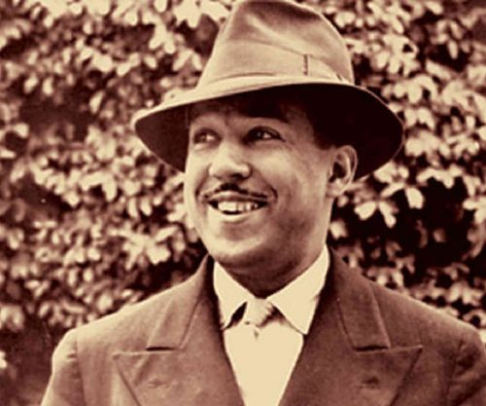
Step 3: Read and Annotate the Poem Below

Before you Read: James Mercer Langston Hughes was born February 1, 1902, in Joplin, Missouri. His parents divorced when he was a young child, and his father moved to Mexico. He was raised by his grandmother until he was thirteen, when he moved to Lincoln, Illinois, to live with his mother and her husband, before the family eventually settled in Cleveland, Ohio. It was in Lincoln that Hughes began writing poetry. After graduating from high school, he spent a year in Mexico followed by a year at Columbia University in New York City. During this time, he held odd jobs such as assistant cook, launderer, and busboy. He also travelled to Africa and Europe working as a seaman. In November 1924, he moved to Washington, D. C. Hughes's first book of poetry, The Weary Blues, (Knopf, 1926) was published by Alfred A. Knopf in 1926. He finished his college education at Lincoln University in Pennsylvania three years later. In 1930 his first novel, Not Without Laughter, (Knopf, 1930) won the Harmon gold medal for literature.

Hughes is known for his insightful, colorful portrayals of black life in America from the twenties through the sixties. He wrote novels, short stories and plays, as well as poetry, and is also known for his engagement with the world of jazz and the influence it had on his writing.

Some vocabulary to understand:
heartstrings: deepest emotions or affections | refugee: one that flees  especially : a person who flees to a foreign country or power to escape danger or persecution | Liberty: having various social, political, or economic rights and privileges
Refugee in America
By Langston Hughes

There are words like Freedom

Sweet and wonderful to say.

On my heartstrings freedom sings

All day everyday.

There are words like Liberty

That almost make me cry.

If you had known what I know

You would know why

Step 4: Answer the following questions
1. The speaker says that the word liberty “almost make(s) me cry.” Why might this be true?

2. What might the sad feelings in the second stanza say about the possibilities and the reality of liberty based on the perspective of the speaker?

3. Freedom and liberty are words that are often associated with each other, but they do not mean exactly the same thing. How is liberty different from freedom?

4. Describe in a sentence or two what you think the theme, or message, of “Refugee in America” is. What evidence in the text helps convey the theme or message?

5. What is a refugee? How can someone be a refugee in his or her own country?

6. Why do you think Hughes titled his poem “Refugee in America” and not “Words Like Freedom,” as it is often called?

Step 5: Read and annotate the quotes below
As you read, annotate each quotation and write notes about what each means.

A man who believes in freedom will do anything under the sun to acquire, or preserve his freedom. Malcolm X

No one outside ourselves can rule us inwardly. When we know this, we become free. Buddha

To enjoy freedom we have to control ourselves. Virginia Woolf

For to be free is not merely to cast off one’s chains, but to live in a way that respects and enhances the freedom of others. Nelson Mandela

The freedom from something is not true freedom. The freedom to do anything you want to do is also not the freedom I am talking about. My vision of freedom is to be yourself. Rajneesh

Those who deny freedom to others deserve it not for themselves. Abraham Lincoln

No man can put a chain about the ankle of his fellow man without at last finding the other end fastened about his own neck. ~Frederick Douglass, speech, Civil Rights Mass Meeting, Washington, D.C., 1883

Pick one quote that you find that you agree with the most.
- Copy the Quote
- Explain how/why the quote defines freedom.
- Explain how the quote applies to you and your life.

Student Feedback:
Circle the emojis that best represents how this activity made you feel.

Day 1: The North Star to Freedom
Science

What is this lesson about?: Today you will read through the North Star to Freedom passage. You will answer a few questions about what you read. You will draw a picture and write a response.

Step 1: Read through the North Star to Freedom passage
(National Park Services)
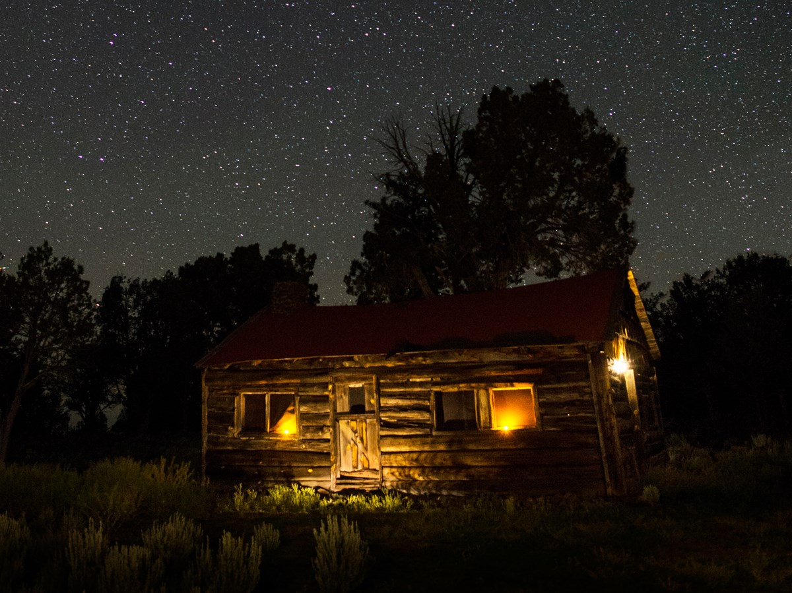
The night sky played a role in helping escaping slaves find their way north to freedom.

The National Park Service (NPS) shares the stories of former slave and abolitionist Harriet Tubman, the Underground Railroad, and the many brave Americans in the 1800s whose courageous actions led slaves to freedom and helped end the slavery era. In celebrating our nation’s independence, the NPS reflects on the role the night sky played in the lives of these early Americans.

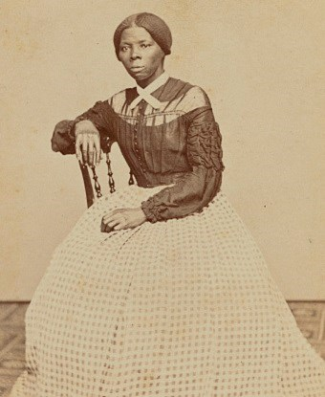
During the height of the Underground Railroad movement prior to the Civil War, Harriet Tubman, the best known conductor of the Underground Railroad, roused many enslaved Americans in the south to seek freedom in the north. Traveling under cover of night often offered the best chances of escaping. However, most slaves did not have maps or compasses to guide them. Without the use of these tools, a fugitive’s ability to successfully navigate to a safe house, railroad station, or the woods was often a matter of life or death.

As slave lore tells it, the North Star played a key role in helping slaves to find their way—a beacon to true north and freedom. Escaping slaves could find it by locating the Big Dipper, a well-recognized asterism most visible in the night sky in late winter and spring. As the name implies, its shape resembles a dipping ladle, or drinking gourd. From the gourd’s outline, the North Star could be found by extending a straight line five times the distance from the outermost star of the bowl.
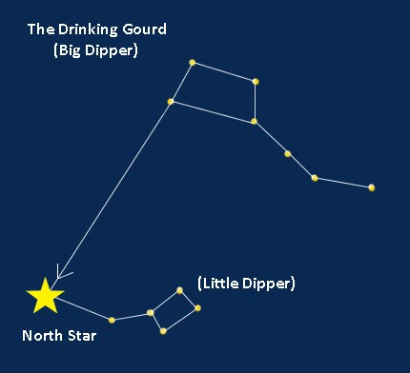
For millenia, celestial wayfinding knowledge—navigating by observing the stars and other night sky patterns—passed from generation to generation. For slaves that did not know how to read or write, "reading" the night sky provided important clues for survival. This information helped slaves to find their way without getting lost. Many former slaves, including historical figures like Tubman, used the celestial gourd, or dipper, to guide them on their journey north. The Big Dipper and North Star were referenced in many slave narratives and songs. Follow the Drinking Gourd was a popular African American folksong composed decades after the War and based on these anecdotes that memorialized the significance of these stars.

The night sky is a canvas of stories that links us to this past. National parks are among the best places to see the stars and hear these stories. The next time you gaze at the stars, think on the drinking gourd story and those early Americans who staked their freedom on a star.

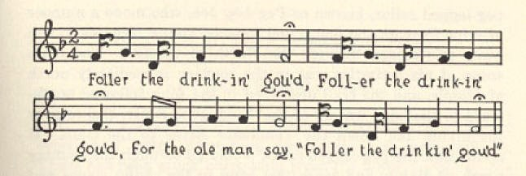

Follow the Drinking Gourd sheet music, fragment
Texas Folklore Society, 1928
Follow the Drinking Gourd
When the sun come back,
and the firs’ quail call,
Then the time is come.
Foller the drinkin gou’d.
Foller the drinking gou’d,
Foller the drinking gou’d;
For the old man say,
“Foller the drinkin gou’d.”
The riva ends a-tween two hills,
Foller the drinkin’ gou’d;
Nuther riva on the other side
Follers the drinkin gou’d.
Wha the little riva
Meet the grea’ big un,
The old man waits –
Foller the drinkin’ gou’d.

Step 2: Answer the following questions

- How would you describe the North Star?

- What does the North Star have to do with freedom?

- If you lived during the days of slavery, what advice would you give to slaves?

Step 3: Draw a picture and describe

If you could design your own set of stars for freedom, what would the night sky look like and why? Draw a picture and describe your drawing.

________________________________________________________________________________________________________________________________________________________________________________________________________________________________________________________________________________________________________________________________________________________________________________________________________________________________________________________________________________________________________________________________________

Student Feedback:
Circle the emojis that best represents how this activity made you feel.

Mindfulness Moment!

Life is good because… (write or draw your response)

Day 1: Freedom/Fractions
Math

What is this lesson about?: Today you will work on fractions.

Warm Up and Review Problems:
Many freed slaves ended up working as small farmers, calles sharecroppers, often on the same land they worked when they were held in bondage. For many, this life was only modestly better than when enslaved. They were ‘free’ but often worked all year only to finish out either still owing the landowner money, or only making enough money to survive for another year. Consider this example:

Kenneth, his wife and two children were ‘freed’ shortly after the Civil War. Unable to move or find work elsewhere, they agreed to work as a sharecropper with their former owner, on a farm/plantation in South Carolina.

Kenneth rented his land, purchased his seeds from and sold back his crops to his former slave owner. Use the chart below to answer some questions about Kenneth.

Expenses-
Annual ‘rent’: $1,200 ($100/month)
Cost of seeds (tobacco, corn): $125
Cost to ‘rent’ horse, plow, etc, $120 ($20/month for 6 months)

Sales-
Sale of cotton and tobacco: $2,400 total

At the end of a year, how much did it cost Kenneth to farm the land, plant and harvest the two crops?
How much did he make in ‘profit’ once he sold his crops and paid these bills?
How much is that ‘per month’ (example: divide by 12 months)______
What are some things that Kenneth would need to use that money for, to survive?

What percent (remember from last lessons) of his total sales dis he spend on renting a horse and plow?
What would happen to Kenneth if there was a drought or some sort of crop failure--if he lost 25% of his revenue, how much would make selling his crop? Would he be able to pay all of his bills if this happened?

Activities/Fraction Problems: Complete the following fractions worksheets
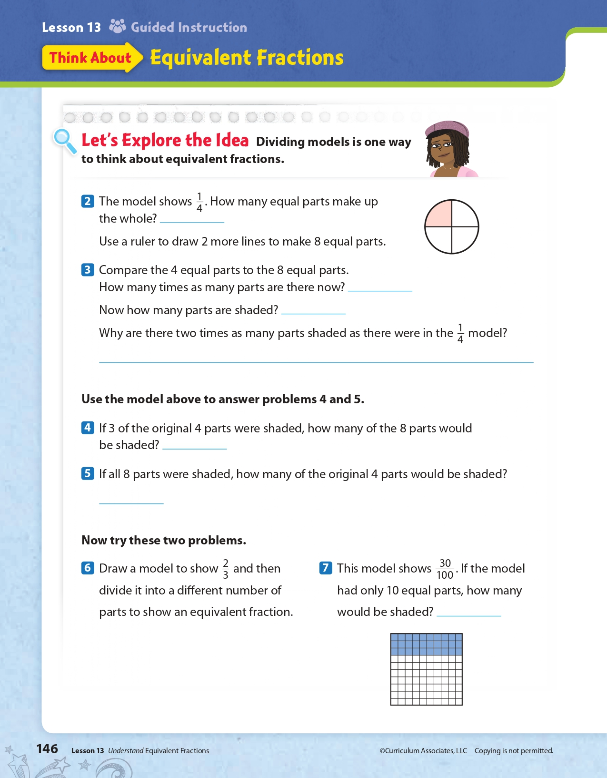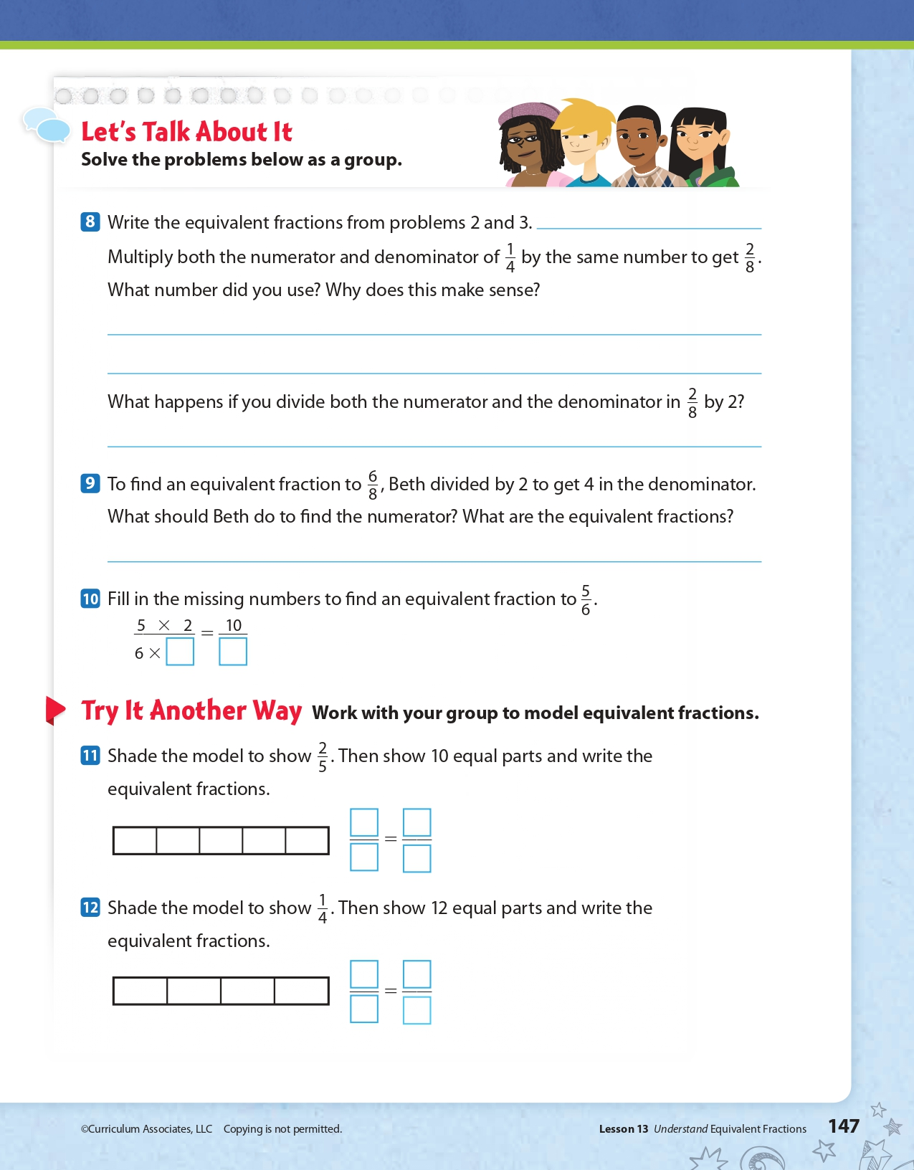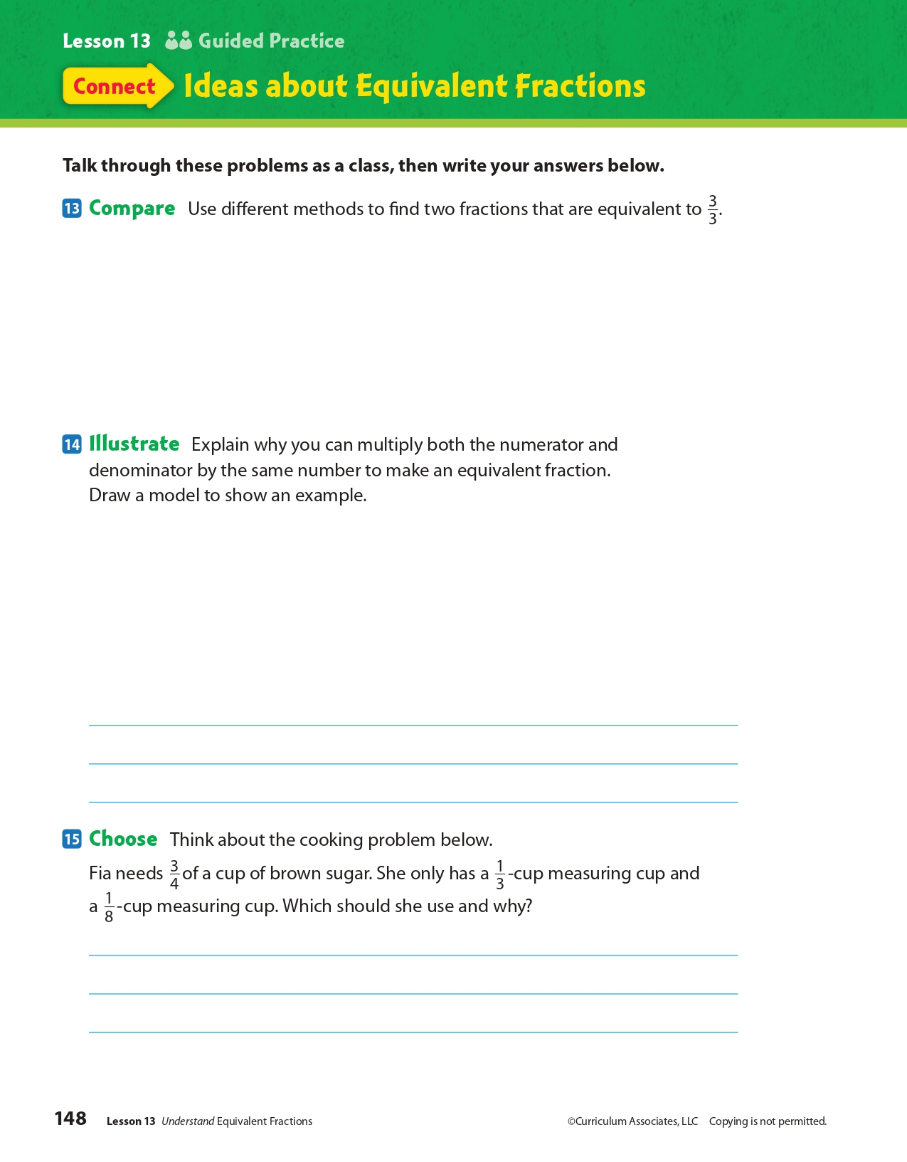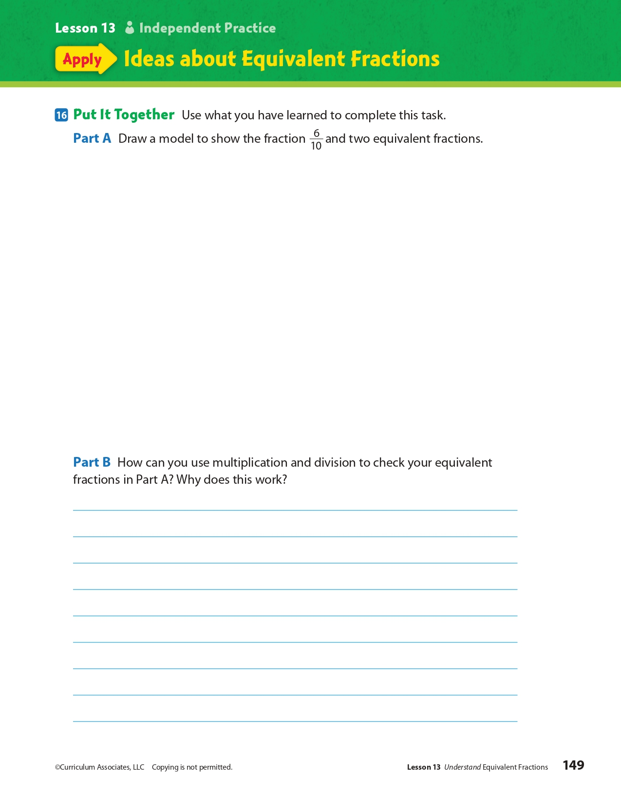
Day 1: When do you have the Freedom of Speech?
Health

What is this lesson about?: In today’s lesson, we will look at your freedom of speech as it relates to you in school. You will discover the rights of a school newspaper that was censored in a school in Arkansas.
Step 1: Warm-Up:
Everyone has the right to freedom of opinion and expression Correct! You have the right to have your own ideas and opinions and to express them to others. We exercise this freedom of speech whenever we text, tweet, or use any other forms of media to publicly express our opinion. However, this doesn’t mean you have a right to say whatever you want. Sometimes a situation can occur when a particular right may be in conflict with another right. For example, your right to express an opinion should not come at the cost of someone else’s right to be treated with respect.
Why is it important for you to have a freedom of speech?

Step 2: Read the story below.
An Arkansas school district ordered a student newspaper to take down an investigative report in November. The school district now says the article can be re-published.

A spokesman for the Springdale School District said on Tuesday, December 4, that the Har-ber Herald could republish the article. The article is a months-long investigation into the transfer of six football players to a rival high school. The article claimed the students transferred for athletic, not academic, reasons. If true, that would go against the school district's rules. Springdale had ordered the article be taken off the paper's website in November. The school had effectively suspended the newspaper's operations.

By late Tuesday, December 4, the article had been re-posted on various websites. Even professional journalists were posting it on social media. The Student Press Law Center is a group that protects student journalists' freedom. The group also posted the article, and an accompanying opinion article by the newspaper's staff, to its website.

Article Removed From Website
The article was first published on October 30, said the paper's editor-in-chief Halle Roberts. Students had been investigating the transfers for nearly a year, though. Three days after the article's publication, Springdale instructed the Herald to remove the article from its website.

The newspaper staff asked the district to reconsider. Then school Superintendent Jim Rollins sent a memo to the teacher who helps run the paper, Karla Sprague, denying the request. Rollins called the article, "demeaning, hurtful and potentially harmful to the students." He claimed it would divide people and cause trouble in the community.

The reporting was led by Har-ber junior Jack Williams. He said that last year some of the football players said in on-the-record conversations they'd transferred to Springdale High School to improve their chances at playing football at a top-level college. The journalists found no new information on the story for a few months. Then Sprague and Roberts assigned Williams and two other reporters, Molly Hendren and Matteo Campagnola, to investigate further.

A Freedom of Information request allows citizens to ask the government for information that wasn't previously available to the public. Williams said an unnamed source used a Freedom of Information request to obtain some documents. The documents suggested the athletes' parents requested the transfers for academic reasons. That went directly against information from the students' stories.
The source also shared a video which showed the father of one football player burning Har-ber gear in a fire pit. Springdale High's football coach was also recorded in the video. The Herald staff thought that broke the school's rules for football recruitment.

Williams said the immediate reception by the school community was almost entirely positive. "My track coach came up and shook my hand and told me it was a good article," he said. In a November 27 letter, Har-ber principal Paul Griep instructed Sprague not to publish anything without prior review from school administrators. The district also said it was reviewing existing rules and would write new guidelines for student publications.

"No student publications will be printed, posted online or distributed until they are reviewed by building/district administration," Griep wrote. He also said that if the staff ignored the directive, Sprague would be in trouble. In the worst case, she might even lose her job as a teacher, Griep wrote.

Challenging Accuracy
Administrators have not challenged the accuracy of the article other than two minor details, Williams said.

They said we said football coach Zak Clark's shirt was red and not bright pink, Williams said.
He also said administrators took issue with the article claiming Clark was drinking in the video. Williams acknowledged the administrators had a point. Although Williams says there are alcohol bottles in the video, it's not clear that Clark was actively drinking. So, the staff changed the descriptions and expected the article would go back online.

The district has not commented on what their review of student publication guidelines will include. Hadar Harris is one of the Student Press Law Center's leaders. He said that any requirement for the administration to review articles in advance would amount to censorship.

Press Freedom For Students

Hadar said his group believes that prior review rules go against the principles of free speech and press freedom for students. "So while we welcome the opportunity for the Herald to republish their important story, we remain concerned that they will be able to operate in an environment that fully enables them to publish their work without censorship or review."

Roberts and Williams said they were happy about the reaction to the article and are proud of their work. However, they feel that as journalists, their rights have not been respected.

Roberts said the journalists felt they did a good job, but then the article was taken down because administrators didn't like it. "It's disappointing," Roberts said.
Step 3: Answer the questions below
- Do you think that this article should have been censored?

- Can you explain your freedom of speech rights?

- What would your world look like if you did not have freedom of speech?

Step 4: Your own Newspaper
Imagine you have your own school newspaper. Brainstorm below some topics that you would like to write articles on.

Student Feedback:
Circle the emojis that best represents how this activity made you feel.

Mindfulness Moment!

Three places I hope to visit someday are…
1.
2.
3.

Draw a representation of one or more of these places!

Day 1: Religious Liberty in Colonial America
Social Studies

What is this lesson about?: Today you will learn of the Puritans establishing the Massachusetts Colony and explore that while the colony was set up under democratic principles, democratic thought didn’t extend to religion. You will learn about religious dissenters in Massachusetts and throughout U.S. history.

Step 1: The role of religion and religious liberty in society

Before we get into the lesson, take a moment to reflect on the role religion plays in our society.

Write down some of the advantages and disadvantages that religion brings to a society. (if possible, discuss with a partner)

Now, read the following definition:
Religious Liberty: the freedom of an individual or community to practice, worship, or observe any religion of choice in public or private. It is also generally recognized that religious liberty means the freedom to change religions or not follow any religion.

What freedom does religious liberty grant members of a society?

Do you think religious liberty allows individuals to wear religious clothing or jewelry that reflects their religious beliefs even if others find it offensive? Why or why not?

Do you think religious liberty allows individuals to disregard or break a law in the practice of their religion? Why or why not?

You don’t need to write a response to this, but think about whether religious liberty should mean people are free to practice their religion any way they want. Do you think that restrictions around practicing religion are sometimes necessary? Why or why not?

Step 2: Read the article

Puritan Life and Dissent in Colonial New England
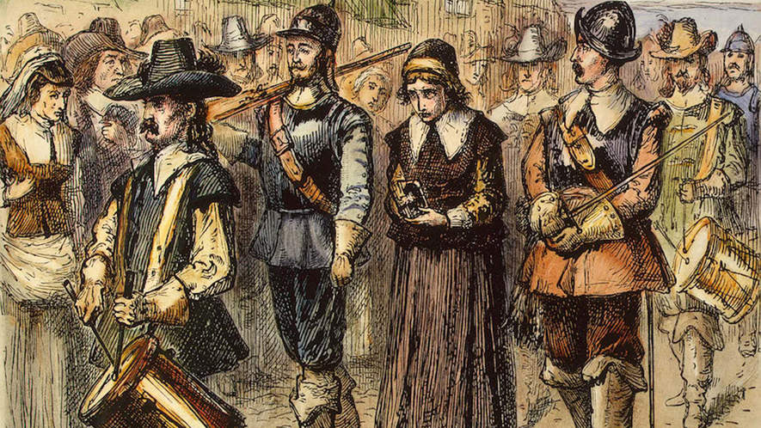
By USHistory.org, adapted by Newsela staff

Massachusetts Bay - “The City Upon a Hill”
The passengers of the ship Arbella and 10 other ships left England in 1630 with their new charter that gave them permission to set up colonies in New England. The Puritans were fed up with the Church of England. They felt they couldn't practice their religion in England. The king of England didn't like the Puritans much either. So, he gave them written permission, in a charter, to set up colonies in New England in the area of Massachusetts. Future governor John Winthrop knew the world would be watching to see if the colony succeeded or failed. He wrote, "We shall be as a city upon a hill, the eyes of all people are upon us."
More than a thousand Puritans sailed to Massachusetts and were determined to be a shining light for the rest of Europe, "A Model of Christian Charity," in the words of the governor.
Puritans believed in predestination which taught that God is all-powerful and all-knowing. So, each person is known to God at birth and nothing a person does or says could change his future. Not everyone could be a Puritan Church member. Only those chosen by God to be saved would become "the elect". Only "the elect" could serve as Church members. A person must experience "conversion" by seeing and feeling the grace and power of God and know he was saved.
If a person were truly saved, he was a "living saint" and would serve as an example to the rest of the world. During the early years, ministers such as John Cotton carefully screened people who claimed to have had a "conversion."
The colony needed more than "the elect" to survive. Many dissenters, or other Christian men and women who had not felt "conversion," lived in Massachusetts Bay Colony. Towns like Marblehead were founded by non-Puritan settlers who had jobs in commerce and business. These skills were necessary for the colony to survive.
There was also a need for self-government and an elected legislature. Although ministers were not allowed to run in elections for political jobs, many of the most important decisions were made by the ministers. In 1636, Harvard College started to train Puritan ministers.

Puritan life
By the end of the 1630s, nearly 14,000 more Puritan settlers came to Massachusetts from England, so the colony began to spread out across New England. People lived longer and healthier lives than those in England and the southern colonies of Virginia and Maryland. It was often said New England invented grandparents, for it was here that people in great numbers first grew old enough to see their children have children. Puritans wanted their children to be able to read the Bible, so every town with at least 50 families built schools.
Massachusetts Bay was a man's world, so women could not speak at town meetings or vote. Puritan ministers preached about the soul that had two parts. The part that lived forever was male, while the female part did not. They believed women who were pregnant with a male child had pink cheeks, and those having a female child had pale cheeks. Names of women included Patience, Silence, Fear, Comfort and Be Fruitful, which shows what Puritans thought about women.
Everyone went to church. People had to pay fines if they missed services. The minister's sermon or speech was about town problems or worries. Often a man held a long pole to wake people or push children who were laughing. Church was very serious.

Puritan dissent
The Puritans believed they were doing God's work. Those who sinned and did not do God's work were punished. If wives had secret lovers, they could be put in jail. Others were whipped or brought to the public square in the center of town, where people would spit on them. Some were even killed.
People were not free to think for themselves. Some free-thinkers could be forced to leave their homes and never return. Such was the case in Massachusetts Bay when Roger Williams and Anne Hutchinson spoke their minds.
Roger Williams preached separation of church and state. He believed no single church should get money from tax dollars. Williams also claimed taking land from the Native Americans without proper payment was unfair. Massachusetts made this minister leave his home in 1636. He was banished.
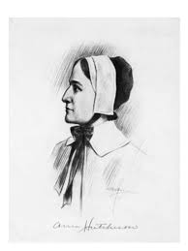
Williams bought some land from the Narragansett Indians and founded the colony of Rhode Island. Here there would be complete religious freedom.
Anne Hutchinson was a deeply religious woman. She believed in predestination, which taught that God is all-powerful and all-knowing. God controlled the future, so she felt the powerful control of the ministers was wrong. If God has blessed me or damned me, she asked, how can anyone change that? She said the ministers were teaching people they could do things to get into heaven. She also said people who were "saved" didn't have to follow the law. Ministers felt this free-thinking was dangerous. As many as 80 people would come to her home each week to hear her sermons.
The ministers decided to arrest her. The court, led by John Winthrop, the governor of the colony, found her guilty and banished her from Massachusetts Bay in 1637. So she moved to Rhode Island.
America has long been a land where people have the right to say, "I disagree." Many left England in the first place because they disagreed with the king. Roger Williams and Anne Hutchinson were two brave souls who reminded everyone of their right to disagree.
There is another side of Puritan life that is not well known. They did have some fun, too. People sang and told stories. They drank wine and beer. Children were allowed to play games with their parents' permission. Puritans did not all dress in black as many believe. They tried to follow God's law. People that did what the ministers said, lived in peace.
Step 3: Answer questions

Why did the Puritans leave England for Massachusetts? What was their goal once they arrived in North America?

What was the infraction Anne Hutchison allegedly committed?

Why do you think the Puritans believe Hutchison’s actions were a threat to the colony?

Which do you think the Puritans were trying to establish? (circle one)

Religious liberty OR Freedom to practice their own form of Christianity

In the case of the Puritans, what was the difference between these two? (discuss your answer with a partner)

Step 4: Religious Dissenters
Religious dissenters have tested the extent of society’s tolerance for as long as religion has existed.
Religious dissent can come in many forms. Sometimes it is individuals who practice a different belief system than the majority of society. Other times, dissent involves challenging the actions of religious leaders because some feel they are corrupt or have deviated from the religion’s original beliefs. In the case of Anne Hutchinson, she challenged the authority of the elders as the only ones qualified to interpret the Bible.

Dissenters aren’t always dissenting for the betterment of society or to improve the religion. Sometimes they dissent for personal reasons. Similar to revolutionaries, who are considered heroes by their followers and terrorists by those against whom they are revolting, some religious dissenters were considered blasphemers or fools by their critics and saints by their followers. Let’s examine several religious dissenters throughout history and compare their similarities and differences to each other and to the case of Anne Hutchinson.

Joseph Smith

1805-1844
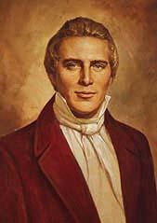
Born on December 23, 1805, in Vermont, Joseph Smith Jr. grew up on a series of tenant farms in Vermont, New Hampshire, and New York. Though in his youth Joseph was largely deprived of a formal education, he was "instructed in reading, writing, and the ground rules of arithmetic."¹ Joseph's mother said that he was often "given to meditation and deep study."²
Affected by the great religious excitement taking place around his home in Manchester, New York, in 1820, fourteen-year-old Joseph was determined to know which of the many religions he should join. He encountered a passage in the Bible instructing any who lacked wisdom to "ask of God" (James 1:5). Early one morning in the spring of 1820, Joseph went to a secluded woods to ask God which church he should join. According to his account, while praying Joseph was visited by two "personages" who identified themselves as God the Father and Jesus Christ. He was told not to join any of the churches.
In 1823, Joseph Smith said he was visited by an angel named Moroni, who told him of an ancient record containing God's teachings. In 1827, Joseph retrieved this record, inscribed on thin golden plates, and shortly afterward began translating its words by the "gift of God."³ The resulting manuscript, the Book of Mormon, was published in March 1830. On April 6, 1830, Joseph Smith organized The Church of Jesus Christ of Latter-day Saints.
During the thirty-nine years of his life, Joseph established cities in Ohio, Missouri, and Illinois. The Mormon settlements in these states were often persecuted by their surrounding neighbors who were fearful of the Mormon communities' economic and political might. Missouri's governor ordered all Mormons to leave the state, and when their stronghold in Far West, Missouri, was surrounded, Smith, fearing an imminent massacre, surrendered.
Smith was a controversial figure in American history—beloved of his followers and hated by his detractors. When Smith announced that he was running for the Presidency of the United States in 1844, opposition to the Mormons reached a climax. Smith was imprisoned in Carthage, Illinois, and charged with inciting a riot after he attempted to destroy a newspaper that exposed the Mormon's practice of polygamy. But before he could be tried on these charges, a mob broke into his cell and brutally killed both him and his brother.

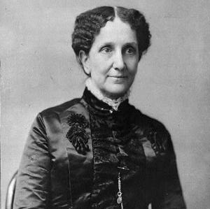
Mary Baker Eddy
1821-1910
Mary Baker Eddy founded a religious movement during the 19th century, Christian Science. As an author and teacher, she helped promote healings through mental and spiritual teachings. Today, her influence can still be seen throughout America.
Eddy was born in 1821, in New Hampshire. Unfortunately, she was very ill and spent most of her childhood bedridden. At the age of fifteen, her family moved to another town in New Hampshire and she began school. Almost immediately, her teachers realized that she was an extremely bright pupil. Eddy finished school at the Holmes Academy and went on to teach.
For many years, Eddy worked to discover a cure for her chronic illness. She experimented with alternative forms of medicine, wholeheartedly rejecting prescription drugs from doctors. Additionally, Eddy studied the Bible. After suffering from an almost deadly illness she became a patient of Phineas Quimby, a healer from Maine. Historians believe Quimby influenced Eddy’s writings.
In 1866, Eddy slipped on an icy sidewalk. The fall forced her to remain in bed for several months. During her downtime, she studied healings in the Bible. Her belief that the healings performed by Jesus could be used in the present day inspired her to create a movement that focused on the mental aspects of sickness. She began to teach others her new method and Christian Science quickly gained a following.
Eddy wrote the principal text for the Christian Science movement, Science and Health with Key to Scriptures in 1872. She opened the Massachusetts Metaphysical College in 1879 to educate others. Eddy’s teaching was extremely attractive to many who suffered from illness. Her students eventually spread the knowledge to others as they traveled throughout the United States. As a result, Christian Science congregations emerged in several cities. Because of Eddy’s growing popularity as a religious leader and woman, she was the center of many rumors and attacks. Her character and sanity were often questioned publicly. However, the attacks did not discourage her followers.
In her later years, Eddy focused much of her attention on expanding her teachings by constantly revising her publications. When Eddy was unable to get others to print her work, she started a publishing society. She published The Christian Science Monitor and the Herald of Christian Science. In 1910, Eddy died of pneumonia. Today, there are still numerous Christian Science churches.
Step 5: Complete the graphic organizer
Complete the graphic organizer on the next page. After, with a partner if possible, consider the following questions:
- How does Joseph Smith’s experience compare to Anne Hutchinson’s?
- How does Mary Baker Eddy’s experience compare to Anne Hutchinson’s?
Student Feedback:
Circle the emojis that best represents how this activity made you feel.
