Week 5
Power

Day 1

NAME:______________________

Day 1 Agenda

Topic | Activity
Warm-Up!
English Language Arts | - Read the transcript to the podcast: This American Life  - Respond to questions about the story.  - Write about what kind of superpower they would choose to help themselves and others fight against injustice.
Science | - Read about Renewable Energy  - Answer questions about what you read  - Draw a picture and explain
Mindfulness Moment!
Math | - Power: Voting and Political Power
Health | - Types of relationships
Mindfulness Moment!
Civics/Social Studies | - Consider types of governmental powers  - Monarchy and Oligarchy

Warm-up Activity: Write a journal entry around the daily quote on identity.

Day 1: What Superpower Would You Choose?
English Language Arts

What is this lesson about? Over the next week, you will be reading and reflecting on the idea of Power. Today, you will have the opportunity to read the transcript of a radio/online show called “This American Life”. In it, John Hodgman provides a commentary on Superpowers and what people might do if they had them.

Step 1: Before reading

Read, think about and answer the following pre-reading question. There is no wrong or right answer. The questions is designed to get you thinking about what the reading will be about and to consider your own thoughts and ideas on some of the issues that it brings up.

Write for 8 minutes: Flight versus invisibility? This question is only for you. Whichever you pick, you'll be the only person in the world to have that particular superpower. You can't have both. Which do you choose? And why?

Step 2: Read and Annotate

The transcript you are about to read, “Invisible Man vs. Hawkman ” was part of a report on This American Life, a radio show/podcast that airs on NPR (National Public Radio). The transcript is a written recording of the broadcast. As you read, think about the questions that people ask about the superpower and the reasons they give for choosing the power they decide on.

Ira Glass: Act One, Invisible Man Vs. Hawkman:

Well, we now present a kind of super-contest for you, beloved super-listener, between two ancient superpowers, two of the superpowers which have fascinated humans since antiquity. And actually, this is kind of a super Rorschach test. John Hodgman has been conducting an unscientific survey, posing for people a very simple choice.
John Hodgman: Flight versus invisibility? This question is only for you. Whichever you pick, you'll be the only person in the world to have that particular superpower. You can't have both. Which do you choose? I started wondering about this a few years ago. I'd bring it up at parties, dinners, wedding receptions. It was more interesting to ask than where people worked or where they went to school, and clearly more fun to answer. Like a magic word, shazam, flight versus invisibility would instantly change an evening's character, opening passionate conversation and debate.
But what surprised me more was how quickly everyone would choose, as though they'd been thinking about it for a long time. Everyone knew exactly which superpower they wanted and what they would do with it. Their plans weren't always flashy or heroic. In fact, they almost never were.
Man 1: If I could fly, the first thing I would do is fly into the bar, check out what's going on there, fly back home. I would attach my baby to me and fly to a doctor's appointment at 11:30, fly right back. And then I think I would fly to Atlantic City.
Man 2: I would imagine, like, if it got around that I had the power of flight and it was a rare type of thing, I mean, there would definitely be flight groupies. I would imagine. So they're going to be just like, oh, yeah, I just slept with the flying dude. You know? People are just like, oh, score.

Woman 1: I'd go into Barney's. I'd pick out the cashmere sweaters that I like. I'd go to the dressing room. The woman says, how many items? I'd say, five. I'd go into the dressing room. I'd put those five sweaters on. And I'd summon my powers of invisibility in the dressing room. I'd turn invisible. I'd walk out, leaving her to wonder why there's a tag hanging from the door that says five, and no person inside.

John Hodgman: So you'd become a thief pretty quickly.

Woman 1: Immediately. Until I had all the sweaters that I wanted, and then I would have to think of other things to do.

John Hodgman: Typically, this is how it goes. People who turn invisible will sneak into the movies or onto airplanes. People who fly stop taking the bus. Here's one thing that pretty much no one ever says-- I would use my power to fight crime. No one seems to care about crime.

Man 3: I don't think I would want to spend a lot of time using my power for good. I mean, if I don't have super strength and I'm not invulnerable, then, I mean, it would be very dangerous. If you had to rescue somebody from a burning building or something like that, you might catch on fire.

Man 2: Just having flight I don't think is necessarily quite enough, because you don't have the super strength.

Man 4: I'd still be weak when I got there, I guess. I don't fight crime now, and people without superpowers do. Sure, in theory, yes. But you know, I'm not a-- I mean, what can I do with this? Either one of those is, you need a whole package. There's not much you can do with any one thing. I'd go to Paris, I suppose.

John Hodgman: That's not being a superhero.

Man 4: Well, maybe I could be a Going to Paris Man, that sort of a superhero.

John Hodgman: Going to Paris Man is not a superhero. And I have to say this drove me crazy a little bit. We are, after all, talking about superpowers. Why not take down organized crime, bring hope to the hopeless, swear vengeance on the underworld, if only a little bit?

John Hodgman: I proposed a variety of sample scenarios along these lines, such as, how would you handle a mad genius taking over the Empire State Building, or a group of terrorists hijacking an overseas flight? And what I learned is, some people should simply not be fighting crime.

Woman 2: Well, first thing that occurs to me is, like, I would sneak up behind them very low with a knife that they didn't see and slice their Achilles tendon. Oh, no. I'd somehow shove a sock in their mouth or something like that, and wrap some tape around their mouth, so that they can't yell out. It might not be a sock. It might just be some napkins or something. I can't keep all of this in my head. I'd have to keep a bag full of stuff with me. Knives. Socks. Tape.

John Hodgman: Do you think you'd be tempted to enlist a teenage helper?

Woman 2: Um. You know, I think a helper would be good, a helper with a complementary power.

John Hodgman: There's no others, anybody else with superpowers.

Woman 2: Oh, it would just be a teenager hanging around me? No.

John Hodgman: People who consider invisibility always want to know, do I have to be naked? People who choose flight want to know, how fast? Almost all asked, who would win in a fight, Mr. Invisible or Flying Man?

And so I had to lay down some rules. Invisibility means the power to become transparent at will, including your clothing, but anything you may pick up is visible. Flight means the power to fly at any altitude within the earth's atmosphere at speeds up to 1000 miles per hour. But even then, they start looking for loopholes, hidden catches, superpower fine print. They start negotiating their dreams with me.

Man 5: Now, when you're flying, if you're flying at 1000 miles an hour at 100,000 feet, are you comfortable? Do you get very cold?

Man 6: Let's say I'm in this room and I'm invisible. And I'm walking around this apartment and I'm invisible. Do I have to be completely quiet, or you guys will, like, hear my footsteps? Because that's a pain in the ass. And also, someone has to let you in.

Man 4: Can I carry someone? Can somebody go on my back?

John Hodgman: Can you carry someone on your back now?

Man 4: Little people. Little people, yeah.

John Hodgman: Then you can carry little people on your back.

Man 4: Done. Flight it is.

John Hodgman: This is all part of what I call the five stages of choosing your superpower. Sometimes this process occurs in just moments. For example, subject A, a tallish man with glasses, wedged into a cramped barroom corner, begins as they all do, with stage one, gut reaction.

Man 7: Initially, I would think perhaps invisibility.

John Hodgman: Next comes stage two, practical consideration.

Man 7: Because you have the ability to walk around work, perhaps show up at one point, and perhaps like go away for a little while, and turn invisible, and then come back and listen to what they say about you. You have the power to spy on your exes. And that would all be enlightening and fun and, in fact, a little bit perverted. And--

John Hodgman: You hear that doubt in his voice? That's the beginning of stage three, philosophical reconsideration.

Man 7: That would-- I believe it would immediately turn into a life of complete depression. You wouldn't be able to really share it with anyone, you know? And I know there'd be some problems with, like, the perversion thing.

John Hodgman: Stage four, self-recrimination.

Man 7: Invisibility leads you-- leads me, as an invisible person, down a dark path, because you're not going to want to miss out, when you're invisible, on-- you know, no matter how many times you've seen a woman naked in the shower, you're going to want to see it again, because there's always a different woman, right? And there's like a lifetime of that. And that's not acceptable behavior, no matter whether you're invisible or not.

John Hodgman: And finally, stage five, acceptance.

Man 7: Yeah, I'd have to go with flight.

John Hodgman: So who chooses invisibility and who chooses flight? In my experience, though there are lots of exceptions, men lean towards flying, women to invisibility. And many brood anxiously over their choice, switching from one to the other and back again. And that's because, more than the ability, say, to burst into flame or shoot arrows with uncanny accuracy, flight and invisibility touch a nerve. Actually, they touch two different nerves, speak to very different primal desires and unconscious fears. My friend Christine chose invisibility.

Christine: One superpower is about something that's obvious, and the other is about something that is hidden. I think it indicates your level of shame.

John Hodgman: How do you mean?

Christine: A person who chooses to fly has nothing to hide. A person who chooses to be invisible wants clearly to hide themselves.

John Hodgmam: Do you feel that you want to hide yourself?

Christine: I want to-- I'd like to not-- I'm not going to answer that question.

Woman 3: It all has to do with guile. Wanting to be invisible means that you're a more guileful person. If you want to fly, it means you're guileless. And I think the reason that I'm so conflicted about flying versus invisibility is that I have guile, but I really wish that I didn't.

John Hodgman: Flight is the hero-- selfless and confident and unashamed. And invisibility, the villain. Almost everyone I talked to called invisibility the sneakier power.

Man 8: Flying is for people who want to let it all hang out. Invisibility is for fearful, crouching people who have something to be embarrassed about.* (*edited for language)

Woman 1: First of all, I think that a lot of people are going to tell you that they would choose flight, and I think they're lying to you. I think they're saying that because they're trying to sound all mythic and heroic, because the better angels of our nature would tell us that the real thing that we should strive for is flight, and that that's noble and all that kind of stuff. But I think actually, if everybody were being perfectly honest with you, they would tell you the truth, which is that they all want to be invisible so that they can shoplift, get into movies for free, go to exotic places on airplanes without paying for airline tickets, and watch celebrities have sex.

John Hodgman: Anyone faced with this choice, in their heart of hearts, will choose invisibility.

Woman 1: Yes. Or they have this sort of inflated, heroic, mythical concept of themselves, and that, in fact, they're not really giving it very much practical thought.

John Hodgman: In the end, it's not a question of what kind of person flies and what kind of person fades. We all do both. Perhaps that's why, when I put the choice to myself, I'm hopelessly, completely stuck. At the heart of this decision, the question I really don't want to face, is this. who do you want to be, the person you hope to be, or the person you fear you actually are? Don't rush into it. Think it over. Which would you choose?

Step 3: Answer the following questions.

            - What were some of the actions people wanted to do if they had a superpower?

            - What reason did most people for not becoming crime fighters?

            - Did John Hodgman find that people were satisfied with the superpower they chose? How do you know?

            - According to Hodgman, what are the five stages of choosing your superpower?

5. Hodgman’s friend Christine says that “A person who chooses to fly has nothing to hid. A person who chooses to be invisible wants clearly to hide themselves.” Do you agree? Why or why not?

Step 4: Write

”With great power comes great responsibility” is a proverb from Spider Man so that he can understand that he should use his power for the benefit of others instead of just for his own benefit. Below is a list of some top superpowers as listed by the CBR (Comic Book Resources) website. Review the different powers and think about how they could be used. Pick three powers that you would pick for your benefit and three powers that you pick to have in order to help others. Explain how you would use the powers to either help others or to solve some local, national or world problem.

x-ray vision: ability to see through solid objects or people. | heat/laser vision/optic blasts: ability to shoot lasers from their eyes at an opponent, a wall, or just about anything else
Intangibility: ability to alter your atoms in such a way that you can walk through walls, or alternatively, let things like bullets pass through you harmlessly. | body manipulation: ability to alter the size or length of a body part. (for example: ant-man’s ability to shrink or grow)
shapeshifting: a form of body manipulation or taking on the form of another person, usually for covert missions | enhanced senses: hyper-powered senses that usually make up for a missing sense. (for example: spidey sense)
immortality: ability to live forever. | flight: ability to fly without using any special devices
regeneration: ability to have a wound heal almost immediately | invisibility: ability to make yourself and possibly other things invisible to the naked eye
teleportation: ability to move from one place to another in the blink of an eye, | super strength: ability to use superhuman strength
invulnerability: the ability to be protected from any injury | super speed: ability to control of not only super speed but the ability to use it to travel through time.
time travel: ability to go back and change things that went wrong or to travel to the future to see what would happen if you made a given choice. | telepathy: ability to read minds, alter or erase someone's memories, or simply make them do what you desire.

Use the space below to write your response.

Student Feedback:
Circle the emojis that best represents how this activity made you feel. | 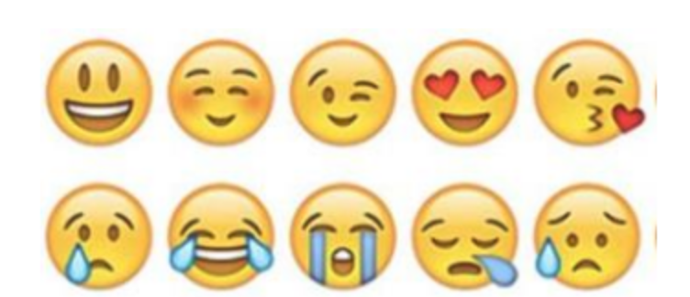  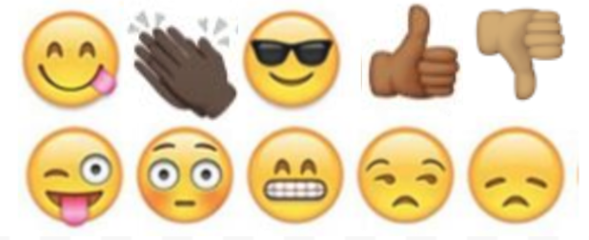

Day 1: Science
Renewable Energy

What is this lesson about?: Today you will read through the Renewable Energy passage. You will answer a few questions about what you read. You will draw a picture and write a response.

Step 1: Read through the Renewable Energy passage

Renewable Energy
(Technological Solutions; eia.gov)

What is renewable energy?
Renewable energy uses energy sources that are not "used up". For example, solar power from the sun is renewable as we won't "use up" all the sunlight from the sun. Examples of non-renewable energy sources include fossil fuels like coal and oil. Once we use or burn these resources, they are gone forever.

Why is renewable energy important?
Much of the world relies on non-renewable energy to heat their homes, power their electronic devices, and power their cars. Once these energy sources are used up, they will be gone forever. Developing technologies that can efficiently use renewable energy sources is critical to our future.

The Environment
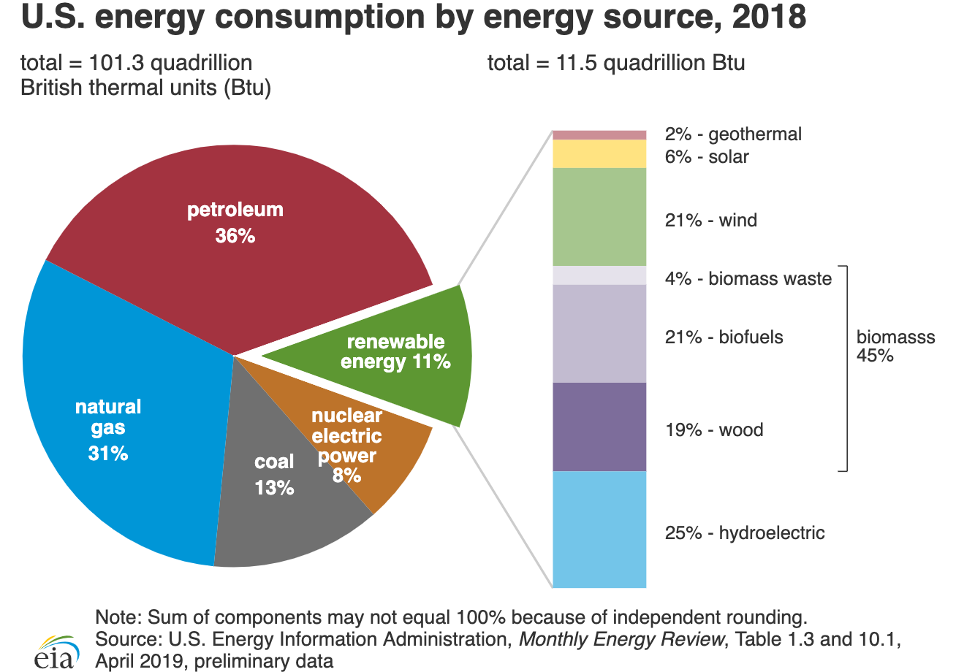
Many renewable energy sources are also better for the environment than burning fossil fuels. They produce less pollution which will help protect the environment and provide us with cleaner air and water.

What role does renewable energy play in the United States?
Until the mid-1800s, wood was the source of nearly all of the nation's energy needs for heating, cooking, and lighting. From the late 1800’s until today, fossil fuels—coal, petroleum, and natural gas—have been the major sources of energy. Hydropower and solid biomass were the most used renewable energy resources until the 1990s. Since then, the shares of U.S. energy consumption from biofuels, solar, and wind energy have increased.
In 2018, renewable energy provided about 11.5 quadrillion British thermal units (Btu)—1 quadrillion is the number 1 followed by 15 zeros—equal to 11% of total U.S. energy consumption. The electric power sector accounted for about 56% of total U.S. renewable energy consumption in 2018, and about 17% of total U.S. electricity generation was from renewable energy sources.
Renewable energy plays an important role in reducing greenhouse gas emissions. Using renewable energy can reduce the use of fossil fuels, which are major sources of U.S. carbon dioxide emissions.
The consumption of biofuels and other non-hydroelectric renewable energy sources in the United States more than doubled from 2000 to 2018, mainly because of state and federal government requirements and incentives to use renewable energy. The U.S. Energy Information Administration projects that U.S. renewable energy consumption will continue to increase through 2050.
Major Types of Renewable Energy
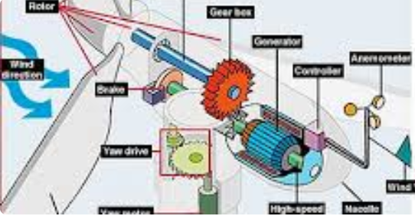

Wind Power - Large wind turbines generate electricity from the power of the wind.

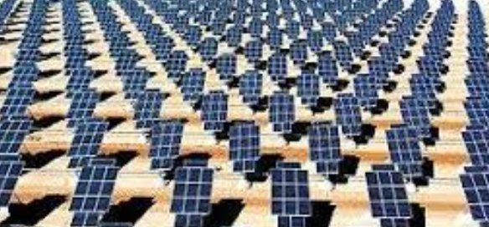

Solar Energy - The rays from the sun can help to heat a building or a pool. They can also be turned into electricity using solar cells.

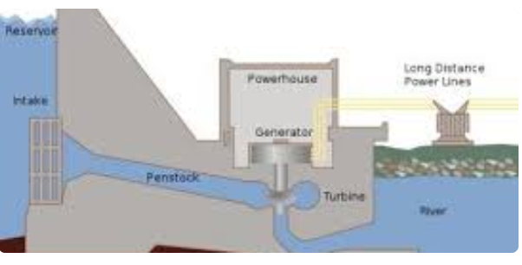

Hydropower - Water from a dam or a river can be used to spin turbines and generate electricity.

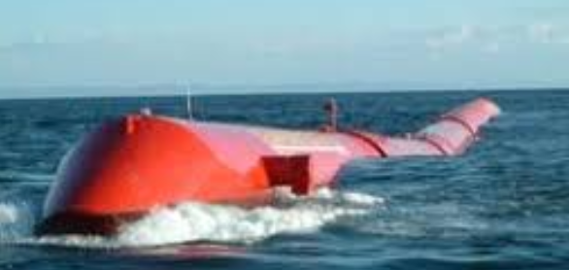

Wave and Tidal Power - This new technology is working on ways to harness the vast power of the ocean's waves and tides.

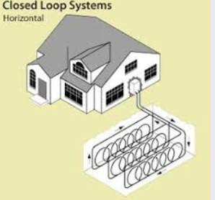
Geothermal Energy - Heat from inside the Earth can be used to heat homes and buildings with heat pumps. Steam from inside the Earth can also be used to generate electricity.

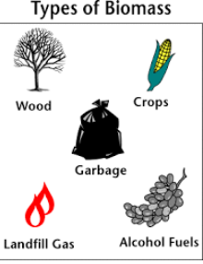

Biomass Energy - Plants gather energy from the sun by photosynthesis. We can harness this energy by burning plants such as trees as well as creating fuel from plants such as ethanol and biodiesel. Even gas from trash and manure can be used to create energy.

Fun Facts About Renewable Energy
- Half of the electricity in the United States is still generated by burning coal. Burning coal is a major source of carbon dioxide gas.
- A single large wind turbine used instead of burning coal can prevent the emission of 5000 tons of carbon dioxide each year.
- In 2008 only around 10% of the world's energy came from renewable sources.
- The United States has around 5 percent of the world's population, but consumes 26 percent of the world's energy.
- Around 28% of the energy used in the United States is for transportation. As of 2010 there were around 9 million cars that were capable of using biofuel.
- If you could harness the energy from all the sunlight that falls on the Earth in one hour, you would have enough energy to supply the world for a year.
- Around 50% of renewable energy is used to produce electricity.
- In some areas you can generate your own renewable energy, like with a solar cell or wind turbine, and then sell it back to the local energy company.

Step 2: Answer the following questions

- Which of the following is an example of a renewable energy source?
  - Gasoline
  - Solar Power
  - Coal

- Which of the following best describes renewable energy?
  - Energy from fossil fuels
  - Energy that is generated by burning up something
  - An energy source that is not used up

- What type of renewable energy comes from building dams on rivers?
  - Wave and tidal power
  - Geothermal energy
  - Hydropower

- What type of renewable energy comes from tapping heat generated inside the Earth?
  - Geothermal energy
  - Solar Power
  - Wind Power

- What type of renewable energy comes from the power of the ocean?
  - Biomass Energy
  - Hydropower
  - Wave and tidal power

- What type of renewable energy comes from burning plants?
  - Geothermal energy
  - Biomass energy
  - Hydropower

- Renewable energy is generally better for the environment as it produces less pollution.
  - TRUE
  - FALSE

Step 3: Draw a picture and respond

Draw a picture of the type of renewable energy you are most interested in learning about.

What questions do you have about this type of renewable energy and/or, what do you want to learn about this type of energy?

____________________________________________________________________________________________________________________________________________________________
____________________________________________________________________________________________________________________________________________________________________________________________________________

Student Feedback:

Circle the emojis that best represents how this activity made you feel. | 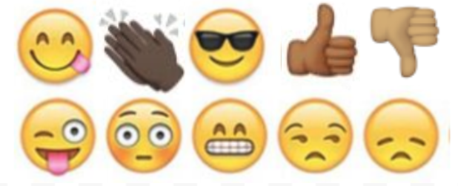  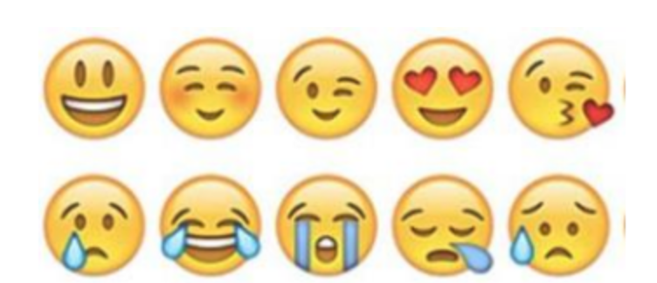

Mindfulness Moment!

Mindfulness Activity:
Fill in the circles the things that make you who you are. You can write words or draw pictures.
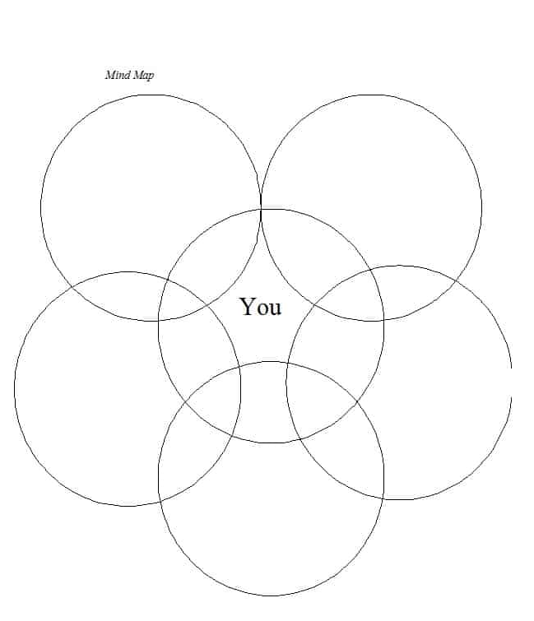

Day 1: Power/Voting and the Electoral College
Math

What is this lesson about?: In this lesson, we will look at voting patterns and practices over the last few presidential elections, and as a part of doing that, assess how each of us, and the collective us, can exert power.

Step 1: Chart of who voted in 2016, by Age Group and % participation, chart of who voted in 2016 by race and participation

% of Population/ | % Who voted for | % Who voted for

 | 2016 | Group | Clinton | Trump
SEX | Men | 48 | 41 | 52
 | Women | 52 | 54 | 41
RACE | White | 70 | 37 | 57
 | African-American | 12 | 89 | 8
 | Hispanic | 11 | 66 | 28
 | Asian | 4 | 65 | 27
 | Other | 3 | 56 | 36
AGE | 18-29 | 19 | 55 | 36
 | 30-44 | 25 | 51 | 41
 | 45-64 | 40 | 44 | 52
 | 65 & over | 16 | 45 | 52
INCOME | <$50,000 | 36 | 53 | 41
 | $50,000-$100,000 | 30 | 46 | 49
 | $100,000 & over | 34 | 47 | 47
Results based on Roper/CNN exit polls.

Refer to the above chart to answer the following questions:
- For men of all races, what % voted for Hillary Clinton?
- What % of African Americans voted for Donald Trump
- What % of voters aged 45 and over voted for Hillary Clinton?
- What % of voters under 30 voted for Hillary Clinton?
- What % of voters who earned less than $50,000 per year voted for Donald Trump?

If you could make 2 or 3 conclusions from the charts, what would they be?

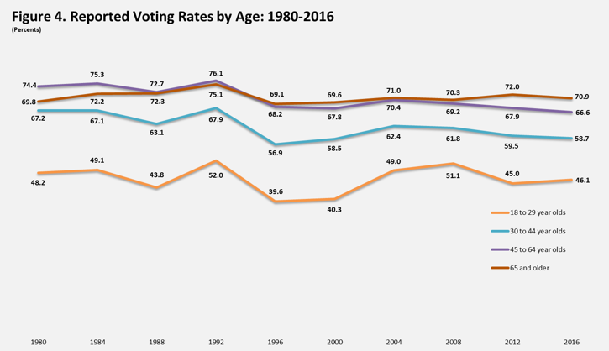
Refer to the above chart to answer the following questions:

- In 2016 about what % of eligible 18-29 year-olds voted?
- In 2016 about what % of eligible 55+ year-olds voted?
- If you compare older voters to younger voters over time, what do you see about their voter participation rates?
- Why, do you think, do so many older voters participate in elections that younger voters?
- What might change this, do you think?

Now, by looking at the two charts combined….what might have happened in the 2016 if 70% of eligible voters under 45 had gone to the polls instead of the % of them that did vote?

Step 2: Understanding how Hillary Clinton won more votes but D. Trump won 2016 election

In the US, we select our Presidents based on the Electoral College system. Each state is allocated a certain number of members to the Electoral College. Each state's number of electors is equal to the combined total of the state's membership in the Senate (100) and House of Representatives (435). Additionally, the District of Columbia (D.C.) is entitled to 3 electors.U.S. territories are not entitled to any electors as they are not states.

So, individuals all go vote for the President and then each state totals up the individual votes for each of the candidates. Based on who wins the individual vote count, the states members of the Electoral College place their votes for the president. Almost all states use an all or nothing system at the Electoral College level. That means if one person receives 52% of the votes and the other candidate receives 48%, the candidate with 53% gets all of the votes in that state’s electoral college votes.
In 2016, Donald Trump was elected President over Hillary Clinton. Donald Trump received 304 votes in the Electoral college and Hillary Clinton received 227. You need 270 to win.

Overall, Clinton got 2.87 million more votes than Trump did in the popular (individual) vote (the largest margin ever for a losing presidential candidate). But Trump won the election.

Trump won six states that President Barack Obama had won in 2012: Florida, Iowa, Michigan, Ohio, Pennsylvania, and Wisconsin.^{[20]} Ultimately, Trump received 304 electoral votes and Clinton 227.

The chart below shows the results of the electoral college votes in 2016. The number in each state shows how many electoral college votes the state gets. States in RED voted for Donald Trump and states in BLUE voted for Hillary Clinton.

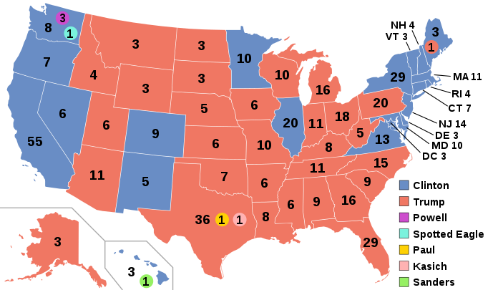

Using the chart above..
- What states with a large number of electoral college voters went for Hillary Clinton?
- What states with a large number of electoral college voters went for Donald Trump.
- What regions of the country primarily voted for Hillary Clinton?
- What regions of the country primarily voted for Donald Trump?
- Identify the state that you are in. Did your state end up selecting Trump or Clinton in 2016?
- Based on this chart and the rules for the Electoral College, can you explain in your own words how someone could win the popular vote, but lose the Presidential Election based on Electoral College Votes?

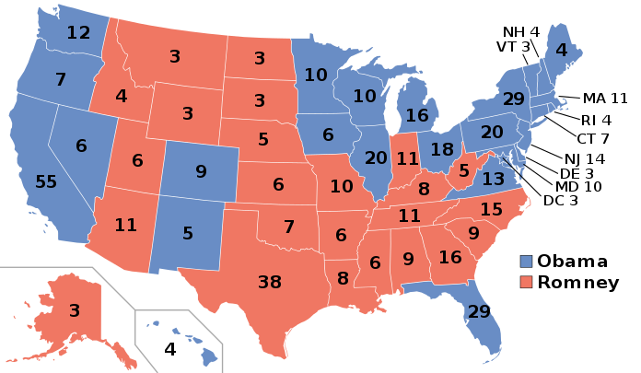
Step 3: Let’s compare who voted for Barack Obama in 2012 vs Hillary Clinton in 2016

In 2012 Barack Obama won the electoral college vote 332 to 206 (Mitt Romney). The map to the right shows the results of the electoral college vote in 2012. Use the two maps to answer the questions below.

- Name 2 or 3 states that Barack Obama won in 2012 that Hillary Clinton didn’t win in 2016.

- How many Electoral College Votes do each of those states have?

- Can you see how winning or losing just a few states can change the outcome of an election?

- Fill in the chart below and see what happens--

Step 4: Looking closely at just Wisconsin and Pennsylvania

The chart below shows how many people voted for D. Trump and H. Clinton in 2016.
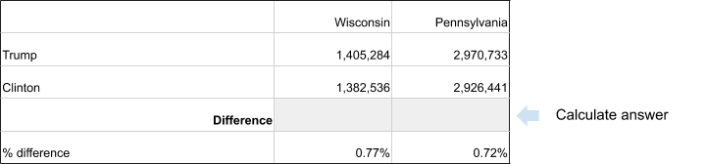

Calculate the difference in Wisconsin and Pennsylvania.
- How many more votes did D. Trump get than H. Clinton in Wisconsin?

- How many more votes did D. Trump get than H. Clinton in Pennsylvania?

- Look at the Map above: How many Electoral College Votes did H. Clinton get in Wisconsin and Pennsylvania combined?

- Look at the Map above: How many Electoral College votes did D.Trump get in Wisconsin and Pennsylvania combined?

What does this chart show about the power of each individual vote?
Student Feedback:

Circle the emojis that best represents how this activity made you feel.

Day 1: Types of Relationships
Health

What is this lesson about?: In today’s lesson, we will learn about healthy, unhealthy, and abusive relationships.

Step 1: Warm-Up: In the relationship below do you feel like one person has more power than the other person?

Who’s got the POWER?
A guy walks his girlfriend to school every morning, meets her for lunch every day, and picks her up to walk her home at the end of each afternoon.

Who has the POWER? Why?

Step 2: Read about the behaviors below.

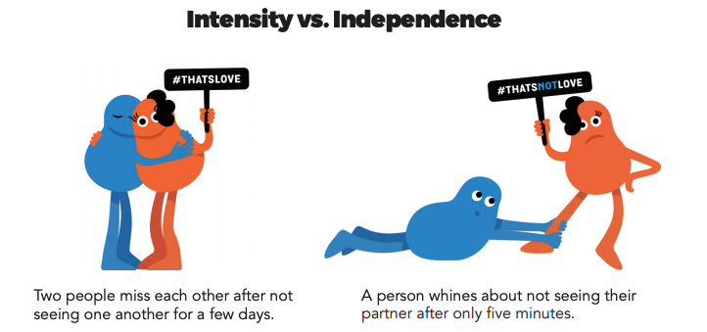

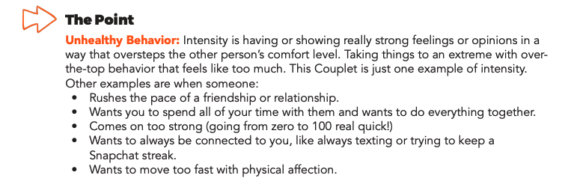
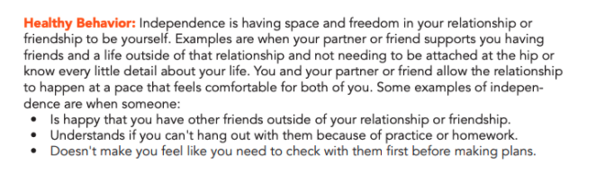

Step 3: Complete the Activity.

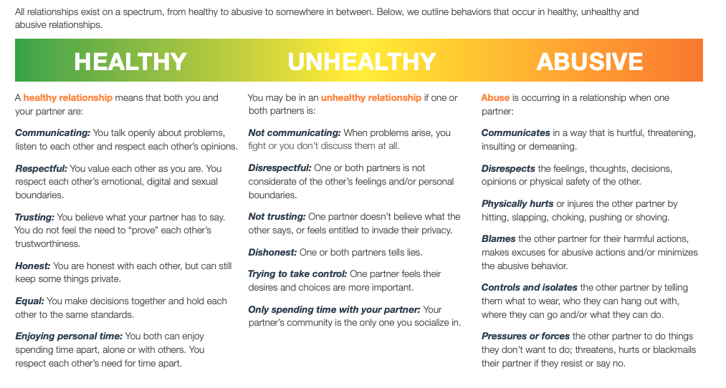
Write three examples of types of relationships you have witnessed below. These do not have to be real-life examples, you can draw from books and movies, too.

Healthy:

Unhealthy:

Abusive:

Mindfulness Moment!

What can I do/say/think/feel right now that will bring me happiness?

Day 1: Governmental Powers: Monarchy v. Oligarchy
Social Studies/Civics

What is this lesson about?: This week you will be exploring different types of government that have existed throughout history. Governments use power and authority to control a country. Sometimes governments can exercise too much power, too little control, or somewhere in between.

Step 1:
Consider the bracket below. Each day this week you will be comparing two types of government. At the end of each day, you will select which type of government, out of the two you compared, you think is better. At the end of the week you will make a determination as to what you think is the best form of government out of the eight below. (for NCAA basketball fans, this is like our Elite 8!)

Types of Government Bracket
Monarchy
Oligarchy
Dictatorship
Theocracy
Direct Democracy
Representative Dem.
Communism
Anarchy

Warm Up: Do you recognize any of these types of government? What do you already know about them?

Step 2: Compare Monarchy and Oligarchy

Monarchy  A monarchy is a type of government having a king or queen. There is only one person in power and that person has total control. Typically a monarch (king or queen) is determined based on family bloodline (a king’s son will become the king once his father dies, for example). When there is a monarch, the law process is much simpler as the laws are made by only one person. Also a monarchy government has less corruption because there aren’t a lot of people involved, which can lead to corruption. A disadvantage is that the people do not have the ability to remove the leader from power and therefore a bad leader can hurt a nation. Also, there are higher chances of rebellion as people cannot change the system. | Oligarchy  In an oligarchy (OH-lih-gar-kee), a small group of people has all the power. Oligarchy is a Greek word that means “rule by a few.” This means that only a certain group has political power, such as members of one political party, one social class, people with military power, or one race. In practice, almost all governments, whatever their form, are run by a small minority of members of society. From this perspective, the major distinction between oligarchy and democracy is that in the latter, elites compete with each other, gaining power by winning public support. Monarchies sometimes function as oligarchies, when there is a powerful and influential group of nobles who advise or even control the ruler.
Step 3: Read about Monarchies in Europe

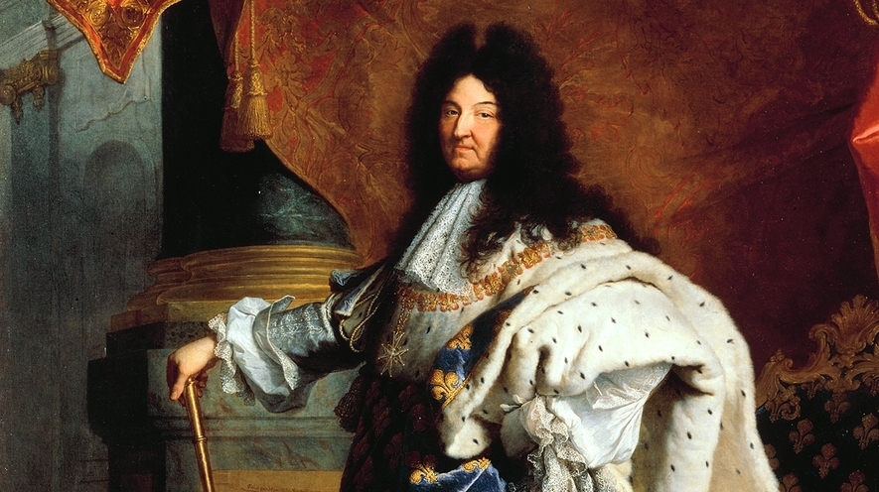
Absolute Monarchs: The Kings and Queens Who Ruled Europe
By ThoughtCo.com, adapted by Newsela staff
Portrait of King Louis XIV of France, 1701
Absolutism is an idea and form of government where total power is held by an individual. Historians have different thoughts about who is an absolute ruler. The word absolute has been used both for leaders like Hitler and Julius Caesar, but this use may not be entirely correct.

The age of absolute monarchies
When talking about European history, Absolutism usually refers to absolute monarchs, like kings or queens. These monarchs ruled during the early modern age, from the 16th to the 18th century. Early modern absolutism is believed to have existed across Europe, but largely in nations such as Spain, Prussia and Austria. Prussia was a powerful kingdom that eventually became the countries of Germany and Poland. Absolutism is considered to have reached its peak under the rule of French King Louis XIV from 1643 to 1715. But there are different views about how it actually worked.
We now generally believe that Europe's absolute monarchs still recognized the laws and authorities lower than them. But these rulers had the ability to ignore the rules if they said it was to benefit the kingdom. This was a way for the government to have more control and collect more money from the territories within the country's borders.
Power had been concentrated in the hands of absolute monarchs through the formation of modern nation states. These modern nation-states had emerged from more medieval forms of government. In those previous governments, nobles, councils and church leaders could sometimes challenge the power of monarchs.
The development of a new style of nation-state had been helped by new tax laws and centralized organization of government. Collecting taxes from everybody in a nation and setting up a central government helped create the idea of a sovereign nation. Sovereign is a word that means something or someone has absolute power. In sovereign nations, the army obeyed the king instead of various nobles. But nobles could benefit too, by having access to jobs, honors and income within the system.
Often there is a confusion between absolutism and despotism. Despotism is a word that describes absolute power used in cruel or oppressive ways. Modern historian John Miller gives a description to better understand the thinkers and kings of the early modern era. Here's Miller's idea: "Absolute monarchies helped to bring a sense of nationhood to disparate(very different) territories, to establish a measure of public order and to promote prosperity."

"Enlightened Absolutism"
Painting of Catherine the Great of Russia.

In the 17th and 18th centuries, there was a movement in Europe known as the Enlightenment. This movement spread new ways of thinking, which were based on ideas of liberty, reason and science.
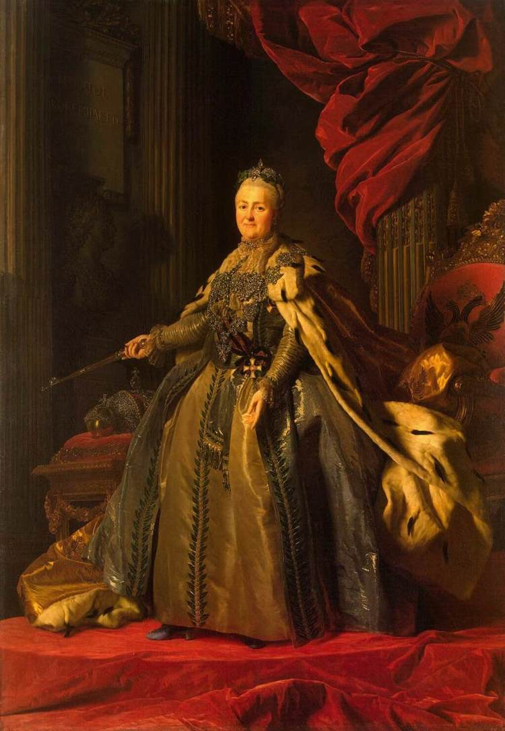
During this period, several absolute monarchs such as Catherine the Great of Russia tried to introduce Enlightenment-inspired reforms while still strictly controlling their nations.
For example, serfdom was abolished or reduced in certain places. Serfdom was a system where peasants lived and worked on a piece of land that they did not own. Serfs had to obey and work for the owner of that land.
Catherine the Great, thought that serfdom was inhuman and wanted to end it. However, she realized that she needed the rich, landowning nobles to help her run Russia. She eventually gave the nobles more control over their land and serfs. This made the lives of serfs even worse.
The Enlightenment-era reforms were meant to establish more equality among subjects, although not with the monarch. The idea was to justify the absolute monarchy with the idea that it would improve people's lives. This style of rule became known as "Enlightened Absolutism."

The end of absolute monarchy
Still, the age of absolute monarchy came to an end in the late 18th and 19th centuries when people began demanding democracy. Many former absolutists had to allow constitutions, which gave people the right to choose their leaders. The absolute kings of France fell the hardest, and one of them was executed during the French Revolution. If Enlightenment thinkers had helped the absolute monarchs, their ideas helped to destroy the rulers that came later.

Step 4: Answer Questions

Would you want to live in a country with a monarch as your ruler? Why or why not?

*share you answer with a partner

Step 5: Read about Oligarchy in South Africa and answer questions

Article One Excerpt (adapted from McGill Encyclopedia)
A modern example of oligarchy can be seen in South Africa during the 20th century. Here, the basic characteristics of oligarchy are particularly easy to observe, since the South African form of oligarchy was based on racism. After the Boer War, an agreement was reached between English- and Afrikaans-speaking whites. Together, they made up about twenty percent of the population, but this small percentage had access to virtually all the educational and trade opportunities, and they proceeded to deny this to the black majority even further than before. Blacks could not vote and had no representation in government. Although this process had been going on since the mid-18th century, after 1948 it became official government policy and became known worldwide as apartheid. After many decades of inequality, other countries began to condemn apartheid. Apartheid ended in 1994 when members of all ethnic classes were allowed to vote in the presidential election. Nelson Mandela became South Africa’s first black president.

What was the ruling group in South Africa during the Apartheid? How did they have all the power?

What group do you think suffered the most under the Apartheid oligarchic government? Why?

How do you think things changed after Nelson Mandela became the first black president of South Africa?

Does the South African Apartheid remind you of any other historical situations? What one(s)?

Step 5: Read about the advantages and disadvantages of oligarchy

The Advantages & Disadvantages of an Oligarchy
By Brian Gabriel
An oligarchy is a society ruled by a small, powerful minority. These are not necessarily the most capable leaders in a society. Oligarchies are not at all similar to democracies, but they are also very different from governments ruled by a single dictator. Oligarchies can have both positive and negative effects on the societies they rule.

Superior Organization
The great Greek philosopher Plato recommended oligarchy, or aristocracy, as the best form of government because it would organize society in the most efficient way possible. He envisioned an ideal society made up of three distinct classes: rulers, soldiers and common people. All of these classes would work together for the common good.
To the extent that a society is actually ruled by its best, and not just its most influential, this theory has some merits. However, there is little practical evidence that even the most worthy minority can organize society.

Incentives For Benevolence
Oligarchs who are given political power to enjoy for their entire lives have a strong incentive (something to motivate them) to rule their subjects well. Without short-term offices and messy democratic elections, oligarchs have no reasons to seek short-term solutions to problems. In democratic societies, politicians spend a lot of time blaming their opponents for bad policies and then proposing equally disastrous policies knowing that they will be comfortably out of office by the time citizens have suffered the consequences. In oligarchies, however, there is no pretense of blame, and the political rulers have incentives to draft good long-term policies to keep the people happy.

Political Exclusion
Oligarchies focus political power into the hands of a small, powerful minority of rulers. Since they control the laws of society, these minorities pass laws for their own interests and exclude the masses from the political process. In the small South American country of Ecuador, for example, an oligarchical government emerged after a coalition of citizens overthrew the president in 1944. As a result, the lower classes in Ecuador were marginalized and systematically excluded from all political processes.

Economic Dominance
Oligarchs who control society compete with one another for control over land, resources and power. The result is that they control all the industries in society and own most or all of the property. The oligarchy in El Salvador during the latter half of the 20th century, for instance, dominated the coffee industry and, therefore, dominated the whole economy because coffee was the most important export crop in the country.

Why did the greek philosopher Plato recommend oligarchy?

What are two advantages of an oligarchy?

What are two disadvantages of an oligarchy?

Step 7: Organize your thoughts

Complete the graphic organizer on the next page to help you compare and contrast monarchy and oligarchy. After completing the graphic organizer, you will reflect on these forms of governments and choose which one you prefer.
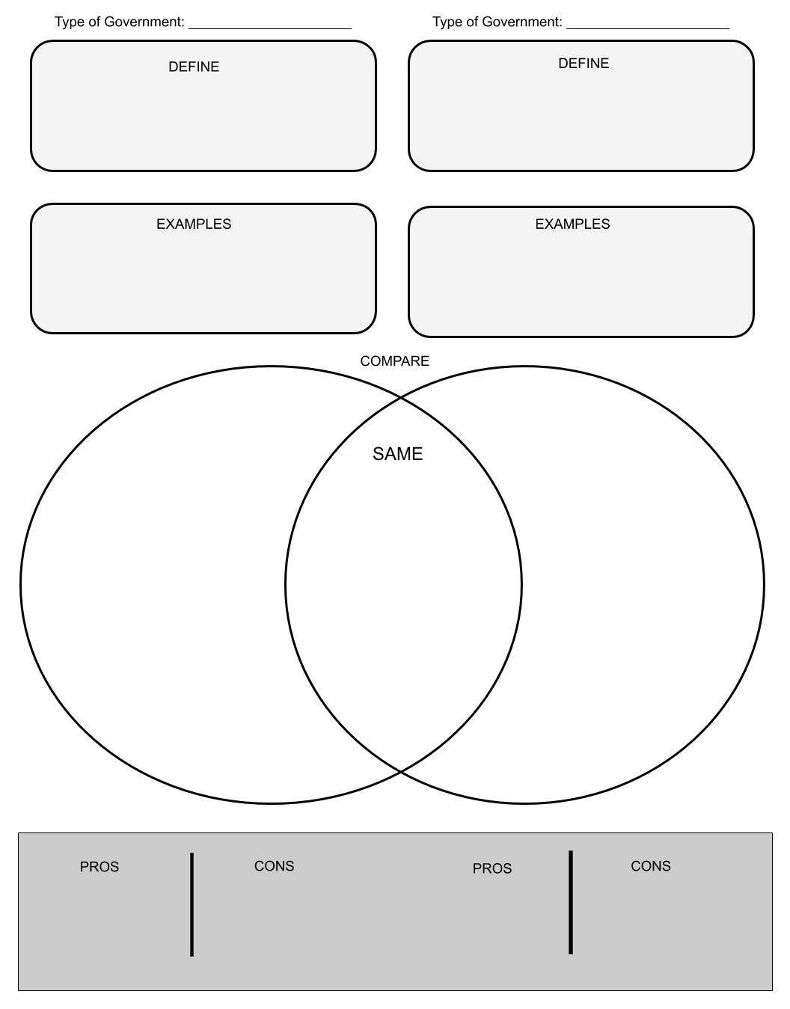

Step 8: Reflect

Complete the bracket below and choose which type of government you prefer:

- Why do you prefer that governmental system? (share three reasons)

- How does it compare to the current governmental system you live in now? (share three reasons)

Step 8: Discuss
- With a partner, share and compare your graphic organizer.
- Can you improve your graphic organizer after discussing with your partner?
- Share what you chose as your winner for this bracket face-off and why.

Student Feedback:

Circle the emojis that best represents how this activity made you feel.

