Week 2
Environment

Day 2

NAME:______________________

Day 2 Agenda
Topic | Activity
Warm-Up!
English Language Arts | - Learn how setting impacts a storyline  - Read passages, analyze them, and respond to questions  - Arts activity (drawing the setting)
Science | - Read the article, Traffic and pollution plummet as US cities shutdown for coronavirus  - Compare and contrast the satellite data for Los Angeles, Seattle, and New York  - Make recommendations for the United States or these three specific cities
Mindfulness Moment!
Math | - Making smart choices about cars. How much is that car really going to cost me? How much do you save on gasoline if you buy a Honda Civic instead of a Ford Mustang, in one year? What sort of insurance is right for me?  - Practice: Fractions and Decimals
Health | - Sleep Journal  - Think about your routines
Civics/Social Studies | Epidemics and the Environment  - Read an article and complete graphic organizer  - Write a letter to a local or national leader

Warm-up Activity: You will determine the conditions of the story by filling in the blank and writing the rest of the story.
Jeremy hated ____________ more than anything but he was so good at it!

Day 2: Setting the Mood
English Language Arts

What is this lesson about?: Yesterday you learned about setting in fictional stories and today we will explore more about the importance of setting. You will learn how setting impacts the characters, plot, and mood of stories. You will analyze different texts to see how the setting impacts stories and you will have the opportunity to be creative in drawing settings from a text.

Step 1: Setting Impact

Remember from yesterday that a story’s setting is it’s time and place, however a setting is much more than just the characters’ environment. The setting can establish the mood and reveal the characters and conflict. It can even give clues to the theme—the universal message—of a story.

Consider the following setting description:
“The main character lives in the coldest part of Alaska, in a town of 500 people that is miles from any other town or city. It is the beginning of spring in the year 2050.”

Describe the other important elements of this story… (be creative!)

Who is the main character?

What conflict does the character face?

What is the tone or mood of this story?

What themes or ideas might the writer explore?

*Share with a classmate what story elements you developed. Did you like your classmat’s storyline? Did you both come up with any similar answers?

Now, consider the following setting description:
“The main character lives in Jamaica in an ocean-front bungalow that has its own beach and dock where the main character keeps their boat. It is the summer of 1980.”

Think about what your answers would be to the questions above. Are they the same?

Why did this new setting change your answers?

Step 2: Does setting affect the mood?

If you wanted to make somebody happy, where would you take them? Why?

If you wanted to make somebody feel inspired, where would you take them? Why?

Places and locations can affect the way we feel and our mood. If you go to a haunted house, the mood is creepy and scary, and you may feel afraid. If an author wants to tell a scary story, they are more likely to tell that story in the setting of a haunted house, than a peaceful spa-like location.

Step 3: Setting and mood analysis

The mood describes how a person feels at any given time. It also reveals the atmosphere of the people, places, or time periods.

Read these three little excerpts. See what they tell you about the character. Likewise, sense what kind of mood these settings evoke:

Spans of Poppies
Her hand reached for the massive, iron door handle. She struggled to pull it toward her. A sapphire studded the top of the handle and, as she slowly made progress on the door, a slash of light popped through. It warmed her face and made her smile, giving her enough energy to heave the massive hunk of wood open wide enough to slip through.

The way the door decisively slammed behind her should've frightened her. Instead, she looked upon spans of green, rolling hills bedecked with colorful poppies and tiny thatched-roof cottages. She debated between rolling down the plush hill at her feet or lifting straight off the ground and flying into the tiny village below.

- How would you describe the character's mood? How is she feeling?

- What quote from the text tells you how the character is feeling?

________________

Filmed in Faithlessness
Dust coated every last surface. He ran his finger across the rows of books, the span of tables, and the wide window frames. It came up black. A fast-winged crow clipped past his ear and he wondered which broken window the ugly creature entered through. As it perched atop a broken spray of glass and squaked at him, he realized he'd never find her again. He was every bit as broken as the tired home, filmed in faithlessness.
- What have you learned about the main character? How is he feeling?

- What quote from the text tells you how the character is feeling?

_________________

Pink Lemonade and Cookies
The lime green patio umbrella flapped happily in the breeze. It covered strawberry slushies, watermelon pies, and bright, cheerful stacks of donuts. Emily stepped outside to feature a crystal pitcher of pink lemonade and a spray of warm cookies in the center of the table. She had on her favorite summer dress and knew that, as soon as he stepped through that patio gate, her life would never be the same again.

- How would you describe the character's mood? How is she feeling?

- What quote from the text tells you how the character is feeling?

Step 4: Setting & Mood Analysis

Read the following song lyrics.

THE TOWN IS LIT
Written by Toni Morrison

[stanza 1]
It’s been suggested:
well kept lawns and fences
white porch swings and toast by the fire.
It’s been requested:
puppies,
a window of blossoming pear trees
and a place for the robins to nest.
But I know that somewhere, out there
The town is lit
The players begin
To make music in all the cafés
Clowns on wheels
Linger to steal
Foxes that click on the curb
Lovers expecting
The night to protect them
The moon too far to disturb
Trees in the park
Dance after dark
To music in all the cafés.
[stanza 2]
It’s been suggested:
well kept lawns and fences
white porch swings and toast by the fire.
It’s been requested:
puppies,
a window of blossoming pear trees
and a place for the robins to nest.
But I know that somewhere, out there
Geminis split
Sagittarians kick
To the music in all the cafés
Aquarians throw
Gold on the floor
To rival the glitter it makes
Pisces swim
Over the rim
Knowing they’ve got what it takes
To cut through the dark
And get to the heart of the music in all the cafés.

What two places is Toni Morrison comparing in this poem? (hint: she starts each stanze describing one place, and then moves on to describe another place “out there”)

How are those two places different?

Do you think the writer likes one place more than the other? Which one? Why?

What is the mood of the first place?

What is the mood of the second place?

Step 5: Draw the Setting

Draw each of the two settings in the song above. Is there any way you can communicate the mood of the setting by what you draw?

Setting 1

Setting 2

Student Feedback:

Circle the emojis that best represents how this activity made you feel. | 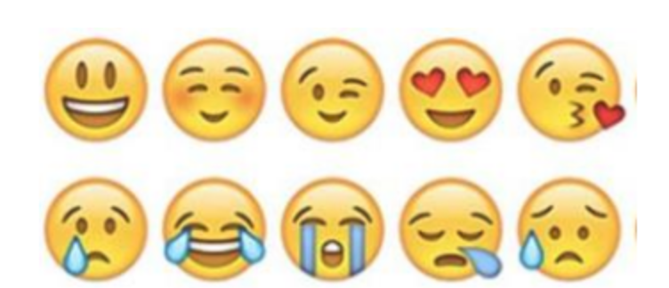  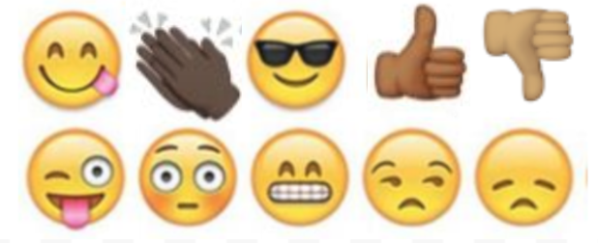

Day 2: Science
Environment

What is this lesson about?: Today you will read the article, Traffic and pollution plummet as US cities shutdown for coronavirus. You will compare and contrast the satellite pollution data for Los Angeles, Seattle, and New York. You will also make recommendations for the United States or these three specific cities.

Step 1: Read the article, Traffic and pollution plummet as US cities shutdown for coronavirus.

Traffic and Pollution Plummet as U.S. Cities Shut Down for Coronavirus

By Brad Plumer and Nadja Popovich (NY Times) March 22, 2020

In cities across the United States, traffic on roads and highways has fallen dramatically over the past week as the coronavirus outbreak forces people to stay at home and everyday life grinds to a halt.
Pollution has dropped too.
A satellite that detects emissions in the atmosphere linked to cars and trucks shows huge declines in pollution over major metropolitan areas, including Los Angeles, Seattle, New York, Chicago and Atlanta.
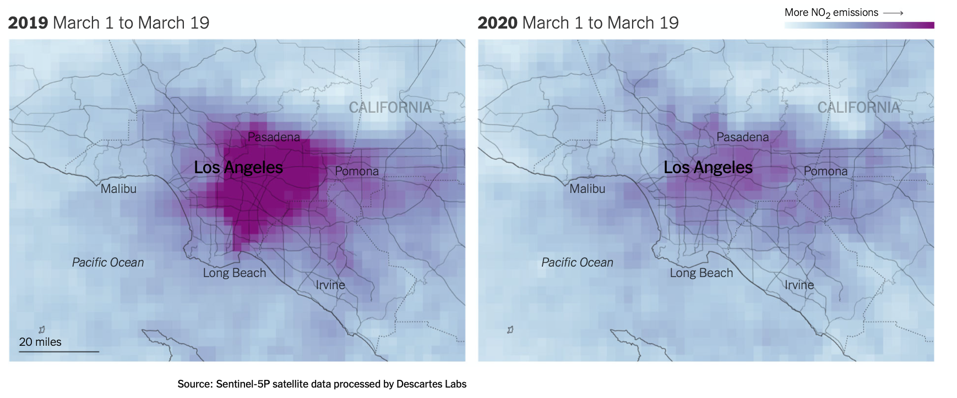

Los Angeles
In Los Angeles, as businesses and schools have closed this month and drivers have stayed off the roads, air pollution has declined and traffic jams have all but vanished.
Preliminary data from the European Space Agency's Sentinel-5P satellite show that atmospheric levels of nitrogen dioxide, which are influenced in large part by car and truck emissions, were considerably lower over Los Angeles in the first two weeks of March compared to the same period last year. The car-dependent city normally features some of the highest smog levels in the country.
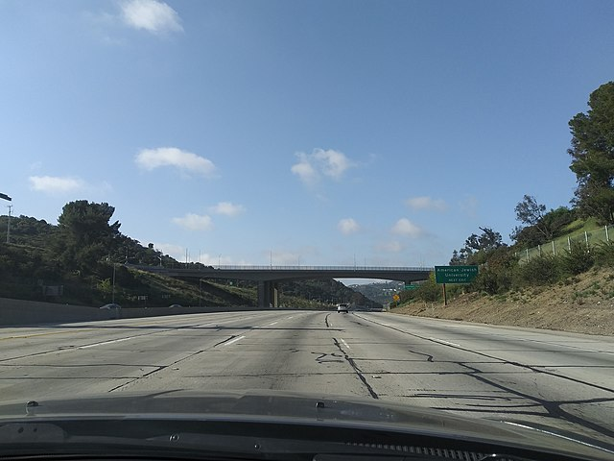
The 110 toward central Los Angeles on Friday afternoon, a time when traffic would normally be bumper-to-bumper

Los Angeles’s famous rush-hour congestion has virtually disappeared. On Wednesday at 8 a.m., traffic in the city was moving 53 percent faster than it usually does on a Wednesday morning, according to data from INRIX, a company that analyzes traffic data from vehicle and phone navigation systems. At 5 p.m., when the freeways are typically congested, traffic was moving 71 percent faster than usual.
“There’s basically no rush hour anymore, or at least not what we would recognize as a rush hour,” said Trevor Reed, a transportation analyst at INRIX. He said that traffic has decreased even more sharply in the evening because that’s when people are normally running errands in addition to commuting home, but many of those activities have now been put on hold.
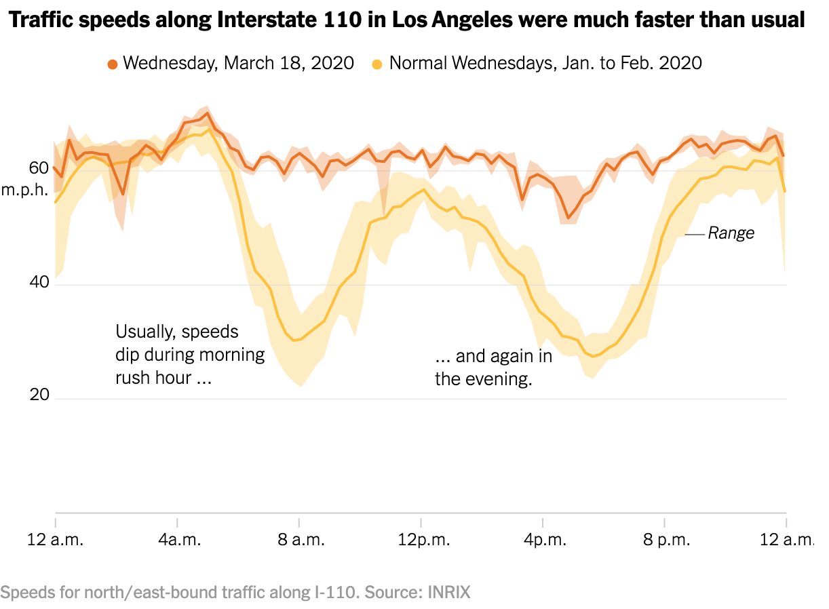
Similar changes can be seen in the Bay Area, where local officials on Monday ordered the region’s 6.7 million residents to shelter in place. Since then, the number of cars and trucks crossing eastbound on the Bay Bridge each day between San Francisco and Oakland has fallen roughly 40 percent compared with two weeks ago, according to data from monitoring stations operated by the California Department of Transportation.
While that’s a sign that people are heeding the advice of public health experts, it’s yet another warning that the nation’s economy is facing serious peril. Traffic and congestion, while often a source of annoyance, are also a telltale sign of bustling economic activity. On Thursday, Gov. Gavin Newsom of California extended the shelter in place order to cover the entire state.
The satellite emissions data was analyzed for The New York Times by Descartes Labs, a geospatial analysis group. Nitrogen dioxide levels can also fluctuate with weather conditions, and experts said quantifying the precise effects of the shutdown on such pollution will take further study.
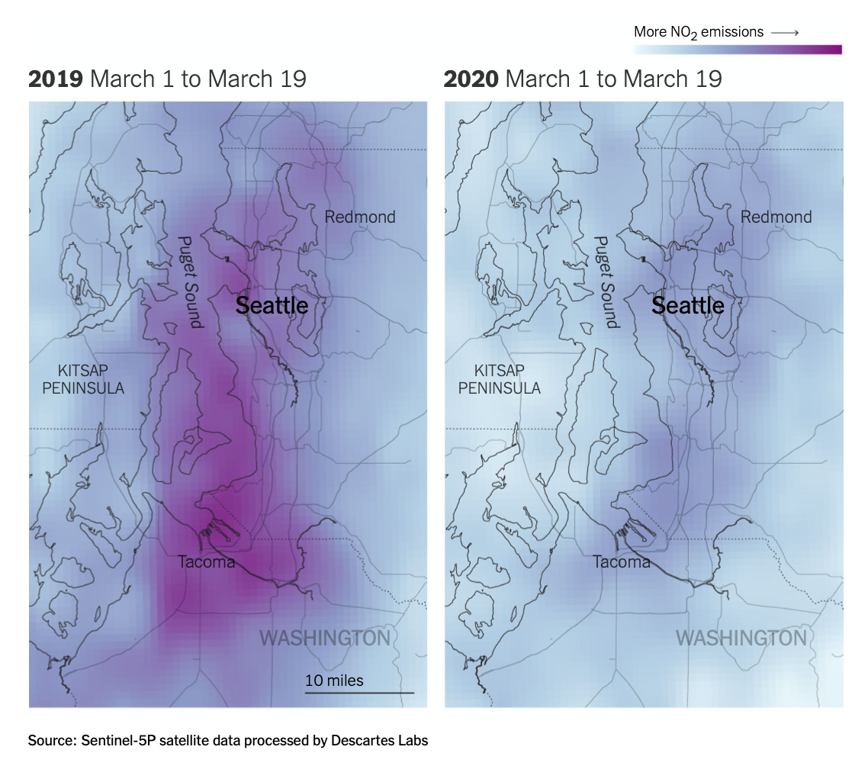

Seattle
Air pollution from vehicles has likewise plummeted in the Seattle area, which had one of the earliest recognized coronavirus outbreaks in the country. Traffic patterns there changed drastically before most other cities.
In early March, local officials recommended that residents over 60 years old stay in their homes and that workers telecommute if possible. Shortly after, Microsoft and Amazon, two of the region’s largest employers, told their workers to stay home.
The impact was immediate: By March 8, the number of trips into downtown Seattle during morning rush hour had declined nearly 40 percent, according to a recent report by INRIX.
But it’s not just commuting patterns that have shifted in Seattle. Traffic on Saturdays has also declined, suggesting that people are making fewer social and recreational trips. The data also shows that visits to grocery stores and bulk retailers like Costco soared early in the month, as residents stocked up on supplies, but have since fallen off. “We saw an upsurge in panic buying in the first part of the month but that seems to be over now that people are stocked up,” Mr. Reed said.
These trends, INRIX noted in its report, represented a “radical departure” from normal driving patterns and offered “a preview of what is to come for hundreds of cities across America if the Covid-19 outbreak continues.”
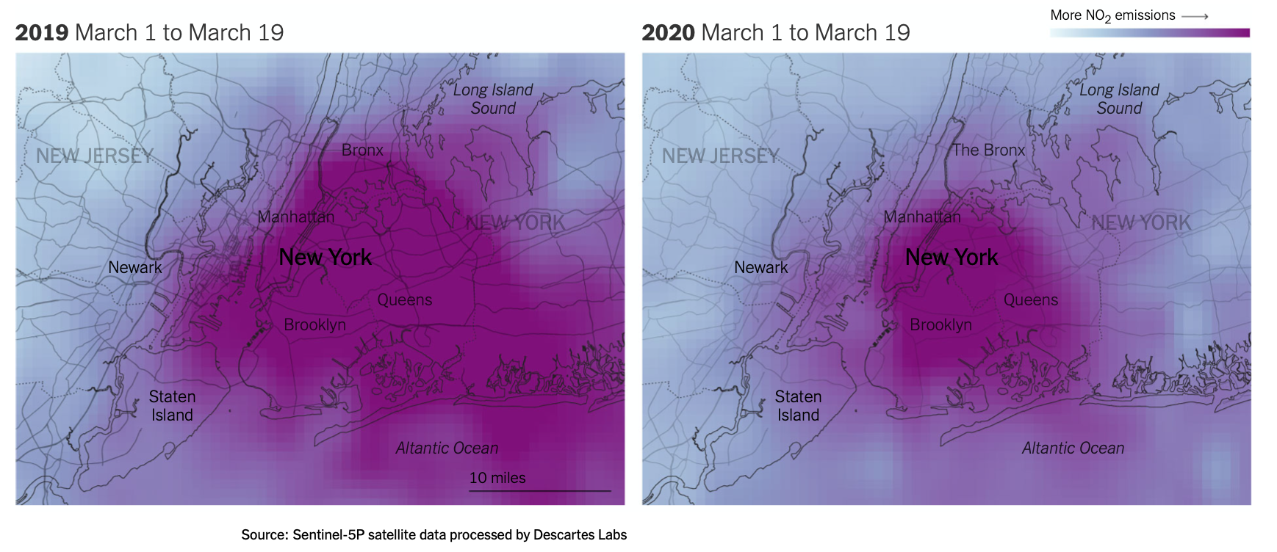

New York
In New York City, residents are less dependent on car travel than in other metro areas, but vehicle traffic has still seen a steep drop-off in recent days as office buildings, schools and restaurants have shut down. On Wednesday afternoon, rush-hour traffic moved 36 percent faster than normal as the roads cleared out, according to data from INRIX.
Separately, researchers at Columbia University have seen emissions of carbon monoxide over New York City decline more than 50 percent below typical levels over the past week — a change linked to the drop in car traffic across the city.
“We’ve never seen anything like the drop we saw starting last Friday,” said Roisin Commane, an assistant professor at Columbia who conducts the air-monitoring work, referring to March 13. “We often see dips during weekends or over holidays, but this is completely different.”
Scientists caution that while the decline in air pollution over U.S. cities could have some near-term health benefits, those are likely to be relatively minor in the grand scheme of things. For one, air pollution is expected to rebound once the coronavirus outbreak subsides and people are allowed to leave their homes, and studies have found that long-term exposure to air pollution tends to have a larger impact on public health.
And any short-term benefits could easily be swamped by the broader impacts from the virus itself, from the risks created by an overloaded health care system and from the negative effects of a large recession and rising unemployment. “This really shouldn’t be seen as a silver lining,” said Jill Baumgartner, an associate professor and epidemiologist at McGill University. “It’s not a sustainable way to reduce air pollution, and the long-term economic and well-being impacts of this crisis are going to be devastating for many people.”

Step 2: Analyze the three satellite pollution data
Analyze the three satellite pollution comparisons that are provided in the article. Share what you notice for:

Los Angeles

Seattle

New York

How are these data similar?

How are they different?

Step 3: Share your thoughts
If you were an environmentalist, based on this article, what recommendations would you make for the United States or for these specific cities?

Student Feedback:
Circle the emojis that best represents how this activity made you feel.

Mindfulness Moment! Respond to your Mindfulness card in the box below.
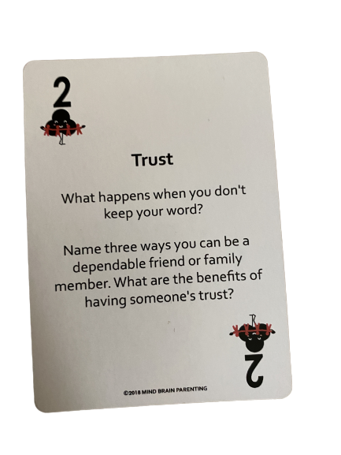

Day 2: Cars
Math

What is this lesson about?: Today we will explore how much it really costs to own a car for a year. Then we will look at the pros and cons of buying an electric car.

One thing is for sure, traditional cars use a lot of gas, add to pollution and that causes lots of problems for the environment. So, we will also explore how much gasoline different cars use, as well.

But first, Today’s Warm-Up
In many cities, you are charged 5 cents each time you use a plastic bag at a grocery store.

- What do you think the purpose of this 5 cents charge?

- Do you agree with this policy?

In Washington, DC, the City collected $45,000 the first year they put this law into effect. That means that people purchased 900,000 plastic bags.

By the 3rd year this law was in effect, the City collected $15,000. About how many plastic bags were sold?

Why do you think that so many fewer bags were sold by the 3rd year?

Discuss:
- Do you have a plastic bag tax in your city?
- Is it a good idea?
- If yes, has the plastic bag tax changed your behavior in any way?

Background Information to get us started

The chart below shows the price of a few cars, and the miles per gallon of gas each gets, as of April 1, 2020.

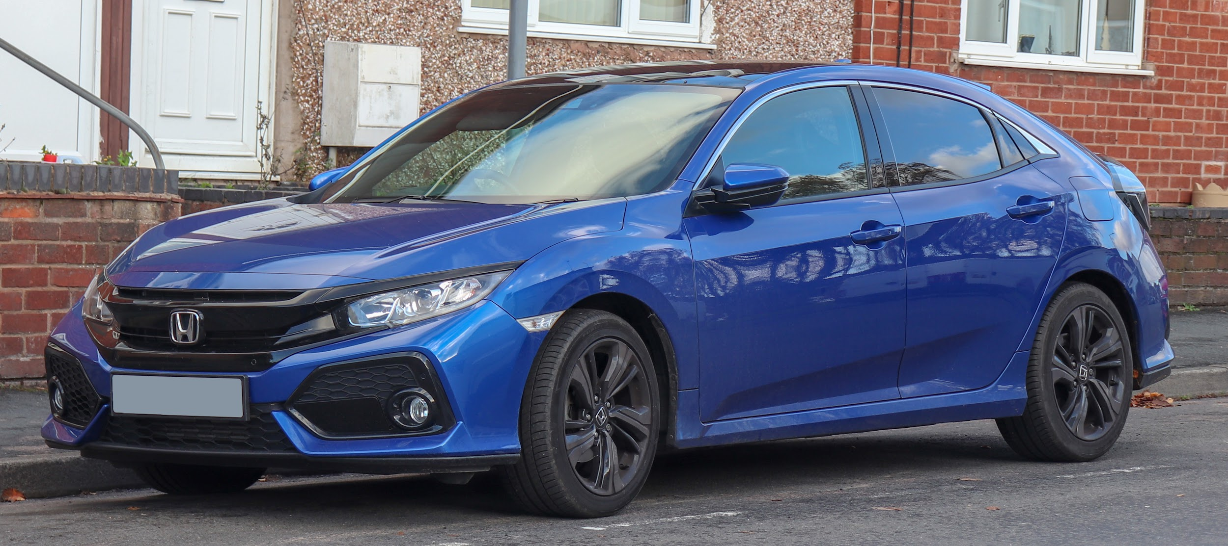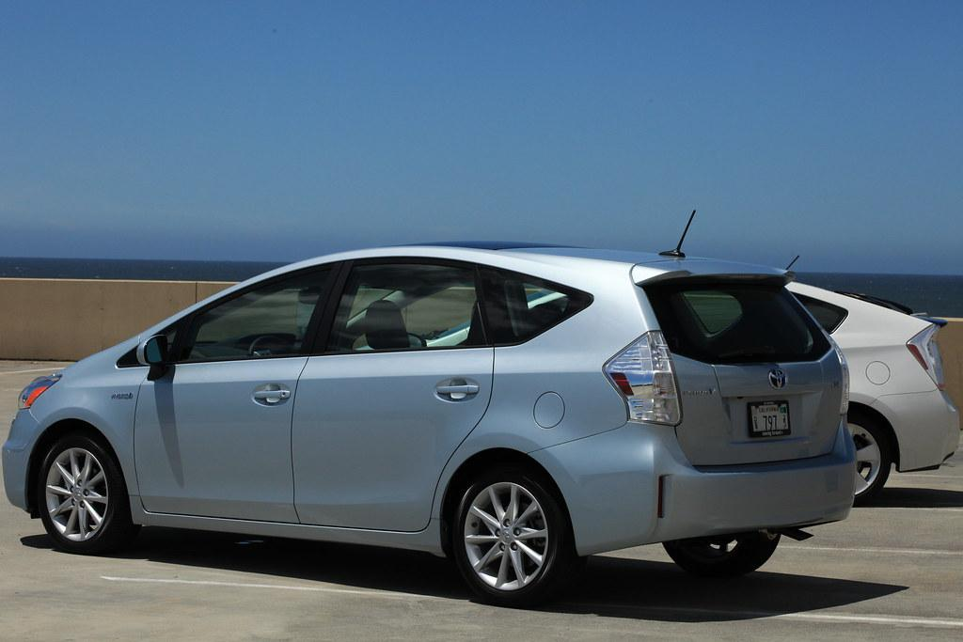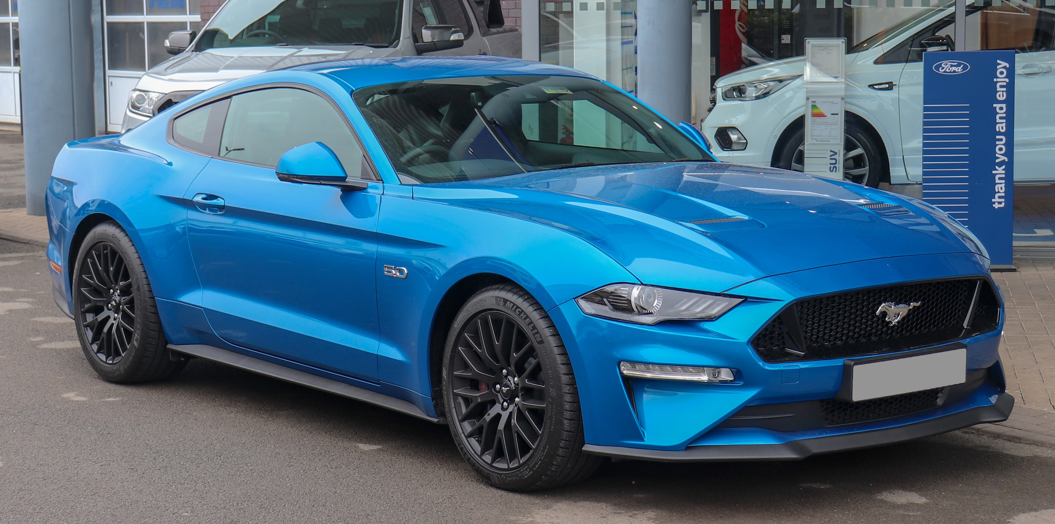

Model Make and Year | Cost | Miles Per Gallon (Gas)
2010 Honda Civic | $6,000 | 32
2010 Ford Mustang | $9,000 | 12
2010 Toyota Prius (hybrid) | $7,000 | 50
2020 Honda Civic | $24,000 | 36
2020 Ford Mustang | $28,000 | 12
2020 Toyota Prius (hybrid) | $26,000 | 55
2020 Nissan Leaf (100% Electric)* | $34,000 | 125
* Note: the Nissan LEAF runs on electricity, not gas. The miles per gallon is based on estimating how much an owner pays in increased electric bills to charge the car.

Step 1: The Cost of Gasoline...
Calculating how much gas you will use in 1 year, and how much it will cost for that gas-

Price for a Gallon of Gas: $2.75 (on April 1, 2020)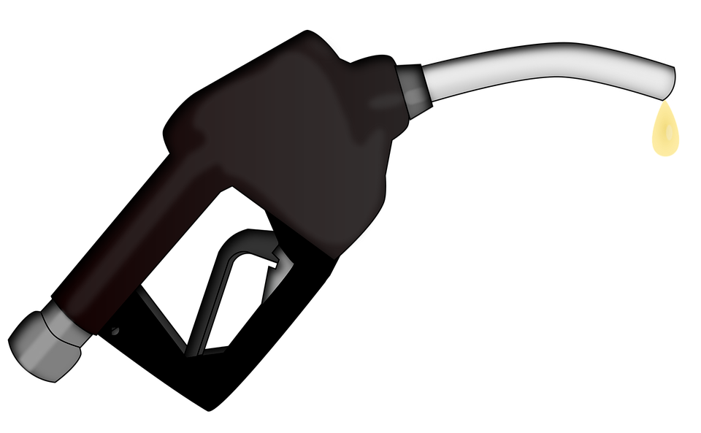

Estimate how many miles you drive your car each day (select one and circle it):
5 miles/day 15 miles/day 30 miles/day

There are 365 days in a year. Assume that you drive your car on 300 of those days. How many miles will you put on your car in 1 year? _____________
(hint: multiply the miles/day x 300 days in a year)

Select which car from the list above you are going to purchase: __________________

- How many miles per gallon does it get: __________________________

- About how much money will you spend on gas in 1 year? ________________

Select a 2nd car option from the list above: ______________

How many miles per gallon does it get: ______________

- About how much money will you spend on gas in 1 year? ______________

How much more or less would you spend per year if you purchased one car or the other, based on your car selection? ____________

Discuss: Based on this comparison, will the gas mileage your car gets impact what type of car you might buy?

Step 2: Understanding annual maintenance costs

Estimated Yearly Maintenance Costs: One ‘hidden’ cost of owning a car is the cost of maintaining it. These costs vary. But they include the average cost of changing the oil, keeping good tires on the car, changing the breaks, and doing other ‘standard’ maintenance that helps keep your car safe and running well. Although this isn’t always exact, you now can go online and use tools to help you estimate the average yearly maintenance cost of cars.

Not surprisingly, brand new cars usually have low maintenance costs. Often, with new cars, most or all ‘standard’ maintenance costs are covered for the first few years.

Also, electric cars (and hybrids) have very low maintenance costs because they don’t have a gasoline engine and have a lot less moving parts that can wear out. Let’s use the chart below to calculate some maintenance costs.

Car Make and Year | Estimated annual maintenance costs for the next 5 years | Comment
2020 Honda Civic | $500/year | Almost all standard maintenance costs are covered by warranty for 5 years
2010 Honda Civic | $750/year | No warranty after 10 years
2005 Honda Civic | $1200/year | No warranty; includes cost of range of parts that need to be replaced after 15 years
2020 Ford Mustang | $500/year | Almost all standard maintenance costs are covered by warranty for 5 years
2010 Ford Mustang | $1,000/year | No warranty after 10 years
2005 Ford Mustang | $1,500/year | No warranty; includes cost of range of parts that need to be replaced after 15 years
2020 Toyota Prius | $250/year | Almost all standard maintenance costs are covered by warranty for 5 years
2010 Toyota Prius | $500/year | No warranty, but estimates of maintenance costs are minimal

For each of the cars in the chart, calculate how much you will spend over the next 5 years on maintenance costs alone.

Car Make and Year | Estimated annual maintenance costs for the next 5 years | Total maintenance cost for the next 5 years -- Fill in this column!!!
2020 Honda Civic | $500/year
2010 Honda Civic | $750/year
2005 Honda Civic | $1200/year
2020 Ford Mustang | $500/year
2010 Ford Mustang | $1,000/year
2005 Ford Mustang | $1,500/year
2020 Toyota Prius | $250/year
2010 Toyota Prius | $500/year

After five years, how much more would you spend on maintaining a 2005 Civic Compared to a new 2020 Civic?

After five years, how much more would you spend on maintaining a 2010 Mustang compared to a 2010 Prius?

Discuss: Explain some of the pros and cons of buying an older car?
What is a good reason to buy a used car? What is one of the downsides of buying a used car?

Step 3: Looking at Insurance costs

In most states it is mandatory to purchase basic insurance that will cover for:
- Liability, medical and related costs (to driver and others): this insurance will cover the costs of damage you cause to other cars, and the medical costs if you or others are injured

You usually have a choice to purchase other more comprehensive insurance that covers:
- Comprehensive/Collision Insurance: The cost of repairing or replacing your car in case of an accident or break-in
- Other: Covering the cost of a rental car while your car is getting fixed and towing if your car breaks down.

How much you pay for insurance is related to 3 things:
- Driver’s Age and Gender: Young drivers get in many more accidents than people over 25. In general, women drive more carefully and get in less accidents than men (that’s the truth)
- Your driving record: Past accidents and speeding tickets greatly increase the cost of insurance, because they signal to insurance companies that you are a risky driver.
- Value of the car: Comprehensive Insurance--covers the cost of fixing or replacing a car. So, it costs more for newer and more expensive cars than for older and less expensive cars. Basic insurance doesn’t change that much by the value of the car.

The chart below breaks down the cost of Insurance. NOTE: this chart is an estimate, and in real life these costs would not be quite this standard.

Basic Liability Insurance:  Under 25 years old, male  Cost per 1 YEAR |  |  |  | Basic Liability Insurance:  Under 25 years old, female  Cost per 1 YEAR
Low Risk | Medium Risk | High Risk |  | Low Risk | Medium Risk | High Risk
$800 | $1,200 | $1,600 |  | $450 | $600 | $900

Marcus is 20 years old. He has a clean driving record, so he is low risk. How much will insurance cost him for 1 year?

Marcus gets two speeding tickets and moves from low risk to high risk. How much will basic insurance cost him for 1 year?

Marcus stays in that category for 3 years. Over 3 years how much will those speeding tickets cost him in insurance (how much more will it cost him to be in the high risk category than the low risk category for 3 years?)?

Marcus has a younger sister. She is 18. She is a low risk, female driver. She drives for three years and never gets a speeding ticket and never gets into an accident. How much will she pay for all 3 years in basic insurance?

Discuss: You get a speeding ticket for $100. Is that the ‘full cost’ of the ticket? Yes/No. Discuss.

Comprehensive/Collision Insurance. When is it worth it? When should you consider switching to basic only. Review the chart below CAREFULLY and then answer the questions below.

 | Value/Cost of the car TODAY | Cost of Comprehensive Insurance for 1 year, for under 25 year old, low-risk driver | Cost of Comprehensive Insurance for 1 year, for under 25 year old, high-risk driver
2020 Honda Civic | $24,000 | $1,200 | $2,400
2010 Honda Civic | $6,000 | $600 | $900
2005 Honda Civic | $3,500 | $500 | $700
2020 Ford Mustang | $28,000 | $1,800 | $3,200
2010 Ford Mustang | $9,000 | $900 | $1,200
2005 Ford Mustang | $5,000 | $600 | $800

How much does it cost to buy comprehensive/collision insurance for a 2020 Honda Civic for a low-risk 22 year-old? How about a high-risk 22 year-old?

Compare that to the cost of the same insurance for a 2020 Ford Mustang. How much more does it cost to insure the 2020 Mustang compared to the 2020 Civic for a low-risk driver?

- Why do you think it costs more for the insurance on the Mustang?

- Do you think it is only because the Mustang is a little more expensive? Why else might the insurance be more?

How much does it cost a high risk 22 year old to purchase comprehensive/collision insurance on a 2005 Civic?

- Discuss: Do you think it is worth it to spend $700 each year when your car is worth $3,500? Yes/No. Why?

If you are a high-risk driver and you are driving a new Mustang around, how much will you pay just in comprehensive/collision insurance over a 3 year period?

- Is it worth it to spend that much money each year on insurance?

- Does that make you consider buying a less expensive car so that you will have lower annual insurance costs? Yes/No?
Step 4: Putting it All Together--This isn’t cheap!

What car did you select for the first part of this project in Step 1?
Model and Year? __________________

Based on your driving habits, how much will gas cost for 1 year________________

How much is the estimated annual maintenance on that car for 1 year? __________

How much will it cost you for Insurance? You will need to rate yourself as low, medium or high risk? Circle which one you are: Low Risk Medium Risk High Risk

- How much will you spend on mandatory Insurance for 1 year?___________

- How much will you spend on comprehensive/collision for 1 year?___________

All together, what will it cost you to operate your car for 1 year? ___________
Remember, this doesn’t include the cost of purchasing it!

Skill Builders and Review Problems-
If you have more time, take a few minutes to complete the “skill builder” problems in the separate handout packet.
- Comparing Fractions
- Adding and Subtracting Fractions
- Multiplying and Dividing Fractions

Student Feedback:
Circle the emojis that best represents how this activity made you feel.

Day 2: Sleep
Health

Step 1: Sleep Journal
Draw or write about a recent dream you had.

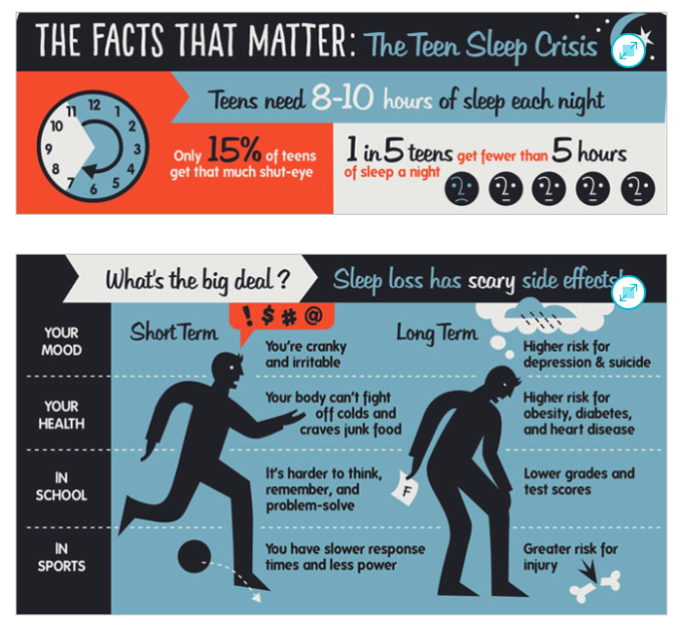
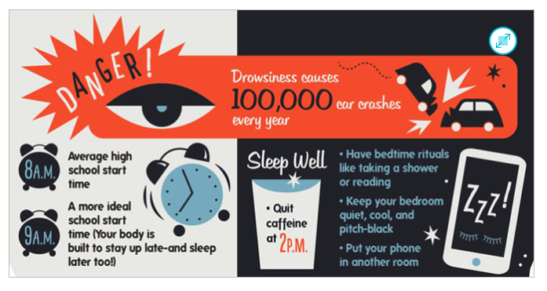
Step 2: Routines and Habits
What is your routine? | What can you change?
Morning

Afternoon

Evening

Day 2: Pandemics & The Environment
Social Studies

What is this lesson about? In this lesson you will read about how two American cities—Philadelphia and St. Louis—responded to the flu epidemic of 1918 and how those responses cost and saved lives. After reading, you will organize your ideas about the article. Then, you will apply what you learned to the current situation the world is facing batting COVID-19.

Step 1: Read the following article.

What happens if parades aren’t canceled during pandemics? Philadelphia found out in 1918, with disastrous results.

On the afternoon of Sept. 28, 1918, about 200,000 people crammed onto the sidewalks in Philadelphia to watch a two-mile parade snake through downtown in the midst of World War I. Billed as the city’s largest parade ever, it featured military planes and aggressive war-bond salesmen working the crowds, in scenes that graced the front pages of the evening papers.
But readers who flipped toward the back of the Evening Bulletin might have stumbled on an unsettling headline: In the last 24 hours, 118 people in Philadelphia had come down with a mysterious, deadly influenza, which was quickly spreading from military camps to civilians amid a worldwide pandemic.

“If the people are careless, thousands of cases may develop and the epidemic may get beyond control,” the city’s health commissioner, Wilmer Krusen, said in the 1918 article, according to the Philly Voice.

He was the same person who, just a day earlier, allowed to go forward what is now known as the deadliest parade in American history. In doing so, he ignored the advice of medical professionals who urged him to cancel the parade or risk an epidemic. Within three days, every bed in the city’s 31 hospitals was filled. There were thousands of influenza patients.

A century later, as the novel coronavirus grips the nation with anxiety and disrupts everyday life, Philadelphia’s 1918 Liberty Loan parade “is a perfect historic example of how the misplaced priorities can become so dangerous,” historian Kenneth C. Davis told The Washington Post on Wednesday. This week, major cities including Philadelphia, New York and Chicago decided to cancel their St. Patrick’s Day parades amid fears of accelerating the spread of coronavirus.

Davis said he was “astonished” it took New York until Wednesday night to make that call, given the cautionary tale of Philadelphia’s deadly Liberty Loan parade.

“It seemed to me to be a perfect parallel to the story of what happened in Philadelphia in 1918, where the health authorities were clearly aware that this was a growing problem, and the health commissioner was absolutely told to stop the parade,” said Davis, author of “More Deadly Than War: The Hidden History of the Spanish Flu and the First World War.”
“But he chose not to.”

The Spanish flu pandemic of 1918 killed an estimated 50 million people worldwide, including about 675,000 in the United States. But no American city was hit harder than Philadelphia.
Trump is ignoring the lessons of 1918 flu pandemic that killed millions, historian says
In retrospect, historians and the federal government have blamed the city’s explosion of influenza infections in 1918 on city officials’ failure to quickly shut down mass gatherings — namely the parade.

Health officials were aware of the risks. The signs were there in the days before the big event. At least 600 enlisted men on military bases on the outskirts of the city were suffering from the influenza, while 47 civilians were reported to be infected just two days before the parade, according to an article by Thomas Wirth in “Pennsylvania History: A Journal of Mid-Atlantic Studies.”

The pernicious flu strain caused head-splitting fevers, crippling coughs and severe body ache. The symptoms, ravaging military camps and battlefields all over Europe and the United States, were now invading city streets.

As a precautionary measure, the city printed out 20,000 fliers giving Philadelphia residents advice on how to avoid catching the flu. They urged people to cover their mouths when they sneezed and coughed.

Still, doctors couldn’t seem to convince the city to halt the beloved war-bonds rally. One doctor called it “a ready-made inflammable mass for conflagration” — but not a single newspaper would print his warning, according to John M. Barry’s “The Great Influenza: The Epic Story of the Deadliest Plague in History.”

Davis said that city leaders were more concerned about boosting morale for the war effort and too afraid of causing panic. In one ad from the parade organizers in the Philadelphia Inquirer, readers were warned, “Citizens! A Crisis Is Here!”

“The influenza epidemic imperils the success of the Fourth Liberty Loan. … The Government calls upon you not to forget your duty to the Fighters in France” — meaning the citizens better not stay home.

Krusen had assured the city that it was safe to go. Yet just one day after the parade, he issued a list of rules for the public to follow, according to Wirth’s article. Chief among them was, “avoid large crowds.”

Within a week of the parade, more than 45,000 people in Philadelphia were infected with influenza, as the entire city, from schools to pool halls, ground to a halt, according to Wirth.
Within six weeks, more than 12,000 Philadelphians were dead.

“The real death and destruction came about after the parade, but it was very sudden and it was very dramatic,” Davis said. “It was an apocalyptic scene, when in some cases, public-health nurses would be walking into tenements and finding whole families dead.”

Around the 100th anniversary of the 1918 pandemic, the Centers for Disease Control and Prevention cited the parade as the prime example of exactly what not to do during a looming pandemic. It compared Philadelphia to St. Louis, which in 1918 canceled its Liberty Loan parade for the war effort, while closing schools and discouraging large social gatherings.

“With the flu pandemic at its peak, St. Louis decided to cancel its parade, while Philadelphia chose to continue. The next month, more than 10,000 people in Philadelphia died from pandemic flu, while the death toll in Saint Louis did not rise above 700,” the CDC noted. “This deadly example shows the benefit of canceling mass gatherings and employing social distancing measures during pandemics.”

The CDC, as well as state and local governments, are urging the same precautions now. Along with St. Patrick’s Day parades, major events including South by Southwest in Austin, the Coachella music festival in California and the remainder of the Houston Livestock Show and Rodeo have been canceled or postponed. On Wednesday, the NBA suspended the rest of its season indefinitely, just as President Trump restricted travel from most of Europe for 30 days.
New York Gov. Andrew M. Cuomo (D) announced that the city’s parade would be postponed in an interview with his brother, Chris Cuomo, on CNN late Wednesday, after numerous articles during the afternoon questioned why the city hadn’t yet taken that precaution.

When his brother asked how the parade organizers were taking the news, the governor said, “Not well, I can tell you that.”

Step 2: Organize your thoughts and ideas.

Summarize the article:
State your opinion or point of view on this article:
Share new insights, information, or awareness you have gained in reading this article.
List 3 questions you have about the article.

Step 3: Connect to today

What lessons should today’s local, state and national leaders learn from the devastating flu pandemic of 1918? Write a letter to your city’s mayor, state’s governor or the President of the United States telling them what specific actions you believe they should take in defending Americans from the corona virus.

Student Feedback:
Circle the emojis that best represents how this activity made you feel. | 