Week 8
Freedom

Day 2

NAME:______________________

Day 2 Agenda

Topic | Activity
Warm-Up!
English Language Arts | - Read and Annotate the poems Sympathy by Paul Laurence Dunbar and Caged Bird by Maya Angelou.  - Analyze both poems for figurative language.  - Complete a graphic organizer.
Science | - Read about Defending Freedom in the Time of Coronavirus  - Answer questions about what you read  - Draw a picture and explain
Mindfulness Moment!
Math | - Word Problems: Chicago Bound: A Taste of Freedom  - Skills: Fractions
Health | - P.E. Bingo
Mindfulness Moment!
Civics/Social Studies | - Evolution of religious liberty in post-revolutionary America

Warm-up Activity: Write a journal entry around the daily quote on identity.
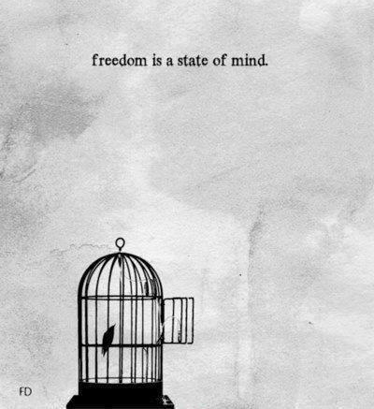

Day 2: Imagery of Freedom
English Language Arts

What is this lesson about? Today you will continue to think about the theme of “Freedom”. Read 2 poems, think about the language the poets use to create images in our minds about freedom and captivity.
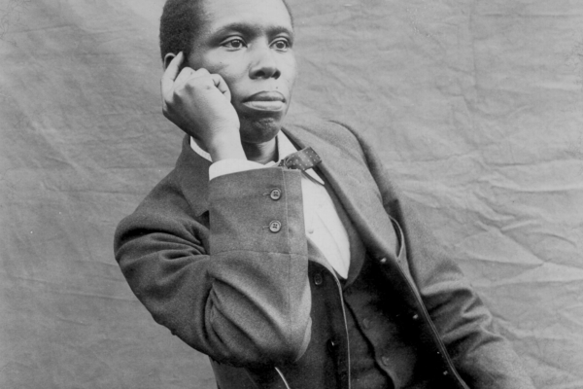
Step 2: Before you read
Paul Laurence Dunbar was one of the first African American poets to gain national recognition. Born on June 27, 1872, he was born to freed slaves from Kentucky. His parents separated shortly after his birth, but Dunbar would draw on their stories of plantation life throughout his writing career. By the age of fourteen, Dunbar had poems published in the Dayton Herald. While in high school he edited the Dayton Tattler, a short-lived black newspaper published by classmate Orville Wright.

Despite being a fine student, Dunbar was financially unable to attend college and took a job as an elevator operator. In 1893, Dunbar moved to Chicago, befriended Frederick Douglass, who found him a job as a clerk, and also arranged for him to read a selection of his poems. By 1895, Dunbar’s poems began appearing in major national newspapers and magazines, such as The New York Times. This recognition helped Dunbar gain national and international acclaim. In 1898, Dunbar’s health deteriorated; he believed the dust in the library contributed to his tuberculosis and left his job to dedicate himself full time to writing and giving readings. Over the next five years, he would produce three more novels and three short story collections. Dunbar separated from his wife in 1902, and shortly thereafter he suffered a nervous breakdown and a bout of pneumonia. Although ill, Dunbar continued to write poems. Dunbar’s steadily deteriorating health caused him to return to his mother’s home in Dayton, Ohio, where he died on February 9, 1906, at the age of thirty-three.

Some vocabulary to review:
alas: an expression of concern or sadness | upland slope: hilly land | fling: to throw
opes: opens | chalice: large cup--usually for drinking wine | perch: thing on which a bird lands or rests
bough: branch | keen: sharp | bosom: chest
carol: religious song | fain: happy

Step 2: Read and annotate the following poem
As you read, go through and underline verbs or action words of the caged bird For example: the caged bird feels.

 | Sympathy  Paul Laurence Dunbar | Notes
1 | I know what the caged bird feels, alas!  When the sun is bright on the upland slopes;  When the wind stirs soft through the springing grass,  And the river flows like a stream of glass;  When the first bird sings and the first bud opes,  And the faint perfume from its chalice steals—  I know what the caged bird feels!
2 | I know why the caged bird beats his wing  Till its blood is red on the cruel bars;  For he must fly back to his perch and cling  When he fain would be on the bough a-swing;  And a pain still throbs in the old, old scars  And they pulse again with a keener sting—  I know why he beats his wing!
3 | I know why the caged bird sings, ah me,  When his wing is bruised and his bosom sore,—  When he beats his bars and he would be free;  It is not a carol of joy or glee,  But a prayer that he sends from his heart’s deep core,  But a plea, that upward to Heaven he flings—  I know why the caged bird sings!

Step 3: Answer the following questions
- Read the first stanza again. How does Dunbar describe the world outside of the cage?

- Read the second stanza. What is the caged bird doing? Is this the first time the bird has done this? How do you know?

- Reread stanza 3. Why does the caged bird sing?

- Why does Paul Laurence Dunbar start and end each stanza with “I know…” What is he communicating to the reader?

Step 4: Share your answers with a partner
Discuss your answers with someone else in your group.
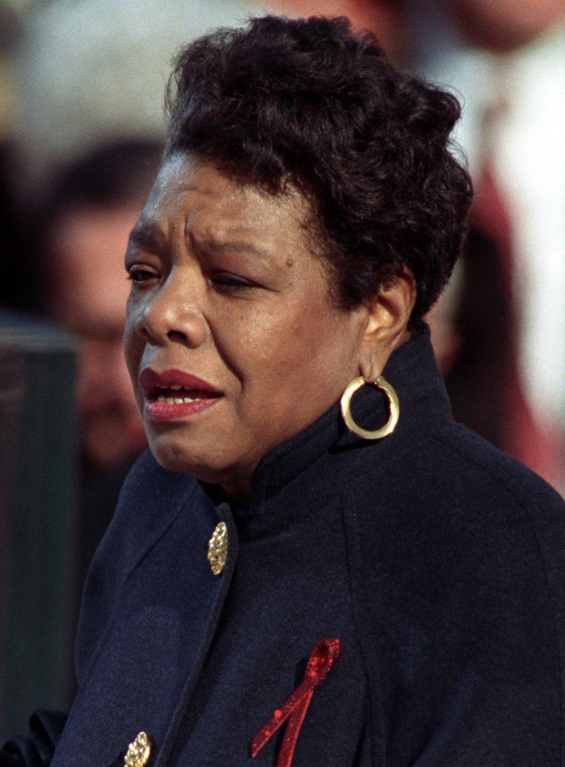
Step 5: Read and annotate the following poem.

Maya Angelou was born Marguerite Johnson in St. Louis, Missouri, on April 4, 1928. She grew up in St. Louis and Stamps, Arkansas. She was an author, poet, historian, songwriter, playwright, dancer, stage and screen producer, director, performer, singer, and civil rights activist. She was best known for her seven autobiographical books and her volumes of poetry. In 1959, at the request of Dr. Martin Luther King Jr., Angelou became the northern coordinator for the Southern Christian Leadership Conference. In 1974, she was appointed by Gerald Ford to the Bicentennial Commission and later by Jimmy Carter to the Commission for International Woman of the Year. She accepted a lifetime appointment in 1982 as Reynolds Professor of American Studies at Wake Forest University in Winston-Salem, North Carolina. In 1993, Angelou wrote and delivered a poem, "On The Pulse of the Morning," at the inauguration for President Bill Clinton at his request. In 2000, she received the National Medal of Arts, and in 2010 she was awarded the Presidential Medal of Freedom by President Barack Obama. The first black woman director in Hollywood, Angelou wrote, produced, directed, and starred in productions for stage, film, and television.She also wrote and produced several prize-winning documentaries. Angelou died on May 28, 2014, in Winston-Salem, North Carolina. She was eighty-six.

As you read, make sure to underline the verbs/action words of the FREE BIRD in the poem.

 | Caged Bird  Maya Angelou | Notes:
1 | A free bird leaps  on the back of the wind  and floats downstream  till the current ends  and dips his wing  in the orange sun rays  and dares to claim the sky.
2 | But a bird that stalks  down his narrow cage  can seldom see through  his bars of rage  his wings are clipped and  his feet are tied  so he opens his throat to sing.
3 | The caged bird sings  with a fearful trill  of things unknown  but longed for still  and his tune is heard  on the distant hill  for the caged bird  sings of freedom
4 | The free bird thinks of another breeze  and the trade winds soft through the sighing trees  and the fat worms waiting on a dawn bright lawn  and he names the sky his own
5 | But a caged bird stands on the grave of dreams  his shadow shouts on a nightmare scream  his wings are clipped and his feet are tied  so he opens his throat to sing.
6 | The caged bird sings  with a fearful trill  of things unknown  but longed for still  and his tune is heard  on the distant hill  for the caged bird  sings of freedom.

Step 6: Answer the Following Questions

- What is Angelou describing in the first stanza? What imagery (descriptive language) does she use to describe the caged bird?

- Re-read Stanza 2. How is the bird in the cage different--both physically and emotionally?

- How does the caged bird sing? What does he sing about?

- At the end of stanzas 1 and 4, Angelou describes the free bird by saying he “dares to claim the sky” and “names the sky his own”. What do these actions say about the free bird?

- In addition to being in a cage, what else keeps the caged bird from being free?

- Draw out the image of the caged bird vs. the free bird in Angelou’s poem.

- Think back to BOTH poems. What is the metaphor (a metaphor is a symbolic comparison) that they both use in their poem? What does it symbolize?

- Why is the caged bird a strong symbol for what they are trying to say?

Step 7: Complete the graphic organizer
Look back at the two poems and think about how both use vivid imagery (descriptive words) to help the reader create a picture in their minds of both the free bird and the caged bird. Pick out the verbs that you underlined for the free bird and for the caged bird. Create some word art. (see example below) and fill the graphic organizer on the next page with the word art that describes each bird.

Examples of Word Art:
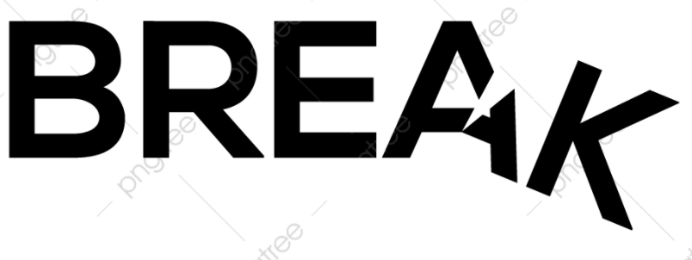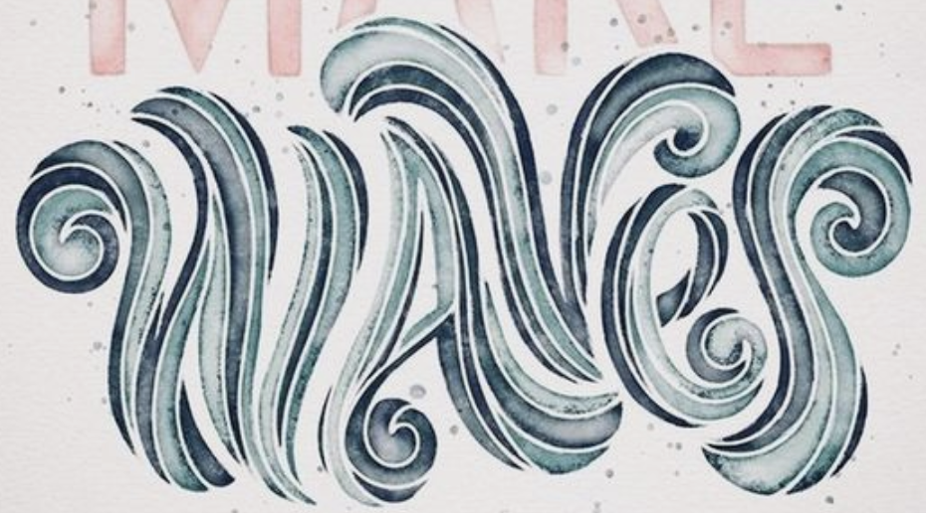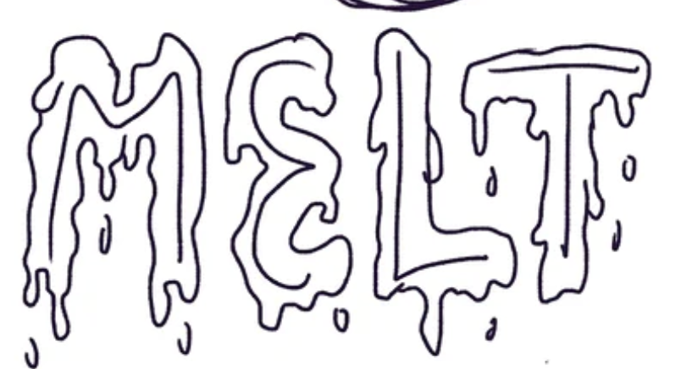

Free Bird | Caged Bird

Student Feedback:
Circle the emojis that best represents how this activity made you feel. | 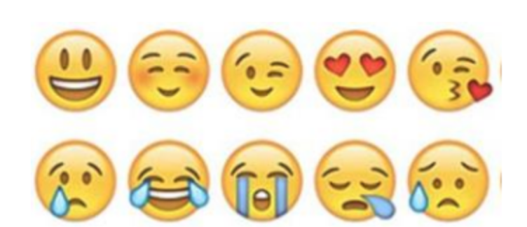  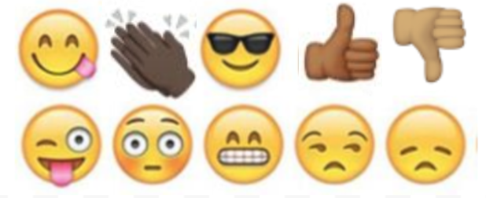

Day 2: Defending Freedom in the Time of Coronavirus
Science

What is this lesson about?: Today you will read through the Defending Freedom in the Time of Coronavirus passage. You will answer a few questions about what you read. You will complete an activity.

Step 1: Read through the Defending Freedom in the Time of Coronavirus passage

(Waterhouse, 2020)

The world is in the grip of a pandemic. Leaders everywhere are racing to gain clarity and develop solutions. Governments are reacting in different ways, but a common thread that’s emerging is a trend toward greater surveillance and restrictions on movement.

The overwhelming goal is averting deaths in the short term -- we don’t have time to worry about long-term consequences. The secondary goal -- as evidenced by the U.S. Congress, which is normally a poster child for partisan dysfunction, passing a unanimous $2 trillion rescue plan in a matter of days -- is to avert the death of the world economy. There is little room for thinking about anything else.

All of this is understandable, unavoidable, needed. But when the dust settles from this emergency and we are able to take stock in the cold light of day, we may find that measures meant to avert disaster have left us permanently less free. We must be vigilant to keep this from happening.

Disasters introduce instability, uncertainty, and fear -- a powerful impulse that can hold people back, even from doing things that are in their best interests. Crises also tend to require large-scale, coordinated responses that can only be mustered by central governments. In many cases, this leads to a permanent expansion of a government’s power over its citizens, at the expense of civil liberties.
Repressive regimes have long turned to “national emergencies” to claim broad powers over their people. Egypt, for example, has been in a declared state of emergency since 1967, with the exception of a roughly five-year period following the overthrow of President Hosni Mubarak in 2012. During that time, opposition parties have been banned, elections canceled, media censored, and people jailed indefinitely without charge. This playbook has been followed in many countries, from China to Venezuela to Pakistan and beyond.

But the use of national emergencies -- real or imagined -- to tighten restrictions on freedom is not limited to the world’s dictatorships. In the United States, governments have a long history of curtailing rights in reaction to crises. Abraham Lincoln famously suspended habeas corpus during the Civil War. President Franklin Roosevelt interned approximately 120,000 Japanese Americans during the Second World War.

These breaches of liberty were ultimately reversed -- though not without permanent damage. In recent decades, though, the shrinking of rights has tended to be permanent. After the 9/11 attacks, Congress passed the USA Patriot Act, which allowed for the indefinite detention of immigrants, expanded federal agencies’ ability to wiretap citizens, and granted the same agencies broadened access to business and personal records. The act has been used to monitor Americans’ online activity, wiretap them, and collect records of all phone calls placed, regardless of reasonable suspicion or possession of a warrant.

Nearly two decades after 9/11 and nine years after the death of Osama Bin Laden, the Patriot Act remains in force.

There is every reason to believe the safety-in-exchange-for-freedom bargain will expand in the wake of the coronavirus pandemic. Already, many are praising China’s authoritarian response, which for the moment appears to have stanched the spread of the disease. Some in the West are arguing that democratic governments must adopt these sorts of severe restrictions on individual behavior, which include widespread surveillance, police checkpoints, and coercive measures including “snitch lines.”

Will coronavirus kill the freedom to move?
The coronavirus also has the potential to change forever the way the world handles human movement, which has traditionally been regarded as a core freedom alongside speech and protest. Freedom of movement is one of the nonnegotiable requirements for EU (European Union) membership, and it is guaranteed within the United States by the Federal Government. But it is under stress. Looking to China’s apparent success in combating the virus through strict lockdowns, European nations have closed their borders to one another. It’s an open question when, and to what degree, they will reopen.

Even in the United States, free movement no longer seems so certain. The island state of Hawaii has imposed a 14-day quarantine on anyone arriving from anywhere, including elsewhere in the U.S., and the governor of Puerto Rico asked the FAA to suspend flights to the territory. Even on the mainland, the governor of Rhode Island announced the state police would pull over every car with New York license plates.

The most recent statistics suggest many people in the United States are still failing to take the crisis seriously. This may present novel challenges as parts of the world now locked down emerge to restart their economies. How can they do so while other regions within the same country, having failed to socially distance, are experiencing the “peak of the curve”? Will we see travel restricted based on residence and health status -- will people be required to carry “immunity passports”? Recent news out of the UK suggests the answer is yes.

The future is up to us
The choice between freedom and safety is a false one. Right now, we are all blinded by the fog of war -- the war against this virus. Those of us who cherish freedom must do everything in our power to overcome the current pandemic without inadvertently surrendering our liberty. This will require us to pursue two goals simultaneously. First, we must overcome this pathogen. But in doing so, we must be careful not to abandon our most deeply held principles.

Step 2: Answer the following questions

- How is the Coronavirus impacting our freedom?

- What parts of your freedom do you believe you still have or you need to be successful in life?

- Do you think people can be both safe from the Coronavirus and free? Why or why not?

Step 3: Draw an image/picture

An attempt to keep people safe from the Coronavirus is causing people’s freedoms to be limited. Draw an image that shows what you would have in place that can help keep people safe while also allowing people to be free. Explain your drawing.

________________________________________________________________________________________________________________________________________________________________________________________________________________________________________________________________________________________________________________________

Student Feedback:
Circle the emojis that best represents how this activity made you feel.

Mindfulness Moment!

There is no one better to be than myself because…

Day 2: Freedom/Fractions
Math
What is this lesson about?: Today you will learn more about fractions.

Warm Up and Review Problems:
In the early 1900s, many African Americans migrated from the south to the north, midwest and even the west coast. Most did this to escape the difficult economic challenges of sharecropping and the dangerous and unsafe living conditions imposed under Jim Crow laws and its pervasive violence. The trec to Chicago, Philadelphia or New York was risky, but offered hope of a more real ‘freedom.”

Consider this example:
Ronald, his wife and two children, Robert and Joe, worked as sharecroppers until the early 1900s. In 1910, Joe, now 30 years old, left the family farm to head to Chicago. He wanted to move away from the only life he had known, living and working on a small farm in Orangeburg, SC. With some modest savings and the support of his family he boarded a train for Chicago. Upon arrival, he was met by an aunt, who helped him find a room in a boarding house and a job working in a meat packing plant. Use the information below to answer some questions about Joe.

Joe rented a room in a boarding house. He paid a little extra to get a hot breakfast and dinner each day, and to get a packed lunch he could take to work. Use the chart below to answer some questions about Joe’s first few months in Chicago.

Expenses-
Monthly’: $90/month ($3/night)
Monthly food from house mom: $60/month ($2/day)
Bus fare to/from work $10/month ($0.50/day round trip on bus)
Weekend ‘fun and food’ $40/month ($10/weekend--movie, dinner, date…)

Wages/Earnings-
Hours worked per week: 40
Wages per hour $1.50/hour
# of days/month worked 20 days per month-

At the end of a month, how much money did Joe spend?
How much did he earn each month?
So, after he paid all of his bills, how much money did Joe have left over at the end of the month?
Joe tried to send his mom and dad $10 each month. Would he have enough money to do that?

He also wanted to save $20 each month so that he could save up money to move into his own apartment in a couple of years. He needed to save up about $300 to put down a security deposit and get some furniture, etc. How many months would it take him to save up to get his own apartment?

What percent (remember from last lessons) of his total monthly wages went to pay for his room and food?
Joe could work one Saturday per month for 8 hours and earn overtime. He would get an extra $0.50 per hour for this. How much would he earn for working an overtime Saturday?

Activities/Fraction Problems: Complete the following fractions worksheets

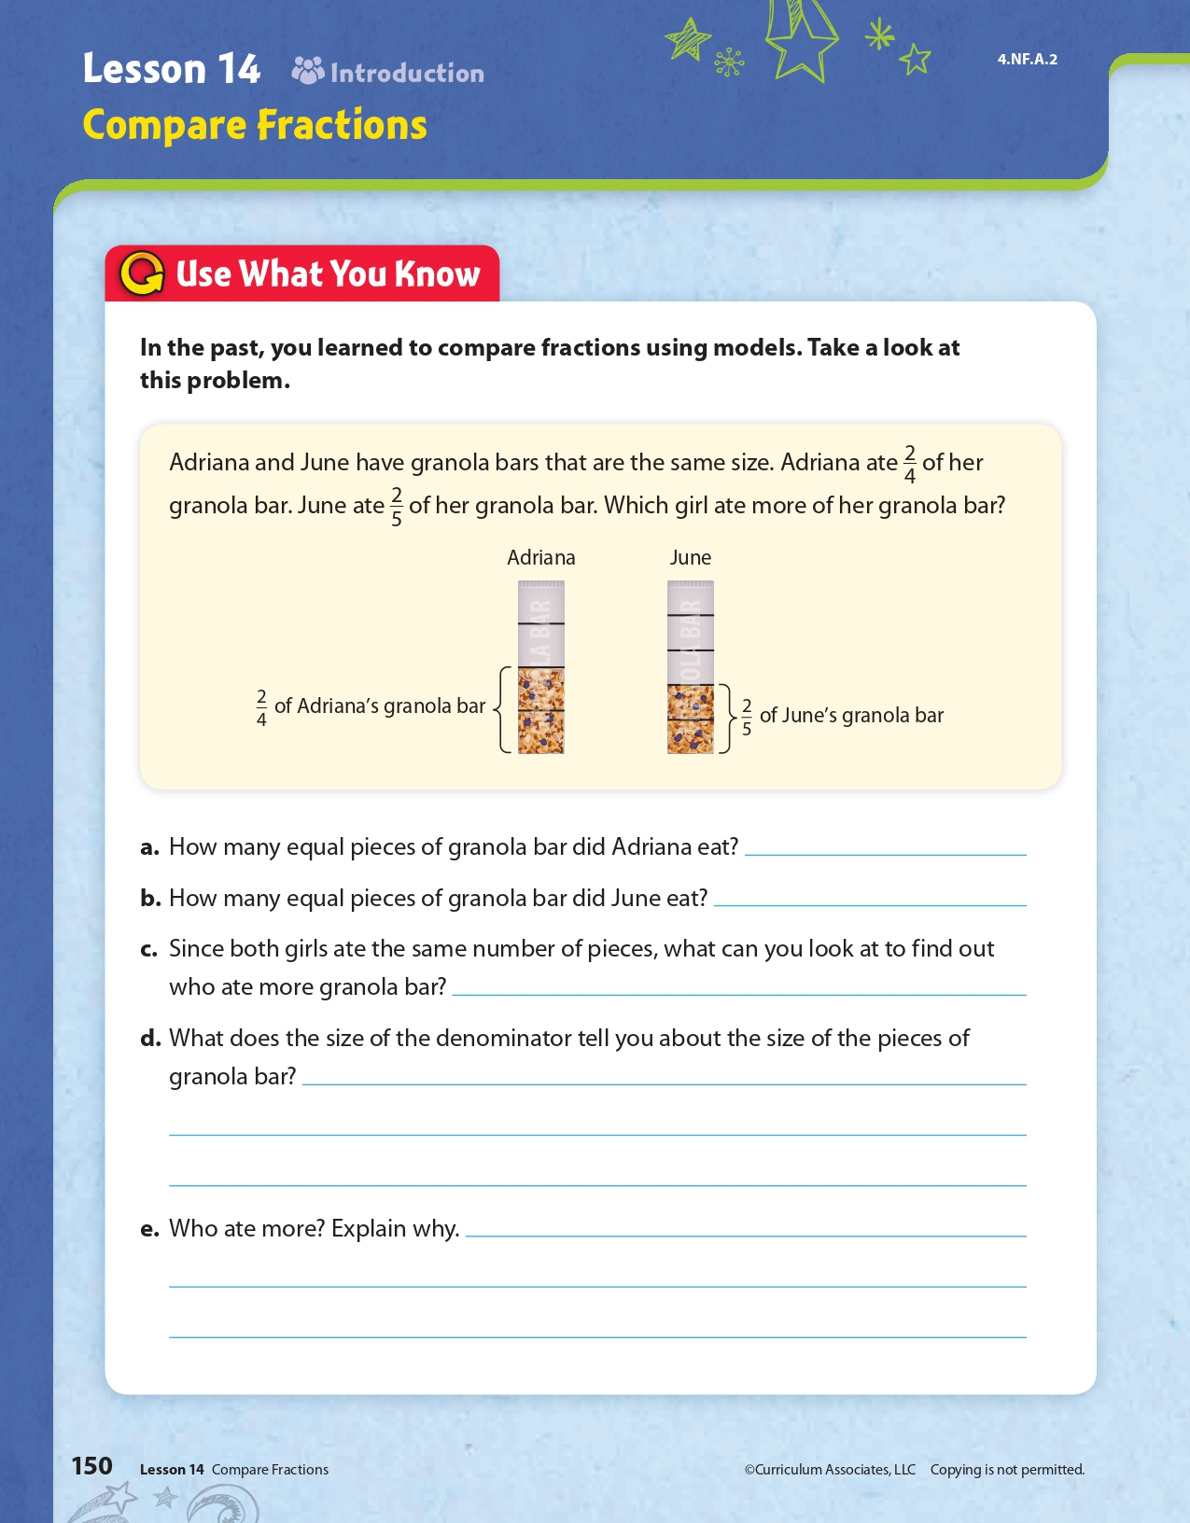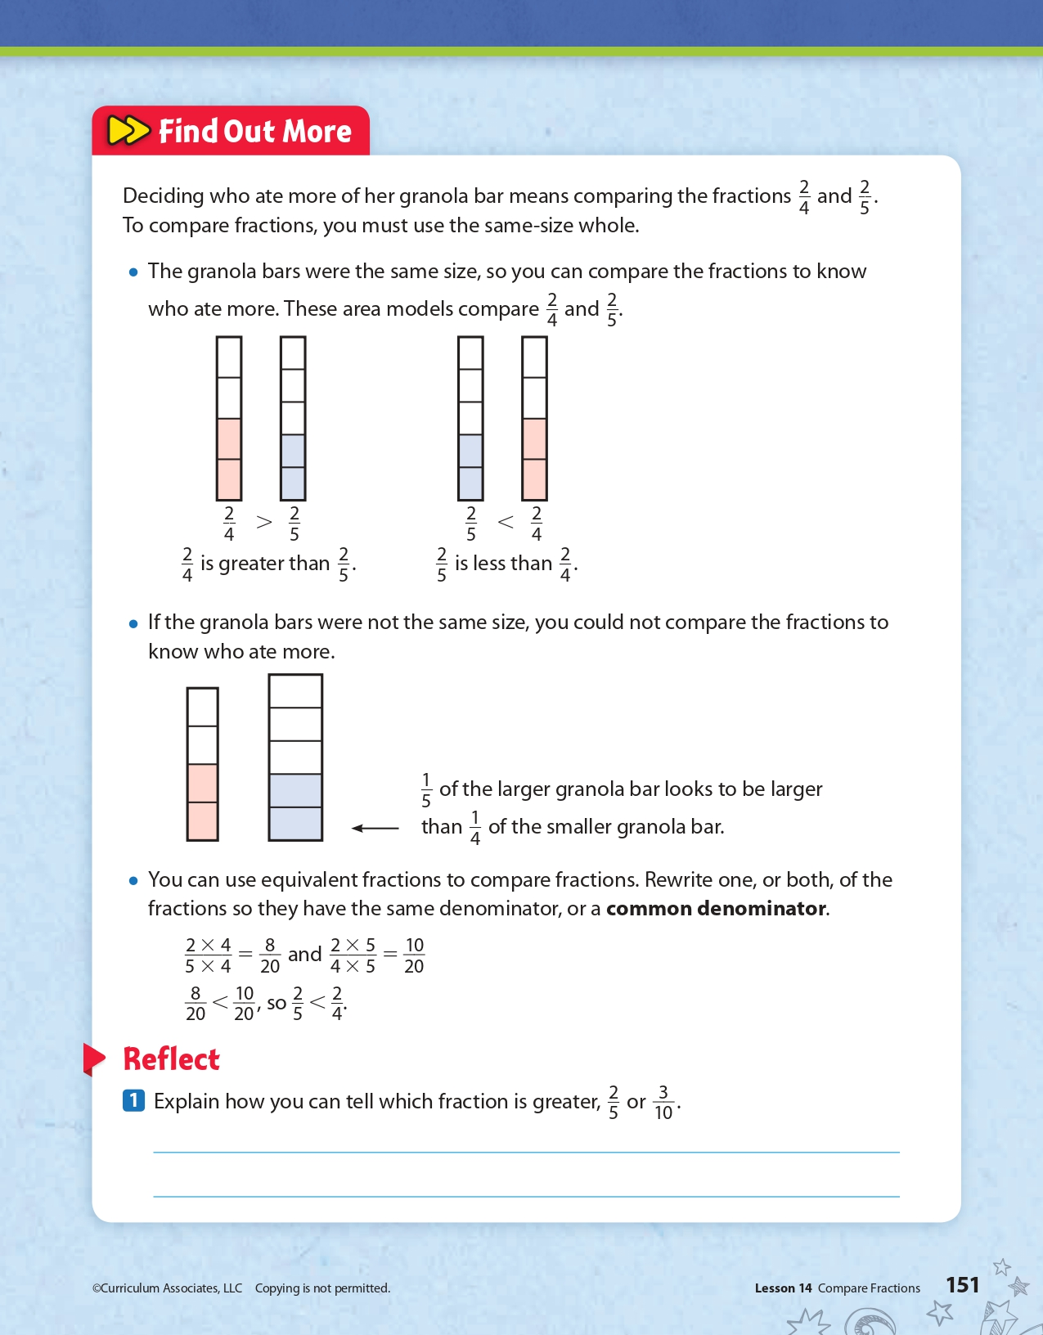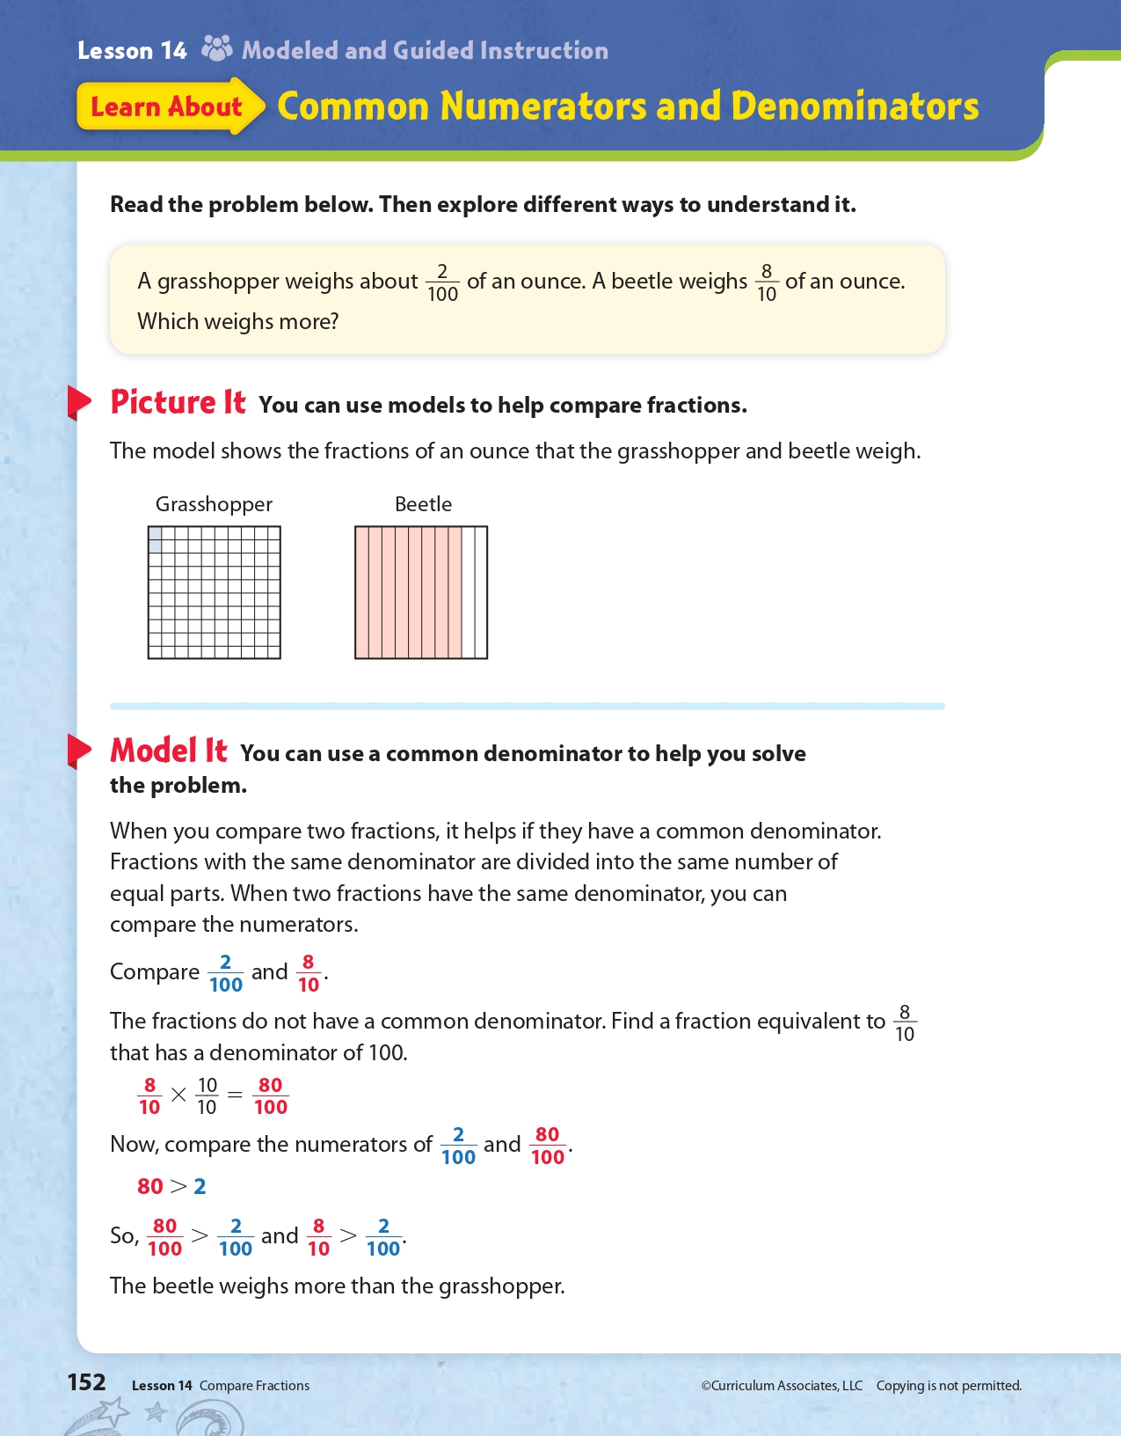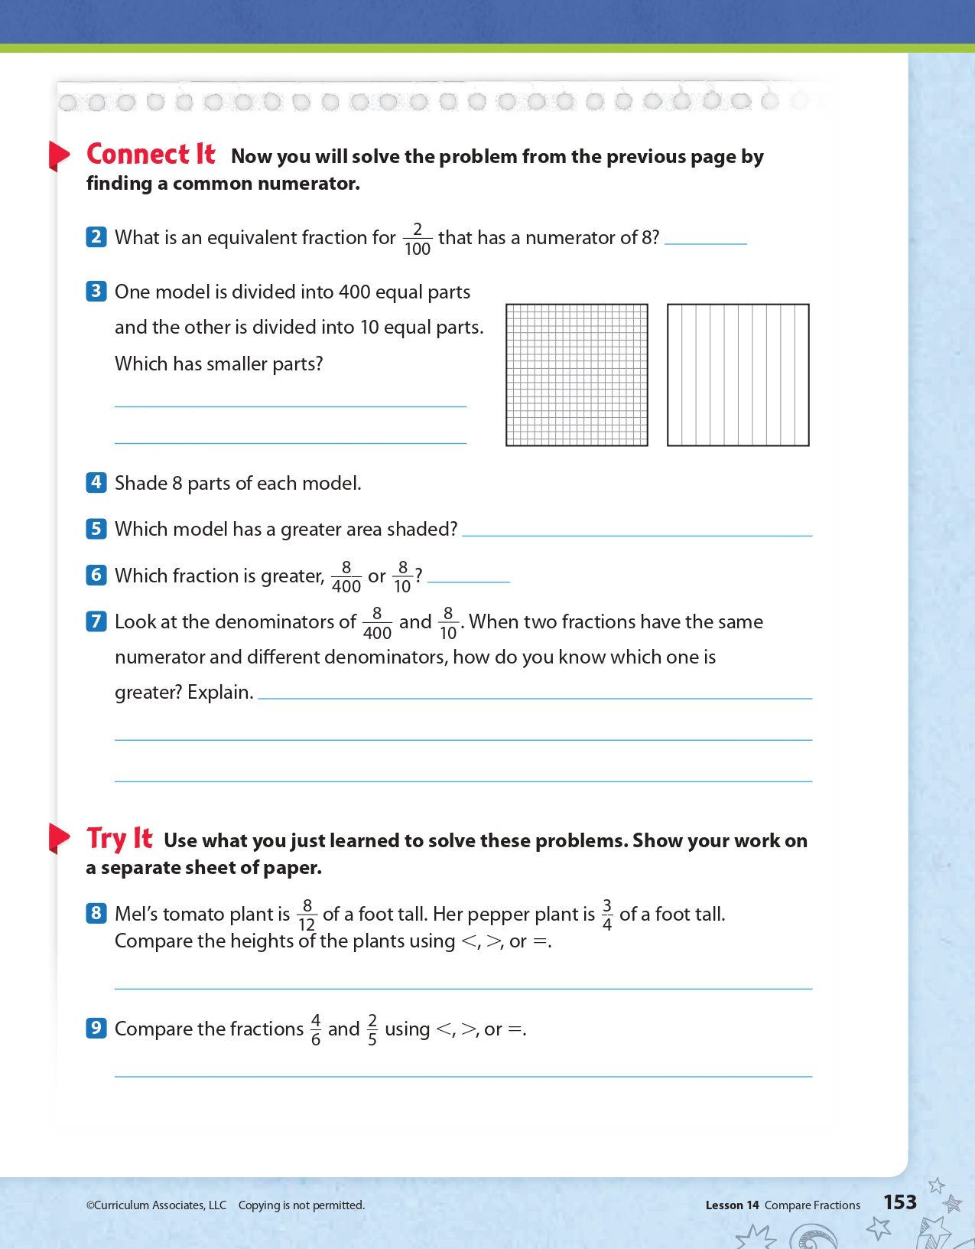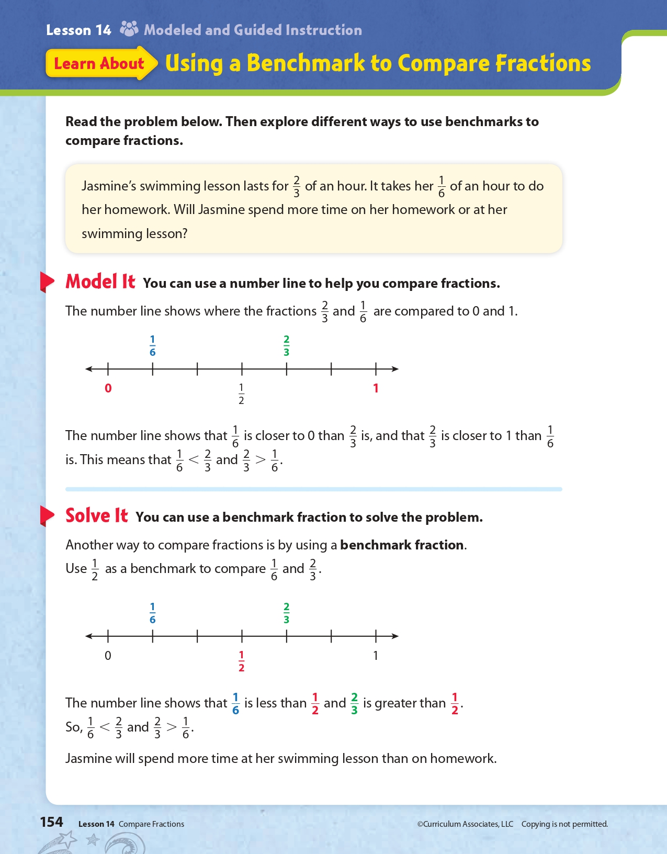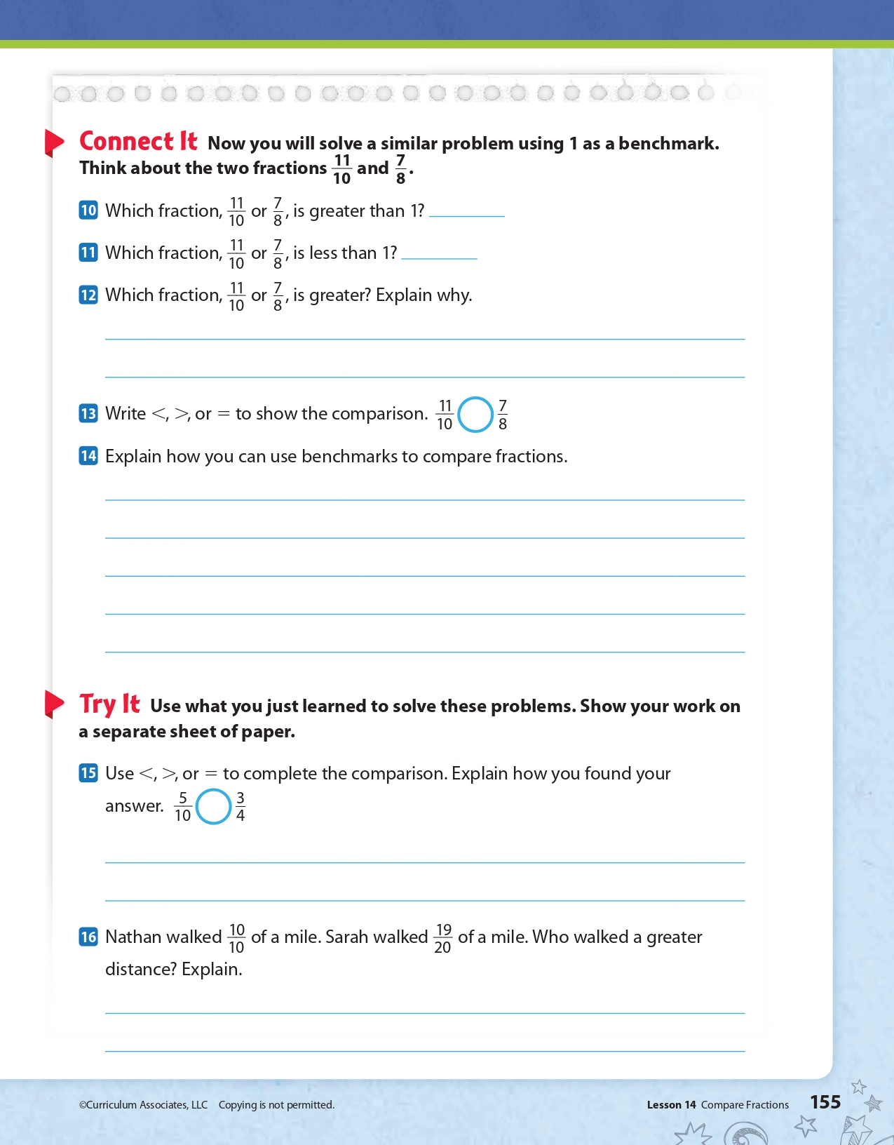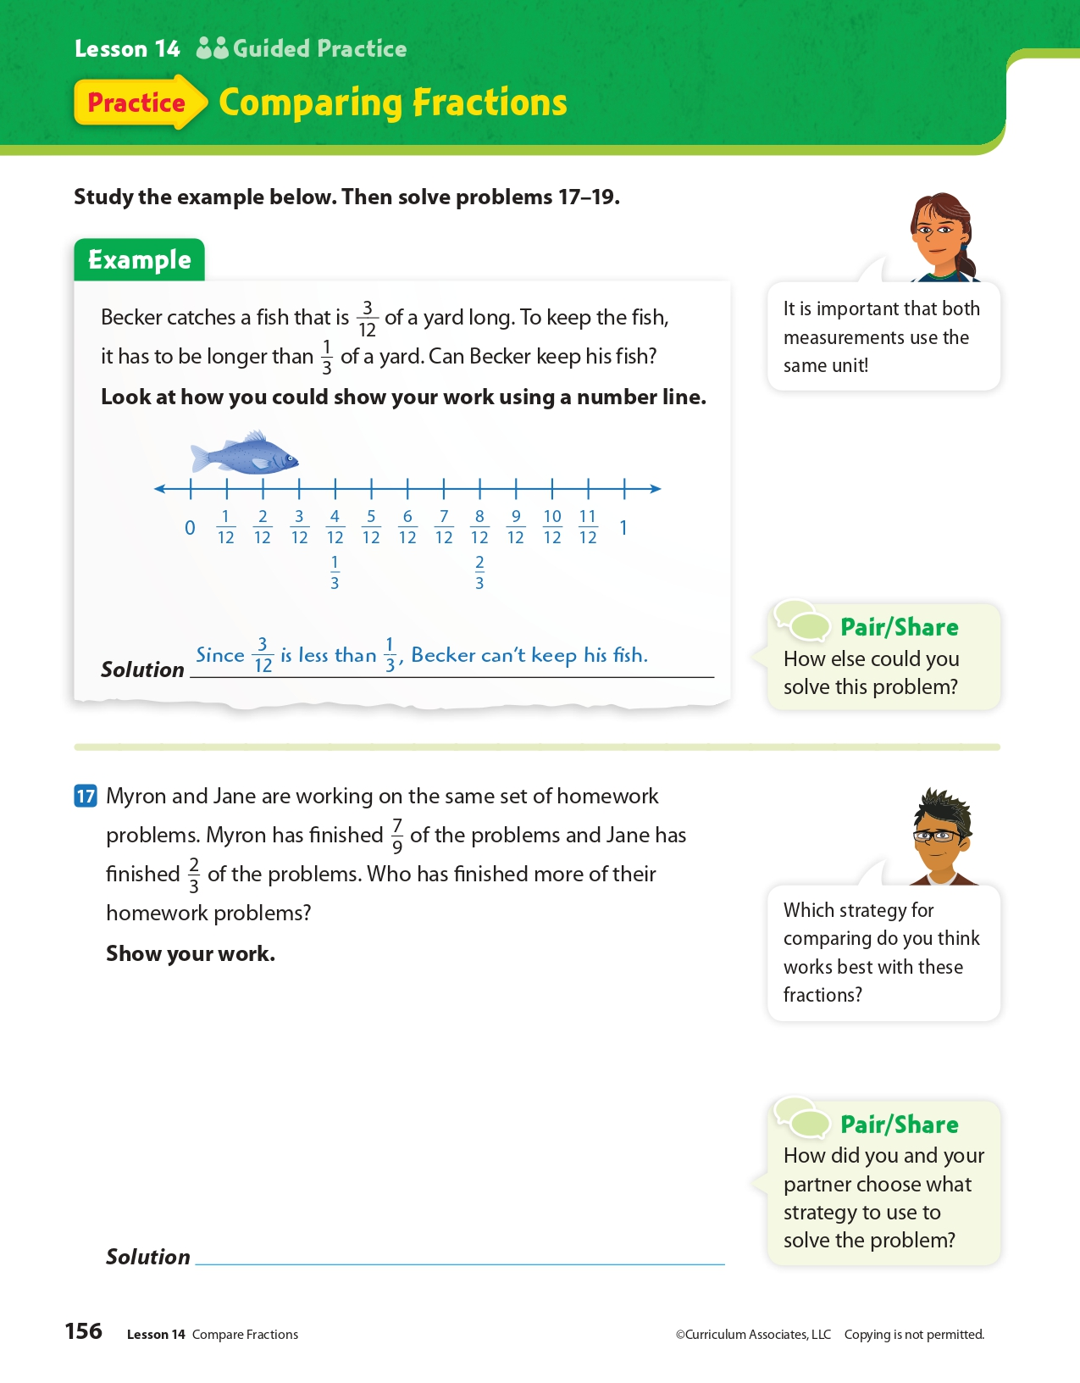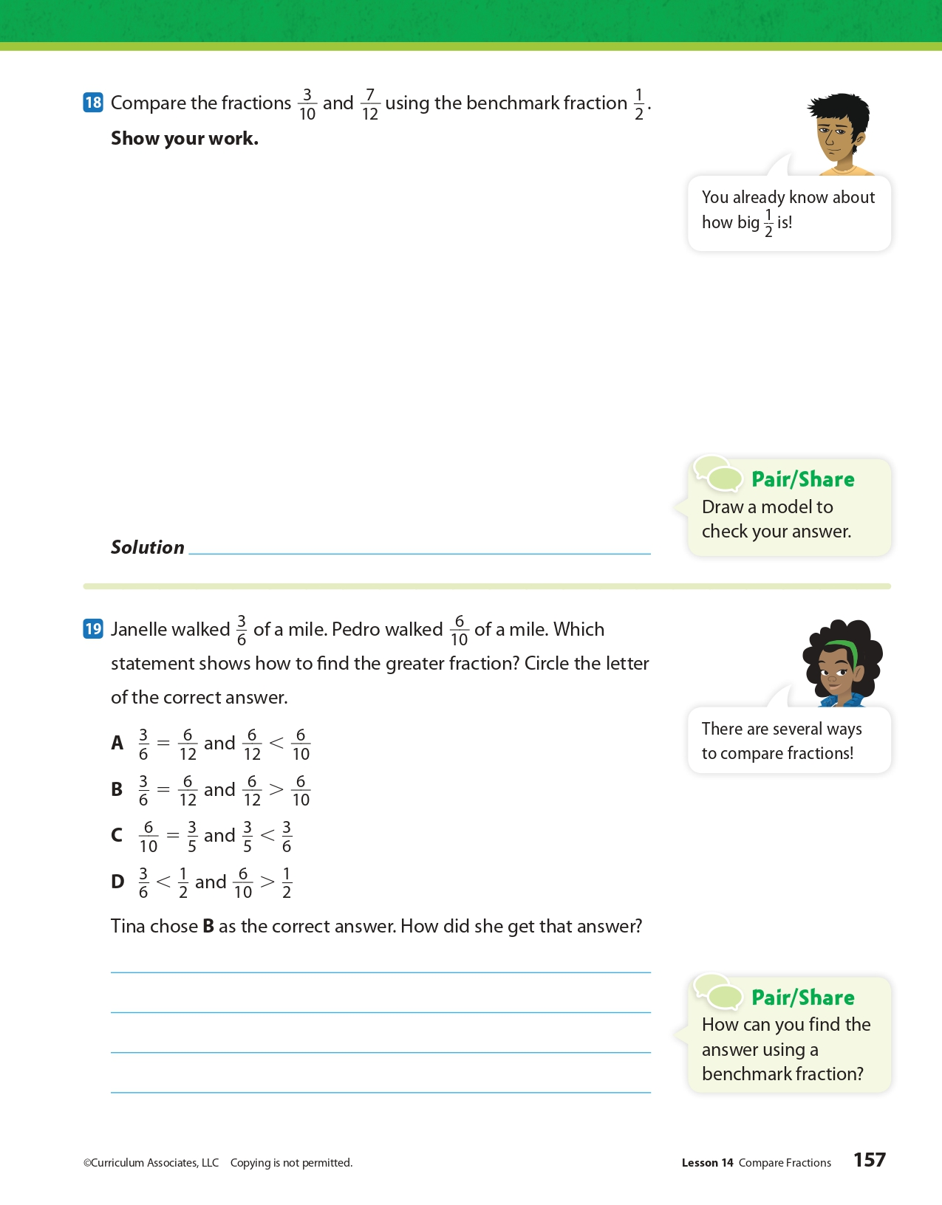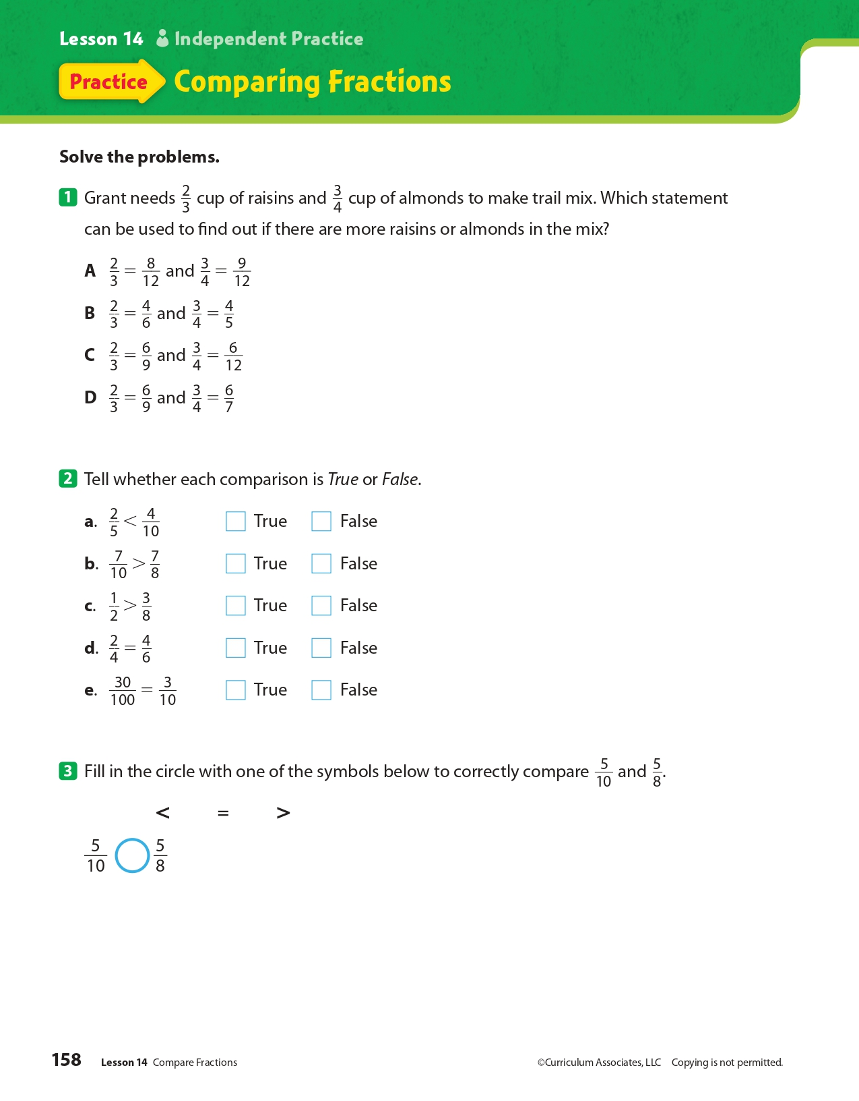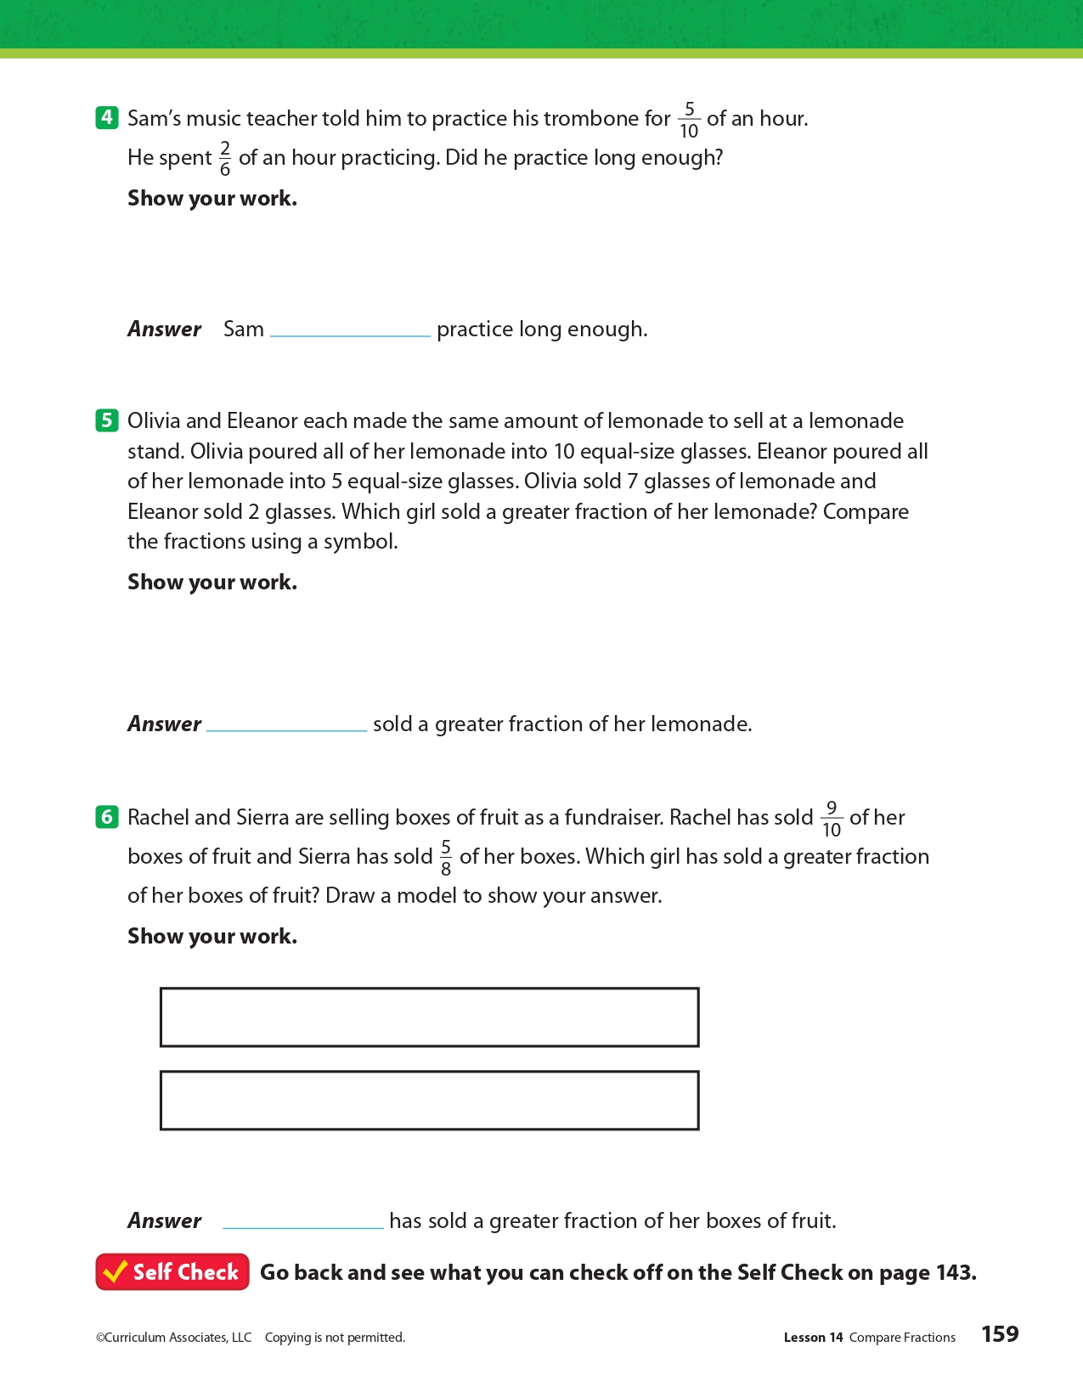
Day 2: PE
Health

What is this lesson about?: In today’s lesson, you will work on your PE BINGO card.

Step 1: Try to complete the PE BINGO card.

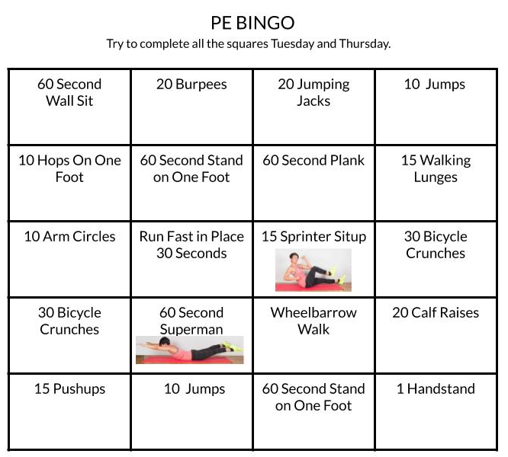

Student Feedback:
Circle the emojis that best represents how this activity made you feel.
Mindfulness Moment!

One of my favorite inventions of all time is...

Day 2: Evolution of Religious Liberty in Post-Revolutionary America
Social Studies

What is this lesson about?: Today you will explore how religious liberty and freedom evolved in America. After the Revolutionary War, the founders wanted to establish a separation of church and state.

Step 1: Warm-up on religious liberty

In France, girls are banned from wearing headscarves in school. In the one year since the law was implemented, 626 girls have arrived to school wearing a Muslim headscarf (compared with 1,465 in the prior year). Of the 626, 496 agreed to remove them when summoned for a talk with the headteacher. 45 of the girls refused and were expelled. What do you think?

Step 2: Read the passage

Background: Early movement towards religious liberty and separation of church and state
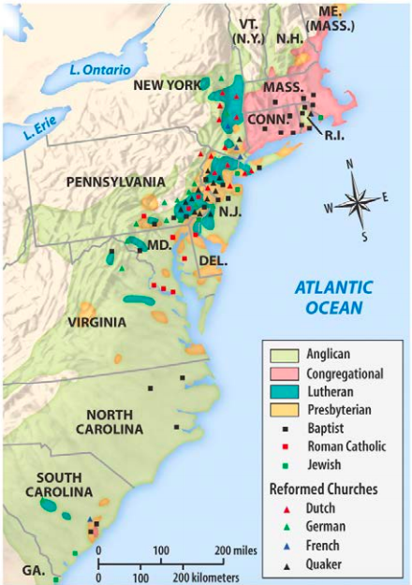
The Massachusetts Bay Colony was founded by a group called the Puritans in 1630. They were fleeing persecution themselves and came on a mission to live and practice religion as they pleased. The Puritans of the Massachusetts Bay Colony established what was essentially a theocracy, a government-controlled by religious leaders. Voting was limited to church members. Leaders did not accept those of other faiths, particularly Quakers and Anabaptists, whom they drove out.
One exile from the Massachusetts Bay Colony was Roger Williams, who founded the colony of Rhode Island in 1636. Williams believed the government should not interfere in religion. He put his beliefs into practice, and Rhode Island became a safe haven for Quakers, Jews and other non-Puritans. Later that century, a Quaker named William Penn founded the colony of Pennsylvania. The colony's law code guaranteed freedom of religion. As a result, Pennsylvania attracted Quakers, Jews, Huguenots, Mennonites, Amish and Lutherans.
The rest of the colonies (and eventually states) were a mixture of religions and levels of religious tolerance. Some, including Virginia, had state-supported churches. (see map of religions in colonies in 1750)

Free Exercise of Religion in Virginia
As Virginia’s governor in 1779, Thomas Jefferson drafted a bill that would guarantee the religious freedoms of Virginians of all faiths—including those with no faith—but the bill did not pass into law right away. The Virginia Statute for Religious Freedom was one of the most important documents in early U.S. religious history. It marked the end of a ten-year struggle for the separation of church and state in Virginia, and it was the driving force behind the religious clauses of the First Amendment of the U.S. Constitution, ratified in 1791.

Statute was first attempt to remove government influence from religious affairs
Drafted by Thomas Jefferson in 1776 and accepted by the Virginia General Assembly in 1786, the bill was, as Jefferson explained, an attempt to provide religious freedom to “the Jew, the Gentile, the Christian, the Mahometan, the Hindoo, and [the] infidel of every denomination.” In effect, it was the first attempt in the new nation to remove the government’s influence from religious affairs.

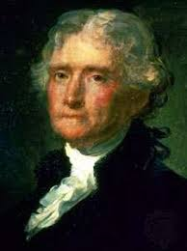
Jefferson created law to undo established churches in Virginia

When the bill was first introduced during the legislative session in 1779, the Episcopal Church, which had just recently declared its independence from the Church of England, was the state-sponsored or established church in Virginia. Tax monies were used to support the church, and colonial laws compelled mandatory church attendance. Enlightenment thinkers such as Jefferson and James Madison had long opposed established churches, because they believed that religion was a natural right best protected without governmental coercion. Furthermore, they objected to the limited religious freedom available to other religious entities in Virginia—most notably Baptists, Quakers, and Presbyterians—although they confined their protest to a few friends during the early years of the American Revolution.

The situation changed, however, in 1779, as the war was winding down. That year, Jefferson’s bill was introduced in the Virginia General Assembly, but it was soon postponed. In response, in 1784 the fiery, headstrong Patrick Henry countered Jefferson’s bill with a bill of his own that called for a general assessment tax to support “Teachers of the Christian Religion.” Each taxpayer was allowed to choose what church or minister could receive his tax money. It was, then, a proposal to replace the Episcopal Church with “multiple establishments” of religion, creating a tight church-state network in Virginia that would use government dollars to support all Christian churches, not just Episcopalian Christianity.

With Jefferson in France serving as American minister during the 1780s, the task of opposing Henry’s bill fell to Madison, Jefferson’s close friend and collaborator. Madison proceeded to pursue successfully three goals, which led to the defeat of Henry’s bill and the passage of Jefferson’s. First, Madison secured an alliance with evangelical sects that were opposed to the assessment bill. Second, he supported Patrick Henry’s election to the governorship in 1784, thereby removing him from the legislature. And, third, he penned a finely crafted pamphlet called “Memorial and Remonstrance Against Religious Assessment,” opposing Henry’s bill, supporting Jefferson’s, and calling for a separation of church and state.

James Madison supported the bill in a pamphlet
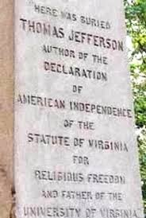
In the “Memorial,” Madison eloquently articulated the principles at stake: “Who does not see that the same authority which can establish Christianity, in exclusion of all other Religions, may establish with the same ease any particular sect of Christians, in exclusion of all other Sects? That same authority which can force a citizen to contribute three pence only of his property for the support of any one establishment, may force him to conform to any other establishment in all cases whatsoever.”

The pamphlet was an instant hit. It was widely circulated in Virginia, and it was signed by over two thousand Virginians, many of whom were Presbyterians and Baptists who thought Henry’s bill posed a threat to religious liberty in the Old Dominion.

The bill outlined why established religions were dangerous
In addition to the pamphlet, Madison guided Jefferson’s bill to passage; it was finally enacted on January 16, 1786. The new statute outlined in clear and coherent language why it was dangerous to have established religions in America. It is organized in three sections.

- The first section, the preamble, affirms “that Almighty God hath created the mind free” and that “to compel a man to furnish contributions of money for the propagation of opinions which he disbelieves and abhors is sinful and tyrannical.”
- The second section discusses the act itself, stating that “no man shall be compelled to frequent or support any religious worship, place or ministry...or otherwise suffer on account of his religious opinions or belief.”
- And the third section concludes by offering a warning to future Assemblies, declaring that repeal of the act would violate “the natural rights of mankind.”

Jefferson considered the bill to be among his greatest accomplishments. When he died in 1826, he instructed that his authorship of the bill be included on his tombstone along with his authorship of the Declaration of Independence and his founding of the University of Virginia.

The First Amendment
Madison would go on to draft the First Amendment, a part of the Bill of Rights that would provide constitutional protection for certain individual liberties including freedom of religion, freedom of speech and the press, and the rights to assemble and petition the government.

The First Amendment was adopted on December 15, 1791. It established a separation of church and state that prohibited the federal government from making any law “respecting an establishment of religion.” It also prohibits the government, in most cases, from interfering with a person’s religious beliefs or practices.

Step 3: Answer questions
How did Patrick Henry’s proposal for a General Assessment Tax provide funds for churches?

Do you think this type of tax law is fair? Why or why not?

Why did Jefferson and Madison oppose any government (state) support for religion?

Do you think keeping government (state) and religion separate makes society more tolerant or less tolerant? Why?

Step 4: Consider the First Amendment

The First Amendment provides:

“Congress shall make no law [1] respecting an establishment of religion or [2] prohibiting the free exercise thereof.”

These two clauses are referred to as the “establishment clause” and the “free exercise clause.” Both of these clauses have been applied to the states, and therefore operate against all levels of government in the United States. The free exercise clause protects the religious beliefs, and to a certain extent, the religious practices of all citizens. The more controversial establishment clause prohibits the government from endorsing, supporting, or becoming too involved in religion and religious activities.

Both clauses protect the same values, and often a violation of one would also be a violation of the other. For example, mandatory prayer in schools would constitute an improper establishment of religion and would also interfere with the free exercise rights of those students who did not believe in that particular prayer or prayer in general.

Step 5: First Amendment practice scenarios

Scenario 1
After a vote by the school district, North High School begins broadcasting a nondenominational Christian prayer over the loudspeaker each morning after the Pledge of Allegiance. Some of the prayers specifically talk about Jesus Christ. Students are told that they may sit or stand during the prayer, as they wish. Those giving the prayers include school administrators, teachers, volunteering students and local Christian clergy. Parents of Jewish, Muslim and Sikh studentsprotest against the practice. They say their students are being forced to hear prayers that do not reflect their faiths, and that the practice is an unconstitutional violation of the First Amendment right to religious freedom.

What do you think? How would you respond?

Scenario 2
Administrators at South High School, fearful of complaints and lawsuits stemming from mentions of religion in public school, declare that any expression of religious belief or faith on school grounds is forbidden. Students who have been gathering each morning to pray before school are told they may no longer do so or risk suspension. Students also may not pray alone, silently or otherwise, or discuss their faith with others on campus. Bibles, Korans and other religious texts are barred from classrooms. A group of parents of several faiths object to the new policy, saying it is an unconstitutional restriction of religious freedom under the First Amendment.

What do you think? How would you respond?

Step 6: What the law says

Read the paragraphs below to understand the laws that pertain to the two situations.

Scenario 1: Under the “establishment” clause of the First Amendment, and in line with U.S. Supreme Court rulings, public schools may not impose prayer or other religious practices on students, even if students are not required to participate. The first religion clause says government and its agencies are prohibited from establishing or requiring religion, including official attempts to impose or instill beliefs in students. This prohibition prevents government from setting up a national religion, and from favoring one religion over another. Therefore, prayers may not be broadcast over the school public-address system.

Scenario 2: Under the “free exercise” clause of the First Amendment, and in line with U.S. Supreme Court rulings, public schools may not prevent students from expressing or sharing religious beliefs, as long as their doing so does not disrupt the school. The second religion clause says government and its agencies may not forbid or interfere with individuals’ practice of religion. Public school students therefore may pray, alone or in groups, silently or aloud, as long as classes and non-participating students are not disturbed. Students may bring religious texts to school and read and discuss them.

How did your answers compare to the explanation of the laws above?

Student Feedback:
Circle the emojis that best represents how this activity made you feel.

