Week 5
Power

Day 5

NAME:______________________
Day 5 Agenda

Topic | Activity
Warm-Up!
English Language Arts | - Read the article: 3 Times in History When Students Turned to Activism  - Respond to questions about the article.  - Create a call to action and hashtags to address an issue in their community, nation or world.
Science | - Review the sources of Renewable Energy  - Design a Power Source project - make one of the current renewable energy sources better or design your own renewable energy/power source (BE CREATIVE)
Mindfulness Moment!
Math | - Power: Sports Stars and Power
Health | - Review of power in relationships
Mindfulness Moment!
Civics/Social Studies | - Consider types of governmental powers  - Determine the best type of government

Warm-up Activity: Write a journal entry around the daily quote on identity.
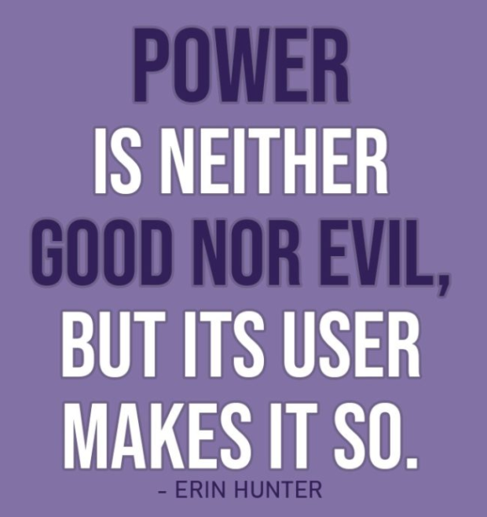

Day 5: Calls to Action—Harnessing the Power of a Movement
English Language Arts

What is this lesson about? Today you will read about how young people have worked to fight against power and have claimed their own power to have a voice in making change. As you read, think about the strategies that these young people used to address issues of power.

Before you Read: Vocabulary to Review
rote: habitual repetition | lobbied: to seek to influence a politician on an issue | incongruity: a difference or inconsistency
albeit: even though | coalesce: to come together | desegregate: to end a policy of racial in segregation
Apartheid: in South Africa a policy or system of laws that enforced segregation or discrimination on grounds of race. | divestment: the process of selling off or removing investments | dismantle: to take apart
laud: to celebrate | prevail: to be victorious

Step 1: Read the Article

3 Times in History When Students Turned to Activism
By Maggie Astor, March 5, 2018
(Article, 7 Times in History When Students Turned to Activism from The New York Times was edited and abridged for space and time constraints)

Every few weeks or months, after a man armed with a high-powered weapon walks into a school or a church or a nightclub and opens fire, the national response plays out in a rote, almost performative way. The outcry lasts only a few days before guns fade back into the background noise of American politics.

But nearly three weeks after a gunman walked into Marjory Stoneman Douglas High School in Parkland, Fla., and killed 17 people with an AR-15, the conversation has not faded, because the students of Stoneman Douglas have taken up the cause of gun control. Already, they have lobbied state lawmakers in Tallahassee, spoken with President Trump and persuaded many companies to cut ties with the National Rifle Association. And on Saturday, they met with students fighting gun violence in Chicago.

Several of those students, and their critics, have noted the incongruity of teenagers getting involved in politics. But history is full of movements led by students — albeit usually in college, not high school. Some were successful and others brutally crushed, but even the latter still resonate. (Most of these campaigns have been liberal-leaning: Though conservative college students have made their presence known, their actions have rarely coalesced into broader movements.)

Here are 3 (abridged) other cases where young people were moved to challenge adult society.
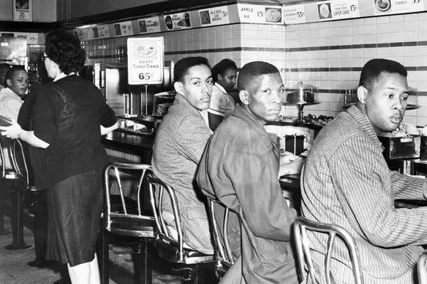
Greensboro Sit-ins, 1960
The lunch counter sit-ins that would change American history began with four teenagers who walked up to a Woolworth’s lunch counter in Greensboro, N.C., and refused to leave.
Those young men — Ezell Blair Jr., 18; Franklin McCain, 19; Joseph McNeil, 17; and David Richmond, 18, all students at North Carolina Agricultural and Technical State University — made their stand on Feb. 1, 1960. Within three days, they were joined by some 300 others. By summer, the sit-ins had spread to more than 50 cities, and lunch counters were rapidly desegregating.

The actions of the so-called Greensboro Four led directly to the creation of the Student Nonviolent Coordinating Committee, which the civil rights organizer Ella Baker urged students to form in April 1960 to coordinate the continuing sit-ins. Later, SNCC would play a major role in the Freedom Rides and in voter registration efforts across the South. And the momentum that began at the Woolworth’s lunch counter would eventually contribute to the passage of the Civil Rights Act of 1964, which outlawed segregation in public spaces.
Perhaps more than anything, the results of the Greensboro sit-ins showed the power of a small group of students prepared to stand alone if necessary.

“Inevitably, people ask me, ‘What can I do?’” Mr. McCain said in an interview in 2005. “What kind of question is that? Look around you. Once you identify what you want to do, don’t ask for the masses to help you, because they won’t come.”

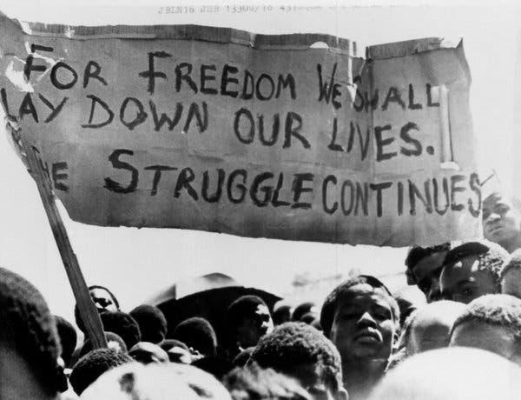
Apartheid Divestment, 1970s-80s
As with the Greensboro sit-ins 16 years earlier, the uprising started by public school students in Soweto, South Africa, would expand far beyond them.
On June 16, 1976, several thousand students near Johannesburg began a peaceful march that turned deadly when the police attacked with guns and tear gas. The protesters were objecting to a law that mandated Afrikaans-language education, but they set in motion a global movement against apartheid. Images of police brutality — particularly a photograph of a high school student carrying the body of Hector Pieterson (12 or 13 years old; accounts differ) — drew international attention to the broader cruelty of South Africa’s government.

From the actions of the students of Soweto grew a vast campaign led by college students in the United States, who built shantytowns on campus quads, blockaded buildings and disrupted speeches by South African politicians. From Columbia University to the University of California, protests compelled administrators to withdraw billions of dollars in investments from companies tied to South Africa. Over time, the resulting economic stress contributed, along with other factors, to the dismantling of apartheid.

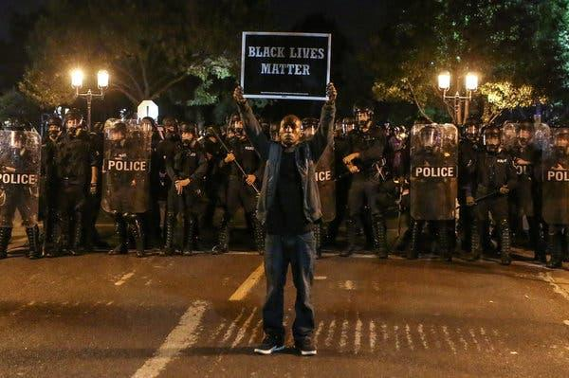
Black Lives Matter, 2013-present
The Black Lives Matter movement began with three women in their late 20s and early 30s: Patrisse Cullors, Alicia Garza and Opal Tometi. But when it exploded into national view in 2014 after the police killing of Michael Brown, 18, many of the protesters who filled the streets of Ferguson, Mo., were students.
Like the students of Parkland, they were protesting gun violence — but by the police, often involving unarmed black suspects, in shootings captured on video. Unlike the students of Parkland, they were not lauded in the prevailing public narrative, a discrepancy that some Black Lives Matter activists have noted in recent weeks. Instead, they were frequently labeled troublemakers and thugs.
But even as questionable police shootings happen, convictions of officers remain rare, and protests on the streets continue, Black Lives Matter has had a fundamental impact on the national conversation about racial bias and the use of excessive force by the police.

Step 2: Answer the following questions

- What were the young people in the Greensboro Sit-Ins protesting?

- Explain the quote by Franklin McCain of the Greensboro Sit-Ins when he says, “Once you identify what you want to do, don’t ask for the masses to help you, because they won’t come”

- What were college students able to pressure their schools to do that began to end the system of Apartheid in South Africa?

- How was the response to the Black Lives Matter movement different from the way that the public responded to the student protestors from Parkland, Florida?

Step 3: Create a Call to Action and Hashtag

As you have read and learned about this week, people have fought against and for power in many different ways, from dance and art to music and marching and protesting. In an article for WIRED Magazine, Bijan Stephan wrote about another tool that is being used to “Fight the Power” in this modern age.

“If you’re a civil rights activist in 2015 and you need to get some news out, your first move is to choose a platform. If you want to post a video of a protest or a violent arrest, you put it up on Vine, Instagram, or Periscope. If you want to avoid trolls or snooping authorities and you need to coordinate some kind of action, you might chat privately with other activists on GroupMe. If you want to rapidly mobilize a bunch of people you know and you don’t want the whole world clued in, you use SMS or WhatsApp. If you want to mobilize a ton of people you might not know and you do want the whole world to talk about it: Twitter.”

We have seen many examples of this, from the hashtag #BlackLivesMatter to the way Facebook was used to organize protestors in Egypt during Arab Spring—a string of anti-government protests that took place across much of the Arab world in the early 2010’s.

Today, you will think about a social issue that is affecting your community, your country or the world.

You will create a “call to action” of what you want people to do about the issue.
In order to do this, keep it simple,.

Write a headline.
All of your calls to action headlines should contain:
- A specific pain or consequence if action is not taken OR a specific benefit that will occur once action is taken
a. Pain or consequence example: “800,000 Monarch butterflies will die unless…”
b. Benefit example: “…over 16,000 new clean-water wells will be dug…”

2. A number
The number you use can either quantify the consequence (“800,000 dead butterflies”), the benefit (“16,000 new wells”), your objective (“We’re collecting 10,000 signatures”), or your timeline
(“…in 30 days…”)
3. A timeline
a. You have several options here that you can map your timeline to:
i. A timeframe for you put your goal into action (“Help us donate 400 books to the library for residents to read over the next four months”)
ii. A legislative lifecycle (“Stop the bill before it reaches the full House floor”),
iii. The legislative calendar (“Tell Congress to act before they head to recess”),
iv. An external event (“This Mother’s Day, call the governor and demand he take action.”)

Example: With students out of school because of Covid-19, over 50,000 students in El Paso do not have access to the internet and cannot participate in online learning. Without this access, students will fall further and further behind and will not be prepared for the challenges of school next year. This May 1st, call the governor and demand that he fund districts so we can provide 100 School Bus hotspots in the communities that need them. #AccessLearningHotSpots

Now it is your turn:

What is an issue you want people to take action on?

_______________________________________________________

Create your Headline: A specific pain or consequence if action is not taken OR a specific benefit that will occur once action is taken

A number: The number you use can either quantify the consequence (“800,000 dead butterflies”), the benefit (“16,000 new wells”), your objective (“We’re collecting 10,000 signatures”), or your timeline (“…in 30 days…”)

A timeline:

Now put it all together:

Finally, create a hashtag that could be spread via Twitter or other social media that would summarize your call to action.

#

Step 4: Share out
Share your call to action with someone in your group or with the whole group.

Student Feedback:

Circle the emojis that best represents how this activity made you feel. | 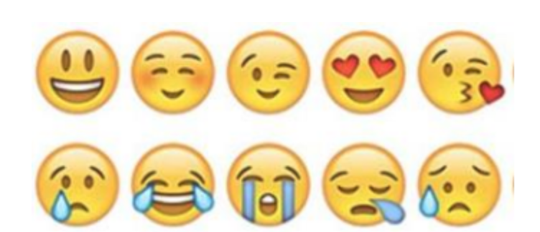  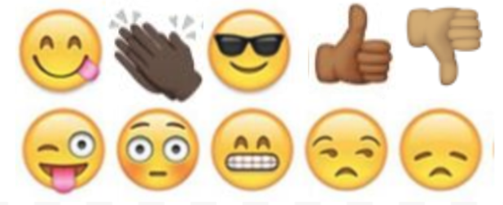

Day 5: Design your own Power Source
Science

What is this lesson about?: Today you will review this week’s readings on renewable energy. You will design your own Power Source.

Step 1: Review this week’s readings about renewable energy

Step 2: Design your own Power Source

As you think about what you read and learned this week regarding renewable energy and power sources, design a power source - either make one of the systems you learned about better or design your own power source.

- Design a draft of your Power Source:

- Questions to think about:
What is a renewable resource?
What is the process it goes through to change into usable energy?
What are the benefits or disadvantages of this type of energy?
What are the best locations to make use of this renewable energy source?
How would your energy/power source benefit your community?
If applicable, how would your energy/power source benefit the world?

- Use a separate sheet of paper to design your power source and be prepared to share your design with your class.

Step 3: Reflect

As you think about this week’s science lessons, what’s one thing you will remember about renewable energy or natural power?

Student Feedback:
Circle the emojis that best represents how this activity made you feel. | 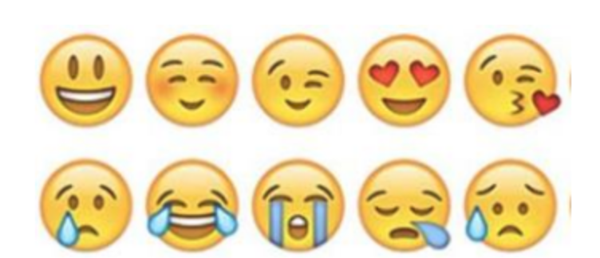  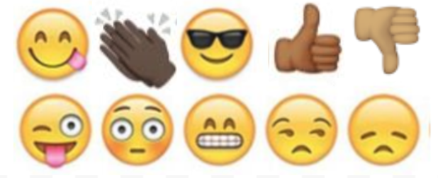

Mindfulness Moment!

What do I need to believe/think/feel in order to achieve what I want?

Day 5: Power and Sports
Math

What is this lesson about? Today’s lesson covers a few diverse sports topics, each of which poses questions about Power.

Activity 1: The Power behind Zion Williamson

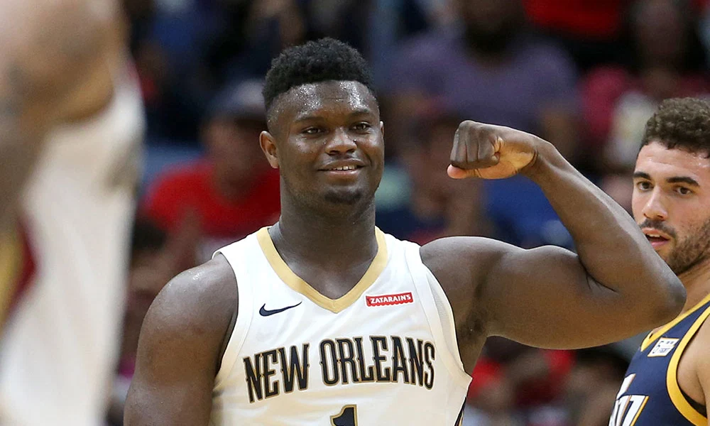

This chart shows the number of season ticket holders (rounded off) to the New Orleans Pelicans in 2010-11, 2015-16, and 2019-20 seasons.

Year | # of Season Tickets Sold | Average price per ticket
2010 | 8,500 | $80
2015 | 9,000 | $110
2019 | 14,000 | $140

- How many more season ticket-holders were there for the 2019-20 season compared to the 2010-11 season?
- The average season ticket ticket sold for _______ in 2015-16. In 2019-20, the average season ticket package sold for _______.
  - Approximately how much more money did the Pelicans take in in season tickets in 2019-20 compared to 2015-16? (Be careful, these are big numbers)

This chart shows the number of times the Pelicans were shown on national TV in 2015-16 compared to scheduled (cancelled both because of his injury and COVID-19) in 2019-20.

Year | Number of National TV Games
2015-16 | 1
2019-20 | 8

- Assume that as a part of its revenue-sharing agreement with the NBA that the Pelicans earn $3.5 million for each nationally televised game.

- How much more were the Pelicans scheduled to earn this year than in 2015-16 from these games?

Very soon after the NBA announced that it was cancelling/postponing the season, Zion Williamson announced that he would pay the salary for one month for the workers at the Smoothie Center who would not be working because of the cancelled games. Use the following information to answer the questions below.

Number of home games scheduled for March, 2020: 7
Average number of game day staff for Pelicans game: 320
Average number of hours worked (includes set-up, clean-up): 9
Average hourly wage + benefits: $11.00 per hour

- Approximately how much does it cost per game to employ the staff at the Smoothie Center?

- Over the month of March, how much money was Zion going to contribute to support the workers for these 7 games?

Consider/Discuss: Read Zion’s instagram post, below..
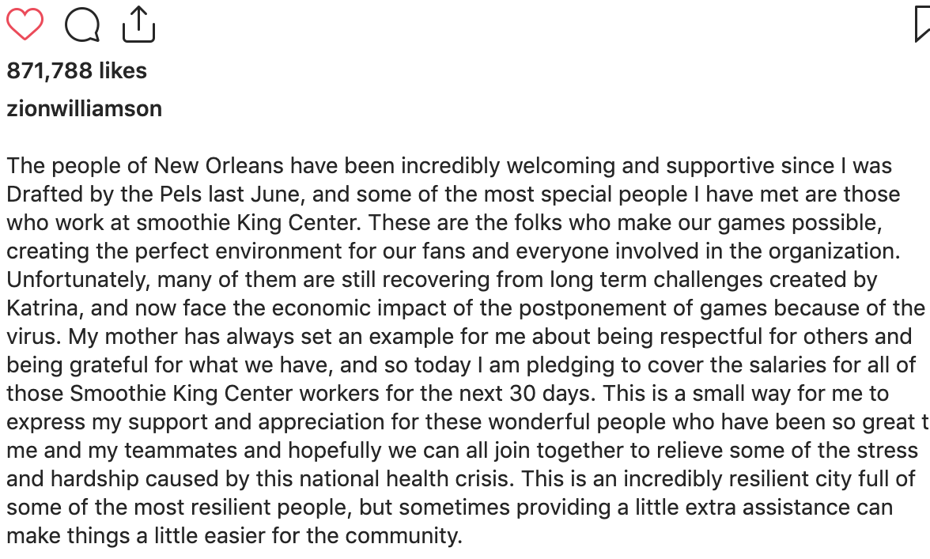
Zion Williamson pledged to support the staff before the owners of the Pelicans did. What do you think about that?

Activity 2: The Power of the 3-point shot
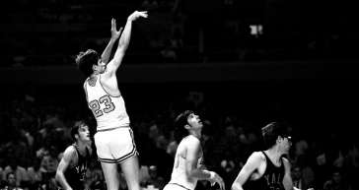
Way back in the late 1970s, a guy named Pete Maravich averaged over 44 points a game playing for Louisiana State University for the season. He remains the highest scoring player ever in college.

Back then, there was not a three point shot.
Using the chart below, calculate…

Opponent | Points scored | Free throws made | 2 pointers made | 2 pointers made behind current 3 point line
Georgia | 64 | 12 | 26 | 8
Kentucky | 41 | 11 | 15 | 4
Yale | 37 | 9 | 14 | 5
Vanderbuilt | 50 | 8 | 21 | 7

- What was his average for these 4 games?

- How many points he would have averaged in the 4 games below if he had taken the same shots but there was a 3-point line? (Be careful-you will need to find how many 2-pointers and how many 3-pointers he would have made in each game)

Discuss/consider: If there actually was a 3-point line, do you think Pete Maravich would have changed his shot selection and taken some different shots than he did?

Activity 3: The Power of Patrick Mahomes left arm

Many of you have seen replays of Patrick Mahomes scrambling around in the backfield and then flicking an incredible pass down the field. You might have also noticed that over the past two years, he shows up on a lot more TV commercials…

Use the information below to answer the questions-

Mahomes current contract (signed in 2017):
Contract length: 4 years
Contract amount: $26,000,000

Aaron Rodgers current contract: 4 years
Contract amount $84,000,000

- Currently how much is Mahomes paid per year?

- One way to look at that is to say that he works full-time and makes that salary over a year. If you rounded off and said that he works 50 weeks in a year, what is his weekly salary?

- Another way to look at this is to say that he gets paid to play in 17 regular season games. If you round it off that way, about how much does he get paid for each regular season game?

- How much does Aaron Rodges make per year currently?

Consider/discuss:
- Why does Aaron Rodgers make so much more than Patrick Mahomes?

- After the 2021 season, Mahomes’ 4-year contract will expire. Based on Aaron Rodgers’ current salary, what is your estimate for how much Mahomes will earn per year in his next contract?

Activity 4: The Power of Carli Lloyd’s leg

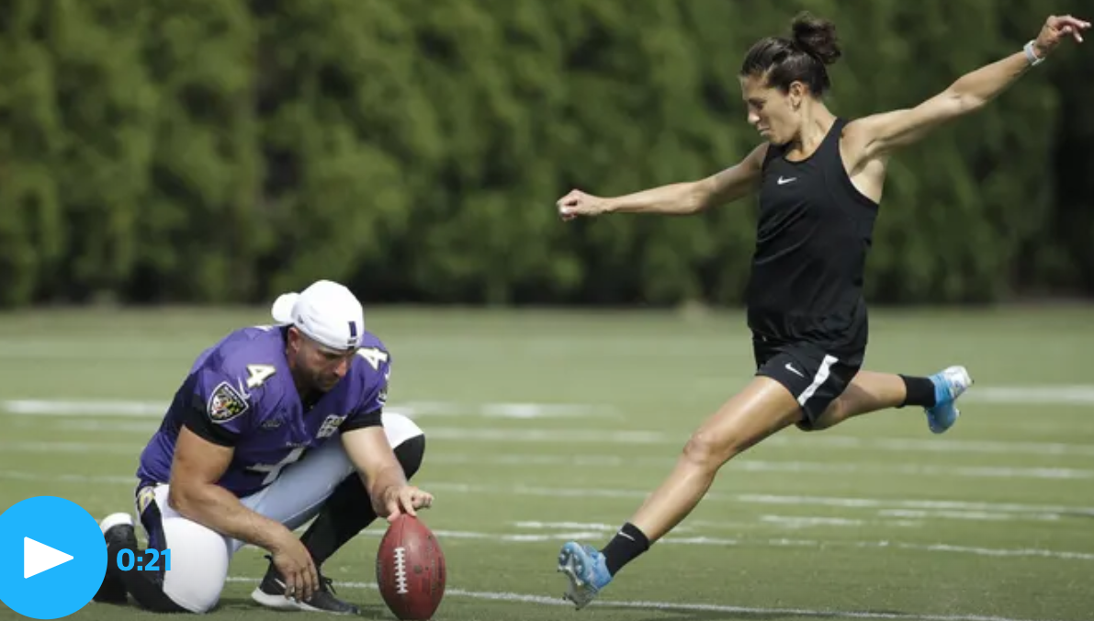
Carli LLoyd is one of the best female soccer players in the world. She may now be 2-3 years past her prime, but she is a 2x FIFA World Player of the Year, a 2x World Cup Champion, and a 2x Olympic Gold Medalist.

Over the course of her career, her annual earnings ranged from approximately $80,000 per year to $350,000 (the last 1-2 years of her career). Overall, it is estimated that she earned approximately $240,000 per year on average for the last 5 years. Her earnings for 2020 (before the COVID-19 outbreak) were estimated to be $290,000.

Last year, a video of her kicking field goals with some Philadelphia Eagles players went viral, prompting many people to encourage her to focus on field goal kicking and try out for an NFL team.

The chart below shows the salaries last year for 10 NFL kickers (2nd column). The 3rd column indicates if their contract is guaranteed beyond the current year.

Player ▾ | Avg./Year | Total Guaranteed
Adam Vinatieri | $3,875,000 | $2,000,000
Aldrick Rosas | $3,259,000 | $0
Austin Seibert | $695,114 | $260,456
Brandon McManus | $3,751,333 | $8,250,000
Brett Maher | $660,000 | $0
Chase McLaughlin | $585,000 | $0
Chris Boswell | $4,201,500 | $7,295,000
Dan Bailey | $3,333,333 | $6,000,000
Daniel Carlson | $750,000 | $0
Dustin Hopkins | $2,525,000 | $1,201,072

Round off the annual salary numbers above and then answer the following questions-
- What is the average annual salary of the 10 kickers above?

- How does that compare with Carli Lloyd’s average salary over the last 5 years?

- What percent of the NFL kickers have guaranteed contracts?

Discuss/Consider:
- If you were Carli Lloyd, would you consider giving up your soccer career to practice full-time to see if you could make it as a NFL kicker? Why/Why not?

- Why do NFL kickers (who only kick a handful of times per game) make more money than most of the best women professional soccer players? Is this fair?

Student Feedback:
Circle the emojis that best represents how this activity made you feel.

Day 5: Who has the POWER?
Health

What is this lesson about?: In today’s lesson,

Step 1: Warm-Up In the relationship below do you feel like one person has more power than the other person?

Who’s got the POWER?
A friend asks you to come with them everywhere they go. You really enjoy their company. Lately, you have had a lot of homework and can’t hang out as often. He just won’t take no for an answer and keeps bugging you until you agree to go.

Who has the POWER? Why?

Step 2: Read about the behaviors below.
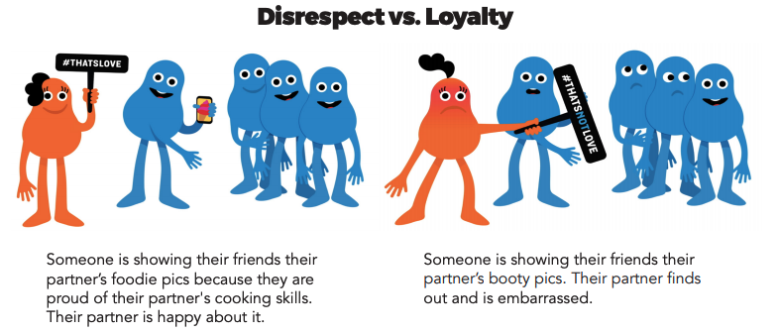
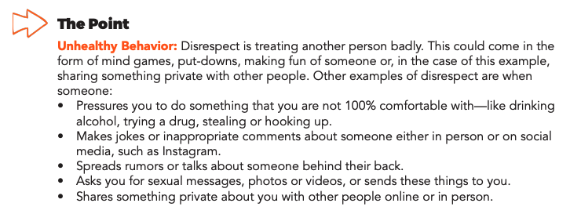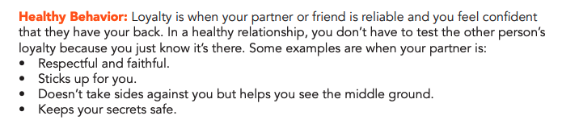
Step 3: Complete the Activity.

Over the course of this week, you learned about some behaviors that lead to unhealthy relationships. Using the list below, write a story, design a comic, or draw a picture that digs deeper into one of these behaviors below.
- Intensity
- Put-downs
- Anger
- Guilt
- Disrespect

Mindfulness Moment!

What memory brings me joy? (write or draw)

Day 5: Governmental Powers: What’s the best type of government?
Social Studies/Civics

What is this lesson about?: So far this week, you have looked at 8 types of governments. Today you will review those governments and determine which one is the best and will win your bracket.

Step 1: Review types of government
Monarchy: Ruled by a king or queen | Oligarchy: A small group of people having control of a country,
Theocracy: Leader has authority given by god | Dictatorship: One leader has absolute control over citizens’ lives
Anarchy: No central government | Communism: When everything is owned by the government and all people are considered equal
Direct Democracy: The people decide on policy initiatives directly | Representative Democracy: Elected officials representing a group of people

Use these definitions to identify the form of government in the examples below.
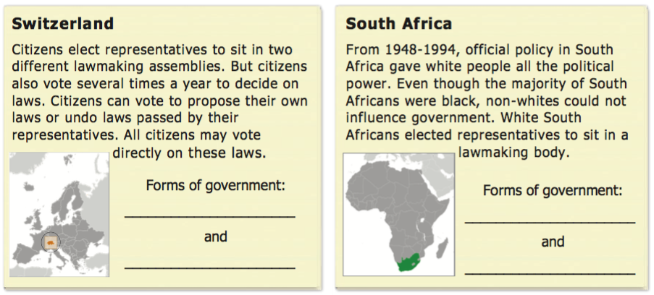

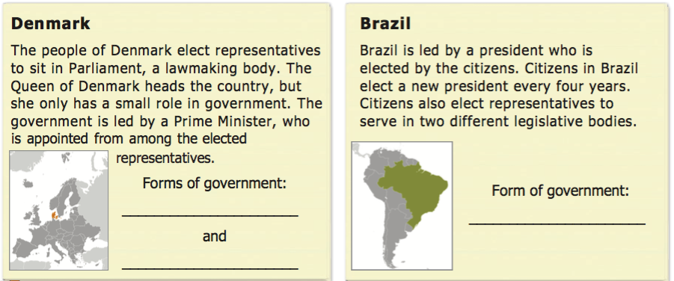
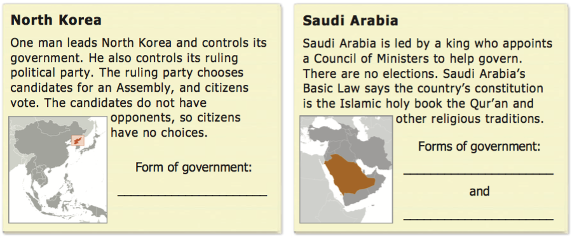
Step 2: Fill in your bracket!
Fill in the squares in the bracket below with the types of government you chose in previous lessons. Then, make a choice again to eliminate two more and identify your top two types of government!

Types of Government Bracket
Monarchy
Oligarchy
Dictatorship
Theocracy
Direct Democracy
Representative Dem.
Communism
Anarchy

Step 3: Final face-off

What are your top two types of government based on the bracket?

Based on those two, make your final determination… what do you think is the best type of government?

Your bracket winner!!! _____________________________________

Why did you choose this as the best type of government? Provide three reasons.

Create a word art for your selected type of government on the next page. Below is an example of a word art. You can just use words that help to describe the type of government, or you can make it into a shape or design as well.

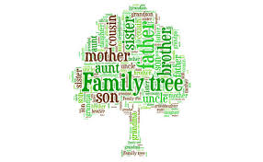
(example word art for ‘family tree’)

Create your word art here!

Step 3: Discuss!
With a partner or as a class discuss the following questions
- Share what type of government won your bracket and why.
- Did you have similar answers?
- Were there any types of government that you immediately eliminated from the bracket? Why?
- Who holds the power in the government you chose? Why does that matter?
- If you lived in the type of government you chose, what political power would you have?

Student Feedback:

Circle the emojis that best represents how this activity made you feel.

