Week 6
Change

Day 1

NAME:______________________

Day 1 Agenda

Topic | Activity
Warm-Up!
English Language Arts | - Read and annotate the poem Nothing Gold Can Stay  - Find common themes in the song “Stay Gold”  - Respond to questions about the poems.
Science | - Read about Chemical and Physical Changes  - Answer questions about what you read  - Draw a picture and explain
Mindfulness Moment!
Math | - Focusing on Percents and Percent Change...
Health | - What impact does change have?
Mindfulness Moment!
Civics/Social Studies | - Does history change over time?  - Read and respond to the text

Warm-up Activity: Write a journal entry around the daily quote on identity.
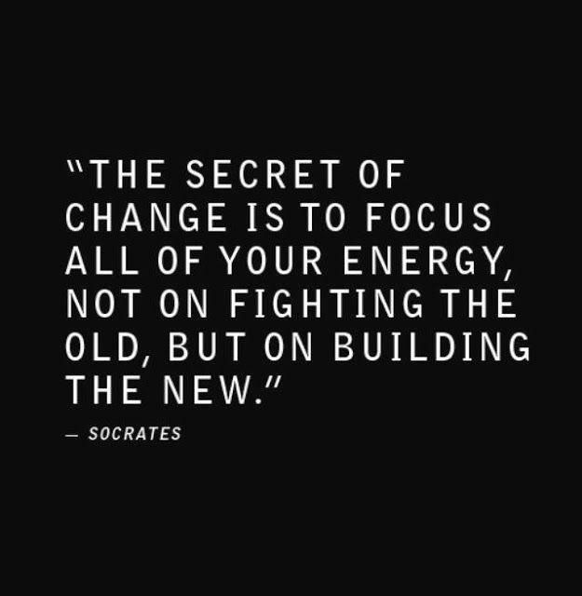

Day 1: Change
English Language Arts

What is this lesson about? Over the next week, you will be reading, thinking, talking and writing about “change”. Change is constantly happening, internally and externally and whether we want it or not. You will be reading about how the teen brain changes and how it handles change and you will read a variety of texts about personal and social change. Today, you will read two pieces of poetry about change and analyze them. You’ll reflect on the theme of change and write about your own experiences.

Before you read: Some vocabulary and references to understand:

hue: color or shade of color | subside: to become less intense, to go down | Eden: the garden as described in the Bible where Adam and Eve lived in paradise or perfection until they fell to temptation and paradise was lost.

Step 1: Read and Annotate the Poem
Before you read, think about springtime in nature and what happens. What are some of the early signs that winter is over and spring is coming? As you read, write notes interpreting what you think it is talking about.

Nothing Gold Can Stay
By Robert Frost.
1  2 | Nature’s first green is gold  Her hardest hue to hold
3  4 | Her early leaf’s a flower;  But only for an hour.
5  6 | Then leaf subsides to leaf,  So Eden sank to grief.
7  8 | So dawn goes down to day  Nothing gold can stay.

Step 2: Answer the following questions.

- In line 1, what is “nature’s first green”? Hint: Think about what happens in the spring.

- The speaker says that nature’s first green “is gold.” What are some words, ideas, images, or emotions that we associate with gold? Are these associations mostly positive or negative?

3. Considering your answer to question 2, what is the speaker saying about “nature’s first green” when he calls it “gold”?

4. In line 2, the speaker says that gold is nature’s “hardest hue to hold.” As it is used in this line, what does hold mean?

5. In lines 3 and 4, the speaker says that nature’s early leaf is a flower that lasts only for “an hour.” Do you think he means this literally—that the flower dies after one hour? If he doesn’t mean it literally, what is the speaker saying here?

6. Tone is the attitude that the speaker or poet has towards what he is writing about. Look at lines 1-4 then lines 5-6. What is the change or shift in tone that happens? What words reveal this change?

7. Consider the three things in the poem that change: a bud, Eden, and dawn. What do these three things have in common?

Step 3: Read the lyrics to the following song.

The Outsiders is a coming-of-age novel by S. E. Hinton, first published in 1967 when] Hinton was 18 years old. The book tells the story of the the conflict between two rival gangs divided by their socioeconomic status: the working-class "greasers" and the upper-class "Socs" (short for Socials).

In the novel, after a particularly dramatic scene, one character tells his very close friend to “Stay Gold” as he is dying, referring to the poem by Frost. When a movie based on the novel was made in 1983, Stevie Wonder wrote and performed a song for the movie called “Stay Gold”. As you read the lyrics think about how this song connects to the original poem by Frost and how it is different.

Before you read: review some vocabulary and references:

seize: to hold on to | steal away: to escape to | compassion: concern for the suffering of others.

 | Stay Gold  By Stevie Wonder | Notes: Summarize your interpretation of what the speaker is saying.
1  2  3  4  5 | Seize ... upon the moment of long ago  One breath away and there you will be  So young and carefree again you will see  That place in time  So gold
6  7  8  9  10 | Steal ... away into that way back when  You thought that all would last forever  But like the weather nothing can ever  And be in time  Stay gold
11  12  13  14  15  16  17  18  19  20  21  22  23 | But can it be ... when we can see  So vividly a memory  And yes you say so must the day  To fade away  And leave a ray of sun  So gold  Life ... is but a twinkling of an eye  Yet filled with sorrow and compassion  Though not imagined all things that happen  Will age too old  Though gold  Stay gold

Step 4: Answer the following questions

- Where does the speaker want the reader to go (in his/her imagination) in lines 1-5?

- According to the speaker, how did they feel about life “way back when”?

- Why do you think most people tend to look at the past in that way? Why is that time considered “so gold”?

- There is a tone shift starting on line 8. What does the speaker start to describe?

- Interpret the lines 17-18 into your own words:
“Life ..is but a twinkling of an eye
Yet filled with sorrow and compassion”

- In the movie, one friend is telling the other to “stay gold”, what does he mean by that?

- In Frost’s poem, he is talking about nature. In Stevie Wonder’s song, he is referring to a friendship. What is the common theme (message of the poem)? What can we learn from this theme?

Step 5: Think, Write and Share your responses with a partner

Read, think about and answer the following questions.. There is no wrong or right answer. The questions are designed to have you reflect on what you read and your own feelings about change.

Write for 8 minutes: Why do we tend to see events “back in the day” or in our pasts generally more positively than what we experience in the present? Do you think that change is good or bad? Explain.

Student Feedback:

Circle the emojis that best represents how this activity made you feel. | 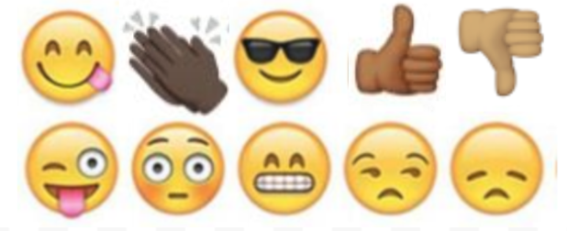  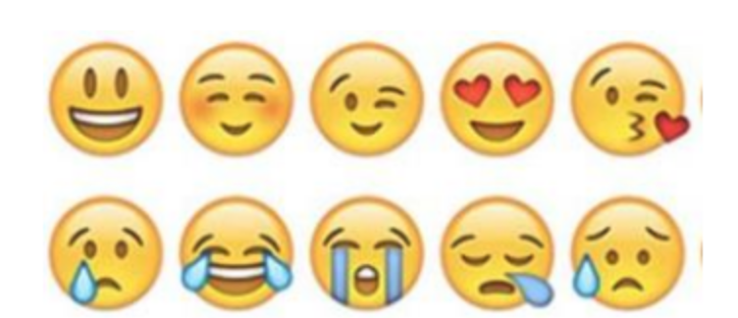

Day 1: Chemical and Physical Changes
Science

What is this lesson about?: Today you will read through the Chemical and Physical Changes passage. You will answer a few questions about what you read. You will draw a picture and write a response.

Step 1: Read through the Chemical and Physical Changes passage

Chemical and Physical Changes
(Generation Genius)

In a chemical change, a new substance is made, like when you burn a candle. In a physical change, no new substance is made, like when water turns to ice. To better understand the difference, let’s break it down!

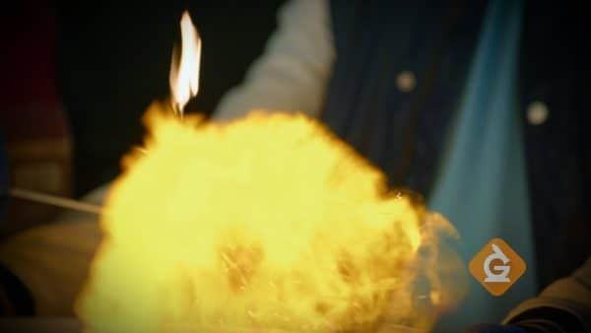
Chemical changes make new substances
Anytime a new substance is made, a chemical change takes place. Usually two or more materials are combined and a new substance is formed. A chemical change can produce amazing explosions, like fireworks. Some chemical changes are a little more difficult to spot, like when a nail rusts.
If you notice bubbles being formed, or a change in color or temperature, there is a good chance a chemical change has taken place, but not always. Scientists can determine if a chemical change has occurred by asking this question: Was the substance formed present before? If the answer is no, then it is a chemical change.

Since chemical changes make new substances, most of them cannot easily be undone. For example, when you burn wood, you can’t really turn the gases back into a log very easily.

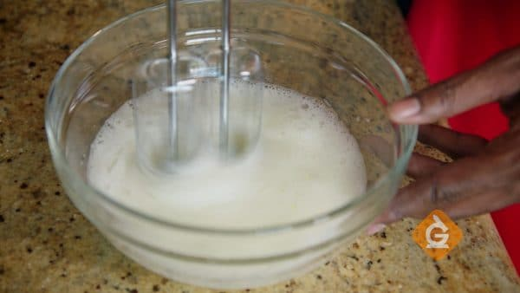
Physical changes do not make a new substance.
Physical changes come in many forms. It can be a change in the shape or appearance of an object, like crumpling a piece of paper, or cutting, bending, or dissolving something.

Since objects do not become a different substance during a physical change, it is usually easy to reverse the change. For example, if you dissolve sugar in water you can easily reverse the change by evaporating the water from the solution. When all the water evaporates, sugar crystals will be left behind.

Physical changes also happen when matter changes states.
There are three common states of matter: solid, liquid, and gas. When a substance changes states (from a liquid to a gas, for example), it is undergoing a physical change.

In the video, when the gallium spoon melted in hot water, the gallium did not become a different metal. Melting is an example of a phase change, where a solid is changed to a liquid. Freezing and boiling are also physical changes.

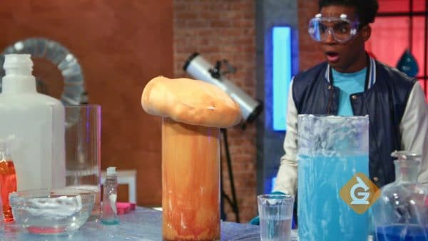
Chemical and physical changes are all around us.
Chemical and physical changes take place around you all the time. When you make cereal for breakfast, combining the milk and cereal is a physical change. When you eat the cereal, a chemical change happens during digestion.

Sometimes, it can be difficult to tell if a chemical or physical change is taking place. In the video, Dr. Jeff and the team explore a few different reactions to determine if they are chemical or physical changes, by figuring out if the material made after the reaction was present before the reaction.

EXAMPLES OF CHEMICAL AND PHYSICAL CHANGES
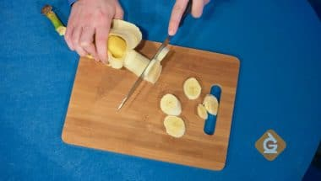
Chopping a banana - Since cutting a banana only changes its appearance, a new substance is NOT formed. That makes this an example of a physical change.
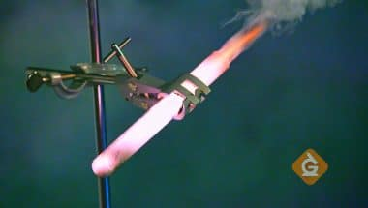
Burning a gummy bear - When the gummy bear was placed into a test tube with the oxidizer, the gummy bear burned up and created new chemicals. Since new chemicals were formed, it is an example of a chemical change.

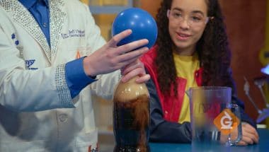
Coke and Mentos - Mixing Coke and Mentos looks like a chemical change, but since the gas released is carbon dioxide AND it was present before the foaming happened, it is actually a physical change.

Vocabulary for Chemical and Physical Changes

Catalyst - A substance that speeds up a chemical reaction.
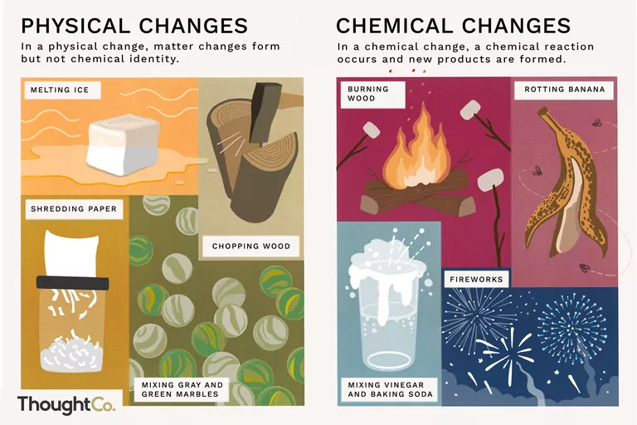
Chemical Change - a type of change in which a new substance is formed; for example: burning something.

Physical Change - a type of change in which a new substance is NOT formed; for example: boiling water.

Oxidizer - a chemical that provides a lot of oxygen to help things burn.

Carbon Dioxide - a gas without any color or smell that is commonly found in soda. It is also called CO2 and comes out the back of a car or bus that is running.

Hydrogen - a gas less dense than air that has no color or smell. It is extremely flammable, meaning it can burn.

Step 2: Answer the following questions

Study the vocabulary words above. Try to complete the vocabulary quiz without referring back to the text.

- ______________________________ is a type of change in which a new substance is formed; for example: burning something.

- ______________________________ is a type of change in which a new substance is NOT formed; for example: boiling water.

- ______________________________ is a substance that speeds up a chemical reaction.

- ______________________________ is a chemical that provides a lot of oxygen to help things burn.

- ______________________________ is a gas less dense than air that has no color or smell. It is extremely flammable, meaning it can burn.

- ______________________________ is a gas without any color or smell that is commonly found in soda. It is also called CO2 and comes out the back of a car or bus that is running.

Word Bank
Catalyst Oxidizer Carbon Dioxide
Chemical Change Physical Change Hydrogen

Step 3: Draw a picture and describe

Draw a picture and describe 2 examples of a chemical change.

________________________________________________________________________________________________________
____________________________________________________________________________________________________________________________________________________________
Draw a picture and describe 2 examples of a physical change.

________________________________________________________________________________________________________________________________________________________________________________________________________________

Student Feedback:

Circle the emojis that best represents how this activity made you feel.

Mindfulness Moment!

Day 1: Change/Understanding %
Math

What is this lesson about?: Today we are going to focus on understanding percentages, and percentage change. These concepts come up often in everyday life and it is important to be able to understand them.

Today’s Warm-Up Problem
Kenny invested $100 in the stock market. One year later his stock was worth $110.
Alvin invested $10 in the stock market. One year later his stock was worth $20.
- Who made more money over the course of the year?
- Who made a better investment?
- Do you know what % return Kenny got on his investment?
- How about Alvin?

San Antonio had a population of 2,000,000 in 1980. By 1990 it had a population of 3,000,000.
Houston had a population of 5,000,000 in 1980. By 1990 it had a population of 6,000,000.
- What city grew more over that 10 year period?
- What city, do you think, experienced a greater % increase over the 10 year period.

Activity #1: Getting the Basics down…

Percent is a way of saying “out of one hundred”

Example: If you get a 90% on a test that means you earned 90 out of 100.
- Consider: How does your teacher know that you got a 90% if the test only had 50 questions (and not 100).

Example: James Harden shoots 40% from behind the three point line means that out of every 100 three point shots he takes, he makes 40.
- Consider: How do we calculate his % shooting in a game when he only takes 20 shots (and not 100?)

When you see decimals written out to 2 decimal places, that is also “out of one hundred” or x “hundredths.”

Example: How do you say: 5.25. Many people say: “five point two-five”.

- But a more correct way to say that is: “five and 25 hundredths.” 25 hundredths is the same as twenty-five percent. You might also think of it as 25 cents….

Practice writing out below how to ‘say’ each of the decimals below. Do NOT write out “point 20” or ‘point 02” or “one hundred point 40”. Use the word “hundredths” -- that will get you thinking in percents!
- Example: 5.25= five and twenty-five hundredths…

.07 = _________________________________ .44 = _________________________________

.21 = _________________________________ 3.14 = ________________________________

21.21 = _________________________________ .09 = _________________________________

.80 = _________________________________ 2.88 = ________________________________

100.07 = _________________________________ .22 = _________________________________

Activity 2: Converting decimals to percents…

When you say .07 as “seven hundredths” you are saying that it is the same as 7 out of 100….and that is the same as 7%!

When you say .50 as “fifty hundredths” you are saying that is the same as 50 out of 100….and that is 50%.

Now, write each of the decimals below as a percent…
- Example: .04 = four percent or 4%

.07 = seven percent or 7% .44 = _________________________________

.21 = _________________________________ .14 = _________________________________

.29 = _________________________________ .18 = _________________________________

.89 = _________________________________ .88 = ________________________________

.079 = _________________________________ .24 = _________________________________

NOTE: If the decimal goes beyond 3 places, round it off to the hundredths place (2 digits) and convert to a %...

- Example: .048 → rounds off to .05 = five percent or 5%
- Example: . 089218 → rounds off to .09 = nine percent or 9%

Round each decimal below to the hundredths place and convert to a %.

Example: .071 rounds to .07 = seven percent or 7%

.222 rounds to _______ = ____________________________

.0295 rounds to ______ = ____________________________

.589 rounds to _______ = ____________________________

.009 rounds to _______ = ____________________________

.8598 rounds to ______ = ____________________________

.031 rounds to _______ = ____________________________

.7575 rounds to ______ = ____________________________

Step 3: Converting Fractions to Decimals

There are two main ways to convert a fraction to a decimal.

- Option 1: You can find an equivalent fraction that has 100 in the denominator (the number at the bottom of the fraction). In that case, the numerator (the number in the top of the fraction) is the number ‘out of one hundred” do it is the %.

Note, you only do this when the denominator can easily be converted to 100. So it works well if the fraction has 2, 4, 5, 10. 20. 25 or 50 in the denominator. Let’s try some of those below-

Example:
¼ = __/100 → ask yourself what you multiply 4 by to = 100. That is 25. So, multiply 1 x 25. → ¼ = 25/100 == 25%

25/100 is the same as twenty-five one hundredths...or 25%

Convert each of the fractions below to a fraction with 100 in the denominator, the write the % below

2/10 = __/100 5/10 = ___/100 9/10 = ___/100

= _____% = _____% = _____%

2/5 = ___/100 4/5 = ____/100 1/5 = ____/100

= _____% = _____% = _____%

2/25 = ___/100 20/25 = ____/100 10/25 = ____/100

= _____% = _____% = _____%
2/50 = ___/100 20/50 = ____/100 40/50 = ____/100

= _____% = _____% = _____%

2/4 = ___/100 1/4 = ____/100 3/4 = ____/100

= _____% = _____% = _____%

- Option 2: You simply divide the numerator by the denominator, and then round the decimal off to two digits (remember from above).... This is what a fraction means: ¾ is the same as three (3) divided by four (4).

If you have a calculator, this can be quite quick (clearly). If you have to do it by hand, make sure only go out to 3 digits and not spend lots and lots of time on it. So, try out a few of these below. If you don’t have a calculator, just try and handful of these to get a feel for how these fractions convert to a decimal...and then to a percentage.

Example:

2/5 = 2 divided 5 = .40 → you say that as “forty hundredths” or 40%

⅛ = ____________________ = _____ → you say that as ____________________ or ____%
Write it out decimal how many hundredths %

3/9= ____________________ = _____ → you say that as ____________________ or ____%
Write it out decimal how many hundredths %

7/15 = ____________________ = _____ → you say that as ____________________or ___%
Write it out decimal how many hundredths %

5/12 = ____________________ = _____ → you say that as ____________________or ___%
Write it out decimal how many hundredths %

Step 4: Percentage Increase or Decrease
One of the most-used tools is to calculate the % change, or increase or decrease, in an amount, over time.

If you look back on the warm-up problem, or problems similar to it, you see why this is so important.

Example:
- Don takes $5,000 and invests it. Two years later, he has $6,000. Manny takes $2,000 and invests it. Two years later, he has $3,000.
- Who earned more money over the two years?
- Who’s investment increased by a greater percent?
Practice: To calculate the Percentage Change between two amounts, or over time you create a fraction that has the amount of change divided by the original amount. You then convert the decimal to a %.

Let’s try that:
Don started with $5,000 and ended up with $6,000.
- His Amount of Change is: $6,000-$5,000= $1,000
- Next, create a fraction -$\frac{Amount of change}{Original amount}$→ write this as $1,000/$5,000
- Next, convert that to a decimal → .20 → say that as Twenty Hundredths...or 20%
- So, Don earned 20%.

Manny started with $2,000 and ended up with $3,000
- His Amount of Change is: $3,000-$2,000= $1,000
- Next, create a fraction -$\frac{Amount of change}{Original amount}$→ write this as $1,000/$2,000
- Next, convert that to a decimal → .50 → say that as Fifty Hundredths...or 50%

So, both Don and Manny earned $1,000. But Manny’s investment went up by 50%. Don’s investment went up by 10%.

Practice problems-

Rember: Percentage change =($\frac{Amount of change}{Original amount}$-))→ then convert the decimal to a %

In 2018, the average number of students held at the DC detention center was 80. In 2019 the average number of students there was 64. By what percentage did the detention population go down?

Janelle averaged 18 points a game during her junior year in high school. During her senior year, she averaged 24 points a game. By what percentage did her scoring average go up?

In April, there is approximately 12 hours of daylight in Alaska each day. By the late June there is nearly 18 hours of daylight. By what percentage has the amount of daylight per day gone up?

In 1980 cars in the US averaged 15 miles per gallon. By 2020, cars in the US averaged 25 miles per gallon. By what % has fuel economy gone up over the 40 years?

Student Feedback:
Circle the emojis that best represents how this activity made you feel.

Day 1: What impact does change have?
Health

What is this lesson about?: In today’s lesson, you will look at the impact of change. The focus will be on adolescence and how you can cope with the change that comes with it.

Step 1: Warm-Up: Respond to the statement below.
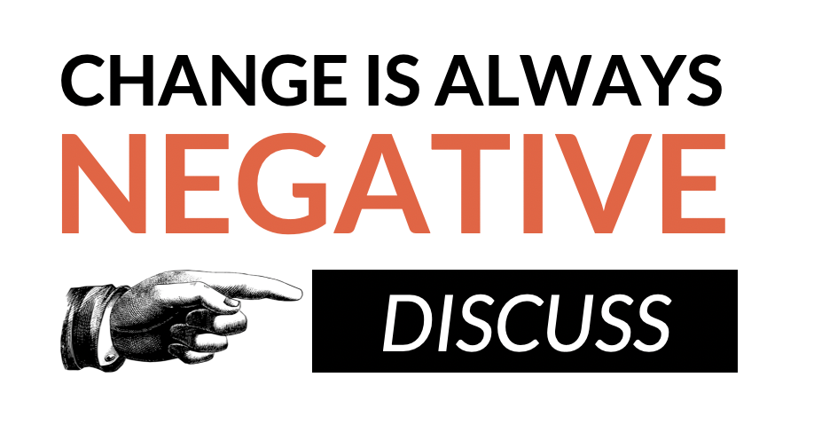
Do you agree with this statement?

Step 2: Respond to the prompts below by using the scale.

Place a letter for each prompt below on the scale.

- How confident are you in identifying changes that can take place in adolescence?

- How confident are you in understanding the effect that change can have? (eg. on friendships, mood, routines, confidence, etc.)

- How confident are you in knowing strategies to manage chance and where to seek support?

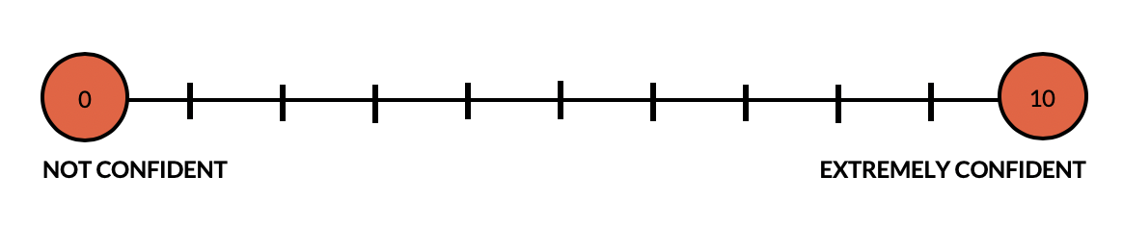
Step 3: Malcolm Chase wrote this Haiku about the struggles he faces when he is trying to write.

Struggle

I can’t do it right
Try and try with all my might
Whatever I write

What would you say to help Malcolm change his perspective on his writing skills:

Step 4: Map out your response to upcoming changes.

Imagine it is the first year of high school:

What are some changes that could take place for a student?
Think about: personal interests, relationships, home life, school life, homework, and society.

Circle the changes that are expected and underline the ones that are unexpected.

Draw emojis that show the impact of each change or write the emotions these changes will cause.

Step 5: Reflection

On your own, or with a partner, reflect on the following questions.

•Do you think some life changes are expected? If so, can you think of any examples?

•Do you think some life changes are unexpected? If so, can you think of any examples?

•What times in your life do you think the most change will take place and why?

Student Feedback:
Circle the emojis that best represents how this activity made you feel.

Mindfulness Moment!

Day 1: Does History Change Over Time?
Social Studies

What is this lesson about?: Today you will begin the week by considering the question: Does history change over time? You will explore how history is interpreted and “produced” by historians and will understand why history evolves. This lesson will prepare you for considering the history lessons for the rest of the week.

Warm-up:

Do you think there is only one correct version of history? Why or why not?

Step 1: Read about how history is produced

Why is history important to society?
History provides a sense of identity, it helps us make sense of the world, and provides lessons in right and wrong. Like a person who has lost their memory and finds the world confusing, a society with no sense of history is unaware of where it has come from or where it is going. A historian’s job is to provide society with its memory. After all, history means “What historians have interpreted from the surviving evidence of the past.” Therefore it is important to carefully analyze and inspect the surviving evidence and how historians present that evidence.

How is history produced?
There is a simple equation as to how history is produced:

Sources + Historians = “History”
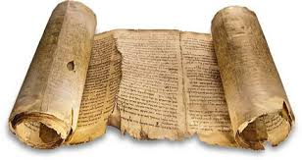
So, let’s start with the first part of the equation: Sources.
When we talk about sources, we are talking about sources of historical evidence. Things like diaries, governmental documents, and other written materials. Also, things like witnesses (people who lived through a historical event), artifacts (antiques), and stories that have been carried down generations verbally are also sources. What’s important to remember is that sources that survive throughout time may not give us the full picture and sources that have been lost (due to decay or destruction) leave major gaps in our ability to understand what truly happened long ago. For example, historically we know far less about poor, working-class people, than we do of the ruling classes, who leave behind much more evidence due to their power, wealth, and literacy.

Next, let’s consider the second part of the equation: Historians.
In order for a historian to piece together what happened in the past, they must select evidence to use and they must interpret (determine the meaning) of the evidence and present it to the public. The role of the historian is to make sense of the facts they discover in the evidence.

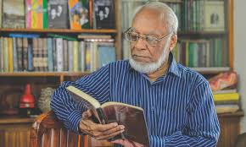
This process, however, of selecting and interpreting the evidence, can distort things. The historian has their own views and perceptions (formed by their life experiences, social background, and current life), which will affect the interpretation they make of the evidence. To give an example, “one man’s terrorist is another man’s freedom fighter.” Different historians will determine different meanings to evidence. Unlike the physical sciences (physics, chemistry, biology), history often produces different answers to the same question. Historians frequently study the same sets of facts (evidence) but end up reaching different explanations or conclusions.

The last part of our equation is “history,” the sum of combining evidence with historians. The history we learn has been weakened or changed from the past. First, this is because some evidence has been lost; some destroyed; and the remaining evidence does not give us the full picture (remember, we read about this above under ‘sources’). Then, historians will use their imagination to fill gaps in the evidence, select the bits of evidence that they think is the most interesting, and then interpret and present that evidence to the public. As such, the history we read about or are taught, is really an interpretation of available evidence made by historians. We rely on historian’s interpretations to explain what has happened in the past.

So, is “objective” history possible?
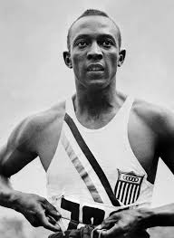
If we think history has been changed by historians, maybe the best thing to do is aim for objective history… history that can be proven; to tell it as it really was. However, even while some historical facts are beyond dispute and can be proven, history will continue to be affected by historians and our own way of interpreting the facts.

- First, those facts are boring and meaningless until a historian helps us learn something more from them. For example, Hitler was born in 1889, but this fact only becomes important when a historian uses it to argue (for example) that Nazism sprung from late 19th Century Austrian nationalism.
- Second, those facts may be the truth, but not the whole truth. For example, Hitler refused to shake hands with the black American athlete Jesse Owens (pictured), who won 8 gold medals at the 1936 Olympics. That is a fact. However, it is also true that Hitler refused to shake anyone’s hand after the first day (he got into trouble for only greeting German athletes).

In conclusion, factual or objective history is impossible. But it also would not be a good thing. The point of history is not to collect facts, but to deal with interpretations, lessons, morals, and values.

What to takeaway: History is evolving
While the past itself never changes, history – in other words, our understanding and interpretations of the past – is always evolving. New historians explore and interpret the past through their own methods, priorities and values. They develop new theories and conclusions that may change the way we understand the past.
Step 2: Answer questions

Why is history so important to society?

Why is it too simple to describe history as “what happened in the past”? What more is in the equation of what history is?

Do you think objective history would be a good thing? Explain your answer.

Why is history evolving?

Step 3: Read a sports analogy

Let’s dig a little deeper and explore this idea that history is evolving because historians' interpretations of historical evidence are evolving. First we need to understand that the history we read in a textbook, watch in a documentary, or hear in a classroom has all been written, told, or explained by a historian. That historian has examined evidence and has made a determination what the evidence means. So in the end, what we read, watch, or hear is the meaning of a historical event as determined by the historian. Further, how the historian interprets the evidence is affected by the historian’s personal and political viewpoints, as well as their life experiences.
Now, think of a significant historical event as being like a major sporting event, such as an important football or basketball game watched by thousands of people. Football games have factual outcomes: scoring charts, a final score, team and player statistics, player injuries and so forth. These are the ‘historical facts’ of the game.
Explaining these outcomes, however, can be a very subjective process (based on or influenced by personal feelings, tastes, or opinions). Witnesses to a football game might attribute its outcomes to different factors – team selections, the performance of individual players, fitness or injuries, referee decisions, weather, grass/turf conditions, ‘home field advantage’, coaching tactics and so forth. There may be some consensus about these causes but not total agreement. In other words, how the event will be interpreted by people will be different based on what factors people focus on.
In some respects, historians are like sports journalists: they explain outcomes after the fact, relying on evidence but also their own judgement and interpretations. These interpretations can vary markedly, to the point where the conclusions of one historian may directly contradict the conclusions of another other.
Step 4: Confirm your understanding

In 8-10 sentences, write a letter to your teacher explaining why history is evolving. Use your own words and examples.

Student Feedback:

Circle the emojis that best represents how this activity made you feel.

