Week 2
Identity

Day 3

NAME:______________________

Day 3 Agenda

Topic | Activity
Warm-Up!
English Language Arts | - Read the poem Identity, by Julio Noboa Polanco  - Annotate and identify imagery in the poem.
Science | - Read about our fingerprints  - Write down three things you learned about fingerprints  - Draw an image/picture
Mindfulness Moment!
Math | - Real-World Math: Identity and place: Migration→ understanding percent increase and decrease  - Practice Problems: Mean, Median and Mode
Health | - Digital Identity
Mindfulness Moment!
Civics/Social Studies | - Read about identified voters
PE | - Bingo!

Warm-up Activity: Write a journal entry around the daily quote on identity.
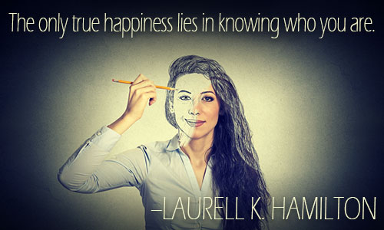

Day 3: English Language Arts
Defining Ourselves Using Metaphor

What is this lesson about?:. Today, you will read a poem that uses an extended metaphor (a comparison that starts at the beginning of the poem and continues throughout).

Step 1: Before reading

Do a 5 minute quick-write where you just write your ideas, don’t worry about your spelling or grammar, just focus on what you feel and want to say.

Write for 5 minutes: If you could compare yourself to something else that is not human, what would you compare yourself to? What qualities or abilities does this non- human being or object have that could describe you? Explain. The first sentence has been started for you.

I am like a….

Step 2: Read the following poem.

In it, Polanco uses an extended metaphor or comparison to describe his chosen identity. As you read, make sure to annotate what you think is being said in the box next to the stanza.

Some vocabulary to review before reading:
harnessed—controlled or held still | wavering—waving, swaying
madness—craziness, insanity | abyss—a bottomless pit
shunned—to be avoided deliberately | stench –a strong, unpleasant smell

 | Identity by Julio Noboa Polanco | Translate into your own words
1 | Let them be as flowers,  Always watered, fed, guarded, admired,  But harnessed to a pot of dirt.
2 | I'd rather be a tall, ugly weed,  Clinging on cliffs, like an eagle  Wind-wavering above high, jagged rocks.
3 | To have broken through the surface of stone,  To live, to feel exposed to the madness  Of the vast, eternal sky.  To be swayed by the breezes of an ancient sea,  Carrying my soul, my seed,  Beyond the mountains of time or into the abyss  of the bizarre.
4 | I'd rather be unseen, and if  Then shunned by everyone,  Than to be a pleasant-smelling flower,  Growing in clusters in the fertile valley,  Where they're praised, handled, and plucked  By greedy, human hands.
5 | I'd rather smell of musty, green stench  Than of sweet, fragrant lilac.  If I could stand alone, strong and free,  I'd rather be a tall, ugly weed.

Step 3: Answer the following questions.

1. Throughout the poem, the author talks of “them” and “they”—who is he referring to? How does he feel about “them”? What words tell you that he feels this way?

- It is often said that a weed is any flower or plant that is unwanted. So, a dandelion can be a beautiful flower if it is appreciated or a weed if you don’t want it in your yard. Why do you think the author wants to identify himself as an “ugly weed” instead of a wildflower or some other plant?

- In his metaphor, the author uses imagery which is descriptive language that appeals to the five senses (smell, taste, sight, hearing and touch) in order to create an image or picture in the mind of the reader. Give an example of an image that the author creates for his reader. Next to your example, draw it out.

- In stanza three, the speaker in the poem says that the he will have “…broken through the surface of stone.” What does this tell you about the weed/speaker?

- Throughout the poem, the author repeats the phrase “I’d rather”. Why do you think that the author emphasizes that he’d “rather” be an ugly weed? Do you think he really believes that he is ugly?

6. Linking this poem back to the idea of identity, is this author/speaker choosing his identity or is he allowing others to define him? Explain.

Student Feedback:

Circle the emojis that best represents how this activity made you feel. | 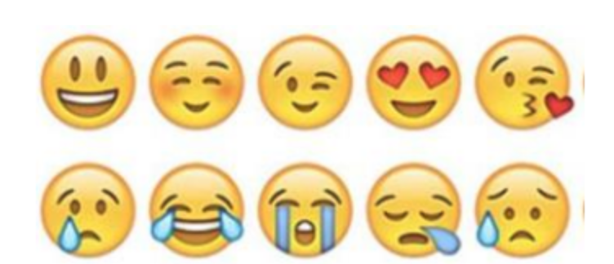  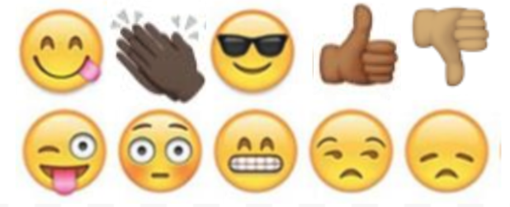

Day 3: Science
Fingerprints

What is this lesson about?: Today you will read through two passages, What is the mystery behind our unique fingerprints? and What are fingerprints? You will write down something new that you learned and you will complete a fingerprint activity.

Step 1: Read through the passages, What is the mystery behind our unique fingerprints? and What are fingerprints?
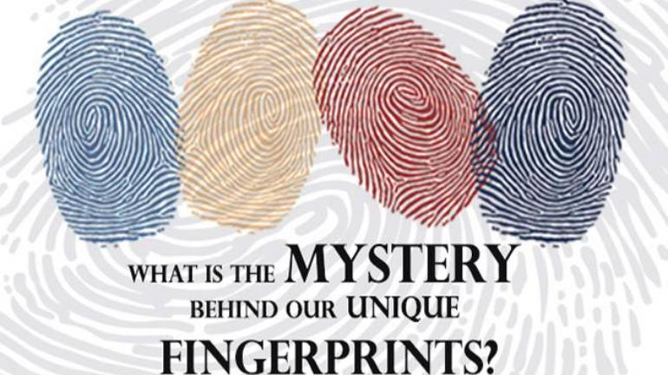
India Today, 2019
How are fingerprints formed?
The patterns on our fingertips, or fingerprints, are truly unique and are not replicated even in the case of identical twins. These patterns are created in the womb when the fetus is barely three inches long.
The process starts at about the 10th week of conception, and by the 14th week, the fingerprints are set in stone.

Your genes decide your fingerprints
Fingerprints are basically a product of your genes. Though the genetic code of the fetus doesn't completely decide the exact patterns that will appear on the fingertips, they do decide the factors that go behind making fingerprints.
The fascination with the uniqueness of fingerprints has continued for a long time. It has been acknowledged for about 2000 years, while scientific research on the matter was carried out for around 200 years.
It was only in 2004 that researchers Michael Kucken and Alan C. Newell from the University of Arizona presented a paper explaining how the epidermal ridges or the fingerprints are biologically formed.

Crumpling skin layer gives rise to patterns
The skin has three main layers - the upper layer of the epidermis on the outside, the inner dermis, and the basal layer of epidermis in between.
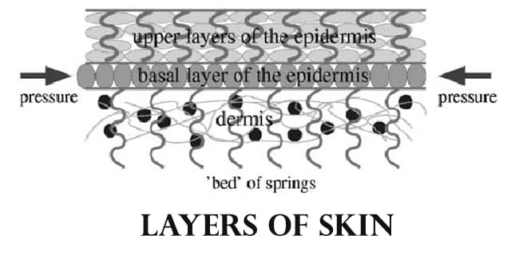
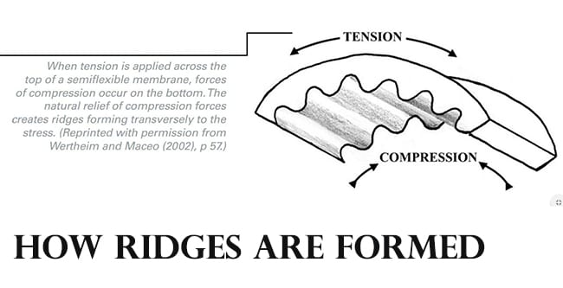
In a fetus, the sandwiched basal layer grows faster than the other two layers of skin and as a result, it kind of crumples in specific ways to produce the patterns on our fingertips that we call fingerprints.
"These folds encode the future fingerprint pattern that becomes visible on the skin surface in subsequent weeks," Kucken told LiveScience. "Because the fingerprint pattern is coded underneath the skin surface, the pattern cannot be destroyed by superficial skin injuries."

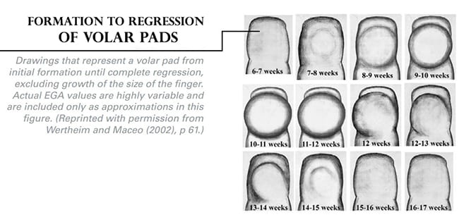
During the formation of fingers, volar pads are formed on the surface of the palm and on the soles of the feet of the fetus at around 7-8 weeks of pregnancy. These are thick pads of skin formed by a kind of swelled stem cell tissue called mesenchyme under the other layers of skin.

The volar pads remain swelled and rounded for some time till after the 9th or 10th week of gestation when they start to change in size and position. After that, they slowly start to disappear and fingerprints are formed during the same time.
The position and state of the volar pads decide what kind of patterns will be formed on the fingers--arches, loops or whorls.
If the receding volar pads are slanted to one side when the first fingerprint ridges are formed, then the pattern will also be slanted, forming a loop.
If the volar pads are still prominent but flat, whorls will be formed, and if the volar pads have almost disappeared, arch patterned ridges will be formed.
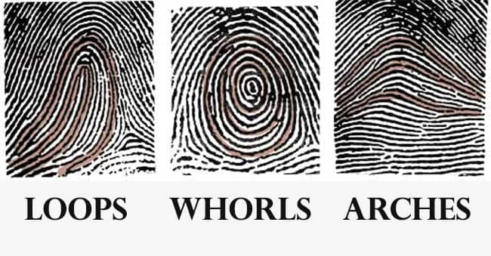

Why do identical twins have different fingerprint patterns?
Since the fingerprint patterns are primarily decided by genes, the similarity in patterns run in families. However, finer points in fingerprints called minutiae can vary even in families.
While it is not completely clear as to what causes these tiny differences, research suggests that they are caused by environmental factors. These include the position and movement of the fetus in the womb when the ridges are formed on the fingertips and even the density of the amniotic fluid.
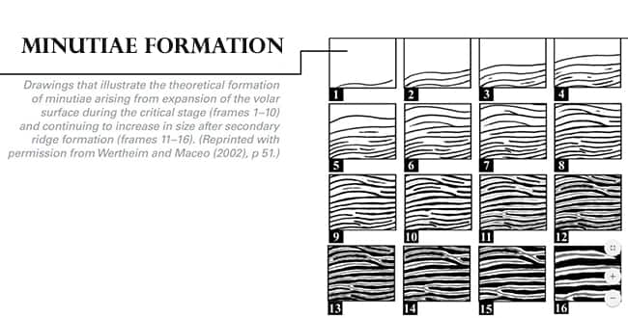
These factors can ultimately change the number of ridges on the fingertips or how they converge.

The intrinsic and extrinsic factors that go into making the human body, especially the human skin, are not possible to duplicate even in small areas. Thus, even in twins, the patterns of fingerprints can be similar, but they won't be exactly the same.

What are fingerprints?
Stephanie Watson
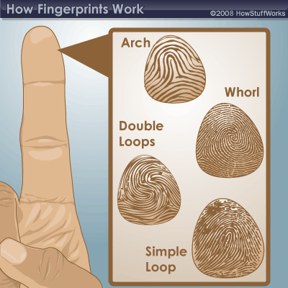
What are fingerprints?

Fingerprints are the tiny ridges, whorls and valley patterns on the tip of each finger. They form from pressure on a baby's tiny, developing fingers in the womb. No two people have been found to have the same fingerprints -- they are totally unique. There's a one in 64 billion chance that your fingerprint will match up exactly with someone else's.
Fingerprints are even more unique than DNA, the genetic material in each of our cells. Although identical twins can share the same DNA -- or at least most of it -- they can't have the same fingerprints.
Fingerprinting is one form of biometrics, a science that uses people's physical characteristics to identify them. Fingerprints are ideal for this purpose because they're inexpensive to collect and analyze, and they never change, even as people age.
­Although hands and feet have many ridged areas ­that could be used for identification, fingerprints became a popular form of biometrics because they are easy to classify and sort. They're also accessible.
Fingerprints are made of an arrangement of ridges, called friction ridges. Each ridge contains pores, which are attached to sweat glands under the skin. You leave fingerprints on glasses, tables and just about anything else you touch because of this sweat.
All of the ridges of fingerprints form patterns called loops, whorls or arches:
- Loops begin on one side of the finger, curve around or upward, and exit the other side. There are two types of loops: Radial loops slope toward the thumb, while ulnar loops slope toward the little finger.
- Whorls form a circular or spiral pattern.
- Arches slope upward and then down, like very narrow mountains.
Scientists look at the arrangement, shape, size and number of lines in these fingerprint patterns to distinguish one from another. They also analyze very tiny characteristics called minutiae, which can't be seen with the naked eye.

Step 2: Write down three things you learned about fingerprints

Write down three things you learned about fingerprints:

1.

2.

3.

Step 3: Draw an image/picture

If you have a water based marker, color one of your fingers with the marker and press your finger here:

[If you are unable to use the marker, take a moment to rub your fingers together and look very closely at your fingers. Draw an image/picture that best represents one of your fingerprints.]

What do you notice about your fingerprint? Be sure to use the proper terminology from the two texts to describe your print.

Student Feedback:

Circle the emojis that best represents how this activity made you feel. | 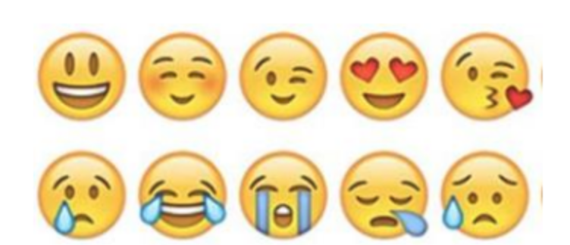  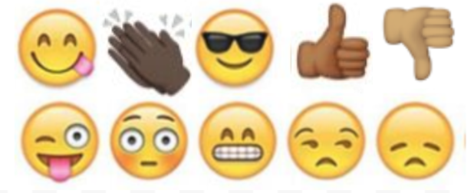

Mindfulness Moment!
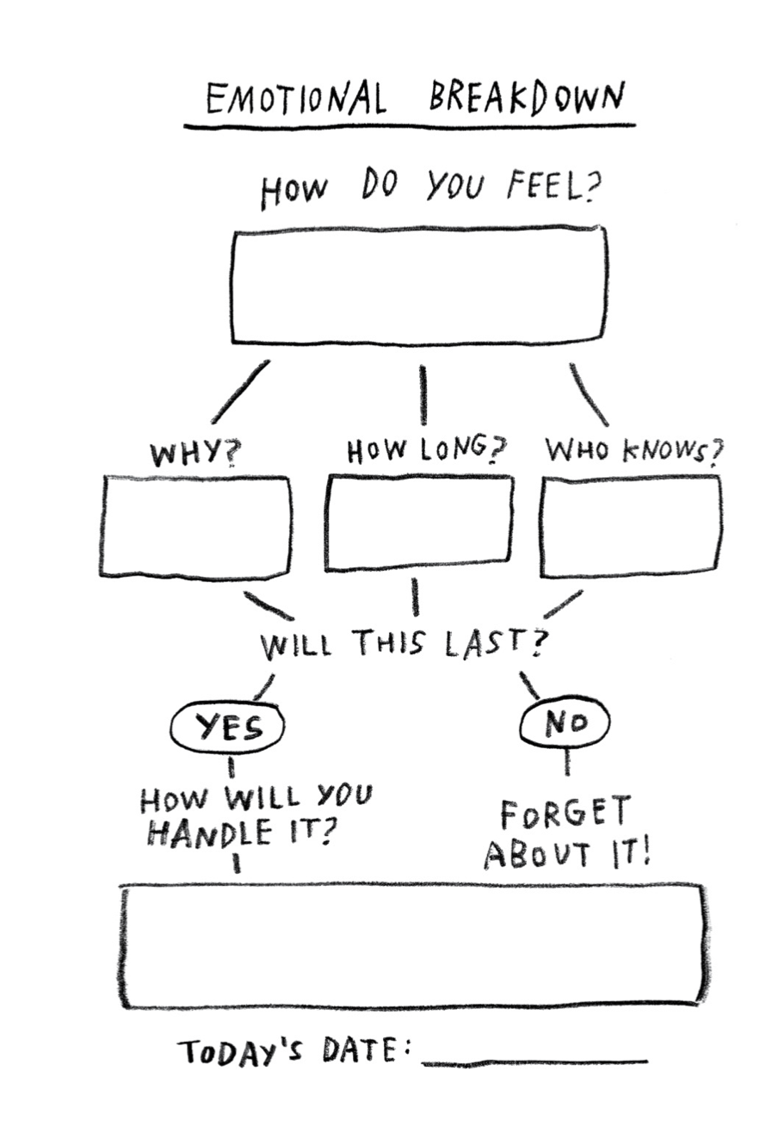

Day 3: Identity/Migration & Immigration
Math

What is this lesson about?: We will use African American migration data from 1910-1930 to learn about calculating percent change.

But first: Today’s Warm-Up
Last week a gallon of milk cost $3.00, this week it costs $3.45.
Did the price increase or decrease and by how much? Does this seem like a normal weekly fluctuation or is this abnormal?

(Hint: Think about what milk would cost in a couple of months if this type of price change continued)

Step 1/Activity 1: Calculating Price Change

Calculating price increases or decreases is fairly easy, just compare the current amount to the previous amount. If the price goes up, it is an increase. If the price goes down, it is a decrease.

Example #1: A Pre-paid cellular phone cost $100 last month, but this month it costs $80 (cellular phone costs continue to decline in our country).
- This is an example of a price decrease.
- By subtracting $80 from $100 we can see that the price decreased $20.

Your turn: Ostrich farms have been increasing in popularity over the past 20 years as people look for more sources of lean protein. You have decided to purchase 15 ostriches for $300 each. This seems like a good deal to you since last year they were priced at $400.

- How much you saved per ostrich and in total for your purchase.

Step 2/Activity 2: Converting decimals to percentages

To be able to calculate percent change, we will need to review converting decimals to percentages. All finite decimals can be converted to percentages, the simple rule is to move the decimal point 2 units to the right.

Example #1: Find what percentage is equivalent to .034.
- Move the decimal 1 unit to the right (now it is between the 0 and the 3)
- Move the decimal 1 more unit to the right (2 units total) and now it reads 03.4.
- Since we have completed the steps to converting to a percentage, we can rewrite 03.4 as 03.4%.
- Now, knock off that 0, there is never a need to start a quantity or price amount with a 0, unless you are stating a value of nothing.

Your Turn: Find which percentage is equivalent to 2.87.

Bonus- Can you figure out which decimal is equivalent to 18.5%?

Step 3/Activity 3: Calculating percentage change
Calculating percentage change requires finding the amount of change and dividing it by the original amount.

Percentage Change=$\frac{Amount of change}{Original amount}$

Example #1: - Using the example from our warm up, the price of a gallon of milk increased from $3.00 per gallon(original amount) to $3.45 per gallon(new amount).
- Using Step#1 we find the price increase(amount of change) to be $.45.
- Remember, Percentage Change=$\frac{Amount of change}{Original amount}$
$\frac{Amount of change}{Original amount}$=$\frac{\$.45}{\$3.00}$=.15
- Then convert .15 to a percentage by moving the decimal 2 units to the right and add the percentage sign, 15%.

Your Turn: You are at an all you can eat buffalo wing restaurant and just finished off 28 wings. Last week you were really hungry and ate 42 buffalo wings, impressive.
Please calculate the amount of change, whether it was an increase or a decrease and calculate the percent change.

Step 4/Activity 4: Using what we have learned.

In the early 1900s, many African American families moved from southern states north and west. This was called the Great Migration. There were lots of reasons for this, but one of them was because African Americans were fleeing the Jim Crow laws and ongoing racial terrorism of the south during these years.

The chart below shows the African American population of each state (20 of them) between 1910 and 1930, based on Census data. Column B is the population in 1910, Column C is the population in 1930.
Note, the numbers are rounded off.

Select 5 of the states below that you want to work with.

- Step 1:In Column A make a prediction about whether you think the population in that state went up or down during this 20 year period.

- Step 2: Go to Column D. Subtract the bigger number from the smaller number in Col. B and Col. D to show the difference in population from 1910 to 1930. Use a +/- to show if it is an increasing or decreasing number.

- Step 3: Calculate percentage change in Col. E. Remember the formula for calculating percentage change is to divide the amount of change by the original amount, then convert your decimal to a %.

Percentage Change=$\frac{Amount of change}{Original amount}$-→ then convert the decimal to a % by moving the decimal 2 units to the right

 | Col. A | Col. B | Col. C | Col.D | Col. E
State | Do you predict the African American population went up or down from 1910 to 1930?  +/- | What was the total number of African Americans in this state in 1910? | What was the total number of African Americansin this state in 1930? | Express the change in the African American population as a number. (+/-) | Express the change in the African American population as a percentage.  (+/-)
Alabama |  | 910,000 | 945,000
Arkansas |  | 443,000 | 479,000
Florida |  | 308,000 | 431,000
Georgia |  | 1,175,000 | 1,071,000
Illinois |  | 109,000 | 328,000
Indiana |  | 60,000 | 111,000
Kentucky |  | 261,000 | 226,000
Louisiana |  | 713,000 | 776,000
Massachusetts |  | 38,000 | 52,00
Michigan |  | 17,000 | 169,000
Minnesota |  | 7,000 | 9,000
Mississippi |  | 1,009,000 | 1,009,000
New Jersey |  | 89,000 | 208,000
New York |  | 134,000 | 412,000
North Carolina |  | 697,000 | 918,000
Pennsylvania |  | 193,000 | 431,000
South Carolina |  | 835,000 | 793,000
Tennessee |  | 473,000 | 477,000
Texas |  | 690,000 | 854,000
Virginia |  | 671,000 | 650,000

Comparing and Analyzing the Data

- Compare Col. A and Col.D in the five states you selected to work with. How many or your predictions were correct? Incorrect?

- Explain why you might have been wrong in some of your predictions. What did you incorrectly assume?

- Which state had the largest number of African Americans in 1910? 1930?

4. Which states had the smallest number of African-Americans in 1910? 1930?

5. Of the 5 states you selected, which states had the largest and smallest percentage changes in their African-American population from 1910 to 1930?

Short Answer Questions: Discuss as well, if permitted.

What state do you live in? Do you know what state you parents or your grandparents were born in? If your family has moved do you know why?

Were your parents or grandparents born outside of the US? If yes, what led them to the US?

How does where you were born, or where your family is from impact your identity?

Skill Builders and Review Problems
- Mean, Median and Mode

Student Feedback:

Circle the emojis that best represents how this activity made you feel.

Day 3: Digital Identity
Health

Step 1: Warm-up

How can my digital identity be a platform for the things I care about?

Step 2: What are sustainable development goals?

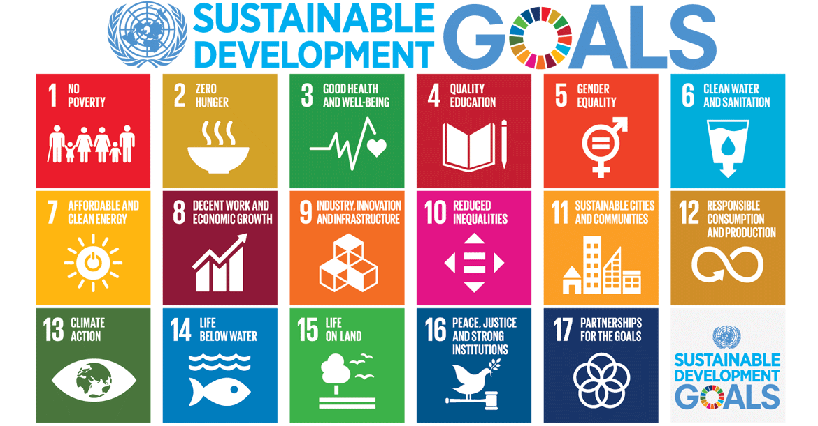

The Sustainable Development Goals are the blueprint to achieve a better and more sustainable future for all. They address the global challenges we face, including those related to poverty, inequality, climate change, environmental degradation, peace, and justice. The 17 Goals are all interconnected, and in order to leave no one behind, it is important that we achieve them all by 2030.

Step 3: What are your sustainable development goals?

Rank your top five sustainable development goals:

1.
2.
3.
4.
5.

Pick one goal and plan how you could use your digital identity to spread awareness.
Make a plan:

Student Feedback:
Circle the emojis that best represents how this activity made you feel.
Mindfulness Moment!
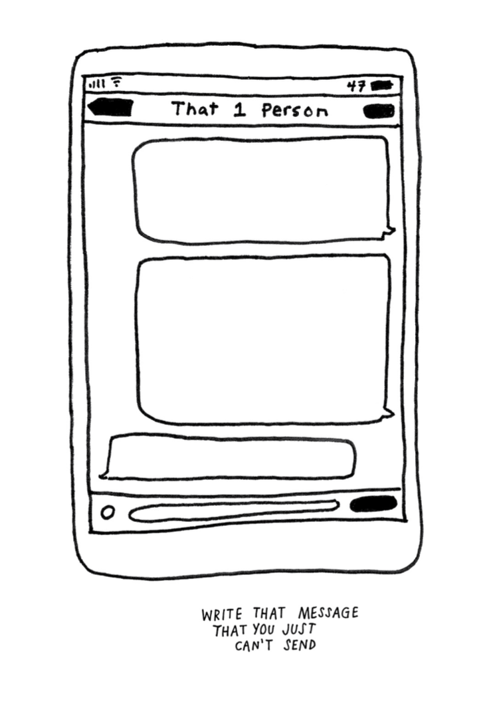

Day 3: Identified Voters
Social Studies
What is this lesson about?: In today’s lesson you will read about how identity impacts your right to vote.

Step 1: Read the article

Time Machine (1916): First Woman is Elected to Congress
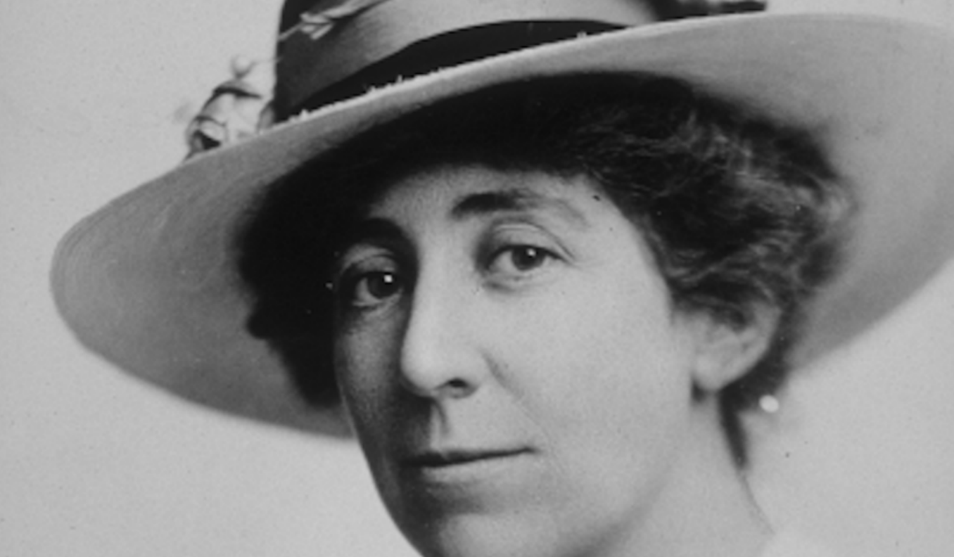

This article was first published in the Nov. 11, 1916, edition of the Public Ledger in Philadelphia, Pennsylvania. Jeannette Rankin became the first woman to hold national office in the United States. She was elected to the U.S. House of Representatives by the state of Montana. She worked to give women the right to vote in all elections. She was defeated in 1918 but re-elected to Congress in 1940. She was a pacifist, a person who is against all war. She voted against declaring war in 1917 and again in 1941. She also protested against the Vietnam War in the 1970s.

She is America's first "Congresswoman." Miss Jeannette Rankin of Missoula, Montana, has won the seat in Congress from her state. She defeated seven men and won by 7,000 votes. She will get a salary of $7,500 a year. Miss Rankin wants to go to Washington to help and serve women and children.

She wants laws that By Public Ledger, adapted by Newsela staff on 05.16.16 Word Count 643 Level 840L This article is available at 5 reading levels at https://newsela.com. would set up an eight-hour workday for women. She wants equal pay for women doing the same work done by men. Miss Rankin was sewing as she said this today. Even after entering politics, she still cooks and sews. Miss Rankin was calm as returns showed she was ahead in the voting. "I'm glad of this chance," was her comment when she was elected.

"I Won't Be The Last"

"Of course," said Miss Rankin today, "I know I'll be the first woman member of Congress, but I won't be the last." She believes she will be welcomed by the other congressmen. She knows they are against women having the right to vote, but she thinks she can get them to listen to her side. "This is not my campaign," she says. She explains that it is a campaign for all Montana women who wanted to have a woman working for them in Congress. Women of Montana say it is her energy, charming personality and wonderful work that brought the right to vote to the women of Montana.

Deserving Of Honor

Miss Belle Fligelman, of Helena, Montana, is also a tireless worker in the cause of women and voting rights, or suffrage. She calls Miss Rankin a "Wonder woman." She tells me Miss Rankin has given of herself, her money and her time for the cause of womankind. Now the women of Montana have rewarded her. They have sent her to Congress. Almost every women's group in the state of Montana came out to support Miss Rankin. Miss Fligelman said each woman voter knows, "If it weren't for Jeannette Rankin, I couldn't be voting at all." She added, "You see she was in charge of the suffrage campaign which swept Montana two years ago." The women won the right to vote on their first try. The women of Montana believe Miss Rankin will help their cause. A woman in Congress fighting for national suffrage can no longer be ignored by congressmen.

Men Could Learn From Her

Miss Fligelman describes Miss Rankin saying, "She is a keen thinker, a tremendous worker, and she has a thorough knowledge of work in Congress." Miss Fligelman explained that Miss Rankin spent years pushing for suffrage with lawmakers all over the country. She feels Miss Rankin knows more about how Congress works than the men in Congress today. She also supports a national law to ban alcohol, called Prohibition. Miss Rankin's Congressional work is also directed toward the little children of the nation. Pointing out this need, she talks about Congress setting aside $300,000 to pay for food for hogs. On the same day, $30,000 was set aside to help children. She argues that hogs are not 10 times more important than children. She worries that hundreds of men in Washington care about taxes and hogs. She wants to be the voice caring about more help for children.

Step 2: Answer the questions below

It is important that our lawmakers represent many different identities. Can you give an example from the article above of why it was important to have a woman’s perspective in Congress?

What role do you think voting plays in making sure that lawmakers identify with their community?

Step 3: Read the article

Maggie Flaherty was so upset that she was too young to cast a ballot against Donald Trump in the 2016 presidential election that one of her first missions when she arrived as a freshman at Dartmouth College in New Hampshire the following year was to register to vote.
Then the California native learned about a new proposal from state Republicans that would subject college students who vote in the state to residency requirements such as getting in-state driver’s licenses and vehicle registrations.

“That costs money,” said Flaherty, who along with a classmate and the American Civil Liberties Union sued the state after the law passed. “And I don’t think it should cost money to be able to vote.”
The fight in New Hampshire is one of at least a dozen legal skirmishes being waged across the country, in the run-up to the 2020 election, that are financed by Democrats and liberal activists who hope to overturn or head off measures they fear could erode the electoral might of young voters — an increasingly left-leaning voting bloc.

Over the past decade, Republicans in more than a dozen states have tried to limit the kinds of student IDs that can be used at the polls, restricted the number of polling locations on or near college campuses, or gerrymandered political boundaries that divide campuses and dilute the power of student voters, as well as other measures.

Among the states with laws that Democrats fear could hamper the youth vote in 2020 are battlegrounds including Wisconsin, Florida and New Hampshire.

Republicans say the rules are meant to prevent fraud and safeguard the integrity of elections, and they deny accusations that they are trying to make it harder for young people to vote.
But there is little doubt that Democrats had more to gain when young voters engaged in recent elections. Voters under 30 turned out in record numbers last fall, helping to power a liberal wave that swept Democrats into power in Congress.

At the same time, that age group still cast ballots at far lower rates than all others. Voting-rights activists believe one reason is a slew of restrictions pushed by GOP state leaders in recent years.
Democrats and their allies are planning to spend millions of dollars on lawsuits arguing that such measures are unconstitutional and aimed at dissuading the participation of young voters.

“Elections are oftentimes a game of inches,” said Marc Elias, a Democratic lawyer in Washington who is leading many of the challenges. “Young voters, particularly given the size of the millennial generation, can be measured in feet or yards. The difference of one percentage point here or there can be the difference between victory and loss.”

Step 4: Answer questions.

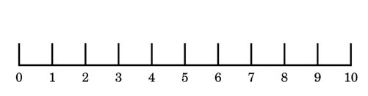

On a scale of 1-10 share how important your right to vote is to you. Why?

Step 5: Review the political cartoons around voting.
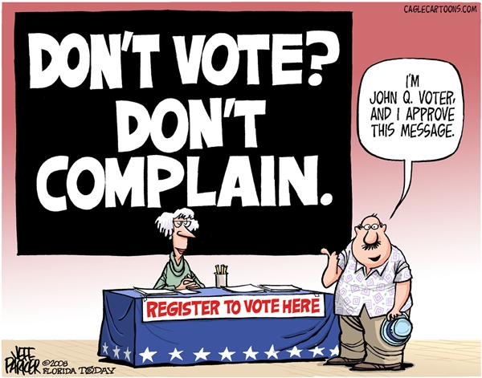
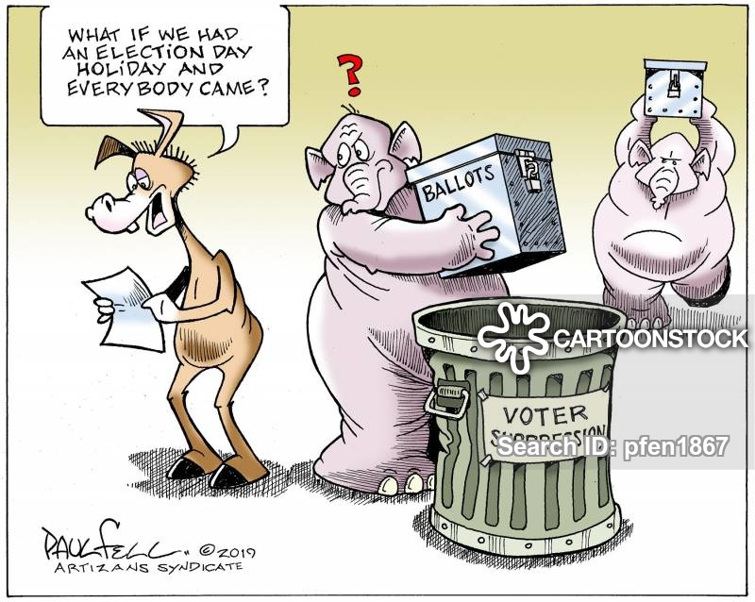

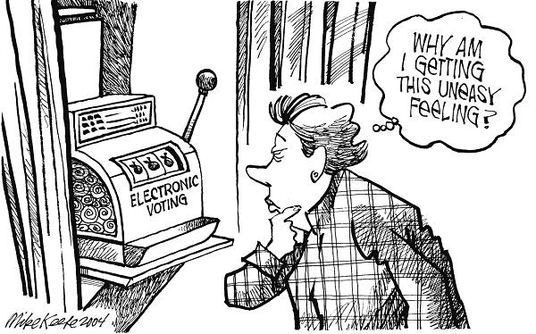
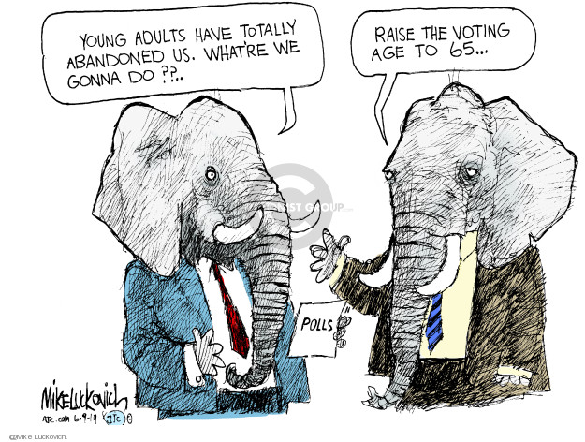

Step 6: Design your own political cartoon about a challenge with voting.

Student Feedback:
Circle the emojis that best represents how this activity made you feel.

