Week 1
Strength

NAME:______________________

Day 1 Agenda

Topic | Activity
Warm-Up!
English Language Arts | - Read letter from Frederick Douglass to Harriet Tubman  - Read a song about Harriet Tubman called “Stand Up”  - Respond to questions about the letter and song
Science | - Read about the different types of bridges and what is considered when designing them  - Answer questions about bridge designs  - Sketch a bridge that you believe would be strong
Mindfulness Moment!
Math | - Read examples of how strong people adopt a growth mindset  - Complete a series of problems and exercises related to the growth mindset  - Create a poster or a 8”x11” staying strong using growth mindset flyer
Mindfulness Moment!
Civics/Social Studies | - Read an article about the start of WWI  - Answer questions about the article

Warm-up Activity: Write a journal entry around the daily quote on strength.
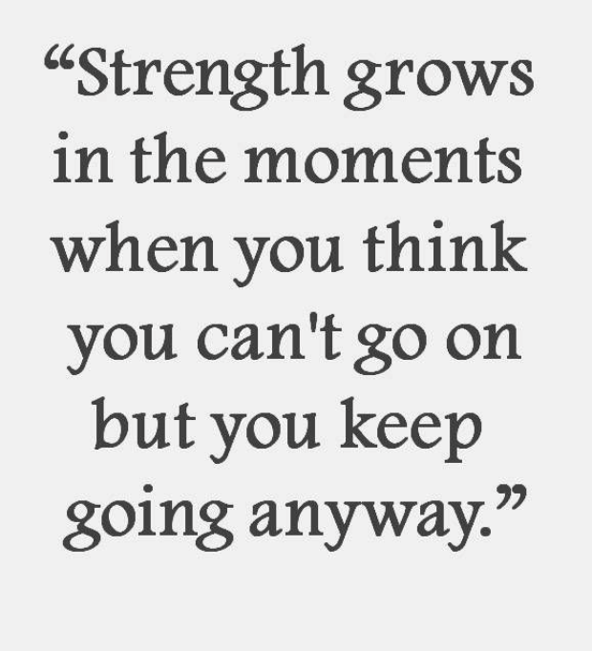

Day 1: English Language Arts
Strong Women

What is this lesson about?: Over the next three days, in honor of March being Women’s History Month, you will be reading about three women who showed strength, bravery, and courage during times of societal challenges and situations they could not control. Today, you will have the opportunity to learn about Harriet Tubman and how people view her actions and work during the civil war. You’ll reflect on Tubman’s actions and strength, and consider what strengths you bring to the table.

Step 1: Read the letter below.
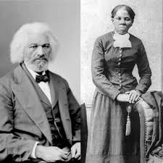
In 1869, Sarah Hopkins Bradford published a biography called Scenes in the Life of Harriet Tubman. Harriet Tubman was an abolitionist who helped slaves escape through the Underground Railroad. She often worked with fellow abolitionist Frederick Douglass, a public speaker and author. When Harriet Tubman reached out to Frederick Douglass requesting he speak to her accomplishments and write a commendation letter to include in the biography, he responded with this letter. As you read, pay attention to how Frederick Douglass defines private and public accomplishments and how Douglass characterizes Tubman. (footnotes have been provided below for important vocabulary words)

Rochester, August 29, 1868

Dear Harriet:

I am glad to know that the story of your eventful life has been written by a kind lady, and that the same is soon to be published. You ask for what you do not need when you call upon me for a word of commendation.¹ I need such words from you far more than you can need them from me, especially where your superior labors and devotion to the cause of the lately enslaved of our land are known as I know them. The difference between us is very marked.² Most that I have done and suffered in the service of our cause has been in public, and I have received much encouragement at every step of the way. You, on the other hand, have labored in a private way. I have wrought³ in the day – you in the night. I have had the applause of the crowd and the satisfaction that comes of being approved by the multitude⁴, while the most that you have done has been witnessed by a few trembling, scarred, and foot-sore bondmen⁵ and women, whom you have led out of the house of bondage, and whose heartfelt, “God bless you,” has been your only reward. The midnight sky and the silent stars have been the witnesses of your devotion to freedom and of your heroism. Excepting John Brown⁶ – of sacred memory – I know of no one who has willingly encountered more perils and hardships to serve our enslaved people than you have. Much that you have done would seem improbable to those who do not know you as I know you. It is to me a great pleasure and a great privilege to bear testimony for your character and your works, and to say to those to whom you may come, that I regard you in every way truthful and trustworthy.

Your friend,
Frederick Douglass

Footnotes
- Commendation (noun): praise
- Marked (adjective): noticeable, visible, or evident
- Wrought (verb, past tense): worked
- Multitude (noun): a great number of people
- A “Bondman” is an old term for “slave.”
- John Brown was an American abolitionist who Harriet Tubman was working with to start a liberation movement among enslaved African Americans in Virginia. The plan failed and Brown was hanged after being found guilty of treason, the murder of five men, and instigating a slave revolt.

Step 2: Answer the following questions.

Who wrote this letter, to whom was it written, and why was it written?

In the third sentence of the letter, the author states, “I need such words from you far more than you can need them from me, especially where your superior labors and devotion to the cause of the lately enslaved of our land are known as I know them.” What is the writer saying in this sentence?

The author uses this sentence: “The difference between us is very marked.” This term means noticeable, visible, or evident. What does Douglass say are the marked
differences between his and Tubman’s actions and their rewards? Use the graph below to organize your answer.

 | Harriet Tubman | Frederick Douglass
Actions (what type of work did this person do for the abolitionist movement?)
Rewards (How was this person rewarded or recognized for their efforts?)

Many people would describe Harriet Tubman as a strong person. Do you think Fredrick Douglass would agree with that statement? Do you agree? If so, what makes Tubman a strong person?

Harriet Tubman asked Frederick Douglass for a commendation letter to include in her biography, and this is the letter he wrote back to her. Who would you ask to write a letter of support for you?

What do you think that person would write about your strengths and accomplishments?

Step 3: Read the lyrics to the following song.

In November 2019, a movie was released about Harriet Tubman. Actress and Singer Cynthia Erivo plays Tubman in the movie and was nominated for an Oscar award for her performance. She also wrote and performed a song, “Stand Up”, for the movie, which was nominated for an Oscar. Below are the lyrics to the song.

I been walkin' with my face turned to the sun
Weight on my shoulders, bullet in my gun
Oh, I got eyes in the back of my head just in case I have to run
I do what I can when I can while I can for my people
While the clouds roll back and the stars fill the night

That's when I'm gonna stand up
Take my people with me
Together we are going to a brand new home
Far across the river
Can you hear freedom calling?
Calling me to answer
Gonna keep on keepin' on
I can feel it in my bones

Early in the mornin' before the sun begins to shine
Gonna start movin' towards that separating line
I'm wading through muddy waters, you know I got a made-up mind
And I don't mind if I lose any blood on the way to salvation
And I'll fight with the strength that I got until I die
So I'm gonna stand up
Take my people with me
Together we are going to a brand new home
Far across the river
Can you hear freedom calling?
Calling me to answer
Gonna keep on keepin' on

And I know what's around the bend
Might be hard to face 'cause I'm alone
And I just might fail, but Lord knows I tried
Sure as stars fill up the sky

Stand up
Take my people with me
Together we are going to a brand new home
Far across the river
Can you hear freedom calling?
Calling me to answer
Gonna keep on keepin' on

I'm gonna stand up
Take my people with me
Together we are going to a brand new home
Far across the river
Do you hear freedom calling?
Calling me to answer
Gonna keep on keepin' on

I'm gonna stand up
Take my people with me
Together we are going to a brand new home
Far across the river
I hear freedom calling?
Calling me to answer
Gonna keep on keepin' on
I can feel it in my bones
I go to prepare a place for you

Step 4: Answer the following questions

Who is the narrator of this song (from whose point of view is the song written)?

What is the tone of this song? How does this song make you feel?

What do you think the songwriter wants you to feel after listening to or reading these lyrics?

At one point, the lyrics say “ And I'll fight with the strength that I got until I die.” List 3 examples that the songwriter includes to show the strength and bravery of Harriet Tubman?

Harriet Tubman was strong for other people. She inspired others to be strong and brave. How have you been strong for others or showed people to be brave?

The song ends with the line “I go to prepare a place for you,” which are the final words Tubman uttered when she died in 1913. Why do you think these words are important?

What did Tubman mean when she said those last words?

If you could choose an artist to write and perform a song about you, who would you choose?

Step 5: Share your responses with a partner

With a classmate, discuss your answers to the following questions.
- What did you both notice about the differences in the actions Tubman and Douglass took during the abolitionist movement?
- Did the song make you feel the same way?
- How do you both think Harriet Tubman showed her strength?
- Who did you both want to write your commendation letter and song about you?

Student Feedback:

Circle the emojis that best represents how this activity made you feel.

Day 1: Science
Bridges

What is this lesson about?: Today you will begin to explore the different types of bridges that exist in today’s world. You will hypothesize about how to make bridges stronger, which we will revisit in lessons later in the week.

Step 1: Consider the following photos and make some predictions.

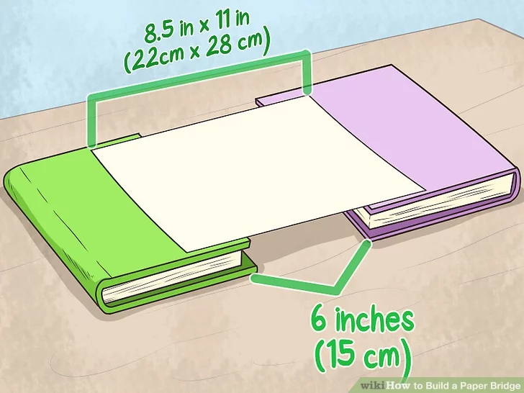
The image shows a piece of paper sitting on top of two books. What do you think would happen if you put a pencil in the middle of the piece of paper?

What do you think would happen if you placed two pencils on the piece of paper? Would something different happen than before?

What if you placed 5 pennies on the piece of paper?

Is there anything you could do to the piece of paper to make it a stronger bridge, so that more weight could be placed on it, without it collapsing?

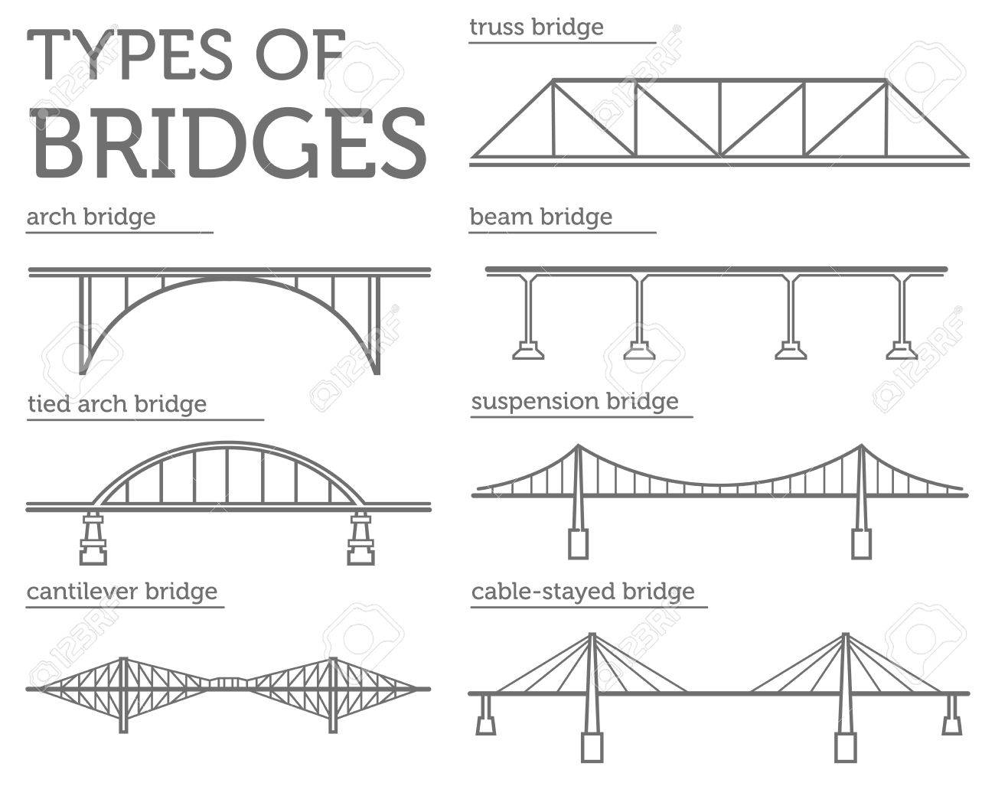

Which type of bridge have you seen before?

Which of these bridges might be easier to build?

Which of these might be the strongest bridges? What makes you think so?

Step 2: Read about the different factors engineers consider when building a bridge.

Tension and Compression: Two Forces Every Bridge Knows Well

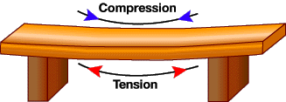
Tension: What happens to a rope during a game of tug-of-war? Correct, it undergoes tension from the two sweaty opposing teams pulling on it. This force also acts on bridge structures, resulting in tensional stress.
Compression: What happens when you push down on a spring and collapse it? That's right, you compress it, and by squishing it, you shorten its length. Compressional stress, therefore, is the opposite of tensional stress.
Compression and tension are present in all bridges, and as illustrated, they are both capable of damaging part of the bridge as varying load weights and other forces act on the structure. It's the job of the bridge design to handle these forces without buckling or snapping.
Buckling occurs when compression overcomes an object's ability to endure that force. Snapping is what happens when tension surpasses an object's ability to handle the lengthening force.
How would you describe what tension is to a 5-year-old?

Provide an example of when something snaps as a result of too much force?

If a bridge is able to withstand tension and compression of its traffic load, is the bridge strong or weak?

Building Bridges

When building a bridge, engineers must consider a number of factors. Different bridge styles distribute stresses in different ways. Engineers must take the length and width of the bridge, local environmental conditions and building materials into account to decide what type of bridge to build. To know what kind of bridge is realistic for what environment, knowing about the 6 different types of bridges is important. Using the wrong type can result in disasters affecting travel and safety.

Arch as Simple Bridge
Arch bridges use arches as the main structural component. The arches put the material that make up the bridge into compression. Most arch bridges are made of steel or concrete, which are good for compression. Arch bridges include those where the arch is underneath the bridge and above it. The Hell Gate Bridge in New York is an example of an arch bridge.

Basic Beam Bridge Construction
Beam bridges are made of a flat piece, or beam, laid across two or more supports. In the beam – which is horizontal - part of the material is in tension and part of the material is in compression. Beam bridges work much like a log overlapping the two sides of a ravine. An example of a beam bridge is the Lake Pontchartrain Causeway in southern Louisiana.

Cable-Stayed Bridge Structures
Cable-stayed bridges are one of two bridge types preferred for longer bridges (the other being suspension bridges). Columns are erected as support with cables to support the deck of the bridge. The design is similar to a suspension bridge but instead of the deck being curved, it is flat. In New York City, the East 153rd Street Bridge is a cable-stayed bridge.

Cantilevered Bridge Types
Kinds of bridges also include cantilevered bridges which are built around horizontal structures supported on only one end. Some cantilevered bridges are very similar in appearance to arch bridges; however, they are supported by diagonal bracing rather than vertical bracing. These types of cantilevered bridges are known as spandrel braced. The other type of cantilevered bridge is the cantilever through truss formation, where trusses are either above the bridge or both above and below. An example of a cantilevered bridge is the Queensboro Bridge.

Suspension Design Bridges
A suspension bridge is made of a platform that is held up by wires or ropes strung from the tops of piers. More recent suspension bridges use steel plates and steel cables that put material into tension. Steel is used for suspension bridges, because steel is strong in tension and concrete is not. With only the supports in the ground, suspension bridges respond to wind and traffic. Some of the most famous examples of suspension bridges are Golden Gate Bridge in San Francisco, Akashi Kaikyō Bridge in Japan and Brooklyn Bridge in New York City.
Truss Bridge
A truss bridge has a structure composed of elements connected to form triangles. Usually made of steel bars, truss bridges use a combination of compression and tension forces. The truss bridge is a simple bridge design that includes most covered bridges. T New York's Kosciuszco Bridge is a truss bridge example.

Step 3: Answer the following questions.
Why are different bridge designs used?

What bridge design is best? Why? Are different bridge designs better for different situations?

Label the type of bridge in the pictures below.
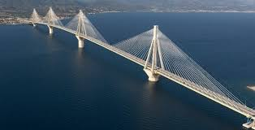Type of bridge__________________
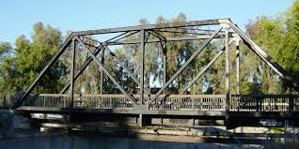Type of bridge__________________
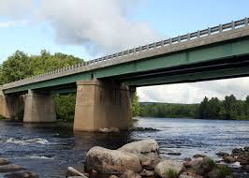Type of bridge_______________________
Step 4: Sketch the type of bridge you think is the strongest

Make a sketch of the type of bridge you think is the strongest. Get creative and include your own design elements!

Student Feedback:

Circle the emojis that best represents how this activity made you feel.

Mindfulness Moment!
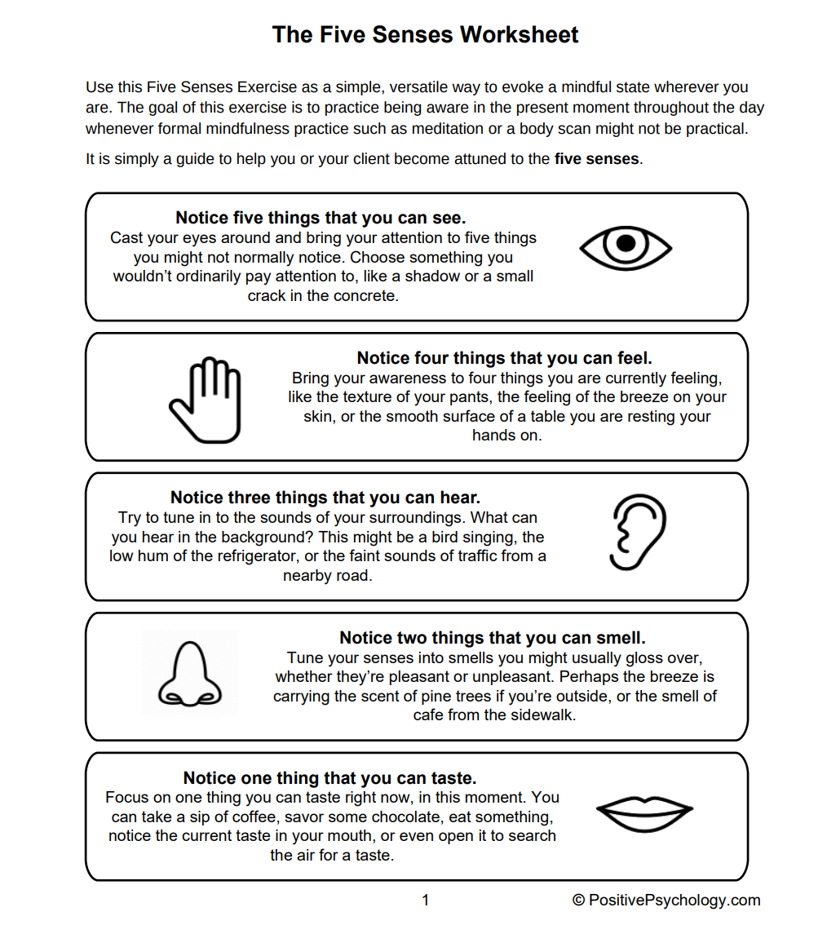

Day 1: Math
Increasing Your Strength: Adopting a Growth Mindset

What is this lesson about?: For this lesson, you will have the chance to learn about the Growth Mindset. You will then brainstorm ways to build up your strength and put that Growth Mindset to work for you and your peers over the next few weeks.

First, take a few minutes for today’s warm up:

Take a few minutes to answer questions below.
On a scale of 1 to 10, how do you rate your math skills? (1 is not good, 10 is great!)

What is one math skill that you would like to improve?

What is one math skill that you think you could help one of your peers or classmates with?

What is one mathematical ‘concept’ that you think would help you in real life, if any?

Step 1: Read and answer.
Read each of the statements below and write down a short answer. Your answer can be just a few words for each one, Once you have answered the questions, talk about them for a few minutes with other students, if you are permitted.
What is something that you are good at or that you are proud of that you can do well now, but that you couldn’t do when you were a little kid?

How did you get ‘good’ at this? What did you do to become good at it? Or did it just happen out of the blue? How did you become ‘stronger’ at it?

Discussion: Share your answers with a classmate or your teacher, if permitted.
Step 2: Answer the questions below.
Answer the questions below once again. Once you have answered the questions, talk about them for a few minutes with other students, if you are permitted.

Write an answer to each question below

6 - 3 = ___

21 + 8 = ___

44 - 9 = ___

How would you rate these three problems? Easy or Hard (circle one)

About how old were you when you learned how to answer those questions?

How did you learn how to do those problems?

Did you know how to do them when you were a baby?

Discuss: How do you get better at things?

Step 3: Read the quotes from Michael Jordan and answer the questions.

"I've missed more than 9,000 shots in my career. I've lost almost 300 games. Twenty-six times, I've been trusted to take the game winning shot and missed. I've failed over and over and over again in my life.”

“People used to say that all I could do was dunk, that my jump shot was no good. They were kind of right. Until I proved them wrong. Until I started shooting hundreds of jumps shots a day, from all angles, with defenders all over me. I still missed some, but not much!”

Many people think Michael Jordan is the greatest basketball player of all time.

Do you think he considers himself a failure or a success?

How did he become successful?

What does he say about failing? Did failing or missing clutch shots stop him?
What did those failures do to him?

What was a challenge that he faced as a basketball player?

How did he overcome it?

Discuss your answers with a classmate or your teacher, if permitted.

Step 4: Growth Mindset - Making it Personal

A “growth mindset” means that you don’t let your present situation define you. You get stronger and stronger by trying, and failing.

A growth mindset means that you don’t limit yourself to what you can do easily, right now. It means that you decide that if you want to get better or if you want to overcome an obstacle, you can.

A growth mindset means that you know that it will take practice, that you will make mistakes, but that you can and will improve--if you try and don’t quit.

Write down something you want to get better at.

Write down what you will need to do to get better at it.

Write down what is most challenging about your present situation--about being locked up right now.

What can you do to overcome that challenge or not make that challenge define you?

Discussion: Share your answers with your classmates or teacher, if permitted.

Step 5: Creating your own Growth Mindset Mantra

In the space below, either write out a quote or draw or sketch out your own Personal Growth Mindset Mantra. Ask your teacher if you can tape this paper up on the wall of the classroom or on your unit, or in your room.

Name:

The challenge I am facing:

How I am going to overcome it:

What I will do if I experience a failure along the way:

Student Feedback:

Circle the emojis that best represents how this activity made you feel.
Mindfulness Moment!
Use the diagrams below to help focus on and deepen your breathing. Using your finger, trace along the shape as you breathe in and breath out.
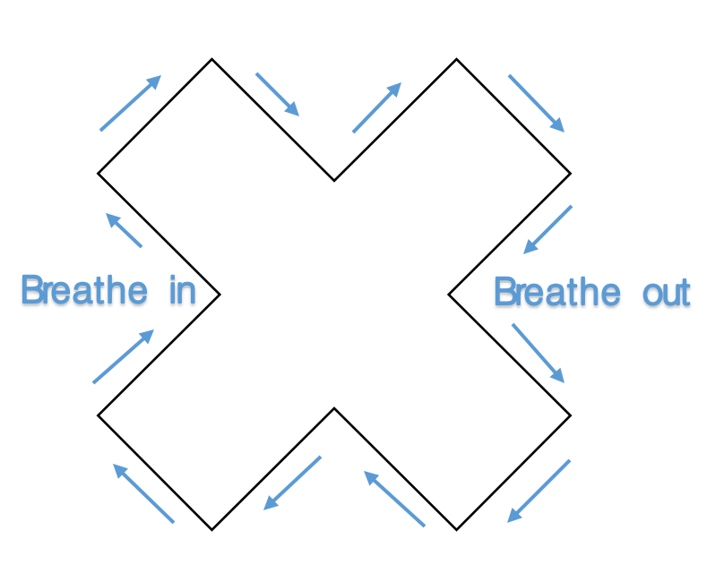
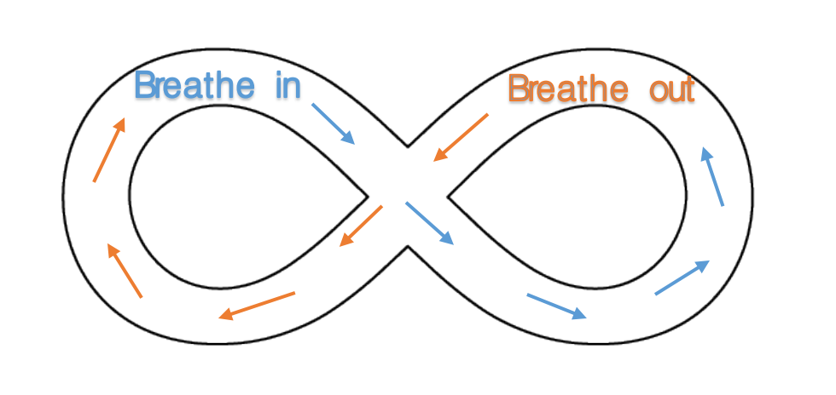
Day 1: Civics/Social Studies
World War I

What is this lesson about?: In this lesson, you will read an article about the start of WWI. You will use this article to answer a question about whether or not you think this war could have been prevented. Then, you will write a letter from the perspective of a WWI soldier.

Step 1: Read the following article.

Time Machine (1914): Assassination of Archduke Ferdinand Starts WWI
On June 28, the Archduke Franz Ferdinand of Austria-Hungary was assassinated. He was traveling by car through the streets of Sarajevo when a young man named Gabriel Prinzip shot and killed him.

Europe Hurtles Toward War
The assassination created a political crisis, and, as a result, war is now breaking out across Europe.
Prinzip was part of a group of Serbians fighting for greater independence from Austria- Hungary. Some Serbians see Austria-Hungary as an oppressive foreign power and believe that they deserve more political freedom. For Prinzip, killing the archduke was a political act meant to achieve freedom for Serbia.
The government of Austria-Hungary, however, was enraged by the assassination, and 25 days later, it sent a note of demands to the Serbian government. The note accused Serbia of helping Prinzip carry out the assassination.
Meet These Demands Now!
Austria-Hungary presented the Serbian government with several demands. The government had to publicly oppose the anti-Austria-Hungary movement and make it against the law to say or write things against Austria-Hungary.
Serbia was given just 48 hours to meet these demands. If Serbia was unwilling, Austria-Hungary would declare war.
Such a war could draw in all of Europe given the continent's delicate balance of power. The countries of Europe have entered into a complicated set of agreements. Germany has promised to defend Austria-Hungary, and Russia has pledged to protect Serbia. So, as Austria-Hungary and Serbia prepared to fight following the assassination of the archduke, so too did Germany and Russia. When Germany began gearing up for war, its rivals France and Great Britain did as well.

Serbia Pulls Russia In
What started as a dispute over Serbian independence is now set to pull all of Europe into war. It is as if Europe had been resting on a pile of explosives, and Prinzip lit a match.
On the night of July 23, a few weeks after the assassination, government workers in Russia received a message from Serbia.
"Help!" it said.
The Russians talked about the message for four hours. Russia was Serbia's ally, but taking their side in the conflict with Austria-Hungary meant risking war with Germany. The Russians reached a secret decision at 7 o'clock in the evening and dashed off in their automobiles to their various offices, each doing his part to prepare for what was coming.
Armies Move Toward Battle
Meanwhile, the armies of Europe were already getting ready to fight.
Serbia's 48 hours were up on July 26 at 6 in the evening. By that time, the Russian army was moving toward Germany, and the German army was moving toward Russia, and in a dozen other different directions.
Prinzip's bullet set all that in motion. It ignited the explosives under Europe, and the fire about to break loose will probably kill a million men. This war may create more destruction than anything else that has ever happened to human beings.
An Assassin's Screed
Did Prinzip know what he was doing when he pulled the trigger? We cannot know for sure. According to the Serbian government, following the assassination, Prinzip said:
"I was not influenced by any other person or persons. The reading of anarchist literature made me believe that there could be nothing finer in the world than to be an assassin. When in Belgrade I read that the Archduke was going to Serajevo, and so I bought a revolver and went there."
Was War Unavoidable?
What he said or thought matters little now, though. Europe is not fighting because Prinzip is a murderer. The real reasons for the war have to do with the long and ancient quarrel for "a place in the sun," a place for each European nation to put its feet in the crowded land. This quarrel has suddenly been turned from a contest of words and into a war of nations.
Perhaps war was unavoidable. Some jolt would have set off the European explosion, at some time. It just happened that Prinzip's bullet did it.

Step 2: Answer the questions below about the article.
Do you think the outbreak of World War I could have been avoided if Archduke Ferdinand had not been assassinated? Why or why not?

The article mentions that Russia was Serbia’s “ally.” What does it mean to be an ally? How might Russia be expected to act if it is Serbia’s ally?

How does creating an alliance make a country stronger?

Do you have any alliances or friendships that make you stronger? How do they make you stronger?

The article states “The real reasons for the war have to do with the long and ancient quarrel for "a place in the sun," a place for each European nation to put its feet in the crowded land.” What do you think this means? What is it that the European countries wanted?

“Imperialism” is when a country wants to expand its power and influence through diplomacy or military actions. Do you think European countries had goals of imperialism during the time of WWI? Why?

Step 3: Read this primary source letter from a soldier in WWI.
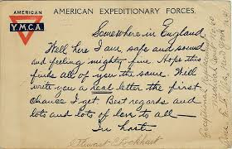

Somewhere in England. Well here I am, safe and sound and feeling mighty fine. Hope this finds all of you the same. Will write you a real letter the first chance I get. But regards and lots and lots of love to all-

What is the tone of this letter? Is it upbeat/happy? Or is it sad/scary?

Why do you think soldiers had to show strength in the letters they wrote home to their families?

Step 4: Write your own letter.
Imagine you are a soldier stationed in England during WWI. Write a letter to your family and give them the strength they need to get through this tough time.
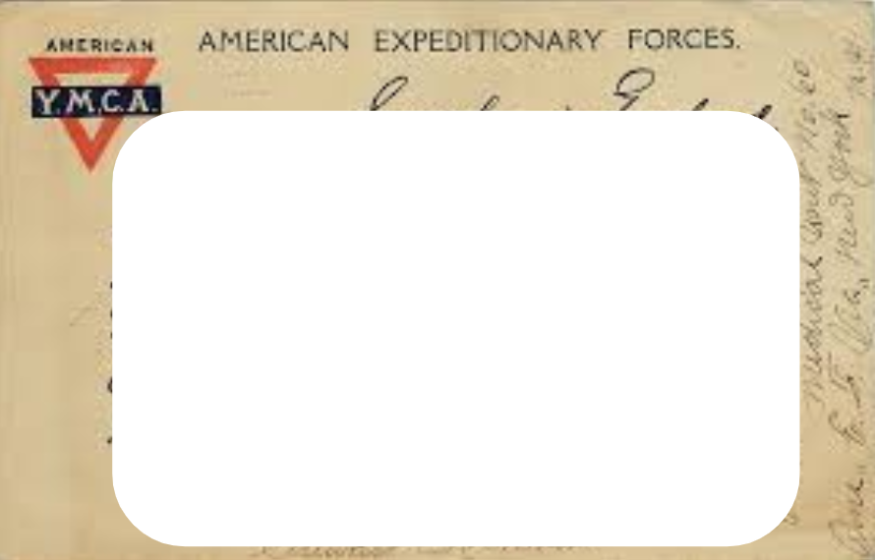
Student Feedback:

Circle the emojis that best represents how this activity made you feel.

Creative Activities: Google Doodle
This year’s Google Doodle theme is to show kindness by…Design your own Google Logo and participate in a school-wide contest. See some examples below.
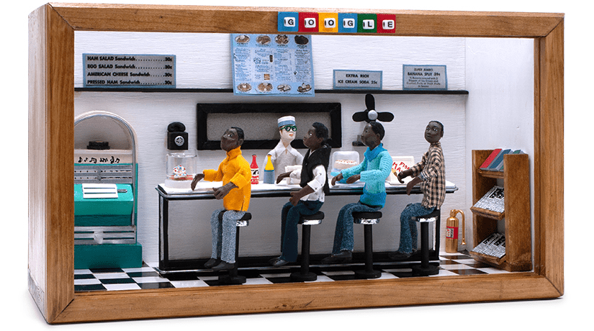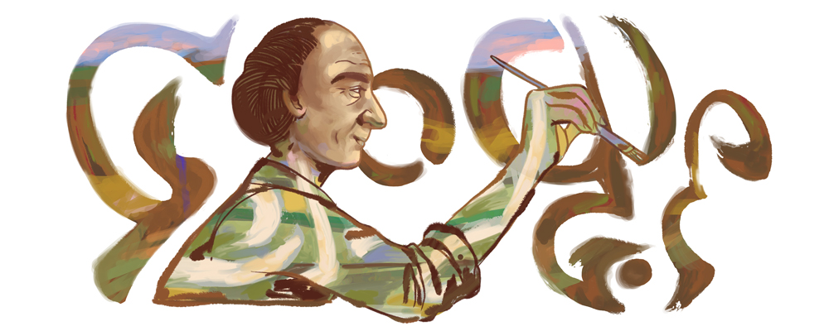

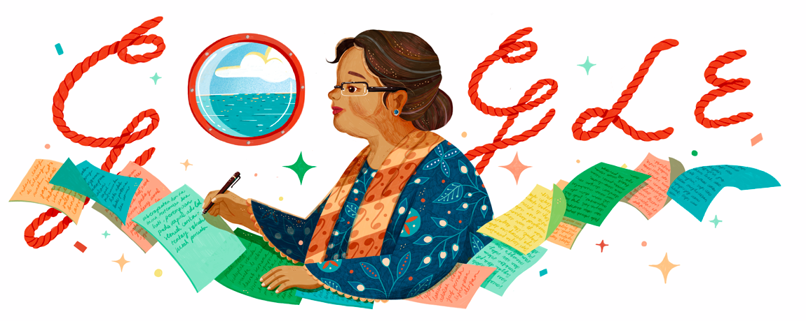

Draw Your Art Here:

Day 2 Agenda

Topic | Activity
Warm-Up!
English Language Arts | - Read a short bio about Frances Harper as well as a short speech she gave  - Respond to questions about the readings  - Prepare a short story to share as a speech
Science | - Design your own bridge and test its strength
Mindfulness Moment!
Math | - Understanding the difference between increase or decrease and percentage increase and decrease
Mindfulness Moment!
Civics/Social Studies | - Read an article about the aftermath of WWI in Europe  - Answer questions about the article
Warm-up Activity: Write a journal entry around the daily quote on strength.
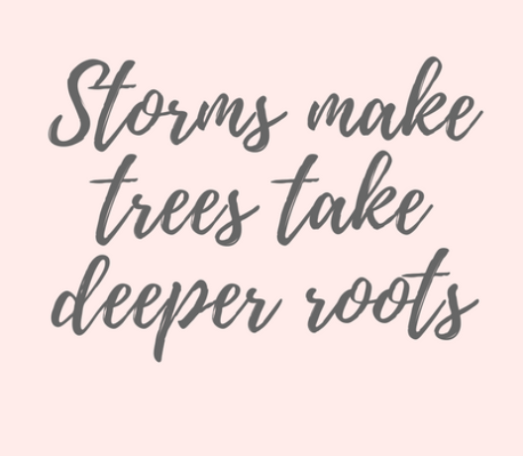

Day 2: English Language Arts
Strong Women

What is this lesson about?: Today you will continue our series on strong women, in line with Women’s History Month. You will learn about Frances Harper, a 19th-century black woman activist who struggled against segregation, you will learn about her work to encourage others to stand up to segregation, and you will analyze part of a speech she gave. You will then have an opportunity to write a speech to encourage people to take action around an issue you care about.

Step 1: Read the following text.
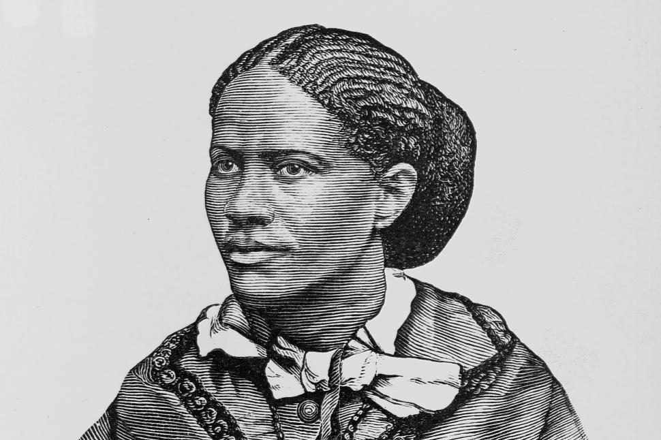
Born free in Baltimore in 1824, Frances Watkins taught at Wilberforce University, lectured for the Maine Anti-Slavery society before the Civil War and collaborated extensively with white suffragists and abolitionists. She married Fenton Harper in 1860 and, until her husband died in 1864, attempted to run a small farm in Ohio. His death left her with a young daughter and very few financial resources. She began a new lecture tour in the South, addressing audiences of freed slaves, and continued to speak at woman suffrage conventions, where her audience was primarily white. Already the best-known and loved African American poet of her time, Harper also began writing novels in 1869.

Harper’s first novel, Minnie’s Sacrifice, tells the story of a young woman from a wealthy family who leaves home to teach the children of former slaves. The heroine, Minnie, gets lynched by the Ku Klux Klan, sacrificing her life for her people. While Harper wrote this novel, she was teaching in the South and often threatened by former slave traders, “rebels” and the Klan. Although Harper, like Minnie, was in grave danger, she wrote letters to Northern friends repeatedly reassuring them that she was not afraid.

Like Rosa Parks who followed her, Harper rarely seemed afraid. In an April 23, 1858, letter she wrote to the Liberator, an anti-slavery newspaper, Harper described her reaction to segregation on public transportation:

I have been insulted on several railroad cars. The other day, in attempting to ride in one of the city cars, after I had entered, the conductor came to me, and wanted me to go out on the platform. Now, was not that brave and noble? As a matter of course, I did not. Some one interfered, and asked or requested that I might be permitted to sit in a corner. I did not move, but kept the same seat. When I was about to leave, he refused my money, and I threw it down on the car floor, and got out, after I had ridden as far as I wished. Such impudence!
Step 2: Answer the following questions

Below are two inferences from the text. Circle one of the inferences. Then cite two lines from the text that support that inference.

Inference | Frances Harper was a strong individual who fought for what she believed in.
 | After the Civil War African Americans faced prejudice and discrimination but showed great perseverance.

Line 1:

Line 2:

The passage notes that although Harper “was in grave danger, she wrote letters to Northern friends repeatedly reassuring them that she was not afraid.” Why do you think Harper did this?

In one of her poems, Harper writes:
Let me make the songs for the weary,
Amid life’s fever and fret,
Till hearts shall relax their tension,
And careworn brows forget.

What is the message of this poem stanza?

How is the message of this poem similar to the message of the letters she wrote to friends reassuring them that she was not afraid?

Do you think Frances Harper was a strong woman? Why or why not?

What part of her life story do you identify or relate to most? How are you similar to Frances Harper?

Step 3: Read the following text.

Excerpt from “We Are All Bound up Together: Proceedings of the Eleventh Women’s Rights Convention,” May 1866, pages 45-48. Below is an excerpt from Frances Harper’s speech at a women’s convention.

Frances Watkins Harper — “You white women speak here of rights. I speak of wrongs. I, as a colored woman, have had in this country an education which has made me feel as if I were in the situation of Ishmael, my hand against every man, and every man’s hand against me. Let me go to-morrow morning and take my seat in one of your street cars — I do not know what they will do it in New York, but they will in Philadelphia — and the conductor will put up his hand and stop the car rather than let me ride.”

A Lady [from the audience] — “They will not do that here.”

Mrs. Harper — “They do in Philadelphia. Going from Washington to Baltimore this Spring, they put me in the smoking car.”

Loud Voices [from the audience] — “Shame.”

Mrs. Harper — “Aye, in the capital of the nation, where the black man consecrated himself to the nation’s defense, faithful when the white man was faithless, they put me in the smoking car! They did it once; but the next time they tried it, they failed; for I would not go in. I felt the fight in me; but I don’t want to have to fight all the time. To-day I am puzzled where to make my home. I would like to make it in Philadelphia, near my own friends and relations, but if I want to ride in the streets of Philadelphia, they send me to ride on the platform with the driver.”

Cries [from the audience] — “Shame.”

Mrs. Harper — “Have women nothing to do with this? Not long since, a colored woman took her seat in an Eleventh Street car in Philadelphia, and the conductor stopped the car, and told the rest of the passengers to get out, and left the car with her in it alone, when they took it back to the station. One day I took my seat in a car, and the conductor came to me and told me to take another seat. I just screamed “murder.” The man said if I was black I ought to behave myself. I knew that if he was white he was not behaving himself. Are there not wrongs to be righted?”

Step 4: Answer the following questions.

According to Harper, black women had to endure social “wrongs” as well as demand “rights.” What does her streetcar story tell us about the way white men and women saw black women?

Harper says “I felt the fight in me; but I don’t want to have to fight all the time. Today I am puzzled where to make my home.” What is Harper implying here? The way she is being treated is preventing her from doing what?

Why does the audience cry out, “Shame,” while Harper speaks?

Who do you think the audience believes should be ashamed?

What do you think Harper wanted to accomplish by giving this speech?

Step 4: Prepare a short story to share as a speech.

Frances Harper shared personal experiences to shed light on injustices and encourage people to take action against wrongdoings. Each of us has personal experiences we can share to help others see why they should act in different or more positive ways. Think about something you have experienced (a time when somebody treated you wrongly or you witnessed another person being treated poorly) and write a short speech using that story to inspire people to take action. (use the below outline when preparing your speech)

My Speech to Inspire Action

Today I want to share a story with you…
(write your experience here-- think about how old you were, who was involved, what happened)

After this, I learned something…
(Write the lesson you learned from this experience. What is the message you want listeners to take away after hearing your story?)

Here’s what I am asking of you....
(Make a plea to your audience, ask them to do something, tell them how you want them to act in similar situations to your story)

Student Feedback:

Circle the emojis that best represents how this activity made you feel.

Day 2: Science
Bridges

What is this lesson about?: Today you will practice building your own bridge and test the strength of the bridge. You will be asked to incorporate concepts you learned previously about bridge designs in order to make the best possible bridge.

Step 1: Consider the following photos and make a prediction.
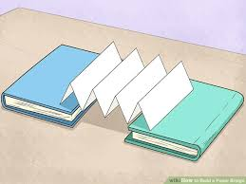
Think back to yesterday and the image of the piece of paper on the textbooks… Consider the image to the right.

Do you think folding the paper like this would make the paper bridge stronger? Why or why not?

Step 2: Design a bridge!

Using only two pieces of paper, you will design two different bridges. Construct the bridges by manipulating the pieces of paper in any way you want. You will then place the paper bridge between two objects (for example, two books) and test the strength of your bridge designs.

Design 1
Draw a sketch of how you manipulated the paper and shaped your bridge.

Design 2
Draw a sketch of how you manipulated the paper and shaped your bridge.

Before you go on, make a hypothesis: which of your bridge designs do you think will be the strongest?

Step 3: Test the strength of your bridges

To test the strength of your designs, you will place objects on the bridges to see which one holds the weight better. Remember to place your bridge across two objects to create an actual bridge. You can use any object of your choosing to test your bridges’ strength (for example, a pencil, eraser, coin, etc.).

Step 4: Reflection

Was your design 1 or 2 stronger?

Did you select the correct bridge in your hypothesis of which design would be stronger? Why or Why not?

In what way, were your bridges successful?

What would you have done differently in designing your bridges?

Student Feedback:
Circle the emojis that best represents how this activity made you feel.

Mindfulness Moment!
STOP is an acronym that stands for:
S: Stop. Whatever you’re doing, just pause momentarily.
T: Take a breath. Reconnect with your breath. The breath is an anchor to the present moment.
O: Observe. Notice what is happening. What is happening inside you, and outside of you? Where has your mind gone? What do you feel? What are you doing?
P: Proceed. Continue doing what you were doing. Or don’t: Use the information gained during this check-in to change course. Whatever you do, do it mindfully.

Day 2: Math
Percents and the Strength of Smart Decisions

What is this lesson about?: Today we are going to do a number of activities that will help you understand what it means when a number increases or decreases by a certain percent.

We will also learn how to calculate the percent increase and percent decrease between numbers.

First, take a few minutes for today’s warm up:
Take a few minutes to answer questions below.

What’s a better deal?

$20 off of a $200 phone or $50 off of a different $500 phone?
What do you think? Write it down.

There is no right answer here…. Things to consider:
→ How much will each phone cost after the discounts?

→ How much money do you have to spend?

→ Which of the phones really meets your needs?

→ which phone is actually better?

What’s a better deal?
$20 off of a $200 phone at Best Buy vs $50 off the exact same phone listed at $220 at a different store?

Discuss: Why is this second question so much easier to answer clearly?

Step 1: What’s a better deal? Understanding Percents.

Answer the problems below, complete the graph/bar chart and then try to answer the word problems.
Kenny’s dad makes him a deal on his birthday: He tells Kenny that if instead of taking $100 on his birthday, he will give him $110 next year.

- How much money will Kenny earn by letting his dad keep the $100 for one year?

Sondra’s dad makes her a deal on her birthday. He tells her that if instead of taking $50 today, he will keep the $50 and give her $60 next year.

- How much money will Sondra earn by letting her dad keep the $50 for one year?

Marcus’s dad makes him a deal on his birthday. He tells him that if instead of taking $10 today, he will keep the $10 and give him $20 next year.

- How much money will Marcus earn by letting his dad keep the $10 for one year?

Who made more money by giving their birthday money to their dad for the year, Kenny, Sondra or Marcus?

Who did ‘better’ over the year--Kenny, Sondra or Marcus? Who’s money got stronger, comparatively?

Explain your answer below:

Would you take any of those deals if they were offered to you by one of your parents? Why, why not?

Complete the graph below to help illustrate this example.
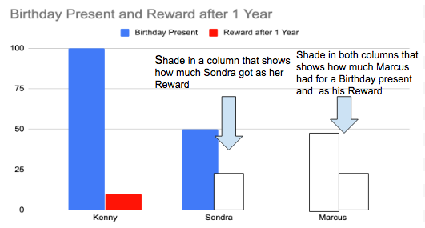
How much money did Kenny have to give up for a year in order to earn $10?

How about Sondra?

And how about Marcus?

Step 2: Complete the problems below

Let’s use information from Kenny, Sondra and Marcus--above--to help us think about percentages and percentage increases.

By what percent (%) did the $100 that Kenny gave to his dad grow over one year?

Here is how you calculate % change:

Make a fraction: Change from year 1 to year 2/Original Investment.

So, for Kenny, this looks like:
→ $10/$100
→ reduce this to $1/$10.
→ 1 divided by 10 = .10 --- say that aloud as 10 hundredths.
→ 10 hundredths is equal to 10%

So, Kenny earned 10%...

Now, try this for Sondra:
For Sondra, this looks like:
→ $___/$100
→ reduce this to $__/$10.
→ ___divided by 10 = .___ --- say that aloud as ____ hundredths.
→ ____ hundredths is equal to ____%

So, Sondra earned _____%

Now, try this for Marcus:
For Marcus, this looks like:
→ $____/$100
→ reduce this to $____/$1.
→ ____ divided by 1 = ____ → say that aoud as 1 whole!
→ 1 whole is equal to 100%

So, Marcus earned _____% by giving his mom the money for one year!

Discuss your answers with your classmates, if permitted.

Step 3: Understanding percentages increase and decrease.

Complete each of the problems below. Use the information provided to answer the questions.

The chart below shows the population of New Orleans (rounded off) in over three time periods. Use the charts to answer each question below.

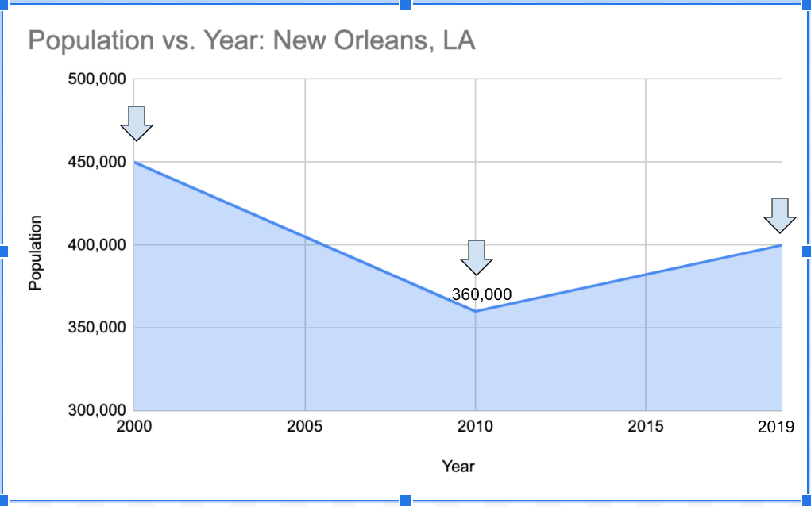
What was the total population of New Orleans in 2000?

What was the total population of New Orleans in 2010?

By how much did the population decrease?

By what percentage did the population decrease?
→ Use these steps to help you calculate this

→ Make a fraction: How much did the population decrease by dividing by the population in 2000.

→ Write the population decrease (as a negative) here: _______________
→ Write the population in 2000 here:

Reduce the fraction:

Divide the top # by the bottom #, using a calculator if needed.

By what % did the population in New Orleans decrease between 2000 and 2010?

Note: In 2005, Hurricane Katrina struck New Orleans and many families had to leave the city, greatly speeding up a long decline in the population..

Now, let’s see what has happened between 2010 and 2019?

What was the total population of New Orleans in 2010?
What was the total population of New Orleans in 2019?
By how much did the population decrease over this time?

By what percentage did the population increase?
Use these steps to help you calculate this

→ Make a fraction: How much did the population increase between 2010 and 2019 divided by the population in 2010.

→ Write the population increase (between 2010 and 2019)
here (look at the graph):
_______________
→ Write the population in 2010 here:

Reduce the fraction:

Divide the top # by the bottom #, using a calculator if needed.

By what % did the population in New Orleans increase between 2010 and 2019?

Student Feedback:
Circle the emojis that best represents how this activity made you feel.

Mindfulness Moment!
Use the diagrams below to help focus on and deepen your breathing. Using your finger, trace along the shape as you breathe in and breath out.
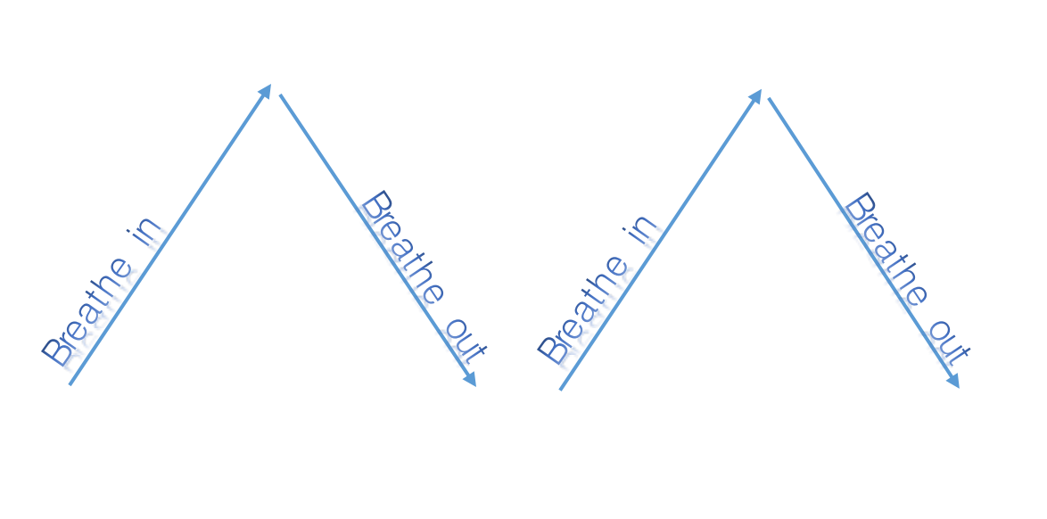
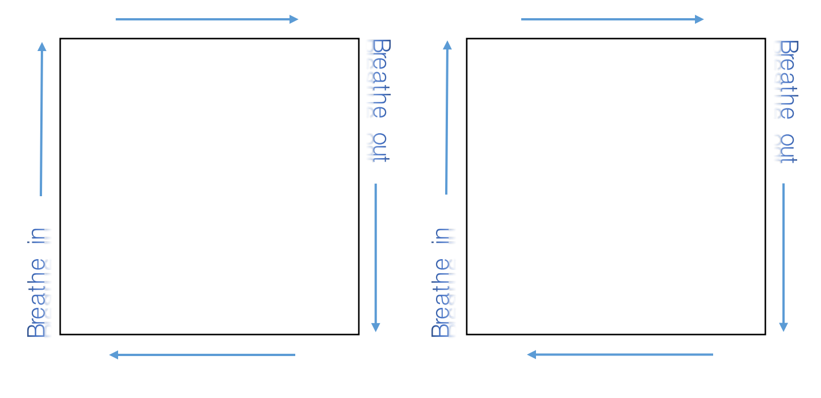

Day 2: Civics/Social Studies
World War I

What is this lesson about?: Today you will study the outcomes of WWI and what happened to Europe after the war ended. You identify and respond to questions about some of the key concepts of WWI. You will then have the opportunity to reflect on what life was like during and after WWI.

Step 1: Read the following article.

After World War I, Nations Were Changed Forever
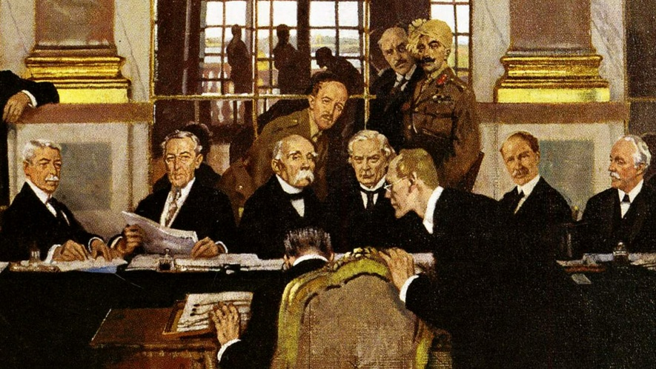
World War I was larger than any war that came before it. It was fought between two sides. The winners were Britain, France, Russia, Italy and the United States. The powers that lost were Germany, the Austro-Hungarian Empire and the Ottoman Empire. The Ottoman Empire was based in today's Turkey, while the Austro-Hungarian Empire occupied the center of Europe.

The war was fought 100 years ago and caused the deaths of millions of people. It left Europe and the world greatly changed. It also set the stage for World War II and many of the horrors that came with it.

A new great power
World War I changed the United States in two important ways. First, it turned the U.S. army into a large, modern fighting force. For the first time, the United States became a match for even the greatest European power.

Second, the war made the United States a much greater economic force, too. Many of the countries in Europe were broken and tired because of the war. This allowed the United States to control much more of the world's trade and business. The country quickly grew richer than it had ever been.

The rise of communism and socialism
World War I greatly weakened Russia. Before the war ended, communist revolutionaries took over the government, and Russia's king, the czar, was killed. This was called the Russian Revolution. Communists, led by Vladimir Lenin, did not want a few people to own all the factories and land as property. They had the government take over those lands instead.

Germany also formed a new government. It was called the Weimar Republic, and it mixed democracy with socialism. Germans could now vote for their leaders in the government. Socialism was less extreme than communism because it did not get rid of private property. But Germany's new government soon came under great pressure. In the end, it was toppled by Adolf Hitler and his Nazi Party. With Hitler in power, the stage for World War II was set.

Nationalism transforms Europe
The German, Russian, Ottoman and Austro- Hungarian Empires fell apart. New countries were formed in Europe, in part due to nationalism.

Nationalism is the idea that people with the same culture have the right to their own separate country. After the war, many people wanted to break from the old empires and form their own nations. But nationalism also caused many problems, especially in Eastern Europe. Many countries had more than one culture and race. Nationalism led to hatred and fighting between these various groups.

The myths of victory and failure
At the end of World War I, the German General Erich Ludendorff wanted Germany to refuse the peace treaty. This treaty, or deal, was written by the winners of the war, and Germany saw it as very unfair. Ludendorff said the army could still fight on. But the new German government wanted peace, so it declared the war over.

This decision gave Ludendorff and other German military leaders someone to blame for Germany's defeat. This started the idea that the German army could have won, but was "stabbed in the back" by socialists and the government. This idea weakened the power of the Weimar Republic. In the end, it allowed Adolf Hitler to rise to power.
Britain was also greatly changed by the war. Its suffering was so great that it wanted to avoid another war at all costs. That made it give in to Hitler when he wanted to grab new territories for Germany. This was called appeasement. But as this went on, World War II became more and more certain.

A "lost generation"
Eight million people died during World War I. Many others were so badly hurt by the war that they took their own lives. In much of Europe, it was hard to find someone who had not lost a loved one to the war.

Step 2: Answer the following questions.

Give two reasons why WWI led to WWII.

1.

2.

In what ways did WWI change the U.S.?

What new countries were created after WWI?

What is the definition of nationalism?

How did nationalism create tensions in Europe after WWI?

Step 3: Time Capsule Activity

Imagine you are opening a time capsule that was made during WWI. You will uncover 5-7 artifacts from the war to help people understand what life was like in 1917. Draw 5-7 artifacts that you unearthed from the time capsule.

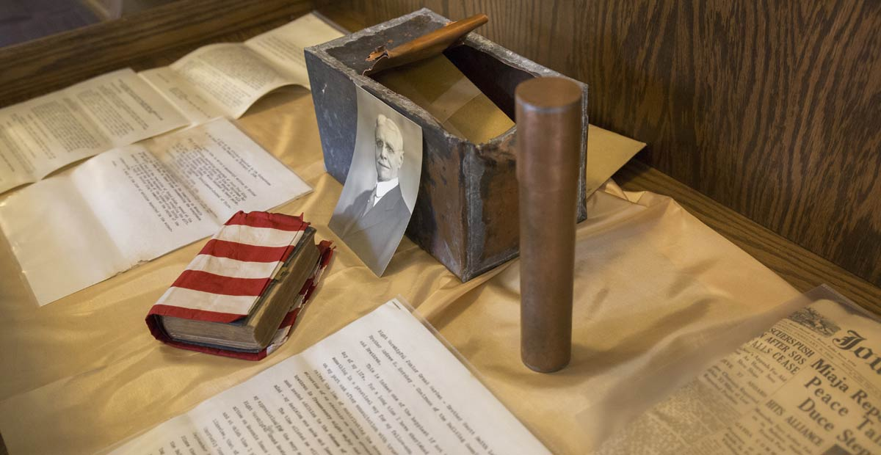

Draw 5-7 items that you found in the WWI time capsule that was buried in 1917.

Student Feedback:

Circle the emojis that best represents how this activity made you feel.

Creative Activities: Puzzles
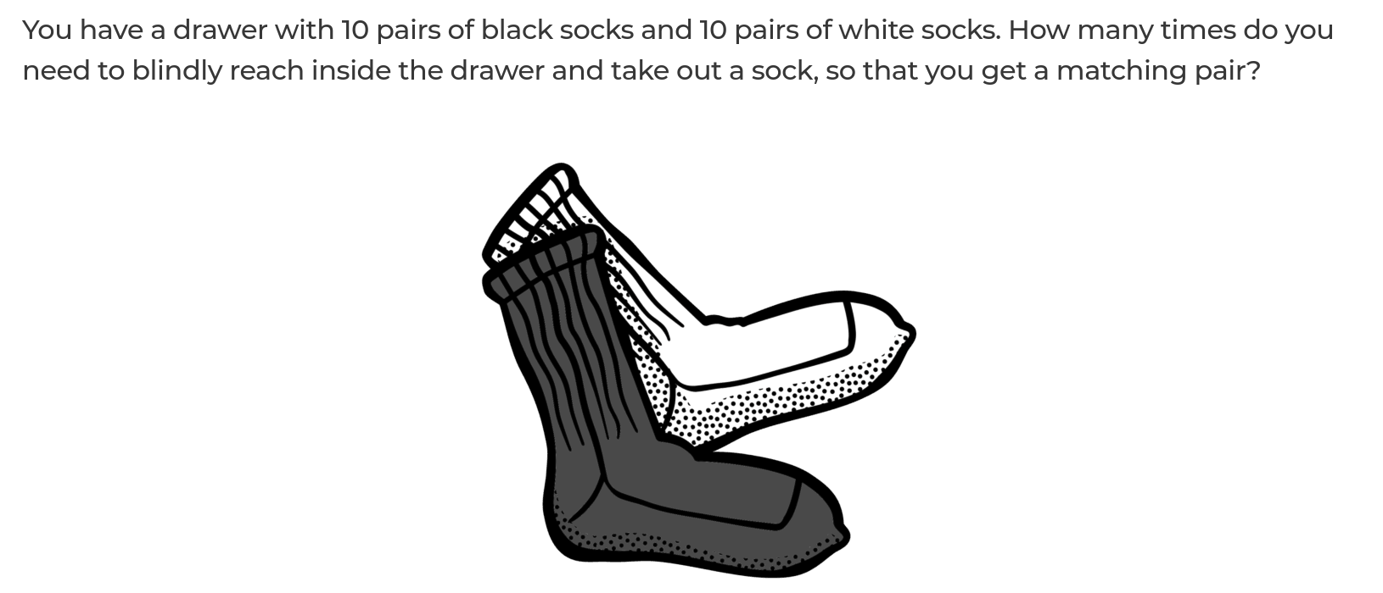

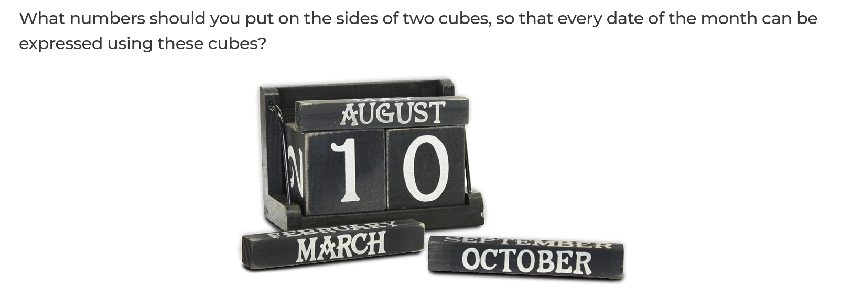

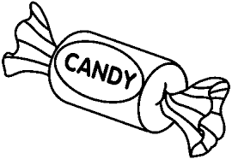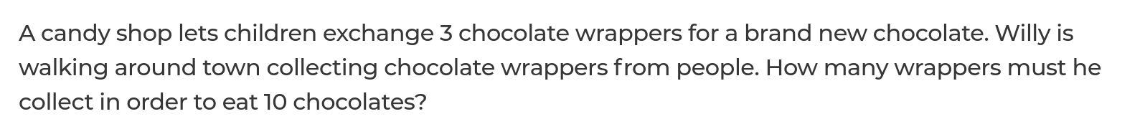

ANSWERS: Puzzles

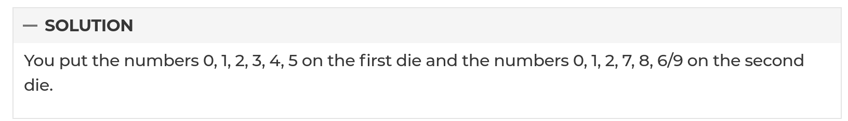

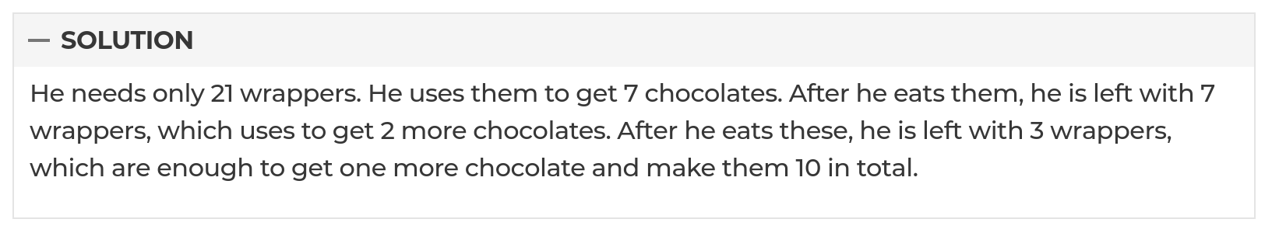

Day 3 Agenda

Topic | Activity
Warm-Up!
English Language Arts | - Read an article about Victoria Woodhull and respond to questions about the reading  - Write a short essay/paragraph about how people respond to challenging times and use evidence from your readings to support your claim
Science | - Check your understanding of bridge designs  - Solve problems around bridge design
Mindfulness Moment!
Math | - Understanding the power and strength of exponential growth--both for good and bad
Mindfulness Moment!
Civics/Social Studies | - Review key vocabulary  - Create a sketchnote about WWI and it’s main themes, key players, and key terms  - Make a meme using images from WWI
Warm-up Activity: Write a journal entry around the daily quote on strength.
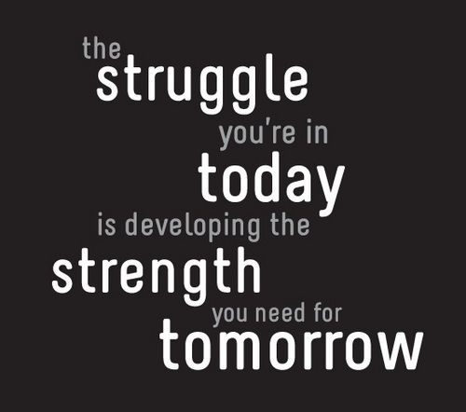

Day 3: English Language Arts
Strong Women

What is this lesson about?: Today you will finish our series on strong women for Women’s History Month. You will learn about Victoria Woodhull, the first woman to run for president in the U.S.

Step 1: Read the following text.
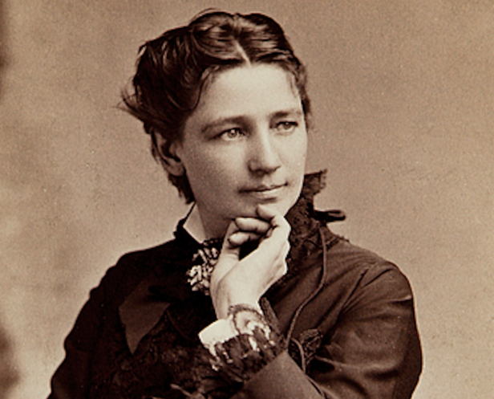
In 2016, Hillary Clinton made history. She became the first woman to be the presidential nominee of a major political party. But she was not the first woman to run as a presidential candidate. That honor belongs to Victoria Claflin Woodhull.
In 1872, Woodhull became a third-party candidate, running against the Republican president, General Ulysses S. Grant, and his Democratic challenger, Horace Greeley. At the time, women in the United States did not even have the right to vote. They wouldn't have that right for another 50 years. But that did not stop Woodhull from making a historic bid for change.

"Women Are The Equals Of Men"
Woodhull was an early feminist and supporter of women's rights. She first received national attention in 1871, when she was invited to Washington to speak before the house judiciary committee. Woodhull made a bold statement before the committee: "Women are the equals of men before the law, and are equal in all their rights."
Woodhull argued that women already had the right to vote. The 14th Amendment to the Constitution granted that right to all citizens born in the United States, she said. She also claimed that the 15th Amendment applied to women as well. The 15th Amendment had ended slavery in 1870. Women, Woodhull said, had long been treated in a similar way to enslaved people. Women needed to be freed from having to act as servants to their husbands and families.
If women were not given their political rights, Woodhull promised, they would have no choice but to revolt. They would rise up and govern themselves.
Not surprisingly, the committee did not agree with any of her positions.

A New Political Party Emerged
For 25 years, suffragists had tried to get the leaders of the two major political parties to listen. Suffragists were people who fought for women's right to vote. Repeatedly, they were ignored. Asking for their rights was getting them nowhere. Now, suffragist leaders decided it was time to act. On May 9, 1872, the National Woman Suffrage Association formed a new political party, The Equal Rights Party. Woodhull was selected to run as its candidate for the presidency of the United States.
Woodhull was far ahead of her time. She pushed for female suffrage, of course. But she also demanded equal pay for men and women. She believed in universal health care and changes had to be made to American prison systems.
Woodhull never had any real chance of being elected, and she was too young to be the president. However, her candidacy helped bring attention to issues that were otherwise ignored.

Political Downfall
Along with her sister, Woodhull ran her own newspaper, Woodhull and Claflin's Weekly. The paper helped bring attention to Woodhull's views. In the end, though, the paper was her downfall. On November 2, 1872, three days before Election Day, Woodhull published two articles about two major critics of her campaign. One of the pieces accused New York preacher Henry Ward Beecher of having an affair with a married woman. The other claimed Wall Street trader Luther Challis had assaulted two girls.
Because the two articles discussed sexual matters, they were considered inappropriate, and against the law. Woodhull and her sister were quickly arrested and jailed.
Even though she was now in jail, Woodhull remained on the ballot. We will never know how many votes she received. This is partly because some polling stations probably threw away her votes. However, we do know she did not win any states. Grant easily won a second term.

Death And Legacy
Woodhull and her sister were later cleared of charges and freed from jail. She continued to give public speeches and to publish her weekly paper, but her political career was over. She suffered from constant poor health and was always short of money. Woodhull eventually moved to England. There she started another newspaper, The Humanitarian, and threw her support behind the British suffragist movement. Woodhull died in 1927. A year later, British women won the right to vote.
Today, Woodhull has mostly been forgotten. When she is remembered, she is usually treated as an odd fact about U.S. history. But Woodhull deserves to be considered an important pioneer in the fight for women's rights.
Following Woodhull's presidential run, suffragists continued fighting for political change. The Equal Rights Party continued to nominate women for the presidency. Each voting day, it sent members to polling stations to insist on women's right to vote.
Progress was slow, but by 1918, women had won the right to vote in 40 states. In 1920, the Constitution was changed to give all women in the United States the right to vote. Since Woodhull's campaign, third parties have nominated 21 more female presidential candidates. Jill Stein ran in 2016 for the Green Party. That same year, Hillary Clinton won the Democrat nomination, 136 years after Woodhull was arrested.
Back in 1872, Woodhull closed her campaign with a letter to the editor of the New York Herald. Woodhull's letter was written from her prison cell. It showed she knew very well what she had begun: "The public may succeed in crushing me, even to the loss of my life. But let me warn them and you that from the ashes of my body a thousand Victoria Woodhulls will spring. They will seize the work laid down by me and carry it forward to victory."

Step 2: Answer the following questions.

Circle what you think is the central idea to the text.
- Suffragettes worked very hard to win the right to vote for women.
- Victoria Woodhull was a strong leader in fighting for women’s equality and other social justices.
- Sometimes we have to fail in order to be successful and Victoria Woodhull did just that.
- Women are equals to men and should, therefore, have the same freedoms and rights as men.

Explain why you chose your answer above. What in the text makes you think that is the central idea?

After reading about Victoria Woodhull, provide three examples from the text that show she was a strong, courageous, and/or brave woman.

Step 3: Write a short essay.

Over the past three days, you have read about women who have had to overcome societal challenges beyond their control. Reflect on the methods that these women used to find strength within to overcome these challenges.

Choose and circle one of the following statements about how individuals handle societal challenges beyond their control. You will then brainstorm and write a paragraph expanding on the statement.

Statements | When faced with opposition, individuals can dig deep to find strength within to do what is right.
 | Individuals who show strength in times of difficulty, inspire others to be strong as well.
 | When we cannot control what is happening, our strength comes from controlling how we respond.

For your paragraph, you will need to support your statement of choice with clear reasons and relevant evidence from your readings on Harriet Tubman, Frances Harper, and Victoria Woodhull. Complete the graphic organizer below to help you brainstorm before writing your paragraph. You must provide 3 pieces of evidence from your readings to support the statement. (the example provided is for statement 2 above)

Evidence | Citation | Explanation of how this evidence supports your statement/argument
The people that Harriet Tubman helped to freedom gave her hugs and told her “God bless you” | Letter to Tubman | Harriet Tubman’s bravery and strength inspired the people she helped to be brave in the face of danger and they showed appreciation to her. (supports statement 2 above)

Now that you have examples to help support your statement of choice, write your paragraph and argue that the statement you chose is true.

Student Feedback:

Circle the emojis that best represents how this activity made you feel.

Day 3: Science
Bridges

What is this lesson about?: Today you will use your knowledge about bridges and designs to solve challenges involving picking the best bridge for a situation.

Step 1: Consider the following quote

“A bridge has no allegiance to either side.”
What do you think is the meaning of this quote?

Step 2: Check your understanding
arch beam cable-stayed cantilever suspension truss

Match the above names with the below pictures:

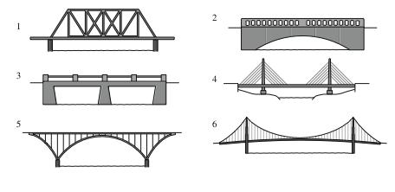
Write your answers here:

- __________________________________
- __________________________________
- __________________________________
- __________________________________
- __________________________________
- __________________________________
Step 3: Solves the following challenges.

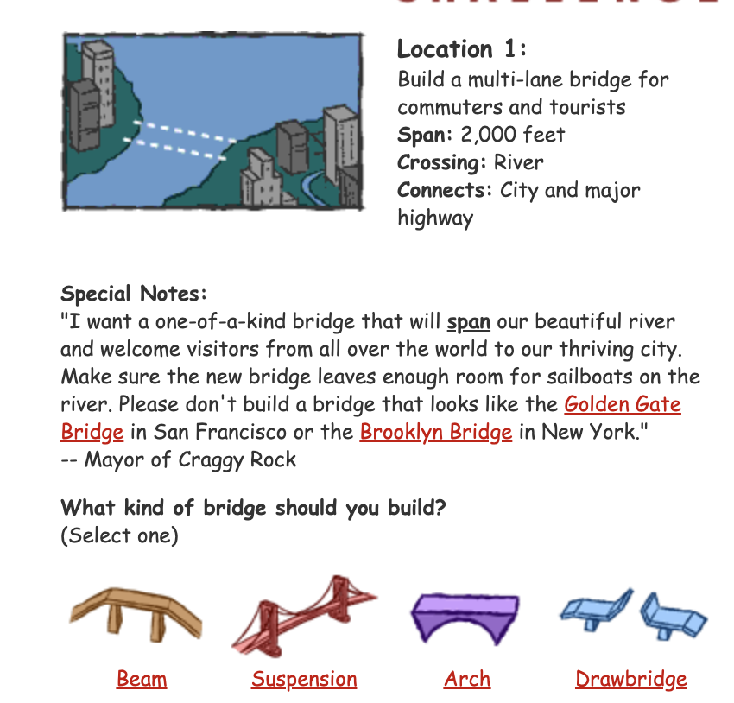

Why:

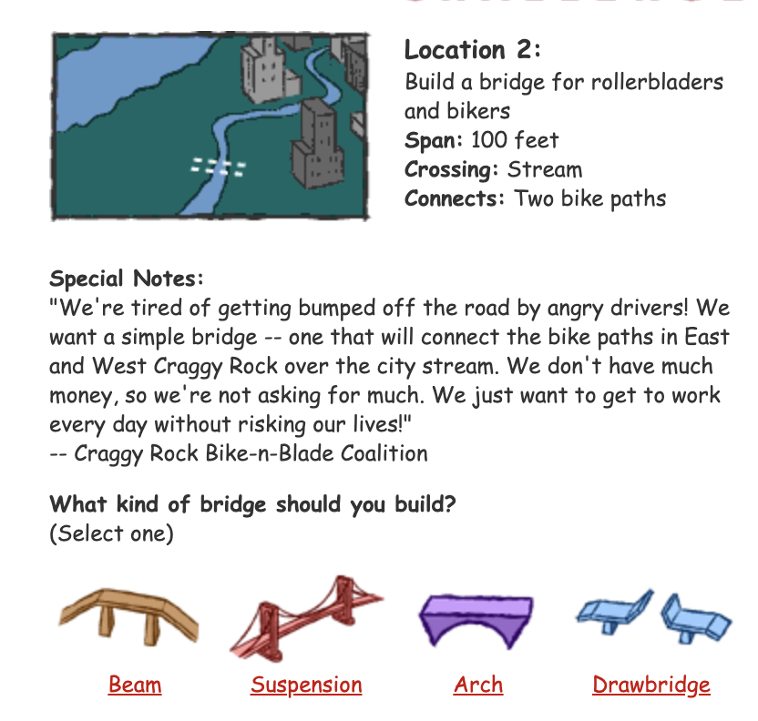

Why?

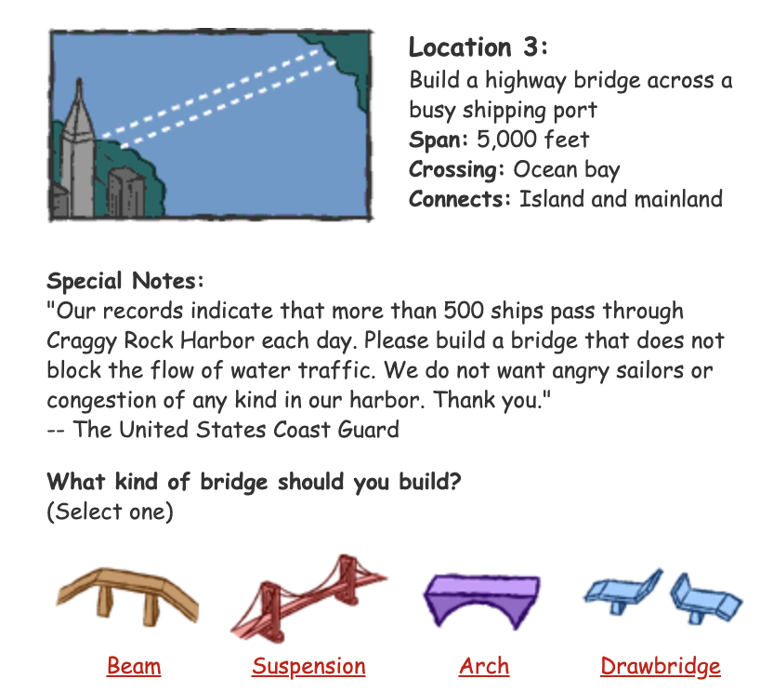

Why?

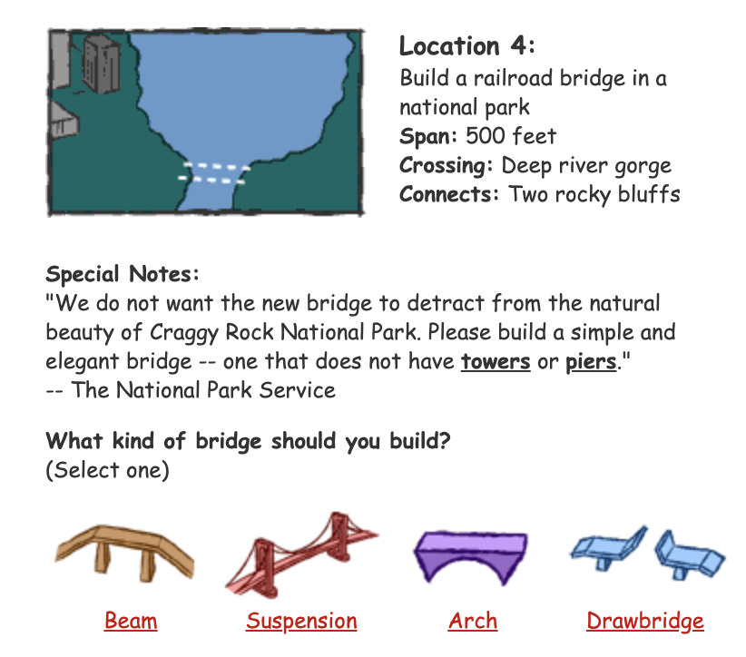

Why?

Step 4: Reflection

What was the most interesting thing you learned about bridges?

What is something you think you would be able to teach someone else about bridges?

Student Feedback:

Circle the emojis that best represents how this activity made you feel.

Mindfulness Moment!
Mantras: Choose one below and say it over and over all day.

I can do more than I believe.
My dreams will come true.
I am great today, and I will be even greater tomorrow.
My heart is full of kindness and courage.
I am what I am.
Life is a daring adventure or nothing at all.
Yesterday is not today.
OR
Create your own mantra:

Day 3: Math
Exponential Growth

What is this lesson about?: There has been a lot of discussion lately about exponential growth. Today we will compare different types of growth -- linear, and exponential -- and look at a couple examples of them.

First, take a few minutes for today’s warm up:
Take a few minutes to answer questions below.

Which would you choose?
A friend of yours goes to work for Nike. After she has worked there for a couple of years, she tells you some pretty amazing news--that some Nike shoes are made in the exact same factory using the exact same supplies and the exact same machines as shoes that are sold at Target under the Champion brand.

- So you check out a pair of Nikes at Foot Locker. They cost $110. You go to Target and look carefully at the shoes--and you are pretty sure that you have found the ‘same’ shoe, but it’s a Champion brand. It costs $45.

Discuss: Which pair of shoes would you buy? Why?

Step 1: Understanding Linear Growth.

Complete each of the problems below. Use the information provided to answer the questions.

Complete the chart below:
Assume that every year a mysterious new, cuddly Teddy Bear reproduces exactly one time and makes a baby all by itself. Each Teddy Bear only makes 1 baby, 1 time. The Teddy Bears do NOT die, ever.

Question: After 6 years how many Teddy Bears will there be? Fill in the table below to help you answer the question-

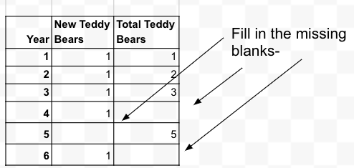
Now, we converted this table to a graph. .
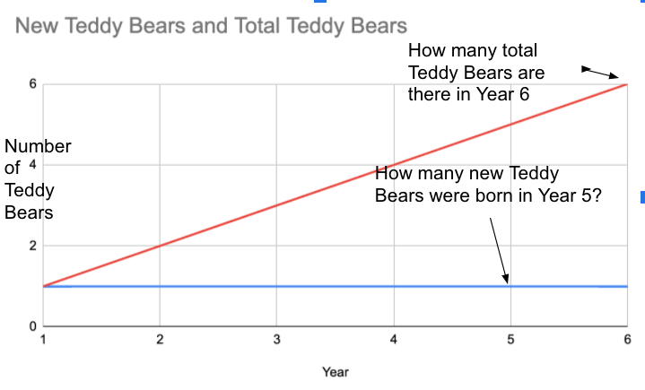Looking at the graph, how many total Teddy Bears are there after 6 years? How many new babies were born in year 5?

Step 2: Understanding Exponential Growth, Round 1
Complete each of the problems below. Use the information provided to answer the questions.

Complete the chart below:

Assume that every year a mysterious new cuddly Teddy Bear reproduces exactly one time and makes two babies all by itself. Each Teddy Bear only makes 2 babies, 1 time. But the creatures do NOT die, ever.

Questions:
How many new Teddy Bears are born in year 4? After 6 years how many Teddy Bears will there be all total? Fill in the table below.
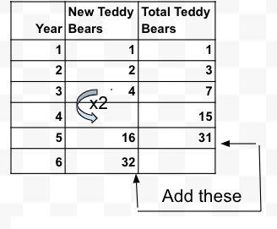
Below we converted this table to a graph.
- Looking at the graph, how many new Teddy Bears are born between year 5 and year 6?
- How many Teddy Bears are there after 6 years?
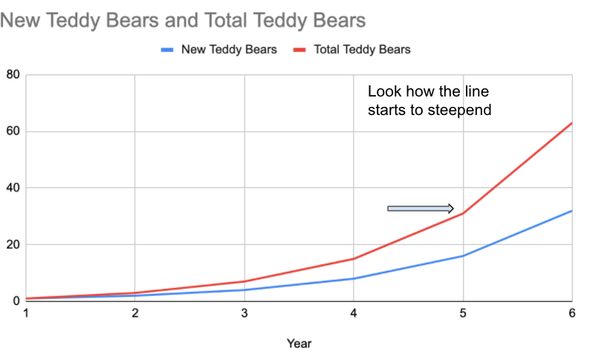
Step 3: Understanding Exponential Growth, Round 2

Complete each of the problems below. Use the information provided to answer the questions.
Complete the chart below:
Assume that every year a mysterious new cuddly Teddy Bear reproduces exactly one time and makes three babies all by itself. Each Teddy Bear only makes 3 babies, 1 time. But the Babies do NOT die, ever.
Questions:
- How many new Teddy Bears will be born in year 5?
- How many total Teddy Bears will there be in year 6?
Fill in the table below.
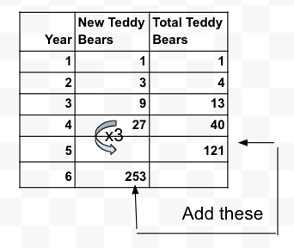
Below we have converted this chart to a graph.
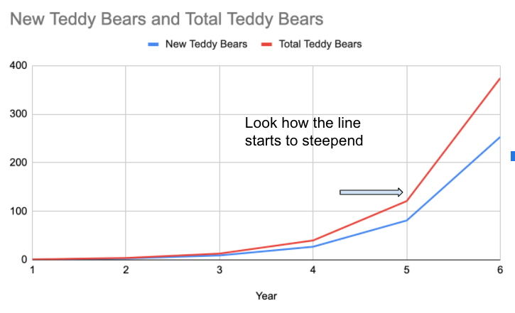
Looking at the graph:
- How many mystery Teddy Bears are there after 6 years?
- What will this graph start to look like by year 8 or 9? Will it flatten out or get steeper?
Step 4: Understanding Exponential Growth, Discussion Questions

What would be something positive that could come from really strong, exponential growth? What is something that you wish would grow faster and faster, really quickly?
- Say every act of kindness resulted in two more acts of kindness and that went on and on?
- Or say that for every flower that blooms, bees can pollinate two more flowers during the spring, making the outdoors beautiful and fresh?
- What would you like to grow exponentially?

What would be something negative that could come from really strong exponential growth?
- Say every time an adult said something negative to a child, that child grew up and said two negative things to their child?
- What would you like to make sure does not grow exponentially?

Student Feedback:

Circle the emojis that best represents how this activity made you feel.
Mindfulness Moment!

A common mindfulness activity is a ‘body-scan’. This involves focusing on different parts of your body, one at a time, and thinking about how they feel. We like to add another dimension to this idea by drawing them. For example, start drawing your hand and fix your attention on how it looks and what sensations you are feeling. It doesn’t have to be perfect because the finished product doesn’t matter – mindfulness drawing is all about the process!
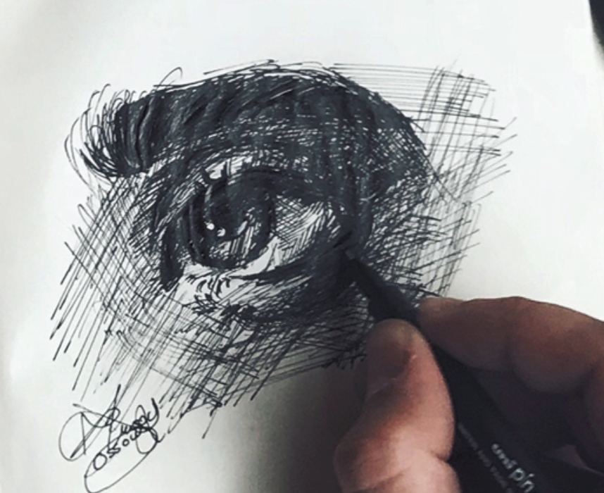
Day 3: Civis/Social Studies
World War I

What is this lesson about?: Today you will review what you have learned about WWI during the past couple days and create graphic notes on the key themes and issues of WWI. You will also use your creativity to make a meme with WWI images.

Step 1: Review of key vocabulary
Match the correct definition with each key term (refer to your readings from Day 1 and 2, if necessary)

- Nationalism _____________
- Imperialism _____________
- Alliance _____________
- Militarism _____________

- Forming friendships with other countries for protection
- To build up and use one’s army
- Love for one’s country and support for its interests, sometimes to the detriment of others
- Spreading a country’s influence by conquering

Step 2: What is a sketchnote?
Look at the image of the sketchnote below. What do you think a sketchnote is?
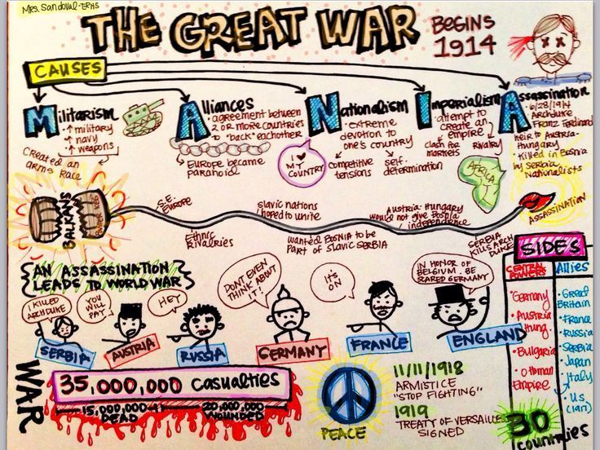

Sketchnoting is a form of note-taking, hence the “noting” part of it, but as you might guess it involves bringing more visuals into the process compared to typical note-taking, hence the “sketch” part. The whole idea behind adding sketches to your notes is that it taps into parts of your brain that would lie dormant if you only use words to explore ideas. It’s the combination of the two that’s most powerful – using both words and visuals while taking notes!

Step 3: Your turn! Create a Sketchnote on WWI

You’ve spent the last two days learning about WWI, and now it’s time to take note of all you have learned. Your assignment is to create a sketchnote titled “World War I.” Here’s what you need to include in your sketchnote:
- Causes of WWI
- Key countries that were involved
- Key vocabulary (nationalism, alliance, imperialism, militarism)
- Who won the war, who lost the war
- The results of the war

Have fun with this assignment! Get started in whatever way works best for you (start drawing images that capture themes of WWI or begin by writing words). You can use arrows and equation signs to help with the slow of your sketchnote, too.
Use this page for your sketchnote

Step 4: Create a WWI meme

Take a look at the example memes below.

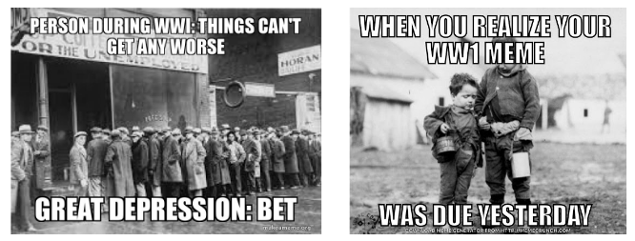

Now, using the below templates, create your own memes with the WWI images.
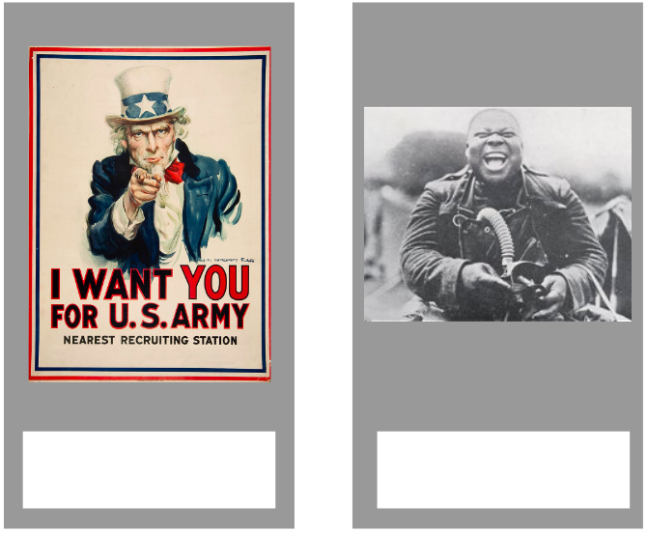

Step 4: Share with a partner.

Review your sketchnote and memes with a classmate.
- Did you include any of the same drawings in your sketchnote?
- What do you like about your classmates Sketchnote that you want to add to yours?
- Do you have any feedback on your classmate’s memes? How might you make your meme stronger after seeing your classmates?

Student Feedback:

Circle the emojis that best represents how this activity made you feel.

Creative Activities: Can you invent a new sport?
List of Supplies
- 2 tennis balls
- a plastic bat
- one goal
- 10 players
Design a game that could use the above supplies.
Rules:

Describe or draw what it looks like:

