Week 3
Identity

Day 1

NAME:______________________

Day 1 Agenda

Topic | Activity
Warm-Up!
English Language Arts | - Read an excerpt “My Name” from The House on Mango Street by Sandra Cisneros.  - Read an article about Hasan Minhaj teaching Ellen Degeneres the correct pronunciation of his name.  - Respond to questions about the story and the article.
Science | - Read about DNA and Genes  - Answer questions about what you read  - Complete the activity
Mindfulness Moment!
Math | - Real World Math: Identity and the clothes you wear: The Cost of Brand Name Clothes and Shoes  - Practice Problems: Organizing Data in Tables
Health | - Digital Identity
Mindfulness Moment!
Civics/Social Studies | - Read articles and answer questions on identity and diversity
PE | - Bingo!

Warm-up Activity: Write a journal entry around the daily quote on identity.
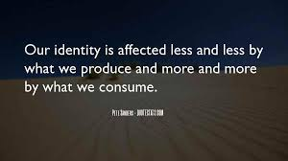

Day 1:The Importance of a Name
English Language Arts

What is this lesson about?: Over the next week, you will be reading and reflecting on the idea of Identity. Today, you will have the opportunity to read about the importance of names and reflect on your own name and how it contributes to who you are.

Step 1: Before reading

Do a 5 minute quick-write where you just write your ideas, don’t worry about your spelling or grammar, just focus on what you feel and want to say.

Write your full name on the line below:

Write for 5 minutes: Do you like your name? Why or why not? If you could change your name, would you? What would you change it to? Explain your choice of name if you would change it.

When you are finished. Share your response with a partner.

Did you and your partner have similar or different opinions?

Step 2: Read the Text

The excerpt you are going to read comes from a book by author Sandra Cisneros called The House on Mango Street which is a collection of memories and short stories about growing up in Chicago. As you read, think about how the author uses imagery (descriptive words that create pictures or images in your mind) to make her reader understand how she feels about her name. Underline or circle words or phrases that create images in your head about how the author feels about her name.

My Name
By Sandra Cisneros

      - In English my name means hope. In Spanish it means too many letters. It means sadness, it means waiting. It is like the number nine. A muddy color. It is the Mexican records my father plays on Sunday mornings when he is shaving, songs like sobbing.

      - It was my great-grandmother’s name and now it is mine. She was a horse woman too, born like me in the Chinese year of the horse—which is supposed to be bad luck of you’re born female—but I think this is a Chinese lie because the Chinese, like the Mexicans, don’t like their women strong.

      - My great-grandmother. I would’ve liked to have known her, a wild horse of a woman, so wild she wouldn’t marry until my great-grandfather threw a sack over her head and carried her off. Just like that, as if she were a fancy chandelier. That’s the way he did it.

      - And the story goes she never forgave him. She looked out the window all her life, the way so many women sit their sadness on an elbow. I wonder if she made the best with what she got or was she sorry because she couldn’t be all the things she wanted to be. Esperanza. I have inherited her name, but I don’t want to inherit her place by the window.

- At school they say my name funny as if the syllables were made out of tin and hurt the roof of your mouth. But in Spanish my name is made out of a softer something, like silver, not quite as thick as sister’s name Magdalena which is uglier than mine. Magdalena who at least can come home and become Nenny. But I am always Esperanza.

- I would like to baptize myself under a new name, a name more like the real me, the one nobody sees. Esperanza as Lisandra or Maritza or Zeze the X. Yes. Something like Zeze the X will do.

Taken from: Cisneros, Sandra. The House on Mango Street. Thorndike Press, a Part of Gale, a Cengage Company, 2019.

Step 2: Answer the following questions.

Look at paragraph 1: how does the narrator describe her name? What are some words that give you a sense of “tone” or the attitude that the author has towards her name?

2. In paragraph 4, the narrator uses the phrase “the way so many women sit their sadness on their elbow”. Act that out, what would that look like? Why do you think the narrator uses this image?

3. The narrator seems to admire her grandmother but she also does not want to be like her. Explain why she feels the same way.

4. The narrator wishes she had a name like Lisandra or Zeze the X. Why does she think these names would be more like the “real” her? What does she reveal about her herself by picking these names over Esperanza?

Step 3: Read the following article.
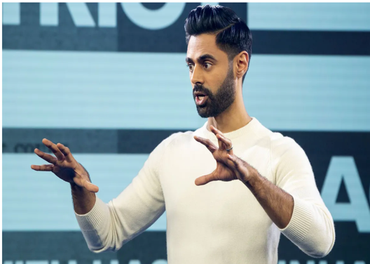
Hasan Minhaj is the first Indian American host of a weekly satirical news show on Netflix called “Patriot Act”. The show covers issues from elections to the changing styles of hip-hop. The following article describes his first appearance on The Ellen Show where he was being introduced to a wide audience of Americans. Video of his conversation with Ellen DeGeneres went viral. As you read, think about his reasons for correcting DeGeneres and what he sees as the importance of the correct pronunciation of his name.

Comedian Hasan Minhaj Explains Why He Corrected Ellen DeGeneres' Pronunciation of His Name
The Netflix star went viral in April after correcting the host during an appearance on the Ellen DeGeneres Show
By Aurelie Corinthios

In his own words, Hasan Minhaj is “trying to live.”
The comedian went viral in April during an appearance on the Ellen DeGeneres Show when he corrected host Ellen DeGeneres‘ pronunciation of his name during an interview. It’s HA-sun MIN-haj, not Ha-SAHN Mi-NAHJ, and the clip sparked a larger conversation about the double standard that exists when it comes to making an effort to correctly pronounce names of people of color vs. names of white people in Hollywood.
During a recent “Deep Cuts” episode of his Netflix show, Patriot Act with Hasan Minhaj, Minhaj, 34, reflected on the moment as he revealed the variations on his name he’s used while performing.
“I remember when I first started comedy, at the first open mics, there was this host,” he recalled. “You’d write your name down and he’d be like, ‘Look, man, nobody’s going to be able to pronounce this. You’ve got to change your name.'”
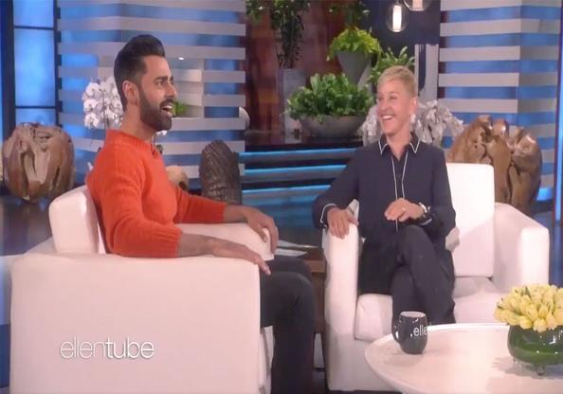
“So for like, two months I’d go to open mics and I was Sean,” he continued. “I kept trying to negotiate. I was like, ‘All right, Hasan — people can pronounce Hasan.’ And it just got weirder and weirder … but I’d always have that open mic host in my head: ‘You’ve got to do it to make it.'”
Minhaj explained that his parents, who are immigrants from India, drove down from their home in Sacramento, California, to attend his Ellen taping in Los Angeles. And so when DeGeneres incorrectly pronounced his name in front of the audience, emphasizing the second syllable of his first name instead of the first, he decided he had to say something.
“I looked in the audience … and [my mom] kind of cringed,” he said. “And I was like, ‘Dude, what am I doing?’ I have a show with my f—ing name on it and I’m still being like, ‘It’s with Sean!'”
“So I was like, ‘All right, Ellen, let’s just do this right now.’ Because we can pronounce Timothée Chalamet, so we’re going to do this right now,” he continued. “I just had her do it and I didn’t know it would be this viral moment or whatever.”
Interestingly, Minhaj said his dad was “super pissed” at him afterwards.
“He was like, ‘Hasan, you wasted your chance! You had seven minutes with her and for four minutes you’re correcting her, why are you doing this?'” he recalled. “And I think that’s the big difference between our generation and our parents’ generation. They’re always trying to survive.”
“Survival is the thing, so just go by whatever she calls you,” he continued. “And that’s cool, when Dad came in ’82, he survived for us. But I’m trying to live.”
“So I’m going to go on Ellen, the most American show ever, and make you hit all the syllables,” he added.
Minhaj rose to prominence as The Daily Show‘s senior correspondent from 2014 to 2018.
The comedian, who has won two Peabody Awards and two Webby Awards, also hosted the White House correspondents’ dinner in 2017.

Step 4: Answer the following questions

      - Why did Hasan Minhaj use an Americanized name when he first started doing comedy?

      - To cringe means that you physically shrink or flinch in distaste or discomfort. What effect did his mother “cringing” when Ellen DeGeneres mispronounced his name have on Hasan? Why do you think he felt this way?

      - Why was Hasan’s father so angry at him? Why do you think his father saw what he did as the wasting of an opportunity?

      - Hasan Minhaj says that his father has always tried to “survive” but that he wants to “live”. What do you think he is trying to say? What is the difference between surviving and living?

Step 5: Share your responses with a partner
With a classmate, discuss your answer to the following question.
            - What is the difference between how the narrator in My Name feels about her name and how Hasan Minhaj feels about his?

Step 6: Think and write.

Go back and look at your quick write. Then think about the two readings. Esperanza wants to change her name so that it can reflect more of who she is even though the name already has meaning in her family. Hasan Minhaj wants to make sure that people pronounce his name correctly because it reflects his culture and his identity. Reflect on what you have read and what you initially wrote about your name at the beginning of the lesson.
Write for 5 minutes: What does your name say about you? Is it important for people to remember your name and pronounce it correctly? Why or why not?

Student Feedback:

Circle the emojis that best represents how this activity made you feel. | 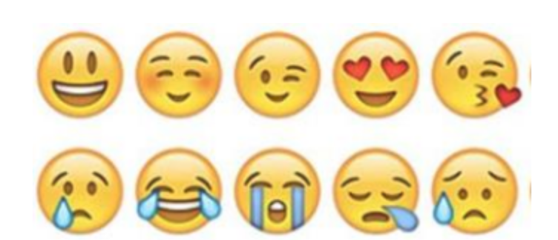  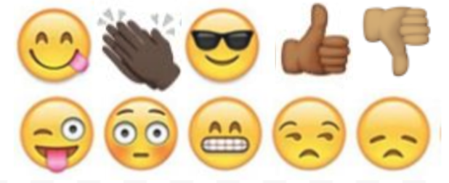

Day 1: Science
DNA and Genes

What is this lesson about?: Today you will read through the DNA and Genes passage. You will answer a few questions about what you read. You will complete a DNA activity.

Step 1: Read through the DNA and Genes passage

DNA and Genes
(Technological Solutions, 2020)

DNA is an essential molecule for life. It acts like a recipe holding the instructions telling our bodies how to develop and function.

What does DNA stand for?
DNA is short for deoxyribonucleic acid.

What is DNA made of?
DNA is a long thin molecule made up of something called nucleotides. There are four different types of nucleotides: adenine, thymine, cytosine, and guanine. They are usually represented by their first letter:
- A- adenine
- T- thymine
- C - cytosine
- G - guanine
Holding the nucleotides together is a backbone made of phosphate and deoxyribose. The nucleotides are sometimes referred to as "bases".
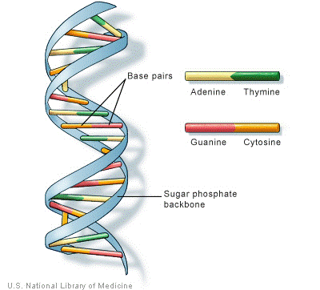
The basic structure of the DNA molecule

Different Cells in the Body
Our bodies have around 210 different types of cells. Each cell does a different job to help our body to function. There are blood cells, bone cells, and cells that make our muscles.

How do cells know what to do?
Cells get their instructions on what to do from DNA. DNA acts sort of like a computer program. The cell is the computer or the hardware and the DNA is the program or code.

The DNA Code
The DNA code is held by the different letters of the nucleotides. As the cell "reads" the instructions on the DNA the different letters represent instructions. Every three letters makes up a word called a codon. A string of codons may look like this:

ATC TGA GGA AAT GAC CAG

Even though there are only four different letters, DNA molecules are thousands of letters long. This allows for billions and billions of different combinations.

Genes
Within each string of DNA are sets of instructions called genes. A gene tells a cell how to make a specific protein. Proteins are used by the cell to perform certain functions, to grow, and to survive.

What are genes?
Genes are the basic units of heredity. They consist of DNA and are part of a larger structure called the chromosome. Genes carry information that determine what characteristics are inherited from an organism's parents. They determine traits such as the color of your hair, how tall you are, and the color of your eyes.

Shape of the DNA Molecule
Although DNA looks like very thin long strings under a microscope, it turns out that DNA has a specific shape. This shape is called a double helix. On the outside of the double helix is the backbone which holds the DNA together. There are two sets of backbones that twist together. Between the backbones are the nucleotides represented by the letters A, T, C, and G. A different nucleotide connects to each backbone and then connects to another nucleotide in the center.

Only certain sets of nucleotides can fit together. You can think of them like puzzle pieces: A only connects with T and G only connects with C.

Interesting Facts about DNA and Genes
- About 99.9 percent of the DNA of every person on the planet is exactly the same. It's that 0.1 percent that is different that makes us all unique.
- The double helix structure of DNA was discovered by Dr. James Watson and Francis Crick in 1953.
- If you unraveled all the DNA molecules in your body and placed them end to end, it would stretch to the Sun and back several times.
- DNA is organized into structures called chromosomes within the cell.
- DNA was first isolated and identified by Swiss biologist Friedrich Meischer in 1869.
- We get 23 chromosomes from our mother and 23 from our father.
- Some diseases are inherited through genes.
- Doctors may be able to cure diseases in the future by replacing bad DNA with good DNA using a process called gene therapy.
- Some inherited traits are determined by multiple different genes.

Step 2: Answer the following questions

- What does DNA stand for?
  - Double nitrogen argon
  - Dioxide nickel acid
  - Deoxyribonucleic acid

- How many types of nucleotides are there in DNA?
  - Three
  - Four
  - Five

- Which of the following is not a letter that represents a nucleotide in DNA?
  - C
  - G
  - R

- Three letters in DNA make up a word called a _________.
  - Codon
  - Chromosome
  - Gene

- What is the shape of a DNA molecule called?
  - Octahedral
  - Covalent
  - Double Helix

- Most genes within DNA hold instructions for the cell to make a specific ______.
  - Chromosome
  - Protein
  - Carbohydrate

- Over 99% of DNA in different human beings is the same.
  - TRUE
  - FALSE

Step 3: Complete the activity

Design your own DNA molecule. You can refer to the sample model that was provided in the text. Remember, A only connects with T and G only connects with C.

Student Feedback:

Circle the emojis that best represents how this activity made you feel. | 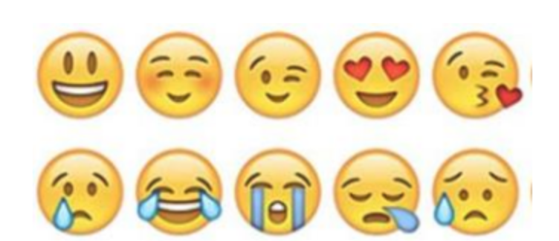  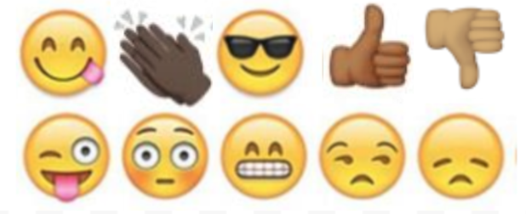

Mindfulness Moment!
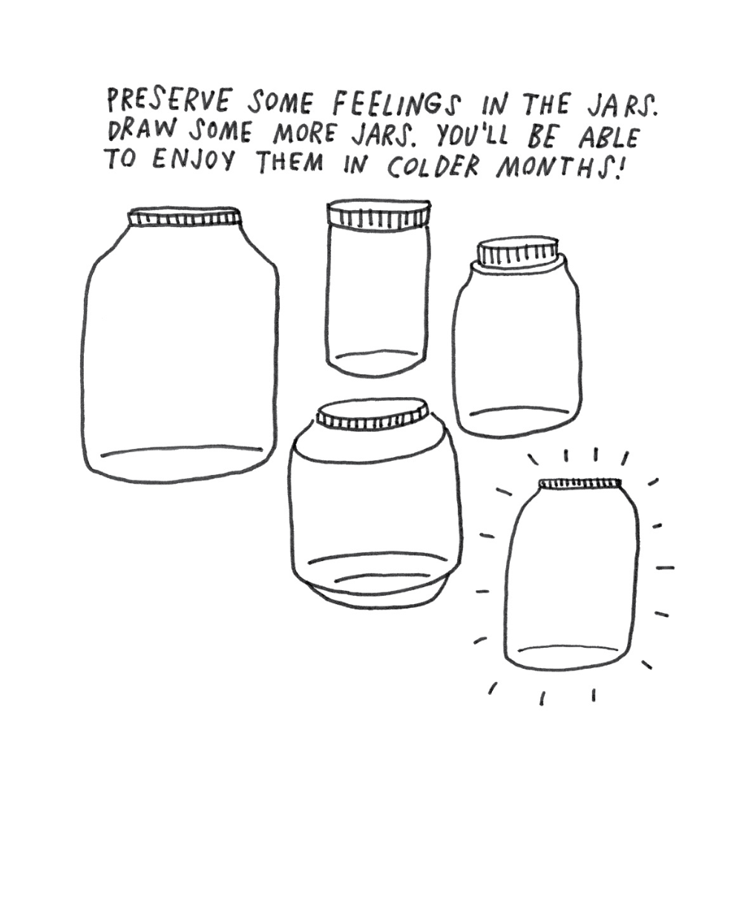

Day 1: Identity/Brand Name Clothes, Shoes, etc.
Math

What is this lesson about?:
Today we are going to take a look at the clothes and shoes we wear, and spend some time thinking about how the prices for these items are set. At the end of the activity, we will pose the questions: how much of your identity is tied up in the brands you wear? And is that worth it?

But first: Today’s Warm-Up
Because of the current situation with COVID-19, people are driving less, and most airline travel has stopped.
- What do you think has happened to the prices of a gallon of gas? Are gasoline prices going up or down?

- What is one good side of lower gas prices?

- What is one bad side of lower gas prices?

Step 1/Activity 1: What goes into that Nike Brand, NBA hoodie?
The chart below shows the cost of making Nike/NBA sweatshirts, as well as the amount that Nike charges when they sell them, to retailers, or directly to you, the consumer.

Costs for Nike/NBA 2019-20 Labron Hoodies
# of Hoodies | 1
Cotton and other material |  | 2.00
Labor |  | 1.00
Shipping (from China to US) |  | 5.00
Marketing/Advertising |  | 6.00
Other fixed costs |  | 3.50
Total Cost to Nike |  | 17.50
Revenu to Nike
Option 1: Nike sells hoodie to Modells, or Foot Locker
- Price to Retailer |  | 20.00
Profit before taxes if Nike sells to first line retailers
Option 2: Nike sells on line from its own website |  | 22.00
Profit before taxes if Nike sells online from it's site

Step 2/Activity 2: Understanding the charts

How much does it cost Nike to make 1 sweatshirt?

How much would it cost Nike to make 1,000 sweatshirts?

Assume that a person working in the Nike Factory can sew 3 sweatshirts in 1 hour, how much money does that person make per hour?

What is the most expensive cost to Nike for each sweatshirt?

Explain in your words where all that advertising and marketing money goes?

How much money (before taxes) does Nike make on each sweatshirt it sells to a retail store like Foot Locker? (first grey box in the above chart)

How much money (before taxes) does Nike make on each sweatshirt it sells directly to a person from its website? (second grey box in the above chart)

Explain: Why does Nike sell its clothes through retail stores at all if it makes more money selling them online from it’s own site?

Step 3/Activity 3: Ok, let’s take a look at Foot Locker and see how a local Foot Locker Store makes money.

Assume that Foot Locker sells the sweatshirt for $30. How much money does it make on one sweatshirt? How about if it sold 1,000 sweatshirts?

Write down some of the costs that Foot Locker has each month other than the cost of buying all of its shoes and clothes.

Do you think the owners of Foot Locker get to keep all of the money they make off of each sale? Yes/No?

Let’s take a closer look:
Footlocker Costs of Selling Hoodies
Fixed Costs Monthly
Rent |  | 3,500
Labor (everyone who works in the store) |  | 24,000
Insurance |  | 3,500
Monthly costs (utilities, technology, ) |  | 1,500
Advertising |  | 2,000
Total Fixed Monthly Costs |  | 34,500
# of Hoodies purchased from Nike | 5,000
Price per Hoodie (Nike) | 20
Cost of purchasing from Nike |  | 100,000
TOTAL MONTHLY COSTS |  | 134,500
Sales
# of Hoodies Sold | 5000
Retail Price | 30
TOTAL SALES FOR THE MONTH |  | 150,000
How much profit did the store owner make? |  | 15,500

Just to keep it straightforward, looking at the chart above, if the Foot Locker buys 5,000 sweatshirts from Nike and sells all of them @ $30 each, how much profit or loss (before taxes) does Foot Locker earn in 1 month?

How about if it (buys and) sells 6,000 sweatshirts @ $30 each and didn’t have to bring on any additional staff or other costs?

Fill in the grey boxes below.
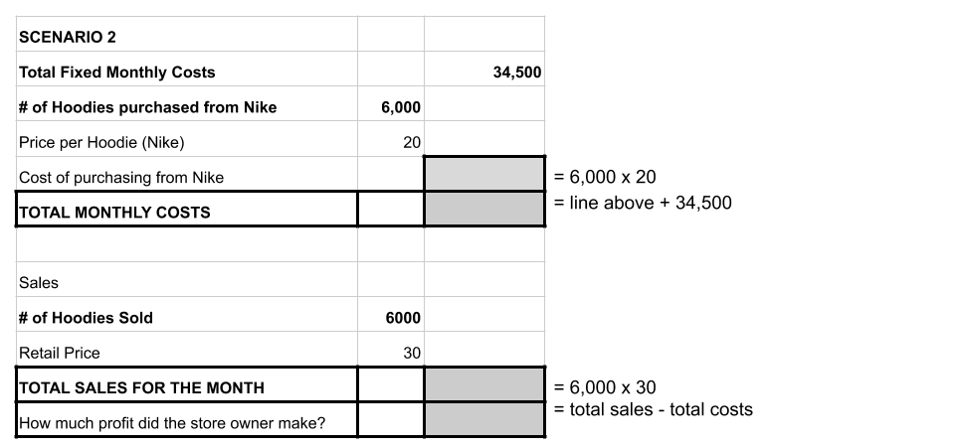

What happens if Foot Locker buys 5,000 sweatshirts but at the end of the season has only sold 3,000 of them (say LaBron gets hurt and no one wants his sweatshirt now)? (fill in the grey boxes)

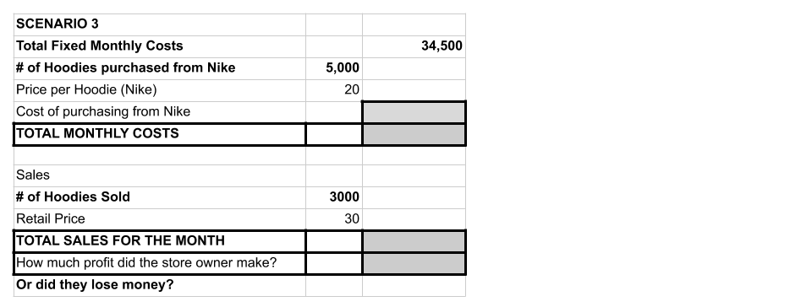

Step 4/Activity 4: Ok, bringing this home to you!
Compare the two charts below, one for the Nike/NBA sweatshirt, the other for a ‘generic’ sweatshirt, sold under the Target Label.

Assume that these two sweatshirts are made in the same factory, with the same materials and by the same workers.

What are the two main differences in costs between making a Nike/NBA hoodie compared to a Target Brand hoodie?

So, looking at the chart below, how much are you ‘paying’ for the Nike/NBA label on each hoodie that you wear?

Consumer Prices
Nike Labron @ Foot Locker |  | 30.00
Nike LaBron @ Nike Shop Online |  | 32.00
Target Brand @ Target |  | 18.00

Is that $ worth it to you? What about over 5-10 years, and all the clothes you are buying ‘for’ the label. Is that worth it? Use this chart to do a rough calculation of how much $ you're spending to support the marketing budget of Nike.

Number of Nike Products Bought Each Year | 10
Amount you ‘overpay; for Nike Brand | $12
Amount overpaid each year
Amount overpaid after 10 years...

Step 5: Sales, Sales….

You are the owner of a Foot Locker. You have lots of the hoodies on your racks and it is nearly summer. You have two choices. Which one would you select?

- Sell 500 of them to Marshalls for $12 each. Marshalls pays cash on the spot.
  - If you do this, how much money will you take in?

  - How much did you spend on those 500 hoodies when you bought them from Nike?

- Keep them on your shelves for 3 more months, taking up space, hoping to sell them $15?

- Discuss: Which one would you do? Explain your answer?

Skill Builders and Review Problems
- Organizing Data in Tables

Student Feedback:

Circle the emojis that best represents how this activity made you feel.

Day 1: Digital Identity
Health

Step 1: Warm-up
How can information you post online affect your future opportunities?

Step 2: What’s this Lesson About?
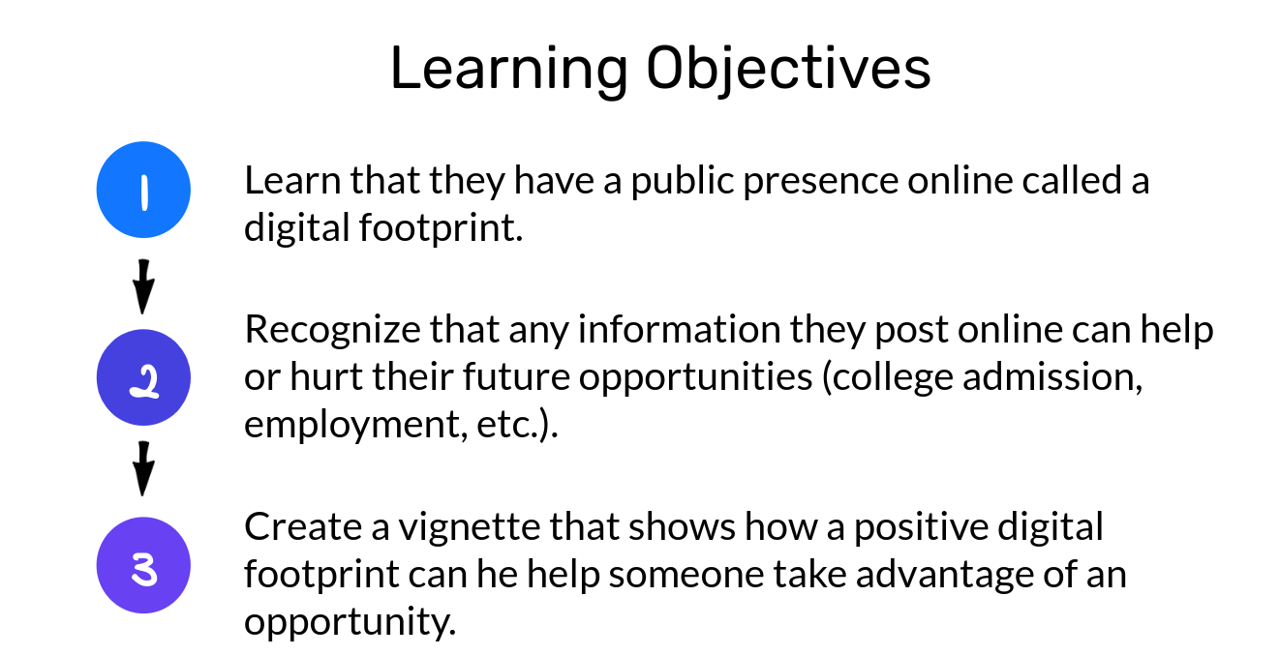
Step 3: What’s a digital footprint?
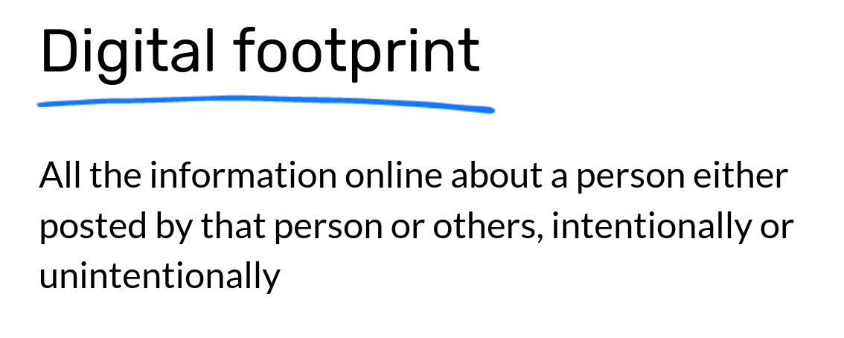
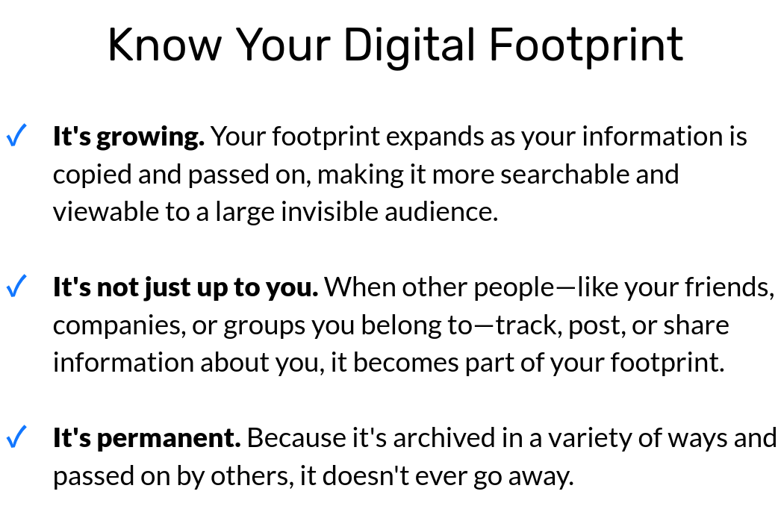

Step 4: Read the text.

Harvard Rescinds Acceptances for At Least Ten Students for Obscene Memes

Harvard College rescinded admissions offers to at least ten prospective members of the Class of 2021 after the students traded explicit memes and messages that sometimes targeted minority groups in a private Facebook group chat.

After discovering the existence and contents of the chat, Harvard administrators revoked admissions offers to at least ten participants in mid-April, according to several members of the group. University officials have previously said that Harvard’s decision to rescind a student’s offer is final.

College spokesperson Rachael Dane wrote in an emailed statement Saturday that “we do not comment publicly on the admissions status of individual applicants.”

The chat grew out of a roughly 100-member messaging group that members of the Class of 2021 set up in early December to share memes about popular culture. Admitted students found and contacted each other using the official Harvard College Class of 2021 Facebook group.

“A lot of students were excited about forming group chats with people who shared similar interests,” Jessica Zhang ’21, an incoming freshman who joined both chats, wrote in an email. “Someone posted about starting a chat for people who liked memes.”

Messages shared in the original group were mostly “lighthearted,” wrote Zhang, who said she did not post in the split off meme group and that her admission offer was not rescinded. Luca said the founders of the “dark” group chat demanded that students post provocative memes in the larger messaging group before allowing them to join the splinter group.

“They were like, ‘Oh, you have to send a meme to the original group to prove that you could get into the new one,’” Luca said. “This was a just-because-we-got-into-Harvard-doesn’t-mean-we-can’t-have- fun kind of thing.”

Employees in the Admissions Office emailed students who posted offensive memes in mid-April asking them to disclose every picture they sent over the group, according to one member of the chat whose admission offer was revoked. The student spoke only on the condition of anonymity because they did not want to be publicly identified with the messages.

“The Admissions Committee was disappointed to learn that several students in a private group chat for the Class of 2021 were sending messages that contained offensive messages and graphics,” reads a copy of the Admissions Office’s email obtained by The Crimson. “As we understand you were among the members contributing such material to this chat, we are asking that you submit a statement by tomorrow at noon to explain your contributions and actions for discussion with the Admissions Committee.”

“It is unfortunate that I have to reach out about this situation,” the email reads.

What do you think about Harvard’s decision?

This isn’t the first time this has happened. How do you think we can help prevent this situation in the future?

Can you fill your digital footprint with things you think make up your digital identity?
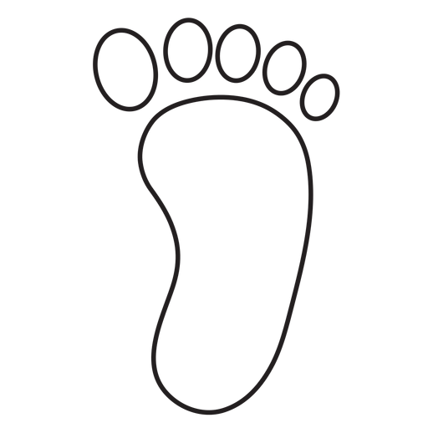
Student Feedback:
Circle the emojis that best represents how this activity made you feel.
Mindfulness Moment!
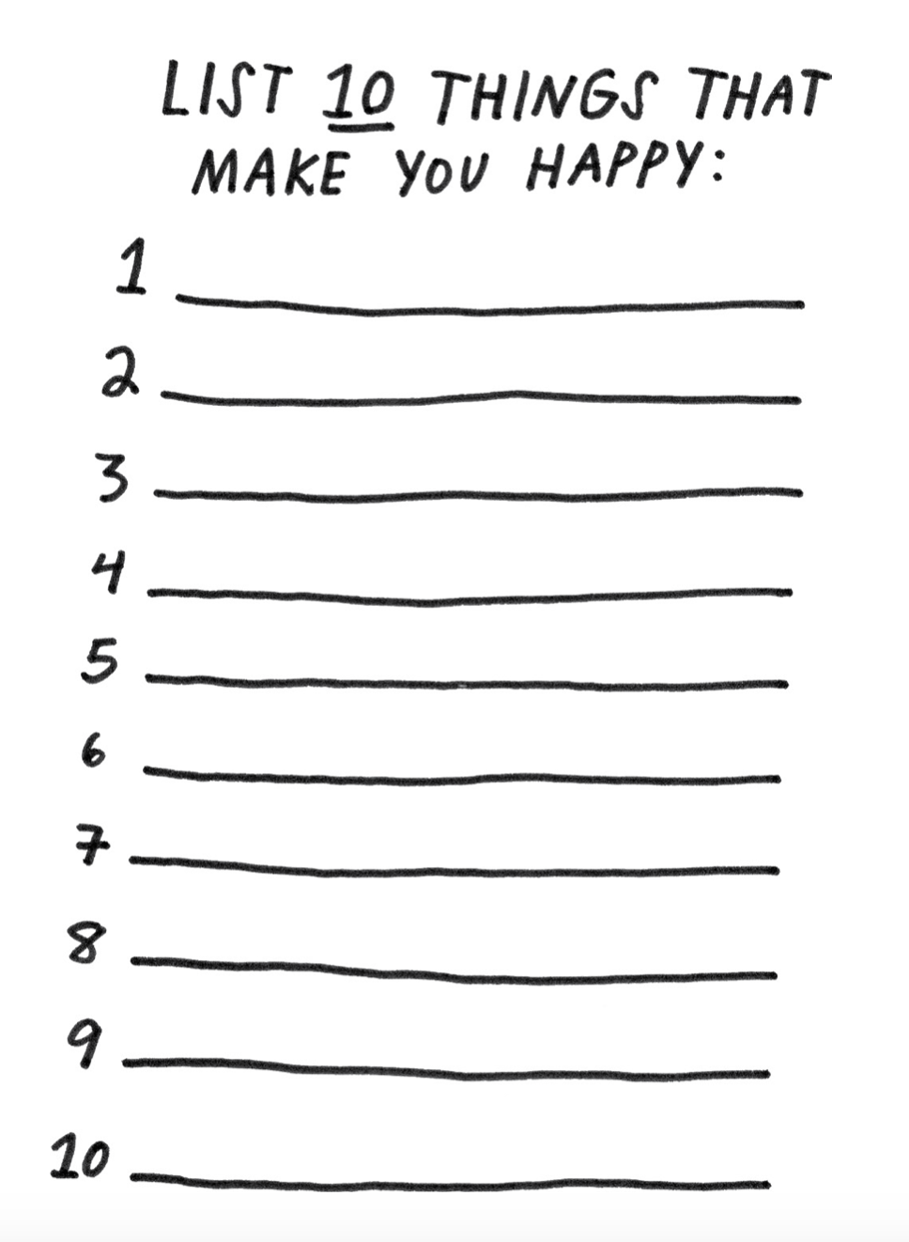
Day 1: Diversity & Intersectionality
Social Studies

What is this lesson about?: In today’s lesson you will read about different areas of our society that are becoming more diverse, from emojis to our government leaders. You will learn what intersectionality means.”

Step 1: Read the article

How diverse emojis encourage more social Inclusion
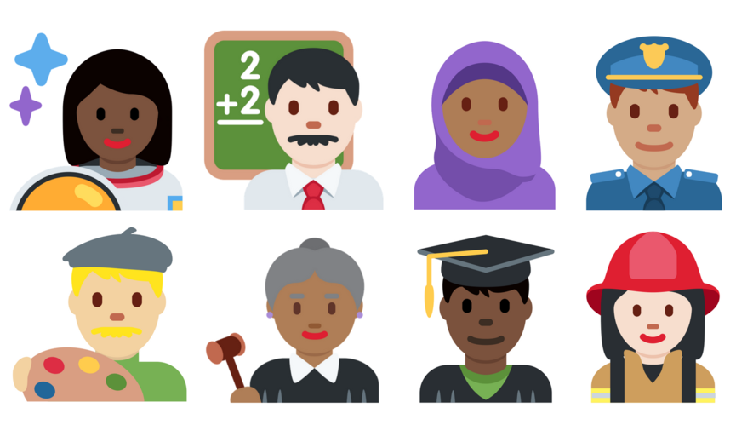
In 2010, emojis looked pretty different. They were all the same generic yellow skin tone. By 2015, emoji-makers had added new codes. People could change their emojis' skin color. The icons still defaulted to yellow, but now they came in five skin tones. They ranged from "pale white" to "darkest brown."

Concerns About Racism On Internet
Not everybody was happy about the new emojis. Some people thought they should all stay yellow. Others argued icons in different colors could be misused on social media. They could lead to hurtful racist comments or other bad behavior. Some people, though, celebrated the new colors. They were excited for the skin tone of the icons to look more like the people using them.
So far, most of those early fears haven't come true. A new study shows that social media users don't use the emojis with different skin tones for anything mean. In fact, these emojis have
actually made the Internet a more welcoming place. More people feel comfortable using emojis when they can find one that looks like them.

"It makes perfect sense" to have emojis that look like the people using them, said Debra Adams Simmons. Simmons is an editor with the magazine National Geographic. In April 2018, she put together a special issue of the magazine. It focuses on race.

People's Skin Color Matches Up With Emojis, Study Says
Researchers at the University of Edinburgh in Scotland have been spending a lot of time on Twitter. To see how people's skin color matches up with the emojis they use, they read through a billion tweets. The researchers found that most people who changed their emojis' skin color picked one similar to their own. Users with darker skin tones were more likely to change their emojis than people with lighter skin tones. Emojis, the researchers say, is one way people express themselves online. Twitter users didn't just make their emojis darker, though. Nearly half of non- yellow emojis used light skin tones.

Positive Tweets
Some tweets used emojis that were darker or lighter than the user's skin tone. These tweets might have been talking about people from a different race. Thankfully, most of these tweets were positive.

According to another study, there are more white people who use Twitter. However, black people use Twitter more often. White people don't usually use emojis with pale skin tones. Why? As emoticon researcher Tyler Schnoebelen told the Atlantic, "they're kind of represented by the default anyway." In other words, people with light skin look more like the yellow emojis than people with dark skin.

Throughout most of the world, the darkest skin tones were used the least. The authors have a guess as to why. Fewer people have Internet access in poorer parts of the world. That also tends to be where people with dark skin make up the majority.

Meeting Demand
"The introduction of skin tone choices for emojis has been a success," said Walid Magdy. He was one of the Edinburgh researchers. The use of these emojis, he said, "shows that they meet a real demand from users."

Not Just Black And White
In the National Geographic issue on race, photographer Angélica Dass took snapshots of 4,000 people. Then she paired their portraits with paint color swatches. The project covers people from
18 countries. Dass' point was to show that the world is not just black and white. People come in all kinds of colors. These days, so do their emojis.

That's no surprise, said Simmons. A person's emoji choice often tells a lot about how they see themselves.

Step 2: Answer the questions

1. Read the section "Concerns About Racism On Internet."
Which sentence from the section shows why some people were concerned about the new emoji colors?
(A) Others argued icons in different colors could be misused on social media.
(B) More people feel comfortable using emojis when they can find one that looks like them.
(C) "It makes perfect sense" to have emojis that look like the people using them, said Debra Adams Simmons.
(D) They were excited for the skin tone of the icons to look more like the people using them.

2. Read the selection from the section "Positive Tweets."
According to another study, there are more white people who use Twitter. However, black people use Twitter more often. White people don't usually use emojis with pale skin tones. Why? As emoticon researcher Tyler Schnoebelen told the Atlantic, "they're kind of represented by the default anyway." In other words, people with light skin look more like the yellow emojis than people with dark skin.

Which of the following is the MOST accurate explanation of this paragraph?
(A) People with darker skin tones prefer to change their emoji's skin tone.
(B) People prefer emojis that match their own skin tone.
(C) People use the darkest skin tones the least for emojis.
(D) People with light skin feel represented by the yellow emojis.

3. Read the paragraph from the article.
In the National Geographic issue on race, photographer Angélica Dass took snapshots of 4,000 people. Then she paired their portraits with paint color swatches. The project covers people from 18 countries. Dass' point was to show that the world is not just black and white. People come in all kinds of colors. These days, so do their emojis.

How does this paragraph support the MAIN idea of the article?
(A) It shows that there are over 4,000 skin tones.
(B) It highlights the diversity of skin tones in the real world.
(C) It explains how the emoji skin tones were developed.
(D) It proves that the skin tone choices have been a success.

4. Which sentence from the article BEST supports the article's CENTRAL idea?
(A) Users with darker skin tones were more likely to change their emojis than people with lighter skin tones.
(B) More people feel comfortable using emojis when they can find one that looks like them.
(C) These tweets might have been talking about people from a different race.
(D) In other words, people with light skin look more like the yellow emojis than people with dark skin.

Step 3: Read the second article.

Elections add a number of firsts for Congressional diversity

WASHINGTON, D.C. — The United States elected new members of Congress on November 6. The new lawmakers will take office in January. When they do, it will be the most diverse Congress ever.
It will include lawmakers from many different backgrounds.

Congress is made up of two chambers, the House of Representatives and the Senate. For the first time, a pair of Native American women are headed to the House of Representatives. So are two Muslim women. Muslims are those who practice Islam, which is a major world religion.
Massachusetts and Connecticut will also send black women to Congress as firsts for their states.
Meanwhile, Arizona and Tennessee are getting their first female senators.

The midterm elections received a lot of attention. Republicans and Democrats are the country's
two main political parties. They were fighting to win a majority of seats in Congress. Democrats
will now have a majority in the House. Republicans will keep their majority in the Senate.
President Donald Trump is a Republican.

Pioneering Lawmakers
The midterms produced a record number of women candidates and candidates of color. This

means a number of winners will make history as trailblazers by taking office. Kimberly Peeler-
Allen is a leader of Higher Heights for America. The group is focused on encouraging black women to vote and electing black women as candidates. The election victories for women and people of color are a good sign for future election cycles, Peeler-Allen said.

Electing a Congress that reflects the population of the United States is still going to take a long
time, Peeler-Allen said. Congress is still more white and more male than the general population.
She said these victories were a big step forward, though. She added that even women of color who were unsuccessful still made a difference. Their experience will show a new group of candidates that they should run, too.

Many First-Time Candidates
Some of the election's black female winners were first-time candidates. They include Illinois nurse
Lauren Underwood and Connecticut teacher Jahana Hayes. Others, like Massachusetts' Ayanna
Pressley, were already lawmakers. Many were considered to have a slim chance of winning.
Several will represent districts that are majority white. Some of those districts have historically
supported more traditional ideas. These candidates' victories challenge common ideas about who
is electable and who is not.

Pressley is currently a Boston city councilwoman. Now she will represent Massachusetts in the
next Congress. Pressley surprised her state's politicians in September by defeating a lawmaker
who had been in office for 20 years. She then ran unopposed in the election on November 6.
Making Change And History "None of us ran to make history," Pressley told supporters in her victory speech on November 6.

"We ran to make change." She said she recognized that her victory was a significant moment in
history, though.

New York's Shirley Chisholm was the first black woman in Congress. She was elected almost
exactly 50 years ago. Several of the black women elected on November 6 have said they were
following her example.

The first two Muslim women to serve in Congress will also be joining the House of
Representatives. They are Ilhan Omar of Minnesota and Rashida Tlaib of Michigan. Both are
Democrats. New Mexico's Deb Haaland and Kansas' Sharice Davids won their elections, too. They will be the first Native American women to serve in Congress. They are also both Democrats.Mike Espy will face Mississippi lawmaker Cindy Hyde-Smith in a December runoff election. Espy could become the state's first black senator since the late 1800s.

Arizona's Senate race is too close to declare a winner yet. Either Republican Martha McSally or
Democrat Kyrsten Sinema will become the state's first woman senator. Marsha Blackburn will become Tennessee's first woman senator.

Significant Governor's Races

Georgia candidate Stacey Abrams was in a fierce battle to become America's first black woman
governor. The race is still too close to call. Democrat Andrew Gillum lost a close race to become
the first black governor of Florida.

Idaho candidate for governor Paulette Jordan also lost her race. She would have become the
country's first Native American governor.

Election night also saw victories for the LGBT community. LGBT stands for lesbian, gay, bisexual
and transgender. Jared Polis became the governor of Colorado. He will be the country's first
openly gay man elected governor.

Step 4: Read the third article.

What is intersectionality?
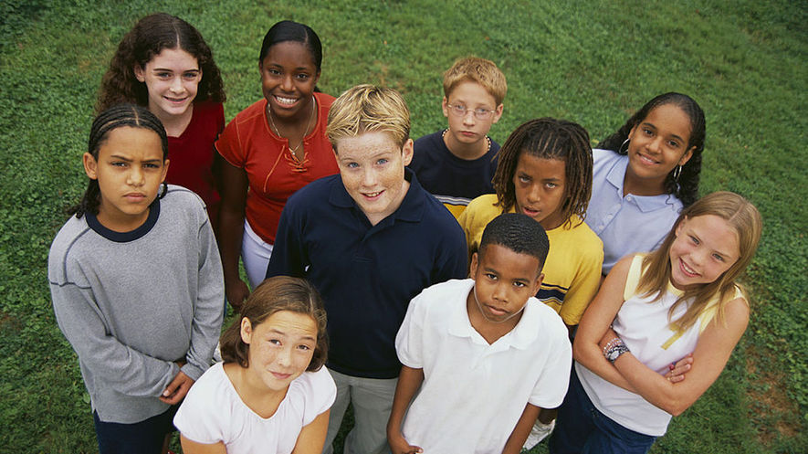
Intersectionality refers to the different kinds of identities people have. It studies how these multiple identities connect and affect a person’s life. These identities are race, gender, sex, disability, and sexual orientation, as well as where they live and socioeconomic status. Intersectionality also impacts how oppression and privilege connect and influence each other. Oppression is when someone faces unfair treatment because of their identity. Privilege is when someone has a special advantage because of their identity.

Nicole: An Intersectional Case Study
Nicole is in the ninth grade. She is a mature, creative, hardworking student, and gets along well with others. The only thing is, she’s always late for school. She frequently misses her first-period class and rarely turns in homework, and as a result, her grades are suffering. Nicole’s teachers know very little about her life, and when they look at her, they may only see an African-American student who isn’t doing well. They may think of Nicole as an example of the fact that most students who miss class or drop out of school are black or Latino.
If teachers took the time to peel back the layers of Nicole’s life they would see another part of her identity — her socioeconomic status. This would offer a better understanding of who Nicole is. Nicole isn’t just a black student, she has other identities. She identifies as a girl and as a kid from a low-income family. She is responsible for taking care of her two younger siblings. To fully and properly support Nicole, a teacher must know and respect these kinds of details. They must see her situation through the many identities that makeup who Nicole is. That is the best way to understand how her identities impact her performance at school. Understanding these can help teachers better understand the circumstances surrounding Nicole that are affecting her grades and absences.
Legal scholar and law professor Kimberlé Crenshaw coined the term intersectionality in 1989. She makes the case that society usually ignores many parts of people’s identities. People may see only the race, religion, or economic status of others, which can lead to prejudice and oppression.
In Nicole’s case, the problems she faces aren’t just about her multiple identities, but also stem from the oppressions that come with her identities. Her situation reflects the experiences of low-income people more than rich people and shows what specific challenges she faces as a girl and a black student. Specifically, Nicole must navigate parents who work long hours outside the home while also facing expectations as a female. As a female she is expected to take care of her siblings as their caretaker while her mother is at work. At school, teachers may have low expectations for her because she is a girl and African-American.

Oppression, Power And Privilege In The Classroom
In the classroom, understanding multiple identities can help teachers and classmates better relate to each other. It can also help them understand the relationship between power and privilege in the classroom.
Christina Torres is a teacher at the University Laboratory School in Honolulu, Hawaii. She makes sure to view her students through their multiple identities. She describes this mindset as “understanding that there’s a long background” to who her students are. In general, girls have different life experiences than boys; blacks have different life experiences than whites; children from rich families have different life experiences than children from low-income families. Understanding context is also key, Torres says. “A woman who is Latina in L.A. is going to have a very different experience from someone who’s in the middle of Arkansas. The place matters, too.”
Torres’ ninth-grade class also explores internalized oppression. Internalized oppression is when people give in to the negative messages about who they are. For example, a mother playing catch with her daughter may tell her not to “throw like a girl.” In this example, the mother has bought into the negative message that boys are better than girls at sports, and may be passing that message to her daughter.

Navigating The Intersections
Discussions about intersectionality and oppression might seem too difficult to talk about in class, but when a teacher brings up these difficult topics they show they care deeply about their students. In fact, Torres begins the year by asking her students to consider where and how they fit into their communities. She asks them to explore what makes them feel worthwhile there.
By emphasizing intersectionality, she equips her students with the skills to examine why they believe what they believe. They learn to question why their beliefs might differ from others’ and to determine how their ideas might be influenced by power and privilege. For Torres, helping students like Nicole navigate the world — and the way the world responds to them — is an important part of her responsibility as an educator.
“Every day kids enter our class, there’s an opportunity for them to be empowered or oppressed,” she says. “When I don’t consider intersectionality and what they might need, I run the risk of oppressing my kids. ... When we stop seeing our kids as whole people ... we stop seeing them as real people.”

Step 5: Answer the Questions

Which sentence from the article is MOST important to include in its summary?
(A) The understanding of how identities overlap and affect each other is called intersectionality.
(B) If her teachers knew more about Nicole, they would find out about the intersectionality within her
identity.
(C) For example, a mother playing catch with her daughter may say "don't throw like a girl."
(D) They learn to question why they may have different ideas than a friend or classmate.

2 What is the MAIN idea of the section "Navigating The Intersections"?
(A) Children should always question their ideas and the ideas of their peers.
(B) Torres believes that her biggest responsibility is to care for her student Nicole.
(C) Being aware of intersectionality in students can help them understand themselves and the world.
(D) Torres is a caring teacher who supports her students no matter what their intersectionality represents.

3 Based on the article, WHY is intersectionality important for understanding oppression?
(A) because it helps people understand that there are many factors that explain a person's situation in life
(B) because it explains why people are born with different races, genders and disabilities
(C) because it is a major cause of all of the unfairness and inequality that everyone faces in the world
(D) because it is the reason why Nicole is struggling in school even though she is a good student and gets along with others

4 Which section of the article explains HOW intersectionality can affect people?
(A) Introduction [paragraphs 1-2]
(B) "Nicole: An Intersectional Case Study"
(C) "Intersectionality In The Classroom"
(D) "Navigating The Intersections"
Student Feedback:

Circle the emojis that best represents how this activity made you feel.

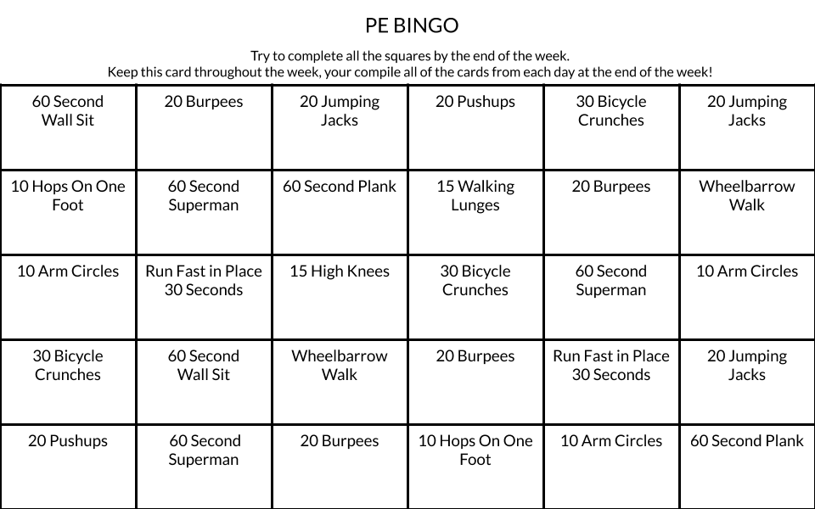

Week 3
Identity

Day 2

NAME:______________________

Day 2 Agenda

Topic | Activity
Warm-Up!
English Language Arts | - Read a poem by Jonathan Rodriguez titled “Two Names, Two Worlds”  - Read the article “Your name is part of your identity”.  - Annotate and respond to questions about the Poem  - Create a Bio Poem
Science | - Read about Chromosomes  - Answer questions about what you read  - Draw an image/picture
Mindfulness Moment!
Math | - Real World Math: Identity and Smoking: What it Costs You, and All of Us  - Practice Problems: Interpreting Data and Graphs
Health | - Digital Identity
Mindfulness Moment!
Civics/Social Studies | - Read articles and answer questions on religious identity
PE | - Bingo!

Warm-up Activity: Write a journal entry around the daily quote on identity.
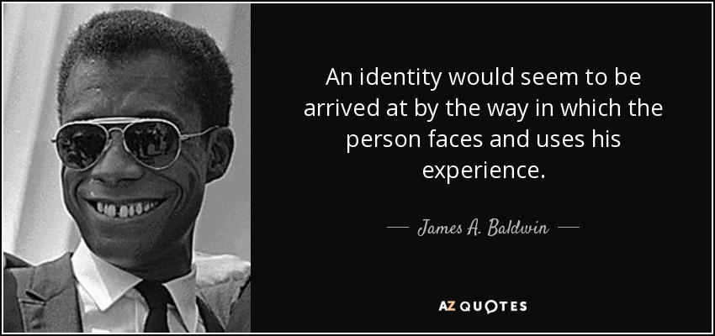

Day 2: What are the different aspects of your identity?
English Language Arts

What is this lesson about?: Today you will continue to explore the theme of identity. You will read a poem about a young man who describes the very different experiences that have shaped his identity. You will also create your own Bio Poem to describe yourself.

Note: There are some words in Spanish in this text. The words are in italics and their definitions are signified by an arrow and short explanation.

Step 1: Read the following text.
Two Names, Two Worlds By Jonathan Rodríguez

Hi I’m Jon...........No—Jonathan
Wait—Jonathan Rodriguez
Hold on—Jonathan Rodríguez
My Name, Two names, two worlds
The duality of my identity like two sides of the same coin
With two worlds, there should be plenty of room
But where do I fit?
Where can I sit?
Is this seat taken? Or is that seat taken?
There never is quite enough room is there?
Two names, Two worlds
Where do I come from?
Born in the Washington Heights of New York City
But raised in good ol’ Connecticut
The smell of freshly mowed grass, autumn leaves
Sancocho, Rice and Beans 🡨--- a popular soup in Puerto Rico
The sound from Billy Joel’s Piano Keys
And the rhythm from Juan Luis Guerra
I’m from the struggle for broken dreams
Of false promises
Of houses with white picket fences
And 2.5 kids
The mountains and campos de la Republica Dominicana < --- countryside of
And the mango trees
I’m not the typical kid from suburbia
Nor am I a smooth Latin cat
My head’s in the clouds, my nose in a comic book
I get lost in the stories and art I’m kinda awkward—so talkin’ to the ladies is hard
I listen to Fernando Villalona and Aventura every chance I get, 🡨popular bands
But don’t make me dance Merengue, Bachata
Or Salsa—I don’t know the steps
I’ve learned throughout these past years I am a mix of cultures, a mix of races
“Una Raza encendida, < ---- “a race that is black, white, and Taina
Negra, Blanca y Taina”
You can find me in the parts of a song, en una cancion. < ---- “a song”
You can feel my African Roots en la Tambora < -- “percussion instrument used in Puerto
Rico”
My Taino screams en la guira < -- “percussion instrument used in the Dominican Republic”
And the melodies of the lyrics are a reminder of my beautiful Spanish heritage
I am African, Taino and Spanish
A Fanboy, an athlete, a nerd, a student, an introvert
I’m proud to say: Yo soy Dominicano < ----- “I am Dominican”
I’m proud to say, I am me
I am beginning to appreciate that I am Una bella mezcla. < ----- “a beautiful blend”
I am beginning to see that this world is also a beautiful mix
Of people, ideas and stories.
Is this seat taken? Or is that seat taken?
Join me and take a seat,
Here we’ll write our own stories

Step 2: Note the Cultural Experience
Throughout the poem, the narrator contrasts his two different experiences growing up. Go through the poem and place a Star next to each line that describes an “American” experience and place a dash next to each line that describes a “Latino” experience.

Step 3: Answer the following questions
- In the first three lines, the narrator repeats his name three times, each time, changing it slightly. What do these three ways of saying his name represent?

- What does Rodriguez mean when he says “”two names, two worlds”? What two worlds does his name represent?

- What are some wrong assumptions that Rodriguez claims some people might make about him because of his name? (list at least two)

- What are some parts of his identity that people might be surprised by if they only think of his name? (list at least two)

- In the first section of the poem, Rodriguez questions “But where do I fit? Where can I fit?” Why does he ask this question? Why do you think it might be hard to fit in somewhere?

- In the last ten lines of the poem, Rodriguez’ tone changes. What does he realize?

- The last two lines of the poem state: “Join me and take a seat, Here we’ll write our own stories.” What does it mean “write your own story, when developing your sense of who you are (your identity)?

Step 3: Look at the following list of words—circle at least three adjectives that describe you.
active | angry | adventurous
affectionate | agreeable | blunt
bold | calm | cautious
compassionate | confident | competitive
cooperative | curious | cynical
deep | determined | diplomatic
direct | disciplined | easygoing
emotional | empathetic | energetic
fair | flexible | focused
forgiving | friendly | funny
generous | goofy | happy
helpful | imaginative | independent
kind | lazy | likeable
logical | messy | mean
neat | nice | nosy
Share with a partner, how these three words describe you. Give an example that shows this quality in your personality.

Step 4: Writing a Bio Poem

A Bio Poem is a structured type of poem that follows a strict form with 11 lines that each specific characteristics about a person.

How to Write a Bio Poem
(Line 1) First name
(Line 2) Three or four adjectives that describe the person
(Line 3) Important relationship (daughter of . . . , mother of . . . , etc)
(Line 4) Three items or people the person loves

(Line 5) Three feelings the person has experienced
(Line 6) Three things the person needs (these can be emotions, experiences or
material things.
(Line 7) Three fears the person experienced
(Line 8) Three things the person is good at or has accomplished
(Line 9) Three things the person wants to see happen or wants to experience
(Line 10) Your Location/Home
(Line 11 ) Last Name
Example:

Lateef
Artistic, strong, funny, loyal
Son of Monique and Andre and brother to Samantha
Loves the feeling of a basketball in his hands, painting, and Ben’s Chili
Who feels happy when hanging with friends, at peace when sketching and
confused when reading poetry.
Who needs time outside, family, and music to be happy in life
Fears the silence, clowns and snakes
Who makes people laugh when someone is sad, who creates beautiful art,
and helped the team win the district trophy.
Would like to visit the ocean, be able to sell his art and own a house
Resident of Washington, DC
Crandall

Write your own Bio Poem in the space below. Be sure to follow the format provided.

Step 3: Share out your poem with other students.
Student Feedback:
Circle the emojis that best represents how this activity made you feel.

Day 2: Science
Chromosomes

What is this lesson about?: Today you will read through the Chromosomes passage. You will answer a few questions about what you read. You will complete a Chromosome activity.

Step 1: Read through the Chromosomes passage

Chromosomes
(Technological Solutions, 2020)
What are chromosomes?
Chromosomes are tiny structures inside cells made from DNA and protein. The information inside chromosomes acts like a recipe that tells cells how to function and replicate. Every form of life has its own unique set of instructions, including you. Your chromosomes describe what color eyes you have, how tall you are, and whether you're a boy or a girl.

Inside the Cell
Chromosomes are found in the nucleus of every cell. Different forms of life have a different number of chromosomes in each cell. Humans have 23 pairs of chromosomes for a total of 46 chromosomes in each cell.

Can we see them?
Normally we can't see chromosomes. They are so small and thin, we can't see them even with a powerful microscope. However, when a cell gets ready to divide, the chromosomes wind themselves up and become tightly packed. With a high powered microscope, scientists can see chromosomes. They are usually in pairs and look like short little worms.
What do they look like?  When a cell is not dividing (called the interphase of the cell cycle), the chromosome is in its chromatin form. In this form it is a long, very thin, strand. When the cell begins to divide, that strand replicates itself and winds up into shorter tubes. Before the split, the two tubes are pinched together at a point called the centromere. The shorter arms of the tubes are called the "p arms" and the longer arms are called the "q arms." | 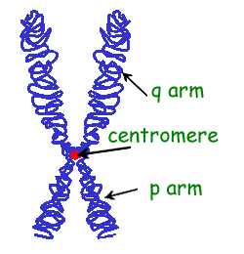
Different Chromosomes
Different chromosomes carry different types of information. For example, one chromosome may contain information on eye color and height while another chromosome may determine blood type.

Genes
Within each chromosome are specific sections of DNA called genes. Each gene contains the code or recipe to make a specific protein. These proteins determine how we grow and what traits we inherit from our parents. The gene is sometimes called a unit of heredity.

Allele
When we talk about a gene we are referring to a section of DNA. One example of this would be the gene that determines the color of your hair. When we talk about the specific sequence of a gene (like the sequence that gives you black hair versus the sequence that gives you blonde hair), this is called an allele. So everyone has a gene that determines their hair color, only blondes have the allele that makes the hair blonde.

Human Chromosomes
As we mentioned above, humans have 23 different pairs of chromosomes for a total of 46 chromosomes. We all get 23 chromosomes from our mother and 23 from our father. Scientists number these pairs from 1 to 22 and then an extra pair called the "X/Y" pair. The X/Y pair determines if you are a boy or a girl. Girls have two X chromosomes called the XX, while boys have an X and a Y chromosome called the XY.

Chromosomes in Different Animals
Different organisms have different numbers of chromosomes: a horse has 64, a rabbit 44, and a fruit fly has 8.

Interesting Facts about Chromosomes
- Some animals have lots of chromosomes, but much of the DNA is blank. This blank DNA is called "junk DNA."
- Nearly every cell in your body carries a complete set of chromosomes.
- Some chromosomes are longer than others because they contain more DNA.
- Humans have about 30,000 genes in their 46 chromosomes.
- The word "chromosome" comes from the Greek words "chroma", meaning color, and "soma", meaning body.

Step 2: Answer the following questions
- Chromosomes are made from protein and what other molecule?
  - ATP
  - Carbon dioxide
  - DNA

- Chromosomes are found inside what structure in the cell?
  - Membrane
  - Nucleus
  - Mitochondria

- How many pairs of chromosomes are in a human being?
  - 23
  - 44
  - 89
- What form does the chromosome take when the cell is not dividing?
  - Wound up like a tube
  - Tubes shaped like an X
  - Long and thin strand

- Which of the following is considered the basic unit of heredity?
  - Chromosomes
  - Genes
  - Enzymes

- What does the X/Y pair of chromosomes determine in humans?
  - What color eyes you have
  - How tall you will be
  - Whether you are a male or female

- Every chromosome carries exactly the same information.
  - TRUE
  - FALSE

Step 3: Draw an image/picture

Draw an image/picture that comes to mind from the passage you read about Chromosomes. What is something you want to remember about this topic? What would you like to learn more about?

Student Feedback:

Circle the emojis that best represents how this activity made you feel.
Day 2: Identity/Cigarettes and Smoking
Math

What is this lesson about?: This lesson focuses on the cost cigarettes--to individuals and to society. And as we look at the costs, we will also try to understand the role that smoking plays in one's identity, and in the identity of regions of the country.

But First: Today’s Warm-Up
Let’s go back to those hoodies/sweatshirts…

You go online and look up the same sweatshirt at a few sites. The chart below shows the prices.

What is the average cost of the sweatshirt?

What is the median cost of the sweatshirt?

What if the sweatshirt sold at Store A is a fake.
- What is the new average price in the remaining 4 stores?

- What is the median price in the remaining 4 stores?

Hint:
- To find the average, add up all the items and divide by the # of items.
- To find the median, arrange the numbers from smallest to largest and select the middle number. If there are 2 middle numbers, add them and divide by 2.

Step 1/Activity 1: Let’s use the chart below to answer a few questions.
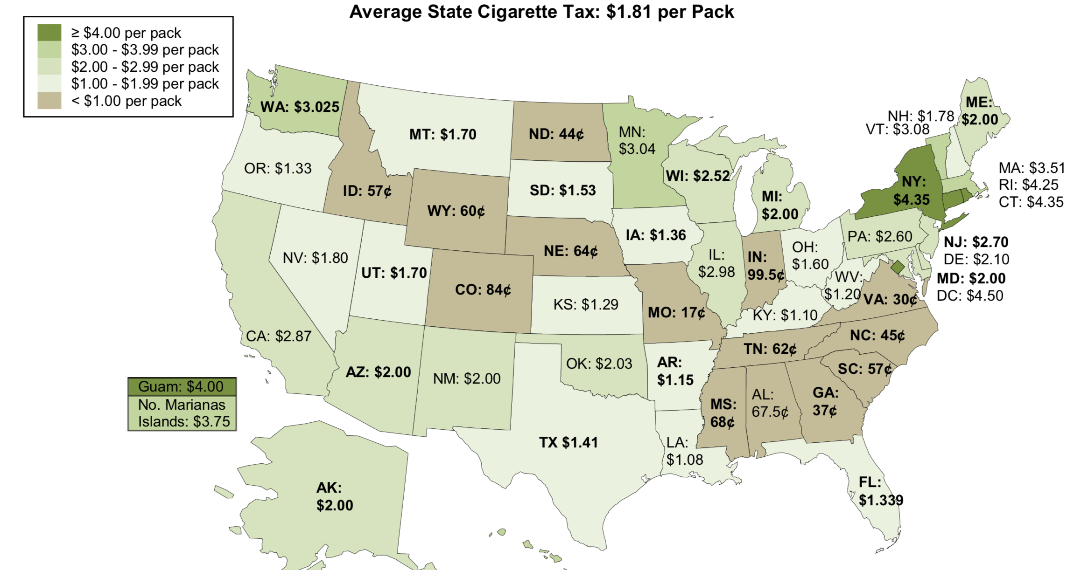
What states have the 5 lowest taxes on a pack of cigarettes. List them below:

- What is the average tax on a pack of cigarettes in those 5 states?

- What is the median tax on a pack of cigarettes in those 5 states?

What states have the highest taxes on a pack of cigarettes. List them below:

- What is the average tax on a pack of cigarettes in those 5 states?

- What is the median tax on a pack of cigarettes in those 5 states?

Looking at the map:
What region of the country has the lowest tax rates on cigarettes? (Circle one)
- North East, Southeast, Midwest, Southwest, Northwest

What other region of the country has pretty low taxes?
- (Circle one) Northeast, Southeast, Midwest, Southwest, Northwest

Discuss/Consider: One of the primary reasons states charge a high sales tax on a pack of cigarettes is to REDUCE cigarette smoking.
- Is there any historical or cultural reason that might be the reason for low sales tax on cigarettes in either the southeastern or midwestern parts of the US?

  - Where in the US was most of the tobacco in the US grown from the 1600s through the early 1900s?

  - What part of the country do you think of when you see the Marlboro Man?

- Would you be surprised to know that in 2015 17% of the adult population in the Midwest and 16% of the adult population in the south smokes cigarettes?

- What % of the adult population do you think smokes in the northeast (New York, Massachusetts, etc.)

Step 2: Teens and Cigarette smoking…
For many teenagers, smoking is something that they start and something that they start to take on as a part of their identity. The chart below shows the 3 primary reasons teens and young adults say they smoke.
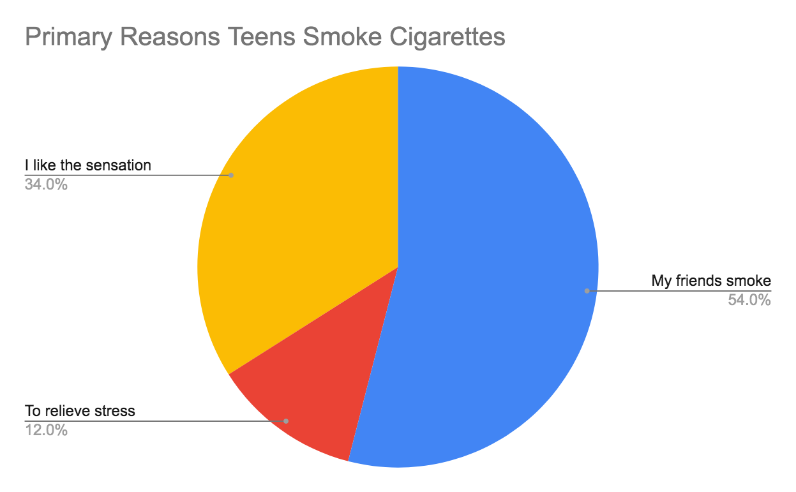
Based on the chart, what is the #1 reason why teens and young adults smoke?

The chart below shows the percent of high school students who smoked cigarettes in the last 30 days, in 1995 compared to 2015.
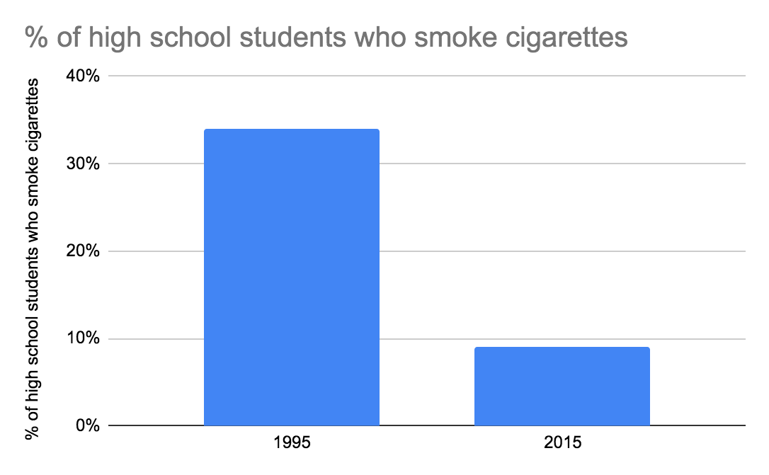

- Out of 100 students in 1995, about how many smoked cigarettes?
- Out of 100 students in 2015 about how many smoked cigarettes?
- Discuss/Consider: what are some reasons for this decline, do you think?
The chart below shows the percent of high school students who smoked cigarettes on average, compared to high school students involved in the juvenile justice system, in 2015.
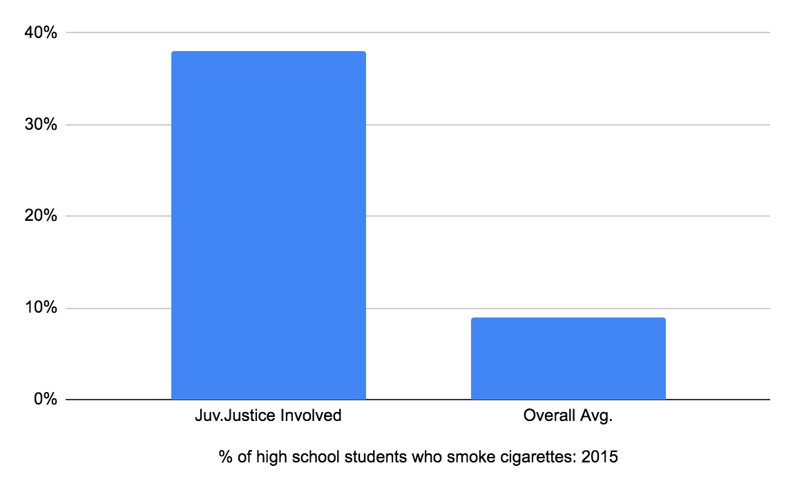
- Out of 100 high school students in 2015, about how many smoked cigarettes?
- Out of 100 high school students who were involved in the juvenile justice system in 2015 about how many smoked cigarettes?
- Discuss/Consider: what are some reasons for this difference, do you think?

The chart below compares smoking habits to education, as of 2015.
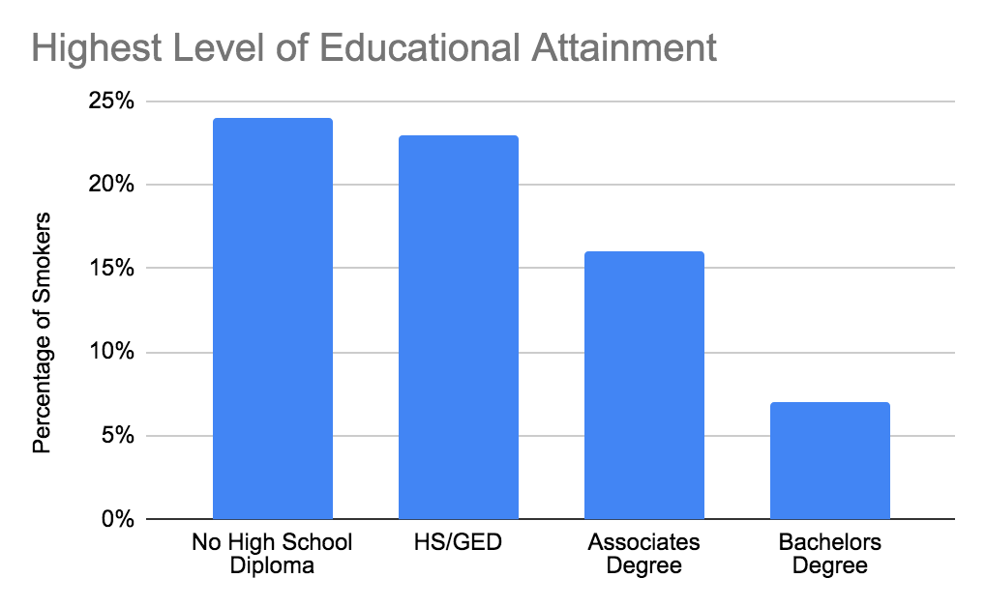
- Out of 100 adults who earn a 4-year college degree, what % smoke cigarettes?
- Out of 100 adults who get their GED but don’t complete college, what % smoke cigarettes?
- Discuss/Consider: what are some reasons for this difference, do you think?

Step 3: Smoking, Addiction and Health Challenges

Each day approximately 2,500 high school students will try a cigarette across the country.
- In one 5-day week, how many students is that?
- The average school year has about 35 weeks in it. About how many students is that over one school year, across the country?

Almost 1 out of every 5 high school students who try a cigarette will become long-term smokers.
- So, of the students who try cigarettes in one year (above), how many of them will become long-term smokers?

The chart below shows the average life expectancy of smokers vs nonsmokers.
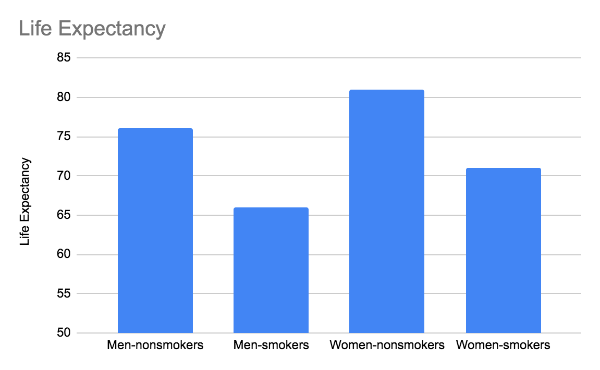
What is the average life expectancy for a non-smoking male?

What is the average life expectancy for a smoking male?

What is the average life expectancy for a non-smoking female?

What is the average life expectancy for a smoking female?

Based on your current identity as a smoker or nonsmoker, what is your current life expectancy?

Step 4: The cost of smoking….Last questions and Identifying as a smoker or nonsmoker?

Complete the chart below and then answer the questions…
State | Cost of 1 pack of cigarettes |  | # of packs/week |  | Cost per week |  | Annual cost |  | Cost after 20 years
New York | 10.00 | x | 1 | = |  | x50 |  | x20
Missouri | 4.00 | x | 1 | = |  | x50 |  | x20
Kentucky | 5.50 | x | 1 | = |  | x50 |  | x20
Arizona | 7.00 | x | 1 | = |  | x50 |  | x20

Based on the 4 states listed, what is the average cost for 1 pack of cigarettes?

How much would you spend over 1 year (1 pack /week) on cigarettes if you live in Kentucky? And in Arizona?

How much would you spend over 20 years on cigarettes if you live in Missouri?
How about in New York? And in Arizona?

Assume that you smoke 2 packs per week, how much would you spend over 20 years in:
New York? Missouri? Kentucky? Arizona

Discuss: Do these amounts seem like a lot of money, or a minor amount?

Discuss/consider: You probably identify yourself in a lot of ways--as a teenager, as a male or female, as Black or White or Latinx, as a scholar, as a son or daughter…

- Do you identify yourself as someone who smokes cigarettes?

- Yes/No? If yes, is this an identity that is essential to you?

- Is this a part of your identity that you would like to keep or shed?

Skill Builders and Review Problems
- Interpreting Data in Charts

Student Feedback:

Circle the emojis that best represents how this activity made you feel.

Day 2: Digital Identity
Health

Step 1: Warm-up
How can you create a digital footprint that showcases your purpose?

Step 2: What’s this Lesson About?
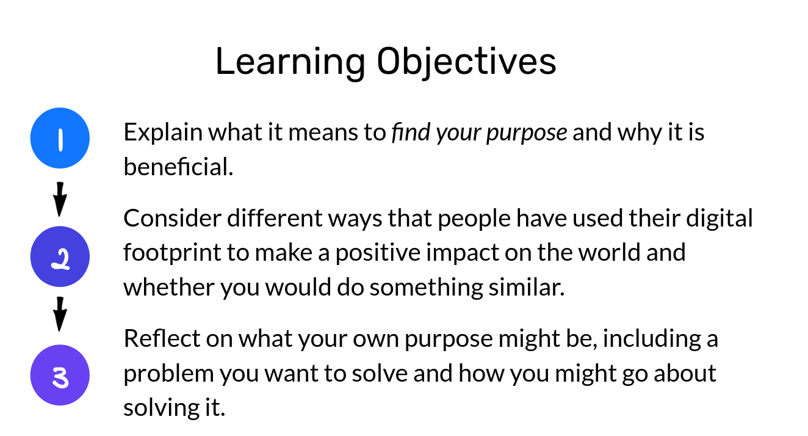
Step 3: Read the text.

We’re not okay with it. We’ll fight back
When we look at 16-year old Jamie Margolin’s bright eyes and impressive scope of work she has done to spread awareness of climate change, we realize how right Satyarthi has been.
Jamie is the founder of This Is Zero Hour. The “Zero Hour” is a youth-led movement that became one of the leading platforms for all young people who feel the need to take concrete action on climate change — before it’s too late. They are young, powerful, and endlessly inspiring.
Their most well-known action is the Zero Hour Youth March, which will take place in Washington D.C. on July 21st. In the midst of doing all the hard work in the face of such a big protest, Jamie was kind enough to answer some questions we had for her. Many of her answers left us standing in awe.
Hi Jamie, thanks for talking to us today. It is always inspiring and touching to see a young person so dedicated to the single most critical issue of today. How did you first engage in climate activism?
When I was 14, I was an intern in the WA state headquarters for Hillary Clinton’s 2016 campaign and did a lot of volunteer training as well as translating for the office because I was the only fluent Spanish speaker there.
After Hillary lost, I wallowed in grief for a bit, and then joined a local environmental organization called Plant for the Planet where I did tons of lobbying, advocacy and work in alliance with local indigenous tribes. I also joined the Washington state Youth vs Government trial by the pro bono law firm “Our Children’s Trust”, where lawyers are helping young people sue the US government over actively making climate change worse and denying our constitutional rights to life, liberty, and the pursuit of happiness.
Can you tell us how, after that, your movement “This Is Zero Hour” came to be?
I had a vision of youth all over the US and the world marching for urgent climate action since the first Women’s March back in January of 2017. At that time I was still fresh to the community organizing world and was nervous to take on the enormous task of starting a mass movement. So I suppressed that vision and continued to do local environmental organizing.
Then, the summer of 2017 happened. That July, I was at a month-long Political Speech and Communication course for high school students at Princeton University. I found myself away from my family for the first time, on the other side of the country, surrounded by politically engaged high schoolers.
By that time I had had a ton of community organizing experience. That was also a summer full of natural disasters, and thick smog that covered Seattle thanks to stronger-than-usual wildfires up north in Canada. That was when I finally decided to take the plunge.
Picking up the courage and taking that plunge yourself is surely challenging, but gathering the core team of people is even more so. How was your team formed?
We are not a movement that happened overnight at all. It took grueling hours and hours every day of slow but gradual movement-building, and it still does.
At first, I had social media friends, like Nadia Nazar, who was also willing to take the plunge with me. My friends from Princeton camp Madeline Tew and Zanagee Artis also joined, and are now the two core team leads.
For a while, we did tons of visioning and brainstorming, struggling to find our footing. Soon we brought on some adult mentors, like Mrinalini Chakraborty, a Women’s March co-founder, and Laura Sanders from DC Local Ambassadors who guided us in the right direction.
We reached out to frontline communities who we knew had to be at the center of the movement, like some of the youth from the Standing Rock tribe who famously led the #NODAPL fight, who were excited by the idea. Since then, we’ve expanded into a full-fledged organization.
What exactly is the “Hour Zero” as a symbol for you?
Zero Hour means that there is no more time to act on climate change. It’s a means of communicating the urgent emergency that we are in.
Our logo speaks volumes about the symbolic. It was beautifully designed by Nadia Nazar, a 16-year-old co-founder of this movement. If you see any Zero Hour graphics out there, chances are they were all designed by Nadia.

The part of the earth that is greyed out represents the time we have already lost, the habitats and lives that have already been destroyed. The damage that has already been done. The little sliver of orange left represents the time and hope that we have to combat the crisis.
We the youth are the sliver of hope — and This Is Zero Hour to act on climate change. Our leaders need to wake up and realize that we have no more time to act. It is Zero Hour.

Your digital identity can also be a platform of purpose. Share some ideas around things that you care about that you want the world to take action on.

Student Feedback:
Circle the emojis that best represents how this activity made you feel.

Mindfulness Moment!

Day 2: Comparing Judaism, Islam and Christianity
Social Studies

What is this lesson about?: In today’s lesson you will read about the three major religions in the world.

Step 1: Read the article, review the chart, and answer the questions-

Understanding the basic tenets of major religions

Judaism, Christianity and Islam are the world's three largest Abrahamic religions. This means the followers of these religions believe that they are all descended from Abraham.

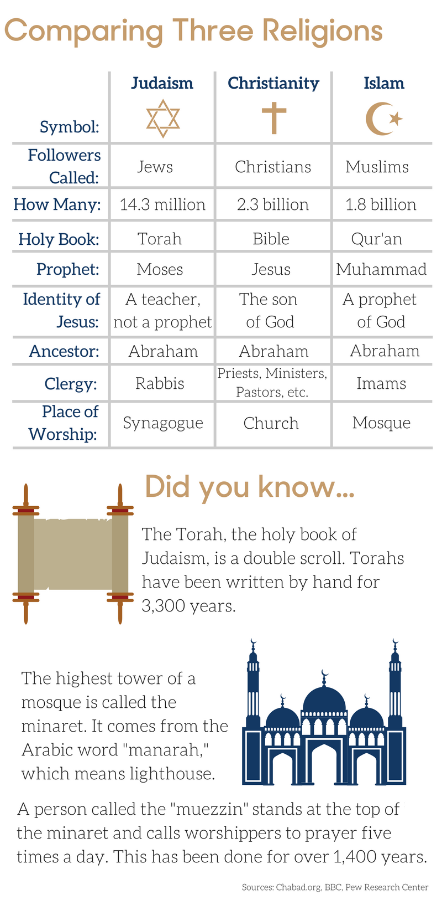
The chart outlines the similarities and differences between these three religions:

Answer the questions based on the chart-

- Which religion has the most followers around the world?
- What is the holy book for:
Judaism:
Christianity:
Islam:
- What it the place of worship for:
Judaism:
Christianity:
Islam:

Step 2: Read this article-

Despite differences, Jews, Christians and Muslims worship the same God
It is often assumed that the God of Islam is fierce and warlike, whereas the God of Christianity and Judaism is loving and merciful. Despite the various differences in the way they worship, Jews, Christians and Muslims actually all worship the same God.
The founder of Islam, Muhammad, saw himself as the last in a line of prophets that included both Jesus and Moses. Going farther back, the line of prophets included Abraham and even Noah. According to the Quran, God (known as Allah) revealed to Muhammad:
"The Book with the truth [the Quran], confirming what was before it, and [before He sent down the Quran] He sent down the Torah of Moses and the Gospel of Jesus … as a guidance for the people."
Thus, since Muhammad inherited the Jewish and Christian understandings of God, it is not surprising that the God of Muhammad, Jesus and Moses has a similarly complex and ambivalent character – a blend of benevolence and compassion, combined with wrath and anger. If you were obedient to his commands, he could be all sweetness and light. But you didn't want to get on his wrong side
To those who turned to him in repentance, this God was infinitely forgiving. Those who failed to find the path, though, or those who found the path but failed to follow it, would know God's judgment and wrath.

God Was Seen As Both Good And Evil
For Jews, God was fully revealed in the Torah (the first five books of the Hebrew Bible, called the Old Testament). The God of the Old Testament was both good and evil. He could act in ways that seem cruel, such as when he ordered Abraham to offer up his son as a burnt sacrifice. He was also a warrior God who murdered the first child of every Egyptian and drowned the army of Pharaoh. He even approved of Elijah killing the 450 prophets of an opposing God, the ancient Canaanite God Baal.
He was, at other times, a merciful God. In Psalm 23 in the Book of Psalms, for example, he is described as a loving guide who brings comfort and happiness to his followers. In the Old Testament, he loves Israel like a father loves a son.
The Christian Bible includes the Old Testament as well as the New Testament, which tells of the life and teachings of Jesus. As in older texts, the God of the New Testament is a complicated figure. On the one hand, Jesus describes him as tender and loving, referring to him as "Father." On the other hand, the God of the New Testament is still very much to be feared.
Like the prophets of the Old Testament, Jesus predicted a day when God would punish humankind, and would be merciless in doing so. On this day, called the Last Judgement, God would bring an end to history. The dead would then be brought back to life. The people that God favored, a fortunate few, would receive eternal happiness in heaven. The wicked majority, including those who refused to listen to Jesus, would be cast into the eternal fires of hell.

A Day Of Judgment
Muhammad warned of a similar day of judgment. At the end of the world, God would act as a God of justice. All the dead would be resurrected to receive God's judgment. God would then reward or punish each person in the gardens of paradise or the fires of hell according to their deeds. Each would be presented with a record of their deeds – in the right hand for those to be saved, in the left for those to be damned to the fires of hell.
For those who were saved, the pleasures and comforts of paradise awaited. Those who died in the cause of Allah, however, did not need to wait for the Last Judgment, as they would go straight to heaven.
The key to being saved was, above all, to surrender to Allah ("islam" means "surrender" in Arabic). In other words, the key was to obey his commands, as described in the Quran, and pledge loyalty to his messenger Muhammad. Like the God of Moses, Allah was a lawmaker. The Quran provided rules and guidelines on various subjects, including marriage and family law, inheritance, food and drink, warfare, punishments for adultery and false accusations of adultery, alcohol and theft. Over the coming centuries, it provided the foundation for an Islam-based system of law, called sharia.
In sum, Muslims, Christians and Jews all worship the same complex God. Each religion believes, however, that its books and teachings reveal the true nature of that God.
This disagreement has helped shape the course of history. The followers of each religion believe that only they will be saved by God and see each other as damned. This way of seeing others, as disfavored by God and beyond any hope of being saved, has led to centuries of violence and intolerance. So it is that these religions both unite and divide.
Step 3: Answer the following Questions:

Which selection from the article BEST explains a key difference between Judaism and Christianity?
- Despite the various differences in the way they worship, Jews, Christians and Muslims actually all worship the same God
- Those who failed to find the path, though, or those who found the path but failed to follow it, would know God's judgment and wrath.
- The Christian Bible includes the Old Testament as well as the New Testament, which tells of the life and teachings of Jesus.
- Like the prophets of the Old Testament, Jesus predicted a day when God would punish humankind, and would be merciless in doing so.
Which two sentences from the article include CENTRAL ideas of the article?
- It is often assumed that the God of Islam is fierce and warlike, whereas the God of Christianity and Judaism is loving and merciful.
- Despite the various differences in the way they worship, Jews, Christians and Muslims actually all worship the same God.
- For Jews, God was fully revealed in the Torah (the first five books of the Hebrew Bible, called the Old Testament).
- The followers of each religion believe that only they will be saved by God and see each other as damned.
Strict followers of religion tend to think only their religion is correct. Which sentence from the article provides the BEST support to the statement above?
- (A) In sum, Muslims, Christians and Jews all worship the same complex God.
- (B) This disagreement has shaped the course of history.
- (C) The followers of each religion believe that only they will be saved by God.
- (D) So it is that these religions both unite and divide.

Step 4: Read this article.

During Ramadan, young Muslims slowly get used to fasting

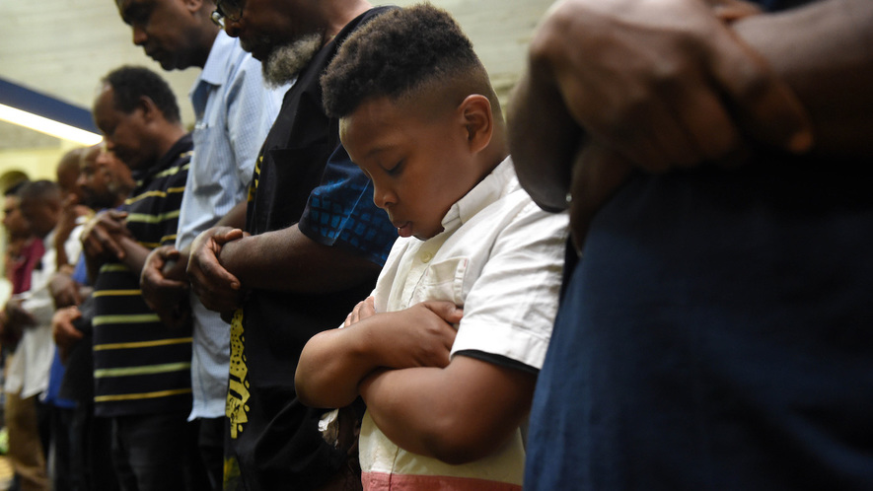
At 8:35 on a Wednesday evening, the sun sets in Washington, D.C., and the call to prayer resounds. In Arabic, a man recites a declaration of faith, practically singing as he praises God — Allah, as he is known in Arabic. The man is signaling to the hundred members at Masjid Muhammad that it is time for two very important events. The first is evening prayer. The second is breaking of the day's fast.

Most of the men, women and children at Masjid Muhammad, a mosque, have not eaten or drunk in nearly 15 hours. They have been fasting since dawn, praying and reading the Quran in snatches while at work or school. They are hungry, but it is Ramadan. Ramadan is a holy month of fasting and prayer for Muslims around the world — and they say their hunger is not important.

"Fasting," explains Imam Talib Shareef, "makes you conscious of human life, aware of universal human needs. Regardless of your race, ethnicity or nationality, you have to eat, drink and sleep," important daily tasks that are carefully controlled during Ramadan. Waking up early to eat before dawn and fasting during the day forces you to think about the essentials in life, he says.

Shareef heads Masjid Muhammad, built in 1960 and one of the oldest mosques in Washington, D.C. He wears a black kufi — a short, brimless hat — and leads daily prayer services for the mosque's 1,500 members, most of whom are black.

Ramadan is the ninth month of the Islamic calendar. It is believed to be the month when the Quran was first revealed to Muhammad, who is considered a prophet and a central figure in Islam. The Islamic calendar is based on the lunar cycle. In a lunar-based calendar, there are 354 or 355 days in a year. This is fewer than in a calendar based on the solar cycle, which has 365 days in a year. That is why Ramadan occurs at a different time each year.

This year, most Muslims are observing Ramadan from May 15 through June 15. The day after Ramadan ends is a holiday, Eid al-Fitr, during which families feast and give gifts.

Fasting isn't the only thing encouraged during Ramadan.

"You try to be the best person you can be," says Asiya Khokhar, one of about a dozen kids at the prayer service. "You try and be nice and polite to other people and try not to fight and yell."

Muslims are expected to pray five times a day and read all of the Quran during Ramadan. Asiya, 14, says she feels "more spiritual, more focused and more happy" during the month.

Members of Masjid Muhammad break their fast with a traditional meal called an "iftar," which is offered for free at the mosque every night during Ramadan. Everyone has water and dates, a fruit common in Africa and the Middle East, and sheds their shoes to take part in a service in the mosque's prayer hall. Women stand in the back, their heads covered by scarves called "hijabs."

The service is in Arabic. Many kids take classes at the mosque to learn the language, but Shareef switches to English for a short sermon. "Help people. Don't be a burden on people," he says. "This is the month where we change habits."

Evening prayer is followed by a larger meal: chicken, rice, salad, watermelon and a slice of cake. Second helpings are discouraged in the name of moderation.

Fasting is hard, many kids say, but you get used to it. Khaled Mohamed, 17, has been fasting since he was about 3. (Most kids start at 12 or 13.) "In winter, it's very easy to fast," he says, "because all you're thinking about is trying to keep warm during the day."

One helpful trick Khaled has learned: Telling his friends he's fasting for the month so that they don't eat around him. "It's easier that way."
Step 5: Answer these Questions
Explain the Muslim holiday of Ramadan?

What part does the calendar play in the holiday?

How do people observe the holiday?

Student Feedback:

Circle the emojis that best represents how this activity made you feel.

Week 3
Identity

Day 3

NAME:______________________

Day 3 Agenda

Topic | Activity
Warm-Up!
English Language Arts | - Read the poem Identity, by Julio Noboa Polanco  - Annotate and identify imagery in the poem.
Science | - Read about our fingerprints  - Write down three things you learned about fingerprints  - Draw an image/picture
Mindfulness Moment!
Math | - Real-World Math: Identity and place: Migration→ understanding percent increase and decrease  - Practice Problems: Mean, Median and Mode
Health | - Digital Identity
Mindfulness Moment!
Civics/Social Studies | - Read about identified voters
PE | - Bingo!

Warm-up Activity: Write a journal entry around the daily quote on identity.
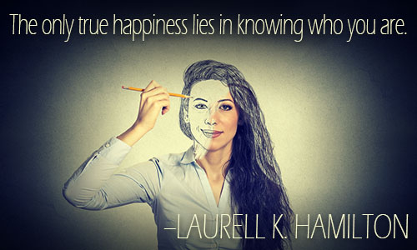

Day 3: English Language Arts
Defining Ourselves Using Metaphor

What is this lesson about?:. Today, you will read a poem that uses an extended metaphor (a comparison that starts at the beginning of the poem and continues throughout).

Step 1: Before reading

Do a 5 minute quick-write where you just write your ideas, don’t worry about your spelling or grammar, just focus on what you feel and want to say.

Write for 5 minutes: If you could compare yourself to something else that is not human, what would you compare yourself to? What qualities or abilities does this non- human being or object have that could describe you? Explain. The first sentence has been started for you.

I am like a….

Step 2: Read the following poem.

In it, Polanco uses an extended metaphor or comparison to describe his chosen identity. As you read, make sure to annotate what you think is being said in the box next to the stanza.

Some vocabulary to review before reading:
harnessed—controlled or held still | wavering—waving, swaying
madness—craziness, insanity | abyss—a bottomless pit
shunned—to be avoided deliberately | stench –a strong, unpleasant smell

 | Identity by Julio Noboa Polanco | Translate into your own words
1 | Let them be as flowers,  Always watered, fed, guarded, admired,  But harnessed to a pot of dirt.
2 | I'd rather be a tall, ugly weed,  Clinging on cliffs, like an eagle  Wind-wavering above high, jagged rocks.
3 | To have broken through the surface of stone,  To live, to feel exposed to the madness  Of the vast, eternal sky.  To be swayed by the breezes of an ancient sea,  Carrying my soul, my seed,  Beyond the mountains of time or into the abyss  of the bizarre.
4 | I'd rather be unseen, and if  Then shunned by everyone,  Than to be a pleasant-smelling flower,  Growing in clusters in the fertile valley,  Where they're praised, handled, and plucked  By greedy, human hands.
5 | I'd rather smell of musty, green stench  Than of sweet, fragrant lilac.  If I could stand alone, strong and free,  I'd rather be a tall, ugly weed.

Step 3: Answer the following questions.

1. Throughout the poem, the author talks of “them” and “they”—who is he referring to? How does he feel about “them”? What words tell you that he feels this way?

- It is often said that a weed is any flower or plant that is unwanted. So, a dandelion can be a beautiful flower if it is appreciated or a weed if you don’t want it in your yard. Why do you think the author wants to identify himself as an “ugly weed” instead of a wildflower or some other plant?

- In his metaphor, the author uses imagery which is descriptive language that appeals to the five senses (smell, taste, sight, hearing and touch) in order to create an image or picture in the mind of the reader. Give an example of an image that the author creates for his reader. Next to your example, draw it out.

- In stanza three, the speaker in the poem says that the he will have “…broken through the surface of stone.” What does this tell you about the weed/speaker?

- Throughout the poem, the author repeats the phrase “I’d rather”. Why do you think that the author emphasizes that he’d “rather” be an ugly weed? Do you think he really believes that he is ugly?

6. Linking this poem back to the idea of identity, is this author/speaker choosing his identity or is he allowing others to define him? Explain.

Student Feedback:

Circle the emojis that best represents how this activity made you feel.

Day 3: Science
Fingerprints

What is this lesson about?: Today you will read through two passages, What is the mystery behind our unique fingerprints? and What are fingerprints? You will write down something new that you learned and you will complete a fingerprint activity.

Step 1: Read through the passages, What is the mystery behind our unique fingerprints? and What are fingerprints?
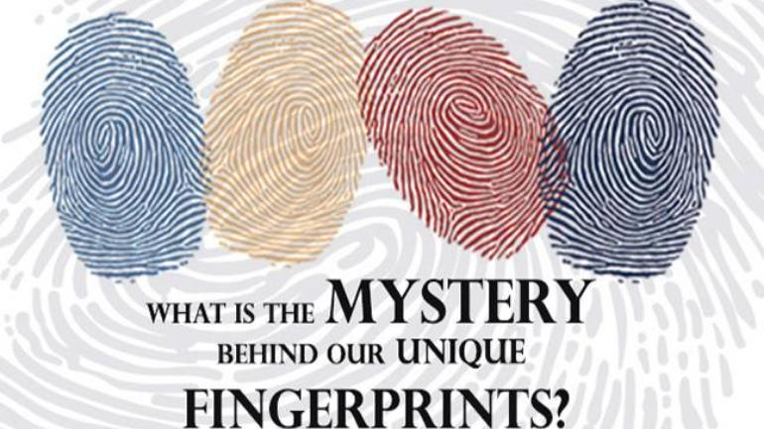
India Today, 2019
How are fingerprints formed?
The patterns on our fingertips, or fingerprints, are truly unique and are not replicated even in the case of identical twins. These patterns are created in the womb when the fetus is barely three inches long.
The process starts at about the 10th week of conception, and by the 14th week, the fingerprints are set in stone.

Your genes decide your fingerprints
Fingerprints are basically a product of your genes. Though the genetic code of the fetus doesn't completely decide the exact patterns that will appear on the fingertips, they do decide the factors that go behind making fingerprints.
The fascination with the uniqueness of fingerprints has continued for a long time. It has been acknowledged for about 2000 years, while scientific research on the matter was carried out for around 200 years.
It was only in 2004 that researchers Michael Kucken and Alan C. Newell from the University of Arizona presented a paper explaining how the epidermal ridges or the fingerprints are biologically formed.

Crumpling skin layer gives rise to patterns
The skin has three main layers - the upper layer of the epidermis on the outside, the inner dermis, and the basal layer of epidermis in between.
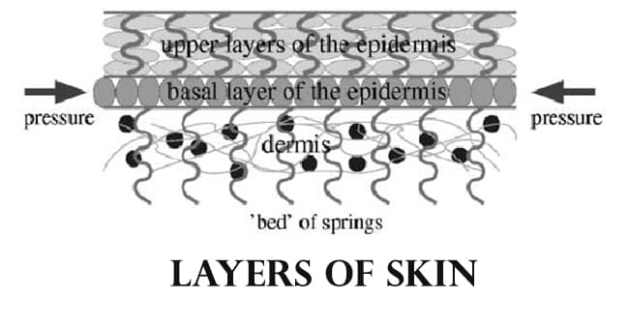
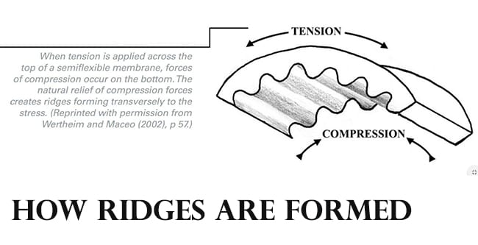
In a fetus, the sandwiched basal layer grows faster than the other two layers of skin and as a result, it kind of crumples in specific ways to produce the patterns on our fingertips that we call fingerprints.
"These folds encode the future fingerprint pattern that becomes visible on the skin surface in subsequent weeks," Kucken told LiveScience. "Because the fingerprint pattern is coded underneath the skin surface, the pattern cannot be destroyed by superficial skin injuries."

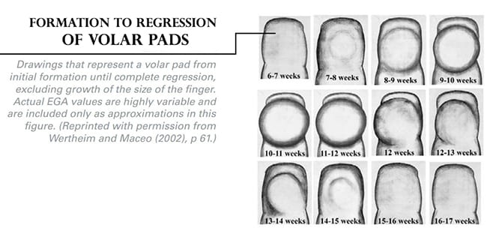
During the formation of fingers, volar pads are formed on the surface of the palm and on the soles of the feet of the fetus at around 7-8 weeks of pregnancy. These are thick pads of skin formed by a kind of swelled stem cell tissue called mesenchyme under the other layers of skin.

The volar pads remain swelled and rounded for some time till after the 9th or 10th week of gestation when they start to change in size and position. After that, they slowly start to disappear and fingerprints are formed during the same time.
The position and state of the volar pads decide what kind of patterns will be formed on the fingers--arches, loops or whorls.
If the receding volar pads are slanted to one side when the first fingerprint ridges are formed, then the pattern will also be slanted, forming a loop.
If the volar pads are still prominent but flat, whorls will be formed, and if the volar pads have almost disappeared, arch patterned ridges will be formed.
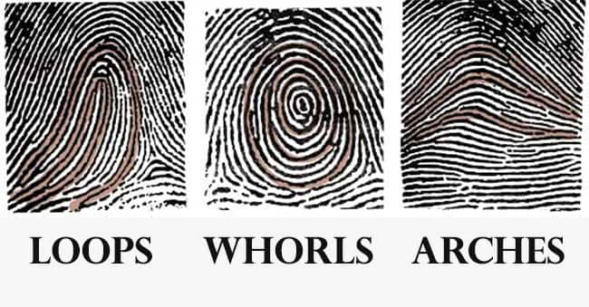

Why do identical twins have different fingerprint patterns?
Since the fingerprint patterns are primarily decided by genes, the similarity in patterns run in families. However, finer points in fingerprints called minutiae can vary even in families.
While it is not completely clear as to what causes these tiny differences, research suggests that they are caused by environmental factors. These include the position and movement of the fetus in the womb when the ridges are formed on the fingertips and even the density of the amniotic fluid.
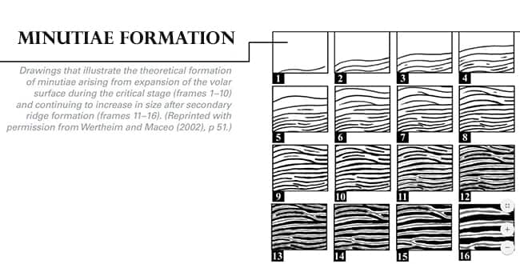
These factors can ultimately change the number of ridges on the fingertips or how they converge.

The intrinsic and extrinsic factors that go into making the human body, especially the human skin, are not possible to duplicate even in small areas. Thus, even in twins, the patterns of fingerprints can be similar, but they won't be exactly the same.

What are fingerprints?
Stephanie Watson
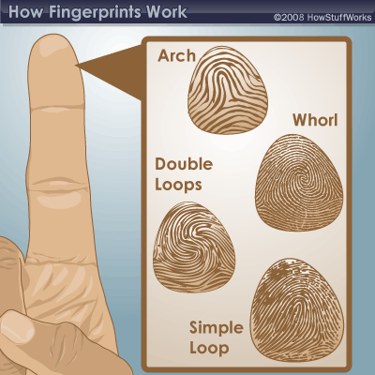
What are fingerprints?

Fingerprints are the tiny ridges, whorls and valley patterns on the tip of each finger. They form from pressure on a baby's tiny, developing fingers in the womb. No two people have been found to have the same fingerprints -- they are totally unique. There's a one in 64 billion chance that your fingerprint will match up exactly with someone else's.
Fingerprints are even more unique than DNA, the genetic material in each of our cells. Although identical twins can share the same DNA -- or at least most of it -- they can't have the same fingerprints.
Fingerprinting is one form of biometrics, a science that uses people's physical characteristics to identify them. Fingerprints are ideal for this purpose because they're inexpensive to collect and analyze, and they never change, even as people age.
­Although hands and feet have many ridged areas ­that could be used for identification, fingerprints became a popular form of biometrics because they are easy to classify and sort. They're also accessible.
Fingerprints are made of an arrangement of ridges, called friction ridges. Each ridge contains pores, which are attached to sweat glands under the skin. You leave fingerprints on glasses, tables and just about anything else you touch because of this sweat.
All of the ridges of fingerprints form patterns called loops, whorls or arches:
- Loops begin on one side of the finger, curve around or upward, and exit the other side. There are two types of loops: Radial loops slope toward the thumb, while ulnar loops slope toward the little finger.
- Whorls form a circular or spiral pattern.
- Arches slope upward and then down, like very narrow mountains.
Scientists look at the arrangement, shape, size and number of lines in these fingerprint patterns to distinguish one from another. They also analyze very tiny characteristics called minutiae, which can't be seen with the naked eye.

Step 2: Write down three things you learned about fingerprints

Write down three things you learned about fingerprints:

1.

2.

3.

Step 3: Draw an image/picture

If you have a water based marker, color one of your fingers with the marker and press your finger here:

[If you are unable to use the marker, take a moment to rub your fingers together and look very closely at your fingers. Draw an image/picture that best represents one of your fingerprints.]

What do you notice about your fingerprint? Be sure to use the proper terminology from the two texts to describe your print.

Student Feedback:

Circle the emojis that best represents how this activity made you feel.

Mindfulness Moment!
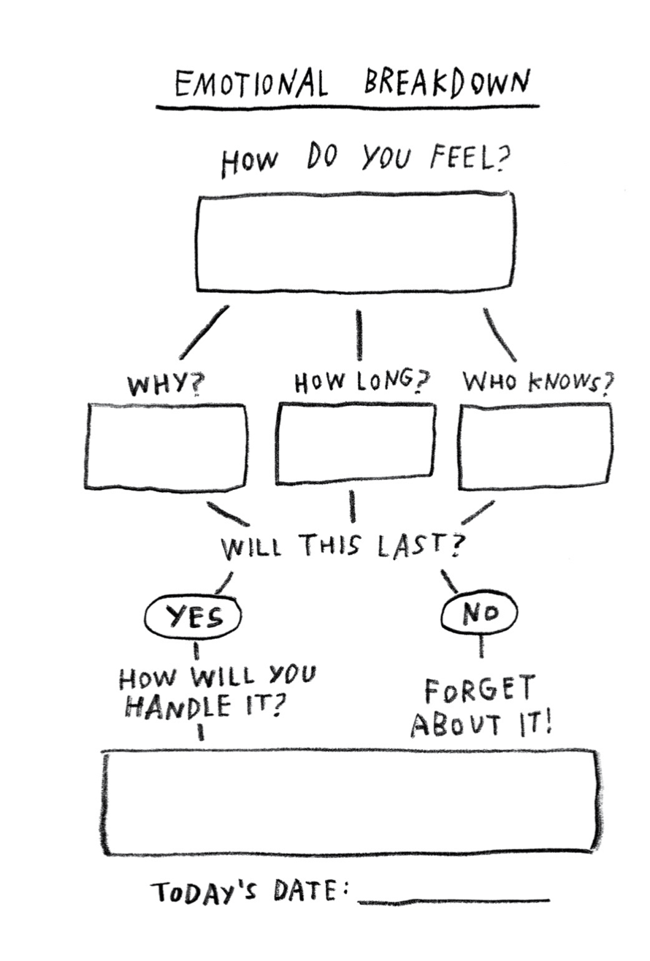

Day 3: Identity/Migration & Immigration
Math

What is this lesson about?: We will use African American migration data from 1910-1930 to learn about calculating percent change.

But first: Today’s Warm-Up
Last week a gallon of milk cost $3.00, this week it costs $3.45.
Did the price increase or decrease and by how much? Does this seem like a normal weekly fluctuation or is this abnormal?

(Hint: Think about what milk would cost in a couple of months if this type of price change continued)

Step 1/Activity 1: Calculating Price Change

Calculating price increases or decreases is fairly easy, just compare the current amount to the previous amount. If the price goes up, it is an increase. If the price goes down, it is a decrease.

Example #1: A Pre-paid cellular phone cost $100 last month, but this month it costs $80 (cellular phone costs continue to decline in our country).
- This is an example of a price decrease.
- By subtracting $80 from $100 we can see that the price decreased $20.

Your turn: Ostrich farms have been increasing in popularity over the past 20 years as people look for more sources of lean protein. You have decided to purchase 15 ostriches for $300 each. This seems like a good deal to you since last year they were priced at $400.

- How much you saved per ostrich and in total for your purchase.

Step 2/Activity 2: Converting decimals to percentages

To be able to calculate percent change, we will need to review converting decimals to percentages. All finite decimals can be converted to percentages, the simple rule is to move the decimal point 2 units to the right.

Example #1: Find what percentage is equivalent to .034.
- Move the decimal 1 unit to the right (now it is between the 0 and the 3)
- Move the decimal 1 more unit to the right (2 units total) and now it reads 03.4.
- Since we have completed the steps to converting to a percentage, we can rewrite 03.4 as 03.4%.
- Now, knock off that 0, there is never a need to start a quantity or price amount with a 0, unless you are stating a value of nothing.

Your Turn: Find which percentage is equivalent to 2.87.

Bonus- Can you figure out which decimal is equivalent to 18.5%?

Step 3/Activity 3: Calculating percentage change
Calculating percentage change requires finding the amount of change and dividing it by the original amount.

Percentage Change=$\frac{Amount of change}{Original amount}$

Example #1: - Using the example from our warm up, the price of a gallon of milk increased from $3.00 per gallon(original amount) to $3.45 per gallon(new amount).
- Using Step#1 we find the price increase(amount of change) to be $.45.
- Remember, Percentage Change=$\frac{Amount of change}{Original amount}$
$\frac{Amount of change}{Original amount}$=$\frac{\$.45}{\$3.00}$=.15
- Then convert .15 to a percentage by moving the decimal 2 units to the right and add the percentage sign, 15%.

Your Turn: You are at an all you can eat buffalo wing restaurant and just finished off 28 wings. Last week you were really hungry and ate 42 buffalo wings, impressive.
Please calculate the amount of change, whether it was an increase or a decrease and calculate the percent change.

Step 4/Activity 4: Using what we have learned.

In the early 1900s, many African American families moved from southern states north and west. This was called the Great Migration. There were lots of reasons for this, but one of them was because African Americans were fleeing the Jim Crow laws and ongoing racial terrorism of the south during these years.

The chart below shows the African American population of each state (20 of them) between 1910 and 1930, based on Census data. Column B is the population in 1910, Column C is the population in 1930.
Note, the numbers are rounded off.

Select 5 of the states below that you want to work with.

- Step 1:In Column A make a prediction about whether you think the population in that state went up or down during this 20 year period.

- Step 2: Go to Column D. Subtract the bigger number from the smaller number in Col. B and Col. D to show the difference in population from 1910 to 1930. Use a +/- to show if it is an increasing or decreasing number.

- Step 3: Calculate percentage change in Col. E. Remember the formula for calculating percentage change is to divide the amount of change by the original amount, then convert your decimal to a %.

Percentage Change=$\frac{Amount of change}{Original amount}$-→ then convert the decimal to a % by moving the decimal 2 units to the right

 | Col. A | Col. B | Col. C | Col.D | Col. E
State | Do you predict the African American population went up or down from 1910 to 1930?  +/- | What was the total number of African Americans in this state in 1910? | What was the total number of African Americansin this state in 1930? | Express the change in the African American population as a number. (+/-) | Express the change in the African American population as a percentage.  (+/-)
Alabama |  | 910,000 | 945,000
Arkansas |  | 443,000 | 479,000
Florida |  | 308,000 | 431,000
Georgia |  | 1,175,000 | 1,071,000
Illinois |  | 109,000 | 328,000
Indiana |  | 60,000 | 111,000
Kentucky |  | 261,000 | 226,000
Louisiana |  | 713,000 | 776,000
Massachusetts |  | 38,000 | 52,00
Michigan |  | 17,000 | 169,000
Minnesota |  | 7,000 | 9,000
Mississippi |  | 1,009,000 | 1,009,000
New Jersey |  | 89,000 | 208,000
New York |  | 134,000 | 412,000
North Carolina |  | 697,000 | 918,000
Pennsylvania |  | 193,000 | 431,000
South Carolina |  | 835,000 | 793,000
Tennessee |  | 473,000 | 477,000
Texas |  | 690,000 | 854,000
Virginia |  | 671,000 | 650,000

Comparing and Analyzing the Data

- Compare Col. A and Col.D in the five states you selected to work with. How many or your predictions were correct? Incorrect?

- Explain why you might have been wrong in some of your predictions. What did you incorrectly assume?

- Which state had the largest number of African Americans in 1910? 1930?

4. Which states had the smallest number of African-Americans in 1910? 1930?

5. Of the 5 states you selected, which states had the largest and smallest percentage changes in their African-American population from 1910 to 1930?

Short Answer Questions: Discuss as well, if permitted.

What state do you live in? Do you know what state you parents or your grandparents were born in? If your family has moved do you know why?

Were your parents or grandparents born outside of the US? If yes, what led them to the US?

How does where you were born, or where your family is from impact your identity?

Skill Builders and Review Problems
- Mean, Median and Mode

Student Feedback:

Circle the emojis that best represents how this activity made you feel.

Day 3: Digital Identity
Health

Step 1: Warm-up

How can my digital identity be a platform for the things I care about?

Step 2: What are sustainable development goals?

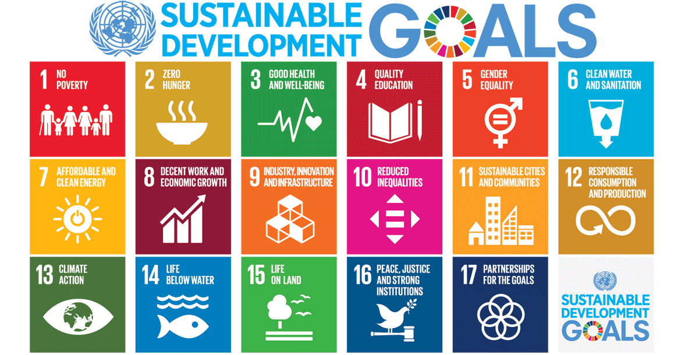

The Sustainable Development Goals are the blueprint to achieve a better and more sustainable future for all. They address the global challenges we face, including those related to poverty, inequality, climate change, environmental degradation, peace, and justice. The 17 Goals are all interconnected, and in order to leave no one behind, it is important that we achieve them all by 2030.

Step 3: What are your sustainable development goals?

Rank your top five sustainable development goals:

1.
2.
3.
4.
5.

Pick one goal and plan how you could use your digital identity to spread awareness.
Make a plan:

Student Feedback:
Circle the emojis that best represents how this activity made you feel.
Mindfulness Moment!
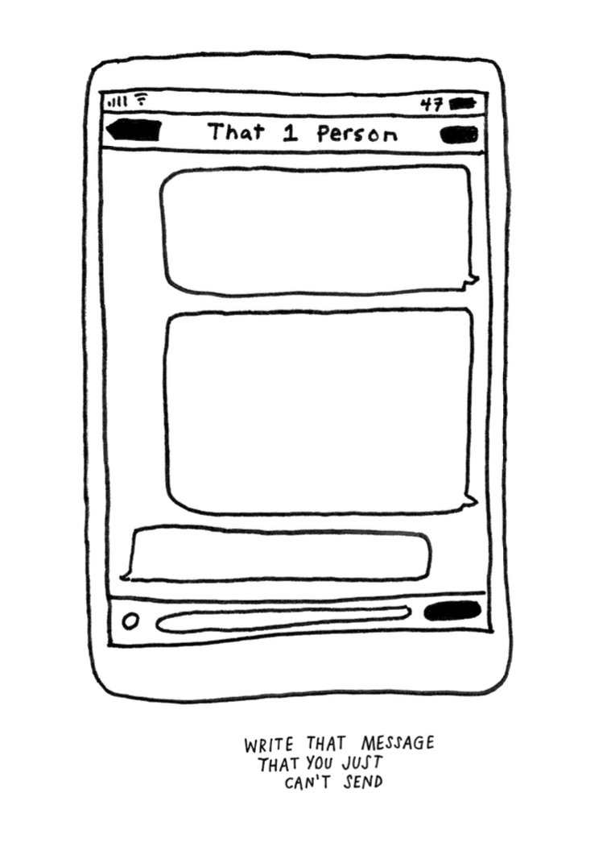

Day 3: Identified Voters
Social Studies
What is this lesson about?: In today’s lesson you will read about how identity impacts your right to vote.

Step 1: Read the article

Time Machine (1916): First Woman is Elected to Congress
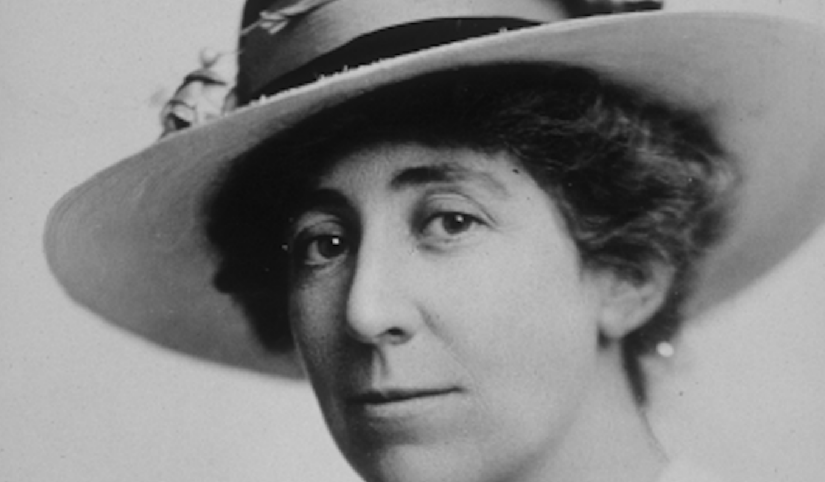

This article was first published in the Nov. 11, 1916, edition of the Public Ledger in Philadelphia, Pennsylvania. Jeannette Rankin became the first woman to hold national office in the United States. She was elected to the U.S. House of Representatives by the state of Montana. She worked to give women the right to vote in all elections. She was defeated in 1918 but re-elected to Congress in 1940. She was a pacifist, a person who is against all war. She voted against declaring war in 1917 and again in 1941. She also protested against the Vietnam War in the 1970s.

She is America's first "Congresswoman." Miss Jeannette Rankin of Missoula, Montana, has won the seat in Congress from her state. She defeated seven men and won by 7,000 votes. She will get a salary of $7,500 a year. Miss Rankin wants to go to Washington to help and serve women and children.

She wants laws that By Public Ledger, adapted by Newsela staff on 05.16.16 Word Count 643 Level 840L This article is available at 5 reading levels at https://newsela.com. would set up an eight-hour workday for women. She wants equal pay for women doing the same work done by men. Miss Rankin was sewing as she said this today. Even after entering politics, she still cooks and sews. Miss Rankin was calm as returns showed she was ahead in the voting. "I'm glad of this chance," was her comment when she was elected.

"I Won't Be The Last"

"Of course," said Miss Rankin today, "I know I'll be the first woman member of Congress, but I won't be the last." She believes she will be welcomed by the other congressmen. She knows they are against women having the right to vote, but she thinks she can get them to listen to her side. "This is not my campaign," she says. She explains that it is a campaign for all Montana women who wanted to have a woman working for them in Congress. Women of Montana say it is her energy, charming personality and wonderful work that brought the right to vote to the women of Montana.

Deserving Of Honor

Miss Belle Fligelman, of Helena, Montana, is also a tireless worker in the cause of women and voting rights, or suffrage. She calls Miss Rankin a "Wonder woman." She tells me Miss Rankin has given of herself, her money and her time for the cause of womankind. Now the women of Montana have rewarded her. They have sent her to Congress. Almost every women's group in the state of Montana came out to support Miss Rankin. Miss Fligelman said each woman voter knows, "If it weren't for Jeannette Rankin, I couldn't be voting at all." She added, "You see she was in charge of the suffrage campaign which swept Montana two years ago." The women won the right to vote on their first try. The women of Montana believe Miss Rankin will help their cause. A woman in Congress fighting for national suffrage can no longer be ignored by congressmen.

Men Could Learn From Her

Miss Fligelman describes Miss Rankin saying, "She is a keen thinker, a tremendous worker, and she has a thorough knowledge of work in Congress." Miss Fligelman explained that Miss Rankin spent years pushing for suffrage with lawmakers all over the country. She feels Miss Rankin knows more about how Congress works than the men in Congress today. She also supports a national law to ban alcohol, called Prohibition. Miss Rankin's Congressional work is also directed toward the little children of the nation. Pointing out this need, she talks about Congress setting aside $300,000 to pay for food for hogs. On the same day, $30,000 was set aside to help children. She argues that hogs are not 10 times more important than children. She worries that hundreds of men in Washington care about taxes and hogs. She wants to be the voice caring about more help for children.

Step 2: Answer the questions below

It is important that our lawmakers represent many different identities. Can you give an example from the article above of why it was important to have a woman’s perspective in Congress?

What role do you think voting plays in making sure that lawmakers identify with their community?

Step 3: Read the article

Maggie Flaherty was so upset that she was too young to cast a ballot against Donald Trump in the 2016 presidential election that one of her first missions when she arrived as a freshman at Dartmouth College in New Hampshire the following year was to register to vote.
Then the California native learned about a new proposal from state Republicans that would subject college students who vote in the state to residency requirements such as getting in-state driver’s licenses and vehicle registrations.

“That costs money,” said Flaherty, who along with a classmate and the American Civil Liberties Union sued the state after the law passed. “And I don’t think it should cost money to be able to vote.”
The fight in New Hampshire is one of at least a dozen legal skirmishes being waged across the country, in the run-up to the 2020 election, that are financed by Democrats and liberal activists who hope to overturn or head off measures they fear could erode the electoral might of young voters — an increasingly left-leaning voting bloc.

Over the past decade, Republicans in more than a dozen states have tried to limit the kinds of student IDs that can be used at the polls, restricted the number of polling locations on or near college campuses, or gerrymandered political boundaries that divide campuses and dilute the power of student voters, as well as other measures.

Among the states with laws that Democrats fear could hamper the youth vote in 2020 are battlegrounds including Wisconsin, Florida and New Hampshire.

Republicans say the rules are meant to prevent fraud and safeguard the integrity of elections, and they deny accusations that they are trying to make it harder for young people to vote.
But there is little doubt that Democrats had more to gain when young voters engaged in recent elections. Voters under 30 turned out in record numbers last fall, helping to power a liberal wave that swept Democrats into power in Congress.

At the same time, that age group still cast ballots at far lower rates than all others. Voting-rights activists believe one reason is a slew of restrictions pushed by GOP state leaders in recent years.
Democrats and their allies are planning to spend millions of dollars on lawsuits arguing that such measures are unconstitutional and aimed at dissuading the participation of young voters.

“Elections are oftentimes a game of inches,” said Marc Elias, a Democratic lawyer in Washington who is leading many of the challenges. “Young voters, particularly given the size of the millennial generation, can be measured in feet or yards. The difference of one percentage point here or there can be the difference between victory and loss.”

Step 4: Answer questions.

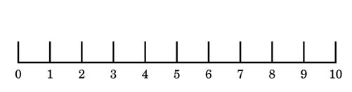

On a scale of 1-10 share how important your right to vote is to you. Why?

Step 5: Review the political cartoons around voting.
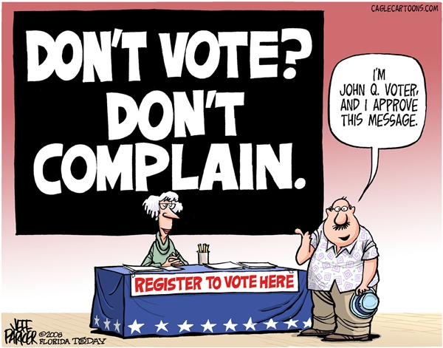
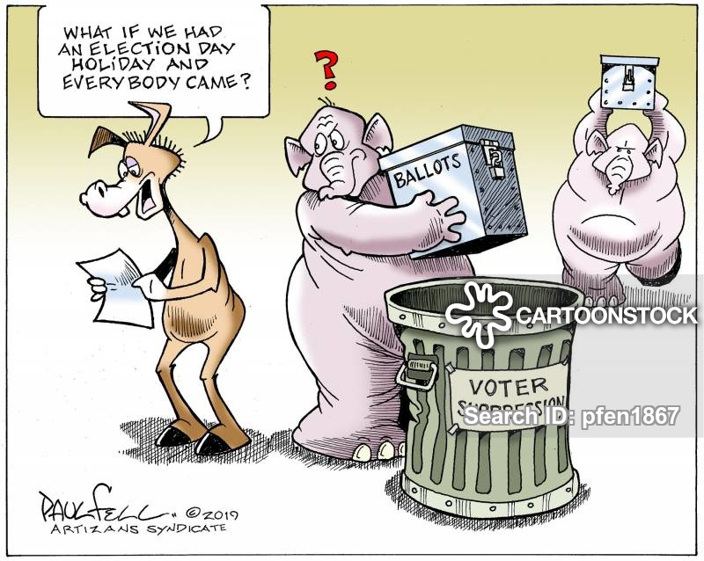

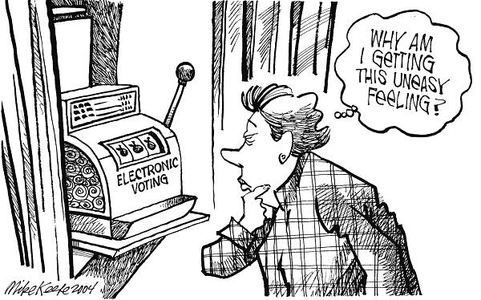
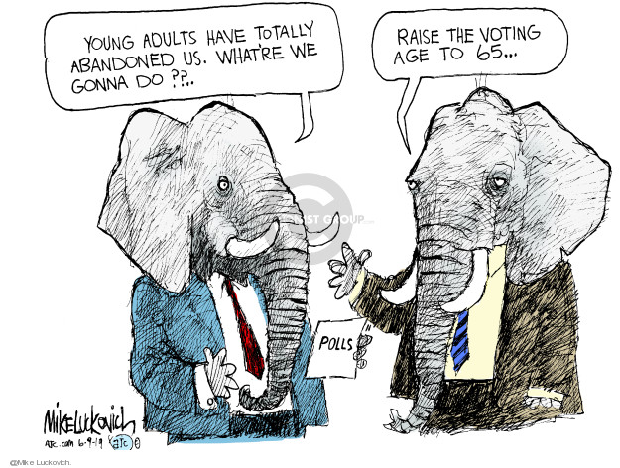

Step 6: Design your own political cartoon about a challenge with voting.

Student Feedback:
Circle the emojis that best represents how this activity made you feel.

Week 3
Identity

Day 4

NAME:______________________
Day 4 Agenda

Topic | Activity
Warm-Up!
English Language Arts | - Read the poem, “The Rose That Grew From Concrete” by Tupac Shakur.  - Annotate and identify imagery in the poem.  - Compare this poem to the poem by Polanco.  - Write an extended metaphor that describes their own identity
Science | - Read about the human brain  - Answer questions about what you read  - Draw a picture
Mindfulness Moment!
Math | - Real World Math: Identity and Race: The U.S. Census  - Practice Problems: Multiples
Health | - Digital Identity
Mindfulness Moment!
Civics/Social Studies | - Race, Ethnicity, and Identity
PE | - Bingo!

Warm-up Activity: Write a journal entry around the daily quote on identity.
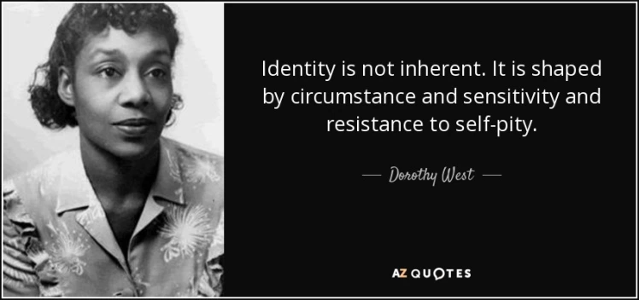

Day 4. : English Language Arts
Defining ourselves using Metaphor

What is this lesson about? Today, you will read another poem about identity that also includes an extended metaphor. You will read and analyze the poem and compare and contrast it to the poem you read yesterday by Julio Noboa Polanco. Lastly, you will also create your own extended metaphor that defines your own identity.

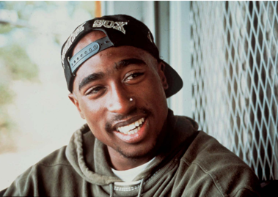
Step 1: Read the Poem

The Rose That Grew From Concrete by Tupac Shakur. This is a poem that was included in a collection of poems that were written between 1989 and 1991 by Tupac Shakur and published posthumously (after his death) in 1999.

The Rose That Grew From Concrete
by Tupac Shakur
Did you hear about the rose that grew
from a crack in the concrete?
Proving nature's law is wrong it
learned to walk without having feet.
Funny it seems, but by keeping its dreams,
it learned to breathe fresh air.
Long live the rose that grew from concrete
when no one else ever cared.

Step 2: Re-Read

Read the poem again and this time write notes alongside the text writing what you think Shakur was talking about when he writes about the rose. Note the extended metaphor that Shakur uses to communicate what he wants his reader to imagine and to feel.

Share your notes with a partner and discuss the following question.
What is the most vivid (strongest) image that Shakur created for you? Why?

Step 3. Answer the questions.

- What do you think that Shakur means when he says that the rose proved “nature’s law is wrong”?

- What helps the rose be able to succeed and learn “to breathe fresh air”?

- What does the fresh air represent?

- PIcture a sidewalk with cracks in it. What usually grows through those cracks? Why do you think Shakur chose to say that a rose was growing instead of a weed or bits of grass? What is he saying about himself?

- Why does Shakur want to celebrate the rose and why is it important to him that people hear about what it has been able to do?

- Think about yesterday’s poem “Identity” by Julio Noboa Polanco. Julio Noboa emphasized that he wanted to be an “ugly wood”. Shakur uses the image of a beautiful rose. How are the rose and the weed similar? How are they different.

Step 4: Write an extended metaphor

This week’s theme is Identity. In the poem, a rose is a beautiful thing that grew in spite of all the challenges it faced and became stronger BECAUSE of those challenges. For Shakur, there is something beautiful about the struggle because it shows strength and resilience. Think about how challenges have helped you grow and become stronger and how they have made you the person that you are.

Write down a few challenges you have faced that you believe have made you change and become stronger or better. Explain how they have made you stronger/better.

1.

2.

3.

Now think of a metaphor that you can use to compare your experience of growing and becoming stronger to something else. (Like a rose that grows through concrete, what are some other things that might push through challenges ? (Example: a bird in the wind, a baby learning to walk, etc.) Write it down.

Work to extend it: Example: Look at that bird flying against the wind, getting beaten back with every gust, eventually learning to ride the waves of the wind, up and down--actually riding the wind that once nearly destroyed it and now using it to fly higher and further.)

Step 5: Share.
Pair work- Share your metaphor with one of your classmates. Read it aloud; listen as he reads his metaphor aloud. After sharing metaphors, draw out your partner’s metaphor.

Draw out the image that your partner described in his metaphor.

Share the image with your partner and explain what you pictured through their imagery.

Based on the image that your partner pictured/imagined (or didn’t), think of 2-3 more details you could add to your metaphor so others can picture what you are describing. Revise your metaphor adding these details to your writing.

Student Feedback: Extended Metaphor
Circle the emojis that best represents how this activity made you feel.

Day 4: Science
The Human Brain

What is this lesson about?: Today you will read through The Human Brain passage. You will answer a few questions about what you read. You will complete a brain activity.

Step 1: Read through The Human Brain passage

The Human Brain
(Technological Solutions, 2020)
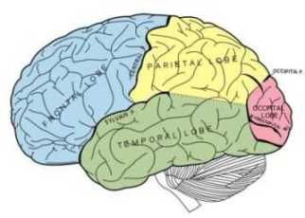
The brain is where we do our thinking. All our senses are tied into our brain allowing us to experience the outside world. We remember, have emotions, solve problems, worry about stuff, dream about the future, and control our bodies in our brain.

For such an awesome organ, the brain doesn't look like much. It's a ball of gray looking wrinkled tissue about the size of two of your fists put together. The brain sits in our hard, thick skull with membranes and fluid around it to protect it.

How the Brain Communicates
The brain is part of the nervous system. Together with the spinal cord, it makes up the central nervous system. The brain connects to nerves that travel throughout the body. Nerves from our senses (hearing, seeing, touch, etc.) send signals to the brain to let the brain know what is going on in the outside world. The brain also sends signals using nerves to muscles in order to make our body move.

Parts of the Brain
Cerebrum - The cerebrum is the biggest part of the brain. It's the gray wrinkly upper part. The surface of the cerebrum is called the cerebral cortex. Different parts of the cerebrum deal with different parts of the body. The back part deals with vision while other parts deal with other functions like movement, hearing, language, and touch.
Cerebellum - At the back and bottom of the brain is the cerebellum. This part of the brain deals with motor movement. It processes all the incoming motor messages from the nerves and figures out what to do with them. The cerebellum can learn motor movements with practice allowing us to do stuff like riding a bike or typing without even thinking about it.
Brain Stem or Medulla - This is where the brain connects to the spinal cord. Also, many automatic functions are controlled here like keeping the heart beating, breathing, and digesting food.
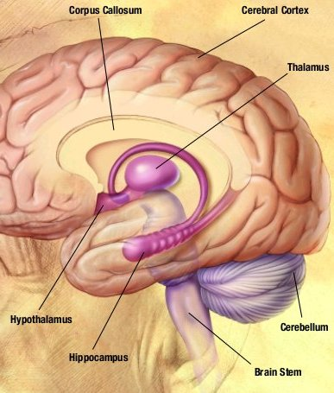
Memory
The brain has two kinds of memory, short term memory and long term memory. Scientists are still learning exactly how memory works, but they know that short term memory allows us to remember something for a very short time without rehearsing or practicing it. We can't remember a lot of things in short term memory though, and, like its name suggests, these memories don't last very long.

The Brain Needs Energy
The brain may not move, but it needs lots of energy. Energy is sent to the brain by our blood. There are lots of blood vessels and blood flowing through the brain at all times. The brain actually uses around twenty percent of the body's energy.

The Brain Has Two Halves
The brain is divided into two halves. Since the nerves cross when they enter the brain, the left side of our brain controls the right half of our body and the right side controls the left. Each half also controls specialized functions. What each half does depends on whether you are left or right handed. In a right handed person the left side of the brain is used for language and numbers while the right side is the more artistic side and is also used for recognizing objects.

Step 2: Answer questions about what you read

- The brain is part of which system?
  - Cardiovascular System
  - Nervous System
  - Digestive System

- Which part of the brain can learn motor movements?
  - Cerebrum
  - Cerebral Cortex
  - Cerebellum

- Which of the following is NOT a function that is controlled by the brain stem?
  - Breathing
  - Vision
  - Digestion

- Which part of the brain controls senses like hearing or touch?
  - Cerebrum
  - Cerebral Cortex
  - Cerebellum
- What is the surface of the Cerebrum called?
  - Cerebral Cortex
  - Cerebellum
  - Brain Stem

- How is energy sent to the brain?
  - Blood
  - Oxygen
  - Nerves

- The left side of the brain controls the left half of the body and the right side of the brain controls the right half of the body.
  - TRUE
  - FALSE

Step 3: Draw a picture

Your brain is the most important organ in your body and it is up to you to keep it healthy. What can you do to keep your brain in the best condition? Draw a picture and explain your answer.

________________________________________________________________________________________________________________________________________________________________________________________________________________________________________________________________________________________________________________________

Student Feedback:

Circle the emojis that best represents how this activity made you feel.
Mindfulness Moment!
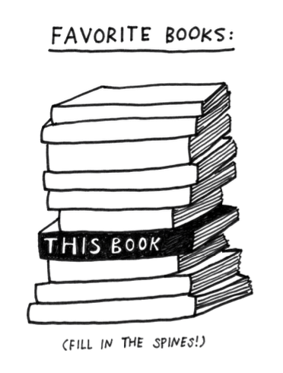

Day 4: Identity/Census Data and More
Math

What is this lesson about?: Today we will learn about the mathematical concepts around proportionment related to the U.S. Census. The U.S. Census happens every 10 years and 2020 is a census year. It is extremely important in how federal resources are allocated to individual states. The basic idea is to count every person possible in the entire country and it is a monumental task. The amount of money a state receives for everything from education to public safety is dependent on it. Apportioning it correctly is essential to a fair republic.

But first: Today’s Warm-Up
You and two friends have decided to order a pizza for dinner. You want Domino’s, one friend wants Papa John’s and another friend wants Pizza Hut. You agree on Papa John’s and place your order after agreeing on which toppings you want. The pizza arrives and you are confronted with the problem of there being 3 of you, but 8 pieces of pizza. 3 doesn’t divide evenly into 8...

What possible solutions could you come up with that are fair to each of you?

BTW, is it possible to have an odd number of pizza slices if the pizza is cut with straight lines through the center?

Step 1: Understanding Greatest Integer
In later high school math classes you may learn about greatest integer functions. Integers, by definition, are numbers that do not have fractions or decimals associated with them.

Examples are 4, 0 and -3. We can find the greatest integer of any number by locating the first integer on the number line to the left of that number. [[ ]] is the mathematical way we represent greatest integer.

Example 1: Find [[3.8]].
- While 3.8 is closer to 4 than 3, we follow our rule and go with the first integer to the left of 3.8 on the number line, so [[3.8]]=3

Your Turn:
- Find [[17.543]].

- Find[[-2.4]]( be really careful with negative numbers, use the number line below if you need to, the answer may surprise you.)

Step 2: Calculating a divisor to apportion delegates

Here is a chart of the U.S. population data based on the 1790 U.S. Census.

State | 1790 Population
Connecticut | 236841
Delaware | 55540
Georgia | 70835
Kentucky | 68705
Maryland | 278514
Massachusetts | 475327
New Hampshire | 141822
New Jersey | 179570
New York | 331589
North Carolina | 353523
Pennsylvania | 432879
Rhode Island | 68446
South Carolina | 206236
Vermont | 85533
Virginia | 630560
Total | 3615920

In 1790 there were a total of 120 delegates in the United States house of representatives. To calculate a divisor, we take the total population 3615920 and divide it by 120. The result is 30,133. That means for every 30,133 residents a state has, they should be awarded a delegate to represent their interests. Alexander Hamilton suggested this approach and at the time it was known as the Hamiltonian method. The results are below.

State | 1790 Population | Delegates(Hamilton)
Connecticut | 236841 | 7.86
Delaware | 55540 | 1.84
Georgia | 70835 | 2.35
Kentucky | 68705 | 2.28
Maryland | 278514 | 9.24
Massachusetts | 475327 | 15.77
New Hampshire | 141822 | 4.71
New Jersey | 179570 | 5.96
New York | 331589 | 11
North Carolina | 353523 | 11.73
Pennsylvania | 432879 | 14.37
Rhode Island | 68446 | 2.27
South Carolina | 206236 | 6.84
Vermont | 85533 | 2.84
Virginia | 630560 | 20.93
Total | 3615920 | 120
Divisor  (120 delegates) | 30133 | 120

While mathematically sound, do you see a problem with the Hamiltonian method of delegate apportionment.

Step 3/Activity 3: Using greatest integer to fix the Hamiltonian method.

Since humans cannot be divided into pieces, unlike pizza, the Hamiltonian method was rejected. Use what we learned earlier in the lesson to apply greatest integer to each Hamiltonian delegate below.

State | 1790 Population | Delegates(Hamilton) | Greatest Integer
Connecticut | 236841 | 7.86
Delaware | 55540 | 1.84
Georgia | 70835 | 2.35
Kentucky | 68705 | 2.28
Maryland | 278514 | 9.24
Massachusetts | 475327 | 15.77
New Hampshire | 141822 | 4.71
New Jersey | 179570 | 5.96
New York | 331589 | 11
North Carolina | 353523 | 11.73
Pennsylvania | 432879 | 14.37
Rhode Island | 68446 | 2.27
South Carolina | 206236 | 6.84
Vermont | 85533 | 2.84
Virginia | 630560 | 20.93
Total | 3615920 | 120
Divisor  (120 delegates) | 30133 | 120

Once you have calculated the greatest integer for each state, add them up to make sure they total 120. If they do not, we must come up with another approach.

Step 4: Rounding saves the day
Another method of eliminating fraction or decimals to make integers is rounding. Rounding is also fairly straight forward. If the number has a fraction or decimal equal to half or more of the next integer, you round up to the next highest integer. If the fraction or decimal is below .5, you simply eliminate the fraction or decimal.
- Ex. Round 3.49 to the nearest integer Answer=3
- Ex Round 5.64 to the nearest integer Answer=6
Use rounding to adjust the Hamiltonian method below.

State | 1790 Population | Delegates(Hamilton) | Greatest Integer | Rounding
Connecticut | 236841 | 7.86 | 7
Delaware | 55540 | 1.84 | 1
Georgia | 70835 | 2.35 | 2
Kentucky | 68705 | 2.28 | 2
Maryland | 278514 | 9.24 | 9
Massachusetts | 475327 | 15.77 | 15
New Hampshire | 141822 | 4.71 | 4
New Jersey | 179570 | 5.96 | 5
New York | 331589 | 11 | 11
North Carolina | 353523 | 11.73 | 11
Pennsylvania | 432879 | 14.37 | 14
Rhode Island | 68446 | 2.27 | 2
South Carolina | 206236 | 6.84 | 6
Vermont | 85533 | 2.84 | 2
Virginia | 630560 | 20.93 | 20
Total | 3615920 | 120 | 111
Divisor(120 delegates) | 30133 | 120

If done correctly you should come to a total of 120 delegates.

What other ways can you think of to apportion delegates? In 1790 there were more than 10 different proposals considered by the house of representatives.

Step 5/Activity 5: Starting to Look at the Census more carefully

The Census asks a number of questions. Below are the questions on the Census that inquire about ethnicity and race. Fill in the sample questions below, if you feel comfortable.
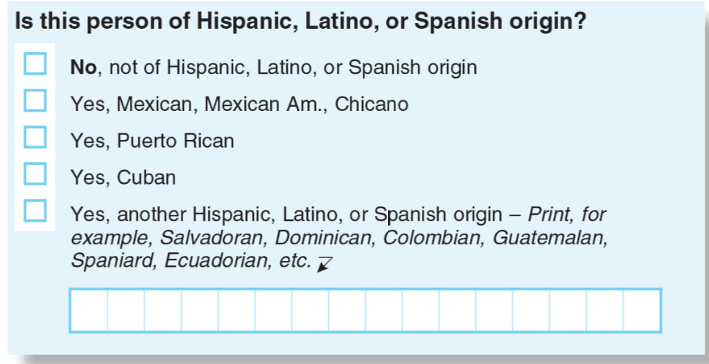
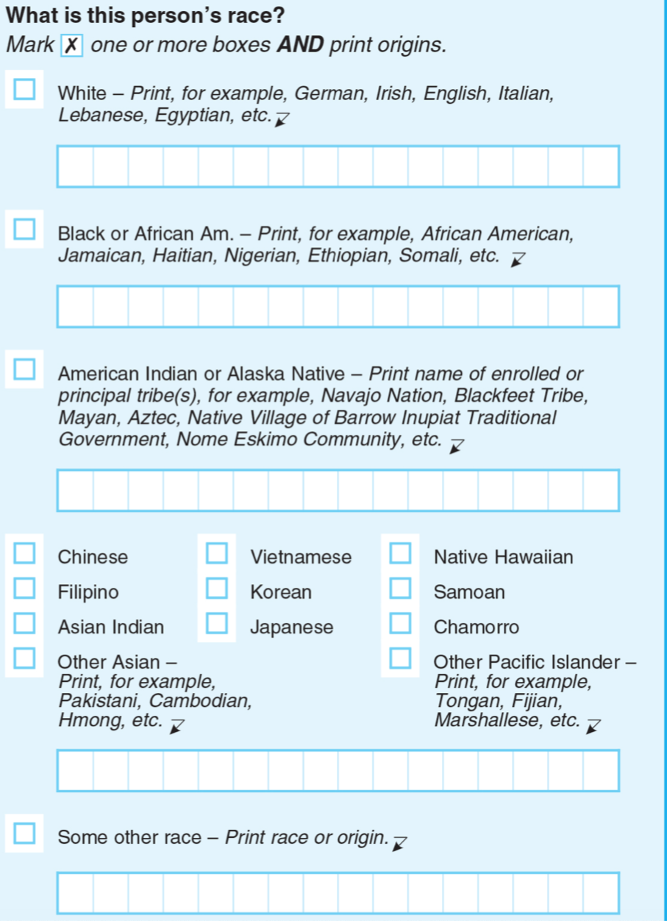
Do you feel a sense of identity based on your race? Yes/No. Explain.

Why, do you think, does the government want to understand the different ethnicities and races in our Country?

Note: We will come back to this next week when we start to consider Community and the following week when we consider Power.

Skill Builders and Review Problems
- Multiples

Day 4: Digital Identity
Health

Step 1: Warm-up
How can I create a social media presence that represents the real me?

Step 2: What’s this Lesson About?
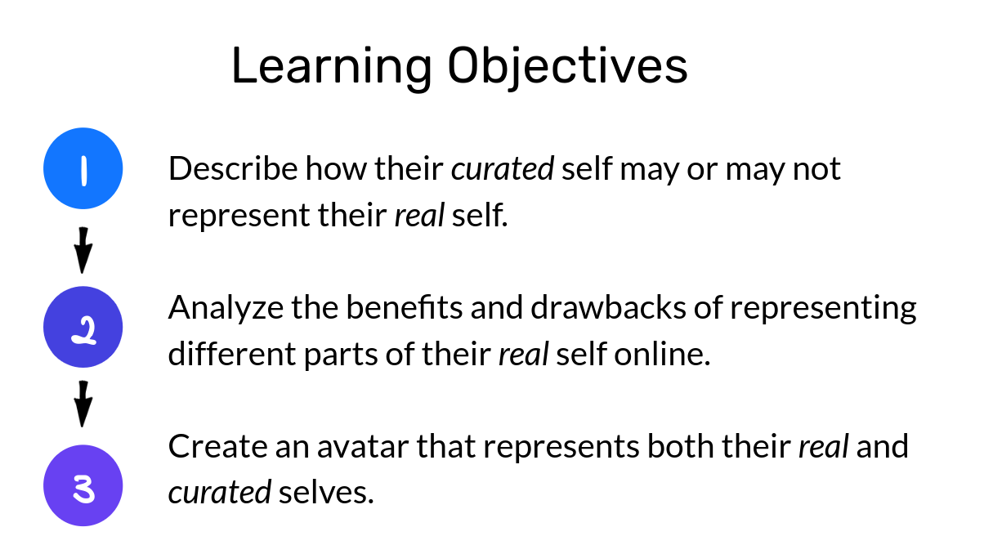
Step 3: Quick Reflection.

Is the you that people see online the real you? Why, or why not?

Step 4: Tread the text.
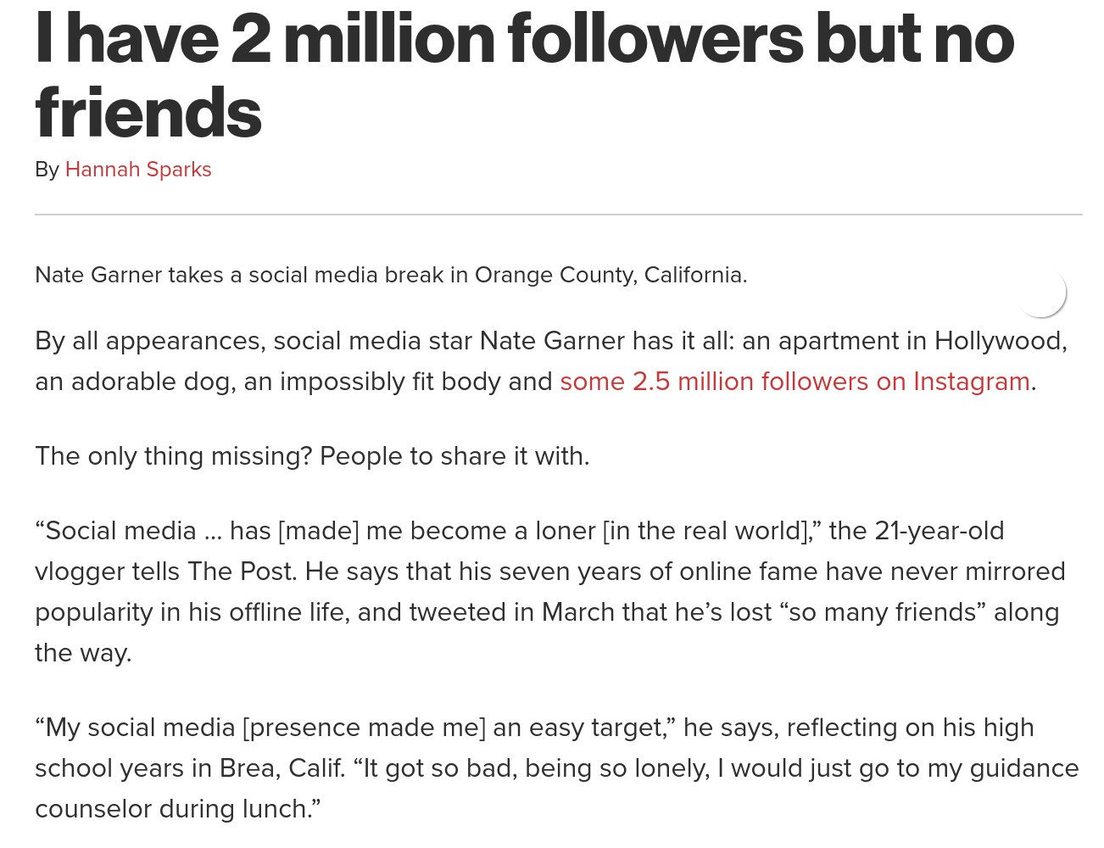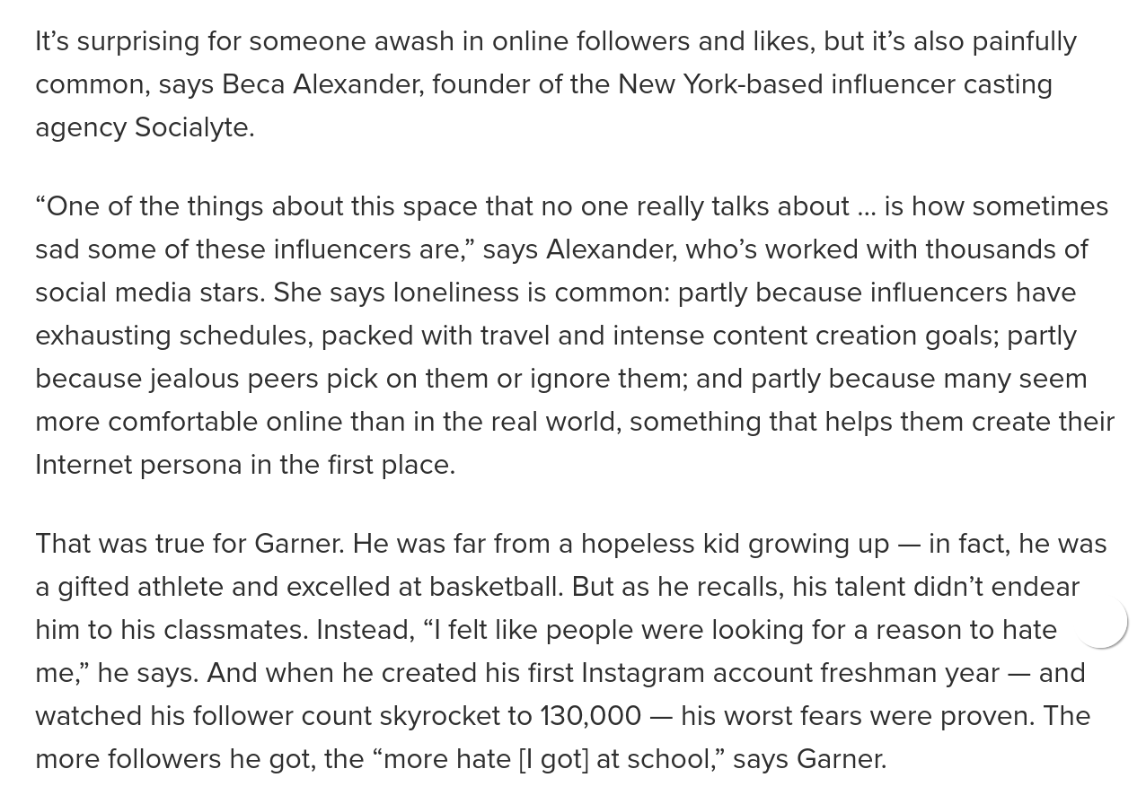
Draw the REAL you | Draw the ONLINE you

Student Feedback:
Circle the emojis that best represents how this activity made you feel.

Day 4: Race & Ethnicity
Social Studies

What is this lesson about?: In this lesson you will read about ethnic cultures and how people are trying to embrace different cultural aspects of their heritage, by the way they dress and the way they wear their hair. You will learn how our identity is partially made up of our race and ethnicity.

Step 1: Read the article

The term "Asian-American" means different things to different people
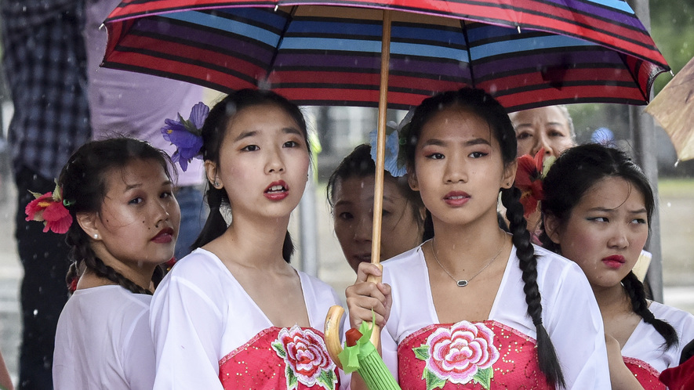
WASHINGTON, D.C. — Parents, under umbrellas, prepare to take photos of their children. The children will soon perform a traditional Filipino dance. The U.S. Capitol building will be in the background.
An announcer thanks families for putting up with the weather. "Anyway, for Asians, this is a blessing," she says of the rain.
Such sweeping statements are part of Fiesta Asia. It's a yearly festival held in Washington, D.C. It broadly celebrates Asian cultures. It is meant to honor the "Asian-American" experience.
The term Asian-American includes many different ethnic identities. Asian-American families come from dozens of different countries. Some have been in the U.S. for generations, while others have come more recently. People within this community, however, have different thoughts about the term "Asian-American." Some appreciate being lumped into the large group. Others question it.
There is another challenge. It is not always clear who is part of this group. Many people think of Asian-Americans as those whose families are from East Asian countries, like China, Japan and Korea. Indian-Americans and Pakistani-Americans, for example, can be left out. India and Pakistan are still part of Asia, as are many other less well-known countries.
What does it actually mean to identify as Asian-American today?

"Asian-American" Term Blends Everyone Together
Melissa dela Cuesta stands under one of many tents at Fiesta Asia. She wears a sash across her body. It shows her second runner-up place in a Miss Teen Philippines pageant. Melissa looks surprised when asked how she would identify herself. Isn't the answer obvious?
"I am Filipino-American," declares the 17-year-old. She is "in love" with her culture. She doesn't understand why anyone would not want to be grouped with their family's country. The Philippines is a nation of islands in Southeastern Asia between the South China Sea and Pacific Ocean.
About two-thirds of Asian-Americans identify primarily with their specific ethnicity, according to the research group AAPI Data. The group provides information on Asian-Americans and Pacific Islanders. Pacific Islanders are from islands in the east and central regions of the Pacific Ocean.
Dina Okamoto wrote the book "Redefining Race." She said many people do not like using the term "Asian-American" because blending everyone together takes away their individual culture. "They don't believe it really captures who they are," she says.
In the past, discrimination motivated strong connections to a family's country of origin. When Japanese-Americans were taken to prison-like camps in the U.S. during World War II, for example, some Chinese-Americans wore buttons or carried signs. The signs made sure others knew they were Chinese rather than Japanese. Japan was America's war enemy.

Discovering A Sense Of Family
Yet that changed in 1968. Activist and historian Yuji Ichioka created the term "Asian-American." It served as what Okamoto now calls a "rallying cry."
Ichioka had seen the success of the Black Power movement, she says. Groups joined together to fight for civil rights for African-Americans. Ichioka felt communities with Asian roots could also benefit from accepting their shared history.
Calling yourself Asian-American meant rejecting disrespectful and hurtful labels. It meant discovering a sense of family. Especially after the 1982 killing of Vincent Chin, it meant banding together to fight injustice. Although Chin was Chinese-American, he was beaten to death by white autoworkers upset by the success of Japanese car makers.
While at Fiesta Asia, Nicholas Lach, age 23, says he'd call himself Asian-American because, as he puts it, "I'm Asian. I'm in America. That's just how it works." His parents are Cambodian refugees who moved to Minnesota.
"Maybe if I was born in Cambodia and then came here," he adds, "I'd consider myself Cambodian-American."

Learning The History Of Asian-Americans
It isn't always an either/or situation, says Jenn Fang, age 36. Fang started the blog Reappropriate. She identifies as both Asian-American and Chinese-American. She says the broad term of Asian-American is popular among civic-minded college students who learn the term's activist roots.
Fang took an Asian-American studies course as a Cornell University student. She describes the class as "completely mind-blowing."
If you're lucky in high school, she says, you might have read a couple paragraphs about Japanese-American internment camps during World War II. This Cornell course had a 300-page textbook on Asian-American history.
"It takes going to a college before any of us learn about the basics of who we are and how we came to be in this country," she says. She says that is wrong. She thinks it's important to have the chance to learn about the history of Asian-Americans and the ways they have changed the country.

Step 2: Answer the questions

1. Read the section "Learning The History Of Asian-Americans."
Which selection from the section supports the conclusion that some people learn very little about Asian-American history before college?
(A) She says the broad term of Asian-American is popular among civic-minded college students who learn the term's activist roots.
(B) Fang took an Asian-American studies course as a Cornell University student. She describes the class as "completely mind-blowing."
(C) If you're lucky in high school, she says, you might have read a couple paragraphs about Japanese-
American internment camps during World War II.
(D) She thinks it's important to have the chance to learn about the history of Asian-Americans and the ways they have changed the country.

2. Read the section "Discovering A Sense Of Family."
Which selection shows the author's point of view about using the term “Asian-American”?
(A) Yet that changed in 1968. Activist and historian Yuji Ichioka created the term "Asian-American."
(B) Ichioka felt communities with Asian roots could also benefit from accepting their shared history.
(C) Calling yourself Asian-American meant rejecting disrespectful and hurtful labels.
(D) Although Chin was Chinese-American, he was beaten to death by white autoworkers upset by the success of Japanese car makers.

3. What do Melissa dela Cuesta and Dina Okamoto AGREE on in the article?
(A) that some people like to identify with their family's country
(B) that it is wrong for people to use the term "Asian-American"
(C) that people should use both "Asian-American" and another term
(D) that using the term "Asian-American" creates a sense of family

Step 3: Read the second article.

New York City just banned discrimination based on hair
New York City has banned policies and practices that penalize black people based on the texture and style of their hair. City leaders say that such actions violate these individuals' human rights and are against the law.
The New York City Commission on Human Rights announced February 18 that it is issuing guidance on an existing law. The law prohibits discrimination based on race, gender or religion. The new guidance says that the same law also applies to hair.
It is about more than what is in style. Hairstyles are an integral part of black identity, going back many years in history.

A Photo With A Powerful Message
"One of my favorite photographs of President Barack Obama is him in the Oval Office leaning down to allow 5-year-old Jacob Philadelphia to touch his hair,'' said Carmelyn Malalis. She is the New York City Human Rights Commissioner and Chairwoman. Malalis called Obama's behavior a powerful "message of affirmation."
"As we were developing the guidance, we had a lot of conversations about the harm that is done to people when they are stigmatized and controlled in regards to who they are and how they move through space. Today being Presidents Day buoys our hope that legislators will take notice," Malalis said. The day of the announcement, February 18, was Presidents Day.
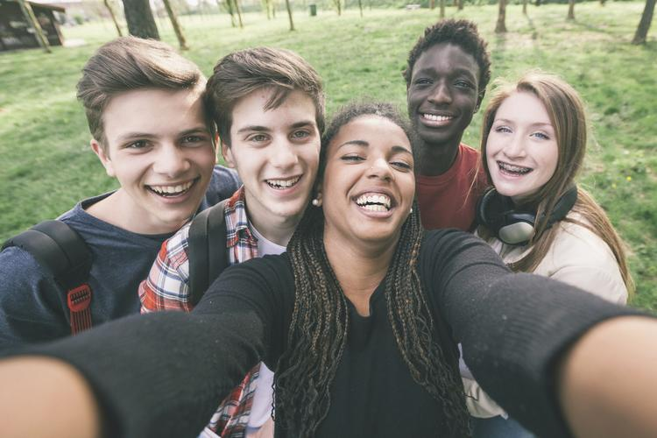
The law bans such bias in workplaces, schools and public spaces. Public spaces include spots ranging from restaurants to nightclubs to museums.

Black Hairstyles Have Been Singled Out
The legal protections apply to any group whose hairstyles are associated with their ethnic identity. For those of African descent, in particular, hair texture and styles have often been singled out and are a historic target for abuse.
Five years ago, the U.S. Department of Defense started a ban on Afros, braids and twists, all of which are traditionally black hairstyles. It reversed the ban after a backlash. In December, there was public outrage after a 16-year-old athlete named Andrew Johnson was forced by a referee to cut his hair before he could proceed with his wrestling match.

A TV Anchor Says Her Braids Led To Her Termination
Brittany Noble-Jones said she faced hair discrimination when she was fired from her job as a television anchor last year. She worked for WJTV in Jackson, Mississippi. She said that wearing braids on air led to performance reviews at work and later her termination.
Noble-Jones, who is based in New York, called the city commission's announcement "huge."
"The fact we have been worried about this all these years is one thing, but I'm very excited we can move forward," she said. She is glad they can "rock our hair and wear it the way God intended us to wear it," she said.
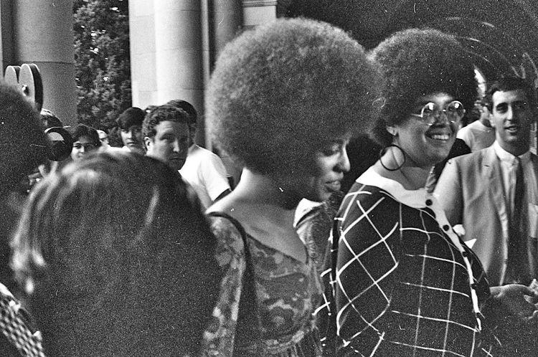
WJTV and its parent company, Nexstar, denied that Noble-Jones was fired over her hair. They said in a statement that their rules do not allow "harassment, discrimination or retaliation of any type. Allegations that Ms. Jones' employment was terminated for her choice of hairstyles have no basis in fact."

"Hair Is Connected To Civil Rights"
The New York City Commission said it is looking into seven cases in which black workers say they were targeted based on their hair. Some workers say they were threatened with termination if they did not stop wearing dreadlocks, also referred to as locs, which the employer arbitrarily considered "unclean." Other workers say they had to pull back their braids although their co-workers were allowed to wear their hair down.
Such complaints accompany incidents around the country in which black workers and school children have been harassed because of their hair. The complaints caused the New York commission to clarify that the city's law against discrimination applies in those cases.
"This is big," said Noliwe Rooks, professor of Africana studies at Cornell University in Ithaca, New York. "Hair is connected to civil rights." The civil rights movement, which took place during the 1950s and 1960s, was the beginning of the fight for black people to gain equal rights under the law.
Rooks said hair needs to be protected by the law.

A Symbol Of Pride For Many Years
Black hair has been deeply symbolic in the U.S. since at least the 1800s, and even before that. It has been a stand-in for a kind of black identity that refuses to assimilate. For many, natural hair symbolizes a rejection of the racist pressures placed on black people to conform to white beauty ideals in order to stay safe and succeed in the U.S.
Rooks explained that in the 1800s, after the Civil War, there were large numbers of African-Americans leaving enslavement and moving north in search of employment and desegregated cities. "There was a lot more contact between communities on more equal footing," she said of the interactions between white and black peoples. "The narrative is 'You just don't look civilized. You just don't look professional,'" she said.
Natural hair became a powerful symbol of pride during the Black Power movement of the 1960s. The movement supported rights and political power for black people.
"It's less about fitting in," Rooks said. "I'm proud of how hair grows out of my head."

Step 4: Answer the Questions

Is your hair a part of your identity? If so, how? If not, what are some other physical characteristics that are a part of your identity? (you can write or draw your answers)

Have you ever seen a person be treated differently because of their hair? How did that make you feel?

One person in the article says that hair needs to be protected as a civil right. What are civil rights? What was the civil rights movement?

Do you think hair style should be protected? Why or why not?

Student Feedback:

Circle the emojis that best represents how this activity made you feel.

Week 3
Identity

Day 5

NAME:______________________

Day 5 Agenda

Topic | Activity
Warm-Up!
English Language Arts | - Read the essay “My Past Has Shaped Me Into The Person I Am Today”  - Answer questions about the text.  - Write a short reflection about what has shaped their identity and who they hope to become.
Science | - Read about multiple intelligences  - Answer questions  - Reflect
Mindfulness Moment!
Math | - Real World Math: Identity and Incarceration: The math of mass incarceration  - Practice Problems: Factors
Health | - Digital Identity
Mindfulness Moment!
Civics/Social Studies | - National Identity
PE | - Bingo!

Warm-up Activity: Write a journal entry around the daily quote on identity.
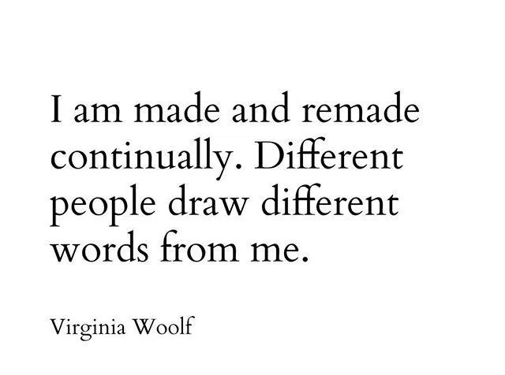

Day 5: English Language Arts
What has and continues to shape my Identity?

What is this lesson about? Identity is something that is always changing as it is shaped by different experiences and influences. Today, you will be reading two essays that talk about the author’s identities and what has shaped those identities. Afterwards, you will write a short reflection about what has helped shape your identity and who you hope to become.

Both of these essays are taken from a website called “This I Believe.” This I Believe, Inc., was founded in 2004 to engage youth and adults from all walks of life in writing, sharing, and discussing brief essays about the core values that guide their daily lives.
Selected contemporary “This I Believe” essays were featured in regular broadcasts on National Public Radio (NPR) in the United States from 2005 to 2009, in a series produced and hosted by Jay Allison. These essays are now collected and stored on their website and also provided in audio form on the This I Believe podcast.

Step 1: Read the Essay.

My Past Has Shaped Me Into The Person I Am Today
Danyelle - Wichita, Kansas
Entered on November 29, 2011

I believe my past has shaped me into the person I am today. The way I have grown up, people would expect me to have already had a child or children, never gone to college, and never made it out of high school. Well, I have turned out to be the total opposite.
My family and I lived in homeless shelters about five or six different times. My mother did not receive a college degree, so she only worked minimum wage jobs. When I was a child, I did not notice as much as I do now. I would dread going to these shelters, but while we were there, we made great friends. Most of the time when we left, we would keep in touch with our friends from the shelter, or the “special apartments,” are what we preferred to call them. My brother and I never really worried about if we had money for food or necessary things when we were younger. We just sat back and enjoyed life, wherever that may be.
When I look back on my childhood, there are problems we faced that I see now, that I did not understand back then. My family moved around quite a bit. I attended about seven elementary schools, and three middle schools. When I was eight, my family moved to Arizona with nowhere to live and no clue of what we were going to do once we got there. When we got back to Wichita, we stayed with my aunt until she kicked us out. Then we lived in Wesley Inn for a week. From there, we lived in another homeless shelter. The first couple weeks of my sixth-grade year, I was forced to ride in a taxicab to school. When we moved into our house, we switched schools, and I had to ride the city bus.
In high school, our situation only got worse. My mother has always received money from the government and has not worked since I was in elementary school. During my junior and senior year, the government started decreasing the amount of money and food stamps my mother was receiving. The only food my brother and I could depend on was the food from school. Dinner has never been promised. My mother became more depressed, as did I. During my junior year, I was tempted to drop out completely.
Despite everything that has happened in my lifetime, I still continue to keep a positive attitude. In high school, I made decent grades, had jobs, was involved in about ten different clubs, and I made it to college. My goal in life is to help people in need, so they do not have to go through what my family struggles with every day. There is so much more that has happened in my life, but without God, my aunt, and my past, I would not be where I am today.
Step 2: Answer the questions.

- What are some of the challenges that the author experienced as a child?

- How did the author’s perspective (the way she looked at her situation) change? Why do you think this changed from elementary school to high school?

- The author says that she has turned out to be the “total opposite” of what others would expect of her. What has been her motivation?

- The author claims that she is a positive person. According to the text, was she always a positive person or is this something that has developed in her?

- The author says that her past has shaped who she has become today but in a positive sense. Describe a challenge that has changed you, but in a positive way.

Step 3: Read the second essay.

I Am Who I Say I Am
Angela - Upper Marlboro, Maryland
Entered on February 15, 2011
That I am who I say I am. My mother was the oldest girl of eight children when she got pregnant with me as a teenager. After I was born, I spent the next 19 years living between my grandmother and my mother. My mother joined the military because there was a serious lack of employment opportunities in Mississippi. My father was never in the picture. I found out later that he had denied that I was his child until I started to look like him. Around that same time, I found out that my father was a rolling stone. He had six children by six different women. The only one he took care of was my youngest sister, whose mother he married.
Four of my grandmother’s eight children were still living with her when my mother asked her to take care of me. She graciously took care of me whenever my mother asked. There were times when I lived with her for years. Some of my happiest memories happened while I was living with my grandmother. She took care of me the best way she knew how. She made me feel loved even though she was a functioning alcoholic. She told me funny and sad stories about her childhood in Mississippi. The story that stuck with me was the one she told me about her mother permanently taking her out of school in the third grade to pick cotton. My grandmother raised eight children and me with a third grade education. That would drive anyone to drink.
My mother had two more daughters after I was born. She got married and had her middle child while I was living with my grandmother. I never understood why she did that. It was so bizarre. How could she leave me with her mother while she was off starting another family? She didn’t have an answer when I asked her about it. While she was apologizing for leaving me I heard, “I don’t want you. I don’t love you. You’re a mistake that I tried to forget about.” I don’t remember being happy living with my mother. I think it was because of her preoccupation with herself that made me feel like an afterthought. Maybe it was because the two men she married made sure I knew that they weren’t there to be my father. Maybe it was because the only emotion I got from my mother was anger when I didn’t do something right. Maybe it was because I felt invisible.
With my family history, I should be messed up in the head in ways that no psychiatrist could fix. Well, I was messed up in the head until I did two things. I changed how I see myself and I forgave my mother. We have a good relationship now. I had to stop seeing myself as little orphan Angela. I had to stop seeing myself as the stepchild that no one wants. I had to stop seeing myself through other people’s eyes because they’re too messed up to know what they’re looking at anyway. They didn’t see the woman I could become. I am a woman that cares for others because I know what it feels like to suffer. I am a woman that is a loyal friend because I know what it’s like to feel abandoned. I am a woman that tells the truth with compassion because I know how it feels to be lied to. I am a woman that listens with my ears and my heart because I know what it’s like to feel unheard. I am a woman that can adapt and recover from negative experiences because that’s what I’ve had to do to survive. I am a woman who isn’t defined by what other people believe about me. I believe I am who I say I am.
What do you believe about yourself?

Step 3: Answer the questions.

- In the first half of her essay, the author describes the challenges she faced as a child. Despite feeling her mother’s neglect, what was something positive in her life at that time?

- Like the author of “My Past Has Shaped Me Into The Person I Am Today”, this author also claims that she should be “…messed up in the head” because of everything that happened to her as a chlld. What did she have to do so she wouldn’t be “messed up”?

- In her last paragraph, the author has a series of statements where she defines who she is and why. How have her experiences allowed her to become a better person?

Step 4: Now it’s your turn to write.

Pre- Writing: First think about 2-3 challenges that you have faced. How have those challenges changed you? Have they changed you for better or for worse? Explain.

Write a short reflection in the style of the “This I Believe” essays you have read. The first paragraph should include a short description of some experiences that have shaped who you are. In the second paragraph, explain how these experiences have made you grow or change. Finally, give at least two more skills or qualities that you want to continue to develop to become the person you want to be.

Student Feedback:
Circle the emojis that best represents how this activity made you feel.

Day 5: Science
Multiple Intelligences

What is this lesson about?: Today you will read through What are multiple intelligences and how do they affect learning? You will answer a few questions and reflect on this week’s science lessons.

Step 1: Read through What are multiple intelligences and how do they affect learning?

WHAT ARE MULTIPLE INTELLIGENCES AND HOW DO THEY AFFECT LEARNING?
By Eve Herndon (2018)

What are multiple intelligences and how do they affect learning?
Over the past few decades, research in the field of learning has led to the discovery of the Theory of Multiple Intelligences. In short, this theory states that each person has different ways of learning and different intelligences they use in their daily lives.

While some can learn very well in a linguistically-based environment (reading and writing), others are better taught through mathematical-logic based learning. Still others benefit most from body-kinesthetic intelligence (learning by doing with the hands).

Each person possesses each intelligence to an extent, but there is always a primary, or more dominant, intelligence.

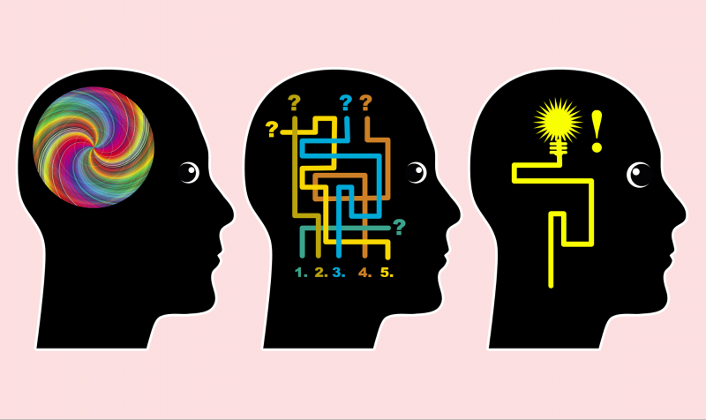
The work on multiple intelligences began in the early 1980s with Howard Gardner, and the research continues.

HOWARD GARDNER'S THEORY OF MULTIPLE INTELLIGENCE

Howard Gardner of Harvard University originally identified seven distinct intelligences. According to Gardner, this theory, which emerged from cognitive research, "documents the extent to which students possess different kinds of minds and therefore learn, remember, perform, and understand in different ways."
In greater detail, the theory proposes that "we are all able to know the world through language, logical-mathematical analysis, spatial representation, musical thinking, the use of the body to solve problems or to make things, an understanding of other individuals and an understanding of ourselves. Where individuals differ is in the strength of these intelligences and the ways in which such intelligences are invoked and combined to carry out different tasks, solve diverse problems and progress in various domains." Hani Morgan (2014) supports Gardner's theory. Morgan's research indicated that differentiated instruction benefits all students, but must be presented by well-prepared, experienced and knowledgeable teachers.
This diversity, according to Gardner, should impact the way people are educated. He stated that these differences "challenge an educational system that assumes that everyone can learn the same materials in the same way and that a uniform, universal measure suffices to test student learning." Joan Hanifin, an Irish researcher, determined in a 2014 publication that the outdated system of education in Ireland was adversely affecting students in the long-term. By not embracing multiple methods of teaching based on different intelligences, students often left school feeling "under-valued."
Gardner goes on to say that, "Indeed, as currently constituted, our educational system is heavily biased toward linguistic modes of instruction and assessment and, to a somewhat lesser degree, toward logical-quantitative modes as well."
Gardner argues that "a contrasting set of assumptions is more likely to be educationally effective. Students learn in ways that are identifiably distinctive. The broad spectrum of students—and perhaps the society as a whole—would be better served if disciplines could be presented in a number of ways and learning could be assessed through a variety of means." In 2010, Bas and Beyhan presented findings based on their study of using Multiple Intelligences theory in learning English. They determined that Multiple IntelligencesI-based learning is more effective in terms of student achievement levels and their attitudes toward learning. Their research supports Gardner's assertion that Multiple Intelligences-based learning will serve students well.

THE 9 MULTIPLE INTELLIGENCES

Gardner claims that all human beings have multiple intelligences. These multiple intelligences can be nurtured and strengthened or ignored and weakened. His research from 1991 identified seven intelligences; in the intervening time, he has come to believe there are a total of nine intelligences:

- Verbal-Linguistic Intelligence: Well-developed verbal skills and sensitivity to the sounds, meanings and rhythms of words.

- Mathematical-Logical Intelligence: The ability to think conceptually and abstractly, and the capacity to discern logical or numerical patterns.

- Musical Intelligence: The ability to produce and appreciate rhythm, pitch and timbre.

- Visual-Spatial Intelligence: The capacity to think in images and pictures, to visualize accurately and abstractly.

- Bodily-Kinesthetic Intelligence: The ability to control one's body movements and to handle objects skillfully.

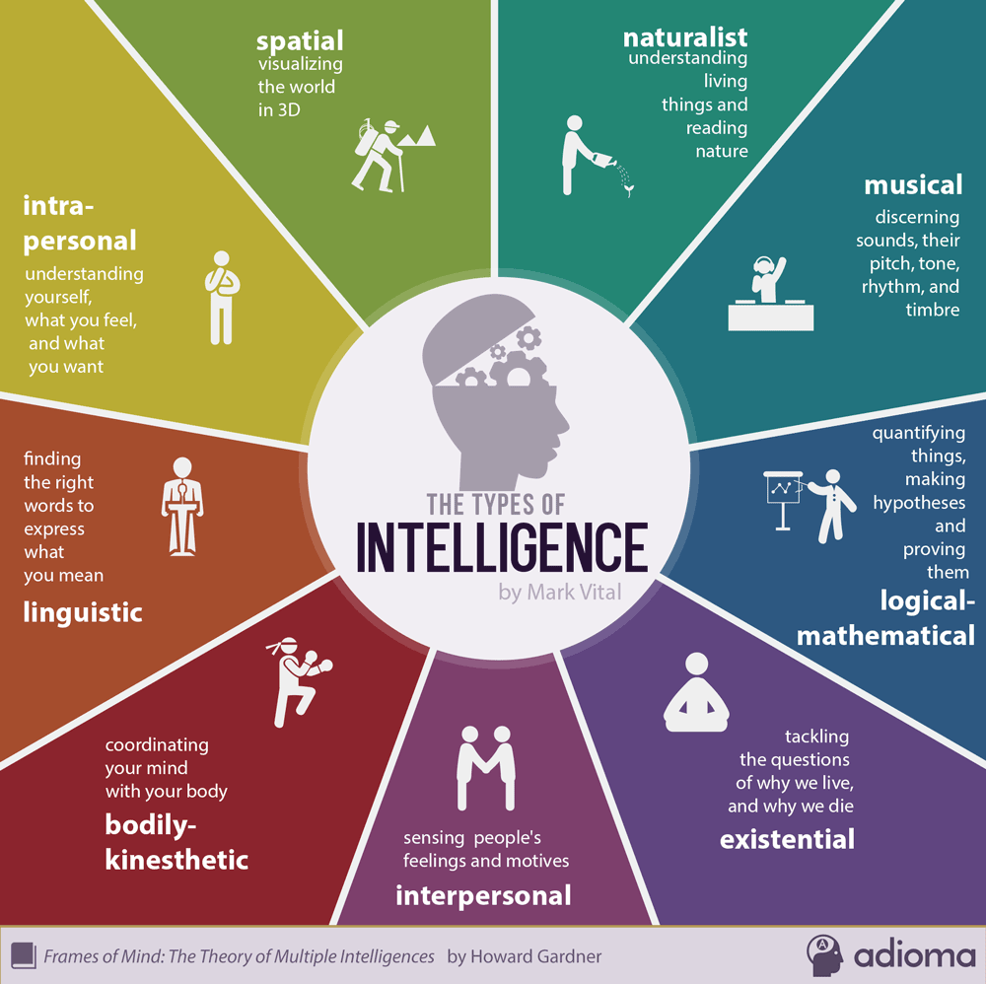
- Interpersonal Intelligence: The capacity to detect and respond appropriately to the moods, motivations and desires of others.

- Intrapersonal Intelligence: The capacity to be self-aware and in tune with inner feelings, values, beliefs and thinking processes.

- Naturalist Intelligence: The ability to recognize and categorize plants, animals and other objects in nature.

- Existential Intelligence: The sensitivity and capacity to tackle deep questions about human existence, such as the meaning of life, why we die and how we got here.

While all people possess some level of each intelligence, most will experience more dominant intelligences which impact the way they learn and interact with the world around them.

Step 2: Answer the questions

As you think about what you just read, and you go back to the descriptions of the nine intelligences (you can refer to the chart above), write down which of these intelligences you believe are your strongest intelligences.

How might school or your learning be different for you if you were able to tap into your different intelligences on a regular basis?

Step 3: Reflect

As you think about this week’s science lessons, what have you learned about your own identity?

Student Feedback:
Circle the emojis that best represents how this activity made you feel.

Mindfulness Moment!
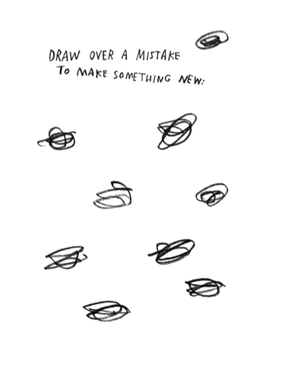

Day 5: Identity/Race, Education, Employment and Incarceration
Math

What is this lesson about?: In this lesson, we will look at some of the math behind a range of topics including racial disparities in education, juvenile and criminal justice, and employment. As a part of this we will try and assess how this ‘math’ may impact one's sense of self-identity.

But first: Today’s Warm-Up
Let’s look at this quote from Nipsey Hussle-

"If you look at people in your circle and you don't get inspired you don't have a circle you have a cage.”
What does this quote mean to you, in your own words?

In your view, do your friends form a circle around you, or more of a cage around you?

Step 1: Race and Economics in DC

The charts below analyze a number of race and economic issues facing Washington, DC between 2007 and 2011. Please take a few minutes to review them and then we will move to the questions below.

Chart 1: High School Age Students in DC Public Schools: 2010-2012, By Race (rounded)
Year/Race | Black | White | Other | Total
2010 | 16,020 | 1,440 | 540 | 18,000
2011 | 16,340 | 1,710 | 950 | 19000
2012 | 16,150 | 1,710 | 1,140 | 19000
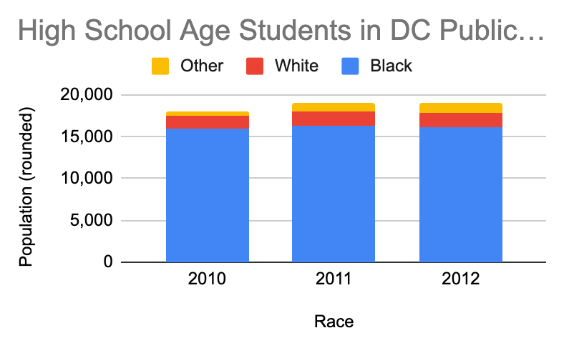

Based on the charts above:
- About how many high school aged students attended public schools Washington, DC in:
2010? 2011? 2012?

- About how many of those students were Black and how many were white in:
2010-Black? White? 2011-Black? White? 2012--Black? White?

Based on these charts, what percentage of DC’s population would you estimate was:
- Black? White? Other?

In fact, DC’s population during this time was about 45% Black, 45% White and 10% other.

If this is the overall population, why do you think the number of Black vs White students in the public schools isn’t almost equal?

Chart 2: Number of students: long-term suspension, expelled and known drop-outs--Grade 9
Year/Race | Black | White | Other
2010 | 650 | 10 | 100
2011 | 525 | 10 | 92
2012 | 400 | 5 | 80

Based on these charts:
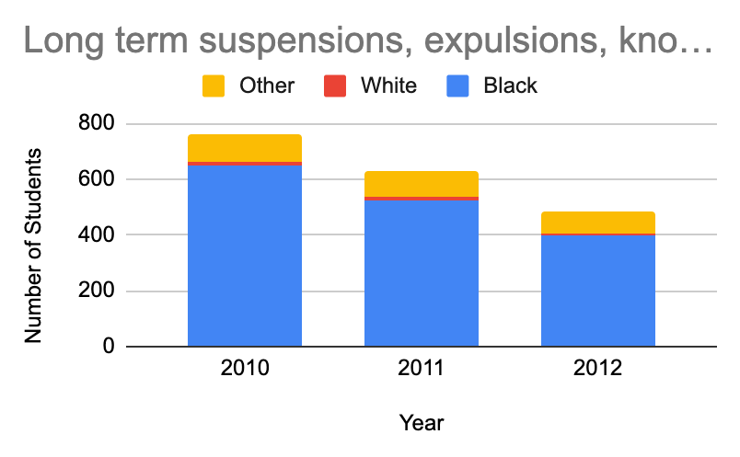
- About how many students total either were suspended, or expelled or dropped out of school in 9th grade in:
2010?

2011?

2012?

- About how many of those students were Black and how many were white in:
2010-Black? White?
2011-Black? White?
2012-Black? White?

Chart 3: Students Committed to New Beginning Youth Development Center -- 2010-2012 - DC’s (rounded)
Year/Race | Black | White | Other
2010 | 150 | 0 | 5
2011 | 130 | 2 | 7
2012 | 100 | 0 | 3

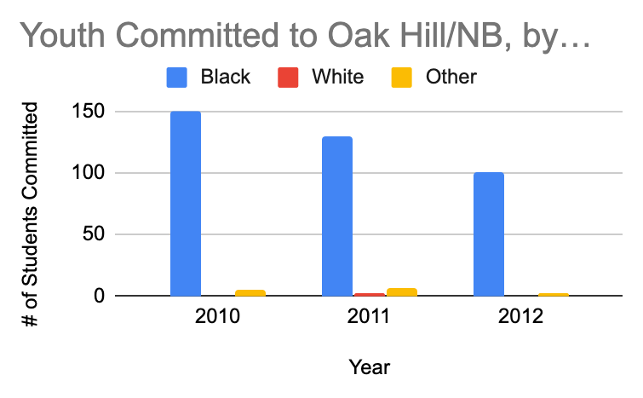
Based on the chart above and to the right:
- About how many students all total were sent to New Beginning Youth Center in:
2010?
2011?
2012?

- About how many of those students were Black and how many were white in:
2010-Black? White?
2011-Black? White?
2012-Black? White?

Step 2: How does your life compare?
Based on these charts, your review of them, and your own life experiences-

- What are some of the factors that lead some students to dropout of high school, especially in 9th grade?

- What could be done in schools in DC to reduce the number of students who were getting expelled or suspended?

- What are some of the factors that are leading teens to getting arrested and sent to DC’s youth facility (called New Beginnings?

- What questions would you want to ask to better understand why there is such a large gap in the number of Black students compared to White students ending up at New Beginnings?

Step 3: Earnings and Education
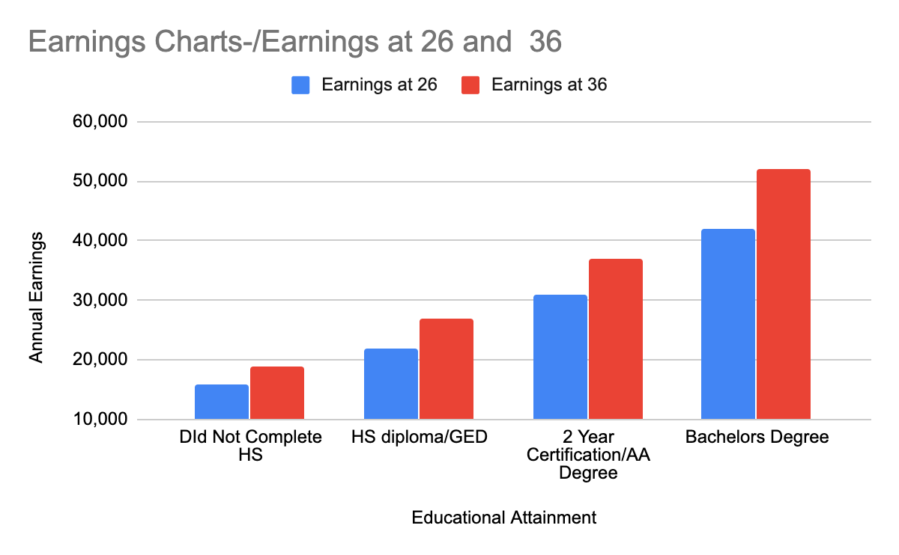
We are now going to look at earnings of adults at age 26 and 36, based on how far they went in school.

Based on this chart:
- How much money per year does a 26 year old:
  - Who has a high school diploma/GED earn?

  - Who earned a two year certification/associates degree earn?
  - Who completed a four-year college degree earn?
  - Who never completed high school earn?

Based on this chart:
- How much money per year does a 36 year old:
Who has a high school diploma/GED earn?
Who earned a two year certification/associates degree earn?
Who completed a four-year college degree earn?
Who never completed high school earn?

Based on this chart:
- How much more per year does a 36 year old earn than a 26 year old, if:
She/he has a high school diploma/GED?
She/he earned a two year certification/associates degree?
She/he completed a four-year college degree?
She/he never completed high?

Discuss/Consider: Does anything about these charts and the earnings raise any specific questions for you?
- Right now, what steps can you be taking to help you increase your earnings potential in the future?
- Many people have an identity that is closely related to the job they have. What sort of “identity” do you want to have as you get older?

Step 4: Criminal Justice Involvement and Education
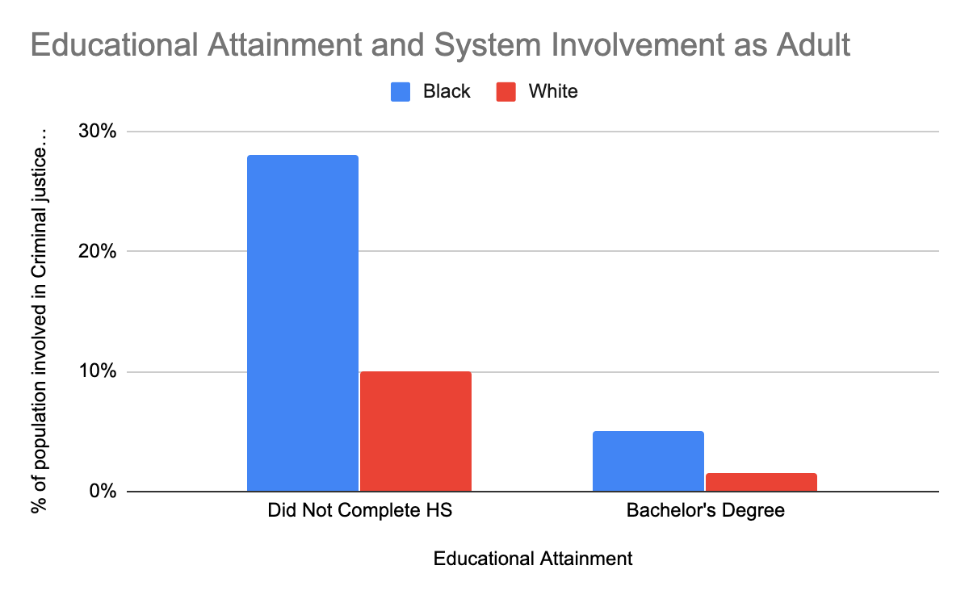
Based on this chart:
- If 100 students drop out high school in the 9th grade, what % of them may end up involved in the criminal justice system as adults if:
They are Black?

They are White?

- If 100 students complete high school and college, what % of them may end up involved in the criminal justice system as adults if:
They are Black? They are White?

- Based on everything we have looked at today, one thing is clear. Making it through 9th grade and graduating high school is really important in helping students, particularly Black students, stay out of the juvenile and criminal justice systems. Systematic racism makes this even more important.

  - What are 3 things that should be put in place to make sure that more and Black students flourish in 9th grade and go on to graduate?

Step 5/Activity 5: Taking ownership of your identity

- The topic of this week’s work was Identity. Often, when teens and young adults are arrested, people unfairly label them or give them an identity (inmate, juvie, etc.)

- But many of us believe in you and identify you in a different way--as a student, or a scholar, or a poet, or hard worker, or funny…..

- How do you want to be identified right now? Feel free to write an answer or make a drawing or sketch.

Skill Builders and Review Problems
- Multiples

Student Feedback:
Circle the emojis that best represents how this activity made you feel.

Day 5: Digital Identity
Health

Step 1: Warm-up

How can you respect the privacy of others online?

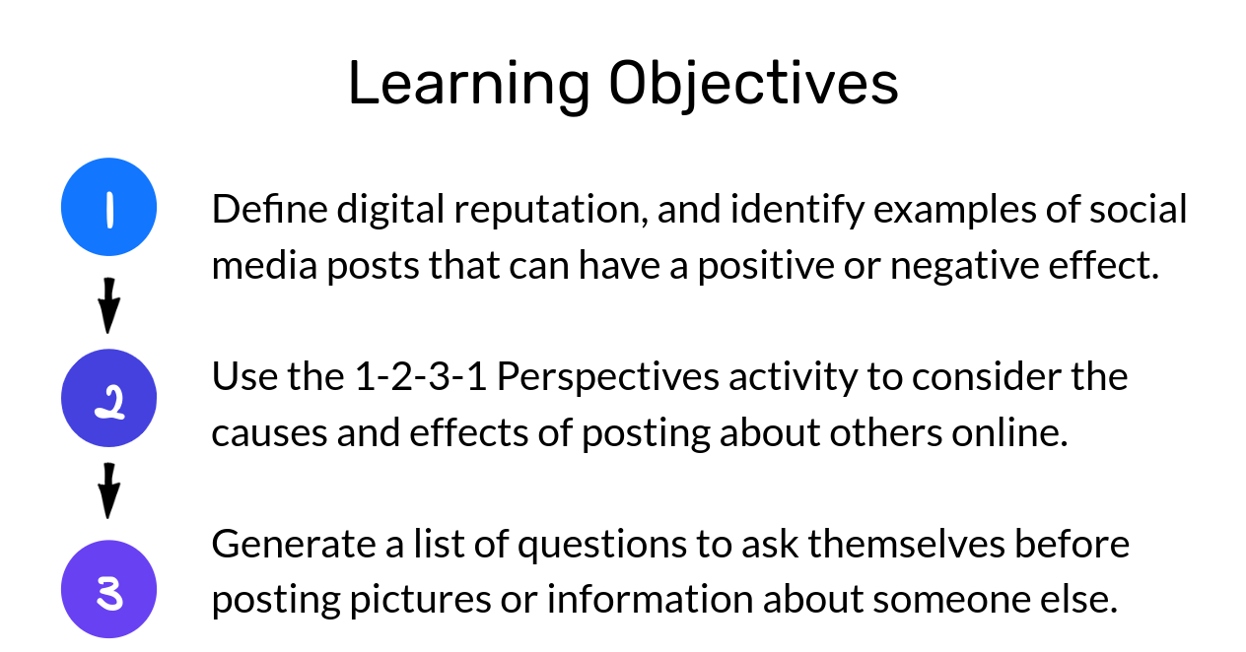
Step 2: What’s this Lesson About?
Step 3: What is digital Reputation?

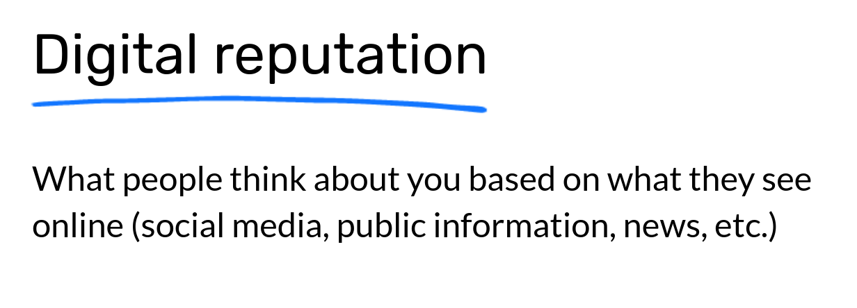

Step 4: Brainstorm

Write down as many ideas as you can in each column below.
Good for digital reputation | Not so good for digital reputation

Step 5: Read the text

Alex and Joran are good friends. One day when they're hanging out after school, as a joke, Joran decides to carve profanity into the sign out front that shows the school name. Alex takes a picture of Joran doing it, tags him, and shares it on social media. Aimee and Max, a couple of friends on social media, see it. Aimee responds with "haha" and a thumbs-up emoji, and Max adds a surprised-face emoji.
A few days later, Alex and Joran get called to see Ms. Varma, the principal, who shows them the photo on her screen. They don't know how she saw the photo. She tells them that Joran will be expelled from school and Alex will be suspended for three days. Alex serves his suspension and returns to school. Joran is forced to find a new school, which ends up being far from his home and a place where he doesn't know any other students.

On your own, notice your gut reaction. What do you think? Do you agree or disagree with the punishments that Alex and Joran received? Why?

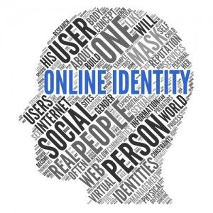
WE Define who WE are.
Mindfulness Moment!

Day 5: National Identity
Social Studies

What is this lesson about?: Today you will learn about national identities and what that means. You will read two articles and see how language can impact national identity.

Step 1: Read the article

It's language – you don't say! – that matters most to national identity
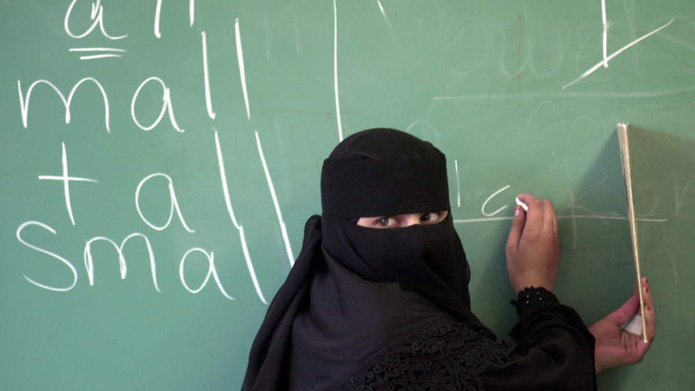
How do people decide what makes someone an American? Many things make up a country's identity, and these things are changing constantly. The same characteristics, though, are used by many different countries to define themselves.
On February 1, the Pew Research Center released a study about national identity. The Pew Research Center studies people's beliefs and attitudes. At the beginning of last year, they asked people across 14 countries about what defines their nation.
Some of the answers were surprising. For instance, many Americans do not think where someone is born matters. In fact, only a handful of the countries Pew surveyed thought where people were born was important. Another surprising fact is that most Americans do not think that customs and religion are really important.

Language Is The Key Factor
Instead, Pew's study found that language was what really defined a country. In all countries, a majority of people said it was "very important" to speak the national language. The importance of language is not surprising. Two people will struggle to find anything in common if they cannot talk to each other. British historian Eric Hobsbawm has written that as countries gradually became democracies, a shared language became a necessity. People need to be able to communicate with each other in order to make decisions about the country instead of the decisions being made by a king or queen.
Many modern states developed around a common language, like Germany, which started as many different German-speaking states. Today, some languages have become symbols for people who want to separate and become their own countries. One example is the Basque language in Spain. There, the Basque people, who speak Basque, want to separate from Spain.
Pew's study does not include countries with many different languages, like India or Switzerland. Instead, most of the countries listed in the research use mostly one language. Often, the language began and is only used in that country.

Canada And The United States Are Exceptions
Canada and the United States, though, are different. Canada is a country where there are two national languages, French and English. Both languages began not in Canada but in Europe. This might be why fewer people in Canada think language is "very important" to national identity than in other countries. It also has the highest number of those who think language is "not at all important."
However, the relationship might be a bit more complicated. For instance, Italy has similar beliefs as Canada, although Italy has strong ties to its language. Also, the United States, another country whose main language is from Europe, seems to have stronger views about language than some European nations.
Pew's study shows that beliefs about national identity are divided across political parties. More Republicans than Democrats say that being able to speak English is very important to being truly American. More Republicans also think American traditions and Christianity are important, too. Many Republicans have conservative beliefs and do not want things to change. Both Republicans and Democrats attach relatively low importance to being born in the United States.

Politics Also Matters In Europe
The connection to political parties is also important across Europe. People who like conservative parties such as the United Kingdom Independence Party (UKIP) and France's National Front thought national customs were very important. These parties are often against people moving in from other countries. They favor what they see as traditional values.
In most of the countries surveyed, people already need to speak the national language to become citizens. In fact, citizenship tests have been becoming more difficult over recent years. For example, the British citizenship test asks people questions about Rudyard Kipling. Kipling was a British writer who published more than a hundred years ago. Some academics say these tests are often a response to conservative political pressure and serve little practical purpose.
The importance of language might change. For one thing, new people can change a language. For example, Germany has developed a conversational language called "Kiezdeutsch," which is used by German speakers whose native tongue is Turkish or Arabic. Also, Pew's study suggests that there is a big generational divide on whether language is very important in most countries. In America, that shift is especially strong. Many more people age 50 or older say language is very important to national identity than people between the ages of 18 to 34.

Step 2: Answer the questions

What is a national identity?

How does speaking a national language form a national identity? What does the article say about this?

What language(s) do you speak? How do you think speaking those languages helps to identify who you are?

What is your national identity?

If you could create your own nation, think about what would it look like. Nations/countries have flags that symbolize who they are. Draw your own flag that represents your identity, below.

Step 3: Read the second article.
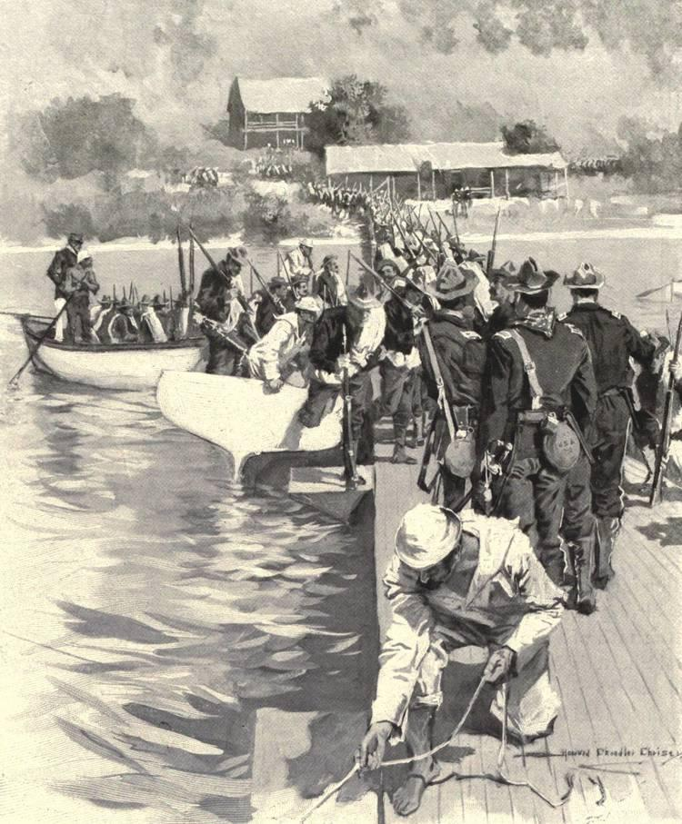
Puerto Ricans continue their search for identity in the United States
The island of Puerto Rico is about 1,150 miles from Florida, just to the east of Cuba. Since 1898, it has been considered a United States territory. It is part of the United States, but it is not a state.
For many years, Puerto Rican citizens lived in uncertainty. Are they citizens of the United States, or something else? Today, being born in Puerto Rico is not much different than being born in the United States. But it wasn't always that way, and a lot of questions still remain.

Status Of Those Born In Puerto Rico
U.S. law still describes Puerto Rico as an "unincorporated territory." That is a general term used in U.S. law. It means it is controlled by the United States government, but not officially a state.
Puerto Rico, Cuba and other islands were once part of the Spanish empire. Spain ruled these islands from thousands of miles away. These islands wanted independence from Spain. In the 1800s, they began to fight against Spain. Sometimes, they asked the U.S. for help in fighting Spain.

In 1898, the United States declared war against Spain in what was called the Spanish-American War. The U.S. won, and it claimed Puerto Rico and other islands owned by Spain.
After this, lawmakers discussed the Constitution. They said that the Constitution allowed the United States to govern Puerto Rico and the other territories taken from Spain after the war.
In 1901, the Supreme Court case Downes v. Bidwell took place. It decided that territories taken after 1898 would be ruled as "unincorporated territories." In other words, these territories were not meant to become states. The decision said that the islands "are inhabited by alien races, differing from us in religion, customs, laws" and "modes of thought."
But how would the Constitution apply to these territories? Are Puerto Ricans considered U.S. citizens?

Are Puerto Ricans Constitutional Citizens?
The Downes v. Bidwell case contains three basic ideas. These ideas are considered by lawmakers to be official rules.
First, it says there's a difference between U.S. states and unincorporated territories like Puerto Rico.
Second, people in unincorporated territories like Puerto Rico are not fully protected by the Constitution. U.S. citizens are fully protected, though.
Third, the U.S. Congress can treat Puerto Rico as a foreign country whenever it wants.

The Citizenship Clause
The 14th Amendment of the Constitution has a special part called the Citizenship Clause. It says that anyone born or "naturalized" in the United States is officially a U.S. citizen. A "naturalized" citizen is someone who wasn't born in the United States, but has lived in the United States for some time and obtained citizenship.
To this day, Puerto Ricans are not protected by the Citizenship Clause.
There was another big problem. In the early 1900s, anyone seeking to become a U.S. citizen had to say they weren't loyal to their old country anymore. For Puerto Rican citizens, this got confusing. In order to become a U.S. citizen, a Puerto Rican also had to reject the United States.
Because of this contradictory requirement, Puerto Ricans could not get U.S. citizenship.
In 1906, Congress passed a law that canceled this requirement. After this, many Puerto Ricans started to become official U.S. citizens. However, they still did not have all the rights of a true U.S. citizen. For example, they cannot vote in U.S. elections.
The Nationality Act of 1940 said that Puerto Rico was a part of the United States for citizenship purposes. Since 1941, when it comes to citizenship, being born in Puerto Rico is officially the same as being born in the United States.

Full Citizenship For Puerto Ricans
However, the general agreement among lawmakers and experts is that Puerto Ricans cannot get full constitutional citizenship. Puerto Ricans are officially U.S. citizens, but the territory remains unincorporated. This has allowed the United States to rule Puerto Rico as a separate and unequal territory. It belongs to the U.S., but is not a part of it.

Step 4: Answer the Questions

What do you think of how the U.S. is treating Puerto Ricans? Is it fair? Why or why not?

Put yourself in the shoes of someone who was born in Puerto Rico. Would you identify as an American, a Puerto Rican, or both? Explain why.

Although English is one of the two official languages in Puerto Rico, only a little more than 10% of people speak it. Most people speak spanish. How do you think this affects Puerto Rico’s national identity?

Student Feedback:
Circle the emojis that best represents how this activity made you feel.

