Week 5
Power

Day 4

NAME:______________________

Day 4 Agenda

Topic | Activity
Warm-Up!
English Language Arts | - Read and analyze the lyrics to the song, Fight the Power.  - Answer questions about the lyrics of the song.  - Complete a graphic organizer about an issue they wish to protest and write a protest song/rap/poem about it.
Science | - Read about HydroPower  - Answer questions about what you read  - Draw a picture and explain
Mindfulness Moment!
Math | - Power: Mothers Against Drunk Driving (MADD) as an example of Power
Health | - Power in digital relationships
Mindfulness Moment!
Civics/Social Studies | - Consider types of governmental powers  - Anarchy v. Communism

Warm-up Activity: Write a journal entry around the daily quote on identity.
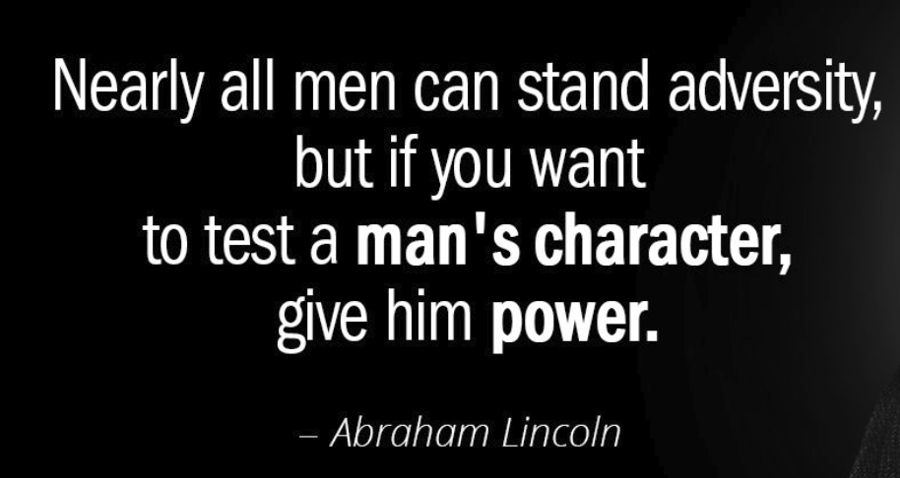

Day 4: Using Music as Protest
English Language Arts

What is this lesson about? Today, you will read the lyrics to a popular protest song. Unlike the subversive (hidden) protest of the women from Chile, this song was direct and explicit. As you read and think about this song, think about the issues of power that the artists address in the song.

Before you read
The song “Fight the Power” by Public Enemy was written for the movie Do the Right Thing which told the story of racial tensions in New York. With the movie’s popularity, the song quickly became an anthem or call to action for many. Public Enemy, were among the most popular, controversial, and influential hip-hop artists of the late 1980s and early ’90s. The original members were Chuck D (original name Carlton Ridenhour) Flavor Flav (original name William Drayton), Terminator X (original name Norman Lee Rogers; and Professor Griff (original name Richard Griffin). They were inducted into the Rock and Roll Hall of Fame in 2013.
(If you have access to the internet, please listen to “Fight the Power “at https://www.youtube.com/watch?v=5UAnW-c57gM)

Step 1: Read the lyrics
Fight The Power
Public Enemy

1 | Yet our best trained, best educated, best equipped, best prepared troops refuse to fight  As a matter of fact, it's safe to say that they would rather switch than fight  1989 the number another summer (get down)  Sound of the funky drummer  Music hitting your heart 'cause I know you got soul  (Brothers and sisters, hey)  Listen if you're missing y'all  Swinging while I'm singing  Giving whatcha getting  Knowing what I know  While the Black bands sweatin'  And the rhythm rhymes rollin'  Got to give us what we want (uh)  Gotta give us what we need (hey)  Our freedom of speech is freedom or death  We got to fight the powers that be | Notes:
2 | (Chorus)  Lemme hear you say  Fight the power (lemme hear you say)  Fight the power (x 6)  We've got to fight  the powers that be
3 | As the rhythm designed to bounce  What counts is that the rhymes  Designed to fill your mind  Now that you've realized the pride's arrived  We got to pump the stuff to make us tough  From the heart  It's a start, a work of art  To revolutionize make a change nothing's strange  People, people we are the same  No we're not the same  'Cause we don't know the game  What we need is awareness, we can't get careless  You say what is this?  My beloved let's get down to business  Mental self defensive fitness  (Yo) bum rush the show  You gotta go for what you know  To make everybody see, in order to fight the powers that be
4 | Chorus
5 | Elvis was a hero to most  But he never meant shit to me you see  Straight up racist that sucker was  Simple and plain  *** him and John Wayne. (**edited for language)  'Cause I'm Black and I'm proud  I'm ready and hyped plus I'm amped  Most of my heroes don't appear on no stamps  Sample a look back you look and find  Nothing but rednecks for four hundred years if you check  Don't worry be happy  Was a number one jam  Damn if I say it you can slap me right here  (Get it) let's get this party started right  Right on, c'mon  What we got to say (yeah)  Power to the people no delay  Make everybody see  In order to fight the powers that be
6 | Chorus

Step 2: Answer the following questions.

      - List two issues that the song is protesting. Use text evidence from the song to explain your answers.

      - In the song, the writer is frustrated with his own community as well as the outside society. What frustrates or angers him about his own community?

      - Chuck D. who co-wrote this song, addressed his mention of Elvis and John Wayne (two very popular performers in American society) when he said,

“Elvis and John Wayne were the icons (symbols) of America. And they kind of got head-and-shoulder treatment over everybody else. It’s not that Elvis was not a talented dude and incredible in his way, but I didn’t like the way that he was talked about all the time, and the pioneers [of rock & roll], especially at that time, weren’t talked about at all. When people said “rock & roll” or “the King,” it was all “Elvis, Elvis, Elvis, one trillion fans can’t be wrong” and John Wayne is “Mr. Kill All the Indians and Everybody Else Who’s Not Full-Blooded American.”

What did he want to communicate about them? (Hint, look at the lines that follow.)

      - The song was considered an “anthem” and is often described as a call to action for their community. What did Public Enemy want their community to do?

Step 3: Write your own protest song/rap/poem
Complete the graphic organizer below.

Choose a problem or issue that you want to address and protest in your song/rap/poem.

Write down 3-4 facts related to your topic that you can mention in your song/rap/poem.

Title your song/rap/poem: Choose a catchy phrase or word that will attract your listener.

Write your song/rap: 4 lines of verse and 4 lines of a chorus.

1st Verse:
Chorus: (this should be part of your call to action like the song Fight the Power)

2nd Verse

And you would finish with repeating the chorus.

Step 4: Practice, Share and Get Feedback

Share your song/rap/poem with another person in the group. The person listening should share:

1 line/verse that they think was really good/strong.

1 line/verse that could be improved.

Go back to your song/rap/poem and revise and finalize. Share out again if you have time.

Student Feedback:

Circle the emojis that best represents how this activity made you feel. | 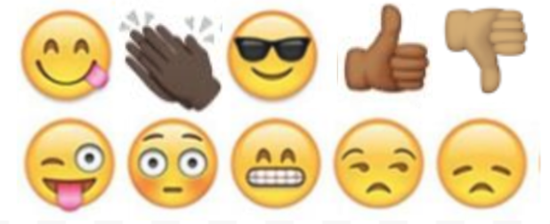  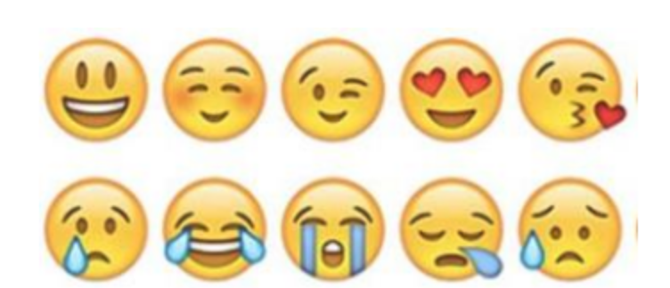

Day 4: Hydropower
Science

What is this lesson about?: Today you will read through the Hydropower passages. You will answer a few questions about what you read. You will complete a Hydropower activity.

Step 1: Read through the Hydropower passages

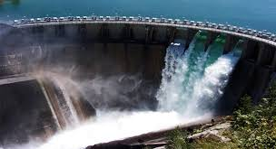
Hydropower
What is hydropower?
Hydropower is power that is generated from moving water such as rivers.

Renewable Energy
Hydropower is a renewable energy source. This means that using a dam or a river to generate electricity doesn't use up any limited resources like coal or gasoline.

How do we get power from water?
Falling or flowing water from a big river has a lot of energy. We can harness this by forcing the water through a pipe called a penstock. As the water flows through the pipe it turns the blades of a turbine which spins an electric generator. As long as the water is flowing, the generator will be able to provide electricity.

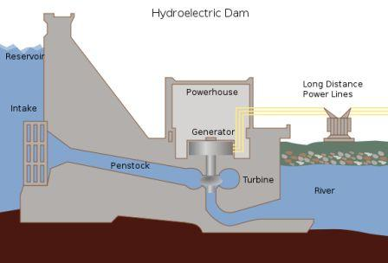
Electricity can be generated by water moving through a dam

There are three main ways that engineers design hydroelectric power plants:
- Storage System - The storage system uses a dam. The dam slows the flow of a river and stores up water in a lake. A portion of the water is released into the river at the bottom of the dam. The fall of the water, and the water pressure from the lake, forces the water through the dam and spins turbine generators. Dams are expensive to build, but they also help control flooding, can create a large recreational lake, and can provide fresh water for surrounding towns.
- Run-of-the-river System - In a run-of-the-river system the turbines are spun by the natural flow of the river. These systems have the advantage of not creating a huge lake and flooding the area above the dam. As a result, they have less overall impact on the environment. However, in order to provide continuous electricity, the river they use must stay full throughout the year, as the flow is not regulated by a dam.
- Pumped Storage System - This system is like the storage system except it uses pumps to pump used water back up into the reservoir. The way this works is that during the night, when electricity use is much less, it uses the extra electricity to pump the water back up to the top of the dam and refill the reservoir. This improves the overall efficiency of the hydropower plant.
History of Hydropower
Using rivers to power mechanical devices is not a new concept. As far back as ancient times, thousands of years ago, people used hydropower to perform tasks such as grinding grain into flour. In the late 1800s scientists first figured out how to use hydropower to generate electricity. The first hydroelectric power plant was built in Wisconsin in 1882. Since then, many more power plants have been built in the United States including the Hoover Dam in 1936 and the Grand Coulee Dam in 1942.

Are there any drawbacks to hydropower?
Like any power source there are some drawbacks to hydropower. One drawback is the loss of land and the damage to the local ecosystem caused when a lake is created by a dam. This can also cause people to have to relocate and leave their homes. Another disadvantage is methane emissions generated by the reservoirs. Dams and turbines can also hurt fish and disrupt their migration to spawning grounds.

Fun Facts about Hydropower
- There are over 2,000 hydroelectric power plants in the United States.
- Many countries, such as Norway and Brazil, get a significant portion of their electricity (as much as 85%) from hydropower.
- The largest dam and hydroelectric power plant in the world is the Three Gorges Dam in China. It provides 22,500 Megawatts of electricity!
- Most of the dams in the United States were not built to supply power. They were built for flood control and to provide local irrigation.
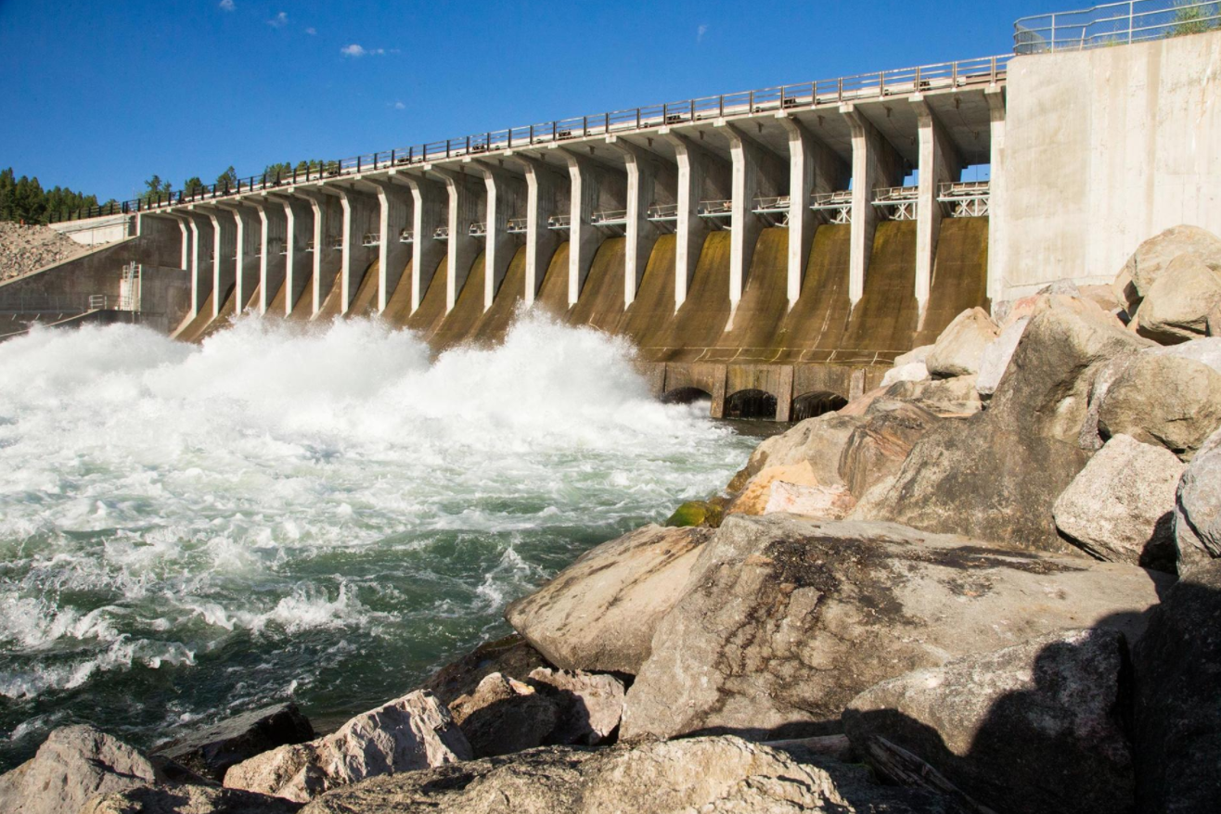
- A large portion of the hydropower generated in the United States occurs in the western states. The number one producer of hydropower is Washington state which produced 29% of the nation's hydropower in 2011.
Jackson Lake Dam in Wyoming's Grand Teton National Park was built in 1906 to provide water to farmers and ranchers. Many older dams are now being rethought.

(National Geographic)
Humans have been harnessing the energy of river currents for centuries, using water wheels spun by rivers initially to process grains and cloth. Today, hydropower provides about 16 percent of the world's electricity, generating power in all but two U.S. states.

Hydropower became an electricity source in the late 19th century, a few decades after British-American engineer James Francis developed the first modern water turbine. In 1882, the world’s first hydroelectric power plant began operating in the United States along the Fox River in Appleton, Wisconsin.

How hydropower works
A typical hydroelectric plant is a system with three parts: a power plant where the electricity is produced, a dam that can be opened or closed to control water flow, and a reservoir where water is stored. The water behind the dam flows through an intake and pushes against blades in a turbine, causing them to turn. The turbine spins a generator to produce electricity.
The amount of electricity that can be generated depends on how far the water drops and how much water moves through the system. The electricity can be transported through long-distance electric lines to homes, factories, and businesses. Other types of hydropower plants make use of the flow through a waterway without a dam.

The largest hydropower plants
China, Brazil, Canada, the United States, and Russia are the five largest producers of hydropower. The world's largest hydroelectric plant in terms of installed capacity is Three Gorges (Sanxia) on China's Yangtze River, which is 1.4 miles (2.3 kilometers) wide and 607 feet (185 meters) high. The facility that actually generates the most electricity annually is the Itaipu plant situated on the ‎Paraná River between Brazil and Paraguay.

The biggest hydropower plant in the United States is at the Grand Coulee Dam on the Columbia River in Washington, a state that gets about two-thirds of its electricity from hydropower.

Hydropower pros and cons
Hydropower has several advantages. Once a dam has been built and the equipment installed, the energy source—flowing water—is free. It's a clean fuel source renewed by snow and rainfall. Hydropower plants can supply large amounts of electricity, and they are relatively easy to adjust for demand by controlling the flow of water through the turbines.

But big dam projects can disrupt river ecosystems and surrounding communities, harming wildlife and forcing out residents. The Three Gorges Dam, for example, displaced an estimated 1.2 million people and flooded hundreds of villages.

Dams also prevent fish such as salmon from swimming upstream to spawn. While equipment such as fish ladders are designed to help salmon go up and over dams and enter upstream spawning areas, such measures aren't always effective. In some cases, fish are collected and trucked around the obstacles. Still, the presence of hydroelectric dams can often change migration patterns and hurt fish populations. In the Columbia River Basin in the Pacific Northwest, for example, salmon and steelhead have lost access to about 40 percent of their historic habitat because of dams.

Hydropower plants can also cause low dissolved oxygen levels in the water, which is harmful to river habitats. Other wildlife can be affected as well: In Indonesia, a hydroelectric project threatens rare Tapanuli orangutans because it stands to fragment their habitat.

RENEWABLE ENERGY 101

Climate change and the increased risk of drought are also having an impact on the world's hydropower plants. In the western U.S., carbon dioxide emissions over a 15-year period were 100 megatons higher than they normally would have been, according to a 2018 study, as utilities turned to coal and gas to replace hydropower lost to drought.

Even the promise of carbon-free electricity from hydropower has been undermined by revelations that decaying organic material in reservoirs releases methane, a potent greenhouse gas that contributes to global warming.

However, some argue that the environmental impacts of hydroelectric power can be mitigated and remain low compared with burning fossil fuels. In some places, small hydro projects can take advantage of existing water flows or infrastructure. Special water intakes and turbines can help make sure water released from a dam is better aerated to address the problem of low dissolved oxygen. Dams can be planned more strategically to allow fish passages, for example, while water flows at existing dams can be calibrated to give ecosystems more recovery time from flooding cycles. And research continues on ways to make hydropower projects more friendly to the ecosystems around them.

A growing movement is also working to tear down dams that are no longer functioning or needed around the world, with the aim at restoring more natural rivers and the many benefits they provide to wildlife and people, including recreation.

Step 2: Answer questions about what you read

- Where does hydropower get its energy from?
  - From the burning of fossil fuels like coal
  - The internal heat of the Earth
  - Moving water sources like rivers

- In a hydropower plant, water flows through a pipe called a _______.
  - Penstock
  - Turbine
  - Generator

- What type of hydropower plant does not use a dam?
  - Pumped storage system
  - Run-of-the-river system
  - Storage system

- What type of hydropower plant uses extra electricity at night to move used water back into the reservoir?
  - Run-of-the-river system
  - Storage system
  - Pumped storage system

- What is a disadvantage to the run-of-the-river hydropower system?
  - It relies on fossil fuels to generate power
  - The river must remain full and flowing in order to generate electricity
  - It can destroy the surrounding environment by creating a large lake

- Where is the largest dam and hydroelectric plant in the world located?
  - Brazil
  - China
  - United States

- Using rivers to power mechanical devices is a new concept invented in the late 1900s.
  - TRUE
  - FALSE

Step 3: Draw a picture/explain

Draw a picture of a hydropower plant. Explain how your hydropower plant can help your community.

________________________________________________________________________________________________________________________________________________________________________________________________________________________________________________________________________________________________________________________

Student Feedback:

Circle the emojis that best represents how this activity made you feel. | 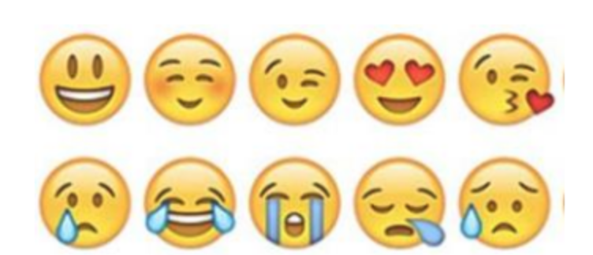  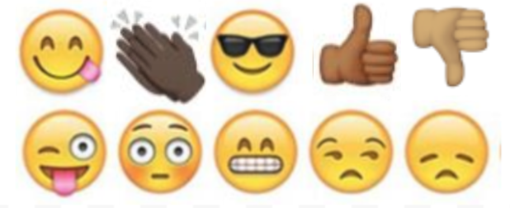

Day 4: Power: MADD - Mothers Against Drunk Driving
Math

What is this lesson about?: This lesson is about Mothers Against Drunk Driving and the Power of a well-coordinated campaign

Step 1: Background - Mothers Against Drunk Driving (MADD) is a nonprofit organization in the United States that seeks to stop drunk driving, support those affected by drunk driving, prevent underage drinking, and strive for stricter impaired driving policy, whether that impairment is caused by alcohol or any other drug.

MADD was founded on September 5, 1980, in California by Candace Lightner after her 13-year-old daughter, Cari, was killed by a drunk driver.

Step 2: Drunk-driving crashes in the U.S.

Every day, almost 30 people in the United States die in drunk-driving crashes — that's one person every 50 minutes. These deaths have fallen by a third in the last three decades; however, drunk-driving crashes claim way too many lives each year.

- If 30 people die per day from drunk driving, how many people in the US died from drunk driving accidents in one year (2018). (There are 365 days/year).

- In 1980, just over 18,000 people died in drunk driving accidents.

- How many fewer people died from drunk driving in 2018 compared to 1980?

Step 3: What changed?

States increased the drinking age 18 to 21. In 1975 in over ½ the states, it was legal to drink at the age of 18.

In response to the drunk driving accidents and fatalities of the 1970s, and in large part because of very effective efforts on the part of MADD, the US Congress passed the Minimum Drinking Age Act in July 1984, a law that mandated states increase the drinking age to 21 if they wanted to continue to receive federal highway funds.

By 1988, all 50 states had changed the drinking age to 21.

The charts below shows some key facts related to automobile fatalities over the last 40 years, comparing 1980 to 2018.

Total Automobiles Registered in the US
1980 | 109,000,000
2018 | 276,000,000

Use the data above to complete the charts below and to answer the related questions…
Draw a line graph using the two points identified to show how the number of registered automobiles in the US changed between 1980 and 2018.
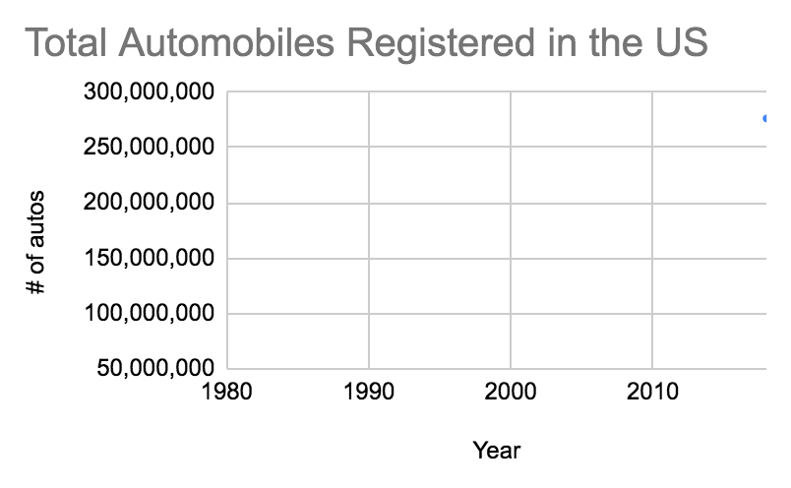
- What does this line indicate?

US Fatalities: Auto | Total | Alcohol Related
1980 | 30000 | 18000
2018 | 28,571 | 10000

Draw a double line graph (two lines) how the number of automobile deaths and alcohol-related automobile deaths changed between 1980 and 2018, using the data from the chart above.
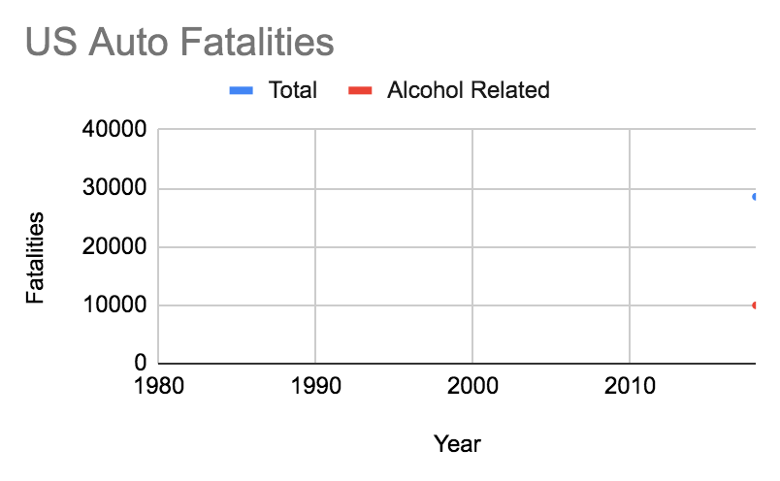

- What do these lines indicate?

- How do they compare to the number of registered cars?

US Fatalities: Auto, Ages 16-20 | Total | Alcohol Related
1980 | 18,000 | 13,500
2018 | 11,429 | 4,571

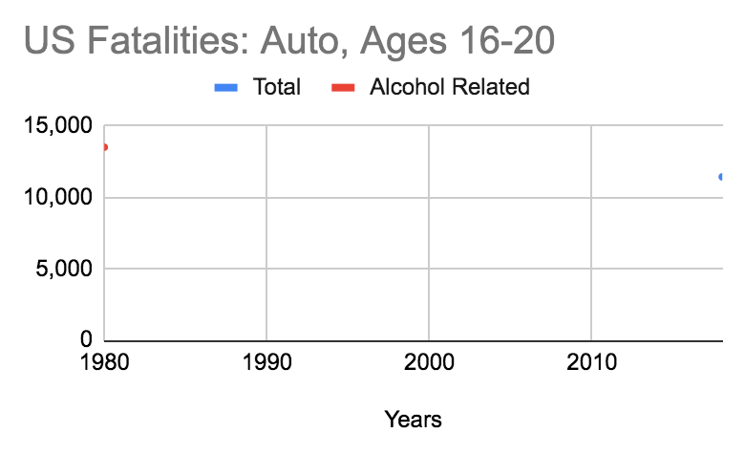
Draw a double line graph (two lines) that shows how the number of automobile deaths and alcohol-related automobile deaths of 16-20 year olds changed between 1980 and 2018 (from the chart above).

What do these lines indicate?

Step 4: Other factors to consider

In addition to changing the legal drinking age, MADD and others have led the charge for other changes related to driving and to drinking and driving.

Discuss/Consider: In your state, how old do you have to be to get your driver’s license? When you first get your license are their restrictions on when you can drive, or who you can drive with?

- Do you know if these same restrictions existed when your parents got their licenses?

Discuss/Consider:
- What is the consequence of getting pulled over and found to be guilty of drunk driving in your state?

- Is this the same penalty that was in place 30 to 40 years ago? Was the punishment more strict or lenient years ago?

Student Feedback:
Circle the emojis that best represents how this activity made you feel.

Day 4: Power in Digital Relationships
Health

What is this lesson about?: In today’s lesson, we will look at digital relationships and how power can travel through technology use and control.

Step 1: Warm-Up In the relationship below do you feel like one person has more power than the other person?

Who’s got the POWER?
Friend one wants to skip school. Friend two says they’re not sure, but after talking about it, gives in and skips school, even though they didn’t really want to.

Who has the POWER? Why?

Step 2: Read about the behaviors below.

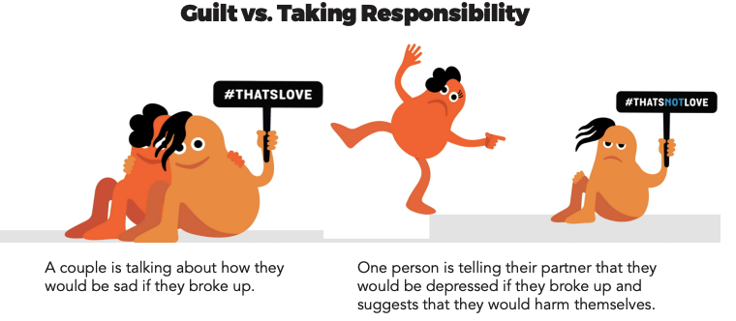

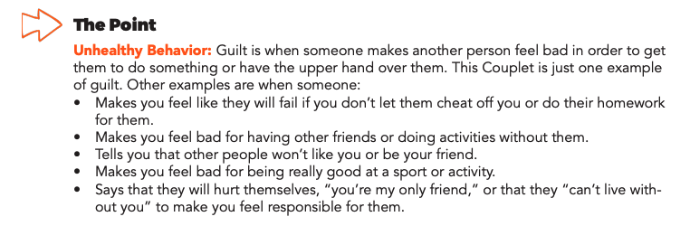
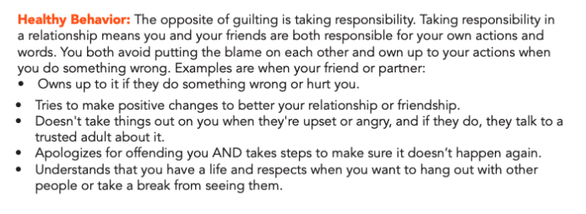

Step 3: Complete the Activity.

Use the two phones below to play out the following scenarios:

Scenario One: One partner usually decides when, where, and what they do together. The other partner says they don’t like making decisions and is fine with this.

Use the phone below to show what this conversation looks like.

Scenario Two: A guy notices his girlfriend is getting a lot more texts than usual. When he mentions it, his girlfriend says he’s imagining things. When she goes to use the bathroom, he checks her phone and reads her texts.

Use the phones below to show who she was texting.

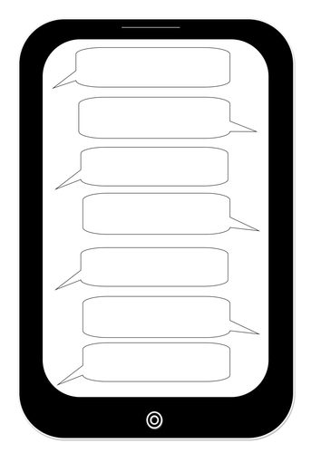

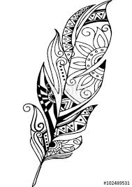
Mindfulness Moment!
Create patterns, shapes, scribbles or whatever comes to mind! It’s that simple.

Day 4: Governmental Powers: Anarchy v. Communism
Social Studies/Civics

What is this lesson about?: Today you will continue exploring different types of government, and will focus on anarchy and communism. Below is a reminder of our Elite 8 bracket. Fill in who you selected to win the face-offs for the last 3 lessons below.

Types of Government Bracket
Monarchy
Oligarchy
Dictatorship
Theocracy
Direct Democracy
Representative Dem.
Communism
Anarchy

Step 1: Compare Anarchy and Communism

Anarchy  In an anarchy, nobody is in control—or everyone is, depending on how you look at it. Sometimes the word anarchy is used to refer to an out-of-control mob. When it comes to government, anarchy would be one way to describe the human state of existence before any governments developed. It would be similar to the way animals live in the wild, with everyone looking out for themselves. Today, people who call themselves anarchists usually believe that people should be allowed to freely associate together without being subject to any nation or government. There are no countries that have anarchy as their form of government. | Communism  Communism is a system of government that puts the power in the hands of ALL the people. The government owns the major industries and shares the money with the people. Its goal is to make poor and rich people equal. Most communist countries are lead by a totalitarian dictator (a leader who has complete control)

Step 2: Read more about anarchy and answer questions

Anarchy
As an American citizen, you are required to respect the mayor and his council at the city level, as well as the police that enforce the laws. You also have to obey the state government's laws and police, and any national laws, treaties, and the FBI.
Anarchy is nothing like that. The word anarchy comes from the Greeks who combined 'an,' meaning not or without, and 'arkhos,' meaning ruler or leader. For them, anarchy was when no one had any authority over anyone else. There would be no laws, no police, nothing.

Philosophers and Anarchy
Starting in the 17th century, anarchy started to get the attention of philosophers. They talked about anarchy, what it was and what it meant. Thomas Hobbes thought of it as man's natural state, where every man had a right to everything he could take, including another person's life or body. In other words, total chaos. His idea is still a popular perception of anarchy to this day.
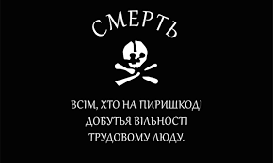
Immanuel Kant, another popular philosopher, believed that people living in an anarchist society could have laws, just with no one to enforce them. For him, it was possible to have people living together without total chaos all the time.
Example of Anarchy
An example of an anarchist state existed from 1918 to 1921 called the Free Territory. The Free Territory was an anarchist state set up in Ukraine by a man named Nestor Makhno. The Free Territory was one of the few states based entirely on anarchist ideas and has a famous flag—a picture of a skull with the words, “Death to all who stand in the way of freedom for working people!” in Ukranian.

With an army of 100,000 men, known as the Black Army, Makhno took over the southeastern section of Ukraine and implemented an anarchist society. The society was structured by establishing worker and peasant organizations where the members voted on specific issues in committees.

Makhno opposed a central government of any kind and instead called together groups of people to discuss national issues that needed debate. In the end, the Russian and Ukranian armies invaded the Free Territory and defeated the Black Army in 1921.

Who has power in an anarchist government? Explain your answer in 3-4 sentences.

Do you think an anarchist government could be successful? Why or why not?

Step 3: Read more about Communism and answer questions

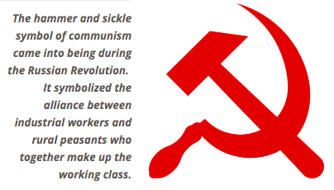
Communism
Visualize a world where everyone has equal amounts of wealth. Everyone has equal amounts of land, equal-sized houses, the same government-issued cars, the same government-issued stoves, the same government-issued cell phones, etc. Although people do different jobs, they all get paid the same. Since everyone is equal, there are no social classes. In fact, there isn't even a need for money. People do not need to fight because all materials are shared in common through the government. Everyone works according to their ability, and everyone receives according to their need. Sounds too good to be true, huh?

The world portrayed here is a communist society. In simple terms, communism is a society in which private property and social class do not exist and the government owns all things necessary to make and transport products.

Marxist Communism
By far the most famous form of communism is Marxist Communism. Based on the writings of Karl Marx, the concept of Marxist Communism became very influential in the 20th century because it inspired the communist revolutions of the Soviet Union, China, Vietnam, Korea, Nicaragua, and Cuba, among others.

Marx believed that the history of the world was about competition between different social classes. In other words, there has always been some small group of people in charge who tells everyone else what to do. That is not to say that the weaker social classes just accept the power of the dominant class, though. Rather, there is always a constant struggle between the social classes.

For Marx, the class in power is made up of people who own factories and businesses. The lower classes are made up by the people who work at the factories. Marx predicted that one day the workers would become so angry with the factory owners they would rise up and overthrow the wealthy class. Then, the workers would create a communist society where all goods were shared publicly and the government owned the factories.
Who has the power in a communist government? Explain your answer in 3-4 sentences

If you had to create a flag for a communist government, what would it look like? You can draw or describe it below.

Step 4: Read about communism in Cuba and reflect

In 1952, General Fulgencio Batista overthrew the government of Cuba, which means he took over control. Fidel Castro was put in prison for 15 years after he planned an uprising to try and force out Batista from office. He left Cuba and went to Mexico. Fidel Castro came back to Cuba in 1956 and fought a battle against the government. In 1958, Fidel Castro forced Batista out of Cuba and Castro became the Prime Minister (leader) of Cuba. Castro introduced Communism to Cuba.

Some people were angry about communism. Many people were forced to leave the country or be imprisoned and many of those people went to the United States to escapr. Communism put the government in control of the economy. Cubans got free public education and free healthcare.

Russia was also a communist country. Russia gave Cuba a lot of money to maintain this system of government. The United States had a conflict with Russia, so the United States stop trading with Cuba, called the trade embargo. In 1991, USSR (Russia) split apart. Russia could no longer give money to Cuba. Cuba had an economic crisis. Many people became poor.

The United States does not like Communism because it is the opposite of Capitalism (where individual businesses control the economy). Also, the United States did not like any country that supported Russia.

When Russia could not help Cuba, maybe people tried to go to the United States illegally in boats. People of Cuba could not speak out against the government. If they say anything bad about the government, there was a chance of going to jail.

After reading about communism in Cuba, do you think Cuba should keep communism? Why or why not?

Step 7: Organize your thoughts
Complete the graphic organizer on the next page to help you compare and contrast Direct and representative democracies. After completing the graphic organizer, you will reflect on these forms of governments and choose which one you prefer.
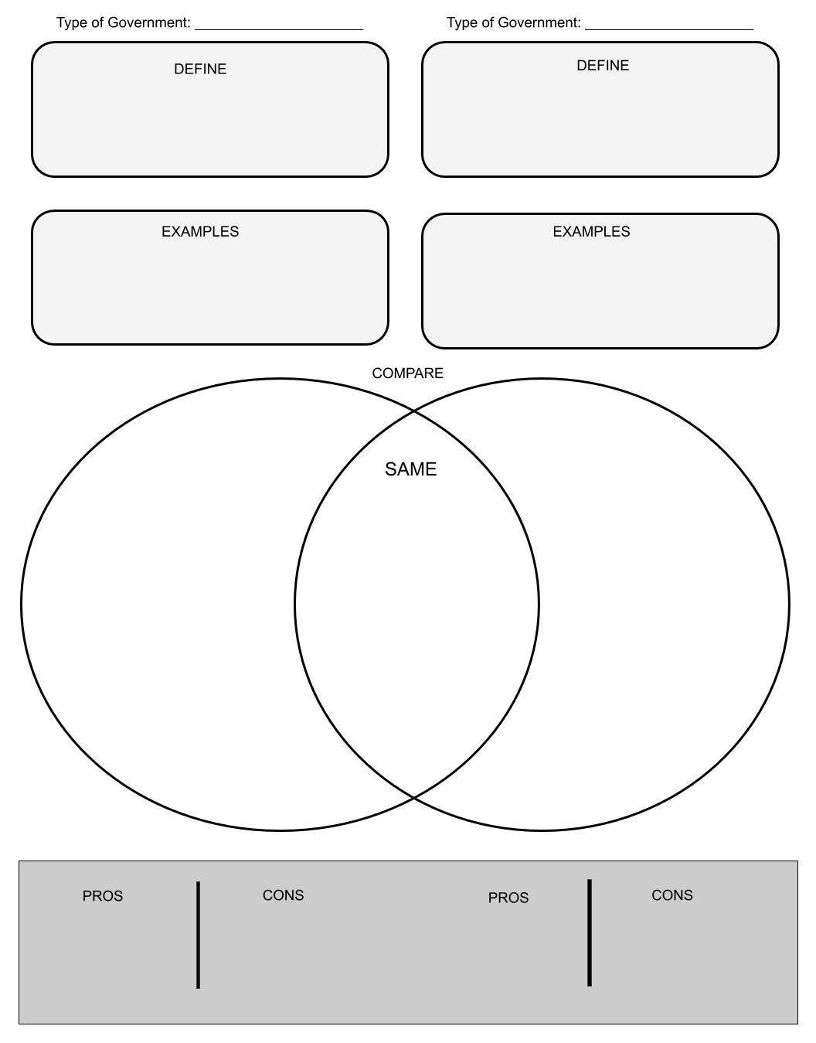

Step 8: Reflect

Complete the bracket below and choose which type of government you prefer:
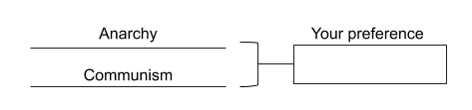

- Why do you prefer that governmental system? (share three reasons)

- How does it compare to the current governmental system you live in now? (share three reasons)

Step 9: Discuss
- With a partner, share and compare your graphic organizer.
- Can you improve your graphic organizer after discussing with your partner?
- Share what you chose as your winner for this bracket face-off and why.

Student Feedback:

Circle the emojis that best represents how this activity made you feel.

