Week 8
Freedom

Day 1

NAME:______________________

Day 1 Agenda

Topic | Activity
Warm-Up!
English Language Arts | - Create their own definition of Freedom.  - Read and Annotate the poem: Refugee in America by Langsont Hughes  - Respond to questions about the reading.  - Respond to a quote about Freedom.
Science | - Read about the North Star to Freedom  - Answer questions about what you read  - Draw a picture and explain
Mindfulness Moment!
Math | - Word Problems: Sharecropping: Freedom, or not  - Skills: Fractions
Health | - Freedom of speech and health
Mindfulness Moment!
Civics/Social Studies | - Religious liberty in colonial America

Warm-up Activity: Write a journal entry around the daily quote on identity.
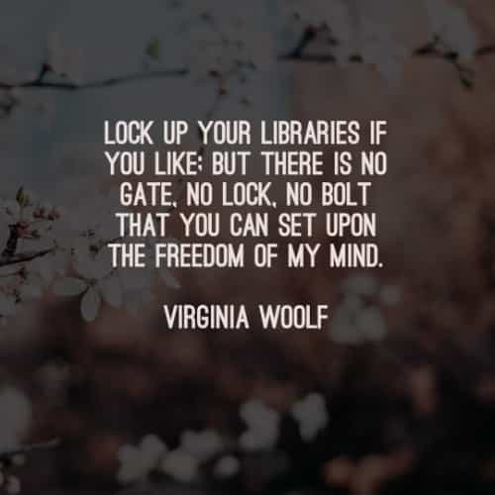

Day 1: Defining Freedom
English Language Arts

What is this lesson about? Over the next week, you will be reading, thinking, talking and writing about “freedom”. While we often think about freedom being the ability to do what we want to be, the concept is much more complex. As you read and think about the concept of freedom this week, consider your own definition of Freedom and what it means to you as an individual and as a part of society.

Step 1: Read, Think, Write
Below, read the multiple definitions of freedom according to Merriam-Webster’s Dictionary. Read through the definitions carefully then think: What does freedom mean to you? Write for 9 minutes and give your own definition of freedom. Give examples of what freedom looks and feels like.

Freedom: noun
noun: freedom
- the power or right to act, speak, or think as one wants without hindrance or restraint.
"we do have some freedom of choice"
synonyms: | right to, entitlement to; More
2. absence of subjection to foreign domination or despotic government.
"he was a champion of Irish freedom"
synonyms: | independence, self-government, self-determination, self-legislation, self rule, home rule, sovereignty, autonomy, autarky, democracy; More
3. the state of not being imprisoned or enslaved.
"the shark thrashed its way to freedom"
Synonyms. | liberty, liberation, release, emancipation, deliverance, delivery, discharge, nonconfining

4. the state of being physically unrestricted and able to move easily.
"the shorts have a side split for freedom of movement"
the state of not being subject to or affected by (a particular undesirable thing).
5. the power of self-determination attributed to the will; the quality of being independent of fate or necessity.
synonyms: | scope, latitude, leeway, margin, flexibility, facility, space, breathing space, room, elbow room; More

6. unrestricted use of something.
"the dog is happy having the freedom of the house when we are out"
familiarity or openness in speech or behavior.
plural noun: freedoms
synonyms: | naturalness, openness, lack of reserve/inhibition, casualness, informality, lack of ceremony, spontaneity, ingenuousness  "I admire her freedom of manner"

Write your answer here:

Step 2: Discuss with a partner or with the group
Share your writing with a partner and look for ideas you have in common.

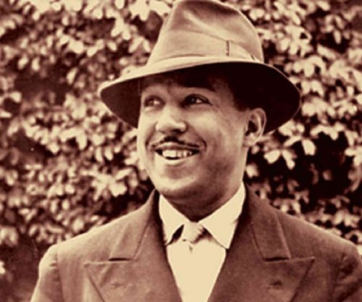
Step 3: Read and Annotate the Poem Below

Before you Read: James Mercer Langston Hughes was born February 1, 1902, in Joplin, Missouri. His parents divorced when he was a young child, and his father moved to Mexico. He was raised by his grandmother until he was thirteen, when he moved to Lincoln, Illinois, to live with his mother and her husband, before the family eventually settled in Cleveland, Ohio. It was in Lincoln that Hughes began writing poetry. After graduating from high school, he spent a year in Mexico followed by a year at Columbia University in New York City. During this time, he held odd jobs such as assistant cook, launderer, and busboy. He also travelled to Africa and Europe working as a seaman. In November 1924, he moved to Washington, D. C. Hughes's first book of poetry, The Weary Blues, (Knopf, 1926) was published by Alfred A. Knopf in 1926. He finished his college education at Lincoln University in Pennsylvania three years later. In 1930 his first novel, Not Without Laughter, (Knopf, 1930) won the Harmon gold medal for literature.

Hughes is known for his insightful, colorful portrayals of black life in America from the twenties through the sixties. He wrote novels, short stories and plays, as well as poetry, and is also known for his engagement with the world of jazz and the influence it had on his writing.

Some vocabulary to understand:
heartstrings: deepest emotions or affections | refugee: one that flees  especially : a person who flees to a foreign country or power to escape danger or persecution | Liberty: having various social, political, or economic rights and privileges
Refugee in America
By Langston Hughes

There are words like Freedom

Sweet and wonderful to say.

On my heartstrings freedom sings

All day everyday.

There are words like Liberty

That almost make me cry.

If you had known what I know

You would know why

Step 4: Answer the following questions
1. The speaker says that the word liberty “almost make(s) me cry.” Why might this be true?

2. What might the sad feelings in the second stanza say about the possibilities and the reality of liberty based on the perspective of the speaker?

3. Freedom and liberty are words that are often associated with each other, but they do not mean exactly the same thing. How is liberty different from freedom?

4. Describe in a sentence or two what you think the theme, or message, of “Refugee in America” is. What evidence in the text helps convey the theme or message?

5. What is a refugee? How can someone be a refugee in his or her own country?

6. Why do you think Hughes titled his poem “Refugee in America” and not “Words Like Freedom,” as it is often called?

Step 5: Read and annotate the quotes below
As you read, annotate each quotation and write notes about what each means.

A man who believes in freedom will do anything under the sun to acquire, or preserve his freedom. Malcolm X

No one outside ourselves can rule us inwardly. When we know this, we become free. Buddha

To enjoy freedom we have to control ourselves. Virginia Woolf

For to be free is not merely to cast off one’s chains, but to live in a way that respects and enhances the freedom of others. Nelson Mandela

The freedom from something is not true freedom. The freedom to do anything you want to do is also not the freedom I am talking about. My vision of freedom is to be yourself. Rajneesh

Those who deny freedom to others deserve it not for themselves. Abraham Lincoln

No man can put a chain about the ankle of his fellow man without at last finding the other end fastened about his own neck. ~Frederick Douglass, speech, Civil Rights Mass Meeting, Washington, D.C., 1883

Pick one quote that you find that you agree with the most.
- Copy the Quote
- Explain how/why the quote defines freedom.
- Explain how the quote applies to you and your life.

Student Feedback:
Circle the emojis that best represents how this activity made you feel. | 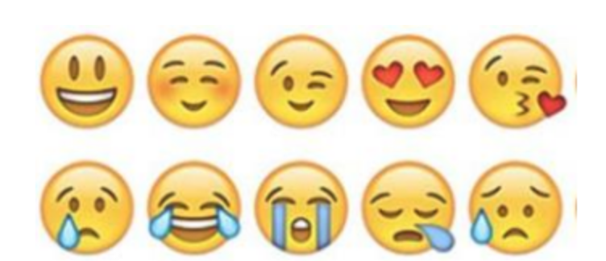  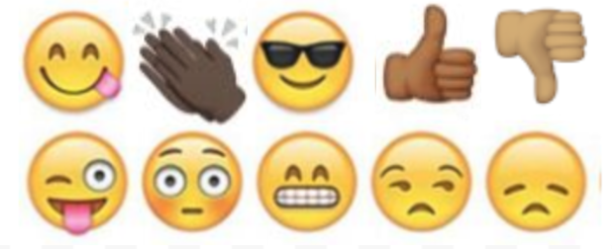

Day 1: The North Star to Freedom
Science

What is this lesson about?: Today you will read through the North Star to Freedom passage. You will answer a few questions about what you read. You will draw a picture and write a response.

Step 1: Read through the North Star to Freedom passage
(National Park Services)
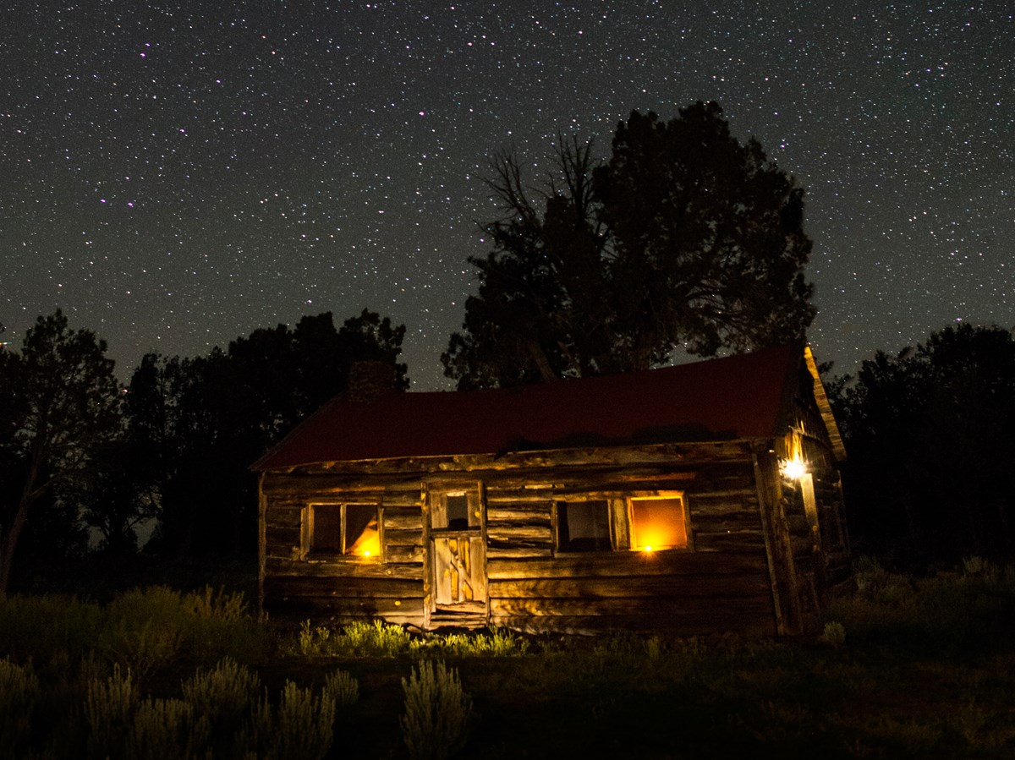
The night sky played a role in helping escaping slaves find their way north to freedom.

The National Park Service (NPS) shares the stories of former slave and abolitionist Harriet Tubman, the Underground Railroad, and the many brave Americans in the 1800s whose courageous actions led slaves to freedom and helped end the slavery era. In celebrating our nation’s independence, the NPS reflects on the role the night sky played in the lives of these early Americans.

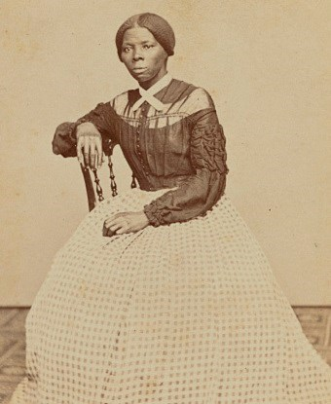
During the height of the Underground Railroad movement prior to the Civil War, Harriet Tubman, the best known conductor of the Underground Railroad, roused many enslaved Americans in the south to seek freedom in the north. Traveling under cover of night often offered the best chances of escaping. However, most slaves did not have maps or compasses to guide them. Without the use of these tools, a fugitive’s ability to successfully navigate to a safe house, railroad station, or the woods was often a matter of life or death.

As slave lore tells it, the North Star played a key role in helping slaves to find their way—a beacon to true north and freedom. Escaping slaves could find it by locating the Big Dipper, a well-recognized asterism most visible in the night sky in late winter and spring. As the name implies, its shape resembles a dipping ladle, or drinking gourd. From the gourd’s outline, the North Star could be found by extending a straight line five times the distance from the outermost star of the bowl.
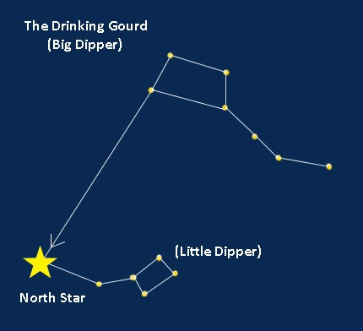
For millenia, celestial wayfinding knowledge—navigating by observing the stars and other night sky patterns—passed from generation to generation. For slaves that did not know how to read or write, "reading" the night sky provided important clues for survival. This information helped slaves to find their way without getting lost. Many former slaves, including historical figures like Tubman, used the celestial gourd, or dipper, to guide them on their journey north. The Big Dipper and North Star were referenced in many slave narratives and songs. Follow the Drinking Gourd was a popular African American folksong composed decades after the War and based on these anecdotes that memorialized the significance of these stars.

The night sky is a canvas of stories that links us to this past. National parks are among the best places to see the stars and hear these stories. The next time you gaze at the stars, think on the drinking gourd story and those early Americans who staked their freedom on a star.

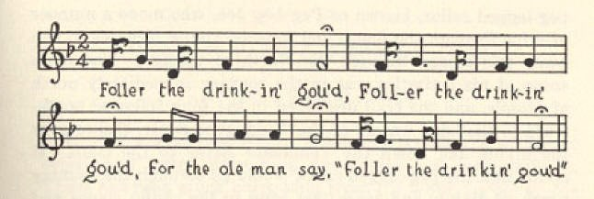

Follow the Drinking Gourd sheet music, fragment
Texas Folklore Society, 1928
Follow the Drinking Gourd
When the sun come back,
and the firs’ quail call,
Then the time is come.
Foller the drinkin gou’d.
Foller the drinking gou’d,
Foller the drinking gou’d;
For the old man say,
“Foller the drinkin gou’d.”
The riva ends a-tween two hills,
Foller the drinkin’ gou’d;
Nuther riva on the other side
Follers the drinkin gou’d.
Wha the little riva
Meet the grea’ big un,
The old man waits –
Foller the drinkin’ gou’d.

Step 2: Answer the following questions

- How would you describe the North Star?

- What does the North Star have to do with freedom?

- If you lived during the days of slavery, what advice would you give to slaves?

Step 3: Draw a picture and describe

If you could design your own set of stars for freedom, what would the night sky look like and why? Draw a picture and describe your drawing.

________________________________________________________________________________________________________________________________________________________________________________________________________________________________________________________________________________________________________________________________________________________________________________________________________________________________________________________________________________________________________________________________________

Student Feedback:
Circle the emojis that best represents how this activity made you feel.

Mindfulness Moment!

Life is good because… (write or draw your response)

Day 1: Freedom/Fractions
Math

What is this lesson about?: Today you will work on fractions.

Warm Up and Review Problems:
Many freed slaves ended up working as small farmers, calles sharecroppers, often on the same land they worked when they were held in bondage. For many, this life was only modestly better than when enslaved. They were ‘free’ but often worked all year only to finish out either still owing the landowner money, or only making enough money to survive for another year. Consider this example:

Kenneth, his wife and two children were ‘freed’ shortly after the Civil War. Unable to move or find work elsewhere, they agreed to work as a sharecropper with their former owner, on a farm/plantation in South Carolina.

Kenneth rented his land, purchased his seeds from and sold back his crops to his former slave owner. Use the chart below to answer some questions about Kenneth.

Expenses-
Annual ‘rent’: $1,200 ($100/month)
Cost of seeds (tobacco, corn): $125
Cost to ‘rent’ horse, plow, etc, $120 ($20/month for 6 months)

Sales-
Sale of cotton and tobacco: $2,400 total

At the end of a year, how much did it cost Kenneth to farm the land, plant and harvest the two crops?
How much did he make in ‘profit’ once he sold his crops and paid these bills?
How much is that ‘per month’ (example: divide by 12 months)______
What are some things that Kenneth would need to use that money for, to survive?

What percent (remember from last lessons) of his total sales dis he spend on renting a horse and plow?
What would happen to Kenneth if there was a drought or some sort of crop failure--if he lost 25% of his revenue, how much would make selling his crop? Would he be able to pay all of his bills if this happened?

Activities/Fraction Problems: Complete the following fractions worksheets
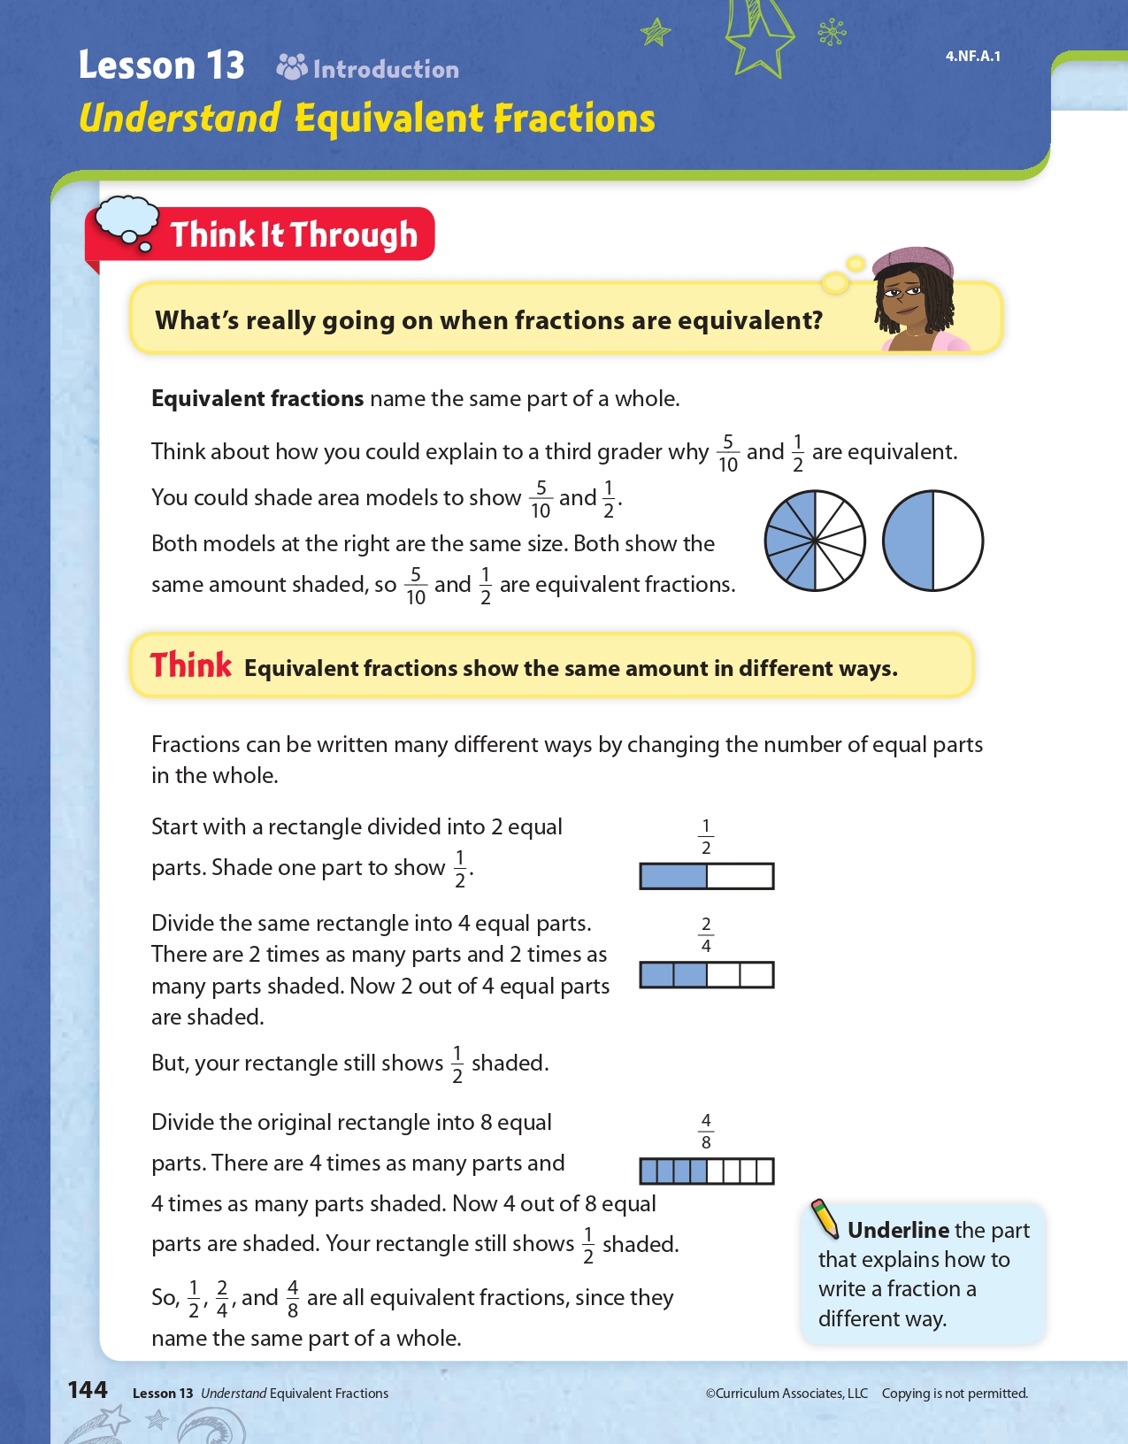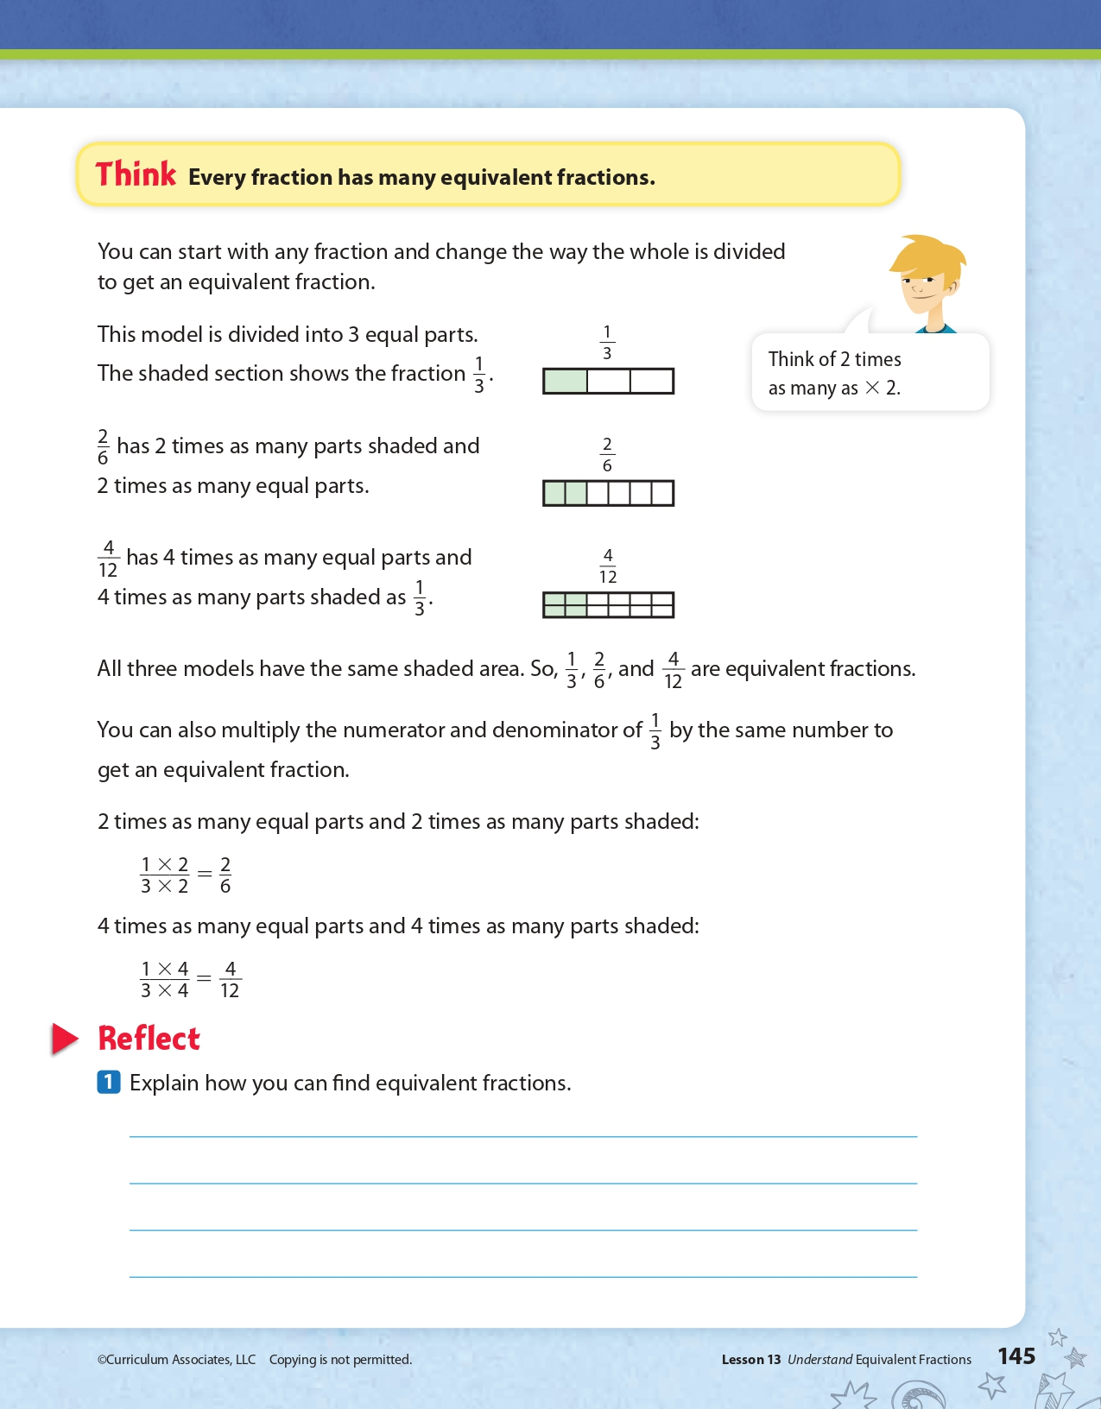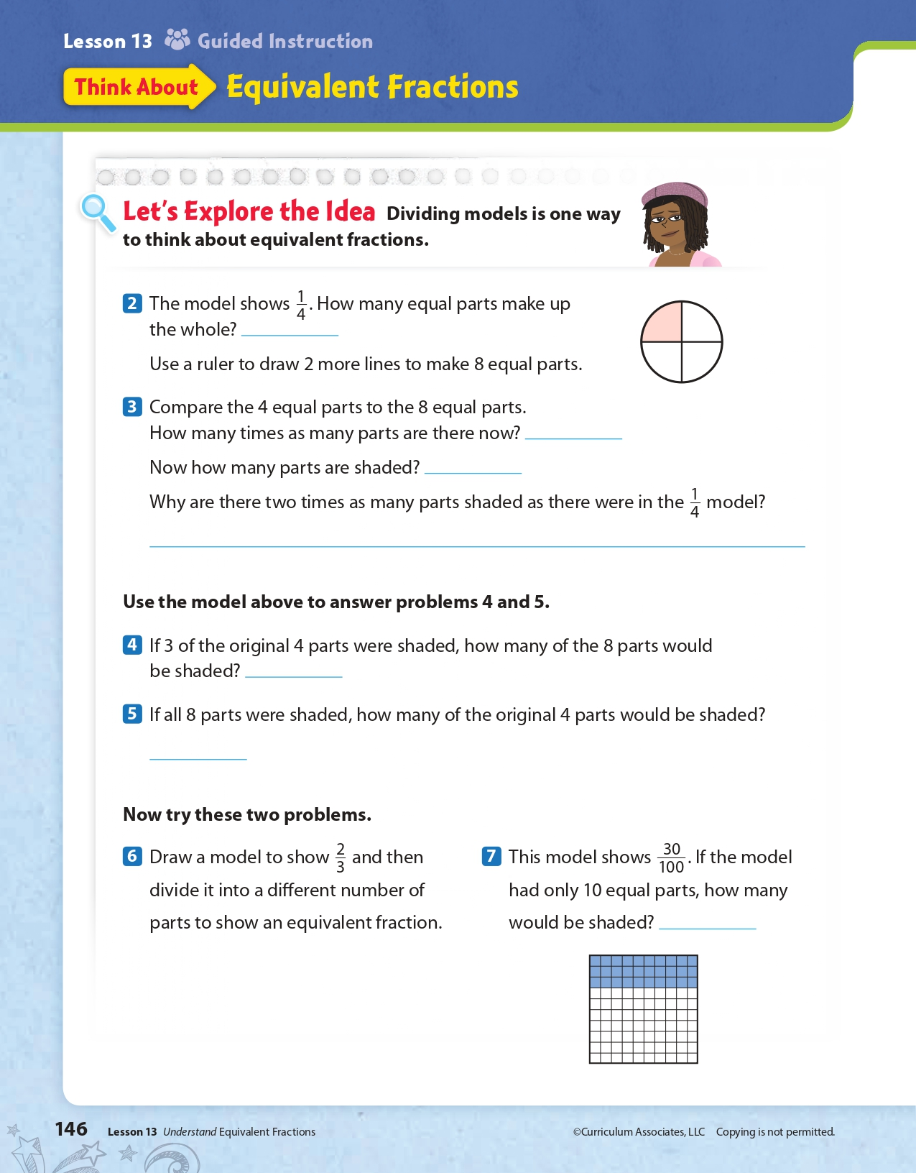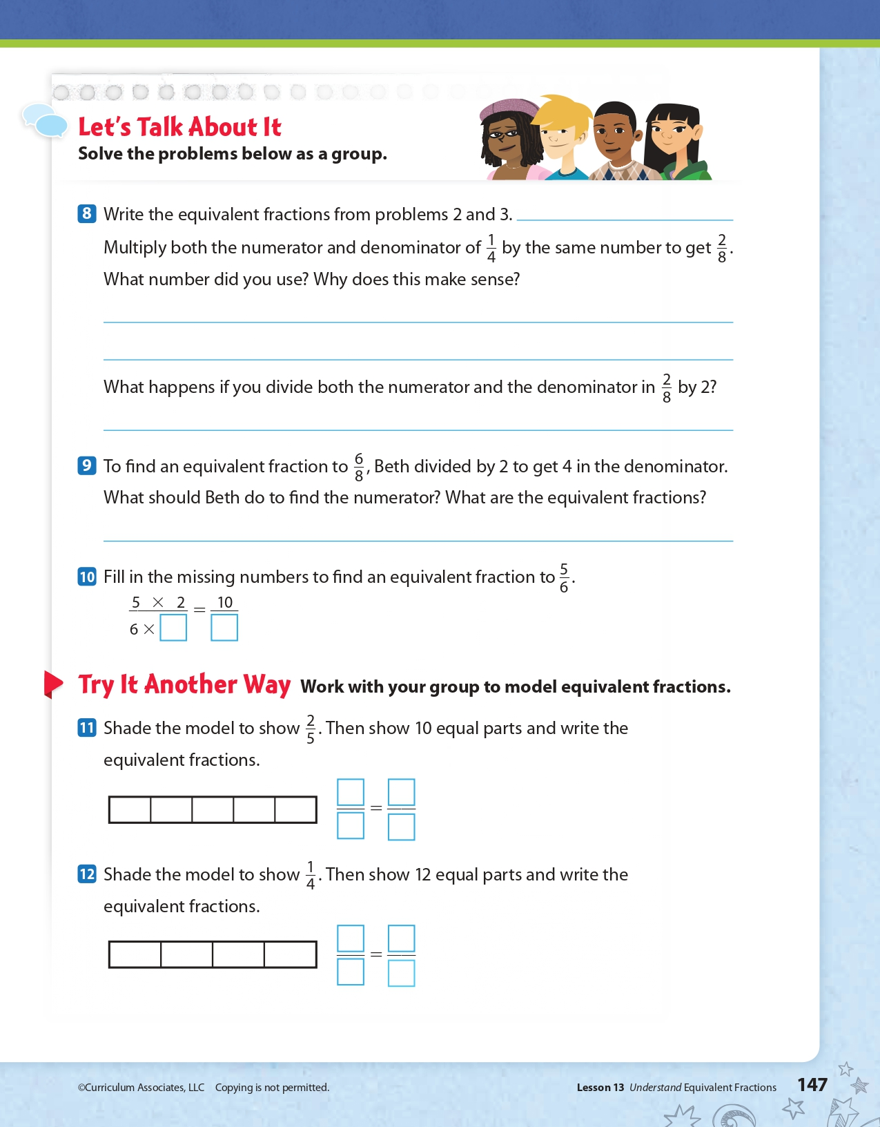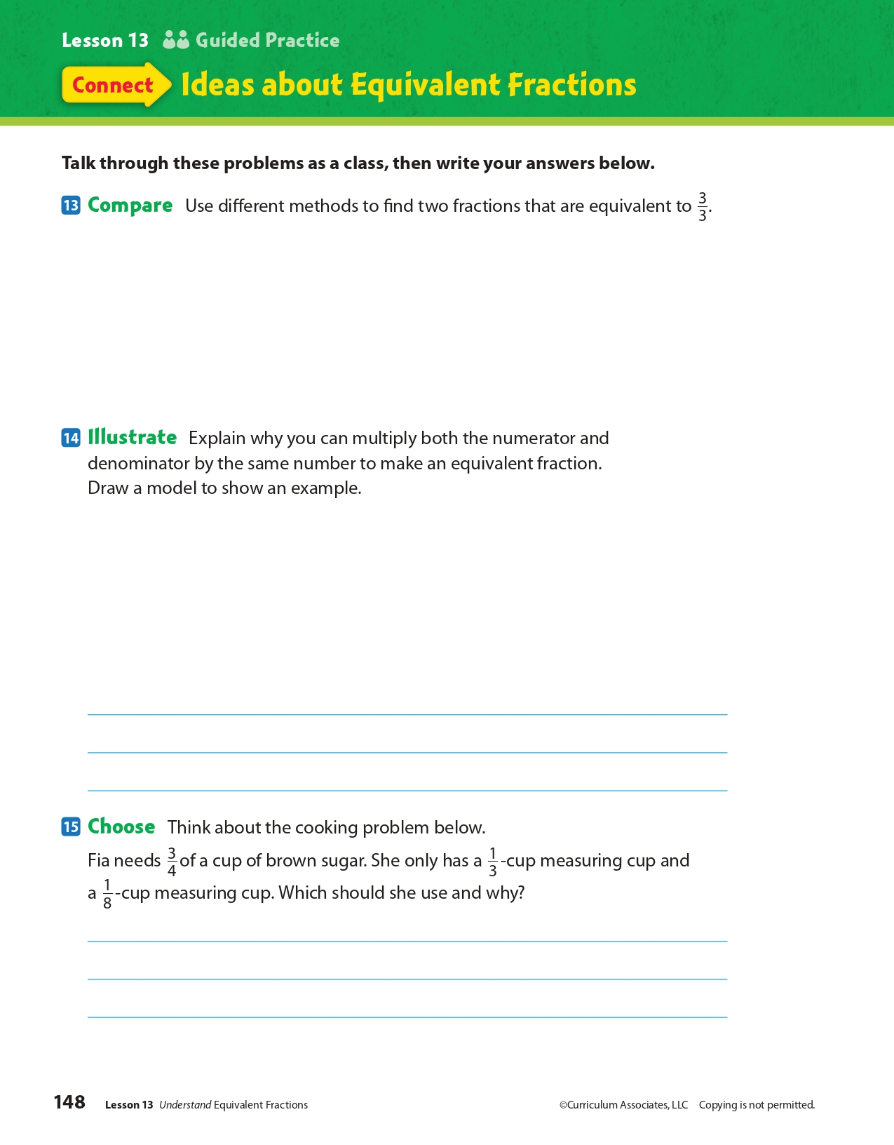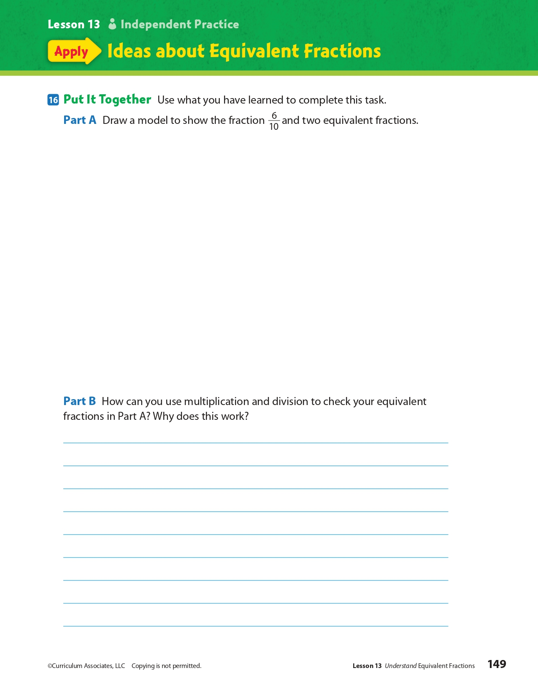
Day 1: When do you have the Freedom of Speech?
Health

What is this lesson about?: In today’s lesson, we will look at your freedom of speech as it relates to you in school. You will discover the rights of a school newspaper that was censored in a school in Arkansas.
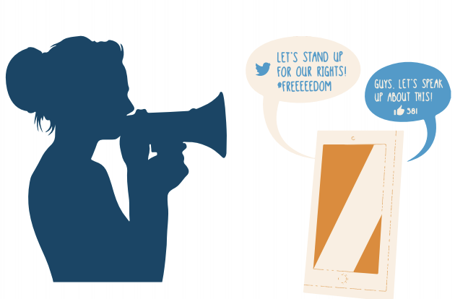
Step 1: Warm-Up:
Everyone has the right to freedom of opinion and expression Correct! You have the right to have your own ideas and opinions and to express them to others. We exercise this freedom of speech whenever we text, tweet, or use any other forms of media to publicly express our opinion. However, this doesn’t mean you have a right to say whatever you want. Sometimes a situation can occur when a particular right may be in conflict with another right. For example, your right to express an opinion should not come at the cost of someone else’s right to be treated with respect.
Why is it important for you to have a freedom of speech?

Step 2: Read the story below.
An Arkansas school district ordered a student newspaper to take down an investigative report in November. The school district now says the article can be re-published.

A spokesman for the Springdale School District said on Tuesday, December 4, that the Har-ber Herald could republish the article. The article is a months-long investigation into the transfer of six football players to a rival high school. The article claimed the students transferred for athletic, not academic, reasons. If true, that would go against the school district's rules. Springdale had ordered the article be taken off the paper's website in November. The school had effectively suspended the newspaper's operations.

By late Tuesday, December 4, the article had been re-posted on various websites. Even professional journalists were posting it on social media. The Student Press Law Center is a group that protects student journalists' freedom. The group also posted the article, and an accompanying opinion article by the newspaper's staff, to its website.

Article Removed From Website
The article was first published on October 30, said the paper's editor-in-chief Halle Roberts. Students had been investigating the transfers for nearly a year, though. Three days after the article's publication, Springdale instructed the Herald to remove the article from its website.

The newspaper staff asked the district to reconsider. Then school Superintendent Jim Rollins sent a memo to the teacher who helps run the paper, Karla Sprague, denying the request. Rollins called the article, "demeaning, hurtful and potentially harmful to the students." He claimed it would divide people and cause trouble in the community.

The reporting was led by Har-ber junior Jack Williams. He said that last year some of the football players said in on-the-record conversations they'd transferred to Springdale High School to improve their chances at playing football at a top-level college. The journalists found no new information on the story for a few months. Then Sprague and Roberts assigned Williams and two other reporters, Molly Hendren and Matteo Campagnola, to investigate further.

A Freedom of Information request allows citizens to ask the government for information that wasn't previously available to the public. Williams said an unnamed source used a Freedom of Information request to obtain some documents. The documents suggested the athletes' parents requested the transfers for academic reasons. That went directly against information from the students' stories.
The source also shared a video which showed the father of one football player burning Har-ber gear in a fire pit. Springdale High's football coach was also recorded in the video. The Herald staff thought that broke the school's rules for football recruitment.

Williams said the immediate reception by the school community was almost entirely positive. "My track coach came up and shook my hand and told me it was a good article," he said. In a November 27 letter, Har-ber principal Paul Griep instructed Sprague not to publish anything without prior review from school administrators. The district also said it was reviewing existing rules and would write new guidelines for student publications.

"No student publications will be printed, posted online or distributed until they are reviewed by building/district administration," Griep wrote. He also said that if the staff ignored the directive, Sprague would be in trouble. In the worst case, she might even lose her job as a teacher, Griep wrote.

Challenging Accuracy
Administrators have not challenged the accuracy of the article other than two minor details, Williams said.

They said we said football coach Zak Clark's shirt was red and not bright pink, Williams said.
He also said administrators took issue with the article claiming Clark was drinking in the video. Williams acknowledged the administrators had a point. Although Williams says there are alcohol bottles in the video, it's not clear that Clark was actively drinking. So, the staff changed the descriptions and expected the article would go back online.

The district has not commented on what their review of student publication guidelines will include. Hadar Harris is one of the Student Press Law Center's leaders. He said that any requirement for the administration to review articles in advance would amount to censorship.

Press Freedom For Students

Hadar said his group believes that prior review rules go against the principles of free speech and press freedom for students. "So while we welcome the opportunity for the Herald to republish their important story, we remain concerned that they will be able to operate in an environment that fully enables them to publish their work without censorship or review."

Roberts and Williams said they were happy about the reaction to the article and are proud of their work. However, they feel that as journalists, their rights have not been respected.

Roberts said the journalists felt they did a good job, but then the article was taken down because administrators didn't like it. "It's disappointing," Roberts said.
Step 3: Answer the questions below
- Do you think that this article should have been censored?

- Can you explain your freedom of speech rights?

- What would your world look like if you did not have freedom of speech?

Step 4: Your own Newspaper
Imagine you have your own school newspaper. Brainstorm below some topics that you would like to write articles on.

Student Feedback:
Circle the emojis that best represents how this activity made you feel.

Mindfulness Moment!

Three places I hope to visit someday are…
1.
2.
3.

Draw a representation of one or more of these places!

Day 1: Religious Liberty in Colonial America
Social Studies

What is this lesson about?: Today you will learn of the Puritans establishing the Massachusetts Colony and explore that while the colony was set up under democratic principles, democratic thought didn’t extend to religion. You will learn about religious dissenters in Massachusetts and throughout U.S. history.

Step 1: The role of religion and religious liberty in society

Before we get into the lesson, take a moment to reflect on the role religion plays in our society.

Write down some of the advantages and disadvantages that religion brings to a society. (if possible, discuss with a partner)

Now, read the following definition:
Religious Liberty: the freedom of an individual or community to practice, worship, or observe any religion of choice in public or private. It is also generally recognized that religious liberty means the freedom to change religions or not follow any religion.

What freedom does religious liberty grant members of a society?

Do you think religious liberty allows individuals to wear religious clothing or jewelry that reflects their religious beliefs even if others find it offensive? Why or why not?

Do you think religious liberty allows individuals to disregard or break a law in the practice of their religion? Why or why not?

You don’t need to write a response to this, but think about whether religious liberty should mean people are free to practice their religion any way they want. Do you think that restrictions around practicing religion are sometimes necessary? Why or why not?
Step 2: Read the article

Puritan Life and Dissent in Colonial New England
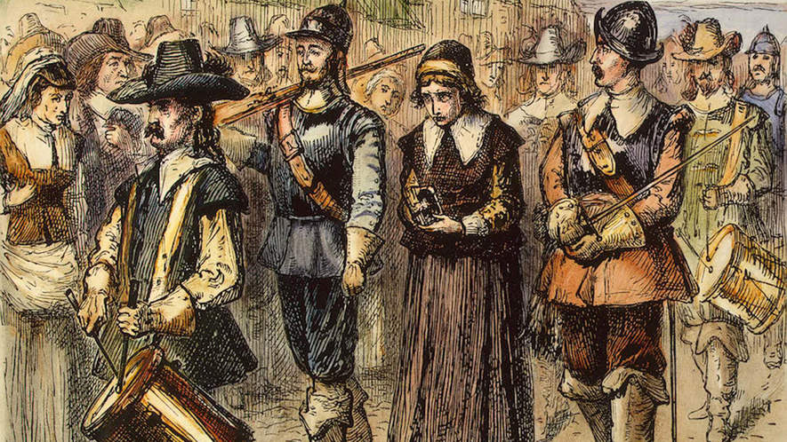
By USHistory.org, adapted by Newsela staff

Massachusetts Bay - “The City Upon a Hill”
The passengers of the ship Arbella and 10 other ships left England in 1630 with their new charter that gave them permission to set up colonies in New England. The Puritans were fed up with the Church of England. They felt they couldn't practice their religion in England. The king of England didn't like the Puritans much either. So, he gave them written permission, in a charter, to set up colonies in New England in the area of Massachusetts. Future governor John Winthrop knew the world would be watching to see if the colony succeeded or failed. He wrote, "We shall be as a city upon a hill, the eyes of all people are upon us."
More than a thousand Puritans sailed to Massachusetts and were determined to be a shining light for the rest of Europe, "A Model of Christian Charity," in the words of the governor.
Puritans believed in predestination which taught that God is all-powerful and all-knowing. So, each person is known to God at birth and nothing a person does or says could change his future. Not everyone could be a Puritan Church member. Only those chosen by God to be saved would become "the elect". Only "the elect" could serve as Church members. A person must experience "conversion" by seeing and feeling the grace and power of God and know he was saved.
If a person were truly saved, he was a "living saint" and would serve as an example to the rest of the world. During the early years, ministers such as John Cotton carefully screened people who claimed to have had a "conversion."
The colony needed more than "the elect" to survive. Many dissenters, or other Christian men and women who had not felt "conversion," lived in Massachusetts Bay Colony. Towns like Marblehead were founded by non-Puritan settlers who had jobs in commerce and business. These skills were necessary for the colony to survive.
There was also a need for self-government and an elected legislature. Although ministers were not allowed to run in elections for political jobs, many of the most important decisions were made by the ministers. In 1636, Harvard College started to train Puritan ministers.

Puritan life
By the end of the 1630s, nearly 14,000 more Puritan settlers came to Massachusetts from England, so the colony began to spread out across New England. People lived longer and healthier lives than those in England and the southern colonies of Virginia and Maryland. It was often said New England invented grandparents, for it was here that people in great numbers first grew old enough to see their children have children. Puritans wanted their children to be able to read the Bible, so every town with at least 50 families built schools.
Massachusetts Bay was a man's world, so women could not speak at town meetings or vote. Puritan ministers preached about the soul that had two parts. The part that lived forever was male, while the female part did not. They believed women who were pregnant with a male child had pink cheeks, and those having a female child had pale cheeks. Names of women included Patience, Silence, Fear, Comfort and Be Fruitful, which shows what Puritans thought about women.
Everyone went to church. People had to pay fines if they missed services. The minister's sermon or speech was about town problems or worries. Often a man held a long pole to wake people or push children who were laughing. Church was very serious.

Puritan dissent
The Puritans believed they were doing God's work. Those who sinned and did not do God's work were punished. If wives had secret lovers, they could be put in jail. Others were whipped or brought to the public square in the center of town, where people would spit on them. Some were even killed.
People were not free to think for themselves. Some free-thinkers could be forced to leave their homes and never return. Such was the case in Massachusetts Bay when Roger Williams and Anne Hutchinson spoke their minds.
Roger Williams preached separation of church and state. He believed no single church should get money from tax dollars. Williams also claimed taking land from the Native Americans without proper payment was unfair. Massachusetts made this minister leave his home in 1636. He was banished.
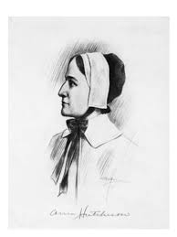
Williams bought some land from the Narragansett Indians and founded the colony of Rhode Island. Here there would be complete religious freedom.
Anne Hutchinson was a deeply religious woman. She believed in predestination, which taught that God is all-powerful and all-knowing. God controlled the future, so she felt the powerful control of the ministers was wrong. If God has blessed me or damned me, she asked, how can anyone change that? She said the ministers were teaching people they could do things to get into heaven. She also said people who were "saved" didn't have to follow the law. Ministers felt this free-thinking was dangerous. As many as 80 people would come to her home each week to hear her sermons.
The ministers decided to arrest her. The court, led by John Winthrop, the governor of the colony, found her guilty and banished her from Massachusetts Bay in 1637. So she moved to Rhode Island.
America has long been a land where people have the right to say, "I disagree." Many left England in the first place because they disagreed with the king. Roger Williams and Anne Hutchinson were two brave souls who reminded everyone of their right to disagree.
There is another side of Puritan life that is not well known. They did have some fun, too. People sang and told stories. They drank wine and beer. Children were allowed to play games with their parents' permission. Puritans did not all dress in black as many believe. They tried to follow God's law. People that did what the ministers said, lived in peace.
Step 3: Answer questions

Why did the Puritans leave England for Massachusetts? What was their goal once they arrived in North America?

What was the infraction Anne Hutchison allegedly committed?

Why do you think the Puritans believe Hutchison’s actions were a threat to the colony?

Which do you think the Puritans were trying to establish? (circle one)

Religious liberty OR Freedom to practice their own form of Christianity

In the case of the Puritans, what was the difference between these two? (discuss your answer with a partner)

Step 4: Religious Dissenters
Religious dissenters have tested the extent of society’s tolerance for as long as religion has existed.
Religious dissent can come in many forms. Sometimes it is individuals who practice a different belief system than the majority of society. Other times, dissent involves challenging the actions of religious leaders because some feel they are corrupt or have deviated from the religion’s original beliefs. In the case of Anne Hutchinson, she challenged the authority of the elders as the only ones qualified to interpret the Bible.

Dissenters aren’t always dissenting for the betterment of society or to improve the religion. Sometimes they dissent for personal reasons. Similar to revolutionaries, who are considered heroes by their followers and terrorists by those against whom they are revolting, some religious dissenters were considered blasphemers or fools by their critics and saints by their followers. Let’s examine several religious dissenters throughout history and compare their similarities and differences to each other and to the case of Anne Hutchinson.

Joseph Smith

1805-1844
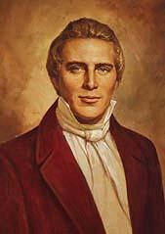
Born on December 23, 1805, in Vermont, Joseph Smith Jr. grew up on a series of tenant farms in Vermont, New Hampshire, and New York. Though in his youth Joseph was largely deprived of a formal education, he was "instructed in reading, writing, and the ground rules of arithmetic."¹ Joseph's mother said that he was often "given to meditation and deep study."²
Affected by the great religious excitement taking place around his home in Manchester, New York, in 1820, fourteen-year-old Joseph was determined to know which of the many religions he should join. He encountered a passage in the Bible instructing any who lacked wisdom to "ask of God" (James 1:5). Early one morning in the spring of 1820, Joseph went to a secluded woods to ask God which church he should join. According to his account, while praying Joseph was visited by two "personages" who identified themselves as God the Father and Jesus Christ. He was told not to join any of the churches.
In 1823, Joseph Smith said he was visited by an angel named Moroni, who told him of an ancient record containing God's teachings. In 1827, Joseph retrieved this record, inscribed on thin golden plates, and shortly afterward began translating its words by the "gift of God."³ The resulting manuscript, the Book of Mormon, was published in March 1830. On April 6, 1830, Joseph Smith organized The Church of Jesus Christ of Latter-day Saints.
During the thirty-nine years of his life, Joseph established cities in Ohio, Missouri, and Illinois. The Mormon settlements in these states were often persecuted by their surrounding neighbors who were fearful of the Mormon communities' economic and political might. Missouri's governor ordered all Mormons to leave the state, and when their stronghold in Far West, Missouri, was surrounded, Smith, fearing an imminent massacre, surrendered.
Smith was a controversial figure in American history—beloved of his followers and hated by his detractors. When Smith announced that he was running for the Presidency of the United States in 1844, opposition to the Mormons reached a climax. Smith was imprisoned in Carthage, Illinois, and charged with inciting a riot after he attempted to destroy a newspaper that exposed the Mormon's practice of polygamy. But before he could be tried on these charges, a mob broke into his cell and brutally killed both him and his brother.

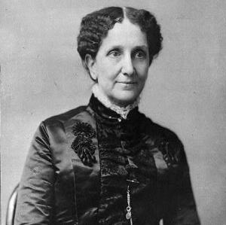
Mary Baker Eddy
1821-1910
Mary Baker Eddy founded a religious movement during the 19th century, Christian Science. As an author and teacher, she helped promote healings through mental and spiritual teachings. Today, her influence can still be seen throughout America.
Eddy was born in 1821, in New Hampshire. Unfortunately, she was very ill and spent most of her childhood bedridden. At the age of fifteen, her family moved to another town in New Hampshire and she began school. Almost immediately, her teachers realized that she was an extremely bright pupil. Eddy finished school at the Holmes Academy and went on to teach.
For many years, Eddy worked to discover a cure for her chronic illness. She experimented with alternative forms of medicine, wholeheartedly rejecting prescription drugs from doctors. Additionally, Eddy studied the Bible. After suffering from an almost deadly illness she became a patient of Phineas Quimby, a healer from Maine. Historians believe Quimby influenced Eddy’s writings.
In 1866, Eddy slipped on an icy sidewalk. The fall forced her to remain in bed for several months. During her downtime, she studied healings in the Bible. Her belief that the healings performed by Jesus could be used in the present day inspired her to create a movement that focused on the mental aspects of sickness. She began to teach others her new method and Christian Science quickly gained a following.
Eddy wrote the principal text for the Christian Science movement, Science and Health with Key to Scriptures in 1872. She opened the Massachusetts Metaphysical College in 1879 to educate others. Eddy’s teaching was extremely attractive to many who suffered from illness. Her students eventually spread the knowledge to others as they traveled throughout the United States. As a result, Christian Science congregations emerged in several cities. Because of Eddy’s growing popularity as a religious leader and woman, she was the center of many rumors and attacks. Her character and sanity were often questioned publicly. However, the attacks did not discourage her followers.
In her later years, Eddy focused much of her attention on expanding her teachings by constantly revising her publications. When Eddy was unable to get others to print her work, she started a publishing society. She published The Christian Science Monitor and the Herald of Christian Science. In 1910, Eddy died of pneumonia. Today, there are still numerous Christian Science churches.
Step 5: Complete the graphic organizer
Complete the graphic organizer on the next page. After, with a partner if possible, consider the following questions:
- How does Joseph Smith’s experience compare to Anne Hutchinson’s?
- How does Mary Baker Eddy’s experience compare to Anne Hutchinson’s?
Student Feedback:
Circle the emojis that best represents how this activity made you feel.
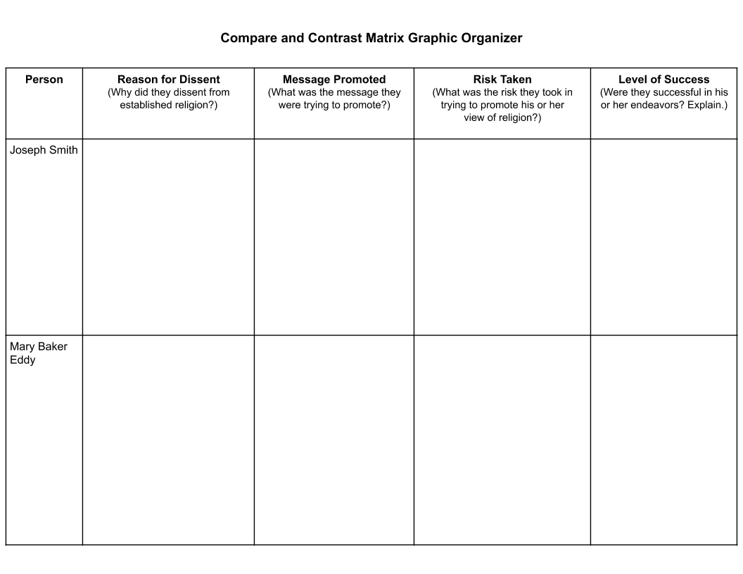

Week 8
Freedom

Day 2

NAME:______________________

Day 2 Agenda

Topic | Activity
Warm-Up!
English Language Arts | - Read and Annotate the poems Sympathy by Paul Laurence Dunbar and Caged Bird by Maya Angelou.  - Analyze both poems for figurative language.  - Complete a graphic organizer.
Science | - Read about Defending Freedom in the Time of Coronavirus  - Answer questions about what you read  - Draw a picture and explain
Mindfulness Moment!
Math | - Word Problems: Chicago Bound: A Taste of Freedom  - Skills: Fractions
Health | - P.E. Bingo
Mindfulness Moment!
Civics/Social Studies | - Evolution of religious liberty in post-revolutionary America

Warm-up Activity: Write a journal entry around the daily quote on identity.
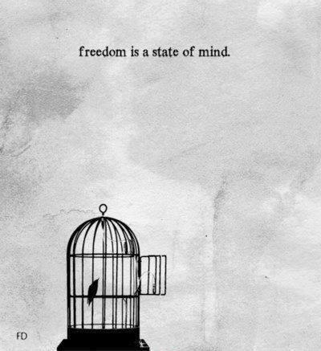

Day 2: Imagery of Freedom
English Language Arts

What is this lesson about? Today you will continue to think about the theme of “Freedom”. Read 2 poems, think about the language the poets use to create images in our minds about freedom and captivity.
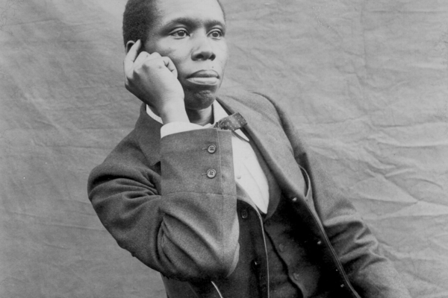
Step 2: Before you read
Paul Laurence Dunbar was one of the first African American poets to gain national recognition. Born on June 27, 1872, he was born to freed slaves from Kentucky. His parents separated shortly after his birth, but Dunbar would draw on their stories of plantation life throughout his writing career. By the age of fourteen, Dunbar had poems published in the Dayton Herald. While in high school he edited the Dayton Tattler, a short-lived black newspaper published by classmate Orville Wright.

Despite being a fine student, Dunbar was financially unable to attend college and took a job as an elevator operator. In 1893, Dunbar moved to Chicago, befriended Frederick Douglass, who found him a job as a clerk, and also arranged for him to read a selection of his poems. By 1895, Dunbar’s poems began appearing in major national newspapers and magazines, such as The New York Times. This recognition helped Dunbar gain national and international acclaim. In 1898, Dunbar’s health deteriorated; he believed the dust in the library contributed to his tuberculosis and left his job to dedicate himself full time to writing and giving readings. Over the next five years, he would produce three more novels and three short story collections. Dunbar separated from his wife in 1902, and shortly thereafter he suffered a nervous breakdown and a bout of pneumonia. Although ill, Dunbar continued to write poems. Dunbar’s steadily deteriorating health caused him to return to his mother’s home in Dayton, Ohio, where he died on February 9, 1906, at the age of thirty-three.

Some vocabulary to review:
alas: an expression of concern or sadness | upland slope: hilly land | fling: to throw
opes: opens | chalice: large cup--usually for drinking wine | perch: thing on which a bird lands or rests
bough: branch | keen: sharp | bosom: chest
carol: religious song | fain: happy

Step 2: Read and annotate the following poem
As you read, go through and underline verbs or action words of the caged bird For example: the caged bird feels.

 | Sympathy  Paul Laurence Dunbar | Notes
1 | I know what the caged bird feels, alas!  When the sun is bright on the upland slopes;  When the wind stirs soft through the springing grass,  And the river flows like a stream of glass;  When the first bird sings and the first bud opes,  And the faint perfume from its chalice steals—  I know what the caged bird feels!
2 | I know why the caged bird beats his wing  Till its blood is red on the cruel bars;  For he must fly back to his perch and cling  When he fain would be on the bough a-swing;  And a pain still throbs in the old, old scars  And they pulse again with a keener sting—  I know why he beats his wing!
3 | I know why the caged bird sings, ah me,  When his wing is bruised and his bosom sore,—  When he beats his bars and he would be free;  It is not a carol of joy or glee,  But a prayer that he sends from his heart’s deep core,  But a plea, that upward to Heaven he flings—  I know why the caged bird sings!

Step 3: Answer the following questions
- Read the first stanza again. How does Dunbar describe the world outside of the cage?

- Read the second stanza. What is the caged bird doing? Is this the first time the bird has done this? How do you know?

- Reread stanza 3. Why does the caged bird sing?

- Why does Paul Laurence Dunbar start and end each stanza with “I know…” What is he communicating to the reader?

Step 4: Share your answers with a partner
Discuss your answers with someone else in your group.
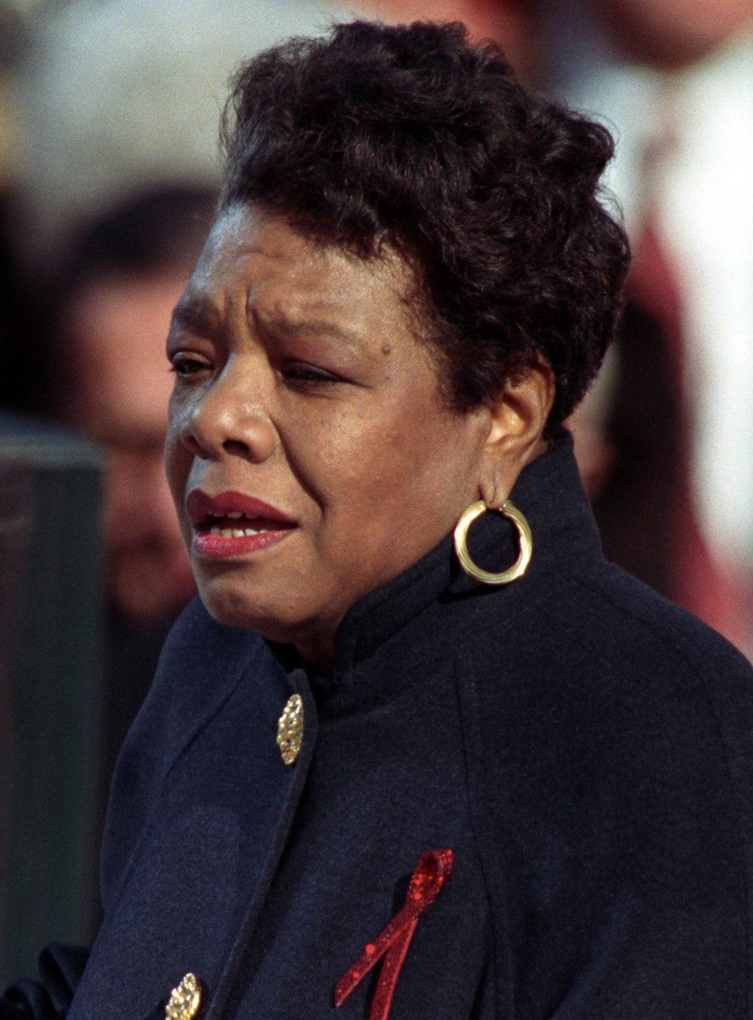
Step 5: Read and annotate the following poem.

Maya Angelou was born Marguerite Johnson in St. Louis, Missouri, on April 4, 1928. She grew up in St. Louis and Stamps, Arkansas. She was an author, poet, historian, songwriter, playwright, dancer, stage and screen producer, director, performer, singer, and civil rights activist. She was best known for her seven autobiographical books and her volumes of poetry. In 1959, at the request of Dr. Martin Luther King Jr., Angelou became the northern coordinator for the Southern Christian Leadership Conference. In 1974, she was appointed by Gerald Ford to the Bicentennial Commission and later by Jimmy Carter to the Commission for International Woman of the Year. She accepted a lifetime appointment in 1982 as Reynolds Professor of American Studies at Wake Forest University in Winston-Salem, North Carolina. In 1993, Angelou wrote and delivered a poem, "On The Pulse of the Morning," at the inauguration for President Bill Clinton at his request. In 2000, she received the National Medal of Arts, and in 2010 she was awarded the Presidential Medal of Freedom by President Barack Obama. The first black woman director in Hollywood, Angelou wrote, produced, directed, and starred in productions for stage, film, and television.She also wrote and produced several prize-winning documentaries. Angelou died on May 28, 2014, in Winston-Salem, North Carolina. She was eighty-six.

As you read, make sure to underline the verbs/action words of the FREE BIRD in the poem.

 | Caged Bird  Maya Angelou | Notes:
1 | A free bird leaps  on the back of the wind  and floats downstream  till the current ends  and dips his wing  in the orange sun rays  and dares to claim the sky.
2 | But a bird that stalks  down his narrow cage  can seldom see through  his bars of rage  his wings are clipped and  his feet are tied  so he opens his throat to sing.
3 | The caged bird sings  with a fearful trill  of things unknown  but longed for still  and his tune is heard  on the distant hill  for the caged bird  sings of freedom
4 | The free bird thinks of another breeze  and the trade winds soft through the sighing trees  and the fat worms waiting on a dawn bright lawn  and he names the sky his own
5 | But a caged bird stands on the grave of dreams  his shadow shouts on a nightmare scream  his wings are clipped and his feet are tied  so he opens his throat to sing.
6 | The caged bird sings  with a fearful trill  of things unknown  but longed for still  and his tune is heard  on the distant hill  for the caged bird  sings of freedom.

Step 6: Answer the Following Questions

- What is Angelou describing in the first stanza? What imagery (descriptive language) does she use to describe the caged bird?

- Re-read Stanza 2. How is the bird in the cage different--both physically and emotionally?

- How does the caged bird sing? What does he sing about?

- At the end of stanzas 1 and 4, Angelou describes the free bird by saying he “dares to claim the sky” and “names the sky his own”. What do these actions say about the free bird?

- In addition to being in a cage, what else keeps the caged bird from being free?

- Draw out the image of the caged bird vs. the free bird in Angelou’s poem.

- Think back to BOTH poems. What is the metaphor (a metaphor is a symbolic comparison) that they both use in their poem? What does it symbolize?

- Why is the caged bird a strong symbol for what they are trying to say?

Step 7: Complete the graphic organizer
Look back at the two poems and think about how both use vivid imagery (descriptive words) to help the reader create a picture in their minds of both the free bird and the caged bird. Pick out the verbs that you underlined for the free bird and for the caged bird. Create some word art. (see example below) and fill the graphic organizer on the next page with the word art that describes each bird.

Examples of Word Art:
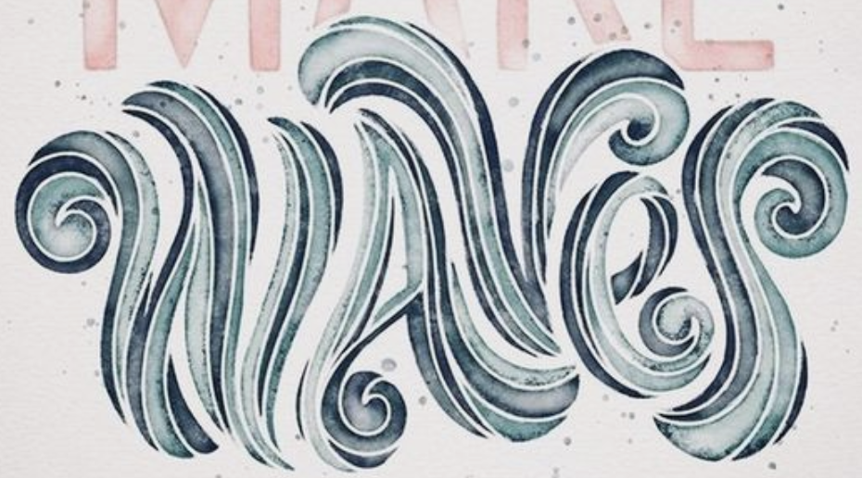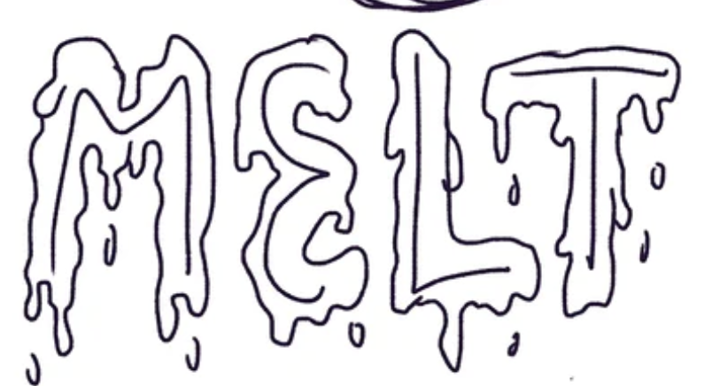

Free Bird | Caged Bird

Student Feedback:
Circle the emojis that best represents how this activity made you feel.

Day 2: Defending Freedom in the Time of Coronavirus
Science

What is this lesson about?: Today you will read through the Defending Freedom in the Time of Coronavirus passage. You will answer a few questions about what you read. You will complete an activity.

Step 1: Read through the Defending Freedom in the Time of Coronavirus passage

(Waterhouse, 2020)

The world is in the grip of a pandemic. Leaders everywhere are racing to gain clarity and develop solutions. Governments are reacting in different ways, but a common thread that’s emerging is a trend toward greater surveillance and restrictions on movement.

The overwhelming goal is averting deaths in the short term -- we don’t have time to worry about long-term consequences. The secondary goal -- as evidenced by the U.S. Congress, which is normally a poster child for partisan dysfunction, passing a unanimous $2 trillion rescue plan in a matter of days -- is to avert the death of the world economy. There is little room for thinking about anything else.

All of this is understandable, unavoidable, needed. But when the dust settles from this emergency and we are able to take stock in the cold light of day, we may find that measures meant to avert disaster have left us permanently less free. We must be vigilant to keep this from happening.

Disasters introduce instability, uncertainty, and fear -- a powerful impulse that can hold people back, even from doing things that are in their best interests. Crises also tend to require large-scale, coordinated responses that can only be mustered by central governments. In many cases, this leads to a permanent expansion of a government’s power over its citizens, at the expense of civil liberties.
Repressive regimes have long turned to “national emergencies” to claim broad powers over their people. Egypt, for example, has been in a declared state of emergency since 1967, with the exception of a roughly five-year period following the overthrow of President Hosni Mubarak in 2012. During that time, opposition parties have been banned, elections canceled, media censored, and people jailed indefinitely without charge. This playbook has been followed in many countries, from China to Venezuela to Pakistan and beyond.

But the use of national emergencies -- real or imagined -- to tighten restrictions on freedom is not limited to the world’s dictatorships. In the United States, governments have a long history of curtailing rights in reaction to crises. Abraham Lincoln famously suspended habeas corpus during the Civil War. President Franklin Roosevelt interned approximately 120,000 Japanese Americans during the Second World War.

These breaches of liberty were ultimately reversed -- though not without permanent damage. In recent decades, though, the shrinking of rights has tended to be permanent. After the 9/11 attacks, Congress passed the USA Patriot Act, which allowed for the indefinite detention of immigrants, expanded federal agencies’ ability to wiretap citizens, and granted the same agencies broadened access to business and personal records. The act has been used to monitor Americans’ online activity, wiretap them, and collect records of all phone calls placed, regardless of reasonable suspicion or possession of a warrant.

Nearly two decades after 9/11 and nine years after the death of Osama Bin Laden, the Patriot Act remains in force.

There is every reason to believe the safety-in-exchange-for-freedom bargain will expand in the wake of the coronavirus pandemic. Already, many are praising China’s authoritarian response, which for the moment appears to have stanched the spread of the disease. Some in the West are arguing that democratic governments must adopt these sorts of severe restrictions on individual behavior, which include widespread surveillance, police checkpoints, and coercive measures including “snitch lines.”

Will coronavirus kill the freedom to move?
The coronavirus also has the potential to change forever the way the world handles human movement, which has traditionally been regarded as a core freedom alongside speech and protest. Freedom of movement is one of the nonnegotiable requirements for EU (European Union) membership, and it is guaranteed within the United States by the Federal Government. But it is under stress. Looking to China’s apparent success in combating the virus through strict lockdowns, European nations have closed their borders to one another. It’s an open question when, and to what degree, they will reopen.

Even in the United States, free movement no longer seems so certain. The island state of Hawaii has imposed a 14-day quarantine on anyone arriving from anywhere, including elsewhere in the U.S., and the governor of Puerto Rico asked the FAA to suspend flights to the territory. Even on the mainland, the governor of Rhode Island announced the state police would pull over every car with New York license plates.

The most recent statistics suggest many people in the United States are still failing to take the crisis seriously. This may present novel challenges as parts of the world now locked down emerge to restart their economies. How can they do so while other regions within the same country, having failed to socially distance, are experiencing the “peak of the curve”? Will we see travel restricted based on residence and health status -- will people be required to carry “immunity passports”? Recent news out of the UK suggests the answer is yes.

The future is up to us
The choice between freedom and safety is a false one. Right now, we are all blinded by the fog of war -- the war against this virus. Those of us who cherish freedom must do everything in our power to overcome the current pandemic without inadvertently surrendering our liberty. This will require us to pursue two goals simultaneously. First, we must overcome this pathogen. But in doing so, we must be careful not to abandon our most deeply held principles.

Step 2: Answer the following questions

- How is the Coronavirus impacting our freedom?

- What parts of your freedom do you believe you still have or you need to be successful in life?

- Do you think people can be both safe from the Coronavirus and free? Why or why not?

Step 3: Draw an image/picture

An attempt to keep people safe from the Coronavirus is causing people’s freedoms to be limited. Draw an image that shows what you would have in place that can help keep people safe while also allowing people to be free. Explain your drawing.

________________________________________________________________________________________________________________________________________________________________________________________________________________________________________________________________________________________________________________________

Student Feedback:
Circle the emojis that best represents how this activity made you feel.

Mindfulness Moment!

There is no one better to be than myself because…

Day 2: Freedom/Fractions
Math
What is this lesson about?: Today you will learn more about fractions.

Warm Up and Review Problems:
In the early 1900s, many African Americans migrated from the south to the north, midwest and even the west coast. Most did this to escape the difficult economic challenges of sharecropping and the dangerous and unsafe living conditions imposed under Jim Crow laws and its pervasive violence. The trec to Chicago, Philadelphia or New York was risky, but offered hope of a more real ‘freedom.”

Consider this example:
Ronald, his wife and two children, Robert and Joe, worked as sharecroppers until the early 1900s. In 1910, Joe, now 30 years old, left the family farm to head to Chicago. He wanted to move away from the only life he had known, living and working on a small farm in Orangeburg, SC. With some modest savings and the support of his family he boarded a train for Chicago. Upon arrival, he was met by an aunt, who helped him find a room in a boarding house and a job working in a meat packing plant. Use the information below to answer some questions about Joe.

Joe rented a room in a boarding house. He paid a little extra to get a hot breakfast and dinner each day, and to get a packed lunch he could take to work. Use the chart below to answer some questions about Joe’s first few months in Chicago.

Expenses-
Monthly’: $90/month ($3/night)
Monthly food from house mom: $60/month ($2/day)
Bus fare to/from work $10/month ($0.50/day round trip on bus)
Weekend ‘fun and food’ $40/month ($10/weekend--movie, dinner, date…)

Wages/Earnings-
Hours worked per week: 40
Wages per hour $1.50/hour
# of days/month worked 20 days per month-

At the end of a month, how much money did Joe spend?
How much did he earn each month?
So, after he paid all of his bills, how much money did Joe have left over at the end of the month?
Joe tried to send his mom and dad $10 each month. Would he have enough money to do that?

He also wanted to save $20 each month so that he could save up money to move into his own apartment in a couple of years. He needed to save up about $300 to put down a security deposit and get some furniture, etc. How many months would it take him to save up to get his own apartment?

What percent (remember from last lessons) of his total monthly wages went to pay for his room and food?
Joe could work one Saturday per month for 8 hours and earn overtime. He would get an extra $0.50 per hour for this. How much would he earn for working an overtime Saturday?

Activities/Fraction Problems: Complete the following fractions worksheets

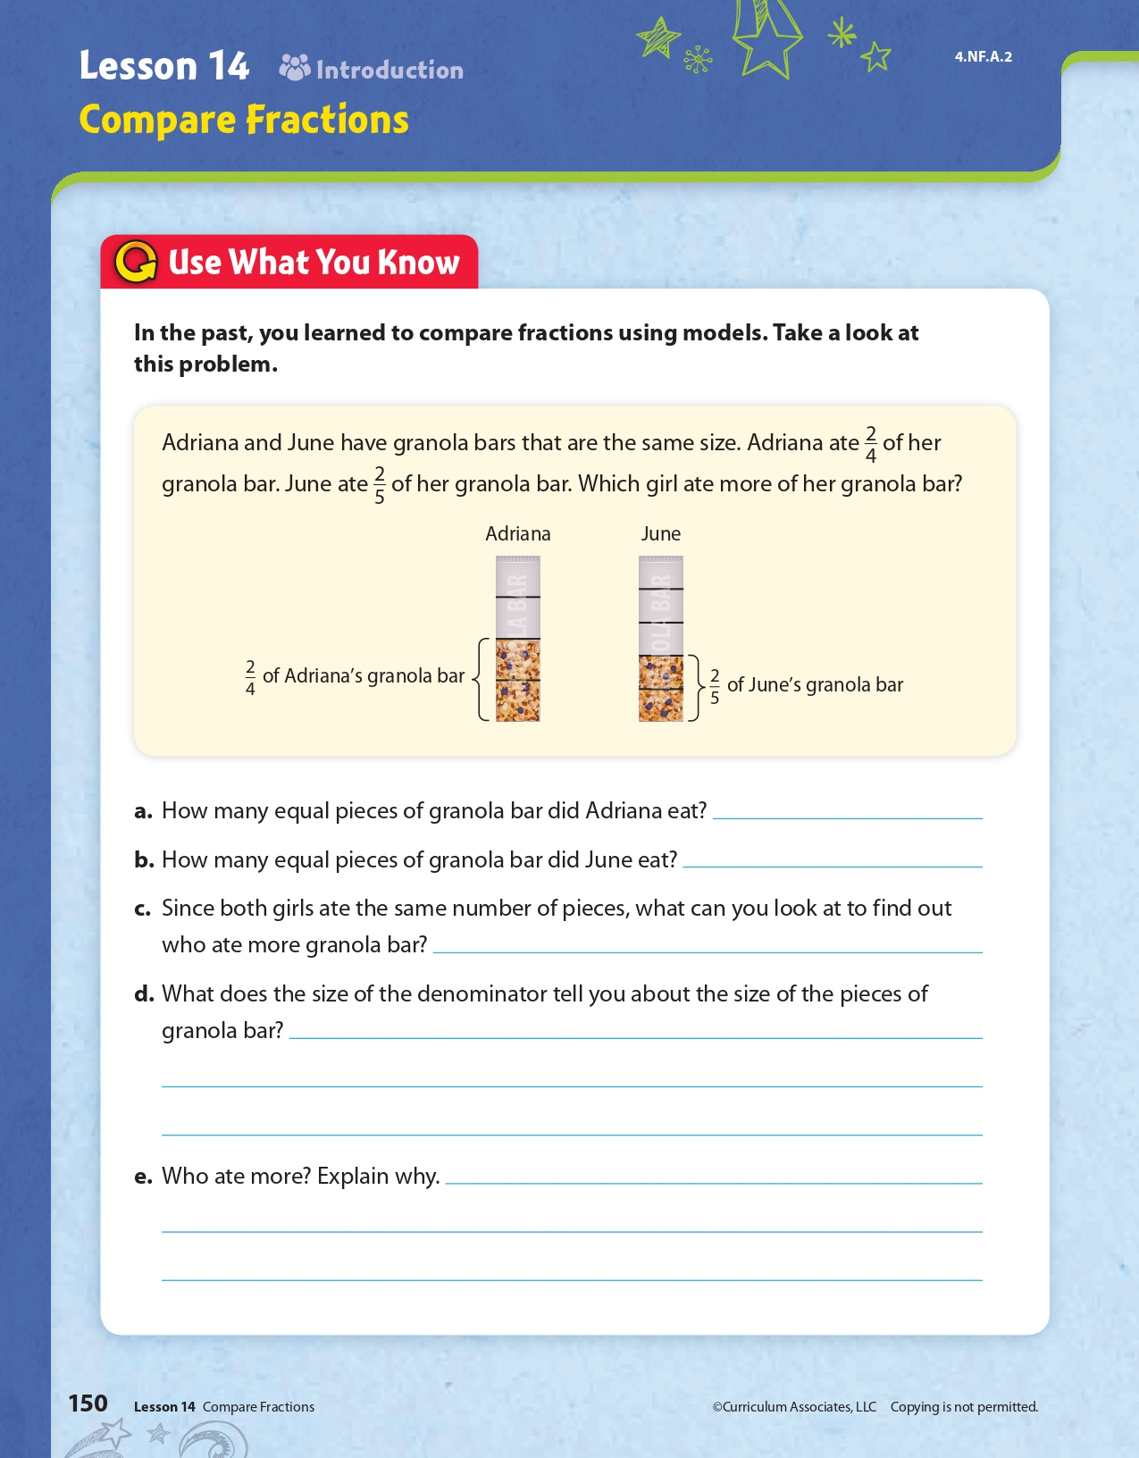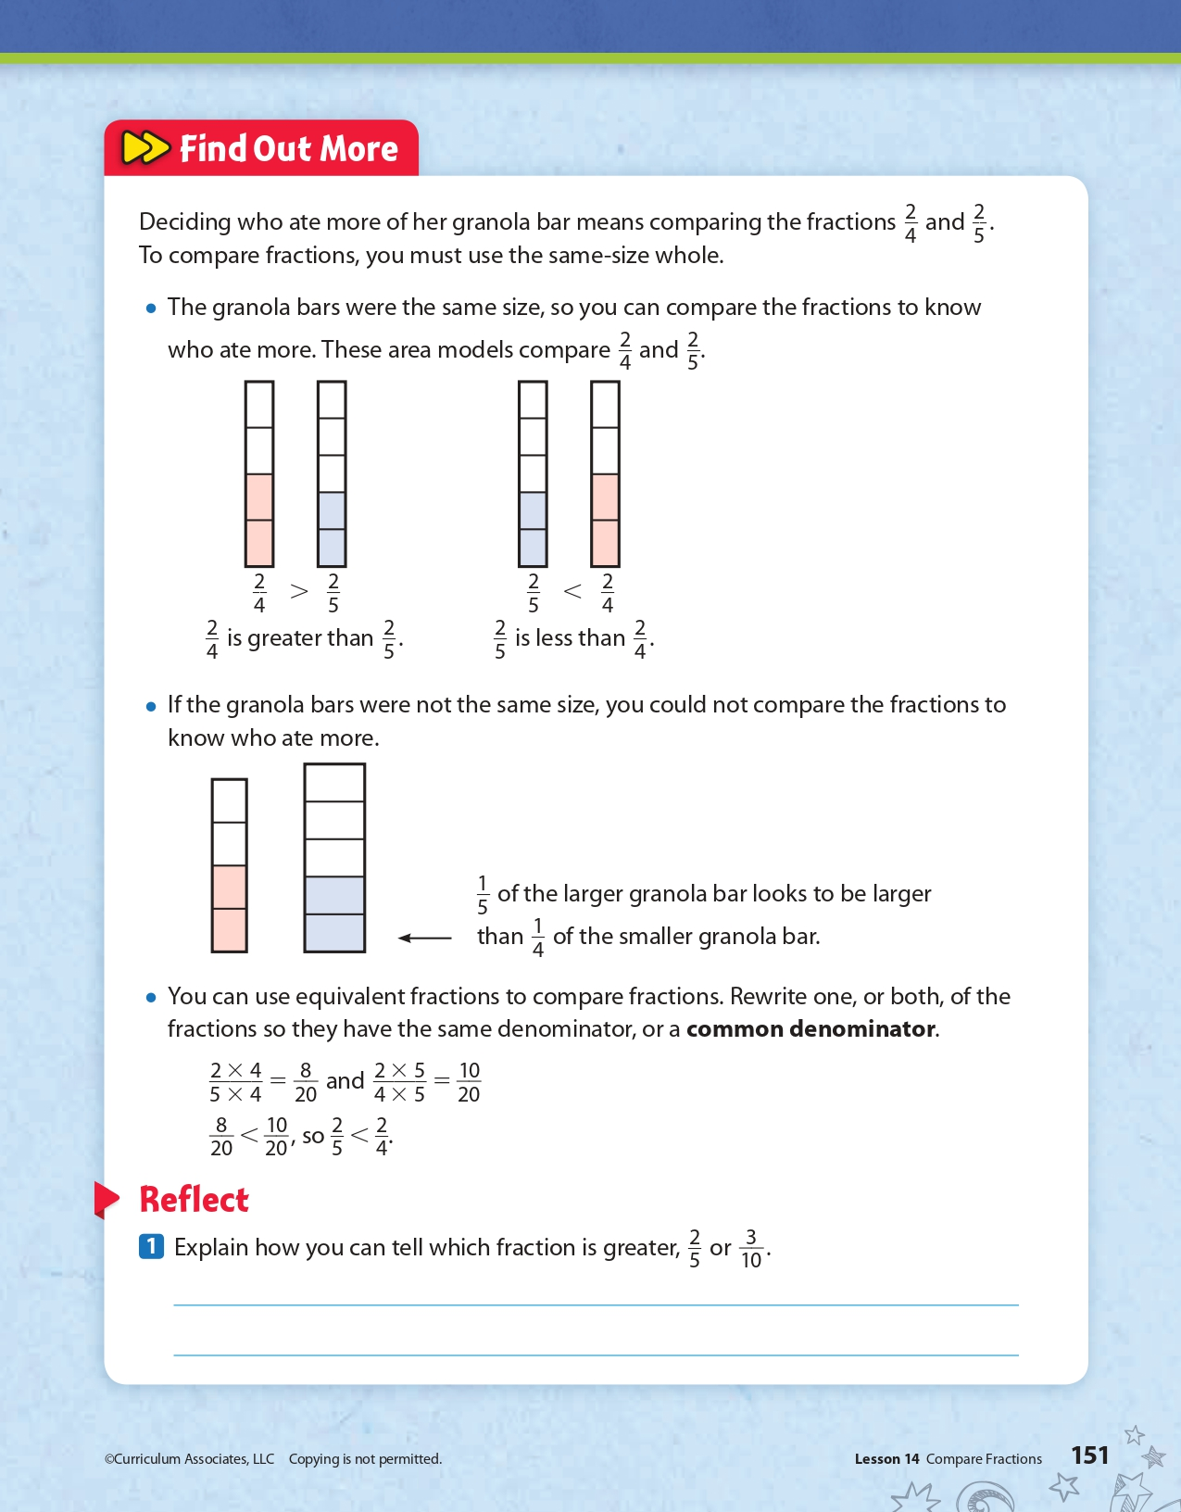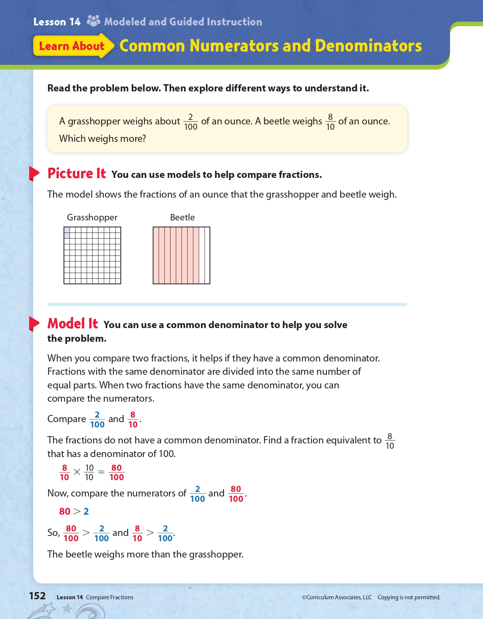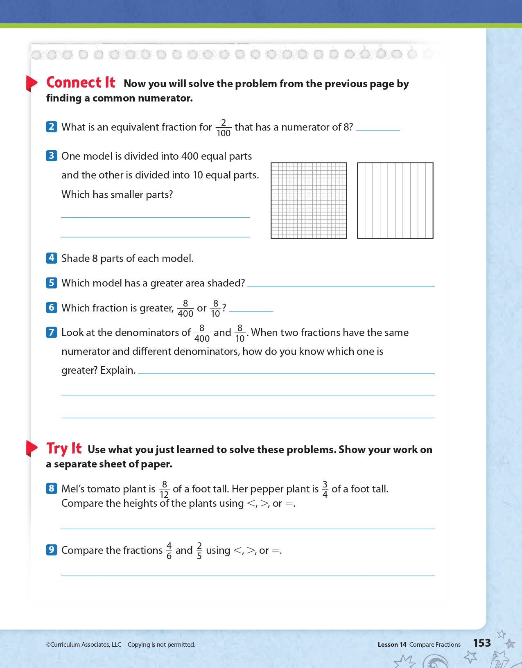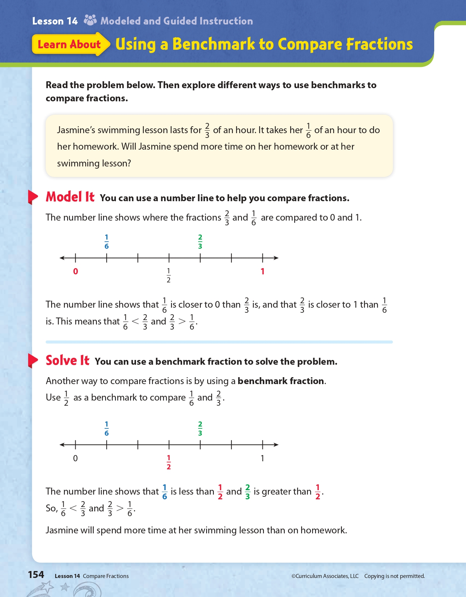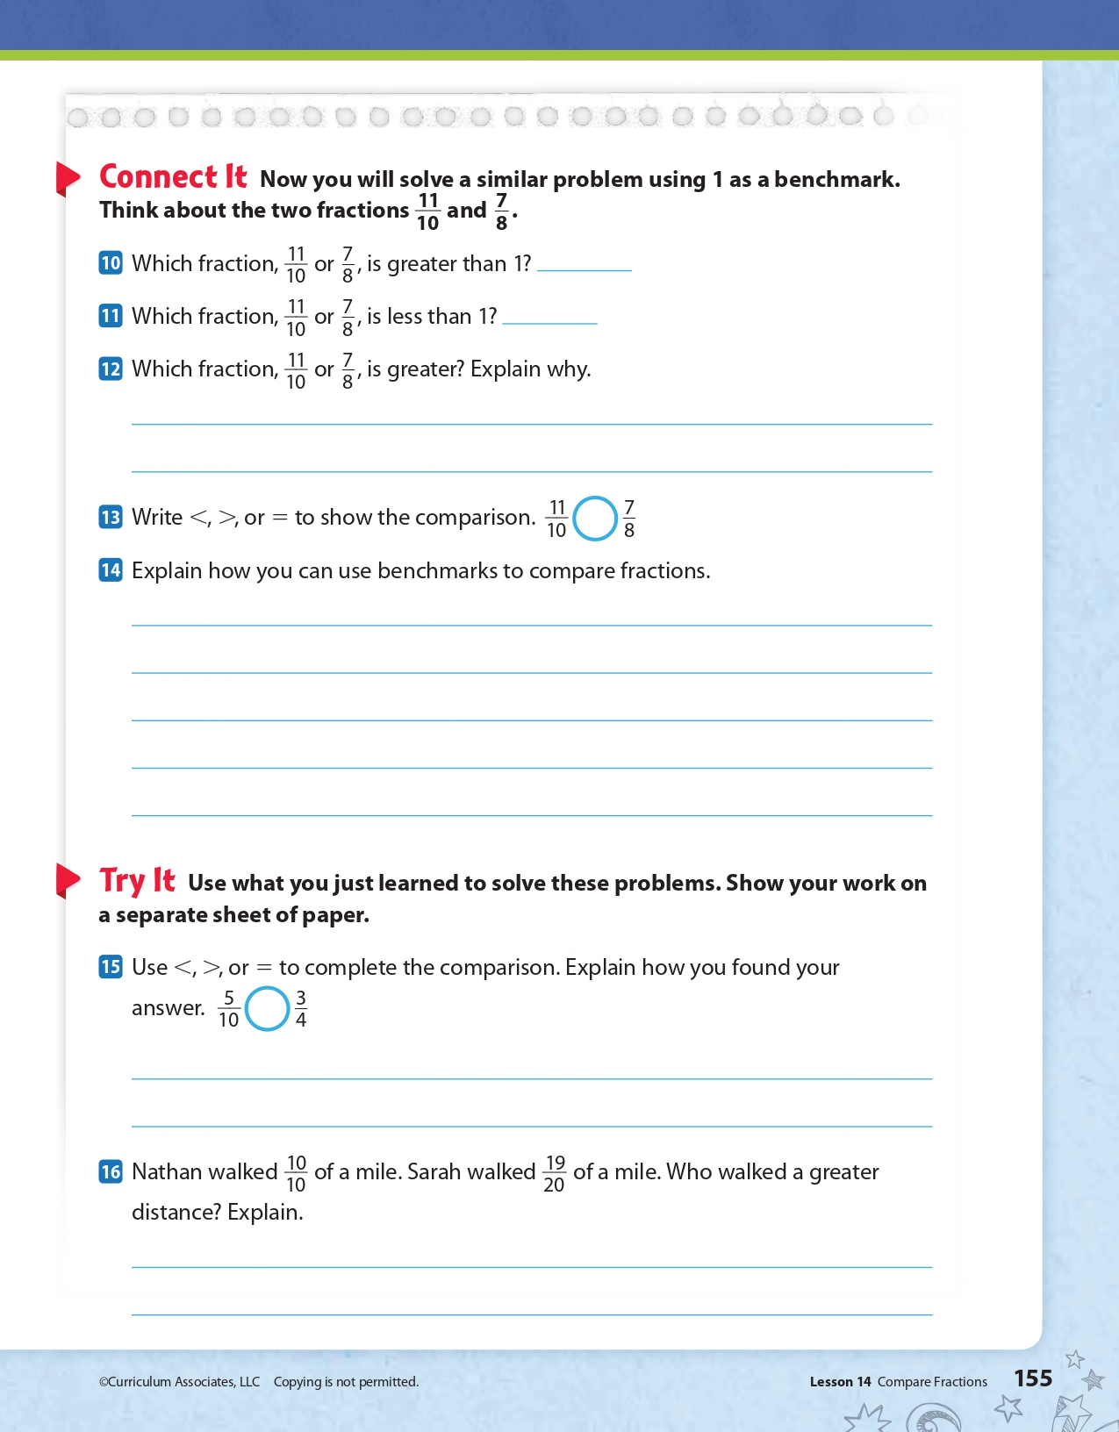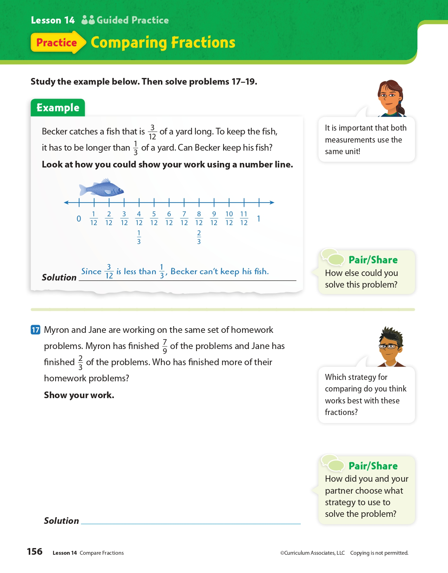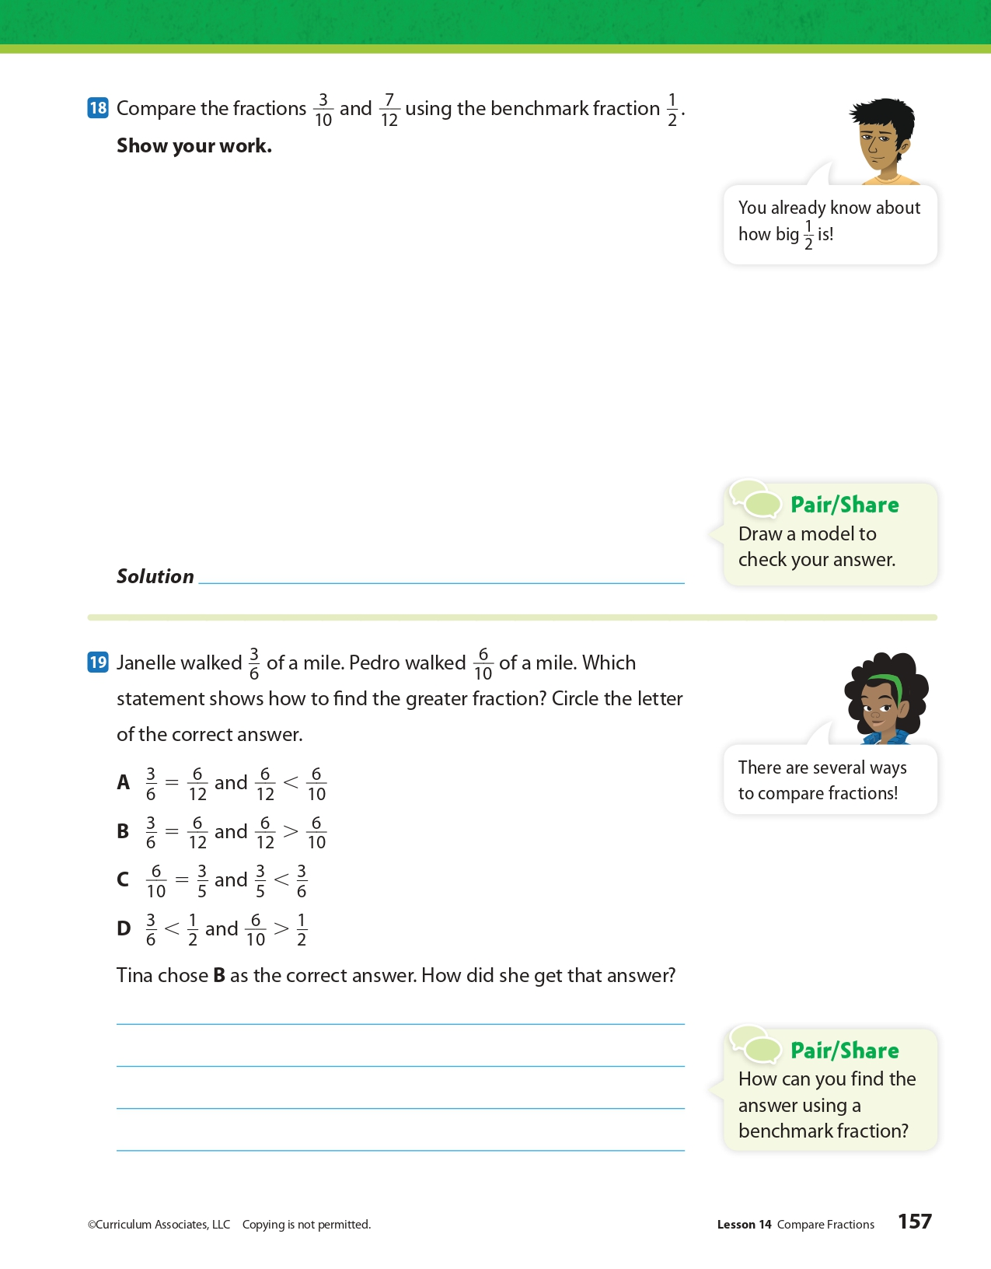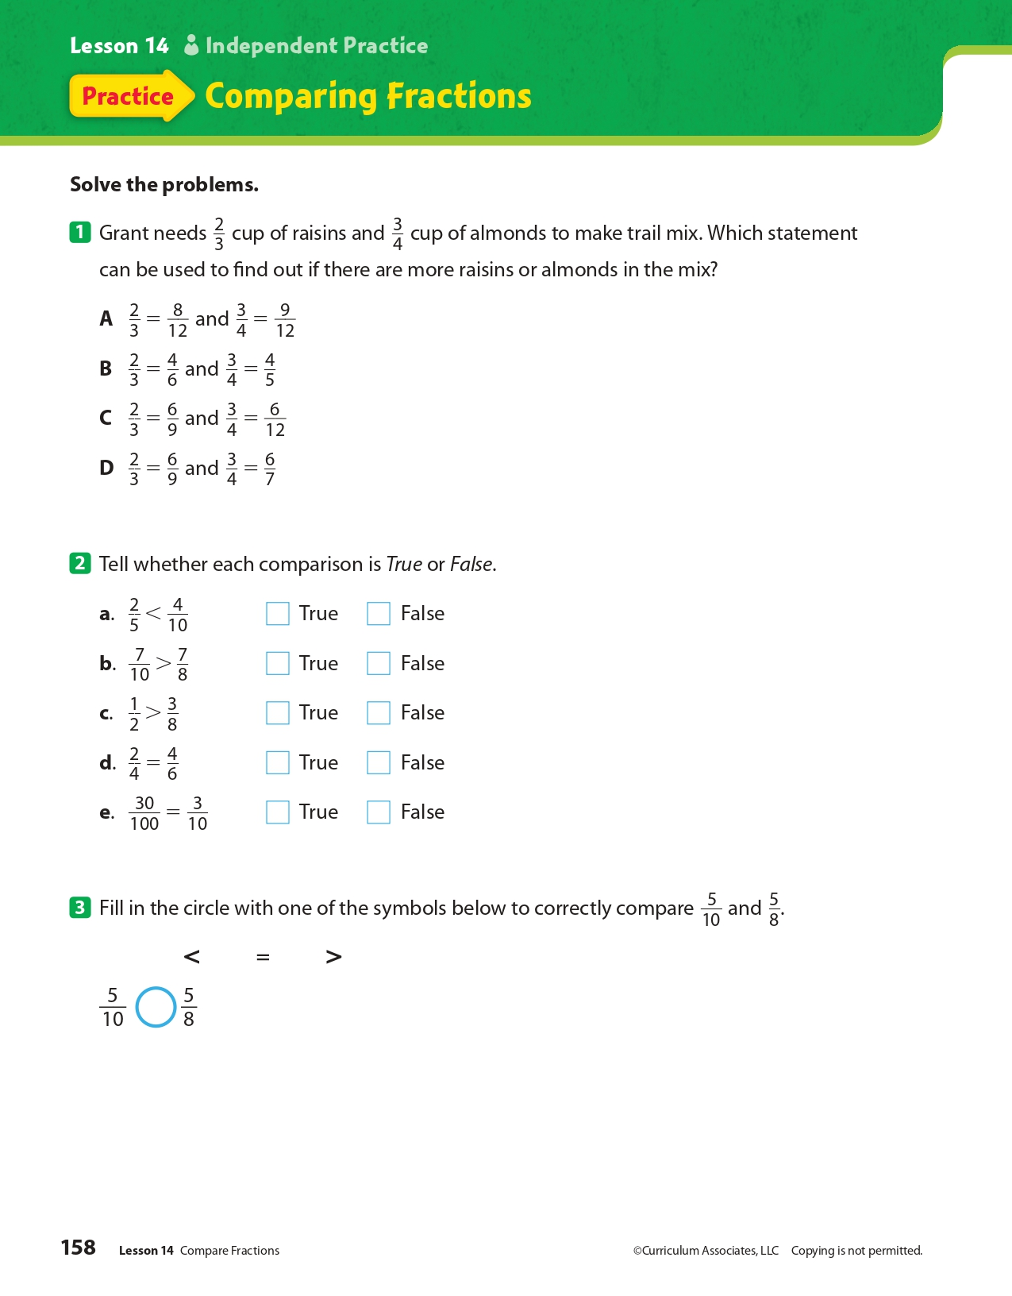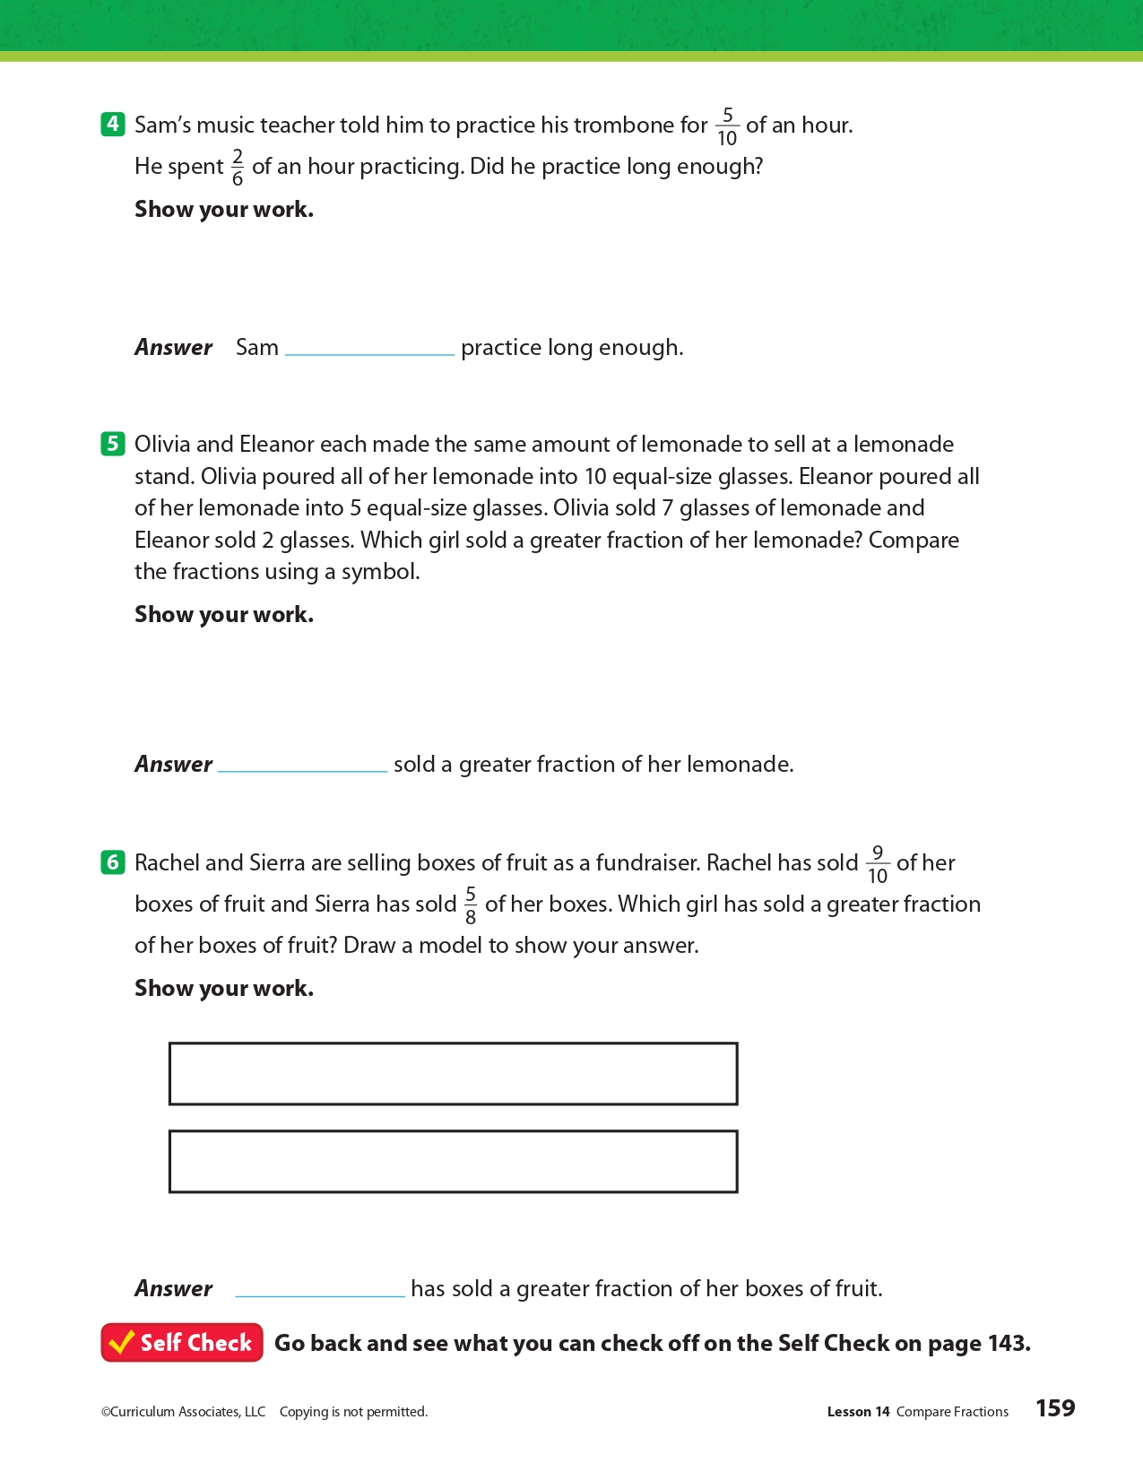
Day 2: PE
Health

What is this lesson about?: In today’s lesson, you will work on your PE BINGO card.

Step 1: Try to complete the PE BINGO card.

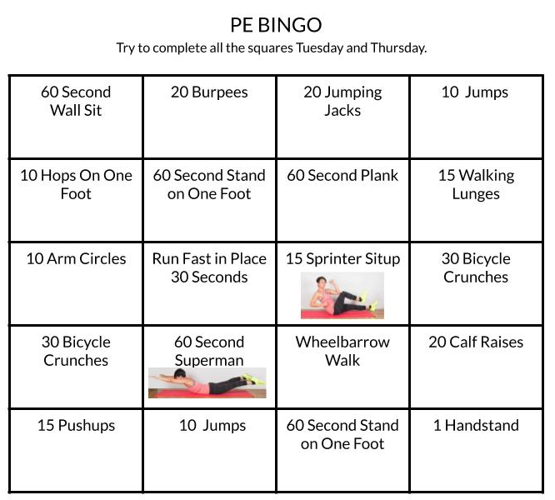

Student Feedback:
Circle the emojis that best represents how this activity made you feel.
Mindfulness Moment!

One of my favorite inventions of all time is...

Day 2: Evolution of Religious Liberty in Post-Revolutionary America
Social Studies

What is this lesson about?: Today you will explore how religious liberty and freedom evolved in America. After the Revolutionary War, the founders wanted to establish a separation of church and state.

Step 1: Warm-up on religious liberty

In France, girls are banned from wearing headscarves in school. In the one year since the law was implemented, 626 girls have arrived to school wearing a Muslim headscarf (compared with 1,465 in the prior year). Of the 626, 496 agreed to remove them when summoned for a talk with the headteacher. 45 of the girls refused and were expelled. What do you think?

Step 2: Read the passage

Background: Early movement towards religious liberty and separation of church and state
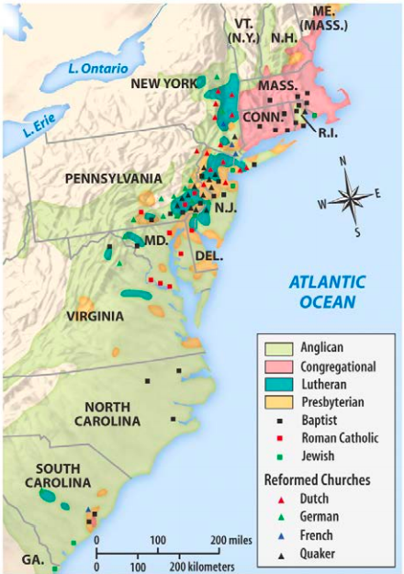
The Massachusetts Bay Colony was founded by a group called the Puritans in 1630. They were fleeing persecution themselves and came on a mission to live and practice religion as they pleased. The Puritans of the Massachusetts Bay Colony established what was essentially a theocracy, a government-controlled by religious leaders. Voting was limited to church members. Leaders did not accept those of other faiths, particularly Quakers and Anabaptists, whom they drove out.
One exile from the Massachusetts Bay Colony was Roger Williams, who founded the colony of Rhode Island in 1636. Williams believed the government should not interfere in religion. He put his beliefs into practice, and Rhode Island became a safe haven for Quakers, Jews and other non-Puritans. Later that century, a Quaker named William Penn founded the colony of Pennsylvania. The colony's law code guaranteed freedom of religion. As a result, Pennsylvania attracted Quakers, Jews, Huguenots, Mennonites, Amish and Lutherans.
The rest of the colonies (and eventually states) were a mixture of religions and levels of religious tolerance. Some, including Virginia, had state-supported churches. (see map of religions in colonies in 1750)

Free Exercise of Religion in Virginia
As Virginia’s governor in 1779, Thomas Jefferson drafted a bill that would guarantee the religious freedoms of Virginians of all faiths—including those with no faith—but the bill did not pass into law right away. The Virginia Statute for Religious Freedom was one of the most important documents in early U.S. religious history. It marked the end of a ten-year struggle for the separation of church and state in Virginia, and it was the driving force behind the religious clauses of the First Amendment of the U.S. Constitution, ratified in 1791.

Statute was first attempt to remove government influence from religious affairs
Drafted by Thomas Jefferson in 1776 and accepted by the Virginia General Assembly in 1786, the bill was, as Jefferson explained, an attempt to provide religious freedom to “the Jew, the Gentile, the Christian, the Mahometan, the Hindoo, and [the] infidel of every denomination.” In effect, it was the first attempt in the new nation to remove the government’s influence from religious affairs.

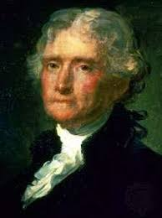
Jefferson created law to undo established churches in Virginia

When the bill was first introduced during the legislative session in 1779, the Episcopal Church, which had just recently declared its independence from the Church of England, was the state-sponsored or established church in Virginia. Tax monies were used to support the church, and colonial laws compelled mandatory church attendance. Enlightenment thinkers such as Jefferson and James Madison had long opposed established churches, because they believed that religion was a natural right best protected without governmental coercion. Furthermore, they objected to the limited religious freedom available to other religious entities in Virginia—most notably Baptists, Quakers, and Presbyterians—although they confined their protest to a few friends during the early years of the American Revolution.

The situation changed, however, in 1779, as the war was winding down. That year, Jefferson’s bill was introduced in the Virginia General Assembly, but it was soon postponed. In response, in 1784 the fiery, headstrong Patrick Henry countered Jefferson’s bill with a bill of his own that called for a general assessment tax to support “Teachers of the Christian Religion.” Each taxpayer was allowed to choose what church or minister could receive his tax money. It was, then, a proposal to replace the Episcopal Church with “multiple establishments” of religion, creating a tight church-state network in Virginia that would use government dollars to support all Christian churches, not just Episcopalian Christianity.

With Jefferson in France serving as American minister during the 1780s, the task of opposing Henry’s bill fell to Madison, Jefferson’s close friend and collaborator. Madison proceeded to pursue successfully three goals, which led to the defeat of Henry’s bill and the passage of Jefferson’s. First, Madison secured an alliance with evangelical sects that were opposed to the assessment bill. Second, he supported Patrick Henry’s election to the governorship in 1784, thereby removing him from the legislature. And, third, he penned a finely crafted pamphlet called “Memorial and Remonstrance Against Religious Assessment,” opposing Henry’s bill, supporting Jefferson’s, and calling for a separation of church and state.

James Madison supported the bill in a pamphlet
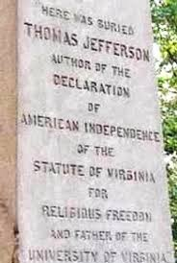
In the “Memorial,” Madison eloquently articulated the principles at stake: “Who does not see that the same authority which can establish Christianity, in exclusion of all other Religions, may establish with the same ease any particular sect of Christians, in exclusion of all other Sects? That same authority which can force a citizen to contribute three pence only of his property for the support of any one establishment, may force him to conform to any other establishment in all cases whatsoever.”

The pamphlet was an instant hit. It was widely circulated in Virginia, and it was signed by over two thousand Virginians, many of whom were Presbyterians and Baptists who thought Henry’s bill posed a threat to religious liberty in the Old Dominion.

The bill outlined why established religions were dangerous
In addition to the pamphlet, Madison guided Jefferson’s bill to passage; it was finally enacted on January 16, 1786. The new statute outlined in clear and coherent language why it was dangerous to have established religions in America. It is organized in three sections.

- The first section, the preamble, affirms “that Almighty God hath created the mind free” and that “to compel a man to furnish contributions of money for the propagation of opinions which he disbelieves and abhors is sinful and tyrannical.”
- The second section discusses the act itself, stating that “no man shall be compelled to frequent or support any religious worship, place or ministry...or otherwise suffer on account of his religious opinions or belief.”
- And the third section concludes by offering a warning to future Assemblies, declaring that repeal of the act would violate “the natural rights of mankind.”

Jefferson considered the bill to be among his greatest accomplishments. When he died in 1826, he instructed that his authorship of the bill be included on his tombstone along with his authorship of the Declaration of Independence and his founding of the University of Virginia.

The First Amendment
Madison would go on to draft the First Amendment, a part of the Bill of Rights that would provide constitutional protection for certain individual liberties including freedom of religion, freedom of speech and the press, and the rights to assemble and petition the government.

The First Amendment was adopted on December 15, 1791. It established a separation of church and state that prohibited the federal government from making any law “respecting an establishment of religion.” It also prohibits the government, in most cases, from interfering with a person’s religious beliefs or practices.

Step 3: Answer questions
How did Patrick Henry’s proposal for a General Assessment Tax provide funds for churches?

Do you think this type of tax law is fair? Why or why not?

Why did Jefferson and Madison oppose any government (state) support for religion?

Do you think keeping government (state) and religion separate makes society more tolerant or less tolerant? Why?

Step 4: Consider the First Amendment

The First Amendment provides:

“Congress shall make no law [1] respecting an establishment of religion or [2] prohibiting the free exercise thereof.”

These two clauses are referred to as the “establishment clause” and the “free exercise clause.” Both of these clauses have been applied to the states, and therefore operate against all levels of government in the United States. The free exercise clause protects the religious beliefs, and to a certain extent, the religious practices of all citizens. The more controversial establishment clause prohibits the government from endorsing, supporting, or becoming too involved in religion and religious activities.

Both clauses protect the same values, and often a violation of one would also be a violation of the other. For example, mandatory prayer in schools would constitute an improper establishment of religion and would also interfere with the free exercise rights of those students who did not believe in that particular prayer or prayer in general.

Step 5: First Amendment practice scenarios

Scenario 1
After a vote by the school district, North High School begins broadcasting a nondenominational Christian prayer over the loudspeaker each morning after the Pledge of Allegiance. Some of the prayers specifically talk about Jesus Christ. Students are told that they may sit or stand during the prayer, as they wish. Those giving the prayers include school administrators, teachers, volunteering students and local Christian clergy. Parents of Jewish, Muslim and Sikh studentsprotest against the practice. They say their students are being forced to hear prayers that do not reflect their faiths, and that the practice is an unconstitutional violation of the First Amendment right to religious freedom.

What do you think? How would you respond?

Scenario 2
Administrators at South High School, fearful of complaints and lawsuits stemming from mentions of religion in public school, declare that any expression of religious belief or faith on school grounds is forbidden. Students who have been gathering each morning to pray before school are told they may no longer do so or risk suspension. Students also may not pray alone, silently or otherwise, or discuss their faith with others on campus. Bibles, Korans and other religious texts are barred from classrooms. A group of parents of several faiths object to the new policy, saying it is an unconstitutional restriction of religious freedom under the First Amendment.

What do you think? How would you respond?

Step 6: What the law says

Read the paragraphs below to understand the laws that pertain to the two situations.

Scenario 1: Under the “establishment” clause of the First Amendment, and in line with U.S. Supreme Court rulings, public schools may not impose prayer or other religious practices on students, even if students are not required to participate. The first religion clause says government and its agencies are prohibited from establishing or requiring religion, including official attempts to impose or instill beliefs in students. This prohibition prevents government from setting up a national religion, and from favoring one religion over another. Therefore, prayers may not be broadcast over the school public-address system.

Scenario 2: Under the “free exercise” clause of the First Amendment, and in line with U.S. Supreme Court rulings, public schools may not prevent students from expressing or sharing religious beliefs, as long as their doing so does not disrupt the school. The second religion clause says government and its agencies may not forbid or interfere with individuals’ practice of religion. Public school students therefore may pray, alone or in groups, silently or aloud, as long as classes and non-participating students are not disturbed. Students may bring religious texts to school and read and discuss them.

How did your answers compare to the explanation of the laws above?

Student Feedback:
Circle the emojis that best represents how this activity made you feel.

Week 8
Freedom

Day 3

NAME:______________________

Day 3 Agenda

Topic | Activity
Warm-Up!
English Language Arts | - Read an informational text about Apartheid in South Africa.  - Read and analyze an essay by Nelson Mandela  - Respond to questions about both texts.  - Create a visual representation their own “Long Road to Freedom”
Science | - Read about Animals Needing More Freedom  - Answer questions about what you read  - Draw a picture and explain
Mindfulness Moment!
Math | - Word Problems: College Bound: Freedom to Grow and Learn  - Skills: Fractions
Health | - Symbols, freedom of speech, and health
Mindfulness Moment!
Civics/Social Studies | - Free Exercise clause of the First Amendment

Warm-up Activity: Write a journal entry around the daily quote on identity.
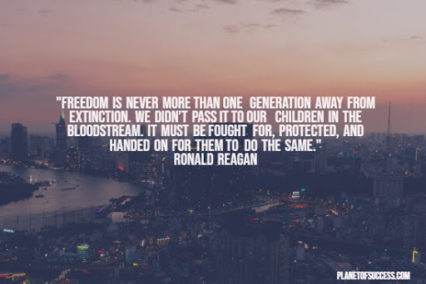

Day 3: Apartheid and Nelson Mandela
English Language Arts

What is this lesson about? Today you will be reading about the lack of freedom that came about because of Apartheid in South Africa. Apartheid only just ended 26 years ago. As you read today, think about how the idea of freedom can change as you mature.

Before you read: Some vocabulary to understand
heartstrings: deepest emotions or affections | sanction: a threatened penalty for disobeying a law or rule. | liberty: having various social, political, or economic rights and privileges
treason: the crime of betraying one's country, especially by attempting to kill the sovereign or overthrow the government. | embargo: an official ban or prohibition on trade or other commercial activity with a particular country. | refugee: one that flees  especially : a person who flees to a foreign country or power to escape danger or persecution

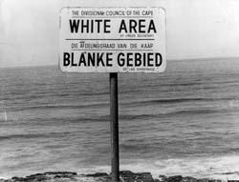
Apartheid and Its Opponents

Apartheid means ‘apart-hood’ or ‘the state of being apart’ and was the system of racial inequality, segregation and discrimination in South Africa that was started after World War II. It was enforced by the laws of the South African National Party governments from 1948 to 1994. These government officials were white rulers in the nation of South Africa that was a majority of black people and their laws cut the rights of all black citizens so that they were not equal to other citizens in the country.

White supremacy in South Africa continued to segregate the black citizens for over 50 years and came to a peak when the 1913 Land Act was passed. The law forced black citizens to live on special reserves that were set aside for them and made it against the law for them to work as sharecroppers. This caused the formation of the organization called the South African National Congress), who opposed the laws, which became the ANC (African National Congress). Nelson Mandela became the leader of the ANC and he began to fight against the new laws that outlawed interracial marriages and the Population Registration Act of 1950.
The last law classified people by their ‘race’ and then they would be given or refused rights based on that classification. Additional laws were passed requiring ‘non-white’ citizens to carry proof documents and other laws reduced the rights of the various African tribes and their leaders, who had lived in these areas of South Africa for centuries. By 1958, the government leaders removed black citizens from their homes, relocated them to other areas and sold their land for cheap prices to white farmers.

As it is with any movement, resistance to apartheid covered many years and appeared in many forms. Some were peaceful protests, while other situations were violent. By 1952, the ANC organized a protest with the South Indian National Congress to burn their ‘passbooks’. By 1955 groups were gathering to try to bring about equality and they were met with police and government officials that arrested them and they were charged with high treason.
Many groups were attacked and killed by the white police officers and the violence became worse as they tried to enforce the ‘white laws’. Nelson Mandela led many of the protests but was then accused of treason and had to go ‘underground’ to avoid arrest. When the officials did locate him in 1961, he was arrested and thrown into prison. The arrest of Nelson Mandela became an outraged cry and symbol for others to continue the fight. His arrest also brought attention to the condition of Apartheid for the rest of the world.

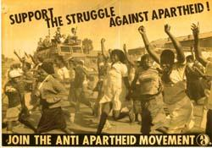
In 1973, the United Nations General Assembly focused on apartheid and denounced it. By 1976 the UN Security Council voted to impose embargos against the sale of firearms to South Africa. People from all over the world began to join the anti-apartheid movement and to protest the imprisonment of Nelson Mandela.

The movement was joined by artists, musicians, politicians, humanitarians and groups from every country. By 1985 both the United States and the United Kingdom imposed ‘economic sanctions’ against South Africa, which reduced the amount of trade that they could receive from both countries.
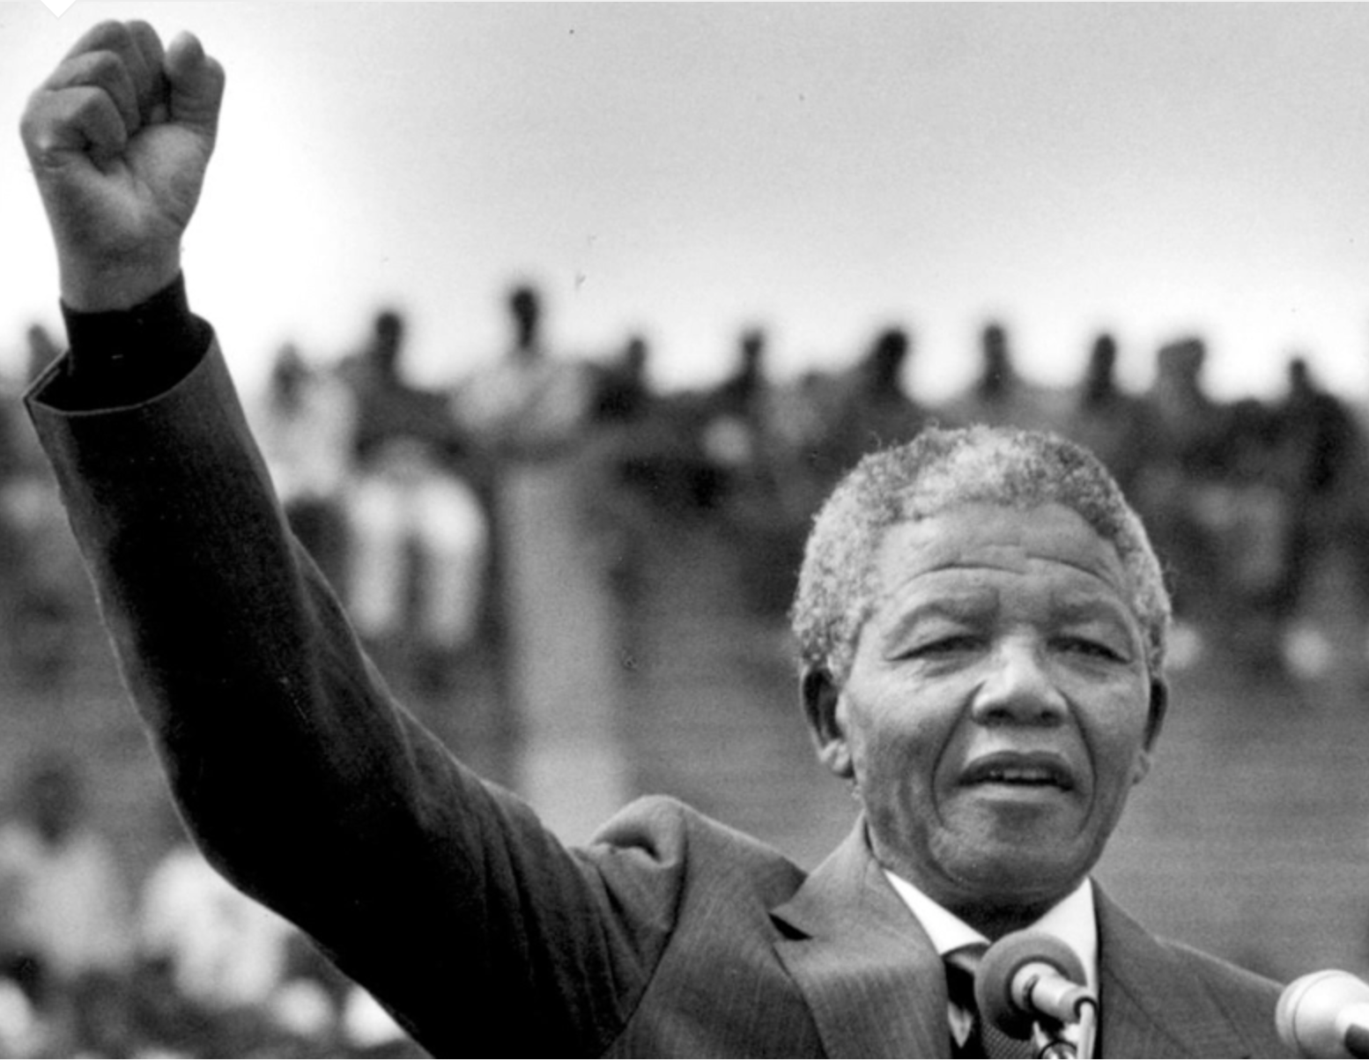
By 1989, the South African government fell to the pressure and began seeking reforms which included getting rid of some of the laws. A new constitution was drawn up to give blacks and other racial groups their freedoms back. Nelson Mandela was released from prison in 1990 and became the popular representative that worked together with the political groups for reform. In 1994, elections were held and, for the first time, there was a nonwhite majority which led to the end of apartheid.
Nelson Mandela was sworn in as President in May, 1994.
Adapted from: https://www.historyforkids.net/apartheid.html
Step 2: Answer the Following Questions
- Describe what the land Act of 1913 did to black citizens in South Africa.

- Apartheid separated South Africans into Whites, Blacks, Coloureds (mixed race), and Asian (meaning Indians and Pakistanis). How do you think this separation was used to maintain the system of oppression when Whites were the minority?

- What was Nelson Mandela accused of and jailed for?

- When was Nelson Mandela released? How many years had he served in prison?

- In your own words, explain what caused the end of Apartheid.

- What happened to Mandela after he was released from prison?

Step 3: Read the essay below

Before you read: Some vocabulary to understand:
mealies: corn | abide: to follow a rule | transitory: temporary
yearn: wish for | curtail: to reduce or put a restriction on | dignity: honor or respect
bold: having the ability to take risks | monk: a member of a religious community of men typically living under vows of poverty, chastity, and obedience. | narrow-minded: not willing to listen to or tolerate other people's views; prejudiced.
falter: to stumble, to move unsteadily | cast: throw

Nelson Mandela Reflects on Working Toward Peace
By Nelson Mandela

I was not born with a hunger to be free. I was born free-free in every way that I could know. Free to run in the fields near my mother's hut, free to swim in the clear stream that ran through my village, free to roast mealies under the stars and ride the broad backs of slow moving bulls. As long as I obeyed my father and abided by the customs of my tribe, I was not troubled by the laws of man or God.

It was only when I began to learn that my boyhood freedom was an illusion, when I discovered as a young man that my freedom had already been taken from me, that I began to hunger for it. At first, as a student, I wanted freedom only for myself, the transitory freedoms of being able to stay out at night, read what I pleased, and go where I chose. Later, as a young man in Johannesburg, I yearned for the basic and honorable freedoms of achieving my potential, or earning my keep, of marrying and having a family-the freedom not to be obstructed in a lawful life.

But then I slowly saw that not only was I not free, but my brothers and sisters were not free. I saw that it was not just my freedom that was curtailed, but the freedom of everyone who looked like I did. That is when I joined the African National Congress, and that is when the hunger for my own freedom became the greater hunger for the freedom of my people. It was this desire for the freedom of my people to live their lives with dignity and self-respect that animated my life, that transformed a frightened young man into a bold one, that drove a law-abiding attorney to become a criminal, that turned a family-loving husband into a man without a home, that forced a life-loving man to live like a monk. I am no more virtuous or self-sacrificing than the next man, but I found that I could not even enjoy the poor and limited freedoms I was allowed when I knew my people were not free. Freedom is indivisible; the chains on any one of my people were the chains on all of them, the chains on all of my people were the chains on me.
It was during those long and lonely years that my hunger for the freedom of my own people became a hunger for the freedom of all people, white and black. I knew as well as I knew anything that the oppressor must be liberated just as surely as the oppressed. A man who takes away another man's freedom is a prisoner of hatred, he is locked behind the bars of prejudice and narrow-mindedness. I am not truly free if I am taking away someone else's freedom, just as surely as I am not free when my freedom is taken from me. The oppressed and the oppressor alike are robbed of their humanity.

When I walked out of prison, that was my mission, to liberate the oppressed and the oppressor both. Some say that has now been achieved. But I know that that is not the case. The truth is that we are not yet free; we have merely achieved the freedom to be free, the right not to be oppressed. We have not taken the final step of our journey, but the first step on a longer and even more difficult road. For to be free is not merely to cast off one's chains, but to live in a way that respects and enhances the freedom of others. The true test of our devotion to freedom is just beginning.

I have walked that long road to freedom. I have tried not to falter; I have made missteps along the way. But I have discovered the secret that after climbing a great hill, one only finds that there are many more hills to climb. I have taken a moment here to rest, to steal a view of the glorious vista that surrounds me, to look back on the distance I have come. But I can rest only for a moment, for with freedom comes responsibilities, and I dare not linger, for my long walk is not yet ended.

Step 4: Answer the questions below
1. How did Mandela’s idea of freedom change when he was a young man? What freedoms did he want then? Were these freedoms available to him?

2. In the third paragraph, what shift took place in Mandela’s thinking about freedom? How does this show that he was maturing?

3. In the fourth paragraph, how does his view of freedom evolve even more? Do you agree with him? Why or why not?

4. In the fifth and sixth paragraphs, what does Mandela say about freedom now in South Africa?

5. What metaphor does Mandela use in the final paragraph, and is it effective in conveying his message? Why or why not?

Step 5: Think, Discuss and Write

Think about the following quote from Mandela’s writing:
Mandela stated “For to be free is not merely to cast off one's chains, but to live in a way that respects and enhances the freedom of others,” now think about what you wrote about earlier this week when you wrote your definition of freedom. Have the readings from this week so far changed your thinking? Why or why not? He also uses the metaphor of having walked the “long road to freedom”. Describe your road to real freedom. What do you think that looks like? Use words and images to share your “road to freedom”. Use the template provided.

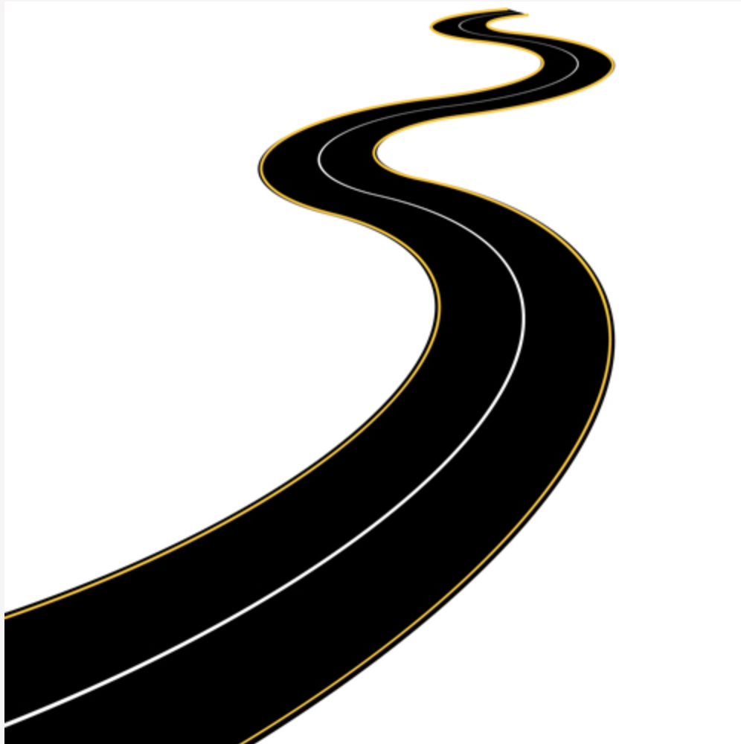

Student Feedback:
Circle the emojis that best represents how this activity made you feel.

Day 3: Electricity Rights
Science

What is this lesson about?: Today you will read through the Do Animals Need More Freedom? passage. You will answer a few questions about what you read. You will complete an activity.

Step 1: Read through the passage

Do Animals Need More Freedom?
(Leahy, 2017)

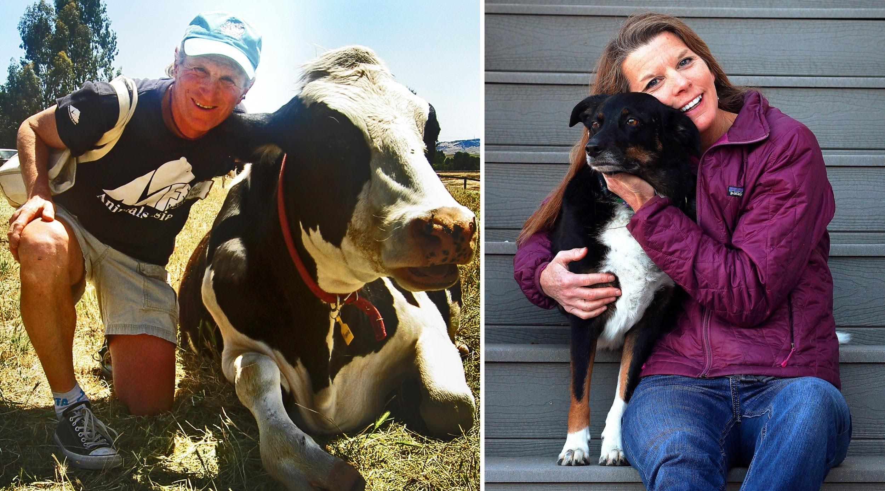
(Courtesy Marc Bekoff and Sage Madden) Animal behaviorist Marc Bekoff, left, with rescued dairy cow Bessie. Bioethicist Jessica Pierce, right, with one of her family dogs, a rescue named Bella.

You’ve probably wondered what your dog or cat is thinking. Perhaps you’ve even considered the thoughts of wild animals and those in zoos. How about the feelings of the cows, chickens and pigs that eventually end up on our dinner plates? University of Colorado bioethicist Jessica Pierce and CU professor emeritus and animal behaviorist Marc Bekoff say science shows that animals have rich inner lives, but their treatment by humans doesn't reflect that. Their new book is "The Animals' Agenda: Freedom, Compassion, and Coexistence in the Human Age." Pierce and Bekoff spoke with Colorado Matters host Andrea Dukakis. Read an Excerpt:

Freedom, Compassion, and Coexistence in the Human Age
There comes a time when one must take a position that is neither safe nor politic nor popular, but he must take it because conscience tells him it is right.
—Martin Luther King Jr.

News headlines these days often center on animals. Stories seem increasingly to be of two types. The first involves reporting on what might be characterized as “the inner lives of animals.” Scientists regularly publish new findings on animal cognition or emotion, and these quickly make their way into the popular press. Here is a sampling of some recent headlines:
- Pigs possess complex ethological traits similar to dogs and chimpanzees
- Squirrels can be deceptive
- Chickens are smart, and they understand their world
- Rats will save their friends from drowning . . . new finding suggests that these rodents feel empathy
- New Caledonian crows show strong evidence of social learning
- Elephants get post-traumatic stress too: calves orphaned by the killing of their parents are haunted by grief decades later
- Fish determine social status using advanced cognitive skills

The other type of news story focuses on individual animals or a particular group of animals who have been wronged by humans in some significant way. These stories often create a social media frenzy, generating both moral outrage and soul-searching. In particular, these stories highlight instances in which the freedom of an animal has been profoundly violated by humans. Some of these recent hot-button stories include the killing of an African lion named Cecil by an American dentist wanting a trophy head; the killing of a mother grizzly bear named Blaze, who attacked a hiker in Yellowstone National Park; the case of a male polar bear named Andy who was suffocating and starving because of an overly tight radio collar placed around his neck by a researcher; the “euthanizing” and public dissection of a giraffe named Marius at the Copenhagen Zoo because he was not good breeding stock; the ongoing legal battle to assign legal personhood to two research chimpanzees, Leo and Hercules; the exposure of SeaWorld for cruel treatment of orcas, inspired by the tragic story of Tilikum and the documentary Blackfish; and the killing of a gorilla named Harambe at the Cincinnati Zoo, after a small boy fell into the animal’s enclosure. The fact that these events have created such a stir suggests that we are at a tipping point. People who have never really been active in defense of animals are outraged by the senseless violation of these animals’ lives and freedom. The growing awareness of animal cognition and emotion has enabled a shift in perspective. People are sick and tired of all the abuse. Animals are sick and tired of it, too.

Yet although we prize our freedom above all else, we routinely deny freedom to nonhuman animals (hereafter, animals) with whom we share our planet. We imprison and enslave animals, we exploit them for their labor and their skin and bodies, we restrict what they can do and with whom they can interact. We don’t let them choose their family or friends, we decide for them when and if and with whom they mate and bear offspring, and often take their children away at birth. We control their movements, their behaviors, their social interactions, while bending them to our will or to our self-serving economic agenda. The justification, if any is given, is that they are lesser creatures, they are not like us, and by implication they are neither as valuable nor as good as we are. We insist that as creatures vastly different from us, they experience the world differently than we do and value different things.

But, in fact, they are like us in many ways; indeed, our basic physical and psychological needs are pretty much the same. Like us, they want and need food, water, air, sleep. They need shelter and safety from physical and psychological threats, and an environment they can control. And like us, they have what might be called higher-order needs, such as the need to exercise control over their lives, make choices, do meaningful work, form meaningful relationships with others, and engage in forms of play and creativity. Some measure of freedom is fundamental to satisfying these higher-order needs, and provides a necessary substrate for individuals to thrive and to look forward to a new day.

Freedom is the key to many aspects of animal well-being. And lack of freedom is at the root of many of the miseries we intentionally and unintentionally inflict on animals under our “care”—whether they suffer from physical or social isolation, or from being unable to move freely about their world and engage the various senses and capacities for which they are so exquisitely evolved. To do better in our responsibilities toward animals, we must do what we can to make their freedoms the fundamental needs we promote and protect, even when it means giving those needs priority over some of our own wants.

The Five Freedoms
Many people who have taken an interest in issues of animal protection are familiar with the Five Freedoms. The Five Freedoms originated in the early 1960s in an eighty-five-page British government study, Report of the Technical Committee to Enquire into the Welfare of Animals Kept Under Intensive Livestock Husbandry Systems. This document, informally known as the Brambell Report, was a response to public outcry over the abusive treatment of animals within agricultural settings. Ruth Harrison’s 1964 book Animal Machines brought readers inside the walls of the newly developing industrialized farming systems in the United Kingdom, what we have come to know as “factory farms.” Harrison, a Quaker and conscientious objector during World War II, described appalling practices like battery-cage systems for egg-laying hens and gestation crates for sows, and consumers were shocked by what was hidden behind closed doors.

To mollify the public, the UK government commissioned an investigation into livestock husbandry, led by Bangor University zoology professor Roger Brambell. The commission concluded that there were, indeed, grave ethical concerns with the treatment of animals in the food industry and that something must be done. In its initial report, the commission specified that animals should have the freedom to “stand up, lie down, turn around, groom themselves and stretch their limbs.” These incredibly minimal requirements became known as the “freedoms,” and represented the conditions the Brambell Commission felt were essential to animal welfare.

The commission also requested the formation of the Farm Animal Welfare Advisory Committee to monitor the UK farming industry. In 1979 the name of this organization was changed to the Farm Animal Welfare Council, and the freedoms were subsequently expanded into their current form. The Five Freedoms state that all animals under human care should have:
- Freedom from hunger and thirst, by ready access to water and a diet to maintain health and vigor.
- Freedom from discomfort, by providing an appropriate environment.
- Freedom from pain, injury and disease, by prevention or rapid diagnosis and treatment.
- Freedom to express normal behavior, by providing sufficient space, proper facilities and appropriate company of the animal’s own kind.
- Freedom from fear and distress, by ensuring conditions and treatment which avoid mental suffering.

The Five Freedoms have become a popular cornerstone of animal welfare in a number of countries. The Five Freedoms are now invoked in relationship not only to farmed animals but also to animals in research laboratories, zoos and aquariums, animal shelters, veterinary practice, and many other contexts of human use. The freedoms appear in nearly every book about animal welfare, can be found on nearly every website dedicated to food-animal or lab-animal welfare, form the basis of many animal welfare auditing programs, and are taught to many of those working in fields of animal husbandry.

The Five Freedoms have almost become shorthand for “what animals want and need.” They provide, according to a current statement by the Farm Animal Welfare Council, a “logical and comprehensive framework for analysis of animal welfare.” Pay attention to these, it seems, and you’ve done your due diligence as far as animal care is concerned. You can rest assured that the animals are doing just fine.

It’s worth stopping for a moment to acknowledge just how forward thinking the Brambell Report really was. This was the 1960s and came on the heels of behaviorism, a school of thought that offered a mechanistic understanding of animals, and at a time when the notion that animals might experience pain was still just a superstition for many researchers and others working with animals. The Brambell Report not only acknowledged that animals experience pain, but also that they experience mental states and have rich emotional lives, and that making animals happy involves more than simply reducing sources of pain and suffering, but actually providing for positive, pleasurable experiences. These claims sound obvious to us now, but in the mid-1960s they were both novel and controversial.
It is hard to imagine that the crafters of the Five Freedoms failed to recognize the fundamental paradox: How can an animal in an abattoir or battery cage be free? Being fed and housed by your captor is not freedom; it is simply what your caregiver does to keep you alive. Indeed, the Five Freedoms are not really concerned with freedom per se, but rather with keeping animals under conditions of such profound deprivation that no honest person could possibly describe them as free. And this is entirely consistent with the development of the concept of animal welfare.

Welfare concerns generally focus on preventing or relieving suffering, and making sure animals are being well-fed and cared for, without questioning the underlying conditions of captivity or constraint that shape the very nature of their lives. We offer lip service to freedom, in talking about “cage-free chickens” and “naturalistic zoo enclosures.” But real freedom for animals is the one value we don’t want to acknowledge, because it would require a deep examination of our own behavior. It might mean we should change the way we treat and relate to animals, not just to make cages bigger or provide new enrichment activities to blunt the sharp edges of boredom and frustration, but to allow animals much more freedom in a wide array of venues.

The bottom line is that in the vast majority of our interactions with other animals, we are seriously and systematically constraining their freedom to mingle socially, roam about, eat, drink, sleep, pee, poop, have sex, make choices, play, relax, and get away from us. The use of the phrase “in the vast majority” might seem too extreme.

However, when you think about it, we are a force to be reckoned with not only in venues in which animals are used for food production, research, education, entertainment, and fashion, but globally; on land and in the air and water, human trespass into the lives of other animals is not subsiding. Indeed, it’s increasing by leaps and bounds. This epoch, which is being called the Anthropocene, or Age of Humanity, is anything but humane. It rightfully could be called the Rage of Humanity.

We want to show how important it is to reflect on the concept of freedom in our discussions of animals. Throughout this book, we are going to examine the myriad ways in which animals under our care experience constraints on their freedom, and what these constraints mean in terms of actual physical and psychological health. Reams of scientific evidence, both behavioral observations and physiological markers, establish that animals have strongly negative reactions to losses of freedom.
One of the most important efforts we can make on behalf of animals is to explore the ways in which we undermine their freedom and then look to how we can provide them with more, not less, of what they really want and need.

Step 2: Answer the following questions

- What are a few examples in the text, of how we limit or take away freedom from animals?

- In what ways do you believe animals and humans are similar and different?

- Do you believe the Five Freedoms are important to have in place? Why or why not?

Step 3: Draw an image/picture

Create your own Five Freedoms for people your age. Design an image for each freedom. (What do you want to make sure is in place for you to live your best life?). Write your Five Freedoms below your drawing.

____________________________________________________________________________________________________________________________________________________________________________________________________________________________________________________________________
________________________________________________________________________________________________________

Student Feedback:
Circle the emojis that best represents how this activity made you feel.

Mindfulness Moment!

Three wonderful things I have done in my life are...

Day 3: Freedom/Fractions
Math
What is this lesson about?: Today you will be exploring addition and subtraction of fractions.

Warm Up and Review Problems:
Destiny was 17 when she was arrested for distributing marijuana and other drugs. She was adjudicated delinquent as a juvenile and spent 8 months in a youth facility Washington, DC. While detained she really got into school and started to catch up. When she was released she went to summer school and then went back to high school full-time, taking extra classes to catch up with her credits. In June of 2018, she graduated. And in August of 2018 she headed off to college. Asked about her road to college she said that she never thought she would experience the sort of Freedom she felt when she got in a car with her dad to go to college.

Consider:
Researchers estimate that only 15% of the students who spend time in a juvenile facility will graduate from high school.
- If 3,000 teens spend time in a youth facility, how many would be projected to graduate high school?

For each youth who does graduate, approximately 10% are projected to go to college and graduate.
- Of those who graduate (from that 3,000), how many are predicted to graduate from college?

So far, Destiny is beating all of these odds!!!
How is she making it happen? We asked her and her are some of her responses-
- Q: How many hours a day do you spend studying at college?
- A: I have classes for about 3 hours each day, but I also work part-time to help me afford school expenses. So, I get up at 530am and study from 6am-9am. Then I eat, go to classes, have some fun with friends, go to the gym….I work every day in the library from 4pm-7pm. Then I have dinner and chill a bit. I go back to the library from 8pm to 11pm. I usually meet a tutor there to help me with my Calculus class for 90 minutes since that is my hardest class. Then I head back to the dorm….

If you count the hours that Destiny is in class and the hours that she is in the library, how many hours a day is Destiny studying?

In addition to the hours mentioned above, Destiny also works from 11am-2pm on Saturdays at the library. How many hours per week does she work?

If Destiny works with her tutor on Calculus for 90 minutes on Mon-Friday and on Sunday, how many hours per week does she study with her tutor?

About how many hours per day does Destiny sleep?

Destiny had a summer job working for a local nonprofit as a social media and communications intern that helps teenagers prepare for college life. She loved it. She said it made her feel free, like all of her work was worth it. She worked 12 weeks over the summer. She earned $15 per hour, working 40 hours per week. About how much money did she earn each week? How much did she earn over the summer?

Activities/Fraction Problems: Complete the following fractions worksheets.

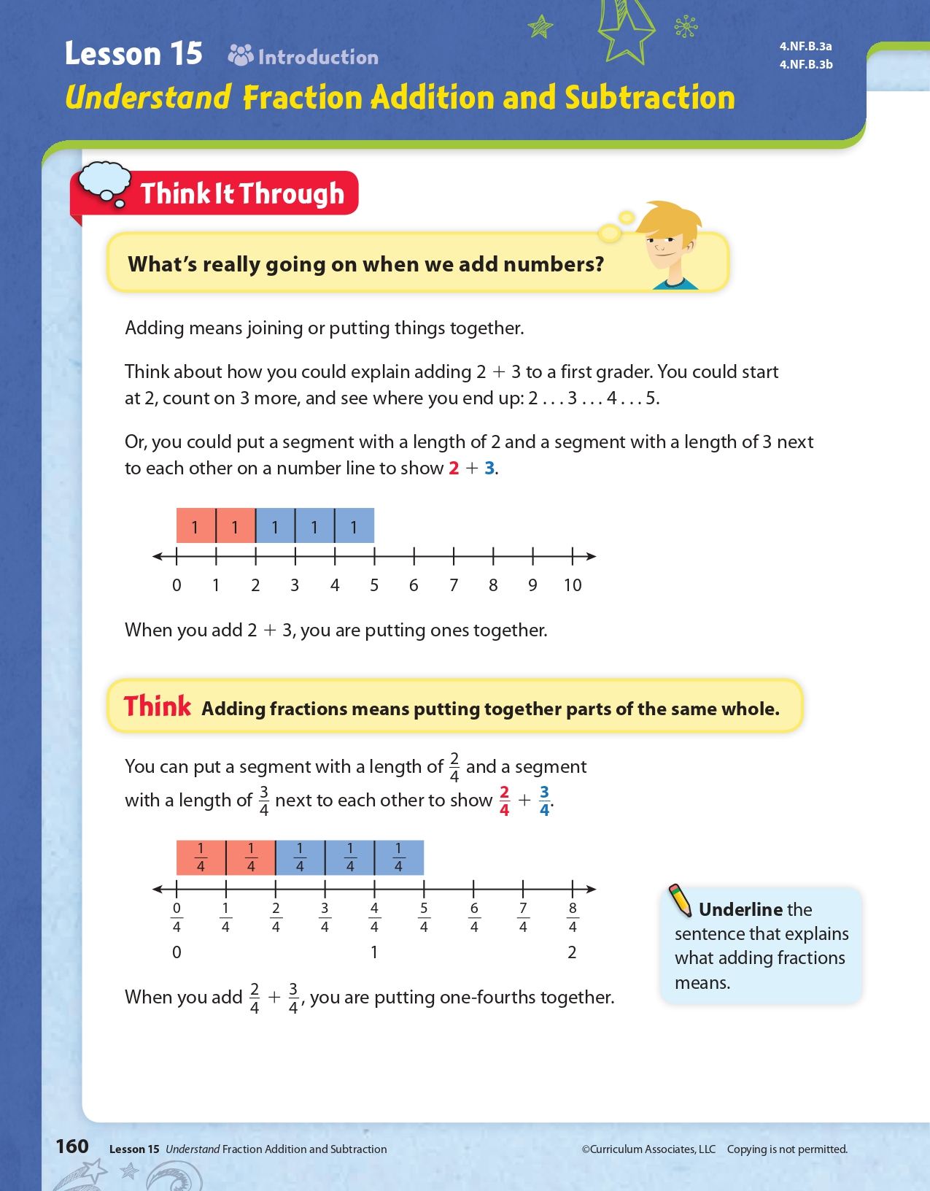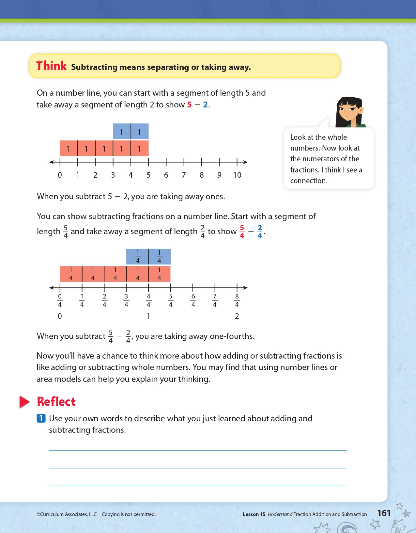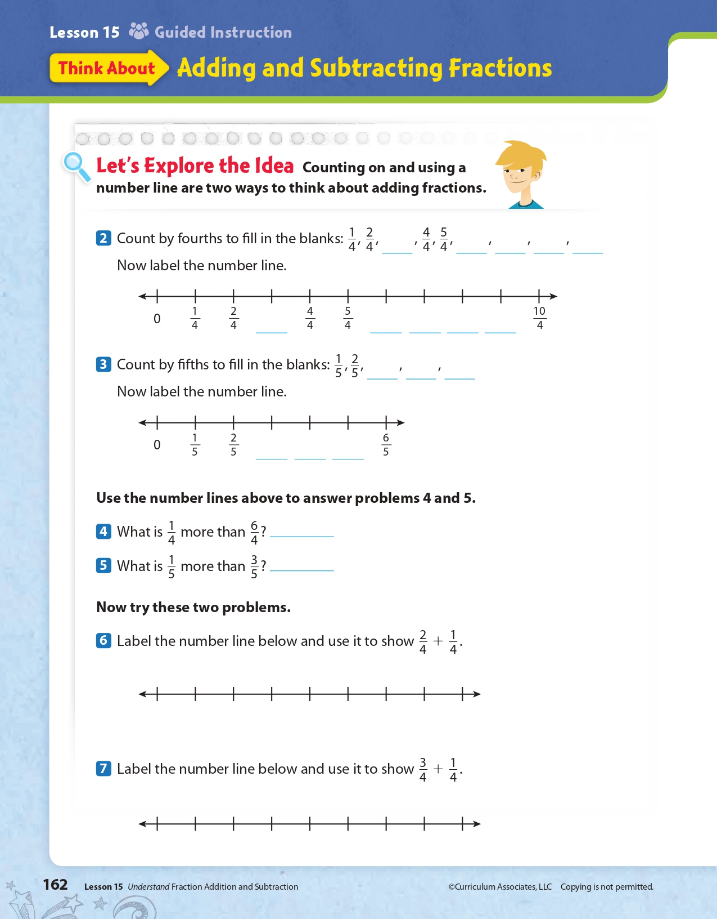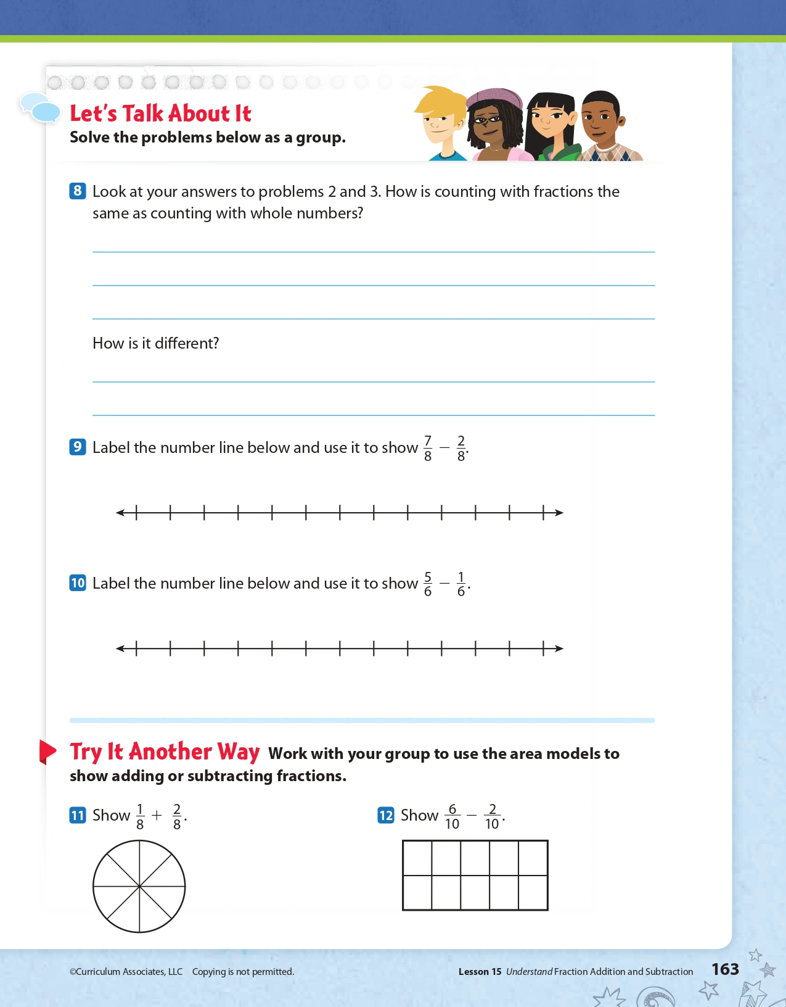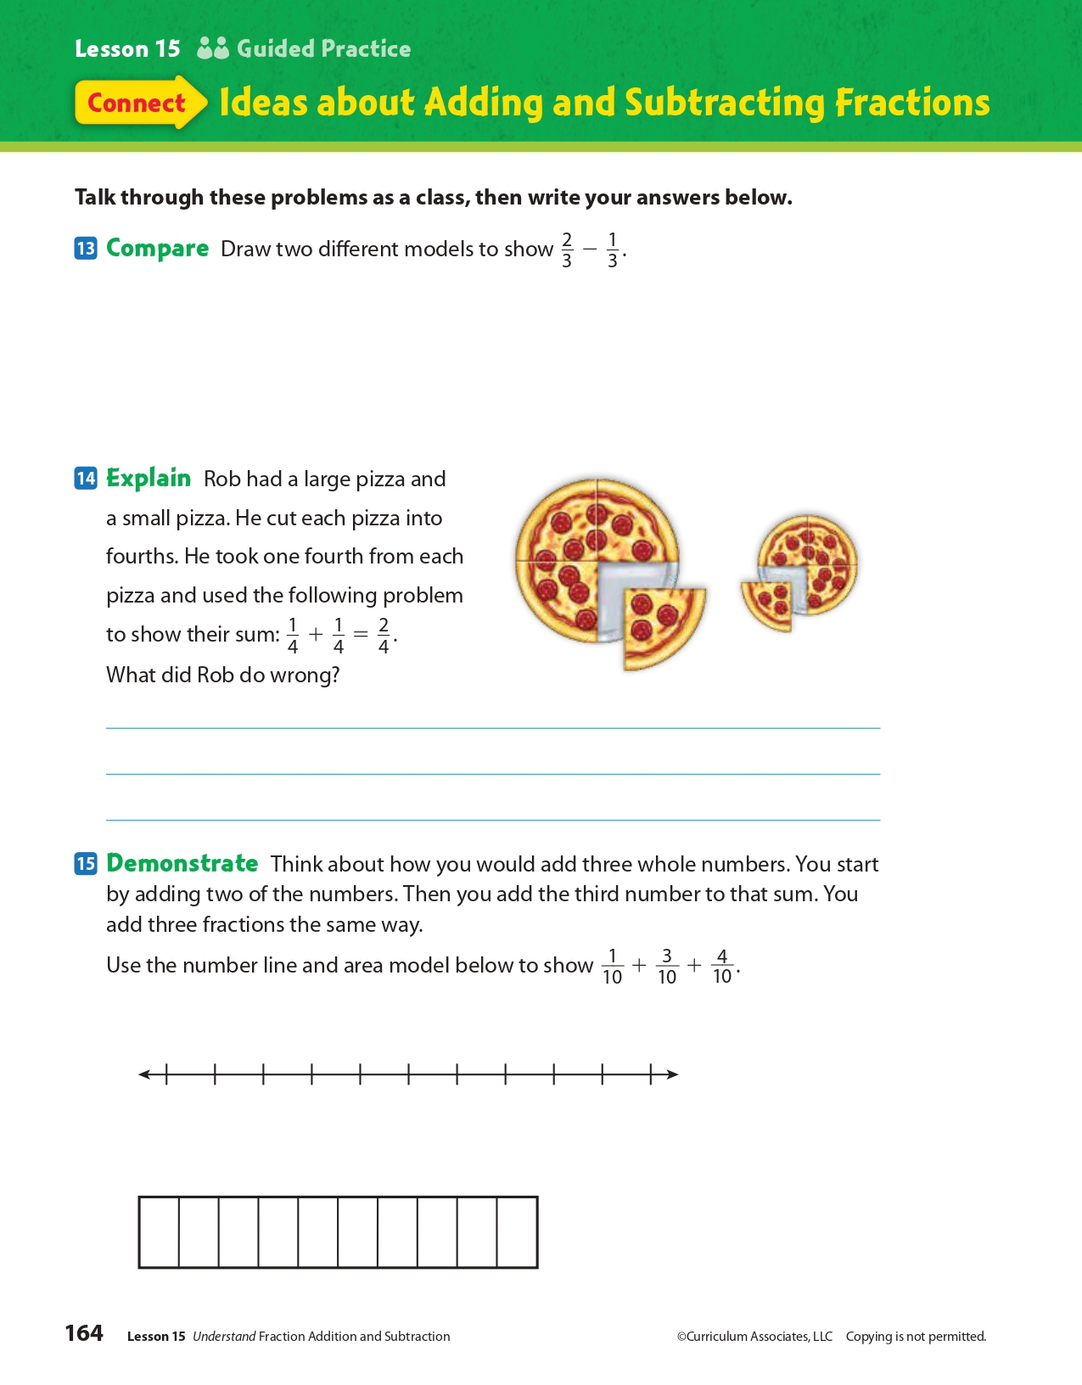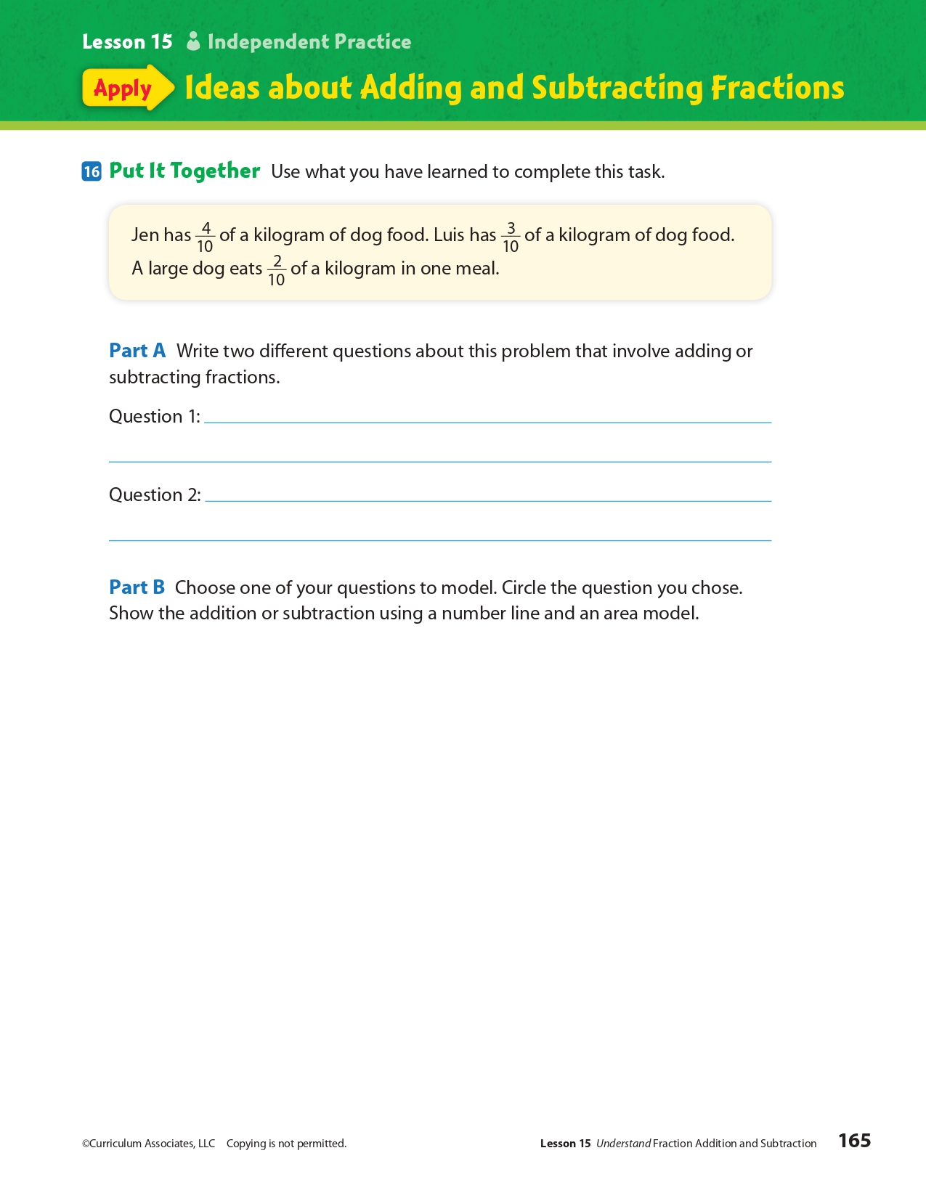
Day 3: How can symbols allow you to express your freedom of speech?
Health

What is this lesson about?: In today’s lesson, you will learn about the Freedom of Speech to express your personal beliefs at school. The story will feature a historical Supreme Court case that shaped the way that we represent our beliefs in a school today.

Step 1: Warm-Up:
The historic 1943 Supreme Court decision West Virginia Board of Education v. Barnette. A West Virginia law penalized students and their parents if the students failed to salute the flag and recite the pledge. A group of Jehovah’s Witnesses, who refused to comply for religious reasons, challenged the law.
The Supreme Court, overruling another decision issued only three years prior, sided with the Jehovah’s Witnesses. The court wrote that school boards must engage in “scrupulous protection of Constitutional freedoms of the individual … [so as] … not to strangle the free mind at its source and teach youth to discount important principles of our government as mere platitudes.” The court reasoned that the First Amendment free-speech clause included the right not to speak.
Did you know you also had the right NOT to speak? How can that be important?

Step 2: Read the story below.
Tinker v. Des Moines Independent Community School District was a Supreme Court case that was decided on February 24, 1969. In a ruling of 7–2, the court established the free speech and political rights of students in school settings. On the basis of the majority decision, school officials have limited authority to regulate student expression. To do so, they must prove one of two things. They must show that the student expression would interfere with the operations of the school or that it would invade the rights of others. When school officials can support predictions of disruption, they can regulate student expression.
Under U.S. law, schools are considered limited public spaces. As such, students have fewer rights in schools than they do on public streets. In schools, student free-speech rights must be balanced against the obligations of school officials. These include the responsibilities to protect student safety and to deliver a quality education. In general, student free-speech rights extend only to expressions of a political, economic or social nature that are not part of a school program. To this end, school officials have the authority to regulate student writing in school newspapers, for example. They have far less authority to regulate student discussions in the cafeteria. However, school officials can ban some forms of student expression that are crude or inappropriate. Officials do not have to show that such speech is disruptive since it has little or no educational value.
Background
On December 16, 1965, two students in Iowa wore black armbands to school in protest against the Vietnam War. One student was 13-year-old Mary Beth Tinker. The other was 16-year-old Christopher Eckhardt. The following day, Mary Beth's older brother John wore an armband, too. School officials suspended the students after they refused to remove their armbands. The protests followed a meeting at the Eckhardt house, where the parents of the students discussed ways to show that they did not support the Vietnam War.
On learning of the plan to protest the war, the principals of the Des Moines schools held a meeting. They created a policy specifically prohibiting the wearing of armbands. The new rule said that students who wore armbands in protest against the war would be subject to suspension and could return only after agreeing not to wear the armbands. The three students were suspended from school and did not return until after New Year's Day. The parents of the students filed a lawsuit. They requested a court order against the school board to prevent officials from punishing the students.
The petitioners argued that wearing the armbands in school was within the students' constitutional rights to free speech. The court disagreed and dismissed the case. It ruled that the board operated within its rights in suspending the students. On further review, the Eighth Circuit Court of Appeals upheld the ruling in 1967. The request for an additional review was granted by the U.S. Supreme Court in 1968.

Majority Opinion
The question presented to the U.S. Supreme Court concerned the First Amendment and the Fourteenth Amendment to the U.S. Constitution. It asked whether these amendments allowed school officials to restrict students from wearing symbols of political expression in school when the symbols are not "disruptive." The petitioners argued that the students' wearing of the armbands was protected by the First Amendment, which guarantees the right to free speech. They argued that it was also protected by the Fourteenth Amendment, which guarantees equal protection to all persons under the law. The respondents countered that officials were within their rights to regulate student expression. They argued that regulations were necessary to prevent disruptions in the classroom.
The Supreme Court's majority opinion was written by Justice Abe Fortas. He penned the famous line that neither teachers nor students "shed their constitutional rights to freedom of speech or expression at the schoolhouse gate." Fortas wrote that the wearing of armbands was akin to "pure speech" and was therefore protected by the Constitution. He added that "undifferentiated fear" of disturbance was not enough to ban student expression. For the school to be justified in banning the armbands, it would need to show that such student expression would interfere with the operations of the school. Otherwise, Fortas wrote, prohibiting student expression would be unconstitutional. Six other justices signed on to the majority opinion.

Dissenting Opinion
Justices Hugo Black and John Marshall did not agree with the other justices. In their dissenting opinions, they focused on the need for school officials to establish order. They argued that student expression can be restricted in order to limit disruptions. Justice Black argued at length for the school, noting that the disruptions anticipated by the administration actually occurred. He warned that the ruling would give students license to defy their teachers' orders.
In sum, Tinker v. Des Moines stands out as the first case dealing with the free-speech rights of students in public schools. It remains a major First Amendment case.

Step 3: Answer some questions below.
- Why do you think schools are considered limited public spaces?

- Do you think students should be allowed to wear symbols that represent their beliefs to school?

- In the Supreme Court decision, “"undifferentiated fear" of disturbance was not enough to ban student expression”. Do you agree that a fear that the expression could cause a disturbance to the school is not enough of a reason to ban freedom of speech on a school campus?

Step 4: Write a policy.
Imagine that you are being asked to outline freedom of speech for students in your school. Below write the rules or policies you would ask them to follow.

Student Feedback:
Circle the emojis that best represents how this activity made you feel.

Mindfulness Moment!

My favorite part of the day is… (be sure to write why!)

Day 3: Free Exercise Clause of the 1st Amendment
Social Studies

What is this lesson about?: Today you will learn more about the ‘Free Exercise’ clause of the 1st Amendment. You will consider situations that raise issues related to the clause and you will see how the U.S. courts have ruled over those issues.

Step 1: Warm-up on religious liberty

An apartment complex has a meeting room that is available for residents to reserve for card games, social activities, and similar events. A resident is told that she may not use the room to hold a Bible study with friends. What do you think?

Step 2: Revisit the Free Exercise clause of the 1st Amendment

“Congress shall make no law [1] respecting an establishment of religion or [2] prohibiting the free exercise thereof.”
The Free Exercise Clause protects citizens' right to practice their religion as they please, so long as the practice does not run afoul of a "public morals" or a "compelling" governmental interest. For instance, in Prince v. Massachusetts, 321 U.S. 158 (1944), the Supreme Court held that a state could force the vaccination of children whose parents would not allow such action for religious reasons. The Court held that the state had an overriding interest in protecting public health and safety.
Step 3: Consider the scenarios

- A family owned company wants an exemption from a federal government healthcare requirement that they provide coverage for medicines or procedures that violate the company’s religious beliefs. Can the company receive an exemption?

Do you think this violates the Free Exercise Clause based on the text of the First Amendment? Why or why not?

- A baker refuses to bake a wedding cake for a same-sex marriage citing deeply held religious beliefs and a violation of free speech. The state punishes the baker for violating state anti-discrimination laws. Is the baker required to make the wedding cake?

Do you think this violates the Free Exercise Clause based on the text of the First Amendment? Why or why not?

Step 4: Read about a Supreme Court case

From the beginning, courts in the United States have struggled to find a balance between the religious liberty of believers, who often claim the right to be excused or “exempted” from laws that interfere with their religious practices, and the interests of society reflected in those very laws. Below, you will read about two recent Supreme Court cases that deal with this issue.

Case Summary: Conestoga Wood Specialties Corp. v. Health and Human Services Department
The Affordable Care Act, enacted on March 23, 2010, includes a provision that mandates health insurance cover “additional preventive care and screenings” for women. The Health Resources and Services Administration (HRSA) issued a set of guidelines in the mandate, which concludes access to contraception is medically necessary to “ensure women’s health and well-being.”
Norman Hahn, owner of Conestoga Wood Specialties Corp., objected to the new provisions set forth, and claimed it would be "sinful and immoral" to pay for or support certain forms of contraception, such as Plan B, as required by compliance with the Affordable Care Act. Although Conestoga Wood Specialities Corp. complied with the mandate to avoid fines of up to $95,000 per day, it filed suit for an exemption.
The case ended up before the Supreme Court (along with a similar case Hobby Lobby). On June 30, 2014, Associate Justice Samuel Alito delivered the judgment of the court. The Supreme Court ruled in favor of Hobby Lobby and Conestoga, finding that closely held for-profit corporations have free exercise of religion under the Religious Freedom Restoration Act (RFRA).

Supreme Court rules in Obamacare challenge case
June 30, 2014 by Scott Bomboy
A divided Supreme Court on Monday said the two for-profit companies that requested religious exemptions from the Affordable Care Act, or Obamacare, can have them under limited circumstances.
In a majority opinion written by Associate Justice Samuel Alito, the Justices said the exceptions only apply to the Affordable Care Act’s contraception mandate and in relation to closely held companies that had objections under the federal Religious Freedom Restoration Act (RFRA).
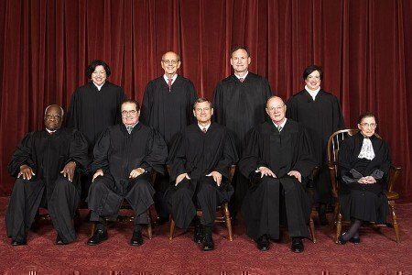
In the 5-4 decision, Alito said the closely held corporations cannot be required to provide contraception coverage under Obamacare if they had religious objections.
"Protecting the free-exercise rights of closely held corporations thus protects the religious liberty of the humans who own and control them," said Alito.
The decision is also narrowly focused on just the contraception mandate, and it doesn’t invalidate other parts of Obamacare.
Alito also stated that the federal government failed to prove that the contraception mandate was the least restrictive means of advancing its interest in guaranteeing cost-free access to birth control. But the decision also allowed the government to provide the same products to employees, instead of their employer.
"There are other ways in which Congress or HHS could equally ensure that every woman has cost-free access to the particular contraceptives at issue here and, indeed, to all FDA-approved contraceptives," Alito said.
In Hobby Lobby Stores v. Burwell, Hobby Lobby, a craft store chain, and its sister company, Mardel Christian bookstore, wanted an exemption from an Obamacare requirement that it provide insurance coverage for morning-after pills and similar emergency birth control methods and devices.
In Conestoga Wood Specialties Corp. v. Health and Human Services Department. a Mennonite family-owned, profit-making business claimed that the ACA’s birth control mandate violated the company’s rights under the First Amendment and the federal Religious Freedom Restoration Act (RFRA).
How did the Supreme Court rule on this case?

After reading about this case, would you change your answer to the 2nd scenario above? Explain.

Step 5: Read about another Supreme Court case

Case Summary: Masterpiece Cakeshop v. Colorado Civil Rights Commission

On December 5, 2017, the U.S. Supreme Court heard the case of Masterpiece Cakeshop v. Colorado Civil Rights Commission, a case about a baker who refused to sell a cake for a same-sex wedding reception because of his religious beliefs. The case began in 2012 when Charlie Craig and Dave Mullins, a same-sex couple, went to Masterpiece Cakeshop, a bakery in Lakewood, Colorado, to purchase a custom wedding cake for their wedding reception. The bakery owner, Jack Phillips, said that he would sell wedding cakes only to heterosexual couples because of his religious beliefs. The couple filed a lawsuit. A court in Colorado found that the bakery discriminated against the couple and ordered the bakery to provide for same-sex marriages. Colorado has a state law which prohibits businesses that are open to the public from discriminating based on characteristics, including sexual orientation. Mr. Phillips responded by arguing that the state’s anti-discrimination law forced him to use his artistic talents to bake a cake for same-sex couples, violating his constitutional rights to free speech and religious liberty. This led to the U.S. Supreme Court taking on the case for ruling.
In June 2018, the Supreme Court ruled in favor of Masterpiece Cakeshop owner Jack Phillips, finding that the Colorado Civil Rights Commission was improperly influenced by religious hostility when it ruled against him in his effort to refuse to bake a cake for a same-sex wedding. It is important to note, however, that the Court ruling was a narrow one that did not give businesses a constitutional right to discriminate. The Court reiterated the importance of the rights and dignity of LGBTQ individuals to be free from discrimination, and recognized that exemptions to anti-discrimination laws for businesses must be limited and confined.

Supreme Court rules for baker in wedding-cake dispute
June 4, 2018 by Scott Bomboy
A divided Supreme Court said on Monday that a Colorado baker and cake artist was wrongly censored by the state of Colorado for refusing to make a cake for a same-sex couple’s wedding party.
In the 7-2 decision, Justice Anthony Kennedy said in Masterpiece Cakeshop, Ltd. v. Colorado Civil Rights Commission that the Colorado Rights Commission incorrectly acted in its considerations that Masterpiece Cakeshop violated the Colorado Anti-Discrimination Act (or CADA).
“The laws and the Constitution can, and in some instances must, protect gay persons and gay couples in the exercise of their civil rights, but religious and philosophical objections to gay marriage are protected views and in some instances protected forms of expression,” Kennedy said.
Kennedy said the baker, Jack Phillips, was “entitled to a neutral and respectful consideration of his claims in all the circumstances of the case,” but the statements of some Colorado commission officials created doubts as to the neutrality of their decision.
“That consideration was compromised, however, by the Commission’s treatment of Phillips’ case, which showed elements of a clear and impermissible hostility toward the sincere religious beliefs motivating his objection,” Kennedy said. For those and other reasons, Kennedy said, “the Commission’s treatment of Phillips’ case violated the State’s duty under the First Amendment not to base laws or regulations on hostility to a religion or religious viewpoint.”
Phillips and his wife own a business in Colorado, where as a cake artist he designs cakes. In their court petition, Phillips’ attorneys note that due to his beliefs, Phillips had also declined to make cakes that celebrate Halloween, anti-American or anti-family themes, atheism, racism, or indecency. When approached by a same-sex couple about making a cake for their wedding, Phillips declined to design a cake with that message, but he offered to make any another cake for them that didn’t conflict with his beliefs.
Phillips had argued that the Colorado Act should be interpreted to allow him to refuse to design the cake under the Constitution’s free exercise of religion doctrine. A Colorado Appeals Court disagreed, upholding the commission’s ruling and saying the commission’s order didn’t violate the Constitution’s free exercise of religion clause.
How did the Supreme Court rule on this case?

After reading about this case, would you change your answer to the 2nd scenario above? Explain.

Step 6: Reflection

The Supreme Court often has to make decisions on very difficult and controversial issues. Ultimately the job of the Supreme Court Justices is to make a ruling that is in line with the U.S. Constitution. Think back on the two cases you read about today and choose one to answer the following questions about:

Do you agree with the Supreme Court’s decision? Why or why not?

Do you think the Supreme Court followed the First Amendment’s Free Exercise clause in their ruling? Why or why not?

Student Feedback:

Circle the emojis that best represents how this activity made you feel.

Week 8
Freedom

Day 4

NAME:______________________

Day 4 Agenda

Topic | Activity
Warm-Up!
English Language Arts | - Read two informational texts about School Policies on Appropriate Dress and Grooming.  - Answer questions about the texts
Science | - Read about if an Elephant Should Have Freedom  - Answer questions about what you read  - Draw a picture and explain
Mindfulness Moment!
Math | - Word Problems: Earlonne Woods: Freedom through Podcasting  - Skills: Fractions
Health | - P.E. Bingo
Mindfulness Moment!
Civics/Social Studies | - The establishment clause of the First Amendment

Warm-up Activity: Write a journal entry around the daily quote on identity.
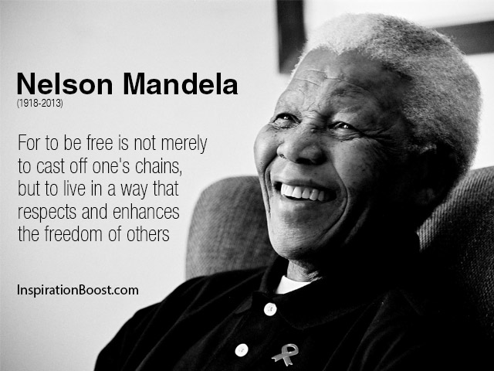

Day 4: Freedom of Expression
English Language Arts
NOTE: Teacher, leader, mentor: Both articles are lengthy. If possible, have some students read one of the articles while others read the other one. They can then discuss the general ideas and points of the articles.

What is this lesson about?
Today you will be reading about how schools and other institutions are being challenged about how they create and enforce student dress codes.

Step 1: Read the following article
As you read, think about how schools and other places regulate how students can express themselves through their appearance and dress.

Some vocabulary to review:
ultimatum: a final demand or statement of terms, the rejection of which will result in retaliation or a breakdown in relations. | Eurocentric: focusing on European culture or history to the exclusion of a wider view of the world; implicitly regarding European culture as superior | micro-aggression: indirect or unintentional discrimination against members of a marginalized group such as a racial or ethnic minority.
marginalized: treat (a person, group, or idea) as unimportant | implication: likely consequence of something. | Institutional: established as a norm in an organization or culture.
underscore: emphasize | subtle: indirect | overt: direct, obvious
perpetuate: to keep going |  | authentic: honest, true

When Natural Hair Wins, Discrimination in School Loses
BY BRENDA ÁLVAREZ
Late last year, a video of a black high school wrestler in New Jersey hit a public nerve when he was given an ultimatum by the referee: cut your hair or forfeit the match. Several news outlets reported that Alan Maloney, who is white, told Andrew Johnson that the cover he had over his hair was non-compliant. Johnson’s hair raised no previous concerns during a match four days earlier, but under pressure, Johnson decided to have his hair cut by the team’s athletic trainer.

The problem here runs deep. “This is not about hair. This is about race,” tweeted the ACLU of New Jersey. “How many different ways will people try to exclude Black people from public life without having to declare their bigotry? We’re so sorry this happened to you, Andrew. This was discrimination, and it’s not okay.” Anti-black hair sentiment in the U.S. has existed for centuries, with Eurocentric norms of beauty taking main stage. This sentiment is directly tied to institutional racism.

According to author Courtney Nunley, “school policies and microaggressions reinforce the idea that Black hair, as it naturally grows and as it has historically been styled, is ‘bad’ because it’s not white enough—and that those policies are part of a nationwide anti-Blackness problem,” she wrote in “Hair Politics: How discrimination against black hair in schools impacts black lives”.

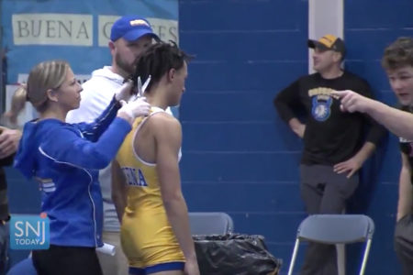
Angel Boose, an elementary school teacher in New Jersey recalls seeing the video of Andrew Johnson and feeling infuriated. “Students are coming to school to learn and participate in activities so they can become well-rounded individuals. These grooming policies make it difficult for students to simply feel comfortable and be their own authentic selves,” Boose says, “and they create another barrier particularly for African American students because clearly these rules don’t affect people of all races.”

While many, specifically black women, have fought against hair discrimination in the workplace by taking their employers to court, the problem is deeply rooted in our culture and it shows up in schools nationwide.

Black students have been asked to cut or straighten their hair to meet dress code policies. Some school districts have banned certain hairstyles, like locs and afros, while other districts have prevented students from attending school events—for example prom—for refusing to remove their braids. Kids have been kicked off school grounds, too.

“This is typical of those in power. They don’t see that something is an issue because they find themselves unable to relate, and since the issue is outside of their immediate experience, they doubt its validity,” explains Gerardo Muñoz, a high school social studies teacher in Denver, Colorado.

“Oppression comes in many forms. We have to believe the victims of this type of oppression. We have to listen to them and make changes where necessary,” he adds. Muñoz is also co-creator and co-host of the podcast “Too Dope Teachers and a Mic.”

Johnson’s incident, which occurred in December 2018, became a spark that led to California becoming the first state in the nation to ban discrimination against black employees and students based on their natural hairstyles.

Los Angeles Democrat Sen. Holly Mitchell wrote the language for the CROWN Act (Creating a Respectful and Open Workplace for Natural Hair) and said the law is about “inclusion, pride and choice,” reports the L.A. Times. The CROWN Act goes into effect on Jan. 1 2020.

“It’s a big win, because every systemic change to fight the effects of oppression and ignorance is a move toward a more just society. The type of body shaming that students of color and people of color in general endure requires a sustained organizing effort, which can only happen through policy changes that may build on the previous ones,” underscores Muñoz, an educator of nearly 20 years.

Banning Hair Discrimination
July 3, 2019 marked an important turning point for racial and social justice when California’s Gov. Gavin Newsom signed the CROWN Act into law, which now legally protects people in workplaces and K-12 public schools from discriminatory grooming policies.

This new law specifically protects African Americans who have historically experienced discrimination based on their hair. The act protects certain hairstyles, too, such as afros, braids, twists, cornrows, and locs.
Pushed Out: The Injustice Black Girls Face in School
Black girls make up 16% of girls in U.S. public schools, but 42% of girls’ expulsions. Monique Morris, author of “Pushout: The Criminalization of Black Girls in Schools”, discusses the forces that have made these students targets.

“[This issue] is played out in workplaces, played out in schools,” said Newsom during the signing ceremony. “Every single day, all across America in ways subtle and in ways overt.” The act is meant to stop these behaviors and practices. California officials are not the only ones to consider such protections.

New York became the second state to officially ban natural hair discrimination. In August, lawmakers amended the state’s Human Rights Law and Dignity for All Students Act, which makes it clear that discrimination based on race includes hairstyles or traits “historically associated with race, including but not limited to hair texture and protective hairstyles.”

New Jersey currently has a bill in the works, too. If passed, it will include protections similar to that of California and New York laws. New Jersey’s Angel Boose says laws that protect natural hair styles are necessary. “We need to name racism when we see it, call it out, and discuss it. Otherwise, we ignore it, pretend it doesn’t matter, and continue to perpetuate racism in a different form other than slavery and Jim Crow,” says the educator of 13 years.

It’s still too early to tell if other states will join California and New York. However, the CROWN Coalition, an alliance that includes the National Urban League, Western Center on Law & Poverty, Color of Change, and Dove, is planning to pursue legislation similar to the California measure in other states.

Color of Change is helping to expand federal protections to end hair discrimination nationwide and have created a petition to get more people involved in ending these unjust and racist practices.

Don’t Wait—Educators Can Take Action Now
While only two states now ban racial discrimination based on natural hair, educators don’t have to wait for legislatures to pass laws that address hair discrimination in schools. Hair discrimination is often included in dress code policies.

This year, for example, the Seattle School Board developed an inclusive dress policy districtwide for students. Previously, each school in the district set its own code, allowing for individual discretion and space for bias. Now, the same rules apply to all students.

According to Seattle’s new policy:
“Students should be able to dress and style their hair for school in a manner that expresses their individuality without fear of unnecessary discipline or body shaming; students have the right to be treated equitably [and] dress code enforcement will not create disparities, reinforce or increase marginalization of any group, nor will it be more strictly enforced against students because of racial identity, ethnicity, gender identity, gender expression, gender nonconformity, sexual orientation, cultural or religious identity, household income, body size/type, or body maturity.”

Adding inclusive hair policy explicitly to school board policy is an important protection against implicit and explicit bias. To learn more, go to NEA EdJustice.

Taken from: http://neatoday.org/2019/09/17/banning-black-hair-discrimination/

Step 2: Think and Respond
Many schools and programs for youth claim that they have different dress and hair policies because they want to make sure that students are getting ready for the work-force where they will be expected to follow certain rules. Do you agree? Why or why not? Explain your opinion.

Step 3: Read the following article

Before you read: Some vocabulary to review.
infraction: violation of a law or rule | debut: first appearance | vain: self-centered, conceited
cis-gender: relating to person whose personal identity and gender corresponds with their birth sex. | dictate: order | advocacy: public support for or recommendation of a particular cause or policy.
disparate: widely different | heed: pay attention to | constitute: make up
vague: not clear | lax: relaxed, not strict

Students are waging war on sexist and racist school dress codes — and they’re winning
Traditional dress codes punish marginalized students disproportionately, but this anti-racist, anti-sexist dress code could fix that. By Nadra Nittle Sep 13, 2018

Emma Stein was just a freshman when she was cited for a dress code violation at her school, suburban Chicago’s Evanston Township High School. A security guard said her dress was too short, so Stein had to pull a pair of sweatpants over her clothes. She was not punished for the infraction, but it was still a really upsetting experience.
“It added a level of insecurity to this already stressful time,” Stein recalled.
Stein wasn’t the only one troubled by the dress code at the 3,700-student school. In 2016, students staged a protest demanding a new policy that didn’t discriminate along gender or racial lines.
And the school’s administration listened. “We needed to look at getting a new dress code, and we wanted to make sure it was body-positive and didn’t marginalize students,” the school’s principal, Marcus Campbell, said.
In 2017, Evanston Township High School debuted its new dress code, which permitted tank tops, leggings, hats, and other previously banned items. The policy also stated that students were not to be marginalized based on race, class, gender, sexual orientation, or other identity markers.
The story of Evanston Township High School’s dress code is an increasingly common one. As dress code controversies sweep the education system, parents and students are fighting back against policies that they see as sexist, racist, or both. And more and more schools are listening to these protests, adopting guidelines that reflect a new understanding of what constitutes “appropriate” student dress.

Oregon NOW’s model dress code has had an international impact
Adopting a new dress code isn’t easy when most existing policies are several years old and contain many of the biases schools are edging away from now. So, the Oregon chapter of the National Organization for Women devised a model policy for Portland Public Schools that took effect in 2016 and has since spread across the country.
School districts such as Evanston’s District 202 and California’s San Jose Unified have either borrowed heavily from the dress code policy or adopted it outright. Praised for being inclusive, progressive, and body-positive, the Oregon NOW model may be the foundation for the dress code policies of the future.
“Boys can dress like girls, and girls can dress like boys,” explained Oregon NOW president Lisa Frack about the code. “You can be trans. You can be cis. Part and parcel on our mind is whoever you are, you can wear whatever you want.”
Within reason, that is. Clothing featuring images of drugs, alcohol, or obscenities is out, as is gang attire. Still, the dress code affords students a great deal of freedom to present themselves how they see fit. The main dictate is: “You have to cover your parts,” Frack said. But how students do so is up to them. They can wear short clothing, leggings, and tank tops — all garments that have been the source of school dress code conflicts.
Oregon NOW turned its model into Portland Public Schools’ official policy by approaching the school board about it during a 2015 meeting where students raised complaints about the existing code, Frack said. The board quickly agreed to form a working group, a mixture of Oregon NOW members and educators, to develop new guidelines. A few months later, the board agreed to implement the model for the 2016–2017 school year. Frack calls the dress code “the fastest advocacy” she’s worked on to date.
The policy has sparked interest from school officials in both the US and Canada, Frack said. Administrators from Evanston’s District 202, which consists only of Evanston Township High School, reviewed the Oregon model after 300 students protested and asked for changes to be made to the previous policy.
The demonstration prompted Campbell, assistant superintendent as well as principal, to research alternatives online, leading him to the Oregon NOW dress code. He and four Evanston Township High School assistant principals looked over the dress code piece by piece to see if it aligned with the high school’s values. They agreed that it did, and so they presented it to the superintendent, who signed off on it. The new policy took effect during the 2017–2018 school year.
The Oregon model also allows students to wear their hair as they please, an ongoing issue for both African Americans and Native Americans in schools. As recently as August, two religious schools faced criticism for telling black children they couldn’t attend classes because of their hairstyles. At A Book’s Christian Academy in Florida, school officials turned away a 6-year-old black boy for wearing dreadlocks. His family ultimately withdrew him from the school. Later that month, an African-American girl at Christ the King Elementary School in Terrytown, Louisiana, was forced out of class for wearing her hair in braided extensions, a popular black hairstyle that school officials said they banned over the summer.
Hearing about these sorts of dress code scandals drove Oregon NOW to write its model policy. “There was no answer,” Frack said. “Everybody’s got the problem, but what’s the answer? We’re a super small organization, but we thought we could do something besides saying, ‘Doesn’t this stink?’ We could write a model code, and it could be progressive, feminist, and anti-racist.”
Historically, school dress codes in the US have been anything but. While many schools continue to impose dress codes shaped by outmoded race, class, and gender constructs, a growing number are addressing how their policies disproportionately affect certain groups of students more than others, and they are letting students dress mostly as they please.

Students are challenging schools to devise fair and equitable dress codes
Dane Caldwell-Holden, director of student services for the San Jose Unified School District, didn’t realize how dress codes targeted certain groups of students until his district came under fire for its policy. “I’ll be honest,” he said. “As a teacher and administrator, I never gave a thought about that.”
Then, in 2015, a female student was pulled out of class and told to change into a baggy pair of shorts because hers didn’t pass the “fingertip test.” (Many schools say that shorts, skirts, or dresses are too short if they don’t hang past a student’s fingertips.) Humiliated, the student decided to fight the dress code. She and her mother spoke to school officials about how the policy harmed girls, and the following year, her mother sent Caldwell-Holden a link to Oregon NOW’s model.
After they reviewed that policy, district officials and school principals reviewed and revised the policy over several months. In June 2017, the board voted to approve the new dress code.
The new policy permits spaghetti straps, halter tops, and short shorts. The previous code in his district had been in use for about 15 years, Caldwell-Holden said, pointing out that’s the case for a number of California districts. Typically, the state develops some sample codes, and school districts adopt one.
“Board policies tend to be replicated,” Caldwell-Holden said. “When you look at dress codes, they all look remarkably similar.”
The old San Jose dress code was never meant to body-shame girls, he said, but to prevent youth from wearing truly disruptive apparel to school. He considers such clothing to be gang attire or T-shirts with violent or profane messages. Rather than direct their attention to these sorts of violations, faculty members unevenly applied the dress code, citing girls nearly all of the time.
“That was completely unfair,” Caldwell-Holden said.
Since about 2010, the disparate impact that school dress codes have on girls and young women has received more attention,
“It’s probably the accumulation of a number of policy streams,” Todd DeMitchell, a professor from the University of New Hampshire, said. “And stories of female students disproportionately being singled out over male students started to be put into more of the popular press. It’s no one single thing, but we do see the news reporting a number of shaming incidents based on student attire.”
He recalled that in 2014, an Orange Park, Florida, high school student was forced to wear a “shame suit” consisting of a shirt and pants printed with the words “dress code violation” because the school considered her clothing too short. The story became national news fodder, complete with photographs of the student in the humiliating outfit.
Whether student complaints about dress codes go viral or stay local, they have the power to effect change. Carrie Truitt, a member of the Marion County school board in Kentucky, became interested in adopting a new dress code after a 5-foot-10 high school student, who was wearing business attire for Dress for Success Day, was told her dress was too short. The student’s father complained, arguing that male students who wear shorts the same length as his daughter’s dress do not receive citations. Truitt thought the parent had a point and began researching dress codes, leading her to Oregon NOW’s model.
“We have a little bit of bias in enforcement,” Truitt admitted. “I don’t know if we can go as far as Oregon NOW in Kentucky; you have to take into account perceptions and beliefs.”
For example, the idea that a tube top is acceptable to wear to school might rub some community members the wrong way, she said. But Marion County is a fairly liberal community, and school leaders will likely take an interest in a progressive new dress code if they know girls typically get the most citations, Truitt explained.
Not every school or district is open to changing its dress code. In fact, some schools continue to spark controversy with policies that shame female students and police their bodies.

LGBTQ youth are vulnerable to school dress code policies
Schools nationally have tried to prevent LGBTQ youth from wearing their preferred attire to prom, homecoming, graduation, and other high-profile events. But choosing clothing for school can be a daily struggle for gender-nonconforming students because dress codes have historically served to make students heed traditional gender roles. And a scan of school dress codes from several decades ago make it clear how administrators viewed gender through a narrow lens. Policies dictated that girls wear skirts, dresses, or blouses.
But boys had to conform to strict gender roles, too. In the early 1960s, the dress code at Pius X High School in Downey, California, cautioned boys as follows:
“Two extremes are to be avoided: both a careless, untidy appearance, and a vain, effeminate use of extreme fashions. What the school seeks to promote in a student is a clean, neat, well-groomed, manly appearance.”
The expectation for a “manly appearance” is why boys, regardless of gender identity or sexual orientation, continue to face school earring bans. Plus, some schools, such as North Carolina’s public K–8 Charter Day School, require girls to wear skirts.
Increasingly, students are challenging gender-based dress codes, and GLSEN (formerly the Gay, Lesbian & Straight Education Network) is one of many organizations advocating for them. In 2015, it updated its model district policy for transgender and gender-nonconforming students. The policy includes guidance about student attire, stating that dress codes may not be based on gender and that students have the right to dress in accordance with their gender identity. Moreover, schools can’t use dress codes to target transgender and gender-nonconforming students.
Ikaika Regidor, GLSEN’s director of education and youth programs, said that he understands that schools have dress code policies to prepare students for adulthood and the workforce, but the enforcement of the policies is often problematic.
“We ended up getting into a place in which some groups of students end up getting hurt more than others,” he said. Students feel, “I’m coming to school. I’m being my authentic self,” only to be told they can’t, he continued.
Regidor said that schools need more training and need to streamline who enforces dress codes. Doing so ensures the staffers imposing these policies on students have the tools to do so fairly, properly, and sensitively to gender-nonconforming youth. GLSEN offers training to schools and educates students about their rights as well. The organization teamed up with the ACLU to give youth a wallet-sized card they can show to administrators who wrongfully cite them for dress code violations.
To avoid litigation, more school districts have implemented gender-neutral dress codes. In 2015, Puerto Rico, where students wear uniforms, changed its policy to permit boys to wear skirts and girls to wear pants. It’s a move GLSEN urges more school systems to make. Regidor said some school officials are ignorant about best practices for dress codes and LGBTQ youth. But once they’re educated, they stop enforcing discriminatory policies. Sometimes, though, the discrimination is intended.
“We could try to train them,” he said. “We could try to change hearts and minds, but we also know there are some administrators who have biases. There’s still work to be done by schools, by states.”

Disciplined for wearing braids to school
Deanna and Mya Cook object to how dress codes have long regulated both gender and race. The twins attend a Boston-area charter school that dictates skirt length, shoe color, nail polish, and makeup. But the girls never thought they’d get in trouble for wearing braided extensions. Last year, that’s exactly what happened.
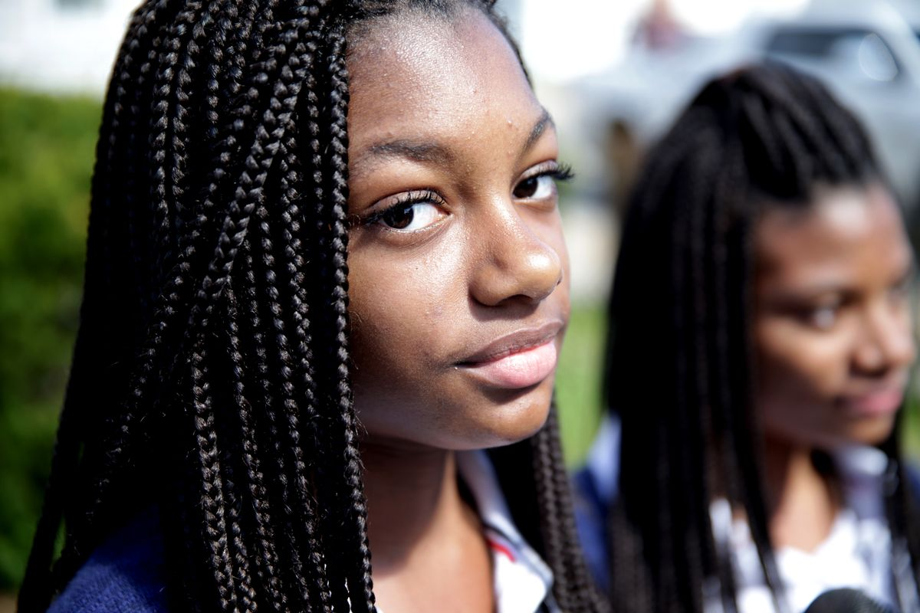
Adopted by white parents, the girls said they got braids for the first time to connect with their African-American heritage. When they showed up at Mystic Valley Regional Charter School with the hairstyles, however, the school disciplined both girls, now 17. Mystic Valley did not respond to Vox’s request for comment about its dress code.
“When we came back to school, we were told braids were not allowed,” Mya said. “They were inappropriate, drastic, needed to be fixed. It really hurt me to my core. I didn’t know what to do because braids meant a lot to me, and they kept telling me to take them out.”
She thought she’d be expelled, and no one would be the wiser. But the school’s treatment of the Cook sisters garnered media attention, and the ACLU, the NAACP, and other groups advocated for the girls.
After a complaint was filed with the state accusing the school’s dress code of being discriminatory, Mystic Valley relented. The school now permits braids, but the twins say it has implemented new rules they believe are retaliatory. Black hair ties, the most common color available in stores, are forbidden; students must wear either navy blue or white hair ties to match the school uniform colors, they said. The girls are not allowed to accessorize their braids with clips, clasps, or beads either.
Similar incidents keep happening to black girls, who are disproportionately pushed out of school due to dress code violations, according to the National Women’s Law Center “Dress Coded” report. Their bodies, hair, and hair accessories such as head wraps are policed more, the study found.
“Many dress code policies include a lot of vague and subjective language that really rubs against our biases,” said Nia Evans, NWLC’s manager of campaign and digital strategies for education. “They include words like ‘appropriate,’ ‘not distracting.’ Because of racism and sexism, I think there are black girls who have kinky, natural hair and are not perceived as clean or appropriate.”
She said rigid dress codes signal to female students that their bodies are a problem. Black girls are uniquely vulnerable because they’re already more likely than other female students to be suspended from school. Evans argues that forcing them out of class for any reason increases their chances of quitting school and entering the prison system. Accordingly, missing class because of dress code citations may have serious consequences.

Concerns about liberal dress code policies
As schools implement new dress codes in an effort to make these policies more equitable for students, they still contend with some doubts and concerns from community members. When San Jose Unified updated its dress code, some school officials and parents feared that a more lax policy would result in girls showing up to school in attire more fit for the nightclub than for school. Caldwell-Holden says that hasn’t happened. Instead, he rarely hears about schools issuing dress code citations and no longer receives complaints from students about the policy.
So far, the district has received just one nasty comment about its new code, he said. Sent in August 2017, it said, “I am just writing to say how disgusted I was to read … that halter tops, spaghetti straps, and short shorts will be allowed in school now. Seems to be that you are following in the new California tradition: slut everything up and dumb everything down.”
But there was a twist. The writer ended the comment by remarking, “I’m sure glad I don’t have kids in school.”
Actual parents have been highly supportive of the change, according to Caldwell-Holden. A few have worried that it might be harder to get kids to follow the rules they set at home about appropriate dress, but that’s it, he said.
While some community members worried that students would dress provocatively, others feared that a less formal code would fail to prepare students for professional life.
But, Frack pointed out, “We’re not raising all of our kids to work in a bank. Some are going to have jobs where they don’t have a collar.”
Good school dress codes show compassion for students and begin with an equity statement, according to the “Dress Coded” report. Evanston’s District 202 dress code states that it “does not reinforce stereotypes and that [it] does not reinforce or increase marginalization or oppression of any group based on race, sex, gender identity, gender expression, sexual orientation, ethnicity, religion, cultural observance, household income or body type/size.”
“Dress Coded” recommends that policies be culturally sensitive, gender-neutral, body-positive, and not shame students. The report also calls for all staff members who enforce them to receive training. Because most schools don’t collect data about dress code citations, the NWLC advises them to start doing so. A record of these citations gives the public an idea of which students are most often cited and why. Additionally, the organization urges schools to give students a say in dress code policies.

How District 202 changed after updating its dress code
Two years ago, Emma Stein protested outside the District 202 superintendent’s office in a bid to get Evanston Township High to change its dress code. An 11th-grader then, Stein remained at the high school after the Oregon NOW model went into effect her senior year. When the school transitioned to its new dress code, Stein realized that getting dressed in the morning was no longer stressful.
“The amount of anxiety I personally had about even wearing a skirt my grandmother bought me dropped,” she said.
Now in her first year at Northwestern University, Stein recalled how each morning at Evanston Township High, a security guard would scan the students entering campus for dress code violations. The day she received a citation, Stein had been excited to attend an assembly about racial equity. In the end, she found herself derailed by a dress code that framed her appearance unfit for school.
About five years have passed since then, but Stein said the day of her dress code citation is burned into her memory because it caused her such embarrassment. Still, she knew she wasn’t the only girl with the same experience. Stein said she routinely saw other girls pulled aside by female security guards and teachers because of their dress. The fact that so few boys ever received dress code citations made her question the fairness of the policy.
When the more liberal code took effect, “The attire of the students didn’t change very much,” Stein said. This was the outcome Marcus Campbell expected. He said he believed in his students enough to know they wouldn’t abuse the new policy.
“We’re happy people have found it affirming, so they can focus on learning,” he said.
Campbell and Stein described the first day of school under the new code similarly. Both remember the tension on campus dissipating.
“It felt so great,” Campbell recalled. “That feeling is still palpable. It’s so great to have the administration listen to some very reasonable guidelines.”
Now, it’s largely up to students and their parents to determine which attire works best for school, he said.
Stein said that when the current dress code rolled out, students appeared lighter, less burdened. “It was such a dramatic change,” she said. “The change was almost tangible. At least for me, when this policy was amended, there was this collective sigh of relief.”
Adapted for length from: https://www.vox.com/the-goods/2018/9/13/17847542/students-waging-war-sexist-racist-school-dress-codes
Step 4: Think and Respond

Do you believe that dress codes are necessary? Why or why not?

Student Feedback:
Circle the emojis that best represents how this activity made you feel.

Day 4: Should an Elephant Have Freedom
Science

What is this lesson about?: Today you will read through the Lawyers argue Happy the elephant should have right to freedom passage. You will answer a few questions about what you read. You will complete an activity.

Step 1: Read through the passage

Lawyers argue Happy the elephant should have right to freedom
(The Guardian, 2019)

Lawyers representing an elephant say she is being detained by the Bronx Zoo ‘illegally’ due to her personhood
Happy the elephant at the Bronx Zoo in New York City on 2 October 2018. Photograph: Bebeto Matthews/AP

Lawyers representing an elephant have argued in New York court that their trunked client be considered a person, in a fresh attempt to upend human dominance over this designation.

Happy the elephant is, contrary to her sunny name, being detained by the Bronx Zoo “illegally”, due to her personhood, and must be released, according to her self-appointed legal team.

The case’s instigator, an animal rights group, hopes it will effect a legal breakthrough that will elevate the status of elephants, which the group calls “extraordinarily complex creatures” similar to humans that should have the fundamental right to liberty.

On Monday, the Bronx supreme court was the latest stage in what has been a quixotic pursuit of animal personhood by the Nonhuman Rights Project. Steven Wise, the founder and lead attorney of the group, has led a quest that is dogged – appropriately, as he has ruminated that dogs may be “legal persons”, too – to confer personhood on a pair of chimpanzees and now Happy.

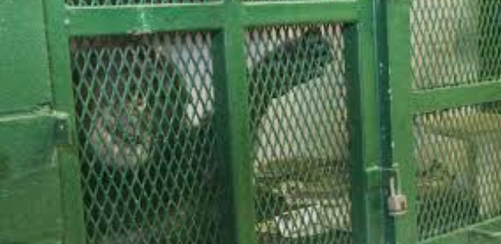
Wise has yet to taste success. In 2017, a New York appeals court ruled that Kiko and Tommy, two chimps in their 30s kept in captivity in the state, could not be considered persons in order to invoke habeas corpus – the right to avoid unlawful detention.

A presiding judge wrote that while chimps share many fundamental characteristics of humans, it would be difficult to hold any ape to account for its personhood by arresting and prosecuting it for a crime. A further blow to Wise came in August, when a Connecticut court similarly decided that three elephants – Beulah, Minnie and Karen – could not be deemed persons.

Undeterred, Wise is now arguing on behalf of Happy, an animal that scientists found can recognize herself in a mirror. The 47-year-old elephant has spent almost all her life in a one-acre enclosure at the Bronx Zoo after being captured along with six other calves – named Sleepy, Grumpy, Sneezy, Doc, Dopey and Bashful – in Thailand and brought to the US.

Happy and Grumpy cohabited until 2002, when they were relocated to an enclosure with two other elephants – Maxine and Patty. This arrangement turned sour when Maxine and Patty fatally attacked Grumpy. Happy has never been able to live contentedly with the duo, with a recent reconciliation attempt ending badly.

Happy’s lone captivity is anathema to the intricate social arrangements elephants have in the wild, according to experts cited by the Nonhuman Rights Project, which wants her relocated to a far larger sanctuary in California that has other elephants.

“Wouldn’t that just be like a larger prison?” asked the Bronx supreme court judge Alison Tuitt, who earlier in proceedings remarked that she had watched a TV show in which a lemur attacked its own reflection in the mirror.

“That’s a bit like saying the Earth is a prison,” Wise replied. The two later had an inconclusive exchange over whether a guide dog could claim personhood.

During lengthy testimony, Wise compared Happy’s situation to the plight of slaves in the US, who weren’t considered fully human, and pointed out how a river in New Zealand and a Colombian portion of the Amazon rainforest have been granted human-like rights. “She is one depressed elephant,” Wise said of Happy, unhappily. “She’s being harmed every day.”

The Wildlife Conservation Society (WCS), which runs Bronx Zoo, strongly rejects any notion that Happy is distressed or badly treated. Jim Breheny, the zoo’s director, has called the lawsuit “ludicrous” and said the Nonhuman Rights Project is “exploiting the Bronx Zoo elephants to advance their own failing cause”.

WCS said that Happy is not kept in isolation given that she has tactile contact with Patty through a barrier, to ensure neither elephant is hurt. The conservation organization said that Happy is “subordinate in nature”, is comfortable with her keepers and likely to be bullied by other elephants if she were to be moved. The zoo has declined to add additional elephants for the past decade.
“It would be irresponsible and risky for Happy’s wellbeing for us to bow to uninformed outside voices with political agendas,” a WCS spokesperson said.

Polling of Americans has shown strong support for granting animals the same rights as humans, with the concept also backed by some philosophers who argue that animals have moral standing and shouldn’t be considered merely as property.

US courts, however, disagree and critics have claimed unintended consequences of animal personhood, such as the potential erosion of rights of disabled people, and difficulties defining which animals deserve rights and who speaks for them.
The idea of “freedom” from humans may also be more opaque at second glance. On Monday, across the road from the court in the Bronx’s Joyce Kilmer Park, starlings cavorted in the bubbling water of a grand fountain dedicated to the German poet Johann Heine. The contrast with Happy, and other captive animals, would appear obvious.

But in the past month it has been revealed that human activity in North America has wiped out an incredible one in four birds since 1970. Two-thirds of the remaining species face being obliterated due to the climate crisis. There may be freedom, even an outpouring of what may look to us as joy in the weak autumn sunshine. But there’s not much escape.

Happy’s case will plod on regardless, with the further court date set for January.

Step 2: Answer questions about what you read

- Do you believe Happy the elephant should be free? Why or why not?

- Do you believe animals and humans should have the same freedoms? Why or why not?

- What’s something new you learned as you read through this article?

Step 3: Draw a picture/explain

What can you design to make sure animals have their appropriate freedom? Draw a picture and write a description of your design.

___________________________________________________________________________________________________________________________________________________________________________________________________________________________________________________________________

Student Feedback:

Circle the emojis that best represents how this activity made you feel.

Mindfulness Moment!

One of my favorite memories is…

Day 4: Fractions/Freedom
Math
What is this lesson about?: Today you will continue to learn about adding and subtracting fractions.

Warm Up and Review Problems:
Earlonne Woods spent over 20 years locked up in prison in California. A few years ago, while incarcerated at San Quentin State Prison, he started working and learning about sound production. He met a woman named Nigel Poor who was volunteering there as an art teacher. They ended up creating an award winning podcast called Ear Hustle, which is all about life inside of the prison.

In November of 2018, Earlonne was pardoned by the Governor Brown of California, earning his freedom after all those years. He now lives and works in the Oakland area. He loves his freedom, even though making ends meet can be tough for him.

Earlonne was shocked to learn how expensive it is to live in northern California. Even with lots of help and subsidized rent, housing costs are expensive.

Here are some of his monthly bills:
Rent: $1400/month
Utilities: $200/month
Cell phone: $50/month
Transportation $5/day to get to and from work (Mon-Friday)
Groceries, etc $75/week

How much money does Earlonne have to spend each month just to pay his basic bills?
If Earlonne decides to go out to dinner 1x per week and that dinner costs $15...how much will that cost him in a month?

Earlonne earns a pretty good salary now. He is paid $65,000 per year to keep producing the show. He end up paying about 30% of that in taxes all total.
- How much does he pay in taxes?
- How much does he have for ‘take-home’ pay?
- How much is that per month?
- How much money does Earlonne have each month after he pays his basic bills from above?
- What are some fun things Earlonne might be able to do with that ‘extra’ money?
- What are some things you think he might want to be saving money for?

When asked what he likes best about being free in an interview, Earlonne said: “It’s impossible to narrow it to one thing. My apartment, learning how to use a cell phone, being able to hug my nephew and niece, going out on a date, sitting down at a restaurant…I’m working hard, but living real well…”
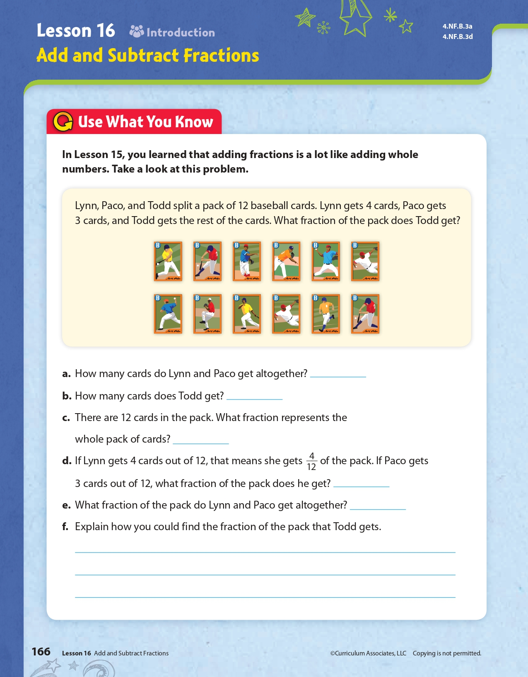
Activities/Fraction Problems: Complete the following fractions worksheets.
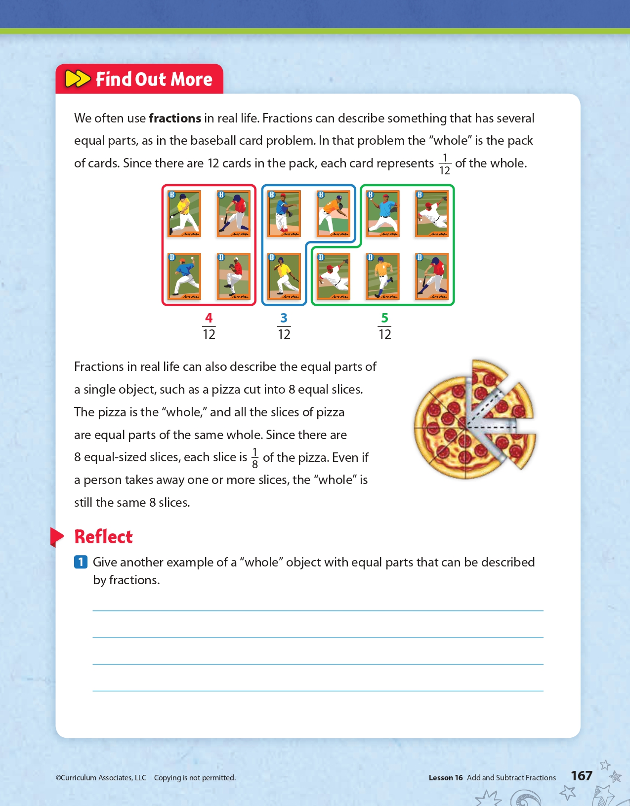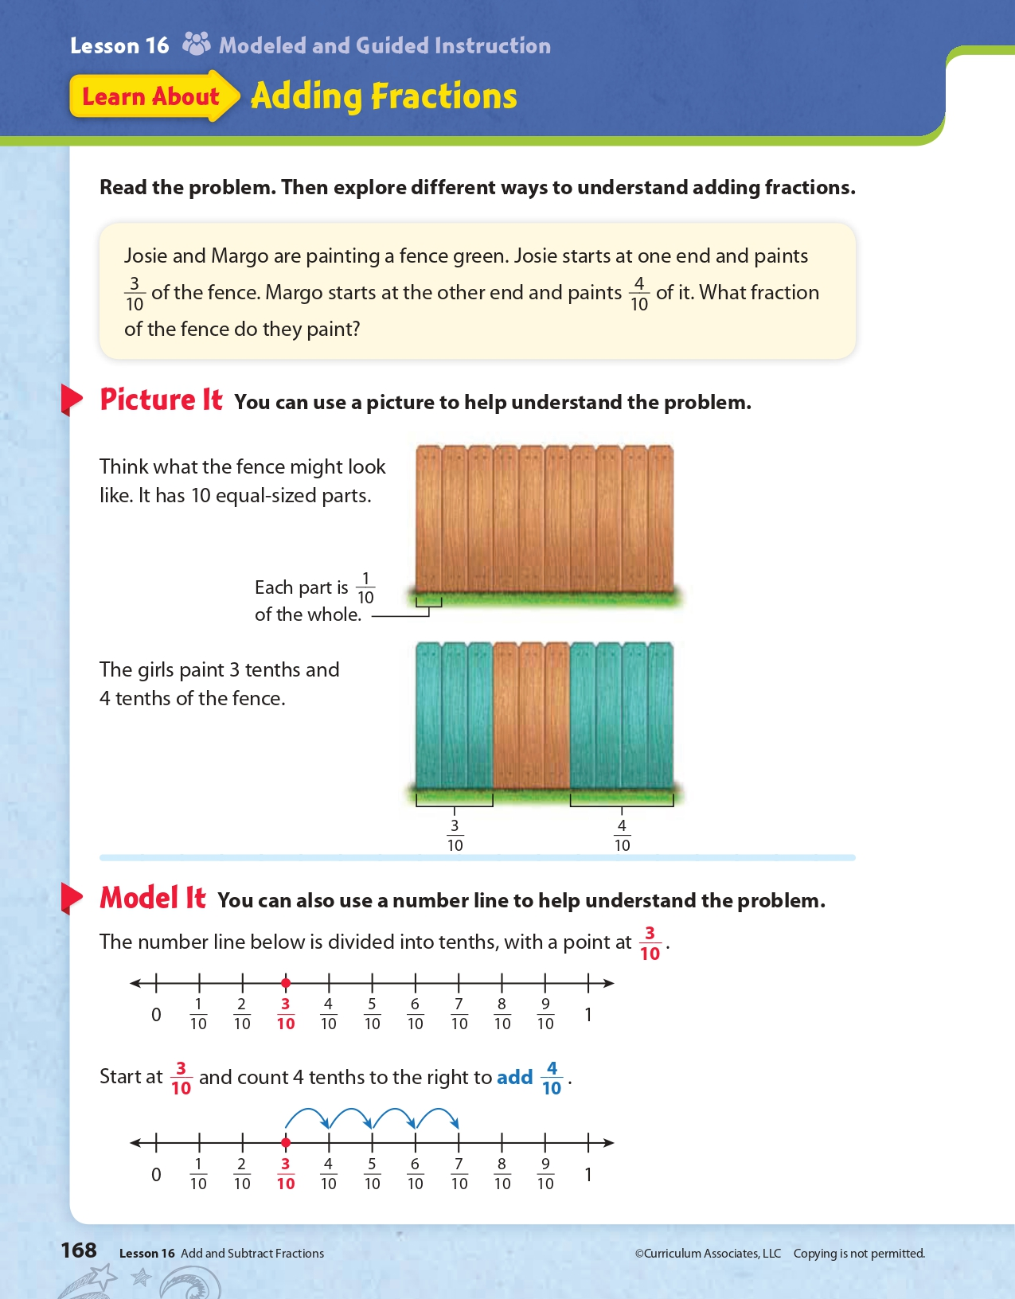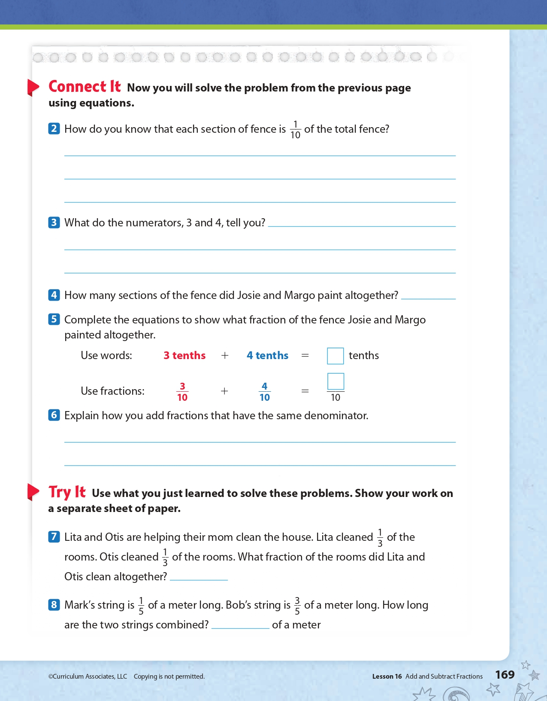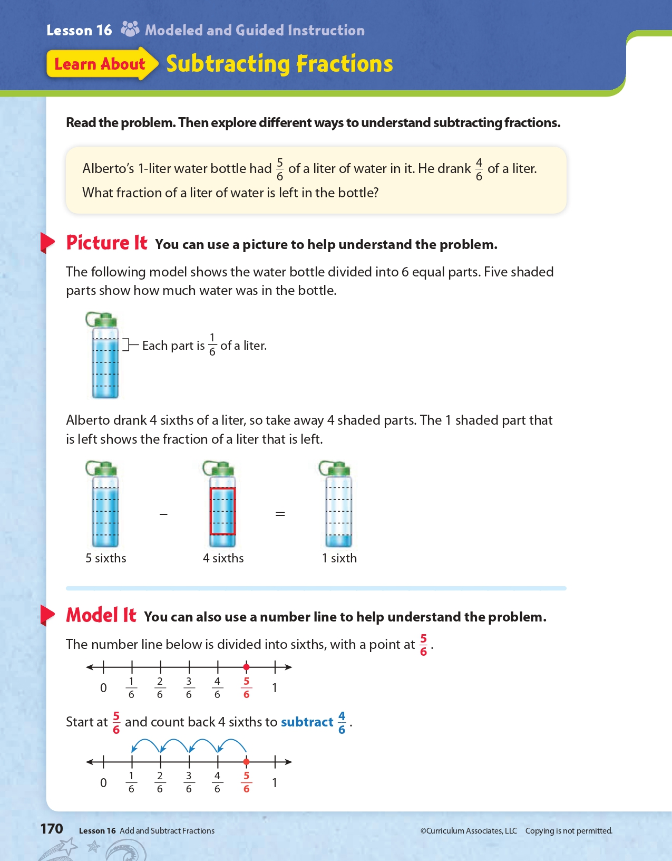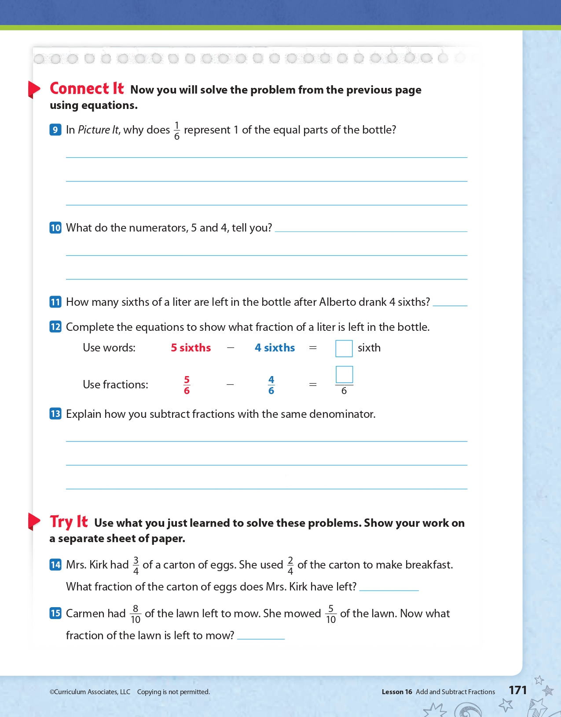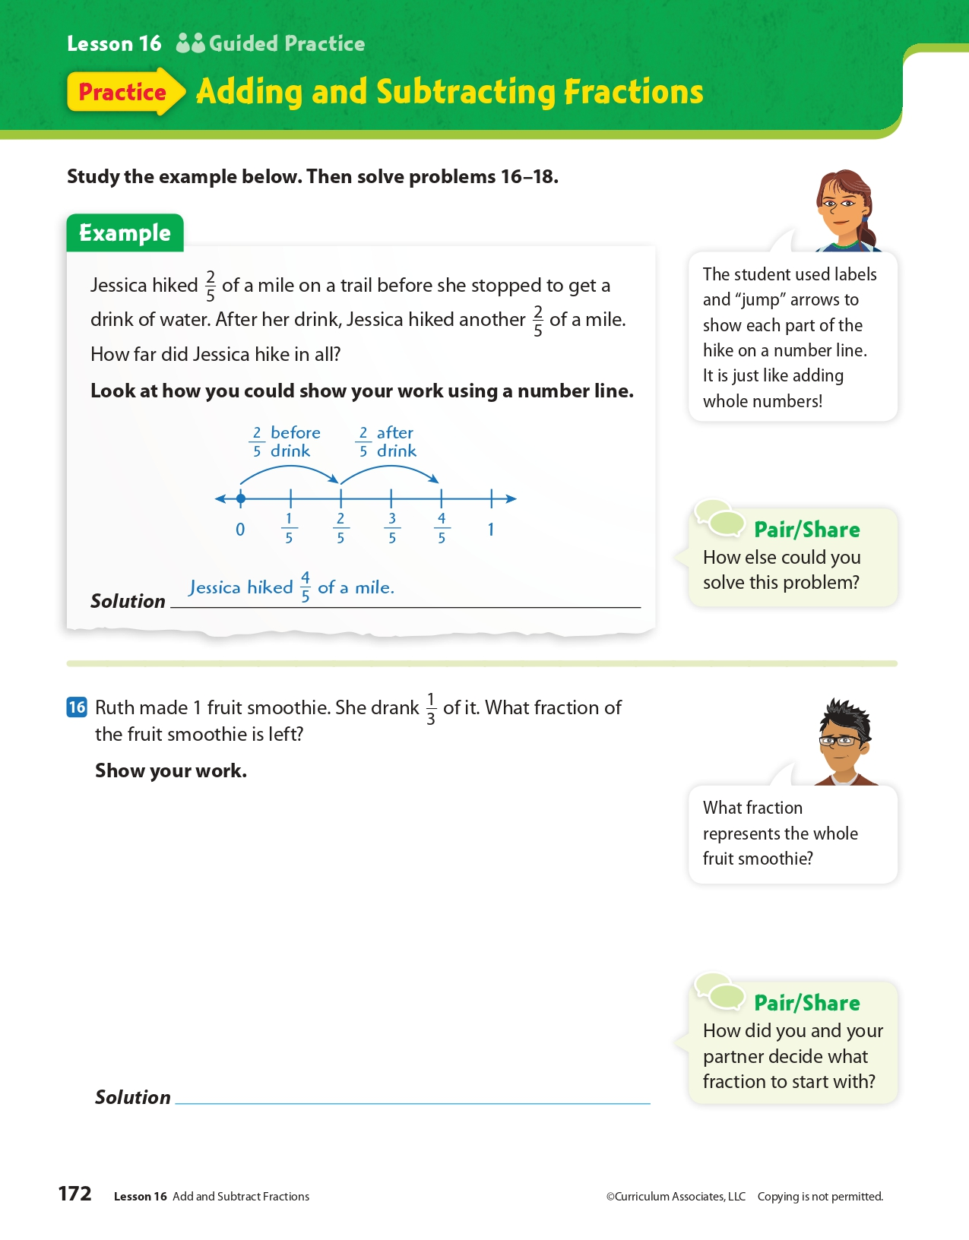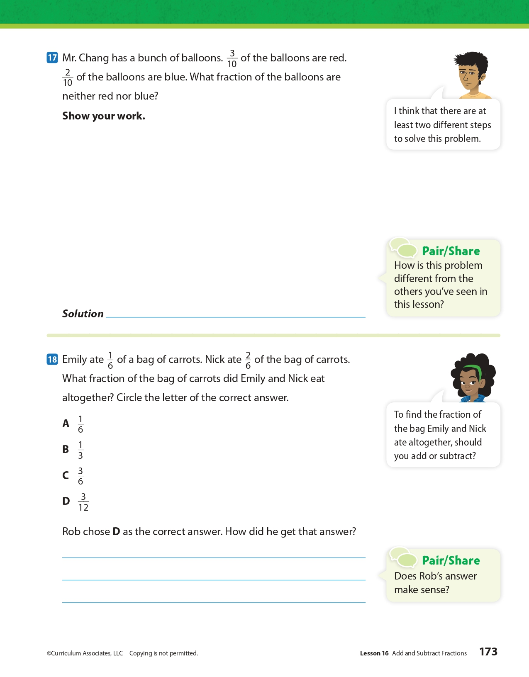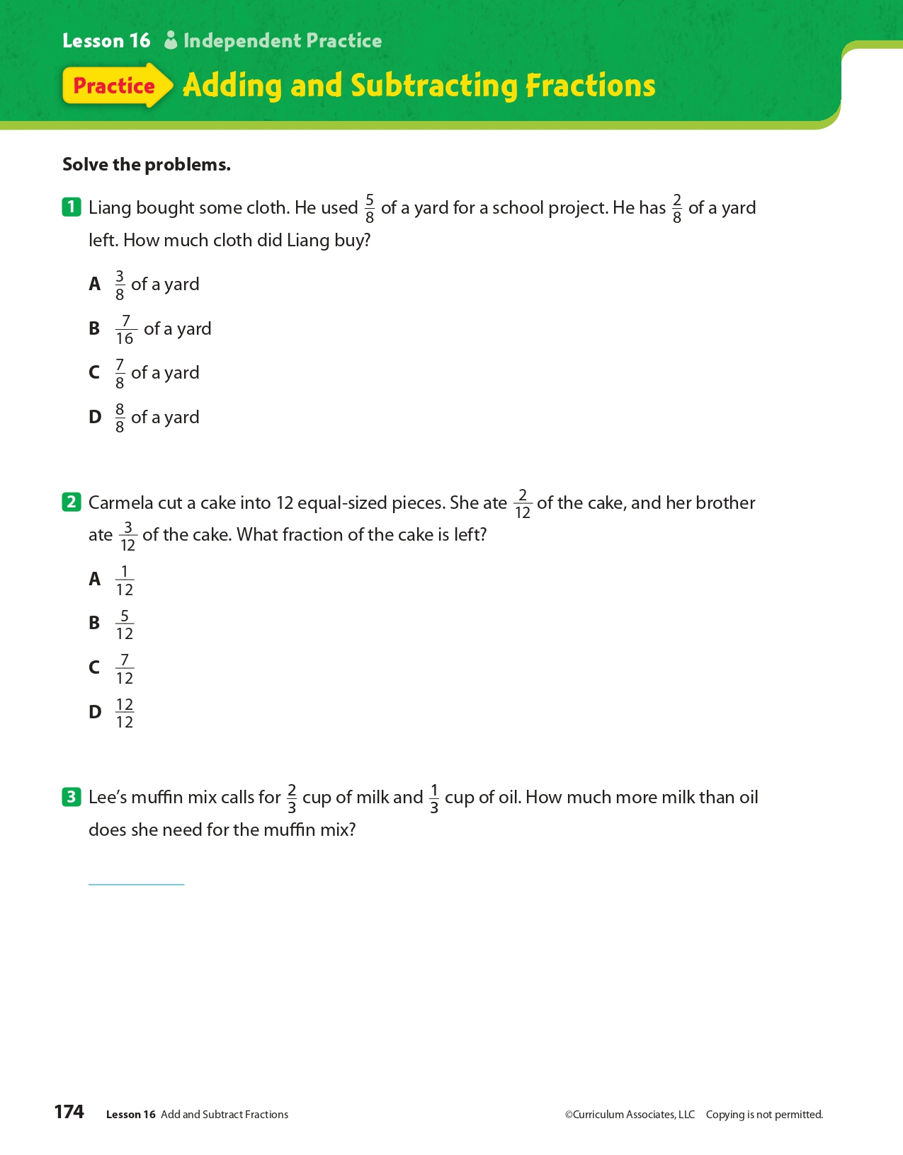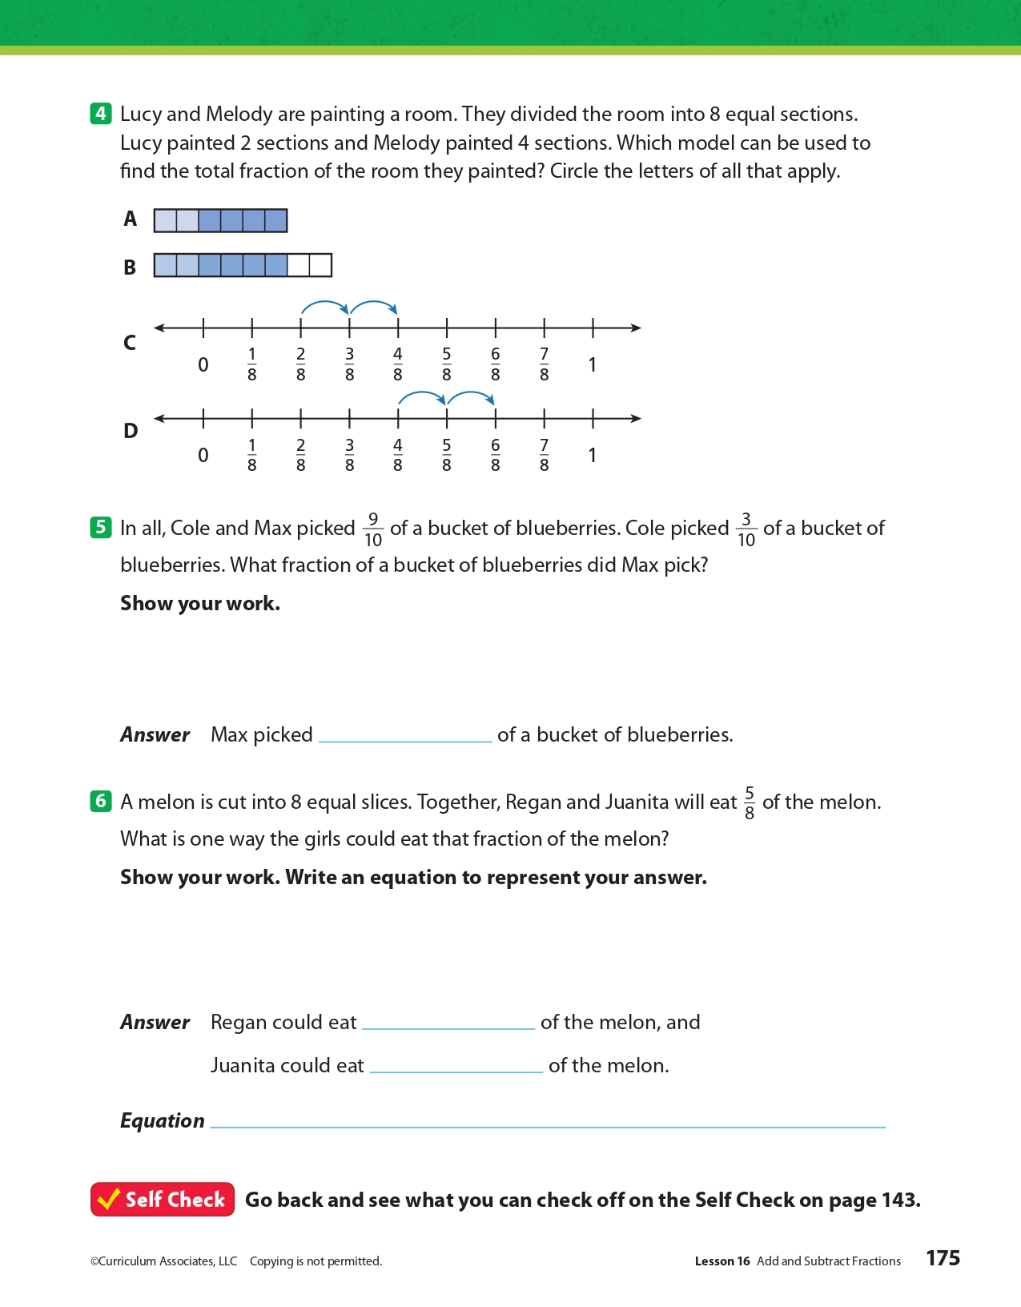
Day 4: PE
Health

What is this lesson about?: In today’s lesson, you will work on your PE BINGO card.

Step 1: Try to complete the PE BINGO card.

Student Feedback:
Circle the emojis that best represents how this activity made you feel.
Mindfulness Moment!

A song that makes me want to get up and dance is…

Day 4: Establishment Clause of 1st Amendment
Social Studies

What is this lesson about?: Today you will learn more about the ‘Establishment’ clause of the 1st Amendment. You will consider situations that raise issues related to the clause and you will see how the U.S. courts have ruled over those issues.

Step 1: Warm-up on religious liberty

A store clerk who is a Seventh-day Adventist is scheduled to work on a Saturday, his Sabbath. Despite the willingness of a coworker with the same level of experience to switch shifts with him, his supervisor tells him that he must work Saturday or be fired. What do you think?

Step 2: Revisit the Establishment clause of the 1st Amendment

“Congress shall make no law [1] respecting an establishment of religion or [2] prohibiting the free exercise thereof.”

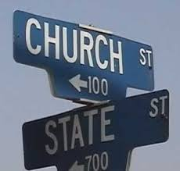
During colonial times, the Church of England was established by law in all of the southern colonies, while localized Puritan establishments held sway in most New England states. In those colonies, clergy were appointed and disciplined by colonial authorities and colonists were required to pay religious taxes and (often) to attend church services. Dissenters were often punished for preaching without a license or refusing to pay taxes to a church they disagreed with. Delaware, New Jersey, Pennsylvania, Rhode Island, and much of New York had no established church.

After Independence, there was widespread agreement that there should be no nationally established church. The Establishment Clause of the First Amendment, principally authored by James Madison, reflects this consensus. The language of the Establishment Clause itself applies only to the federal government (“Congress shall pass no law respecting an establishment of religion”). All states disestablished religion by 1833, and in the 1940s the Supreme Court held that disestablishment applies to state governments through the Fourteenth Amendment.

Adapted from the National Constitution Center

Step 3: Consider the scenarios

- A football coach at a public high school was put on paid administrative leave and was not allowed to coach the football team after leading students in voluntary prayers before and after games.

Do you think this violates the Establishment Clause based on the text of the First Amendment? Why or why not?

- A state constitution prohibits state funding from going to religious institutions. A religiously operated school applies to receive funding to receive materials made from used tires for a playground, arguing that the specific benefit has no relation to religion. Can the state prevent the religiously operated school from receiving the playground materials?

Do you think this violates the Establishment Clause based on the text of the First Amendment? Why or why not?

Step 4: Read about a Supreme Court case

Case Summary: Trinity Lutheran Church of Columbia v. Comer
The Bremerton (WA) School District suspended, and later fired, Coach Kennedy over his silent, 15-second prayer. First Liberty Institute filed a lawsuit against the school district, Kennedy v. Bremerton School District. A federal district court upheld Coach Kennedy’s termination. On appeal, a three-judge panel of the U.S. Court of Appeals for the Ninth Circuit concluded that, because Coach Kennedy could be seen by students and fans engaging in religious expression, the school lawfully terminated his employment and his silent prayers were not protected by the Constitution. In January 2019, the Supreme Court of the United States declined to review Coach Kennedy's case but the case has returned to the District Court to answer some of the questions raised by the Justices. Upon re-hearing, the District Court again sided with the school district setting up a return to the Ninth Circuit.

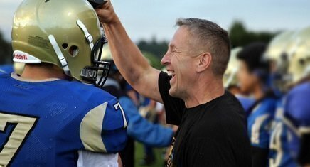
Ex-football coach loses federal appeal over prayer case
August 25, 2017 by Scott Bomboy
A former Washington state public high school football coach has lost his latest court battle over his right to lead prayers on the gridiron after games.
We first wrote about the case of former Bremerton High School assistant coach Joseph Kennedy back in October 2015. At the time, the school district put Kennedy on paid administrative leave. The district didn’t agree with Coach Kennedy’s practice of leading voluntary prayer on a publicly owned football field.
Back then, Kennedy's lawyers said they planned to go to court. And nearly two years later, the case has made it to the federal Ninth Circuit Court of Appeals after Kennedy lost in the United States District Court for the Western District of Washington.
On Wednesday, the three-judge Ninth Circuit appeals court panel upheld the lower court’s decision against Kennedy, who sought an injunction against the school district seeking his reinstatement as a coach and the resumption of his prayer practice after his reinstatement.
The appeals court decision stated that Kennedy didn’t apply for a coaching position for the 2016 season after the team’s head coach left. The school athletic director also recommended that Kennedy not be rehired, said the court documents.
Kennedy’s attorneys filed suit in the Western District in August 2016. He claimed his rights under the First Amendment and Title VII of the Civil Rights Act of 1964 were violated.
The lower court denied the injunction request because it believed Kennedy as a public employee fell under the school district’s policy rights to ensure the First Amendment’s Establishment Clause was respected and that the district wasn’t advocating a religion.
The Ninth Circuit appeals court panel agreed on Wednesday.
“By kneeling and praying on the fifty-yard line immediately after games while in view of students and parents, Kennedy was sending a message about what he values as a coach, what the District considers appropriate behavior, and what students should believe, or how they ought to behave,” the appeals court concluded. “Because such demonstrative communication fell well within the scope of Kennedy’s professional obligations, the constitutional significance of Kennedy’s job responsibilities is plain—he spoke as a public employee, not as a private citizen, and his speech was therefore unprotected.”
The First Liberty Institute, which helped in Kennedy’s legal representation, told the Seattle Times on Wednesday that it was disappointed and considering its options, including a Supreme Court appeal.
How did the Ninth Circuit Court rule on this case?

After reading about this case, would you change your answer to the 2nd scenario above? Explain.

Step 5: Read another Supreme Court Case

Case Summary: Trinity Lutheran Church of Columbia v. Comer

In this case, a church that operates a preschool applied for a state grant that provides funds for resurfacing playgrounds with rubberized material. 1 Missouri denied Trinity Lutheran Church’s application because Article I, Section 7 of the Missouri Constitution states, “no money shall ever be taken from the public treasury, directly or indirectly, in aid of any church, sect or denomination of religion.” Missouri refused to provide a grant to the church based on its state constitutional policy of denying grants to religiously affiliated organizations—a policy that is rooted in the fundamental principle that the government must not “establish” an official religion, but rather maintain the separation of church and state. In refusing the grant, the state was upholding a long-standing state policy of enforcing the state’s anti-establishment interests. As the Eighth Circuit observed, Missouri “has a long history of maintaining a very high wall between church and state.”

However, contrary to Missouri’s anti-establishment concerns, the Supreme Court in Trinity Lutheran determined that the state could not deny generally available benefits to the church because of its religious character.

Supreme Court rules for church in playground materials case
June 26, 2017 by Scott Bomboy
A divided Supreme Court said on Monday that a Missouri church had a right to receive a public grant for rubber playground materials, but it stopped short of determining if the state’s Blaine Amendment was unconstitutional.
In Trinity Lutheran Church of Columbia v. Comer, Chief Justice John Roberts said that the Missouri Department of Natural Resources violated the church’s rights under the First Amendment’s Free Exercise Clause by denying it “an otherwise available public benefit on account of its religious status.”
The case involved the constitutional question of whether a religiously-operated school has an equal right to take part in a state program of handing out materials made from used tires to be used as school playground matting. Such aid was barred for the school under the Missouri state constitution’s ban on any public aid to religion, even though the specific benefit had no religious content.
That provision in Missouri’s constitution is one of the Blaine amendments. The controversy over Blaine amendments has its origins in the presidential campaign of 1876. At the time, Republican candidate James G. Blaine sought anti-Catholic voters in his quest for the White House.
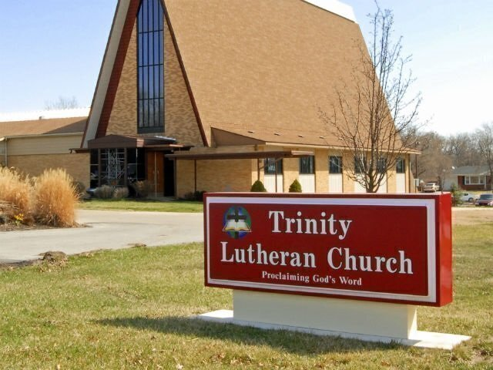
Blaine proposed a federal constitutional amendment that stated in part that “no money raised by taxation in any State for the support of public schools, or derived from any public fund therefor, nor any public lands devoted thereto, shall ever be under the control of any religious sect.”
Blaine’s effort for a national constitutional amendment failed in Congress, but many states over the years adopted their own “Blaine amendments” in their own constitutions. About 35 states now have some form of a Blaine amendment on the books.
In the majority opinion, Roberts said in one of his footnotes that the decision was limited in scope to just the issue involving the playground. “This case involves express discrimination based on religious identity with respect to playground resurfacing. We do not address religious uses of funding or other forms of discrimination,” Roberts said in the opinion’s footnote 3.
“The State in this case expressly requires Trinity Lutheran to renounce its religious character in order to participate in an otherwise generally available public benefit program, for which it is fully qualified. Our cases make clear that such a condition imposes a penalty on the free exercise of religion that must be subjected to the ‘most rigorous’ scrutiny,” Roberts concluded.
“The result of the State’s policy is nothing so dramatic as the denial of political office. The consequence is, in all likelihood, a few extra scraped knees. But the exclusion of Trinity Lutheran from a public benefit for which it is otherwise qualified, solely because it is a church, is odious to our Constitution all the same, and cannot stand,” Roberts said.
Two Justices, Neil Gorsuch and Clarence Thomas, objected to Roberts’ footnote, but agreed with the rest of his opinion. “Of course the footnote is entirely correct, but I worry that some might mistakenly read it to suggest that only ‘playground resurfacing’ cases, or only those with some association with children’s safety or health, or perhaps some other social good we find sufficiently worthy, are governed by the legal rules recounted in and faithfully applied by the Court’s opinion,” said Gorsuch.
Justice Sonia Sotomayor issued a strongly worded 27-page dissent, which was joined by Justice Ruth Bader Ginsburg.
“To hear the Court tell it, this is a simple case about recycling tires to resurface a playground. The stakes are higher. This case is about nothing less than the relationship between religious institutions and the civil government—that is, between church and state,” Sotomayor said.
“The Court today profoundly changes that relationship by holding, for the first time, that the Constitution requires the government to provide public funds directly to a church. Its decision slights both our precedents and our history, and its reasoning weakens this country’s longstanding commitment to a separation of church and state beneficial to both,” she concluded.
Justice Stephen Breyer concurred with Roberts’ controlling opinion. “Public benefits come in many shapes and sizes. I would leave the application of the Free Exercise Clause to other kinds of public benefits for another day,” he said.
In recent years, the United States Supreme Court has made it clear that states can relax some of their Blaine amendment provisions, and they can provide some forms of neutral aid to religious institutions.
How did the Supreme Court rule on this case?

After reading about this case, would you change your answer to the 2nd scenario above? Explain.

Step 6: Reflection
Think back on the two cases you read about today and choose one to answer the following questions about:

Do you agree with the Supreme Court’s decision? Why or why not?

Do you think the Supreme Court followed the First Amendment’s Free Exercise clause in their ruling? Why or why not?

Student Feedback:
Circle the emojis that best represents how this activity made you feel.

Week 8
Freedom

Day 5

NAME:______________________

Day 5 Agenda

Topic | Activity
Warm-Up!
English Language Arts | - Read and analyze and informational text about 9/11 and the Patriot Act of 2015.  - Develop an argument about their stance on the balance between National Security and Citizen’s Privacy.
Science | - Review the readings for this week  - Design your own Science Freedom Project  - Reflect
Mindfulness Moment!
Math | - Word Problems: Frosted Flakes, Pop Tarts and Milk: Freedom to Eat, A lot  - Skills: Fractions
Health | - What makes communities healthy or unhealthy?
Mindfulness Moment!
Civics/Social Studies | - Freedom of religion and religious tolerance around the world

Warm-up Activity: Write a journal entry around the daily quote on identity.
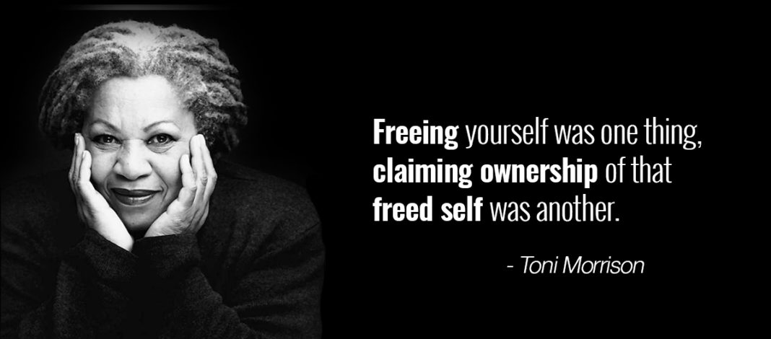

Day 5: Balancing Freedom and Public Safety
English Language Arts

What is this lesson about?
While we value our freedoms, it is important that we balance those freedoms with safety. After all, even though we have the freedom of speech, we are not allowed to yell “Fire!” in a movie theatre because it could cause panic and harm. This balance is often difficult to achieve. Ayour read and think about today’s lesson, think about that balance and how you would work to achieve the balance between freedom and responsibility in your own life.

Step 1: Read the following article

Before you read:
On September 11, 2001, 19 militants associated with the Islamic extremist group al Qaeda hijacked four airplanes and carried out suicide attacks against targets in the United States. Two of the planes were flown into the twin towers of the World Trade Center in New York City, a third plane hit the Pentagon just outside Washington, D.C., and the fourth plane crashed in a field in Shanksville, Pennsylvania. Almost 3,000 people were killed during the 9/11 terrorist attacks, which triggered major U.S. initiatives to combat terrorism and defined the presidency of George W. Bush.

After September 11, frightened Americans wanted something to be done to protect the United States from another terrorist attack. Responding to this overpowering public sentiment, and to the enormous sense of vulnerability revealed by the successful Al Qaeda strike against the United States, the Bush Administration hurried to put in place a set of measures that would answer public concerns and improve the nation’s ability to cope with terrorism. The agenda of steps and measures that followed were regarded as a program for “Homeland Security” – a program that was regarded, at least initially, as a major national priority.

The lesson below was taken and adapted from: https://newseumed.org/tools/critical-debate/2015-debating-usa-patriot-act

Some Vocabulary to Review.
tangible: able to be touched | chilling effect: frightening | bulk: in large amounts
hail: praise | lapse: a stop or pause | expeditious: quickly and efficiently

Case Study Background: USA PATRIOT Act (2015)

Less than two months after the Sept. 11, 2001, terror attacks, President George W. Bush signed the USA PATRIOT Act – that stands for "Uniting and Strengthening America by Providing Appropriate Tools Required to Intercept and Obstruct Terrorism.” The legislation was rushed through Congress, intended to strengthen the ability of law enforcement and government agencies to pursue suspected terrorists quickly. It included a number of controversial sections that sparked debate over how much power the government should have to spy on its citizens and whether the government’s increased security measures would make people fearful of exercising their freedom of speech.

The law included several sections that directly impacted freedom of speech, including a ban on supplying any form of “material support” to terrorist groups. This ban was built on existing federal laws, but the USA PATRIOT Act expanded the definition of “material support” to include not only goods or money but also “expert assistance or advice.” In other words, speech alone – advising a designated terrorist group, even if the advice dealt with a peaceful and lawful subject – would violate the law. The act also broadened the power of government officials to secretly gather public library records, Internet usage logs and “any tangible things” in the course of their investigations, which some argued could have a chilling effect on free speech. In later years, it was revealed that the government was also collecting massive amounts of email and phone call data with no direct ties to specific, active investigations – a practice termed bulk metadata collection.

From the beginning, the PATRIOT Act carried a built-in expiration date that would require lawmakers to reconsider its necessity and reach. The PATRIOT Act was first renewed in 2006. Many parts were made permanent, and the more controversial sections were renewed through 2009. After an extension, it was renewed again in 2010 for an additional year. Renewal passed again in 2011, when a new expiration date of June 30, 2015, was set.

In 2015, the Senate failed to pass the PATRIOT Act renewal before the expiration deadline. President Barack Obama stressed the importance of renewing the law to enable the government to fully protect its citizens and urged the Senate to act quickly. Without the PATRIOT Act, the government would lose its power for bulk metadata collection, to issue special warrants allowing monitoring of all of a suspect’s electronic devices, and to use anti-terror investigation methods against “lone wolf” terrorists who were not part of known terror groups.

Some senators wanted this outcome of stripped powers. Sen. Rand Paul, R-Ky., spoke on the floor of Congress for 11 hours in opposition to the act. However, there was not enough support to fully block the law’s renewal. On July 2, the Senate effectively renewed the PATRIOT Act, one day late, by approving legislation called the USA Freedom Act.

The powers the USA Freedom Act grants the government are largely the same as those in the PATRIOT Act, with one key difference. The USA Freedom Act changes the method of bulk metadata collection by making phone and Internet companies responsible for storing data on their users rather than allowing the government to collect and store all such data. The government must then obtain targeted warrants to access information that has been collected. Supporters of the bill hailed it as the first step toward rolling back the post-9/11 expansion of the government’s power to spy on its citizens. Some opponents of the PATRIOT Act renewal, including Sen. Paul, did not feel this change went far enough and did not vote for the USA Freedom Act.

Within hours after the Senate passed the USA Freedom Act, President Obama signed it into law. "After a needless delay and inexcusable lapse in important national security authorities,” he said in a statement, “my administration will work expeditiously to ensure our national security professionals again have the full set of vital tools they need to continue protecting the country.”

Step 2: Answer the Following Questions

- What are the responsibilities of an elected representative? How should constituents’ feedback – exercising their right to petition the government – affect your actions?

- Do you think the government should have access to the phone calls and emails of suspected terrorists? How should it identify “suspected terrorists”?

- How would it make you feel if you found out that the government could access your phone calls and emails? Would you change what you said/wrote in any way?

- Does knowing the government has far-reaching powers to gather information on individuals’ phone calls, emails, Internet usage, etc., suppress free speech?

- What effect might another major terrorist attack on U.S. soil have on individuals’ ability to exercise their freedoms?

Step 3: Consider your opinion and prepare an argument

EXPLORE THE DEBATE
What would you do if you had to decide whether the government should have power to monitor citizens’ phone calls and emails to fight terrorism?

THE CASE
You are a U.S. senator facing an upcoming vote on whether to renew provisions of a law that gives the government wide-reaching powers to investigate possible terrorists and terrorism organizations. The law was passed more than a decade earlier, in the wake of a devastating terrorist attack. In the years since, there has been intense debate over whether the law goes too far. A particularly controversial portion of the law gives the government the power to collect Americans' phone call records and emails in bulk for potential use in investigations.

You know that your constituents want to be safe, and you want to use your position of power to help prevent future terrorist attacks. However, some of your constituents say this law gives the government too much power, violates their privacy and makes them feel wary of exercising their freedom of speech. How will you vote?

PICK A POSITION
1. Vote to renew the provisions. Protecting the country from future terrorist attacks is the most important goal.
2. Do not vote to renew the law. The powers it grants the government go too far and are no longer needed.
3. Propose a new, alternative law that keeps many of the expanded government powers in the original law, but more closely regulates the bulk data collection. Attempt to find a more delicate balance between empowering terrorism investigations and citizens’ rights.
4. Abstain from the vote. This issue is too controversial, and a vote either way is likely to alienate a large portion of your constituents.
5. Something else. Explain your idea.

Explain your choice below. Write your explanation in the form of a speech. Your audience is your constituents--the people you represent. Some may agree with the law, while others may not. Remember that you represent all of them as you present why you made your choice and why you believe it is the best choice for them.

Step 3: Share your response with a partner
As you discuss your responses, think about where you agree and where you disagree. Is there room for a compromise?

Student Feedback:
Circle the emojis that best represents how this activity made you feel.

Day 5: Design your own Science Freedom Project
Science

What is this lesson about?: Today you will review this week’s readings. You will design your own Science Freedom Project. You will reflect on this week’s lessons.

Step 1: Review this week’s readings

Step 2: Design your own Science Freedom Project

Choose one of the projects below or design your own Science Freedom Project. You will complete this project on the next page, which is blank. Be prepared to share your project with your class.
- Draw a picture of two animals and two plants that most represent freedom to you. Explain.
- What kind of animal do you believe experiences the most freedom in its lifetime? Draw a picture and explain.
- Draw an image showing how humans have impacted the freedom of any two types of animals. Show at least one positive impact and one negative impact. Explain.
- Draw an image that shows what is needed for human beings to be free. Is 100% freedom possible? Explain.

Step 3: Reflect

As you think about this week’s science lessons, what’s one thing you will remember about freedom?

Student Feedback:
Circle the emojis that best represents how this activity made you feel.

Page for your project

Mindfulness Moment!

One of the coolest things I have ever seen is...

Day 5: Freedom/Fractions
Math

What is this lesson about?: Today you will learn about equivalent fractions.

Warm Up and Review Problems:
Malcolm was born in Philadelphia, PA. Over the first 12 years of his life he lived with 6 different families, as a foster care kid. Later, he moved to Florida, near Tampa. He lived there until he turned 17, when he moved to Baltimore, MD, to live with some family friends. From 13 to 17 he was in and out of juvenile facilities in Florida four times.

He is now 22. He attends college part-time, and works 20+ hours per week in a restaurant. He is 1 and ½ years away from earning his degree in criminal justice. He hopes to work with court-involved students once he graduates.

We asked him a few questions, about what Freedom means to him, at age 22 and used his responses to create some math questions about Freedom.

Malcolm says he was always hungry growing up, so whenever he gets a chance to eat a full meal, he does, plus some.

His favorite breakfast is a bowl of frosted flakes, 2 poptarts crumbled up in it and a cup of milk. He estimates that he eats a whole box of cereal in 5 days. If a box of frosted flakes costs $4.50, and a box of 10 pop tarts costs $4.00 and a gallon of milk (16 cups), how much, approximately, does his bowl of cereal cost him?

For dinner, he loves going to Wendy’s. He usually orders two sandwiches/burgers, a large fries and a large drink. He says he stops at Wendy’s 2xs per week when he finishes work. He says the burgers he really likes cost $3.50 each, the fries cost $2.75 and he gets his drink for free. How much does he spend on this dinner by eating it 2xs/week?

Malcolm also loves socks….he said that growing up he never had nice socks...So he has lots of pairs of socks, and is always getting them for gifts. He says that he has about 40 pairs of socks. On average, he says they cost about $4.50/pair. What’s the value of his socks?

Malcolm has to pay for his own college. Because he goes to the local community college, classes cost about $1600 per semester. Malcolm qualifies for 60% of his costs to be covered by a Pell Grant. How much is left for him to pay each semester, after his Pell Grant?

We asked Malcolm what Freedom meant to him at age 22. He said that Freedom is being able to go to the community college gym and work out by just showing his college ID, that Freedom is having his own room, and that Freedom will be getting a car in a couple years...
Activities/Fraction Problems: Complete the following fractions worksheets.
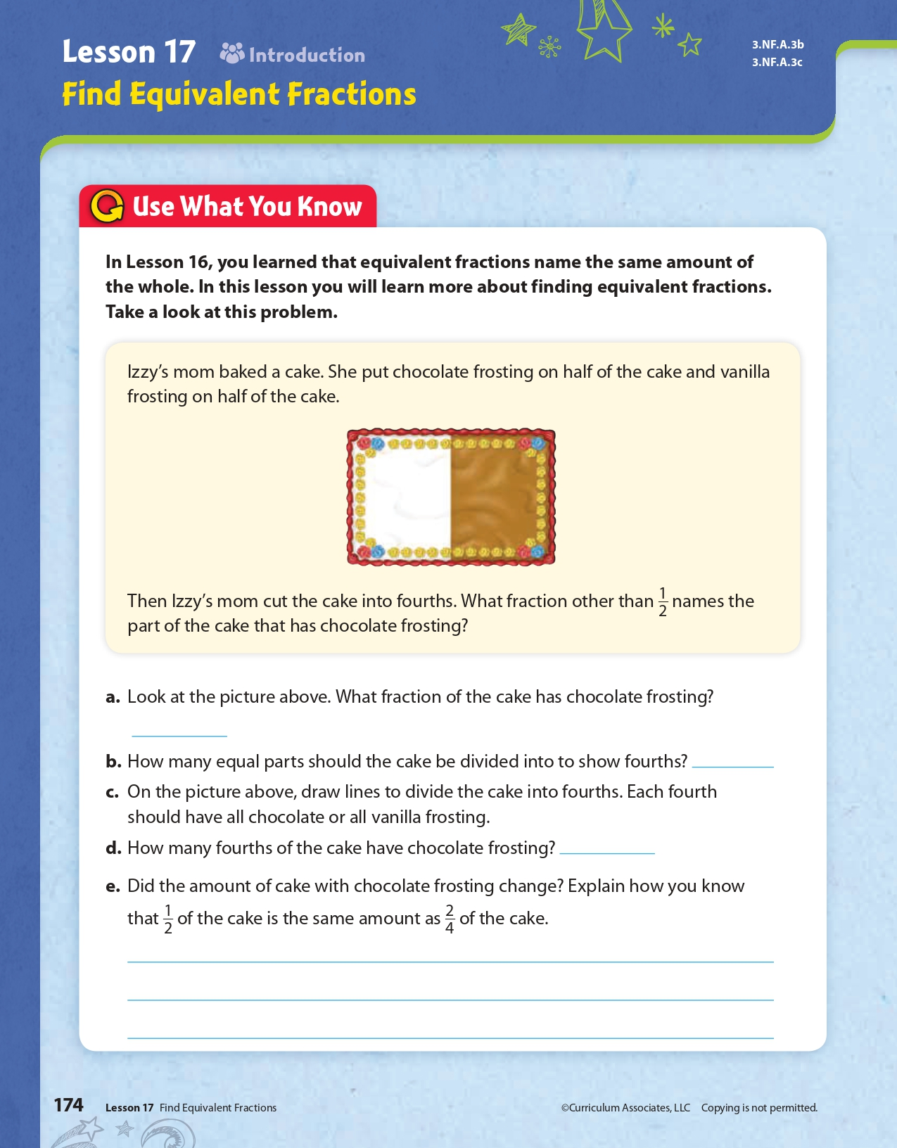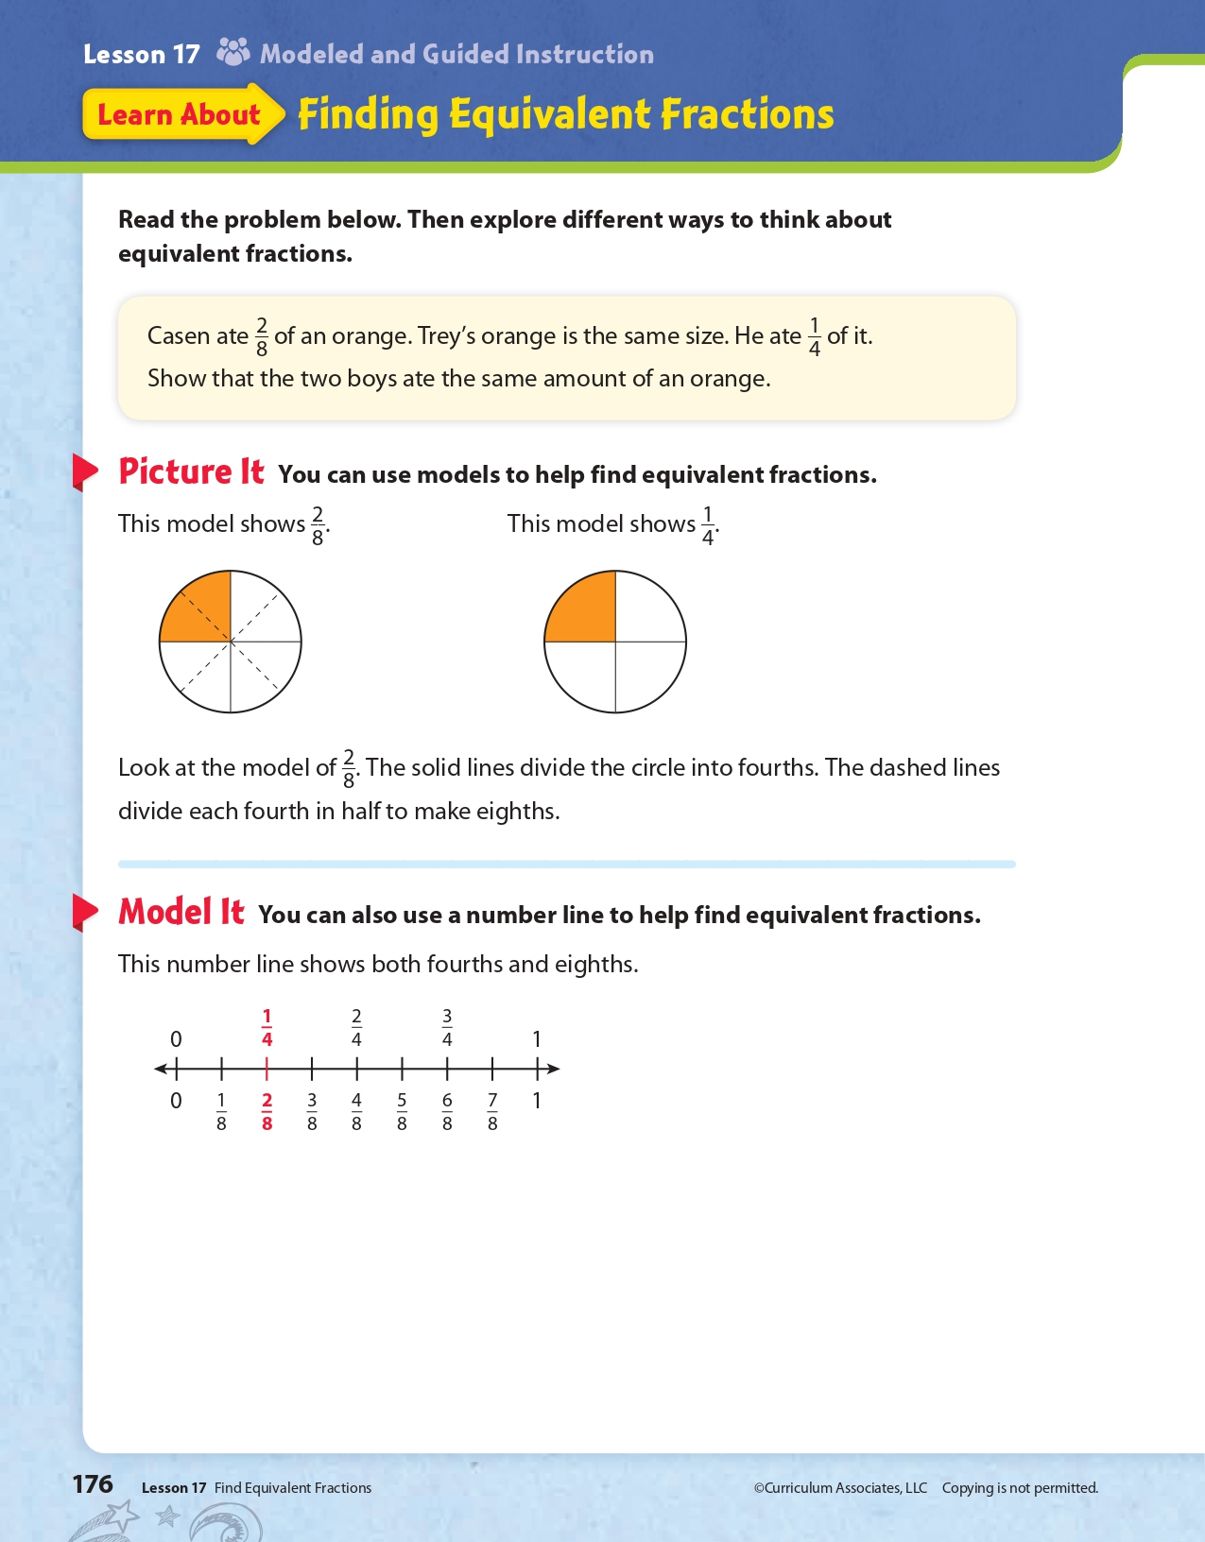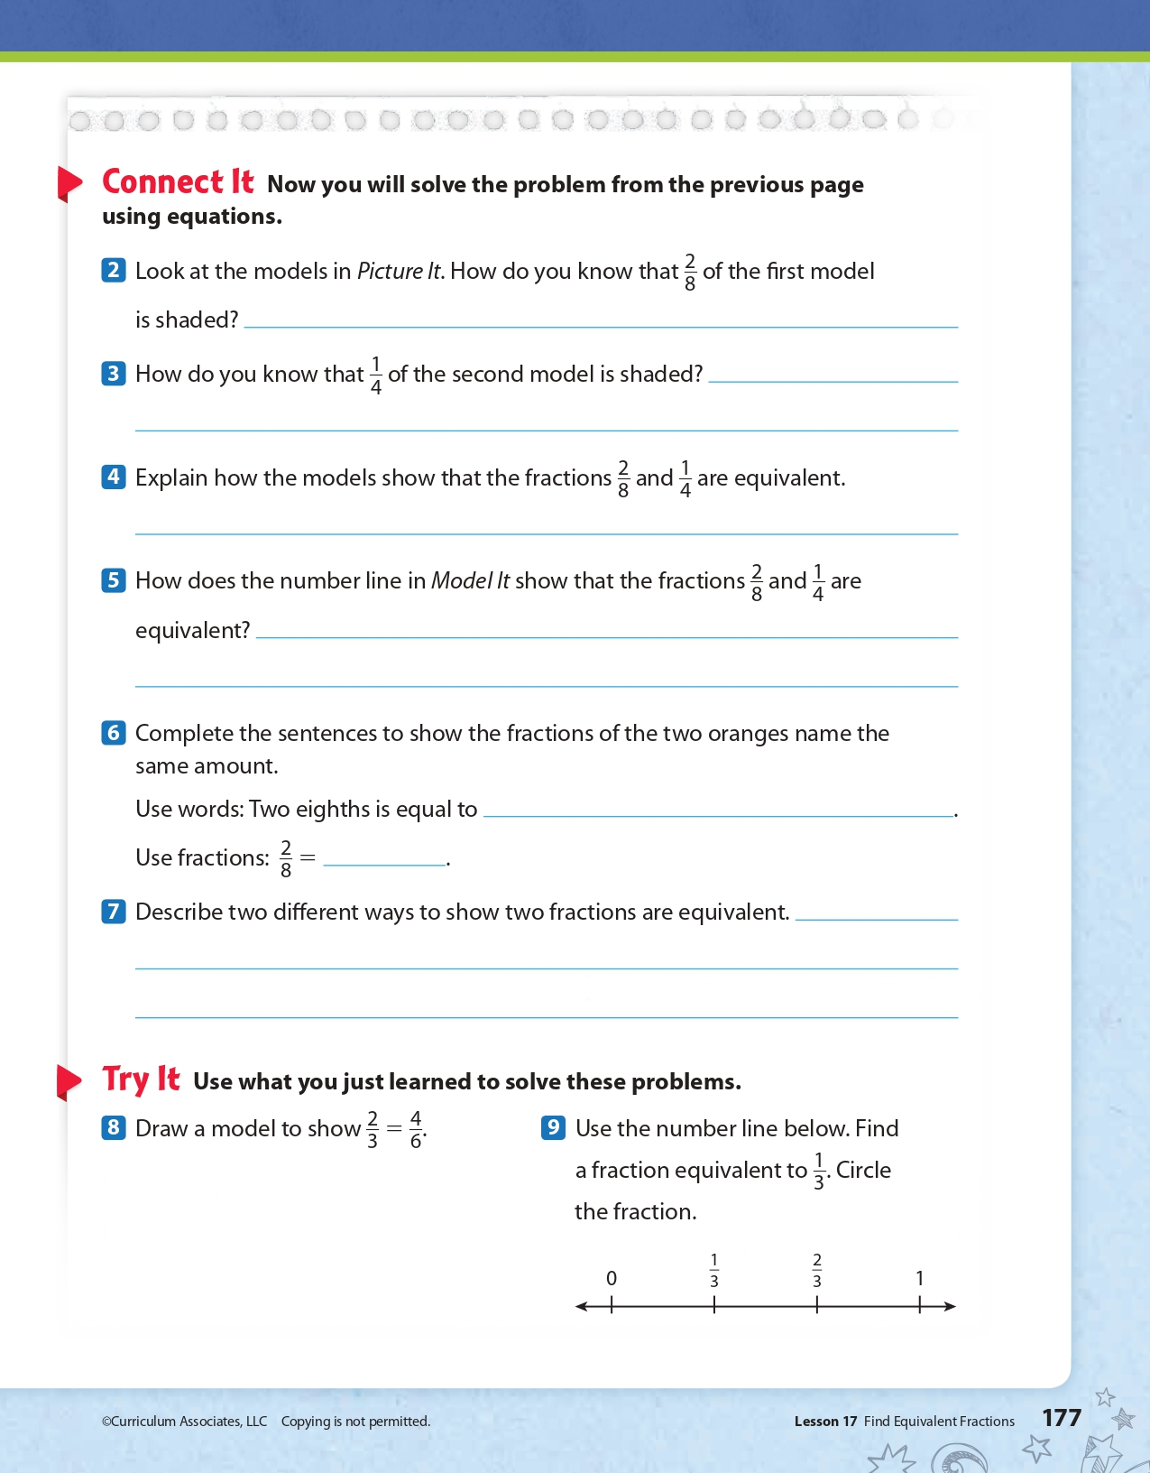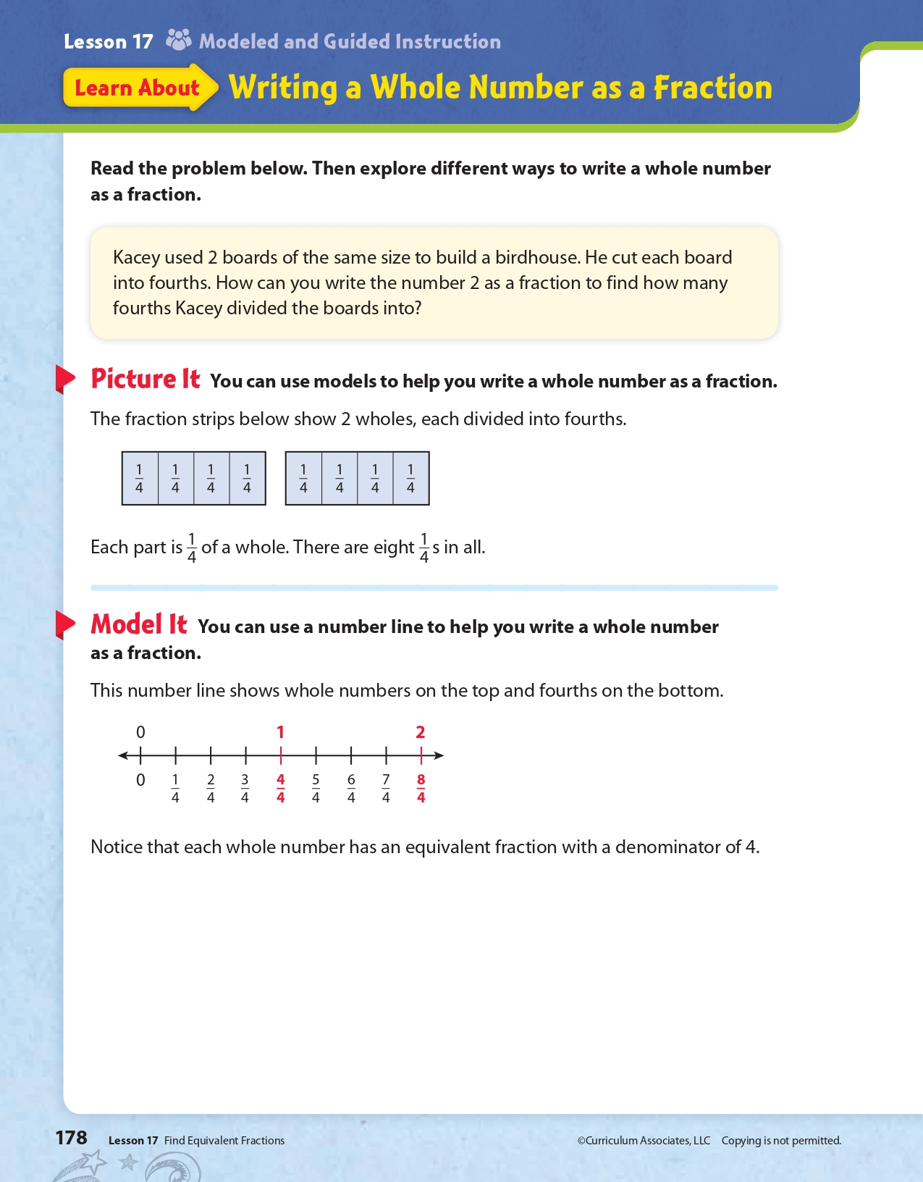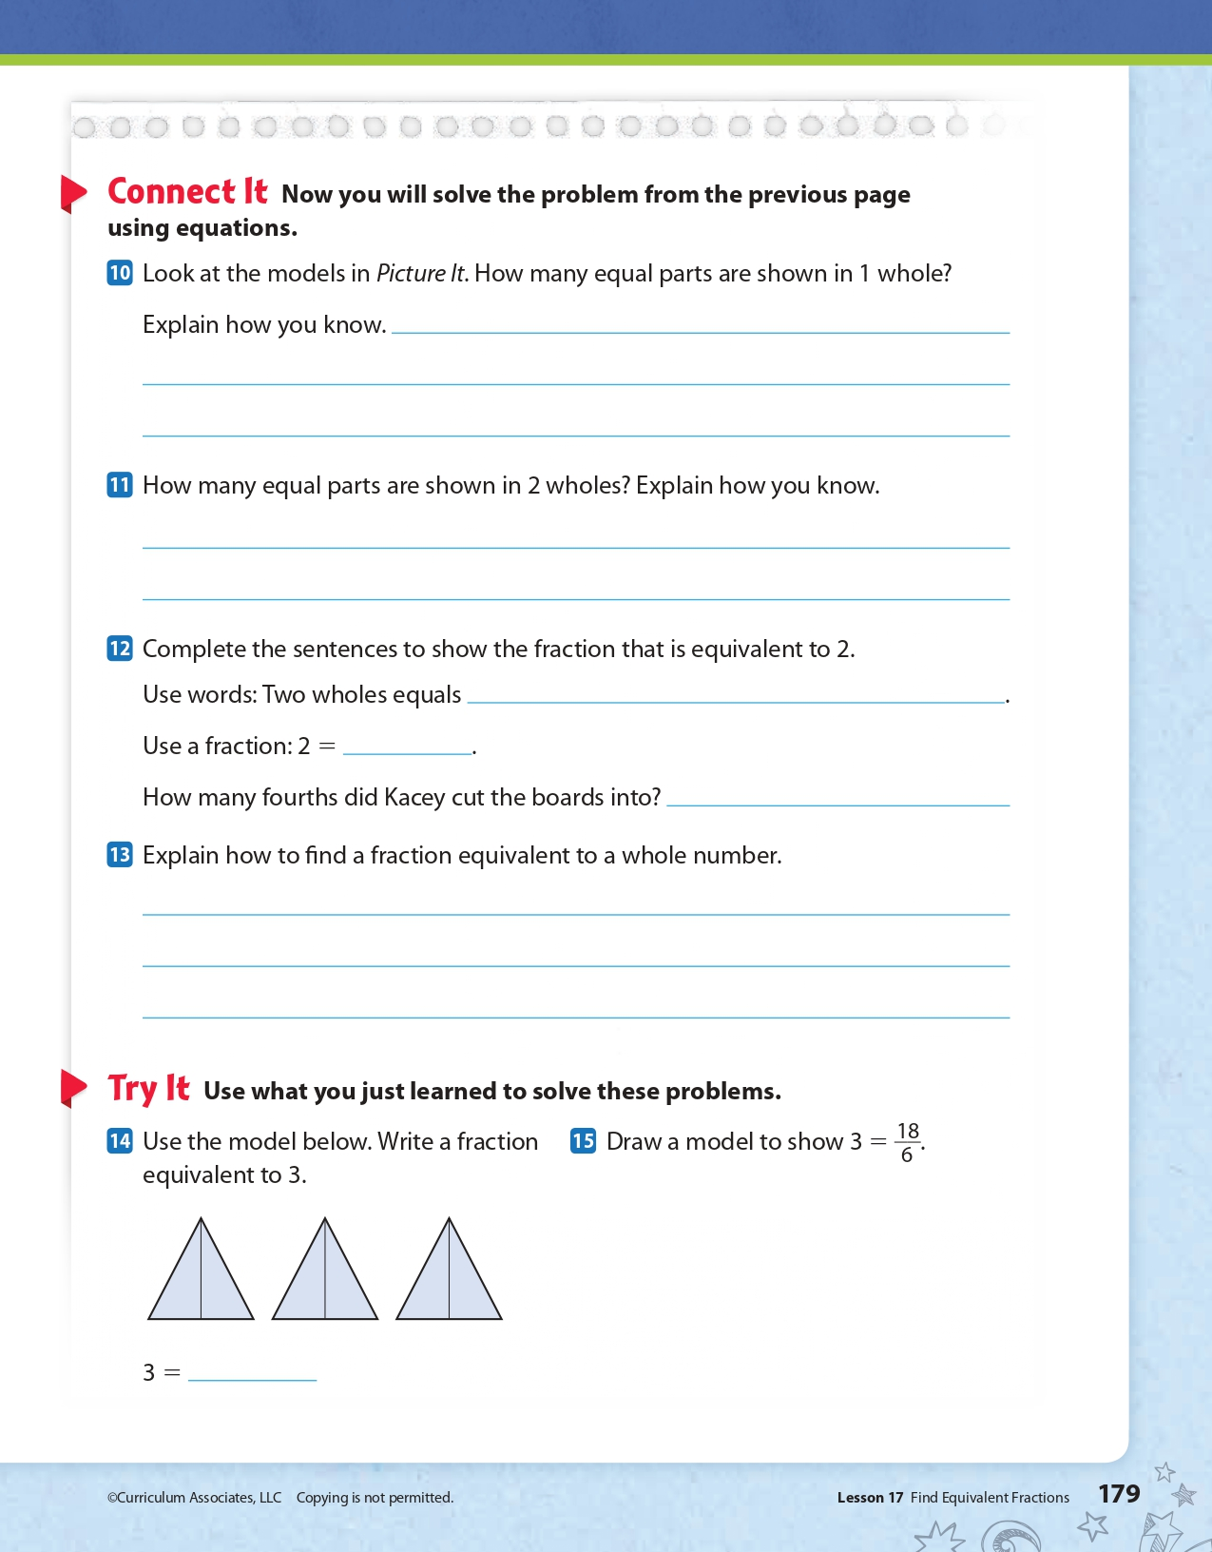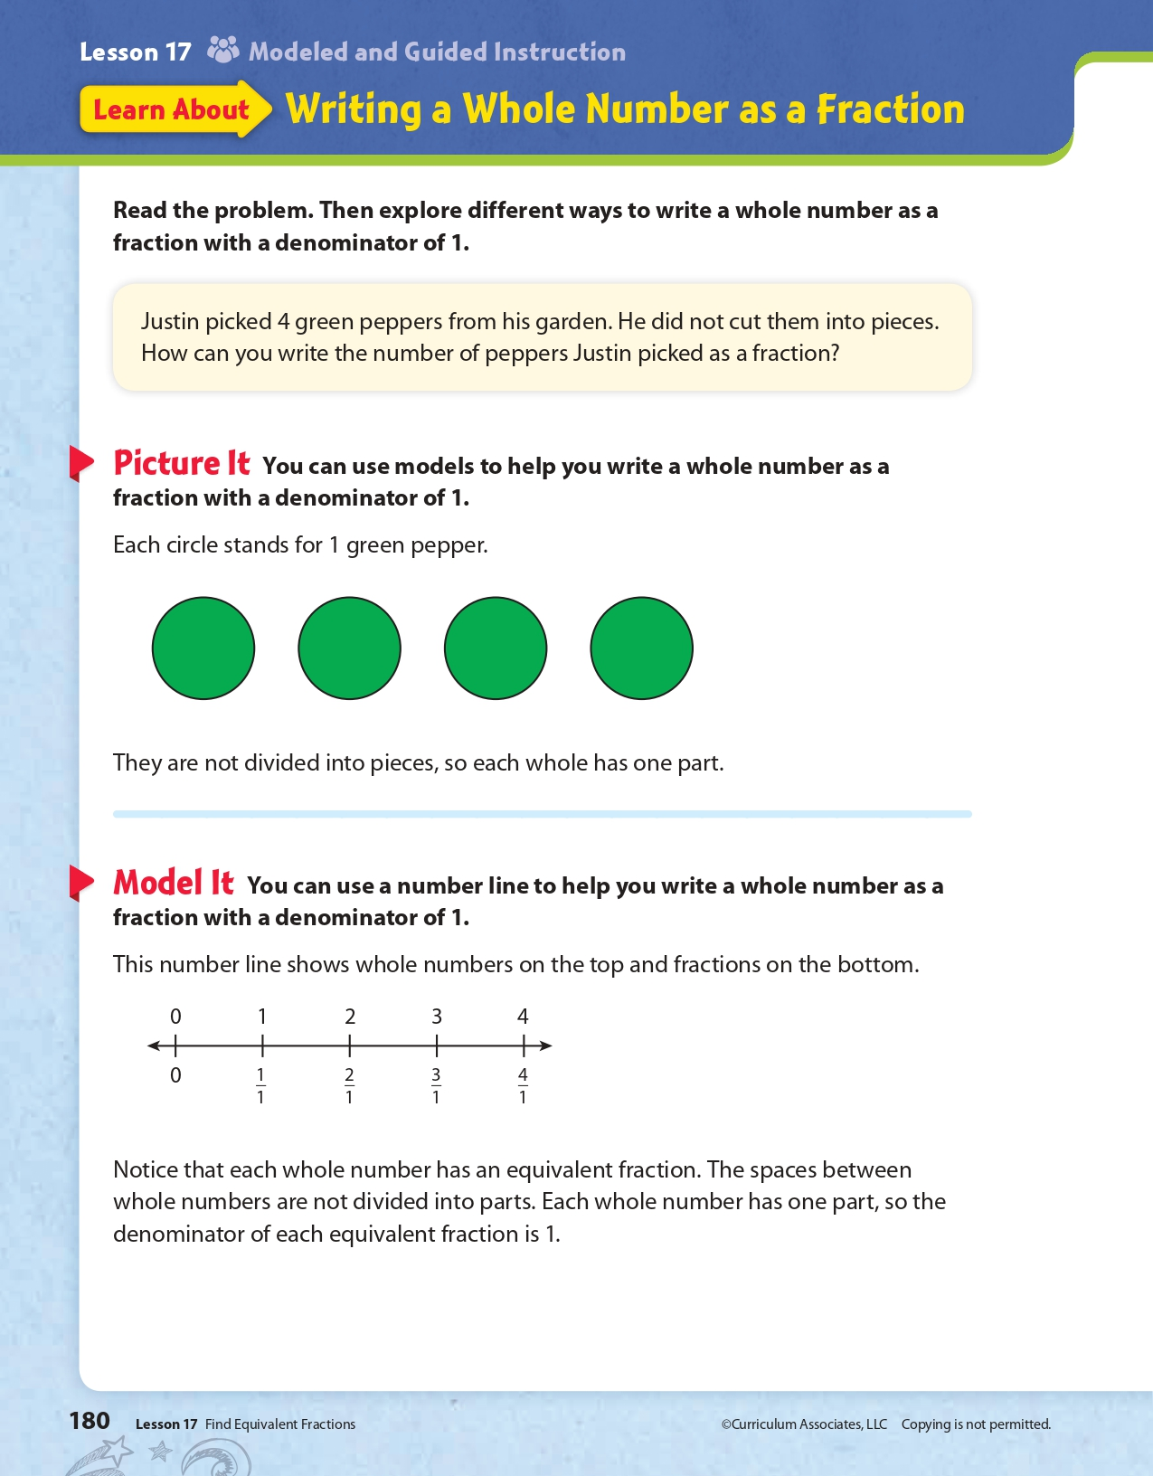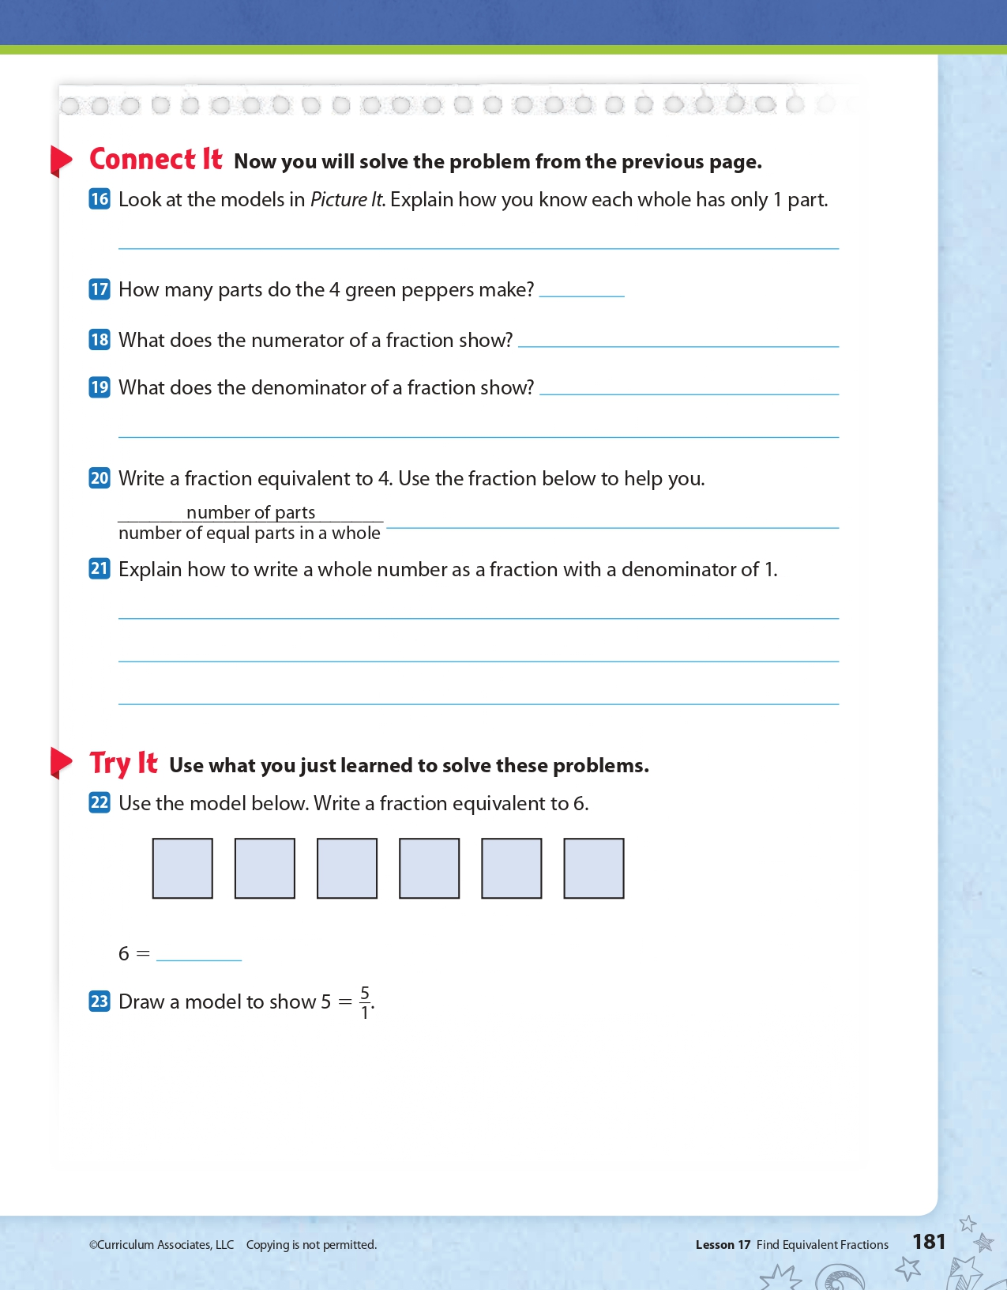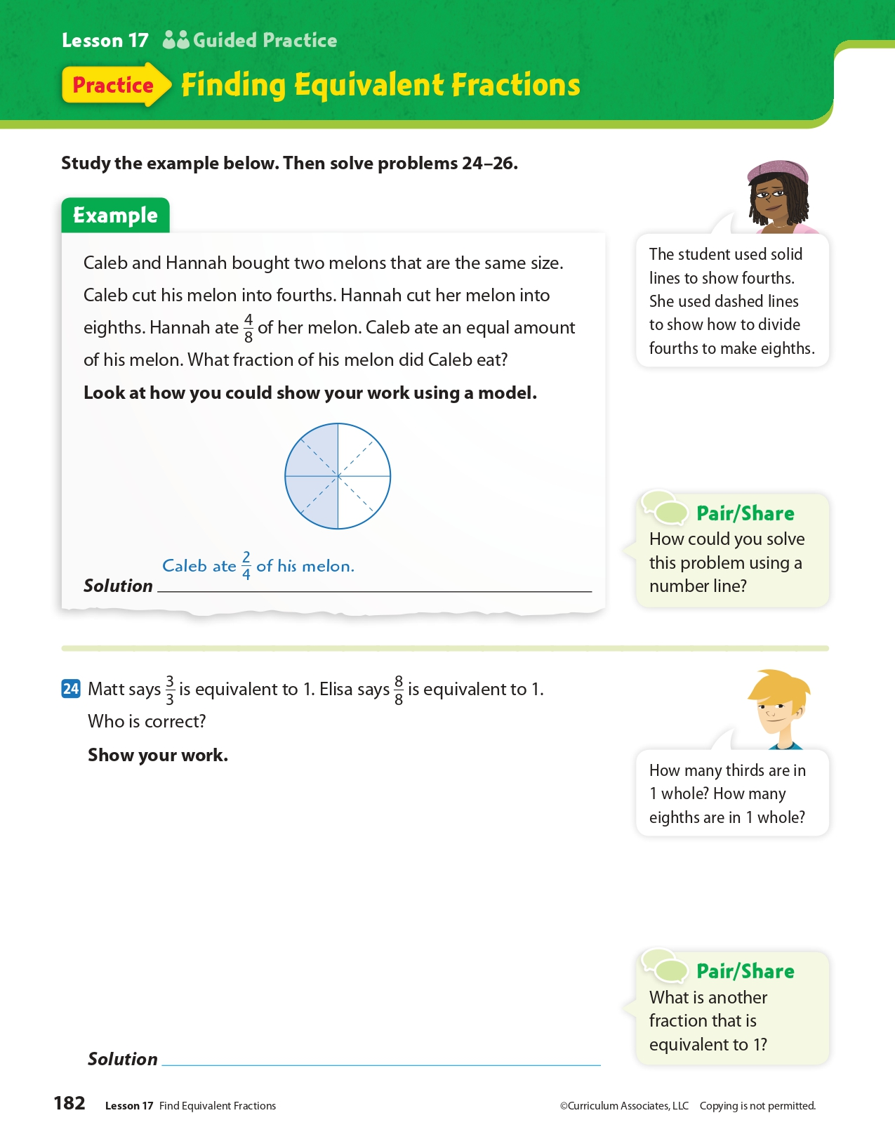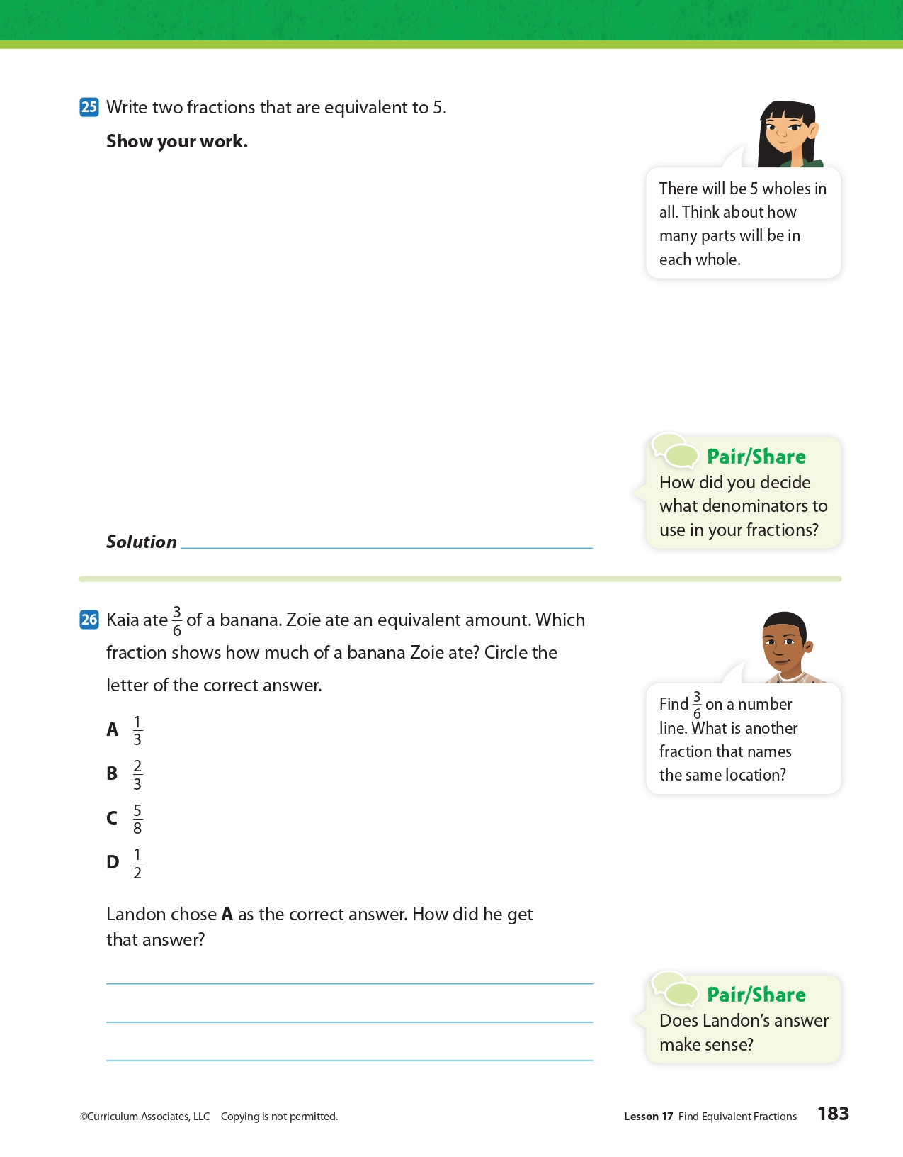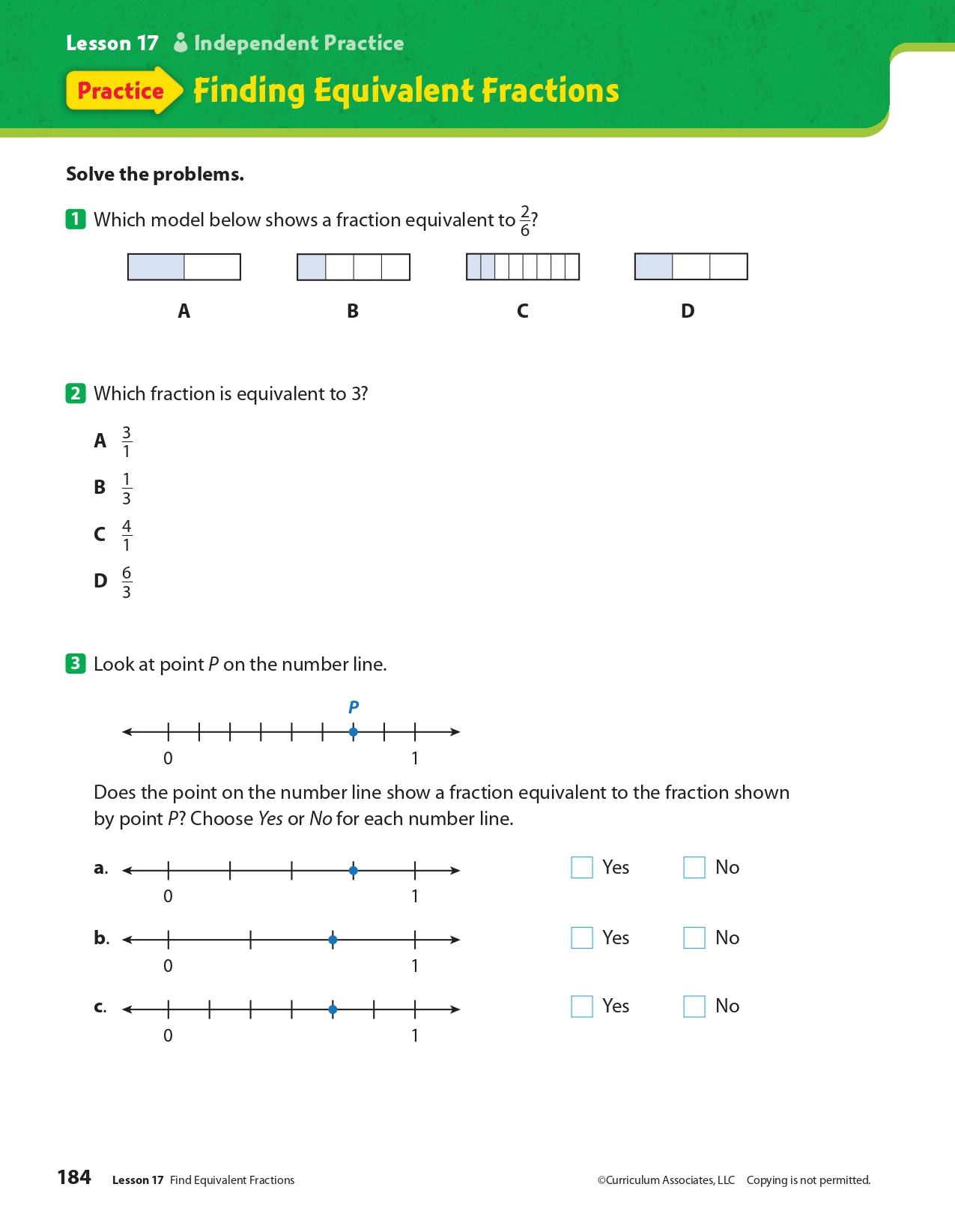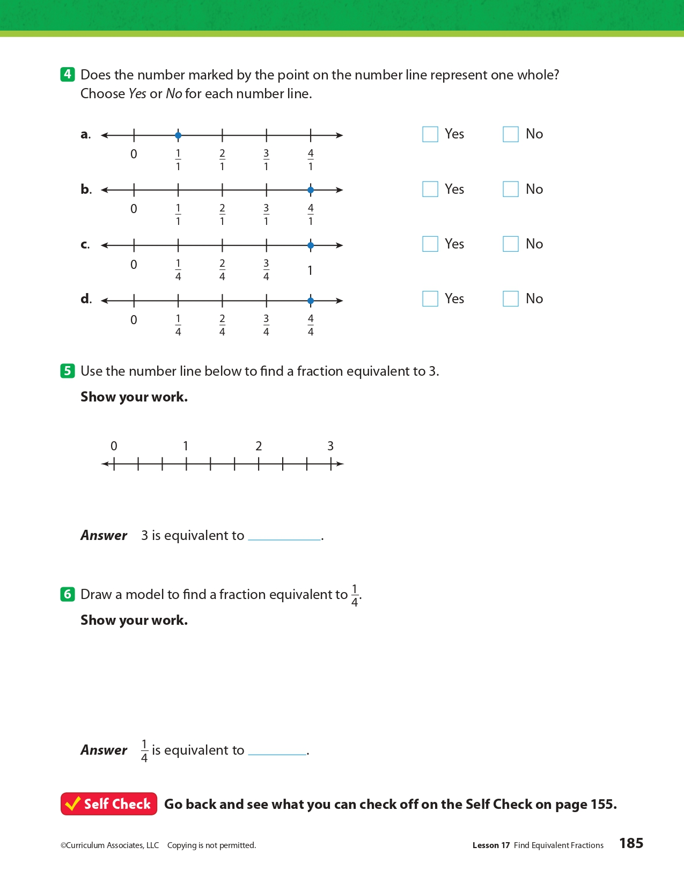
Day 5: What makes communities healthy or unhealthy?
Health

What is this lesson about?: In today’s lesson, you will consider hate speech in relation to the First Amendment and how it affects the health of a community.

Step 1: Warm-Up:

Write a short journal entry describing an incident in which you or someone you know has been the target of hate speech of any kind. If you cannot think of one, you can describe an incident in literature, on television, or in the movies.

Step 2: Read the story below.

Hate speech is an expression that mocks or belittles a person because he or she may belong to a certain social group. That group may be a certain race, ethnicity, gender, sexual orientation, religion, age, someone with physical or mental disability or something else.
Typical hate speech involves labels and slurs. Hate speech can be directed so people inflict hatred or violence against a group. Some hate speech involves cruel stereotypes — believing that all people of one group act a certain way, or have a certain attribute.
Hate speech can also include unspoken pictures and symbols. For example, the Nazi swastika and the Confederate battle flag (of the Confederate States of America) are considered hate speech by many people.
Critics of hate speech argue that it causes psychological harm to its victims, and physical harm when it incites violence. They also say that it makes its victims less equal in society. That is particularly true, they claim, because hate speech is usually directed at marginalized groups — people who have less power in society.

The Ongoing Debate About Hate Speech
Therefore, hate speech poses a challenge for modern, free societies. Free, democratic nations believe that all people are equal, but they should also be free to express themselves and their feelings. Thus, there is an ongoing debate in those societies: Should hate speech be regulated or censored? If so, how?
In the traditional idea of what liberal, democratic societies should be, all speech is typically allowed — even hate speech. A person may be disgusted by hate speech. But they may also find it worse to allow their government to censor the words of a citizen, even if those words are bigoted or hateful.
Any censorship, they might say, would lead to more censorship by a government. If the government were allowed more freedom to censor, who's to say they wouldn't censor anything that is unpopular? That could mean that something important, like criticism of the government, might get censored just because some people didn't like it. This kind of censorship would be unthinkable: Criticism of government is key to the health of a free, open democracy.

Discussing And Agreeing On Ideas
Some people argue that the best way to fight hate speech is to point out how wrong and false it is as an idea. In this "liberal" society, there's an "open exchange of ideas." In this situation, all ideas are to be discussed and debated. Society then comes to an agreement about what ideas it wants or doesn't want.
Some people believe that hate speech should be censored. They typically argue against the traditional liberal model above, which says that all people and groups are equal in society. The "open exchange of ideas" doesn't fairly recognize the fact that there are marginalized groups who could get hurt because of hate speech.
Hate speech, they argue, is not simply the "free expression of ideas." It actually causes its victims to be unsafe and lesser in society. When aimed at oppressed minorities and other people of color, hate speech is not just insulting — it also continues the oppression of these minorities. It causes the victims, the people spewing hate and the rest of society to absorb the hateful messages and act on that hate.

U.S. Courts Don't Censor Hate Speech
To them, victims of hate speech cannot enter the “open marketplace of ideas” as equal participants to defend themselves. For them, hate speech is part of a broader system of inequality and unjust discrimination. It just causes more problems for the victims, effectively silencing them.
The United States protects freedom of speech in the First Amendment. U.S. courts have generally ruled against attempts to censor hate speech. The only exceptions are if hate speech is being used to incite immediate harm to a person or group.
Other liberal democracies such as France, Germany, Canada and New Zealand have laws designed to lessen hate speech. Such laws have gotten more popular since World War II.

Step 3: Answer some questions below.

- Do you think we should censor speech or have an “open exchange of ideas? Why?

- Why do you think laws in France and Germany have gotten more popular since WWII?

- Why do you think hate crimes and hate speech are viewed differently in the eyes of the court? (hate crime laws include crimes committed on the basis of the victim’s perceived or actual race, color, religion, national origin, sexual orientation, gender, gender identity, or disability.)

Step 4: Practice scenario

A student in your class just used hate speech (Calling people names based on their race, religion, national origin, disability, gender, sexual orientation, or any other type of group that is disenfranchised in our society) against another student. How would you respond?

You:

Student Feedback:
Circle the emojis that best represents how this activity made you feel.

Mindfulness Moment!

A challenge that helped me learn and grow was...

Day 5: Freedom of Religion & Religious Tolerance Around the World
Social Studies

What is this lesson about?: So far this week you have learned about religious freedom in the United States. Today, you will explore whether religious freedom exists throughout the world.

Step 1: Warm-up on religious liberty

In Pakistan, Asia Bibi was convicted on blasphemy charges in 2009 after a quarrel with a fellow farmworker who accused her of insulting Islam's Prophet Muhammad. After spending eight years on death row, the 54-year-old’s conviction was overturned by Pakistan’s Supreme Court. Despite being a “free woman” after the death sentence was thrown out, she has been in protective custody - itself a kind of prison - because of religious extremists' calls for her hanging. Do you think someone should face these consequences just because they have different religious beliefs?

Step 2: What is religious tolerance?

The term "religious tolerance" can apply to governments, religions, faith groups, individuals, etc. It can involve:
- Allowing others to freely hold different religious beliefs. This includes granting everyone freedom of personal belief, and freedom of religious speech
- Allowing others to freely change their religion, or denomination or beliefs.
- Allowing children to hold religious beliefs that are different from their parents to a degree that depends on their age.
- Allowing others to practice their religious faith, within reasonable limits. This includes granting everyone freedom of assembly and freedom to practice what their religion requires of them.
- Refusing to discriminate in employment, accommodation etc. on religious grounds.
- Accepting that followers of various religions consider their own beliefs to be true.
- Making a reasonable effort to accommodate other people's religious needs. For example:
  - Allowing an employee to work overtime in order to take off a religious festival or holy day that is significant to them.
  - Scheduling meetings so that they do not conflict with common holy days.

Do you think there is religious tolerance in the U.S. ? Why or why not?

Do you think the 1st Amendment’s freedom of religion clause establishes tolerance? Explain.

Step 3: Read the article

Religious Restrictions Growing Around the World, Study Finds

The Middle East witnesses the highest levels of restrictions, while Europe sees the largest increase in hostilities directed at religion, Pew report finds.
By Lauren Favre ContributorJuly 17, 2019, at 5:00 p.m.

RATHER THAN PROGRESSING to provide openness and inclusivity, countries imposed an increasing number of restrictions on religion over a decade, according to a newly published international study.
Additionally, the number of countries where people are experiencing the highest levels of social hostilities involving religion rose by more than 40 percent over the same period, according to the report produced by the nonpartisan Pew Research Center.
To provide a broader understanding of how the global situation has changed, the report, entitled, "A Closer Look at How Religious Restrictions Have Risen Around the World," covered a 10-year span, from 2007 to 2017. The study tracked 198 countries within five particular regions: the Americas, Asia-Pacific, Europe, Middle East-North Africa and sub-Saharan Africa. The study broke down the two indexes, government restrictions and social hostilities, into four categories each.
While some governments scored particularly high in specific categories, the Middle East-North Africa region, with its relatively high level of government restrictions on religion, ranked highest each year of the study. Fifty-two governments, including China and Russia, were found to impose either "high" or "very high" levels of restrictions on religion, a significant increase from the 40 countries so designated in 2007, when the study began.
The most prevalent categories of government restrictions have consistently been "government favoritism of religious groups," such as the 17 Middle Eastern countries that have an official state religion, and "law and policies restricting religious freedom," such as in Eritrea where the government only recognizes and registers four religious groups. During the past decade, the global average score in the two categories increased by more than 20 percent.
The two other categories, "government limits on religious activities" and "government harassment of religious groups," also increased over the 10-year period, although at lower levels. In 2011, France banned full-face coverings, prohibiting Muslim women from wearing the burqa or niqab in public. And in the Maldives, as noted by the U.S. State Department, it's a criminal offense to promote a religion other than Islam. Violence, intimidation and other types of harassment were found to take place in numerous countries, including Myanmar and China, the Pew report found.
In Myanmar, more than 700,000 ethnic Rohingya have fled to neighboring Bangladesh since the Myanmar military launched a clearance campaign in 2017 against the Muslim group. And earlier in July, nearly two dozen countries called on China to halt its mass detention of ethnic Uighurs, Reuters reported. U.N. experts say at least 1 million Uighurs and other Muslims are being held in detention centers.
The Social Hostilities Index examined acts of religious hostility by private individuals, organizations or groups through four categories: hostilities related to religious norms, inter-religious tension and violence, religious violence by organized groups and individual and social group harassment. The largest increase in social hostilities related to religious norms occurred in Europe, where incidents of threats and violence multiplied throughout the span of the study.
Unlike the other categories, since 2007 interreligious tension and violence decreased in most regions, with the exception of sub-Saharan Africa. Europe and the Middle East-North Africa region saw the largest increases in religious violence by organized groups. ISIS and other terrorist groups have committed deadly attacks, including the incident on Palm Sunday and the attack on a Sufi mosque in northern Sinai.
The Americas were found to have the lowest levels of individual and social group harassment, while the Middle East and North Africa almost always had the highest hostilities.
What does this article tell you about religious freedoms throughout the world? Choose three things to write down.

Step 4: Consider the pictures below
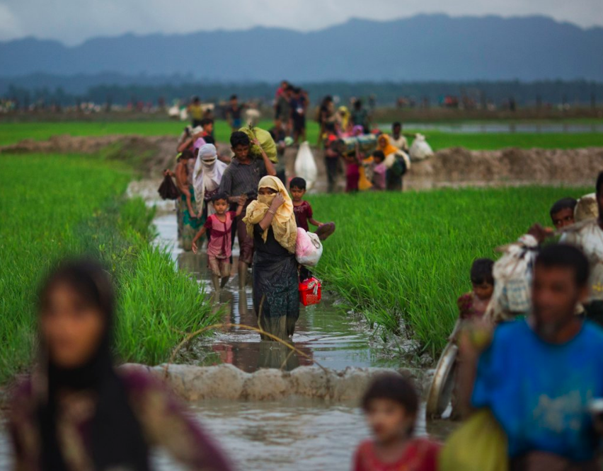
Sept. 1, 2017 | Members of Myanmar's Rohingya ethnic minority group walk through rice fields after crossing over to the Bangladesh side of the border near Cox's Bazar's Teknaf area. Thousands of Rohingya Muslims are pouring into Bangladesh as part of an exodus of the beleaguered group from neighboring Myanmar that began when violence erupted there on Aug. 25. Most of Myanmar's estimated 1 million Rohingya live in northern Rakhine state. With the government refusing to recognize them as a legitimate native ethnic minority, they face severe persecution, leaving them without citizenship and basic rights.

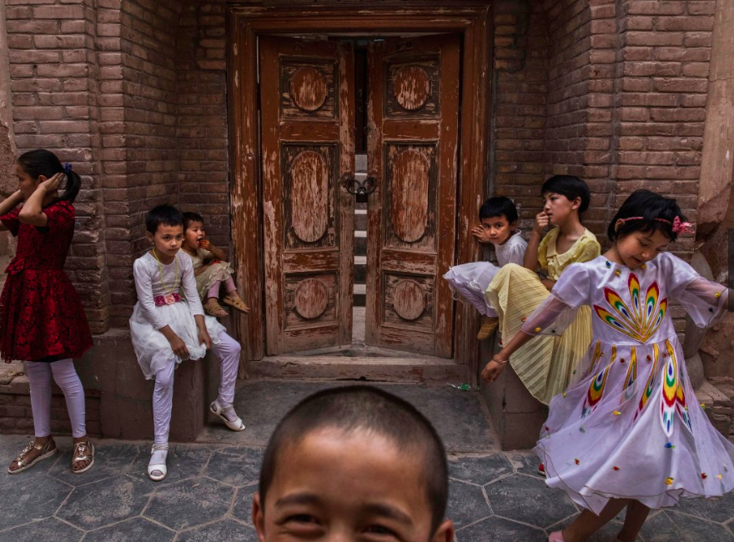
June 27, 2017 | Uighur children sit outside a local mosque that was shut down by authorities.

KASHGAR, CHINA - Kashgar has long been considered the cultural heart of Xinjiang for the region's nearly 10 million Muslim Uighurs. At a historic crossroads linking China to Asia, the Middle East and Europe, the city has changed under Chinese rule with government development, unofficial Han Chinese settlement to the western autonomous region, and restrictions imposed by the Communist Party. Beijing says it regards Kashgar's development as an improvement to the local economy, but many Uighurs consider it a threat that is eroding their language, traditions and cultural identity. The friction has fueled a separatist movement that has sometimes turned violent, triggering a crackdown on what China's government considers 'terrorist acts' by religious extremists. Tension has increased with stepped up security in the city and the enforcement of measures including restrictions at mosques.
Step 5: Read the article

The 10 Countries With the Most Religious Freedom, Ranked by Perception

Respondents to the 2019 Best Countries survey say these nations offer the most religious freedom.
By U.S. News Staff May 3, 2019,

The attack on a synagogue outside of San Diego in late April 2019, where a gunman opened fire and killed one woman and wounded three others, is the latest incident where individuals have targeted places of worship around the world. In the past six months a series of deadly explosions hit Christian churches across Sri Lanka on Easter; mass shootings occurred at mosques in New Zealand in March; and a deadly shooting took place at another synagogue in the U.S. last October, in Pittsburgh, Pennsylvania.

The attacks raise questions about the freedom to practice religion in countries without fear of being attacked, or restricted by governments. In 2018, the nonpartisan Pew Research Center published an analysis noting that restrictions on religion continued to increase around the world. However, the study also noted that most countries still have low to moderate levels of religious restrictions.
European, North American and Asia-Pacific countries dominate the rankings of nations seen to offer the greatest amount of religious freedom, according to the 2019 Best Countries report. The Best Countries survey is based on a study that surveyed more than 20,000 global citizens from four regions to assess perceptions of 80 countries on 75 different metrics. Being seen as offering religious freedom is one of eight equally weighted country attributes used to develop the Best Countries Citizenship sub-ranking.

The following are the top 10 countries viewed as offering the greatest levels of religious freedom.
- Netherlands
- Canada
- Norway
- Australia
- United States
- United Kingdom
- Belgium
- Denmark
- New Zealand
- Sweden

Step 6: Reflect and answer questions

As you learned this week, you have freedom of religion here in the U.S. How do you practice your religious freedom?

Do you think the U.S. Founders did a good thing by creating freedom of religion in the Bill of Rights? Was their idea relevant to today’s world?

Reconsider your answer to the following questions above: Do you think there is religious tolerance in the U.S. ? Why or why not?... After considering the articles you read today, does your answer change at all? Explain.

Think about your own neighborhood. How might the U.S. society, your neighborhood included, help to respect people’s freedom of religion more carefully? Do you have any ideas on how we, as a society, can show more religious tolerance.

How might you show better religious tolerance in your own life?

Student Feedback:
Circle the emojis that best represents how this activity made you feel.

