Week 8
Freedom

Day 3

NAME:______________________

Day 3 Agenda

Topic | Activity
Warm-Up!
English Language Arts | - Read an informational text about Apartheid in South Africa.  - Read and analyze an essay by Nelson Mandela  - Respond to questions about both texts.  - Create a visual representation their own “Long Road to Freedom”
Science | - Read about Animals Needing More Freedom  - Answer questions about what you read  - Draw a picture and explain
Mindfulness Moment!
Math | - Word Problems: College Bound: Freedom to Grow and Learn  - Skills: Fractions
Health | - Symbols, freedom of speech, and health
Mindfulness Moment!
Civics/Social Studies | - Free Exercise clause of the First Amendment

Warm-up Activity: Write a journal entry around the daily quote on identity.
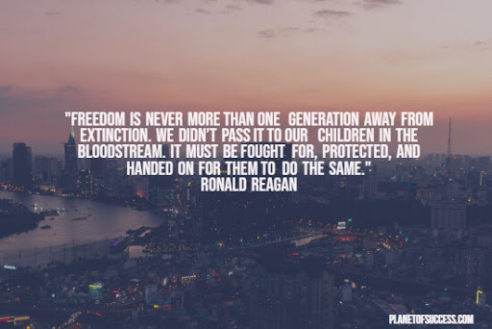

Day 3: Apartheid and Nelson Mandela
English Language Arts

What is this lesson about? Today you will be reading about the lack of freedom that came about because of Apartheid in South Africa. Apartheid only just ended 26 years ago. As you read today, think about how the idea of freedom can change as you mature.

Before you read: Some vocabulary to understand
heartstrings: deepest emotions or affections | sanction: a threatened penalty for disobeying a law or rule. | liberty: having various social, political, or economic rights and privileges
treason: the crime of betraying one's country, especially by attempting to kill the sovereign or overthrow the government. | embargo: an official ban or prohibition on trade or other commercial activity with a particular country. | refugee: one that flees  especially : a person who flees to a foreign country or power to escape danger or persecution

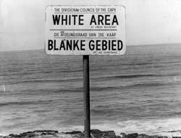
Apartheid and Its Opponents

Apartheid means ‘apart-hood’ or ‘the state of being apart’ and was the system of racial inequality, segregation and discrimination in South Africa that was started after World War II. It was enforced by the laws of the South African National Party governments from 1948 to 1994. These government officials were white rulers in the nation of South Africa that was a majority of black people and their laws cut the rights of all black citizens so that they were not equal to other citizens in the country.

White supremacy in South Africa continued to segregate the black citizens for over 50 years and came to a peak when the 1913 Land Act was passed. The law forced black citizens to live on special reserves that were set aside for them and made it against the law for them to work as sharecroppers. This caused the formation of the organization called the South African National Congress), who opposed the laws, which became the ANC (African National Congress). Nelson Mandela became the leader of the ANC and he began to fight against the new laws that outlawed interracial marriages and the Population Registration Act of 1950.
The last law classified people by their ‘race’ and then they would be given or refused rights based on that classification. Additional laws were passed requiring ‘non-white’ citizens to carry proof documents and other laws reduced the rights of the various African tribes and their leaders, who had lived in these areas of South Africa for centuries. By 1958, the government leaders removed black citizens from their homes, relocated them to other areas and sold their land for cheap prices to white farmers.

As it is with any movement, resistance to apartheid covered many years and appeared in many forms. Some were peaceful protests, while other situations were violent. By 1952, the ANC organized a protest with the South Indian National Congress to burn their ‘passbooks’. By 1955 groups were gathering to try to bring about equality and they were met with police and government officials that arrested them and they were charged with high treason.
Many groups were attacked and killed by the white police officers and the violence became worse as they tried to enforce the ‘white laws’. Nelson Mandela led many of the protests but was then accused of treason and had to go ‘underground’ to avoid arrest. When the officials did locate him in 1961, he was arrested and thrown into prison. The arrest of Nelson Mandela became an outraged cry and symbol for others to continue the fight. His arrest also brought attention to the condition of Apartheid for the rest of the world.

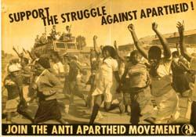
In 1973, the United Nations General Assembly focused on apartheid and denounced it. By 1976 the UN Security Council voted to impose embargos against the sale of firearms to South Africa. People from all over the world began to join the anti-apartheid movement and to protest the imprisonment of Nelson Mandela.

The movement was joined by artists, musicians, politicians, humanitarians and groups from every country. By 1985 both the United States and the United Kingdom imposed ‘economic sanctions’ against South Africa, which reduced the amount of trade that they could receive from both countries.
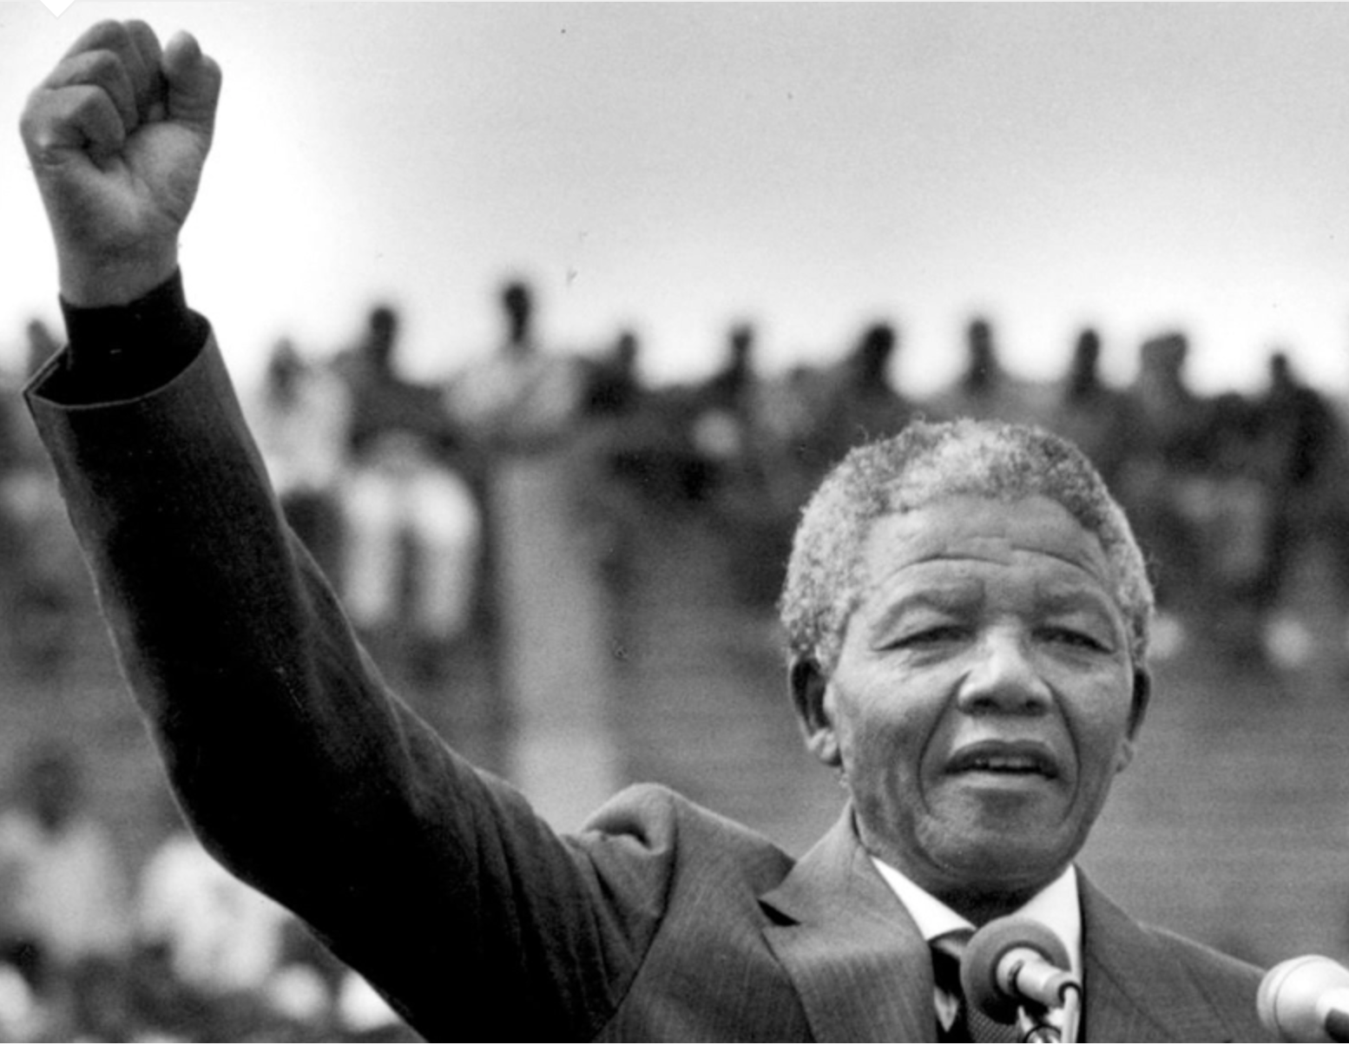
By 1989, the South African government fell to the pressure and began seeking reforms which included getting rid of some of the laws. A new constitution was drawn up to give blacks and other racial groups their freedoms back. Nelson Mandela was released from prison in 1990 and became the popular representative that worked together with the political groups for reform. In 1994, elections were held and, for the first time, there was a nonwhite majority which led to the end of apartheid.
Nelson Mandela was sworn in as President in May, 1994.
Adapted from: https://www.historyforkids.net/apartheid.html
Step 2: Answer the Following Questions
- Describe what the land Act of 1913 did to black citizens in South Africa.

- Apartheid separated South Africans into Whites, Blacks, Coloureds (mixed race), and Asian (meaning Indians and Pakistanis). How do you think this separation was used to maintain the system of oppression when Whites were the minority?

- What was Nelson Mandela accused of and jailed for?

- When was Nelson Mandela released? How many years had he served in prison?

- In your own words, explain what caused the end of Apartheid.

- What happened to Mandela after he was released from prison?

Step 3: Read the essay below

Before you read: Some vocabulary to understand:
mealies: corn | abide: to follow a rule | transitory: temporary
yearn: wish for | curtail: to reduce or put a restriction on | dignity: honor or respect
bold: having the ability to take risks | monk: a member of a religious community of men typically living under vows of poverty, chastity, and obedience. | narrow-minded: not willing to listen to or tolerate other people's views; prejudiced.
falter: to stumble, to move unsteadily | cast: throw

Nelson Mandela Reflects on Working Toward Peace
By Nelson Mandela

I was not born with a hunger to be free. I was born free-free in every way that I could know. Free to run in the fields near my mother's hut, free to swim in the clear stream that ran through my village, free to roast mealies under the stars and ride the broad backs of slow moving bulls. As long as I obeyed my father and abided by the customs of my tribe, I was not troubled by the laws of man or God.

It was only when I began to learn that my boyhood freedom was an illusion, when I discovered as a young man that my freedom had already been taken from me, that I began to hunger for it. At first, as a student, I wanted freedom only for myself, the transitory freedoms of being able to stay out at night, read what I pleased, and go where I chose. Later, as a young man in Johannesburg, I yearned for the basic and honorable freedoms of achieving my potential, or earning my keep, of marrying and having a family-the freedom not to be obstructed in a lawful life.

But then I slowly saw that not only was I not free, but my brothers and sisters were not free. I saw that it was not just my freedom that was curtailed, but the freedom of everyone who looked like I did. That is when I joined the African National Congress, and that is when the hunger for my own freedom became the greater hunger for the freedom of my people. It was this desire for the freedom of my people to live their lives with dignity and self-respect that animated my life, that transformed a frightened young man into a bold one, that drove a law-abiding attorney to become a criminal, that turned a family-loving husband into a man without a home, that forced a life-loving man to live like a monk. I am no more virtuous or self-sacrificing than the next man, but I found that I could not even enjoy the poor and limited freedoms I was allowed when I knew my people were not free. Freedom is indivisible; the chains on any one of my people were the chains on all of them, the chains on all of my people were the chains on me.
It was during those long and lonely years that my hunger for the freedom of my own people became a hunger for the freedom of all people, white and black. I knew as well as I knew anything that the oppressor must be liberated just as surely as the oppressed. A man who takes away another man's freedom is a prisoner of hatred, he is locked behind the bars of prejudice and narrow-mindedness. I am not truly free if I am taking away someone else's freedom, just as surely as I am not free when my freedom is taken from me. The oppressed and the oppressor alike are robbed of their humanity.

When I walked out of prison, that was my mission, to liberate the oppressed and the oppressor both. Some say that has now been achieved. But I know that that is not the case. The truth is that we are not yet free; we have merely achieved the freedom to be free, the right not to be oppressed. We have not taken the final step of our journey, but the first step on a longer and even more difficult road. For to be free is not merely to cast off one's chains, but to live in a way that respects and enhances the freedom of others. The true test of our devotion to freedom is just beginning.

I have walked that long road to freedom. I have tried not to falter; I have made missteps along the way. But I have discovered the secret that after climbing a great hill, one only finds that there are many more hills to climb. I have taken a moment here to rest, to steal a view of the glorious vista that surrounds me, to look back on the distance I have come. But I can rest only for a moment, for with freedom comes responsibilities, and I dare not linger, for my long walk is not yet ended.

Step 4: Answer the questions below
1. How did Mandela’s idea of freedom change when he was a young man? What freedoms did he want then? Were these freedoms available to him?

2. In the third paragraph, what shift took place in Mandela’s thinking about freedom? How does this show that he was maturing?

3. In the fourth paragraph, how does his view of freedom evolve even more? Do you agree with him? Why or why not?

4. In the fifth and sixth paragraphs, what does Mandela say about freedom now in South Africa?

5. What metaphor does Mandela use in the final paragraph, and is it effective in conveying his message? Why or why not?

Step 5: Think, Discuss and Write

Think about the following quote from Mandela’s writing:
Mandela stated “For to be free is not merely to cast off one's chains, but to live in a way that respects and enhances the freedom of others,” now think about what you wrote about earlier this week when you wrote your definition of freedom. Have the readings from this week so far changed your thinking? Why or why not? He also uses the metaphor of having walked the “long road to freedom”. Describe your road to real freedom. What do you think that looks like? Use words and images to share your “road to freedom”. Use the template provided.

Student Feedback:
Circle the emojis that best represents how this activity made you feel. | 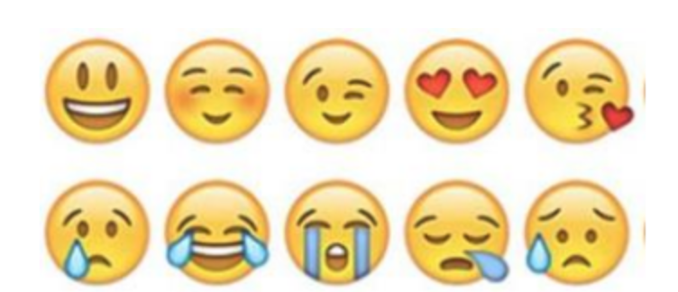  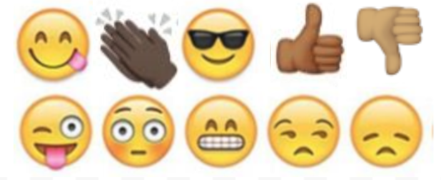

Day 3: Electricity Rights
Science

What is this lesson about?: Today you will read through the Do Animals Need More Freedom? passage. You will answer a few questions about what you read. You will complete an activity.

Step 1: Read through the passage

Do Animals Need More Freedom?
(Leahy, 2017)

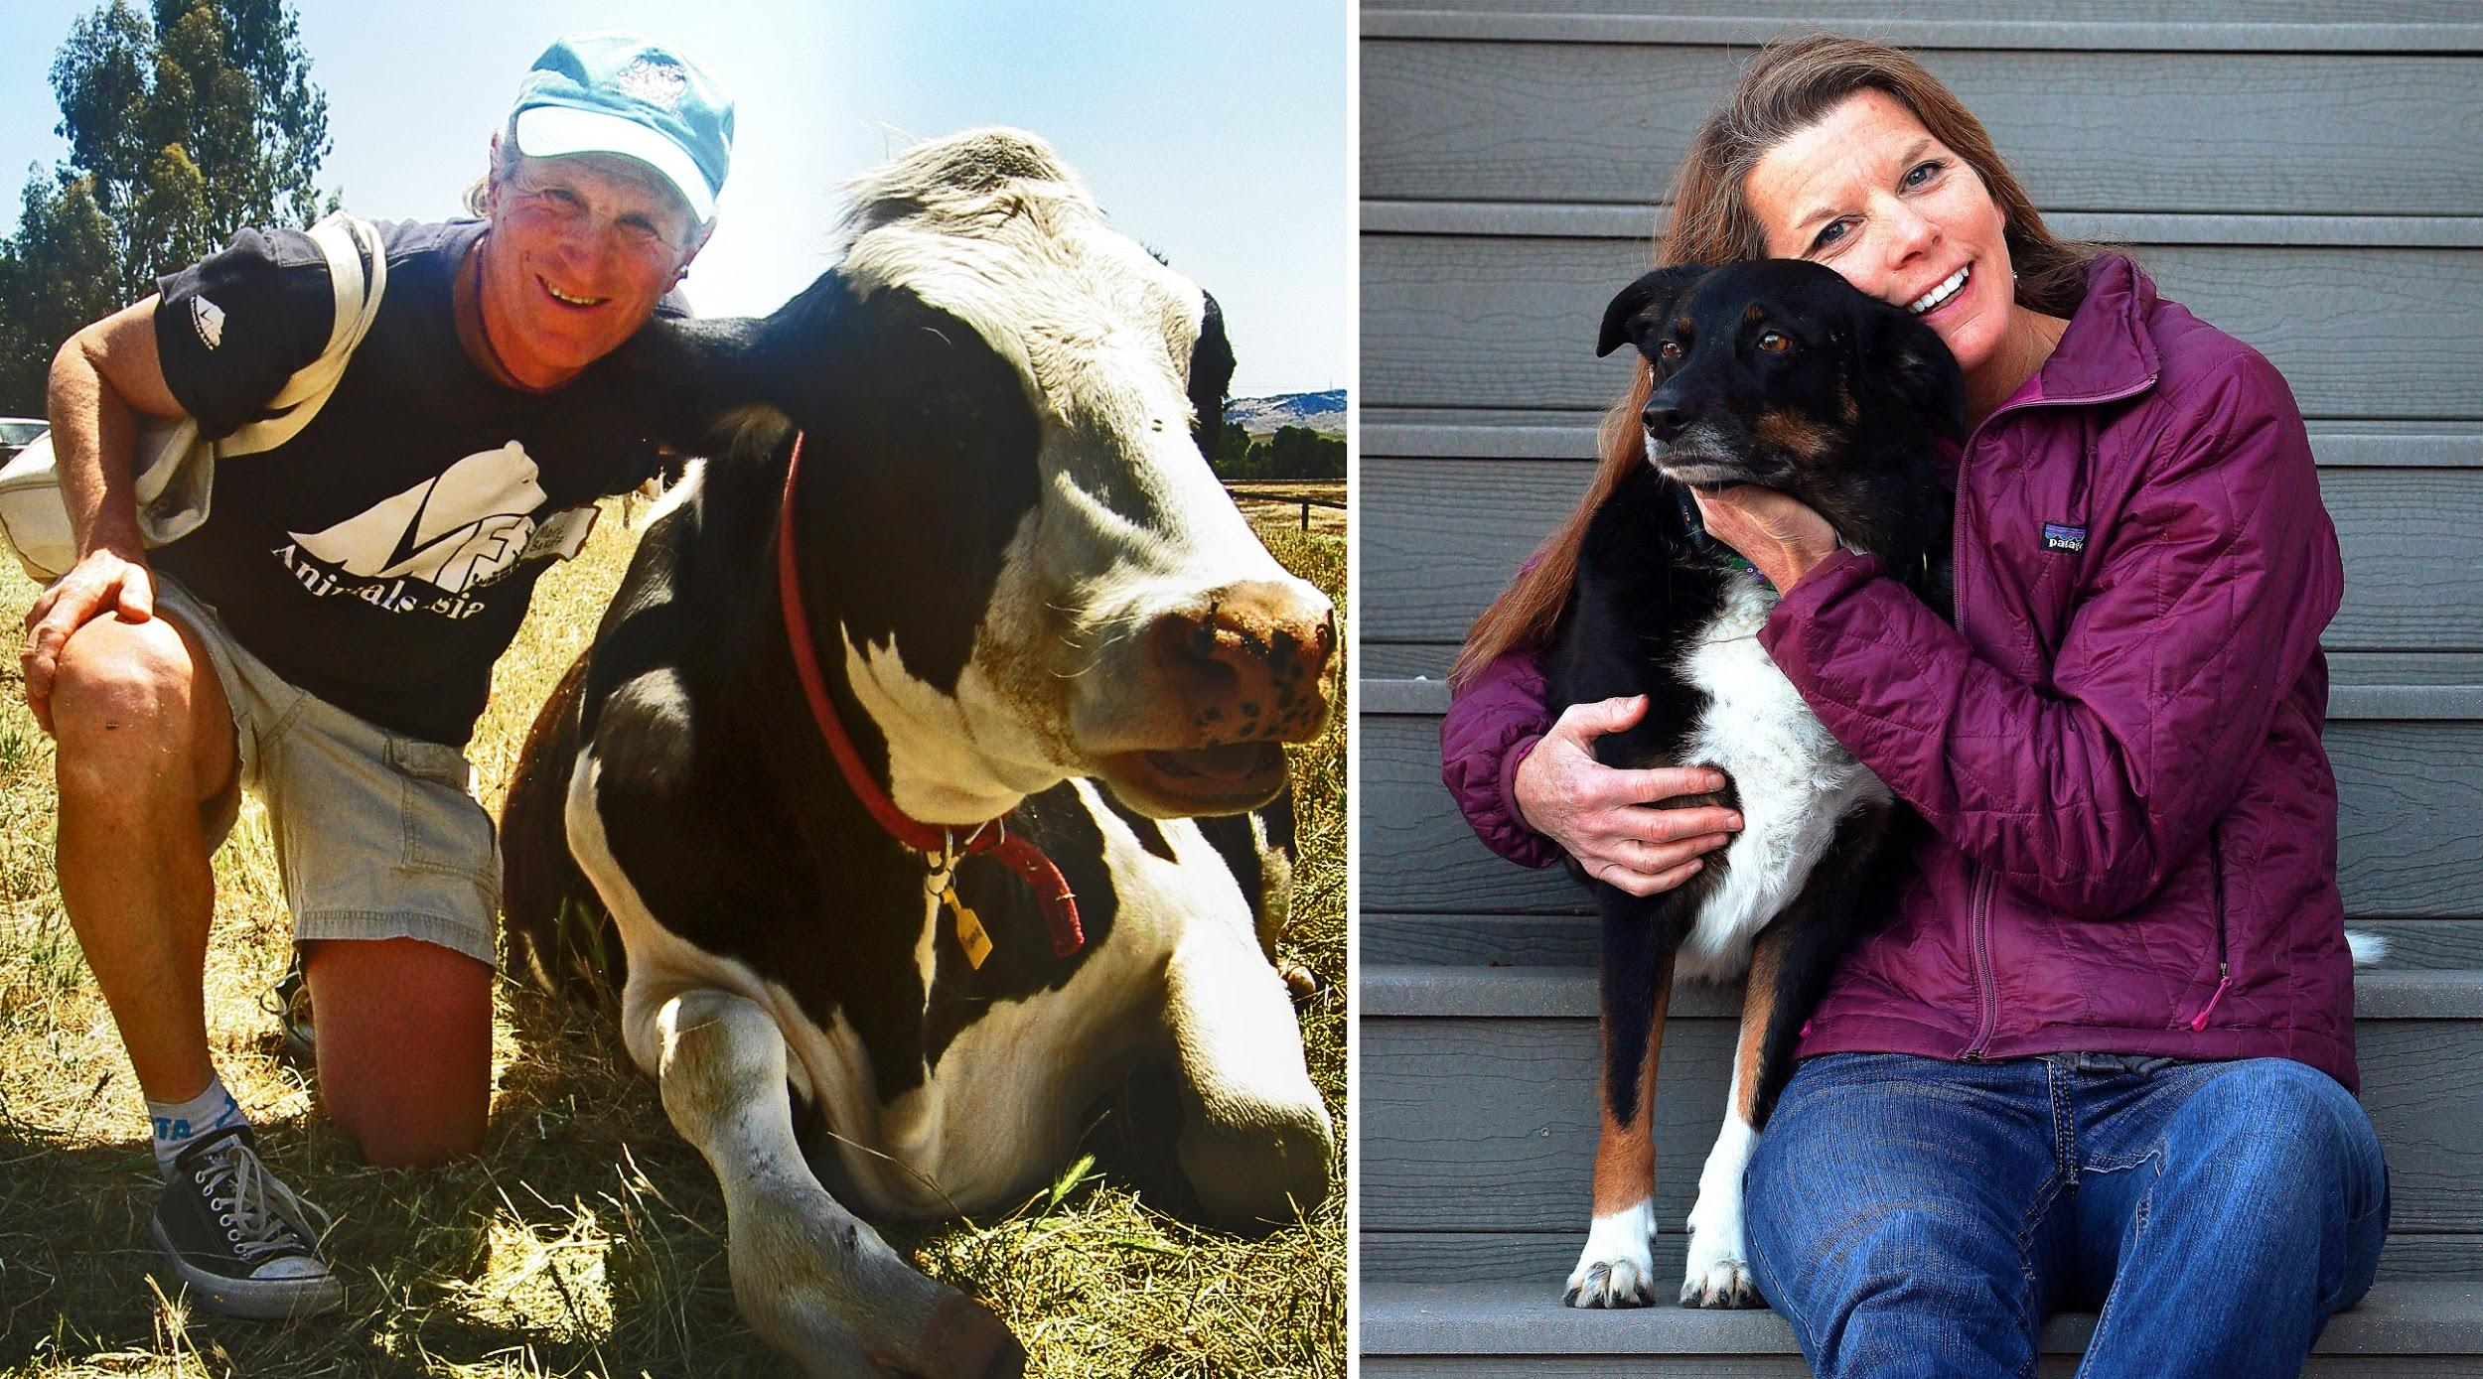
(Courtesy Marc Bekoff and Sage Madden) Animal behaviorist Marc Bekoff, left, with rescued dairy cow Bessie. Bioethicist Jessica Pierce, right, with one of her family dogs, a rescue named Bella.

You’ve probably wondered what your dog or cat is thinking. Perhaps you’ve even considered the thoughts of wild animals and those in zoos. How about the feelings of the cows, chickens and pigs that eventually end up on our dinner plates? University of Colorado bioethicist Jessica Pierce and CU professor emeritus and animal behaviorist Marc Bekoff say science shows that animals have rich inner lives, but their treatment by humans doesn't reflect that. Their new book is "The Animals' Agenda: Freedom, Compassion, and Coexistence in the Human Age." Pierce and Bekoff spoke with Colorado Matters host Andrea Dukakis. Read an Excerpt:

Freedom, Compassion, and Coexistence in the Human Age
There comes a time when one must take a position that is neither safe nor politic nor popular, but he must take it because conscience tells him it is right.
—Martin Luther King Jr.

News headlines these days often center on animals. Stories seem increasingly to be of two types. The first involves reporting on what might be characterized as “the inner lives of animals.” Scientists regularly publish new findings on animal cognition or emotion, and these quickly make their way into the popular press. Here is a sampling of some recent headlines:
- Pigs possess complex ethological traits similar to dogs and chimpanzees
- Squirrels can be deceptive
- Chickens are smart, and they understand their world
- Rats will save their friends from drowning . . . new finding suggests that these rodents feel empathy
- New Caledonian crows show strong evidence of social learning
- Elephants get post-traumatic stress too: calves orphaned by the killing of their parents are haunted by grief decades later
- Fish determine social status using advanced cognitive skills

The other type of news story focuses on individual animals or a particular group of animals who have been wronged by humans in some significant way. These stories often create a social media frenzy, generating both moral outrage and soul-searching. In particular, these stories highlight instances in which the freedom of an animal has been profoundly violated by humans. Some of these recent hot-button stories include the killing of an African lion named Cecil by an American dentist wanting a trophy head; the killing of a mother grizzly bear named Blaze, who attacked a hiker in Yellowstone National Park; the case of a male polar bear named Andy who was suffocating and starving because of an overly tight radio collar placed around his neck by a researcher; the “euthanizing” and public dissection of a giraffe named Marius at the Copenhagen Zoo because he was not good breeding stock; the ongoing legal battle to assign legal personhood to two research chimpanzees, Leo and Hercules; the exposure of SeaWorld for cruel treatment of orcas, inspired by the tragic story of Tilikum and the documentary Blackfish; and the killing of a gorilla named Harambe at the Cincinnati Zoo, after a small boy fell into the animal’s enclosure. The fact that these events have created such a stir suggests that we are at a tipping point. People who have never really been active in defense of animals are outraged by the senseless violation of these animals’ lives and freedom. The growing awareness of animal cognition and emotion has enabled a shift in perspective. People are sick and tired of all the abuse. Animals are sick and tired of it, too.

Yet although we prize our freedom above all else, we routinely deny freedom to nonhuman animals (hereafter, animals) with whom we share our planet. We imprison and enslave animals, we exploit them for their labor and their skin and bodies, we restrict what they can do and with whom they can interact. We don’t let them choose their family or friends, we decide for them when and if and with whom they mate and bear offspring, and often take their children away at birth. We control their movements, their behaviors, their social interactions, while bending them to our will or to our self-serving economic agenda. The justification, if any is given, is that they are lesser creatures, they are not like us, and by implication they are neither as valuable nor as good as we are. We insist that as creatures vastly different from us, they experience the world differently than we do and value different things.

But, in fact, they are like us in many ways; indeed, our basic physical and psychological needs are pretty much the same. Like us, they want and need food, water, air, sleep. They need shelter and safety from physical and psychological threats, and an environment they can control. And like us, they have what might be called higher-order needs, such as the need to exercise control over their lives, make choices, do meaningful work, form meaningful relationships with others, and engage in forms of play and creativity. Some measure of freedom is fundamental to satisfying these higher-order needs, and provides a necessary substrate for individuals to thrive and to look forward to a new day.

Freedom is the key to many aspects of animal well-being. And lack of freedom is at the root of many of the miseries we intentionally and unintentionally inflict on animals under our “care”—whether they suffer from physical or social isolation, or from being unable to move freely about their world and engage the various senses and capacities for which they are so exquisitely evolved. To do better in our responsibilities toward animals, we must do what we can to make their freedoms the fundamental needs we promote and protect, even when it means giving those needs priority over some of our own wants.

The Five Freedoms
Many people who have taken an interest in issues of animal protection are familiar with the Five Freedoms. The Five Freedoms originated in the early 1960s in an eighty-five-page British government study, Report of the Technical Committee to Enquire into the Welfare of Animals Kept Under Intensive Livestock Husbandry Systems. This document, informally known as the Brambell Report, was a response to public outcry over the abusive treatment of animals within agricultural settings. Ruth Harrison’s 1964 book Animal Machines brought readers inside the walls of the newly developing industrialized farming systems in the United Kingdom, what we have come to know as “factory farms.” Harrison, a Quaker and conscientious objector during World War II, described appalling practices like battery-cage systems for egg-laying hens and gestation crates for sows, and consumers were shocked by what was hidden behind closed doors.

To mollify the public, the UK government commissioned an investigation into livestock husbandry, led by Bangor University zoology professor Roger Brambell. The commission concluded that there were, indeed, grave ethical concerns with the treatment of animals in the food industry and that something must be done. In its initial report, the commission specified that animals should have the freedom to “stand up, lie down, turn around, groom themselves and stretch their limbs.” These incredibly minimal requirements became known as the “freedoms,” and represented the conditions the Brambell Commission felt were essential to animal welfare.

The commission also requested the formation of the Farm Animal Welfare Advisory Committee to monitor the UK farming industry. In 1979 the name of this organization was changed to the Farm Animal Welfare Council, and the freedoms were subsequently expanded into their current form. The Five Freedoms state that all animals under human care should have:
- Freedom from hunger and thirst, by ready access to water and a diet to maintain health and vigor.
- Freedom from discomfort, by providing an appropriate environment.
- Freedom from pain, injury and disease, by prevention or rapid diagnosis and treatment.
- Freedom to express normal behavior, by providing sufficient space, proper facilities and appropriate company of the animal’s own kind.
- Freedom from fear and distress, by ensuring conditions and treatment which avoid mental suffering.

The Five Freedoms have become a popular cornerstone of animal welfare in a number of countries. The Five Freedoms are now invoked in relationship not only to farmed animals but also to animals in research laboratories, zoos and aquariums, animal shelters, veterinary practice, and many other contexts of human use. The freedoms appear in nearly every book about animal welfare, can be found on nearly every website dedicated to food-animal or lab-animal welfare, form the basis of many animal welfare auditing programs, and are taught to many of those working in fields of animal husbandry.

The Five Freedoms have almost become shorthand for “what animals want and need.” They provide, according to a current statement by the Farm Animal Welfare Council, a “logical and comprehensive framework for analysis of animal welfare.” Pay attention to these, it seems, and you’ve done your due diligence as far as animal care is concerned. You can rest assured that the animals are doing just fine.

It’s worth stopping for a moment to acknowledge just how forward thinking the Brambell Report really was. This was the 1960s and came on the heels of behaviorism, a school of thought that offered a mechanistic understanding of animals, and at a time when the notion that animals might experience pain was still just a superstition for many researchers and others working with animals. The Brambell Report not only acknowledged that animals experience pain, but also that they experience mental states and have rich emotional lives, and that making animals happy involves more than simply reducing sources of pain and suffering, but actually providing for positive, pleasurable experiences. These claims sound obvious to us now, but in the mid-1960s they were both novel and controversial.
It is hard to imagine that the crafters of the Five Freedoms failed to recognize the fundamental paradox: How can an animal in an abattoir or battery cage be free? Being fed and housed by your captor is not freedom; it is simply what your caregiver does to keep you alive. Indeed, the Five Freedoms are not really concerned with freedom per se, but rather with keeping animals under conditions of such profound deprivation that no honest person could possibly describe them as free. And this is entirely consistent with the development of the concept of animal welfare.

Welfare concerns generally focus on preventing or relieving suffering, and making sure animals are being well-fed and cared for, without questioning the underlying conditions of captivity or constraint that shape the very nature of their lives. We offer lip service to freedom, in talking about “cage-free chickens” and “naturalistic zoo enclosures.” But real freedom for animals is the one value we don’t want to acknowledge, because it would require a deep examination of our own behavior. It might mean we should change the way we treat and relate to animals, not just to make cages bigger or provide new enrichment activities to blunt the sharp edges of boredom and frustration, but to allow animals much more freedom in a wide array of venues.

The bottom line is that in the vast majority of our interactions with other animals, we are seriously and systematically constraining their freedom to mingle socially, roam about, eat, drink, sleep, pee, poop, have sex, make choices, play, relax, and get away from us. The use of the phrase “in the vast majority” might seem too extreme.

However, when you think about it, we are a force to be reckoned with not only in venues in which animals are used for food production, research, education, entertainment, and fashion, but globally; on land and in the air and water, human trespass into the lives of other animals is not subsiding. Indeed, it’s increasing by leaps and bounds. This epoch, which is being called the Anthropocene, or Age of Humanity, is anything but humane. It rightfully could be called the Rage of Humanity.

We want to show how important it is to reflect on the concept of freedom in our discussions of animals. Throughout this book, we are going to examine the myriad ways in which animals under our care experience constraints on their freedom, and what these constraints mean in terms of actual physical and psychological health. Reams of scientific evidence, both behavioral observations and physiological markers, establish that animals have strongly negative reactions to losses of freedom.
One of the most important efforts we can make on behalf of animals is to explore the ways in which we undermine their freedom and then look to how we can provide them with more, not less, of what they really want and need.

Step 2: Answer the following questions

- What are a few examples in the text, of how we limit or take away freedom from animals?

- In what ways do you believe animals and humans are similar and different?

- Do you believe the Five Freedoms are important to have in place? Why or why not?

Step 3: Draw an image/picture

Create your own Five Freedoms for people your age. Design an image for each freedom. (What do you want to make sure is in place for you to live your best life?). Write your Five Freedoms below your drawing.

____________________________________________________________________________________________________________________________________________________________________________________________________________________________________________________________________
________________________________________________________________________________________________________

Student Feedback:
Circle the emojis that best represents how this activity made you feel.

Mindfulness Moment!

Three wonderful things I have done in my life are...

Day 3: Freedom/Fractions
Math
What is this lesson about?: Today you will be exploring addition and subtraction of fractions.

Warm Up and Review Problems:
Destiny was 17 when she was arrested for distributing marijuana and other drugs. She was adjudicated delinquent as a juvenile and spent 8 months in a youth facility Washington, DC. While detained she really got into school and started to catch up. When she was released she went to summer school and then went back to high school full-time, taking extra classes to catch up with her credits. In June of 2018, she graduated. And in August of 2018 she headed off to college. Asked about her road to college she said that she never thought she would experience the sort of Freedom she felt when she got in a car with her dad to go to college.

Consider:
Researchers estimate that only 15% of the students who spend time in a juvenile facility will graduate from high school.
- If 3,000 teens spend time in a youth facility, how many would be projected to graduate high school?

For each youth who does graduate, approximately 10% are projected to go to college and graduate.
- Of those who graduate (from that 3,000), how many are predicted to graduate from college?

So far, Destiny is beating all of these odds!!!
How is she making it happen? We asked her and her are some of her responses-
- Q: How many hours a day do you spend studying at college?
- A: I have classes for about 3 hours each day, but I also work part-time to help me afford school expenses. So, I get up at 530am and study from 6am-9am. Then I eat, go to classes, have some fun with friends, go to the gym….I work every day in the library from 4pm-7pm. Then I have dinner and chill a bit. I go back to the library from 8pm to 11pm. I usually meet a tutor there to help me with my Calculus class for 90 minutes since that is my hardest class. Then I head back to the dorm….

If you count the hours that Destiny is in class and the hours that she is in the library, how many hours a day is Destiny studying?

In addition to the hours mentioned above, Destiny also works from 11am-2pm on Saturdays at the library. How many hours per week does she work?

If Destiny works with her tutor on Calculus for 90 minutes on Mon-Friday and on Sunday, how many hours per week does she study with her tutor?

About how many hours per day does Destiny sleep?

Destiny had a summer job working for a local nonprofit as a social media and communications intern that helps teenagers prepare for college life. She loved it. She said it made her feel free, like all of her work was worth it. She worked 12 weeks over the summer. She earned $15 per hour, working 40 hours per week. About how much money did she earn each week? How much did she earn over the summer?

Activities/Fraction Problems: Complete the following fractions worksheets.

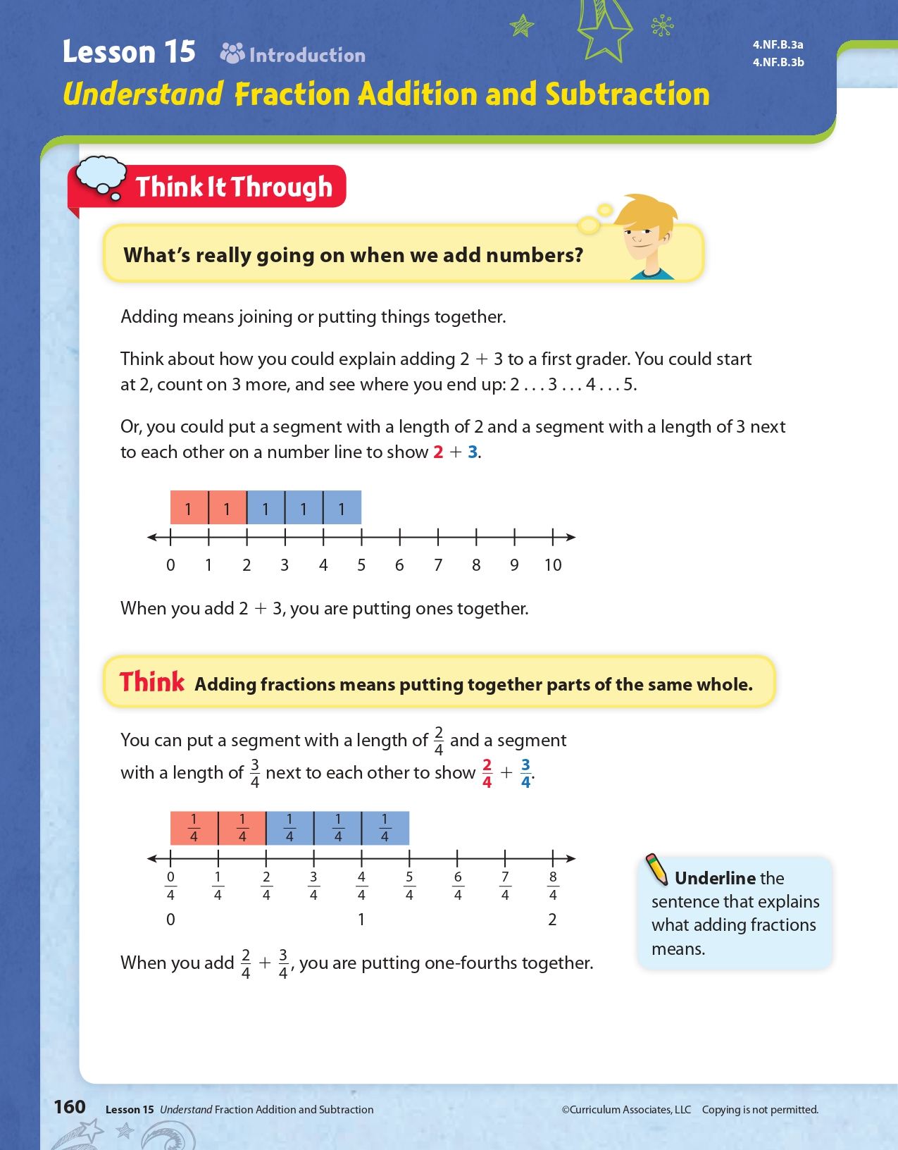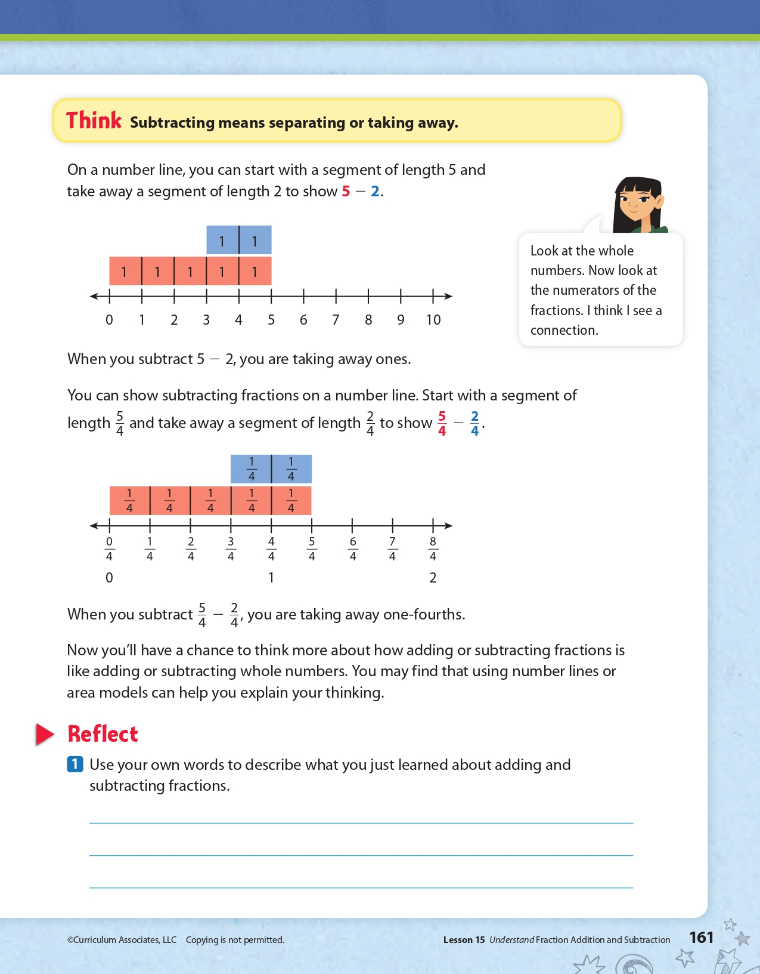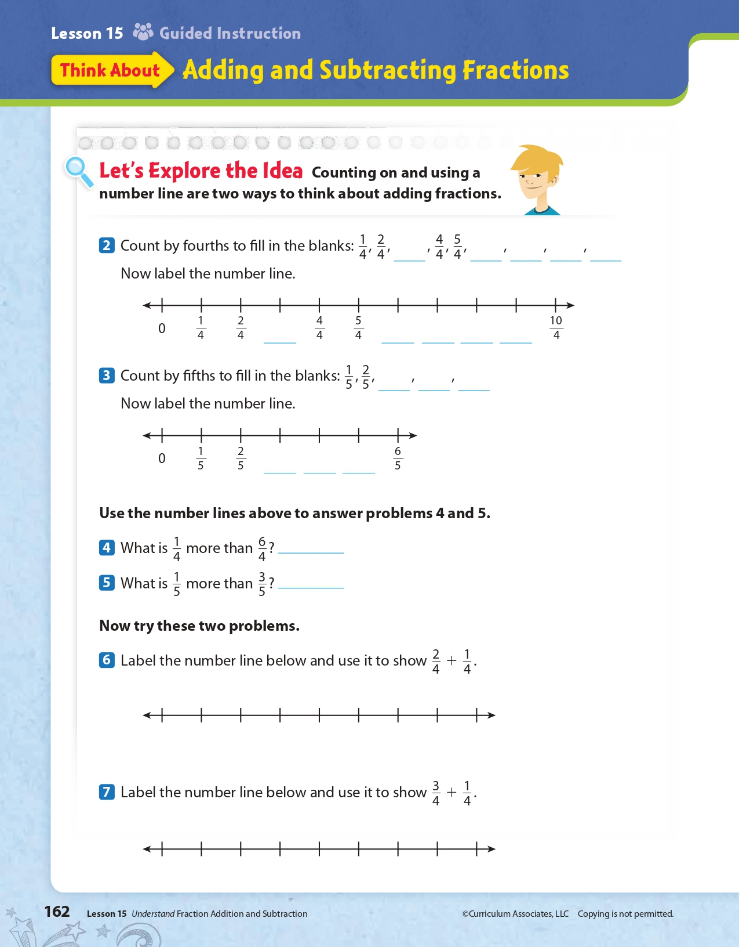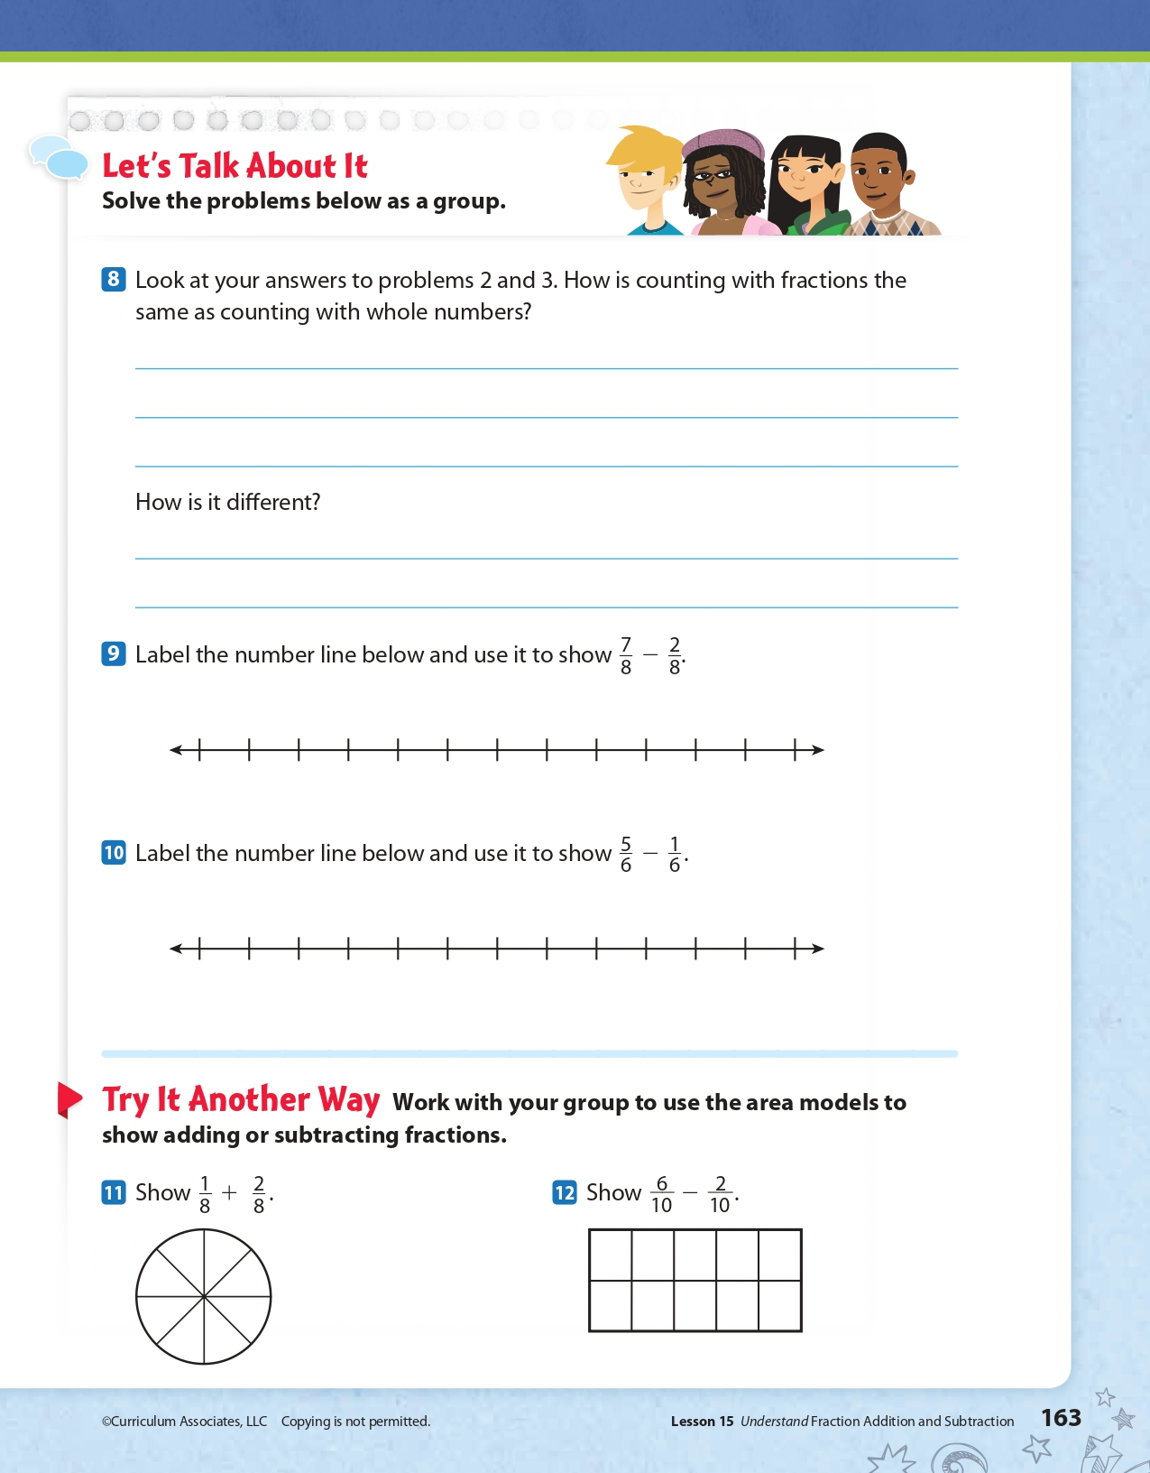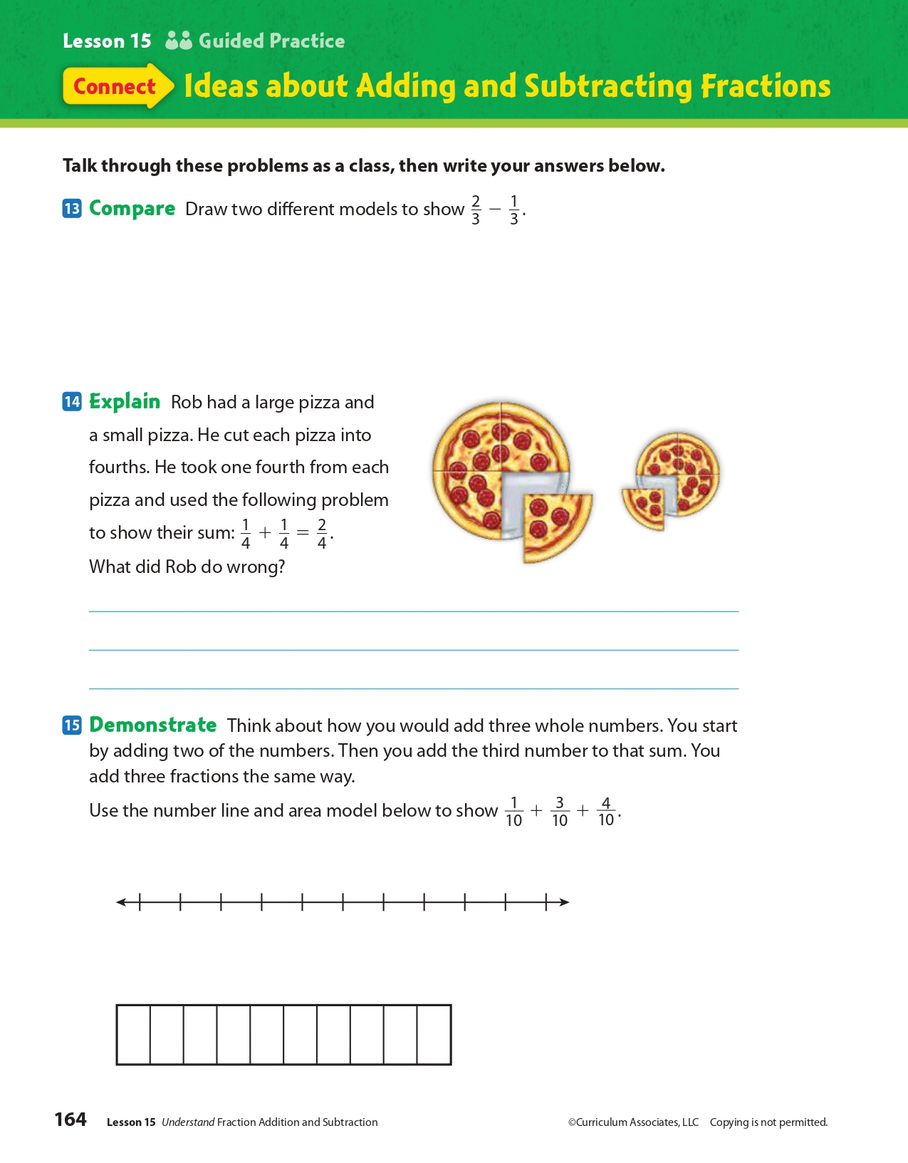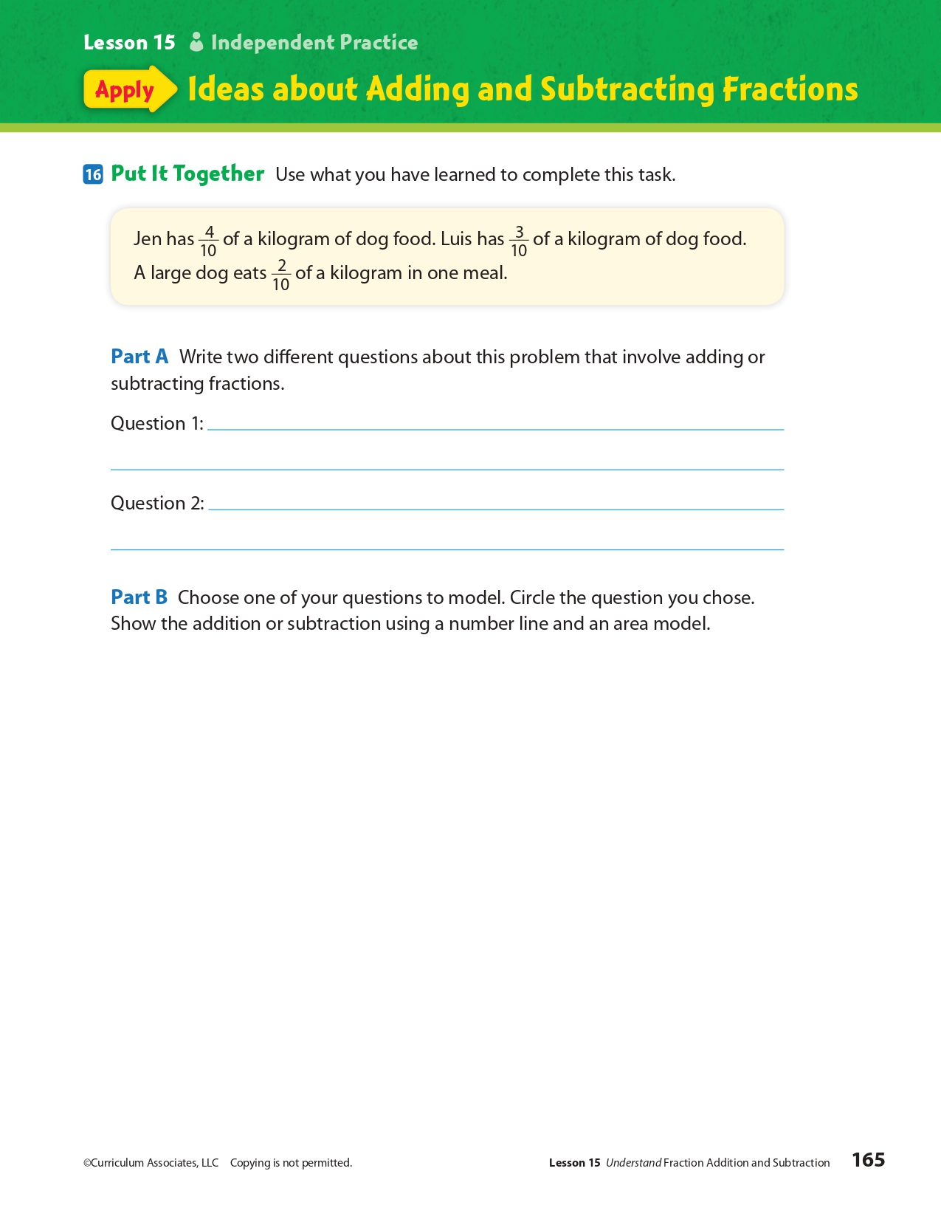
Day 3: How can symbols allow you to express your freedom of speech?
Health

What is this lesson about?: In today’s lesson, you will learn about the Freedom of Speech to express your personal beliefs at school. The story will feature a historical Supreme Court case that shaped the way that we represent our beliefs in a school today.

Step 1: Warm-Up:
The historic 1943 Supreme Court decision West Virginia Board of Education v. Barnette. A West Virginia law penalized students and their parents if the students failed to salute the flag and recite the pledge. A group of Jehovah’s Witnesses, who refused to comply for religious reasons, challenged the law.
The Supreme Court, overruling another decision issued only three years prior, sided with the Jehovah’s Witnesses. The court wrote that school boards must engage in “scrupulous protection of Constitutional freedoms of the individual … [so as] … not to strangle the free mind at its source and teach youth to discount important principles of our government as mere platitudes.” The court reasoned that the First Amendment free-speech clause included the right not to speak.
Did you know you also had the right NOT to speak? How can that be important?

Step 2: Read the story below.
Tinker v. Des Moines Independent Community School District was a Supreme Court case that was decided on February 24, 1969. In a ruling of 7–2, the court established the free speech and political rights of students in school settings. On the basis of the majority decision, school officials have limited authority to regulate student expression. To do so, they must prove one of two things. They must show that the student expression would interfere with the operations of the school or that it would invade the rights of others. When school officials can support predictions of disruption, they can regulate student expression.
Under U.S. law, schools are considered limited public spaces. As such, students have fewer rights in schools than they do on public streets. In schools, student free-speech rights must be balanced against the obligations of school officials. These include the responsibilities to protect student safety and to deliver a quality education. In general, student free-speech rights extend only to expressions of a political, economic or social nature that are not part of a school program. To this end, school officials have the authority to regulate student writing in school newspapers, for example. They have far less authority to regulate student discussions in the cafeteria. However, school officials can ban some forms of student expression that are crude or inappropriate. Officials do not have to show that such speech is disruptive since it has little or no educational value.

Background
On December 16, 1965, two students in Iowa wore black armbands to school in protest against the Vietnam War. One student was 13-year-old Mary Beth Tinker. The other was 16-year-old Christopher Eckhardt. The following day, Mary Beth's older brother John wore an armband, too. School officials suspended the students after they refused to remove their armbands. The protests followed a meeting at the Eckhardt house, where the parents of the students discussed ways to show that they did not support the Vietnam War.
On learning of the plan to protest the war, the principals of the Des Moines schools held a meeting. They created a policy specifically prohibiting the wearing of armbands. The new rule said that students who wore armbands in protest against the war would be subject to suspension and could return only after agreeing not to wear the armbands. The three students were suspended from school and did not return until after New Year's Day. The parents of the students filed a lawsuit. They requested a court order against the school board to prevent officials from punishing the students.
The petitioners argued that wearing the armbands in school was within the students' constitutional rights to free speech. The court disagreed and dismissed the case. It ruled that the board operated within its rights in suspending the students. On further review, the Eighth Circuit Court of Appeals upheld the ruling in 1967. The request for an additional review was granted by the U.S. Supreme Court in 1968.

Majority Opinion
The question presented to the U.S. Supreme Court concerned the First Amendment and the Fourteenth Amendment to the U.S. Constitution. It asked whether these amendments allowed school officials to restrict students from wearing symbols of political expression in school when the symbols are not "disruptive." The petitioners argued that the students' wearing of the armbands was protected by the First Amendment, which guarantees the right to free speech. They argued that it was also protected by the Fourteenth Amendment, which guarantees equal protection to all persons under the law. The respondents countered that officials were within their rights to regulate student expression. They argued that regulations were necessary to prevent disruptions in the classroom.
The Supreme Court's majority opinion was written by Justice Abe Fortas. He penned the famous line that neither teachers nor students "shed their constitutional rights to freedom of speech or expression at the schoolhouse gate." Fortas wrote that the wearing of armbands was akin to "pure speech" and was therefore protected by the Constitution. He added that "undifferentiated fear" of disturbance was not enough to ban student expression. For the school to be justified in banning the armbands, it would need to show that such student expression would interfere with the operations of the school. Otherwise, Fortas wrote, prohibiting student expression would be unconstitutional. Six other justices signed on to the majority opinion.

Dissenting Opinion
Justices Hugo Black and John Marshall did not agree with the other justices. In their dissenting opinions, they focused on the need for school officials to establish order. They argued that student expression can be restricted in order to limit disruptions. Justice Black argued at length for the school, noting that the disruptions anticipated by the administration actually occurred. He warned that the ruling would give students license to defy their teachers' orders.
In sum, Tinker v. Des Moines stands out as the first case dealing with the free-speech rights of students in public schools. It remains a major First Amendment case.

Step 3: Answer some questions below.
- Why do you think schools are considered limited public spaces?

- Do you think students should be allowed to wear symbols that represent their beliefs to school?

- In the Supreme Court decision, “"undifferentiated fear" of disturbance was not enough to ban student expression”. Do you agree that a fear that the expression could cause a disturbance to the school is not enough of a reason to ban freedom of speech on a school campus?

Step 4: Write a policy.
Imagine that you are being asked to outline freedom of speech for students in your school. Below write the rules or policies you would ask them to follow.

Student Feedback:
Circle the emojis that best represents how this activity made you feel.

Mindfulness Moment!

My favorite part of the day is… (be sure to write why!)

Day 3: Free Exercise Clause of the 1st Amendment
Social Studies

What is this lesson about?: Today you will learn more about the ‘Free Exercise’ clause of the 1st Amendment. You will consider situations that raise issues related to the clause and you will see how the U.S. courts have ruled over those issues.

Step 1: Warm-up on religious liberty

An apartment complex has a meeting room that is available for residents to reserve for card games, social activities, and similar events. A resident is told that she may not use the room to hold a Bible study with friends. What do you think?

Step 2: Revisit the Free Exercise clause of the 1st Amendment

“Congress shall make no law [1] respecting an establishment of religion or [2] prohibiting the free exercise thereof.”
The Free Exercise Clause protects citizens' right to practice their religion as they please, so long as the practice does not run afoul of a "public morals" or a "compelling" governmental interest. For instance, in Prince v. Massachusetts, 321 U.S. 158 (1944), the Supreme Court held that a state could force the vaccination of children whose parents would not allow such action for religious reasons. The Court held that the state had an overriding interest in protecting public health and safety.
Step 3: Consider the scenarios

- A family owned company wants an exemption from a federal government healthcare requirement that they provide coverage for medicines or procedures that violate the company’s religious beliefs. Can the company receive an exemption?

Do you think this violates the Free Exercise Clause based on the text of the First Amendment? Why or why not?

- A baker refuses to bake a wedding cake for a same-sex marriage citing deeply held religious beliefs and a violation of free speech. The state punishes the baker for violating state anti-discrimination laws. Is the baker required to make the wedding cake?

Do you think this violates the Free Exercise Clause based on the text of the First Amendment? Why or why not?

Step 4: Read about a Supreme Court case

From the beginning, courts in the United States have struggled to find a balance between the religious liberty of believers, who often claim the right to be excused or “exempted” from laws that interfere with their religious practices, and the interests of society reflected in those very laws. Below, you will read about two recent Supreme Court cases that deal with this issue.

Case Summary: Conestoga Wood Specialties Corp. v. Health and Human Services Department
The Affordable Care Act, enacted on March 23, 2010, includes a provision that mandates health insurance cover “additional preventive care and screenings” for women. The Health Resources and Services Administration (HRSA) issued a set of guidelines in the mandate, which concludes access to contraception is medically necessary to “ensure women’s health and well-being.”
Norman Hahn, owner of Conestoga Wood Specialties Corp., objected to the new provisions set forth, and claimed it would be "sinful and immoral" to pay for or support certain forms of contraception, such as Plan B, as required by compliance with the Affordable Care Act. Although Conestoga Wood Specialities Corp. complied with the mandate to avoid fines of up to $95,000 per day, it filed suit for an exemption.
The case ended up before the Supreme Court (along with a similar case Hobby Lobby). On June 30, 2014, Associate Justice Samuel Alito delivered the judgment of the court. The Supreme Court ruled in favor of Hobby Lobby and Conestoga, finding that closely held for-profit corporations have free exercise of religion under the Religious Freedom Restoration Act (RFRA).

Supreme Court rules in Obamacare challenge case
June 30, 2014 by Scott Bomboy
A divided Supreme Court on Monday said the two for-profit companies that requested religious exemptions from the Affordable Care Act, or Obamacare, can have them under limited circumstances.
In a majority opinion written by Associate Justice Samuel Alito, the Justices said the exceptions only apply to the Affordable Care Act’s contraception mandate and in relation to closely held companies that had objections under the federal Religious Freedom Restoration Act (RFRA).
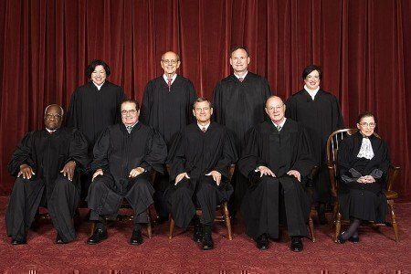
In the 5-4 decision, Alito said the closely held corporations cannot be required to provide contraception coverage under Obamacare if they had religious objections.
"Protecting the free-exercise rights of closely held corporations thus protects the religious liberty of the humans who own and control them," said Alito.
The decision is also narrowly focused on just the contraception mandate, and it doesn’t invalidate other parts of Obamacare.
Alito also stated that the federal government failed to prove that the contraception mandate was the least restrictive means of advancing its interest in guaranteeing cost-free access to birth control. But the decision also allowed the government to provide the same products to employees, instead of their employer.
"There are other ways in which Congress or HHS could equally ensure that every woman has cost-free access to the particular contraceptives at issue here and, indeed, to all FDA-approved contraceptives," Alito said.
In Hobby Lobby Stores v. Burwell, Hobby Lobby, a craft store chain, and its sister company, Mardel Christian bookstore, wanted an exemption from an Obamacare requirement that it provide insurance coverage for morning-after pills and similar emergency birth control methods and devices.
In Conestoga Wood Specialties Corp. v. Health and Human Services Department. a Mennonite family-owned, profit-making business claimed that the ACA’s birth control mandate violated the company’s rights under the First Amendment and the federal Religious Freedom Restoration Act (RFRA).
How did the Supreme Court rule on this case?

After reading about this case, would you change your answer to the 2nd scenario above? Explain.

Step 5: Read about another Supreme Court case

Case Summary: Masterpiece Cakeshop v. Colorado Civil Rights Commission

On December 5, 2017, the U.S. Supreme Court heard the case of Masterpiece Cakeshop v. Colorado Civil Rights Commission, a case about a baker who refused to sell a cake for a same-sex wedding reception because of his religious beliefs. The case began in 2012 when Charlie Craig and Dave Mullins, a same-sex couple, went to Masterpiece Cakeshop, a bakery in Lakewood, Colorado, to purchase a custom wedding cake for their wedding reception. The bakery owner, Jack Phillips, said that he would sell wedding cakes only to heterosexual couples because of his religious beliefs. The couple filed a lawsuit. A court in Colorado found that the bakery discriminated against the couple and ordered the bakery to provide for same-sex marriages. Colorado has a state law which prohibits businesses that are open to the public from discriminating based on characteristics, including sexual orientation. Mr. Phillips responded by arguing that the state’s anti-discrimination law forced him to use his artistic talents to bake a cake for same-sex couples, violating his constitutional rights to free speech and religious liberty. This led to the U.S. Supreme Court taking on the case for ruling.
In June 2018, the Supreme Court ruled in favor of Masterpiece Cakeshop owner Jack Phillips, finding that the Colorado Civil Rights Commission was improperly influenced by religious hostility when it ruled against him in his effort to refuse to bake a cake for a same-sex wedding. It is important to note, however, that the Court ruling was a narrow one that did not give businesses a constitutional right to discriminate. The Court reiterated the importance of the rights and dignity of LGBTQ individuals to be free from discrimination, and recognized that exemptions to anti-discrimination laws for businesses must be limited and confined.

Supreme Court rules for baker in wedding-cake dispute
June 4, 2018 by Scott Bomboy
A divided Supreme Court said on Monday that a Colorado baker and cake artist was wrongly censored by the state of Colorado for refusing to make a cake for a same-sex couple’s wedding party.
In the 7-2 decision, Justice Anthony Kennedy said in Masterpiece Cakeshop, Ltd. v. Colorado Civil Rights Commission that the Colorado Rights Commission incorrectly acted in its considerations that Masterpiece Cakeshop violated the Colorado Anti-Discrimination Act (or CADA).
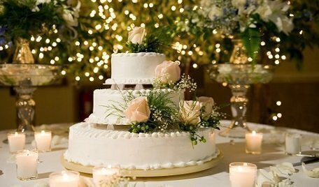
“The laws and the Constitution can, and in some instances must, protect gay persons and gay couples in the exercise of their civil rights, but religious and philosophical objections to gay marriage are protected views and in some instances protected forms of expression,” Kennedy said.
Kennedy said the baker, Jack Phillips, was “entitled to a neutral and respectful consideration of his claims in all the circumstances of the case,” but the statements of some Colorado commission officials created doubts as to the neutrality of their decision.
“That consideration was compromised, however, by the Commission’s treatment of Phillips’ case, which showed elements of a clear and impermissible hostility toward the sincere religious beliefs motivating his objection,” Kennedy said. For those and other reasons, Kennedy said, “the Commission’s treatment of Phillips’ case violated the State’s duty under the First Amendment not to base laws or regulations on hostility to a religion or religious viewpoint.”
Phillips and his wife own a business in Colorado, where as a cake artist he designs cakes. In their court petition, Phillips’ attorneys note that due to his beliefs, Phillips had also declined to make cakes that celebrate Halloween, anti-American or anti-family themes, atheism, racism, or indecency. When approached by a same-sex couple about making a cake for their wedding, Phillips declined to design a cake with that message, but he offered to make any another cake for them that didn’t conflict with his beliefs.
Phillips had argued that the Colorado Act should be interpreted to allow him to refuse to design the cake under the Constitution’s free exercise of religion doctrine. A Colorado Appeals Court disagreed, upholding the commission’s ruling and saying the commission’s order didn’t violate the Constitution’s free exercise of religion clause.
How did the Supreme Court rule on this case?

After reading about this case, would you change your answer to the 2nd scenario above? Explain.

Step 6: Reflection

The Supreme Court often has to make decisions on very difficult and controversial issues. Ultimately the job of the Supreme Court Justices is to make a ruling that is in line with the U.S. Constitution. Think back on the two cases you read about today and choose one to answer the following questions about:

Do you agree with the Supreme Court’s decision? Why or why not?

Do you think the Supreme Court followed the First Amendment’s Free Exercise clause in their ruling? Why or why not?

Student Feedback:
Circle the emojis that best represents how this activity made you feel.

