Week 2
Environment

Day 5

NAME:______________________

Day 5 Agenda

Topic | Activity
Warm-Up!
English Language Arts | - Prepare for writing a persuasive speech  - Write a speech  - Give your speech and reflect
Science | - Read the article, East Africa’s huge locust outbreak spreads to Congo  - Respond to the questions  - Reflect on the articles you read for this week; respond to the questions
Mindfulness Moment!
Math | - Credit Card wisdom  - Practice: Fractions, Decimals and Percents
Health | - Sleep Journal  - Sleep Advice
Civics/Social Studies | - Recap and reflect on the week’s learning  - Make a personal connection to the topics  - Use personal expression and collaboration to show what you know

Warm-up Activity: You will determine the conditions of the story by filling in the blank and writing the rest of the story.
“That was a reporter, the video I made of ______________ went viral.”

Day 5: Recycling Debate - Persuasive Writing
English Language Arts

What is this lesson about?: Today you will complete your preparation for the debate on whether we should continue recycling, and you will write a short persuasive speech presenting your argument.

Step 1: Organize your thoughts
Reminder: The purpose of a persuasive speech is to convince your audience to agree with an idea or opinion that you present.

Use the speech organizer on the next page to help you prepare a persuasive speech. Imagine you will be giving this speech at a community meeting where community members will be voting on whether to continue the recycling program.

For your main reasons, you can use the arguments to support your position from yesterday’s graphic organizer. For facts or examples, you may draw from yesterday’s article or from your own personal experience.

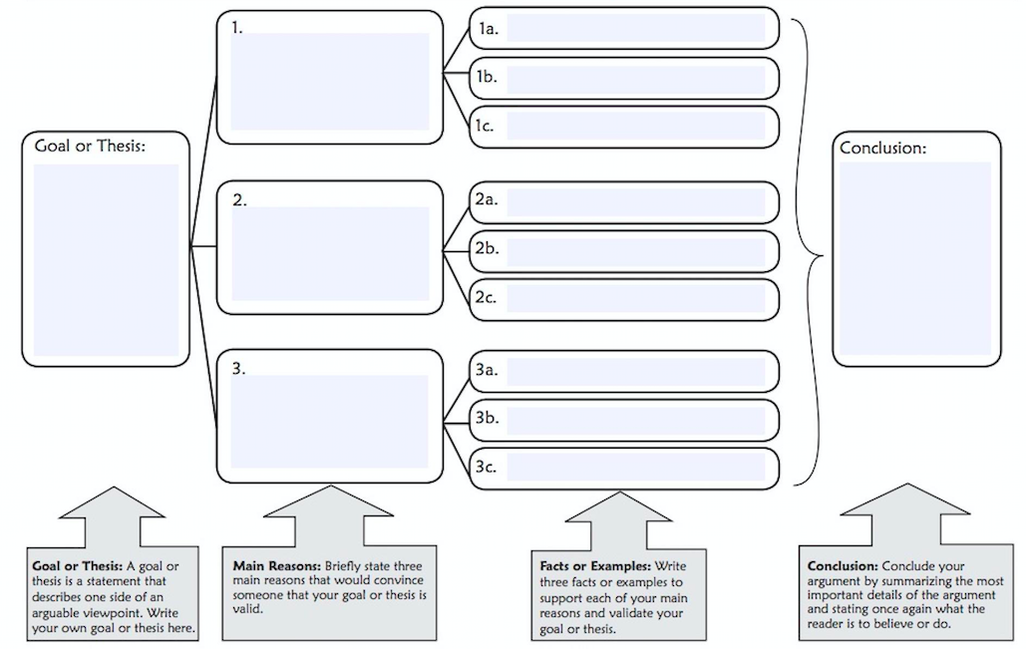
Step 2: Write your speech!

Now that you’ve organized your thoughts and arguments, write a 3-5 minute speech trying to persuade community members to take your position on this recycling debate.

Step 3: Give your speech
Now it’s time to share your speech! Working with a partner or a group, give your speech and allow your partner(s) to ask a couple questions. Now listen to your partner(s) speech and do the same for them.

Take a quick vote:
How many people want to continue recycling? _______
How many people want to stop recycling? _______

Why do you think the winning side won?

Some people say that if you don’t control your environment, your environment will control you. Does your group agree or disagree with that statement?

Why?

How might we try to control our environment in a way that will benefit us? (note: this can be any environment… mother nature, our current location, our current period of time, etc.)

Student Feedback:

Circle the emojis that best represents how this activity made you feel. | 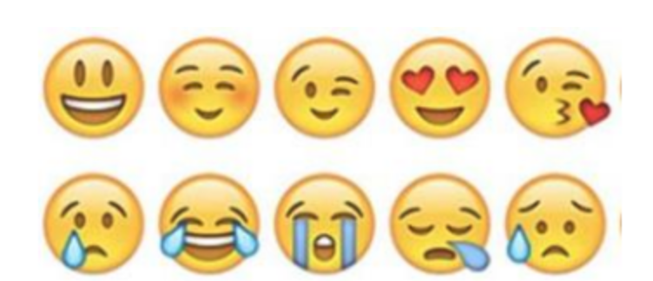  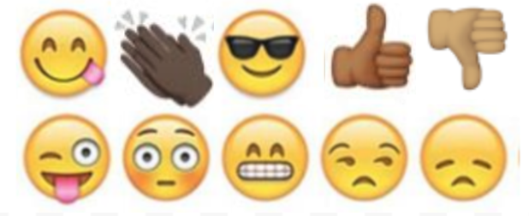

Day 5: Science
Environment

What is this lesson about?: Today you will read the article, East Africa’s huge locust outbreak spreads to Congo. You will respond to the questions at the end of the article.

Step 1: Read the article.

East Africa’s Huge Locust Outbreak spreads to Congo
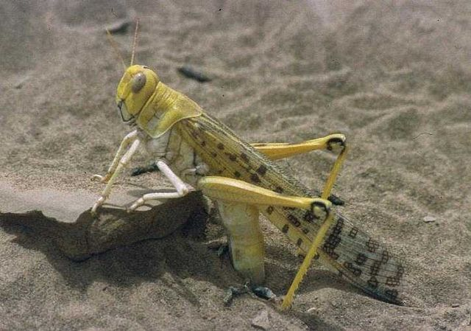

https://commons.wikimedia.org/w/index.php?search=locust&title=Special:MediaSearch&go=Go&type=image

Kenya on Feb. 1, 2020.
KAMPALA, Uganda — A small group of desert locusts has entered Congo, marking the first time the voracious insects have been seen in the Central African country since 1944, the U.N. Food and Agriculture Agency said Tuesday as U.N. agencies warned of a "major hunger threat" in East Africa from the flying pests.
Kenya, Somalia and Uganda have been battling the swarms in the worst locust outbreak that parts of East Africa have seen in 70 years. The U.N. said swarms have also been sighted in Djibouti, Eritrea and Tanzania and recently reached South Sudan, a country where roughly half the population already faces hunger after years of civil war.
A joint statement Tuesday from FAO director-general Qu Dongyu, U.N. humanitarian chief Mark Lowcock, and World Food Program Executive Director David Beasley called the swarms of locusts "a scourge of biblical proportions" and "a graphic and shocking reminder of this region's vulnerability."
The FAO said mature locusts, carried in part by the wind, arrived on the western shore of Lake Albert in eastern Congo on Friday near the town of Bunia. The country has not seen locusts for 75 years, it said.
"Needless to say the potential impact of locusts on a country still grappling with complex conflict, Ebola and measles outbreaks, high levels of displacement, and chronic food insecurity would be devastating," the U.N. officials said in the joint statement.
Locust swarms can reach the size of major cities and can destroy crops and devastate pasture for animals.
Experts have warned that the outbreak is affecting millions of already vulnerable people across the region.
Uganda's government said Tuesday it was trying to contain a large swarm and will need more resources to control the infestation that has spread to over 20 districts in the north. Soldiers have been battling swarms using hand-held spray pumps, while experts have said aerial spraying is the only effective control.
The U.N. recently raised its aid appeal from $76 million to $138 million, saying the need for more help is urgent.
"This funding will ensure that activities to control the locusts can take place before new swarms emerge," the U.N. officials said, noting that to date only $33 million has been received or committed.
Experts have warned that the number of locusts if unchecked could grow 500 times by June, when drier weather is expected in the region.
"WFP has estimated the cost of responding to the impact of locusts on food security alone to be at least 15 times higher than the cost of preventing the spread now," the U.N. officials said in the statement.
A changing climate has contributed to this outbreak as a warming Indian Ocean means more powerful tropical cyclones hitting the region. A cyclone late last year in Somalia brought heavy rains that fed fresh vegetation to fuel the locusts that were carried in by the wind from the Arabian Peninsula.
Desert locusts have a reproduction cycle of three months, the U.N. officials said, and mature swarms are laying eggs in vast areas of Ethiopia, Kenya and Somalia, "many of which are already hatching."
"In just a few weeks, the next generation of the pests will transition from their juvenile stage and take wing in a renewed frenzy of destructive swarm activity," the joint statement said.
This is a time when farmers' crops begin to sprout, which could devastate East Africa's most important crop of the year, the U.N. officials said.
"But that doesn't have to happen," they said. "The window of opportunity is still open. The time to act is now."

Step 2: Answer the following questions

After reading the article, and as you think of your role as an environmentalist, answer any 2 questions:
- What suggestions would you make to the United Nations?
- What supports would you make sure are in place for East Africa, Congo, and other impacted countries?
- What will you do to make sure these locusts or other similar bugs do not take over the United States?
Question ___

Question ___

Step 3: Reflection

As you think about the articles you read in Science this week, which article did you enjoy reading the most? Why?

What positive change to your environment do you hope to make one day, as a result of what you learned?

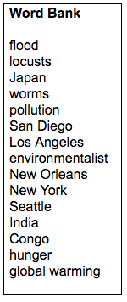
Step 4: Quiz
Fill in the blanks below with a word from the word bank.

- An ______________________ is someone who is concerned with or advocates the protection of the environment.
- There is far less air __________________ as a result of the Coronavirus shutdown.
- The three main cities in the United States currently showing cleaner air are: ____________________ _____________________ ___________________
- Many people in __________________ are more afraid of dying of _________________ than dying of the Coronavirus.
- ____________________ is the gradual increase of the Earth’s temperature.
- __________________ is an example of a natural disaster.
- East Africa is experiencing an outbreak of ___________________.

Student Feedback:
Circle the emojis that best represents how this activity made you feel.

Mindfulness Moment! Respond to your Mindfulness card in the box below.
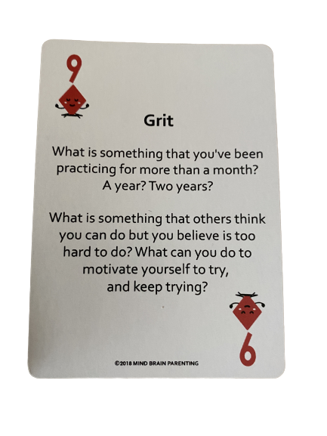

Day 5: Credit Cards and Debt
Math

What is this lesson about?: We are going to finish out this week looking at Credit Cards and how credit card fees and debt can really get you if you aren’t careful. The environment you are living in might have a big impact on how and whether you use a credit card.

Today’s Warm-Up (it’s a little more than a warm-up!)
Let’s take a look at cigarette prices and state taxes...

Use the table below to answer the warm-up questions below.

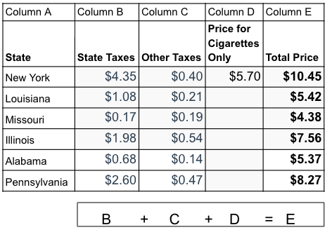
Complete Column D in the chart.
- How much does it cost for the cigarettes ONLY in Illinois?
- How much does it cost for the cigarettes ONLY in Louisiana?

Carefully look at Column B in the chart.
- Write the states in order of highest to lowest state taxes on Cigarettes below:

- Very roughly place the Total Cost (Column E) in the correct location on the map below in the correct state on the map!
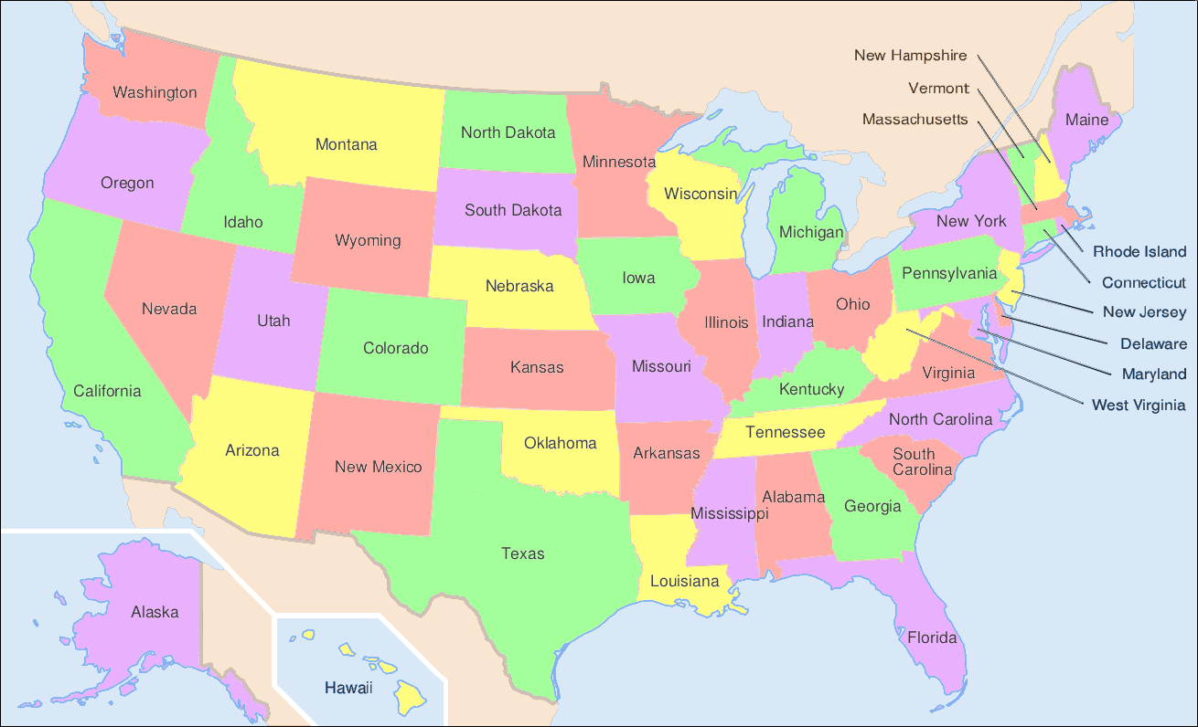

- Write or DISCUSS if permitted: What do you notice if anything, from this map once you write the cost of cigarettes in.

- Write or DISCUSS if permitted: Is there any relationship between the price of cigarettes and where the state is located in the US?

Step 1: Understanding the key ways that Credit Cards ‘get you’

Annual Fee: This is a flat yearly fee that some credit cards charge for you to have and use the card, no matter how much you use it
- Annual fees range from $0 to approx. $50 per year.

Late Fee: Late fee is the flat amount that a credit card company charges you if you don’t pay your monthly bill on time. The late fee is the same if you owe the bank $10 or $1,000. It kicks in once you are late making your monthly payment.

Interest Rate: Interest rate is the rate the bank charges you for any amount of money that you don’t totally pay off at the end of the month.
- If you put $1000 on your credit card and the pay it all off at the end of the month, you pay $ 0 in interest.
- If you put $1000 on your credit card and do NOT pay it all off, you start paying interest. If this $1000 goes unpaid for 1 year, you may pay as much as $200 in interest (20%).

Minimum Payment: This is a monthly amount that credit card companies charge. It is important to know that the ‘minimum payment’ is generally a small dollar amount, just enough for them to keep you on the hook, but not enough to help you pay off your loan amount--so if you ONLY pay the minimum amount, you NEVER pay off your credit card.

Carefully review the chart below and then try and answer the questions below.
 | Credit Card #1 | Credit Card #2 | Credit Card #3
Annual Fee | 0 | 50 | 50
Late Fee | 25 | 20 | 30
Interest Rate | 20% | 15% | 10%

Step 2: Let’s consider Marcus, a very good credit card user!

Marcus is very, very careful with his credit card. He uses it to buy his groceries and a few other necessities each month. He has it set up that he automatically pays off his TOTAL monthly bill each month, automatically, 1 day before the payment is due. He has NO late fees, NO interest charges...

- How much will it cost him to use Credit Card #1 for the whole year?

- How about Credit Card #2?

- How about Credit Card #3?

- So, what card should he sign up for?

Step 3: Let’s consider Stephanie, under 23 scenarios…

Stephanie is also quite careful. She almost always pays off her Credit Card each month. But occasionally she just pays the Minimum Amount Due. One year ago, she got into a bad car accident. That repair cost her $2,500.

She didn’t have comprehensive/collision insurance, so went out and got a separate credit card just to help her pay off her repair.

Assume that she decided on Credit Card #3. Here’s what happens:
- For the first 2 months, Stephanie is late with her minimum payments, so she gets charged a late fee each time.
- She gets a part-time job in the evening. Each month she saves some money and puts it in the bank. She isn’t late anymore and she does make her minimum payments, but she does NOT pay down her credit card balance. Finally after 12 months, she thinks she has saved enough money. How can we calculate how much she will end up spending all together to pay for her car to get fixed using this card.

  - A. Annual Fee for the new card: ______

  - B. LATE FEES for the two months she was late? ______
  - C. How much does she owe in interest (approximately).
    - Hint: what is 10% of the $2500 she borrowed? ______

  - D. Original amount of $ for car repair $2500
  - E. SO, in total, how much did her car repair cost her by
  - using Credit Card #3? (A+B+C+D) = ______
What would have happened to Stephanie is she decided to use Credit Card #1 to pay for her $2,500 car repair? Assume everything is the same, except that she used Card #1.

Assume that she decided on Credit Card #1. Here’s what happens:
- For the first 2 months, Stephanie is late with her minimum payments, so she gets charged a late fee each time.
- She gets a part-time job in the evening. Each month she saves some money and puts it in the bank. She isn’t late anymore with her minimum payments, but she does NOT pay down her credit card balance. Finally after 12 months, she thinks she has saved enough money. How can we calculate how much she will end up spending all together to pay for her car to get fixed using this card.
  - A. Annual Fee for the new card (Card #1): ______

  - B. LATE FEES for the two months she was late? ______
  - C. How much does she owe in interest (approximately).
    - Hint: what is 20% of the $2500 she borrowed? ______

  - D. Original amount of $ for car repair $2500
  - E. SO, in total, how much did her car repair cost her by
  - using Credit Card #1? (A+B+C+D) = ______

Step 4: Conclusions...and next steps with credit cards

Write down short answers, and DISCUSS if permitted, to each of the questions below-

- What is the absolute best way to keep down your credit card costs?

- How can you avoid late fees that credit cards charge you?

- When could it be worth it to use a credit card that charges an annual feel?

- What is the problem with only paying off the ‘monthly minimum payment’ on a credit card?

Skill Builders and Review Problems-
If you have more time, take a few minutes to complete the “skill builder” problems in the separate handout packet.
- Comparing and Converting--Fractions, Decimals and Percents

Student Feedback:
Circle the emojis that best represents how this activity made you feel.

Day 5: Sleep
Health
Step 1: Sleep Journal

Summarize what you have learned about sleep this week.

Step 2: Sleep Advice
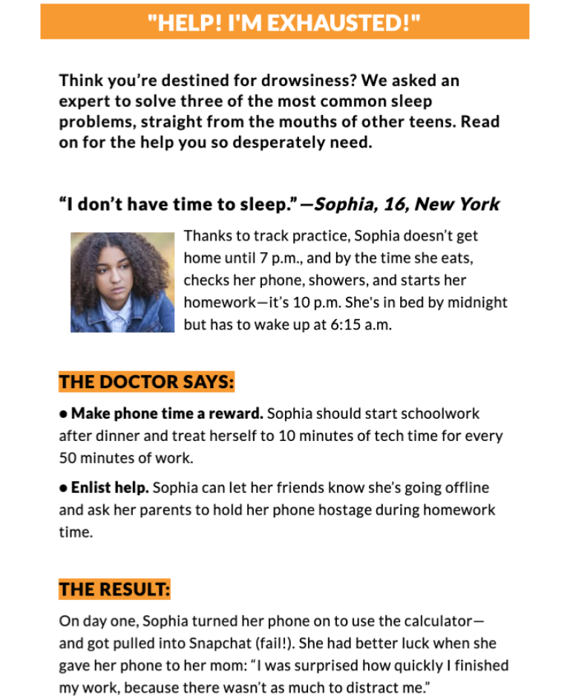
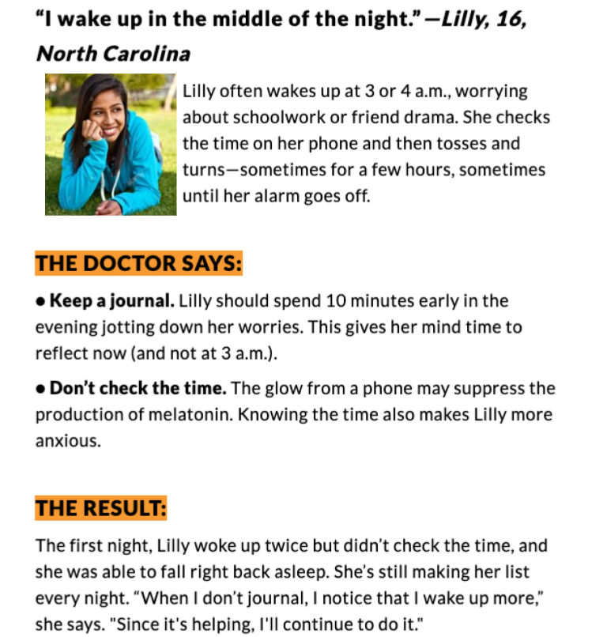

Step 2: Share your ideas
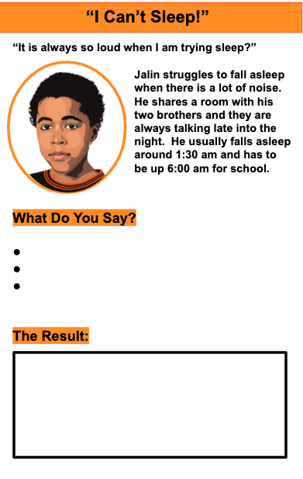

Day 5: End of the Week Playlist
Social Studies

What is this lesson about? In this final lesson of the week you have the opportunity to create a playlist of music. Use this activity to express yourself personally and also to recap and reflect upon the things you learned in this week’s social studies lessons.

Step 1: List
Brainstorm and list some of your favorite songs. Think about ones that connect to and relate somehow to what you’ve learned in social studies this week. To make your playlist you need a list of 7 songs. Here’s a list reviewing some of the main ideas, themes and topics you read about this week. Come up with a song for each of the following:

- Day one’s lesson (Wangari Maathai; environmentalism; activism; deforestation; Nobel Peace Prize; Kenya)
- Day two’s lesson (Environmental racism; air pollution; inequality; racism)
- Day three’s lesson (The Flu Pandemic of 1918; Philadelphia; St. Louis; epidemic; pandemic; influenza; coronavirus)
- Day four’s lesson (D-Nice; music and culture; quarantine; isolation; hip-hop; DJ’ing; virtual community; celebrity)
- The way you’re feeling personally and the kind of week you’ve had.
- Someone or something from home that you love and miss.
- Something happening out there in the world that weighs on your mind.

Step 2: Explain
Write 1-2 sentences explaining why you chose each song. What is the connection or meaning of each song and the themes or topics listed in Step 1? What do the artist or lyrics represent and why does that matter to you

Step 3: Compile
Once you’ve gathered your ideas from Steps 1-2, use the space below to compose your playlist. Don’t forget the very important step of giving the play list a title!

Playlist Name:__________________
Track1:
Why I chose this song:

Track 2:
Why I chose this song:

Track 3:
Why I chose this song:

Track 4:
Why I chose this song:

Track 5:
Why I chose this song:

Track 6:
Why I chose this song:

Track 7:
Why I chose this song:

Step 4: Extension Ideas
- Share your list with a peer. Discuss ideas and defend the tracks you chose.
- Either with the same peer or a group of peers, combine the best of everyone’s playlists into a GREATEST HITS or Top 10 list.
- When and IF you have access, and with the help and permission of an adult, create the actual playlist you and your peers worked on.
- Listen and enjoy!
Student Feedback:
Circle the emojis that best represents how this activity made you feel. | 