Week 2
Environment

Day 1

NAME:______________________

Day 1 Agenda

Topic | Activity
Warm-Up!
English Language Arts | - Discover what this week’s theme means  - Learn about setting in fictional stories  - Read passages and respond to questions about setting
Science | - Read the article, Coronavirus shutdowns have unintended climate benefits: cleaner air, clearer water  - Make recommendations to continue the cleaner air and clearer water  - Draw a picture of something within your environment that most concerns you and make suggestions to bring about change
Mindfulness Moment!
Math | - Real world Problem: Making smart choices about cell phones and cell phone plans-  - Practice: Multiplication & Division, Quick Hits
Health | - Sleep Journal  - Sleep Survey
Civics/Social Studies | Environmental Activism: Wangari Maathai  - Read an article  - Answer questions about the article  - Summarize the article

Warm-up Activity: You will determine the conditions of the story by filling in the blank and writing the rest of the story.
Lori did not want to leave town, but when Ashleigh did ________________, she felt she had no choice.

Day 1: Settings in Fictional Stories
English Language Arts

What is this lesson about?: In this lesson, you will consider the theme for the week, which is “Environment.” You will explore what “environment” is in fictional story-telling by learning about story settings. In the next two classes, we will continue exploring settings of stories and how the setting informs a story’s theme, mood, and plot.

Step 1: Reflect on this week’s theme

This week, your lessons are organized around the theme of “Environment.” Write a definition for “environment” below.

Circle the words below that you think are synonyms to “environment.” (Reminder: A synonym is a word or phrase that means exactly or nearly the same as another word)

Habitat Life Surroundings America Theory Place
Farm Structure Setting Neighborhood

Look at the definition of environment on the next page. Was your definition close?
After looking at the definition of Environment, list 5 environments in which you could find a bird?

Question to consider: Does our environment affect how we act? How we think? How we feel? Write down a short answer:

Definition
Environment: 1. the surroundings or conditions in which a person, animal, or plant lives or operates; 2. the natural world, as a whole or in a particular geographical area, especially as affected by human activity.

Step 2: Learn about “settings” and environments in stories

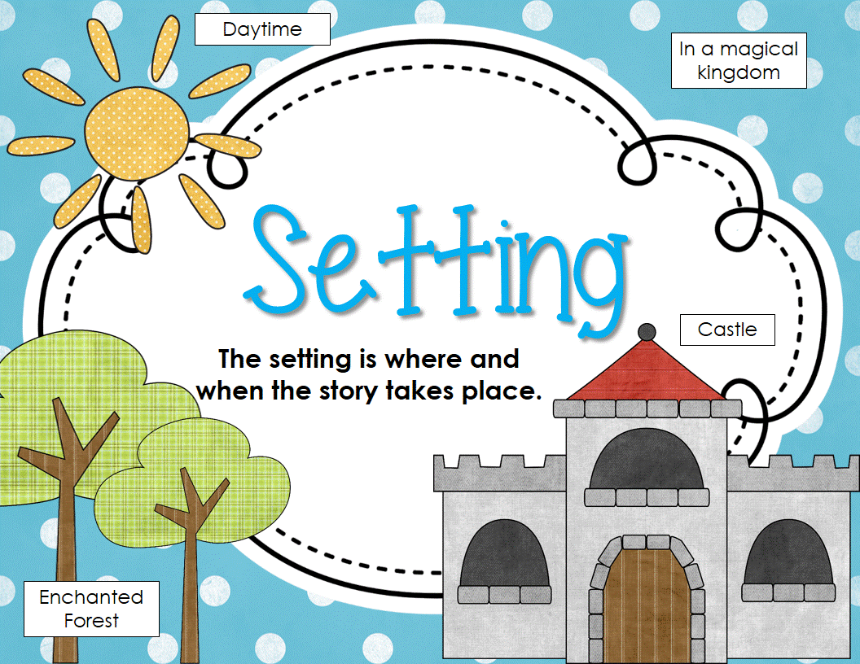
What is setting?
The definition for “setting” is time and place. The setting informs a story’s theme, mood, and plot, and provides context. Setting isn’t only in the background of a story! Setting can play an important role in the stories we read and the movies we watch. Setting can establish the mood and reveal the characters and conflict. It can even give clues to the theme—the universal message—of a story.

How do you know what the setting of a story is?
Sometimes, a narrator will tell you where and when the story occurs right away. Often, though, you’ll have to look for clues to determine the setting. Try to find words or phrases that tell you what it looks like or sounds like where the characters are. Characters can also give clues about the setting. Authors often describe the setting by relying on our senses and providing details about what the setting tastes, feels, sounds, smells, or looks like.

Think about the five senses. Act as if you are an author writing a story, write short phrases or words to brainstorm what your character might sense in the location of a jungle.

See
Feel
Hear
Smell
Taste

Now, using your brainstorm above, write a short intro paragraph to your story. You can give details about your main character to help describe what they are sensing. Do not use the word “jungle” in your paragraph, let the reader figure out the setting on their own.

Step 3: Read and answer the questions.

Read the passage and answer the following questions.

As Maribelle hurried down the street, the wind swept the snow along the sidewalk and hid her footsteps, so that it looked as if no one had passed. Above her, the cold, silent skyscrapers of the city loomed. The whole block was eerily silent in the snowstorm, and she pulled her coat tightly around her. Maribelle had only moved here a few months before. She came because she wanted to be a singer. But right now, she was frightened.

Question 1: Where do you think Maribelle is?

Question 2: What quote helped you to determine where Maribelle is?

A “Above her, the cold, silent skyscrapers of the city loomed.”
B “Maribelle had only moved here a few months before.”
C “But right now, she was frightened.”
D “She came because she wanted to be a singer.”
___________

Setting can symbolize, or stand for, other elements of a story. For example, when setting changes, a character might change. Setting can also symbolize what a character is feeling in a particular scene. Setting can also help us understand the choices that characters make.

Read the following passage and answer the question.

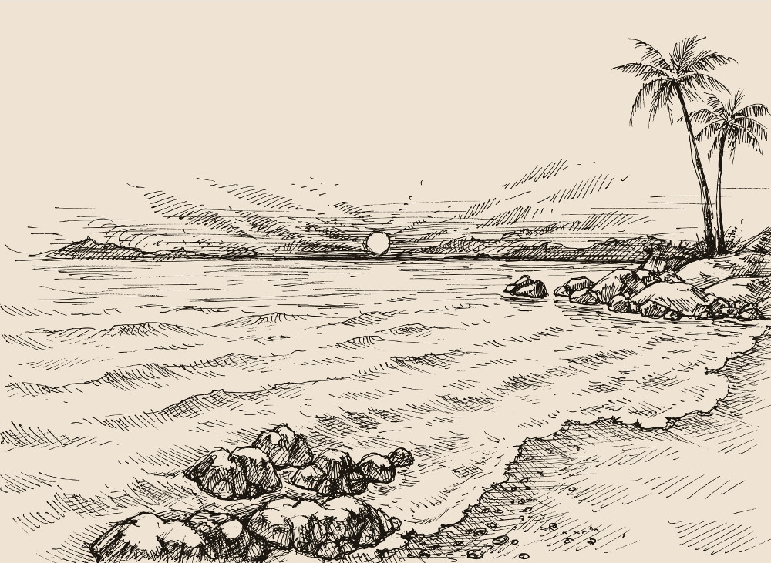
Gilberto had been excited to go to the beach but when he got there and saw how crowded it was, he became annoyed. The sun twinkled in the sky, a warm yellow globe. The sound of the ocean drummed in his ears and the sand itched his ankles and feet. Beside him, his sister slurped loudly on an ice cream cone. “Could you not?” Gilberto asked.

Question 1: What quote about the setting helps you to understand how Gilberto is feeling?

A “The sound of the ocean drummed in his ears and the sand itched his ankles and feet.”
B “The sun twinkled in the sky, a warm yellow globe.”
C “Beside him, his sister slurped loudly on an ice cream cone.”
D “Gilberto had been excited to go to the beach...”

Question 2: Explain why you chose your answer:

Step 4: Practice developing the setting of a story

Read the following sentences describing a situation or character. Develop a setting that would give context to the sentence and make the sentence more understandable.

Example: Jeremy was standing, waiting. His jaw was clenched and he was sweating.

What setting could this happen in?

In this example, the mood is tense and nervous. A setting that would fit this might be a sporting event, say Jeremy is at a racetrack and is about to race in the 100-meter sprint.

Sentence 1: Chills drew down Maria’s spine and she sprang to her feet.

What setting could this happen in?

Sentence 2: Peter’s grandma was looking at him and smiling, she was proud of her grandson.

What setting could this happen in?

Sentence 3: Marcus stared into the eyes of Kevin, there was no way he was going to let Kevin win this time.

What setting could this happen in?

Sentence 4: The wind blew in Jackie’s hair as the sun warmed her skin. She could hear the birds chirping in the distance.

What setting could this happen in?

Step 4: Closing Reflection

Complete the graphic organizer and answer the question below about today’s lesson on setting.

What I learned | What I have questions about

Now that you have learned about the importance of story settings, how will you change the way you consider the setting or environment of a story as you read in the future. (Will you pay more attention to the setting? Why?)

Student Feedback:

Circle the emojis that best represents how this activity made you feel. | 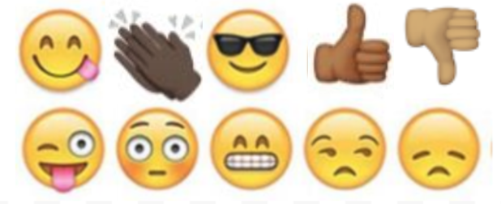  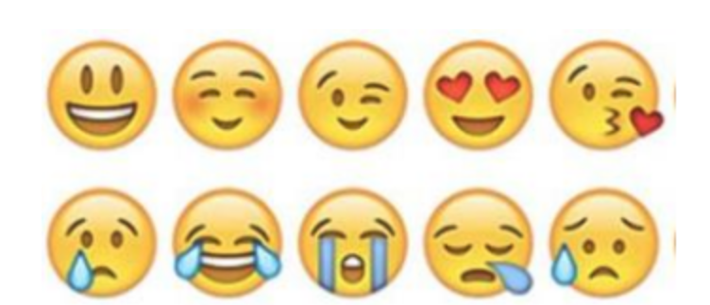

Day 1: Science
Environment

What is this lesson about?: Today you will read through the article, Coronavirus shutdowns have unintended climate benefits: cleaner air, clearer water
You will take on the role of an environmentalist. An environmentalist is someone who is concerned with or advocates the protection of the environment. After you read the article, please answer the questions.

Step 1: Read through the article, Coronavirus shutdowns have unintended climate benefits: cleaner air, clearer water

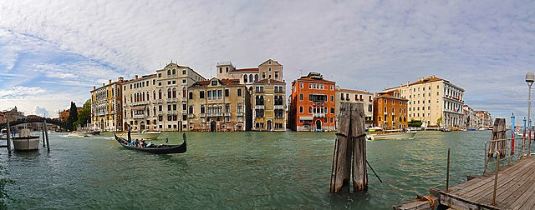
https://commons.wikimedia.org/wiki/File:Canal_Grande_in_Venice_001.jpg

In Venice, the often murky canals recently began to get clearer, with fish visible in the water below. Italy's efforts to limit the coronavirus meant an absence of boat traffic on the city's famous waterways. And the changes happened quickly.
Countries that have been under stringent lockdowns to stop the spread of the coronavirus have experienced an unintended benefit. The outbreak has, at least in part, contributed to a noticeable drop in pollution and greenhouse gas emissions in some countries.
Although grim, it's something scientists said could offer tough lessons for how to prepare — and ideally avoid — the most destructive impacts of climate change.
"If we can think about how to prepare for climate change like a pandemic, maybe there will be a positive outcome to all of this," said Christopher Jones, lead developer of the CoolClimate Network, an applied research consortium at the University of California, Berkeley. "We can help prevent crises in the future if we are prepared. I think there are some big-picture lessons here that could be very useful."
The coronavirus pandemic has sickened more than 180,000 people and killed more than 7,100 worldwide since early January. Some countries, most notably China and Italy, have been forced to seal their borders and restrict residents' movements to control the rates of infection.
Satellite observations have shown that the temporary measures have also driven significant decreases in harmful emissions.
"Carbon dioxide is tied to industrial activity, electricity production and transportation, so anything that affects those sectors will impact greenhouse gases, as well," Jones said.
Nitrogen dioxide over #China has dropped with the coronavirus quarantine, Chinese New Year, and a related economic slowdown.
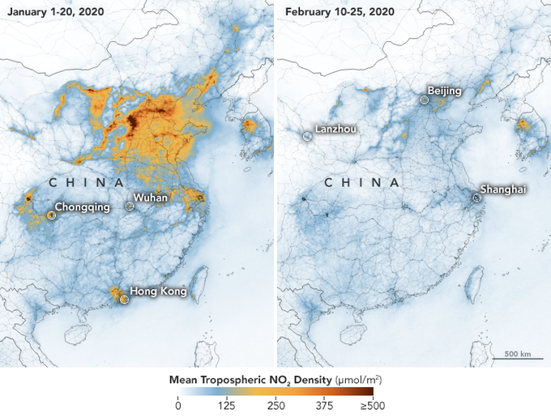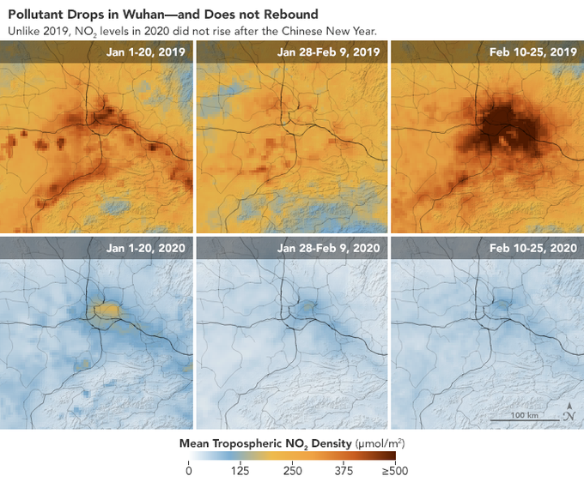
The coronavirus first emerged in late December in Wuhan, China. As it rapidly spilled into neighboring regions, the Chinese government locked down the city, quarantining 11 million people in Wuhan. Eventually, the lockdown would include almost 60 million people in the province of Hubei.
Industrial operations in the coronavirus hot spot ground to a halt, and travel restrictions within China meant that air, rail and road traffic were paused or scaled back across some regions.
According to Lauri Myllyvirta, an analyst at the Centre for Research on Energy and Clean Air in Finland, the restrictions contributed to a 25 percent drop in China's carbon dioxide emissions over four weeks beginning in late January, compared to the same time last year.
Myllyvirta's analysis also found that industrial operations were reduced by 15 percent to 40 percent in some sectors and that coal consumption at power plants fell by 36 percent.
Pollution-monitoring satellites operated by NASA and the European Space Agency observed drastic decreases in air pollution over China over two weeks in February when the quarantine was in effect. The satellites measured concentrations of nitrogen dioxide, which is released by cars, power plants and industrial facilities, from Jan. 1 to Jan. 20 and again from Feb. 10 to Feb. 25. The difference was unmistakable.
Clearer waters in Venice in early March were an unintended climate benefit of the coronavirus lockdowns in Italy.Marco Capovilla / Venezia Pulita
The cloud of nitrogen dioxide that was parked over China in January seemed to evaporate in February. NASA scientists said that similar emissions reductions have been observed in other countries during economic disruptions but that the sharp decrease in air pollution in China during the quarantine period was especially rapid.
"This is the first time I have seen such a dramatic dropoff over such a wide area for a specific event," Fei Liu, an air quality researcher at NASA's Goddard Space Flight Center, said in a statement this month.
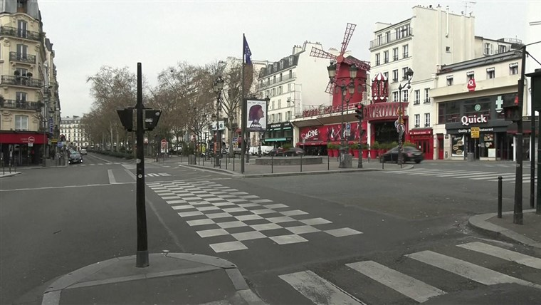
Pollution levels have similarly decreased over Italy, which has become the center of the coronavirus pandemic outside China. On March 8, as cases spiked, Italy locked down its northern Lombardy region. Two days later, the prime minister expanded the quarantine to include the entire country.
Concentrations of nitrogen dioxide in the atmosphere over Italy also fell precipitously, as they did in China. An analysis by The Washington Post found that the most dramatic drop was observed over northern Italy.
Nitrogen dioxide can irritate the lungs, and inhaling the pollutant can increase the risk of asthma and inflammation of the lungs. Although the noxious gas isn't thought to be a major contributor to climate change, studying its concentration in the atmosphere can help scientists understand other heat-trapping greenhouse gases that do drive global warming.
Jacqueline Klopp, co-director of the Center for Sustainable Urban Development at Columbia University in New York City, said she expects to see greenhouse gas emissions plummet across the board because of the
"People were in their homes and really stopped a lot of the activities that lead to greenhouse gas emissions and other pollution," she said.
Early observations have shown that extreme social-distancing measures are likely also having an effect on air pollution at the city level in the U.S.
Jordan Wildish, a project director at Earth Economics, an environmental non-profit organization based in Tacoma, Washington, developed an online dashboard to track air quality in San Francisco, New York City and the Seattle area, comparing the measurements with figures from the same time last year.
In San Francisco, which is under shelter-in-place orders to control the spread of the coronavirus, the average concentration of fine particulate matter — tiny particles in the air that are dangerous because they can be breathed deeply into the lungs — over the past five days was almost 40 percent lower than the previous year.
In New York City, there was a 28 percent drop over the same period of time, and the Seattle-Tacoma-Bellevue saw a 32 percent decrease.
But experts warned that observed reductions are temporary and that as cities, countries and economies bounce back, so, too, will emissions — unless major infrastructure or societal changes are adopted.
Klopp said the pandemic could make companies and governments realize that other threats to humanity, including climate change, could be just as devastating and that it's imperative to develop protective measures.
"As we move to restart these economies, we need to use this moment to think about what we value," she said. "Do we want to go back to the status quo, or do we want to tackle these big structural problems and restructure our economy and reduce emissions and pollution?"

Step 2: Answer the following question

An environmentalist is someone who is concerned with or advocates the protection of the environment. If you were an environmentalist, based on what you are noticing with Italy’s waters and China’s skies from this article, what recommendations would you make so the cleaner air and clearer waters continue?

Step 3: Draw a picture

Draw a picture of something within your environment that most concerns you.

As an environmentalist, what suggestions will you make to bring about the change that is needed? Please write your response on the lines below:

Student Feedback:

Circle the emojis that best represents how this activity made you feel.

Mindfulness Moment! Respond to your Mindfulness card in the box below.
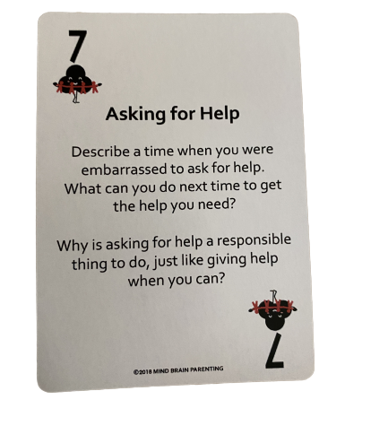

Day 1: Cell Phones
Math
What is this lesson about?:
Today’s lesson is about Cell Phone purchasing plans. Every day you are bombarded with advertisements about different cell phone purchase options. In this environment it’s easy to make poor decisions or get confused. Hopefully, today’s project will help on this.

But first: Today’s Warm-Up
It’s spring. You plant a small tree outside. It is 6 inches tall when you plant it.

- If it grows 6 inches every month for 5 months, how tall will it be in 5 months (In inches? In feet and inches)?

- If it doubles in size every month for 5 months, how tall will it be in 5 months? (In inches? In feet and inches)?

- If it doubles in size for 3 months and then grows 6 inches for the last 3 months, how tall will it be in 5 months?

Step 1: Let’s consider these different phone/coverage plans, just to make sure we understand the options.
A | The  Phone/Plan | What’s included | Money At Purchase | Monthly Cost | # of Months
B | IPhone 10 only, pay at purchase | Phone only | $700 | $0 | 0
C | IPhone 10 only, pay monthly | Phone only | $200 | $20 | 3 years/36 months
D | IPhone 10, plus max coverage, pay monthly | Phone, plus coverage | $200 | $50 | 3 years/36 months
E | IPhone 7 only, pay at purchase | Phone only | $350 | $0 | 0
F | IPhone 7, plus max coverage, pay monthly | Phone, plus coverage | $50 | $20 | 3 years/36 months
G | Coverage only: AT&T | Unlimited | $75 (first 3 months) | $25 (after the first 3) | Requires you to sign up minimum of 12 months
H | Coverage only: COX | Unlimited | $60 (first 2 months) | $30 (after the first 2) | Requires you to sign up minimum of 12 months
I | Coverage only: Straight talk | Unlimited | $35 | $35 | Pay monthly

Step 2: Answer the questions below, using the information in the chart above. Be careful!!!

If you buy the IPhone 10 on the monthly plan (Row C), how much will you pay for the phone after 3 years (36 months)?

How much more is that than if you buy the same IPhone 10 all cash up front (Row B)?

- Why would you choose the monthly plan (Row C) instead of the all cash up front plan (Row B)?

How much more is an IPhone 10 than and IPhone 7, all cash up front?

- Is that difference worth it? Yes/No. Why?

If you buy the IPhone 10, plus max coverage, on the monthly plan (Row D) how much will you pay for your phone and coverage after 3 years?

How much more, over three years is that than a similar plan, but with the IPhone 7 (Row F)?

- Is that difference worth it? Yes/No. Why?

Now, let’s take a look at the coverage plans, only.

What is the primary reason to purchase Straight Talk, if it costs more per month than ATT or Verizon?

- Over 1 year (12 months) how much will you pay for
  - ATT?
  - Verizon?
  - Straight Talk?

What is one good reason to go with AT&T?

What is one reason not to go with AT&T?

Step 3: Make Your Own Plan
Based on the information above, design an advertisement for a cell phone plan below. You are trying to appeal to teenagers. What sort of plan works best for you and other teenagers you know.

- Do you want to have a high or low cost to acquire the phone? Do you want to bundle the phone plus the service? Do you want this to be month to month or longer?

Write out or draw your cell phone plan below!

Name:

My plan to not get ripped off buying a cell phone:
RIPPED OFF BY CELL PHONE DEALERS - NO WAY!!!

Discuss: share your plan with others, if permissible.

Step 4: Understanding the environmental costs of discarded cell phones.

Each year millions of phones are traded in, thrown away and discarded. They have plastic and metals in them that can cause health and environmental problems. These problems can be mostly solved if the phone is taken apart and certain pieces recycled.

There are estimates that each phone that is discarded and not disposed of properly costs society up to $10 in pollution.

Do you have any ideas on what could be done to encourage people to turn in their cell phones to a cell phone store/dealer so that it will be properly taken apart and recycled?

What about some sort of plan where if you turn in an old phone you will get a certain amount of $.

Design a pop-up add below designed to get people to turn in all of their old phones…
󠀠
Make Your Pop Up Ad HERE

Cash $ for turning in used cell phones!!!
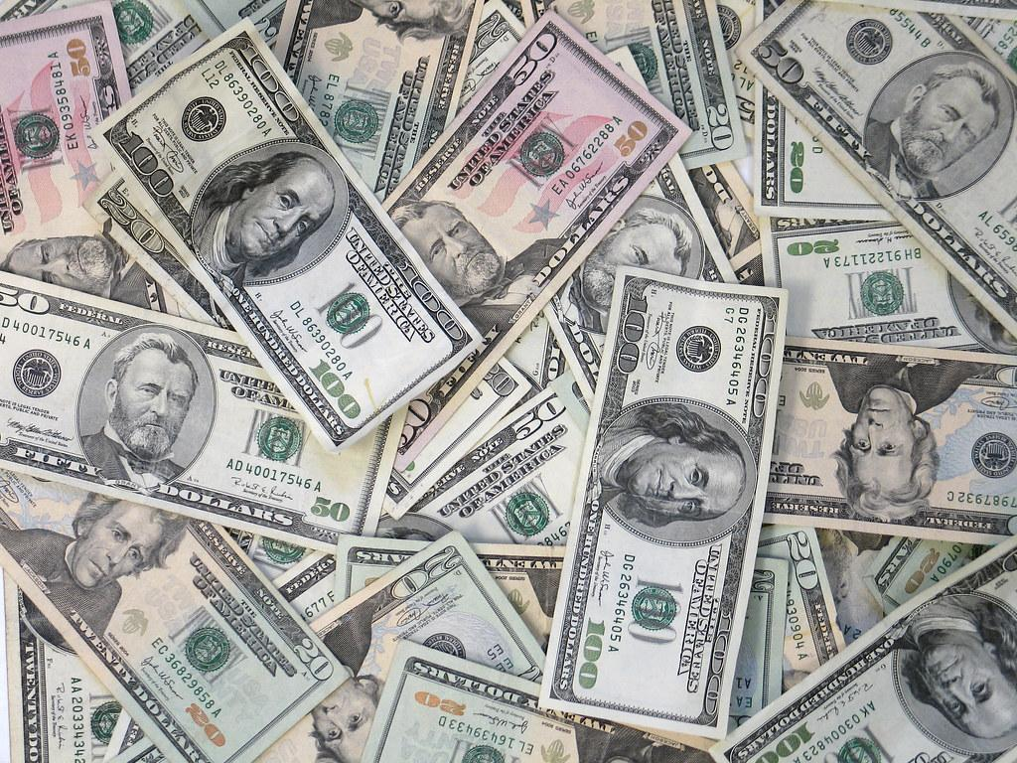

Skill Builders and Review Problems-
If you have time, complete the “skill builder” problems in the separate handout packet for Day 1.
- Divisibility
- Multiplication in 1 minute
- Multiplication Table

Student Feedback:

Circle the emojis that best represents how this activity made you feel.

Day 1: Sleep
Health

Step 1: Sleep Journal
Describe your sleep last night...light, heavy, too much, too little, snoring?

Step 2: Read the article

Teens are getting less sleep than ever before, and experts are calling it a national health crisis. Read on to learn the shocking consequences—and real strategies for getting the rest you so desperately need.

Generation Zzzzzzzz
It was the last class of the day, and George Sinclair’s eyelids felt like bricks. He tried to pay attention to his teacher, but his chin kept dropping toward his chest. George was operating on an hour of sleep after staying up to rehearse a history presentation and study for finals, so this one last period was feeling like an eternity.
Finally, the bell rang, and George headed to his pickup truck to make the 25-minute drive to his home in El Cajon, California. He blasted music to try to stay alert, but as he turned onto his street, no sound was strong enough. George nodded off.
When he jerked awake, his truck was veering across the road. It flipped on its side and slammed into a fence; a post crashed through the windshield, missing him by inches. “The two-by-four was under my armpit,” George recalls. “The car alarm went off, and I had to step on the board to climb out. I am so lucky to be alive.”
You know drinking or using drugs is dangerous, but the latest research shows that not getting enough sleep—like 85 percent of teens—can be just as hazardous. Missing just two hours of shut-eye quadruples your risk of a car accident and affects your decision-making—like George’s choice to get behind the wheel.
What’s more, experts say the teen sleep crisis is fueling a rise in mental-health issues and suicide. “Teens are getting less sleep now than ever before,” says Dr. Nathaniel Watson, a sleep specialist at the University of Washington. “This is a public health epidemic.”
Step 2: Sleep Survey
Thinking about a typical night in the last month . . .

1. How long does it take you to fall asleep?
0–15 min. 4 points
16–30 min. 3 points
31–45 min. 2 points
46–60 min. 1 point
>60 min. 0 points

2. If you then wake up one or more times during the night, how long are you awake in total? (Add up all the time you are awake.)
0–15 min. 4 points
16–30 min. 3 points
31–45 min. 2 points
46–60 min. 1 point
>60 min. 0 points

3. If your final wake-up time occurs before you intend to wake up, how much earlier is this?
I don’t wake up too early/Up to 15 min. early 4 points
16–30 min. early 3 points
31–45 min. early 2 points
46–60 min. early 1 point
>60 min. early 0 points

4. How many nights a week do you have a problem with your sleep?
0–1 4 points
2 3 points
3 2 points
4 1 point
5–7 0 points

5. How would you rate your sleep quality?
Very good 4 points
Good 3 points
Average 2 points
Poor 1 point
Very poor 0 points

Thinking about the past month, to what extent has poor sleep . . .
6. affected your mood, energy, or relationships?
Not at all 4 points
A little 3 points
Somewhat 2 points
Much 1 point
Very much 0 points

7. affected your concentration, productivity, or ability to stay awake?
Not at all 4 points
A little 3 points
Somewhat 2 points
Much 1 point
Very much 0 points

8. troubled you in general?
Not at all 4 points
A little 3 points
Somewhat 2 points
Much 1 point
Very much 0 points

Finally . . .
9. How long have you had a problem with your sleep?
I don’t have a problem/<1 month 4 points
1–2 months 3 points
3–6 months 2 points
7–12 months 1 point
>1 year 0 points

Now add up your total score and enter it here: _____________________

Use the following as a guide:

0–9 Your sleep problems seem to be severe. You should definitely try to get some help.

10–18 You have some sleep problems. It’s important to examine your sleep habits and see how you can make changes.

19–27 Your sleep is in good shape, but there are still many steps you can take to make it even better.
28–36 Your sleep is in great shape. Keep doing what you’re doing and spread the word!
Share
Share your results. Do you agree with them?

Student Feedback:

Circle the emojis that best represents how this activity made you feel.

Day 1: Environmental Activism
Social Studies

What is this lesson about?
In this lesson, you will read and respond to questions about Wangari Maathai, a social, environmental and political activist and the first African woman to win the Nobel Prize. Then, you will paraphrase and summarize the main ideas in a closing activity.
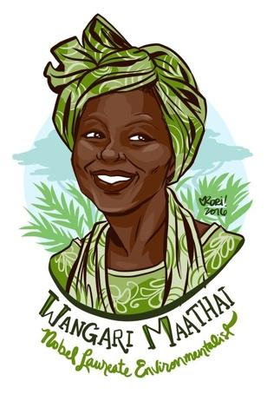
Step 1: Read the following short biography.
Wangari Maathai
In poor countries it is women who most often are sustained by the forests around them. From forests they fetch their wood for fuel, animal fodder, healing herbs, fresh spring water and nutritious fruits and nuts to eat and sell. When forests are cut for timber or large-scale agriculture, women’s livelihood and the health of their families suffer. In Kenya, a modern “Johnny Appleseed” has initiated a successful program to counteract the alarming destruction of Africa’s forests. Her Green Belt Movement seeks not to preserve wildernesses, but to conserve places that have been home to people through the centuries.
Political activist and environmentalist Wangari Maathai was trained to be a leader. When she was growing up, her father, a truck driver, made sure she was brought into family discussions and valued her opinions. This was a rare occurrence in her male-dominated society. At school she was taught that her generation had to accept responsibilities for the development of their young country. Sent to the United States and Germany for her formal education, Maathai took degrees in biology, becoming Kenya’s first female Ph.D. recipient. She then became the first woman to teach and chair a department at the University of Nairobi’s Department of Veterinary Anatomy. At age 25, she was ready to look for “new challenges so that I could play my part as a leader. … I felt ready to play my role in the development of my country.”
When Maathai’s husband was elected to parliament in 1993, she formed Envirocare, a program that hired the poor to help clean up their districts. Envirocare was once given over 6,000 tree seedlings to distribute. This event started Maathai on her future course: to introduce community tree planting as a way to improve human settlements and avert desertification.
In 1977 Maathai joined the National Council of Women in Kenya, a powerful organization which represents scores of national women’s organizations, both urban and rural. She became head of its Environment and Habitat Committee, which gave her a platform to expand her ideas. On Earth Day in 1977, she mounted a rally that resulted in the planting of seven trees in honor of legendary women and men who had made contributions to their communities. With that act, Maathai’s organization, the Green Belt Movement, was born.
Green Belt’s campaign started by planting protective “green belts” to help preserve the land. They initiated tree-planting activities at schools, in national parks and in communities. Farmers, 70 percent of whom were women, were also targeted. Maathai says that “It was important to be simple and practical. … Planting trees and food crops was easy and practical as agroforestry had always been our people’s way of farming.”
The hunger for free seedlings, which were distributed to those wanting them, was there. The next step was to ensure that the green belts would generate income for the women, thus ensuring their participation as stewards of the environment. One strategy was to have women own the trees they planted, and the products from them. Wangari wanted to develop a positive change for women since they were not usually given ownership of the land they farmed.
Maathai taught women how to rear the seedlings, plant, and market them. She helped develop environmental education classes which taught professional forestry techniques. The graduates took jobs as tree nursery managers, teachers in environmental programs for children, Green Belt promoters and rangers. The Green Belt Movement also encouraged training of the handicapped and school dropouts, hoping to curb the rural migration to urban centers for better prospects.
In 1981, Maathai tried to enter politics by becoming a candidate for parliament. To do so she resigned her position at the University of Nairobi. In the end, the ruling party refused to accept her as a candidate. By then, Maathai had lost not only her university position, but also the government-sponsored housing that went with it.
Being jobless and homeless did not stop Maathai. In 1990 her activism became well known when she opposed the ruling party’s plan to use the only green space in downtown Nairobi, Uhuru Park, for a skyscraper and shopping mall. Maathai sued to stop the project, but lost the suit in court. The Green Belt Movement was thrown out of its state-owned building with the government threatening to make the group illegal. Nonetheless, foreign investors behind the skyscraper project got the word; the proposed multistory complex was halted. Even though Maathai lost the suit, she won the struggle in the real world of international economics. Maathai’s name now became a rallying point for people around the nation and the world.
In 1992 Maathai returned to the same spot where plans to build the complex had been fought. This time it was as the head of mothers of political prisoners, some of whom were prisoners of conscience. Maathai and the mothers, most of whom were between 60 and 82 years old, camped and began a hunger strike. Riot police with tear gas moved against them. One canister hit Maathai, knocking her unconscious. The mothers returned, however, and kept up the protest for a year until 52 political prisoners were released. Today the area is known as Freedom Corner. Maathai regularly returns to it to plant and water trees in memory of those who died in the struggle for freedom, justice and democracy in Kenya.
Following her support of victims of violent ethnic clashes in Western Kenya, Maathai went into hiding in 1993 in fear for her life. Because of pressure by Amnesty International, she surfaced within a month. Most recently she has been trying to get opposition parties united behind one candidate. She entered the last race herself, but was too late to mount a successful campaign.
Because of her active support for the environment and for victims of oppression, Maathai has been honored around the world. She has received the Right Livelihood Award, called “the alternative Nobel Peace Prize,” the U.N. Environmental Program (UNEP) Global 500 Award, and the 1991 Africa Prize for Leadership for the Sustainable End of Hunger, as well as other awards. One of the founders of the Women’s Environment and Development Organization (WEDO), Maathai co-chairs its international board of directors. The Green Belt Movement, which Maathai still coordinates, has gone international with branches in 13 countries, including the United States. Groups from other countries have come to Kenya to study the movement’s ideas, and Maathai travels to numerous international conferences as an honored speaker. In the years ahead, she is planning to expand her activism into three new areas which are becoming critically important in Kenya: food security, health and the welfare of children, particularly the increasing numbers of street children.
Over the decades, Green Belt members have planted millions of trees that have produced income for tens of thousands of families. Eighty percent of the 15 million seedlings first planted have matured, encouraging the Kenyan government to increase spending for more tree seedlings. The success of this grassroots attempt to combine community development and environmental protection has proven Maathai correct when she states that environmental degradation can be reversed. But protecting forests is not only the responsibility of governments and foresters, she says. “The responsibility is ours individually.”
Step 2: Answer the questions below.
Reread the first paragraph. What is the Green Belt Movement and why did it start?

Maathai was an accomplished scholar. Why did she return home to Kenya?

Reread the paragraph that begins, “The hunger for free seedlings.” What does it mean to ensure something happens?

Reread the paragraph that begins, “The hunger for free seedlings.” Why did Maathai think it effective to ensure the plantings led to money for the women?

Reread the paragraph that begins, “The hunger for free seedlings.” How did this idea differ from the women’s usual experience?

Step 3: Summarize

Step 2: Complete one of the following summarizing activities in the space below
- Dear Fam: Summarize the reading’s central ideas and most significant developments in a letter to one of your family members.
- Text Message: Summarize the reading’s central ideas and most significant developments in the form of a text message to a peer who didn’t read it.
- Draw it Out: Summarize the reading’s central ideas and most significant developments by sketching a comic strip with at least 3 panels to illustrate the beginning, middle and end of the narrative.

Student Feedback:
Circle the emojis that best represents how this activity made you feel. | 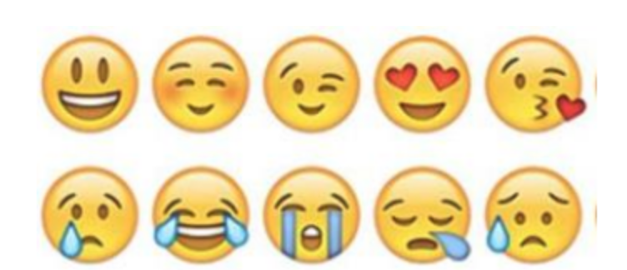  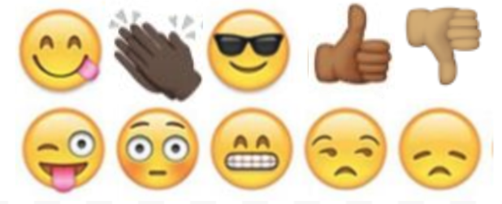

Week 2
Environment

Day 2

NAME:______________________

Day 2 Agenda
Topic | Activity
Warm-Up!
English Language Arts | - Learn how setting impacts a storyline  - Read passages, analyze them, and respond to questions  - Arts activity (drawing the setting)
Science | - Read the article, Traffic and pollution plummet as US cities shutdown for coronavirus  - Compare and contrast the satellite data for Los Angeles, Seattle, and New York  - Make recommendations for the United States or these three specific cities
Mindfulness Moment!
Math | - Making smart choices about cars. How much is that car really going to cost me? How much do you save on gasoline if you buy a Honda Civic instead of a Ford Mustang, in one year? What sort of insurance is right for me?  - Practice: Fractions and Decimals
Health | - Sleep Journal  - Think about your routines
Civics/Social Studies | Epidemics and the Environment: St. Louis vs. Philadelphia  - Read an article  - Complete a graphic organizer  - Write a letter to a local or national leader

Warm-up Activity: You will determine the conditions of the story by filling in the blank and writing the rest of the story.
Jeremy hated ____________ more than anything but he was so good at it!

Day 2: Setting the Mood
English Language Arts

What is this lesson about?: Yesterday you learned about setting in fictional stories and today we will explore more about the importance of setting. You will learn how setting impacts the characters, plot, and mood of stories. You will analyze different texts to see how the setting impacts stories and you will have the opportunity to be creative in drawing settings from a text.

Step 1: Setting Impact

Remember from yesterday that a story’s setting is it’s time and place, however a setting is much more than just the characters’ environment. The setting can establish the mood and reveal the characters and conflict. It can even give clues to the theme—the universal message—of a story.

Consider the following setting description:
“The main character lives in the coldest part of Alaska, in a town of 500 people that is miles from any other town or city. It is the beginning of spring in the year 2050.”

Describe the other important elements of this story… (be creative!)

Who is the main character?

What conflict does the character face?

What is the tone or mood of this story?

What themes or ideas might the writer explore?

*Share with a classmate what story elements you developed. Did you like your classmat’s storyline? Did you both come up with any similar answers?

Now, consider the following setting description:
“The main character lives in Jamaica in an ocean-front bungalow that has its own beach and dock where the main character keeps their boat. It is the summer of 1980.”

Think about what your answers would be to the questions above. Are they the same?

Why did this new setting change your answers?

Step 2: Does setting affect the mood?

If you wanted to make somebody happy, where would you take them? Why?

If you wanted to make somebody feel inspired, where would you take them? Why?

Places and locations can affect the way we feel and our mood. If you go to a haunted house, the mood is creepy and scary, and you may feel afraid. If an author wants to tell a scary story, they are more likely to tell that story in the setting of a haunted house, than a peaceful spa-like location.

Step 3: Setting and mood analysis

The mood describes how a person feels at any given time. It also reveals the atmosphere of the people, places, or time periods.

Read these three little excerpts. See what they tell you about the character. Likewise, sense what kind of mood these settings evoke:

Spans of Poppies
Her hand reached for the massive, iron door handle. She struggled to pull it toward her. A sapphire studded the top of the handle and, as she slowly made progress on the door, a slash of light popped through. It warmed her face and made her smile, giving her enough energy to heave the massive hunk of wood open wide enough to slip through.

The way the door decisively slammed behind her should've frightened her. Instead, she looked upon spans of green, rolling hills bedecked with colorful poppies and tiny thatched-roof cottages. She debated between rolling down the plush hill at her feet or lifting straight off the ground and flying into the tiny village below.

- How would you describe the character's mood? How is she feeling?

- What quote from the text tells you how the character is feeling?

________________

Filmed in Faithlessness
Dust coated every last surface. He ran his finger across the rows of books, the span of tables, and the wide window frames. It came up black. A fast-winged crow clipped past his ear and he wondered which broken window the ugly creature entered through. As it perched atop a broken spray of glass and squaked at him, he realized he'd never find her again. He was every bit as broken as the tired home, filmed in faithlessness.
- What have you learned about the main character? How is he feeling?

- What quote from the text tells you how the character is feeling?

_________________

Pink Lemonade and Cookies
The lime green patio umbrella flapped happily in the breeze. It covered strawberry slushies, watermelon pies, and bright, cheerful stacks of donuts. Emily stepped outside to feature a crystal pitcher of pink lemonade and a spray of warm cookies in the center of the table. She had on her favorite summer dress and knew that, as soon as he stepped through that patio gate, her life would never be the same again.

- How would you describe the character's mood? How is she feeling?

- What quote from the text tells you how the character is feeling?

Step 4: Setting & Mood Analysis

Read the following song lyrics.

THE TOWN IS LIT
Written by Toni Morrison

[stanza 1]
It’s been suggested:
well kept lawns and fences
white porch swings and toast by the fire.
It’s been requested:
puppies,
a window of blossoming pear trees
and a place for the robins to nest.
But I know that somewhere, out there
The town is lit
The players begin
To make music in all the cafés
Clowns on wheels
Linger to steal
Foxes that click on the curb
Lovers expecting
The night to protect them
The moon too far to disturb
Trees in the park
Dance after dark
To music in all the cafés.
[stanza 2]
It’s been suggested:
well kept lawns and fences
white porch swings and toast by the fire.
It’s been requested:
puppies,
a window of blossoming pear trees
and a place for the robins to nest.
But I know that somewhere, out there
Geminis split
Sagittarians kick
To the music in all the cafés
Aquarians throw
Gold on the floor
To rival the glitter it makes
Pisces swim
Over the rim
Knowing they’ve got what it takes
To cut through the dark
And get to the heart of the music in all the cafés.

What two places is Toni Morrison comparing in this poem? (hint: she starts each stanze describing one place, and then moves on to describe another place “out there”)

How are those two places different?

Do you think the writer likes one place more than the other? Which one? Why?

What is the mood of the first place?

What is the mood of the second place?

Step 5: Draw the Setting

Draw each of the two settings in the song above. Is there any way you can communicate the mood of the setting by what you draw?

Setting 1

Setting 2

Student Feedback:

Circle the emojis that best represents how this activity made you feel.

Day 2: Science
Environment

What is this lesson about?: Today you will read the article, Traffic and pollution plummet as US cities shutdown for coronavirus. You will compare and contrast the satellite pollution data for Los Angeles, Seattle, and New York. You will also make recommendations for the United States or these three specific cities.

Step 1: Read the article, Traffic and pollution plummet as US cities shutdown for coronavirus.

Traffic and Pollution Plummet as U.S. Cities Shut Down for Coronavirus

By Brad Plumer and Nadja Popovich (NY Times) March 22, 2020

In cities across the United States, traffic on roads and highways has fallen dramatically over the past week as the coronavirus outbreak forces people to stay at home and everyday life grinds to a halt.
Pollution has dropped too.
A satellite that detects emissions in the atmosphere linked to cars and trucks shows huge declines in pollution over major metropolitan areas, including Los Angeles, Seattle, New York, Chicago and Atlanta.
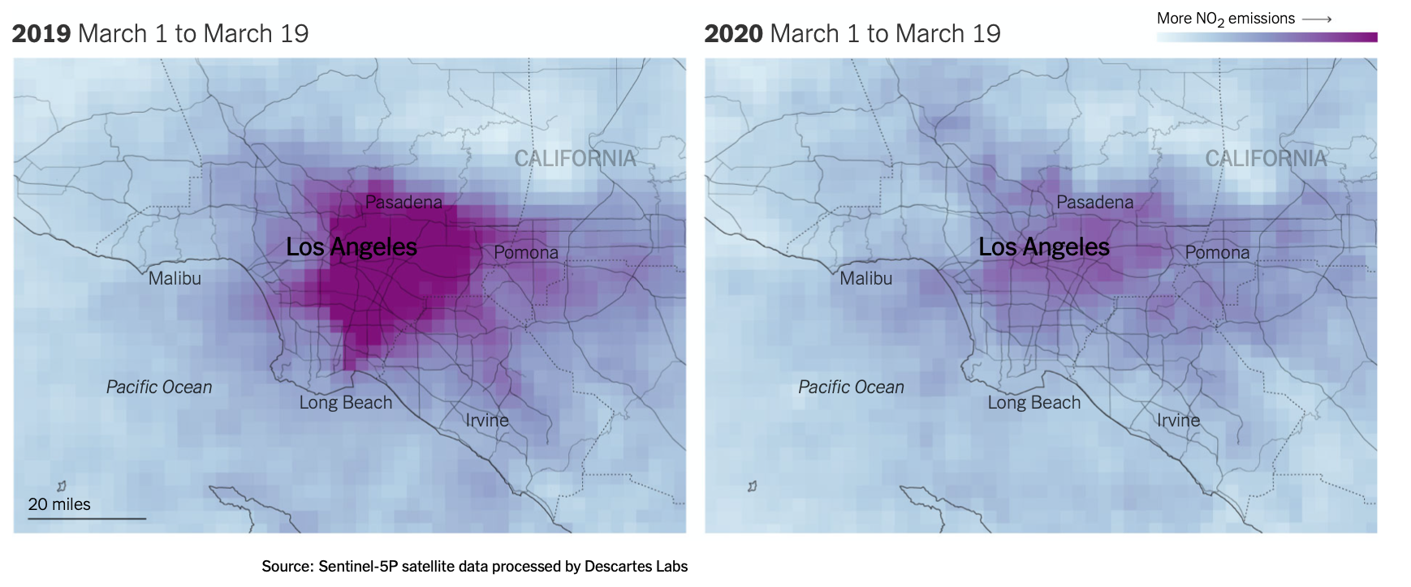

Los Angeles
In Los Angeles, as businesses and schools have closed this month and drivers have stayed off the roads, air pollution has declined and traffic jams have all but vanished.
Preliminary data from the European Space Agency's Sentinel-5P satellite show that atmospheric levels of nitrogen dioxide, which are influenced in large part by car and truck emissions, were considerably lower over Los Angeles in the first two weeks of March compared to the same period last year. The car-dependent city normally features some of the highest smog levels in the country.
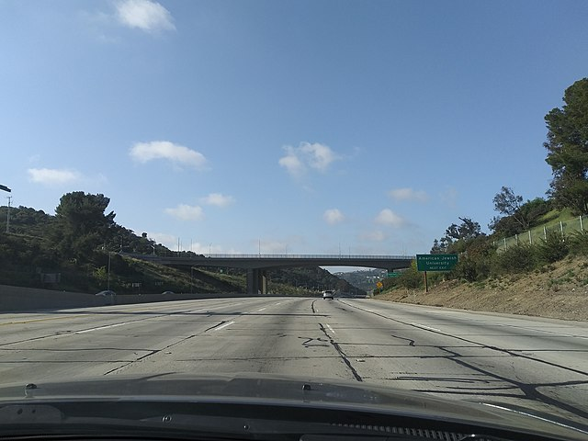
The 110 toward central Los Angeles on Friday afternoon, a time when traffic would normally be bumper-to-bumper

Los Angeles’s famous rush-hour congestion has virtually disappeared. On Wednesday at 8 a.m., traffic in the city was moving 53 percent faster than it usually does on a Wednesday morning, according to data from INRIX, a company that analyzes traffic data from vehicle and phone navigation systems. At 5 p.m., when the freeways are typically congested, traffic was moving 71 percent faster than usual.
“There’s basically no rush hour anymore, or at least not what we would recognize as a rush hour,” said Trevor Reed, a transportation analyst at INRIX. He said that traffic has decreased even more sharply in the evening because that’s when people are normally running errands in addition to commuting home, but many of those activities have now been put on hold.
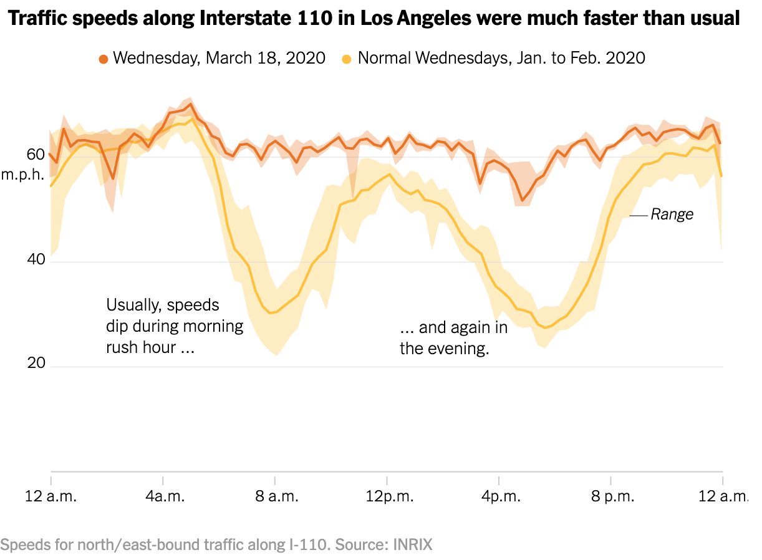
Similar changes can be seen in the Bay Area, where local officials on Monday ordered the region’s 6.7 million residents to shelter in place. Since then, the number of cars and trucks crossing eastbound on the Bay Bridge each day between San Francisco and Oakland has fallen roughly 40 percent compared with two weeks ago, according to data from monitoring stations operated by the California Department of Transportation.
While that’s a sign that people are heeding the advice of public health experts, it’s yet another warning that the nation’s economy is facing serious peril. Traffic and congestion, while often a source of annoyance, are also a telltale sign of bustling economic activity. On Thursday, Gov. Gavin Newsom of California extended the shelter in place order to cover the entire state.
The satellite emissions data was analyzed for The New York Times by Descartes Labs, a geospatial analysis group. Nitrogen dioxide levels can also fluctuate with weather conditions, and experts said quantifying the precise effects of the shutdown on such pollution will take further study.
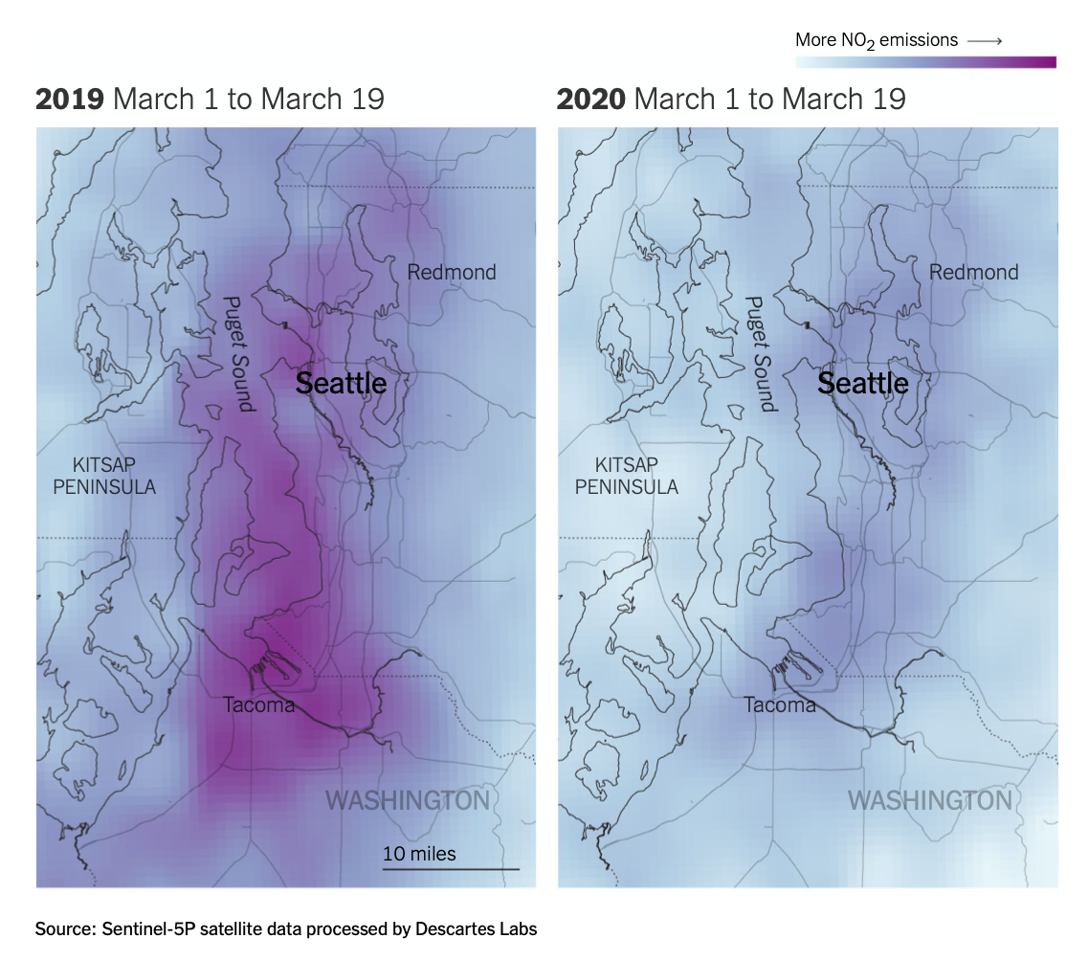

Seattle
Air pollution from vehicles has likewise plummeted in the Seattle area, which had one of the earliest recognized coronavirus outbreaks in the country. Traffic patterns there changed drastically before most other cities.
In early March, local officials recommended that residents over 60 years old stay in their homes and that workers telecommute if possible. Shortly after, Microsoft and Amazon, two of the region’s largest employers, told their workers to stay home.
The impact was immediate: By March 8, the number of trips into downtown Seattle during morning rush hour had declined nearly 40 percent, according to a recent report by INRIX.
But it’s not just commuting patterns that have shifted in Seattle. Traffic on Saturdays has also declined, suggesting that people are making fewer social and recreational trips. The data also shows that visits to grocery stores and bulk retailers like Costco soared early in the month, as residents stocked up on supplies, but have since fallen off. “We saw an upsurge in panic buying in the first part of the month but that seems to be over now that people are stocked up,” Mr. Reed said.
These trends, INRIX noted in its report, represented a “radical departure” from normal driving patterns and offered “a preview of what is to come for hundreds of cities across America if the Covid-19 outbreak continues.”
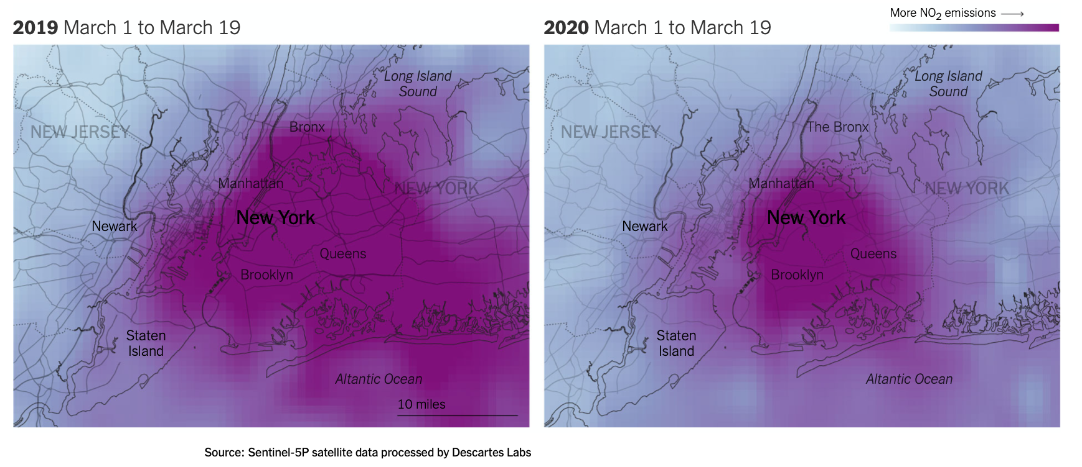

New York
In New York City, residents are less dependent on car travel than in other metro areas, but vehicle traffic has still seen a steep drop-off in recent days as office buildings, schools and restaurants have shut down. On Wednesday afternoon, rush-hour traffic moved 36 percent faster than normal as the roads cleared out, according to data from INRIX.
Separately, researchers at Columbia University have seen emissions of carbon monoxide over New York City decline more than 50 percent below typical levels over the past week — a change linked to the drop in car traffic across the city.
“We’ve never seen anything like the drop we saw starting last Friday,” said Roisin Commane, an assistant professor at Columbia who conducts the air-monitoring work, referring to March 13. “We often see dips during weekends or over holidays, but this is completely different.”
Scientists caution that while the decline in air pollution over U.S. cities could have some near-term health benefits, those are likely to be relatively minor in the grand scheme of things. For one, air pollution is expected to rebound once the coronavirus outbreak subsides and people are allowed to leave their homes, and studies have found that long-term exposure to air pollution tends to have a larger impact on public health.
And any short-term benefits could easily be swamped by the broader impacts from the virus itself, from the risks created by an overloaded health care system and from the negative effects of a large recession and rising unemployment. “This really shouldn’t be seen as a silver lining,” said Jill Baumgartner, an associate professor and epidemiologist at McGill University. “It’s not a sustainable way to reduce air pollution, and the long-term economic and well-being impacts of this crisis are going to be devastating for many people.”

Step 2: Analyze the three satellite pollution data
Analyze the three satellite pollution comparisons that are provided in the article. Share what you notice for:

Los Angeles

Seattle

New York

How are these data similar?

How are they different?

Step 3: Share your thoughts
If you were an environmentalist, based on this article, what recommendations would you make for the United States or for these specific cities?

Student Feedback:
Circle the emojis that best represents how this activity made you feel.

Mindfulness Moment! Respond to your Mindfulness card in the box below.
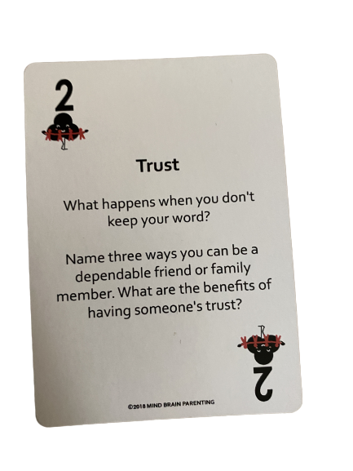

Day 2: Cars
Math

What is this lesson about?: Today we will explore how much it really costs to own a car for a year. Then we will look at the pros and cons of buying an electric car.

One thing is for sure, traditional cars use a lot of gas, add to pollution and that causes lots of problems for the environment. So, we will also explore how much gasoline different cars use, as well.

But first, Today’s Warm-Up
In many cities, you are charged 5 cents each time you use a plastic bag at a grocery store.

- What do you think the purpose of this 5 cents charge?

- Do you agree with this policy?

In Washington, DC, the City collected $45,000 the first year they put this law into effect. That means that people purchased 900,000 plastic bags.

By the 3rd year this law was in effect, the City collected $15,000. About how many plastic bags were sold?

Why do you think that so many fewer bags were sold by the 3rd year?

Discuss:
- Do you have a plastic bag tax in your city?
- Is it a good idea?
- If yes, has the plastic bag tax changed your behavior in any way?

Background Information to get us started

The chart below shows the price of a few cars, and the miles per gallon of gas each gets, as of April 1, 2020.

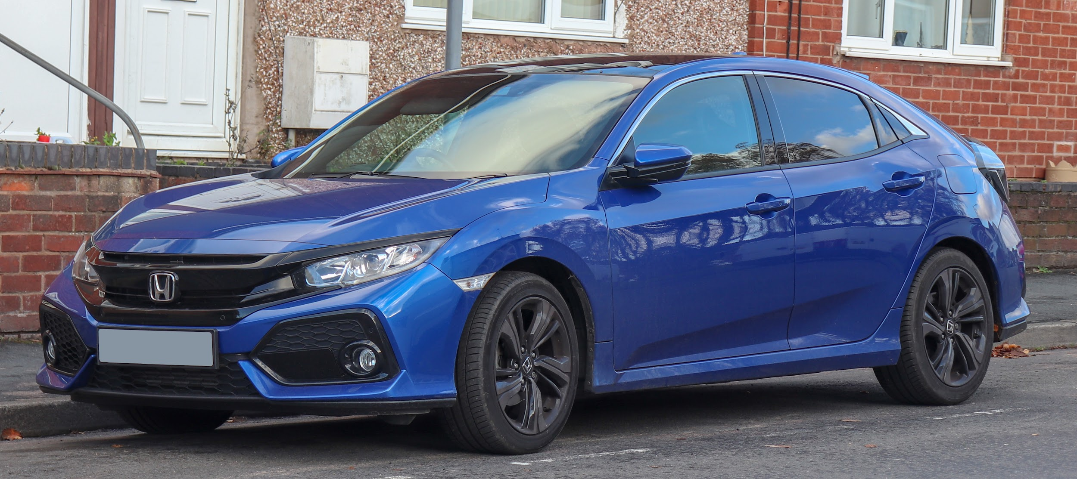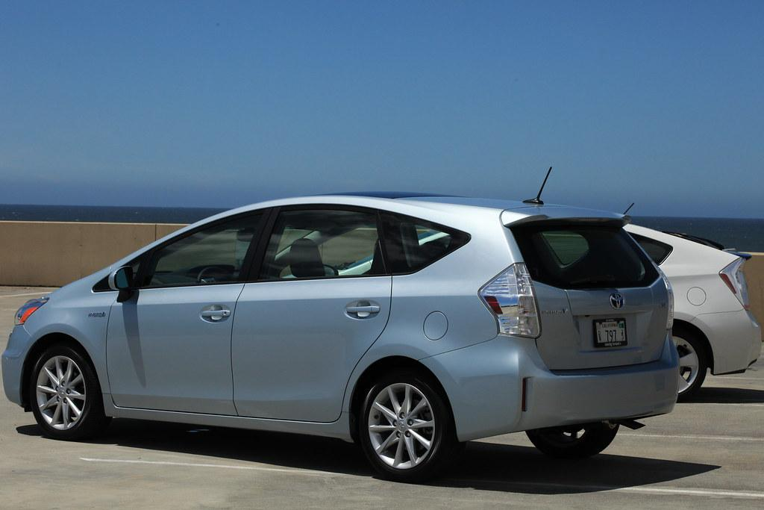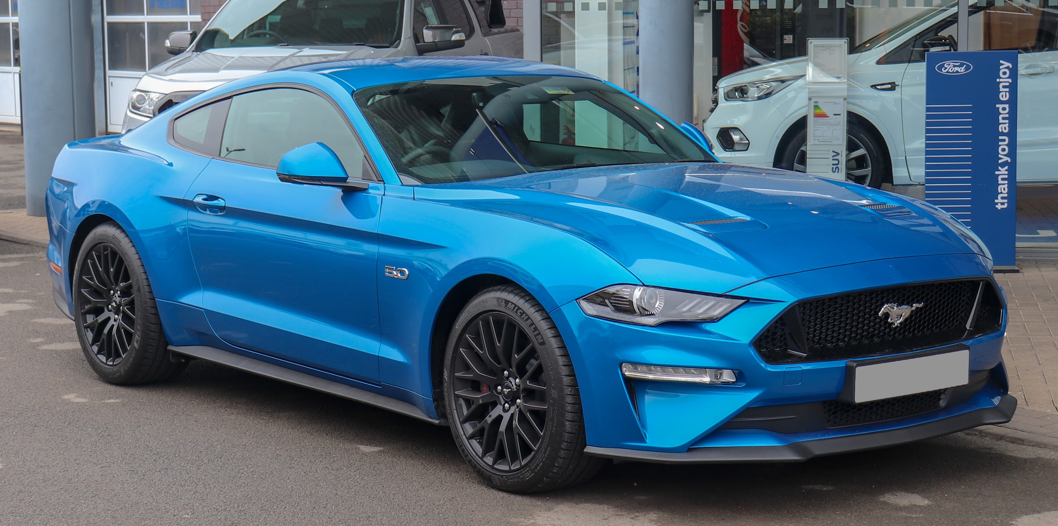

Model Make and Year | Cost | Miles Per Gallon (Gas)
2010 Honda Civic | $6,000 | 32
2010 Ford Mustang | $9,000 | 12
2010 Toyota Prius (hybrid) | $7,000 | 50
2020 Honda Civic | $24,000 | 36
2020 Ford Mustang | $28,000 | 12
2020 Toyota Prius (hybrid) | $26,000 | 55
2020 Nissan Leaf (100% Electric)* | $34,000 | 125
* Note: the Nissan LEAF runs on electricity, not gas. The miles per gallon is based on estimating how much an owner pays in increased electric bills to charge the car.

Step 1: The Cost of Gasoline...
Calculating how much gas you will use in 1 year, and how much it will cost for that gas-

Price for a Gallon of Gas: $2.75 (on April 1, 2020)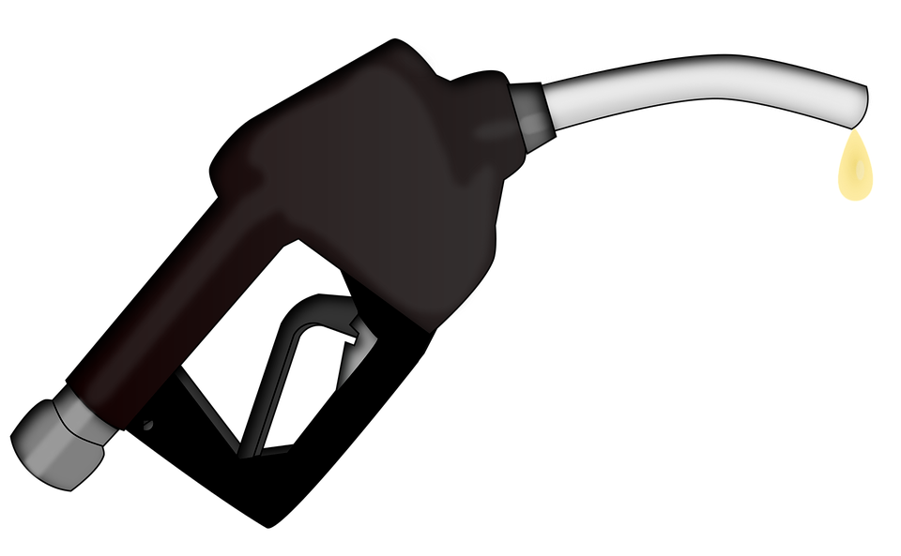

Estimate how many miles you drive your car each day (select one and circle it):
5 miles/day 15 miles/day 30 miles/day

There are 365 days in a year. Assume that you drive your car on 300 of those days. How many miles will you put on your car in 1 year? _____________
(hint: multiply the miles/day x 300 days in a year)

Select which car from the list above you are going to purchase: __________________

- How many miles per gallon does it get: __________________________

- About how much money will you spend on gas in 1 year? ________________

Select a 2nd car option from the list above: ______________

How many miles per gallon does it get: ______________

- About how much money will you spend on gas in 1 year? ______________

How much more or less would you spend per year if you purchased one car or the other, based on your car selection? ____________

Discuss: Based on this comparison, will the gas mileage your car gets impact what type of car you might buy?

Step 2: Understanding annual maintenance costs

Estimated Yearly Maintenance Costs: One ‘hidden’ cost of owning a car is the cost of maintaining it. These costs vary. But they include the average cost of changing the oil, keeping good tires on the car, changing the breaks, and doing other ‘standard’ maintenance that helps keep your car safe and running well. Although this isn’t always exact, you now can go online and use tools to help you estimate the average yearly maintenance cost of cars.

Not surprisingly, brand new cars usually have low maintenance costs. Often, with new cars, most or all ‘standard’ maintenance costs are covered for the first few years.

Also, electric cars (and hybrids) have very low maintenance costs because they don’t have a gasoline engine and have a lot less moving parts that can wear out. Let’s use the chart below to calculate some maintenance costs.

Car Make and Year | Estimated annual maintenance costs for the next 5 years | Comment
2020 Honda Civic | $500/year | Almost all standard maintenance costs are covered by warranty for 5 years
2010 Honda Civic | $750/year | No warranty after 10 years
2005 Honda Civic | $1200/year | No warranty; includes cost of range of parts that need to be replaced after 15 years
2020 Ford Mustang | $500/year | Almost all standard maintenance costs are covered by warranty for 5 years
2010 Ford Mustang | $1,000/year | No warranty after 10 years
2005 Ford Mustang | $1,500/year | No warranty; includes cost of range of parts that need to be replaced after 15 years
2020 Toyota Prius | $250/year | Almost all standard maintenance costs are covered by warranty for 5 years
2010 Toyota Prius | $500/year | No warranty, but estimates of maintenance costs are minimal

For each of the cars in the chart, calculate how much you will spend over the next 5 years on maintenance costs alone.

Car Make and Year | Estimated annual maintenance costs for the next 5 years | Total maintenance cost for the next 5 years -- Fill in this column!!!
2020 Honda Civic | $500/year
2010 Honda Civic | $750/year
2005 Honda Civic | $1200/year
2020 Ford Mustang | $500/year
2010 Ford Mustang | $1,000/year
2005 Ford Mustang | $1,500/year
2020 Toyota Prius | $250/year
2010 Toyota Prius | $500/year

After five years, how much more would you spend on maintaining a 2005 Civic Compared to a new 2020 Civic?

After five years, how much more would you spend on maintaining a 2010 Mustang compared to a 2010 Prius?

Discuss: Explain some of the pros and cons of buying an older car?
What is a good reason to buy a used car? What is one of the downsides of buying a used car?

Step 3: Looking at Insurance costs

In most states it is mandatory to purchase basic insurance that will cover for:
- Liability, medical and related costs (to driver and others): this insurance will cover the costs of damage you cause to other cars, and the medical costs if you or others are injured

You usually have a choice to purchase other more comprehensive insurance that covers:
- Comprehensive/Collision Insurance: The cost of repairing or replacing your car in case of an accident or break-in
- Other: Covering the cost of a rental car while your car is getting fixed and towing if your car breaks down.

How much you pay for insurance is related to 3 things:
- Driver’s Age and Gender: Young drivers get in many more accidents than people over 25. In general, women drive more carefully and get in less accidents than men (that’s the truth)
- Your driving record: Past accidents and speeding tickets greatly increase the cost of insurance, because they signal to insurance companies that you are a risky driver.
- Value of the car: Comprehensive Insurance--covers the cost of fixing or replacing a car. So, it costs more for newer and more expensive cars than for older and less expensive cars. Basic insurance doesn’t change that much by the value of the car.

The chart below breaks down the cost of Insurance. NOTE: this chart is an estimate, and in real life these costs would not be quite this standard.

Basic Liability Insurance:  Under 25 years old, male  Cost per 1 YEAR |  |  |  | Basic Liability Insurance:  Under 25 years old, female  Cost per 1 YEAR
Low Risk | Medium Risk | High Risk |  | Low Risk | Medium Risk | High Risk
$800 | $1,200 | $1,600 |  | $450 | $600 | $900

Marcus is 20 years old. He has a clean driving record, so he is low risk. How much will insurance cost him for 1 year?

Marcus gets two speeding tickets and moves from low risk to high risk. How much will basic insurance cost him for 1 year?

Marcus stays in that category for 3 years. Over 3 years how much will those speeding tickets cost him in insurance (how much more will it cost him to be in the high risk category than the low risk category for 3 years?)?

Marcus has a younger sister. She is 18. She is a low risk, female driver. She drives for three years and never gets a speeding ticket and never gets into an accident. How much will she pay for all 3 years in basic insurance?

Discuss: You get a speeding ticket for $100. Is that the ‘full cost’ of the ticket? Yes/No. Discuss.

Comprehensive/Collision Insurance. When is it worth it? When should you consider switching to basic only. Review the chart below CAREFULLY and then answer the questions below.

 | Value/Cost of the car TODAY | Cost of Comprehensive Insurance for 1 year, for under 25 year old, low-risk driver | Cost of Comprehensive Insurance for 1 year, for under 25 year old, high-risk driver
2020 Honda Civic | $24,000 | $1,200 | $2,400
2010 Honda Civic | $6,000 | $600 | $900
2005 Honda Civic | $3,500 | $500 | $700
2020 Ford Mustang | $28,000 | $1,800 | $3,200
2010 Ford Mustang | $9,000 | $900 | $1,200
2005 Ford Mustang | $5,000 | $600 | $800

How much does it cost to buy comprehensive/collision insurance for a 2020 Honda Civic for a low-risk 22 year-old? How about a high-risk 22 year-old?

Compare that to the cost of the same insurance for a 2020 Ford Mustang. How much more does it cost to insure the 2020 Mustang compared to the 2020 Civic for a low-risk driver?

- Why do you think it costs more for the insurance on the Mustang?

- Do you think it is only because the Mustang is a little more expensive? Why else might the insurance be more?

How much does it cost a high risk 22 year old to purchase comprehensive/collision insurance on a 2005 Civic?

- Discuss: Do you think it is worth it to spend $700 each year when your car is worth $3,500? Yes/No. Why?

If you are a high-risk driver and you are driving a new Mustang around, how much will you pay just in comprehensive/collision insurance over a 3 year period?

- Is it worth it to spend that much money each year on insurance?

- Does that make you consider buying a less expensive car so that you will have lower annual insurance costs? Yes/No?
Step 4: Putting it All Together--This isn’t cheap!

What car did you select for the first part of this project in Step 1?
Model and Year? __________________

Based on your driving habits, how much will gas cost for 1 year________________

How much is the estimated annual maintenance on that car for 1 year? __________

How much will it cost you for Insurance? You will need to rate yourself as low, medium or high risk? Circle which one you are: Low Risk Medium Risk High Risk

- How much will you spend on mandatory Insurance for 1 year?___________

- How much will you spend on comprehensive/collision for 1 year?___________

All together, what will it cost you to operate your car for 1 year? ___________
Remember, this doesn’t include the cost of purchasing it!

Skill Builders and Review Problems-
If you have more time, take a few minutes to complete the “skill builder” problems in the separate handout packet.
- Comparing Fractions
- Adding and Subtracting Fractions
- Multiplying and Dividing Fractions

Student Feedback:
Circle the emojis that best represents how this activity made you feel.

Day 2: Sleep
Health

Step 1: Sleep Journal
Draw or write about a recent dream you had.

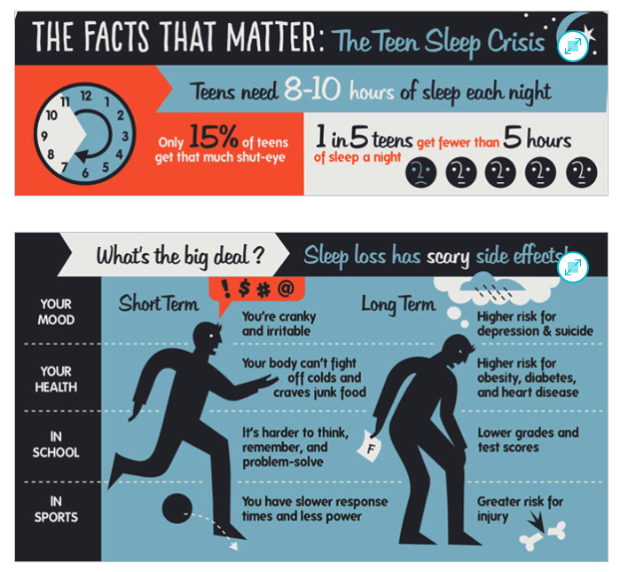
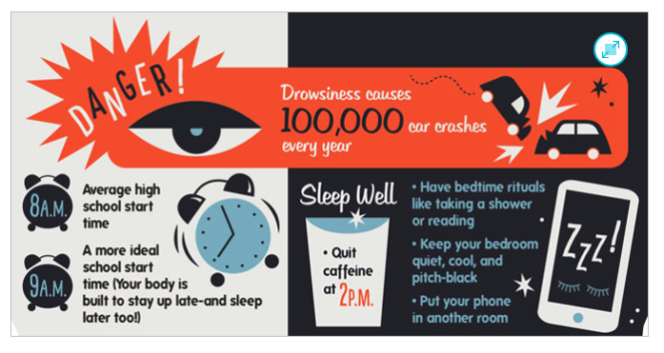
Step 2: Routines and Habits
What is your routine? | What can you change?
Morning

Afternoon

Evening

Day 2: Pandemics & The Environment
Social Studies

What is this lesson about? In this lesson you will read about how two American cities—Philadelphia and St. Louis—responded to the flu epidemic of 1918 and how those responses cost and saved lives. After reading, you will organize your ideas about the article. Then, you will apply what you learned to the current situation the world is facing batting COVID-19.

Step 1: Read the following article.

What happens if parades aren’t canceled during pandemics? Philadelphia found out in 1918, with disastrous results.

On the afternoon of Sept. 28, 1918, about 200,000 people crammed onto the sidewalks in Philadelphia to watch a two-mile parade snake through downtown in the midst of World War I. Billed as the city’s largest parade ever, it featured military planes and aggressive war-bond salesmen working the crowds, in scenes that graced the front pages of the evening papers.
But readers who flipped toward the back of the Evening Bulletin might have stumbled on an unsettling headline: In the last 24 hours, 118 people in Philadelphia had come down with a mysterious, deadly influenza, which was quickly spreading from military camps to civilians amid a worldwide pandemic.

“If the people are careless, thousands of cases may develop and the epidemic may get beyond control,” the city’s health commissioner, Wilmer Krusen, said in the 1918 article, according to the Philly Voice.

He was the same person who, just a day earlier, allowed to go forward what is now known as the deadliest parade in American history. In doing so, he ignored the advice of medical professionals who urged him to cancel the parade or risk an epidemic. Within three days, every bed in the city’s 31 hospitals was filled. There were thousands of influenza patients.

A century later, as the novel coronavirus grips the nation with anxiety and disrupts everyday life, Philadelphia’s 1918 Liberty Loan parade “is a perfect historic example of how the misplaced priorities can become so dangerous,” historian Kenneth C. Davis told The Washington Post on Wednesday. This week, major cities including Philadelphia, New York and Chicago decided to cancel their St. Patrick’s Day parades amid fears of accelerating the spread of coronavirus.

Davis said he was “astonished” it took New York until Wednesday night to make that call, given the cautionary tale of Philadelphia’s deadly Liberty Loan parade.

“It seemed to me to be a perfect parallel to the story of what happened in Philadelphia in 1918, where the health authorities were clearly aware that this was a growing problem, and the health commissioner was absolutely told to stop the parade,” said Davis, author of “More Deadly Than War: The Hidden History of the Spanish Flu and the First World War.”
“But he chose not to.”

The Spanish flu pandemic of 1918 killed an estimated 50 million people worldwide, including about 675,000 in the United States. But no American city was hit harder than Philadelphia.
Trump is ignoring the lessons of 1918 flu pandemic that killed millions, historian says
In retrospect, historians and the federal government have blamed the city’s explosion of influenza infections in 1918 on city officials’ failure to quickly shut down mass gatherings — namely the parade.

Health officials were aware of the risks. The signs were there in the days before the big event. At least 600 enlisted men on military bases on the outskirts of the city were suffering from the influenza, while 47 civilians were reported to be infected just two days before the parade, according to an article by Thomas Wirth in “Pennsylvania History: A Journal of Mid-Atlantic Studies.”

The pernicious flu strain caused head-splitting fevers, crippling coughs and severe body ache. The symptoms, ravaging military camps and battlefields all over Europe and the United States, were now invading city streets.

As a precautionary measure, the city printed out 20,000 fliers giving Philadelphia residents advice on how to avoid catching the flu. They urged people to cover their mouths when they sneezed and coughed.

Still, doctors couldn’t seem to convince the city to halt the beloved war-bonds rally. One doctor called it “a ready-made inflammable mass for conflagration” — but not a single newspaper would print his warning, according to John M. Barry’s “The Great Influenza: The Epic Story of the Deadliest Plague in History.”

Davis said that city leaders were more concerned about boosting morale for the war effort and too afraid of causing panic. In one ad from the parade organizers in the Philadelphia Inquirer, readers were warned, “Citizens! A Crisis Is Here!”

“The influenza epidemic imperils the success of the Fourth Liberty Loan. … The Government calls upon you not to forget your duty to the Fighters in France” — meaning the citizens better not stay home.

Krusen had assured the city that it was safe to go. Yet just one day after the parade, he issued a list of rules for the public to follow, according to Wirth’s article. Chief among them was, “avoid large crowds.”

Within a week of the parade, more than 45,000 people in Philadelphia were infected with influenza, as the entire city, from schools to pool halls, ground to a halt, according to Wirth.
Within six weeks, more than 12,000 Philadelphians were dead.

“The real death and destruction came about after the parade, but it was very sudden and it was very dramatic,” Davis said. “It was an apocalyptic scene, when in some cases, public-health nurses would be walking into tenements and finding whole families dead.”

Around the 100th anniversary of the 1918 pandemic, the Centers for Disease Control and Prevention cited the parade as the prime example of exactly what not to do during a looming pandemic. It compared Philadelphia to St. Louis, which in 1918 canceled its Liberty Loan parade for the war effort, while closing schools and discouraging large social gatherings.

“With the flu pandemic at its peak, St. Louis decided to cancel its parade, while Philadelphia chose to continue. The next month, more than 10,000 people in Philadelphia died from pandemic flu, while the death toll in Saint Louis did not rise above 700,” the CDC noted. “This deadly example shows the benefit of canceling mass gatherings and employing social distancing measures during pandemics.”

The CDC, as well as state and local governments, are urging the same precautions now. Along with St. Patrick’s Day parades, major events including South by Southwest in Austin, the Coachella music festival in California and the remainder of the Houston Livestock Show and Rodeo have been canceled or postponed. On Wednesday, the NBA suspended the rest of its season indefinitely, just as President Trump restricted travel from most of Europe for 30 days.
New York Gov. Andrew M. Cuomo (D) announced that the city’s parade would be postponed in an interview with his brother, Chris Cuomo, on CNN late Wednesday, after numerous articles during the afternoon questioned why the city hadn’t yet taken that precaution.

When his brother asked how the parade organizers were taking the news, the governor said, “Not well, I can tell you that.”

Step 2: Organize your thoughts and ideas.

Summarize the article:
State your opinion or point of view on this article:
Share new insights, information, or awareness you have gained in reading this article.
List 3 questions you have about the article.

Step 3: Connect to today

What lessons should today’s local, state and national leaders learn from the devastating flu pandemic of 1918? Write a letter to your city’s mayor, state’s governor or the President of the United States telling them what specific actions you believe they should take in defending Americans from the corona virus.

Student Feedback:
Circle the emojis that best represents how this activity made you feel.

Week 2
Environment

Day 3

NAME:______________________

Day 3 Agenda

Topic | Activity
Warm-Up!
English Language Arts | - Answer the question is home is an environment  - Read a text and respond to questions  - Write a letter home
Science | - Read the article, India’s poorest ‘fear hunger may kill us before coronavirus’  - If you had to choose between hunger and coronavirus, what would you choose  - Make recommendations to India’s government so that no one has to choose between hunger and coronavirus
Mindfulness Moment!
Math | - More on cars. What does it mean to pay off a car monthly vs all cash? What does it mean to Lease a car? What is all of that gasoline costing ‘us’?  - Practice: Fractions and Decimals
Health | - Sleep Journal  - Tips for good sleep
Civics/Social Studies | Environmental Racism: Air Pollution in Minority Areas  - Read and interpret data in a map  - Respond to related questions
P.E.

Warm-up Activity: You will determine the conditions of the story by filling in the blank and writing the rest of the story.
I turned around and shrugged, I had to go to ____________ in the morning, I had no choice.

Day 3: Is Home an Environment?
English Language Arts

What is this lesson about?: Today you will explore what home means to you. You will also read a text written by Gwendolyn Brooks that focuses on the importance of home. You will then have an opportunity to write a letter home.

Step 1: Warmup

What is home for you?

How would you describe your home if it was the setting of a story about you? Write a short paragraph describing it.

Do you consider your home to be an “environment”? Why or why not?

Step 2: Read the text

Read this chapter from a book entitled Maud Martha by Gwendolyn Brooks. Think about how the girls and their mother feel about Papa and their home, and then answer the questions that follow.

Home
By Gwendolyn Brooks

Mama, Maud Martha and Helen rocked slowly in their rocking chairs, and looked at the late afternoon light on the lawn, and at the emphatic iron of the fence and at the poplar tree. These things might soon be theirs no longer. Those shafts and pools of light, the tree, the graceful iron, might soon be viewed possessively by different eyes.
Papa was to have gone that noon, during his lunch hour, to the office of the Home Owners’ Loan. If he had not succeeded in getting another extension, they would be leaving this house in which they had lived for more than fourteen years. There was little hope. The Home Owners’ Loan was hard. They sat, making their plans.
“We’ll be moving into a nice flat somewhere,” said Mama. “Somewhere on South Park, or on Michigan, or in Washington Park Court.” Those flats, as the girls and Mama knew well, were burdens on wages twice the size of Papa’s. This was not mentioned now.
“They’re much prettier than this old house,” said Helen. “I have friends I’d just as soon not bring here. And I have other friends that wouldn’t come down this far for anything, unless they were in a taxi.”
Yesterday, Maud Martha would have attacked her. Tomorrow she might. Today she said nothing. She merely gazed at a little hopping robin in the tree, her tree, and tried to keep the fronts of her eyes dry.
“Well, I do know,” said Mama, turning her hands over and over, “that I’ve been getting tireder and tireded of doing that firing. From October to April, there’s firing to be done.”
“But lately we’ve been helping, Harry and I,” said Maud Martha. “And sometimes in March and April and in October, and even on November, we could build a little fire in the fireplace. Sometimes the weather was just right for that.”
She knew, from the way they looked at her, that this had been a mistake. They did not want to cry.
But she felt that the little line of white, somewhat ridged with smoked purple, and all that cream-shot saffron, would never drift across any western sky except that in back of this house. The rain would drum with as sweet a dullness nowhere but here. The birds on South Park were mechanical birds, no better than the poor caught canaries in those “rich” women’s sun parlors.
“It’s just going to kill Papa!” burst out Maud Martha. “He loves this house! He lives for this house!”
“He lives for us,” said Helen. “It’s us he loves. He wouldn’t want the house, except for us.”
“And he’ll have us,” added Mama, “wherever.”
“You know,” Helen sighed, “if you want to know the truth, this is a relief. If this hadn’t come up, we would have gone on, just dragged on, hanging out here forever.”
“It might,” allowed Mama, “be an act of God. God may just have reached down, and picked up the reins.”
“Yes,” Maud Martha cracked in, “that’s what you always say – that God knows best.”
Her mother looked at her quickly, decided the statement was not suspect, looked away.
Helen saw Papa coming. “There’s Papa,” said Helen.
They could not tell a thing from the way Papa was walking. It was the same dear little staccato walk, one shoulder down, then the other, then repeat and repeat. They watched his progress. He passed the Kennedys’, he passed the vacant lot, he passed Mrs. Blakemore’s. They wanted to hurl themselves over the fence, into the street, and shake the truth out of his collar. He opened his gate – the gate- and still his stride and face told them nothing.
“Hello,” he said.
Mama got up and followed him through the front door. The girls knew better than to go in too.
Presently Mama’s head emerged. Her eyes were lamps turned on.
“It’s all right,” she exclaimed. “He got it. It’s all over. Everything is all right.
The door slammed shut. Mama’s footsteps hurried away.
“I think,” said Helen, rocking rapidly, “I think I’ll give a party. I haven’t given a party since I was eleven. I’d like some of my friends to just casually see that we’re homeowners.”
Step 3: Answer the questions

Where does this story take place? What is the setting?

The story is entitled “home.” Why do you think the author chose this title?

How does Maud Martha feel about their home? Write down two quotes that helped answer this question.

Consider this quote from the text:
“He lives for us,” said Helen. “It’s us he loves. He wouldn’t want the house, except for us.” “And he’ll have us,” added Mama, “wherever.”
What do you think Mama means when she says “He’ll have us wherever”?

Is there a difference between a house and a home?

What is the conflict in the story? What are they waiting to hear back about from Papa?

How does the story end? Is it a happy ending?

Share and compare your answers with a classmate.

Step 4: Write Home

Just like Mama implies, family and loved ones can stay connected no matter where they are in space or time, whether they are physically together or not.
Write a letter home to a loved one and tell them what home means to them. How are they a part of your home?

Student Feedback:

Circle the emojis that best represents how this activity made you feel.

Day 3: Science
Environment

What is this lesson about?: Today you will read the article, India’s poorest ‘fear hunger may kill us before coronavirus’. You will respond to the questions at the end of the article.

Step 1: Read the article
As you read through this article, circle anything that you are able to make a connection with and underline anything that you read that you wonder about or have questions.

India’s poorest ‘fear hunger may kill us before coronavirus’
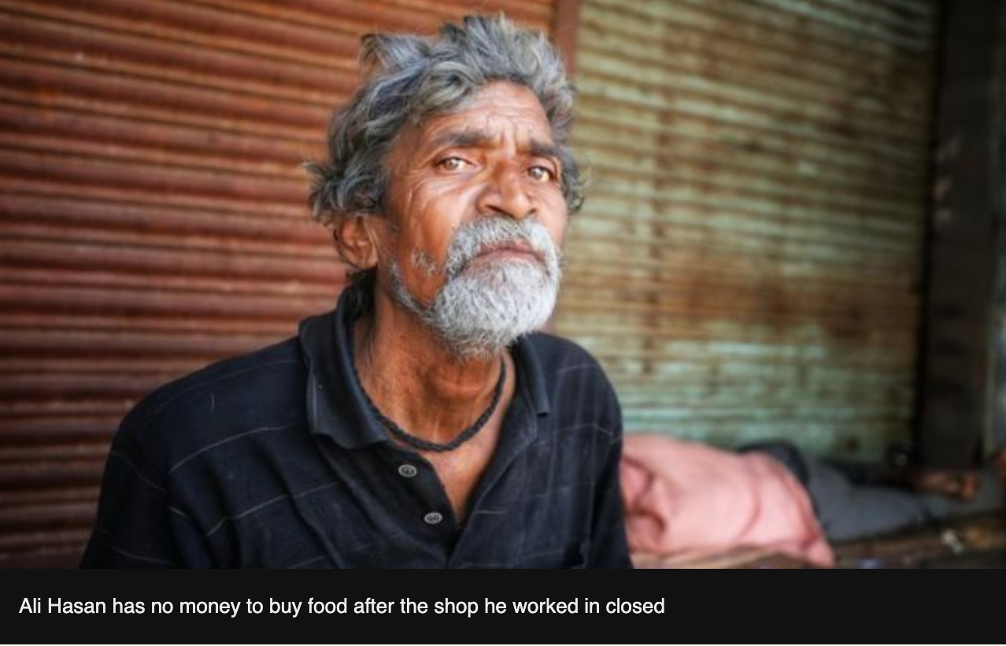
BBC News March 25, 2020India has been put in lockdown to halt the spread of the coronavirus outbreak. People have been told to stay indoors, but for many daily-wage earners this is not an option. The BBC's Vikas Pandey finds out how they were coping in the days leading up to Tuesday's announcement.
Labour Chowk in Noida is usually brimming with hundreds of men looking for jobs as construction labourers.
The small intersection of roads in this suburban area of Delhi is a hotspot where builders come to hire workers.
But it was eerily quiet when I drove there on Sunday during the initial lockdown. Everything was still - one could never imagine listening to the sound of birds chirping in such a busy area.
But I did - almost in disbelief.
I soon spotted a group of men huddled in a corner.
I stopped and asked them, from a safe distance, if they were following the lockdown.
Ramesh Kumar, who comes from Banda district in Uttar Pradesh state, said that he knew "there won't be anybody to hire us, but we still took our chances".
"I earn 600 rupees ($8; £6.50) every day and I have five people to feed. We will run out of food in a few days. I know the risk of coronavirus, but I can't see my children hungry," he said.
Millions of other daily-wage earners are in a similar situation. The lockdown announced by Prime Minister Narendra Modi on Tuesday evening means they are now facing no prospect of income for the next three weeks. The likelihood is, some will run out of food in the coming days.
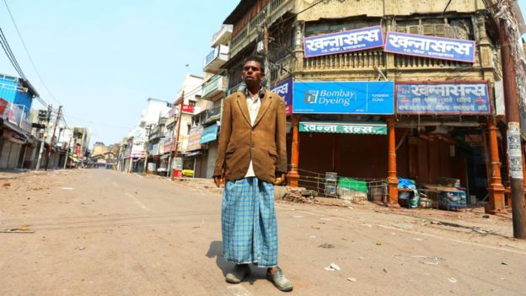
India has reported more than 500 confirmed cases and at least 10 people have died.
Several state governments, including Uttar Pradesh in the north, Kerala in the south and the national capital Delhi, have promised direct cash transfers into the accounts of workers like Mr Kumar. Prime Minister Modi's government has also promised to help daily-wage earners affected by the lockdown.
Kishan Lal - a rickshaw puller in the northern city of Allahabad - has earned no money in four days
But there are logistical challenges.
At least 90% of India's workforce is employed in the informal sector, according to the International Labour Organization, working in roles like security guards, cleaners, rickshaw pullers, streets vendors, garbage collectors and domestic helps.
Most do not have access to pensions, sick leave, paid leave or any kind of insurance. Many do not have bank accounts, relying on cash to meet their daily needs.
Lots are migrant workers, which means that they are technically residents of a different state to the one where they work. Then there is the problem of the floating population: people who do not live in any state for a long period as they move around to find work.
Akhilesh Yadav, the former chief minister of Uttar Pradesh, admits these challenges are huge, acknowledging that "nobody in any government has faced them before".
"All governments need to act lightning fast because the situation is changing every day. We need to activate big community kitchens and deliver food to people who need it. We need to hand out cash or rice and wheat - irrespective of who comes from which state," he said.
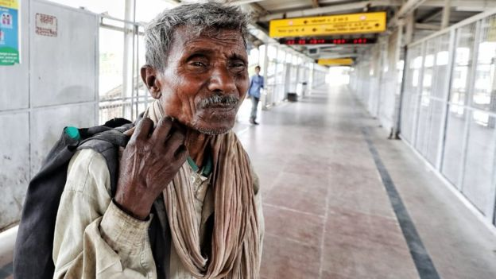
This cobbler - who did not give his name - did not know why the station was empty
Mr Yadav is particularly worried about his state, which is India's most populous, with an estimated 220m residents.
"We have got to stop people from travelling to one city from another to avoid community transmission. And one way of doing is to ensure food security. People rush to their villages in times of crisis," he added.
Uttar Pradesh chief minister Yogi Adityanath has said that a team of workers was tracking those who have arrived from other states and everybody who needs help will be supported by his government.
Indian Railways has now suspended all passenger services until 31 March.
But just days before the suspension kicked in on 23 March, hundreds of thousands of migrant workers travelled in packed trains from outbreak-hit cities like Delhi, Mumbai and Ahmedabad to their villages in Uttar Pradesh and Bihar states.
That has heightened the risk of community transmission and experts fear that the coming two weeks are the most challenging for India.
However, not everybody could afford to travel to their villages.
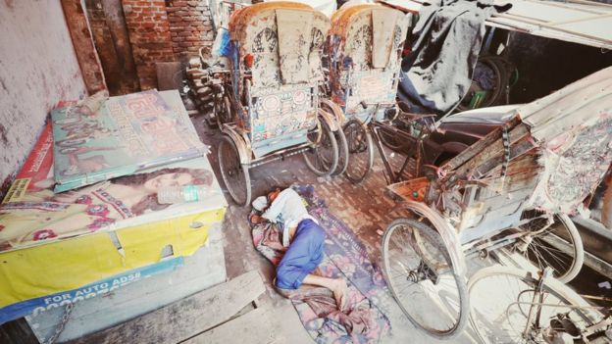
Kishan Lal, who works as rickshaw puller in the northern city of Allahabad, said he had not made any money in the past four days.
"I need to earn to feed my family. I have heard that the government is going to give us money - though I have no idea when and how," he said.
His friend Ali Hasan, who works as a cleaner in a shop, said he had run out of money to buy food.
"The shop shut down two days ago and I haven't been paid. I don't know when it will open. I am very scared. I have a family, how am I going to feed them?" he asked.

Step 2: Answer the following questions

If you had to choose between hunger or potentially getting the coronavirus, what would you choose and why?

What recommendations would you make to India’s government so that no one has to choose between hunger or sickness?

Step 3: Reflection

What was the biggest connection you made to this article?

Student Feedback:

Circle the emojis that best represents how this activity made you feel.

Mindfulness Moment! Respond to your Mindfulness card in the box below.
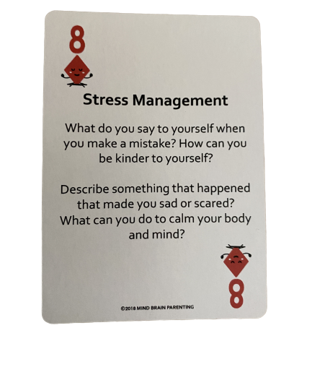

Day 3: Cars, again!
Math

What is this lesson about?: Today we are going to continue to look at cars and the cost of owning and driving cars.

Today’s Warm-Up
Cars and more…New Tires vs Old Tires. What’s a better deal?
The tires on your car are worn thin.
The table below has some possible options that you find online and by talking w/ your cousin who knows someone who owns a used tire shop

Tire | Cost | Guaranteed # of Miles
Michelin’s Best | $100 per tire | 25,000
Costo Basic | $70 per tire | 20,000
Used from your Cousin | $50 per tire | No guarantee; he says they are ‘almost new’

If you need 4 new tires, how much will a full set of Michelin tires cost?
How about the Costco Basic?
How about the tires from your Cousin?

Which set of tires should you buy? What is the main reason for your decision?
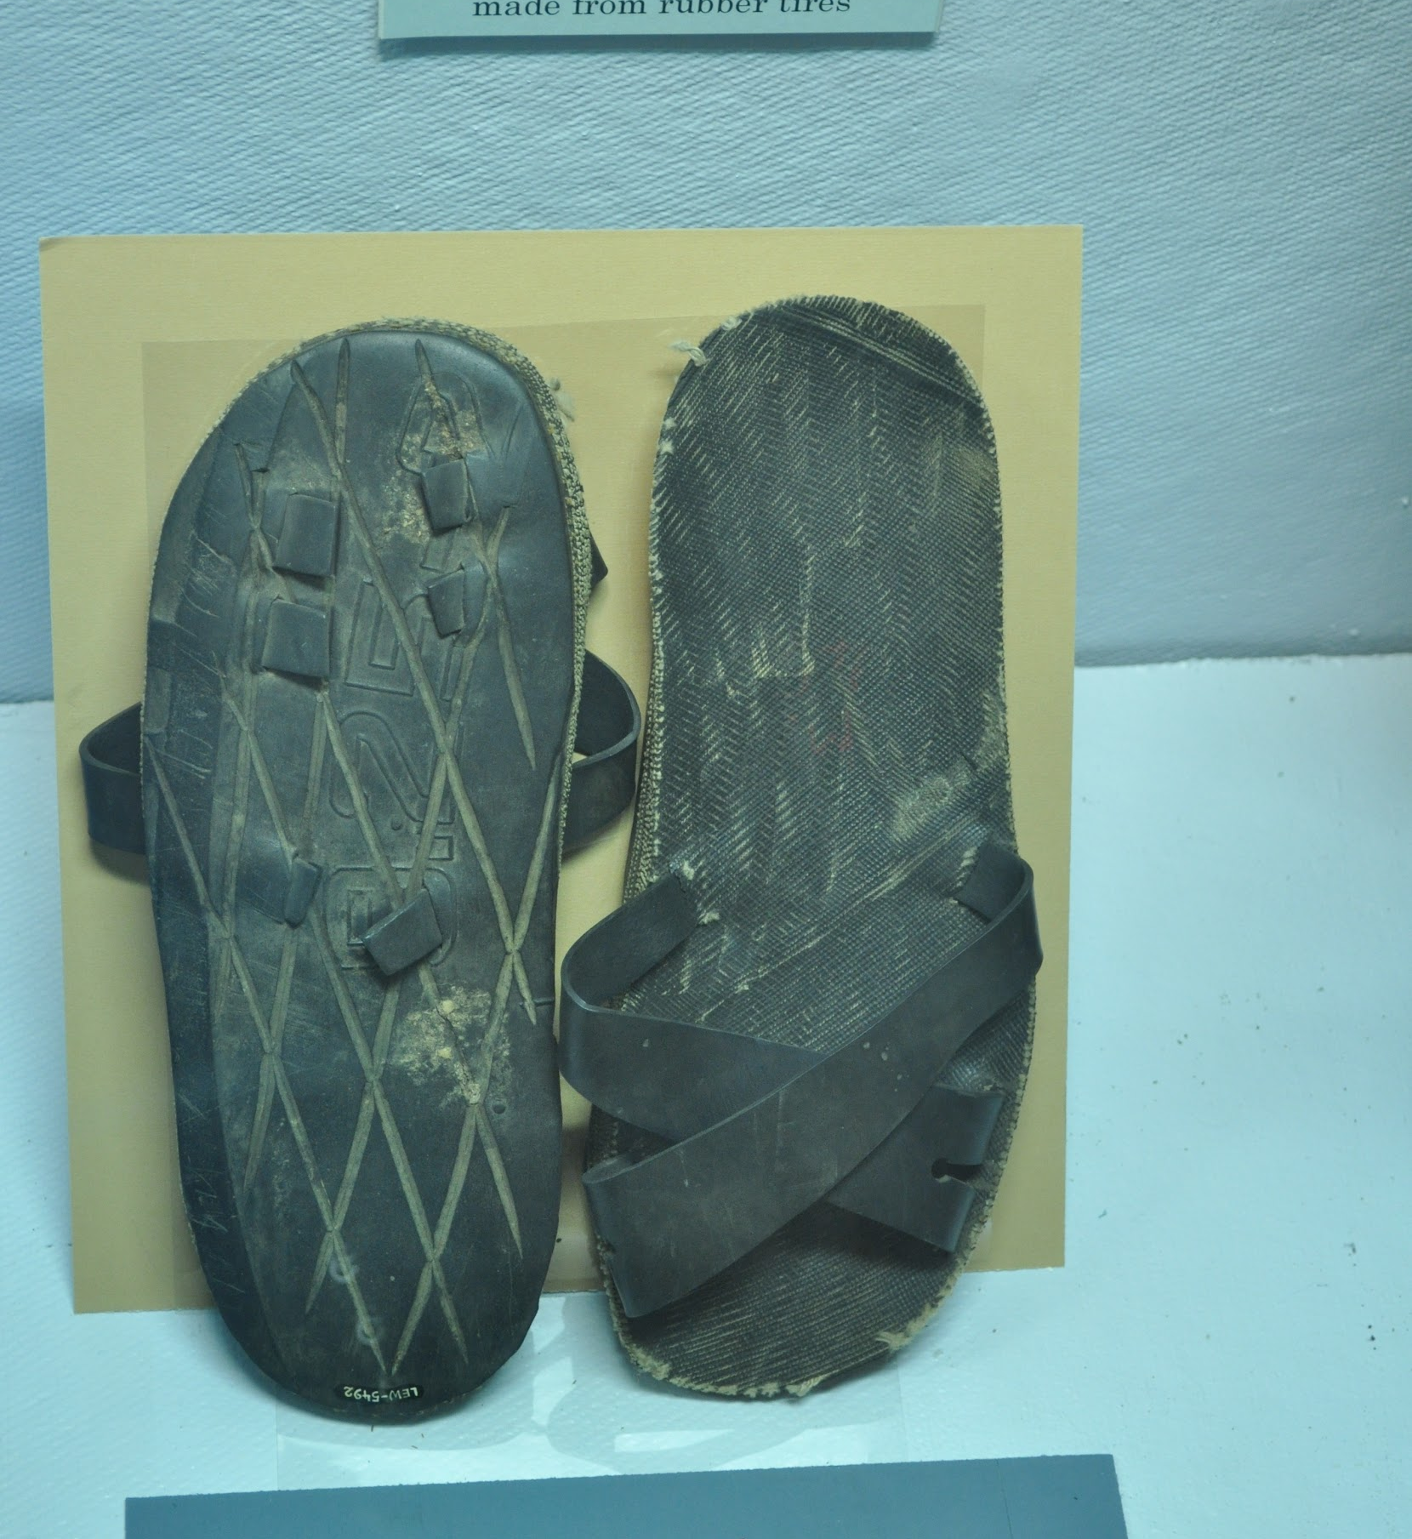
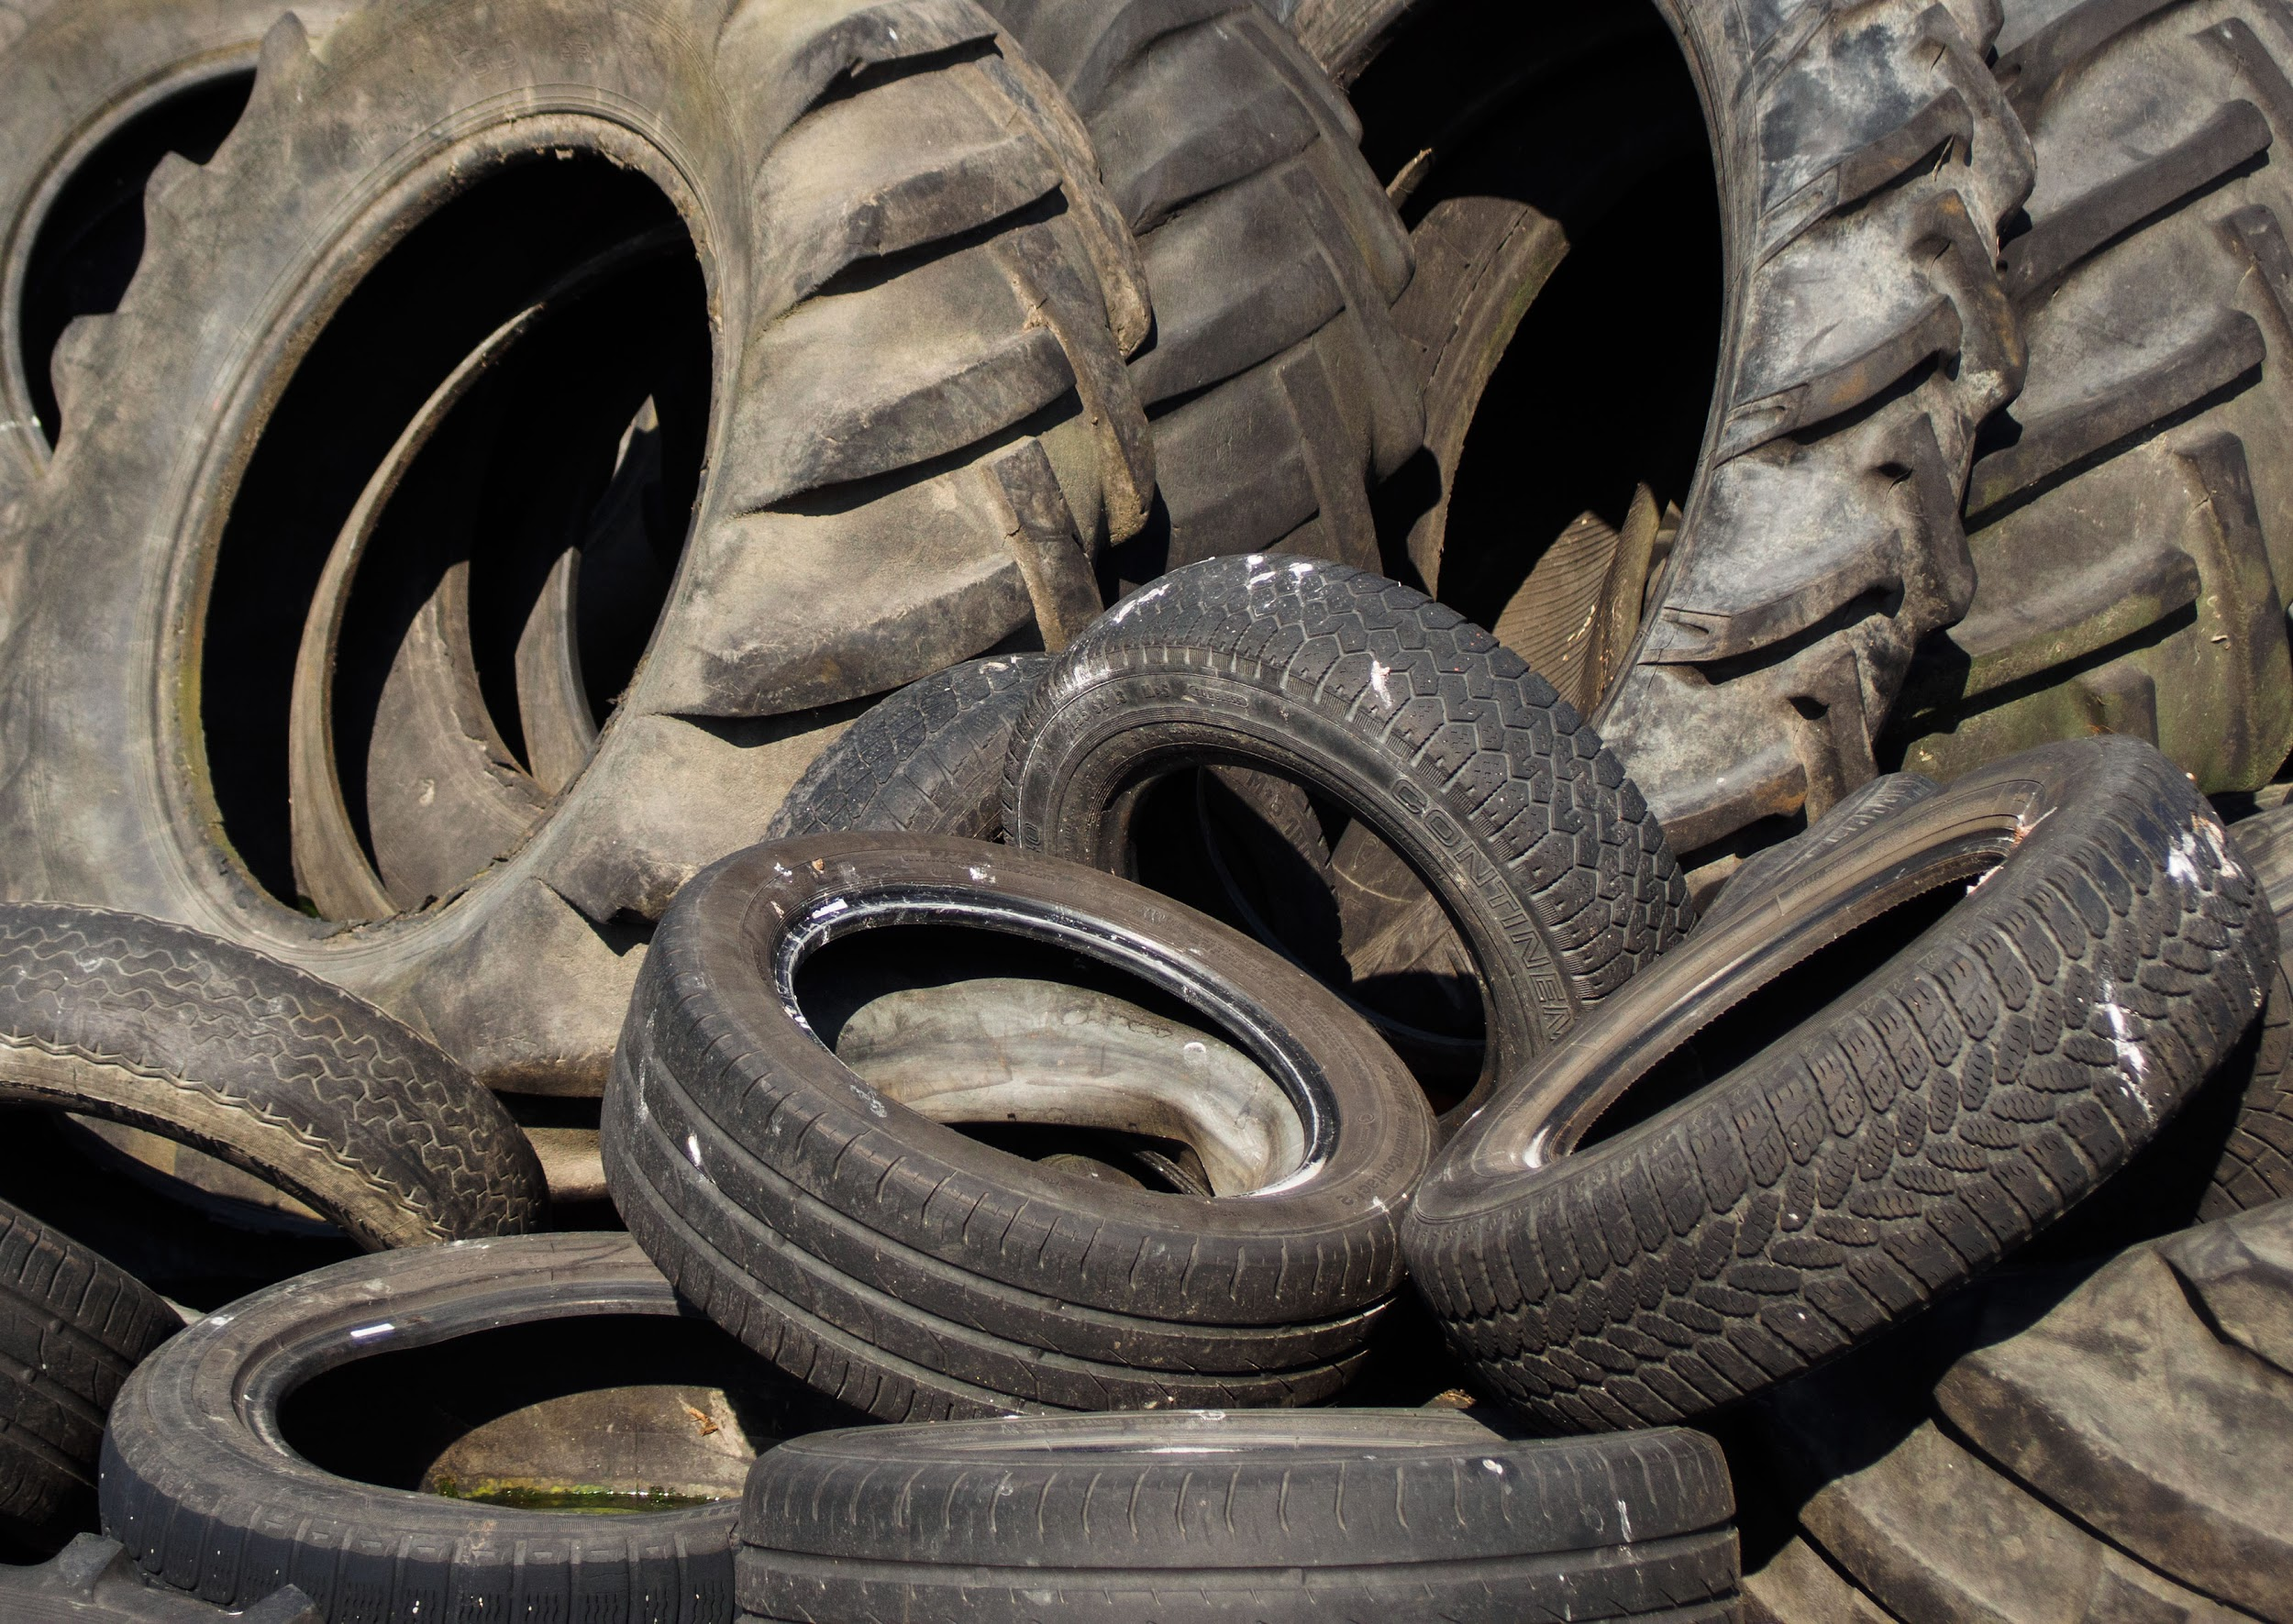
Discuss: What happens to all of the car and truck tires that get worn out? What can be done with them to help preserve our environment?

Step 1: Let’s look really carefully at 3 scenarios. Review the charts carefully and fill in the indicated spaces using the ‘hints’

We are going to keep looking into cars today, including how the cost of a car might vary based on how you purchase it, and the full cost of gasoline.

There are three main ways to ‘buy’ a car. Pay all cash up front, to pay a small amount down and pay the car off over 3 to five years, or to lease a car for 3 to 5 years. Let’s go.

Scenario #1

Scenario #2

Scenario #3
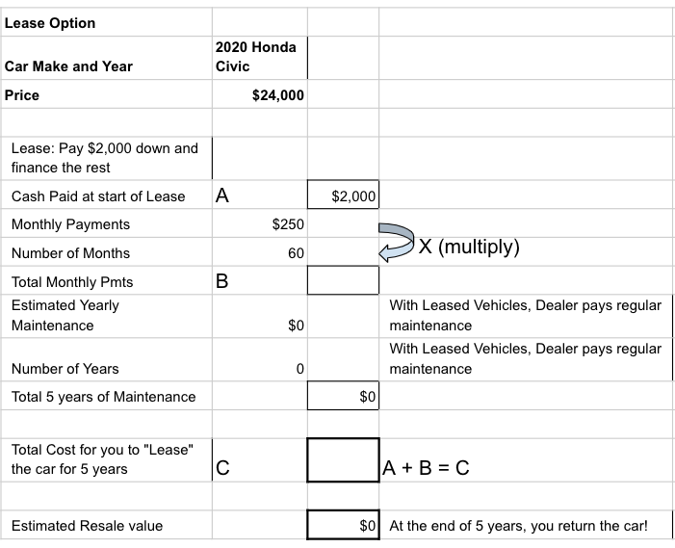

Step 2: Now let’s see what we have learned from the 3 scenarios.

Purchasing the 2020 Civic with all Cash-

- Cash paid for the car __________

- All total, how much will your maintenance cost be? __________

- After 5 years what is the total cost of the car and maintenance? __________

- And how much is the car still worth? __________
- So, if you had decided to sell the car in 2025, how much will it
have cost you to have that car for those 5 years? __________

Purchasing the 2020 Civic with 25% down ($6,000 out of $24,000)

- Cash/down payment paid for the car __________

- All total,how much will your monthly payments be? __________

- All total, how much will your maintenance cost be? __________

- After 5 years what is the total cost of the car and maintenance? __________

- And how much is the car still worth? __________
- So, if you had decided to sell the car in 2025, how much will it
have cost you to have that car for those 5 years? __________

Leasing the 2020 Civic with $2,000 down (out of $24,000)
(Remember, under lease you do not own the car)

- Cash paid/down payment on Lease for the car? __________

- All total, how much will your monthly lease payments be? __________

- All total, how much will your maintenance cost be? __________

- After 5 years what is the total LEASE cost of the car? __________

- And how much is the car still worth to you? __________
BE CAREFUL--you have to give it back to the dealer and they won’t give you any $ back)

- So, you can’t sell the car. How much did it cost you to use it for
those 5 years? __________

Step 3: Follow-up Questions based on the 3 scenarios and the answers above.
- Overall, how much did it cost you to operate the car (just the cost + basic maintenance) the car for five years under each plan-
    - All Cash Up Front ______________

    - DownPayment and 5 Years of Payment ______________

    - Total LEASE cost ______________

Discuss (or just jot down short answers)

- What is one good reason to pay all cash up front for the car?

- What is one good reason to make a downpayment and pay over 5 years?

- What is one good reason to LEASE the car?

Step 4: Ok, let’s go back and take a closer look at the full cost of gasoline

- It costs YOU $2.75 for a gallon of gas.

- Research shows that each gallon of gas that is used/burned by a car engine costs society an additional $3.80. This $3.80 includes the cost of the environmental, health and other problems caused by releasing all of the carbon into the air when we use up gasoline: air pollution that is bad for our lungs, greenhouse gasses that cause temperatures to rise, and more.

- Remember that Ford Mustang that gets 12 miles per gallon. If you drive it 60 miles in a week, how many gallons of gas do you use in one week?

  - How much does that cost you?

  - How much does that cost all of us because of the pollution and health costs of burning that much gas that week?

- How about the Honda Civic (let's round it off and say the Civic gets 30 miles to the gallon).
  - How much does it cost you to drive 60 miles?

  - How much does that cost all of us because of the pollution and health costs of burning that much gas that week?

Discuss (or just jot down short answers)

- Does this cost to society impact what sort of car you would purchase or drive?

- What can we do to make people take this cost into consideration when they drive cars that pollute a lot?

Skill Builders and Review Problems-
If you have more time, take a few minutes to complete the “skill builder” problems in the separate handout packet.
- Decimals - rounding
- Decimals - comparing
- Decimals - multiplying and dividing

Student Feedback:

Circle the emojis that best represents how this activity made you feel.

Day 3: Sleep
Health

Step 1: Sleep Journal
Sleep Journal: What tips do you have for falling asleep?

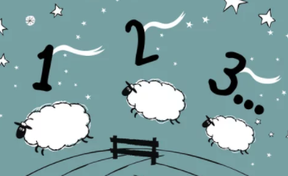

Step 2: Review some Vocabulary
Vocabulary:
Recuperate: recover from illness or exertion.
Circadian rhythm: physical, mental, and behavioral changes that follow a daily cycle
Melatonin: helps control your daily sleep-wake cycles

Step 2: Read the text

Before the crash, George was like most high schoolers. He never got a full eight hours of sleep, and he occasionally nodded off in class. A busy after-school schedule and demanding academics often kept him up into the wee hours.
Even when George could get to bed earlier, however, he didn’t feel tired. And there’s a scientific explanation for that: In your teen years, your body’s circadian rhythm, or natural clock, shifts. Melatonin, the hormone that makes you drowsy, is released later, making it difficult to fall asleep before 11 p.m. Couple that with the fact that, on average, high school starts at 8 a.m., and it doesn’t leave much time for rest. George, for one, had to leave for school by 6:45 a.m.
Watson puts it this way: “Teens are being squeezed on both ends.”
But George’s school isn’t entirely to blame. Today, he confesses another reason for his sleep problems: his iPhone. “I always had it in hand,” he admits.
If someone asked you if your phone keeps you up too, you’d probably say, “No way.” But researchers have found a clear link between your sleep and phone habits. “Today’s teens have more distractions than any previous generation,” says Kristin Daley, a psychologist who treats sleep problems. “It takes tremendous self-control to ignore those dinging notifications so you get everything done and get to bed.”
And even after you finally close Snapchat, your phone—yep, the one innocently charging on your nightstand—can still ruin your sleep. That’s because a screen’s glow keeps your brain from releasing melatonin (the hormone that makes you sleepy).
Meanwhile, your body needs shut-eye. Sleep allows your cells to repair themselves and your muscles to recuperate. Your brain also processes all the information it collected that day during sleep, so you can learn and remember.
Sleep is especially key for teens: It’s when the hormones and chemicals your developing brain needs are released. Skimp on rest and you might struggle to think clearly or keep emotions in check.
Step 2: Tips for good sleeping
Try one of these four tips for falling asleep and be ready to share your results in tomorrow’s sleep journal.

1. Use the 4-7-8 Breathing Method
The “4-7-8” method is a simple but powerful breathing method that promotes calmness and relaxation. It might also help you unwind before bed. It consists of a breathing pattern that relaxes the nervous system. It can be practiced anytime you feel anxious or stressed. Here are the steps:
- First, place the tip of your tongue behind your upper front teeth.
- Exhale completely through your mouth and make a whoosh sound.
- Close your mouth and inhale through your nose while mentally counting to four.
- Hold your breath and mentally count to seven.
- Open your mouth and exhale completely, making a whoosh sound and mentally counting to eight.
- Repeat this cycle at least three more times.
This technique can relax you and help you fall asleep quickly.

2. Visualize Things That Make You Happy
- Instead of lying in bed worrying and thinking about stressful things, visualize a place that makes you feel happy and calm. 41 participants suffering from insomnia were able to fall asleep faster after they were instructed to use an imaginary distraction.
- This technique helped them occupy their mind with good thoughts instead of engaging with worries and concerns during the pre-sleep time.
- Picturing and concentrating on an environment that makes you feel peaceful and relaxed can take your mind away from the thoughts that keep you up at night.

3. The military method
- Relax your entire face, including the muscles inside your mouth.
- Drop your shoulders to release the tension and let your hands drop to the side of your body.
- Exhale, relaxing your chest.
- Relax your legs, thighs, and calves.
- Clear your mind for 10 seconds by imagining a relaxing scene.
- If this doesn’t work, try saying the words “don’t think” over and over for 10 seconds.
- Within 10 seconds, you should fall asleep!

4. Relaxation script
- Raise your eyebrows as high as possible for 5 seconds. This will tighten your forehead muscles.
- Relax your muscles immediately and feel the tension drop. Wait 10 seconds.
- Smile widely to create tension in your cheeks. Hold for 5 seconds. Relax.
- Pause 10 seconds.
- Squint with your eyes shut. Hold 5 seconds. Relax.
- Pause 10 seconds.
- Tilt your head slightly back so you’re comfortably looking at the ceiling. Hold 5 seconds. Relax as your neck sinks back into the pillow.
- Pause 10 seconds.
- Keep moving down the rest of the body, from your triceps to chest, thighs to feet.
- Let yourself fall asleep, even if you don’t finish tensing and relaxing the rest of your body.

Day 3: Environmental Racism
Social Studies

What is this lesson about? In this lesson you will learn about the relationship between the environment and inequality. Specifically, you will us a map to examine how air pollution affects people of color and those living in poverty

Step 1: Reflect

Start by reflecting on the following questions. You can do this in conversation with a peer or adult or on your own through journaling:
- What is air pollution?
- What are some causes of air pollution? What are some effects of air pollution?
- Who do you think are some groups of people who are affected most by air pollution? Sometimes people are affected for reasons besides their physical health.
- People who don’t have much money often live near places that produce air pollution—like factories and power plants. Why do you think it is that people who have more money often live farther away from those places?
- What makes a place a good place to live? Who has enough money to live in places like that? Are places with a lot of air pollution good places to live? Why or why not?

Step 2: Examine the map
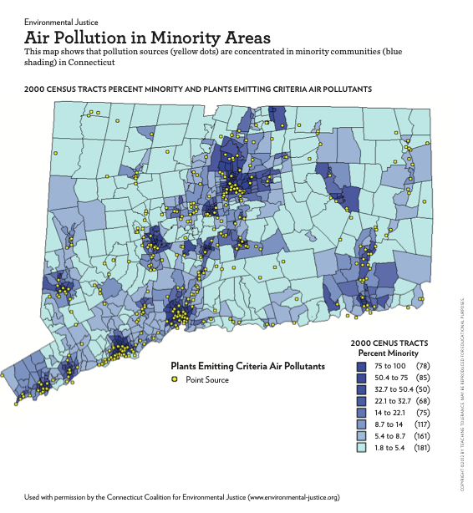
How much money people have affects whether they live near places that pollute the air. Let’s look at other groups that might be more affected by air pollution. Look at the map Air Pollution in Minority Areas. This is a map of the state of Connecticut. It shows two different things. It shows the parts of the state where lots of members of minority groups live, and it also shows where power plants that pollute the air are located.

Look at the key at the bottom of the map. It tells you what the different colors on the map mean. First, there are yellow dots. It says in the key that the yellow dots show where power plants are. Power plants make electricity for homes and businesses to use. They need to burn coal, gas or oil to make the electricity. When they burn these fuels, the power plants pollute the air.

There are also parts of the map that are different shades of blue. The key tells you what the different colors stand for. In the areas that are the darkest blue, most of the people are members of minority groups. The second darkest shade of blue shows areas where more than half the people are members of minority groups. As the shades of blue get lighter, there are fewer minority people living there. In other words, the lighter the blue, the fewer minority residents.

Step 3: Analyze the map

Now put together the two kinds of information on the map: The yellow dots and the shades of blue.
Where are the yellow dots?

What do the yellow dots tell you?

What shades of blue are there?

What does that tell you?

What pattern do you see? In what shade(s) of blue do you see the most yellow dots?

Sum up what you’ve seen on the map by completing this prompt:

There are more power plants located in areas where people who are __________ and people who are _______ live.

Step 4: Take a Stand
Do you think it’s fair that people who are poor and people who are members of minority groups live in areas where there is more pollution? Why do you think they stay in those areas? What makes it hard for them to move to a place with less pollution? What would you suggest as a way to make the situation fairer?

Write a response sharing your opinion on these questions about environmental racism and justice.

Student Feedback:
Circle the emojis that best represents how this activity made you feel.

Week 2
Environment

Day 4

NAME:______________________

Day 4 Agenda

Topic | Activity
Warm-Up!
English Language Arts | - Learn about the debate around recycling  - Read an article  - Choose a position on the debate and organize your thoughts
Science | - Read the article, In just 10 years, warming has increased the odds of disasters  - Respond to questions about the text; make recommendations
Mindfulness Moment!
Math | - Apartment hunting. What to look for in a lease. Understanding the full cost of renting an apartment. How about a roommate?  - Practice: Fractions, Decimals and Percents
Health | - Sleep Journal  - Sleep Comic
Civics/Social Studies | Culture and the Arts: DJ D-Nice’s Club Quarantine  - Do a close reading of an interview/article  - Annotate the text with thinking notes  - Develop interview questions

Warm-up Activity: You will determine the conditions of the story by filling in the blank and writing the rest of the story.
“I know you were expecting an asteroid to hit your house but on the bright side now you have ________________ to look forward to.”

Day 4: Recycling Debate - Persuasive Writing
English Language Arts

What is this lesson about?: For today’s lesson, you will explorethe debate around whether recycling programs are actually helping our environment. There are both pros and cons to recycling and you will read an article that explains both sides of this debate. You will then have the opportunity to choose a side and prepare for a debate speech in which you make your argument. You will finish your speech tomorrow (you will need today’s materials to finish your lesson tomorrow).

Step 1:
From an early age, kids are taught the three R's of protecting the planet: Reduce, Reuse and Recycle. But is recycling really the environmental fix it's made out to be?

What have you been taught about recycling?

Do you know people that recycle? What do they recycle and how?

Step 2: Read the text

*Before you begin reading, quickly turn to Step 3 and review the graphic organizer you will be filling out after reading. Now, keep in mind what information you will need to put into your graphic organizer as you read!

PRO/CON: Should we throw away the recycling program?
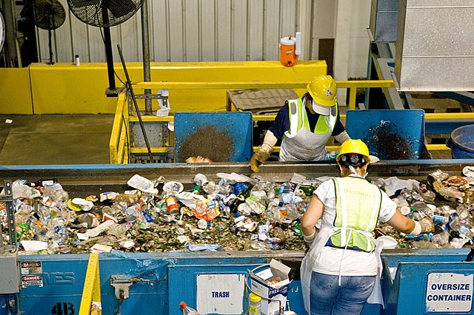

PRO: The costs of recycling outweigh the benefits
If you’re worried about the planet, please make sure your garbage is buried in a landfill. There is plenty of space available.
On the surface, the phrase “reduce, reuse, recycle” may seem like a realistic call to action. It makes particular sense to those who want to reduce the amount of oil and gas that are burned and halt climate change, and reduce the amount of garbage we will leave for future generations to deal with.
Image: https://commons.wikimedia.org/w/index.php?search=recycling+center&title=Special:MediaSearch&go=Go&type=image
The truth, however, is that the cost of the recycling process almost always outweighs the benefits.
Even the U.S. Environmental Protection Agency (EPA) says it only makes sense economically and environmentally to recycle about 35 percent of our trash. Among those materials are paper and aluminum cans, according to the government department.

More Expensive And More Electricity
Recycling 1 ton of paper or aluminum cans, the agency says, can save about 3 tons of carbon dioxide emissions over producing new materials. Carbon dioxide, a gas, is produced during the recycling process and can lead to climate change. A ton equals 2,000 pounds.
Not so fast.
Paper mills pay for the trees they process. If it was cheap enough to recycle scrap paper, producers would be beating down your door to buy it. There is a good reason why they aren’t.
It’s more expensive and takes more electricity and water to recycle old paper than to cut down pine trees, turn them into paper, and then grow new trees.
Plastic, which is made from oil, is another problem. Recently the price of oil has gone way down. It has now become cheaper to make a new plastic container than to recycle an old one.
Also, the EPA says that recycling a ton of plastic saves only about a ton of carbon dioxide. However, that doesn’t take into account the water to rinse their plastic containers before people put them into a recycling bin.
John Tierney is a science writer for The New York Times newspaper. He pointed out that if people use hot water to wash plastic containers, they actually contribute to sending more carbon dioxide into the atmosphere. Coal or gas is burned to heat the water up in the first place.

Are We Pretending About Recycling?
Glass is even worse. To reduce emissions by 1 ton you have to recycle 3 tons of glass. Including the cost of collecting old glass from neighborhoods, and the pollution produced by the collection trucks and the recycling process itself, glass recycling creates more emissions. It is also more expensive than making glass from scratch. New glass is made mainly from sand, and we have plenty of cheap sand in the world.
Many cities pick up glass in recycling trucks only to dump it at the local landfill.
Why are they pretending? Because people feel emotional about the motto “reduce, reuse, recycle.” They learn it in school and hear it everywhere they go. Most Americans are blind to the evidence about recycling programs.
More environmentalists should consider the costs and benefits of recycling programs. They should get rid of those that waste money and harm the environment.
If recycling saved money, companies would be lined up at your doorstep to buy your trash. Don’t look now, because they’re not there.
The true recycling test is whether someone will pay you to sort and save your trash. If they’re not, what you’ve been told about recycling is probably just garbage.

CON: Recycling cuts down the amount we waste
We Americans use a lot and waste a lot. We dump far more trash than we need to into landfills. In fact, we make twice as much garbage per person as Western Europe.
The amount of trash produced annually in the United States has tripled since 1960. In 2013, it totaled 254 million tons, which comes to 4.4 pounds per person every day. A ton equals 2,000 pounds.
We’ve made a lot of progress over the years in handling garbage. People started recycling much more after the mid-1980s. On average, Americans today recycle or compost about one-third of their trash.

Seattle's Pay-As-You-Throw System
The U.S. Environmental Protection Agency (EPA) is a government department. It reports that we recycle about two-thirds of paper, and just over half of aluminum cans. Yet, we recycle only 4 out of 10 electronics items such as cellphones and computers, and only about one-third of glass containers and even slightly less of plastic bottles and jars.
We should be able to do much better than this. So why don’t we? Some people just don't want to bother recycling. A number of states say that people have to recycle, but they don’t enforce their laws. In most cases, they do not offer people much reason to recycle.
Some states and cities do much better because they take recycling seriously. Cities such as Seattle, Washington, encourage recycling. Seattle charges people money for throwing out their garbage. People call it a pay-as-you-throw system. Even if the cost is small, it encourages people to recycle, and they do.
In 2014, half the people in Seattle recycled their trash. This rate continues to improve. The city is trying to reduce as much garbage as possible. Few other cities have set such a high goal.

Critics Sending The Wrong Message
Some critics see matters differently. They argue that recycling costs too much and is not effective. Some states seem to agree with them. They do not want to contribute to the cost of city recycling programs and say the cities should end their programs or pay for the cost themselves.
Is this the right action to take? Recycle only if there are enough benefits? Doing that would send exactly the wrong message.
Some experts believe that we should start way before this point. We should prevent or reduce waste when things are made. Then we should reuse what is left over, and only then throw out what cannot be recycled.
No one argues that the cost of recycling is not important. Still, there are ways to deal with that cost rather than say it is too high and abandon recycling programs. We could follow the lead of cities like Seattle by putting a price on trash. If people have to pay more, they will find ways to reduce the amount of trash they throw out. Also, the fees can cover the cost of recycling programs.
We are in the early stages of an important change. It will reduce waste and pollution and get people to change what they use and what they throw out. That’s the way to go.

Step 3: Organize your thoughts

Tomorrow you will be asked to prepare a persuasive speech. The purpose of a persuasive speech is to convince your audience to agree with an idea or opinion that you present. First, you'll need to choose a side on a controversial topic, then you will write a speech to explain your position, and convince the audience to agree with you.

Today you will work on the first step. Use the graphic organizer below to outline your points for a debate.

The topic of this debate is: Should we stop recycling?

What is your position on this topic? Circle one: Yes No

Explain your position:

Argument to support your position | Evidence to support your argument  (provide quotes or facts taken from the text)
Step 4: Closing Thoughts

How can debates be positive for our society?

What is a current hot topic or debate that you feel strongly about?

Student Feedback:

Circle the emojis that best represents how this activity made you feel.

Day 4: Science
Environment

What is this lesson about?: Today you will read the article, In just 10 years, warming has increased the odds of disasters. You will respond to the questions at the end of the article.

Step 1: Read the article

In just 10 years, warming has increased the odds of disaster.
- By Chelsea Harvey, E&E News on March 20, 2020
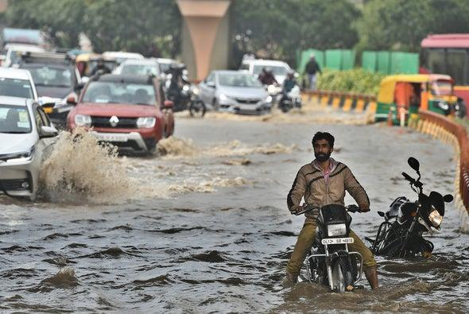
A motorcyclist tries to cross a waterlogged stretch amid slow moving traffic near AIIMS, on March 14, 2020 in New Delhi, India. Credit: Biplov Bhuyan Getty Images

Small levels of global warming can increase the likelihood of extreme events, new research warns. That’s prompting scientists to question how accurately disasters in the recent past can be used to predict extreme events today.

A study published Wednesday in Science Advances suggests that some research attributing climate change to individual disasters has underestimated the probability of certain extremes in the last decade. That’s especially true of unprecedented hot and wet events.

That’s because researchers were basing their analyses on a historical study period extending only up to the year 2005, said author Noah Diffenbaugh, a climate scientist at Stanford University. As it turns out, the warming that’s occurred since then has had a big impact on global extreme events.

“The global warming, even just in the 21st century, has created such a substantial increase in the frequency of extreme hot and extreme wet events over these regions that those frequencies fall well outside of the [previously] predicted probabilities,” Diffenbaugh told E&E News.

Studies investigating the influence of climate change on extreme events often use climate models to conduct their analyses. A common method is to run two series of simulations—one based on historical climate data reflecting the real-life progression of climate change over time, and one based on an imaginary world in which climate change does not exist.

The difference between the two simulations can reveal the way climate change affects the probability of extreme events occurring around the world.

One of the most commonly used model suites is an ensemble known as CMIP5—it was developed by an international team of scientists and has served as the basis for countless climate impact studies. The issue is that CMIP5’s historical simulations only reflect data up to 2005.

That’s not a flaw in the models’ design; it’s just the information that was available when they were first being developed. A new suite of climate models, known as CMIP6, is in development and will reflect an up-to-date historical climate period.
It means that analyses relying on CMIP5’s historical climate period don’t necessarily account for the warming that has occurred since 2005.

Diffenbaugh’s study presents a new method for checking predictions made in previous papers that relied on data from the past. These include some of his own past work, which used CMIP5 simulations to estimate the influence of climate change on extreme heat and precipitation events in the historical period and made predictions about future extremes.

Wednesday’s study suggests that predictions based on data from the past can substantially underestimate the probability of extremes in the present. This was the case for record-breaking hot and wet events in the Northern Hemisphere between 2006 and 2017, Diffenbaugh found.

“One implication of these results is the present probabilities are potentially closer to the period going forward ... than they are to the previous two decades,” he said.
Diffenbaugh added that the method outlined in his paper isn’t limited to checking studies based on CMIP5 simulations ending in 2005.

That was the main example used to illustrate the point in the new study. But the method could be used to evaluate other predictions based on data from earlier historical periods, just as long as the time window in which the predictions were made has already passed.
The study’s findings aren’t particularly surprising, other experts say.
“Of course the role of climate change is larger than originally estimated if you have another 10 years of warming in the data,” said Friederike Otto, an expert on climate change and extreme events at the University of Oxford, in an email.
But the size of the effect is worth pointing out, added Sebastian Sippel, a climate extremes expert at the Swiss Federal Institute of Technology in Zurich.
“The finding of this study, which in a sense is expected but in a sense is also kind of surprising, is how strong the change is,” he said.
According to Diffenbaugh, the paper could have practical applications for community planners working to address the impacts of climate change.
If people are designing infrastructure or making other decisions using recent climate data, instead of future climate projections, they could be significantly underestimating the consequences of global warming.
“That’s kind of the crucial point of this paper, is that climate change has to be taken into account, even on time scales of 10 years or so,” Sippel added.
The paper serves as yet another “wake-up call” about the speed at which climate change is progressing on Earth, he noted.
“The expectation that the next 10 years would be broadly the same as the last 20 or 30 years—this just cannot be expected anymore,” Sippel said.

Step 2: Answer the following questions

Do you believe global warming is impacting or drastically changing our Earth?

What data do you think is important to collect?

If you were an environmentalist, based on this article, what recommendations would make that you believe would lead to positive changes within the environment?

Student Feedback:
Circle the emojis that best represents how this activity made you feel.

Mindfulness Moment! Respond to your Mindfulness card in the box below.
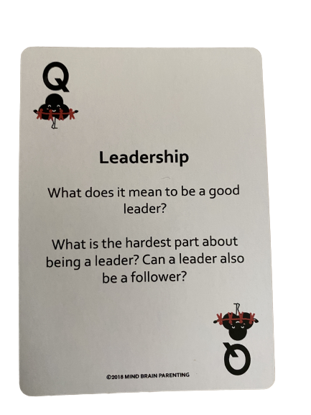

Day 4: Housing
Math

What is this lesson about?: Today we are going to look into the ways that your home environment impacts your financial status. Mostly, we are going to look at the cost of living on your own vs the cost of living with others and a more shared space.

Today’s Warm-Up
Back to those cell phones, and more…

You walk into a store and they offer you an IPhone 10 for free so long as you purchase a second IPhone 10 for $200 and sign onto a three year plan where you pay $150 per month. For that $150, you get both phones and unlimited call/data for three years

Answer these questions to help you consider this deal.

- After three years, how much money will you have paid all total, including the $200 you put down?
  - Down payment= _____________
  - $150 x _____________ months = _____________
  - Total cost for 2 phones and service for 3 years: _____________

  - Should you take the deal? Yes/No? Why?
.
Step 1: Compare the three rental options below

One Bedroom Apartment for Rent.
$800 per month.
Water included.
Tenant pays gas, electric, phone/cable
Estimated gas: $45/month
Estimated electric: $70
Phone/Cable/other-no estimate
1 month security deposit due with application

Two Bedroom Apartment for Rent.
$1200 per month.
Water included.
Tenant pays gas, electric, phone/cable
Estimated gas: $70/month
Estimated electric: $100
Phone/Cable/other-no estimate
1 month security deposit due with application

Three Bedroom House for Rent.
$1800 per month.
Tenant pays water, gas, electric, phone/cable
Estimated water: $60/month
Estimated gas: $90/month
Estimated electric: $120
Phone/Cable/other-no estimate
1 month security deposit due with application

Step 2: Answer the questions below to help figure out which of these options might be best for you

Living on your own: Assuming the estimates are correct,
- How much will it cost you per month for rent and related costs on your own, in a 1 Bedroom Apartment?

- How much will this be over 1 year?

Sharing a 2 bedroom: Assume you find a good roommate and you decide to rent the 2 bedroom apartment.
- How much will your total monthly cost be --- for you and your roommate?

- How much will it cost you per month?

- How much will this be over 1 year?

Renting a 3 bedroom house: Assume you find 2 good roommates and you decide to rent the 3 bedroom house…
- How much will your total monthly cost be --- for you and your two roommates?

- How much will it cost you per month?

- How much will this be over 1 year?

Step 3: Considering these options and making a decision.

What is one good thing about living alone?

What is one of the not so good things about living alone?

How much money would you save over 1 year if you lived in a 3 bedroom house with roommates instead of in a 1 bedroom apartment?

Is that savings worth it to you? Yes/No.

Step 4: Getting Real…

Ok, assume you are 19 and you are working part-time and going to college part-time. Your mom and dad tell you you can stay with them for the next couple of years to save money. They would like you to contribute $100 per month for rent.
- How much will that cost over 1 year?

- What would be one benefit of living with your parents for another year?

- What would be the downside of living with your parents for another year?

- Discuss: Would you accept this offer? Why/Why not?

Assume that at your job you earn $550 per week. After taxes, you take home $400 per week (we will learn about taxes this next week).

- How much money will you take home each month after taxes?

- Discuss: Now, with that amount of pay each month, what housing options look like they could work for you?

Skill Builders and Review Problems-
If you have more time, take a few minutes to complete the “skill builder” problems in the separate handout packet.
- Decimals - rounding
- Decimals - converting

Student Feedback:

Circle the emojis that best represents how this activity made you feel.

Day 4: Sleep
Health

Step 1: Sleep Journal
How did the tip that you used from yesterday help you sleep?

Step 2: Read the Text

Let’s say you’re taking a Spanish test when an answer just won’t come to you, even though you nailed it on last night’s practice quiz (10 sleepless hours ago). Or maybe you miss every free throw during your basketball game—and to top it off, you snap at your teammate on the way to the locker room.
These may seem like unrelated events, but here’s the surprising truth: Each may be a direct consequence of your lack of snooze time. In one study, just an hour less of sleep each night made sixth-graders perform like fourth-graders on mental tests. Other research shows that sleep loss makes you run slower and miss more shots in sports, while doubling your odds of injury.
Some experts even argue that teens would be less likely to take risks or suffer from anxiety and depression if they could just get enough sleep.
“When you’re sleep-deprived and you run into a stressful situation, whether it’s with your friends or something else, you’re going to get angry and upset,” explains Dr. Kathleen Berchelmann, a pediatrician in St. Louis, Missouri. “I see a lot of depression, anxiety, and even suicide attempts in teens who aren’t getting enough sleep.”
It’s stunning to think that by spending more time in bed, you could potentially lift your GPA, get along with your loved ones, excel on the field, and just plain feel happier. But scientists say it’s true—many teens are walking around like zombies without even realizing it.
We get it: With so much on your plate, sleep seems like the easiest thing to sacrifice. But that’s a mistake. “You cannot hack your sleep,” Watson says. “If you want to be your best version of yourself, sleep is crucial.” And the only way to get it is to go totally lights-out for at least eight hours.
George, for his part, says that since his crash, he takes his shut-eye seriously. But it can be tricky now that he’s living with a roommate in a college dorm.
“Sometimes I just go to sleep while people are hanging out in the room,” he says. “My friends say, ‘Hey, why are you going to bed so early?’ I tell them, ‘I need my sleep—and you guys should go to bed too.’”
Sound impossible? It’s not—
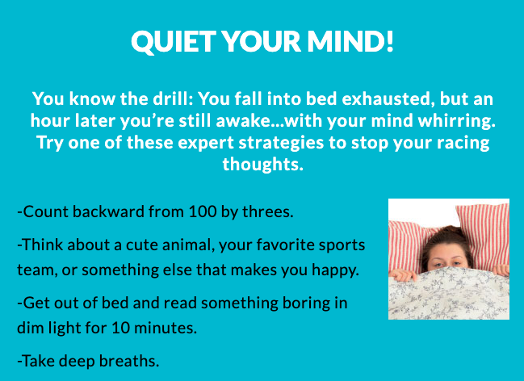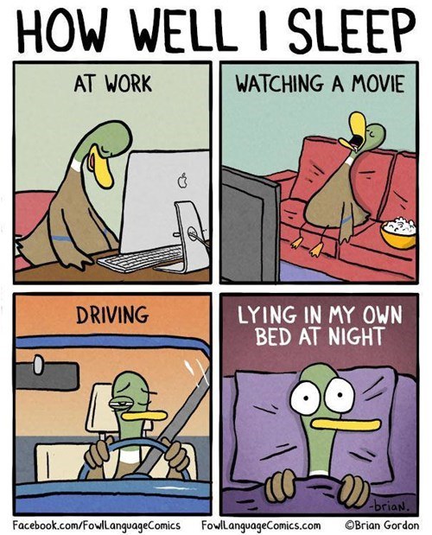
Step 2: Design a comic strip!

Design a Comic Strip that shows teens tips to developing better sleep skills. (look at the example above!)

Day 4: DJ D-Nice’s Club Quarantine
Social Studies

What is this lesson about? In this lesson you will read about how culture and the arts can bring people comfort during times of distress and how a sense of community can exist even when folks don’t share the same physical environment.

Step 1: “First Read”
Read the article one time through, independently or out loud with a peer or adult.

How DJ D-Nice’s Club Quarantine Became an Isolation Sensation
Rihanna, Oprah, Michelle Obama, Drake and Democratic candidates Joe Biden and Bernie Sanders were among the 100,000-plus who tuned in.
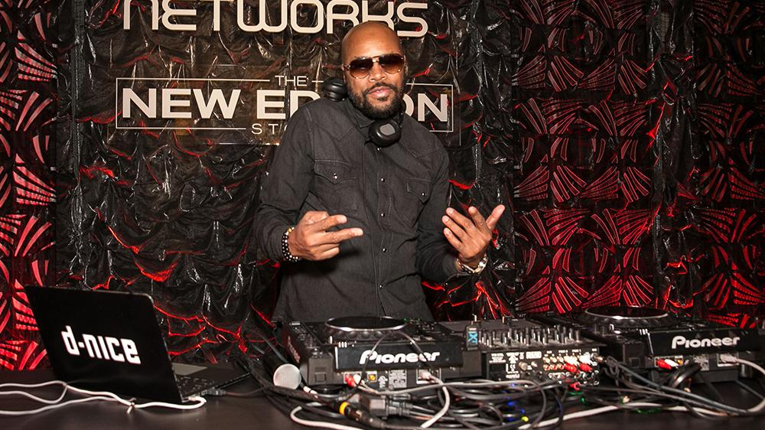
CREDIT: BRIAN TO/SHUTTERSTOCK
DJ D-Nice’s Instagram Live virtual dance parties have been the sensation of isolation, drawing upwards of 150,000 viewers — among them, both Democratic candidates, Joe Biden and Bernie Sanders, former first lady Michelle Obama, Drake, Oprah Winfrey, Will Smith and even Facebook CEO Mark Zuckerberg — and helping relieve anxiety during this time of stress and uncertainty. The Bronx native, whose real name is Derrick Jones, currently lives in Los Angeles and is, like all of the city’s residents, under a “safer at home” mandate calling for a weeks-long quarantine.
So last Friday, he took to the turntables — DJ-ing and mixing for some eight hours straight with barely a bathroom break. Under the banner “Home School at Club Quarantine,” his sets featured an abundant mix of genres — from disco to funk to soul and hip-hop.
Jones got his start at age 15 with rap group Boogie Down Productions alongside KRS-One and DJ Scott La Rock. After selling millions of records, putting out two successful solo albums and helping Kid Rock get a deal and working on his first album, Jones decided to leave the music industry in 1993, telling Variety, “I just felt burnt out.”
Fast forward to 2020, and his audience has never been bigger or his presence more impactful. Just yesterday, legendary rapper Scarface, who tested positive for COVID-19, credited D-Nice’s IG Live for “saving” him. Currently counting 1.7 million followers on Instagram, the outpouring of support and feedback has commended the DJ’s cheerful spirit, positivity and talents on the turntables. D-Nice spoke with Variety and revealed the one song he played twice: for Rihanna.
Where did the idea to host a virtual dance party originate and how did you get it going?
I live in L.A. now so when the quarantine happened, I felt stuck. I started going through withdrawals. I miss being in front of a crowd. All my life, whether I was rapping or DJ-ing, there’s always a crowd involved. To be isolated and not have that as an option, it threw me off. I decided to jump on IG Live and create a fun small party. I didn’t have any turntables hooked up, I was pressing buttons on my computer directly into my iPhone. My friends were joining in, we’re all having a great time. It was people in the music industry or in fashion. There were roughly 200 of us, all cool people I’ve known throughout years.
We’re in there pretending we’re in a club. I was playing music and telling stories about certain songs I produced back in the day. Just a fun time. I did it the next day. The third day, I could tell there was something different about it. More people were coming, so I decided to go out and buy new turntables and really DJ, Not just play music, to really get in there and spin records. That particular day — last Friday — Jennifer Lopez happened to stop in, and so did Drake. I couldn’t believe so many people were in this chat room. Michelle Obama to Oprah to Ellen Degeneres, it ended up being amazing. They weren’t just popping in, they’re in there listening to the music and interacting with people in the comment section. Gayle King, Lionel Richie, Jimmy Jam and Terry Lewis, The Rock, Rihanna came in.
Then as it was building, and we got to 95,000 people, I felt like we’re about to get cut off [after an hour if IG]. All of a sudden, Mark Zuckerberg signed in. We’re all tripping, like. “Wait, Mark Zuckerberg is in here!” I’m begging him, “Mark, please don’t shut it off! We need to reach at least 100K.” As soon as we hit 100K, everyone’s going crazy. Everyone erupted — happy in being a part of something so monumental. The number 100K doesn’t truly reflect the amount of people who actually heard everything, because people were in and out of the chat room. Knowing we did something so iconic is a great feeling.
What was the purpose of it, in your view?
To provide enjoyment for my friends. I figured, I’m sitting here isolated, I knew that feeling wasn’t unique. Other people were in the same predicament. If we can connect in this chat room while I’m playing music, then we’d all have a good time. Pretend that we’re together. Even though we weren’t physically there, we’re connected. We’re still communicating with one another via text. So many people felt that way because it started to take off, and it wasn’t celebrity-driven. … It grew organically. People caught on.
What was the greater cultural significance?
Oh man, this is a weird time. We’re all dealing with the coronavirus. To have a few hours of not worrying about a thing and hearing music, celebrating with each other and allowing that to relieve some stress is important. Music relieves all stress. No matter what type of music you listen to, it literally changes and touches your spirit. I play more of an uplifting set. Disco music always had a feeling of love and celebration so I tend to find records that feel that way. Whether I’m playing Stevie Wonder “All I Do” or First Choice’s old disco record “Doctor Love,” it feels like love. You want to dance, get up and celebrate. For music to have the ability to take the focus off what’s going on in the world, for an hour or two or however long you’re in that chat room, it’s extremely important finding a way to be happy right now.
How are you feeling in isolation and what were you hoping to provide for others?
Sometimes, I forget I’m here alone. Once I have on headphones and I’m playing music, I actually feel connected as well. It hasn’t really bothered me to be honest, I’m much happier now that I’m doing this. I hope other people feel the same way. We’re caught up in this virtual world of hanging out in Club Quarantine — that doesn’t really exist but for some reason, it’s the biggest club in the world right now.
What do you think drew so many there?
The music, it came from an honest place. I didn’t do this to have all the fanfare that’s going on, I did it because we love music. That’s why I ended up doing a playlist on Spotify. Even after I finished DJ-ing, I wanted the music that I played to actually have a home. [Those who] may not have heard a certain song, they could go back and play that song. Now they’re being introduced to new artists.
What’s the significance of having Biden and Sanders in the room?
With the internet chat room, everyone’s on a level playing field. No one’s really a celebrity. Biden came in and lifted people’s spirits. In their mind, they never imagined being in a text or chat room with Joe Biden. It’s important for [Biden and Sanders] to be there because we’re all going through this together. And for Biden or Bernie supporters, everyone felt good seeing them in there. They felt like they could touch them.
How long did you intend on spinning? Was it to break a record?
It wasn’t really about breaking a record. I was so caught up with enjoying the moment and the music. I play what I love, the music happens to feel good to me. Even though I was getting tired by hour seven, I watched Rihanna come in and I was happy to play even more music. Even though I’ve DJ’d for her in the past, the feeling that I had was… imagine this: most of the parties I DJ, I’m going into someone else’s world. I have to cater my set to what they want. In this case, they’re coming into my world. They’re coming to D-Nice’s Instagram Live. I played what I wanted to hear and wanted to expose them to, and they had a great time.
You said several times “we made history,” how do you mean?
There’s never been 100,000 people in one IG Live.
Describe how you felt when it reached 100,000?
Man, I was definitely emotional. To start something out of being lonely and doing it with 200 friends, to build that so quickly — it was less than a week. Five days. To build something that impacted people on such a large scale, that provided them with happiness and joy, to take their minds off what’s going on. Some people may have a hard time paying their bills they’re losing jobs; doctors and nurses on the front line dealing with this — and for one or two hours to allow them to escape that reality? It makes me emotional when I think about it. I had the ability to do that from my kitchen counter.
Of the hundreds of celebrities that popped in, who blew your mind the most?
Well, I’ve met Mrs. Obama before. I’ve met Joe Biden before. I was extremely happy they’re there but the one person who surprised me was The Rock. The Rock being in my IG live leaving comments, like, “Hey D, great job brother,” that meant a lot to me. I’m a big fan.
Did you have any communication with Zuckerberg?
We interacted one time, just one line each. When we’re about to reach that 100K mark, I yelled out “Zuck, yo Mark, please don’t cut us off!” His response was, “You got this.” That’s what made it all exciting; We were all rooting to get to that number.
To confirm, no songs were repeated throughout?
One song was repeated: Burna Boy’s “Ye” record. I played that earlier, then when Rihanna was there. I know that’s one of her favorite songs, so I decided to play it again.
Who are your top artists in rotation?
I play a lot of Stevie Wonder and Prince.
How did you get into DJ-ing?
I love creativity, so I started a creative services agency developing websites for iconic artists like Luther Vandross, Aaliyah and Alicia Keys. I was doing online marketing for Reebok, Violator Records, 50 Cent’s G-Unit sneaker and in 2003, I was invited to a party by a friend, Q Tip from A Tribe Called Quest. He was spinning with Mark Ronson and being there, I fell in love with music again. I fell in love with DJ-ing.
I started from the bottom. I was one of those guys who’d DJ for six hours in New York City clubs. Even though they weren’t paying a lot, it was gratifying to me. I had my first residency at Serena At the iconic Chelsea Hotel. Similar to the story I’m having right now, it started with 10 people, then it grew to a real party. I was able to play the set I play currently: a mix of everything. I went on to do a lot of clubs — residencies in Cane and Canal Room in NYC. One day, Kid Rock asked me to DJ a Sports Illustrated event he was hosting ahead of the Super Bowl. After that, I became more of a private event DJ. I did tons of huge events all the way until I played the inaugural ball for President Obama’s second term. I became one of the DJs the Obamas would frequently use.
Are you planning to keep Club Quarantine going on a regular schedule?
We’re determining that now. I don’t want to burn it out. It’s been such a great party for people to keep their spirits lifted, but I know I can’t physically do that every day. I’m going to see as far as we can take it. When this is over, I want to take it on the road. Allow people to have that experience of Club Quarantine in person.
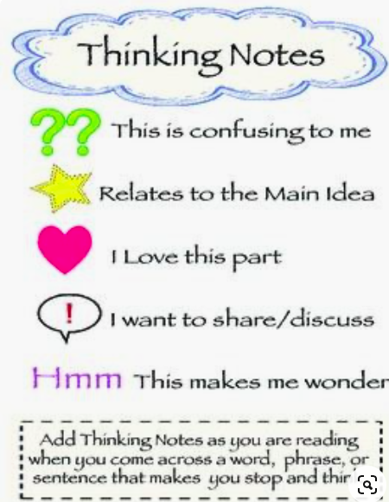
Step 2: “Second Read”

Read the article again, this time marking your paper with “Thinking Notes” in the text and margins. Thinking notes are your way of interacting with and “talking back to” the author and people in the story. Underline, circle or make a note next to things that excite you, touch your heart, make you sad, make you laugh, make you wonder, remind you of something, or even things that make you want to holler! Here are some ideas for symbols to help get you started.

Step 3: Your Turn

D-Nice answers over a dozen questions in this interview.
Are there things you still want to know that didn't get addressed? What are they? Are there follow up questions you think should be asked? Jot down 3 additional questions YOU would ask DJ D-Nice if you were doing the interview:

1.

2.

3.

Student Feedback:
Circle the emojis that best represents how this activity made you feel.

Week 2
Environment

Day 5

NAME:______________________

Day 5 Agenda

Topic | Activity
Warm-Up!
English Language Arts | - Prepare for writing a persuasive speech  - Write a speech  - Give your speech and reflect
Science | - Read the article, East Africa’s huge locust outbreak spreads to Congo  - Respond to the questions  - Reflect on the articles you read for this week; respond to the questions
Mindfulness Moment!
Math | - Credit Card wisdom  - Practice: Fractions, Decimals and Percents
Health | - Sleep Journal  - Sleep Advice
Civics/Social Studies | End of the Week Playlist  - Recap and reflect on the week’s learning.  - Make personal connections and associations to the themes and topics.  - Use personal expression and collaboration to show what you know.

Warm-up Activity: You will determine the conditions of the story by filling in the blank and writing the rest of the story.
“That was a reporter, the video I made of ______________ went viral.”

Day 5: Recycling Debate - Persuasive Writing
English Language Arts

What is this lesson about?: Today you will complete your preparation for the debate on whether we should continue recycling, and you will write a short persuasive speech presenting your argument.

Step 1: Organize your thoughts
Reminder: The purpose of a persuasive speech is to convince your audience to agree with an idea or opinion that you present.

Use the speech organizer on the next page to help you prepare a persuasive speech. Imagine you will be giving this speech at a community meeting where community members will be voting on whether to continue the recycling program.

For your main reasons, you can use the arguments to support your position from yesterday’s graphic organizer. For facts or examples, you may draw from yesterday’s article or from your own personal experience.

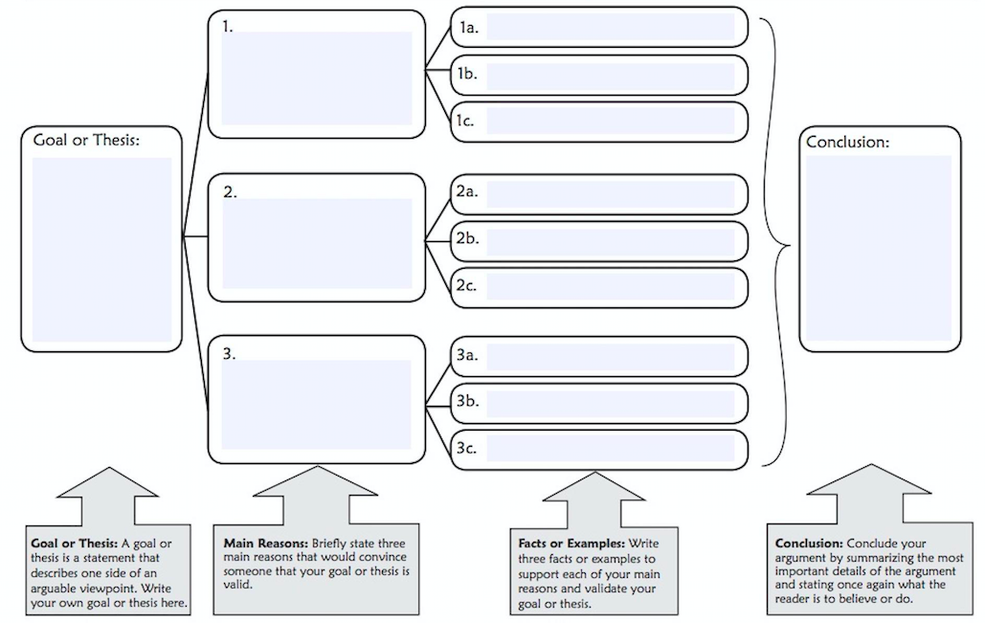
Step 2: Write your speech!

Now that you’ve organized your thoughts and arguments, write a 3-5 minute speech trying to persuade community members to take your position on this recycling debate.

Step 3: Give your speech
Now it’s time to share your speech! Working with a partner or a group, give your speech and allow your partner(s) to ask a couple questions. Now listen to your partner(s) speech and do the same for them.

Take a quick vote:
How many people want to continue recycling? _______
How many people want to stop recycling? _______

Why do you think the winning side won?

Some people say that if you don’t control your environment, your environment will control you. Does your group agree or disagree with that statement?

Why?

How might we try to control our environment in a way that will benefit us? (note: this can be any environment… mother nature, our current location, our current period of time, etc.)

Student Feedback:

Circle the emojis that best represents how this activity made you feel.

Day 5: Science
Environment

What is this lesson about?: Today you will read the article, East Africa’s huge locust outbreak spreads to Congo. You will respond to the questions at the end of the article.

Step 1: Read the article.

East Africa’s Huge Locust Outbreak spreads to Congo
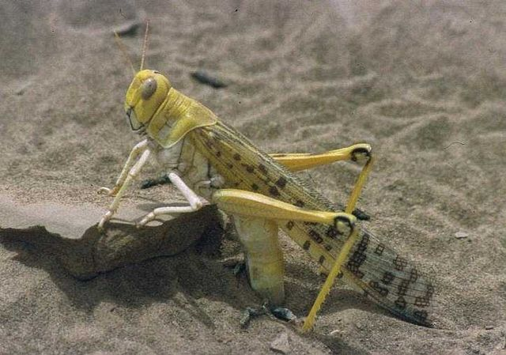

Image: https://commons.wikimedia.org/w/index.php?search=locust&title=Special:MediaSearch&go=Go&type=image

Kenya on Feb. 1, 2020.
KAMPALA, Uganda — A small group of desert locusts has entered Congo, marking the first time the voracious insects have been seen in the Central African country since 1944, the U.N. Food and Agriculture Agency said Tuesday as U.N. agencies warned of a "major hunger threat" in East Africa from the flying pests.
Kenya, Somalia and Uganda have been battling the swarms in the worst locust outbreak that parts of East Africa have seen in 70 years. The U.N. said swarms have also been sighted in Djibouti, Eritrea and Tanzania and recently reached South Sudan, a country where roughly half the population already faces hunger after years of civil war.
A joint statement Tuesday from FAO director-general Qu Dongyu, U.N. humanitarian chief Mark Lowcock, and World Food Program Executive Director David Beasley called the swarms of locusts "a scourge of biblical proportions" and "a graphic and shocking reminder of this region's vulnerability."
The FAO said mature locusts, carried in part by the wind, arrived on the western shore of Lake Albert in eastern Congo on Friday near the town of Bunia. The country has not seen locusts for 75 years, it said.
"Needless to say the potential impact of locusts on a country still grappling with complex conflict, Ebola and measles outbreaks, high levels of displacement, and chronic food insecurity would be devastating," the U.N. officials said in the joint statement.
Locust swarms can reach the size of major cities and can destroy crops and devastate pasture for animals.
Experts have warned that the outbreak is affecting millions of already vulnerable people across the region.
Uganda's government said Tuesday it was trying to contain a large swarm and will need more resources to control the infestation that has spread to over 20 districts in the north. Soldiers have been battling swarms using hand-held spray pumps, while experts have said aerial spraying is the only effective control.
The U.N. recently raised its aid appeal from $76 million to $138 million, saying the need for more help is urgent.
"This funding will ensure that activities to control the locusts can take place before new swarms emerge," the U.N. officials said, noting that to date only $33 million has been received or committed.
Experts have warned that the number of locusts if unchecked could grow 500 times by June, when drier weather is expected in the region.
"WFP has estimated the cost of responding to the impact of locusts on food security alone to be at least 15 times higher than the cost of preventing the spread now," the U.N. officials said in the statement.
A changing climate has contributed to this outbreak as a warming Indian Ocean means more powerful tropical cyclones hitting the region. A cyclone late last year in Somalia brought heavy rains that fed fresh vegetation to fuel the locusts that were carried in by the wind from the Arabian Peninsula.
Desert locusts have a reproduction cycle of three months, the U.N. officials said, and mature swarms are laying eggs in vast areas of Ethiopia, Kenya and Somalia, "many of which are already hatching."
"In just a few weeks, the next generation of the pests will transition from their juvenile stage and take wing in a renewed frenzy of destructive swarm activity," the joint statement said.
This is a time when farmers' crops begin to sprout, which could devastate East Africa's most important crop of the year, the U.N. officials said.
"But that doesn't have to happen," they said. "The window of opportunity is still open. The time to act is now."

Step 2: Answer the following questions

After reading the article, and as you think of your role as an environmentalist, answer any 2 questions:
- What suggestions would you make to the United Nations?
- What supports would you make sure are in place for East Africa, Congo, and other impacted countries?
- What will you do to make sure these locusts or other similar bugs do not take over the United States?
Question ___

Question ___

Step 3: Reflection

As you think about the articles you read in Science this week, which article did you enjoy reading the most? Why?

What positive change to your environment do you hope to make one day, as a result of what you learned?

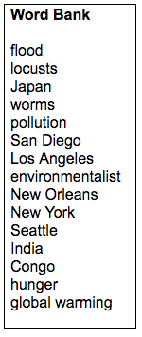
Step 4: Quiz
Fill in the blanks below with a word from the word bank.

- An ______________________ is someone who is concerned with or advocates the protection of the environment.
- There is far less air __________________ as a result of the Coronavirus shutdown.
- The three main cities in the United States currently showing cleaner air are: ____________________ _____________________ ___________________
- Many people in __________________ are more afraid of dying of _________________ than dying of the Coronavirus.
- ____________________ is the gradual increase of the Earth’s temperature.
- __________________ is an example of a natural disaster.
- East Africa is experiencing an outbreak of ___________________.

Student Feedback:
Circle the emojis that best represents how this activity made you feel.

Mindfulness Moment! Respond to your Mindfulness card in the box below.
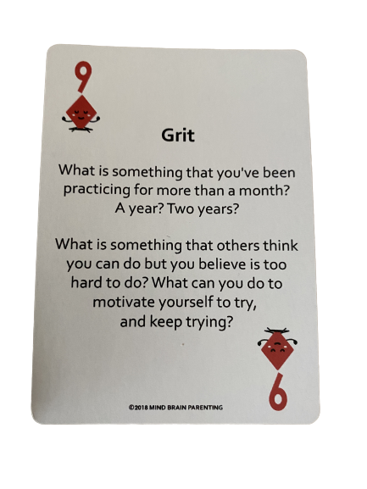

Day 5: Credit Cards and Debt
Math

What is this lesson about?: We are going to finish out this week looking at Credit Cards and how credit card fees and debt can really get you if you aren’t careful. The environment you are living in might have a big impact on how and whether you use a credit card.

Today’s Warm-Up (it’s a little more than a warm-up!)
Let’s take a look at cigarette prices and state taxes...

Use the table below to answer the warm-up questions below.

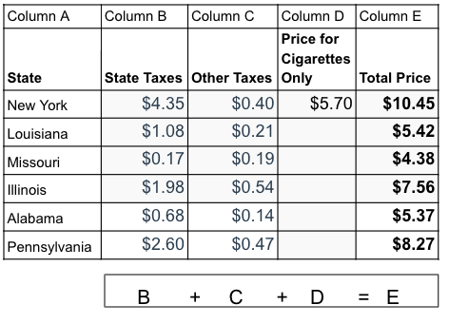
Complete Column D in the chart.
- How much does it cost for the cigarettes ONLY in Illinois?
- How much does it cost for the cigarettes ONLY in Louisiana?

Carefully look at Column B in the chart.
- Write the states in order of highest to lowest state taxes on Cigarettes below:

- Very roughly place the Total Cost (Column E) in the correct location on the map below in the correct state on the map!
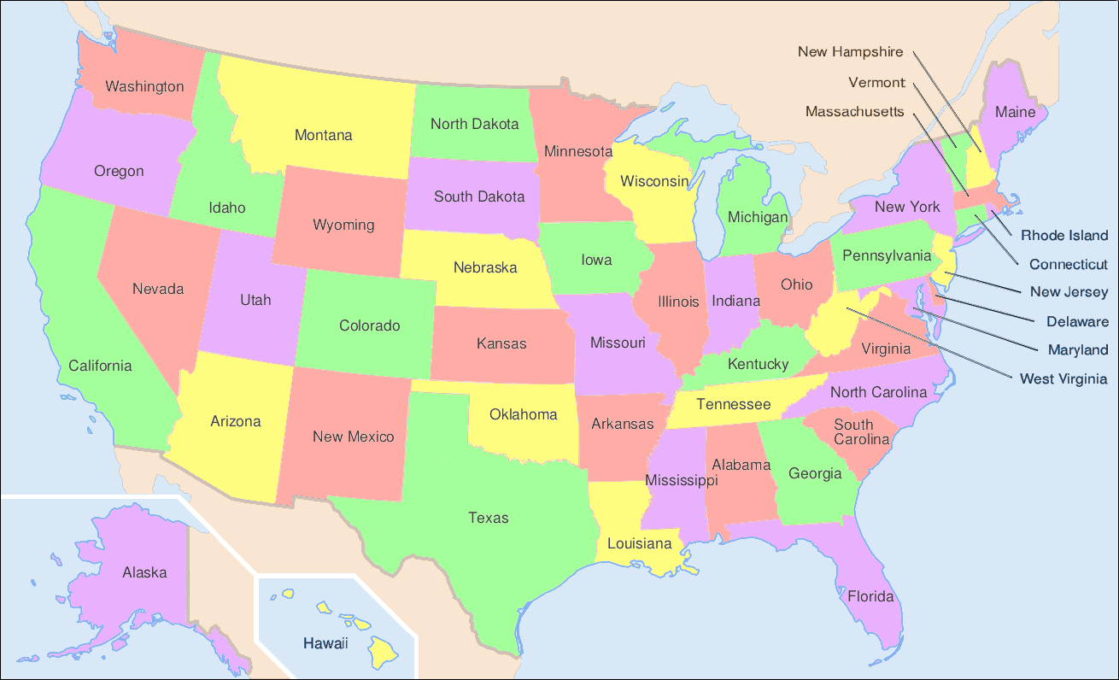

- Write or DISCUSS if permitted: What do you notice if anything, from this map once you write the cost of cigarettes in.

- Write or DISCUSS if permitted: Is there any relationship between the price of cigarettes and where the state is located in the US?

Step 1: Understanding the key ways that Credit Cards ‘get you’

Annual Fee: This is a flat yearly fee that some credit cards charge for you to have and use the card, no matter how much you use it
- Annual fees range from $0 to approx. $50 per year.

Late Fee: Late fee is the flat amount that a credit card company charges you if you don’t pay your monthly bill on time. The late fee is the same if you owe the bank $10 or $1,000. It kicks in once you are late making your monthly payment.

Interest Rate: Interest rate is the rate the bank charges you for any amount of money that you don’t totally pay off at the end of the month.
- If you put $1000 on your credit card and the pay it all off at the end of the month, you pay $ 0 in interest.
- If you put $1000 on your credit card and do NOT pay it all off, you start paying interest. If this $1000 goes unpaid for 1 year, you may pay as much as $200 in interest (20%).

Minimum Payment: This is a monthly amount that credit card companies charge. It is important to know that the ‘minimum payment’ is generally a small dollar amount, just enough for them to keep you on the hook, but not enough to help you pay off your loan amount--so if you ONLY pay the minimum amount, you NEVER pay off your credit card.

Carefully review the chart below and then try and answer the questions below.
 | Credit Card #1 | Credit Card #2 | Credit Card #3
Annual Fee | 0 | 50 | 50
Late Fee | 25 | 20 | 30
Interest Rate | 20% | 15% | 10%

Step 2: Let’s consider Marcus, a very good credit card user!

Marcus is very, very careful with his credit card. He uses it to buy his groceries and a few other necessities each month. He has it set up that he automatically pays off his TOTAL monthly bill each month, automatically, 1 day before the payment is due. He has NO late fees, NO interest charges...

- How much will it cost him to use Credit Card #1 for the whole year?

- How about Credit Card #2?

- How about Credit Card #3?

- So, what card should he sign up for?

Step 3: Let’s consider Stephanie, under 23 scenarios…

Stephanie is also quite careful. She almost always pays off her Credit Card each month. But occasionally she just pays the Minimum Amount Due. One year ago, she got into a bad car accident. That repair cost her $2,500.

She didn’t have comprehensive/collision insurance, so went out and got a separate credit card just to help her pay off her repair.

Assume that she decided on Credit Card #3. Here’s what happens:
- For the first 2 months, Stephanie is late with her minimum payments, so she gets charged a late fee each time.
- She gets a part-time job in the evening. Each month she saves some money and puts it in the bank. She isn’t late anymore and she does make her minimum payments, but she does NOT pay down her credit card balance. Finally after 12 months, she thinks she has saved enough money. How can we calculate how much she will end up spending all together to pay for her car to get fixed using this card.

  - A. Annual Fee for the new card: ______

  - B. LATE FEES for the two months she was late? ______
  - C. How much does she owe in interest (approximately).
    - Hint: what is 10% of the $2500 she borrowed? ______

  - D. Original amount of $ for car repair $2500
  - E. SO, in total, how much did her car repair cost her by
  - using Credit Card #3? (A+B+C+D) = ______
What would have happened to Stephanie is she decided to use Credit Card #1 to pay for her $2,500 car repair? Assume everything is the same, except that she used Card #1.

Assume that she decided on Credit Card #1. Here’s what happens:
- For the first 2 months, Stephanie is late with her minimum payments, so she gets charged a late fee each time.
- She gets a part-time job in the evening. Each month she saves some money and puts it in the bank. She isn’t late anymore with her minimum payments, but she does NOT pay down her credit card balance. Finally after 12 months, she thinks she has saved enough money. How can we calculate how much she will end up spending all together to pay for her car to get fixed using this card.
  - A. Annual Fee for the new card (Card #1): ______

  - B. LATE FEES for the two months she was late? ______
  - C. How much does she owe in interest (approximately).
    - Hint: what is 20% of the $2500 she borrowed? ______

  - D. Original amount of $ for car repair $2500
  - E. SO, in total, how much did her car repair cost her by
  - using Credit Card #1? (A+B+C+D) = ______

Step 4: Conclusions...and next steps with credit cards

Write down short answers, and DISCUSS if permitted, to each of the questions below-

- What is the absolute best way to keep down your credit card costs?

- How can you avoid late fees that credit cards charge you?

- When could it be worth it to use a credit card that charges an annual feel?

- What is the problem with only paying off the ‘monthly minimum payment’ on a credit card?

Skill Builders and Review Problems-
If you have more time, take a few minutes to complete the “skill builder” problems in the separate handout packet.
- Comparing and Converting--Fractions, Decimals and Percents

Student Feedback:
Circle the emojis that best represents how this activity made you feel.

Day 5: Sleep
Health
Step 1: Sleep Journal

Summarize what you have learned about sleep this week.

Step 2: Sleep Advice
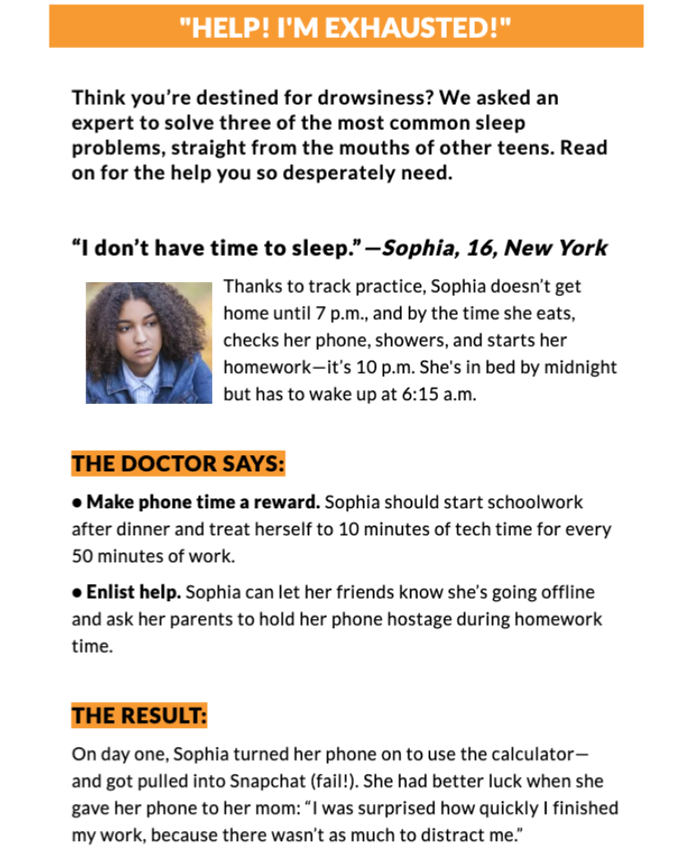
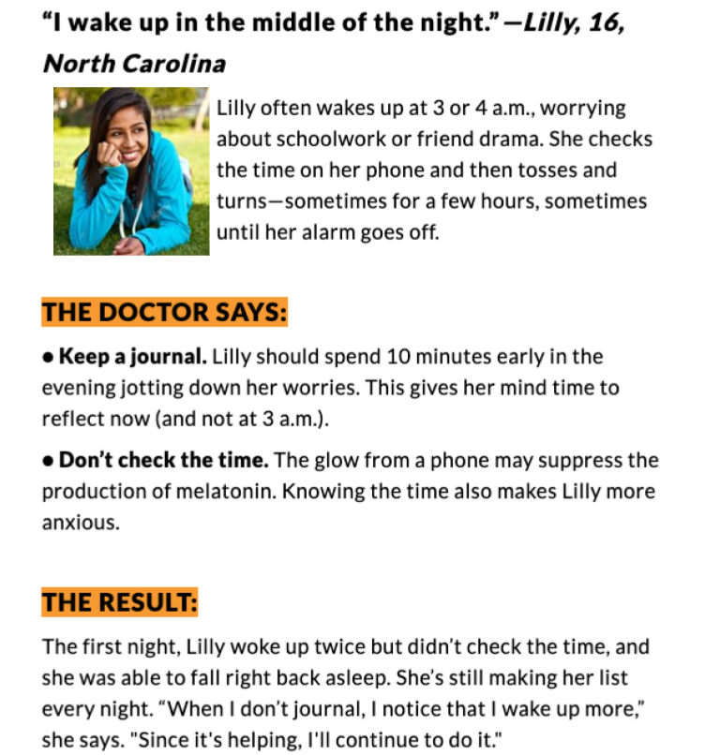

Step 2: Share your ideas
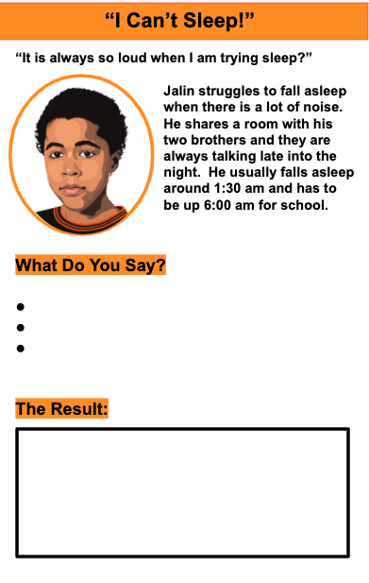

Day 5: End of the Week Playlist
Social Studies

What is this lesson about? In this final lesson of the week you have the opportunity to create a playlist of music. Use this activity to express yourself personally and also to recap and reflect upon the things you learned in this week’s social studies lessons.

Step 1: List
Brainstorm and list some of your favorite songs. Think about ones that connect to and relate somehow to what you’ve learned in social studies this week. To make your playlist you need a list of 7 songs. Here’s a list reviewing some of the main ideas, themes and topics you read about this week. Come up with a song for each of the following:

- Day one’s lesson (Wangari Maathai; environmentalism; activism; deforestation; Nobel Peace Prize; Kenya)
- Day two’s lesson (Environmental racism; air pollution; inequality; racism)
- Day three’s lesson (The Flu Pandemic of 1918; Philadelphia; St. Louis; epidemic; pandemic; influenza; coronavirus)
- Day four’s lesson (D-Nice; music and culture; quarantine; isolation; hip-hop; DJ’ing; virtual community; celebrity)
- The way you’re feeling personally and the kind of week you’ve had.
- Someone or something from home that you love and miss.
- Something happening out there in the world that weighs on your mind.

Step 2: Explain
Write 1-2 sentences explaining why you chose each song. What is the connection or meaning of each song and the themes or topics listed in Step 1? What do the artist or lyrics represent and why does that matter to you

Step 3: Compile
Once you’ve gathered your ideas from Steps 1-2, use the space below to compose your playlist. Don’t forget the very important step of giving the play list a title!

Playlist Name:__________________
Track1:
Why I chose this song:

Track 2:
Why I chose this song:

Track 3:
Why I chose this song:

Track 4:
Why I chose this song:

Track 5:
Why I chose this song:

Track 6:
Why I chose this song:

Track 7:
Why I chose this song:

Step 4: Extension Ideas
- Share your list with a peer. Discuss ideas and defend the tracks you chose.
- Either with the same peer or a group of peers, combine the best of everyone’s playlists into a GREATEST HITS or Top 10 list.
- When and IF you have access, and with the help and permission of an adult, create the actual playlist you and your peers worked on.
- Listen and enjoy!
Student Feedback:
Circle the emojis that best represents how this activity made you feel.

