Week 5
Power

Day 1

NAME:______________________

Day 1 Agenda

Topic | Activity
Warm-Up!
English Language Arts | - Read the transcript to the podcast: This American Life  - Respond to questions about the story.  - Write about what kind of superpower they would choose to help themselves and others fight against injustice.
Science | - Read about Renewable Energy  - Answer questions about what you read  - Draw a picture and explain
Mindfulness Moment!
Math | - Power: Voting and Political Power
Health | - Types of relationships
Mindfulness Moment!
Civics/Social Studies | - Consider types of governmental powers  - Monarchy and Oligarchy

Warm-up Activity: Write a journal entry around the daily quote on identity.

Day 1: What Superpower Would You Choose?
English Language Arts

What is this lesson about? Over the next week, you will be reading and reflecting on the idea of Power. Today, you will have the opportunity to read the transcript of a radio/online show called “This American Life”. In it, John Hodgman provides a commentary on Superpowers and what people might do if they had them.

Step 1: Before reading

Read, think about and answer the following pre-reading question. There is no wrong or right answer. The questions is designed to get you thinking about what the reading will be about and to consider your own thoughts and ideas on some of the issues that it brings up.

Write for 8 minutes: Flight versus invisibility? This question is only for you. Whichever you pick, you'll be the only person in the world to have that particular superpower. You can't have both. Which do you choose? And why?

Step 2: Read and Annotate

The transcript you are about to read, “Invisible Man vs. Hawkman ” was part of a report on This American Life, a radio show/podcast that airs on NPR (National Public Radio). The transcript is a written recording of the broadcast. As you read, think about the questions that people ask about the superpower and the reasons they give for choosing the power they decide on.

Ira Glass: Act One, Invisible Man Vs. Hawkman:

Well, we now present a kind of super-contest for you, beloved super-listener, between two ancient superpowers, two of the superpowers which have fascinated humans since antiquity. And actually, this is kind of a super Rorschach test. John Hodgman has been conducting an unscientific survey, posing for people a very simple choice.
John Hodgman: Flight versus invisibility? This question is only for you. Whichever you pick, you'll be the only person in the world to have that particular superpower. You can't have both. Which do you choose? I started wondering about this a few years ago. I'd bring it up at parties, dinners, wedding receptions. It was more interesting to ask than where people worked or where they went to school, and clearly more fun to answer. Like a magic word, shazam, flight versus invisibility would instantly change an evening's character, opening passionate conversation and debate.
But what surprised me more was how quickly everyone would choose, as though they'd been thinking about it for a long time. Everyone knew exactly which superpower they wanted and what they would do with it. Their plans weren't always flashy or heroic. In fact, they almost never were.
Man 1: If I could fly, the first thing I would do is fly into the bar, check out what's going on there, fly back home. I would attach my baby to me and fly to a doctor's appointment at 11:30, fly right back. And then I think I would fly to Atlantic City.
Man 2: I would imagine, like, if it got around that I had the power of flight and it was a rare type of thing, I mean, there would definitely be flight groupies. I would imagine. So they're going to be just like, oh, yeah, I just slept with the flying dude. You know? People are just like, oh, score.

Woman 1: I'd go into Barney's. I'd pick out the cashmere sweaters that I like. I'd go to the dressing room. The woman says, how many items? I'd say, five. I'd go into the dressing room. I'd put those five sweaters on. And I'd summon my powers of invisibility in the dressing room. I'd turn invisible. I'd walk out, leaving her to wonder why there's a tag hanging from the door that says five, and no person inside.

John Hodgman: So you'd become a thief pretty quickly.

Woman 1: Immediately. Until I had all the sweaters that I wanted, and then I would have to think of other things to do.

John Hodgman: Typically, this is how it goes. People who turn invisible will sneak into the movies or onto airplanes. People who fly stop taking the bus. Here's one thing that pretty much no one ever says-- I would use my power to fight crime. No one seems to care about crime.

Man 3: I don't think I would want to spend a lot of time using my power for good. I mean, if I don't have super strength and I'm not invulnerable, then, I mean, it would be very dangerous. If you had to rescue somebody from a burning building or something like that, you might catch on fire.

Man 2: Just having flight I don't think is necessarily quite enough, because you don't have the super strength.

Man 4: I'd still be weak when I got there, I guess. I don't fight crime now, and people without superpowers do. Sure, in theory, yes. But you know, I'm not a-- I mean, what can I do with this? Either one of those is, you need a whole package. There's not much you can do with any one thing. I'd go to Paris, I suppose.

John Hodgman: That's not being a superhero.

Man 4: Well, maybe I could be a Going to Paris Man, that sort of a superhero.

John Hodgman: Going to Paris Man is not a superhero. And I have to say this drove me crazy a little bit. We are, after all, talking about superpowers. Why not take down organized crime, bring hope to the hopeless, swear vengeance on the underworld, if only a little bit?

John Hodgman: I proposed a variety of sample scenarios along these lines, such as, how would you handle a mad genius taking over the Empire State Building, or a group of terrorists hijacking an overseas flight? And what I learned is, some people should simply not be fighting crime.

Woman 2: Well, first thing that occurs to me is, like, I would sneak up behind them very low with a knife that they didn't see and slice their Achilles tendon. Oh, no. I'd somehow shove a sock in their mouth or something like that, and wrap some tape around their mouth, so that they can't yell out. It might not be a sock. It might just be some napkins or something. I can't keep all of this in my head. I'd have to keep a bag full of stuff with me. Knives. Socks. Tape.

John Hodgman: Do you think you'd be tempted to enlist a teenage helper?

Woman 2: Um. You know, I think a helper would be good, a helper with a complementary power.

John Hodgman: There's no others, anybody else with superpowers.

Woman 2: Oh, it would just be a teenager hanging around me? No.

John Hodgman: People who consider invisibility always want to know, do I have to be naked? People who choose flight want to know, how fast? Almost all asked, who would win in a fight, Mr. Invisible or Flying Man?

And so I had to lay down some rules. Invisibility means the power to become transparent at will, including your clothing, but anything you may pick up is visible. Flight means the power to fly at any altitude within the earth's atmosphere at speeds up to 1000 miles per hour. But even then, they start looking for loopholes, hidden catches, superpower fine print. They start negotiating their dreams with me.

Man 5: Now, when you're flying, if you're flying at 1000 miles an hour at 100,000 feet, are you comfortable? Do you get very cold?

Man 6: Let's say I'm in this room and I'm invisible. And I'm walking around this apartment and I'm invisible. Do I have to be completely quiet, or you guys will, like, hear my footsteps? Because that's a pain in the ass. And also, someone has to let you in.

Man 4: Can I carry someone? Can somebody go on my back?

John Hodgman: Can you carry someone on your back now?

Man 4: Little people. Little people, yeah.

John Hodgman: Then you can carry little people on your back.

Man 4: Done. Flight it is.

John Hodgman: This is all part of what I call the five stages of choosing your superpower. Sometimes this process occurs in just moments. For example, subject A, a tallish man with glasses, wedged into a cramped barroom corner, begins as they all do, with stage one, gut reaction.

Man 7: Initially, I would think perhaps invisibility.

John Hodgman: Next comes stage two, practical consideration.

Man 7: Because you have the ability to walk around work, perhaps show up at one point, and perhaps like go away for a little while, and turn invisible, and then come back and listen to what they say about you. You have the power to spy on your exes. And that would all be enlightening and fun and, in fact, a little bit perverted. And--

John Hodgman: You hear that doubt in his voice? That's the beginning of stage three, philosophical reconsideration.

Man 7: That would-- I believe it would immediately turn into a life of complete depression. You wouldn't be able to really share it with anyone, you know? And I know there'd be some problems with, like, the perversion thing.

John Hodgman: Stage four, self-recrimination.

Man 7: Invisibility leads you-- leads me, as an invisible person, down a dark path, because you're not going to want to miss out, when you're invisible, on-- you know, no matter how many times you've seen a woman naked in the shower, you're going to want to see it again, because there's always a different woman, right? And there's like a lifetime of that. And that's not acceptable behavior, no matter whether you're invisible or not.

John Hodgman: And finally, stage five, acceptance.

Man 7: Yeah, I'd have to go with flight.

John Hodgman: So who chooses invisibility and who chooses flight? In my experience, though there are lots of exceptions, men lean towards flying, women to invisibility. And many brood anxiously over their choice, switching from one to the other and back again. And that's because, more than the ability, say, to burst into flame or shoot arrows with uncanny accuracy, flight and invisibility touch a nerve. Actually, they touch two different nerves, speak to very different primal desires and unconscious fears. My friend Christine chose invisibility.

Christine: One superpower is about something that's obvious, and the other is about something that is hidden. I think it indicates your level of shame.

John Hodgman: How do you mean?

Christine: A person who chooses to fly has nothing to hide. A person who chooses to be invisible wants clearly to hide themselves.

John Hodgmam: Do you feel that you want to hide yourself?

Christine: I want to-- I'd like to not-- I'm not going to answer that question.

Woman 3: It all has to do with guile. Wanting to be invisible means that you're a more guileful person. If you want to fly, it means you're guileless. And I think the reason that I'm so conflicted about flying versus invisibility is that I have guile, but I really wish that I didn't.

John Hodgman: Flight is the hero-- selfless and confident and unashamed. And invisibility, the villain. Almost everyone I talked to called invisibility the sneakier power.

Man 8: Flying is for people who want to let it all hang out. Invisibility is for fearful, crouching people who have something to be embarrassed about.* (*edited for language)

Woman 1: First of all, I think that a lot of people are going to tell you that they would choose flight, and I think they're lying to you. I think they're saying that because they're trying to sound all mythic and heroic, because the better angels of our nature would tell us that the real thing that we should strive for is flight, and that that's noble and all that kind of stuff. But I think actually, if everybody were being perfectly honest with you, they would tell you the truth, which is that they all want to be invisible so that they can shoplift, get into movies for free, go to exotic places on airplanes without paying for airline tickets, and watch celebrities have sex.

John Hodgman: Anyone faced with this choice, in their heart of hearts, will choose invisibility.

Woman 1: Yes. Or they have this sort of inflated, heroic, mythical concept of themselves, and that, in fact, they're not really giving it very much practical thought.

John Hodgman: In the end, it's not a question of what kind of person flies and what kind of person fades. We all do both. Perhaps that's why, when I put the choice to myself, I'm hopelessly, completely stuck. At the heart of this decision, the question I really don't want to face, is this. who do you want to be, the person you hope to be, or the person you fear you actually are? Don't rush into it. Think it over. Which would you choose?

Step 3: Answer the following questions.

            - What were some of the actions people wanted to do if they had a superpower?

            - What reason did most people for not becoming crime fighters?

            - Did John Hodgman find that people were satisfied with the superpower they chose? How do you know?

            - According to Hodgman, what are the five stages of choosing your superpower?

5. Hodgman’s friend Christine says that “A person who chooses to fly has nothing to hid. A person who chooses to be invisible wants clearly to hide themselves.” Do you agree? Why or why not?

Step 4: Write

”With great power comes great responsibility” is a proverb from Spider Man so that he can understand that he should use his power for the benefit of others instead of just for his own benefit. Below is a list of some top superpowers as listed by the CBR (Comic Book Resources) website. Review the different powers and think about how they could be used. Pick three powers that you would pick for your benefit and three powers that you pick to have in order to help others. Explain how you would use the powers to either help others or to solve some local, national or world problem.

x-ray vision: ability to see through solid objects or people. | heat/laser vision/optic blasts: ability to shoot lasers from their eyes at an opponent, a wall, or just about anything else
Intangibility: ability to alter your atoms in such a way that you can walk through walls, or alternatively, let things like bullets pass through you harmlessly. | body manipulation: ability to alter the size or length of a body part. (for example: ant-man’s ability to shrink or grow)
shapeshifting: a form of body manipulation or taking on the form of another person, usually for covert missions | enhanced senses: hyper-powered senses that usually make up for a missing sense. (for example: spidey sense)
immortality: ability to live forever. | flight: ability to fly without using any special devices
regeneration: ability to have a wound heal almost immediately | invisibility: ability to make yourself and possibly other things invisible to the naked eye
teleportation: ability to move from one place to another in the blink of an eye, | super strength: ability to use superhuman strength
invulnerability: the ability to be protected from any injury | super speed: ability to control of not only super speed but the ability to use it to travel through time.
time travel: ability to go back and change things that went wrong or to travel to the future to see what would happen if you made a given choice. | telepathy: ability to read minds, alter or erase someone's memories, or simply make them do what you desire.

Use the space below to write your response.

Student Feedback:
Circle the emojis that best represents how this activity made you feel. | 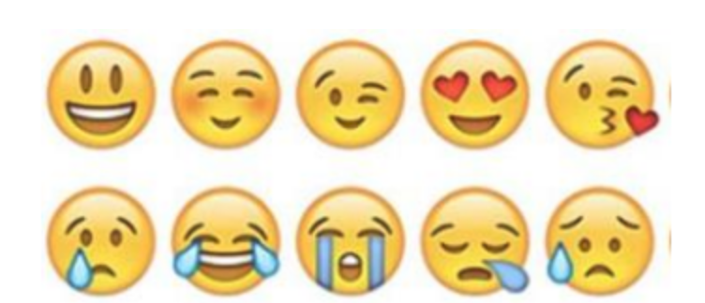  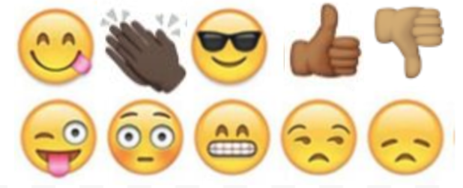

Day 1: Science
Renewable Energy

What is this lesson about?: Today you will read through the Renewable Energy passage. You will answer a few questions about what you read. You will draw a picture and write a response.

Step 1: Read through the Renewable Energy passage

Renewable Energy
(Technological Solutions; eia.gov)

What is renewable energy?
Renewable energy uses energy sources that are not "used up". For example, solar power from the sun is renewable as we won't "use up" all the sunlight from the sun. Examples of non-renewable energy sources include fossil fuels like coal and oil. Once we use or burn these resources, they are gone forever.

Why is renewable energy important?
Much of the world relies on non-renewable energy to heat their homes, power their electronic devices, and power their cars. Once these energy sources are used up, they will be gone forever. Developing technologies that can efficiently use renewable energy sources is critical to our future.

The Environment
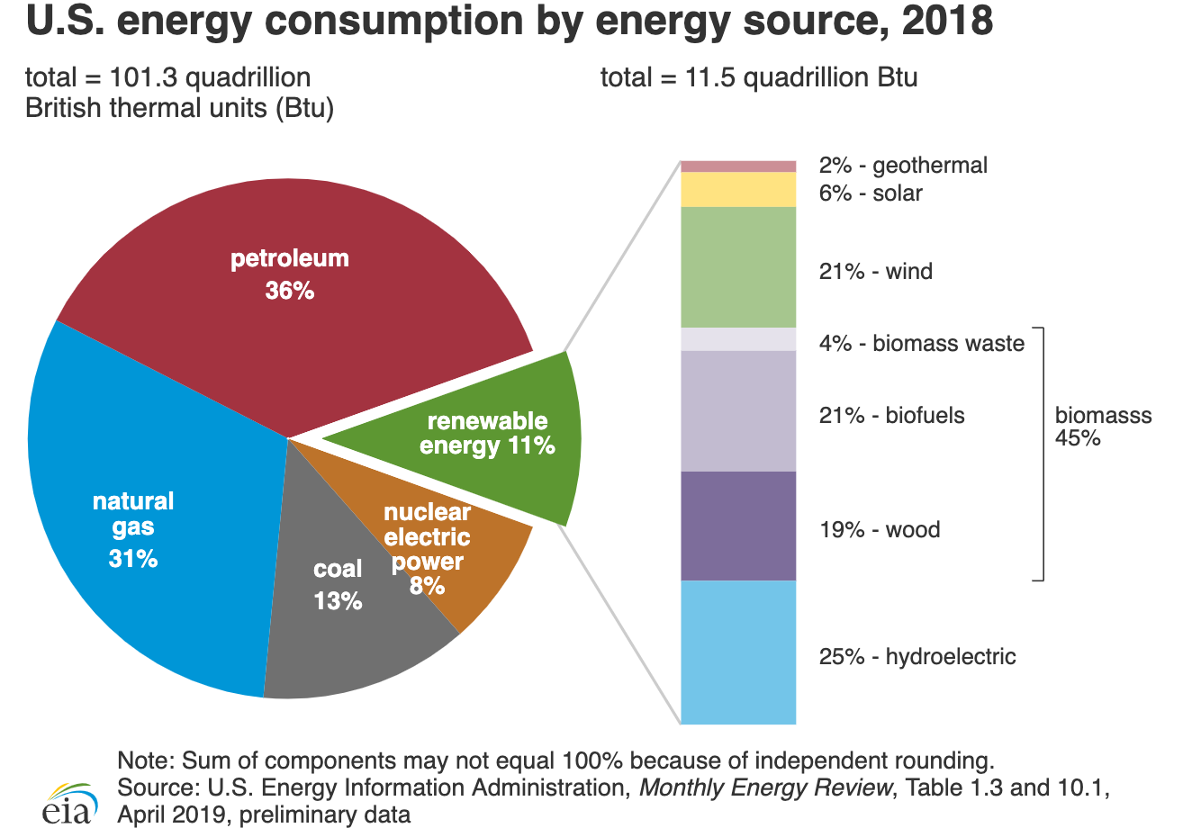
Many renewable energy sources are also better for the environment than burning fossil fuels. They produce less pollution which will help protect the environment and provide us with cleaner air and water.

What role does renewable energy play in the United States?
Until the mid-1800s, wood was the source of nearly all of the nation's energy needs for heating, cooking, and lighting. From the late 1800’s until today, fossil fuels—coal, petroleum, and natural gas—have been the major sources of energy. Hydropower and solid biomass were the most used renewable energy resources until the 1990s. Since then, the shares of U.S. energy consumption from biofuels, solar, and wind energy have increased.
In 2018, renewable energy provided about 11.5 quadrillion British thermal units (Btu)—1 quadrillion is the number 1 followed by 15 zeros—equal to 11% of total U.S. energy consumption. The electric power sector accounted for about 56% of total U.S. renewable energy consumption in 2018, and about 17% of total U.S. electricity generation was from renewable energy sources.
Renewable energy plays an important role in reducing greenhouse gas emissions. Using renewable energy can reduce the use of fossil fuels, which are major sources of U.S. carbon dioxide emissions.
The consumption of biofuels and other non-hydroelectric renewable energy sources in the United States more than doubled from 2000 to 2018, mainly because of state and federal government requirements and incentives to use renewable energy. The U.S. Energy Information Administration projects that U.S. renewable energy consumption will continue to increase through 2050.
Major Types of Renewable Energy
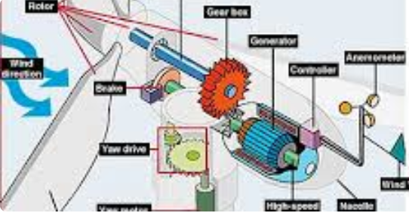

Wind Power - Large wind turbines generate electricity from the power of the wind.

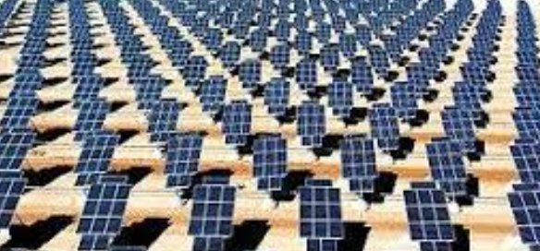

Solar Energy - The rays from the sun can help to heat a building or a pool. They can also be turned into electricity using solar cells.

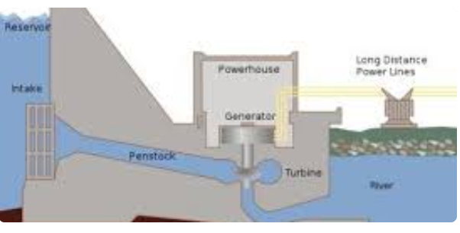

Hydropower - Water from a dam or a river can be used to spin turbines and generate electricity.

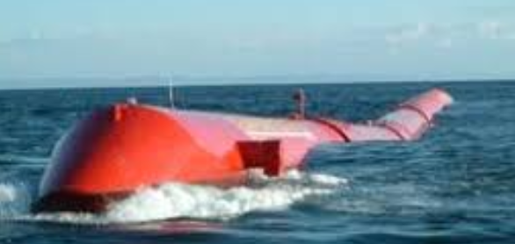

Wave and Tidal Power - This new technology is working on ways to harness the vast power of the ocean's waves and tides.

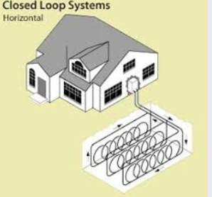
Geothermal Energy - Heat from inside the Earth can be used to heat homes and buildings with heat pumps. Steam from inside the Earth can also be used to generate electricity.

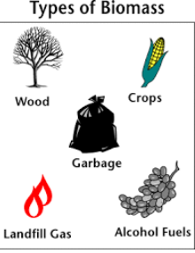

Biomass Energy - Plants gather energy from the sun by photosynthesis. We can harness this energy by burning plants such as trees as well as creating fuel from plants such as ethanol and biodiesel. Even gas from trash and manure can be used to create energy.

Fun Facts About Renewable Energy
- Half of the electricity in the United States is still generated by burning coal. Burning coal is a major source of carbon dioxide gas.
- A single large wind turbine used instead of burning coal can prevent the emission of 5000 tons of carbon dioxide each year.
- In 2008 only around 10% of the world's energy came from renewable sources.
- The United States has around 5 percent of the world's population, but consumes 26 percent of the world's energy.
- Around 28% of the energy used in the United States is for transportation. As of 2010 there were around 9 million cars that were capable of using biofuel.
- If you could harness the energy from all the sunlight that falls on the Earth in one hour, you would have enough energy to supply the world for a year.
- Around 50% of renewable energy is used to produce electricity.
- In some areas you can generate your own renewable energy, like with a solar cell or wind turbine, and then sell it back to the local energy company.

Step 2: Answer the following questions

- Which of the following is an example of a renewable energy source?
  - Gasoline
  - Solar Power
  - Coal

- Which of the following best describes renewable energy?
  - Energy from fossil fuels
  - Energy that is generated by burning up something
  - An energy source that is not used up

- What type of renewable energy comes from building dams on rivers?
  - Wave and tidal power
  - Geothermal energy
  - Hydropower

- What type of renewable energy comes from tapping heat generated inside the Earth?
  - Geothermal energy
  - Solar Power
  - Wind Power

- What type of renewable energy comes from the power of the ocean?
  - Biomass Energy
  - Hydropower
  - Wave and tidal power

- What type of renewable energy comes from burning plants?
  - Geothermal energy
  - Biomass energy
  - Hydropower

- Renewable energy is generally better for the environment as it produces less pollution.
  - TRUE
  - FALSE

Step 3: Draw a picture and respond

Draw a picture of the type of renewable energy you are most interested in learning about.

What questions do you have about this type of renewable energy and/or, what do you want to learn about this type of energy?

____________________________________________________________________________________________________________________________________________________________
____________________________________________________________________________________________________________________________________________________________________________________________________________

Student Feedback:

Circle the emojis that best represents how this activity made you feel. | 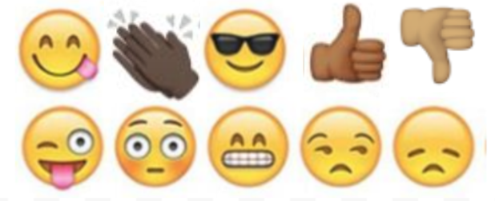  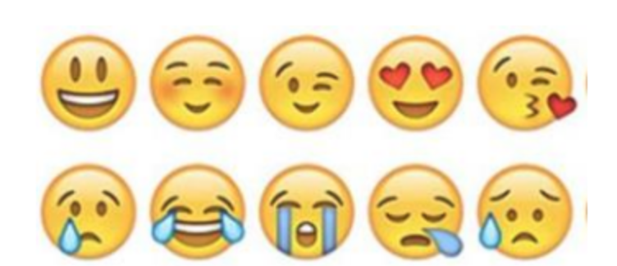

Mindfulness Moment!

Mindfulness Activity:
Fill in the circles the things that make you who you are. You can write words or draw pictures.
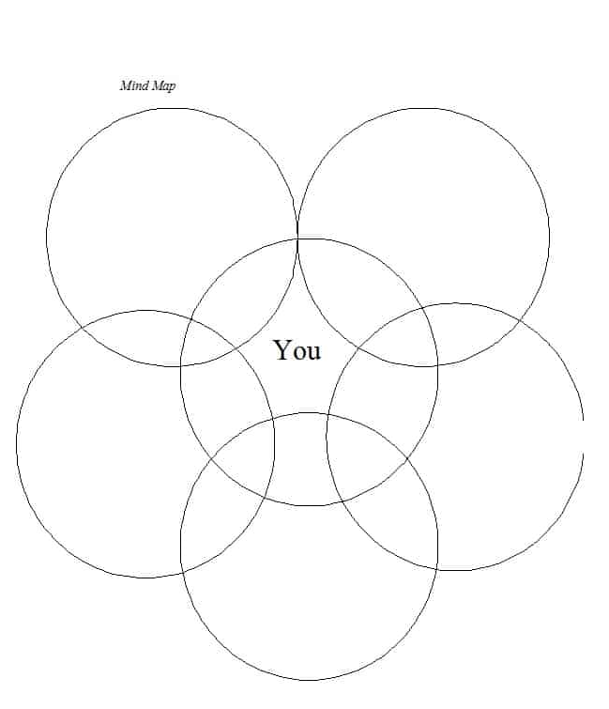

Day 1: Power/Voting and the Electoral College
Math

What is this lesson about?: In this lesson, we will look at voting patterns and practices over the last few presidential elections, and as a part of doing that, assess how each of us, and the collective us, can exert power.

Step 1: Chart of who voted in 2016, by Age Group and % participation, chart of who voted in 2016 by race and participation

% of Population/ | % Who voted for | % Who voted for

 | 2016 | Group | Clinton | Trump
SEX | Men | 48 | 41 | 52
 | Women | 52 | 54 | 41
RACE | White | 70 | 37 | 57
 | African-American | 12 | 89 | 8
 | Hispanic | 11 | 66 | 28
 | Asian | 4 | 65 | 27
 | Other | 3 | 56 | 36
AGE | 18-29 | 19 | 55 | 36
 | 30-44 | 25 | 51 | 41
 | 45-64 | 40 | 44 | 52
 | 65 & over | 16 | 45 | 52
INCOME | <$50,000 | 36 | 53 | 41
 | $50,000-$100,000 | 30 | 46 | 49
 | $100,000 & over | 34 | 47 | 47
Results based on Roper/CNN exit polls.

Refer to the above chart to answer the following questions:
- For men of all races, what % voted for Hillary Clinton?
- What % of African Americans voted for Donald Trump
- What % of voters aged 45 and over voted for Hillary Clinton?
- What % of voters under 30 voted for Hillary Clinton?
- What % of voters who earned less than $50,000 per year voted for Donald Trump?

If you could make 2 or 3 conclusions from the charts, what would they be?

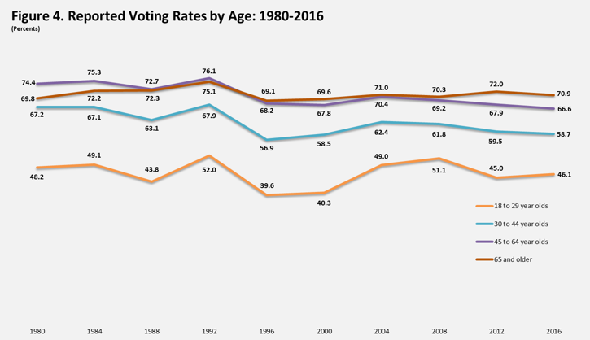
Refer to the above chart to answer the following questions:

- In 2016 about what % of eligible 18-29 year-olds voted?
- In 2016 about what % of eligible 55+ year-olds voted?
- If you compare older voters to younger voters over time, what do you see about their voter participation rates?
- Why, do you think, do so many older voters participate in elections that younger voters?
- What might change this, do you think?

Now, by looking at the two charts combined….what might have happened in the 2016 if 70% of eligible voters under 45 had gone to the polls instead of the % of them that did vote?

Step 2: Understanding how Hillary Clinton won more votes but D. Trump won 2016 election

In the US, we select our Presidents based on the Electoral College system. Each state is allocated a certain number of members to the Electoral College. Each state's number of electors is equal to the combined total of the state's membership in the Senate (100) and House of Representatives (435). Additionally, the District of Columbia (D.C.) is entitled to 3 electors.U.S. territories are not entitled to any electors as they are not states.

So, individuals all go vote for the President and then each state totals up the individual votes for each of the candidates. Based on who wins the individual vote count, the states members of the Electoral College place their votes for the president. Almost all states use an all or nothing system at the Electoral College level. That means if one person receives 52% of the votes and the other candidate receives 48%, the candidate with 53% gets all of the votes in that state’s electoral college votes.
In 2016, Donald Trump was elected President over Hillary Clinton. Donald Trump received 304 votes in the Electoral college and Hillary Clinton received 227. You need 270 to win.

Overall, Clinton got 2.87 million more votes than Trump did in the popular (individual) vote (the largest margin ever for a losing presidential candidate). But Trump won the election.

Trump won six states that President Barack Obama had won in 2012: Florida, Iowa, Michigan, Ohio, Pennsylvania, and Wisconsin.^{[20]} Ultimately, Trump received 304 electoral votes and Clinton 227.

The chart below shows the results of the electoral college votes in 2016. The number in each state shows how many electoral college votes the state gets. States in RED voted for Donald Trump and states in BLUE voted for Hillary Clinton.

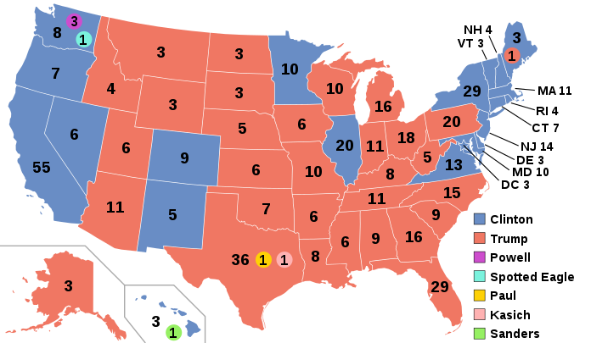

Using the chart above..
- What states with a large number of electoral college voters went for Hillary Clinton?
- What states with a large number of electoral college voters went for Donald Trump.
- What regions of the country primarily voted for Hillary Clinton?
- What regions of the country primarily voted for Donald Trump?
- Identify the state that you are in. Did your state end up selecting Trump or Clinton in 2016?
- Based on this chart and the rules for the Electoral College, can you explain in your own words how someone could win the popular vote, but lose the Presidential Election based on Electoral College Votes?

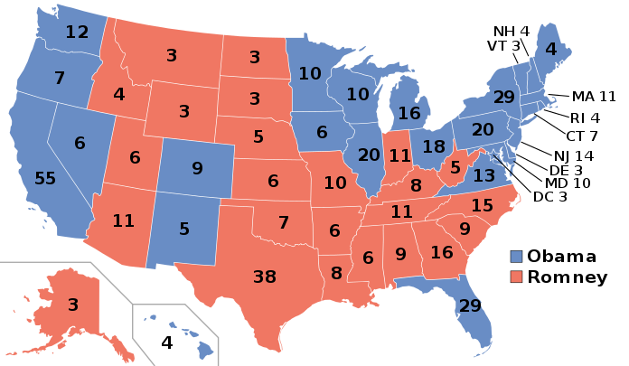
Step 3: Let’s compare who voted for Barack Obama in 2012 vs Hillary Clinton in 2016

In 2012 Barack Obama won the electoral college vote 332 to 206 (Mitt Romney). The map to the right shows the results of the electoral college vote in 2012. Use the two maps to answer the questions below.

- Name 2 or 3 states that Barack Obama won in 2012 that Hillary Clinton didn’t win in 2016.

- How many Electoral College Votes do each of those states have?

- Can you see how winning or losing just a few states can change the outcome of an election?

- Fill in the chart below and see what happens--

Step 4: Looking closely at just Wisconsin and Pennsylvania

The chart below shows how many people voted for D. Trump and H. Clinton in 2016.

Calculate answer

Calculate the difference in Wisconsin and Pennsylvania.
- How many more votes did D. Trump get than H. Clinton in Wisconsin?

- How many more votes did D. Trump get than H. Clinton in Pennsylvania?

- Look at the Map above: How many Electoral College Votes did H. Clinton get in Wisconsin and Pennsylvania combined?

- Look at the Map above: How many Electoral College votes did D.Trump get in Wisconsin and Pennsylvania combined?

What does this chart show about the power of each individual vote?

Student Feedback:

Circle the emojis that best represents how this activity made you feel.

Day 1: Types of Relationships
Health

What is this lesson about?: In today’s lesson, we will learn about healthy, unhealthy, and abusive relationships.

Step 1: Warm-Up: In the relationship below do you feel like one person has more power than the other person?

Who’s got the POWER?
A guy walks his girlfriend to school every morning, meets her for lunch every day, and picks her up to walk her home at the end of each afternoon.

Who has the POWER? Why?

Step 2: Read about the behaviors below.

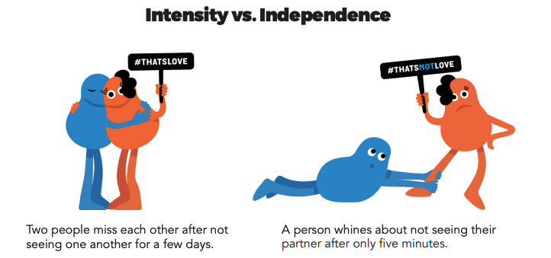

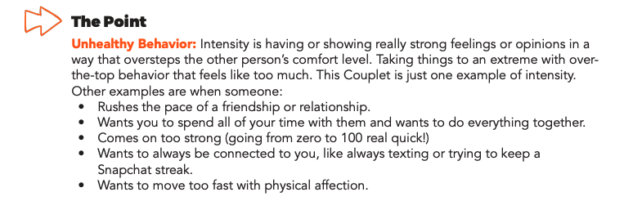
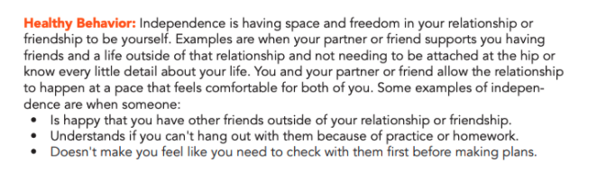

Step 3: Complete the Activity.

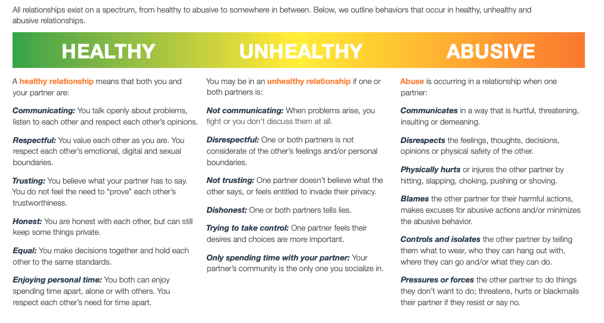
Write three examples of types of relationships you have witnessed below. These do not have to be real-life examples, you can draw from books and movies, too.

Healthy:

Unhealthy:

Abusive:

Mindfulness Moment!

What can I do/say/think/feel right now that will bring me happiness?

Day 1: Governmental Powers: Monarchy v. Oligarchy
Social Studies/Civics

What is this lesson about?: This week you will be exploring different types of government that have existed throughout history. Governments use power and authority to control a country. Sometimes governments can exercise too much power, too little control, or somewhere in between.

Step 1:
Consider the bracket below. Each day this week you will be comparing two types of government. At the end of each day, you will select which type of government, out of the two you compared, you think is better. At the end of the week you will make a determination as to what you think is the best form of government out of the eight below. (for NCAA basketball fans, this is like our Elite 8!)

Types of Government Bracket
Monarchy
Oligarchy
Dictatorship
Theocracy
Direct Democracy
Representative Dem.
Communism
Anarchy

Warm Up: Do you recognize any of these types of government? What do you already know about them?

Step 2: Compare Monarchy and Oligarchy

Monarchy  A monarchy is a type of government having a king or queen. There is only one person in power and that person has total control. Typically a monarch (king or queen) is determined based on family bloodline (a king’s son will become the king once his father dies, for example). When there is a monarch, the law process is much simpler as the laws are made by only one person. Also a monarchy government has less corruption because there aren’t a lot of people involved, which can lead to corruption. A disadvantage is that the people do not have the ability to remove the leader from power and therefore a bad leader can hurt a nation. Also, there are higher chances of rebellion as people cannot change the system. | Oligarchy  In an oligarchy (OH-lih-gar-kee), a small group of people has all the power. Oligarchy is a Greek word that means “rule by a few.” This means that only a certain group has political power, such as members of one political party, one social class, people with military power, or one race. In practice, almost all governments, whatever their form, are run by a small minority of members of society. From this perspective, the major distinction between oligarchy and democracy is that in the latter, elites compete with each other, gaining power by winning public support. Monarchies sometimes function as oligarchies, when there is a powerful and influential group of nobles who advise or even control the ruler.
Step 3: Read about Monarchies in Europe

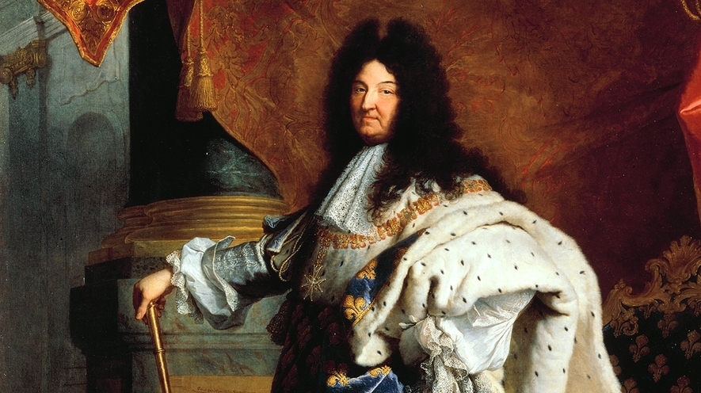
Absolute Monarchs: The Kings and Queens Who Ruled Europe
By ThoughtCo.com, adapted by Newsela staff
Portrait of King Louis XIV of France, 1701
Absolutism is an idea and form of government where total power is held by an individual. Historians have different thoughts about who is an absolute ruler. The word absolute has been used both for leaders like Hitler and Julius Caesar, but this use may not be entirely correct.

The age of absolute monarchies
When talking about European history, Absolutism usually refers to absolute monarchs, like kings or queens. These monarchs ruled during the early modern age, from the 16th to the 18th century. Early modern absolutism is believed to have existed across Europe, but largely in nations such as Spain, Prussia and Austria. Prussia was a powerful kingdom that eventually became the countries of Germany and Poland. Absolutism is considered to have reached its peak under the rule of French King Louis XIV from 1643 to 1715. But there are different views about how it actually worked.
We now generally believe that Europe's absolute monarchs still recognized the laws and authorities lower than them. But these rulers had the ability to ignore the rules if they said it was to benefit the kingdom. This was a way for the government to have more control and collect more money from the territories within the country's borders.
Power had been concentrated in the hands of absolute monarchs through the formation of modern nation states. These modern nation-states had emerged from more medieval forms of government. In those previous governments, nobles, councils and church leaders could sometimes challenge the power of monarchs.
The development of a new style of nation-state had been helped by new tax laws and centralized organization of government. Collecting taxes from everybody in a nation and setting up a central government helped create the idea of a sovereign nation. Sovereign is a word that means something or someone has absolute power. In sovereign nations, the army obeyed the king instead of various nobles. But nobles could benefit too, by having access to jobs, honors and income within the system.
Often there is a confusion between absolutism and despotism. Despotism is a word that describes absolute power used in cruel or oppressive ways. Modern historian John Miller gives a description to better understand the thinkers and kings of the early modern era. Here's Miller's idea: "Absolute monarchies helped to bring a sense of nationhood to disparate(very different) territories, to establish a measure of public order and to promote prosperity."

"Enlightened Absolutism"
Painting of Catherine the Great of Russia.

In the 17th and 18th centuries, there was a movement in Europe known as the Enlightenment. This movement spread new ways of thinking, which were based on ideas of liberty, reason and science.
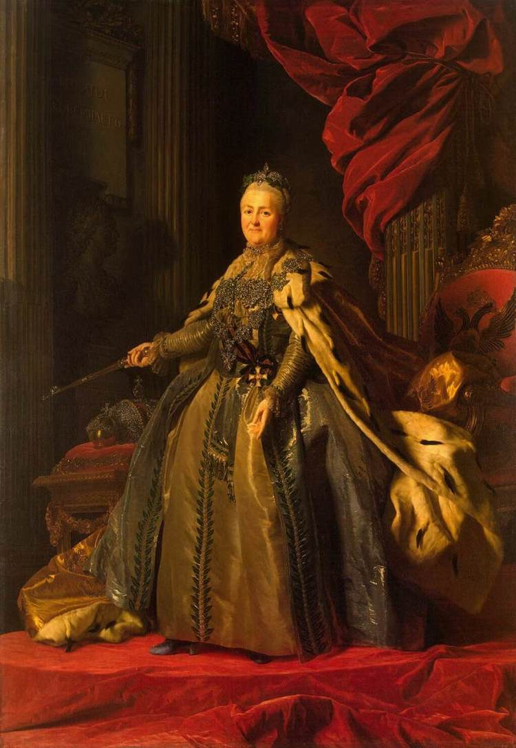
During this period, several absolute monarchs such as Catherine the Great of Russia tried to introduce Enlightenment-inspired reforms while still strictly controlling their nations.
For example, serfdom was abolished or reduced in certain places. Serfdom was a system where peasants lived and worked on a piece of land that they did not own. Serfs had to obey and work for the owner of that land.
Catherine the Great, thought that serfdom was inhuman and wanted to end it. However, she realized that she needed the rich, landowning nobles to help her run Russia. She eventually gave the nobles more control over their land and serfs. This made the lives of serfs even worse.
The Enlightenment-era reforms were meant to establish more equality among subjects, although not with the monarch. The idea was to justify the absolute monarchy with the idea that it would improve people's lives. This style of rule became known as "Enlightened Absolutism."

The end of absolute monarchy
Still, the age of absolute monarchy came to an end in the late 18th and 19th centuries when people began demanding democracy. Many former absolutists had to allow constitutions, which gave people the right to choose their leaders. The absolute kings of France fell the hardest, and one of them was executed during the French Revolution. If Enlightenment thinkers had helped the absolute monarchs, their ideas helped to destroy the rulers that came later.

Step 4: Answer Questions

Would you want to live in a country with a monarch as your ruler? Why or why not?

*share you answer with a partner

Step 5: Read about Oligarchy in South Africa and answer questions

Article One Excerpt (adapted from McGill Encyclopedia)
A modern example of oligarchy can be seen in South Africa during the 20th century. Here, the basic characteristics of oligarchy are particularly easy to observe, since the South African form of oligarchy was based on racism. After the Boer War, an agreement was reached between English- and Afrikaans-speaking whites. Together, they made up about twenty percent of the population, but this small percentage had access to virtually all the educational and trade opportunities, and they proceeded to deny this to the black majority even further than before. Blacks could not vote and had no representation in government. Although this process had been going on since the mid-18th century, after 1948 it became official government policy and became known worldwide as apartheid. After many decades of inequality, other countries began to condemn apartheid. Apartheid ended in 1994 when members of all ethnic classes were allowed to vote in the presidential election. Nelson Mandela became South Africa’s first black president.

What was the ruling group in South Africa during the Apartheid? How did they have all the power?

What group do you think suffered the most under the Apartheid oligarchic government? Why?

How do you think things changed after Nelson Mandela became the first black president of South Africa?

Does the South African Apartheid remind you of any other historical situations? What one(s)?

Step 5: Read about the advantages and disadvantages of oligarchy

The Advantages & Disadvantages of an Oligarchy
By Brian Gabriel
An oligarchy is a society ruled by a small, powerful minority. These are not necessarily the most capable leaders in a society. Oligarchies are not at all similar to democracies, but they are also very different from governments ruled by a single dictator. Oligarchies can have both positive and negative effects on the societies they rule.

Superior Organization
The great Greek philosopher Plato recommended oligarchy, or aristocracy, as the best form of government because it would organize society in the most efficient way possible. He envisioned an ideal society made up of three distinct classes: rulers, soldiers and common people. All of these classes would work together for the common good.
To the extent that a society is actually ruled by its best, and not just its most influential, this theory has some merits. However, there is little practical evidence that even the most worthy minority can organize society.

Incentives For Benevolence
Oligarchs who are given political power to enjoy for their entire lives have a strong incentive (something to motivate them) to rule their subjects well. Without short-term offices and messy democratic elections, oligarchs have no reasons to seek short-term solutions to problems. In democratic societies, politicians spend a lot of time blaming their opponents for bad policies and then proposing equally disastrous policies knowing that they will be comfortably out of office by the time citizens have suffered the consequences. In oligarchies, however, there is no pretense of blame, and the political rulers have incentives to draft good long-term policies to keep the people happy.

Political Exclusion
Oligarchies focus political power into the hands of a small, powerful minority of rulers. Since they control the laws of society, these minorities pass laws for their own interests and exclude the masses from the political process. In the small South American country of Ecuador, for example, an oligarchical government emerged after a coalition of citizens overthrew the president in 1944. As a result, the lower classes in Ecuador were marginalized and systematically excluded from all political processes.

Economic Dominance
Oligarchs who control society compete with one another for control over land, resources and power. The result is that they control all the industries in society and own most or all of the property. The oligarchy in El Salvador during the latter half of the 20th century, for instance, dominated the coffee industry and, therefore, dominated the whole economy because coffee was the most important export crop in the country.

Why did the greek philosopher Plato recommend oligarchy?

What are two advantages of an oligarchy?

What are two disadvantages of an oligarchy?

Step 7: Organize your thoughts

Complete the graphic organizer on the next page to help you compare and contrast monarchy and oligarchy. After completing the graphic organizer, you will reflect on these forms of governments and choose which one you prefer.
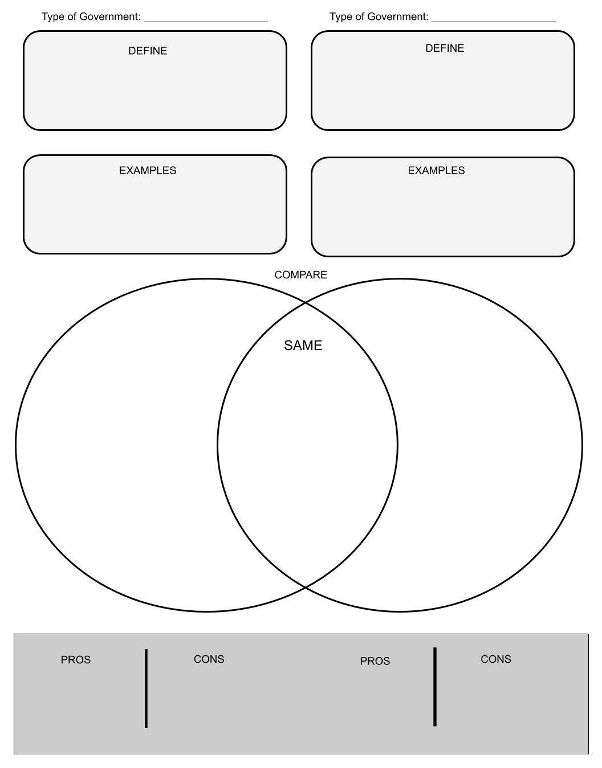

Step 8: Reflect

Complete the bracket below and choose which type of government you prefer:

- Why do you prefer that governmental system? (share three reasons)

- How does it compare to the current governmental system you live in now? (share three reasons)

Step 8: Discuss
- With a partner, share and compare your graphic organizer.
- Can you improve your graphic organizer after discussing with your partner?
- Share what you chose as your winner for this bracket face-off and why.

Student Feedback:

Circle the emojis that best represents how this activity made you feel.

Week 5
Power

Day 2

NAME:______________________

Day 2 Agenda

Topic | Activity
Warm-Up!
English Language Arts | - Read the article, Bird, Plane or SuperMensch? Jews and Superheros Share a Rich History  - Respond to questions about the poem.  - Create their own Superhero
Science | - Read about Solar Power  - Answer questions about what you read  - Draw a picture and explain
Mindfulness Moment!
Math | - Power: Striking and the Power of Holding Out and Holding Strong
Health | - Showing respect: What do you say?
Mindfulness Moment!
Civics/Social Studies | - Consider types of governmental powers  - Theocracy v. Dictatorship

Warm-up Activity: Write a journal entry around the daily quote on identity.
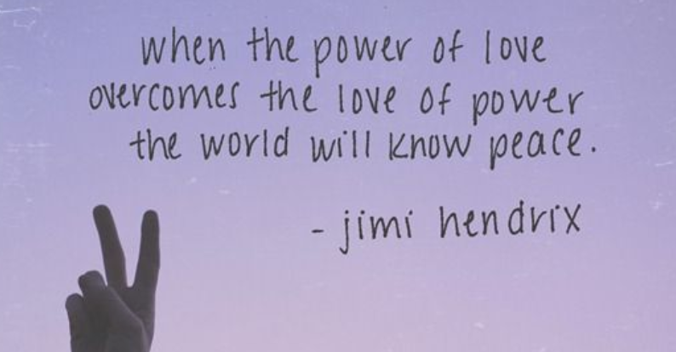

Day 2: Using Superpowers to Fight Injustice
English Language Arts

What is this lesson about?: Today you will continue to explore the theme of power by reading about the creation of superheroes. As you read today, think about how the experiences of the comic book creators affected the Superheroes they created and how they used these characters to protest against injustice and abuse of power.

Step 1: Review Vocabulary

mensch: Yiddish word that means person of integrity and honor. | idealized: represented as perfect or better than reality. | wield: to hold and use or to be able to use
wimp: a weakling or coward | psyche: a human mind, soul or spirit | persecuted: to abuse or punish someone especially because of their race or political or religious beliefs
harmony: agreement and peace | conscious: aware, having knowledge of | herald: to announce
orthodox: traditional or strict about one’s religion | legacy: something of value handed down by an elder | archetype: an original that has been imitated.

Step 2: Read and annotate the transcript from an interview in Wired Magazine.

Bird, Plane or SuperMensch? Jews and Superheroes Share a Rich History
Danny Fingeroth SAN DIEGO – Superman, Batman, Captain American and a slew of other superheroes have something in common besides funny-looking tights. They were all created by Jews, many from Eastern European backgrounds. Jewish comics creators and co-creators include Joe Shuster and Jerry Siegel (Superman); Bob Kane and Bill Finger (Batman); Will Eisner (The Spirit); Jack Kirby (Fantastic Four, Incredible Hulk, the X-Men); Jack Kirby and Joe Simon (Captain America); and of course Stan Lee (who helped create Spider-Man and a whole bunch of others).

This is more than a coincidence, argues Danny Fingeroth, former editorial director of the Spider-Man comic books, in his upcoming book Disguised as Clark Kent: Jews, Comics and the Creation of the Superhero. While he may not go as far as some authors who claim Superman is an incarnation of Moses, he does believe the Jewish heritage of their creators influenced the first generation of superheroes and the worlds in which they lived.

In an interview with Wired News, Fingeroth – author of 2004's well-received Superman on the Couch: What Superheroes Really Tell Us about Ourselves and Our Society – talked about Jews and superheroes prior to this weekend's Comic-Con, the world's largest comics convention.

Wired News: How do you think the lives of Jewish comics creators influenced the fictional worlds they created?

Danny Fingeroth: You had a bunch of young men whose parents were immigrants, writing stories about a very idealized world, where force is wielded wisely and people are judged by their individual character, not by who they are or who their parents were. For the guys who made the comics, it was a way to transcend who you were and become locked into and involved with the American mainstream, to blend in.

Wired News: Do you think Jews worked in comics because they couldn't get jobs elsewhere?

Fingeroth: That was a big part of it. Because of various types of prejudice, things were closed off to Jews in the first half of the 20th century. Maybe it's hard to believe now, but Jews were not accepted in a lot of the publishing or advertising industries. There was a great deal of discrimination. There were no official policies like “No Jews allowed,” but you could interview all you want and still not get work you might have been highly qualified for.

Wired News: Many superheroes, if not all of them, are outsiders in some way in their civilian incarnations. They're orphans, weaklings, ordinary men. Is there a connection here to their creators being Jewish?

Fingeroth: Historically, the racist caricature of the Jew is of someone who somehow is simultaneously weak and yet controls the world, or significant aspects of it. So one could say that the wimpy secret identity was the Jewish creators' ways of saying that we're powerful, in an individual sense, not wimps, and guided, individually and as a group, by the selfless desire to do good. Of course, this is all reading things into the work way after the fact. None of the creators consciously thought about this stuff when they were writing and drawing the stories. It's also a comment on the immigrant desire, Jewish and otherwise, to both be part of the society – be Clark Kent – and also be separate from it as a being of superhuman power. On a larger metaphorical level, it's about the need we all have to feel that we are more than the world thinks we are. "If only they knew my secret, they'd be sorry for the way they treated me!"

Wired News: Do you think the heritage of the creators made them especially interested in secret identities?

Fingeroth: I think they were interested in the part of the psyche that compels us to operate on multiple levels, playing different roles depending on the circumstances.
I don't know if there's anything exclusively Jewish about that, although as a group with a history of being persecuted, doing what you can to achieve harmony with the dominant society could make someone preoccupied with what role they're playing when.
Wired News: Do you think the creators consciously thought of the Jewish influences on their work?

Fingeroth: They were sitting around thinking, “How can I make a living and move out of my parents’ house or help my parents out? How can I survive the Depression as a creative person, when there aren't many options?” They were 18, 19, 20 years old.
Some of them were from really poor families and couldn’t afford to go to college. What were they going to do?
What I also found was that a lot of early comics creators were from families that, when they were kids, had been relatively prosperous and then lost everything in the (stock market) crash of 1929 that heralded the beginning of the Great Depression. They had this weird background of having been fairly secure as kids, and suddenly having nothing at all. It's like Superman having his whole planet blown up, or Bruce Wayne (Batman) having his parents murdered, or Peter Parker (Spider-Man), already an orphan as a baby, having his adoptive father – Uncle Ben – murdered.
Wired News: How did these men look at being Jewish? Did they tend to be very observant?

Fingeroth: No. I think back in the '30s and '40s, if you were Orthodox, you wouldn’t do something like comics. I think it was considered something not serious. (Today), you can see 125,000 people migrate to San Diego to the Comic-Con to pray in the Church of Popular Culture. There's something about being able to take a lot of what would ordinarily be religious impulses (and direct them) into creating fiction. It's like a religious substitute, where nobody ever – well, hardly ever – gets into violent confrontations about if their favorite superhero is somehow better than someone else’s.

Wired News: Did critics – including psychologist Frederic Wertham, who helped launch public and political outrage against comic books in the 1950s – ever pick up on the fact that many comics creators were Jewish?

Fingeroth: Wertham was from a more-well-to do German/Austrian Jewish background, as opposed to the mostly Russian- and Polish-descended Jewish men and women who worked in comics (along with Italian-Americans and people of all sorts of backgrounds). In hindsight, you could see his hostility to comics as his seeing the comics publishers and creators as being the cultural equivalent of junk dealers, an embarrassment to Jewish people.

Wired News: You're Jewish yourself. Are you worried that your book might give ammunition to anti-Semites who like to make claims about Jewish domination?

Fingeroth: My joke is that it's of most interest to Jews and anti-Semites. Most other people don’t give a shit. I think it's one of the best things I've written, but it was one of the hardest to write, too, because of how careful I wanted to be about how I framed things so as not to give ammunition to bigots who might want to twist what I was saying. I ultimately decided that if I was going to write this book, and I did and do think it was important to write, I had to put that fear out of my mind and figure that if someone has a reason to hate Jews, they don’t need to me as an excuse to do it.

WN: What is the legacy of the superheroes these men created?

Fingeroth: Seventy years later, these characters, such as Superman, Batman, and Spider-Man (who was created in the 1960s) are still such powerful archetypes that nothing has come along to replace them. The creations of these mostly Jewish guys now being interpreted by people from all backgrounds because their appeal is universal. The characters and what they symbolize mean a lot to people – although what they symbolize is different for each reader or moviegoer. People find the most lasting superheroes entertaining, of course, but also inspiring.

Taken from: https://www.wired.com/2007/07/jews-comics-qa/. Wired Magazine, 2007.

Step 3 : Answer the Following Questions

- How did the experience of being the children of immigrants influence the creation of superheroes in comic books?

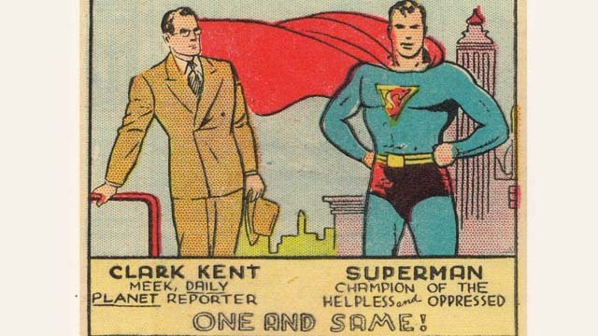
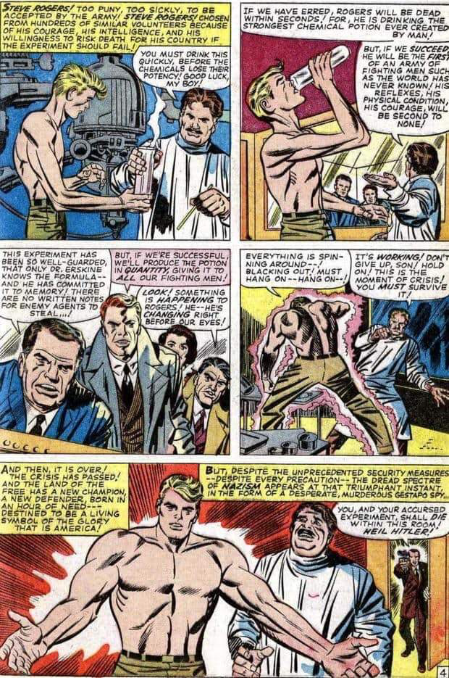

- Look at the images above. These were taken from comic books in the 1940s and show Clark Kent/Superman and Steve Rogers/Captain America. Both superheroes had identities as “wimpy” or meek men who turned into superheroes. How do you think this might connect to how the young Jewish writers felt during World War II?

- Look at the illustrations below that show scenes from comic books in the 1940’s. One shows Superman and the other shows Captain America—each punching or beating Adolf Hitler.
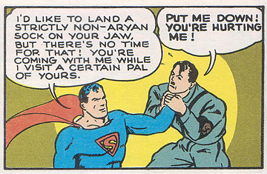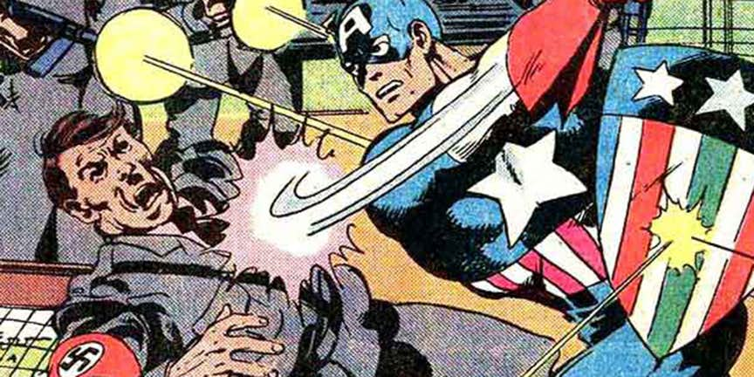
How do you think that these representations were a way that young Jewish writers and illustrators were able to assert some power against the Nazis?

- Fingeroth states that now people from different kinds of backgrounds are interpreting the characters and that the characters are popular because their “appeal is universal”. What theme do most of these comic books illustrate that makes them “universal” and something that everyone can relate to?

- Is there a superhero that you find inspiring? If yes, which one and why? If not, name one that you cannot relate to and explain why.

Step 4: Create your own superhero.
Superheroes come in many forms—From Captain America to Black Panther to Wonder Woman and Valkyrie. Create your own Superhero.
How did your character come to have his/her superpower?

What are your hero’s superpowers?

What is your superhero’s normal life like? What did they experience in the past that influences them now?

Describe what your Superhero looks like (if you don’t want to use words, draw him/her/it out.

What is your Superhero’s Name?

Who or what is your superhero’s arch-nemesis? What does he/she fight against?

Step 5: Share Out

*Share your superhero with a partner. After he/she has shared their superhero, answer the following question. Do you think your superheroes would get along? Could they work together or are they too different? Why?

Step 6: Write
Think of a local, national or world problem that currently exists. Create an archnemesis that embodies (takes on the characteristics) of this problem. How would your superhero battle this problem? How can his/her super-power help him/her try to defeat this problem?

Student Feedback:
Circle the emojis that best represents how this activity made you feel.

Day 2: Solar Power
Science

What is this lesson about?: Today you will read through the Solar Power passages. You will answer a few questions about what you read. You will complete a Solar Power activity.

Step 1: Read through the Solar Power passages

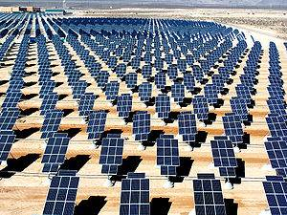
Solar Power
(Technological Solutions)

What is solar power?
The primary source of all energy on planet Earth is from the sun. Solar power is power generated directly from sunlight. Solar power can be used for heat energy or converted into electric energy.

Renewable Energy
When we use solar power, we don't use any of the Earth's resources like coal or oil. This makes solar power a renewable energy source. Solar power is also clean power that doesn't generate a lot of pollution.

Solar Power for Heat
Solar power can be used for heating up homes and other buildings. Sometimes solar power for heating can be passive. This is when there are no mechanical components used to move the heat around. Passive heating helps to keep houses warm in the winter, to heat up swimming pools, and even makes our car warm when we park it outside (which is nice in the winter, but not so much on a hot summer day).

Active heating is when there are mechanical components to help move the heat around. The sun could be used to heat up water or air that is then pumped around a building to provide even heat in all the rooms.

Solar Power for Electricity
When most of us think of solar power, we think of the solar cells that turn rays of sunshine into electricity. Solar cells are also called photovoltaic cells. The word "photovoltaic" comes from the word "photons", which are particles that make up sunlight, as well as the word "volts", which is a measurement of electricity.

Today solar cells are commonly used in small handheld devices like calculators and wrist watches. They are becoming more popular for buildings and homes as they become more efficient. One nice thing about solar cells is that they can be placed on the roof of a building or home, not taking up any extra space.

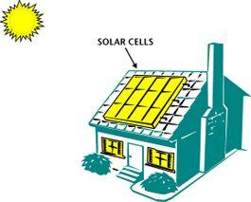
How do solar cells work?
Solar cells convert the energy of photons from the sun into electricity. When the photon hits the top of the cell, electrons will be attracted to the surface of the cell. This causes a voltage to form between the top and the bottom layers of the cell. When an electric circuit is formed across the top and the bottom of the cell, current will flow, powering electrical equipment.

It takes a lot of solar cells to power a building or a home. In this case, a number of solar cells are connected into a large array of cells that can produce more total energy.

History of Solar Power
The photovoltaic cell was invented in 1954 by researchers at Bell Labs. Since then, solar cells have been used on small items such as calculators. They have also been an important power source for spaceships and satellites.

Starting in the 1990s the government has funded research and offered tax incentives to people using clean and renewable power such as solar energy. Scientists have made advances in the efficiency of the solar cell. Today solar cells are around 5 to 15% efficient, meaning a lot of the energy of the sunlight is wasted. They hope to achieve 30% or better in the future. This will make solar energy a much more economical and viable energy alternative.

Are there any drawbacks to solar power?
Solar power has two major drawbacks. One drawback is that the amount of sunshine in a specific place changes due to the time of day, the weather, and the time of the year. The other drawback is that with current technology it takes a lot of expensive photovoltaic cells to produce a decent amount of electricity.

Fun Facts about Solar Power
- The world's largest solar thermal plants are located in the state of California.
- Many large photovoltaic plants are being built around the world. Some of the largest are located in China, Canada, and the United States (Nevada).
- If only 4% of the world's deserts were covered in photovoltaic cells, they could supply all of the world's electricity.
- Many people think that as solar panels become more efficient and less expensive they will become a standard feature of new homes and buildings.
- In 1990 a solar powered aircraft flew across the United States using no fuel.
- Albert Einstein won a Nobel Prize in 1921 for his research into photovoltaic power.
Solar energy is the technology used to harness the sun's energy and make it useable. As of 2011, the technology produced less than one tenth of one percent of global energy demand.

Many are familiar with so-called photovoltaic cells, or solar panels, found on things like spacecraft, rooftops, and handheld calculators. The cells are made of semiconductor materials like those found in computer chips. When sunlight hits the cells, it knocks electrons loose from their atoms. As the electrons flow through the cell, they generate electricity.
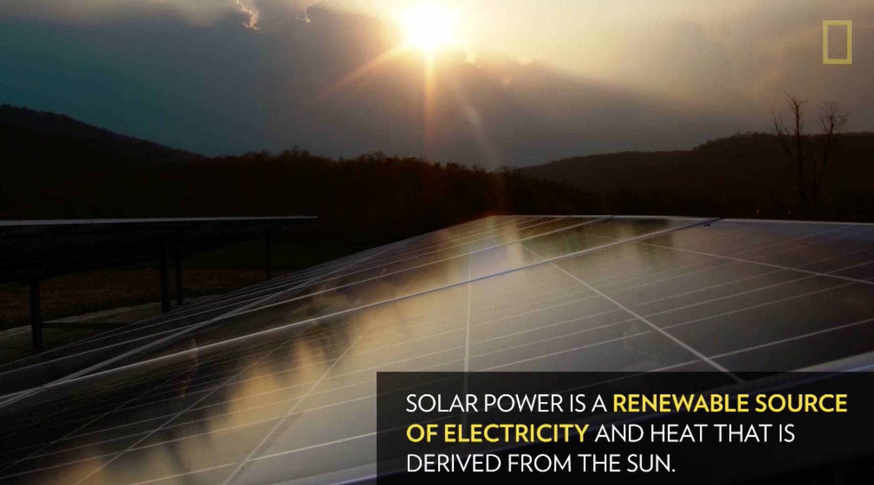
On a much larger scale, solar-thermal power plants employ various techniques to concentrate the sun's energy as a heat source. The heat is then used to boil water to drive a steam turbine that generates electricity in much the same fashion as coal and nuclear power plants, supplying electricity for thousands of people.

How to Harness Solar Power
In one technique, long troughs of U-shaped mirrors focus sunlight on a pipe of oil that runs through the middle. The hot oil then boils water for electricity generation. Another technique uses moveable mirrors to focus the sun's rays on a collector tower, where a receiver sits. Molten salt flowing through the receiver is heated to run a generator.

Other solar technologies are passive. For example, big windows placed on the sunny side of a building allow sunlight to heat-absorbent materials on the floor and walls. These surfaces then release the heat at night to keep the building warm. Similarly, absorbent plates on a roof can heat liquid in tubes that supply a house with hot water.

Solar energy is lauded as an inexhaustible fuel source that is pollution- and often noise-free. The technology is also versatile. For example, solar cells generate energy for far-out places like satellites in Earth orbit and cabins deep in the Rocky Mountains as easily as they can power downtown buildings and futuristic cars.

Pitfalls
Solar energy doesn't work at night without a storage device such as a battery, and cloudy weather can make the technology unreliable during the day. Solar technologies are also very expensive and require a lot of land area to collect the sun's energy at rates useful to lots of people.

Despite the drawbacks, solar energy use has surged at about 20 percent a year over the past 15 years, thanks to rapidly falling prices and gains in efficiency. Japan, Germany, and the United States are major markets for solar cells. With tax incentives, and efficient coordination with energy companies, solar electricity can often pay for itself in five to ten years.

Step 2: Answer the following questions

- Where does solar power get its energy from?
  - The internal heat of the Earth
  - From the burning of fossil fuels like coal
  - The rays of the Sun

- What kind of solar heating uses no mechanical components to move the heat around?
  - Active
  - Passive
  - Electric

- Which of the following is another name for solar cells?
  - Voltage cells
  - Active cells
  - Photovoltaic cells

- What particles from the sun help to generate power from solar cells?
  - Photons
  - Protons
  - Electrons

- Where are the world's largest solar thermal plants located?
  - China
  - Texas
  - California

- What should help make solar energy a viable energy source in the future?
  - Longer days
  - Improved efficiency of solar panels
  - More energy output from the Sun

- Solar power is considered a renewable energy source.
  - TRUE
  - FALSE

Step 3: Draw an image/picture

Draw a picture of how you would use solar power in your community. Describe your picture.

Student Feedback:

Circle the emojis that best represents how this activity made you feel.

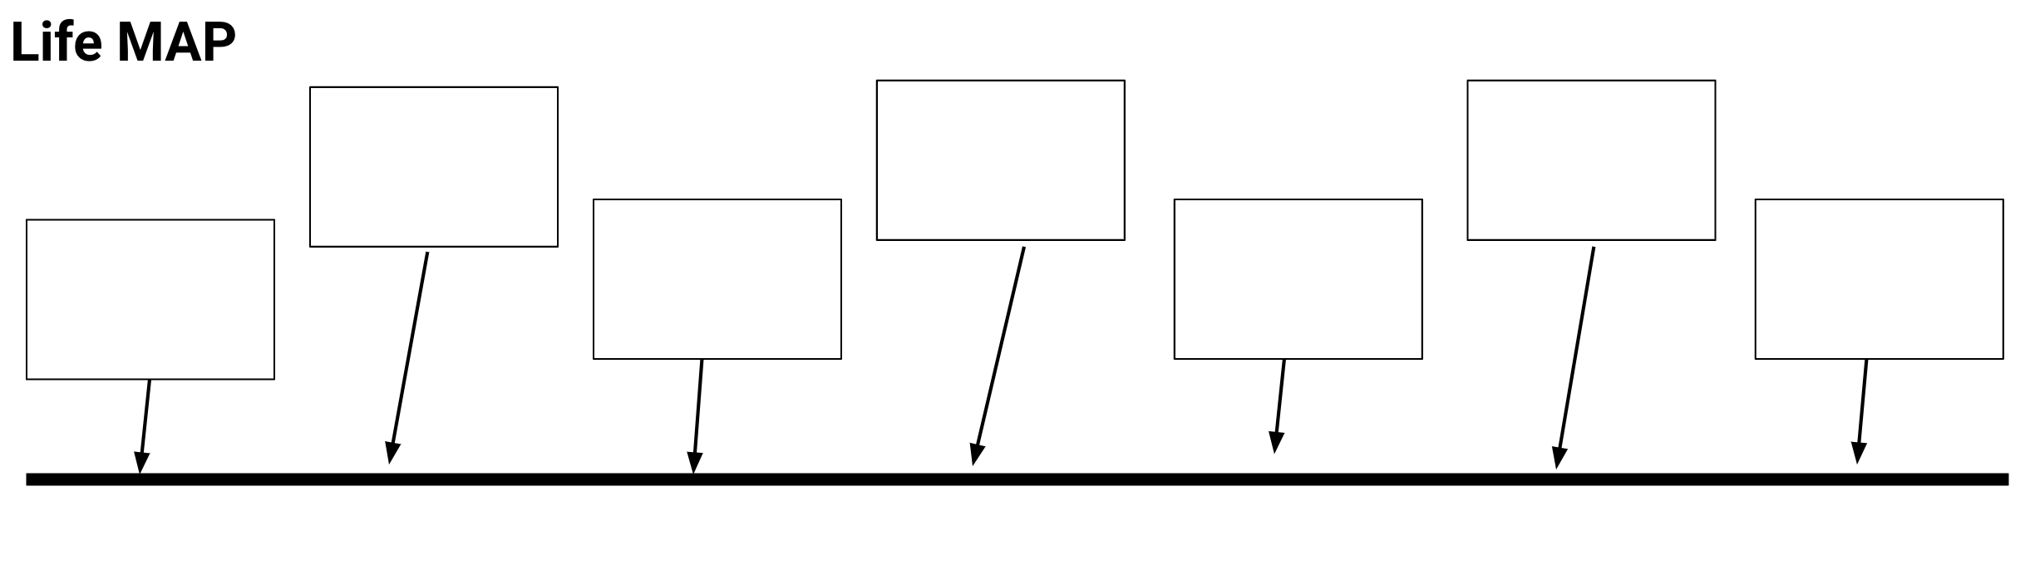
Mindfulness Moment!

Directions: Fill in the boxes on the timeline to build your life map. You may include pictures, videos, audio to make your timeline interactive.

Day 2: Power/Strikes
Health

What is this lesson about?: In this lesson we are going to look at some of the major strikes that have enabled groups of individuals to pull together in powerful ways.

Activity 1: United Farm Workers Strike and Wages, Background

In the late 1960s, the average wage for a farmworker -- someone working the fields harvesting grapes or strawberries -- was $1.20 per hour. Almost none had any sort of health insurance; most were ‘forced’ to work 10 hour shifts during the peak seasons.

Over the course of a few years, the United Farm Workers, led by Cesar Chavez, held a number of strikes. One of their most successful campaigns focused on getting lots and lots of Americans to join their cause--not by striking (refusing to work), but by refusing to buy (boycotting) certain fruits.

In fact, in 1973, more than 17 million Americans joined their cause and stopped buying grapes. Over the years, the wages and benefits of farm workers have continued to be well below that of other occupations, but the major breakthrough that happened in the late 1960s and early 1970s, were critical and paved the way for the average farmworker in California to now be earning between $12 and $15 per hour.

Use the charts below to answer the questions about the impact of the United Farm Workers Strikes.
 | Pre-Strike | Post-Strike
Grape Picker
Hourly Wage | $1.10 | $1.40
Add-on per bucket | $0.10 | $0.43

Assume the average farmworker picked 4 buckets of grapes per hour and worked 9 hours a day.

Daily, weekly, yearly earnings-
- In one day how much would he earn in one day (9 hours) pre-strike?
Hint: calculate how much he would earn through the add-on per hour, then use his hourly wage plus his hourly add-on to calculate how much he would earn over 9 hours.

- In one day how much would he earn in one day (9 hours) post-strike?

- In one week (5 days) how much would he earn pre-strike?

- In one week (5 days) how much would he earn post-strike?

- In one year (52 weeks) how much would he earn pre-strike?

- In one year (52 weeks) how much would he earn post-strike?

Another way of looking at wages is to compare how one job pays compared to another one. Before the strikes, farm workers earned about 45% of what a person working in a manufacturing job earned (like a welder or someone or making aluminum products). The chart below shows how the wages of the farm works change compared to manufacturing jobs over a 12 year span.
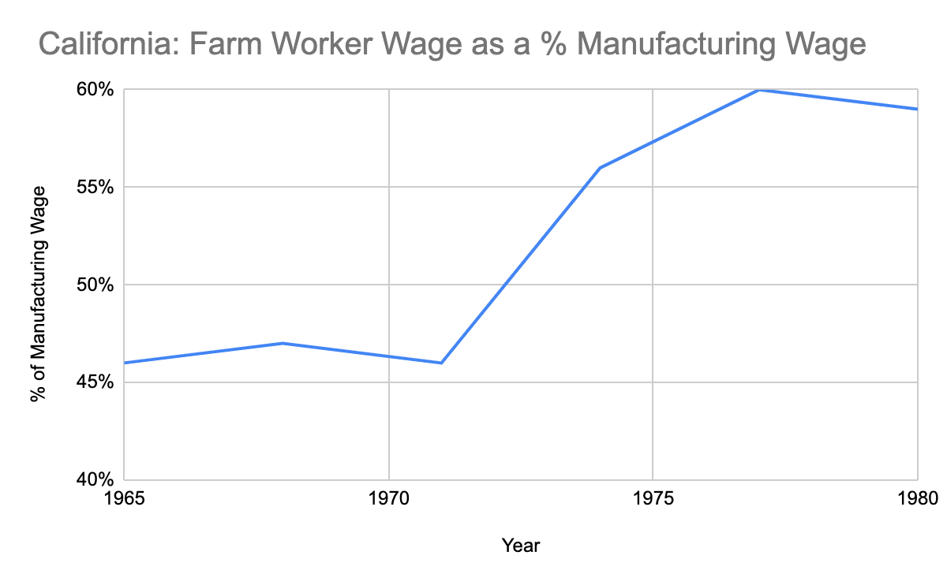
Based on this chart:
- For every $100 that a welder earned how much did a farm worker earn…
  - In 1965? ______ In 1971? ______

  - In 1974? ______ In 1977? ______

- Even with these improvements, why do you think that a welder or someone who works in an automobile factory would earn more than someone who works a farmworker?

For the first years of the attempted strikes, every time the farmworkers would try to strike and to demand higher wages, the companies that owned the big farms would bring in other workers to work for them as substitutes. This was hard for the farm workers to stop because lots of people in California were desperate for work, especially many recent immigrants.

- Why was it hard for the farmworkers to convince the substitutes to NOT take the jobs, do you think?

- How do you think the farm workers union was able, over time, to convince the substitutes to not take the work at lower wages?

Activity 2: United Farm Workers Strike, the Boycott

This chart shows the demand for grapes across the US from 1965 to 1977.

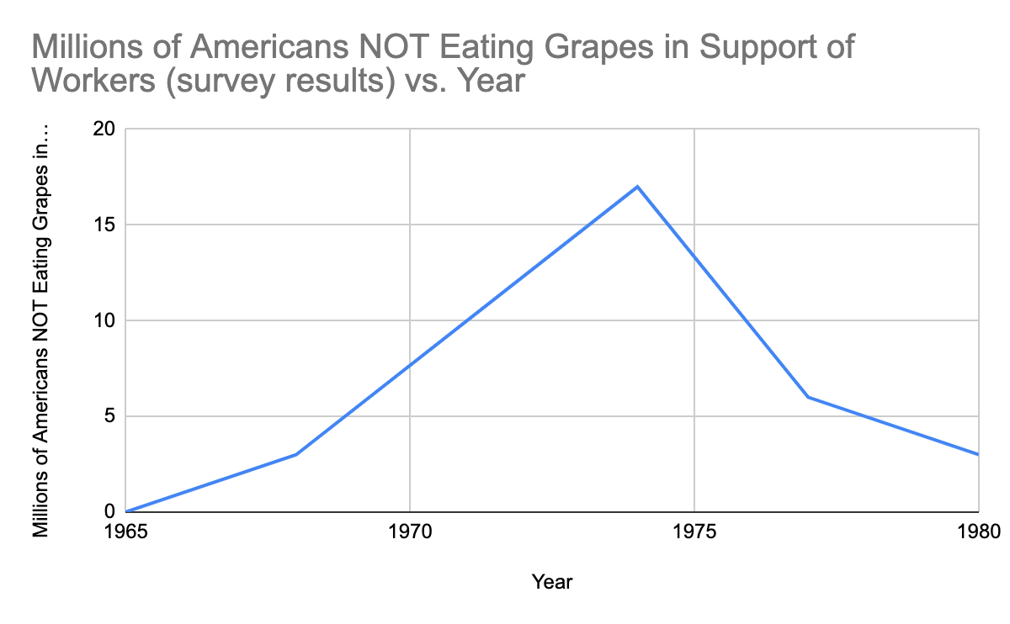
- How many Americans reported that they were NOT eating grapes in 1965?
- How about by 1970?

- In about what year did the number of consumers boycotting grapes reach its peak?

- In 1973 it is estimated that nearly one in three US homes was not eating grapes….

- What did this boycott do to the demand for grapes?

- How did this impact the profit of the farm owners?

- Ultimately, how did this boycott help the striking farm workers?

Activity 3: Montgomery Bus Boycott and impact on the local economy, etc.

Many of you are familiar with the Montgomery Bus Boycott. The boycott took place from December 5, 1955 and lasted for just over a year, until December 20, 1956. Rosa Parks is famous for starting to build support for the boycott, which was aimed at ending the city’s policy of forcing African Americans to sit in a separate section in the back of the city’s public busses. The Montgomery Bus Boycott is considered one of the seminal events of the Civil Rights movement, with the US Supreme Court upholding a ruling that the City’s ordinance violated the 14th Amendment of the US Constitution.

What may be less familiar is some of the math of the Boycott. The chart below provides a slightly simplified analysis of bus ridership in Montgomery in 1955 and 1956. Nearly 40,000 African Americans took the bus daily prior to the strike; approximately 13,000 whites took the bus daily.

Montgomery Bus Boycott
Average total ridership on Montgomery, AL Buses, November 1955
Black | 40,000
White | 13,000
Total | 53,000
Average total ridership on Montgomery, AL Buses, November 1956
Black | 0
White | 13,000
Total | 13,000

It cost $.075 (7.5 cents) to ride the bus.
- About how much money did this City take in each day in November 1955?
- About how much money did the City take in each day in November 1956?
- So, how much was the strike costing the City each day?

Activity 3: Montgomery Bus Boycott, Keeping it Going!
African Americans organized carpools and all sorts of other ways to help each other get to work during the year-long strike. But nearly 20,000 of the daily ridership ended up walking to work each day. The average person who walked to work covered over 3 miles each way, for over a year.

Assuming that 20,000 people walked 3 miles to work and 3 miles home from work each day…
- How many miles did they all walk together each day?
- Over the course of 5 days how many miles did each person walk, on average?
- If each person did that for 52 weeks (1 year), how many miles on average did each person walk during the strike?

Discuss/Consider: Based on this information:
- What are some essential elements to using a strike to exercise power and create change?
- How much power did each person who decided to not take the bus each day have?
- How much power did the group of people have once they committed to sticking together?
Student Feedback:
Circle the emojis that best represents how this activity made you feel.

Day 2: What do you say? Showing respect
Health

What is this lesson about?: In today’s lesson, we will look at put downs and respect in our work relationships.

Step 1: Warm-Up In the relationship below do you feel like one person has more power than the other person?

Who’s got the POWER?
A boy notices his girlfriend is getting a lot of attention from two different people at school. He goes up to each of them separately and warns them to stay away from her, “or else.”

Who has the POWER? Why?

Step 2: Read about the behaviors below.
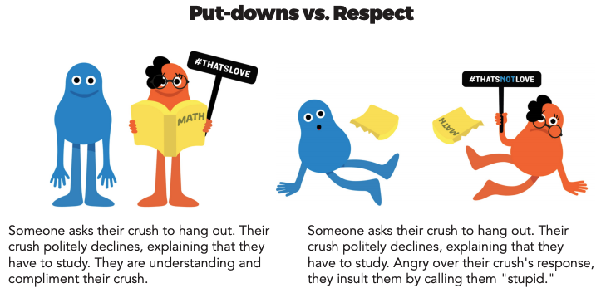
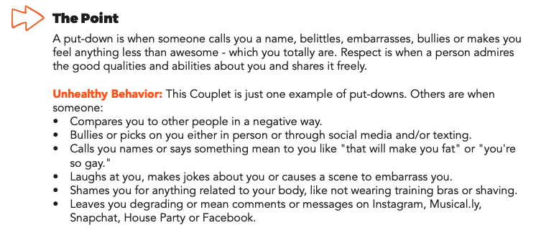
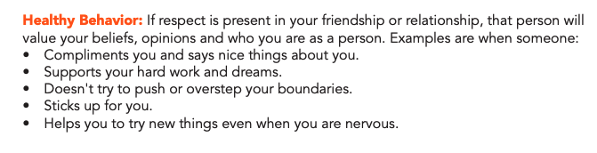
Step 3: Complete the Activity.

Read the following Facebook post and comments. Respond to the questions.
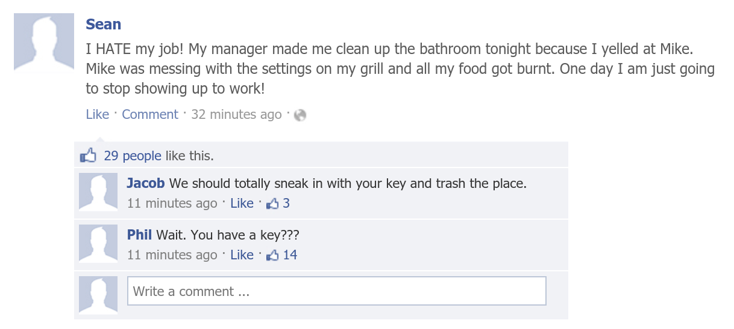

- What should Sean do?

- What impact will that have on Sean’s relationship with his boss?

- Was Sean’s reaction to Mike Healthy, Unhealthy, or Abusive?

- How could Sean have handled his reaction to Mike differently?

Student Feedback:
Circle the emojis that best represents how this activity made you feel.

Mindfulness Moment!

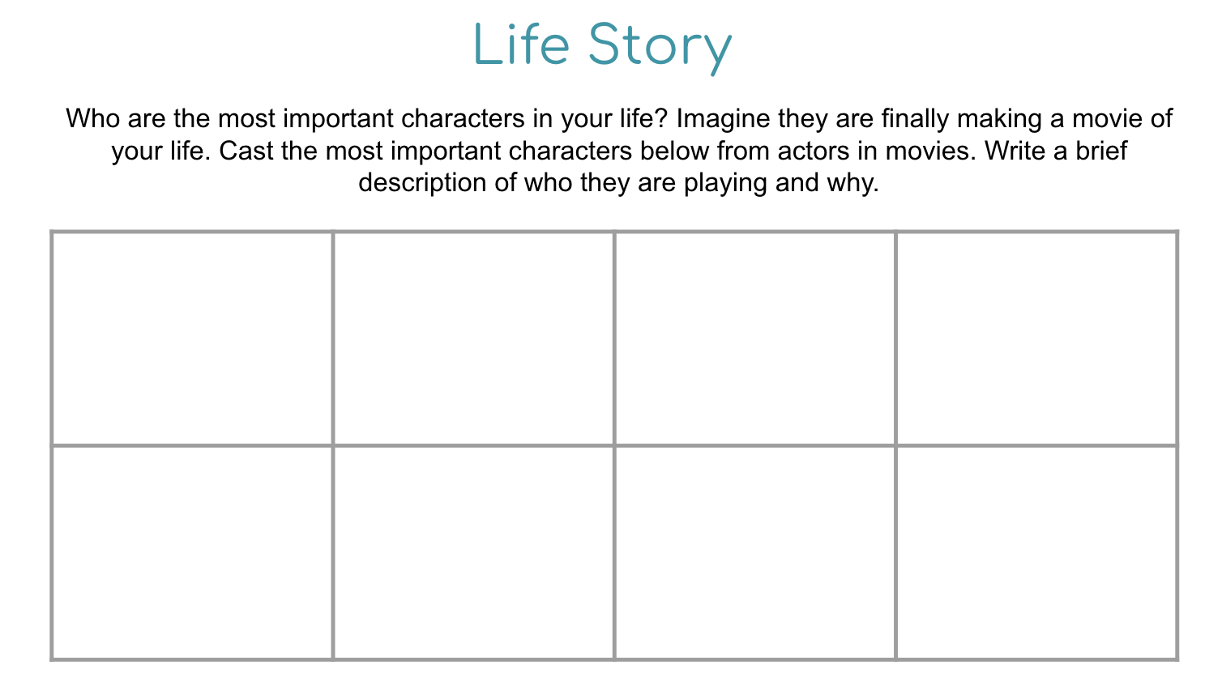

Day 2: Governmental Powers: Dictatorship v. Theocracy
Social Studies/Civics

What is this lesson about?: Today you will continue exploring different types of government, and will focus on dictatorships and oligarchies. Below is a reminder of our Elite 8 bracket. Fill in who won the face-off in yesterday’s lesson below.

Types of Government Bracket
Monarchy
Oligarchy
Dictatorship
Theocracy
Direct Democracy
Representative Dem.
Communism
Anarchy

Step 1: Compare Dictatorship and Oligarchy

Dictatorship  A dictatorship is a form of government where one leader has absolute control over citizens’ lives. Typically the dictator has obtained control by force. If there is a constitution, the dictator has control over that, too—so it doesn’t matter much. Although other parts of the government may exist, such as courts or a lawmaking body, these branches always do what the dictator wants them to do. They do not represent citizens. The advantages to a dictatorship include speed of making decisions as there is onlu one person to make the decision. Also, during emergencies, it is easier for a single ruler to make decisions. On the other hand, the dictator has absolute power to make any and all rules. Opinions of the citizens barely matter, which means rules and laws are not likely to be fair and rights of citizens aren't valued as much. | Theocracy  When someone who has a religious authority rules a government or a country it is called a Theocracy. Often, the ruling person is viewed to be a god or to have authority given by God. In a theocracy the leader has governmental as well as religious power. Since there are only a few people who make all the laws and rules, the process of the system is faster. Also, not many people are involved in the jurisdiction, which reduces the corruption rate in the government system. However, as authority is in the hands of religious groups, laws are based on religious beliefs and this may not be fair if people practice different religions in the country. Also, there are a small number of people in power, hence individual vote does not count and there is no political freedom.

Step 2: Read about Dictatorship in Chile

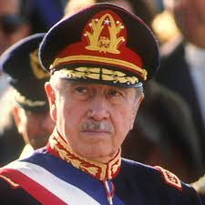
World politics explainer: Pinochet’s Chile
(Excerpt) By Peter Read, The Conversation, adapted by Newsela staff
General Augusto Pinochet Ugarte (1915–2006) was a Chilean military officer. In August 1973, Chile's president, Salvador Allende, made him commander in chief of the Chilean army. Eighteen days later, Pinochet turned on Allende's socialist government. With the help of the American CIA, he and troops loyal to him removed Allende from office. Pinochet then set up a military dictatorship.
Pinochet's rule was not the first, last or worst dictatorship in the history of Latin America. However, it did grip the attention of western countries. This was because before Pinochet's rule, Chile was the first freely elected Marxist government in the west. Marxism is the name for a set of political and economic ideas created by Karl Max. In Marxism, there are no classes. The government controls all the resources, and distributes them to people. This is supposed to ensure equality.
On hearing the news of the coup, Allende returned quickly to the capital city of Santiago. He gave one last remarkable radio address. Then, he shot himself rather than becoming a prisoner.
Pinochet named himself president of the military junta, or dictatorship, that followed.
Pinochet at first claimed that he would rule only for a year. However, he continued to rule up until 1988. At that point, he held a national vote, which he and his followers were sure he would win. Unexpectedly, however, 55 percent of the country voted against him.

Criminal Charges In Britain And Chile
Pinochet stepped down soon after, in 1990. In 1998, he was arrested in Britain to answer charges of torturing Spanish citizens in Chile during his rule. He was held in Britain for 18 months. Then, he was allowed to return to Chile to answer further charges.
Pinochet returned to face 59 criminal complaints for kidnapping, murder and torture. Those charges were never pursued, however. The Chilean Supreme Court ruled that Pinochet was too sick to stand trial. Pinochet died in 2006.
By then, even many of his supporters had turned against him. Their minds had been changed by the findings of two national commissions. These findings detailed the many crimes that had happened under Pinochet's dictatorship. They revealed that many innocent people had been arrested and jailed. Many of them were tortured, put to death or simply disappeared.

National Commission Reports Accused Pinochet Of Many Crimes
After taking power, Pinochet at first only attacked the most extreme communist groups, such as the Armed Revolutionary Movement (El MIR). Later, however, his attacks broadened. No member of any left-wing party was safe.
Many Chileans had supported Pinochet's attempt to rid the country of communism. They excused the arrests and executions as necessary evils. Yet, even some of these faithful supporters changed their minds after the national commission reports were released. The reports showed that Pinochet might have misused government money to make himself rich.
Despite all the charges leveled against him, Pinochet admitted nothing. Instead, he blamed others for the terrible crimes he himself had authorized. In particular, he heaped blame on Manuel Contreras, his much-hated head of the secret police.

Remembered for Sensational Arrest
During his years in power, Pinochet pushed through various economic reforms. Pinochet did have some major success in improving Chile's economic condition. Today, some still consider these improvements to be a Chilean miracle. However, for most people the good Pinochet may have done is far outweighed by his many terrible crimes.
Internationally, Pinochet is now remembered not so much for what he did while in power. Rather, he is most recalled for his sensational arrest in the U.K. What happened to him might make every retired dictator think twice before traveling abroad.
Step 3: Answer questions

How did Pinochet gain power in Chile?

What are two things that his dictatorship is remembered by? (pull your answers from the text)

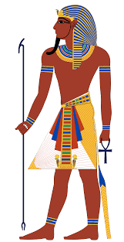
Step 4: Read about Theocracy in Ancient Egypt

Ancient Egypt
One of the most well-known theocratic governments was that of Ancient Egypt. Though it is divided into different periods, the theocracy of Egypt lasted for about 3,000 years. In Egypt, pharaohs were seen as divine connections to the gods. They were actually thought of as being descendents (family) of the god Ra (the sun god). The people believed the pharaoh protected them during hard times.While the pharaoh was the top representative, he or she was also guided by advisors and high priests in carrying out the gods' wishes for temples, laws and defense of Egypt.

The pharaoh had total power. He could use all the land in Egypt any way he wanted. His orders were obeyed without question. Pharaohs appointed officials called bureaucrats. They were in charge of irrigation canals and crop planting. They made sure grain was saved to help people get through hard times. Bureaucrats also controlled trade and collected tax payments from farmers.
As a religious leader, a pharaoh participated in ceremonies that helped the kingdom. For example, he was the first to cut the grain at harvest time.

Step 5: To truly understand theocratic governments, look at a couple more historical examples.

Historical Theocracy Examples
Separation of church and state isn't a new idea, but it is more prevalent than it once was. Early civilizations often had a king that was guided by a god or gods. A few examples of countries ruled by theocracy include Ancient Egypt, Tibet and China.
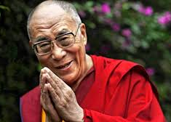

Tibet

Prior to 1959, the Tibetan government was headed by the Dalai Lama. This Buddhist leader is considered to be a reincarnation (the rebirth of a soul in a new body) of the previous Dalai Lama. He is seen as a ruling god. There have only been 14 Dalai Lamas throughout history. The reincarnation of the Dalai Lama is chosen by the High Lamas through a dream, smoke or holy lake.

China

There were several Chinese dynasties that practiced a theocratic government, including the Shang and Zhou Dynasties. During the Shang Dynasty, the priest king was thought to communicate and interpret the wishes of the gods and ancestors. The Shang Dynasty was overthrown by the Zhou Dynasty, which used the Mandate of Heaven as a way to overthrow the government. This mandate stated that the current ruler was chosen by a divine force.
Step 6: Answer questions

Based on the reading, do you think the Pharaohs of Egypt were liked or disliked by the people? Why?

What gives a theocratic ruler, like the Pharaoh power? Why do people obey theocratic leaders?

Step 7: Organize your thoughts
Complete the graphic organizer on the next page to help you compare and contrast dictatorship and theocracy. After completing the graphic organizer, you will reflect on these forms of governments and choose which one you prefer.

Step 8: Reflect

Complete the bracket below and choose which type of government you prefer:
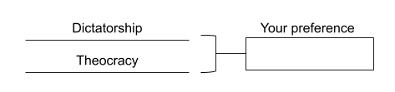

- Why do you prefer that governmental system? (share three reasons)

- How does it compare to the current governmental system you live in now? (share three reasons)

Step 9: Discuss
- With a partner, share and compare your graphic organizer.
- Can you improve your graphic organizer after discussing with your partner?
- Share what you chose as your winner for this bracket face-off and why.

Student Feedback:

Circle the emojis that best represents how this activity made you feel.

Week 5
Power

Day 3

NAME:______________________

Day 3 Agenda

Topic | Activity
Warm-Up!
English Language Arts | - Read the article, They Dance Alone  - Respond to questions about the text.  - Read and analyze the lyrics to the song, They Dance Alone and write a response piece.
Science | - Read about Wind Power  - Answer questions about what you read  - Draw a picture and explain
Mindfulness Moment!
Math | - Power: Marching and and Power of Solidarity Movements
Health | - How are privacy and power related?
Mindfulness Moment!
Civics/Social Studies | - Consider types of governmental powers  - Direct democracy v. Representative democracy

Warm-up Activity: Write a journal entry around the daily quote on identity.
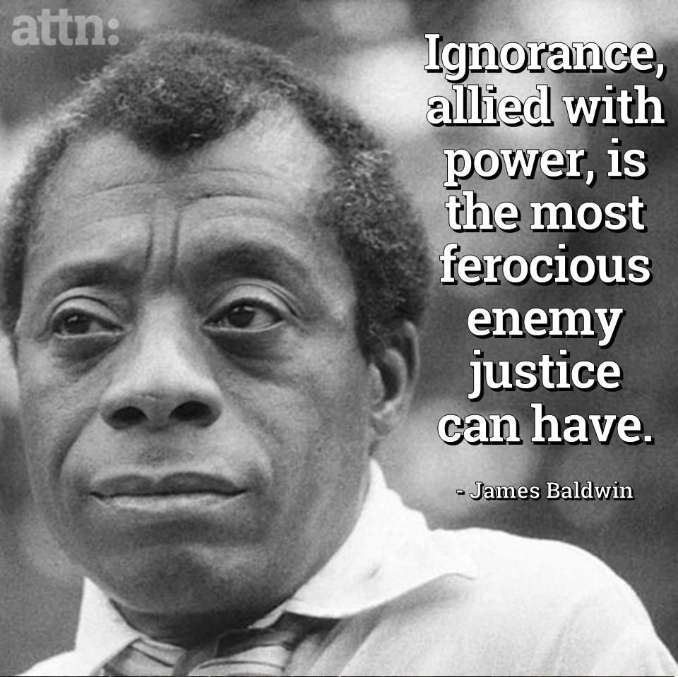

Day 3: Fighting power in disguise
English Language Arts

What is this lesson about? Today you will be reading about a group of women who fought against abuse of power in their country. They protested in a way that was considered “quiet” but yet were able to make themselves heard throughout the world.

Step 1: Before reading

expropriate: to (especially the government) take away from its owner | permeate: to spread out or disperse | ire: anger, annoyance
poignantly: causing a feeling of sadness or regret | atrocity: a cruel act | ghastly: causing great horror or fear

Step 2: Read the article from The International News by Haris Ahmed.
Background: General Augusto Pinochet, who ruled Chile as a dictator for 17 years, led the military coup that overthrew Chile's elected socialist president, Salvador Allende, in 1973. He was ruthless in eliminating his political opponents in Chile, and ultimately was held responsible for the torture and deaths of thousands of people. The article below tells the story of La Cueca, considered the national dance of Chile, and how it was used to protest Pinochet’s power. It was also one way in which women, who seemed powerless, were able to protest and gain world-wide attention for what was happening in Chile.

They Dance Alone
Haris Ahmed, May 10, 2018
La Cueca has been around in Chile for generations. Rooted deep in the country’s working-class culture, the dance is believed to have European Spanish, African and indigenous roots. It arrived in Chile in the 19th century, becoming popular in its working class and rural taverns in the early 20th century.
La Cueca is all about romantic conquest. It imitates the mating ritual of a rooster and a hen, and hence, requires a male and a female participant. The use of a handkerchief is vital too, as partners raise it above their heads or behind their backs as they stomp their feet and circle one another. It is important that the dancers maintain strong eye contact throughout the different steps and movements. The dance ends with the man on his knees, having symbolically been able to woo his woman. The dance is a celebration of love.
After the CIA-backed push against Salvador Allende’s socialist government in 1973, the cueca came under the shadow of Augusto Pinochet’s tyrannical regime. Apart from the curfews, torture and enforced disappearances, the cueca, too, did not escape his gaze. He expropriated the dance from the working class and incorporated it into his military parades, so much so that the dance became a symbol of the dictatorship’s oppression. It was also declared Chile’s national dance in 1979.
With fear permeating the very fabric of society, any form of political dissent was cracked down upon extremely violently. Painters, poets, intellectuals and writers were tortured for merely expressing their aversion to the dictator’s authoritarian rule. Special ire was reserved for leftists and socialists. Enforced disappearances were routine, with those picked up rarely ever heard of or seen again.
It was in these times, at the height of Pinochet’s oppression in 1983, when la cueca took on an entirely new meaning. Several women whose husbands and sons had been ‘picked up’ by Pinochet’s regime and had been missing for years decided to perform the cueca in public without their partners. The aim was to force those in attendance to ask where their partner was. The women had a picture of their loved one around their neck. Thus, was born the la cueca sola.
A Chilean writer later writing about the dance described it poignantly: “Through la cueca sola, the dancers tell a story with their solitary feet, the story of the mutilated body of a loved one. Through their movements and the guitar music, the women also recreate the pleasure of dancing with the missing person”. The striking visual of the solo dancer, thus, displayed the absence of the lost lives.
These brave women were known as the ‘arpilleristas’, because with the men of their households gone, the women depended on these brightly coloured patchwork pictures called ‘arpilleras’ for a living. These arpilleras were made of simple materials such as burlap and scraps of clothing, often from the clothes of the men who had gone missing, as economic constraints meant these women could not afford to buy new fabric. The pictures depicted scenes of hardship and violence that these women experienced during the dictatorship. These arpilleras depicted politically motivated messages.
Thus, la cueca sola was an expression of disgust at Pinochet and his regime, while also being just one part of the diverse womens’ rights movement that the women led against the Pinochet regime. These women had become familiar with each another after seeing each other daily on their visits to jails, courthouses and mortuaries as they searched in vain for their loved ones. Predictably, the Pinochet regime did not take all this lightly. Many of these women were detained by law enforcement, and were stripped naked, humiliated and tortured. This only further strengthened their resolve to fight for their loved ones’ emancipation. The beautifully crafted arpilleras were the only way their message could penetrate the print and broadcast censorship, which had barred all outlets from reporting on any human rights violations of the regime.
However, la cueca sola, did not escape the attention of the world. Rock icon Sting wrote and sang the song ‘They Dance Alone’ in 1987 in which he poignantly pointed to the pain and grace of these women:
They’re dancing with the missing/ They’re dancing with the dead/ They dance with the invisible ones/ Their anguish is unsaid.
Sting’s effort made the world sit-up and take notice of these extraordinary women, and the atrocities carried out by Pincohet’s regime. However, there are few happy endings in life. Very few who had been detained and tortured ever returned to tell their tale – and the tales were ghastly indeed.
Pinochet was never convicted of the many crimes he was accused of. He was charged for murder, torture, developing and using nerve gas on his opponents, partaking in the trans-continental drug trafficking operations, among other crimes. He died of heart failure in 2006 while he was under house-arrest. Since the return of democratic rule in Chile in the 1990, the country has tried its best to forget its past, but the ghosts still linger.
In those dark times, the arpilleristas were those remarkable women who raised their voice for their loved ones when there was no one to do it for them. They gave Chilean women a brand new identity and, using dance as a medium of dissent, reclaimed the cueca for the Chilean people from Pinochet’s clutches, all the while bearing their unspeakable grief with a grace that cannot be put into words.
The arpilleristas are a lesson for all autocrats around the world that no matter how tightly they curb freedoms and no matter how furiously they attempt to stifle all voices of dissent, resistance will arise from where they least expect it. Democracy sustains in a strong society and flourishes only where people are masters of their own destiny and retain the will to resist any efforts made to alter it against their wishes.
https://www.thenews.com.pk/print/314802-they-dance-alone

Step 3: Answer the following questions:

- Why did the women decide to dance the Cueca Sola in public alone?

- Why did the dance, which was originally a dance of love, come to represent Pinochet’s oppression?

- The women who danced also created “arpilleras” or quilt squares which they sold both in Chile and internationally to support themselves and their families. What were the squares made of and what did they depict?

- How did Pinochet react to the Arpellistas?

- The arpilleras (quilt squares) were sold to tourists and internationally. Pinochet, at one point, confiscated and outlawed the selling of these arpilleras. Why do you think he did that? Explain.

- What was the benefit for the women that a world famous musician like Sting decided to release a song that told their stories?

- In the last paragraph of the article, the author writes,

“The arpilleristas are a lesson for autocrats (rulers with absolute power) around the world that no matter how tightly they curb freedoms and no matter how furiously they attempt to stifle all voices of dissent, resistance will arise from where they least expect it.”

Explain how these women were considered “the least expected”. How were they able to use that to fight against power and to gain some power for their resistance?

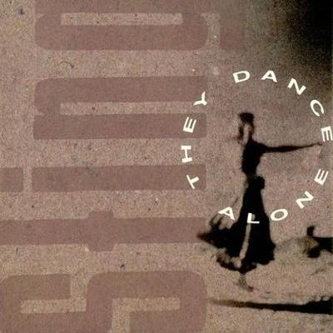
Step 3: Read and Annotate:

Before you read:
During the 1970s , Sting and his band The Police, toured Chile at the height of the Pinochet regime. He told the Independent On Sunday in 1994: "I asked Amnesty International what they thought and their advice was that I should go, because rock'n'roll means freedom in these countries. So we went out there and it was pretty painful. There were troops and tanks on every street. While there, he witnessed the Arpellistas, "This was something that I saw when I went to Chile with the Police. The mothers and wives of "the disappeared" do this amazing thing; they pin photographs of their loved ones to their clothes and go out in groups and do this folk dance with invisible partners in front of the police station. It's this incredible gesture of grief and protest. But it's a feminine way of combating oppression. The masculine way is to burn cars or to throw rocks. Yet this feminine way is so much more powerful because what can the police do These women are simply dancing. What I'm trying to say on the record is that the female ultimately is superior to the male. That's what will bring Pinochet down - the mother's sense of injustice." When he released the song in in 1987, the song was banned in Chile.

As you read, pay close attention to the images that the author creates as he describes the dance.

They Dance Alone (Gueca Solo)
Sting

1 | Why are these women here dancing on their own?  Why is there this sadness in their eyes?  Why are the soldiers here  Their faces fixed like stone?  I can't see what it is they despise | Who is the author describing in this stanza?
2 | (Chorus)  Dancing with the missing  They're dancing with the dead  They dance with the invisible ones  Their anguish is unsaid  They're dancing with their fathers  They're dancing with their sons  Dancing with their husbands  They dance alone  They dance alone | Summarize what the author is describing in this stanza.
3 | The only form of protest they're allowed  I've seen their silent faces, they scream so loud  If they were to speak these words  They'd go missing, too  Another woman on the torture table  What else can they do? | What is the risk that the women run by protesting in this way?
4 | (chorus)
5 | One day we'll dance on their graves  One day we'll sing our freedom  One day we'll laugh in our joy  And we'll dance  One day we'll dance on their graves  One day we'll sing our freedom  One day we'll laugh in our joy  And we'll dance | What is the author picturing in this stanza? How will the dance be different?
6 | Hey Mr. Pinochet  You've sown a bitter crop  It's foreign money that supports you  One day the money's going to stop  No wages for your torturers  No budget for your guns  Can you think of your own mother  Dancing with her invisible son | Summarize this stanza.
7 | (Chorus)
8 | One day we'll dance on their graves  One day we'll sing our freedom  One day we'll laugh in our joy  And we'll dance  One day we'll dance on their graves  One day we'll sing our freedom  One day we'll laugh in our joy  And we'll dance  And we'll dance | Why does the author end with repeating this stanza—what is the tone or attitude of the author in this stanza?

Step 5: Read, Think, Write, Share

When Sting wrote this song, he was moved by the fact that the women used what he called “feminine power” instead of being overt/explicit and using either violent or even very traditional ways of protesting. So, in many ways, these women used what could be called “subversive” or hidden ways of protesting and to make their voices heard. What were the advantages of doing this? Do you think it was effective? Why or why not?

Student Feedback:

Circle the emojis that best represents how this activity made you feel.

Day 3: Wind Power
Science

What is this lesson about?: Today you will read through the Wind Power passages. You will answer a few questions about what you read. You will complete a Wind Power activity.

Step 1: Read through the Wind Power passages

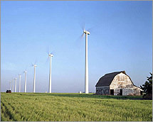
Wind Power
What is wind power?
Wind power is energy, such as electricity, that is generated directly from the wind. It is considered a renewable energy source because there is always wind on the Earth and we aren't "using up" the wind when we make energy from it. Wind power also does not cause pollution.

Wind Turbines and Wind Farms
In order to make electricity from wind, energy companies use large windmills called wind turbines. They are called this because they use turbine generators to generate the electricity.

In order to create a lot of energy capable of powering thousands of homes, energy companies build large wind farms with lots of wind turbines. They usually build these in consistently windy places. Some companies build wind farms out in the ocean. These are called offshore wind farms.

How tall are wind turbines?
Wind turbines are really big structures. The tower itself is typically between 200 and 300 feet tall. When you add in the height of the blades, some turbines tower 400 feet high! The blades are quite big, too. There are typically three wind blades on a wind turbine. Each blade is usually between 115 and 148 feet long.

How does a wind turbine work?
A wind turbine works the opposite of a fan. Instead of using electricity to turn the blades to make wind, it uses the wind to turn the blades to make electricity.

When the wind turns the blades, the blades turn a shaft inside the turbine. This shaft is big, but turns slowly. The shaft, however, is connected to a number of gears which causes a smaller shaft to turn much faster. This smaller shaft drives the electrical generator which generates the electricity that can be used by homes and businesses.

What if there isn't any wind?
If there isn't any wind, then no energy will be generated by the wind turbine. However, engineers do a lot of measurements and calculations to figure out the best areas to place the wind turbines. The wind won't be blowing all the time, but the important thing is how much the wind blows on average.

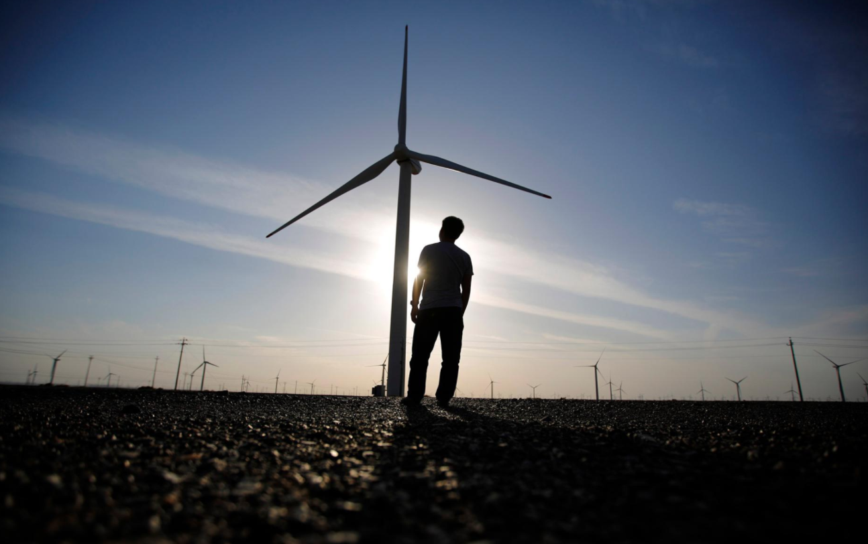
History of Windmills
Windmills have been used since the Middle Ages in order to harness the energy of the wind. They were initially used to pump water or to grind flour. They are still used in many places of the world today to pump water. It was in the late 1800s and early 1900s that windmills were first used to generate electricity.

Are there any drawbacks to wind power?
One major issue some people have with wind power is how the wind turbines mess up the view or landscape. Other drawbacks include the large blades killing birds and noise pollution from the turbine. Most people agree that the positives of a fully renewable and clean energy resource far outweigh the negatives.

Fun Facts about Wind Power
- For a wind turbine to make money it must be placed in a spot with an average annual wind speed of 15 miles per hour.
- In 2011, the top wind power producing state in the United States was Texas. Texas was followed by Iowa, California, Minnesota, and Illinois.
- Around 3% of the electricity in the United States in 2011 was provided by wind power. This was enough to power around 10 million homes.
- Tax breaks and new technologies have helped the output from wind power to grow significantly in the last 10 years.
- The largest wind farm in the United States is the Horse Hollow Wind Energy Center in Texas. It has 421 wind turbines.
Wind is the movement of air from an area of high pressure to an area of low pressure. In fact, wind exists because the sun unevenly heats the surface of the Earth. As hot air rises, cooler air moves in to fill the void. As long as the sun shines, the wind will blow. And wind has long served as a power source to humans.

Ancient mariners used sails to capture the wind. Farmers once used windmills to grind their grains and pump water. Today, more and more wind turbines wring electricity from the breeze. Over the past decade, wind turbine use has increased more than 25 percent per year. Still, it only provides a small fraction of the world's energy.

How it Works
Most wind energy comes from turbines that can be as tall as a 20-story building and have three 200-foot (60-meter)-long blades. The wind spins the blades, which turn a shaft connected to a generator that produces electricity.

The biggest wind turbines generate enough electricity in a year (about 12 megawatt-hours) to supply about 600 U.S. homes. Wind farms have tens and sometimes hundreds of these turbines lined up together in particularly windy spots. Smaller turbines erected in a backyard can produce enough electricity for a single home or small business.

The Booming Wind Energy Industry
Wind is a clean source of renewable energy that produces no air or water pollution. And since the wind is free, operational costs are nearly zero once a turbine is erected. Mass production and technology advances are making turbines cheaper, and many governments offer tax incentives to spur wind-energy development.

Drawbacks include complaints from locals that wind turbines are ugly and noisy. The slowly rotating blades can also kill birds and bats, but not nearly as many as cars, power lines, and high-rise buildings do. The wind is also variable: If it's not blowing, there's no electricity generated.

Nevertheless, the wind energy industry is booming. Thanks to global efforts to combat climate change, such as the Paris Agreement, renewable energy is seeing a boom in growth, with wind energy leading the way. From 2000 to 2015, cumulative wind capacity around the world increased from 17,000 megawatts to more than 430,000 megawatts. In 2015, China also surpassed the EU in the number of installed wind turbines and continues to lead installation efforts.

Industry experts predict that if this pace of growth continues, by 2050 one third of the world's electricity needs will be fulfilled by wind power.

Step 2: Answer the following questions

- What are large windmills used for generating electricity called?
  - Energy mills
  - Wind turbines
  - Winders

- Which of the following works the opposite of a wind turbine?
  - Nuclear power plant
  - Solar panel
  - Electric fan

- Around how long is the typical blade on a wind turbine?
  - 20 feet
  - Over 100 feet
  - 50 feet

- What US state produces the most energy from wind?
  - Texas
  - California
  - Washington

- What do we call a large group of wind turbines used to generate electricity?
  - Wind mill
  - Wind pack
  - Wind farm

- What is a drawback to using wind turbines to generate electricity?
  - The blades can kill birds
  - They can cause noise pollution
  - All of the above
  - None of the above

- Wind turbines will continue to generate energy even when there isn't any wind.
  - TRUE
  - FALSE

Step 3: Draw an image/picture

Draw a picture of your own wind farm. Where is it located? What do you hope will happen as a result of your wind farm?

Student Feedback:

Circle the emojis that best represents how this activity made you feel.

Mindfulness Moment!

How can I express my feeling without hurting anyone?

Day 3: Power/Marching and Organizing
Math

What is this lesson about?: Today we will be looking at Marching and Power of the Marching...

Activity #1: The Selma to Montgomery, Alabama March for Voting Rights in 1965

Background: Just over 55 years ago, Civil Rights leaders attempted to march over the Edmund Pettus Bridge in Selma, Alabama and then continue on to Montgomvery, Alabama. The march was to be a nonviolent march, designed to highlight the restrictions African Americans faced when trying to exercise their right to vote in Alabama and in the South.

[Christina, Insert photo from the 1st March -- Rep. Lewis/others getting beaten back]

In the years directly following the Civil War, African American participation in voting grew significantly, often under protection of federal troops. However, by the late 1800s and the turn of the century, many states in the south started to enforce restrictions on voting, including a poll tax and a literacy test.

Questions from an actual Literacy Test Poll Tax Flier

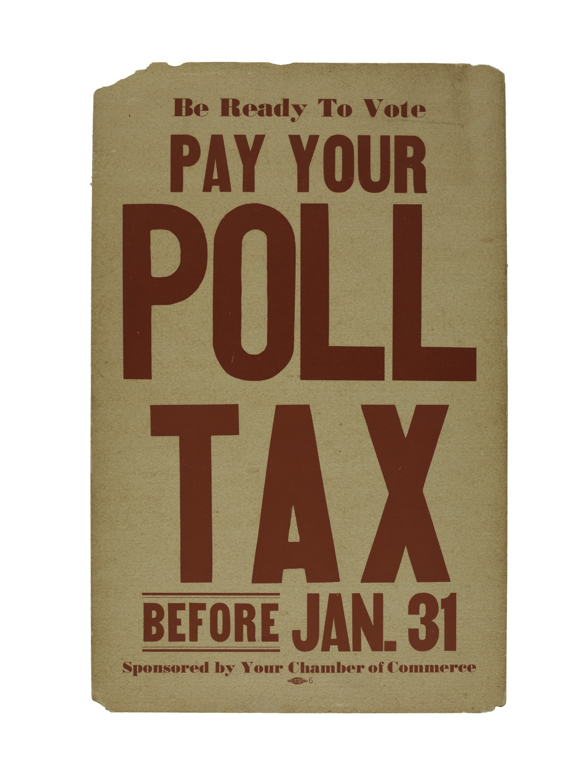
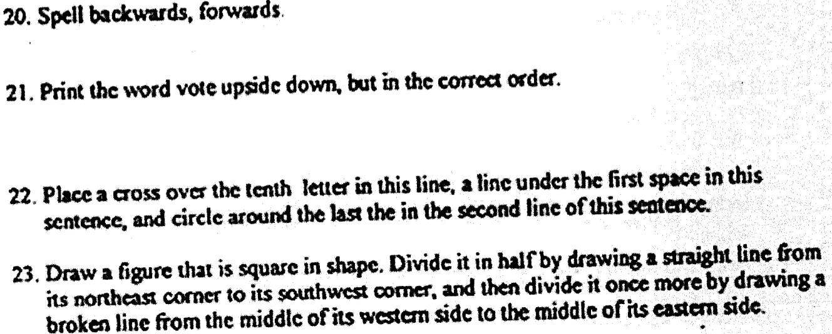

Exception: if your family voted BEFORE the Civil War, you did NOT have to pay….No Black families were able to vote before the Civil War...

With these barriers, African American voting in Alabama and throughout the South plummeted.

For example, in Dallas County, Alabama--where the city of Selma is located--the Black population remained fairly flat from 1890 until 1964, with right around 15,000 eligible voters. In 1880 nearly one-half of them registered to vote, but by 1964, only 156 of the approximately 15,000 eligible Black voters (1%) were registered! By contrast nearly 66% of eligible White voters were registered.

***

On March 5, 1965, a group of Civil Rights leaders organized a protest March to draw attention to the unfair laws and restrictions related to Black voter registration.

Approximately 600 prepared for the March. The marchers were turned back brutally. Videos of the violence circulated widely.

After two weeks of negotiations, that included representatives from the federal government, a 2nd March was organized, with assurances that the marchers would not be harmed. 3,200 started the 50+ mile march over the bridge toward Montgomery.

Along the way, and over the 5 days that followed, nearly 25,000 people joined the march.

This growth, from 600 marchers to nearly 25,000 is remarkable. To help us, we are going to round the numbers off to 600 (first march), 3,000 (start of 2nd march) and 24,000 (end of 2nd march).

- How many times more people started the 2nd march than started the first march?

- If you were going to diagram that, how many add-ons would you place around each of the first marchers? See below-
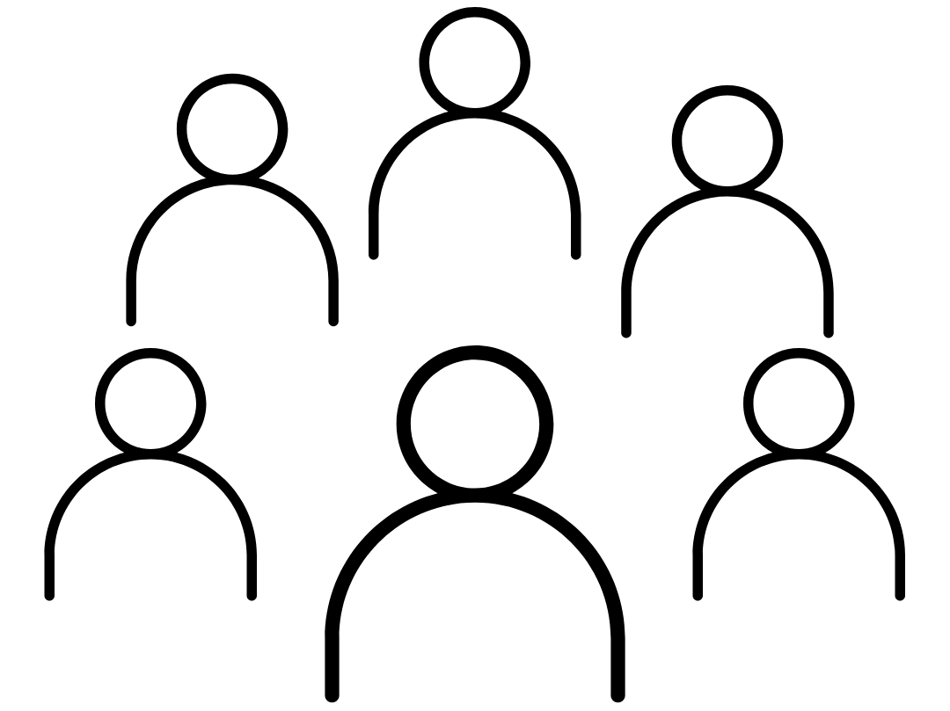
- If you were going to use this same model, how many objects would be orbiting each of the first marchers by the end of the 2nd march? (Hint: what is 24,000 divided by 600?)

- Could you even fit that drawing below?

Discuss/Consider: What do you think took place that lead to so many more people joining the marches?

Activity 2: Assessing increased access to the Polls

Shortly after the Selma to Montgomery march, Congress passed the Voting Rights Act of 1965 and it was signed into law by the President.

The charts below show the change in Black registered voters between 1964 and 1972 in Dallas County, Alabama--where Selma is located.
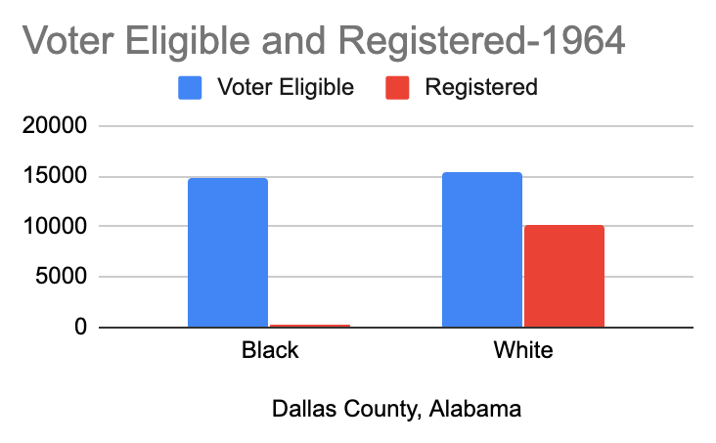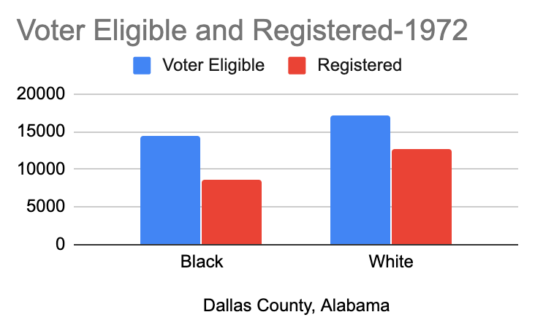
Based on the above charts….
- In 1964 before the March and the passage of the Voting Rights Act, about how many African Americans eligible to vote were registered in Dallas County?

- By 1972, about how many African Americans eligible to vote were registered in Dallas County?
  - Estimating from the chart, about what % of eligible African American voters registered to vote in 1972?

Discuss/Consider:
- What difference does it make, or should it make, if people vote or not?
- What is an example of a policy or law that could change based on who votes in a local election?
- What about in a Presidential Election?
- Do you know if judges are elected or appointed in your state?

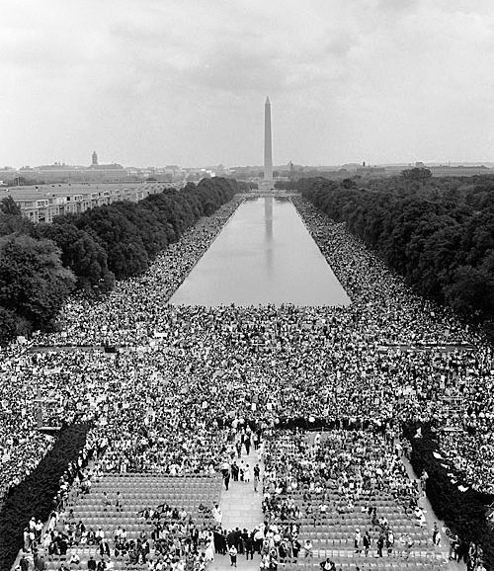
Activity 3: Understanding the March on Washington, and what it took to sustain it….

Background: The March on Washington, which took place on August 28, 1963, was one of the largest civil rights rallies in US history, and one of the most famous examples of nonviolent, mass direct action. The March on Washington was highly publicized in the news media, and helped to gather momentum for the passage of the Civil Rights Act in 1964. The majority of the demands revolved around issues of economic justice – like equal access to public facilities and accommodations, housing, education, and jobs.

In fact the full name of the March was the March for Jobs and Freedom. 1963 was the 100th anniversary of Abraham Lincoln’s Emancipation Proclamation, and one of the major themes of the rally was that the promises of emancipation remained unfulfilled.
More than 250,000 people attended the March, with many of them traveling hundreds, some more than one thousand, of miles to join in the March and rally. Organizing so many people was a huge task, clearly. And the person in charge of the logistics was Bayard Rustin. In this activity, we are going to focus on some of the logistics of the March and answer the question, what does it take to make such an event take place?
Busses: Many of the attendees came to Washington, DC by bus, usually in large groups, sponsored by local churches or organizing groups.
Assume that you are in charge of organizing a bus ride from your city to Washington, DC. Complete the following chart:
Hometown: Based on this information, how much will it cost you to rent your bus and bring your local group to the March. Remember to calculate the cost based on the # of people, the # of bussed you will need, the # of days you will spend going and coming, and to take into the cost for each day and for each rider. Use the space below to calculate your answer.

Insert your answers in grey boxes
Food and Housing: Many of the attendees who came to Washington, DC for the March stayed in local churches and other facilities like recreation centers. So it wasn’t as costly as staying in hotels. But people needed places to sleep and food to eat.
Assume that you were able to negotiate a good deal with Howard University. They charged you:
- $10 per night per person to sleep in the dorm.
- $5 (total) for breakfast and lunch each day.
Your group decided to stay in DC two nights and two days.

Based on the number of people you brought with you (from above), how much would it cost for your housing and to ensure that everyone got breakfast and lunch both days?
Organizing and preparing for the March and the Attendees.
Bayard Rustin had a huge job to plan for such a large event on the Mall. This chart outlines some of the main costs of putting on the event.
Items(s) | Cost
City Permits | $10,000
Stage and Sound System | $5,500
Port a Potties  - Required to have 1 for every 500 people attending  - Use estimates of 250,000 attendees | $10 rental fee for the 1 day for each Port-a-Pottie
City Fees for Police, Fire, Rescue | $20,000 flat fee, plus  $5,000 additional for every 50,000 people over 100,000
Private security | $2,500
How much money would Bayard Rustin need to raise to host the March on the Mall?
- Be careful with the cost of the Port-a-Potties and the cost of Police, Fire, Rescue. Remember to use the # of attendees as 250,000.

Activity 4: Media Coverage of the March and the Speeches
Back in 1963 there wasn’t any cable TV, nor did the Internet exist. But there was basic TV. Based on estimates from the TV ratings, nearly 1 in 10 households watched Martin Luther King, Jr’s final I have a Dream Speech that day.
- Assuming there were 80 million households then, how many people watched the speech live?
- The speech was covered on the TV news repeatedly for days, with estimates of over an additional 20 million people viewing the speech on the local news.
How many people in the US saw the speech on TV that week?
It is estimated that nearly 10 million Americans watch a clip of that speech every year now--most on or around the Martin Luther King, Jr holiday.
- Assuming this same number of viewers each year from 1965 to the present (2020), how many millions of times has that speech been viewed?

Consider/Discuss: Some of the most popular songs over the last few years get hundreds of millions of views over just 2-3 months on YouTube.
- Is this good or bad?
- What could be done, if anything, to increase the viewership of important events and speeches on social media?

Student Feedback:

Circle the emojis that best represents how this activity made you feel.

Day 3: How are privacy and power related?
Health

What is this lesson about?: In today’s lesson, we will look at how privacy and power are critical components in relationships.

Step 1: Warm-Up In the relationship belowdo you feel like one person has more power than the other person?

Who’s got the POWER?
A girl convinces her boyfriend that they won’t put passwords on their phones and can check each others’ texts and social media accounts whenever they feel like it.

Who has the POWER? Why?

Step 2: Read about the behaviors below.
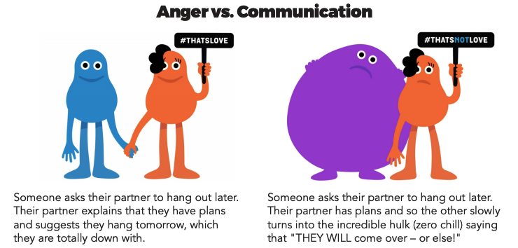

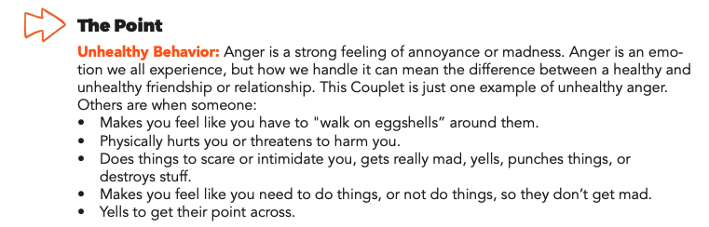

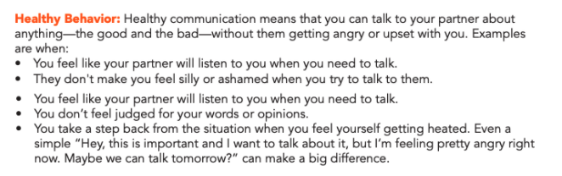
Step 3: Complete the Activity.

Write a letter to a friend who insists that they should have your passwords so they can control what you do on your phone and on social media. Tell them why privacy is important and how it helps you maintain a healthy relationship.

Dear

Student Feedback:

Circle the emojis that best represents how this activity made you feel.
Mindfulness Moment!

What went well for me today and how did I contribute to it?

Day 3: Governmental Powers: Direct v. Representative Democracies
Social Studies/Civics
What is this lesson about?: Today you will continue exploring different types of government, and will focus on direct democracies and representative democracies. Below is a reminder of our Elite 8 bracket. Fill in who won the face-offs for the last 2 lessons below.

Types of Government Bracket
Monarchy
Oligarchy
Dictatorship
Theocracy
Direct Democracy
Representative Dem.
Communism
Anarchy

Step 1: Compare Direct and Representative Democracies

Direct Democracy  In a true direct democracy, every single law, bill, or issue of justice is voted on by all the people. One advantage of a direct democracy is that people can see the changes being reflected in the system faster because they determine everything with their votes. Also citizens have power of voting and individual rights, which is a benefit as it increases self-empowerment for people. Alternatively, disadvantages of a direct democracy include the potential for the people to vote negligently, or without proper care and consideration. This could be bad because the people’s vote is very important in a direct democracy. | Representative Democracy  A representative democracy is a system of government in which all eligible citizens vote on representatives to pass laws for them. The people vote to elect their representatives or leaders, and then the representatives act on behalf of the voters. Advantages of a representative democracy include more freedom for individuals and people have a right to vote and voice their opinion. On the other hand, disadvantages include people potentially voting for representatives without full information or without exercising care. There is also the possibility of corruption because there are a lot of people operating the government and it can be difficult to hold everyone accountable.

Step 2: Read the article and answer questions

The difference between a democracy and a republic
By USHistory.org, adapted by Newsela staff

Nowhere is the word "democracy" mentioned in the Declaration of Independence or the U.S. Constitution. How could that be? Our government is a democracy!

Well, for one, as we'll discuss later, the Founders actually feared democratic rule. In the late 18th century, rule by the people was thought to lead to chaos and disruption. Yet a democratically based government was seen as superior to the kings and queens of Europe.
Democracy Gives Power To The People
Democracies did not begin with the founding of the United States. The term "democracy" comes from two Greek words: "demos" (the people) and "kratia" (power or authority). So of course, democracy is a form of government that gives power to the people. But how, when and to which people? The answer to those questions changes through history.
Democracies are based on "rule of law." The ancient Greeks (particularly Aristotle) valued natural law. This is the idea that human societies should be ruled by certain general principles of what is right that are common to human nature. The Greeks are famous for practicing direct democracy. This is a system in which citizens meet to discuss all new laws. Then they voted, making decisions by majority rule. However, only free males were considered to be citizens, not women or slaves. So their democracy was certainly limited. Today, direct democracy is practiced in New England town meetings, where all citizens of voting age meet to decide important political decisions.

America's Population Was Too Big For A Direct Democracy
But how could direct democracy work in a large population with many different groups spread over long geographical distances? Generally, the answer has been that it can't. In the place of direct democracy, the American Founders chose "indirect" or "representative" democracy. In this system, Representatives are chosen by the people to make decisions for them. The representative body, Congress, was considered to be the right size for doing the business of government.
The Founders preferred the term "republic" to "democracy." This is because in a republic, the interests of the people are represented by more knowledgeable or wealthier citizens. These representatives are responsible to those that elected them. Today, we tend to use the terms "republic" and "democracy" to mean the same thing. It can all get a little confusing. Sometimes people call the United States "the Republic," and other countries use the term also in their names, like the Republic of Ghana, in Africa.
One of the issues many people have with representative democracy is that the representatives become the "elites" that seldom consult ordinary citizens. Even though they are elected, a truly representative government doesn't really exist.

What type of democracy does the U.S. have? Explain your answer.

What type of government did the newly formed United States want to move away from? What type of government had they revolted against in the American Revolution?

What is a potential problem with representative democracy discussed in the article above?

What is the biggest difference between a direct democracy and a representative democracy?

Step 3: Read the article and answer questions

Where Does Democracy Come From?
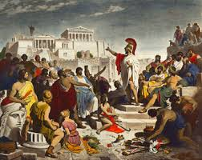
Winston Churchill once said democracy 'is the worst form of government in the world, except all those other forms that have been tried from time to time.' Many human societies have practiced some form of democracy over the millennia, the most important (for the American version, at any rate) example originated in ancient Greece. The world's first working democracy, as far as we can tell, was established by Cleisthenes in the Greek city-state of Athens, around 508 BCE.
The Greeks came up with the form of government that we call direct democracy, which is a precursor to representative democracy. In a direct democracy, all eligible citizens vote on every issue. For example, if a direct democracy were considering a tax increase, all the eligible voters would vote on that decision. This form of government is often called 'participatory' or 'Aristotelian democracy.' In Athens, the concept of 'eligible' voters only included male citizens and excluded all others (slaves and women could not vote).
However, imagine for a moment having to vote on every single thing that happens in a country—it would be impossible, for many reasons, especially in a country the size of the U.S. The Greeks thought so, too, so they came up with a way to choose a smaller subset of individuals to do the voting. In Athens, for example, the citizens made use of a device called a kleroterion, which was something like a bingo-ball selector. Each citizen would receive a token representing him; several hundred were picked each day, and for a time, they would make decisions for the entire city-state. This was an early form of the next evolution of democracy, called representative democracy.

Basics of a Democracy
But what is democracy, anyhow? It's generally agreed that there are five criteria that are necessary for any society to call itself democratic:
- Equality in voting
- Effective participation
- Enlightened understanding
- Citizen control of the agenda
- Inclusion (must be open to all citizens within a nation)

What type of democracy did the early Greeks have?

Is a direct democracy always possible? What may make it difficult to have this type of government?

In a democracy, ‘the people’ are supposed to have the power. Either directly or through a representative. Do you feel like you have political power in the U.S.? Why or why not.

If you’re not 18 yet and are not able to vote, how might youth be able to influence politics and use their power? (hint: think about how students have responded after school shootings)

Step 7: Organize your thoughts
Complete the graphic organizer on the next page to help you compare and contrast Direct and representative democracies. After completing the graphic organizer, you will reflect on these forms of governments and choose which one you prefer.

Step 8: Reflect

Complete the bracket below and choose which type of government you prefer:
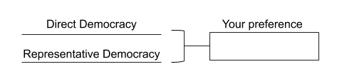

- Why do you prefer that governmental system? (share three reasons)

- How does it compare to the current governmental system you live in now? (share three reasons)

Step 9: Discuss
- With a partner, share and compare your graphic organizer.
- Can you improve your graphic organizer after discussing with your partner?
- Share what you chose as your winner for this bracket face-off and why.

Student Feedback:

Circle the emojis that best represents how this activity made you feel.

Week 5
Power

Day 4

NAME:______________________

Day 4 Agenda

Topic | Activity
Warm-Up!
English Language Arts | - Read and analyze the lyrics to the song, Fight the Power.  - Answer questions about the lyrics of the song.  - Complete a graphic organizer about an issue they wish to protest and write a protest song/rap/poem about it.
Science | - Read about HydroPower  - Answer questions about what you read  - Draw a picture and explain
Mindfulness Moment!
Math | - Power: Mothers Against Drunk Driving (MADD) as an example of Power
Health | - Power in digital relationships
Mindfulness Moment!
Civics/Social Studies | - Consider types of governmental powers  - Anarchy v. Communism

Warm-up Activity: Write a journal entry around the daily quote on identity.
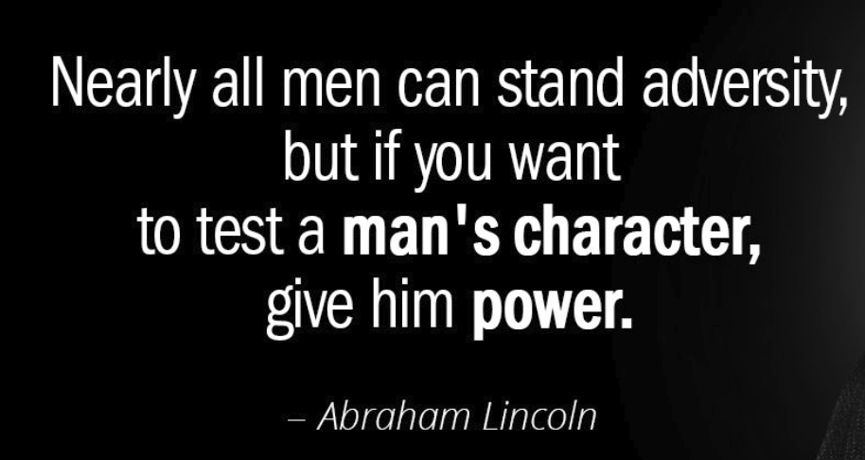

Day 4: Using Music as Protest
English Language Arts

What is this lesson about? Today, you will read the lyrics to a popular protest song. Unlike the subversive (hidden) protest of the women from Chile, this song was direct and explicit. As you read and think about this song, think about the issues of power that the artists address in the song.

Before you read
The song “Fight the Power” by Public Enemy was written for the movie Do the Right Thing which told the story of racial tensions in New York. With the movie’s popularity, the song quickly became an anthem or call to action for many. Public Enemy, were among the most popular, controversial, and influential hip-hop artists of the late 1980s and early ’90s. The original members were Chuck D (original name Carlton Ridenhour) Flavor Flav (original name William Drayton), Terminator X (original name Norman Lee Rogers; and Professor Griff (original name Richard Griffin). They were inducted into the Rock and Roll Hall of Fame in 2013.
(If you have access to the internet, please listen to “Fight the Power “at https://www.youtube.com/watch?v=5UAnW-c57gM)

Step 1: Read the lyrics
Fight The Power
Public Enemy

1 | Yet our best trained, best educated, best equipped, best prepared troops refuse to fight  As a matter of fact, it's safe to say that they would rather switch than fight  1989 the number another summer (get down)  Sound of the funky drummer  Music hitting your heart 'cause I know you got soul  (Brothers and sisters, hey)  Listen if you're missing y'all  Swinging while I'm singing  Giving whatcha getting  Knowing what I know  While the Black bands sweatin'  And the rhythm rhymes rollin'  Got to give us what we want (uh)  Gotta give us what we need (hey)  Our freedom of speech is freedom or death  We got to fight the powers that be | Notes:
2 | (Chorus)  Lemme hear you say  Fight the power (lemme hear you say)  Fight the power (x 6)  We've got to fight  the powers that be
3 | As the rhythm designed to bounce  What counts is that the rhymes  Designed to fill your mind  Now that you've realized the pride's arrived  We got to pump the stuff to make us tough  From the heart  It's a start, a work of art  To revolutionize make a change nothing's strange  People, people we are the same  No we're not the same  'Cause we don't know the game  What we need is awareness, we can't get careless  You say what is this?  My beloved let's get down to business  Mental self defensive fitness  (Yo) bum rush the show  You gotta go for what you know  To make everybody see, in order to fight the powers that be
4 | Chorus
5 | Elvis was a hero to most  But he never meant shit to me you see  Straight up racist that sucker was  Simple and plain  *** him and John Wayne. (**edited for language)  'Cause I'm Black and I'm proud  I'm ready and hyped plus I'm amped  Most of my heroes don't appear on no stamps  Sample a look back you look and find  Nothing but rednecks for four hundred years if you check  Don't worry be happy  Was a number one jam  Damn if I say it you can slap me right here  (Get it) let's get this party started right  Right on, c'mon  What we got to say (yeah)  Power to the people no delay  Make everybody see  In order to fight the powers that be
6 | Chorus

Step 2: Answer the following questions.

      - List two issues that the song is protesting. Use text evidence from the song to explain your answers.

      - In the song, the writer is frustrated with his own community as well as the outside society. What frustrates or angers him about his own community?

      - Chuck D. who co-wrote this song, addressed his mention of Elvis and John Wayne (two very popular performers in American society) when he said,

“Elvis and John Wayne were the icons (symbols) of America. And they kind of got head-and-shoulder treatment over everybody else. It’s not that Elvis was not a talented dude and incredible in his way, but I didn’t like the way that he was talked about all the time, and the pioneers [of rock & roll], especially at that time, weren’t talked about at all. When people said “rock & roll” or “the King,” it was all “Elvis, Elvis, Elvis, one trillion fans can’t be wrong” and John Wayne is “Mr. Kill All the Indians and Everybody Else Who’s Not Full-Blooded American.”

What did he want to communicate about them? (Hint, look at the lines that follow.)

      - The song was considered an “anthem” and is often described as a call to action for their community. What did Public Enemy want their community to do?

Step 3: Write your own protest song/rap/poem
Complete the graphic organizer below.

Choose a problem or issue that you want to address and protest in your song/rap/poem.

Write down 3-4 facts related to your topic that you can mention in your song/rap/poem.

Title your song/rap/poem: Choose a catchy phrase or word that will attract your listener.

Write your song/rap: 4 lines of verse and 4 lines of a chorus.

1st Verse:
Chorus: (this should be part of your call to action like the song Fight the Power)

2nd Verse

And you would finish with repeating the chorus.

Step 4: Practice, Share and Get Feedback

Share your song/rap/poem with another person in the group. The person listening should share:

1 line/verse that they think was really good/strong.

1 line/verse that could be improved.

Go back to your song/rap/poem and revise and finalize. Share out again if you have time.

Student Feedback:

Circle the emojis that best represents how this activity made you feel.

Day 4: Hydropower
Science

What is this lesson about?: Today you will read through the Hydropower passages. You will answer a few questions about what you read. You will complete a Hydropower activity.

Step 1: Read through the Hydropower passages

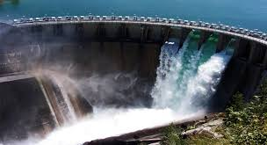
Hydropower
What is hydropower?
Hydropower is power that is generated from moving water such as rivers.

Renewable Energy
Hydropower is a renewable energy source. This means that using a dam or a river to generate electricity doesn't use up any limited resources like coal or gasoline.

How do we get power from water?
Falling or flowing water from a big river has a lot of energy. We can harness this by forcing the water through a pipe called a penstock. As the water flows through the pipe it turns the blades of a turbine which spins an electric generator. As long as the water is flowing, the generator will be able to provide electricity.

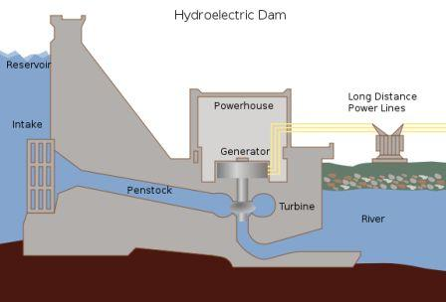
Electricity can be generated by water moving through a dam

There are three main ways that engineers design hydroelectric power plants:
- Storage System - The storage system uses a dam. The dam slows the flow of a river and stores up water in a lake. A portion of the water is released into the river at the bottom of the dam. The fall of the water, and the water pressure from the lake, forces the water through the dam and spins turbine generators. Dams are expensive to build, but they also help control flooding, can create a large recreational lake, and can provide fresh water for surrounding towns.
- Run-of-the-river System - In a run-of-the-river system the turbines are spun by the natural flow of the river. These systems have the advantage of not creating a huge lake and flooding the area above the dam. As a result, they have less overall impact on the environment. However, in order to provide continuous electricity, the river they use must stay full throughout the year, as the flow is not regulated by a dam.
- Pumped Storage System - This system is like the storage system except it uses pumps to pump used water back up into the reservoir. The way this works is that during the night, when electricity use is much less, it uses the extra electricity to pump the water back up to the top of the dam and refill the reservoir. This improves the overall efficiency of the hydropower plant.
History of Hydropower
Using rivers to power mechanical devices is not a new concept. As far back as ancient times, thousands of years ago, people used hydropower to perform tasks such as grinding grain into flour. In the late 1800s scientists first figured out how to use hydropower to generate electricity. The first hydroelectric power plant was built in Wisconsin in 1882. Since then, many more power plants have been built in the United States including the Hoover Dam in 1936 and the Grand Coulee Dam in 1942.

Are there any drawbacks to hydropower?
Like any power source there are some drawbacks to hydropower. One drawback is the loss of land and the damage to the local ecosystem caused when a lake is created by a dam. This can also cause people to have to relocate and leave their homes. Another disadvantage is methane emissions generated by the reservoirs. Dams and turbines can also hurt fish and disrupt their migration to spawning grounds.

Fun Facts about Hydropower
- There are over 2,000 hydroelectric power plants in the United States.
- Many countries, such as Norway and Brazil, get a significant portion of their electricity (as much as 85%) from hydropower.
- The largest dam and hydroelectric power plant in the world is the Three Gorges Dam in China. It provides 22,500 Megawatts of electricity!
- Most of the dams in the United States were not built to supply power. They were built for flood control and to provide local irrigation.
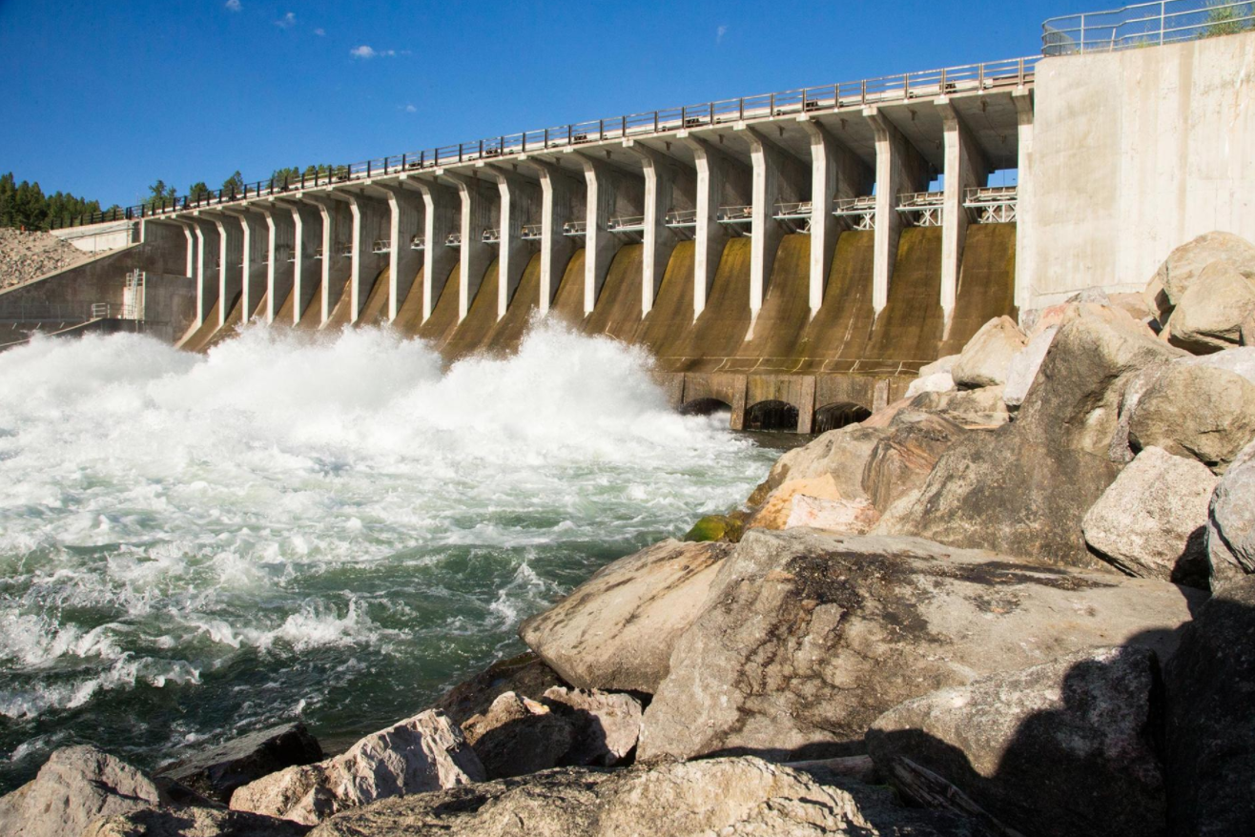
- A large portion of the hydropower generated in the United States occurs in the western states. The number one producer of hydropower is Washington state which produced 29% of the nation's hydropower in 2011.
Jackson Lake Dam in Wyoming's Grand Teton National Park was built in 1906 to provide water to farmers and ranchers. Many older dams are now being rethought.

(National Geographic)
Humans have been harnessing the energy of river currents for centuries, using water wheels spun by rivers initially to process grains and cloth. Today, hydropower provides about 16 percent of the world's electricity, generating power in all but two U.S. states.

Hydropower became an electricity source in the late 19th century, a few decades after British-American engineer James Francis developed the first modern water turbine. In 1882, the world’s first hydroelectric power plant began operating in the United States along the Fox River in Appleton, Wisconsin.

How hydropower works
A typical hydroelectric plant is a system with three parts: a power plant where the electricity is produced, a dam that can be opened or closed to control water flow, and a reservoir where water is stored. The water behind the dam flows through an intake and pushes against blades in a turbine, causing them to turn. The turbine spins a generator to produce electricity.
The amount of electricity that can be generated depends on how far the water drops and how much water moves through the system. The electricity can be transported through long-distance electric lines to homes, factories, and businesses. Other types of hydropower plants make use of the flow through a waterway without a dam.

The largest hydropower plants
China, Brazil, Canada, the United States, and Russia are the five largest producers of hydropower. The world's largest hydroelectric plant in terms of installed capacity is Three Gorges (Sanxia) on China's Yangtze River, which is 1.4 miles (2.3 kilometers) wide and 607 feet (185 meters) high. The facility that actually generates the most electricity annually is the Itaipu plant situated on the ‎Paraná River between Brazil and Paraguay.

The biggest hydropower plant in the United States is at the Grand Coulee Dam on the Columbia River in Washington, a state that gets about two-thirds of its electricity from hydropower.

Hydropower pros and cons
Hydropower has several advantages. Once a dam has been built and the equipment installed, the energy source—flowing water—is free. It's a clean fuel source renewed by snow and rainfall. Hydropower plants can supply large amounts of electricity, and they are relatively easy to adjust for demand by controlling the flow of water through the turbines.

But big dam projects can disrupt river ecosystems and surrounding communities, harming wildlife and forcing out residents. The Three Gorges Dam, for example, displaced an estimated 1.2 million people and flooded hundreds of villages.

Dams also prevent fish such as salmon from swimming upstream to spawn. While equipment such as fish ladders are designed to help salmon go up and over dams and enter upstream spawning areas, such measures aren't always effective. In some cases, fish are collected and trucked around the obstacles. Still, the presence of hydroelectric dams can often change migration patterns and hurt fish populations. In the Columbia River Basin in the Pacific Northwest, for example, salmon and steelhead have lost access to about 40 percent of their historic habitat because of dams.

Hydropower plants can also cause low dissolved oxygen levels in the water, which is harmful to river habitats. Other wildlife can be affected as well: In Indonesia, a hydroelectric project threatens rare Tapanuli orangutans because it stands to fragment their habitat.

RENEWABLE ENERGY 101

Climate change and the increased risk of drought are also having an impact on the world's hydropower plants. In the western U.S., carbon dioxide emissions over a 15-year period were 100 megatons higher than they normally would have been, according to a 2018 study, as utilities turned to coal and gas to replace hydropower lost to drought.

Even the promise of carbon-free electricity from hydropower has been undermined by revelations that decaying organic material in reservoirs releases methane, a potent greenhouse gas that contributes to global warming.

However, some argue that the environmental impacts of hydroelectric power can be mitigated and remain low compared with burning fossil fuels. In some places, small hydro projects can take advantage of existing water flows or infrastructure. Special water intakes and turbines can help make sure water released from a dam is better aerated to address the problem of low dissolved oxygen. Dams can be planned more strategically to allow fish passages, for example, while water flows at existing dams can be calibrated to give ecosystems more recovery time from flooding cycles. And research continues on ways to make hydropower projects more friendly to the ecosystems around them.

A growing movement is also working to tear down dams that are no longer functioning or needed around the world, with the aim at restoring more natural rivers and the many benefits they provide to wildlife and people, including recreation.

Step 2: Answer questions about what you read

- Where does hydropower get its energy from?
  - From the burning of fossil fuels like coal
  - The internal heat of the Earth
  - Moving water sources like rivers

- In a hydropower plant, water flows through a pipe called a _______.
  - Penstock
  - Turbine
  - Generator

- What type of hydropower plant does not use a dam?
  - Pumped storage system
  - Run-of-the-river system
  - Storage system

- What type of hydropower plant uses extra electricity at night to move used water back into the reservoir?
  - Run-of-the-river system
  - Storage system
  - Pumped storage system

- What is a disadvantage to the run-of-the-river hydropower system?
  - It relies on fossil fuels to generate power
  - The river must remain full and flowing in order to generate electricity
  - It can destroy the surrounding environment by creating a large lake

- Where is the largest dam and hydroelectric plant in the world located?
  - Brazil
  - China
  - United States

- Using rivers to power mechanical devices is a new concept invented in the late 1900s.
  - TRUE
  - FALSE

Step 3: Draw a picture/explain

Draw a picture of a hydropower plant. Explain how your hydropower plant can help your community.

________________________________________________________________________________________________________________________________________________________________________________________________________________________________________________________________________________________________________________________

Student Feedback:

Circle the emojis that best represents how this activity made you feel.

Day 4: Power: MADD - Mothers Against Drunk Driving
Math

What is this lesson about?: This lesson is about Mothers Against Drunk Driving and the Power of a well-coordinated campaign

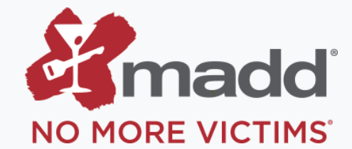
Step 1: Background - Mothers Against Drunk Driving (MADD) is a nonprofit organization in the United States that seeks to stop drunk driving, support those affected by drunk driving, prevent underage drinking, and strive for stricter impaired driving policy, whether that impairment is caused by alcohol or any other drug.

MADD was founded on September 5, 1980, in California by Candace Lightner after her 13-year-old daughter, Cari, was killed by a drunk driver.

Step 2: Drunk-driving crashes in the U.S.

Every day, almost 30 people in the United States die in drunk-driving crashes — that's one person every 50 minutes. These deaths have fallen by a third in the last three decades; however, drunk-driving crashes claim way too many lives each year.

- If 30 people die per day from drunk driving, how many people in the US died from drunk driving accidents in one year (2018). (There are 365 days/year).

- In 1980, just over 18,000 people died in drunk driving accidents.

- How many fewer people died from drunk driving in 2018 compared to 1980?

Step 3: What changed?

States increased the drinking age 18 to 21. In 1975 in over ½ the states, it was legal to drink at the age of 18.

In response to the drunk driving accidents and fatalities of the 1970s, and in large part because of very effective efforts on the part of MADD, the US Congress passed the Minimum Drinking Age Act in July 1984, a law that mandated states increase the drinking age to 21 if they wanted to continue to receive federal highway funds.

By 1988, all 50 states had changed the drinking age to 21.

The charts below shows some key facts related to automobile fatalities over the last 40 years, comparing 1980 to 2018.

Total Automobiles Registered in the US
1980 | 109,000,000
2018 | 276,000,000

Use the data above to complete the charts below and to answer the related questions…
Draw a line graph using the two points identified to show how the number of registered automobiles in the US changed between 1980 and 2018.
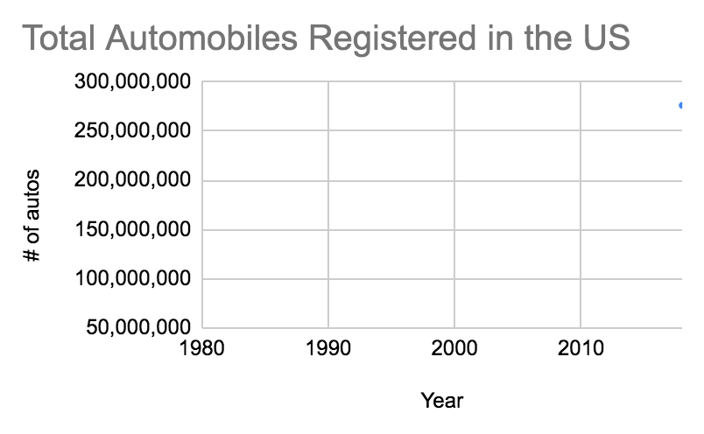
- What does this line indicate?

US Fatalities: Auto | Total | Alcohol Related
1980 | 30000 | 18000
2018 | 28,571 | 10000

Draw a double line graph (two lines) how the number of automobile deaths and alcohol-related automobile deaths changed between 1980 and 2018, using the data from the chart above.
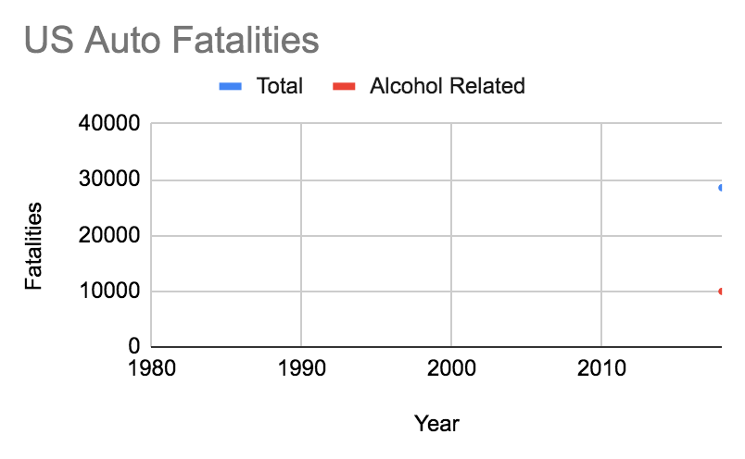

- What do these lines indicate?

- How do they compare to the number of registered cars?

US Fatalities: Auto, Ages 16-20 | Total | Alcohol Related
1980 | 18,000 | 13,500
2018 | 11,429 | 4,571

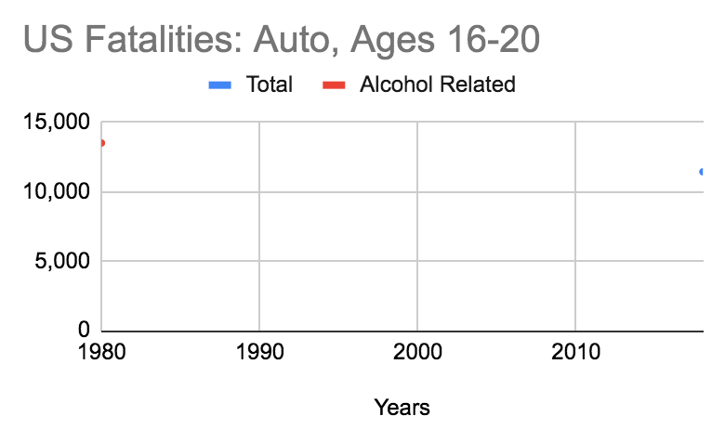
Draw a double line graph (two lines) that shows how the number of automobile deaths and alcohol-related automobile deaths of 16-20 year olds changed between 1980 and 2018 (from the chart above).

What do these lines indicate?

Step 4: Other factors to consider

In addition to changing the legal drinking age, MADD and others have led the charge for other changes related to driving and to drinking and driving.

Discuss/Consider: In your state, how old do you have to be to get your driver’s license? When you first get your license are their restrictions on when you can drive, or who you can drive with?

- Do you know if these same restrictions existed when your parents got their licenses?

Discuss/Consider:
- What is the consequence of getting pulled over and found to be guilty of drunk driving in your state?

- Is this the same penalty that was in place 30 to 40 years ago? Was the punishment more strict or lenient years ago?

Student Feedback:
Circle the emojis that best represents how this activity made you feel.

Day 4: Power in Digital Relationships
Health

What is this lesson about?: In today’s lesson, we will look at digital relationships and how power can travel through technology use and control.

Step 1: Warm-Up In the relationship below do you feel like one person has more power than the other person?

Who’s got the POWER?
Friend one wants to skip school. Friend two says they’re not sure, but after talking about it, gives in and skips school, even though they didn’t really want to.

Who has the POWER? Why?

Step 2: Read about the behaviors below.

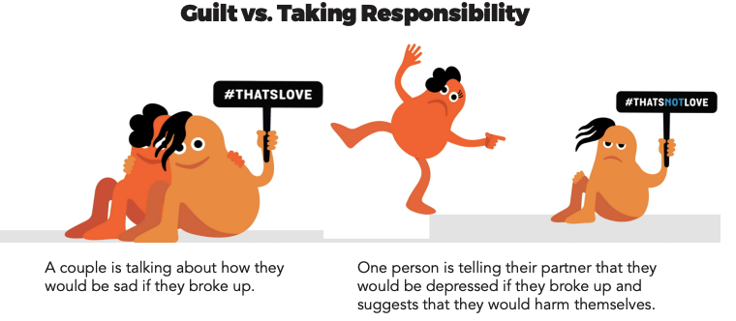

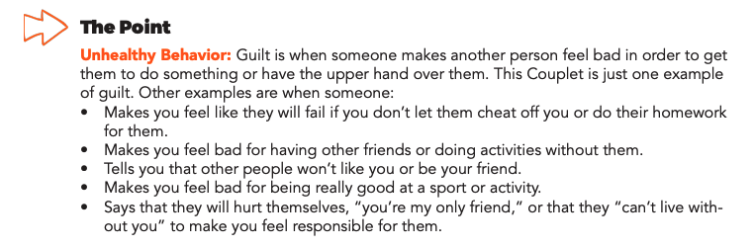
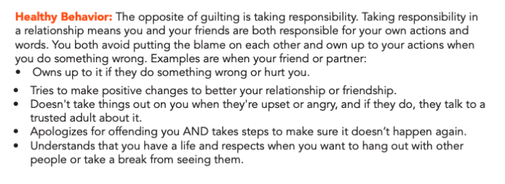

Step 3: Complete the Activity.

Use the two phones below to play out the following scenarios:

Scenario One: One partner usually decides when, where, and what they do together. The other partner says they don’t like making decisions and is fine with this.

Use the phone below to show what this conversation looks like.

Scenario Two: A guy notices his girlfriend is getting a lot more texts than usual. When he mentions it, his girlfriend says he’s imagining things. When she goes to use the bathroom, he checks her phone and reads her texts.

Use the phones below to show who she was texting.

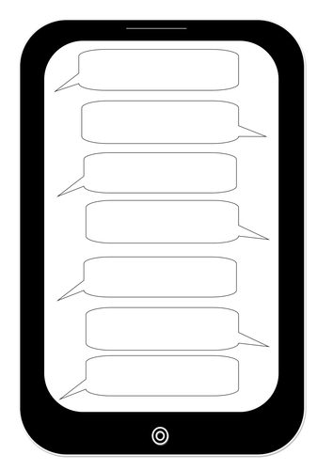

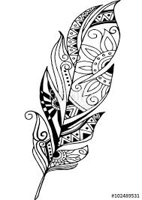
Mindfulness Moment!
Create patterns, shapes, scribbles or whatever comes to mind! It’s that simple.

Day 4: Governmental Powers: Anarchy v. Communism
Social Studies/Civics

What is this lesson about?: Today you will continue exploring different types of government, and will focus on anarchy and communism. Below is a reminder of our Elite 8 bracket. Fill in who you selected to win the face-offs for the last 3 lessons below.

Types of Government Bracket
Monarchy
Oligarchy
Dictatorship
Theocracy
Direct Democracy
Representative Dem.
Communism
Anarchy

Step 1: Compare Anarchy and Communism

Anarchy  In an anarchy, nobody is in control—or everyone is, depending on how you look at it. Sometimes the word anarchy is used to refer to an out-of-control mob. When it comes to government, anarchy would be one way to describe the human state of existence before any governments developed. It would be similar to the way animals live in the wild, with everyone looking out for themselves. Today, people who call themselves anarchists usually believe that people should be allowed to freely associate together without being subject to any nation or government. There are no countries that have anarchy as their form of government. | Communism  Communism is a system of government that puts the power in the hands of ALL the people. The government owns the major industries and shares the money with the people. Its goal is to make poor and rich people equal. Most communist countries are lead by a totalitarian dictator (a leader who has complete control)

Step 2: Read more about anarchy and answer questions

Anarchy
As an American citizen, you are required to respect the mayor and his council at the city level, as well as the police that enforce the laws. You also have to obey the state government's laws and police, and any national laws, treaties, and the FBI.
Anarchy is nothing like that. The word anarchy comes from the Greeks who combined 'an,' meaning not or without, and 'arkhos,' meaning ruler or leader. For them, anarchy was when no one had any authority over anyone else. There would be no laws, no police, nothing.

Philosophers and Anarchy
Starting in the 17th century, anarchy started to get the attention of philosophers. They talked about anarchy, what it was and what it meant. Thomas Hobbes thought of it as man's natural state, where every man had a right to everything he could take, including another person's life or body. In other words, total chaos. His idea is still a popular perception of anarchy to this day.
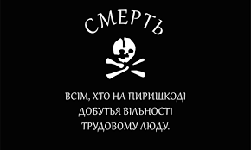
Immanuel Kant, another popular philosopher, believed that people living in an anarchist society could have laws, just with no one to enforce them. For him, it was possible to have people living together without total chaos all the time.
Example of Anarchy
An example of an anarchist state existed from 1918 to 1921 called the Free Territory. The Free Territory was an anarchist state set up in Ukraine by a man named Nestor Makhno. The Free Territory was one of the few states based entirely on anarchist ideas and has a famous flag—a picture of a skull with the words, “Death to all who stand in the way of freedom for working people!” in Ukranian.

With an army of 100,000 men, known as the Black Army, Makhno took over the southeastern section of Ukraine and implemented an anarchist society. The society was structured by establishing worker and peasant organizations where the members voted on specific issues in committees.

Makhno opposed a central government of any kind and instead called together groups of people to discuss national issues that needed debate. In the end, the Russian and Ukranian armies invaded the Free Territory and defeated the Black Army in 1921.

Who has power in an anarchist government? Explain your answer in 3-4 sentences.

Do you think an anarchist government could be successful? Why or why not?

Step 3: Read more about Communism and answer questions

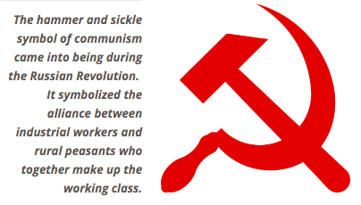
Communism
Visualize a world where everyone has equal amounts of wealth. Everyone has equal amounts of land, equal-sized houses, the same government-issued cars, the same government-issued stoves, the same government-issued cell phones, etc. Although people do different jobs, they all get paid the same. Since everyone is equal, there are no social classes. In fact, there isn't even a need for money. People do not need to fight because all materials are shared in common through the government. Everyone works according to their ability, and everyone receives according to their need. Sounds too good to be true, huh?

The world portrayed here is a communist society. In simple terms, communism is a society in which private property and social class do not exist and the government owns all things necessary to make and transport products.

Marxist Communism
By far the most famous form of communism is Marxist Communism. Based on the writings of Karl Marx, the concept of Marxist Communism became very influential in the 20th century because it inspired the communist revolutions of the Soviet Union, China, Vietnam, Korea, Nicaragua, and Cuba, among others.

Marx believed that the history of the world was about competition between different social classes. In other words, there has always been some small group of people in charge who tells everyone else what to do. That is not to say that the weaker social classes just accept the power of the dominant class, though. Rather, there is always a constant struggle between the social classes.

For Marx, the class in power is made up of people who own factories and businesses. The lower classes are made up by the people who work at the factories. Marx predicted that one day the workers would become so angry with the factory owners they would rise up and overthrow the wealthy class. Then, the workers would create a communist society where all goods were shared publicly and the government owned the factories.
Who has the power in a communist government? Explain your answer in 3-4 sentences

If you had to create a flag for a communist government, what would it look like? You can draw or describe it below.

Step 4: Read about communism in Cuba and reflect

In 1952, General Fulgencio Batista overthrew the government of Cuba, which means he took over control. Fidel Castro was put in prison for 15 years after he planned an uprising to try and force out Batista from office. He left Cuba and went to Mexico. Fidel Castro came back to Cuba in 1956 and fought a battle against the government. In 1958, Fidel Castro forced Batista out of Cuba and Castro became the Prime Minister (leader) of Cuba. Castro introduced Communism to Cuba.

Some people were angry about communism. Many people were forced to leave the country or be imprisoned and many of those people went to the United States to escapr. Communism put the government in control of the economy. Cubans got free public education and free healthcare.

Russia was also a communist country. Russia gave Cuba a lot of money to maintain this system of government. The United States had a conflict with Russia, so the United States stop trading with Cuba, called the trade embargo. In 1991, USSR (Russia) split apart. Russia could no longer give money to Cuba. Cuba had an economic crisis. Many people became poor.

The United States does not like Communism because it is the opposite of Capitalism (where individual businesses control the economy). Also, the United States did not like any country that supported Russia.

When Russia could not help Cuba, maybe people tried to go to the United States illegally in boats. People of Cuba could not speak out against the government. If they say anything bad about the government, there was a chance of going to jail.

After reading about communism in Cuba, do you think Cuba should keep communism? Why or why not?

Step 7: Organize your thoughts
Complete the graphic organizer on the next page to help you compare and contrast Direct and representative democracies. After completing the graphic organizer, you will reflect on these forms of governments and choose which one you prefer.

Step 8: Reflect

Complete the bracket below and choose which type of government you prefer:
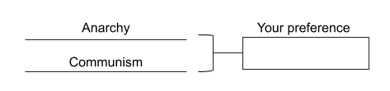

- Why do you prefer that governmental system? (share three reasons)

- How does it compare to the current governmental system you live in now? (share three reasons)

Step 9: Discuss
- With a partner, share and compare your graphic organizer.
- Can you improve your graphic organizer after discussing with your partner?
- Share what you chose as your winner for this bracket face-off and why.

Student Feedback:

Circle the emojis that best represents how this activity made you feel.

Week 5
Power

Day 5

NAME:______________________
Day 5 Agenda

Topic | Activity
Warm-Up!
English Language Arts | - Read the article: 3 Times in History When Students Turned to Activism  - Respond to questions about the article.  - Create a call to action and hashtags to address an issue in their community, nation or world.
Science | - Review the sources of Renewable Energy  - Design a Power Source project - make one of the current renewable energy sources better or design your own renewable energy/power source (BE CREATIVE)
Mindfulness Moment!
Math | - Power: Sports Stars and Power
Health | - Review of power in relationships
Mindfulness Moment!
Civics/Social Studies | - Consider types of governmental powers  - Determine the best type of government

Warm-up Activity: Write a journal entry around the daily quote on identity.
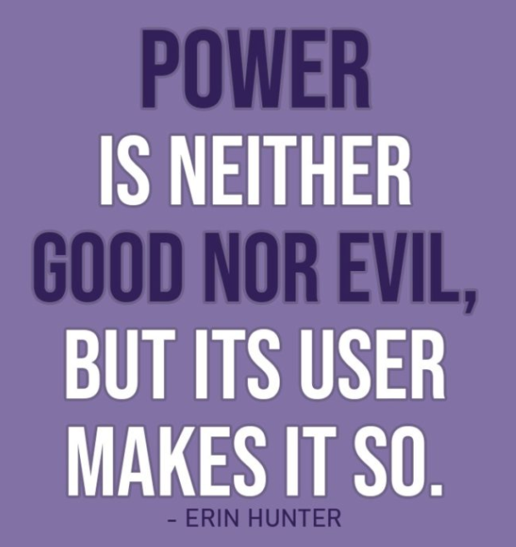

Day 5: Calls to Action—Harnessing the Power of a Movement
English Language Arts

What is this lesson about? Today you will read about how young people have worked to fight against power and have claimed their own power to have a voice in making change. As you read, think about the strategies that these young people used to address issues of power.

Before you Read: Vocabulary to Review
rote: habitual repetition | lobbied: to seek to influence a politician on an issue | incongruity: a difference or inconsistency
albeit: even though | coalesce: to come together | desegregate: to end a policy of racial in segregation
Apartheid: in South Africa a policy or system of laws that enforced segregation or discrimination on grounds of race. | divestment: the process of selling off or removing investments | dismantle: to take apart
laud: to celebrate | prevail: to be victorious

Step 1: Read the Article

3 Times in History When Students Turned to Activism
By Maggie Astor, March 5, 2018
(Article, 7 Times in History When Students Turned to Activism from The New York Times was edited and abridged for space and time constraints)

Every few weeks or months, after a man armed with a high-powered weapon walks into a school or a church or a nightclub and opens fire, the national response plays out in a rote, almost performative way. The outcry lasts only a few days before guns fade back into the background noise of American politics.

But nearly three weeks after a gunman walked into Marjory Stoneman Douglas High School in Parkland, Fla., and killed 17 people with an AR-15, the conversation has not faded, because the students of Stoneman Douglas have taken up the cause of gun control. Already, they have lobbied state lawmakers in Tallahassee, spoken with President Trump and persuaded many companies to cut ties with the National Rifle Association. And on Saturday, they met with students fighting gun violence in Chicago.

Several of those students, and their critics, have noted the incongruity of teenagers getting involved in politics. But history is full of movements led by students — albeit usually in college, not high school. Some were successful and others brutally crushed, but even the latter still resonate. (Most of these campaigns have been liberal-leaning: Though conservative college students have made their presence known, their actions have rarely coalesced into broader movements.)

Here are 3 (abridged) other cases where young people were moved to challenge adult society.
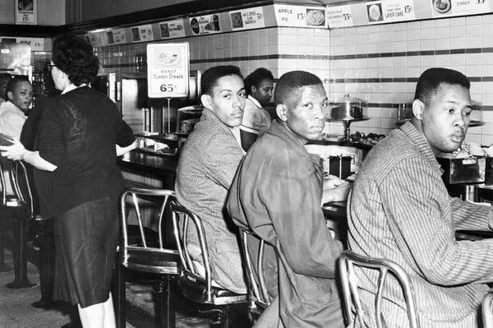
Greensboro Sit-ins, 1960
The lunch counter sit-ins that would change American history began with four teenagers who walked up to a Woolworth’s lunch counter in Greensboro, N.C., and refused to leave.
Those young men — Ezell Blair Jr., 18; Franklin McCain, 19; Joseph McNeil, 17; and David Richmond, 18, all students at North Carolina Agricultural and Technical State University — made their stand on Feb. 1, 1960. Within three days, they were joined by some 300 others. By summer, the sit-ins had spread to more than 50 cities, and lunch counters were rapidly desegregating.

The actions of the so-called Greensboro Four led directly to the creation of the Student Nonviolent Coordinating Committee, which the civil rights organizer Ella Baker urged students to form in April 1960 to coordinate the continuing sit-ins. Later, SNCC would play a major role in the Freedom Rides and in voter registration efforts across the South. And the momentum that began at the Woolworth’s lunch counter would eventually contribute to the passage of the Civil Rights Act of 1964, which outlawed segregation in public spaces.
Perhaps more than anything, the results of the Greensboro sit-ins showed the power of a small group of students prepared to stand alone if necessary.

“Inevitably, people ask me, ‘What can I do?’” Mr. McCain said in an interview in 2005. “What kind of question is that? Look around you. Once you identify what you want to do, don’t ask for the masses to help you, because they won’t come.”

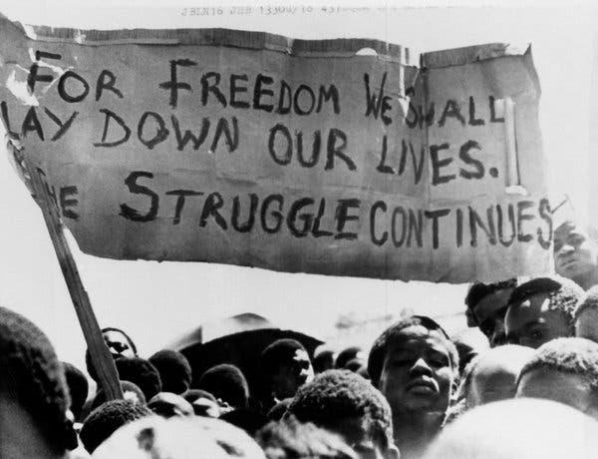
Apartheid Divestment, 1970s-80s
As with the Greensboro sit-ins 16 years earlier, the uprising started by public school students in Soweto, South Africa, would expand far beyond them.
On June 16, 1976, several thousand students near Johannesburg began a peaceful march that turned deadly when the police attacked with guns and tear gas. The protesters were objecting to a law that mandated Afrikaans-language education, but they set in motion a global movement against apartheid. Images of police brutality — particularly a photograph of a high school student carrying the body of Hector Pieterson (12 or 13 years old; accounts differ) — drew international attention to the broader cruelty of South Africa’s government.

From the actions of the students of Soweto grew a vast campaign led by college students in the United States, who built shantytowns on campus quads, blockaded buildings and disrupted speeches by South African politicians. From Columbia University to the University of California, protests compelled administrators to withdraw billions of dollars in investments from companies tied to South Africa. Over time, the resulting economic stress contributed, along with other factors, to the dismantling of apartheid.

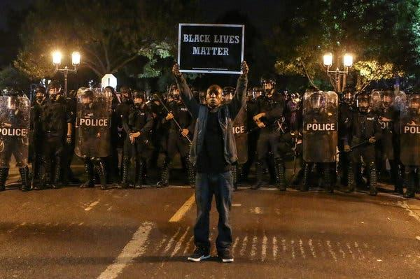
Black Lives Matter, 2013-present
The Black Lives Matter movement began with three women in their late 20s and early 30s: Patrisse Cullors, Alicia Garza and Opal Tometi. But when it exploded into national view in 2014 after the police killing of Michael Brown, 18, many of the protesters who filled the streets of Ferguson, Mo., were students.
Like the students of Parkland, they were protesting gun violence — but by the police, often involving unarmed black suspects, in shootings captured on video. Unlike the students of Parkland, they were not lauded in the prevailing public narrative, a discrepancy that some Black Lives Matter activists have noted in recent weeks. Instead, they were frequently labeled troublemakers and thugs.
But even as questionable police shootings happen, convictions of officers remain rare, and protests on the streets continue, Black Lives Matter has had a fundamental impact on the national conversation about racial bias and the use of excessive force by the police.

Step 2: Answer the following questions

- What were the young people in the Greensboro Sit-Ins protesting?

- Explain the quote by Franklin McCain of the Greensboro Sit-Ins when he says, “Once you identify what you want to do, don’t ask for the masses to help you, because they won’t come”

- What were college students able to pressure their schools to do that began to end the system of Apartheid in South Africa?

- How was the response to the Black Lives Matter movement different from the way that the public responded to the student protestors from Parkland, Florida?

Step 3: Create a Call to Action and Hashtag

As you have read and learned about this week, people have fought against and for power in many different ways, from dance and art to music and marching and protesting. In an article for WIRED Magazine, Bijan Stephan wrote about another tool that is being used to “Fight the Power” in this modern age.

“If you’re a civil rights activist in 2015 and you need to get some news out, your first move is to choose a platform. If you want to post a video of a protest or a violent arrest, you put it up on Vine, Instagram, or Periscope. If you want to avoid trolls or snooping authorities and you need to coordinate some kind of action, you might chat privately with other activists on GroupMe. If you want to rapidly mobilize a bunch of people you know and you don’t want the whole world clued in, you use SMS or WhatsApp. If you want to mobilize a ton of people you might not know and you do want the whole world to talk about it: Twitter.”

We have seen many examples of this, from the hashtag #BlackLivesMatter to the way Facebook was used to organize protestors in Egypt during Arab Spring—a string of anti-government protests that took place across much of the Arab world in the early 2010’s.

Today, you will think about a social issue that is affecting your community, your country or the world.

You will create a “call to action” of what you want people to do about the issue.
In order to do this, keep it simple,.

Write a headline.
All of your calls to action headlines should contain:
- A specific pain or consequence if action is not taken OR a specific benefit that will occur once action is taken
a. Pain or consequence example: “800,000 Monarch butterflies will die unless…”
b. Benefit example: “…over 16,000 new clean-water wells will be dug…”

2. A number
The number you use can either quantify the consequence (“800,000 dead butterflies”), the benefit (“16,000 new wells”), your objective (“We’re collecting 10,000 signatures”), or your timeline
(“…in 30 days…”)
3. A timeline
a. You have several options here that you can map your timeline to:
i. A timeframe for you put your goal into action (“Help us donate 400 books to the library for residents to read over the next four months”)
ii. A legislative lifecycle (“Stop the bill before it reaches the full House floor”),
iii. The legislative calendar (“Tell Congress to act before they head to recess”),
iv. An external event (“This Mother’s Day, call the governor and demand he take action.”)

Example: With students out of school because of Covid-19, over 50,000 students in El Paso do not have access to the internet and cannot participate in online learning. Without this access, students will fall further and further behind and will not be prepared for the challenges of school next year. This May 1st, call the governor and demand that he fund districts so we can provide 100 School Bus hotspots in the communities that need them. #AccessLearningHotSpots

Now it is your turn:

What is an issue you want people to take action on?

_______________________________________________________

Create your Headline: A specific pain or consequence if action is not taken OR a specific benefit that will occur once action is taken

A number: The number you use can either quantify the consequence (“800,000 dead butterflies”), the benefit (“16,000 new wells”), your objective (“We’re collecting 10,000 signatures”), or your timeline (“…in 30 days…”)

A timeline:

Now put it all together:

Finally, create a hashtag that could be spread via Twitter or other social media that would summarize your call to action.

#

Step 4: Share out
Share your call to action with someone in your group or with the whole group.

Student Feedback:

Circle the emojis that best represents how this activity made you feel.

Day 5: Design your own Power Source
Science

What is this lesson about?: Today you will review this week’s readings on renewable energy. You will design your own Power Source.

Step 1: Review this week’s readings about renewable energy

Step 2: Design your own Power Source

As you think about what you read and learned this week regarding renewable energy and power sources, design a power source - either make one of the systems you learned about better or design your own power source.

- Design a draft of your Power Source:

- Questions to think about:
What is a renewable resource?
What is the process it goes through to change into usable energy?
What are the benefits or disadvantages of this type of energy?
What are the best locations to make use of this renewable energy source?
How would your energy/power source benefit your community?
If applicable, how would your energy/power source benefit the world?

- Use a separate sheet of paper to design your power source and be prepared to share your design with your class.

Step 3: Reflect

As you think about this week’s science lessons, what’s one thing you will remember about renewable energy or natural power?

Student Feedback:
Circle the emojis that best represents how this activity made you feel.

Mindfulness Moment!

What do I need to believe/think/feel in order to achieve what I want?

Day 5: Power and Sports
Math

What is this lesson about? Today’s lesson covers a few diverse sports topics, each of which poses questions about Power.

Activity 1: The Power behind Zion Williamson

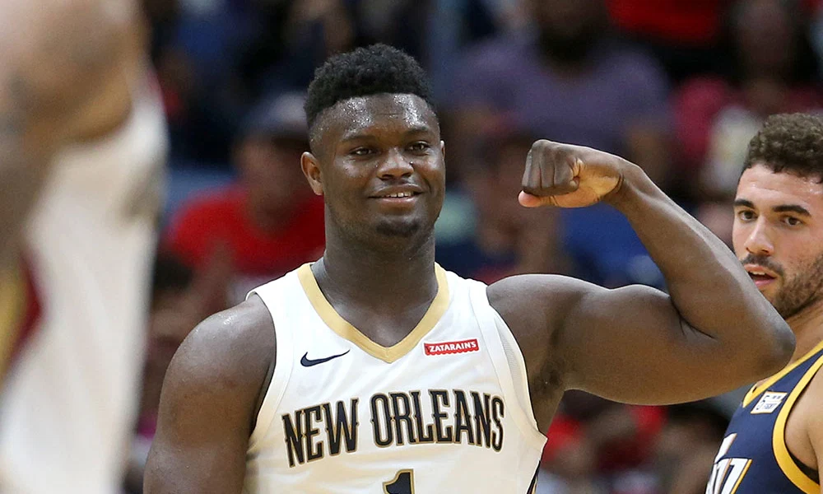

This chart shows the number of season ticket holders (rounded off) to the New Orleans Pelicans in 2010-11, 2015-16, and 2019-20 seasons.

Year | # of Season Tickets Sold | Average price per ticket
2010 | 8,500 | $80
2015 | 9,000 | $110
2019 | 14,000 | $140

- How many more season ticket-holders were there for the 2019-20 season compared to the 2010-11 season?
- The average season ticket ticket sold for _______ in 2015-16. In 2019-20, the average season ticket package sold for _______.
  - Approximately how much more money did the Pelicans take in in season tickets in 2019-20 compared to 2015-16? (Be careful, these are big numbers)

This chart shows the number of times the Pelicans were shown on national TV in 2015-16 compared to scheduled (cancelled both because of his injury and COVID-19) in 2019-20.

Year | Number of National TV Games
2015-16 | 1
2019-20 | 8

- Assume that as a part of its revenue-sharing agreement with the NBA that the Pelicans earn $3.5 million for each nationally televised game.

- How much more were the Pelicans scheduled to earn this year than in 2015-16 from these games?

Very soon after the NBA announced that it was cancelling/postponing the season, Zion Williamson announced that he would pay the salary for one month for the workers at the Smoothie Center who would not be working because of the cancelled games. Use the following information to answer the questions below.

Number of home games scheduled for March, 2020: 7
Average number of game day staff for Pelicans game: 320
Average number of hours worked (includes set-up, clean-up): 9
Average hourly wage + benefits: $11.00 per hour

- Approximately how much does it cost per game to employ the staff at the Smoothie Center?

- Over the month of March, how much money was Zion going to contribute to support the workers for these 7 games?

Consider/Discuss: Read Zion’s instagram post, below..
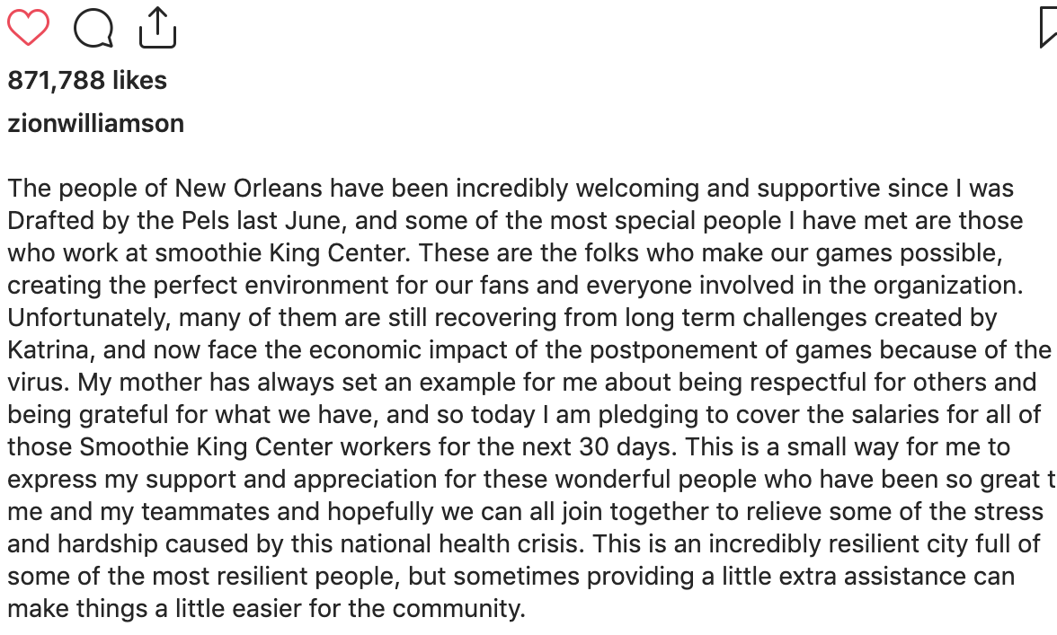
Zion Williamson pledged to support the staff before the owners of the Pelicans did. What do you think about that?

Activity 2: The Power of the 3-point shot
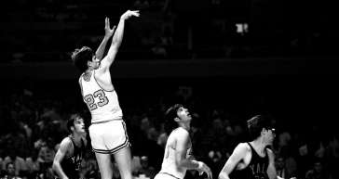
Way back in the late 1970s, a guy named Pete Maravich averaged over 44 points a game playing for Louisiana State University for the season. He remains the highest scoring player ever in college.

Back then, there was not a three point shot.
Using the chart below, calculate…

Opponent | Points scored | Free throws made | 2 pointers made | 2 pointers made behind current 3 point line
Georgia | 64 | 12 | 26 | 8
Kentucky | 41 | 11 | 15 | 4
Yale | 37 | 9 | 14 | 5
Vanderbuilt | 50 | 8 | 21 | 7

- What was his average for these 4 games?

- How many points he would have averaged in the 4 games below if he had taken the same shots but there was a 3-point line? (Be careful-you will need to find how many 2-pointers and how many 3-pointers he would have made in each game)

Discuss/consider: If there actually was a 3-point line, do you think Pete Maravich would have changed his shot selection and taken some different shots than he did?

Activity 3: The Power of Patrick Mahomes left arm

Many of you have seen replays of Patrick Mahomes scrambling around in the backfield and then flicking an incredible pass down the field. You might have also noticed that over the past two years, he shows up on a lot more TV commercials…

Use the information below to answer the questions-

Mahomes current contract (signed in 2017):
Contract length: 4 years
Contract amount: $26,000,000

Aaron Rodgers current contract: 4 years
Contract amount $84,000,000

- Currently how much is Mahomes paid per year?

- One way to look at that is to say that he works full-time and makes that salary over a year. If you rounded off and said that he works 50 weeks in a year, what is his weekly salary?

- Another way to look at this is to say that he gets paid to play in 17 regular season games. If you round it off that way, about how much does he get paid for each regular season game?

- How much does Aaron Rodges make per year currently?

Consider/discuss:
- Why does Aaron Rodgers make so much more than Patrick Mahomes?

- After the 2021 season, Mahomes’ 4-year contract will expire. Based on Aaron Rodgers’ current salary, what is your estimate for how much Mahomes will earn per year in his next contract?

Activity 4: The Power of Carli Lloyd’s leg

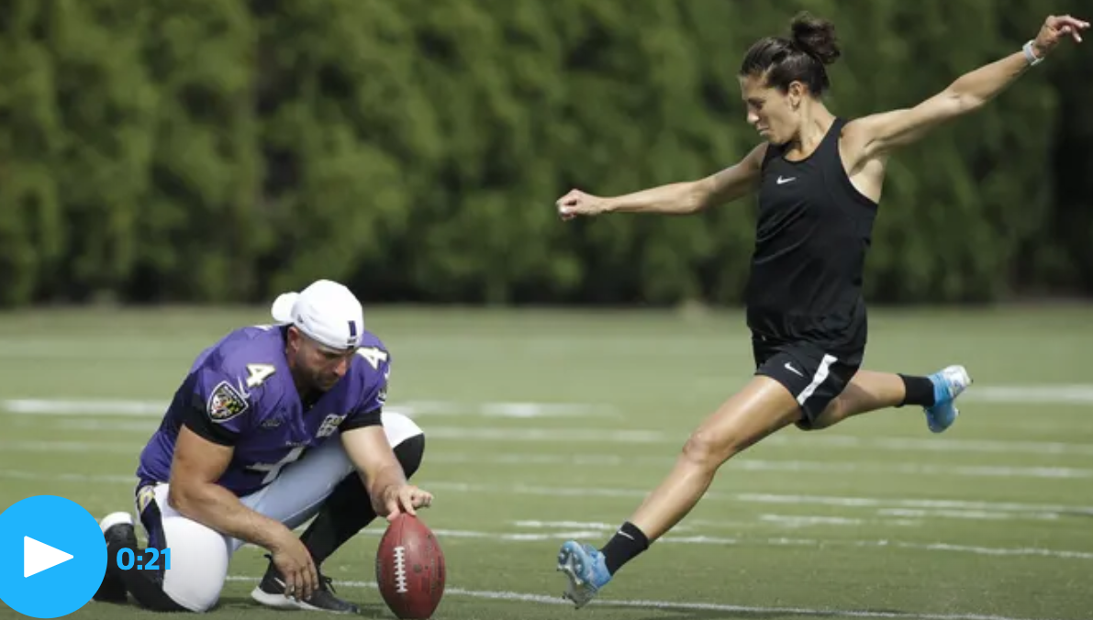
Carli LLoyd is one of the best female soccer players in the world. She may now be 2-3 years past her prime, but she is a 2x FIFA World Player of the Year, a 2x World Cup Champion, and a 2x Olympic Gold Medalist.

Over the course of her career, her annual earnings ranged from approximately $80,000 per year to $350,000 (the last 1-2 years of her career). Overall, it is estimated that she earned approximately $240,000 per year on average for the last 5 years. Her earnings for 2020 (before the COVID-19 outbreak) were estimated to be $290,000.

Last year, a video of her kicking field goals with some Philadelphia Eagles players went viral, prompting many people to encourage her to focus on field goal kicking and try out for an NFL team.

The chart below shows the salaries last year for 10 NFL kickers (2nd column). The 3rd column indicates if their contract is guaranteed beyond the current year.

Player ▾ | Avg./Year | Total Guaranteed
Adam Vinatieri | $3,875,000 | $2,000,000
Aldrick Rosas | $3,259,000 | $0
Austin Seibert | $695,114 | $260,456
Brandon McManus | $3,751,333 | $8,250,000
Brett Maher | $660,000 | $0
Chase McLaughlin | $585,000 | $0
Chris Boswell | $4,201,500 | $7,295,000
Dan Bailey | $3,333,333 | $6,000,000
Daniel Carlson | $750,000 | $0
Dustin Hopkins | $2,525,000 | $1,201,072

Round off the annual salary numbers above and then answer the following questions-
- What is the average annual salary of the 10 kickers above?

- How does that compare with Carli Lloyd’s average salary over the last 5 years?

- What percent of the NFL kickers have guaranteed contracts?

Discuss/Consider:
- If you were Carli Lloyd, would you consider giving up your soccer career to practice full-time to see if you could make it as a NFL kicker? Why/Why not?

- Why do NFL kickers (who only kick a handful of times per game) make more money than most of the best women professional soccer players? Is this fair?

Student Feedback:
Circle the emojis that best represents how this activity made you feel.

Day 5: Who has the POWER?
Health

What is this lesson about?: In today’s lesson,

Step 1: Warm-Up In the relationship below do you feel like one person has more power than the other person?

Who’s got the POWER?
A friend asks you to come with them everywhere they go. You really enjoy their company. Lately, you have had a lot of homework and can’t hang out as often. He just won’t take no for an answer and keeps bugging you until you agree to go.

Who has the POWER? Why?

Step 2: Read about the behaviors below.
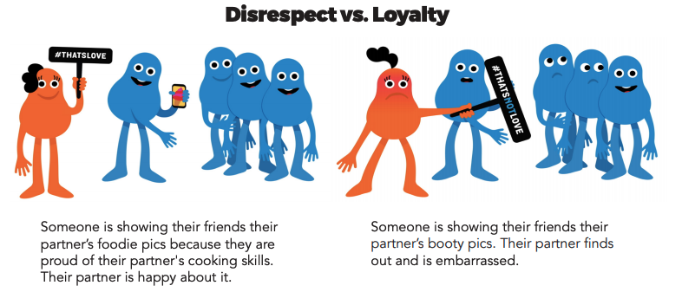
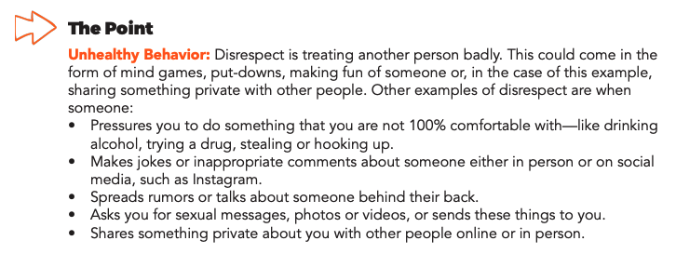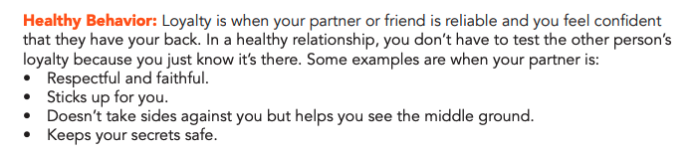
Step 3: Complete the Activity.

Over the course of this week, you learned about some behaviors that lead to unhealthy relationships. Using the list below, write a story, design a comic, or draw a picture that digs deeper into one of these behaviors below.
- Intensity
- Put-downs
- Anger
- Guilt
- Disrespect

Mindfulness Moment!

What memory brings me joy? (write or draw)

Day 5: Governmental Powers: What’s the best type of government?
Social Studies/Civics

What is this lesson about?: So far this week, you have looked at 8 types of governments. Today you will review those governments and determine which one is the best and will win your bracket.

Step 1: Review types of government
Monarchy: Ruled by a king or queen | Oligarchy: A small group of people having control of a country,
Theocracy: Leader has authority given by god | Dictatorship: One leader has absolute control over citizens’ lives
Anarchy: No central government | Communism: When everything is owned by the government and all people are considered equal
Direct Democracy: The people decide on policy initiatives directly | Representative Democracy: Elected officials representing a group of people

Use these definitions to identify the form of government in the examples below.
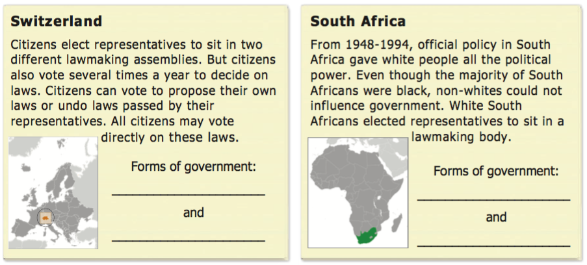

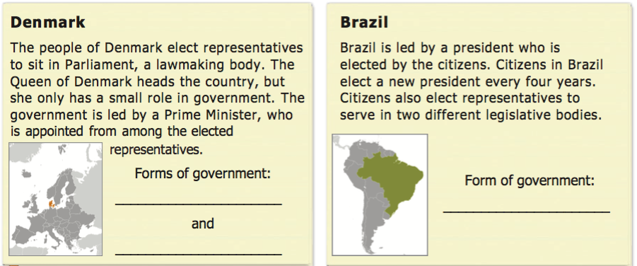
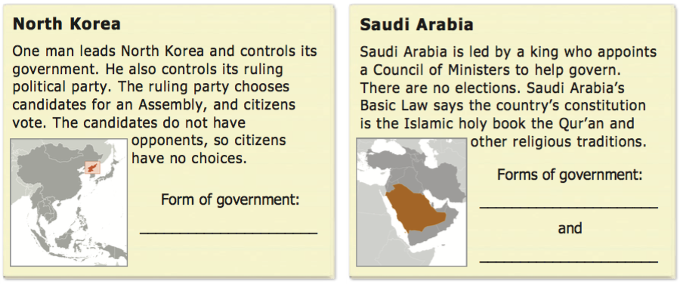
Step 2: Fill in your bracket!
Fill in the squares in the bracket below with the types of government you chose in previous lessons. Then, make a choice again to eliminate two more and identify your top two types of government!

Types of Government Bracket
Monarchy
Oligarchy
Dictatorship
Theocracy
Direct Democracy
Representative Dem.
Communism
Anarchy

Step 3: Final face-off

What are your top two types of government based on the bracket?

Based on those two, make your final determination… what do you think is the best type of government?

Your bracket winner!!! _____________________________________

Why did you choose this as the best type of government? Provide three reasons.

Create a word art for your selected type of government on the next page. Below is an example of a word art. You can just use words that help to describe the type of government, or you can make it into a shape or design as well.

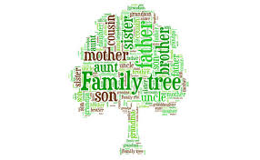
(example word art for ‘family tree’)

Create your word art here!

Step 3: Discuss!
With a partner or as a class discuss the following questions
- Share what type of government won your bracket and why.
- Did you have similar answers?
- Were there any types of government that you immediately eliminated from the bracket? Why?
- Who holds the power in the government you chose? Why does that matter?
- If you lived in the type of government you chose, what political power would you have?

Student Feedback:

Circle the emojis that best represents how this activity made you feel.

