Week 2
Environment

Day 3

NAME:______________________

Day 3 Agenda
Topic | Activity
Warm-Up!
English Language Arts | - Answer the question is home is an environment  - Read a text and respond to questions  - Write a letter home
Science | - Read the article, India’s poorest ‘fear hunger may kill us before coronavirus’  - If you had to choose between hunger and coronavirus, what would you choose  - Make recommendations to India’s government so that no one has to choose between hunger and coronavirus
Mindfulness Moment!
Math | - More on cars. What does it mean to pay off a car monthly vs all cash? What does it mean to Lease a car? What is all of that gasoline costing ‘us’?  - Practice: Fractions and Decimals
Health | - Sleep Journal  - Tips for good sleep
Civics/Social Studies | Environmental Racism  - Read and interpret data in map  - Respond to related questions  - Write an opinion response about the topic
P.E.

Warm-up Activity: You will determine the conditions of the story by filling in the blank and writing the rest of the story.
I turned around and shrugged, I had to go to ____________ in the morning, I had no choice.

Day 3: Is Home an Environment?
English Language Arts

What is this lesson about?: Today you will explore what home means to you. You will also read a text written by Gwendolyn Brooks that focuses on the importance of home. You will then have an opportunity to write a letter home.

Step 1: Warmup

What is home for you?

How would you describe your home if it was the setting of a story about you? Write a short paragraph describing it.

Do you consider your home to be an “environment”? Why or why not?

Step 2: Read the text

Read this chapter from a book entitled Maud Martha by Gwendolyn Brooks. Think about how the girls and their mother feel about Papa and their home, and then answer the questions that follow.

Home
By Gwendolyn Brooks

Mama, Maud Martha and Helen rocked slowly in their rocking chairs, and looked at the late afternoon light on the lawn, and at the emphatic iron of the fence and at the poplar tree. These things might soon be theirs no longer. Those shafts and pools of light, the tree, the graceful iron, might soon be viewed possessively by different eyes.
Papa was to have gone that noon, during his lunch hour, to the office of the Home Owners’ Loan. If he had not succeeded in getting another extension, they would be leaving this house in which they had lived for more than fourteen years. There was little hope. The Home Owners’ Loan was hard. They sat, making their plans.
“We’ll be moving into a nice flat somewhere,” said Mama. “Somewhere on South Park, or on Michigan, or in Washington Park Court.” Those flats, as the girls and Mama knew well, were burdens on wages twice the size of Papa’s. This was not mentioned now.
“They’re much prettier than this old house,” said Helen. “I have friends I’d just as soon not bring here. And I have other friends that wouldn’t come down this far for anything, unless they were in a taxi.”
Yesterday, Maud Martha would have attacked her. Tomorrow she might. Today she said nothing. She merely gazed at a little hopping robin in the tree, her tree, and tried to keep the fronts of her eyes dry.
“Well, I do know,” said Mama, turning her hands over and over, “that I’ve been getting tireder and tireded of doing that firing. From October to April, there’s firing to be done.”
“But lately we’ve been helping, Harry and I,” said Maud Martha. “And sometimes in March and April and in October, and even on November, we could build a little fire in the fireplace. Sometimes the weather was just right for that.”
She knew, from the way they looked at her, that this had been a mistake. They did not want to cry.
But she felt that the little line of white, somewhat ridged with smoked purple, and all that cream-shot saffron, would never drift across any western sky except that in back of this house. The rain would drum with as sweet a dullness nowhere but here. The birds on South Park were mechanical birds, no better than the poor caught canaries in those “rich” women’s sun parlors.
“It’s just going to kill Papa!” burst out Maud Martha. “He loves this house! He lives for this house!”
“He lives for us,” said Helen. “It’s us he loves. He wouldn’t want the house, except for us.”
“And he’ll have us,” added Mama, “wherever.”
“You know,” Helen sighed, “if you want to know the truth, this is a relief. If this hadn’t come up, we would have gone on, just dragged on, hanging out here forever.”
“It might,” allowed Mama, “be an act of God. God may just have reached down, and picked up the reins.”
“Yes,” Maud Martha cracked in, “that’s what you always say – that God knows best.”
Her mother looked at her quickly, decided the statement was not suspect, looked away.
Helen saw Papa coming. “There’s Papa,” said Helen.
They could not tell a thing from the way Papa was walking. It was the same dear little staccato walk, one shoulder down, then the other, then repeat and repeat. They watched his progress. He passed the Kennedys’, he passed the vacant lot, he passed Mrs. Blakemore’s. They wanted to hurl themselves over the fence, into the street, and shake the truth out of his collar. He opened his gate – the gate- and still his stride and face told them nothing.
“Hello,” he said.
Mama got up and followed him through the front door. The girls knew better than to go in too.
Presently Mama’s head emerged. Her eyes were lamps turned on.
“It’s all right,” she exclaimed. “He got it. It’s all over. Everything is all right.
The door slammed shut. Mama’s footsteps hurried away.
“I think,” said Helen, rocking rapidly, “I think I’ll give a party. I haven’t given a party since I was eleven. I’d like some of my friends to just casually see that we’re homeowners.”
Step 3: Answer the questions

Where does this story take place? What is the setting?

The story is entitled “home.” Why do you think the author chose this title?

How does Maud Martha feel about their home? Write down two quotes that helped answer this question.

Consider this quote from the text:
“He lives for us,” said Helen. “It’s us he loves. He wouldn’t want the house, except for us.” “And he’ll have us,” added Mama, “wherever.”
What do you think Mama means when she says “He’ll have us wherever”?

Is there a difference between a house and a home?

What is the conflict in the story? What are they waiting to hear back about from Papa?

How does the story end? Is it a happy ending?

Share and compare your answers with a classmate.

Step 4: Write Home

Just like Mama implies, family and loved ones can stay connected no matter where they are in space or time, whether they are physically together or not.
Write a letter home to a loved one and tell them what home means to them. How are they a part of your home?

Student Feedback:

Circle the emojis that best represents how this activity made you feel. | 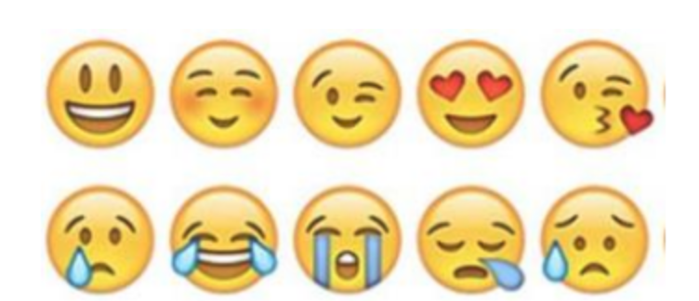  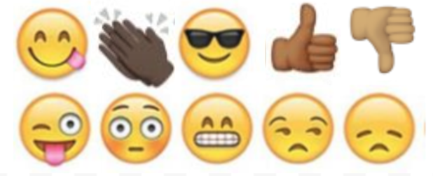

Day 3: Science
Environment

What is this lesson about?: Today you will read the article, India’s poorest ‘fear hunger may kill us before coronavirus’. You will respond to the questions at the end of the article.

Step 1: Read the article
As you read through this article, circle anything that you are able to make a connection with and underline anything that you read that you wonder about or have questions.

India’s poorest ‘fear hunger may kill us before coronavirus’
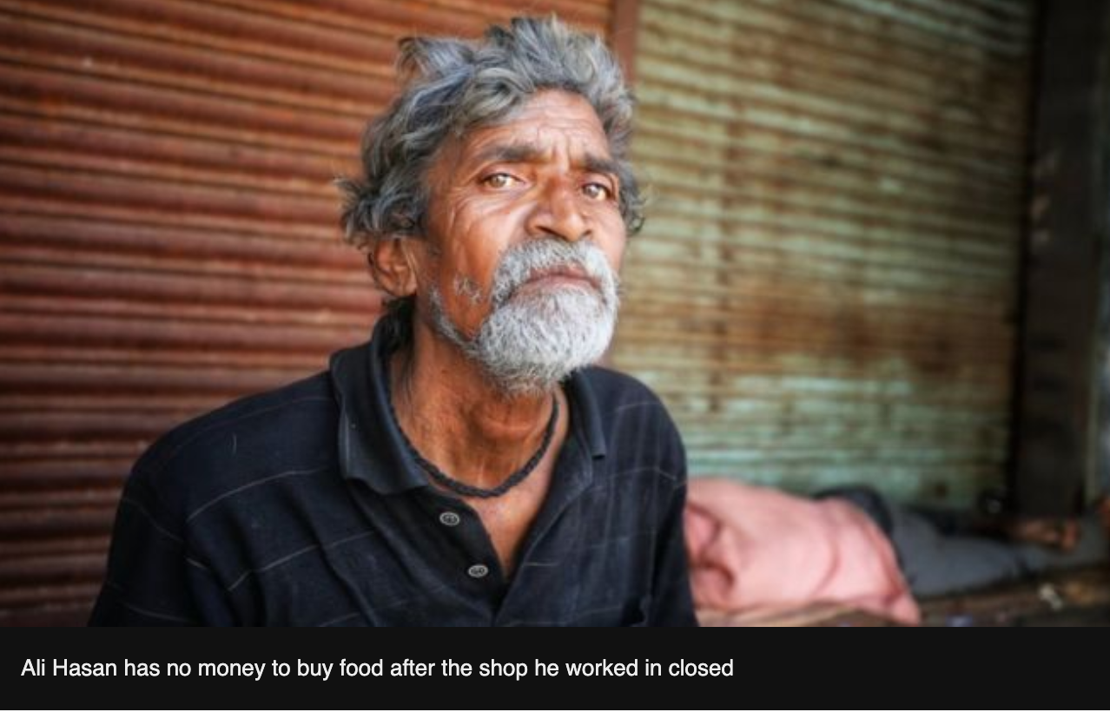
BBC News March 25, 2020India has been put in lockdown to halt the spread of the coronavirus outbreak. People have been told to stay indoors, but for many daily-wage earners this is not an option. The BBC's Vikas Pandey finds out how they were coping in the days leading up to Tuesday's announcement.
Labour Chowk in Noida is usually brimming with hundreds of men looking for jobs as construction labourers.
The small intersection of roads in this suburban area of Delhi is a hotspot where builders come to hire workers.
But it was eerily quiet when I drove there on Sunday during the initial lockdown. Everything was still - one could never imagine listening to the sound of birds chirping in such a busy area.
But I did - almost in disbelief.
I soon spotted a group of men huddled in a corner.
I stopped and asked them, from a safe distance, if they were following the lockdown.
Ramesh Kumar, who comes from Banda district in Uttar Pradesh state, said that he knew "there won't be anybody to hire us, but we still took our chances".
"I earn 600 rupees ($8; £6.50) every day and I have five people to feed. We will run out of food in a few days. I know the risk of coronavirus, but I can't see my children hungry," he said.
Millions of other daily-wage earners are in a similar situation. The lockdown announced by Prime Minister Narendra Modi on Tuesday evening means they are now facing no prospect of income for the next three weeks. The likelihood is, some will run out of food in the coming days.
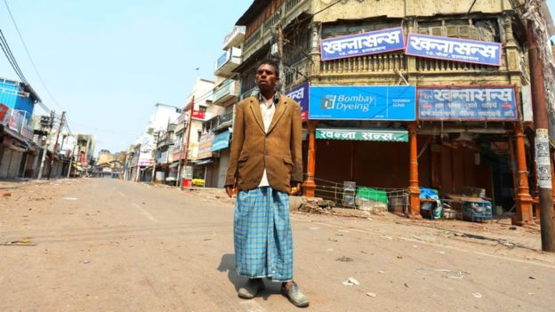
India has reported more than 500 confirmed cases and at least 10 people have died.
Several state governments, including Uttar Pradesh in the north, Kerala in the south and the national capital Delhi, have promised direct cash transfers into the accounts of workers like Mr Kumar. Prime Minister Modi's government has also promised to help daily-wage earners affected by the lockdown.
Kishan Lal - a rickshaw puller in the northern city of Allahabad - has earned no money in four days
But there are logistical challenges.
At least 90% of India's workforce is employed in the informal sector, according to the International Labour Organization, working in roles like security guards, cleaners, rickshaw pullers, streets vendors, garbage collectors and domestic helps.
Most do not have access to pensions, sick leave, paid leave or any kind of insurance. Many do not have bank accounts, relying on cash to meet their daily needs.
Lots are migrant workers, which means that they are technically residents of a different state to the one where they work. Then there is the problem of the floating population: people who do not live in any state for a long period as they move around to find work.
Akhilesh Yadav, the former chief minister of Uttar Pradesh, admits these challenges are huge, acknowledging that "nobody in any government has faced them before".
"All governments need to act lightning fast because the situation is changing every day. We need to activate big community kitchens and deliver food to people who need it. We need to hand out cash or rice and wheat - irrespective of who comes from which state," he said.
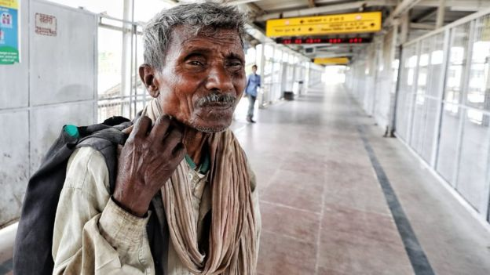
This cobbler - who did not give his name - did not know why the station was empty
Mr Yadav is particularly worried about his state, which is India's most populous, with an estimated 220m residents.
"We have got to stop people from travelling to one city from another to avoid community transmission. And one way of doing is to ensure food security. People rush to their villages in times of crisis," he added.
Uttar Pradesh chief minister Yogi Adityanath has said that a team of workers was tracking those who have arrived from other states and everybody who needs help will be supported by his government.
Indian Railways has now suspended all passenger services until 31 March.
But just days before the suspension kicked in on 23 March, hundreds of thousands of migrant workers travelled in packed trains from outbreak-hit cities like Delhi, Mumbai and Ahmedabad to their villages in Uttar Pradesh and Bihar states.
That has heightened the risk of community transmission and experts fear that the coming two weeks are the most challenging for India.
However, not everybody could afford to travel to their villages.
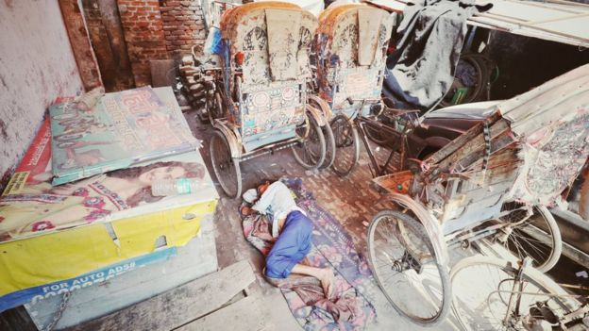
Kishan Lal, who works as rickshaw puller in the northern city of Allahabad, said he had not made any money in the past four days.
"I need to earn to feed my family. I have heard that the government is going to give us money - though I have no idea when and how," he said.
His friend Ali Hasan, who works as a cleaner in a shop, said he had run out of money to buy food.
"The shop shut down two days ago and I haven't been paid. I don't know when it will open. I am very scared. I have a family, how am I going to feed them?" he asked.

Step 2: Answer the following questions

If you had to choose between hunger or potentially getting the coronavirus, what would you choose and why?

What recommendations would you make to India’s government so that no one has to choose between hunger or sickness?

Step 3: Reflection

What was the biggest connection you made to this article?

Student Feedback:

Circle the emojis that best represents how this activity made you feel.

Mindfulness Moment! Respond to your Mindfulness card in the box below.
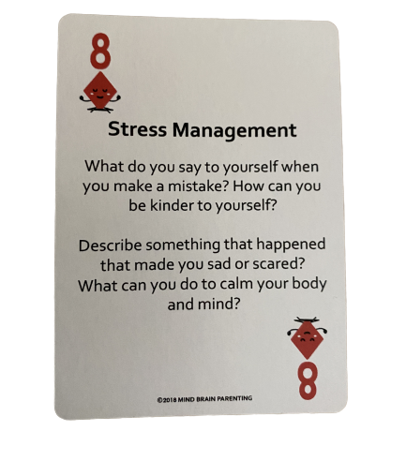

Day 3: Cars, again!
Math

What is this lesson about?: Today we are going to continue to look at cars and the cost of owning and driving cars.

Today’s Warm-Up
Cars and more…New Tires vs Old Tires. What’s a better deal?
The tires on your car are worn thin.
The table below has some possible options that you find online and by talking w/ your cousin who knows someone who owns a used tire shop

Tire | Cost | Guaranteed # of Miles
Michelin’s Best | $100 per tire | 25,000
Costo Basic | $70 per tire | 20,000
Used from your Cousin | $50 per tire | No guarantee; he says they are ‘almost new’

If you need 4 new tires, how much will a full set of Michelin tires cost?
How about the Costco Basic?
How about the tires from your Cousin?

Which set of tires should you buy? What is the main reason for your decision?
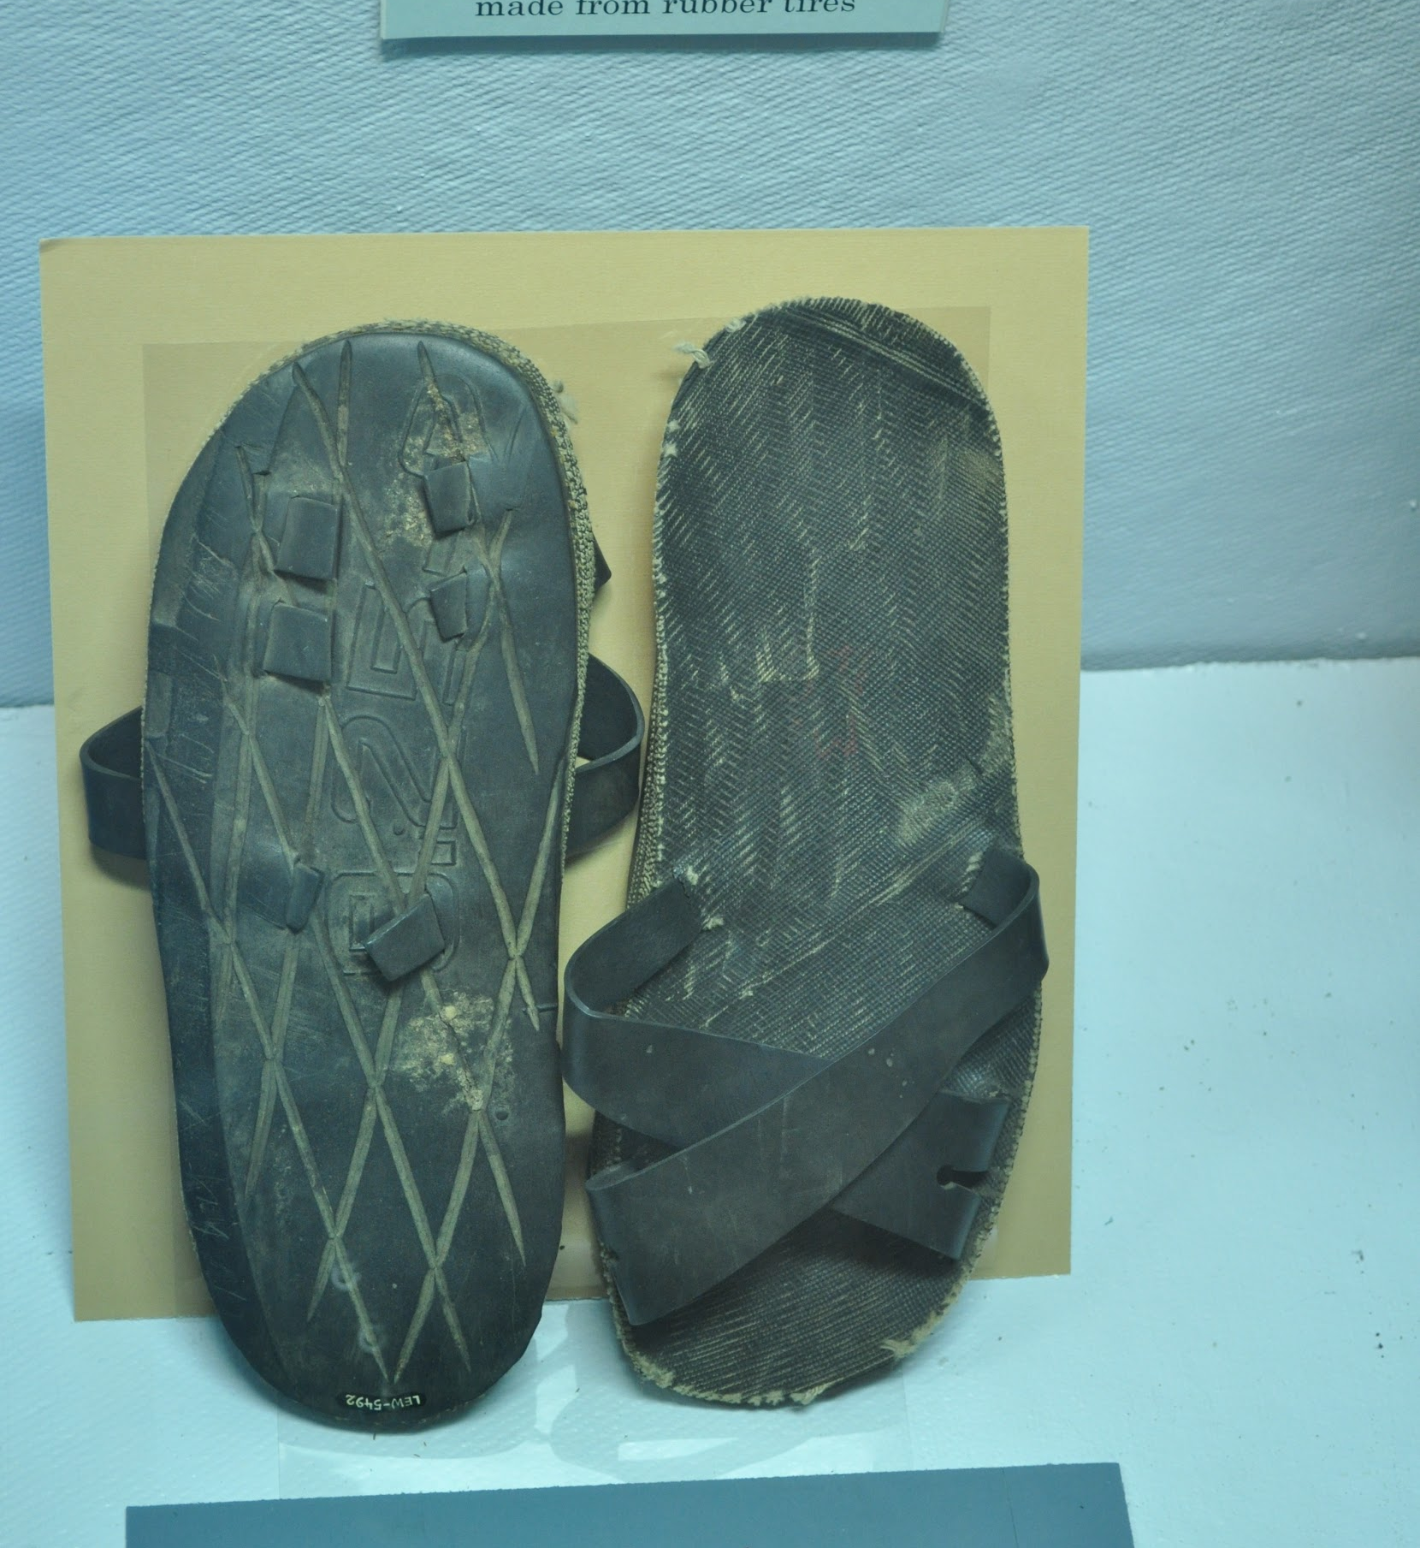
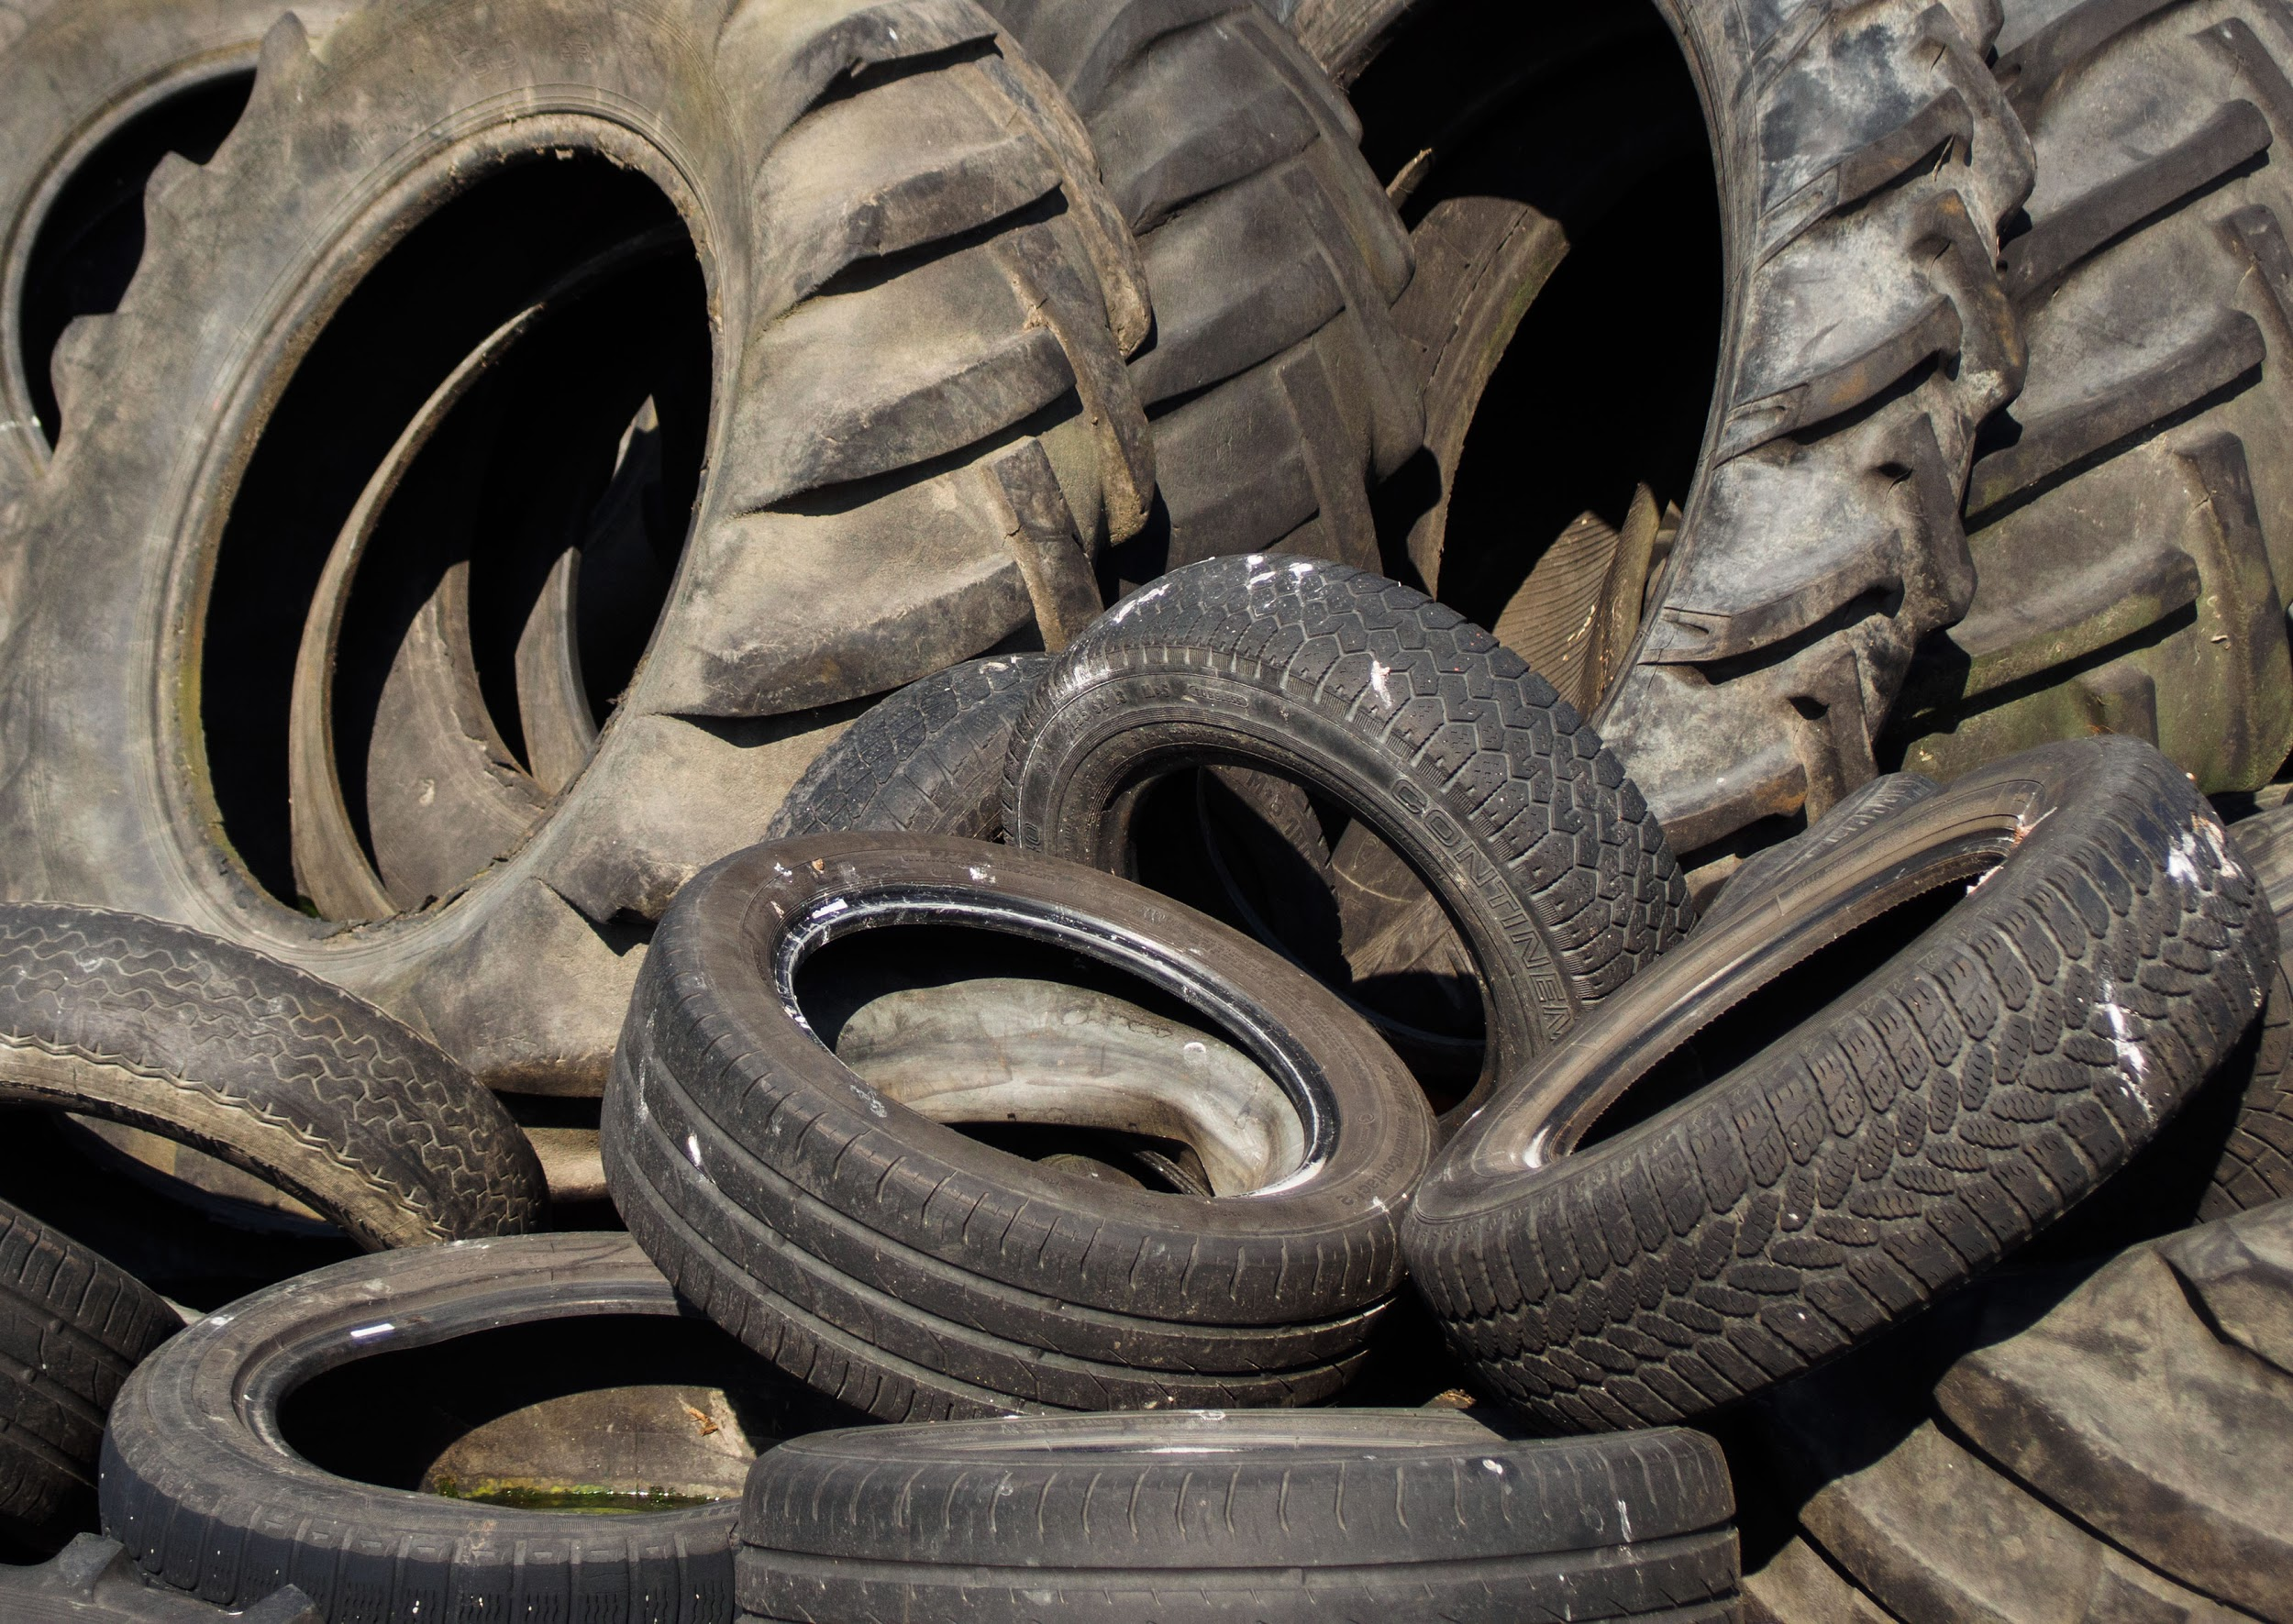
Discuss: What happens to all of the car and truck tires that get worn out? What can be done with them to help preserve our environment?

Step 1: Let’s look really carefully at 3 scenarios. Review the charts carefully and fill in the indicated spaces using the ‘hints’

We are going to keep looking into cars today, including how the cost of a car might vary based on how you purchase it, and the full cost of gasoline.

There are three main ways to ‘buy’ a car. Pay all cash up front, to pay a small amount down and pay the car off over 3 to five years, or to lease a car for 3 to 5 years. Let’s go.

Scenario #1

Scenario #2

Scenario #3
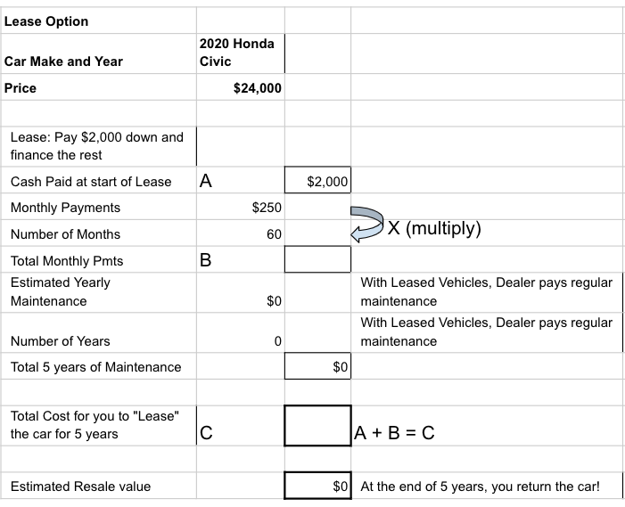

Step 2: Now let’s see what we have learned from the 3 scenarios.

Purchasing the 2020 Civic with all Cash-

- Cash paid for the car __________

- All total, how much will your maintenance cost be? __________

- After 5 years what is the total cost of the car and maintenance? __________

- And how much is the car still worth? __________
- So, if you had decided to sell the car in 2025, how much will it
have cost you to have that car for those 5 years? __________

Purchasing the 2020 Civic with 25% down ($6,000 out of $24,000)

- Cash/down payment paid for the car __________

- All total,how much will your monthly payments be? __________

- All total, how much will your maintenance cost be? __________

- After 5 years what is the total cost of the car and maintenance? __________

- And how much is the car still worth? __________
- So, if you had decided to sell the car in 2025, how much will it
have cost you to have that car for those 5 years? __________

Leasing the 2020 Civic with $2,000 down (out of $24,000)
(Remember, under lease you do not own the car)

- Cash paid/down payment on Lease for the car? __________

- All total, how much will your monthly lease payments be? __________

- All total, how much will your maintenance cost be? __________

- After 5 years what is the total LEASE cost of the car? __________

- And how much is the car still worth to you? __________
BE CAREFUL--you have to give it back to the dealer and they won’t give you any $ back)

- So, you can’t sell the car. How much did it cost you to use it for
those 5 years? __________

Step 3: Follow-up Questions based on the 3 scenarios and the answers above.
- Overall, how much did it cost you to operate the car (just the cost + basic maintenance) the car for five years under each plan-
    - All Cash Up Front ______________

    - DownPayment and 5 Years of Payment ______________

    - Total LEASE cost ______________

Discuss (or just jot down short answers)

- What is one good reason to pay all cash up front for the car?

- What is one good reason to make a downpayment and pay over 5 years?

- What is one good reason to LEASE the car?

Step 4: Ok, let’s go back and take a closer look at the full cost of gasoline

- It costs YOU $2.75 for a gallon of gas.

- Research shows that each gallon of gas that is used/burned by a car engine costs society an additional $3.80. This $3.80 includes the cost of the environmental, health and other problems caused by releasing all of the carbon into the air when we use up gasoline: air pollution that is bad for our lungs, greenhouse gasses that cause temperatures to rise, and more.

- Remember that Ford Mustang that gets 12 miles per gallon. If you drive it 60 miles in a week, how many gallons of gas do you use in one week?

  - How much does that cost you?

  - How much does that cost all of us because of the pollution and health costs of burning that much gas that week?

- How about the Honda Civic (let's round it off and say the Civic gets 30 miles to the gallon).
  - How much does it cost you to drive 60 miles?

  - How much does that cost all of us because of the pollution and health costs of burning that much gas that week?

Discuss (or just jot down short answers)

- Does this cost to society impact what sort of car you would purchase or drive?

- What can we do to make people take this cost into consideration when they drive cars that pollute a lot?

Skill Builders and Review Problems-
If you have more time, take a few minutes to complete the “skill builder” problems in the separate handout packet.
- Decimals - rounding
- Decimals - comparing
- Decimals - multiplying and dividing

Student Feedback:

Circle the emojis that best represents how this activity made you feel.

Day 3: Sleep
Health

Step 1: Sleep Journal
Sleep Journal: What tips do you have for falling asleep?

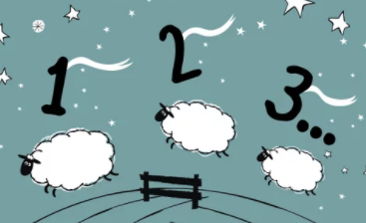

Step 2: Review some Vocabulary
Vocabulary:
Recuperate: recover from illness or exertion.
Circadian rhythm: physical, mental, and behavioral changes that follow a daily cycle
Melatonin: helps control your daily sleep-wake cycles

Step 2: Read the text

Before the crash, George was like most high schoolers. He never got a full eight hours of sleep, and he occasionally nodded off in class. A busy after-school schedule and demanding academics often kept him up into the wee hours.
Even when George could get to bed earlier, however, he didn’t feel tired. And there’s a scientific explanation for that: In your teen years, your body’s circadian rhythm, or natural clock, shifts. Melatonin, the hormone that makes you drowsy, is released later, making it difficult to fall asleep before 11 p.m. Couple that with the fact that, on average, high school starts at 8 a.m., and it doesn’t leave much time for rest. George, for one, had to leave for school by 6:45 a.m.
Watson puts it this way: “Teens are being squeezed on both ends.”
But George’s school isn’t entirely to blame. Today, he confesses another reason for his sleep problems: his iPhone. “I always had it in hand,” he admits.
If someone asked you if your phone keeps you up too, you’d probably say, “No way.” But researchers have found a clear link between your sleep and phone habits. “Today’s teens have more distractions than any previous generation,” says Kristin Daley, a psychologist who treats sleep problems. “It takes tremendous self-control to ignore those dinging notifications so you get everything done and get to bed.”
And even after you finally close Snapchat, your phone—yep, the one innocently charging on your nightstand—can still ruin your sleep. That’s because a screen’s glow keeps your brain from releasing melatonin (the hormone that makes you sleepy).
Meanwhile, your body needs shut-eye. Sleep allows your cells to repair themselves and your muscles to recuperate. Your brain also processes all the information it collected that day during sleep, so you can learn and remember.
Sleep is especially key for teens: It’s when the hormones and chemicals your developing brain needs are released. Skimp on rest and you might struggle to think clearly or keep emotions in check.
Step 2: Tips for good sleeping
Try one of these four tips for falling asleep and be ready to share your results in tomorrow’s sleep journal.

1. Use the 4-7-8 Breathing Method
The “4-7-8” method is a simple but powerful breathing method that promotes calmness and relaxation. It might also help you unwind before bed. It consists of a breathing pattern that relaxes the nervous system. It can be practiced anytime you feel anxious or stressed. Here are the steps:
- First, place the tip of your tongue behind your upper front teeth.
- Exhale completely through your mouth and make a whoosh sound.
- Close your mouth and inhale through your nose while mentally counting to four.
- Hold your breath and mentally count to seven.
- Open your mouth and exhale completely, making a whoosh sound and mentally counting to eight.
- Repeat this cycle at least three more times.
This technique can relax you and help you fall asleep quickly.

2. Visualize Things That Make You Happy
- Instead of lying in bed worrying and thinking about stressful things, visualize a place that makes you feel happy and calm. 41 participants suffering from insomnia were able to fall asleep faster after they were instructed to use an imaginary distraction.
- This technique helped them occupy their mind with good thoughts instead of engaging with worries and concerns during the pre-sleep time.
- Picturing and concentrating on an environment that makes you feel peaceful and relaxed can take your mind away from the thoughts that keep you up at night.

3. The military method
- Relax your entire face, including the muscles inside your mouth.
- Drop your shoulders to release the tension and let your hands drop to the side of your body.
- Exhale, relaxing your chest.
- Relax your legs, thighs, and calves.
- Clear your mind for 10 seconds by imagining a relaxing scene.
- If this doesn’t work, try saying the words “don’t think” over and over for 10 seconds.
- Within 10 seconds, you should fall asleep!

4. Relaxation script
- Raise your eyebrows as high as possible for 5 seconds. This will tighten your forehead muscles.
- Relax your muscles immediately and feel the tension drop. Wait 10 seconds.
- Smile widely to create tension in your cheeks. Hold for 5 seconds. Relax.
- Pause 10 seconds.
- Squint with your eyes shut. Hold 5 seconds. Relax.
- Pause 10 seconds.
- Tilt your head slightly back so you’re comfortably looking at the ceiling. Hold 5 seconds. Relax as your neck sinks back into the pillow.
- Pause 10 seconds.
- Keep moving down the rest of the body, from your triceps to chest, thighs to feet.
- Let yourself fall asleep, even if you don’t finish tensing and relaxing the rest of your body.

Day 3: Environmental Racism
Social Studies

What is this lesson about? In this lesson you will learn about the relationship between the environment and inequality. Specifically, you will us a map to examine how air pollution affects people of color and those living in poverty

Step 1: Reflect

Start by reflecting on the following questions. You can do this in conversation with a peer or adult or on your own through journaling:
- What is air pollution?
- What are some causes of air pollution? What are some effects of air pollution?
- Who do you think are some groups of people who are affected most by air pollution? Sometimes people are affected for reasons besides their physical health.
- People who don’t have much money often live near places that produce air pollution—like factories and power plants. Why do you think it is that people who have more money often live farther away from those places?
- What makes a place a good place to live? Who has enough money to live in places like that? Are places with a lot of air pollution good places to live? Why or why not?

Step 2: Examine the map
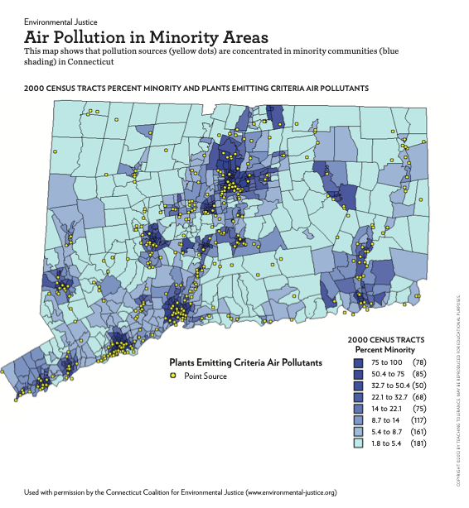
How much money people have affects whether they live near places that pollute the air. Let’s look at other groups that might be more affected by air pollution. Look at the map Air Pollution in Minority Areas. This is a map of the state of Connecticut. It shows two different things. It shows the parts of the state where lots of members of minority groups live, and it also shows where power plants that pollute the air are located.

Look at the key at the bottom of the map. It tells you what the different colors on the map mean. First, there are yellow dots. It says in the key that the yellow dots show where power plants are. Power plants make electricity for homes and businesses to use. They need to burn coal, gas or oil to make the electricity. When they burn these fuels, the power plants pollute the air.

There are also parts of the map that are different shades of blue. The key tells you what the different colors stand for. In the areas that are the darkest blue, most of the people are members of minority groups. The second darkest shade of blue shows areas where more than half the people are members of minority groups. As the shades of blue get lighter, there are fewer minority people living there. In other words, the lighter the blue, the fewer minority residents.

Step 3: Analyze the map

Now put together the two kinds of information on the map: The yellow dots and the shades of blue.
Where are the yellow dots?

What do the yellow dots tell you?

What shades of blue are there?

What does that tell you?

What pattern do you see? In what shade(s) of blue do you see the most yellow dots?

Sum up what you’ve seen on the map by completing this prompt:

There are more power plants located in areas where people who are __________ and people who are _______ live.

Step 4: Take a Stand
Do you think it’s fair that people who are poor and people who are members of minority groups live in areas where there is more pollution? Why do you think they stay in those areas? What makes it hard for them to move to a place with less pollution? What would you suggest as a way to make the situation fairer?

Write a response sharing your opinion on these questions about environmental racism and justice.

Student Feedback:
Circle the emojis that best represents how this activity made you feel. | 