Week 2
Identity

Day 4

NAME:______________________
Day 4 Agenda

Topic | Activity
Warm-Up!
English Language Arts | - Read the poem, “The Rose That Grew From Concrete” by Tupac Shakur.  - Annotate and identify imagery in the poem.  - Compare this poem to the poem by Polanco.  - Write an extended metaphor that describes their own identity
Science | - Read about the human brain  - Answer questions about what you read  - Draw a picture
Mindfulness Moment!
Math | - Real World Math: Identity and Race: The U.S. Census  - Practice Problems: Multiples
Health | - Digital Identity
Mindfulness Moment!
Civics/Social Studies | - Race, Ethnicity, and Identity
PE | - Bingo!

Warm-up Activity: Write a journal entry around the daily quote on identity.
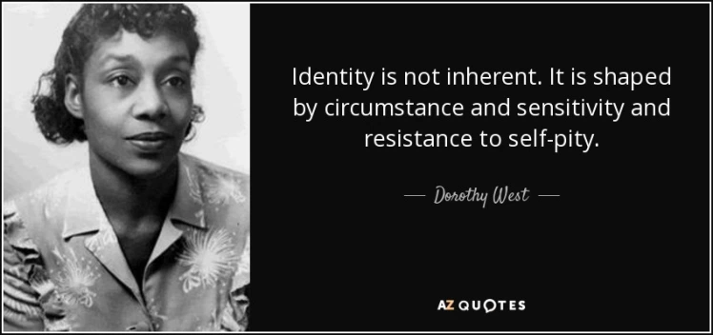

Day 4. : English Language Arts
Defining ourselves using Metaphor

What is this lesson about? Today, you will read another poem about identity that also includes an extended metaphor. You will read and analyze the poem and compare and contrast it to the poem you read yesterday by Julio Noboa Polanco. Lastly, you will also create your own extended metaphor that defines your own identity.

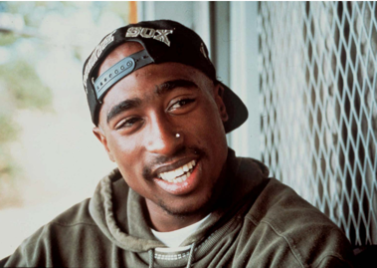
Step 1: Read the Poem

The Rose That Grew From Concrete by Tupac Shakur. This is a poem that was included in a collection of poems that were written between 1989 and 1991 by Tupac Shakur and published posthumously (after his death) in 1999.

The Rose That Grew From Concrete
by Tupac Shakur
Did you hear about the rose that grew
from a crack in the concrete?
Proving nature's law is wrong it
learned to walk without having feet.
Funny it seems, but by keeping its dreams,
it learned to breathe fresh air.
Long live the rose that grew from concrete
when no one else ever cared.

Step 2: Re-Read

Read the poem again and this time write notes alongside the text writing what you think Shakur was talking about when he writes about the rose. Note the extended metaphor that Shakur uses to communicate what he wants his reader to imagine and to feel.

Share your notes with a partner and discuss the following question.
What is the most vivid (strongest) image that Shakur created for you? Why?

Step 3. Answer the questions.

- What do you think that Shakur means when he says that the rose proved “nature’s law is wrong”?

- What helps the rose be able to succeed and learn “to breathe fresh air”?

- What does the fresh air represent?

- PIcture a sidewalk with cracks in it. What usually grows through those cracks? Why do you think Shakur chose to say that a rose was growing instead of a weed or bits of grass? What is he saying about himself?

- Why does Shakur want to celebrate the rose and why is it important to him that people hear about what it has been able to do?

- Think about yesterday’s poem “Identity” by Julio Noboa Polanco. Julio Noboa emphasized that he wanted to be an “ugly wood”. Shakur uses the image of a beautiful rose. How are the rose and the weed similar? How are they different.

Step 4: Write an extended metaphor

This week’s theme is Identity. In the poem, a rose is a beautiful thing that grew in spite of all the challenges it faced and became stronger BECAUSE of those challenges. For Shakur, there is something beautiful about the struggle because it shows strength and resilience. Think about how challenges have helped you grow and become stronger and how they have made you the person that you are.

Write down a few challenges you have faced that you believe have made you change and become stronger or better. Explain how they have made you stronger/better.

1.

2.

3.

Now think of a metaphor that you can use to compare your experience of growing and becoming stronger to something else. (Like a rose that grows through concrete, what are some other things that might push through challenges ? (Example: a bird in the wind, a baby learning to walk, etc.) Write it down.

Work to extend it: Example: Look at that bird flying against the wind, getting beaten back with every gust, eventually learning to ride the waves of the wind, up and down--actually riding the wind that once nearly destroyed it and now using it to fly higher and further.)

Step 5: Share.
Pair work- Share your metaphor with one of your classmates. Read it aloud; listen as he reads his metaphor aloud. After sharing metaphors, draw out your partner’s metaphor.

Draw out the image that your partner described in his metaphor.

Share the image with your partner and explain what you pictured through their imagery.

Based on the image that your partner pictured/imagined (or didn’t), think of 2-3 more details you could add to your metaphor so others can picture what you are describing. Revise your metaphor adding these details to your writing.

Student Feedback: Extended Metaphor
Circle the emojis that best represents how this activity made you feel. | 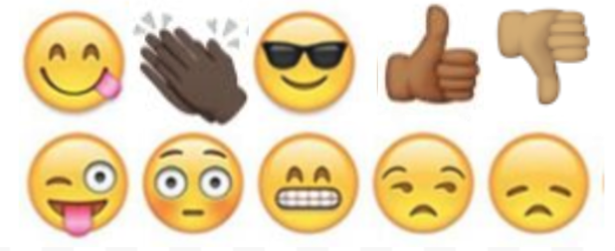  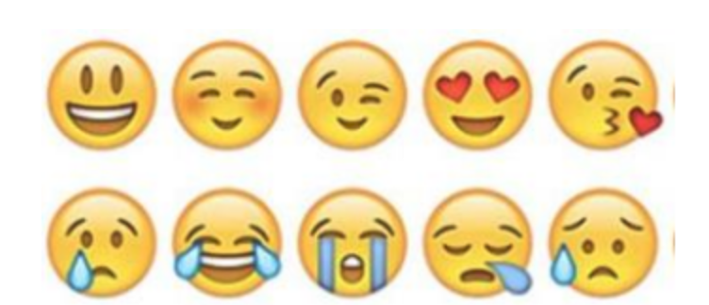

Day 4: Science
The Human Brain

What is this lesson about?: Today you will read through The Human Brain passage. You will answer a few questions about what you read. You will complete a brain activity.

Step 1: Read through The Human Brain passage

The Human Brain
(Technological Solutions, 2020)
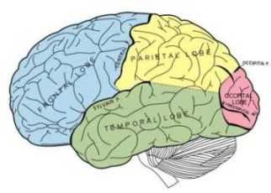
The brain is where we do our thinking. All our senses are tied into our brain allowing us to experience the outside world. We remember, have emotions, solve problems, worry about stuff, dream about the future, and control our bodies in our brain.

For such an awesome organ, the brain doesn't look like much. It's a ball of gray looking wrinkled tissue about the size of two of your fists put together. The brain sits in our hard, thick skull with membranes and fluid around it to protect it.

How the Brain Communicates
The brain is part of the nervous system. Together with the spinal cord, it makes up the central nervous system. The brain connects to nerves that travel throughout the body. Nerves from our senses (hearing, seeing, touch, etc.) send signals to the brain to let the brain know what is going on in the outside world. The brain also sends signals using nerves to muscles in order to make our body move.

Parts of the Brain
Cerebrum - The cerebrum is the biggest part of the brain. It's the gray wrinkly upper part. The surface of the cerebrum is called the cerebral cortex. Different parts of the cerebrum deal with different parts of the body. The back part deals with vision while other parts deal with other functions like movement, hearing, language, and touch.
Cerebellum - At the back and bottom of the brain is the cerebellum. This part of the brain deals with motor movement. It processes all the incoming motor messages from the nerves and figures out what to do with them. The cerebellum can learn motor movements with practice allowing us to do stuff like riding a bike or typing without even thinking about it.
Brain Stem or Medulla - This is where the brain connects to the spinal cord. Also, many automatic functions are controlled here like keeping the heart beating, breathing, and digesting food.
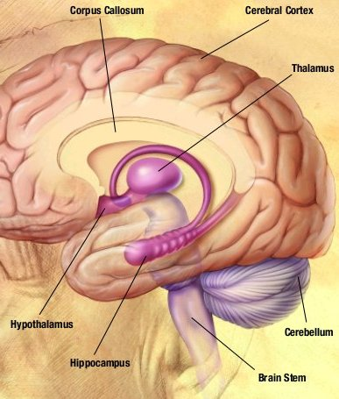
Memory
The brain has two kinds of memory, short term memory and long term memory. Scientists are still learning exactly how memory works, but they know that short term memory allows us to remember something for a very short time without rehearsing or practicing it. We can't remember a lot of things in short term memory though, and, like its name suggests, these memories don't last very long.

The Brain Needs Energy
The brain may not move, but it needs lots of energy. Energy is sent to the brain by our blood. There are lots of blood vessels and blood flowing through the brain at all times. The brain actually uses around twenty percent of the body's energy.

The Brain Has Two Halves
The brain is divided into two halves. Since the nerves cross when they enter the brain, the left side of our brain controls the right half of our body and the right side controls the left. Each half also controls specialized functions. What each half does depends on whether you are left or right handed. In a right handed person the left side of the brain is used for language and numbers while the right side is the more artistic side and is also used for recognizing objects.

Step 2: Answer questions about what you read

- The brain is part of which system?
  - Cardiovascular System
  - Nervous System
  - Digestive System

- Which part of the brain can learn motor movements?
  - Cerebrum
  - Cerebral Cortex
  - Cerebellum

- Which of the following is NOT a function that is controlled by the brain stem?
  - Breathing
  - Vision
  - Digestion

- Which part of the brain controls senses like hearing or touch?
  - Cerebrum
  - Cerebral Cortex
  - Cerebellum
- What is the surface of the Cerebrum called?
  - Cerebral Cortex
  - Cerebellum
  - Brain Stem

- How is energy sent to the brain?
  - Blood
  - Oxygen
  - Nerves

- The left side of the brain controls the left half of the body and the right side of the brain controls the right half of the body.
  - TRUE
  - FALSE

Step 3: Draw a picture

Your brain is the most important organ in your body and it is up to you to keep it healthy. What can you do to keep your brain in the best condition? Draw a picture and explain your answer.

________________________________________________________________________________________________________________________________________________________________________________________________________________________________________________________________________________________________________________________

Student Feedback:

Circle the emojis that best represents how this activity made you feel. | 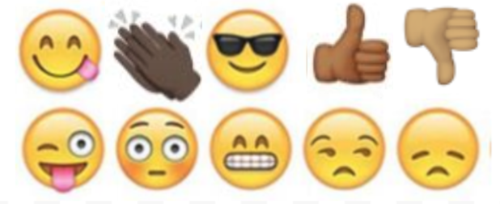  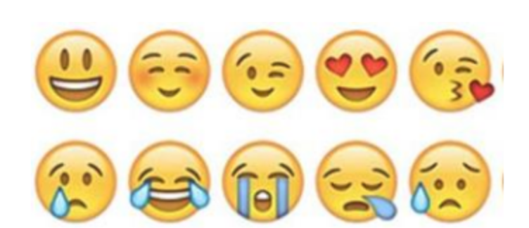
Mindfulness Moment!
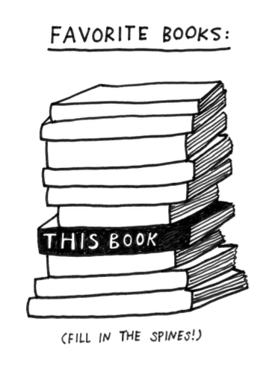

Day 4: Identity/Census Data and More
Math

What is this lesson about?: Today we will learn about the mathematical concepts around proportionment related to the U.S. Census. The U.S. Census happens every 10 years and 2020 is a census year. It is extremely important in how federal resources are allocated to individual states. The basic idea is to count every person possible in the entire country and it is a monumental task. The amount of money a state receives for everything from education to public safety is dependent on it. Apportioning it correctly is essential to a fair republic.

But first: Today’s Warm-Up
You and two friends have decided to order a pizza for dinner. You want Domino’s, one friend wants Papa John’s and another friend wants Pizza Hut. You agree on Papa John’s and place your order after agreeing on which toppings you want. The pizza arrives and you are confronted with the problem of there being 3 of you, but 8 pieces of pizza. 3 doesn’t divide evenly into 8...

What possible solutions could you come up with that are fair to each of you?

BTW, is it possible to have an odd number of pizza slices if the pizza is cut with straight lines through the center?

Step 1: Understanding Greatest Integer
In later high school math classes you may learn about greatest integer functions. Integers, by definition, are numbers that do not have fractions or decimals associated with them.

Examples are 4, 0 and -3. We can find the greatest integer of any number by locating the first integer on the number line to the left of that number. [[ ]] is the mathematical way we represent greatest integer.

Example 1: Find [[3.8]].
- While 3.8 is closer to 4 than 3, we follow our rule and go with the first integer to the left of 3.8 on the number line, so [[3.8]]=3

Your Turn:
- Find [[17.543]].

- Find[[-2.4]]( be really careful with negative numbers, use the number line below if you need to, the answer may surprise you.)

Step 2: Calculating a divisor to apportion delegates

Here is a chart of the U.S. population data based on the 1790 U.S. Census.

State | 1790 Population
Connecticut | 236841
Delaware | 55540
Georgia | 70835
Kentucky | 68705
Maryland | 278514
Massachusetts | 475327
New Hampshire | 141822
New Jersey | 179570
New York | 331589
North Carolina | 353523
Pennsylvania | 432879
Rhode Island | 68446
South Carolina | 206236
Vermont | 85533
Virginia | 630560
Total | 3615920

In 1790 there were a total of 120 delegates in the United States house of representatives. To calculate a divisor, we take the total population 3615920 and divide it by 120. The result is 30,133. That means for every 30,133 residents a state has, they should be awarded a delegate to represent their interests. Alexander Hamilton suggested this approach and at the time it was known as the Hamiltonian method. The results are below.

State | 1790 Population | Delegates(Hamilton)
Connecticut | 236841 | 7.86
Delaware | 55540 | 1.84
Georgia | 70835 | 2.35
Kentucky | 68705 | 2.28
Maryland | 278514 | 9.24
Massachusetts | 475327 | 15.77
New Hampshire | 141822 | 4.71
New Jersey | 179570 | 5.96
New York | 331589 | 11
North Carolina | 353523 | 11.73
Pennsylvania | 432879 | 14.37
Rhode Island | 68446 | 2.27
South Carolina | 206236 | 6.84
Vermont | 85533 | 2.84
Virginia | 630560 | 20.93
Total | 3615920 | 120
Divisor  (120 delegates) | 30133 | 120

While mathematically sound, do you see a problem with the Hamiltonian method of delegate apportionment.

Step 3/Activity 3: Using greatest integer to fix the Hamiltonian method.

Since humans cannot be divided into pieces, unlike pizza, the Hamiltonian method was rejected. Use what we learned earlier in the lesson to apply greatest integer to each Hamiltonian delegate below.

State | 1790 Population | Delegates(Hamilton) | Greatest Integer
Connecticut | 236841 | 7.86
Delaware | 55540 | 1.84
Georgia | 70835 | 2.35
Kentucky | 68705 | 2.28
Maryland | 278514 | 9.24
Massachusetts | 475327 | 15.77
New Hampshire | 141822 | 4.71
New Jersey | 179570 | 5.96
New York | 331589 | 11
North Carolina | 353523 | 11.73
Pennsylvania | 432879 | 14.37
Rhode Island | 68446 | 2.27
South Carolina | 206236 | 6.84
Vermont | 85533 | 2.84
Virginia | 630560 | 20.93
Total | 3615920 | 120
Divisor  (120 delegates) | 30133 | 120

Once you have calculated the greatest integer for each state, add them up to make sure they total 120. If they do not, we must come up with another approach.

Step 4: Rounding saves the day
Another method of eliminating fraction or decimals to make integers is rounding. Rounding is also fairly straight forward. If the number has a fraction or decimal equal to half or more of the next integer, you round up to the next highest integer. If the fraction or decimal is below .5, you simply eliminate the fraction or decimal.
- Ex. Round 3.49 to the nearest integer Answer=3
- Ex Round 5.64 to the nearest integer Answer=6
Use rounding to adjust the Hamiltonian method below.

State | 1790 Population | Delegates(Hamilton) | Greatest Integer | Rounding
Connecticut | 236841 | 7.86 | 7
Delaware | 55540 | 1.84 | 1
Georgia | 70835 | 2.35 | 2
Kentucky | 68705 | 2.28 | 2
Maryland | 278514 | 9.24 | 9
Massachusetts | 475327 | 15.77 | 15
New Hampshire | 141822 | 4.71 | 4
New Jersey | 179570 | 5.96 | 5
New York | 331589 | 11 | 11
North Carolina | 353523 | 11.73 | 11
Pennsylvania | 432879 | 14.37 | 14
Rhode Island | 68446 | 2.27 | 2
South Carolina | 206236 | 6.84 | 6
Vermont | 85533 | 2.84 | 2
Virginia | 630560 | 20.93 | 20
Total | 3615920 | 120 | 111
Divisor(120 delegates) | 30133 | 120

If done correctly you should come to a total of 120 delegates.

What other ways can you think of to apportion delegates? In 1790 there were more than 10 different proposals considered by the house of representatives.

Step 5/Activity 5: Starting to Look at the Census more carefully

The Census asks a number of questions. Below are the questions on the Census that inquire about ethnicity and race. Fill in the sample questions below, if you feel comfortable.
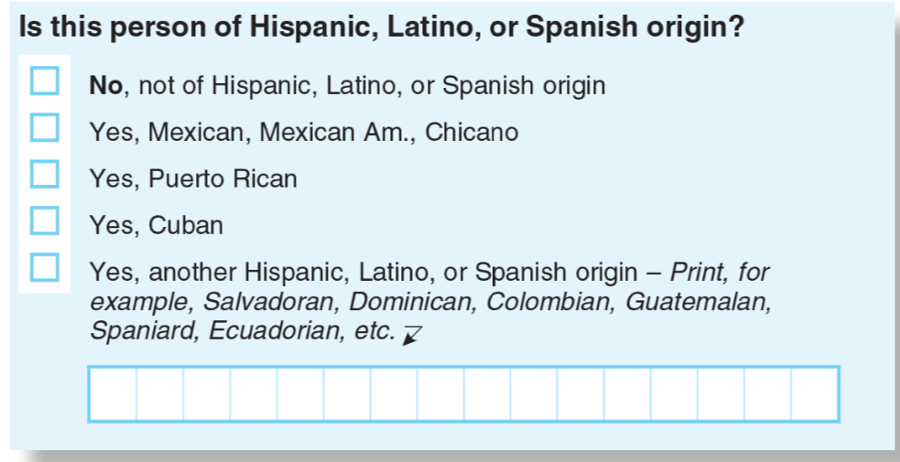
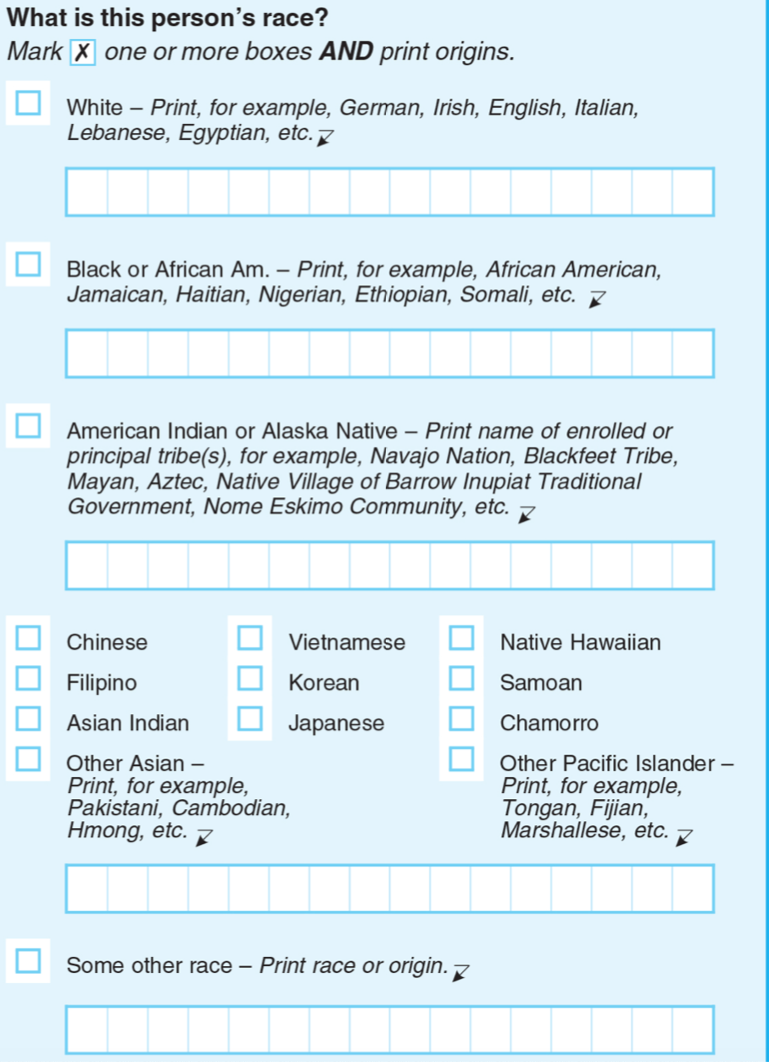
Do you feel a sense of identity based on your race? Yes/No. Explain.

Why, do you think, does the government want to understand the different ethnicities and races in our Country?

Note: We will come back to this next week when we start to consider Community and the following week when we consider Power.

Skill Builders and Review Problems
- Multiples

Day 4: Digital Identity
Health

Step 1: Warm-up
How can I create a social media presence that represents the real me?

Step 2: What’s this Lesson About?
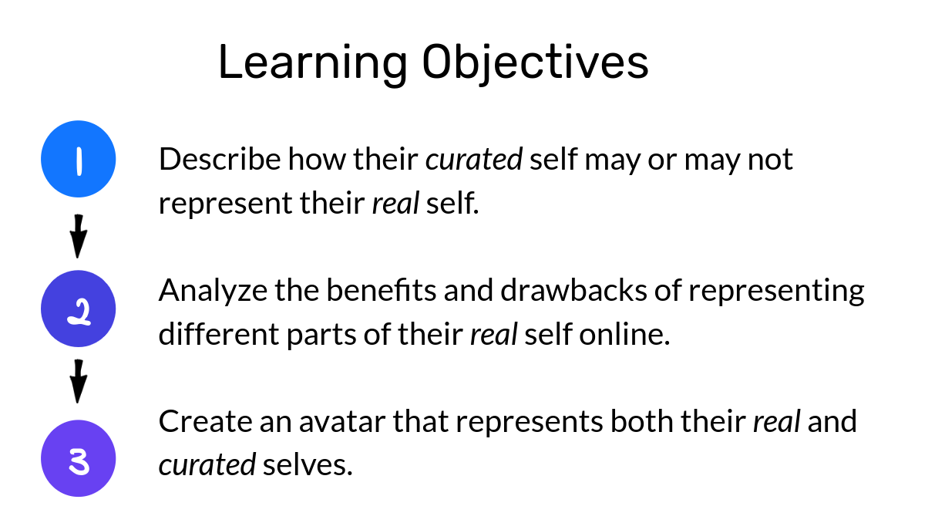
Step 3: Quick Reflection.

Is the you that people see online the real you? Why, or why not?

Step 4: Tread the text.
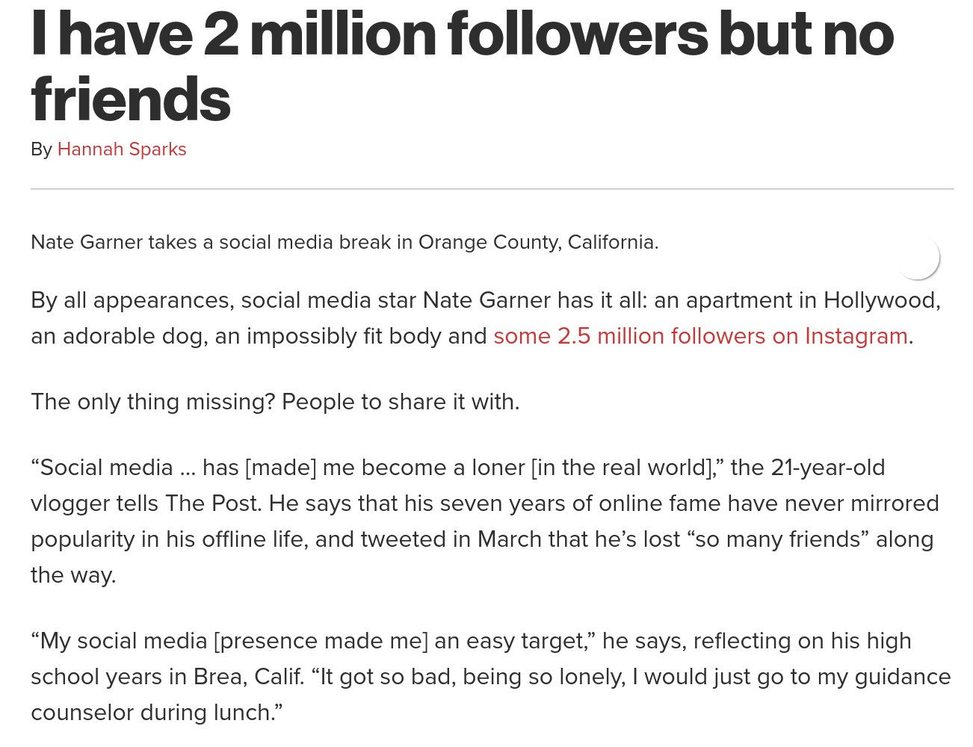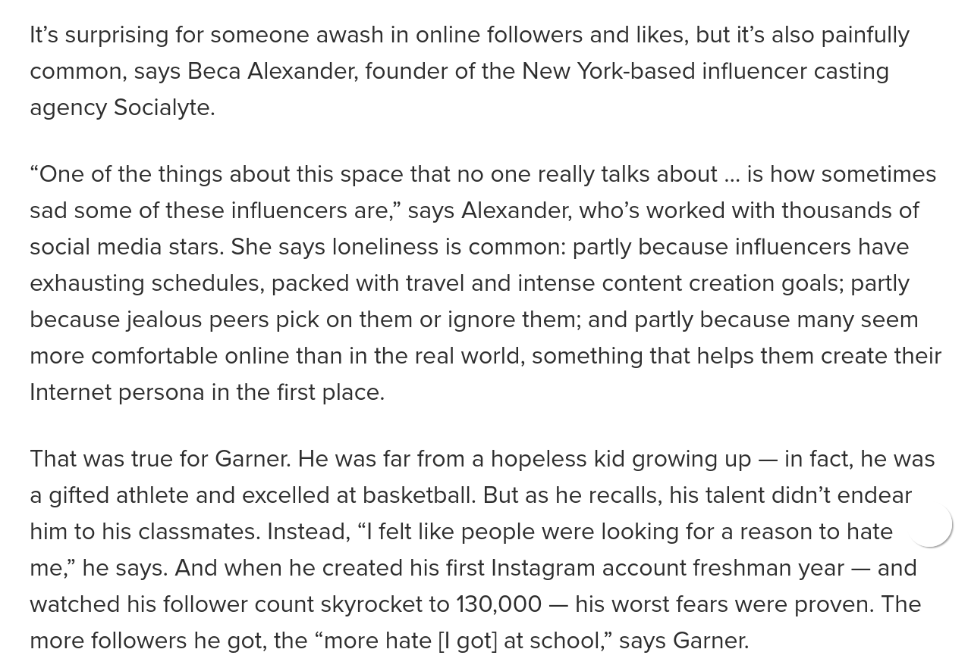
Draw the REAL you | Draw the ONLINE you

Student Feedback:
Circle the emojis that best represents how this activity made you feel.

Day 4: Race & Ethnicity
Social Studies

What is this lesson about?: In this lesson you will read about ethnic cultures and how people are trying to embrace different cultural aspects of their heritage, by the way they dress and the way they wear their hair. You will learn how our identity is partially made up of our race and ethnicity.

Step 1: Read the article

The term "Asian-American" means different things to different people
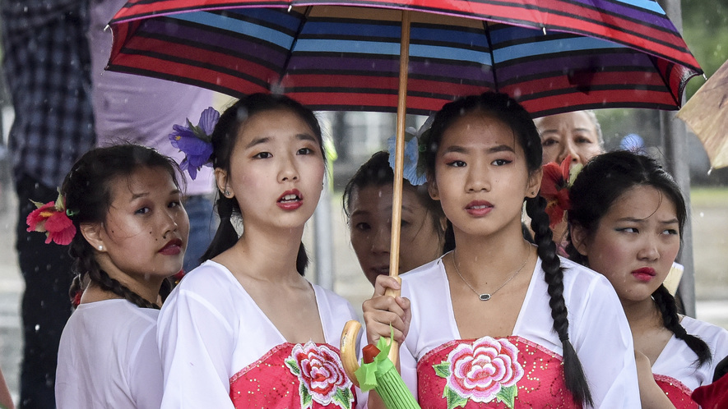
WASHINGTON, D.C. — Parents, under umbrellas, prepare to take photos of their children. The children will soon perform a traditional Filipino dance. The U.S. Capitol building will be in the background.
An announcer thanks families for putting up with the weather. "Anyway, for Asians, this is a blessing," she says of the rain.
Such sweeping statements are part of Fiesta Asia. It's a yearly festival held in Washington, D.C. It broadly celebrates Asian cultures. It is meant to honor the "Asian-American" experience.
The term Asian-American includes many different ethnic identities. Asian-American families come from dozens of different countries. Some have been in the U.S. for generations, while others have come more recently. People within this community, however, have different thoughts about the term "Asian-American." Some appreciate being lumped into the large group. Others question it.
There is another challenge. It is not always clear who is part of this group. Many people think of Asian-Americans as those whose families are from East Asian countries, like China, Japan and Korea. Indian-Americans and Pakistani-Americans, for example, can be left out. India and Pakistan are still part of Asia, as are many other less well-known countries.
What does it actually mean to identify as Asian-American today?

"Asian-American" Term Blends Everyone Together
Melissa dela Cuesta stands under one of many tents at Fiesta Asia. She wears a sash across her body. It shows her second runner-up place in a Miss Teen Philippines pageant. Melissa looks surprised when asked how she would identify herself. Isn't the answer obvious?
"I am Filipino-American," declares the 17-year-old. She is "in love" with her culture. She doesn't understand why anyone would not want to be grouped with their family's country. The Philippines is a nation of islands in Southeastern Asia between the South China Sea and Pacific Ocean.
About two-thirds of Asian-Americans identify primarily with their specific ethnicity, according to the research group AAPI Data. The group provides information on Asian-Americans and Pacific Islanders. Pacific Islanders are from islands in the east and central regions of the Pacific Ocean.
Dina Okamoto wrote the book "Redefining Race." She said many people do not like using the term "Asian-American" because blending everyone together takes away their individual culture. "They don't believe it really captures who they are," she says.
In the past, discrimination motivated strong connections to a family's country of origin. When Japanese-Americans were taken to prison-like camps in the U.S. during World War II, for example, some Chinese-Americans wore buttons or carried signs. The signs made sure others knew they were Chinese rather than Japanese. Japan was America's war enemy.

Discovering A Sense Of Family
Yet that changed in 1968. Activist and historian Yuji Ichioka created the term "Asian-American." It served as what Okamoto now calls a "rallying cry."
Ichioka had seen the success of the Black Power movement, she says. Groups joined together to fight for civil rights for African-Americans. Ichioka felt communities with Asian roots could also benefit from accepting their shared history.
Calling yourself Asian-American meant rejecting disrespectful and hurtful labels. It meant discovering a sense of family. Especially after the 1982 killing of Vincent Chin, it meant banding together to fight injustice. Although Chin was Chinese-American, he was beaten to death by white autoworkers upset by the success of Japanese car makers.
While at Fiesta Asia, Nicholas Lach, age 23, says he'd call himself Asian-American because, as he puts it, "I'm Asian. I'm in America. That's just how it works." His parents are Cambodian refugees who moved to Minnesota.
"Maybe if I was born in Cambodia and then came here," he adds, "I'd consider myself Cambodian-American."

Learning The History Of Asian-Americans
It isn't always an either/or situation, says Jenn Fang, age 36. Fang started the blog Reappropriate. She identifies as both Asian-American and Chinese-American. She says the broad term of Asian-American is popular among civic-minded college students who learn the term's activist roots.
Fang took an Asian-American studies course as a Cornell University student. She describes the class as "completely mind-blowing."
If you're lucky in high school, she says, you might have read a couple paragraphs about Japanese-American internment camps during World War II. This Cornell course had a 300-page textbook on Asian-American history.
"It takes going to a college before any of us learn about the basics of who we are and how we came to be in this country," she says. She says that is wrong. She thinks it's important to have the chance to learn about the history of Asian-Americans and the ways they have changed the country.

Step 2: Answer the questions

1. Read the section "Learning The History Of Asian-Americans."
Which selection from the section supports the conclusion that some people learn very little about Asian-American history before college?
(A) She says the broad term of Asian-American is popular among civic-minded college students who learn the term's activist roots.
(B) Fang took an Asian-American studies course as a Cornell University student. She describes the class as "completely mind-blowing."
(C) If you're lucky in high school, she says, you might have read a couple paragraphs about Japanese-
American internment camps during World War II.
(D) She thinks it's important to have the chance to learn about the history of Asian-Americans and the ways they have changed the country.

2. Read the section "Discovering A Sense Of Family."
Which selection shows the author's point of view about using the term “Asian-American”?
(A) Yet that changed in 1968. Activist and historian Yuji Ichioka created the term "Asian-American."
(B) Ichioka felt communities with Asian roots could also benefit from accepting their shared history.
(C) Calling yourself Asian-American meant rejecting disrespectful and hurtful labels.
(D) Although Chin was Chinese-American, he was beaten to death by white autoworkers upset by the success of Japanese car makers.

3. What do Melissa dela Cuesta and Dina Okamoto AGREE on in the article?
(A) that some people like to identify with their family's country
(B) that it is wrong for people to use the term "Asian-American"
(C) that people should use both "Asian-American" and another term
(D) that using the term "Asian-American" creates a sense of family

Step 3: Read the second article.

New York City just banned discrimination based on hair
New York City has banned policies and practices that penalize black people based on the texture and style of their hair. City leaders say that such actions violate these individuals' human rights and are against the law.
The New York City Commission on Human Rights announced February 18 that it is issuing guidance on an existing law. The law prohibits discrimination based on race, gender or religion. The new guidance says that the same law also applies to hair.
It is about more than what is in style. Hairstyles are an integral part of black identity, going back many years in history.

A Photo With A Powerful Message
"One of my favorite photographs of President Barack Obama is him in the Oval Office leaning down to allow 5-year-old Jacob Philadelphia to touch his hair,'' said Carmelyn Malalis. She is the New York City Human Rights Commissioner and Chairwoman. Malalis called Obama's behavior a powerful "message of affirmation."
"As we were developing the guidance, we had a lot of conversations about the harm that is done to people when they are stigmatized and controlled in regards to who they are and how they move through space. Today being Presidents Day buoys our hope that legislators will take notice," Malalis said. The day of the announcement, February 18, was Presidents Day.
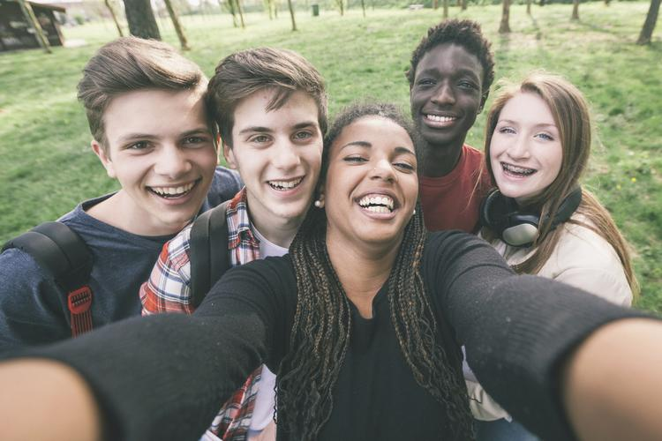
The law bans such bias in workplaces, schools and public spaces. Public spaces include spots ranging from restaurants to nightclubs to museums.

Black Hairstyles Have Been Singled Out
The legal protections apply to any group whose hairstyles are associated with their ethnic identity. For those of African descent, in particular, hair texture and styles have often been singled out and are a historic target for abuse.
Five years ago, the U.S. Department of Defense started a ban on Afros, braids and twists, all of which are traditionally black hairstyles. It reversed the ban after a backlash. In December, there was public outrage after a 16-year-old athlete named Andrew Johnson was forced by a referee to cut his hair before he could proceed with his wrestling match.

A TV Anchor Says Her Braids Led To Her Termination
Brittany Noble-Jones said she faced hair discrimination when she was fired from her job as a television anchor last year. She worked for WJTV in Jackson, Mississippi. She said that wearing braids on air led to performance reviews at work and later her termination.
Noble-Jones, who is based in New York, called the city commission's announcement "huge."
"The fact we have been worried about this all these years is one thing, but I'm very excited we can move forward," she said. She is glad they can "rock our hair and wear it the way God intended us to wear it," she said.
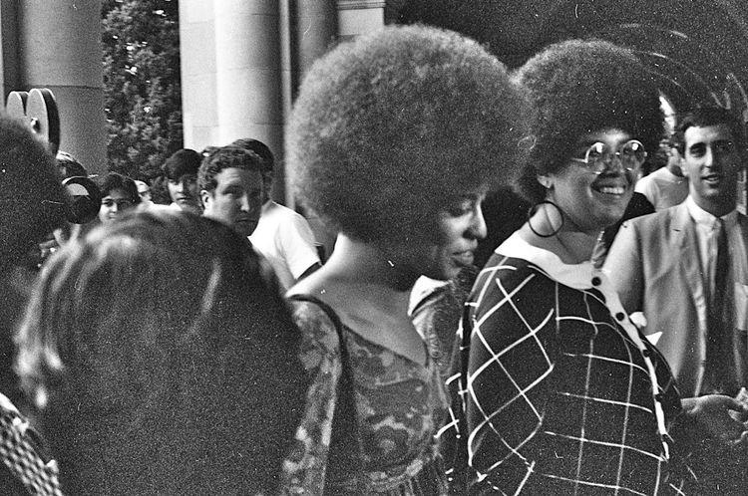
WJTV and its parent company, Nexstar, denied that Noble-Jones was fired over her hair. They said in a statement that their rules do not allow "harassment, discrimination or retaliation of any type. Allegations that Ms. Jones' employment was terminated for her choice of hairstyles have no basis in fact."

"Hair Is Connected To Civil Rights"
The New York City Commission said it is looking into seven cases in which black workers say they were targeted based on their hair. Some workers say they were threatened with termination if they did not stop wearing dreadlocks, also referred to as locs, which the employer arbitrarily considered "unclean." Other workers say they had to pull back their braids although their co-workers were allowed to wear their hair down.
Such complaints accompany incidents around the country in which black workers and school children have been harassed because of their hair. The complaints caused the New York commission to clarify that the city's law against discrimination applies in those cases.
"This is big," said Noliwe Rooks, professor of Africana studies at Cornell University in Ithaca, New York. "Hair is connected to civil rights." The civil rights movement, which took place during the 1950s and 1960s, was the beginning of the fight for black people to gain equal rights under the law.
Rooks said hair needs to be protected by the law.

A Symbol Of Pride For Many Years
Black hair has been deeply symbolic in the U.S. since at least the 1800s, and even before that. It has been a stand-in for a kind of black identity that refuses to assimilate. For many, natural hair symbolizes a rejection of the racist pressures placed on black people to conform to white beauty ideals in order to stay safe and succeed in the U.S.
Rooks explained that in the 1800s, after the Civil War, there were large numbers of African-Americans leaving enslavement and moving north in search of employment and desegregated cities. "There was a lot more contact between communities on more equal footing," she said of the interactions between white and black peoples. "The narrative is 'You just don't look civilized. You just don't look professional,'" she said.
Natural hair became a powerful symbol of pride during the Black Power movement of the 1960s. The movement supported rights and political power for black people.
"It's less about fitting in," Rooks said. "I'm proud of how hair grows out of my head."

Step 4: Answer the Questions

Is your hair a part of your identity? If so, how? If not, what are some other physical characteristics that are a part of your identity? (you can write or draw your answers)

Have you ever seen a person be treated differently because of their hair? How did that make you feel?

One person in the article says that hair needs to be protected as a civil right. What are civil rights? What was the civil rights movement?

Do you think hair style should be protected? Why or why not?

Student Feedback:

Circle the emojis that best represents how this activity made you feel.

