Week 1
Strength

Day 1

NAME:______________________

Day 1 Agenda

Topic | Activity
Warm-Up!
English Language Arts | - Read letter from Frederick Douglass to Harriet Tubman  - Read a song about Harriet Tubman called “Stand Up”  - Respond to questions about the letter and song
Science | - Read about the different types of bridges and what is considered when designing them  - Answer questions about bridge designs  - Sketch a bridge that you believe would be strong
Mindfulness Moment!
Math | - Read examples of how strong people adopt a growth mindset  - Complete a series of problems and exercises related to the growth mindset  - Create a poster or a 8”x11” staying strong using growth mindset flyer
Mindfulness Moment!
Civics/Social Studies | - Read an article about the start of WWI  - Answer questions about the article

Warm-up Activity: Write a journal entry around the daily quote on strength.
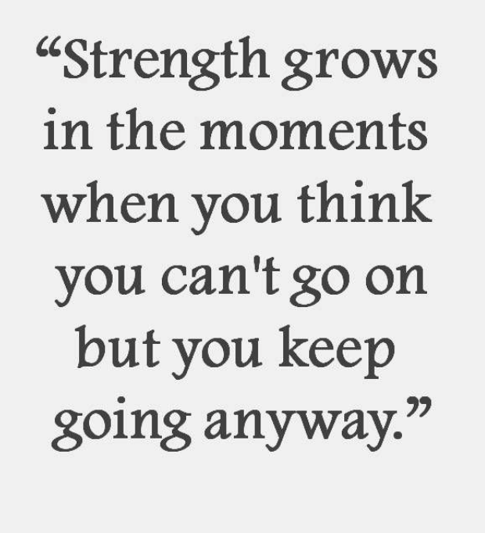

Day 1: English Language Arts
Strong Women

What is this lesson about?: Over the next three days, in honor of March being Women’s History Month, you will be reading about three women who showed strength, bravery, and courage during times of societal challenges and situations they could not control. Today, you will have the opportunity to learn about Harriet Tubman and how people view her actions and work during the civil war. You’ll reflect on Tubman’s actions and strength, and consider what strengths you bring to the table.

Step 1: Read the letter below.
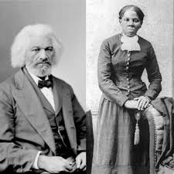
In 1869, Sarah Hopkins Bradford published a biography called Scenes in the Life of Harriet Tubman. Harriet Tubman was an abolitionist who helped slaves escape through the Underground Railroad. She often worked with fellow abolitionist Frederick Douglass, a public speaker and author. When Harriet Tubman reached out to Frederick Douglass requesting he speak to her accomplishments and write a commendation letter to include in the biography, he responded with this letter. As you read, pay attention to how Frederick Douglass defines private and public accomplishments and how Douglass characterizes Tubman. (footnotes have been provided below for important vocabulary words)

Rochester, August 29, 1868

Dear Harriet:

I am glad to know that the story of your eventful life has been written by a kind lady, and that the same is soon to be published. You ask for what you do not need when you call upon me for a word of commendation.¹ I need such words from you far more than you can need them from me, especially where your superior labors and devotion to the cause of the lately enslaved of our land are known as I know them. The difference between us is very marked.² Most that I have done and suffered in the service of our cause has been in public, and I have received much encouragement at every step of the way. You, on the other hand, have labored in a private way. I have wrought³ in the day – you in the night. I have had the applause of the crowd and the satisfaction that comes of being approved by the multitude⁴, while the most that you have done has been witnessed by a few trembling, scarred, and foot-sore bondmen⁵ and women, whom you have led out of the house of bondage, and whose heartfelt, “God bless you,” has been your only reward. The midnight sky and the silent stars have been the witnesses of your devotion to freedom and of your heroism. Excepting John Brown⁶ – of sacred memory – I know of no one who has willingly encountered more perils and hardships to serve our enslaved people than you have. Much that you have done would seem improbable to those who do not know you as I know you. It is to me a great pleasure and a great privilege to bear testimony for your character and your works, and to say to those to whom you may come, that I regard you in every way truthful and trustworthy.

Your friend,
Frederick Douglass

Footnotes
- Commendation (noun): praise
- Marked (adjective): noticeable, visible, or evident
- Wrought (verb, past tense): worked
- Multitude (noun): a great number of people
- A “Bondman” is an old term for “slave.”
- John Brown was an American abolitionist who Harriet Tubman was working with to start a liberation movement among enslaved African Americans in Virginia. The plan failed and Brown was hanged after being found guilty of treason, the murder of five men, and instigating a slave revolt.

Step 2: Answer the following questions.

Who wrote this letter, to whom was it written, and why was it written?

In the third sentence of the letter, the author states, “I need such words from you far more than you can need them from me, especially where your superior labors and devotion to the cause of the lately enslaved of our land are known as I know them.” What is the writer saying in this sentence?

The author uses this sentence: “The difference between us is very marked.” This term means noticeable, visible, or evident. What does Douglass say are the marked
differences between his and Tubman’s actions and their rewards? Use the graph below to organize your answer.

 | Harriet Tubman | Frederick Douglass
Actions (what type of work did this person do for the abolitionist movement?)
Rewards (How was this person rewarded or recognized for their efforts?)

Many people would describe Harriet Tubman as a strong person. Do you think Fredrick Douglass would agree with that statement? Do you agree? If so, what makes Tubman a strong person?

Harriet Tubman asked Frederick Douglass for a commendation letter to include in her biography, and this is the letter he wrote back to her. Who would you ask to write a letter of support for you?

What do you think that person would write about your strengths and accomplishments?

Step 3: Read the lyrics to the following song.

In November 2019, a movie was released about Harriet Tubman. Actress and Singer Cynthia Erivo plays Tubman in the movie and was nominated for an Oscar award for her performance. She also wrote and performed a song, “Stand Up”, for the movie, which was nominated for an Oscar. Below are the lyrics to the song.

I been walkin' with my face turned to the sun
Weight on my shoulders, bullet in my gun
Oh, I got eyes in the back of my head just in case I have to run
I do what I can when I can while I can for my people
While the clouds roll back and the stars fill the night

That's when I'm gonna stand up
Take my people with me
Together we are going to a brand new home
Far across the river
Can you hear freedom calling?
Calling me to answer
Gonna keep on keepin' on
I can feel it in my bones

Early in the mornin' before the sun begins to shine
Gonna start movin' towards that separating line
I'm wading through muddy waters, you know I got a made-up mind
And I don't mind if I lose any blood on the way to salvation
And I'll fight with the strength that I got until I die
So I'm gonna stand up
Take my people with me
Together we are going to a brand new home
Far across the river
Can you hear freedom calling?
Calling me to answer
Gonna keep on keepin' on

And I know what's around the bend
Might be hard to face 'cause I'm alone
And I just might fail, but Lord knows I tried
Sure as stars fill up the sky

Stand up
Take my people with me
Together we are going to a brand new home
Far across the river
Can you hear freedom calling?
Calling me to answer
Gonna keep on keepin' on

I'm gonna stand up
Take my people with me
Together we are going to a brand new home
Far across the river
Do you hear freedom calling?
Calling me to answer
Gonna keep on keepin' on

I'm gonna stand up
Take my people with me
Together we are going to a brand new home
Far across the river
I hear freedom calling?
Calling me to answer
Gonna keep on keepin' on
I can feel it in my bones
I go to prepare a place for you

Step 4: Answer the following questions

Who is the narrator of this song (from whose point of view is the song written)?

What is the tone of this song? How does this song make you feel?

What do you think the songwriter wants you to feel after listening to or reading these lyrics?

At one point, the lyrics say “ And I'll fight with the strength that I got until I die.” List 3 examples that the songwriter includes to show the strength and bravery of Harriet Tubman?

Harriet Tubman was strong for other people. She inspired others to be strong and brave. How have you been strong for others or showed people to be brave?

The song ends with the line “I go to prepare a place for you,” which are the final words Tubman uttered when she died in 1913. Why do you think these words are important?

What did Tubman mean when she said those last words?

If you could choose an artist to write and perform a song about you, who would you choose?

Step 5: Share your responses with a partner

With a classmate, discuss your answers to the following questions.
- What did you both notice about the differences in the actions Tubman and Douglass took during the abolitionist movement?
- Did the song make you feel the same way?
- How do you both think Harriet Tubman showed her strength?
- Who did you both want to write your commendation letter and song about you?

Student Feedback:

Circle the emojis that best represents how this activity made you feel.

Day 1: Science
Bridges

What is this lesson about?: Today you will begin to explore the different types of bridges that exist in today’s world. You will hypothesize about how to make bridges stronger, which we will revisit in lessons later in the week.

Step 1: Consider the following photos and make some predictions.

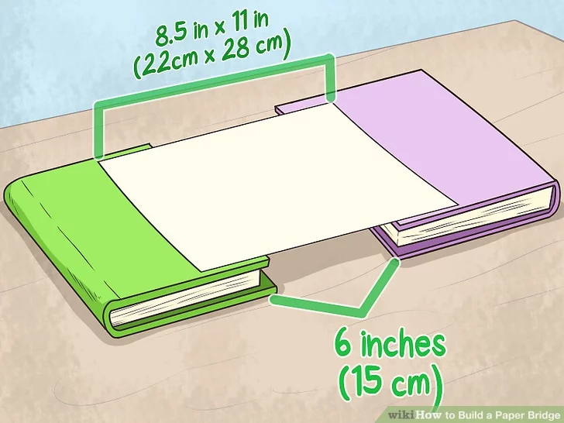
The image shows a piece of paper sitting on top of two books. What do you think would happen if you put a pencil in the middle of the piece of paper?

What do you think would happen if you placed two pencils on the piece of paper? Would something different happen than before?

What if you placed 5 pennies on the piece of paper?

Is there anything you could do to the piece of paper to make it a stronger bridge, so that more weight could be placed on it, without it collapsing?

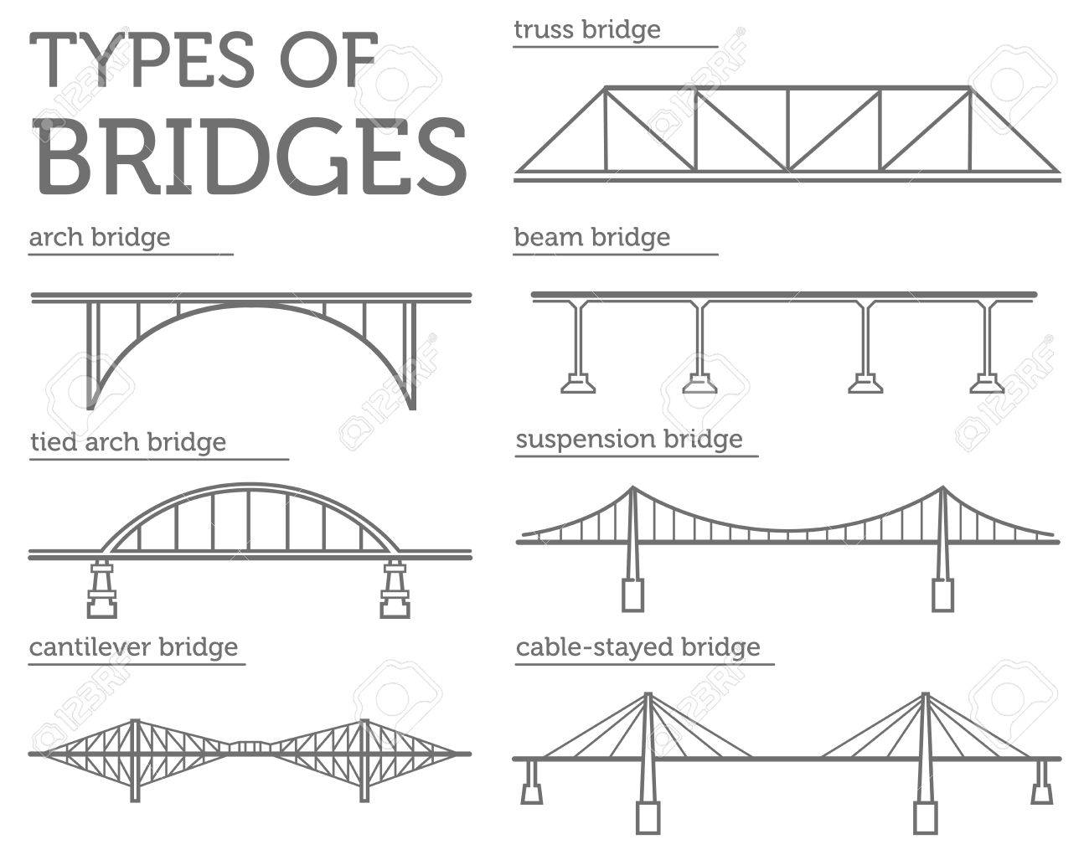

Which type of bridge have you seen before?

Which of these bridges might be easier to build?

Which of these might be the strongest bridges? What makes you think so?

Step 2: Read about the different factors engineers consider when building a bridge.

Tension and Compression: Two Forces Every Bridge Knows Well

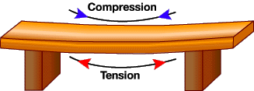
Tension: What happens to a rope during a game of tug-of-war? Correct, it undergoes tension from the two sweaty opposing teams pulling on it. This force also acts on bridge structures, resulting in tensional stress.
Compression: What happens when you push down on a spring and collapse it? That's right, you compress it, and by squishing it, you shorten its length. Compressional stress, therefore, is the opposite of tensional stress.
Compression and tension are present in all bridges, and as illustrated, they are both capable of damaging part of the bridge as varying load weights and other forces act on the structure. It's the job of the bridge design to handle these forces without buckling or snapping.
Buckling occurs when compression overcomes an object's ability to endure that force. Snapping is what happens when tension surpasses an object's ability to handle the lengthening force.
How would you describe what tension is to a 5-year-old?

Provide an example of when something snaps as a result of too much force?

If a bridge is able to withstand tension and compression of its traffic load, is the bridge strong or weak?

Building Bridges

When building a bridge, engineers must consider a number of factors. Different bridge styles distribute stresses in different ways. Engineers must take the length and width of the bridge, local environmental conditions and building materials into account to decide what type of bridge to build. To know what kind of bridge is realistic for what environment, knowing about the 6 different types of bridges is important. Using the wrong type can result in disasters affecting travel and safety.

Arch as Simple Bridge
Arch bridges use arches as the main structural component. The arches put the material that make up the bridge into compression. Most arch bridges are made of steel or concrete, which are good for compression. Arch bridges include those where the arch is underneath the bridge and above it. The Hell Gate Bridge in New York is an example of an arch bridge.

Basic Beam Bridge Construction
Beam bridges are made of a flat piece, or beam, laid across two or more supports. In the beam – which is horizontal - part of the material is in tension and part of the material is in compression. Beam bridges work much like a log overlapping the two sides of a ravine. An example of a beam bridge is the Lake Pontchartrain Causeway in southern Louisiana.

Cable-Stayed Bridge Structures
Cable-stayed bridges are one of two bridge types preferred for longer bridges (the other being suspension bridges). Columns are erected as support with cables to support the deck of the bridge. The design is similar to a suspension bridge but instead of the deck being curved, it is flat. In New York City, the East 153rd Street Bridge is a cable-stayed bridge.

Cantilevered Bridge Types
Kinds of bridges also include cantilevered bridges which are built around horizontal structures supported on only one end. Some cantilevered bridges are very similar in appearance to arch bridges; however, they are supported by diagonal bracing rather than vertical bracing. These types of cantilevered bridges are known as spandrel braced. The other type of cantilevered bridge is the cantilever through truss formation, where trusses are either above the bridge or both above and below. An example of a cantilevered bridge is the Queensboro Bridge.

Suspension Design Bridges
A suspension bridge is made of a platform that is held up by wires or ropes strung from the tops of piers. More recent suspension bridges use steel plates and steel cables that put material into tension. Steel is used for suspension bridges, because steel is strong in tension and concrete is not. With only the supports in the ground, suspension bridges respond to wind and traffic. Some of the most famous examples of suspension bridges are Golden Gate Bridge in San Francisco, Akashi Kaikyō Bridge in Japan and Brooklyn Bridge in New York City.
Truss Bridge
A truss bridge has a structure composed of elements connected to form triangles. Usually made of steel bars, truss bridges use a combination of compression and tension forces. The truss bridge is a simple bridge design that includes most covered bridges. T New York's Kosciuszco Bridge is a truss bridge example.

Step 3: Answer the following questions.
Why are different bridge designs used?

What bridge design is best? Why? Are different bridge designs better for different situations?

Label the type of bridge in the pictures below.
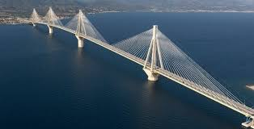Type of bridge__________________
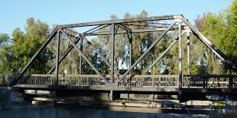Type of bridge__________________
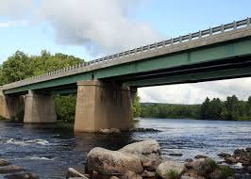Type of bridge_______________________
Step 4: Sketch the type of bridge you think is the strongest

Make a sketch of the type of bridge you think is the strongest. Get creative and include your own design elements!

Student Feedback:

Circle the emojis that best represents how this activity made you feel.

Mindfulness Moment!
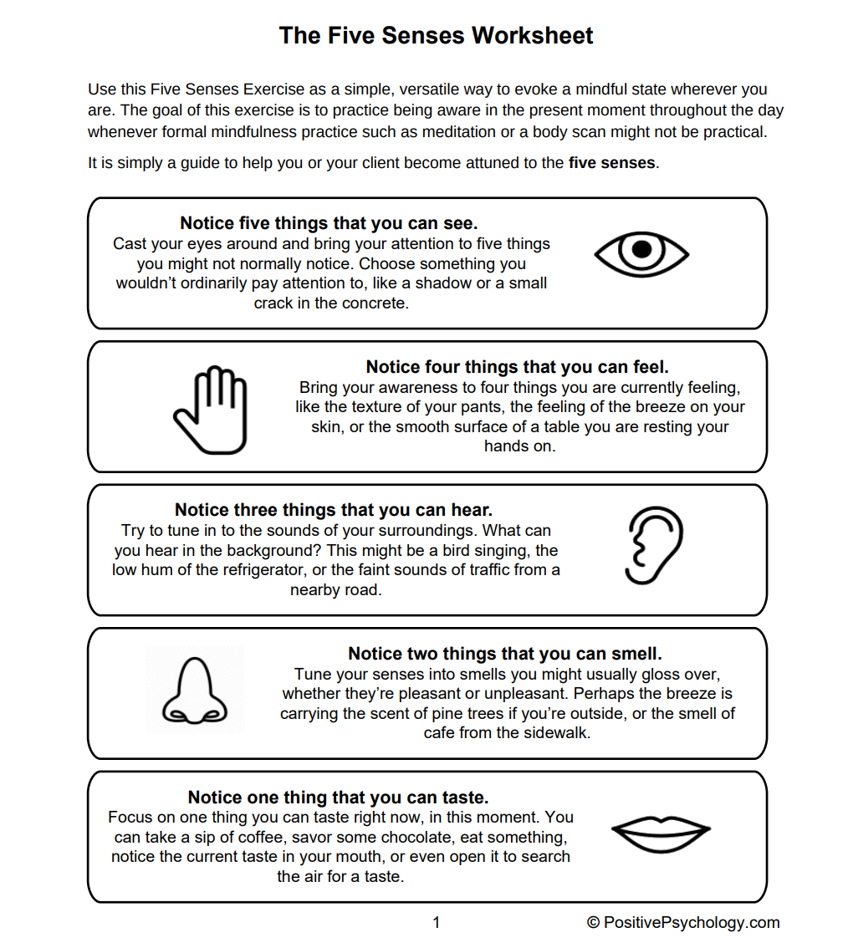

Day 1: Math
Increasing Your Strength: Adopting a Growth Mindset

What is this lesson about?: For this lesson, you will have the chance to learn about the Growth Mindset. You will then brainstorm ways to build up your strength and put that Growth Mindset to work for you and your peers over the next few weeks.

First, take a few minutes for today’s warm up:

Take a few minutes to answer questions below.
On a scale of 1 to 10, how do you rate your math skills? (1 is not good, 10 is great!)

What is one math skill that you would like to improve?

What is one math skill that you think you could help one of your peers or classmates with?

What is one mathematical ‘concept’ that you think would help you in real life, if any?

Step 1: Read and answer.
Read each of the statements below and write down a short answer. Your answer can be just a few words for each one, Once you have answered the questions, talk about them for a few minutes with other students, if you are permitted.
What is something that you are good at or that you are proud of that you can do well now, but that you couldn’t do when you were a little kid?

How did you get ‘good’ at this? What did you do to become good at it? Or did it just happen out of the blue? How did you become ‘stronger’ at it?

Discussion: Share your answers with a classmate or your teacher, if permitted.
Step 2: Answer the questions below.
Answer the questions below once again. Once you have answered the questions, talk about them for a few minutes with other students, if you are permitted.

Write an answer to each question below

6 - 3 = ___

21 + 8 = ___

44 - 9 = ___

How would you rate these three problems? Easy or Hard (circle one)

About how old were you when you learned how to answer those questions?

How did you learn how to do those problems?

Did you know how to do them when you were a baby?

Discuss: How do you get better at things?

Step 3: Read the quotes from Michael Jordan and answer the questions.

"I've missed more than 9,000 shots in my career. I've lost almost 300 games. Twenty-six times, I've been trusted to take the game winning shot and missed. I've failed over and over and over again in my life.”

“People used to say that all I could do was dunk, that my jump shot was no good. They were kind of right. Until I proved them wrong. Until I started shooting hundreds of jumps shots a day, from all angles, with defenders all over me. I still missed some, but not much!”

Many people think Michael Jordan is the greatest basketball player of all time.

Do you think he considers himself a failure or a success?

How did he become successful?

What does he say about failing? Did failing or missing clutch shots stop him?
What did those failures do to him?

What was a challenge that he faced as a basketball player?

How did he overcome it?

Discuss your answers with a classmate or your teacher, if permitted.

Step 4: Growth Mindset - Making it Personal

A “growth mindset” means that you don’t let your present situation define you. You get stronger and stronger by trying, and failing.

A growth mindset means that you don’t limit yourself to what you can do easily, right now. It means that you decide that if you want to get better or if you want to overcome an obstacle, you can.

A growth mindset means that you know that it will take practice, that you will make mistakes, but that you can and will improve--if you try and don’t quit.

Write down something you want to get better at.

Write down what you will need to do to get better at it.

Write down what is most challenging about your present situation--about being locked up right now.

What can you do to overcome that challenge or not make that challenge define you?

Discussion: Share your answers with your classmates or teacher, if permitted.

Step 5: Creating your own Growth Mindset Mantra

In the space below, either write out a quote or draw or sketch out your own Personal Growth Mindset Mantra. Ask your teacher if you can tape this paper up on the wall of the classroom or on your unit, or in your room.

Name:

The challenge I am facing:

How I am going to overcome it:

What I will do if I experience a failure along the way:

Student Feedback:

Circle the emojis that best represents how this activity made you feel.
Mindfulness Moment!
Use the diagrams below to help focus on and deepen your breathing. Using your finger, trace along the shape as you breathe in and breath out.
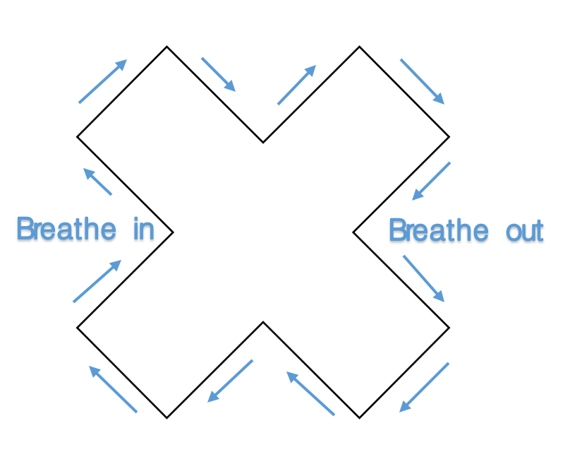
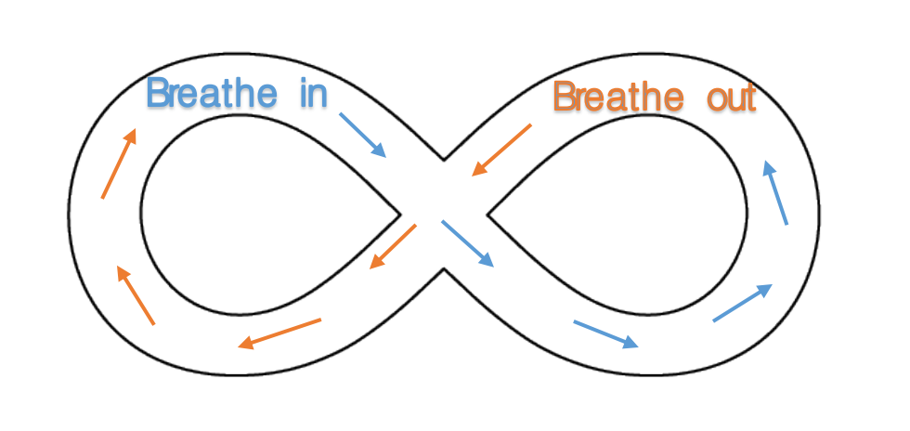
Day 1: Civics/Social Studies
World War I

What is this lesson about?: In this lesson, you will read an article about the start of WWI. You will use this article to answer a question about whether or not you think this war could have been prevented. Then, you will write a letter from the perspective of a WWI soldier.

Step 1: Read the following article.

Time Machine (1914): Assassination of Archduke Ferdinand Starts WWI
On June 28, the Archduke Franz Ferdinand of Austria-Hungary was assassinated. He was traveling by car through the streets of Sarajevo when a young man named Gabriel Prinzip shot and killed him.

Europe Hurtles Toward War
The assassination created a political crisis, and, as a result, war is now breaking out across Europe.
Prinzip was part of a group of Serbians fighting for greater independence from Austria- Hungary. Some Serbians see Austria-Hungary as an oppressive foreign power and believe that they deserve more political freedom. For Prinzip, killing the archduke was a political act meant to achieve freedom for Serbia.
The government of Austria-Hungary, however, was enraged by the assassination, and 25 days later, it sent a note of demands to the Serbian government. The note accused Serbia of helping Prinzip carry out the assassination.
Meet These Demands Now!
Austria-Hungary presented the Serbian government with several demands. The government had to publicly oppose the anti-Austria-Hungary movement and make it against the law to say or write things against Austria-Hungary.
Serbia was given just 48 hours to meet these demands. If Serbia was unwilling, Austria-Hungary would declare war.
Such a war could draw in all of Europe given the continent's delicate balance of power. The countries of Europe have entered into a complicated set of agreements. Germany has promised to defend Austria-Hungary, and Russia has pledged to protect Serbia. So, as Austria-Hungary and Serbia prepared to fight following the assassination of the archduke, so too did Germany and Russia. When Germany began gearing up for war, its rivals France and Great Britain did as well.

Serbia Pulls Russia In
What started as a dispute over Serbian independence is now set to pull all of Europe into war. It is as if Europe had been resting on a pile of explosives, and Prinzip lit a match.
On the night of July 23, a few weeks after the assassination, government workers in Russia received a message from Serbia.
"Help!" it said.
The Russians talked about the message for four hours. Russia was Serbia's ally, but taking their side in the conflict with Austria-Hungary meant risking war with Germany. The Russians reached a secret decision at 7 o'clock in the evening and dashed off in their automobiles to their various offices, each doing his part to prepare for what was coming.
Armies Move Toward Battle
Meanwhile, the armies of Europe were already getting ready to fight.
Serbia's 48 hours were up on July 26 at 6 in the evening. By that time, the Russian army was moving toward Germany, and the German army was moving toward Russia, and in a dozen other different directions.
Prinzip's bullet set all that in motion. It ignited the explosives under Europe, and the fire about to break loose will probably kill a million men. This war may create more destruction than anything else that has ever happened to human beings.
An Assassin's Screed
Did Prinzip know what he was doing when he pulled the trigger? We cannot know for sure. According to the Serbian government, following the assassination, Prinzip said:
"I was not influenced by any other person or persons. The reading of anarchist literature made me believe that there could be nothing finer in the world than to be an assassin. When in Belgrade I read that the Archduke was going to Serajevo, and so I bought a revolver and went there."
Was War Unavoidable?
What he said or thought matters little now, though. Europe is not fighting because Prinzip is a murderer. The real reasons for the war have to do with the long and ancient quarrel for "a place in the sun," a place for each European nation to put its feet in the crowded land. This quarrel has suddenly been turned from a contest of words and into a war of nations.
Perhaps war was unavoidable. Some jolt would have set off the European explosion, at some time. It just happened that Prinzip's bullet did it.

Step 2: Answer the questions below about the article.
Do you think the outbreak of World War I could have been avoided if Archduke Ferdinand had not been assassinated? Why or why not?

The article mentions that Russia was Serbia’s “ally.” What does it mean to be an ally? How might Russia be expected to act if it is Serbia’s ally?

How does creating an alliance make a country stronger?

Do you have any alliances or friendships that make you stronger? How do they make you stronger?

The article states “The real reasons for the war have to do with the long and ancient quarrel for "a place in the sun," a place for each European nation to put its feet in the crowded land.” What do you think this means? What is it that the European countries wanted?

“Imperialism” is when a country wants to expand its power and influence through diplomacy or military actions. Do you think European countries had goals of imperialism during the time of WWI? Why?

Step 3: Read this primary source letter from a soldier in WWI.
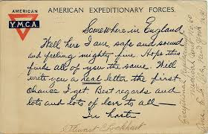

Somewhere in England. Well here I am, safe and sound and feeling mighty fine. Hope this finds all of you the same. Will write you a real letter the first chance I get. But regards and lots and lots of love to all-

What is the tone of this letter? Is it upbeat/happy? Or is it sad/scary?

Why do you think soldiers had to show strength in the letters they wrote home to their families?

Step 4: Write your own letter.
Imagine you are a soldier stationed in England during WWI. Write a letter to your family and give them the strength they need to get through this tough time.
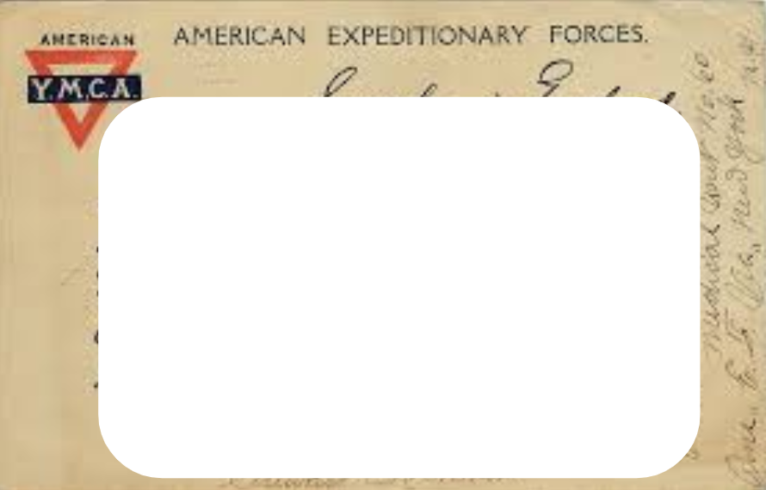
Student Feedback:

Circle the emojis that best represents how this activity made you feel.

Creative Activities: Google Doodle
This year’s Google Doodle theme is to show kindness by…Design your own Google Logo and participate in a school-wide contest. See some examples below.
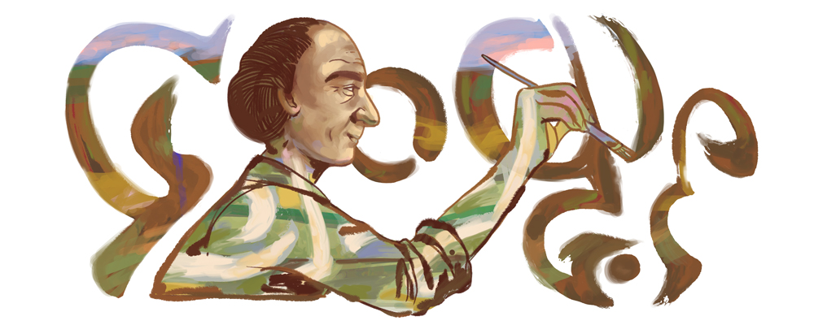

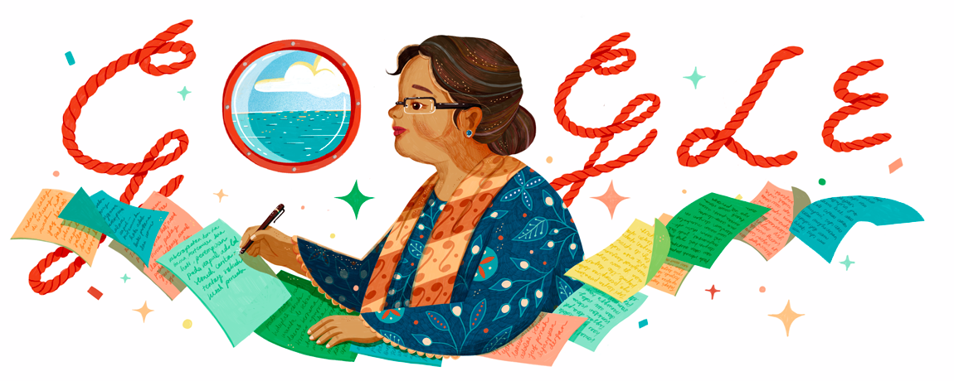

Draw Your Art Here:

