Week 7
Rights

Day 5

NAME:______________________

Day 5 Agenda
Topic | Activity
Warm-Up!
English Language Arts | - Read and analyze the speech All Together Now by Barbara Jordan.  - Answer questions about the speech.  - Demonstrate their understanding of the theme “All Together Now” through their choice of a short poem/song/rap, a drawing or an adaptation of Jordan’s speech to update it for an audience in 2020.
Science | - Read about the Flint Water Crisis  - Answer questions about what you read  - Draw a picture  - Reflect
Mindfulness Moment!
Math | - Rights-How about Right Angles
Health | - Internet Rights
Mindfulness Moment!
Civics/Social Studies | - Choose Your Rights!

Warm-up Activity: Write a journal entry around the daily quote on identity.
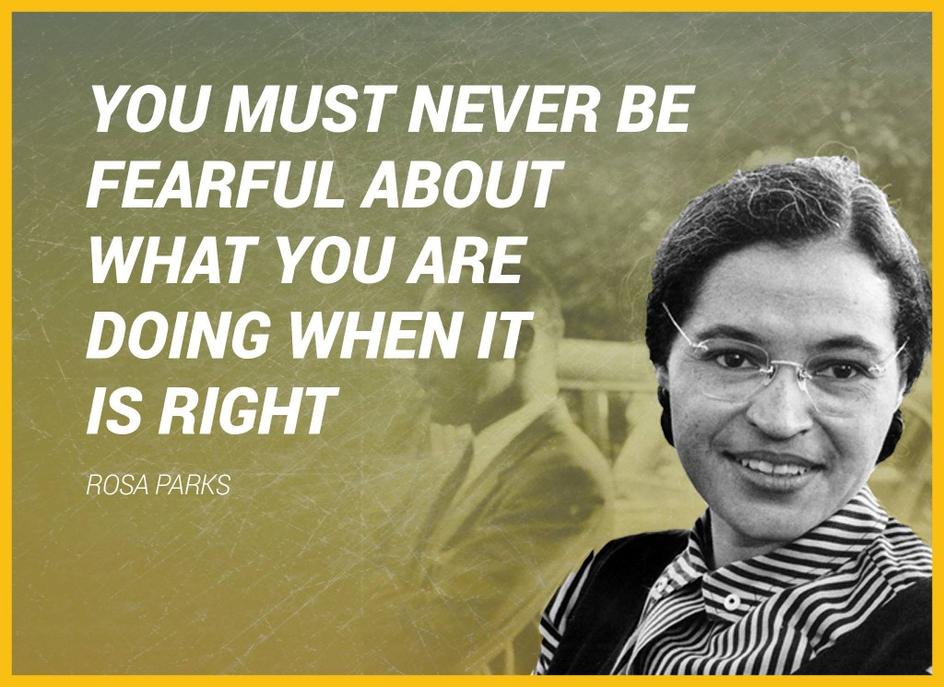

Day 5: Barbara Jordan
English Language Arts

What is this lesson about? Today you will read a persuasive speech by Barbara Jordan given while addressing the Democratic Convention in 1992 where Bill Clinton was declared the Democratic Nominee for President.

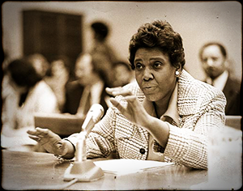
Before you read:
Barbara Jordan was a lawyer and educator who was a congresswoman from 1972 to 1978—the first African-American congresswoman to come from the deep South and the first woman ever elected to the Texas Senate (1966). Advancing in her career, Jordan won election to the U.S. House of Representatives in 1972. As a member of the House Judiciary Committee, she was thrust into the national spotlight during the Watergate scandal. Jordan stood as a moral compass during this time of crisis, calling for the impeachment of President Richard M. Nixon for his involvement in this illegal political enterprise. "I am not going to sit here and be an idle spectator to the diminution, the subversion, the destruction of the Constitution," she said in a nationally televised speech during the proceedings. In 1992, Jordan once again took the national stage to deliver a speech at the Democrats ic National Convention. Her health had declined by this point, and she had to give her address from her wheelchair. Still, Jordan spoke to rally her party with the same powerful and thoughtful style she had displayed 16 years earlier. In 1994, President Bill Clinton appointed Jordan to head up the Commission on Immigration Reform. He also honored her with the Presidential Medal of Freedom that same year. She passed away two years later, on January 17, 1996, in Austin, Texas. Jordan died of pneumonia, a complication of her battle with leukemia.

Some Vocabulary to review:
slate: flat board used for writing on, typically framed in wood, formerly used in schools. | heyday: the period of one's greatest popularity or prosperity | culminate: to reach the highest point
fatigue: tiredness, exhaustion | compassion: concern for the sufferings or misfortunes of others. | optimist: someone who always looks at things positively
harmonious: free from disagreement

Step 1: Read the speech below
All Together Now
Barbara Jordan
When I look at race relations today I can see that some positive changes have come about. But much remains to be done, and the answer does not lie in more legislation. We have the legislation we need: we have the laws. Frankly, I don’t believe that the task of bringing us all together can be accomplished by government. What we need now is soul force—the efforts of people working on a small scale to build a truly tolerant, harmonious society. And parents can do a great deal to create that tolerant society.
We all know that race relations in America have had a very rocky history. Think about the 1960s when Dr. Martin Luther King Jr. was in his heyday and there were marches and protests against segregation and discrimination. The movement culminated in 1963 with the March on Washington.
Following that event, race relations reached an all-time peak. President Lyndon B. Johnson pushed through the Civil Rights Act of 1964, which remains the fundamental piece of civil rights legislation in this century. The Voting Rights Act of 1965 ensured that everyone in our country could vote. At last, black people and white people seemed ready to live together in peace.
But that is not what happened. By the 1990’s the good feelings had diminished. Today the nation seems to be suffering from compassion fatigue, and issues such as race relations and civil rights have never regained momentum.
Those issues, however, remain crucial. As our society becomes more diverse, people of all races and backgrounds will have to learn to live together. If we don’t think this is important, all we have to do is look at the situation in Bosnia today.
How do we create a harmonious society out of so many kinds of people? The key is tolerance—the one value that is indispensable in creating community.
If we are concerned about community, if it is important to us that people not feel excluded, then we have to do something. Each of us can decide to have one friend of a different race or background in our mix of friends. If we do this, we’ll be working together to push things forward.
One thing is clear to me: We, as human beings, must be willing to accept people who are different from ourselves. I must be willing to accept people who don’t look as I do and don’t talk as I do. It is crucial that I am open to their feelings, their inner reality.
What can parents do? We can put our faith in young people as a positive force. I have yet to find a racist baby. Babies come into the world as blank as slates and, with their beautiful innocence, see others not as difficult but as enjoyable companions. Children learn ideas and attitudes from the adults who nurture them. I absolutely believe that children do not adopt prejudices unless they absorb them from their parents or teachers.
The best way to get this country faithful to the American dream of tolerance and equality is to start small. Parents can actively encourage their children to be in the company of people who are of other racial and ethnic backgrounds. If a child thinks, “Well, that person’s color is not the same as mine, but she must be okay because she likes to play with the same things I like to play with,” that child will grow up with a broader view of humanity.
I’m an incurable optimist. For the rest of the time that I have left on this planet I want to bring people together. You might think of this as a labor of love. Now, I know that love means different things to different people. But what I mean is this: I care about you because you are a fellow human being and I find it okay in my mind, in my heart, to simply say to you, I love you. And maybe that would encourage you to love me in return.
It is possible for all of us to work on this—at home, in our schools, at our jobs. It is possible to work on human relationships in every area of our lives.

Step 2: Answer the following questions
Make sure to answer in complete sentences and cite evidence from the text to strengthen your answer.

- How does Jordan summarize the history of race relations in the 1960’s and the 1990’s?

- In your own words, describe what Jordan means by “compassion fatigue”

- Which value is necessary in order to create a “harmonious society”?

- Explain what Jordan means when she says that she has yet to find “a racist baby”.

- What does Jordan suggest that parents do in order to create a sense of community?

- This speech was given in 1992, are there parts of it that still apply today? Why or why not? If yes, which ones? Explain your answer.

Step 3: Think, Write, Draw, Share
The title of the speech is All Together Now. Why might this title be especially appropriate for an audience at a political convention where people were going to decide who the Democratic nominee for President was going to be?

To demonstrate your understanding, you can create any of the following:
- A short poem/song/rap with the theme of All Together Now

- A drawing with the theme of All Together Now

- An adaptation of Jordan’s speech (you can go through the speech and change different portions of it to update it for an audience in 2020.

Make sure you brainstorm your ideas here first then use the following page for work.

Step 4: Share out
Share your All Together Now representation with your peers.

Student Feedback:

Circle the emojis that best represents how this activity made you feel. | 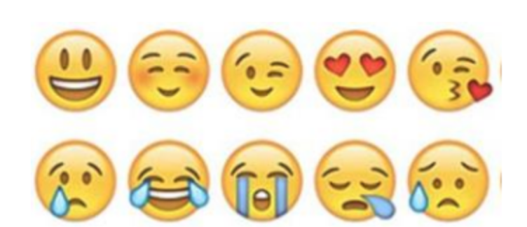  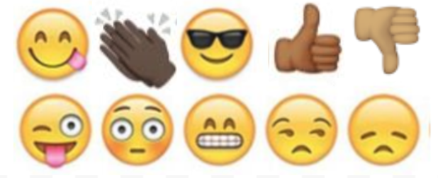

Day 5: Flint Water Crisis
Science

What is this lesson about?: Today you will read the Flint water crisis: Everything you need to know passage. You will respond to questions and complete an activity.

Step 1: Read the passage

Flint Water Crisis: Everything You Need to Know

(NRDC, 2018)
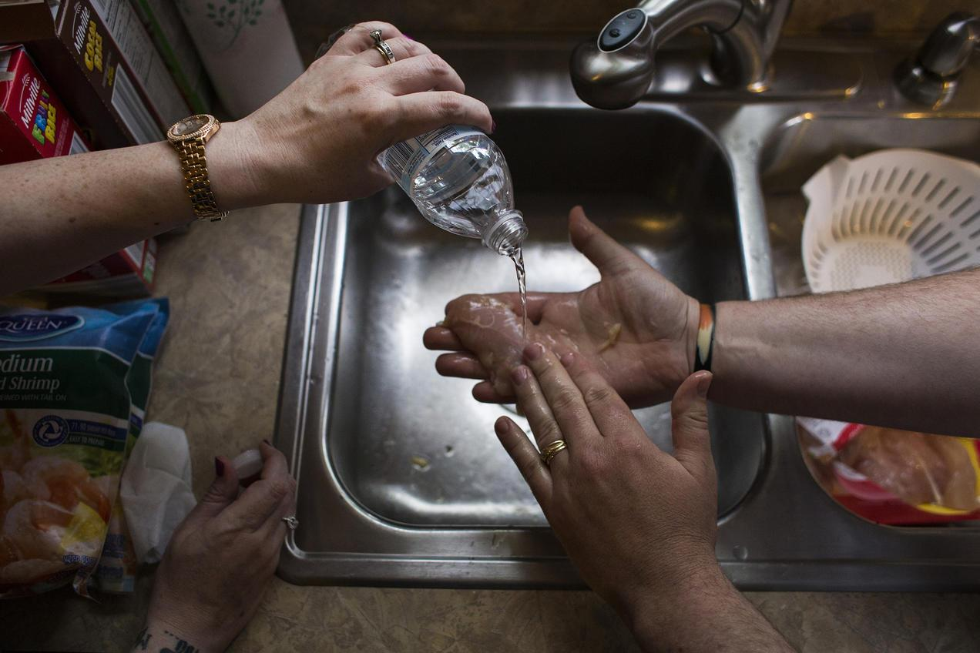
Fearful of using the tap water to wash their food, Flint residents Melissa and Adam Mays prepare meals with bottled water. Brittany Greeson

A story of environmental injustice and bad decision making, the water crisis in Flint, Michigan, began in 2014, when the city switched its drinking water supply from Detroit’s system to the Flint River in a cost-saving move. Inadequate treatment and testing of the water resulted in a series of major water quality and health issues for Flint residents—issues that were chronically ignored, overlooked, and discounted by government officials even as complaints mounted that the foul-smelling, discolored, and off-tasting water piped into Flint homes for 18 months was causing skin rashes, hair loss, and itchy skin. The Michigan Civil Rights Commission, a state-established body, concluded that the poor governmental response to the Flint crisis was a “result of systemic racism.”

Later studies would reveal that the contaminated water was also contributing to a doubling—and in some cases, tripling—of the incidence of elevated blood lead levels in the city’s children, imperiling the health of its youngest generation. It was ultimately the determined, relentless efforts of the Flint community—with the support of doctors, scientists, journalists, and citizen activists—that shined a light on the city’s severe mismanagement of its drinking water and forced a reckoning over how such a scandal could have been allowed to happen.

Flint Water Crisis Summary
Long before the recent crisis garnered national headlines, the city of Flint was eminently familiar with water woes. For more than a century, the Flint River, which flows through the heart of town, has served as an unofficial waste disposal site for treated and untreated refuse from the many local industries that have sprouted along its shores, from carriage and car factories to meatpacking plants and lumber and paper mills. The waterway has also received raw sewage from the city’s waste treatment plant, agricultural and urban runoff, and toxics from leaching landfills. Not surprisingly, the Flint River is rumored to have caught fire—twice.

As the industries along the river’s shores evolved, so too did the city’s economy. In the mid-20th century, Flint—the birthplace of General Motors—was the flourishing home to nearly 200,000 people, many employed by the booming automobile industry. But the 1980s put the brakes on that period of prosperity, as rising oil prices and auto imports resulted in shuttered auto plants and laid-off workers, many of whom eventually relocated. The city found itself in a precipitous decline: Flint’s population has since plummeted to just 100,000 people, a majority of whom are African-American, and about 45 percent of its residents live below the poverty line. Nearly one in six of the city’s homes has been abandoned.
This was the lay of the land in 2011, when Flint, cash-strapped and shouldering a $25 million deficit, fell under state control. Michigan Governor Rick Snyder appointed an emergency manager (basically an unelected official chosen to set local policy) to oversee and cut city costs. This precipitated the tragic decision in 2013 to end the city’s five-decade practice of piping treated water for its residents from Detroit in favor of a cheaper alternative: temporarily pumping water from the Flint River until a new water pipeline from Lake Huron was built. Although the river water was highly corrosive, Flint officials failed to treat it, and lead leached out from aging pipes into thousands of homes.
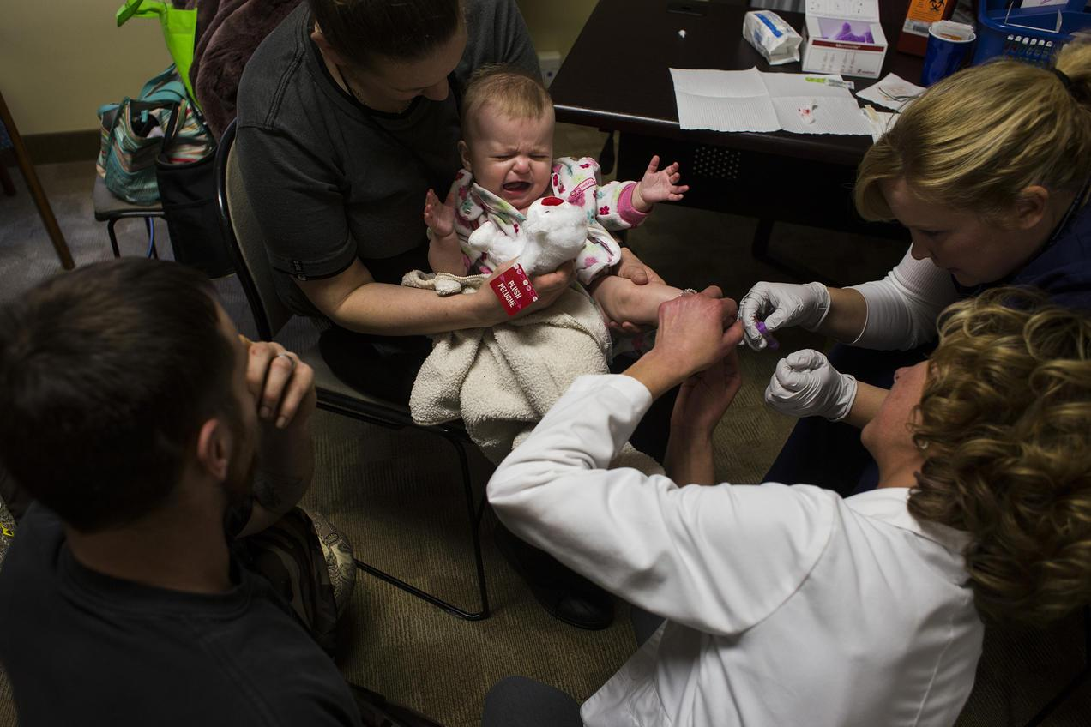

Five-month-old Dakota Erler of Flint gets blood drawn from her heel in order to have her lead levels tested at Carriage Town Ministries in 2016. Brittany Greeson

Lead levels in Flint water
Soon after the city began supplying residents with Flint River water in April 2014, residents started complaining that the water from their taps looked, smelled, and tasted foul. Despite protests by residents lugging jugs of discolored water, officials maintained that the water was safe. A study conducted the following year by researchers at Virginia Tech revealed the problem: Water samples collected from 252 homes through a resident-organized effort indicated citywide lead levels had spiked, with nearly 17 percent of samples registering above the federal “action level” of 15 parts per billion (ppb), the level at which corrective action must be taken. More than 40 percent measured above 5 ppb of lead, which the researchers considered an indication of a “very serious” problem.

Even more alarming were findings reported in September 2015 by Flint pediatrician Mona Hanna-Attisha: The incidence of elevated blood-lead levels in children citywide had nearly doubled since 2014—and nearly tripled in certain neighborhoods. As Hanna-Attisha noted, “Lead is one of the most damning things you can do to a child in their entire life-course trajectory.” In Flint, nearly 9,000 children were supplied lead-contaminated water for 18 months.

More problems with Flint water
Flint’s water supply was plagued by more than lead. The city’s switch from Detroit water to the Flint River coincided with an outbreak of Legionnaires’ disease (a severe form of pneumonia) that killed 12 and sickened at least 87 people between June 2014 and October 2015. The third-largest outbreak of Legionnaires’ disease recorded in U.S. history—as well as the discovery in 2014 of fecal coliform bacteria in city water—was likely a result of the city’s failure to maintain sufficient chlorine in its water mains to disinfect the water. Ironically, the city’s corrective measure—adding more chlorine without addressing other underlying issues—created a new problem: elevated levels of total trihalomethanes (TTHM), cancer-causing chemicals that are by-products of the chlorination of water.
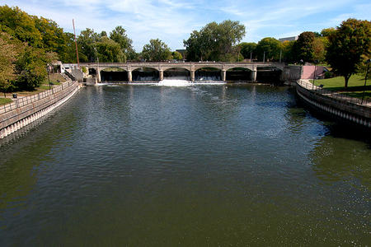
Flint residents go to court
One of the few bright spots of the Flint water crisis was the response of everyday citizens who, faced with the failure of city, state, and federal agencies to protect them, united to force the government to do its job. On the heels of the release of test results in the fall of 2015 showing elevated lead levels in Flint’s water—and its children—local residents joined with NRDC and other groups to petition the U.S. Environmental Protection Agency (EPA) to launch an immediate emergency federal response to the disaster. The EPA failed to act, which only spurred residents on.

Flint Water Crisis
In early 2016, a coalition of citizens and groups—including Flint resident Melissa Mays, the local group Concerned Pastors for Social Action, NRDC, and the ACLU of Michigan—sued the city and state officials in order to secure safe drinking water for Flint residents. Among the demands of the suit: the proper testing and treatment of water for lead and the replacement of all the city’s lead pipes. In March 2016, the coalition took additional action to address an urgent need, filing a motion to ensure that all residents—including children, the elderly, and others unable to reach the city’s free water distribution centers—would have access to safe drinking water through a bottled water delivery service or a robust filter installation and maintenance program.

Those efforts paid off. In November 2016, a federal judge sided with Flint residents and ordered the implementation of door-to-door delivery of bottled water to every home without a properly installed and maintained faucet filter. A more momentous win came the following March with a major settlement requiring the city to replace the city’s thousands of lead pipes with funding from the state, and guaranteeing further funding for comprehensive tap water testing, a faucet filter installation and education program, free bottled water through the following summer, and continued health programs to help residents deal with the residual effects of Flint’s tainted water.

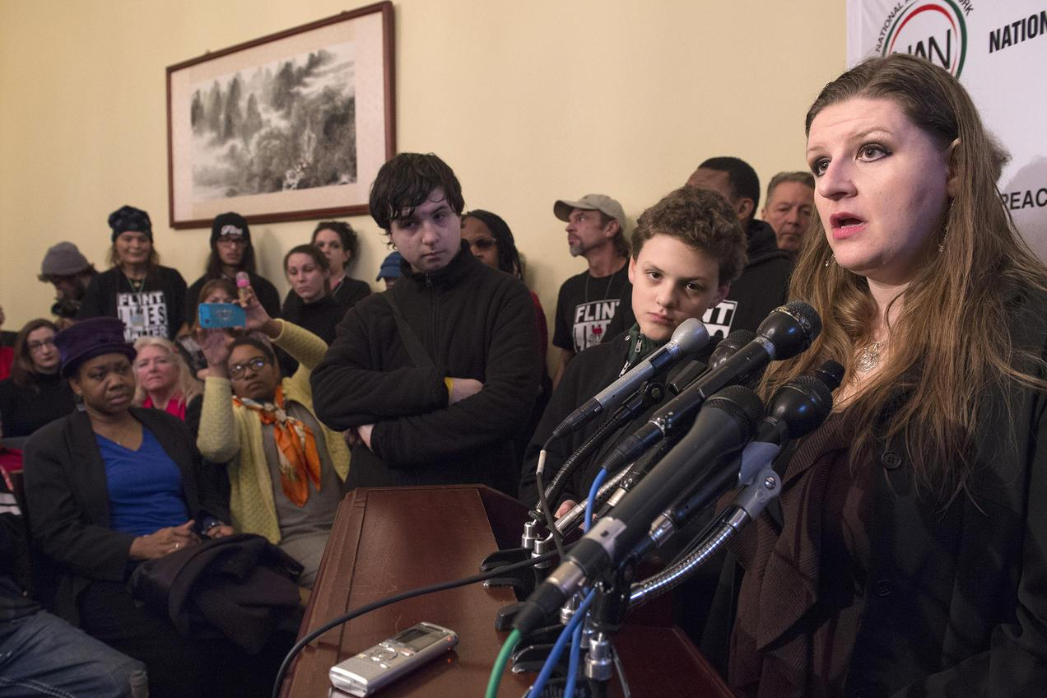
But the work of Flint residents and their advocates isn’t finished yet. Ensuring that the provisions of the 2017 settlement are met is an ongoing task. Indeed, members of the lawsuit have already returned to court to see that the city properly manages its lead service line replacement program and provides filters for faucets.

Melissa Mays and other Flint residents address the media after the House Oversight and Government Reform Committee hearing to examine the Flint water situation in 2016. Molly Riley/Associated Press

Flint Water Crisis Update
Does Flint have safe water yet?
Governor Snyder seemed to signal the all-clear in April 2018 when he announced that the city would stop providing bottled water to residents. Indeed, there is some evidence that the situation in Flint is improving, with lead levels remaining below the federal action level for the past four six-month monitoring periods, from July 2016 to June 2018.

However, it is important to note that thousands of Flint residents are still getting their water from lead pipes. The federal action level for lead is not a health-based number; it merely is an administrative trigger for remediation by the water utility. The EPA and other health authorities agree that there is no safe level of lead in water, so the continuing use of lead pipes by thousands of Flint residents remains a concern, particularly in light of their cumulative lead exposure over many years.

The FAST Start program implemented by the city in March 2016 is working to replace the thousands of lead and galvanized steel service lines that connect Flint water mains to city homes by 2020. But as of October 2018, only a little more than 7,500 pipes had been upgraded. The slow pace of progress drew the group of residents working with NRDC back to court to demand that Flint comply with its obligations to identify and replace lead pipes and supply filters to residents after each pipe replacement.

Flint water crisis charges

In early 2016, Michigan Attorney General Bill Schuette announced an independent review to “determine what, if any, Michigan laws were violated” during Flint’s drinking water disaster. Over the course of his investigation, 15 people have been charged as criminally responsible for causing or contributing to the crisis.

To date, the most senior official to be charged is Nick Lyon, director of Michigan’s Department of Health and Human Services (MDHHS), who is standing trial for involuntary manslaughter in the deaths of two men linked to the Legionnaires’ disease outbreak. While awaiting trial, Lyon remains the state’s health director.

Among other officials charged are the state’s chief medical executive, Dr. Eden Wells, who allegedly threatened to withhold funds for a project after researchers began looking into the Legionnaires’ outbreak, and four state officials charged with tampering with lead test results and instructing residents to flush their taps ahead of testing (which can produce artificially low lead-level results). Two former Flint emergency managers, three Flint city officials, and a handful of Michigan Department of Environmental Quality (MDEQ) and MDHHS employees have also been charged. Meanwhile, Governor Snyder has not been charged with any crime.
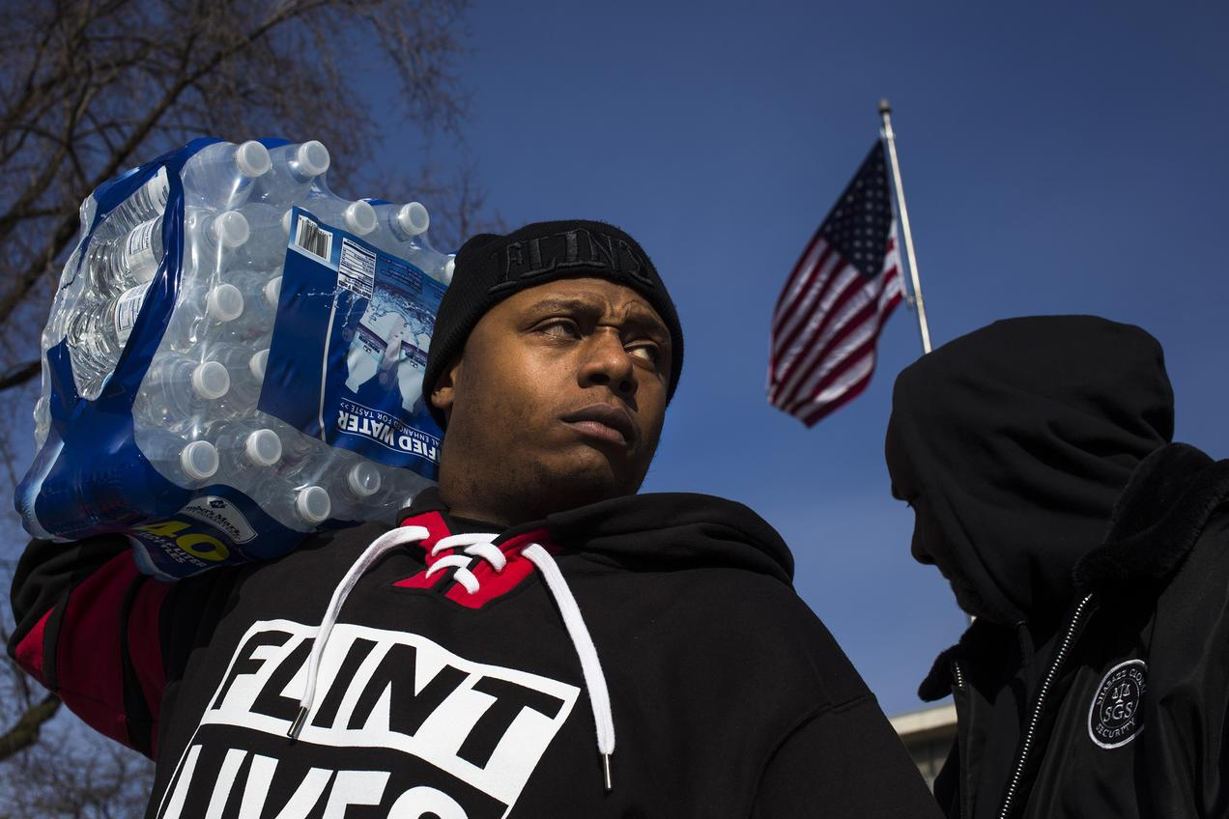
Resident Lorenzo Lee Avery Jr. stands outside of Flint City Hall during a Flint Lives Matter event in 2016. The city’s ongoing water crisis has left residents dependent on bottled water. Brittany Greeson

Step 2: Answer the following questions

- Provide three details that describe the Flint water crisis.

________________________________________________________________________________________________________________________________________________________________________________________________________________________________________________________________________________________________________________________

- If you lived in Flint, what would you do to make sure your rights were not being violated?
________________________________________________________________________________________________________________________________________________________________________________________________________________

- Do you believe those who were charged with the water crisis got “what they deserved”? If not, share what you think should have happened?
________________________________________________________________________________________________________________________________________________________________________________________________________________
________________________________________________________________________________________________________

Step 3: Draw a picture

Draw a picture that shows how you would have tried to help the residents in Flint during the water crisis. Share your drawing and explain what you would do.

Step 4: Reflect

As you think about this week’s science lessons, what’s one thing you will remember about rights?

________________________________________________________________________________________________________________________________________________________________________________________________________________
____________________________________________________

Student Feedback:

Circle the emojis that best represents how this activity made you feel.

Mindfulness Moment!

Deep Breathing
To do this:
- While standing or sitting, draw your elbows back slightly to allow your chest to expand.
- Take a deep inhalation through your nose.
- Retain your breath for a count of 5.
- Slowly release your breath by exhaling through your nose.

Day 5: Right Angles and Related
Math

What is this lesson about?: Today we will take a break from voting rights and related and focus on a bit of geometry, much of which is premised on right angles and related concepts.

Warm Up Problem
 | 1800 | 1850 | 1900
New York, NY | 60,515 | 515,547 | 3,437,202
Philadelphia, PA | 41,220 | 121,376 | 1,293,697

The chart above show the growth of the two largest cities on the East Coast, from 1800 to 1900.
- By approximately how much did New York grow from 1800 to 1850?
- How about from 1850 to 1900?
- What might have been a cause of this huge population increase in the late 1800s, do you think?
Step 1: Basic review
To make sure that everyone has the basic information necessary for today’s activities, we will just review a few key concepts.

Rectangle: A rectangle is a 4 sided figure with all right angles (90⁰). The opposite sides are equal in length.

Example:
Square: A square is a special rectangle, where all 4 sides are the same length.

Example:
Triangle: A triangle is a three sided figure.

Area: The area of a figure is the amount of space inside. It is measured in units² (or square units). Example:
Perimeter: The perimeter is the distance around something. It is measured in units.
Examples:
Measure of an Angle: The measure of an angle is the amount of ‘twist’ you move when you take two lines, connected at one point and move around a circle.
Examples:

Right Triangle:
- A right triangle is a triangle where one of its angles is exactly 90⁰.
- Because the three angles in a triangle add up to 180, if one angle is 90⁰, the other two have to add to 90, as well.
Examples:

Step 2: Area and Perimeter Problems (Round 1)

Find the area, perimeter, or missing length or width of each of the objects below:

Step 3: Area and Perimeter Problems (Round 2)
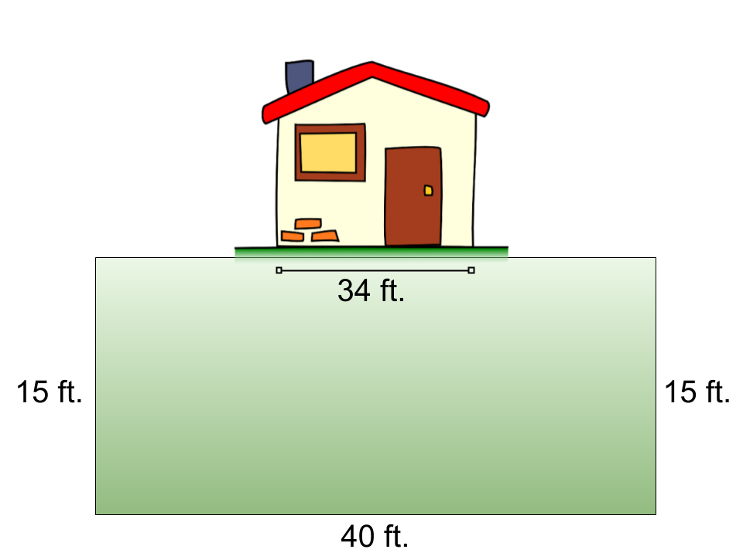
Word problems:

- Marcus wants to put up a small fence around his yard. His yard is 40 feet wide and 15 feet long. He needs to build a fence around 3 sides and have it run directly up to the side of the house on each side. The house is 34 feet side to side….See the diagram to the right.

  - How many feet of fencing does he need to purchase?
  - If the fencing costs $4.00 per foot, how much will it cost him to purchase the fence?

- For years Marcus has been battling weeds in his yard. He wants to start over and put in a rock garden. He can purchase large bags that have an assortment of rocks from Home Depot. Each bag will cover 20 ft^{2.} Each bag costs $12.
  - How many bags of rocks will he need to purchase?

  - How much will he have to spend?

- The city of Cleveland is going to redo all of its swimming pools this summer. They want to fix them up and get rid of all of the cracked concrete and replace it with a newer, safer soft rubber. Using the diagram below, along with the hints--see if you can determine how much it will cost them to replace the old cracked concrete with new material at this one, model swimming pool.
Facts:
- The model pool is 165 feet long and 80 feet wide.
- The city wants to have 10 feet of the new ‘rubber cement’ around the edge of the pool.
Questions:
  - How many square yards of the rubber cement does the city need to purchase to surround the pool?
    - Hint: be careful...How many square yards is the pool and the rubber cement surrounding it? If you ‘take away’ the area of the pool, you will be left with the area needed for the rubber cement.

  - If the rubber cement costs $20 per yd², how much will it cost to purchase it?

- A rectangle has an area of 40in². It is 10 inches long.
- How wide is it?
- What is its perimeter?

- A rectangle is 8 inches long. It is 3 inches shorter in length.
- What is its area?
- What is its perimeter?

- A rectangle is 4 inches longer than it is wide. It has an area of 12 in².
Be careful and check your work!
- How long is it?
- How wide is it?
- What is its perimeter?

- A rectangle is 6 inches longer than it is wide. It has a perimeter of 32 inches.
- How long is it?
- How wide is it?
- What is its area?

Step 4: Triangle Problems
Reminders: The three inside angles of a triangle add up to 180⁰.

What is the measure of angle A in each of the triangles below?

What is the measure of angle a and angle b in the triangle below if angle a and angle b are the same?

What is the measure of angle a and angle b in the triangle below if angle a is twice as large as angle b? (remember, angle a + angle b = 90⁰)

Student Feedback:

Circle the emojis that best represents how this activity made you feel.

Day 5: Internet Rights
Digital Health

What is this lesson about?: Today you will learn about how we have the right to develop an internet infrastructure. In some countries they do not have the internet and communications are monitored and limited.

Step 1: Warm-up

Describe what life would look like without the cellphones?

Step 2: Read the article on your internet infrastructure.

As the World Wide Web approaches its 30th birthday this March, most Americans can't imagine life without it — especially young people born into a digital world. The World Wide Web is a collection of web pages that can be accessed through the internet. The Internet is an electronic communications network. It connects computer networks around the world. It is much older than the World Wide Web.

Toddlers use the Internet to learn colors and letters on their parents' cellphones. Teens Netflix away boredom on hours-long car rides. Young adults Uber food to their doorsteps, and their friends Venmo them to pay their share of the tab.

But, it's not that easy for everyone. In fact, according to "The State of Broadband: Broadband catalyzing sustainable development," a United Nations report tracking the current status of broadband globally, more than half of the world's population has never been online. And many who have been online in developing nations run into obstacles that their peers in developed nations rarely encounter.

Our teen staff at iGeneration Youth wanted to explore the role the Internet plays — and sometimes doesn't play — in the lives of young people who may not be able to access the Internet with the same ease we're accustomed to. What's it like for our peers on the other side of the digital divide?

Of course, finding sources through the internet who struggle to access the Internet presented an obvious challenge. Here's how we did it. First, we combed the Web to find young videographers in 10 countries. Next, we gave them a set of questions to learn where and how youths access the Internet, the quality of Internet service, what young people mainly use the Internet for, the cool things young people are using the Internet for, and what they are hoping for in the future of the Internet.

Each videographer took to the streets to conduct on-camera interviews with young people 21 and younger.

Venezuela
Estefanía García, or "Chia," depends on the Internet for practically everything: doing homework, which is always online; managing social media for her theater group; posting her writing on her Instagram account; and watching music videos on YouTube.

"Sometimes, though, the videos don't load," said the 21-year-old from Caracas, who is studying visual arts and scriptwriting at Venezuela's Católica Andés Bello University. "Or the signal just doesn't work."

The Internet is important for young people in Venezuela because it allows them to earn money, García said. "With the hard economic situation, everyone just tries to work everywhere, even if they have to use their phone."

While the priority is work, people are using the Internet in creative ways, she said. For example, her friend, who is studying graphic design, makes videos and short films with animation. "It wouldn't be possible without the internet," said García. "She wouldn't have even learned it."
The coolest thing she's heard about is the ability to control a house from a phone. "Control the volume of the TV, the lights, turn the kitchen on with your phone. Everything for comfort. It's fantastic."

She hopes in the future that the signal will be good in every corner of the world.

Turkey
Yagiz Akkaya, age 18, spends about five hours a day on the Internet, usually at home in Istanbul. Very rarely, he uses Wi-Fi at Kahve Dünyasi, a Starbucks-style cafe. He doesn't use any other community Wi-Fi because he doesn't think it's safe.

When he's not watching movies or television series, Akkaya uses the internet for self-improvement, such as Google's online marketing training, which he's finished, earning a certificate. Although he's not actually interested in online marketing, it's something to put on his Curriculum Vitae.

"The Internet is important because it is very difficult for us to learn something, whether it is education or things in society," said Akkaya. "There are some online platforms, publishing the classes of world universities such as Cambridge and Sorbonne. Google also offers wonderful free things that are certified. I think they're terrific platforms."

However, although some of the workshops are free, if you want a certificate, you have to pay for it, he said.

Akkaya also likes watching cool things on the Internet, from little kids who post amazing videos to bands who play music on the subway.

He does worry about the younger generations, especially his circle of friends, which he said gets false hope from the Internet.

"There really is a lot of trash content on YouTube," said Akkaya. "Most of them want to make content like others on YouTube. They come up with ideas to me. 'Come on, buddy, I have a video idea. Let's make money on YouTube.' They want to make money, and they think they can use the Internet for this. They are losing time."
He worries about children who grow up on what he considers to be empty content. "Their sole purpose is to watch videos."

Overall, Akkaya thinks the Internet is effective. It helps him to find useful things, he said.
In the future, he hopes more free content will come to the forefront.

Mauritius
Paige McIntyre, age 13, lives in Beau-Bassin Rose Hill on the African island nation, located about 1,200 miles off the continent's southeast coast, in the Indian Ocean. She has access to the Internet most of the time using Wi-Fi at her house or in a commercial center, but the connections are not very good. Although 4G networks are available through her cellphone, mobile packages are expensive.

Like most young people in Mauritius, McIntyre uses the Internet mostly for social media — that is, Facebook, Instagram and sometimes Twitter, she said. She's a student, so she communicates with her teachers via email. But the Internet is much cooler than that, she said.
"I try to post all my photos on Instagram and Facebook, so people would see my work," said McIntyre, who loves photography. "I look at what professional photographers post online."
Her cousin is also recording and sharing her songs on YouTube, she said.

The coolest thing McIntyre said she's found on the Internet are all the YouTube influencers. "They are people who travel the world and post videos on their adventure and the countries they discover. I think this is very interesting, and it pushes me to want to travel more."

McIntyre said the Internet helps young people to reinvent themselves and create new things.
In the future, she hopes to see improvements to the Internet, which is not highly developed in Mauritius. "I would like the Internet to be free for everyone so that we can access it everywhere."

Step 3: Answer the questions below about the article

- List three ways that internet access varied for these teens?

- How does this change your view on communication across the world?

- Why do you think different countries provide different levels of access online?

Step 4: Write a letter

Write a letter to explain why everyone should have access to information. Keep in mind, it is optional whether or not they want to access it but it should be accessible to all.

Dear ,

Sincerely,

Mindfulness Moment!

Draw with your eyes closed. See what happens below:

Day 5: Choose Your Rights
Social Studies

What is this lesson about?: This week you learned about the U.S. Constitution and its Bill of Rights and additional amendments that creat rights and provisions to protect Americans. Now it’s your turn to choose your rights and establish your own Bill of Rights!

Step 1: Warm-Up

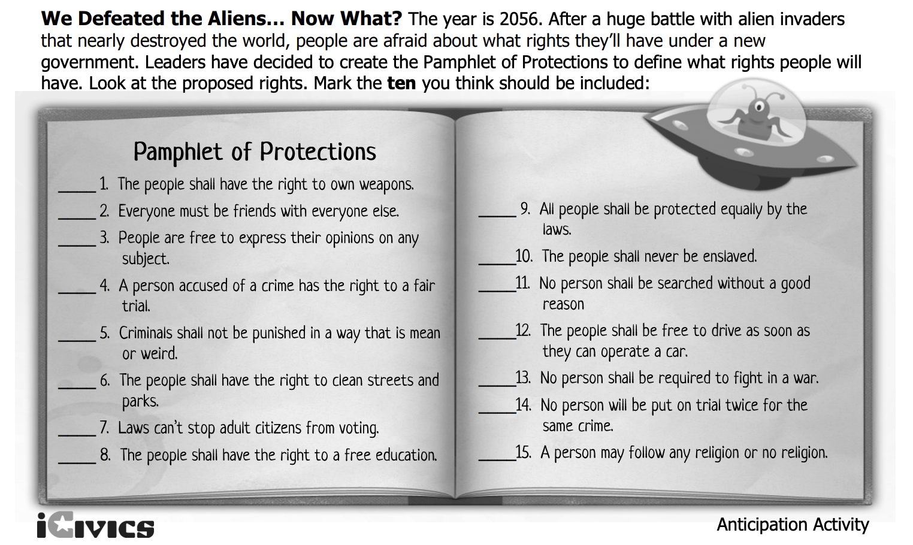

Step 2: Consider your task- activity 1

Directions: The country has just passed a new law: every school must form its own constitution and submit it to the state government for approval. You’ve been tasked to write the proposed constitution for your school. Working together with a partner or individually, write up ten rules and/or rights that will be included in your school constitution.

Step 3: Brainstorm

What is important to making a school safe?

What protections do students need in a school?

How can you make sure students are being treated fairly?

How might you make sure students receive the education they need?

Step 4: Write your school Bill of Rights

___________________________________
(School Name)

Student Bill of Rights

- ____________________________________________
- ____________________________________________
- ____________________________________________
- ____________________________________________
- ____________________________________________
- ____________________________________________
- ____________________________________________
- ____________________________________________
- ____________________________________________
- __________________________________________
Step 5: Consider your task - Activity 2

Directions: Just like you’ve seen with the 18th and 19th Amendments, proposals for new amendments to the Constitution can get started with ordinary citizens who want to see change in their country. Now it’s your turn to encourage congress to consider a new proposal for an amendment! What right or protection would you want to add to our Constitution? Select one from below or come up with your own. Then write a letter to congress requesting they consider your proposal. Be sure to explain why the amendment is needed and how it would help Americans.
- Options to choose from:
  - Equal Rights for all
  - Rights for same-sex marriage
  - Changes to the 2nd Amendment’s right to bear arms
  - Creating the right to affordable housing for all Americans
  - Choose your own!

Step 6: Write your letter!

Dear Congress,

I am writing to propose an amendment to the Constitution. My proposal is to include an amendment that

*Share your letter with a partner and compare what each of you proposed for a new amendment. Ask yourselves:
- Does your partner’s argument for why this amendment is necessary make sense? Do you agree with it?
- How can their argument be stronger?
- Do you think your proposals would be likely to get passed? Why or why not? (remember what is required for the amendment ratification process-- it’s difficult).

Student Feedback:

Circle the emojis that best represents how this activity made you feel.

