Week 7
Rights

Day 2

NAME:______________________

Day 2 Agenda

Topic | Activity
Warm-Up!
English Language Arts | - Read the Universal Declaration of Human Rights ratified by the United Nations.  - Analyze an informational document and respond to questions  - Complete a graphic organizer.
Science | - Read about Ethics of Artificial Intelligence  - Answer questions about what you read  - Draw a picture and explain
Mindfulness Moment!
Math | - Rights: the Math of Voting/Women
Health | - Freedom of Speech Online
Mindfulness Moment!
Civics/Social Studies | - The Bill of Rights Today

Warm-up Activity: Write a journal entry around the daily quote on identity.
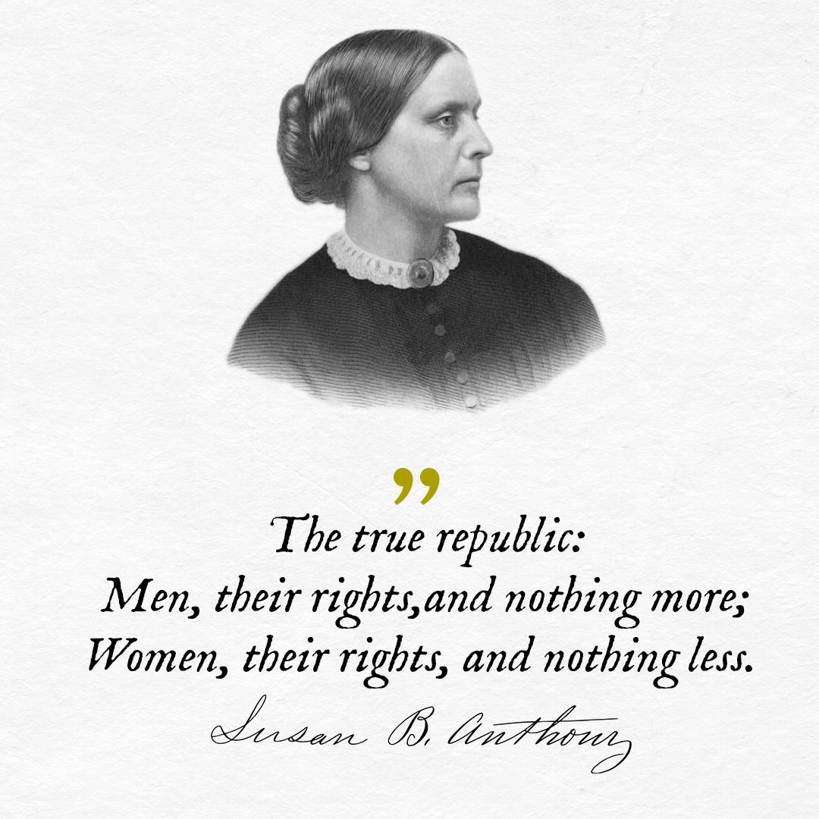

Day 2: The Universal Declaration of Human Rights
English Language Arts

What is this lesson about? Today you will continue to think about the theme of “Rights”. Read the Universal Declaration of Human Rights (UDHR) and consider what each means.

Before you read:
The Universal Declaration of Human Rights (UDHR) is a historic document that was adopted by the United Nations December 10, 1948 as a response to what had happened in World War II. The Declaration includes 30 articles affirming an individual's rights which, although not legally binding, have been referred to and used in subsequent international treaties, economic transfers, regional human rights instruments, national constitutions, and other laws.

Step 2: Read the following text

UNIVERSAL DECLARATION OF HUMAN RIGHTS: Simplified
- We are all born free. We all have our own thoughts and ideas. We should all be treated in the same way.
- These rights belong to everybody; whether we are rich or poor, whatever country we live in, whatever sex or whatever colour we are, whatever language we speak, whatever we think or whatever we believe.
- We all have the right to life, and to live in freedom and safety.
- Nobody has any right to make us a slave. We cannot make anyone else our slave.
- Nobody has any right to hurt us or to torture us.
- We all have the same right to use the law.
- The law is the same for everyone. It must treat us all fairly.
- We can all ask for the law to help us when we are not treated fairly.
- Nobody has the right to put us in prison without a good reason, to keep us there or to send us away from our country.
- If someone is accused of breaking the law they have the right to a fair and public trial.
- Nobody should be blamed for doing something until it has been proved that they did it. If people say we did something bad, we have the right to show this was not true. Nobody should punish us for something that we did not do, or for doing something which was not against the law when we did it.
- Nobody should try to harm our good name. Nobody has the right to come into our home, open our letters, or bother us or our family without a very good reason.
- We all have the right to go where we want to in our own country and to travel abroad as we wish.
- If we are frightened of being badly treated in our own country, we all have the right to run away to another country to be safe.
- We all have the right to belong to a country.
- Every grown up has the right to marry and have a family if they want to. Men and women have the same rights when they are married, and when they are separated.
- Everyone has the right to own things or share them. Nobody should take our things from us without a good reason.
- We all have the right to believe in what we want to believe, to have a religion, or to change it if we want.
- We all have the right to make up our own minds, to think what we like, to say what we think, and to share our ideas with other people wherever they live, through books, radio, television and in other ways.
- We all have the right to meet our friends and to work together in peace to defend our rights. Nobody can make us join a group if we don’t want to.
- We all have the right to take part in the government of our country. Every grown up should be allowed to choose their own leaders from time to time and should have a vote which should be made in secret.
- We all have the right to a home, to have enough money to live on and medical help if we are ill. We should all be allowed to enjoy music, art, craft, sport and to make use of our skills.
- Every grown up has the right to a job, to get a fair wage for their work, and to join a trade union.
- We all have the right to rest from work and relax.
- We all have the right to a good life, with enough food, clothing, housing, and healthcare. Mothers and children, people without work, old and disabled people all have the right to help.
- We all have the right to an education, and to finish primary school, which should be free. We should be able learn a career, or to make use of all our skills. We should learn about the United Nations and about how to get on with other people and respect their rights. Our parents have the right to choose how and what we will learn.
- We all have the right to our own way of life, and to enjoy the good things that science and learning bring.
- We have a right to peace and order so we can all enjoy rights and freedoms in our own country and all over the world.
- We have a duty to other people, and we should protect their rights and freedoms.
- Nobody can take away these rights and freedoms from us.
Step 3: Think, Write, Share

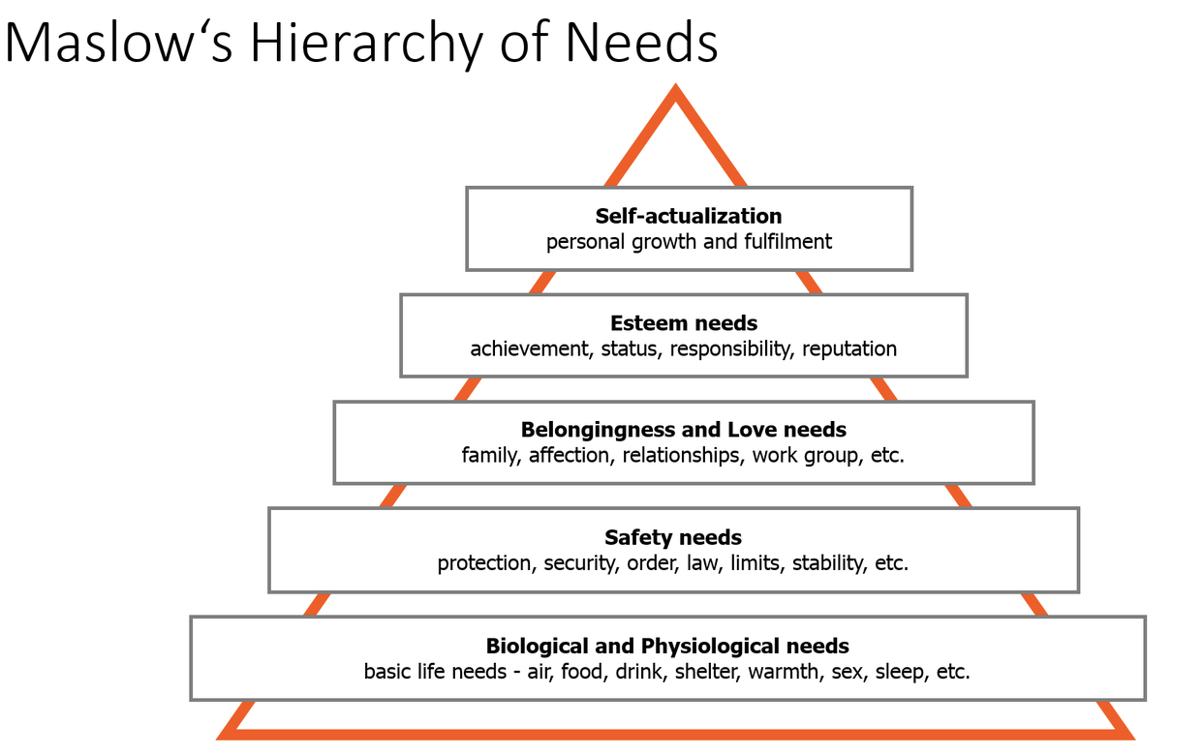
Review Maslow’s Hierarchy of needs from yesterday while also looking at the list of human rights in the UDHU. For each level of needs on Maslow’s pyramid, match up one of those human rights that you believe meets that level of need.

- Biological and Physiological Needs:

____________________________________________________________________

- Safety Needs:

____________________________________________________________________

- Belongingness and Love Needs:

____________________________________________________________________

- Esteem Needs:

_____________________________________________________________________

- Self-Actualization Needs:

_____________________________________________________________________

Share your answers with someone else in the room. Explain why you think that each of your answers meets the needs at each level. Do you and your partner have any of the same answers? How do your answers differ?

Step 4: Complete the Graphic Organizer

Look at the list of rights in the Universal Declaration of Human Rights. Pick three of the rights listed (make sure you have not already used them on the previous list. For each, you will create a drawing that shows:
Column 1: this right being enjoyed
Column 2: what it looks like when this right is denied.

Right #:
What it looks like being enjoyed. | What it looks like being denied.
Right #:
What it looks like being enjoyed. | What it looks like being denied.
Right #:
What it looks like being enjoyed. | What it looks like being denied.

Step 5: Share out with a partner.
What do your posters have in common? Tell your partner which one of his/her drawings you found to be the best.

Student Feedback:

Circle the emojis that best represents how this activity made you feel. | 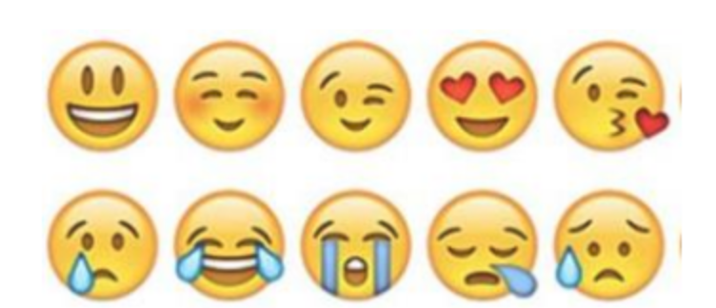  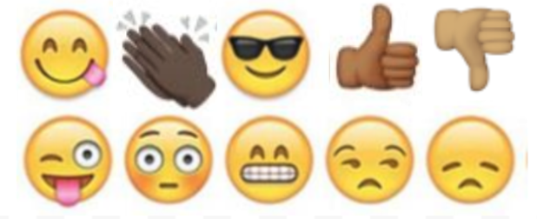

Day 2: The Ethics of Artificial Intelligence
Science

What is this lesson about?: Today you will read through the Ethics of AI: Should sentient (able to perceive or feel things) robots have the same rights as humans? passage. You will answer a few questions about what you read. You will complete an AI activity.

Step 1: Read through the article

Ethics of AI: Should sentient (able to perceive or feel things) robots have the same rights as humans?

With the growing pursuit of artificial intelligence, questions about our moral duty towards new technology could become increasingly important
(McLachlan, 2019)
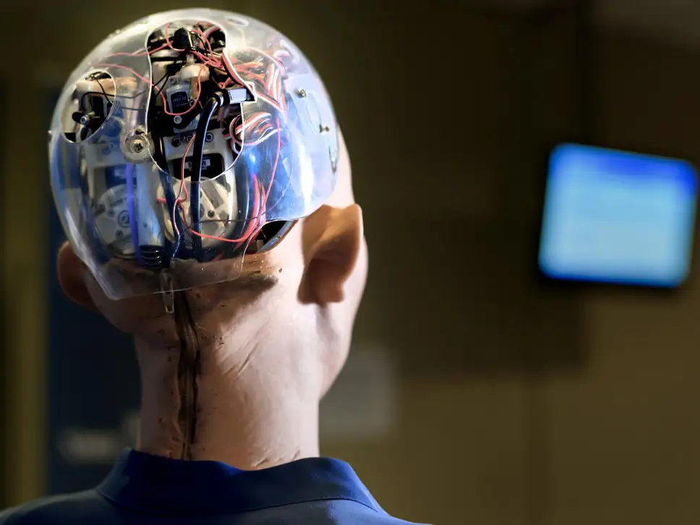
Imagine a world where humans coexisted with beings who, like us, had minds, thoughts, feelings, self-conscious awareness and the capacity to perform purposeful actions – but, unlike us, these beings had artificial mechanical bodies that could be switched on and off.
That brave new world would throw up many issues as we came to terms with our robot counterparts as part and parcel of everyday life. How should we behave towards them? What moral duties would we have? What moral rights would such non-human persons have? Would it be morally permissible to try to thwart their emergence? Or would we have a duty to promote and foster their existence?

Intriguing ethical questions such as these are raised in Ian McEwan’s recent novel, Machines Like Me, in which Alan Turing lives a long successful life and explosively propels the development of artificial intelligence (AI) that leads to the creation of “a manufactured human with plausible intelligence and looks, believable motion and shifts of expression”.

As intellectual speculation, to consider the ethics of the treatment of rational, sentient machines is interesting. But two common arguments might suggest that the matter has no practical relevance and any ethical questions need not be taken seriously.

The first is that such artificial people could not possibly exist. The second, often raised in the abortion debate, is that only persons who have living and independently viable human bodies are due moral respect and are worthy of moral consideration. As we shall see, these arguments are debatable.
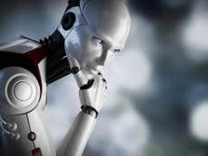
Mind, matter and emergent properties

We might suppose that mental phenomena – consciousness, thoughts, feelings and so on, are somehow different from the stuff that constitutes computers and other machines manufactured by humans. And we might suppose that material brains and material machines are fundamentally different from conscious minds. But whether or not such suppositions are true – and I think that they are – it does not follow that sentient, consciously aware, artificially produced people are not possible.

The French sociologist Emile Durkheim argued very convincingly that we should beware of simplistic arguments in social science. Social phenomena, such as language, could not exist without the interaction of individual human beings with their particular psychological and biological features. But it does not follow that the resultant social phenomena – or “emergent properties” – can be completely and correctly explained solely in terms of these features.
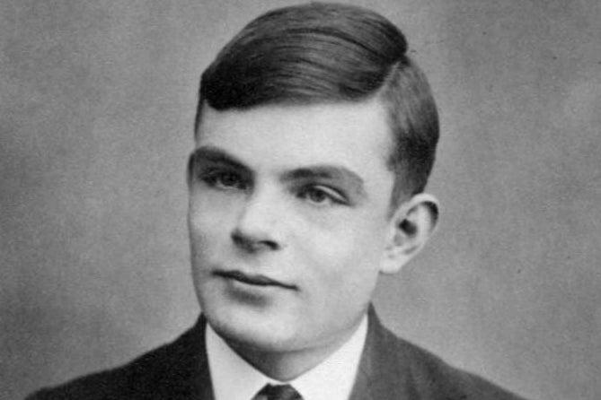

Alan Turing created a test to see if a computer could fool a human into thinking it too was human (Wikimedia Commons)

The same point about the possibility of emergent properties applies to all sciences. There could not be, for instance, computers of the sort I am now working at without the pieces of plastic, wires, silicon chips and so forth that make up the machine. Still, the operations of a computer cannot be explained solely in terms of the features of these individual components. Once these components are combined and interact in particular ways with electricity, a phenomenon of a new sort emerges: a computer. Similarly, once computers are combined and interact in particular ways, the internet is created. But clearly, the internet is a different sort of phenomenon from a tangible, physical computer.
In a similar way, we need not suppose that minds are reducible to brains, molecules, atoms or any other physical elements that are required for them to function. They might be entities of a different sort that emerge from particular interactions and combinations of them.

There’s no obvious logical reason why conscious awareness of the sort that human beings possess – the capacity to think and make decisions – could not appear in a human machine some day. Whether it is physically possible and, therefore likely to actually happen, is open to debate.
Do machines deserve our consideration?
It doesn’t seem controversial to say that we shouldn’t slander dead people or wantonly destroy the planet so that future generations of unborn people are unable to enjoy it as we have. Both groups are due moral respect and consideration. They should be regarded as potential objects of our moral duties and potential recipients of our benevolence.

But the dead and the yet to be born do not have viable bodies of any sort – whether natural or artificial. To deny conscious persons moral respect and consideration on the grounds that they had artificial rather than natural bodies would seem to be arbitrary and whimsical. It would require a justification, and it is not obvious what that might be.
One day, maybe sooner than we think, a consideration of the ethics of the treatment of rational, sentient machines might turn out to be more than an abstract academic exercise.

Step 2: Answer the following questions

- What’s something new you learned from this article?

________________________________________________________________________________________________________________________________________________________________________________________________________________

- Do you believe sentient robots should have the same rights as humans? Why/Why not?

________________________________________________________________________________________________________________________________________________________________________________________________________________

Step 3: Draw an image/picture

Design your own sentient robot. What does it have the power to do? How can your robot have a positive impact on your school, community, and/or the world?

Draw a picture of your robot and share your thoughts.

________________________________________________________________________________________________________________________________________________________________________________________________________________
________________________________________________________________________________________________________________________________________________________________________________________________________________
____________________________________________________________________________________________________________________________________________________________

Student Feedback:
Circle the emojis that best represents how this activity made you feel.

Mindfulness Moment!

Alternate Nostril Breathing
- Choose a comfortable seated position.
- Lift up your right hand toward your nose, pressing your first and middle fingers down toward your palm and leaving your other fingers extended.
- After an exhale, use your right thumb to gently close your right nostril.
- Inhale through your left nostril and then close your left nostril with your right pinky and ring fingers.
- Release your thumb and exhale out through your right nostril.
- Inhale through your right nostril and then close this nostril.
- Release your fingers to open your left nostril and exhale through this side.
- This is one cycle.
- Continue this breathing pattern for up to 5 minutes.
- Finish your session with an exhale on the left side.

Day 2: Right to Vote: the Women’s Suffrage Movement
Math

What is this lesson about?: In this lesson we will look at the math of the Women’s Suffrage Movement

Warm Up Problem
What is ⅗ of 100?

What is 60% of 200?

Which is bigger -- 60% of 500 or 400?

Which is bigger -- 60% of 500 or 275?
Is ⅗ more or less than ½?

Activity #1: The 19th Amendment
In 1920, the 19th Amendment, enfranchising women, was finally ratified by Congress. It was the single largest extension of democratic voting rights in our nation’s history, and it was achieved peacefully, through democratic processes.

Remember, when the 15th Amendment passed, guaranteeing the right to vote to Americans regardless of their race, nonwhites made up approximately 20% of the population...so the percentage of eligible voters overall went up by approximately 20%.

But women made up approximately 50% of the eligible voters in 1920, so then they were granted the right to vote, the percentage of eligible voters almost doubled, immediately!

Activity #2: Voter participation in the Elections following suffrage

According to political scientists J. Kevin Corder and Christina Wolbrecht, few women turned out to vote in the first national elections after the Nineteenth Amendment gave them the right to do so.

1920 Elections-
Eligible Women Voters | 26,000,000
Women Voters | 9,360,000
% of Eligible Women Voting

- In 1920, approximately what percentage of women voted?

- In 1920, approximately 68% of men voted. Why, do you think so fewer women might have voted than men in 1920?

More women than men have voted in each presidential election since 1960! The chart below shows voter participation rates over the last four elections, by gender. Use the chart to answer the questions below.
 | Women | Men
2016 | 64% | 62%
2012 | 60% | 58%
2008 | 62% | 56%
2004 | 58% | 58%

- Over the last four elections, what is the average percentage of eligible women who have voted?

- How does that compare to the average percentage of eligible men who have voted?

- Why do you think that a greater percentage of women are voting than men?

Activity #3: Women in congress and the US Senate

The chart below offers a detailed look at women in Congress, from 1920 to the present. D and R are short for Democrat and Republican. Use the chart to answer the questions below.

Congress | Dates | Women in the Senate |  | Women in the House |  | Total Women
65th | 1917-1919 | 0 | (OD, 0R) | 1 | (OD, 1R) | 1 | (0D, 1R)
66th | 1919-1921 | 0 | (0D, 0R) | 0 | (0D, OR) | 0 | (0D, 0R)
71st | 1929-1931 | 0 | (0D, 0R) | 9 | (5D, 4R) | 9 | (5D, 4R)
72nd | 1931-1933 | 1 | (1D, 0R) | 7 | (5D, 2R) | 8 | (6D, 2R)
73rd | 1933-1935 | 1 | (1D, 0R) | 7 | (4D, 3R) | 8 | (5D, 3R)
74th | 1935-1937 | 2 | (2D, 0R) | 6 | (4D, 2R) | 8 | (6D, 2R)
75th | 1937-1939 | 2 | (1D, 1R)1 | 6 | (5D, 1R) | 8 | (6D, 2R)
80th | 1947-1949 | 1 | (0D, 1R) | 7 | (3D, 4R) | 8 | (3D, 5R)
81st | 1949-1951 | 1 | (0D, 1R) | 9 | (5D, 4R) | 10 | (5D, 5R)
82nd | 1951-1953 | 1 | (0D, 1R) | 10 | (4D, 6R) | 11 | (4D, 7R)
86th | 1959-1961 | 2 | (1D, 1R) | 17 | (9D, 8R) | 19 | (10D, 9R)
87th | 1961-1963 | 2 | (1D, 1R) | 18 | (11D, 7R) | 20 | (12D, 8R)
92nd | 1971-1973 | 2 | (1D, 1R) | 13 | (10D, 3R) | 15 | (11D, 4R)
97th | 1981-1983 | 2 | (0D, 2R) | 21 | (11D, 10R) | 23 | (11D, 12R)
102nd | 1991-1993 | 4 | (3D, 1R)3 | 28 | (19D, 9R)4 | 32 | (22D, 10R)4
103rd | 1993-1995 | 7 | (5D, 2R)5 | 47 | (35D, 12R)4 | 54 | (40D, 14R)4
104th | 1995-1997 | 9 | (5D, 4R)6 | 48 | (31D, 17R)4 | 57 | (36D, 21R)4
109th | 2005-2007 | 14 | (9D, 5R) | 68 | (43D, 25R)11 | 82 | (52D, 30R)11
114th | 2015-2017 | 20 | (14D, 6R) | 85 | (63D, 22R) | 105 | (77D, 28R)18
115th | 2017-2019 | 23 | (17D, 6R) | 87 | (64D, 23R)16 | 110 | (81D, 29R)16
116th | 2019-2021 | 26 | (17D, 9R)17 | 101 | (88D, 13R)19 | 127 | (105D, 22R)

- In general terms, what does this chart show about women in Congress from 1920 to the present?
- Remember, there are 100 US Senators and 435 US Representatives.
- What percentage of US Senators are women right now?
- What percentage of US Senators were women in the year 2000?
- Approximately what percentage of US Representatives (House) are women right now?
- Of the 127 women in congress right now, approximately what percentage are Democrats and what percentage are Republicans?
- Look back to the 1980s. What percentage of women in congress were Democrats and Republicans during the 1980s?
- Do you have any ideas on why this may have changed between the 1980s and the present?
- If you looked at these results on a line graph, the line would stay pretty flat from the 1920s until the 1950s. Then it stayed sort of flat again until the late 1980s.
  - How many more women are in congress today than in 1930?
  - How many more women are in congress now than in the 1980s?
  - Look closely at the chart between 1980 and 2000. When did the number of women in congress really take off, more than doubling over a couple elections?
    - Do you have any ideas on what happened in the1990s to lead to this?

Step 4: Women in your City and State
- Do you have any idea if the Mayor of your city is a man or woman?
- What about the judges down in the courthouse, or the local Sheriff?
- Do you know if you have a woman Governor? Or if you have a woman Senator or Congressperson?

Student Feedback:

Circle the emojis that best represents how this activity made you feel.

Day 2: Freedom of Speech Online
Digital Health

What is this lesson about?: Today you will learn what it really means when you say freedom of speech online. Free speech online is not quite as free as it seems.

Step 1: Warm-up
What is your definition of hate speech?

Step 2: Read the article on your digital rights.
You’ve heard it or have seen it posted…
Someone saying they can say whatever they want, post whatever they want and no-one can do anything to them. As if the First Amendment is their sword and shield. And you can’t do anything about it. Freedom of speech. Three words that get thrown around and written about so often that what the expression means is more about misinformation than truth.

And misinformation can be detrimental to online professionals as they try to separate the wheat from the chaff and understand a right so important to the foundation of the United States that the founding fathers made it the first amendment to the Constitution to better clarify what rights belong to its citizens.

Congress shall make no law respecting an establishment of religion, or prohibiting the free exercise thereof; or abridging the freedom of speech, or of the press; or the right of the people peaceably to assemble, and to petition the Government for a redress of grievances.
Source: First Amendment, U.S. Constitution

This article will specifically focus on the portion relating to speech and how this applies to the online community.

In 1996, in the landmark case Reno v. ACLU, a unanimous Supreme Court specifically extended the First Amendment to written, visual and spoken expression posted on the Internet.
For those of us who work in an increasingly online environment, more and more we’re seeing behavior that would never fly in the “real world.” Social psychologists are having a field day picking apart tweets, status updates, and social network posts.

As you’ve likely seen, people will say anything! Justified or not, the fact is many people feel safe in their cocoon of online anonymity.

Of course, the First Amendment doesn’t give us the right to say whatever we want, whenever we want, to whomever we want. But that doesn’t stop people from thinking otherwise.

“Speech” Is More than Written or Spoken Words
While the dictionary definition of speech may be limited to the written or spoken word, we’re really looking at types of expression. This applies to visual interpretations, as well as artistic forms of speech.

In addition, symbolic speech—symbols that have meaning (for example, a swastika or peace sign)—is covered by what we often refer to as freedom of speech.

What Speech Is Protected by the First Amendment?
The right to free speech means that you are allowed to express yourself without interference or constraint by the government. And while that seems very broad, the U.S. Supreme Court has been involved in this debate for nearly a century and has determined that the government can limit both the content of speech and the ability to engage in speech as long as the government has a “substantial justification.”

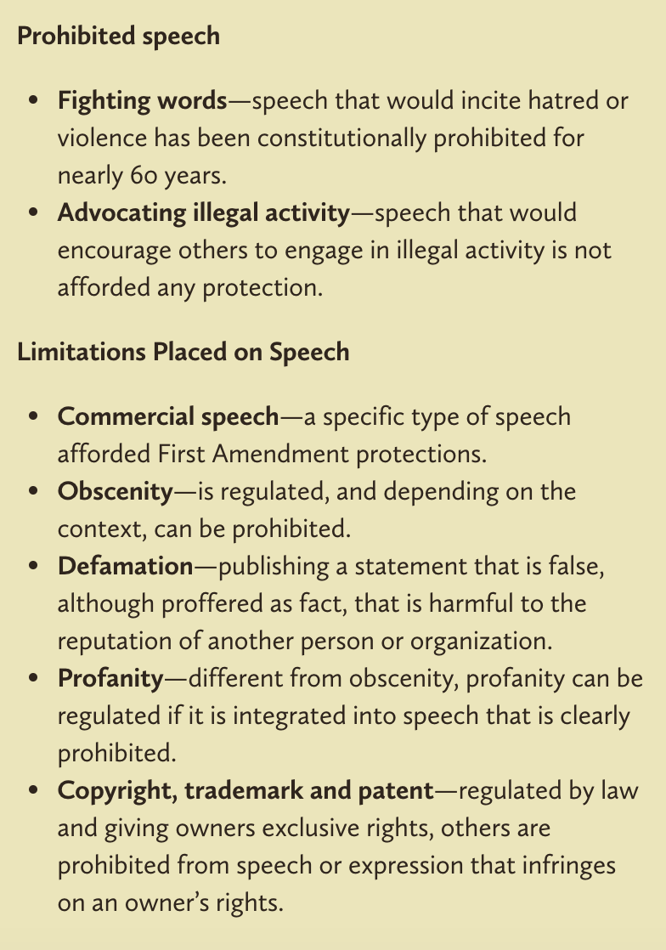
It’s nearly impossible to create a list of what types of speech are protected because there are quite a few caveats, and “it depends” would be tacked onto the end of each enumerated list.

Take advertising, for example. Advertising is a type of commercial speech. Commercial speech is a specific type of speech afforded First Amendment protections. It has been defined by the Supreme Court as speech where the speaker is more likely to be engaged in commerce, where the intended audience is commercial or actual or potential consumers, and where the content of the message is commercial in character.

However, the FTC and the FCC are both permitted to restrict certain types of advertisements. They restrict those that are misleading or deceptive or use profanity, racial slurs or nudity. Clearly, the FTC and FCC are both arms of the government. Advertising (“Commercial Speech”) is then protected speech, sometimes.

What is NOT Protected Speech?
Fortunately, the U.S. Supreme Court over time has created a number of categories of speech that are not afforded protection. What this means is that these types of speech are subject to prohibitions.

Step 3: Answer the questions below.

- How would you explain the difference between free speech and prohibited speech online?

- What did you learn the most from this article?

- What would you do if you saw prohibited speech online?

Step 4: Draw a sign that shows Internet Users what is allowed online and what is not allowed online.

Mindfulness Moment!

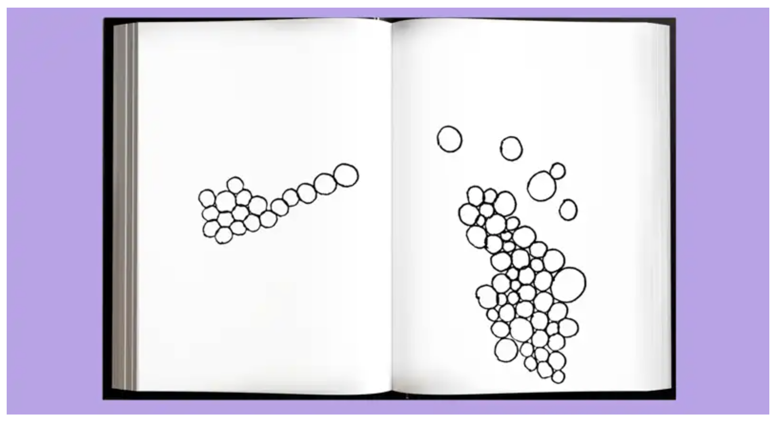
Draw circles that are connected to fill the space below:

Day 2: Bill of Rights Today
Social Studies

What is this lesson about?: Today you will continue to explore the Bill of Rights and consider current events that involve issues about the Bill of Rights.

Step 1: Review the Bill of Rights

Take a moment to read through this breakdown of the Bill of Rights and remind yourself what rights each amendment protects.

FIRST AMENDMENT
This amendment guarantees the right of freedom of religion, freedom of speech, freedom of the press, freedom of association, freedom for people to get together peacefully, and freedom for people to send petitions to their government.

SECOND AMENDMENT
This amendment states that in order to have a prepared military, people are guaranteed the right to keep and bear arms.

THIRD AMENDMENT
This amendment states that the government cannot force people to house and feed soldiers in their homes during times of peace.

FOURTH AMENDMENT
This amendment states that people, their homes or their belongings are protected from unreasonable searches or seizures. Warrants may not be issued except upon probable cause and must specifically describe the place to be searched and the person/thing to be seized.

FIFTH AMENDMENT
This amendment guarantees a person accused of a serious crime the right to be charged by a grand jury. Persons cannot be forced to give evidence against themselves. If a person is found not guilty of a crime, he/she cannot be put on trial for the same crime again. The federal government cannot unfairly take peoples' lives, freedom or property. The government must pay a person for any property it takes for public use.
SIXTH AMENDMENT
This amendment guarantees a speedy and public trial by an impartial jury if a person is accused of a crime. The accused has the right to be told what they are accused of. They have the right to a lawyer. They have a right to see and to question those people who accuse them of the crime.

SEVENTH AMENDMENT
This amendment guarantees a trial by jury in civil cases (Disputes between private parties or between the government and a private party.)

EIGHTH AMENDMENT
This amendment guarantees that excessive bail or excessive fines will not be imposed and that punishment will not be cruel and unusual.

NINTH AMENDMENT
This amendment states that the people have other rights that are not stated here.

TENTH AMENDMENT
This amendment states that the people have all the rights not given to the United States government or forbidden to state governments by the U.S. Constitution.

Step 2: Rank the rights

Now that you have read over the Bill of Rights and the rights protected in each amendment, think about which rights are most important to you. Choose five that you believe are the most important, and list them in the chart below. Then answer the questions below.

Right | Amendment
1
2
3
4
5

Why did you select these rights?

How would life change without the other rights?

Why is it important that we have all of the rights enumerated in the Bill of Rights?

* With a partner or group: Share what rights/amendments made your top 5 list.
- What similarities do your rankings show?
- Do you think people’s rankings might change based on the person’s age? Or time in history?
- Why is it wrong for governments to infringe on these individual rights?

Step 3: Current events and the Bill of Rights

Read the following two articles on current events that involve issues around the Bill of Rights.

Do coronavirus social distancing orders violate religious freedom? Local pastors say yes
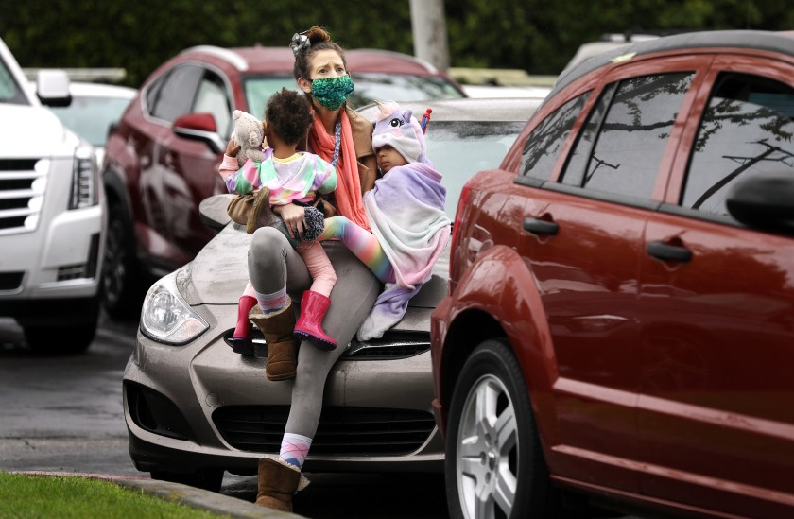
By Cindy Change for the Los Angeles Times - April 15, 2020

On Easter Sunday at a church in Fontana, a pastor delivered a fiery sermon to worshipers who crowded the pews in defiance of government orders prohibiting in-person services even on this holiest of days. The next day, the pastor, Patrick Scales of the Shield of Faith Family Church, filed a lawsuit contesting the stay-at-home orders as a violation of 1st Amendment religious freedom. (pictured: Ashley Amon and her daughters, Alysha, 2, and Alexandria, 4, attend an Easter service with fellow worshipers in their cars in a parking lot)

“We’re not going to stay home. We went to the house of God anyway,” Scales thunders in a video of the Easter service posted on Facebook. “We were threatened by jail. We were threatened by a fine. I chose to come worship.” People in the pews cheered and applauded, many wearing masks and gloves but appearing to be closer to each other than the six-foot distance mandated by officials to stop the spread of the coronavirus that has killed more than 126,000 worldwide.

Much about the COVID-19 pandemic is unprecedented, from the mass closure of schools and restaurants to the social distancing rules requiring that religious services be held online only. The U.S. Constitution is also being tested in unprecedented ways, with religious leaders from Mississippi to Kentucky to San Diego County suing their governments, asserting that they are being treated differently from businesses that can remain open, such as supermarkets and liquor stores.

Other plaintiffs in the lawsuit include one of Scales’ parishioners, Wendy Gish, and two Riverside County pastors, James Moffatt and Brenda Wood. Moffatt was fined $1,000 for conducting a church service on Palm Sunday, according to the complaint. On Easter Sunday, his church held a drive-in service, which was permitted by Riverside County only for that weekend. Photos on the church’s Facebook page show cars lined up in the parking lot, where a live band performed. Some worshipers emerged into the sunshine, standing on the curbs or in the narrow gaps between cars.

“It doesn’t work for the government to tell you or me that it’s good enough to load up Zoom and your high-speed internet and do your service remotely,” said the plaintiffs’ lead attorney, Harmeet Dhillon. “That’s incredibly arrogant and out of touch.” Dhillon noted that in rural areas, many people do not have internet access. On Tuesday, she filed for a temporary restraining order to obtain a ruling on whether the defendants, who include Gov. Gavin Newsom and officials from Riverside and San Bernardino counties, should allow the churches to resume in-person services. A hearing before U.S. District Judge Jesus G. Bernal is scheduled for June 1.

Constitutional law scholars interviewed by The Times were divided on the strength of Scales’ case. During an infectious disease pandemic, government officials have a public health interest in restricting people’s movements, which can clash with constitutional rights such as freedom of religion, speech and assembly.

Barry McDonald, a professor at Pepperdine’s Caruso School of Law, said the plaintiffs have a “decent claim.” The government must have a compelling reason to treat churches differently from other organizations it has deemed essential, he said. If churches agree to maintain safe social distancing, according to McDonald, they could argue for a carve-out like supermarkets and pharmacies. “These are important material needs that must be fulfilled, important social needs — courts, day care, child care,” he said. “You could say spiritual needs are essential and necessary as well.”

In Kentucky, a federal judge granted the On Fire Christian Center’s request for a temporary restraining order against the city of Louisville so it could hold drive-in services. Because Louisville allows drive-through liquor services, it must allow church services, U.S. District Judge Justin R. Walker ruled. “But if beer is ‘essential,’ so is Easter,” Walker wrote.

In San Diego, a judge came out on the other side, rejecting a church’s request for a temporary restraining order so it could hold Easter services. The right to freedom of religion doesn’t “include the right to expose the community to communicable disease,” U.S. District Judge Cynthia A. Bashant said.

Lawrence Sager, a professor at the University of Texas at Austin School of Law and visiting professor at UCLA School of Law, said the Riverside and San Bernardino county churches did not provide strong evidence of unconstitutional religious discrimination. Whereas people cannot rely exclusively on online deliveries of food and medicine, churches can deliver their messages online, he said. “They can behave virtually and do what needs to be done virtually. You can’t give someone food virtually or medicine virtually,” he said. “I think that makes the case that churches aren’t being treated fairly a weak case — a very weak case.”

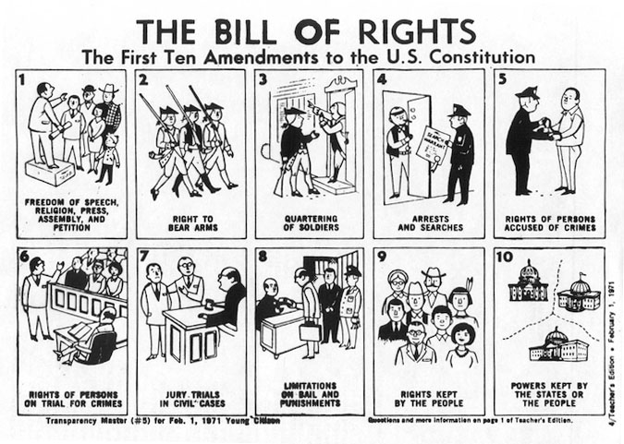
But on Easter in Fontana, Scales recited the 1st Amendment and said the church was “facing the enemy” as best it could by taking legal action. “We can’t roll over and play dead. The devil’s playing for keeps,” he said. “We’re living in the last days. It’s time to stand up — hallelujah — not to run and hide.” The applause from the pews intensified. People rose to their feet, waving hands in rubber gloves.

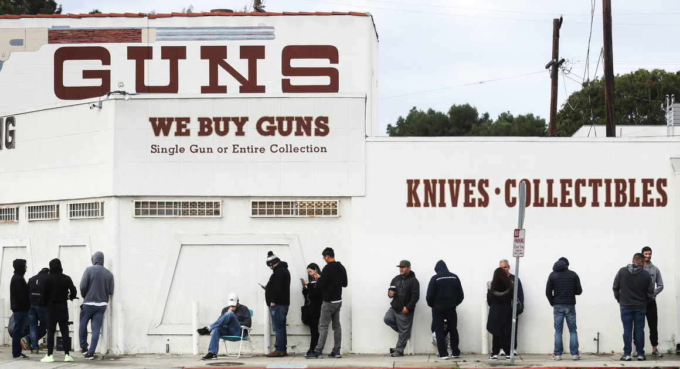
Gun-rights coalition sues New Jersey governor for closing gun dealers during coronavirus pandemic
By Jeff Mordock - The Washington Times - Monday, March 23, 2020

A coalition of gun-rights activists Monday filed a lawsuit against New Jersey Gov. Phil Murphy for closing gun stores and suspending legally required background checks amid the coronavirus pandemic. The lawsuit charges that Mr. Murphy’s actions violate the Second Amendment’s right to bear arms.

“This emergency has its constitutional limits. It would not justify a prior restraint on speech nor a suspension of the right to vote. Just the same, it does not justify a ban on obtaining guns and ammunition,” the plaintiffs wrote in a court filing. Mr. Murphy, a Democrat, issued an executive order Saturday closing all non-essential businesses in New Jersey. Firearms dealers were not deemed essential and the state also stopped processing background checks.

Roughly a dozen states have shuttered “non-essential” businesses as the deadly coronavirus sweeps across the country. Some of those states have kept gun stores opened, while others have shuttered them. Illinois Gov. J.B. Pritzker, a Democrat, issued a shelter-in-place order Friday, but said firearm retailers could stay open “for purposes of safety and security.”

The plaintiffs said Mr. Murphy’s order is essentially a ban on firearm purchases because it does not have an end date and experts have differed on the length of time it will take the pandemic to run its course. “Gov. Murphy cannot simply suspend the Second Amendment and neither can Supt. Callahan,” Alan Gottlieb, executive vice president of the Second Amendment Foundation, said. “Yet, under this emergency order, that’s exactly what they’re doing. The Constitution and federal law don’t allow that.” Mr. Gottlieb told The Washington Times his group is weighing lawsuits against other states and cities that have deemed firearms retailers as “non-essential.”

Gun sales have skyrocketed since the coronavirus outbreak became a pandemic earlier this month. The National Shooting Sports Foundation said the FBI processed more than 300% more background checks on March 16 than it did on the same day in 2019. Ammo.com, which ships ammunition to gun dealers, said its total transactions jumped 222% between Feb. 23 and March 15.

The sales are being driven by fears of an economic recession along with looting and pandemonium because of the pandemic. Many of those flocking to firearms dealers are said to be first-time buyers.
The gun-sale spike is leading to long delays in approvals and wait times could get even longer.

Earlier this month, the FBI office that operates the National Instant Criminal Background Check System said it is considering staff reductions or shuttering some offices in response to the coronavirus pandemic.

Step 4: Current event assessment

Complete the chart below by using the articles above about issues related to the Bill of Rights. As you respond to each article, think about ways the issue or event may touch your life.

Summary of Article | Related Amendment | Your Response to this Issue/Event

Student Feedback:

Circle the emojis that best represents how this activity made you feel.

